

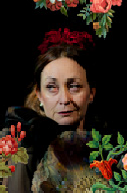
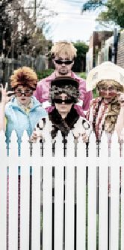




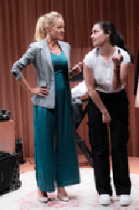
POTATO SHED
2025

SEASON

We Acknowledge the Wadawurrung People as the Traditional

HOW TO BOOK A TICKET
ONLINE potatoshed.com.au
PHONE with credit card Ph 5251 1998
IN PERSON at the Box Office.
BOX OFFICE Open 10am–4pm Monday to Friday and one hour before any scheduled performance.
VIP DISCOUNT Book five or more shows tagged with the VIP Symbol and receive $3 off each ticket (Box Office only)

THE POTATO SHED
41 Peninsula Drive
Drysdale VIC 3222
P: 03 5251 1998
E: potatoshed@geelongcity.vic.gov.au potatoshed.com.au

VIP
GRUBB RD
H
IG
TO DRYSDALE
H
ST

NORTH BELLARINE AQUATIC CENTRE
DRYSDALE BYPASS
TO GEELONG
PENINSULA
DR
TO OCEAN GROVE

Owners of the Land, Waterways and Skies. We pay our respects to their Elders, past, present and emerging. We
potatosheddrysdale
potatosheddrysdale
DISCLAIMER: Program subject to change.

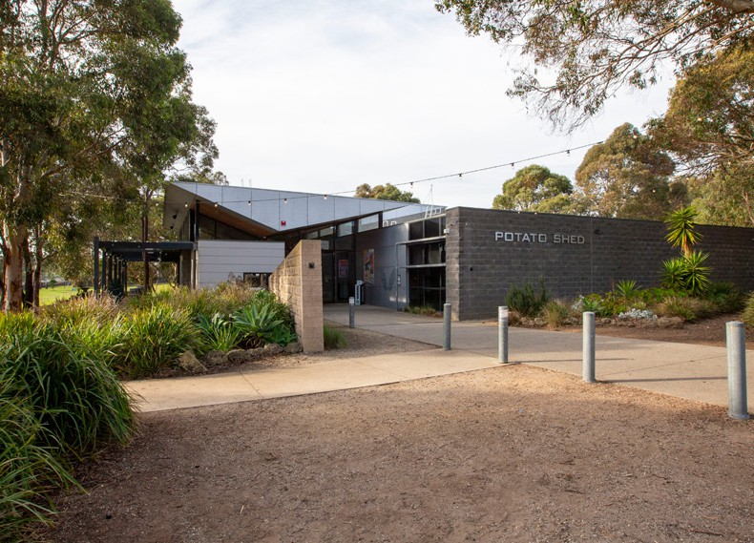




Acknowledge all Aboriginal and Torres Strait Islander people who are part of our Greater Geelong community today.
2
Licensed bar available at all season shows.
© City of Greater Geelong 2024
3

CEO MESSAGE
At our home of the performing arts on the Bellarine, we are proud that the
Potato Shed is a vital resource for Greater Geelong, giving our
community access to a range of performing arts practices, while entertaining, educating and, occasionally, challenging our audiences.
The 2025 season features theatre, comedy, opera, cabaret, live music, and the opportunity for resident theatre companies to shine the limelight on local playwrights, directors and actors.
Program highlights include celebrated singer-songwriter Mike Brady, HiT
Productions Waltzing the Wilarra, Geraldine Quinn’s Passion of St Nicolas, a look back at 1930s Melbourne in Garage Girls and the return of Americana on the Bellarine, part of our sensational Summer Series.
Entertainment stalwarts Issi Dye and Colin Mockett keep the musical memories alive when they present their respective Morning Showtime shows and the young (and young- at-heart) will thrill to the school holiday program.
Take time to peruse the program, as I’m sure you will be booking tickets to see one or more shows at the Shed.

ALI WASTIE
Chief Executive Officer City of Greater Geelong



Georgia Fields conjures a mesmerising spell of art-
SUMMER SERIES
GEORGIA FIELDS
Saturday 8 February at twilight (gates open 6pm)
Tickets $40 Adult $35 Conc
SHOW
Bring a blanket or picnic
OUTDOOR
VIP
pop alchemy in her captivating solo show. Accompanying herself on electric guitar, mini-synth and textural live loops, the singer-songwriter “paints entire worlds with her tunes” Frankie Magazine.
Georgia’s distinctive vocal brings to mind the piercing, understated clarity of Sarah Blasko, and the shoulders-back power-stance of Sharon Van Etten. Building layer upon layer to create complex and ethereal arrangements, she uses her voice like an instrument.
“Georgia Fields dreams in fantastic Technicolor.” Sydney Morning Herald



4 5


AMERICANA ON THE BELLARINE ’25
SUMMER SERIES
SHOW
Bring a blanket or picnic
OUTDOOR
Saturday 22 February at twilight
(gates open at 6pm)
Presented by Andrea Robertson
Tickets $45* Full $35* Seniors/Conc $30* Youth under 12s free
*plus booking fee

Music lovers rejoice! Americana on the Bellarine returns with the best of Bellarine Americana.
Featuring some of our region’s finest songwriters and musicians, performing on our outdoor stage as the sun sets and stars begin to twinkle.
There will be blues, roots, country, folk and rock, rockabilly and gospel, all doused with a whole lot of soul.
The 2025 lineup features one of the Bellarine’s favourite songwriters, Andrea Robertson and band along with The Mojo Corner, and more artists to be announced.

IT’S DE-LOVELY –

A CELEBRATION OF COLE PORTER
VIP
Presented by JTM Productions Saturday 15 March, 8pm
Cabaret Seating $45 Adult $40 Conc $25 Under 25s Theatre Seating $40 Adult $35 Conc $25 Under 25s

It’s De-Lovely – A Celebration of Cole Porter features hits from Broadway and Hollywood’s most popular musicals.
Starring international cabaret performer and jazz singer Belinda Hanne-Reid, Tim Carney (International Tour of Mamma Mia) and accompanied by Mark Bradley on piano, with songs like I Get A Kick Out of You, Night and Day, I’ve Got Your Under My Skin, You’re the Top and many more.
If you love the Great American Songbook, you’ll be enchanted by this elegant and jazzy celebration of Cole Porter.
PHOTO Belinda Hanne-Reid

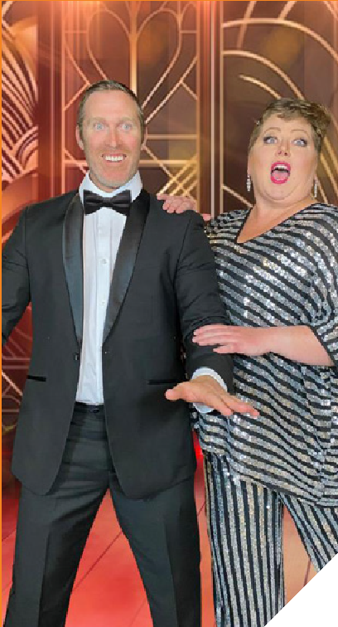


6 7

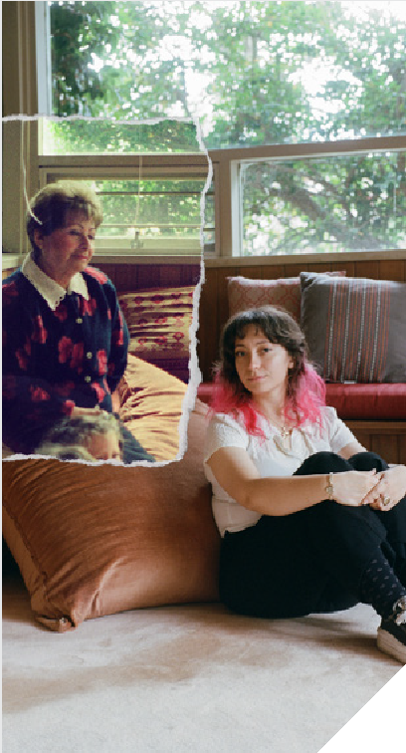
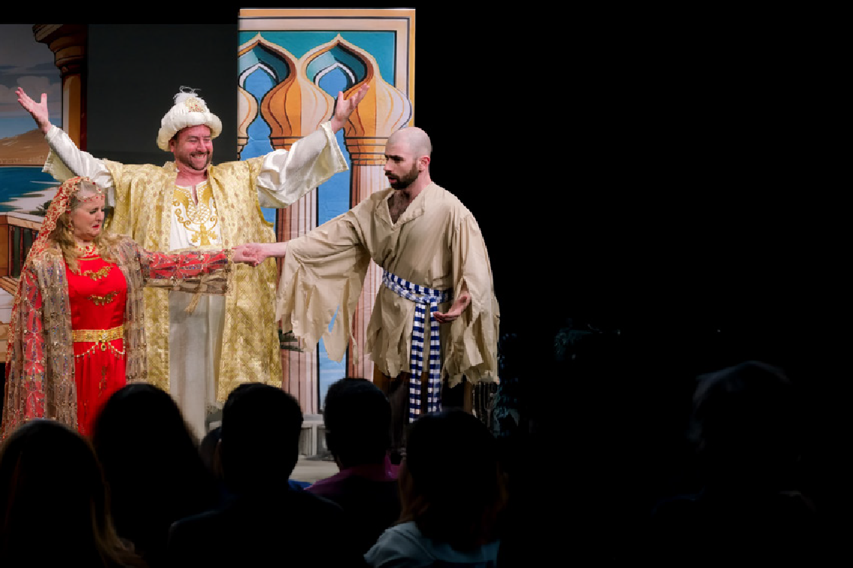
THE ABDUCTION OF SERAGLIO

Presented by Lyster Opera
Saturday 5 April 2pm Theatre Seating
$40 Adult $35 Conc $30 Under 25s

Belmonte, with his sidekick Pedrillo, sets off to Turkey to rescue his betrothed Konstanze. This hilarious, action-packed opera focusses on our heroes and heroines and how they outwit their captors, particularly the fiendish Osmin, overseer of the Pasha’s harem. One of Mozart’s first successes as a composer, The Abduction from the Seraglio is a farcical, colourful romance.

8

NIUSIA
Sunday 4 May 4.00pm
VIP
Theatre Seating $40 Adult $35 Conc $25 Under 25s

How do you honour the legacy of a woman you hardly knew? and didn’t really like?
Niusia was a Holocaust survivor. Charming, savvy, and if you ask granddaughter, Beth, a pretty mean lady.
By reading, interviewing, and weaving memories and handed-down stories, Beth sets out to understand Niusia’s complex legacy. She gives voice to the thoughts you shouldn’t have about your holocaust-surviving nana,
explores her own Jewishness, and ultimately confronts how deeply embedded these memories are in her family line.


9

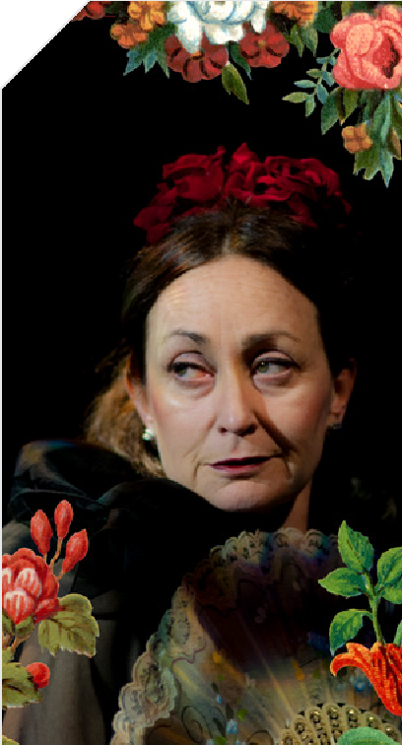
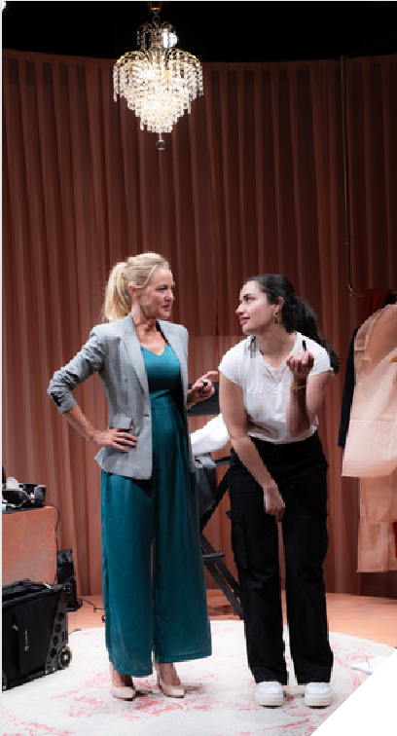
THE EXOTIC LIVES OF LOLA MONTEZ
Finucane & Smith Unlimited Saturday 17 May 8pm
Cabaret Seating $45 Adult $40 Conc $25 Under 25s
Theatre Seating $40 Adult $35 Conc $25 Under 25s

In 1855, Lola Montez, wildest showgirl of the known world, toured Australia’s goldfields. The scandal is legend. Horsewhipping the editor of the Ballarat Times (for a bad review). Swinging down mine-shafts, champagne in hand. Escaping arrest wearing only jewels. Her erotic Spider
Dance was “the most libertinish and indelicate performance given on the public stage” Sydney Morning Herald 1855.
Starring award winner and direct descendant of Lola Montez, Miss Caroline Lee, her Luscious Lolettes, Maple Rose, Piera Dennerstein, Iva Rosebud and more!
Directed by Moira Finucane.



MONUMENT
Red Stitch Theatre Saturday 14 June 8pm
VIP
Theatre Seating $40 Adult $35 Conc $25 Under 25s

Edith Aldridge is the youngest woman to be elected leader of her country. In the lush presidential suite of a heritage listed hotel, she has ninety minutes to get ready for the biggest day of her life. Enter Rosie, a 22-year-old makeup artist from the David Jones counter, sent to help Edith get camera-ready. In Rosie’s capable hands, this morning will be a breeze, so long as they both stick to the brief.
An unlikely friendship between women of different generations and class backgrounds.


11

WINTER SOLSTICE ONE ACT PLAYS
Theatre 3triple2
Friday 20 June 7.30pm | Saturday 21 June 2pm and 7.30pm
Theatre Seating All tickets $27.50

Theatre 3triple2 is celebrating the 17th anniversary of Winter Solstice at the Potato Shed. Two unique
performances of cosy entertainment in the form of one-act plays from our talented local playwrights and performers. Live music, mulled wine and warm fires included.

THE PASSION OF ST NICHOLAS

Saturday 12 July 8pm
VIP
Cabaret Seating $45 Adult $40 Conc $25 Under 25s Theatre Seating $40 Adult $35 Conc $25 Under 25s

Geraldine and her brother Nick always shared a passion for music. But he got a “normal job”, and she went into musical comedy. Could things get worse? Spoiler: they did…
Their journey, from being arty kids in a sporty school and sharing dreams of a music career is cathartic and hilarious, with original music and a profound message of moving forward with love and loss in your heart.
A fantastic tale about following dreams and keeping the band together when you lose your biggest cheerleader.
Winner – Best Cabaret Production, Best Artiste and Best Musical Direction – Green Room Awards 2022

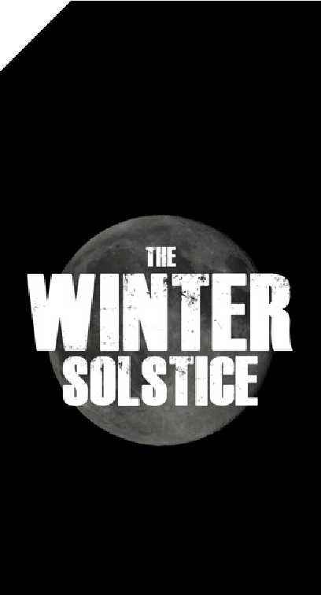


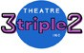

12 13

WALTZING THE WILARRA
VIP
HiT Productions Saturday 19 July 8pm
Cabaret Seating $45 Adult $40 Conc $25 Under 25s Theatre Seating $40 Adult $35 Conc $25 Under 25s

Charlie, Elsa and Fay take you on a musical journey to 1940’s post-war Perth. White and Black manage to form their own club where they can forget their worries, singing, dancing, listening to music, and maybe finding romance.
Forty years later, when the club faces demolition, they meet again to stage a musical protest to save it. As the trio reflects, old arguments and alliances re-surface.
Dark secrets and ghosts revealed, and we discover that reconciliation is more than saying sorry.

WOMEN OF WIT ‘25
Comedy Victoria Saturday 26 July 8pm
VIP
Cabaret Seating $45 Adult $40 Conc $25 Under 25s
Theatre Seating $40 Adult $35 Conc $25 Under 25s

Roll on up for a guaranteed night of belly-shaking laughter when Women of Wit returns to our black box theatre.
You can expect celebrities, rising stars and a special local guest or two to tickle your funny bone. The line up for 2025 will be announced closer to the date.
As always, you will be impressed. Produced by Comedy Victoria.

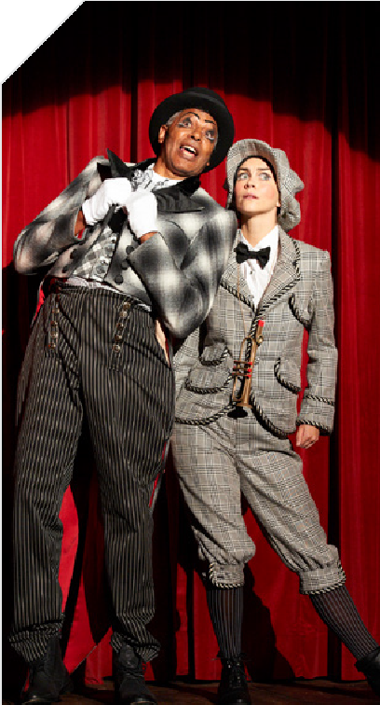



14 15

STICKYBEAK
VIP
The Beaks
Saturday 2 August 3pm
Cabaret Seating $45 Adult $40 Conc $25 Under 25s Theatre Seating $40 Adult $35 Conc $25 Under 25s

Stickybeak is multi-character, expertly observed, laugh- out-loud physical comedy set on a street everyone will recognise.
Feral toddlers escaping onto the street, uppity teens sneaking home drunk, exhausted parents dying for a ciggy, white collar snobs obsessed with their roses, cats in heat, dogs on the loose, snails, magpies, rotten figs and everything in between.
Four performers play 15+ characters, as the drama of a suburban street unfolds.
Who would have thought there could be so much drama in one day around three little fences?
AN EVENING WITH UP THERE CAZALY’S

MIKE BRADY AND SPECIAL GUEST ISSI DYE
VIP
Saturday 16 August 8pm
Cabaret Seating $45 Adult $40 Conc $25 Under 25s Theatre Seating $40 Adult $35 Conc $25 Under 25s

Mike Brady has been a household name on the Australian music scene since the ‘60s with his first hit band MPD LTD and their number one song Little Boy Sad.
Mike is most well-known today for his powerful rendition of the hit song Up There Cazaly which he wrote and performs each year at the AFL Grand Final day.
Mike will sing hit songs from his 60-year music career, plus hits from other artists he has performed with. Special guest will be long-time friend and Aussie music legend Issi Dye.
This is a show not to be missed with these two Aussie music icons…with over 120 years’ experience in showbiz!

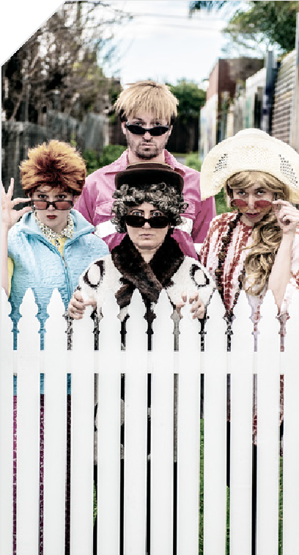
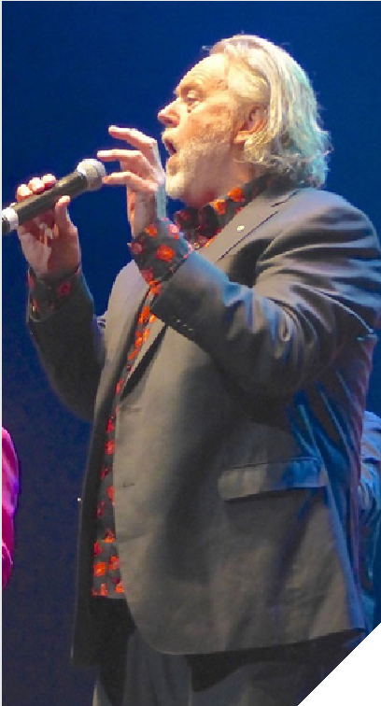
16 17

GARAGE GIRLS
VIP
Sunday 17 August 4pm
Theatre Seating $40 Adult $35 Conc $25 Under 25s

Imagine 1920’s Melbourne and the advent of the motorcar! Society reels from the aftermath of war and a second wave of Spanish flu wreaks havoc. Theatres buzz with vaudeville hacks and men with an eye for enterprise seize every opportunity to weasel wealth. Meanwhile, one small woman defies convention and makes her mark…
Meet Alice Anderson. Mechanic. Trailblazer. Entrepreneur. Part history, part farce, part who-done-it, Garage Girls shines a light on one remarkable young woman’s short but eventful life.
Inspired by actual events with colourful characters played by five actors, Garage Girls is a rollicking ride celebrating a Victorian icon.

LEGALLY BLONDE THE MUSICAL JR
Bellarine Jongleurs
Friday 29 August 7pm and Saturday 30 August 2pm, 7pm
$20 Adult $18 Conc

Based on the award-winning Broadway musical and the smash hit motion picture, and presented by local youth theatre company ‘The Bellarine Jongleurs’, Legally Blonde The Musical JR. is
a fabulously fun journey of self-empowerment and expanding horizons. The show’s instantly recognisable songs are filled with humour, wit and sass, leaving cast members and audiences alike seeing pink!

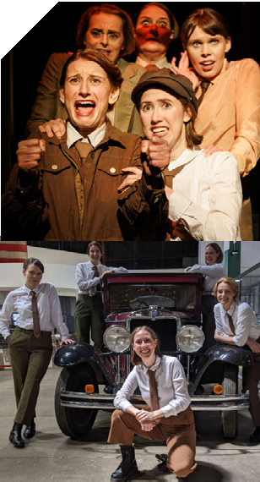



18 19

MAGIC OF PARIS
VIP
DUSTY SPRINGFIELD AND CONNIE FRANCIS SHOW WITH SPECIAL GUEST THE DEAN MARTIN SHOW
VIP

Saturday 20 September 8pm
Cabaret Seating $45 Adult $40 Conc $25 Under 25s Theatre Seating $40 Adult $35 Conc $25 Under 25s

Magic of Paris is a new French international concert experience where French classics rub shoulders with the pop songs of ‘60s and ‘70s that somehow found
their niche in the world of French popular music through some of the French pop stars and songwriters of the time.
Because they can, performers Milko and Corinne also venture into the fascinating world of musicals, operetta and the movies, all with French connections, performing a cavalcade of hits delivered with a French flair.
Saturday 4 October 8pm
Cabaret Seating $45 Adult $40 Conc $25 Under 25s Theatre Seating $40 Adult $35 Conc $25 Under 25s

Dusty Springfield was an English singer with a distinctive mezzo-soprano sound.
She enjoyed major music chart success with songs such as
I Only Want To Be With You, Son Of A Preacher Man, Wishin & Hopin and many more!
Lyndal Anderson will perform as Dusty and also include hits from 60’s music and movie star Connie Francis who enjoyed great success with Lipstick On Your Collar, Stupid Cupid and many more.
Special guest Issi Dye will perform the songs of Dean Martin.

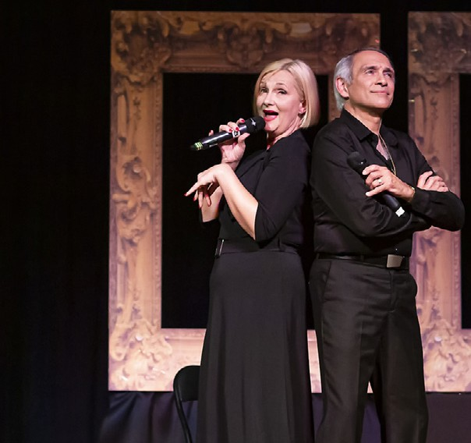


20 21

AN AFTERNOON OF A CAPELLA
Geelong Harmony Chorus Sunday 19 October 2pm
Theatre Seating $38 Adult $30 Conc $18 Child/student

Geelong and the Bellarine Peninsula are rightly very proud of their medal-winning a cappella women’s choir, Geelong Harmony Chorus. Known for their four-part harmonies, their entertaining showmanship and their sheer joy of singing, this concert is one not to be missed.
A sumptuous afternoon tea is included in the ticket price.

SPOOKFEST!
Family Fun Day Sunday 26 October 10am–3pm
Outdoor grounds and indoors Outdoor entertainment is free Pay what you can
Bookings essential

Celebrate the best Halloween on the Bellarine at our family- friendly Spookfest. Food vans, games, entertainment are all on offer. For more information, follow our socials or visit potatoshed.com.au

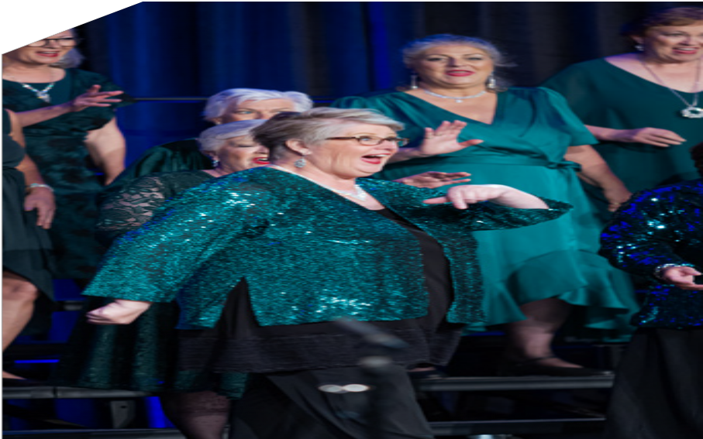
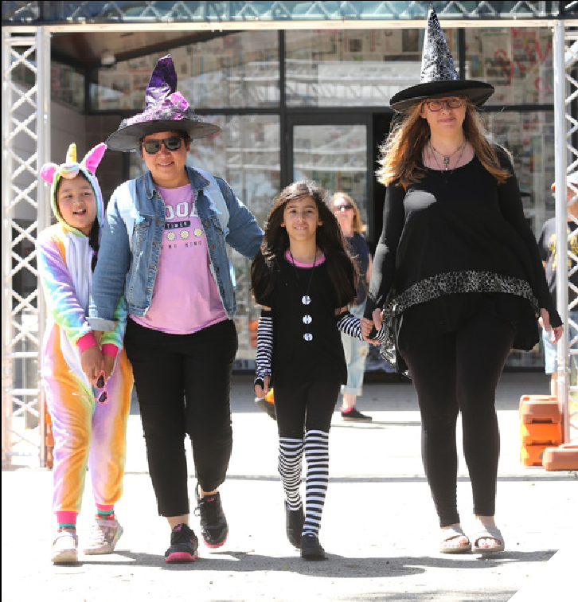


22 23

GEELONG WELSH LADIES CHOIR

CELEBRATE CHRISTMAS
Sunday 7 December 2.30pm
Theatre Seating $35 Adult $30 Conc

The Geelong Welsh Ladies Choir are excited this year to celebrate Christmas with our choir friends, families and guests.
We are planning a beautiful program incorporating some special and traditional Christmas music.
We hope to see you all there so that we can create wonderful musical memories with you, our audience.

12 X 12 PLAYS
Theatre 3triple2
Friday 12 December 7.30pm | Saturday 13 December 2pm and 7.30pm
Theatre Seating $30 Adult $28 Conc $28 Group 10+

Over 150 short plays have had their showcase at the annual 12 x 12 Plays presentation. In 2025, Theatre 3triple2 will once again showcase 12 original short plays (under 12 minutes) presented on the 12th day off the 12th month.
Always a delight to view and even vote on your favourite and best written play. This unique event has been running for over 12 years and is a popular event in the annual calendar!
Remember if you don’t like a particular play, it will only be a few minutes, and you will get to experience a new one – truly something for everyone.


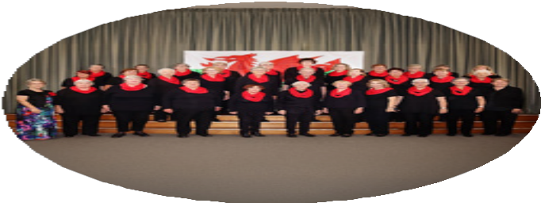
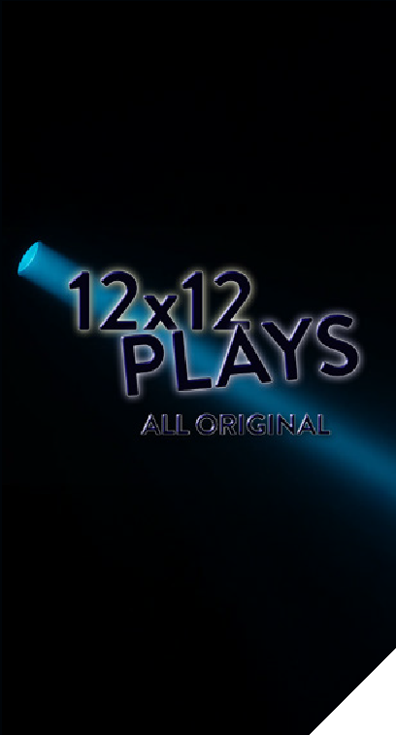

24 25

CHRISTMAS AT THE SHED
Friday 19 December 6pm
FREE. Bookings essential.

Come along and enjoy some relaxed time before the Christmas season hits.
Sing-along carols, fun games, along with popcorn and a family-friendly Christmas- themed film. And as always, Santa will swing past for a visit.
Part of the City of Greater Geelong Christmas in Geelong program for 2025.

Photo:
BECOME A VOLUNTEER

Our volunteers are our lifeblood. Without them, there would, quite simply, be no shows. Want to join our volunteers to help keep live entertainment alive at the Shed? Call us now on 5251 1998 or visit geelongaustralia. com.au/volunteer.

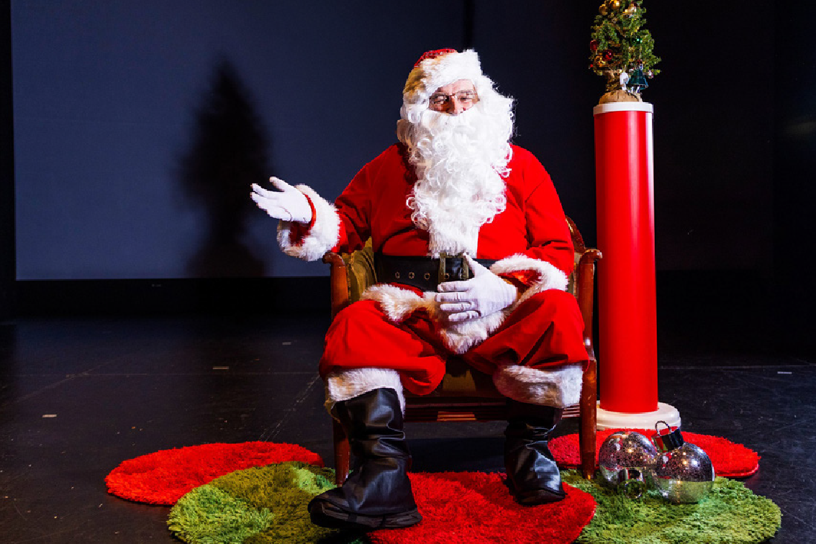
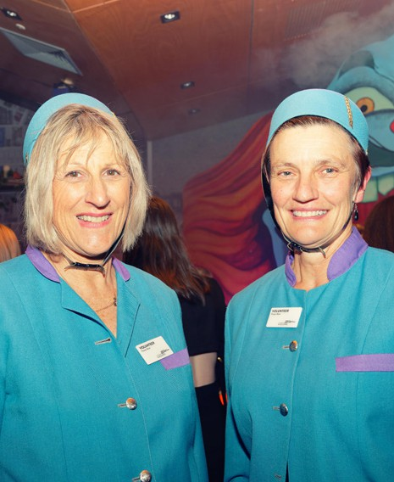
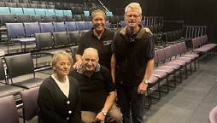
26 Ivan Kemp Photography 27

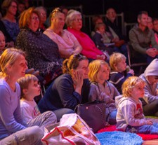




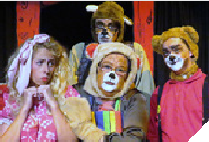
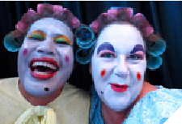


SCHOOL HOLIDAYS AT THE POTATO
SHED
January 2025 to
December 2025
$15.00 each or $50.00 for family of 4 (under 2 free).
Join us at the Shed for school holiday fun! There is always something happening for kids of
all ages.

28

POLITE MAMMALS
The Wholesome Hour Wednesday 9 April 11am Polite Mammals is a totally wild, neo- vaudevillian variety show the whole family can enjoy.
Celebrate animals of all kinds: real, imaginary, sparkly, stinky, polite and rude!

FRITZ
lumibloomi Wednesday 9 July 11am Step into the
charming and comical universe of Fritz, an eccentric and loveable magician’s rabbit.
Fuelled by slapstick, object puppetry and clowning, this hilarious entertainment is suitable for the whole family.

CINDERELLA SPINDERELLA
Jally Entertainment
Thursday 25 September
11am
Cinderella is always cleaning, cooking and spinning and she gets very dizzy! Find out
if she will ever meet Prince Perfect and if she will ever stop spinning!
3TRIPLE2 4 KIDS
January, July and September
All tickets $15 or
$50 for a family of 4 (under 2 free).
Group 10+ $12.50 each

CINDERELLA
Tuesday 14 to Thursday 16 January
10.30am and 1.30pm daily
Lots of singing, dancing and laughs will ensure that everyone enjoys a fun time at the palace!
Make sure you wear you best ball gown and get ready for lots of participation.

GOLDILOCKS AND THE THREE BEARS
Tuesday 15 to Thursday 17 July
10.30am and 1.30pm daily
Join this famous family as they take you on a magical journey through the woods with singing, dancing and lots of participation!

321…BLAST OFF –
THE FINAL MISSION – OR IS IT?
Tuesday 30 September to Thursday 2 October 10.30am and 1.30pm daily
It’s time to join the Space Rescue Team with Captain James Link, Astronaut Luna Tik and Commander Carl Cosmic as they embark their final mission into the galaxy (or is it?) together.
29

MORNING SHOWTIME
All shows are Tuesday mornings at 10.30am
Tickets
$20 each
(group discounts available through our Box Office)
Morning tea provided.

THE SONGS OF JOHN DENVER AND KENNY ROGERS
Tuesday 25 February
Col Perkins pays tribute to two of the biggest Country music stars, John Denver and Kenny Rogers.
Sing along and hear the great stories and music from

ISSI DYE - BARBARA
STREISAND AND BETTE MIDLER SHOW
starring Victoria Stanborough Tuesday 25 March
Let Issi and Victoria transport you to a beautiful time in the ‘70s and ‘80s with the songs by these two amazing divas!

ISSI DYE - THE VERA LYNN ANZAC TRIBUTE SHOW
starring Leslie Martin Tuesday 22 April
Join Issi Dye to hear the songs of Dame Vera Lynn, the singing darling pinup girl, of the British and Australian troops during World War II.

ALL YOU NEED IS LOVE
Drop of a Hat Productions Tuesday 27 May
Enjoy The Beatles love songs in one place.
Colin Mockett explains who wrote which song, to
whom, and why - then Adam Parsons performs it with
his astonishing flair.

WONDER WOMEN OF GEELONG
Drop of a Hat Productions Tuesday 24 June
Join Colin Mockett for a presentation about some of our region’s historic women that received a rapturous reception at the Beta Sigma Phi women’s convention in

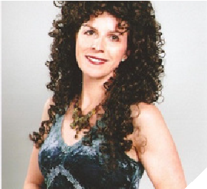
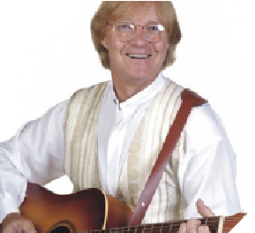
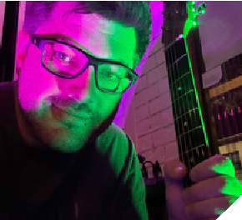
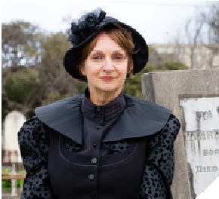
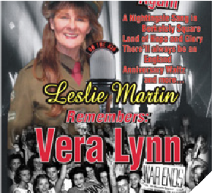
30 these Country superstars!
Melbourne. 31

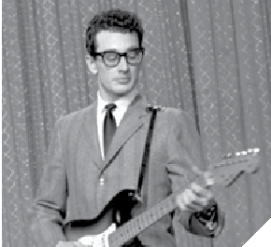
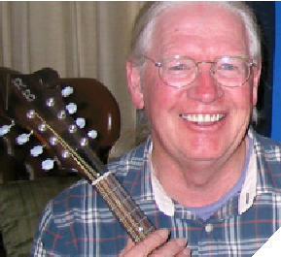


PAUL MACARTNEY AND FRIENDS SHOW
starring Marty Rose Tuesday 22 July
Marty Rose will make you feel like Paul Macartney is in the house…with wonderful stories and amazing songs! Don’t miss this show.

32

MONEY FOR NOTHING (AND YOUR CHICKS FOR FREE)
Drop of a Hat Productions Tuesday 12 August
The amazing true-life story of Mark Knopfler and Dire Straits. Colin Mockett tells
stories and explains meanings of their songs, performed by Geoff and Adam.

TRIBUTE TO BUDDY HOLLY
Drop of a Hat Productions Tuesday 16 September
The Buddy Holly story, from glory to tragedy, always with a glorious soundtrack.
Exactly what happened on The Day The Music Died is told by Colin Mockett with our favourite Rockers All Shook Up.

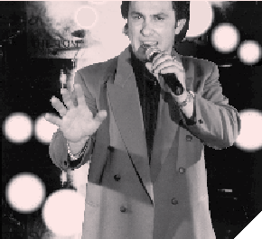

THE TOM JONES STORY
starring Tony Jones with guest Bobby Darin Show
Tuesday 7 October
Tony Jones looks and sounds like Tom Jones and he will take you on a wonderful journey of the great songs and style of the music legend!

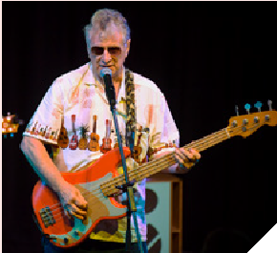

ROCKIN’ ALL OVER THE WORLD
Drop of a Hat Productions Tuesday 25 November
The follow-up to last year’s hit, The History of Rock & Roll. This brand-new show explains how Rock & Roll changed pop music forever in the 1950s and 60s.

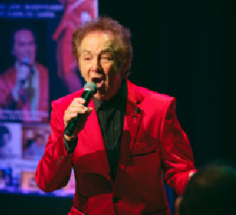

Photo: Ivan Kemp Photography

ISSI DYE SPECIAL XMAS SHOW
starring Aussie music legend Issi Dye Tuesday 2 December
Aussie music legend Issi Dye will perform his hits songs One Last Kiss and Personality as well as a host of fun Christmas songs to sing along with.

33

Theatre 3triple2
Local theatre group 16+ years theatre3triple2.com
E: Theatre3triple2@gmail.com

Fuse Dance
Jazz, funk, lyrical, hip hop P: Amy 0400 615 689
W: fusedance.com.au

S & S Dance
For 8 to 10-years
Modern jazz
Enquiries of all ages welcome
E: sas.dance23@gmail.com
Children’s Musical Theatre Classes
Children’s Acting Classes Grade 1 to high school bellarineperformingarts.com.au
bellarinepa@gmail.com

Kelly Club St Thomas Before and After School Care
P: 0459 902 431
potatoshed@kellycluboshc. com.au

The Potato Shed is for hire. Call 5251 1998.

PRACTICE?
BAND
HIRE US

PUTTING ON A
SHOW TOGETHER?

IMPORTANT CELEBRATION ON THE HORIZON?


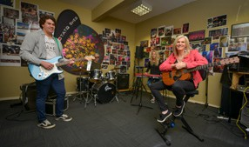
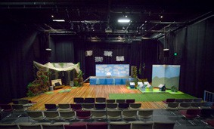
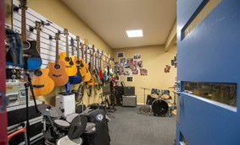
SHED
RESIDENTS
Adult Ballet Bellarine
Classes for all levels
P: Allegonda 0432 784 312
theballetschool@tpg.com.au

Bellarine Jongleurs Inc.
Acting, singing, dancing
Dynamic performing arts group that nurtures young talent
8 to16-years
bjongleurs@outlook.com
34
35






THE POTATO SHED
41 Peninsula Drive
Drysdale VIC 3222
P: 03 5251 1998
potatoshed.com.au
potatosheddrysdale potatosheddrysdale

