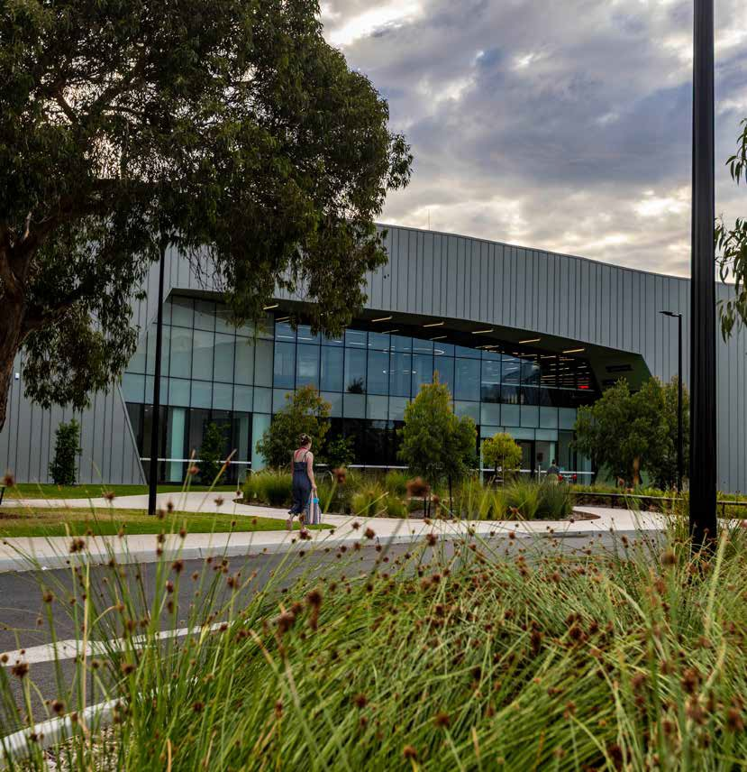



DHILPAMARNA AUDITORIUM
HIRE GUIDE 2026-27


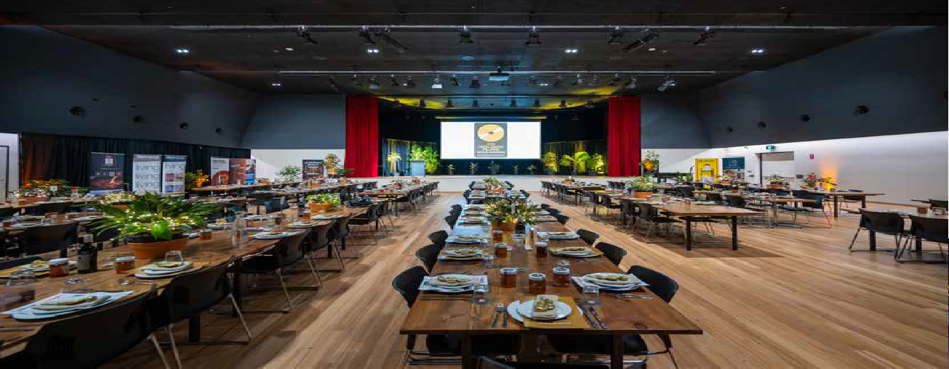

ABOUT DHILPAMARNA AUDITORIUM
Located within Norlane ARC, the Dhilpamarna Auditorium is a modern, flexible venue designed to accommodate a wide range of community, corporate and social events.
The 1,000-square-metre space features a 730-seat theatre-style auditorium, performance area, commercial kitchen and bar service area, making it ideal for performances, conferences, exhibitions, celebrations, meetings and community gatherings.
Venue features include:
- Stage with lift access, professional lighting and sound system.
- Projection screens at both ends of the auditorium.
- Two green rooms.
- Tables and chairs available for a variety of event formats.
- Commercial kitchen and bar service area.
- Operable partition wall allowing the space to be divided into two separate areas.
Designed with flexibility in mind, Dhilpamarna Auditorium provides a versatile setting for arts and cultural events, performances, recreational activities, community programs and special occasions. performances, recreational activities and social events.

This facility has achieved a 5 - star Green Star Design and As Built v1.2 Certified Rating.

HIRE RATES
Prices valid until 30 June 2027.

Commercial Hourly | Peak  inc GST | Off-peak  inc GST
Auditorium Entire | $364.00 | $291.00

Community Hourly* | Peak  inc GST | Off-peak  inc GST
Auditorium Entire | $273.00 | $218.00

Auditorium Performance A $346.00 $277.00 Auditorium B $73.00 $58.00
Commercial Kitchen $55.00 $44.00
Room Hire $44.00 $44.00
Auditorium Performance A $259.00 $207.00 Auditorium B $55.00 $44.00
Commercial Kitchen $41.00 $33.00
Room Hire $33.00 $33.00


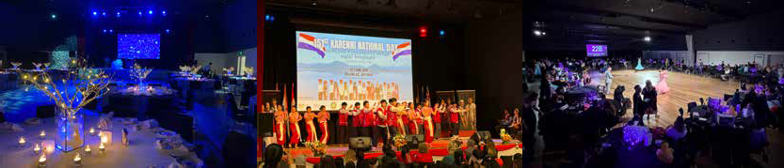
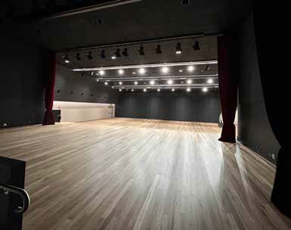
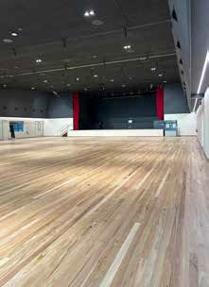
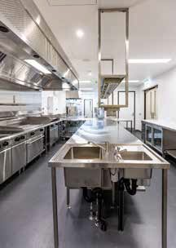
View of partition wall from the stage
Kitchen
Auditorium

Booking Extras | Peak  inc GST | Off-peak  inc GST
Cleaning - Additional Hourly | $56.00 | $56.00
Tea & Coffee Station (per person) $2.00 $2.00
Waste Removal (1,100L Skip) $80.00 $80.00

Peak times: Friday 5:00pm to Sunday and all public holidays.
Off-peak times: Monday until Friday 5:00pm.
*Community rates apply to incorporated community groups, not-for-profit organisations, school groups and registered charities.
All rates include a basic AV package with premium packages additional. Please contact us for a tailored quote including staff, supervisors, security, set up and pack down.


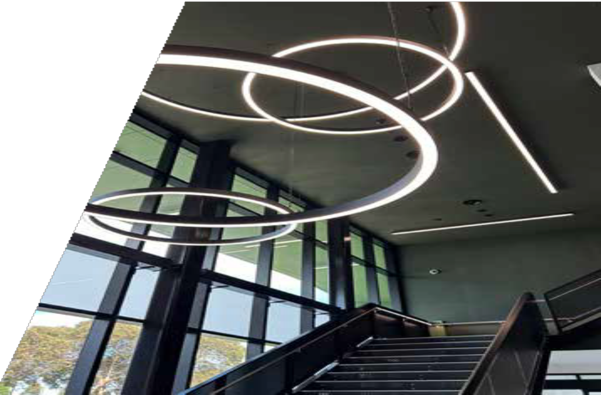
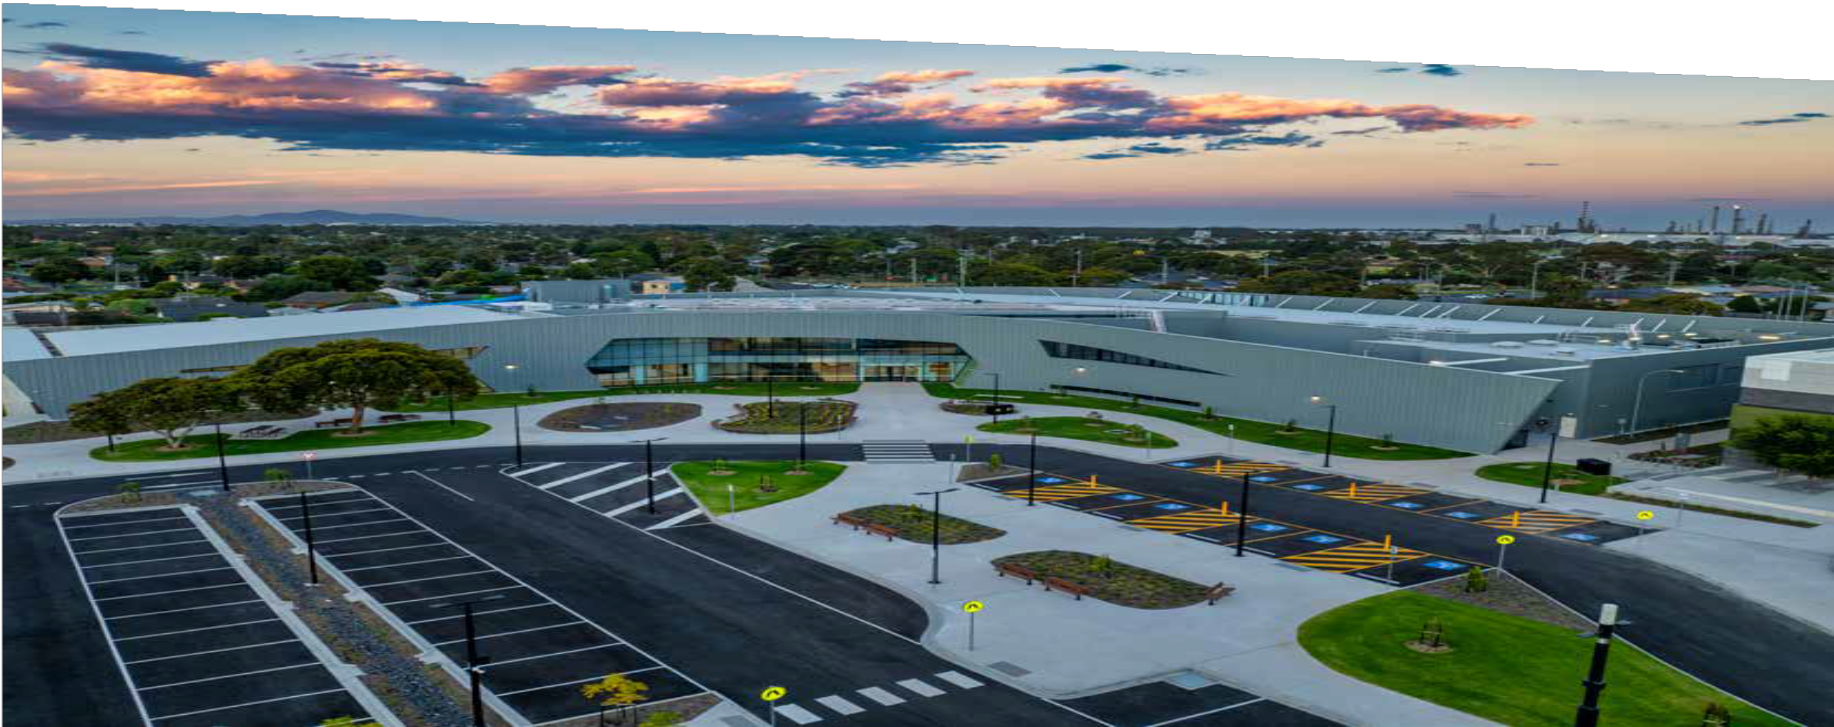

ENQUIRIES
E NorlaneARCauditorium@geelongcity.vic.gov.au
P 03 5275 1909
W geelongcity.vic.gov.au/norlanearc

Venue inspections welcome by appointment Monday to Friday from 9:00am-5:00pm.

Norlane ARC

