AMENDMENT C270 - PUBLIC ACQUISTION OVERLAY 4 (pao4) - nORTH sOUTH COLLECTOR rOAD AND iNTERSECTION, JETTY ROAD URBAN GROWTH AREA

Portfolio: Planning – Cr Macdonald
Source: Economic Development, Planning Strategy Tourism- Strategic Implementation
General Manager: Peter Bettess
Index Reference: Amendment: C270 Public Acquisition Overlay 4
Subject: Council Reports 2013
Summary
- The purpose of this report is to seek Council support to prepare and exhibit a planning scheme amendment to the Greater Geelong Planning Scheme.
- Amendment C270 is Council-initiated and seeks to apply the Public Acquisition Overlay 4 (PAO4) on land at Portarlington Road.
- C270 will facilitate the construction of the North South Collector Road and the intersection at Portarlington Road, forming part of the Jetty Road Urban Growth Area primary road network.
- The affected land forms part of the Curlewis Golf Club at 1201-1419 Portarlington Road, Curlewis, and privately owned land at 1421-1423 Portarlington Road, Drysdale, (Appendix 1 provides a plan of the subject land).
- The two affected property owners have previously been notified of the additional land required for the construction of the road and intersection. Further discussions will be held with the owners prior to public exhibition.
- The PAO4 will cover an area of 0.39ha.
- The existing zoning is Special Use Zone 3 (Curlewis Golf Club) and Rural Living Zone (Privately owned land). (Appendix 2 provides a copy of the existing zoning controls).
- C270 follows amendment C230, which applied the existing PAO4 for the initial stage of the North South Collector Road. Additional land is now required to facilitate both the construction of the North South Collector Road and the intersection at Portarlington Road in a concurrent manner.
- The additional areas of land have been determined by a detailed re-examination of the original intersection design. (Appendix 3 provides a copy of the proposed additional land take areas.)
- Amendment C270 will facilitate the development of the North South Collector Road and intersection funded by the Jetty Road Urban Growth Area Stage 1 Development Contributions Plan.
- The amendment will result in a good planning outcome. The amendment will assist in delivering key infrastructure as part of the Jetty Road Urban Growth Area.
AMENDMENT C270- PUBLIC ACQUISTION OVERLAY 4 (pao4) - nORTH sOUTH COLLECTOR rOAD AND iNTERSECTION, JETTY ROAD URBAN GROWTH AREA (CONT’d)
Recommendation
That Council resolves to support the preparation and exhibition of amendment C270 to the Greater Geelong Planning Scheme, to apply a Public Acquisition Overlay (PAO4) as shown in Appendix 4 of this report, subject to the authorisation of the Minister for Planning being obtained.
Report
Background
Amendment C270 is Council-initiated and proposes to apply the Public Acquisition Overlay 4 (PAO4) on land at 1201-1419 and 1425-1429 Portarlington Road. The amendment will facilitate the construction of a new North South Collector Road and intersection at Portarlington Road. (Appendix 4 provides a copy of the proposed PAO4).
The proposed North South Road was originally designated in the Jetty Road Urban Growth Plan as shown on the Structure Plan in Appendix 5. It will provide a new entry road to the growth area and the future activity centre and will alleviate traffic pressure on Jetty Road and the Jetty Road/Portarlington Road intersection.
The adopted Jetty Road Urban Growth Area Stage 1 Development Contributions Plan identifies the North South Collector Road and intersection as two key infrastructure items that require the application of the PAO4:
- North South Collector Road (DCP Project Ref: ROO1)
- North South Collector Road and Portarlington Road Intersection (DCP Project Ref: ROO3)
C270 follows amendment C230 Jetty Road Development Contributions Plan. C230 applied a number of planning overlays, including the PAO4 on land to facilitate the initial construction of the North South Collector Road along the western edge of property 1421-1423 Portarlington Road, Drysdale.
Amendment C230 was subject to review by an Independent Panel. For the North South Collector Road, the Panel recommended the proposed layout and costings of the intersection be revisited to allow the signalised intersection to be constructed at the same time as the North South Collector Road is opened.
Council accepted the Panel’s recommendations and the original North South Collector Road and Portarlington Road intersection layout has now been reviewed. Additional land must be acquired either side of the area subject to the existing Public Acquisition Overlay 4 to enable the construction of a duplicated road reserve layout at the approach to the intersection and to accommodate existing services running along Portarlington Road.
The additional areas of land required to accommodate the revised layout for the North South Collector Road and Portarlington Road intersection are shown in Appendix 3 (highlighted colours- blue and red) and are detailed below in Table 1. Table 2 details the land take area of the existing PAO4.
AMENDMENT C270- PUBLIC ACQUISTION OVERLAY 4 (pao4) - nORTH sOUTH COLLECTOR rOAD AND iNTERSECTION, JETTY ROAD URBAN GROWTH AREA (CONT’d)
Table 1 – Land Acquisition for North South Road and Intersection
Address | Dimensions of area to be acquired (metres) | Area to be acquired (square metres) | Notes | Colour on map
1201-1419 Portarlington Road, Curlewis VIC 3222 | 3 x 145  (Splay of 12.3m²) | 447.3 | This is a 3 metre wide strip of land along Portarlington Rd – part of Curlewis Golf Course | Red
1425-1429 Portarlington Road, Drysdale VIC 3222 | 3 x 87.4  16 x 198.4  (Splay of 12.5m²) | 262.2  3174.4  Total: 3449.1 | This is a 3 metre wide strip of private land along Portarlington Rd, plus a section of the North South Collector Road | Blue
Total Acquisition Land: |  | 3896.4  (.39 ha)

Table 2- Existing PAO
Address | Dimensions of area to be acquired (metres) | Area to be acquired (square metres) | Notes | Colour on map
1421-1423 Portarlington Road, Drysdale VIC 3222 | 9600 | 16 x 600 | This land is already subject to the PAO4, applied by Amendment C230 | Yellow
Discussion
The PAO4 will act as a safeguard necessary for the construction of the new road/intersection and, importantly, the acquisition of privately owned land in accordance with the provisions of the Land Acquisition and Compensation Act 1986.
As a result of the C230 Panel recommendations, Council commissioned an independent engineering firm to prepare a more precise functional layout and review and cost the intersection. The revised layout now accommodates a fully signalised intersection to be constructed at the same time as the opening of the North South Collector Road. The revised design has resulted in the requirement for additional land.
The additional land required to the west of PAO4 comprises land within the grounds of Curlewis Golf Club. Presently, this land is zoned ‘Special Use Zone’. The inclusion of this area of land within the PAO4 boundary might have an impact on the golf course itself in terms of the minor repositioning of existing greens/tee-offs. Any uncertainty regarding the overall proposals and potential impact will be discussed with the golf course board members prior to exhibition of the proposed amendment.
AMENDMENT C270- PUBLIC ACQUISTION OVERLAY 4 (pao4) - nORTH sOUTH COLLECTOR rOAD AND iNTERSECTION, JETTY ROAD URBAN GROWTH AREA (CONT’d)
The additional land to the east of the existing PAO4 will require acquisition from a private land owner. Presently, this land is zoned ‘Rural Living’. There will be an impact on the landowner but the additional land take falls within the area identified as Stage 2 of the Jetty Growth Area. Consequently, the future development of this land for an enlarged road reservation including the intersection, was already planned as part of the Stage 2 development of Jetty Road UGA.
The two affected property owners have previously been notified of the additional land required for the construction of the road and intersection. Further discussions will be held with the owners prior to public exhibition.
The Jetty Road Urban Growth Area Stage 1 Development Contributions Plan Overlay Schedule 2 (DCPO2), deals with the necessary infrastructure items to facilitate development in this area. Amendment C230 implemented DCPO2, also incorporating the costings and delivery timescales associated with the revised North South Collector Road and intersection.
DCPO2 provides Infrastructure Project Sheets in relation to key projects associated with the Jetty Road Urban Growth Area. The timing of Project R002- North South Collector Road Part A- Land Acquisition has a commencement date of 2013-2014 or 450 lots. Amendment C270 will facilitate with meeting these timescales by way of acquiring the necessary additional areas of land to facilitate the construction of the North South Collector Road and Intersection (DCPO2 Projects ROO1 and ROO3).
Vic Roads and Council Engineering Services have been involved in the review of the intersection.
Environmental Implications
The construction of the North South Collector Rd and intersection will result in the loss of vegetation. However, prior to the construction of the new road and intersection, a survey will be undertaken of the affected land to confirm the species and quality of vegetation.
Financial Implications
The Jetty Rd Stage 1 Development Contributions Plan (DCP) includes the cost of the land to be acquired by the Council for the new road. The cost for the land will be collected from the Stage 1 landowners/developers.
DCP Infrastructure Item R002 - North South Collector Road Part A- Land Acquisition has established a project cost of $294,800 to acquire the land. The project cost is expressed in July 2011 dollars and is based on a land valuation undertaken in 2011. When the Council formally engages in the land acquisition process i.e. the process of purchasing the land, the affected area will be re-valued to provide an updated cost for the land.
The DCP funds only cover the value of the land to be acquired. Associated costs such as legal fees, conveyancing fees etc. are not included in the DCP project cost. Council has been advised by its DCP consultants that legal costs cannot be included when preparing a DCP.
AMENDMENT C270- PUBLIC ACQUISTION OVERLAY 4 (pao4) - nORTH sOUTH COLLECTOR rOAD AND iNTERSECTION, JETTY ROAD URBAN GROWTH AREA (CONT’d)
There will be associated planning scheme amendment costs (amendment fees, panel costs and representation as required) as part of the implementation process given this is a Council initiated amendment. This can be accommodated within the existing budget.
Policy/Legal/Statutory Implications
Amendment C270 is consistent with State and Local Planing Policy Frameworks. Council, in its role as Planning Authority, will bound by the provisions of the Land Acquisition and Compensation Act 1986 in its pursuit of land for the above purpose.
The planning scheme amendment will be carried out in accordance with the Planning and Environment Act 1987.

Officer Direct or Indirect Interest
No officers or contractors involved in the preparation of this report have a direct or indirect interest in matters to which this report relates.
Risk Assessment
There are no notable risks associated with the implementation of the Public Acquisition Overlay 4 (PAO4).
However, should the process of land acquisition run into difficulties, this could create issues for delivery of the intersection. The timely acquisition of land is important to the overall delivery of the North South Collector Road and Intersection.
Acquisition of land will be purchased using monies collected from Stage1 landowners.
Social Considerations
The amendment is not expected to generate any significant social impacts.
Communication
Prior to formal exhibition of the amendment, all landowners will be notified of the Council’s intention to prepare and exhibit amendment C270. During the formal exhibition of the planning scheme amendment, all landowners will be notified of the proposed PAO.
Respective landowners will have the opportunity to make submissions and be heard by an Independent Panel.
Consultation with relevant referral authorities has also been undertaken in the lead up to the Amendment exhibition i.e. Vic Roads, and liaison with key referral authorities will continue during the course of the amendment process.
Appendix 1 Subject Land
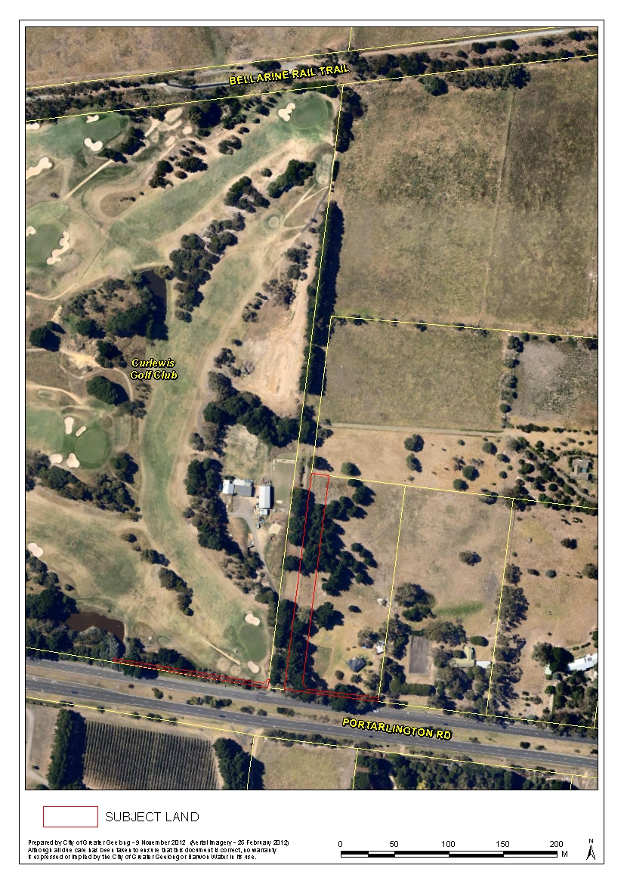
Appendix 2 Existing Zoning Map
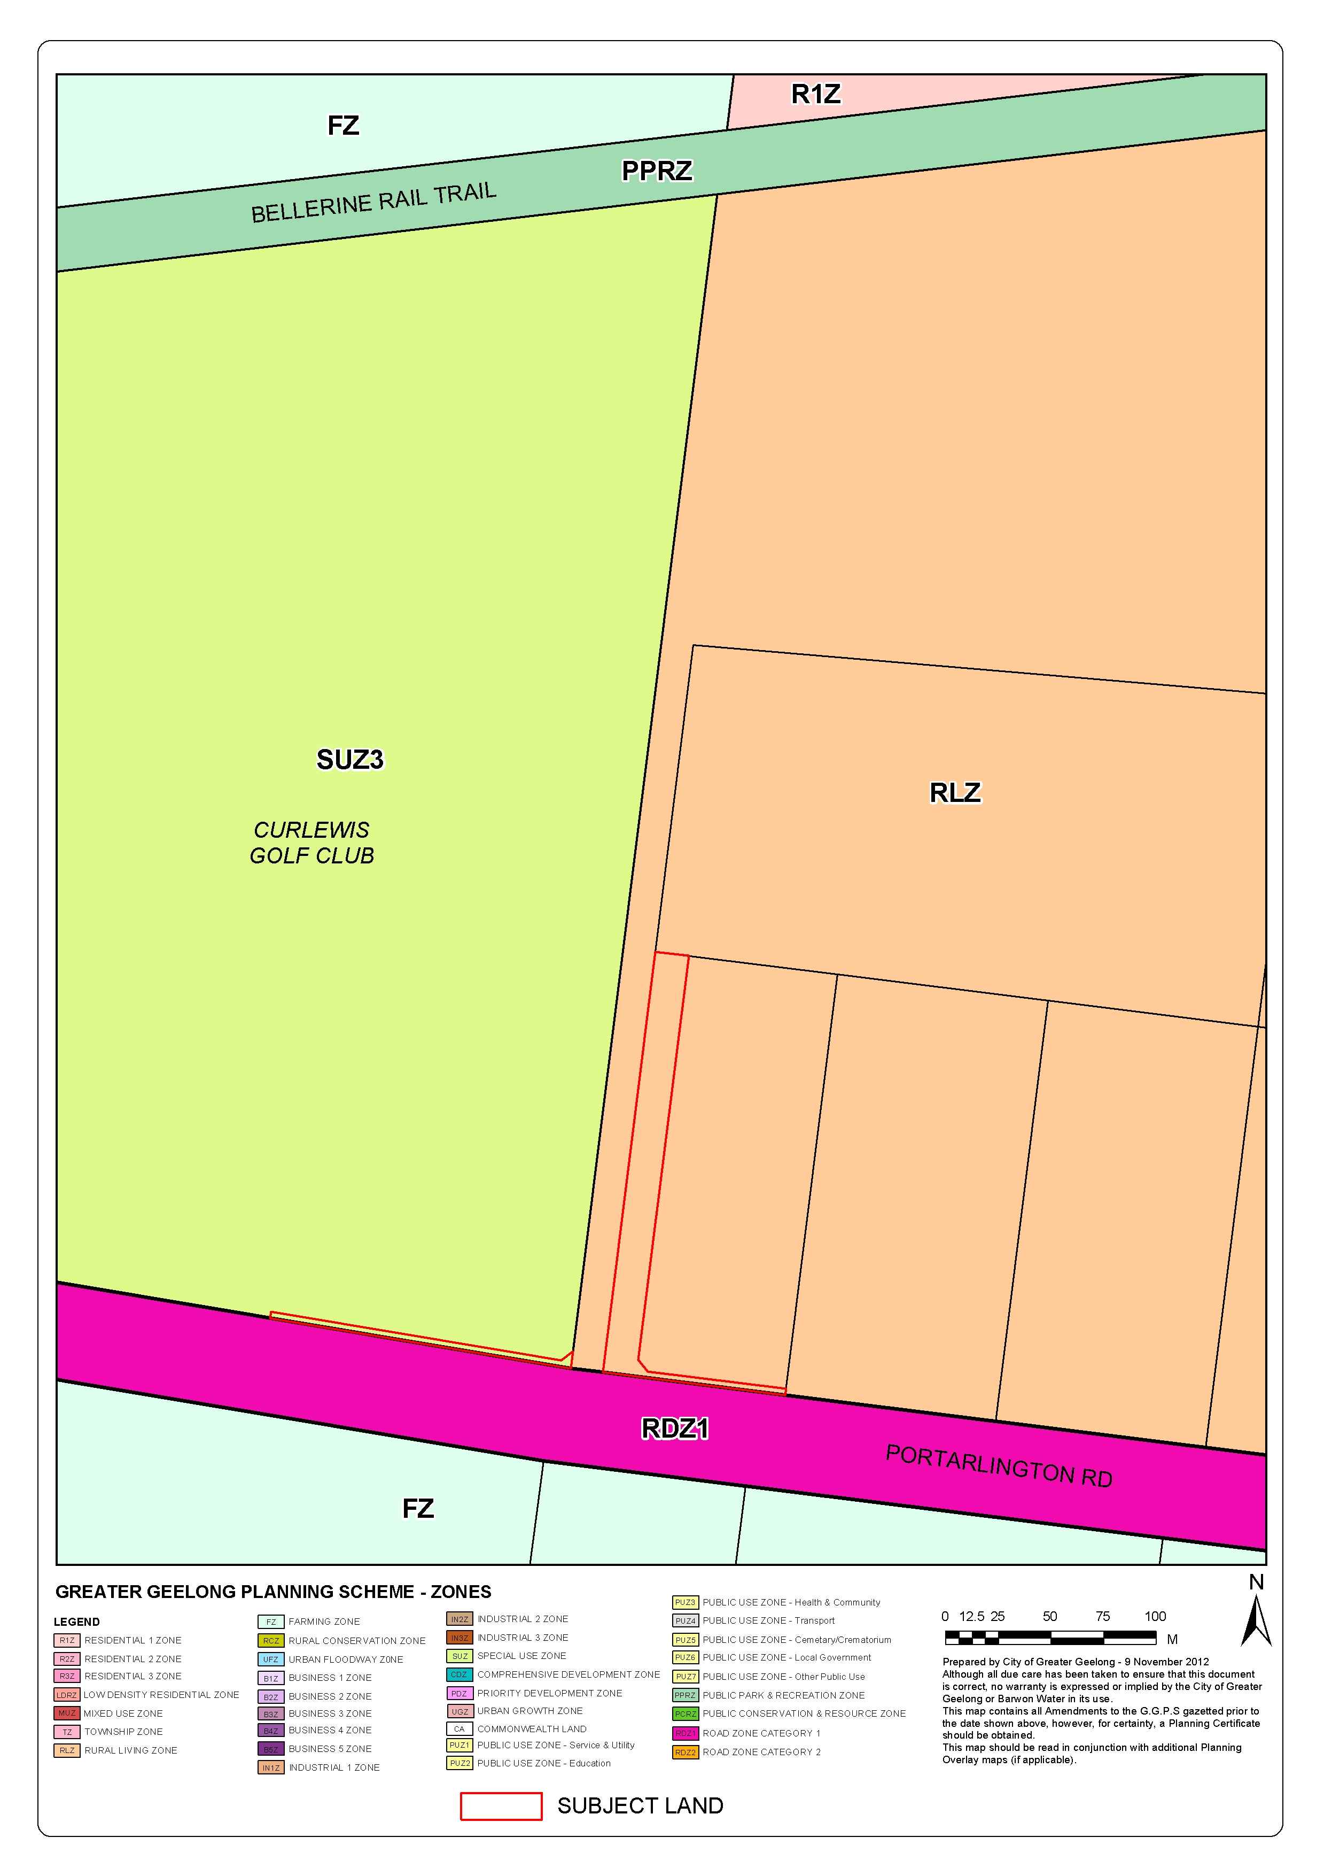
Appendix 3 Land Take Areas
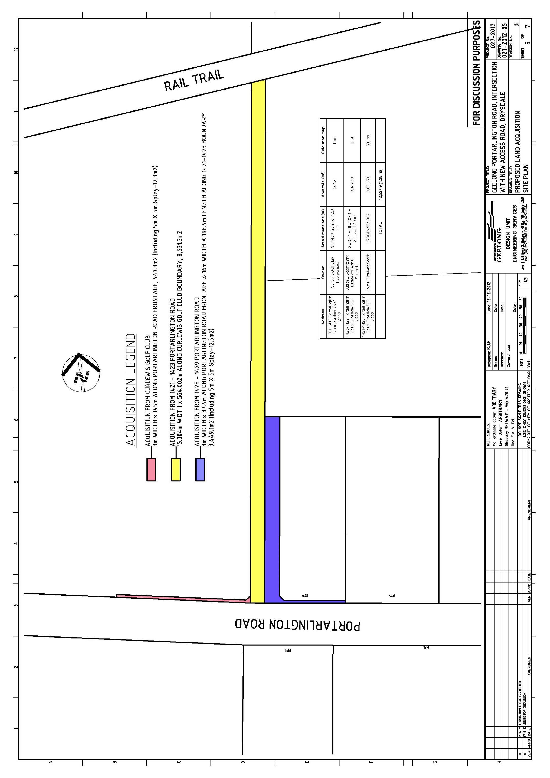
Appendix 4 Proposed PAO4 in red outline (existing PAO4 shown in yellow)
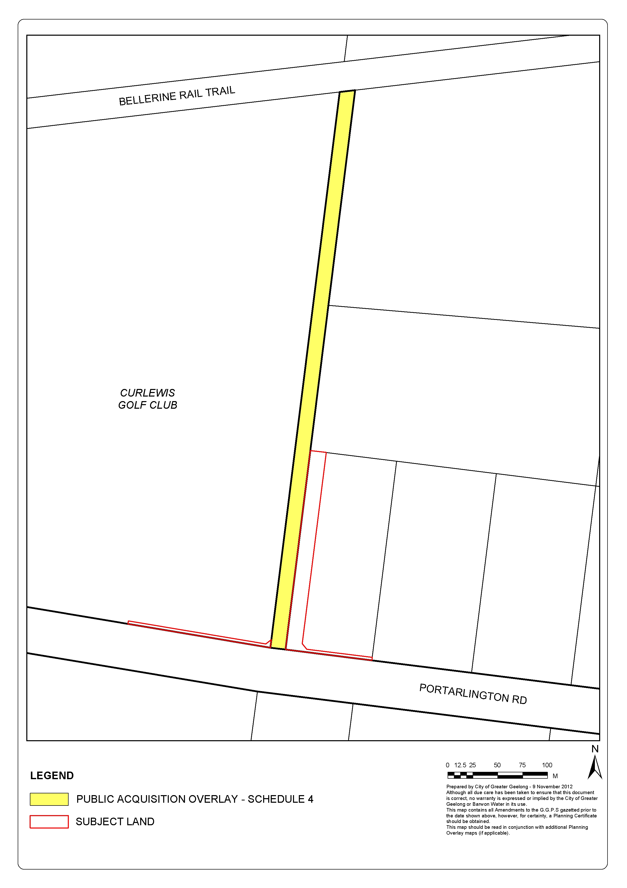
Appendix 5 Jetty Road Urban Growth Plan – Structure Plan

