Traffic Impact Assessment
Ceremira P/L
Retail development
Fairbairn Drive
Corio

Ceremira P/L
Traffic Impact Assessment for
Retail Development
Fairbairn Drive Corio

Author - Kevin J Flynn

Project: CAT – 21-2012
July 2012
This is intended as an inside title page, but can be used as a cover for small proposals or reports. Use the cover template or preprinted cover pages for major projects. You can also insert a picture onto the front cover – make sure that it is resized – not straight from the digital camera. Delete the approved boxes below if not required.

Acknowledgement
This is a revised version of a traffic report prepared by the same author on behalf of CPG Australia P/L for the client Ceremira P/L in March 2011.
Contents
1. Traffic Impacts Summary 1
2. Introduction 5
2.1 References 6
2.2 Documentation 6
3. The Development Proposal 7
4. Site Conditions – Land Use 7
5. Local Road Network Characteristics 8
5.1 Local Streets 8
5.1.1 Broderick Road 8
5.1.2 Pearce Street 8
5.1.3 Fairbairn Drive 8
5.1.4 Melbourne Road (Princes Highway – A10) 8
5.2 Local Intersections 8
5.3 ALDI Store Traffic Generation (Empirical Study) 9
5.4 Crash History 9
6. Traffic Generation & Impacts 10
6.1 Traffic Generation & Distribution 10
6.2 Traffic Impacts 10
6.3 Traffic Management & Road Safety Mitigation Measures 11
6.4 Sight Distance 12
6.4.1 Safe Intersection Sight Distance (SISD) 12
6.4.2 Sight distance at access driveway exits 13
6.5 Public Lighting 15
6.6 Loading / Unloading 16
7. Parking Generation & Impacts 17
7.1 Parking Generation – Planning Scheme – Clause 52.06 17
7.2 Parking Generation – Planning Scheme – Clause 45.09 17
7.3 Parking Impacts 17
7.4 Parking Design 17
8. Other Road User Groups 19
8.1 Pedestrians 19
8.2 Cyclists 19
8.3 Buses (Public Transport) 19
8.4 Corio – Norlane Active Transport Plan 20
9. Conclusions & Recommendations 21

Appendices
Appendix A – Development Sketch Plan
Appendix B – Photographs

Traffic Impacts Summary
The proposed development in Fairbairn Drive Corio will provide approximately 3,267m² of ground level retail floor space. The total site area is approximately 8,000m². Principal access to the development will be provided by a driveway style access on Broderick Road, and a secondary access will be provided on Fairbairn Drive.
Refer to Fig 1.1 below for Locality Plan.
Refer to Appendix A for the Concept Development Plan
Based on the investigations and analysis it is considered that there would be no traffic management, safety or operational grounds that would impede this development.
A summary of investigations and findings of the proposed development is shown in the Table below:
Summary – Fairbairn Drive, Proposed Retail Development
Address | 12 Fairbairn Drive Corio, 3214. Melway Map 432-F5
Proposed development | Proposed retail development on “greenfield” site 8,014m² in area, adjacent to the Corio ALDI store.  The total proposed ground level retail floor space is approximately 3,267m² being accommodated in four separate buildings. An on-site car park will provide for 94 cars and the loading bay will accommodate vehicles up to a 12.5m single unit truck.
Road Hierarchy: | Broderick Road – Secondary collector road under the care and management of the City of Greater Geelong.  Fairbairn Drive and Pearce Street – Local Access Streets under the care and management of the City of Greater Geelong.  Melbourne Road (Princes Highway A10) – A major transport route linking Geelong with Melbourne under the care and management of VicRoads.
Proposed Use: | Retail / Commercial.
Crash History: | No crashes have been recorded on the local roads adjacent to the subject site in the latest 5 years of VicRoads data, from Jan 2007 to Dec 2011. The lack of crashes on the local road system indicates that there is no pre-existing structural deficiency that should be addressed with this development proposal. Conclusions should not be drawn that the adjacent road system is entirely safe, considering the lack of crash data.  In the same period of recording, there have been five crashes at the Broderick Road / Melbourne Road intersection. These crashes should be the subject of a separate investigation by VicRoads.
Traffic Generation & Distribution: | The total trip generation of the ground level retail development is calculated to be 3,750 vpd (125 x 30) and 381 trips in the peak hour periods (12.7 x 30) with 50% arriving and 50% departing. The trips will be distributed to the local road network with 75% utilising the Broderick Road entry and 25% utilising the Fairbairn Drive entry. Of the generated traffic, 70% will be attracted from Melbourne Road (east) and 30% from Broderick Road / Fairbairn Drive (west).
Traffic Impacts: | The generated traffic will have negligible impact on the operating efficiency of roads and intersections that constitute the local road network. The level of control proposed for new internal intersections and the major external intersections is considered adequate for the expected increases in demand.
Public Lighting: | The detail design will include a public lighting design for the development. The lighting scheme will provide the appropriate level of lighting for the car park, entry intersections, pedestrian crossings, medians and traffic islands in accordance with the Australian Standard - AS 1158.1.1 (2005) Lighting for Roads and Public Spaces.
Parking Demand: | For shop developments, Clause 52.06 (Column A of Table 1) of the Planning Scheme requires a provision of four (4) car spaces per 100m² of Leasable Area.  Under Clause 45.09 (Parking Overlay) and Column B of Clause 52.06, a rate of 3.5 spaces for 100m² of GLFA is recommended.  It is recommended that the City of Greater Geelong approves adoption of a level of parking provision, determined with reference to Column B of 52.06 being more appropriate for Activity Centres, where 104 spaces should be provided by this development (3.5 x 29.7).
Parking Impacts: | The anticipated retail shop parking demand of 104 spaces for the proposed development shall met through the provision of 94 spaces on-site and the spare capacity in the adjacent retail car parks.
Parking Design: | The detailed design of the internal car park, access aisles and loading facilities will consider:  - Appropriate Sight Distance; and  - Design Vehicle Turning Movements and Swept Paths.  The design of the on-site parking will accord with Clause 52.06 of the Geelong Planning Scheme. Where Clause 52.06 cannot be applied the Australian Standard AS/NZS 2890, Part 1: 2004 “Off Street Car Parking” shall be used.
New Access Driveways: | The minimum width of the new access points is 6m and the detailed design of the access driveways proposed for the development will consider:  - Appropriate Sight Distance; and  - Design Vehicle Turning Movements and Swept Paths.
Proposed Landscaping Works: | The detailed design of proposed landscaping for the development will consider the provision of safe sight distance to the desirable accepted standards.
Pedestrians and Cyclists: | Extensions of the external pedestrian path and cycle path network will be incorporated into the development in accordance with the City of Greater Geelong’s Walking and Cycling Strategy Plan. The internal path network will provide good connectivity to the existing external path network and provide safe crossing points to the minimum sight distance requirements. The detailed design of the development will look for opportunities in improving pedestrian and cycling amenity.  The concept plan shows the provision of 24 bicycle racks at several locations throughout the site that exceeds the minimum requirements of the Planning Scheme for shoppers. Employee bike spaces, lockers and showers will be provided within the site development.
Public Transport: | Geelong Transit System (GTS) bus service 12 operates along Broderick Road and informal bus stops are provided adjacent to the subject site. It is recommended that the bus stops are formalised with the provision of indented bays, hardstand areas, seats and shelters.
Loading / Unloading | The concept development plan shows the provision of a loading bay large enough to accommodate 12.5m long single unit vehicles, being the maximum size design vehicle for this site. The area set aside for the loading bay satisfies the minimum area requirements of the Planning Scheme.
Recommended Actions: | - Apply a splitter island to Pearce Street at Broderick Road. Improve pedestrian safety and convenience along Broderick Road and Pearce Street.  - Relocate existing Bus Stop away from proposed new access point on Broderick Road.  - Extend the existing left turn lane for Pearce Street to include the ALDI entry and the subject development.

Figure 1.1 – Locality Plan of Subject Site

Introduction
On behalf of the applicant Ceremira P/L, Insite Architects have engaged Civil and Ytaffic Consulting P/L to undertake a Traffic and Parking Impact Assessment of a proposed retail development on vacant land bounded by Broderick Road, Pearce Street and Fairbairn Drive in Corio.
Refer to current Development Plans
The specific tasks of this traffic study were to:
- Identify the traffic and parking impacts as a result of the proposed development;
- Assess the movement and access functionality of the current development plan, for all road user groups;
- Recommend any mitigation measures required to maintain a safe and efficient local road network environment.
The purpose of this report is to support the development application under the Greater Geelong Planning Scheme.
This traffic assessment report consists of:
- A description of the subject site;
- A description of the existing road network and traffic conditions;
- A description of the proposal;
- An assessment of Traffic & Parking requirements and; and
- An analysis of the Traffic & Parking Impacts.
The Traffic and Parking issues related to the proposed retail development include:
- Adequate on-site parking provision;
- Access to the on-site parking and conformity to accepted design standards;
- Traffic generation and impacts;
- Provision for delivery and service vehicles (also emergency services);
- Public Transport Provisions;
- Provision for bicycles; and
- Provision for pedestrians.
This traffic assessment is based on:
- The concept development plans, prepared by Insite Architects;
- Site inspections undertaken during December 2010.

2.1 References
References used in the preparation of this Traffic Impact Assessment Report include the following:
- The Austroads Turning Movement Guidelines, 2006;
- The Austroads Guide to Road Design Part 4A: Un-signalised and Signalised Intersections, 2010;
- The Greater Geelong Planning Scheme;
- VicRoads Crash Stats website, July 2012, http://www.vicroads.vic.gov.au/Home/SafetyAndRules/AboutRoadSafety/StatisticsAndResearch/CrashStats.htm ; and
- The Benders Bus Lines website, July 2012, http://www.cdcvictoria.com.au/geelong.html
- Australian Standard AS/NZS 2890, Part 5: 1993 “On Street Car Parking”;
- Australian Standard AS/NZS 2890, Part 1: 2004 “Off Street Car Parking”;
- The RTA Guide to Traffic Generating Developments – Ver 2.2, 2002.
- The Corio – Norlane Active Transport Plan - 2010

2.2 Documentation
The documentation used in this investigation includes:
- The concept development plans, prepared by Insite Architects;

The Development Proposal
The proposal is to develop several retail buildings that will include 13 tenancies of various floor areas.
The gross floor area of the buildings is 3,267m² and the gross leasable floor area (GLFA) is determined as 2,970m², GLFA is used in calculating the peak parking and traffic demand for the development.
The principal site access is proposed off Broderick Rd, approximately 48m north-west of the existing ALDI entry. A secondary access from Fairbairn Drive is also proposed at a point just north of the Kilpatrick Court / Fairbairn Drive roundabout. The detail design of the development will ensure that the location of the secondary access will not impact on the operation of the roundabout. The provision of the secondary entry will reduce the impacts of the right turn into the subject site from Broderick Road.
The concept development plan shows the provision of 94 on-site car parks and a loading bay large enough to accommodate 12.5m long single unit vehicles.
The development plan shows a pedestrian link between the subject land and the ALDI store entry point. This link is considered vital in reducing overall parking and traffic demand as parking opportunities could be shared between the two sites. The provision of an internal vehicle link should also be explored in the future so that vehicles can flow freely between the two sites thus reducing some traffic impact on Broderick Road.

Site Conditions – Land Use
The subject land is undeveloped and unfenced open grass land 8,014m² in area. The land is bounded by the existing ALDI store to the east, by Fairbairn Drive to the west, by Pearce Street to the north-west and by Broderick Road to the north-east.
The subject land is zoned Residential 1 (R1Z) under the Greater Geelong Planning Scheme.
The existing ALDI building is approximately 2,100m² in area (approximately 1,900m² GLFA). The ALDI site is 7,715m² in area and provides 106 on-site car spaces (including 3 disabled) at a calculated rate of 6 spaces per 100m2.
Land to the north of Broderick Road contains the Beckley Racing Centre for Harness Racing and Greyhound Racing.
Land to the south and west contains the Rosewall residential area.
Refer to photographs in Appendix B

Local Road Network Characteristics

5.1 Local Streets
Melbourne Road is a declared State Highway under the care and management of VicRoads, all other roads are under the care and management of the City of Greater Geelong.

5.1.1 Broderick Road
Broderick Road can be best described as a sub-arterial transport link between Melbourne Road, the new Geelong Ring Road and the Heales Road industrial area. Traffic counts provided by the City of Greater Geelong and a turning movement study indicate the traffic volumes on Broderick Road are approximately 1,650 vehicles per day (vpd) to the north of Pearce Street, 2,900 vehicles per day (vpd) between Pearce Street and the ALDI entry and approximately 3,700 vehicles per day between Melbourne Road and the ALDI entry. The intersection of Broderick Road and Melbourne Road is controlled by traffic signals and is located approximately 100m east of the proposed entry to the subject development. The posted speed limit on Broderick Road past the subject site is 60km/h.
Refer to photos 4, 5, 6 & 7 in Appendix B

5.1.2 Pearce Street
Pearce Street is a local access link between Broderick Road and Fairbairn Drive. Traffic volume data is not available however is estimated to be approximately 1,000 vpd. Posted Speed is urban default of 50km/h.
Refer to photo 3 in Appendix B

5.1.3 Fairbairn Drive
Fairbairn Drive is a local access street / distributor road and with Pearce Street provides a link between Broderick Road and Sharland Road. The traffic volume (provided by CoGG) is approximately 1,100vpd west of Pearce Street, no volumes or speed data available for south of Pearce Street. Posted Speed is urban default of 50km/h.
Refer to photos 1 & 2 in Appendix B

5.1.4 Melbourne Road (Princes Highway – A10)
Melbourne Road in Corio is the principal urban arterial road linking Geelong central with Melbourne. In the vicinity of the subject land Melbourne Road is a six lane divided carriageway carrying approx. 35,000 vpd (source VicRoads, post opening of Geelong Ring Road). Posted speed limit is 80km/h.
Refer to photo 10 in Appendix B

5.2 Local Intersections
The Fairbairn Drive / Pearce Street intersection has a “Modified Tee” treatment applied. Refer to photo 2 in Appendix B.
The Fairbairn Drive / Kilpatrick Court intersection has a small urban roundabout applied.
The Pearce Street / Broderick Road intersection and the Fairbairn Drive / Pearce Street intersection are Give Way sign controlled. Refer to photos 2 & 4 in Appendix B.
The intersection of Broderick Road and Melbourne Road is a major signalised intersection.
Austroads “AU type” left turn lanes are provided for Pearce Street and the Beckley Park float entry opposite the ALDI entry point.
Austroads “AU type” right turn lanes are provided for Pearce Street and for the Beckley Park main public entry to the north of Pearce Street.
Bus stops are provided on Broderick Road within the left turn lanes between the ALDI entry and Pearce Street, both sides of the road. Refer to photos 4 & 5 in Appendix B.

5.3 ALDI Store Traffic Generation (Empirical Study)
A turning movement count was undertaken at the ALDI store entry on Broderick Road, between 4:15 PM and 5:30 PM on Thursday 16th December 2010. It is considered that the sample count would represent average to above average traffic conditions considering the lead up to Christmas.
The RTA 2002 indicates that Thursday evenings and Saturday mornings represent the peak traffic conditions for shopping centres / activity centres.
The observations indicates a likely weekday peak traffic generation of approximately 240 trips per hour (50% entering and 50% leaving) and a daily generation of approximately 2,400 trips. At the start and at the end of observation it was noted that the car park was approximately 65% occupied.
The data indicated that of all generated traffic, 70% arrived and departed to/from the east (Melbourne Road) and 30% to/from the north-west (Broderick / Fairbairn).
From the data the traffic generation rate of the 2,100m² ALDI store is calculated to be 115 trips per 100m² per day with 12 per 100m² in the peak hour.
Refer to photo 10 in Appendix B for a view of the ALDI store entry on Broderick Road.

5.4 Crash History
There are no recorded crashes on the road network adjacent to the subject site for the five year period January 2007 to December 2011. The lack of crashes on the local road system indicates that there is no pre-existing structural deficiency that should be addressed with this development proposal. Although there is no casualty crash data, conclusions should not be drawn that the local road system is operating entirely safely.
It was noted that in the same time period, five crashes occurred at Broderick Road / Melbourne Road signalised intersection that should be the subject of a separate investigation by VicRoads.

Traffic Generation & Impacts
The RTA Guide to Traffic Generating Developments (Ver 2.2, 2002) provides guidance in the determination of traffic demand for land use developments.
In accordance with the RTA 2002, activity centres of this type will generate approximately 125 trips per 100m² GLFA per day with approximately 12.7 trips per 100m² in the peak hour.
The GLFA for this development is calculated as 2,970m².

6.1 Traffic Generation & Distribution
The total generation of the ground level retail development is calculated to be 3,750 vpd (125 x 30) and 381 trips in the peak hour periods (12.7 x 30) with approximately 50% arriving and 50% departing.
The ALDI entry observations indicate that the true traffic generation is likely to be 10% lower than the computed figure from the theoretical generation rates.
Considering the traffic patterns observed at the ALDI entrance, it is estimated that 75% of traffic (2,815 vpd or 286 vph) will access the development from the Broderick Road entry and 25% from the Fairbairn Drive entry (935 vpd or 95 vph).
At the Broderick Road entry, it is estimated that 70% of traffic will arrive from the east (Melbourne Road) and 30% from the north-west. For the Fairbairn Drive entry, it is reasonably estimated that 60% of traffic will arrive from the south and 40% from the north.
Based on the distribution assumptions above, the following table indicates the likely peak hour traffic flows at the two entry points.
Entry | Left Out | Right Out | Left In | Right In | Out Total | In Total | Entry Total | Through Road Total
Fairbairn Drive | 30 | 19 | 19 | 31 | 47 | 48 | 95 | 110
Broderick Road | 44 | 104 | 103 | 44 | 143 | 143 | 286 | 350
Table 6.1 – Estimated peak hour traffic flow at the development access points.

6.2 Traffic Impacts
It is expected that the arrival pattern will be similar to that for the ALDI store where 70% of generated traffic will be from the east and 30% from the west.
Minimal impact is expected on the existing signalised intersection of Broderick Road and Melbourne Road, nearby. A large proportion of generated traffic will already be travelling on the system (linked trips).
It is considered that the traffic generated by the new development will have negligible impact on the safety and efficiency of the local road network. Traffic management and road safety will be improved with the implementation of the mitigation measures described below.
In accordance with GTEP 2, (Table 8.1), the traffic volumes indicated in table 8.1 do not meet the analysis warrants and consequently it is considered there is no requirement for capacity analysis of the two entry points and local road intersections.

6.3 Traffic Management & Road Safety Mitigation Measures
- For improvements to pedestrian safety it is considered that a splitter island should be installed at the Pearce Street & Broderick Road intersection, sometime in the near future.
The island should be similar to that shown in Figure 6.1 (reproduced below) of the Austroads Guide to Road Design Part 4A: Un-signalised and Signalised Intersections (GTRD:4A). The island should be designed for the swept path of larger vehicles and be set up with a pedestrian refuge to complement the footpath extension on the west side of Broderick Road. The critical dimensions of the island can be found in Tables 6.2 & 6.3 of GTRD: 4A also reproduced below. Where in this instance, an island length of 10m and a width of 2.5m is required to accommodate pedestrians in the 60km/h speed zone.

- The existing left turn lane for Pearce Street on Broderick Road may be extended to service the ALDI entry and the subject development.
- The bus stop on Broderick Road adjacent to the subject site will require relocation and formalisation by installing a hard stand waiting area, bus shelter and seats. The new site for the bus stop shall be subject to the approval of Council and the Department of Transport.

6.4 Sight Distance
Appropriate sight distances will be applied at the intersection of the newly established streets. Any new landscaping works and traffic management treatments proposed for the existing streets will consider the provision of safe intersection sight distance in accordance with the Austroads Guidelines.
Appropriate Sight distance will be evaluated against criteria for intersections in the Austroads Guide to Road Design Part 4A: Un-signalised and Signalised Intersections, 2010, as well as those for private access driveways set out in Australia/New Zealand Standard 2890.1, both referenced in Section 8.3.1 and Section 8.3.2 of this report.

6.4.1 Safe Intersection Sight Distance (SISD)
SISD is defined in Section 3.2.2 of the Austroads Guide to Road Design, Part 4A, Signalised and Un-signalised intersections, as the minimum standard to be provided at an intersection with a major road.
This sight distance is to provide sufficient distance for a driver on the major road to observe a vehicle on the minor road approach moving into a collision situation (e.g. in the worst case, stalling across the traffic lanes) and to decelerate to a stop before reaching the collision point (as outlined in Figure 6.4.1 below reproduced from the Austroads Guide).
The minimum SISD criteria specified in Table 3.2 of the Austroads Guide requires clear visibility for a desirable minimum distance of 123m for a major road design speed of 60 km/h and 97m for a major road speed of 50 km/h. This requirement will be satisfied for all new civil and landscaping works proposed in the detail design of the retail development.
Figure 6.4.1: Safe Intersection Sight Distance

6.4.2 Sight distance at access driveway exits
Sight distance requirements at access driveways are set out in Section 3.2.4 of AS/NZS 2890.1:2004 Parking Facilities - Part 1: Off-street Car Parking.
Access driveways will be located and constructed so that there is adequate entering sight distance to traffic on the frontage road and sight distance to pedestrians on the frontage road footpath for traffic entering the frontage road, as follows:
- Entering sight distance. Un-signalised access driveways shall be located so that the intersection sight distance along the frontage road available to drivers leaving the car park or domestic driveway is at least that shown in Figure 6.4.2a.
- Sight distance to pedestrians. Clear sight lines as shown in Figure 6.4.2b shall be provided at the property line to ensure adequate visibility between vehicles leaving the car park or domestic driveway and pedestrians on the frontage road footpath.
Figure 6.4.2a: Sight Distance Requirements at Access Driveways

Entering Sight Distance
Entering Sight Distance (ESD) requires driveways to be located so that the sight distance along the frontage road available to drivers leaving a driveway complies with the minimum criteria of AS/NZS 2890.1, represented in Figure 6.4.2a (reproduced from the code). The table included in Figure 6.4.2a indicates that ESD should be 83m desirable for a 5 second gap selection or 65m for Stopping Sight Distance (SSD) for the applicable frontage road speed of about 60 km/h.

Figure 6.4.2b: Minimum Sight Lines for Pedestrian Safety

Pedestrian Sight Distance
Sight Distance to Pedestrians criterion requires the provision of minimum sight triangles as set out in Figure 6.4.2b (reproduced from the code) at the property line to ensure adequate visibility between exiting vehicles and pedestrians on the frontage footpath.
It is expected that these criteria will be satisfied at all new driveway connections. Detailed design will confirm that buildings, fences and shrubs adjacent to the access driveways do not limit sight lines below the specified values.

6.5 Public Lighting
A public lighting design will be carried out for development. The overall lighting scheme will take into consideration the appropriate level of lighting required for the internal car park, access road intersections, pedestrian crossings, medians and traffic islands in accordance with the Australian Standard - AS 1158.1.1 (2005) Lighting for Roads and Public Spaces.

6.6 Loading / Unloading
The concept development plan shows the provision of a loading bay large enough to accommodate 12.5m long single unit vehicles, being the maximum size design vehicle for this site. It is proposed that this bay will be utilised by all tenancies that require loading / unloading to be performed by 8.5m service vehicles or 12.5m single unit trucks. The internal layout allows for safe access and egress for the maximum design vehicle from the loading bay to the Broderick Road entry point. It is expected that loading and unloading by smaller delivery vehicles will utilise vacant car spaces adjacent to respective tenancies.
The area set aside for a loading bay on the concept plan (approximately 75m²) satisfies the minimum area requirements of the Greater Geelong Planning Scheme for this size of development (being approximately 45m²).

Parking Generation & Impacts

7.1 Parking Generation – Planning Scheme – Clause 52.06
Clause 52.06 of the Greater Geelong Planning Scheme prescribes car parking rates for land use activities. Under the planning scheme this development could be best described as shops with a prescribed rate under Column A of four (4) car spaces per 100 m² of gross leasable floor area. The car parking requirement under Column A for this development is calculated as 118 spaces (29.7 x 4).

7.2 Parking Generation – Planning Scheme – Clause 45.09
Clause 45.09 of the Greater Geelong Planning Scheme allows Councils to develop Parking Overlays for prescribed areas such as activity centres. Among other things the Parking Overlay sets parking generation rates more fitting the shared parking arrangements for the varied land uses typical of activity centres. It is considered that this development, along with the ALDI store and the retail centre on the east side of the Princes Highway may constitute a local activity centre, where Council may consider the application of a Parking Overlay. Column B of Clause 52.06 specifies parking rates for shops under a Parking Overlay as 3.5 spaces per 100 m² of gross leasable floor area.
The car parking requirement under a Parking Overlay (Column B) for this is development is calculated as 104 spaces (29.7 x 3.5).

7.3 Parking Impacts
It is considered that the Planning Scheme provisions under Column B of Clause 52.06 is appropriate for this development. The concept development plan shows a total provision of 94 spaces on-site which is 10 spaces short of the Column B requirement.
It is considered that the overall car parking demand for this development will be reduced with the expected sharing of parking facilities with the ALDI store, and the shortfall will be taken up with the identified spare capacity in the adjacent car parks.
The pedestrian connections between the two sites will be critical to developing a shared car parking and shopping environment.
Clause 52.06-6 of the Planning Scheme grants the Council discretionary powers to reduce or waive the number of car spaces required by Table 52.06-5 of the Planning Scheme and it is recommended approval be granted for the lower rate as prescribed for a Parking Overlay (Column B).
The development plans show that the parking demand can be met with a combination of the proposed on-site car park and the spare parking capacity on the ALDI site (it can be seen from the ALDI observations that the parking provision on that site may be over supplied at 6 spaces per 100m² GLFA).

7.4 Parking Design
The layout and functionality of the internal car park and the sight distance considerations at the entry points will accord with the requirements Clause 52.06-8 (Table 2) of the Geelong Planning Scheme. Under Table 2 the parking spaces should have a minimum bay width of 2.6m, minimum bay length of 4.9m and a minimum aisle width of 6.4m for 90˚ angle parking or minimum aisle width of 4.9m for 60˚ angle parking. The circulating flow in the main car park will follow a clockwise manner as indicated on the drawings. The entry points from the local roads should be a minimum width of 6m.
A minimum of two disabled car spaces should be provided with a minimum width of 3.2m. It is recommended that one space is provided adjacent to the walkway opposite the Major Tenancy and one space is provided adjacent to Tenancy 7, being close to the walkway link to ALDI.

Other Road User Groups

8.1 Pedestrians
It is anticipated there will be minimal pedestrian demand from the north and from the east side of Melbourne Road. It is expected that the majority of pedestrian demand will occur from Fairbairn Drive and the ALDI store. Currently the ALDI back fence has panels missing allowing pedestrians from Fairbairn Drive access to the store entrance. The current proposal includes a formalised pedestrian link to the ALDI store entrance.
Refer to photo 9 in Appendix B.
Pedestrian amenity and safety will be improved with construction of a shared pathway across the Broderick Road frontage to complete the linkage for the Broderick Road path. The crossing of Pearce Street can utilise a new splitter island as the pedestrian refuge.
Refer to photos 7 & 8 in Appendix B
It will also be beneficial for pedestrians to construct a footpath across the Pearce Street frontage (east side) to connect the Broderick Road shared path with the Fairbairn Drive footpath. The existing “seagull” traffic management treatment at the intersection of Pearce and Fairbairn Street may require modification to provide safe refuge for pedestrians crossing Fairbairn Drive.

8.2 Cyclists
Clause 52.34 of the Greater Geelong Planning Scheme prescribes the provisions required for bicycle facilities. Under the planning scheme this development could be best described as a shop with a prescribed rate of 1 space to each 600m² of leasable floor area for employees and 1 space to each 500m² of leasable floor area for shoppers, if the leasable floor area exceeds 1,000m².
Under the Planning Scheme, the minimum overall bicycle space provision for this retail development is calculated as 12 spaces, 5 for employees and 7 for shoppers ((1x30/6) + (1x30/5)).
The concept design has allowed for sufficient spaces in the forecourt, enough to meet the minimum number of bike spaces required for shoppers, in several bike racks located conveniently around the activity centre. Secure employee bike space provision and locker shall be made within each tenancy (at a minimum rate of one space per tenancy) and a shower will be made available to all employee cyclists within the development, in accordance with the Planning Scheme requirements.
It is recommended that shared pathways, internally and externally, are developed in accordance with Councils walking and cycling strategies.

8.3 Buses (Public Transport)
The nearest Bus route is the GTS 12 service (Geelong - Lara) operating along Broderick Rd, with 15 services in both directions and 1 hour headways at peak times.
Informal bus stops are provided on Broderick adjacent to the subject land (both sides). The location of the bus stop for the north-west direction is situated in the left turn lane for Pearce Street and may conflict with the new entry point. This stop will require relocation and formalisation under the guidance of the Department of Transport.
Refer to photos 4, 5, 6 & 7 in Appendix B
GTS Route 10 (Geelong Rosewall) travels along Sharland Road some 235m walking distance along Fairbairn Drive to the south of the subject site with 44 services in both directions daily and 20m headway at peak times.

8.4 Corio – Norlane Active Transport Plan
The Corio – Norlane Active Transport Plan encourages the development of pathways on the south-east section of Fairbairn Drive and along Melbourne Road, north of Plantation Road, to form part of the overall strategic path network. These pedestrian initiatives would link into the subject development and to the adjacent ALDI site.
Refer to the report prepared by David Lock and Associates in 2010.

Conclusions & Recommendations
Based on the analysis and investigations contained in this report it is concluded that:
- Under Column B of Clause 52.06, the peak car parking demand for the proposed 2,970m² (GLFA) retail development will require the provision of 104 spaces, 94 of which will be provided on-site. It is proposed that the remaining 10 spaces will be provided from the spare capacity in adjacent car parks;
- The total traffic generation of the retail development is calculated to be 3,750 vpd (125 x 30) and 381 trips in the peak hour periods (12.7 x 30) with approximately 50% arriving and 50% departing;
- The traffic generated by the development will have negligible impact on the operation and efficiency of the local road network;
- The loading bay indicated is sufficient to accommodate safe access and parking for the maximum design vehicle, being a 12.5m SU Truck;
- The minimum bicycle facility requirements under the Planning Scheme will be met within the development; and
- There are no traffic engineering reasons that would preclude the issue of a Planning Permit for the development.
It is noted that in the preparation of detailed designs for the development the following will be taken into account:
- The layout and functionality of the internal car park and the sight distance considerations at the entry points is to accord with the requirements of Clause 52.06 of the Geelong Planning Scheme and the Australian Standard AS/NZS 2890, Part 1: 2004 “Off Street Car Parking”;
- Under the Geelong Planning Scheme the parking spaces should have a minimum bay width of 2.6m, minimum bay length of 4.9m and a minimum aisle width of 6.4m for 90˚ angle parking or minimum aisle width of 4.9m for 60˚ angle parking . The circulating flow in the main car park will follow a clockwise manner as indicated in the drawings. The entry points from the local roads should be a minimum width of 6m;
- A minimum of two disabled car spaces should be provided with a minimum width of 3.2m. It is recommended that one space is provided adjacent to the walkway opposite the Major Tenancy and one space is provided adjacent to Tenancy 7, being close to the walkway link to ALDI.
- Sight distance criteria will be satisfied at all new established driveways and intersections with new and existing roads;
- Sight distance criteria will be maintained at existing road intersections with the implementation of any civil and landscaping works proposed as part of the development;
- The design of access driveways will allow vehicles to enter, turn around and exit in a forward manner;
- The detail design of the new access intersection will fit the ultimate development of Broderick Road and will accord with the minimum requirements indicated in Fig 5.1 and Fig 7.17 of the Austroads Guide to Road Design Part 4A; and
- An overall public lighting scheme will be developed and will take into consideration the appropriate level of lighting required for intersections, pedestrian crossings, medians and traffic islands in accordance with the with the Australian Standard - AS 1158.1.1 (2005) Lighting for Roads and Public Spaces.
It is recommended that:
- The City of Greater Geelong approves adoption of a level of parking provision of 3.5 spaces per 100m² GLFA, determined with reference to Column B of Table 1 in Clause 52.06 of the Geelong Planning Scheme, for this retail development;
- A splitter island is installed in Pearce Street at the Broderick Road intersection. The island should be designed for the swept path of large vehicles and should provide refuge for pedestrians;
- The left turn lane at Pearce Street on Broderick Road is extended to include the new development entry and the existing ALDI store entry;
- Safe pedestrian & bicycle pathways, crossing points and connections are provided and or maintained throughout the development including safe and convenient crossing points of Pearce Street and Fairbairn Drive;
- The bus stop on the south side of Broderick Road is relocated away from the proposed development entry point to the satisfactory of Council and the Department of Transport; and
- Both bus stops in Broderick Road for the GTS Route 10 bus service are formalised with the installation of kerbed indented bays, a hard standing area, seats and a shelter.

Author
Kevin J Flynn
Senior Traffic Engineer & Director
Civil and Traffic Consulting Pty Ltd
0409 542 915

Appendix - A
CONCEPT Layout PLAN

Figure A.1 – Proposed Site Plan

Appendix - B
Photographs

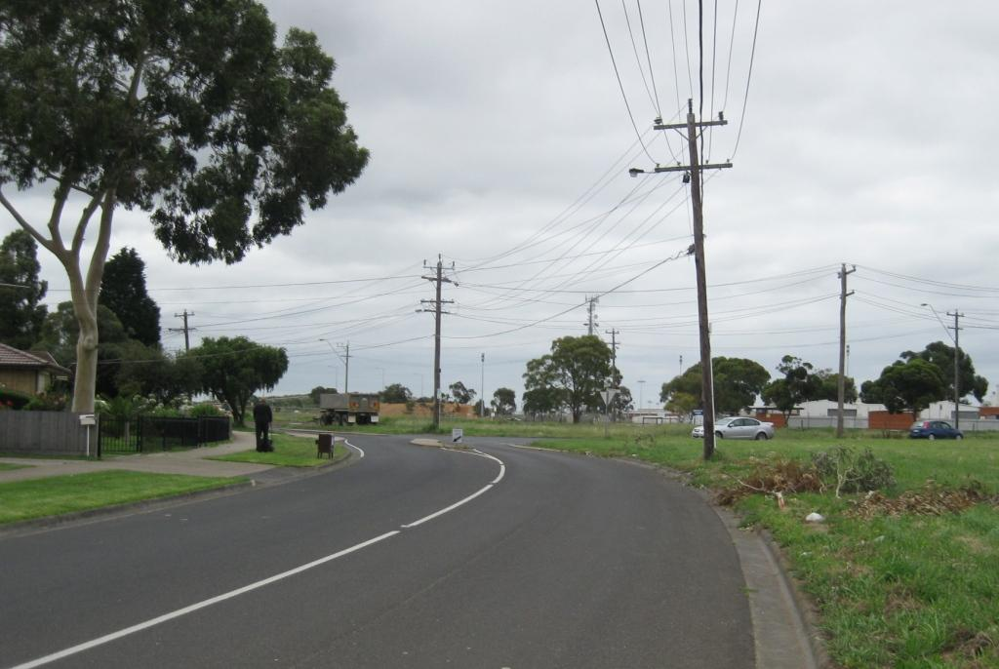
Photo 1: Fairbairn Drive looking north-west towards the Pearce Street intersection. Subject land is on the right of picture.

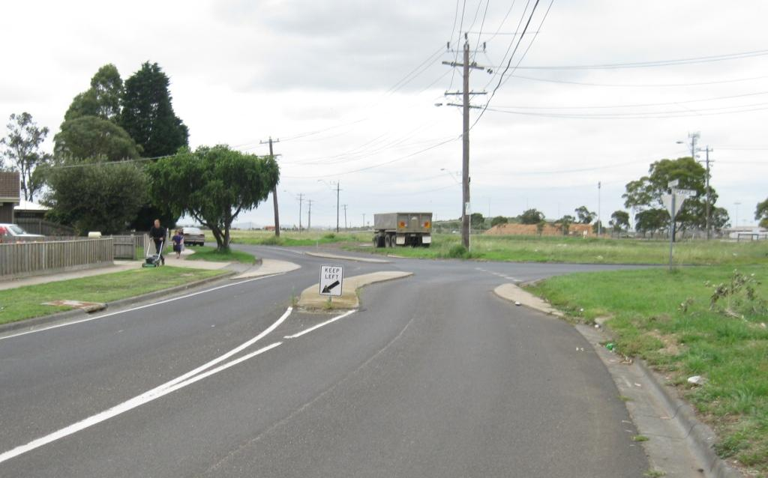
Photo 2: Intersection of Fairbairn Drive and Pearce Street looking north-west showing modified T treatment.

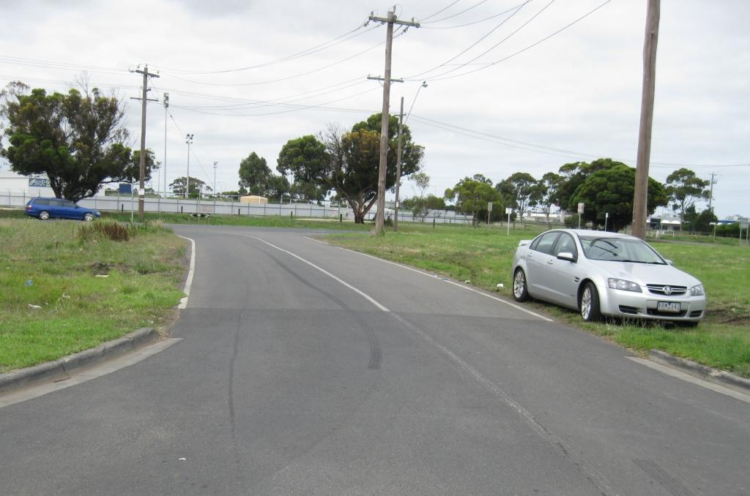
Photo 3: Pearce Street looking north from the Fairbairn Drive intersection towards the Broderick Road intersection. Beckley Park racing centre is in the background of picture.
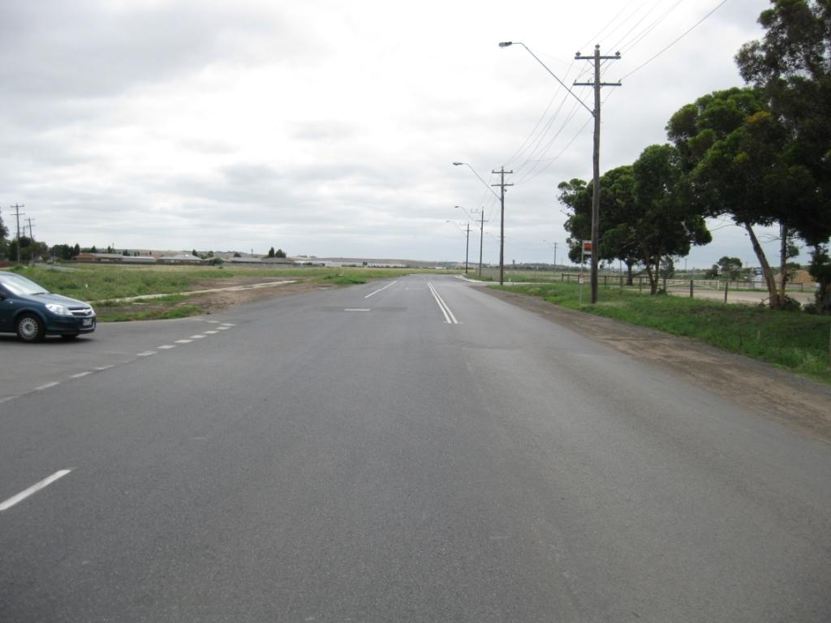
Photo 4: Broderick Road looking north-west from the Pearce Street intersection. The southbound bus stop and the Beckley Park racing centre are to the right of picture.
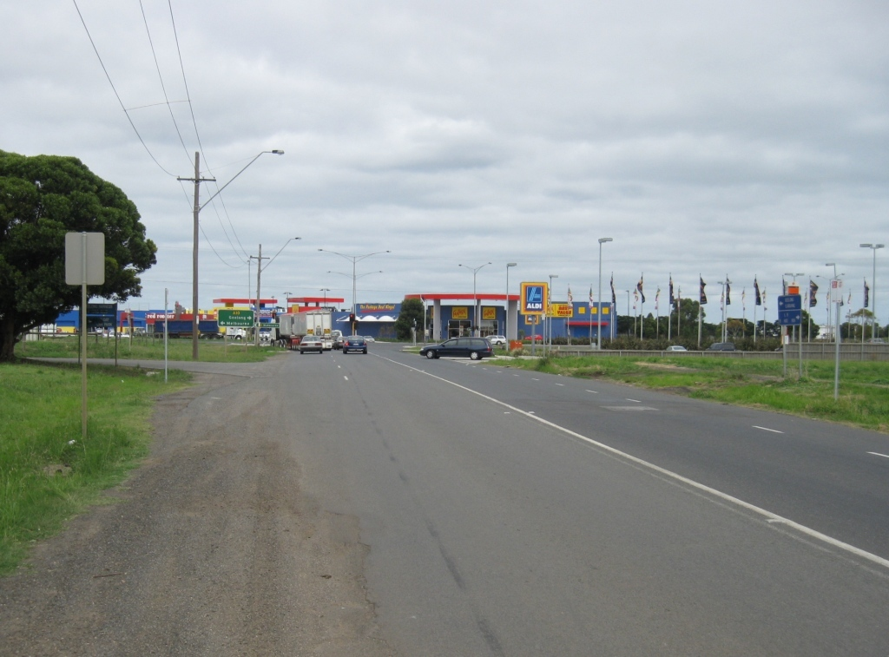
Photo 5: Broderick Road looking south-east from the Pearce Street intersection towards the Melbourne Road intersection in the distance. The ALDI store is in the right background of picture. The northbound bus stop and the subject site are to the right of picture. The Beckley Park horse float entry is to the left of picture.
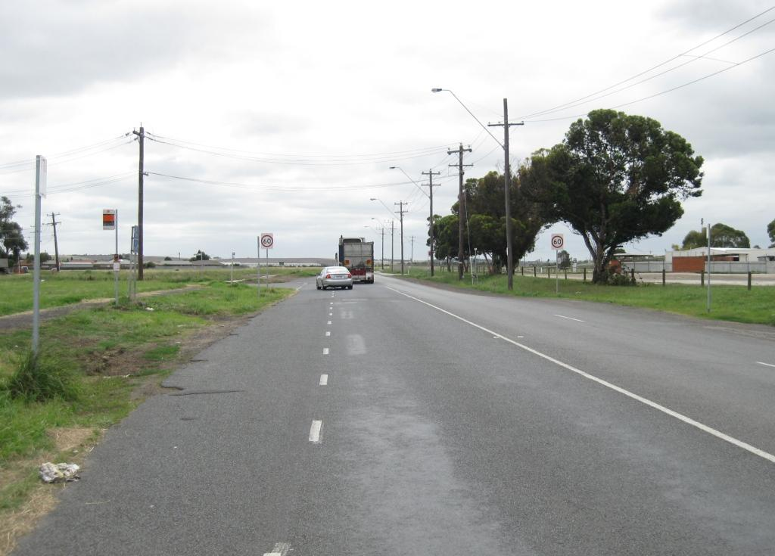
Photo 6: Broderick Road looking north-west from the proposed main entry to the subject development.
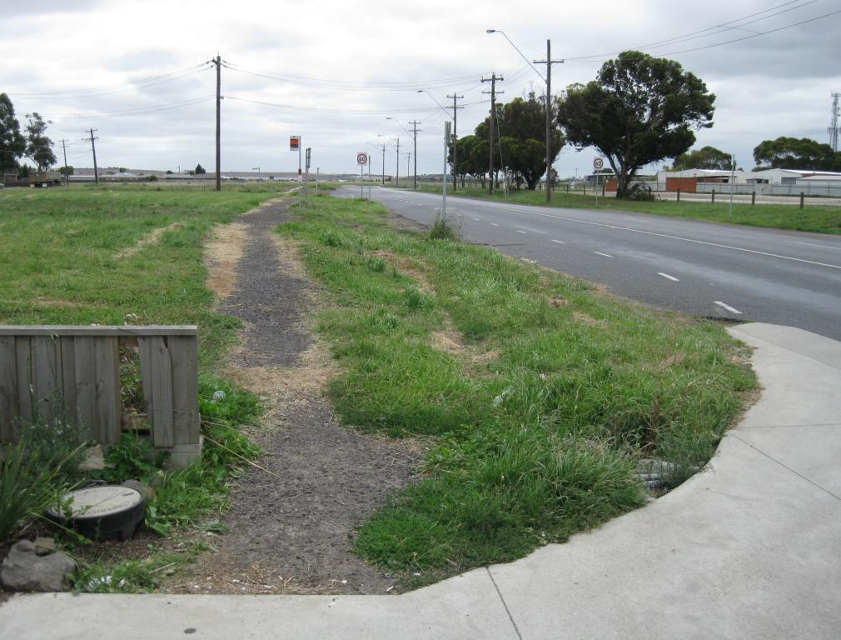
Photo 7: Looking along Broderick Road from the ALDI store entry past the subject site. Notice the unconstructed footpath that services the bus stops and connections further north-west.
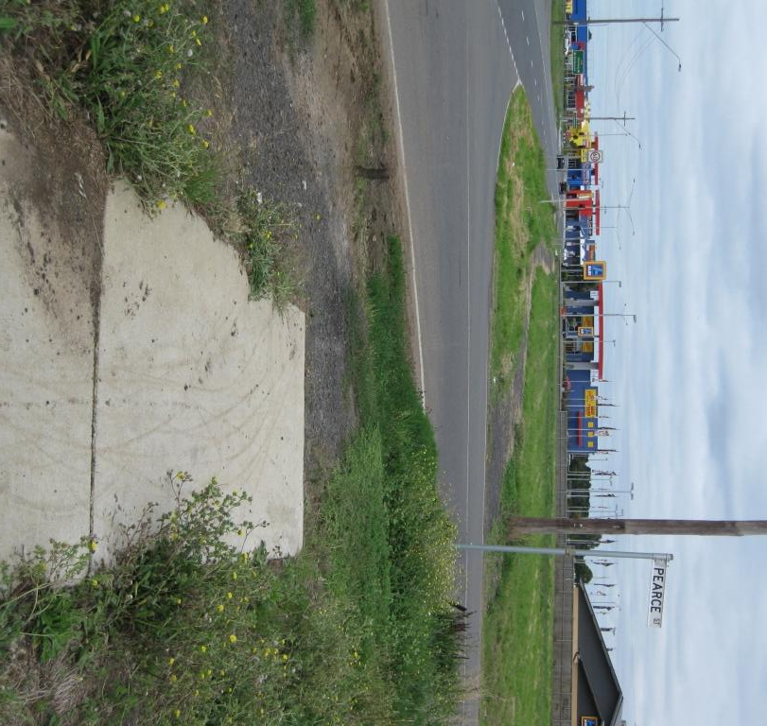
Photo 8: Looking along Broderick Road over the Pearce Street intersection. The subject land is to the right of picture. Notice the poor connectivity between the constructed footpath in the foreground and the unconstructed footpath that services the bus stops and connections further south-east including the ALDI store.
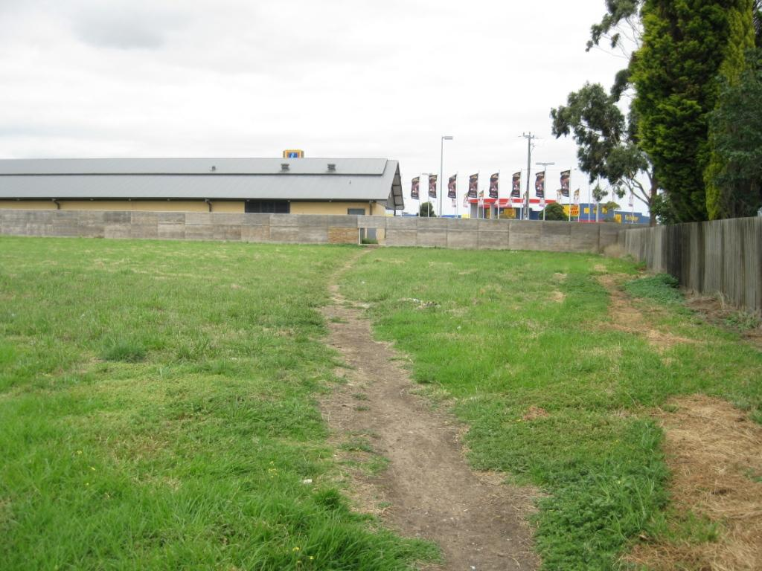
Photo 9: Looking towards the rear of the ALDI store from the south-west corner of the subject land at Fairbairn Drive. Notice the informal but desired pedestrian path to access the ALDI store through a hole in the fence.
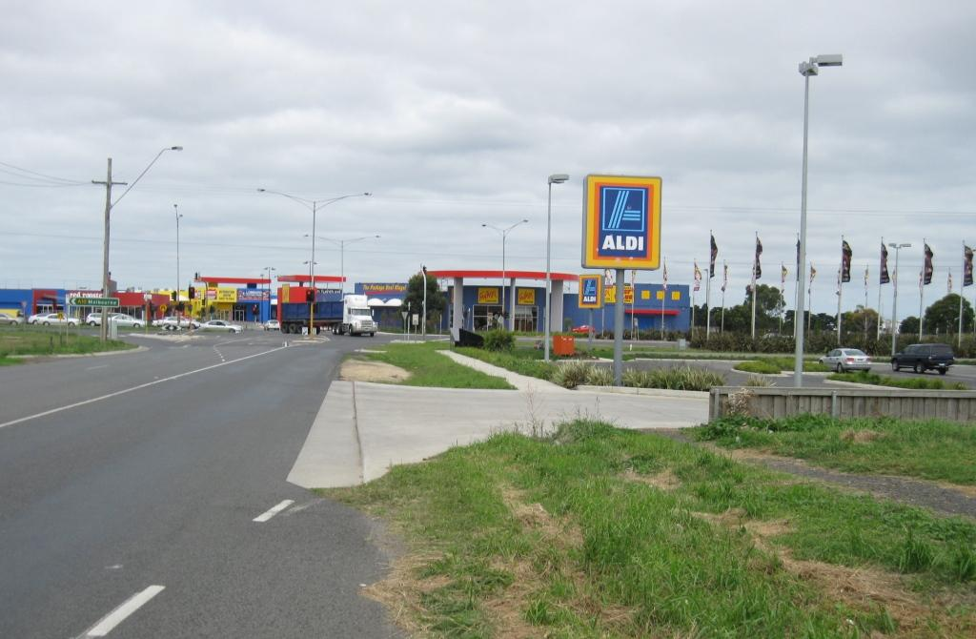
Photo 10: Looking along Broderick Road over the ALDI store entry towards the Melbourne Road signalised intersection in the background.

