AMENDMENT C247 & PP366/2011 – PROPOSED ROSEWALL NEIGHBOURHOOD ACTIVITY CENTRE, 12-20 FAIRBAIRN DRIVE, CORIO

Portfolio: Planning
Source: Economic Development, Planning and Tourism – Strategic Implementation
General Manager: Peter Bettess
Index Reference: Project: Amendment C247 & PP366/2011
Summary
- This report seeks Council approval for the preparation and public exhibition of a Planning Scheme Amendment (C247) to facilitate the development of land for shops to the immediate west of the Corio ALDI Store.
- The application was lodged on 11 July 2012 by CPG Australia (now known as Spiire) on behalf of Ceremira Pty Ltd.
- The application seeks to rezone 0.8 hectares of land from the Residential 1 Zone to the Business 1 Zone and obtain planning approval for the construction of a neighbourhood shopping centre.
- The rezoning will necessitate an amendment to the Retail Activity Centre Hierarchy Map and Table at Clause 21.07-8 of the Greater Geelong Planning Scheme to show a new Rosewall Neighbourhood Centre. Amendment will also be made to Clause 52.28-3 to prohibit the use of gaming machines.
- The shopping centre (excluding the ALDI Store) is proposed to contain 3,267 sq m gross floor area, comprising a major tenant of 1,020 sq m, 11 smaller retail tenancies and provision of 94 on-site car parking spaces.
- The initial application lodged in April 2011 cited the major tenant as a butcher shop. The development has the capacity to attract destination based retailers such as a major packaged liquor outlet. The impacts of such a use on nearby residents would need to be carefully considered under Clause 52.27 Licensed Premises, which triggers a planning permit.
- The subject land is vacant and mainly used as an informal access to the ALDI Store by nearby Rosewall residents. The land has good exposure to Broderick Road and the Princes Highway, with the Geelong Gateway Homemaker Centre located on the opposite side of the highway. To the north is Beckley Park.
- The application is accompanied by comprehensive architectural and landscape plans of the proposed development and technical reports (planning, economic assessment, traffic and stormwater drainage), which have been assessed by relevant internal Council departments.
- From a planning policy perspective the proposal is considered an ‘out-of-centre’ development as established by the City of Greater Geelong Retail Strategy. The economic assessment supporting the application concludes the development will deliver a greater range and choice of retail goods and services without impacting or undermining the wider retail hierarchy of centres.
- Critically, the recently adopted Corio Norlane Structure Plan, which provides direction for key development sites in the study area, identifies the site for rezoning to the Business 1 Zone.
AMENDMENT C247 & PP366/2011 – PROPOSED ROSEWALL NEIGHBOURHOOD ACTIVITY CENTRE, 12-20 FAIRBAIRN DRIVE, CORIO (CONT’D)

- It is considered that the proposal will result in an overall net community benefit and greatly improve the retail offer available to residents in Rosewall and Corio, as well as providing investment and job opportunities. The new shops will complement the existing ALDI Store and benefit from exposure to the Princes Highway.
- Conditions on the planning permit relating to building design, landscaping, traffic management, delivery times, noise attenuation, etc should ensure that impact on the local residential amenity is reduced to acceptable levels.
- It is recommended that the Planning Scheme Amendment and accompanying draft permit be exhibited, subject to authorisation from the Minister for Planning.
Recommendation
That Council:
1) Resolves to support the preparation and exhibition of Amendment C247 to the Greater Geelong Planning Scheme to:
- Rezone the land at 12-20 Fairbairn Drive, Corio from the Residential 1 Zone to the Business 1 Zone as shown in Appendix 1; and
- Amend the Retail Activity Centre Hierarchy Map and Table at Clause 21.07-8 to show a new Rosewall Neighbourhood Centre on Princes Highway, Corio
- Amend Clause 52.28-3 to prohibit the installation and use of gaming machines on the subject land.
2) Agrees to consider the application for a planning permit for the neighbourhood activity centre development concurrently with the preparation of the Amendment in accordance with Section 96A of the Planning and Environment Act 1987, and that draft planning permit 366/2011 be prepared and exhibited with the Amendment, subject to resolution of the detail of the permit conditions as outlined in this report; and
3) Request the Minister for Planning to authorise the preparation and exhibition of Amendment C247 and Planning Permit 366/2011.
Report
Background
A combined Planning Scheme Amendment/Planning Permit Application has been made by planning consultants CPG Australia (now known as Spiire) on behalf of Ceremari Pty Ltd to enable the development of a new neighbourhood shopping centre (adjoining the Corio ALDI Store) on land at 12-20 Fairbairn Drive, Corio.
AMENDMENT C247 & PP366/2011 – PROPOSED ROSEWALL NEIGHBOURHOOD ACTIVITY CENTRE, 12-20 FAIRBAIRN DRIVE, CORIO (CONT’D)
The application was initially lodged in April 2011 however it was placed on hold pending the preparation of the Corio Norlane Structure Plan, which included the subject land within the study area. The application was re-lodged on 11 July 2012, following exhibition of the draft Structure Plan, and includes a revised development layout and supporting documentation.
The subject land is vacant and mainly used as an informal pedestrian access to the Corio ALDI Store by nearby residents. The land has good exposure to Broderick Road and the Princes Highway, with the Geelong Gateway Homemaker Centre located on the opposite side of the highway. To the north is Beckley Park, and to the south and west are residential dwellings. The site is served by an existing bus stop.
The Planning Scheme Amendment proposes to rezone 0.8 hectares of vacant residential land to the Business 1 Zone. The rezoning will also necessitate an amendment to the Retail Activity Centre Hierarchy Map and Table at Clause 21.07-8 of the Greater Geelong Planning Scheme to show a new Rosewall Neighbourhood Centre.
The existing zoning of the subject land and surrounding area is shown in Appendix 2 and an aerial map of the area is shown in Appendix 3.
The planning permit application seeks approval to construct the neighbourhood shopping centre in accordance with the submitted development plans and dispensation from car parking and loading requirements, and approval to erect associated business identification signage. The Centre will contain 3,267 sq m gross floor area, comprising a major tenant of 1,020 sq m of leasable floor area and 11 smaller tenancies totalling 1,950 sq m leasable floor area.
Other features of the development include:
- 94 on-site car parking spaces, including 4 disabled spaces, and 12 bicycle parks;
- Landscaping as part of the development using water Sensitive Urban Design and stormwater drainage principles;
- Vehicle access and exit via a new crossover on Broderick Road and a secondary access and exit via a new crossover on Fairbairn Drive;
- Perimeter footpath and formal pedestrian link to the ALDI Store; and
- Loading dock located to the south of the major retail tenant.
The proposed development comprises a single storey built form character. The major tenancy in the north-east corner has a slightly extended form to accentuate the structure and differentiate it from the neighbouring smaller tenancies. Glazing is used to shop frontages and partial glazing to the Pearce Street frontage. Overhanging verandas and staff toilets are also provided.
Appendix 4 shows the development plan and Appendix 5 shows the west elevations.
The development plan was prepared in consultation with Council. An on-site inspection and follow-up workshop was held on 23 March 2012 and involved the proponent’s project architect and planning consultant, together with Council planning, urban design, community development and traffic and drainage engineering officers.
AMENDMENT C247 & PP366/2011 – PROPOSED ROSEWALL NEIGHBOURHOOD ACTIVITY CENTRE, 12-20 FAIRBAIRN DRIVE, CORIO (CONT’D)
Discussion
Discussion of the proposal will be split into an assessment of the strategic planning and retail merits, followed by consideration of residential amenity, traffic requirements and permit conditions.
Planning and Retail Merits
The application is for an “out-of-centre” development according to the Geelong Retail Activity Centre Hierarchy included at Clause 21.07-8 of the Greater Geelong Planning Scheme. The Geelong Retail Strategy was established in 2006, and while the Corio ALDI Store is briefly mentioned, no assessment of its position in the hierarchy was made as a planning scheme amendment was under active consideration at that time.
Council was supportive of the Corio ALDI amendment (approved July 2006). Council acknowledged that the proposed supermarket is not located within an established activity centre however considered demonstrated community benefits for northern suburb residents outweighed the negatives of a stand alone store.
It could be argued that the proposal is an edge-of-centre development in association with the established ALDI Store. Proposed Amendment C247 will entrench the site as a genuine neighbourhood centre, consistent with the Geelong Retail Strategy definition:
“Neighbourhood centres are generally characterised by a range of mainly convenience related shopping needs such as newsagent, chemist, hairdresser, green grocer, butcher, takeaway food, etc, and anchored by a supermarket”.
In considering this application there was concern as to the location of this proposed new neighbourhood centre. The site is not central to the nearby residential community and many of the surrounding uses are not residential in nature. At the same time it is vacant Residential 1 zoned land and unlikely to be developed for housing in the near future. The land is currently derelict and used as an informal, less than adequate access to the ALDI Store.
This proposal needs to be considered in the context of the surrounding area. Corio residents and in particular the Rosewall community, are poorly served by local retail choice and employment opportunities. The development will bring welcome new investment in services and infrastructure. The proposed development will have good exposure to the Princes Highway, Beckley Park and the Geelong Gateway Homemaker Precinct, as well as the co-location benefits with the ALDI Store.
The Amendment includes the prohibition on the installation and use of gaming machines consistent with the retail policy objective to avoid the risk of exacerbating problem gambling. The local policy at Clause 22.57 of the Greater Geelong Planning Scheme directs that gaming machines should be located away from areas of socio-economic disadvantage.
The initial application lodged in April 2011 cited the major tenant as a butcher shop. Other tenancies are not known however the development has the capacity to attract destination based retailers such as a major packaged liquor outlet. The impacts of such a use on nearby residents would need to be carefully considered under Clause 52.27 Licensed Premises, which triggers a planning permit. The purpose of this provision is to ensure that the impact of a licensed premises on the amenity of the surrounding area is considered.
AMENDMENT C247 & PP366/2011 – PROPOSED ROSEWALL NEIGHBOURHOOD ACTIVITY CENTRE, 12-20 FAIRBAIRN DRIVE, CORIO (CONT’D)
The site was considered in the preparation of the Corio Norlane Structure Plan (CNSP), recently adopted by Council. The CNSP provides direction for key development sites and identifies appropriate planning controls to achieve desired outcomes, including private sector investment.
The Structure Plan identifies the site for rezoning to the Business 1 Zone. Under Principle 6 – Support opportunities to improve the retail offer for local communities, the following comment is made (pp. 16-17):
“The stand-alone Corio Aldi is a suitable site for a second neighbourhood centre and would greatly improve the retail offer available to residents in the Rosewall area. The site is adjoined by a 0.8 hectare vacant site at 12-20 Fairbairn Drive that can be immediately rezoned to Business 1 Zone to enable the expansion of this centre. A proposal to rezone this land has already been submitted to the City of Greater Geelong containing plans to develop the site with 3,100 square metres of leasable floor area”.
For the reasons stated above, the proposal is considered to meet a key objective of Clause 21.07-3 Retail – that is, to ensure all major retail developments, and out-of-centre developments, provide a clear net community benefit.
Clause 22.03 provides assessment criteria for retail planning applications. In line with the policy requirement for an economic impact assessment (EIA) where the development is for 2,000 sq m or more in gross leasable floor area, a Corio Retail Needs and Catchment Assessment was prepared by MacroPlan Australia.
The MacroPlan assessment concludes that the proposed development would create a more balanced and efficient neighbourhood centre, delivering residents with a greater range and choice of retail goods and services without impacting or undermining the wider retail hierarchy of centres.
The assessment identifies a primary and two secondary catchments from which the new centre will draw trade. With regard to food and grocery retailing, the primary trade area only accommodates the Corio ALDI. Key centres serving the secondary catchments include Corio Village, Bell Post Shopping Centre and the Lara Town Centre – given existing travel patterns and insufficient supermarket offer.
It would be expected that, in addition to the ALDI Store, the proposed larger tenancies will attract customers from the broader catchment. The assessment finds that the secondary trade areas have considerable retail leakage, and demonstrate clear market gap potential to retain some of this food and grocery and convenience retail expenditure leakage within the catchment.
Residential Amenity Issues
The subject land is located in an exposed area with vacant land to the north and north-west, bounded by Broderick Road. Broderick Road is a sub-arterial link carrying heavy vehicle traffic over the freeway to the Geelong Ring Road Employment Precinct. To the east of the site is the ALDI Store and Princes Highway. These characteristics mean the site is constrained for residential use with a lesser level of amenity.
Converting this vacant land into a contemporary low-scale retail centre is considered to have positive amenity benefits for residents on the opposite side of Fairbairn Avenue. The buildings will help screen traffic noise and the landscaping and design will be an improvement on the current stark, dull outlook to the ALDI Store and Beckley Park.
AMENDMENT C247 & PP366/2011 – PROPOSED ROSEWALL NEIGHBOURHOOD ACTIVITY CENTRE, 12-20 FAIRBAIRN DRIVE, CORIO (CONT’D)

The development site has a direct interface with two residential properties to the south. It is proposed to locate 4 attached single-storey shops offset by a 2 m service yard to the south boundary. Loading areas are central to the site and the primary vehicle access will be from Broderick Road.
The development will substantially improve pedestrian and cycle connections and safety to the ALDI Store, nearby bus stop and across to the Geelong Gateway Homemaker Centre and Beckley Park. The new retail outlets will also provide local residents with convenient places to meet and recreate.
Traffic and Parking Issues
The application is accompanied by a Traffic Impact Assessment. The assessment is generally supported and concludes that:
- The peak car parking demand for the proposed retail development will require the provision of 104 spaces, 94 of which will be provided on-site. The remaining 10 spaces will be provided from the spare capacity in adjacent car parks.
- The total traffic generation of the retail development is calculated to be 3,750 vehicles per day. It is estimated that 75% of traffic will gain access from the Broderick Road entry and 25% from the Fairbairn Drive entry.
- The traffic generated by the development will have negligible impact on the operation and efficiency of the local road network.
Accompanying Permit 366/2011
As outlined in this report, it is proposed that a draft permit be prepared to enable development of the retail centre which would be exhibited with the Amendment pursuant to Section 96A of the Planning and Environment Act. Permit conditions will reflect referral comments from internal Council departments and Government Authorities.
The Permit will include conditions to address the following issues:
- Road treatments, intersection works and bus stop relocation, to improve safe and efficient access as recommended in the Traffic Impact Assessment. It may be necessary that the developer enters into a Section 173 Agreement to delivery the road infrastructure.
- Stormwater management requirements to ensure best practice treatment of run-off and storage within the boundaries of the site.
- Footpaths to ensure formalised access to the ALDI Store and safe links to, through and around the development.
- Acoustic screening to safeguard the amenity of residents to the south.
- Urban design treatments including building materials/colours, etc.
- Landscaping treatments, particularly to the Fairbairn Drive/Pearce Street frontage, to screen and soften the impact of buildings and car parking areas.
- Outdoor advertising.
AMENDMENT C247 & PP366/2011 – PROPOSED ROSEWALL NEIGHBOURHOOD ACTIVITY CENTRE, 12-20 FAIRBAIRN DRIVE, CORIO (CONT’D)
Environmental Implications
The proposed development is not expected to result in any adverse environmental impacts because the subject land is vacant and contains no significant vegetation. Large and medium sized canopy trees are proposed to be planted which will provide much needed “greening” of an area otherwise devoid of natural features.
Landscaping works proposed for the site are based around incorporating the principles of Water Sensitive Urban Design. The drainage network will be designed and constructed to the satisfaction of Council.
Vehicle shopping trips will be reduced as the development is physically linked to the adjacent ALDI Store allowing one trip to serve a customer’s shopping needs. This will help reduce traffic congestion and encourages walking/cycling by local residents.
Financial Implications
It is not expected that the proposal will result in any financial implications for Council, other than those associated with the usual processing of an amendment.
Policy/Legal/Statutory Implications
State Planning Policy Framework (SPPF)
The Amendment is considered to be consistent with Clauses 11.01-2 Activity centre planning and 17.01-1 Business of the SPPF by making provision for a conveniently located neighbourhood activity centre to serve the needs of northern suburb residents.
Local Planning Policy Framework (LPPF)
The Amendment is generally consistent with the relevant directions of the LPPF, including the Municipal Strategic Statement (MSS) and local policies.
In relation to the MSS the Amendment is consistent with key directions as follows:
- The Amendment will assist in consolidating development within the identified boundaries of Geelong, consistent with the direction of Clause 21.02; and
- The out-of-centre retail development proposed by the Amendment will provide a clear net community benefit, consistent with Clause 21.07-3.
In relation to local planning policies, Clause 22.03 outlines a set of criteria against which applications for new retail floor space must be assessed, including out-of-centre proposals. It is considered that the Amendment responds appropriately to the nominated criteria, in that the proposal is consistent with the urban context of the surrounding area, will not significantly impact on local amenity, and will result in a net community benefit. It is considered that the proposal will not detract from the operation of the Retail Activity Centres Hierarchy articulated at Clause 21.07-8.
AMENDMENT C247 & PP366/2011 – PROPOSED ROSEWALL NEIGHBOURHOOD ACTIVITY CENTRE, 12-20 FAIRBAIRN DRIVE, CORIO (CONT’D)

Corio Norlane Structure Plan
As mentioned above, the subject land is identified in the Corio Norlane Structure Plan for rezoning to the Business 1 Zone. The Structure Plan was adopted by Council on 24 July 2012 and Council officers will request the Minister for Planning to prepare and approve a planning scheme amendment to implement the Plan into the Greater Geelong Planning Scheme.
Officer Direct or Indirect Interest
No Council Officers have any direct or indirect interest, in accordance with section 80(C) of the Local Government Act, to which this report relates.
Risk Assessment
There are not expected to be any notable risks associated with either implementing or not implementing the recommendations contained in this report.
Social Considerations
It is considered the Amendment will result in an overall net community benefit by improving the retail and service offer to local residents, and consolidating the new outlets with the existing ALDI Store to create a true neighbourhood activity centre.
The development will significantly improve the visual amenity of the immediate area and provide sort after investment and job opportunities for a community in need of urban renewal.
Communication
Should Council resolve to exhibit the Amendment, the usual statutory notifications will take place, including a notice in City News and letters to surrounding land owners and residents.

APPENDIX 1
Proposed Rezoning Map

APPENDIX 2
Existing Zoning Map
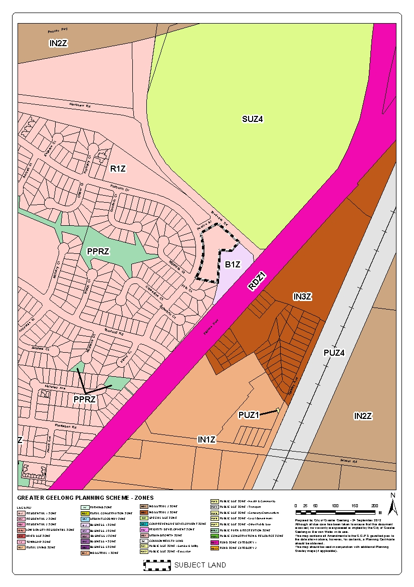

APPENDIX 3
Aerial Map
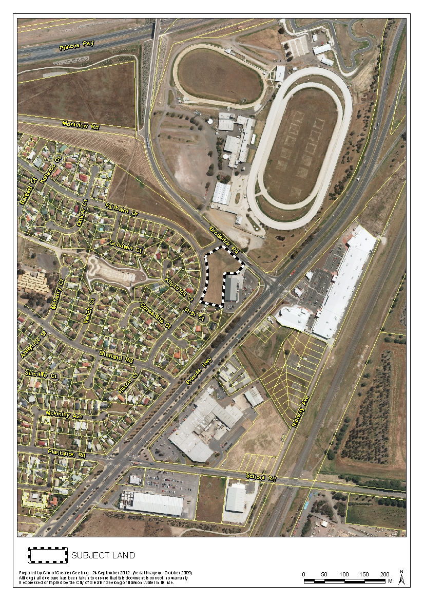

APPENDIX 4
Proposed Development Plan
Appendix 5 – Proposed Elevations (West) Plan

