Gateway Plaza Leopold, VIC

Economic Impact Assessment
for Future Expansion
Updated with discussion of Stages 1 & 2

May 2012

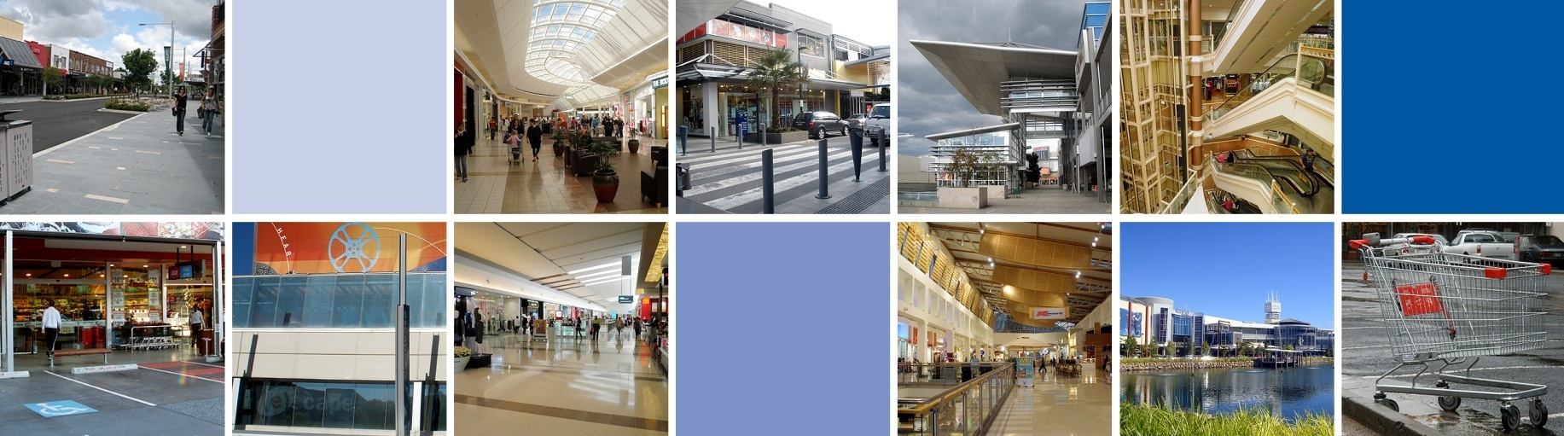

MacroPlan Dimasi

MELBOURNE  Level 4  356 Collins Street  Melbourne VIC 3000  (03) 9600 0500 | SYDNEY  Level 4  39 Martin Place  Sydney NSW 2000  (02) 9221 5211
BRISBANE  Level 15  111 Eagle Street  Brisbane QLD 4000  (07) 3221 8166 | PERTH  Ground Floor  12 St Georges Terrace  Perth WA 6000  (08) 9225 7200

Prepared for: Malaluka Commercial Pty Ltd

MacroPlan Dimasi staff responsible for this report:
Tony Dimasi, Managing Director – Retail
Ellis Davies, Manager – Retail

Table of contents

Introduction i
Executive summary iii
Section 1: Site location and proposed development 1
1.1 Regional & local context 1
1.2 Planning environment 5
1.3 Existing centre and proposed expansion 7
Section 2: Trade area analysis 11
2.1 Trade area definition 11
2.2 Trade area population 14
2.3 Socio-demographic profile 18
2.4 Trade area retail spending 21
Section 3: Competitive context & retail demand 25
3.1 Competitive context 25
3.2 Retail floorspace supply and demand 29
Section 4: Sales potential 33
4.1 Discount department store sales potential 34
4.2 Supermarket sales potential 35
4.3 Total centre sales potential 37
4.4 Centre market shares 40
Section 5: Economic impact considerations 43
5.1 Economic and social benefits 43
5.2 Employment stimulus 45
5.3 Consideration of trading impacts 47

This page has been intentionally left blank.

Introduction

This report presents an independent assessment of the demand and market scope for a proposed expansion of Gateway Plaza, which is currently a neighbourhood shopping centre located in Leopold. The report also considers the various impacts, both positive and negative, that would result from the further expansion of the centre as proposed. The report has been updated in August 2013 to include a brief overview of the planned stages of the proposed development.

The report is presented in four sections as follows:

- Section 1 provides a description of the site, including its location and context within the surrounding region, as well as outlining the relevant planning framework as it relates to the centre. The proposed expansion of the centre is also detailed.
- Section 2 examines the trade area which is relevant to this proposal, including current and projected population and retail spending levels within the trade area.
- Section 3 examines the current and future competitive retail facilities within the surrounding region, and thus the competitive environment which Gateway Plaza faces and will face in the future.
- Section 4 outlines our assessment of the sales potential for an expansion of Gateway Plaza.
- Section 5 presents an economic impact assessment for the proposal, including considering likely trading impacts on other retailers throughout the surrounding region, as well as the employment and other economic effects of the proposed expansion.

This page has been intentionally left blank.

Executive summary

- Gateway Plaza is currently a neighbourhood centre located in Leopold. The centre is now proposed to be expanded, adding two discount department stores, a second supermarket, and a range of other retail and non-retail facilities. A planning permit application has been lodged for Stage 1 of the development which includes a total ‘shop’ floorspace of 21,435 sq.m.
- The City of Greater Geelong Retail Strategy outlines that the Gateway Plaza site should be investigated for a potential new sub-regional centre. The strategy details that a centre on the subject site would be able to serve the entire Bellarine Peninsula, while not undermining the core catchment of the Geelong CBD.
- The main trade area that would be served by Gateway Plaza following its expansion is defined to include Leopold, the Bellarine Peninsula and Newcomb. The trade area population is estimated at nearly 68,000 people at 2011, and is forecast to grow solidly to over 80,000 residents by 2021.
- There is currently no discount department store, other than a small Target Country store in Ocean Grove, located in the trade area. In non-metropolitan areas of Australia, there is typically one discount department store for every 30,000 – 35,000 residents. In terms of total retail floorspace, there is currently considered a substantial shortfall in the trade area, while a shortfall is still anticipated in 2016 following the expansion of Gateway Plaza.
- An expansion of Gateway Plaza to sub-regional status will greatly enhance the shopping choice for local residents and visitors to the region, with significant improvements in the available range of food and non-food retail facilities. The expansion of Gateway Plaza will also contribute to the local economy through increased employment, both during the construction phase and ongoing at the centre once it has opened. The expansion of Gateway Plaza may have some impact on other retailers in the region, though the assessed impacts are considered to be reasonable and would not threaten the ongoing viability of any existing retailers.

This page has been intentionally left blank.

Section 1: Site location and proposed development

This section of the report details the location of Gateway Plaza and the local and regional contexts of the site and the centre. The relevant planning environment is reviewed, and the proposed expansion plans are also detailed.

1.1 Regional & local context
Gateway Plaza is a single supermarket based centre located at the western edge of the Leopold urban area. Leopold is a satellite town situated 9.5 km east of Geelong and acts as a gateway to the popular Bellarine Peninsula (refer Map 1.1).

The centre occupies a high profile site on the Bellarine Highway, which is the main traffic route linking Geelong with Leopold, Ocean Grove, Point Lonsdale and Queenscliff (refer Map 1.2). The site also adjoins Melaluka Road, which extends north to the Geelong - Portarlington Road and also provides easy access to the Estuary residential estate to the south.

Gateway Plaza is currently anchored by a Coles supermarket and includes 14 specialty shops, as well as a medical clinic. Other existing retail facilities in Leopold are limited to small strip centres provided on Dorothy Street and Ash Road. Gateway Plaza is identified as a potential future sub-regional centre for the surrounding region, including Leopold and the Bellarine Peninsula, as outlined in the City of Greater Geelong Retail Strategy, which is detailed in a later sub-section of this report.

The Bellarine Peninsula is a popular tourist destination, particularly for residents of Melbourne during weekends and over the summer holiday period. Furthermore, strong population growth is occurring on the Bellarine Peninsula, with key growth areas located in Curlewis (west of the Drysdale urban area) and to the north of Ocean Grove, while the Leopold urban area will also enjoy substantial future growth.

The main higher-order non-food retailers currently serving the surrounding region are provided in the Geelong CBD, which comprises Westfield Geelong, Market Square Shopping Centre and street based retailing provided along Ryrie Street, Moorabool Street and Malop Street. Central Geelong is estimated to contain around 125,000 sq.m of retail floorspace in total. In addition, Geelong is served by three sub-regional centres namely Belmont Shopping Village to the south, Waurn Ponds Shopping Centre to the south-west and Corio Shopping Centre to the north.

Over the longer term (i.e. around 2020) the Geelong Ring Road is proposed to be extended to link through to the Bellarine Highway, a short distance west of Gateway Plaza. If this occurs, it will increase the amount of passing traffic along the Bellarine Highway and further strengthen the Gateway Plaza site as a key retail destination for the region.

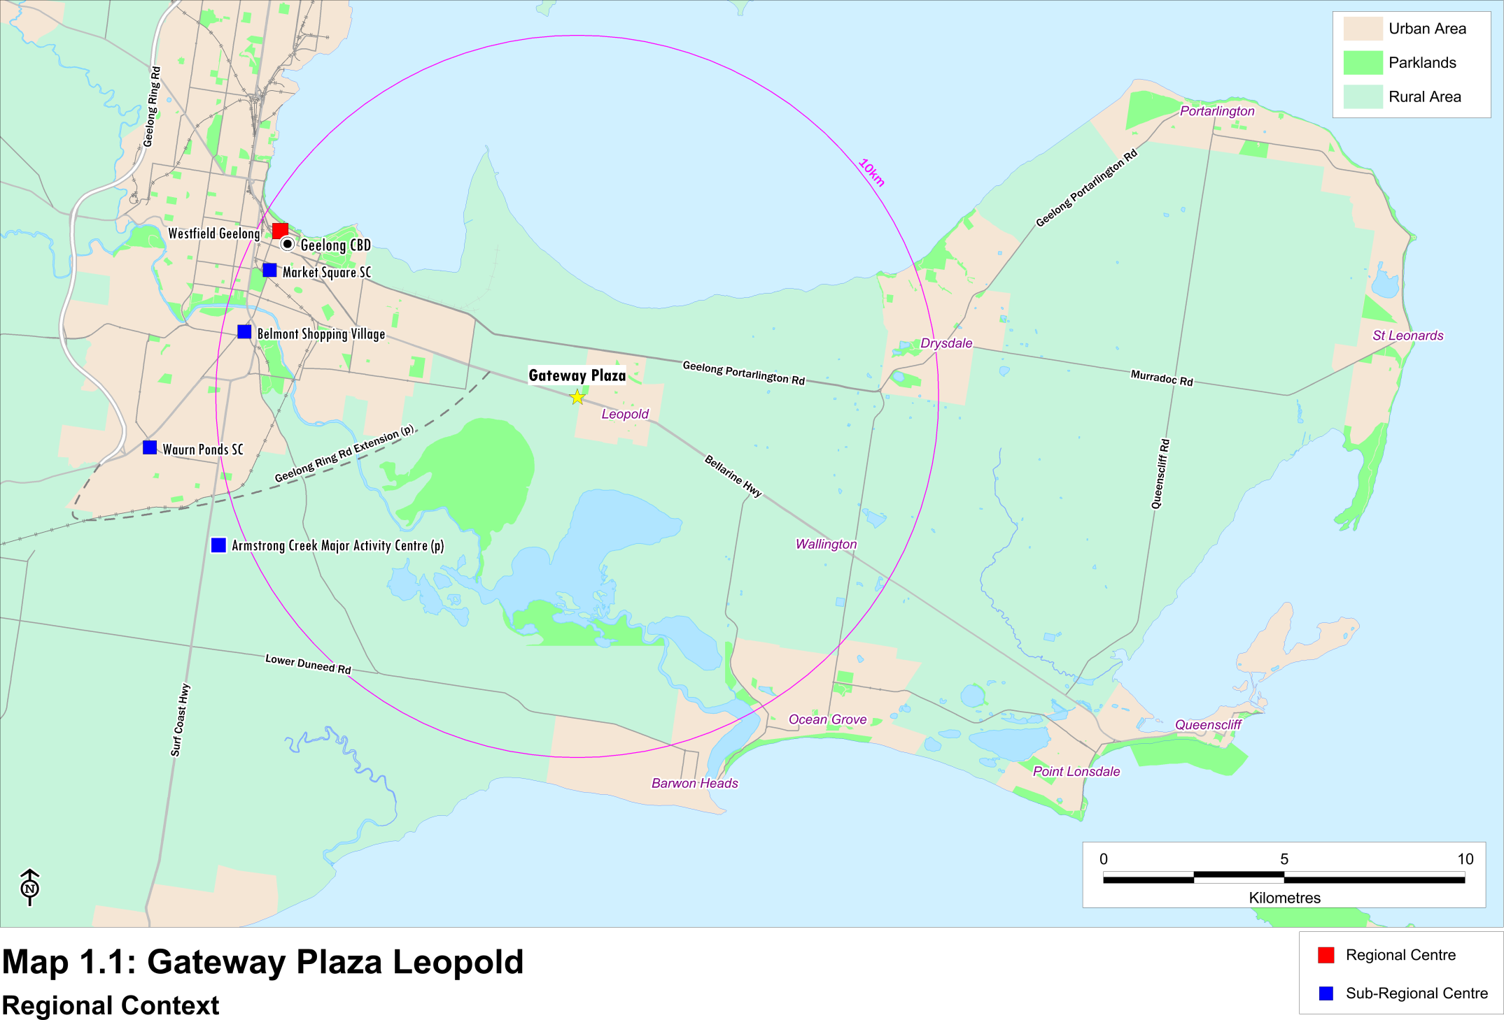

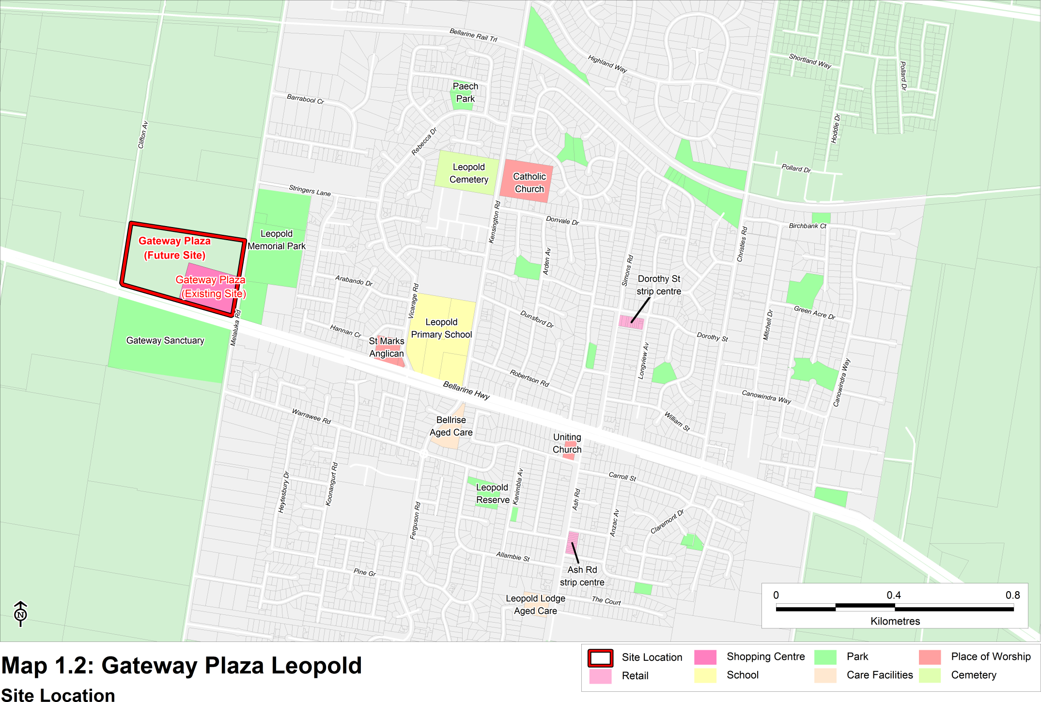

1.2 Planning environment
The Leopold Structure Plan (the Structure Plan) was adopted by the City of Greater Geelong in September 2011. The purpose of the Structure Plan is to provide a strategic framework and vision for the future planning and development of Leopold. The vision of the Structure Plan is to be delivered by (page 7):

- Providing opportunities for the creation of a potential sub-regional retail centre which serves the Bellarine Peninsula but also creates a ‘town centre’ for Leopold residents; and
- Providing for local employment opportunities.
The Structure Plan also states that Leopold is well located to serve the townships of the Bellarine Peninsula, while also being situated in close proximity to Geelong. The Structure Plan draws on a number of previous reports including:
- The City of Greater Geelong Retail Strategy (the Retail Strategy); and
- The Leopold Sub-Regional Activity Centre Master Plan (the Centre Master Plan).
The Retail Strategy was prepared by Essential Economics in June 2006. It was prepared to guide the ongoing development of the retail sector and retail activity centres in the Greater Geelong municipality. Some of the key points to highlight from the retail strategy include the following:

- The Bellarine Peninsula had a population of 63,700 people in 2006, which is forecast to increase to 82,000 people by 2021 – a figure equivalent to the 2005 population of the City of Greater Bendigo (page 34). The main trade area defined for Gateway Plaza in Section 2 of this report is the same as the definition of the Bellarine Peninsula utilised in the Retail Strategy.

- The Gateway Plaza site should be investigated for a potential new sub-regional centre for the following reasons (page 34 of the Retail Strategy):
- The site contains the required amount of vacant land.
- A sub-regional centre on the Gateway Plaza site in Leopold would serve the entire Bellarine Peninsula.
- As Leopold is located 8.5 km from Central Geelong, it would not be expected to undermine Central Geelong’s core primary catchment.
- By around 2016, the forecast population on the Bellarine Peninsula should support sub-regional facilities without having an undue adverse effect on retailing in central Geelong (page 35 of the Retail Strategy).
- Table 12.1 on page 95 of the Retail Strategy outlines the retail hierarchy of centres serving the Geelong region. Most relevant is the definition of ‘sub-regional centre’ which is described as typically serving a catchment population of between 40,000 and 80,000 people and having a retail floorspace range of between 15,000 sq.m and 35,000 sq.m. Examples of key tenants include discount department stores, supermarkets, mini-majors and specialty shops.
The Centre Master Plan was prepared for the City of Greater Geelong by Beca, in partnership with Sykes Consulting and Tim Nott Economics in December 2010. Key findings of the report include the broad estimates of required additional floorspace at a future sub-regional centre in Leopold by 2021 (page 21). It estimated in the Centre Master Plan that a sub-regional activity centre in Leopold could support an additional 45,300 sq.m floorspace by that date, including 27,700 sq.m of retail floorspace and 17,600 sq.m of non-retail floorspace.

1.3 Existing centre and proposed expansion
Gateway Plaza is anchored by a Coles supermarket of 3,200 sq.m and includes one mini-major of 426 sq.m (Priceline) and 14 retail specialty shops totalling 1,136 sq.m of floorspace. The centre is now proposed to be expanded to sub-regional status in two stages as detailed in Table 1.1.

Stage 1 of the proposed expansion is illustrated on Figure 1.1 and is to include the following:

- The addition of a discount department store of 5,000 sq.m;
- An expansion of the existing Coles supermarket to 4,200 sq.m;
- The addition of a second supermarket of 4,200 sq.m;
- A further 900 sq.m of mini-major floorspace;
- Around 7,180 sq.m of additional retail specialty space, which would incorporate a range of fresh food, take-away food, apparel, household goods, leisure, general retailers as well as retail services;
- An expansion of the medical facility to 471 sq.m;
- Office space of 2,380 sq.m;
- A gymnasium of 562 sq.m; and
- An external restaurant fronting the Bellarine Highway of 350 sq.m.
The Stage 2 expansion is illustrated in Figure 1.2 with the key features including the following:

- The addition of a second discount department store of 8,200 sq.m;
- An increase in the retail specialty space by 365; and
- Showroom floorspace of 650 sq.m;
Overall, Stage 1 is proposed to increase ‘shop’ floorspace to 21,435 sq.m and total floorspace to 27,143 sq.m. Stage 2 is proposed to add 8,565 sq.m of retail floorspace as well as 650 sq.m of showrooms.

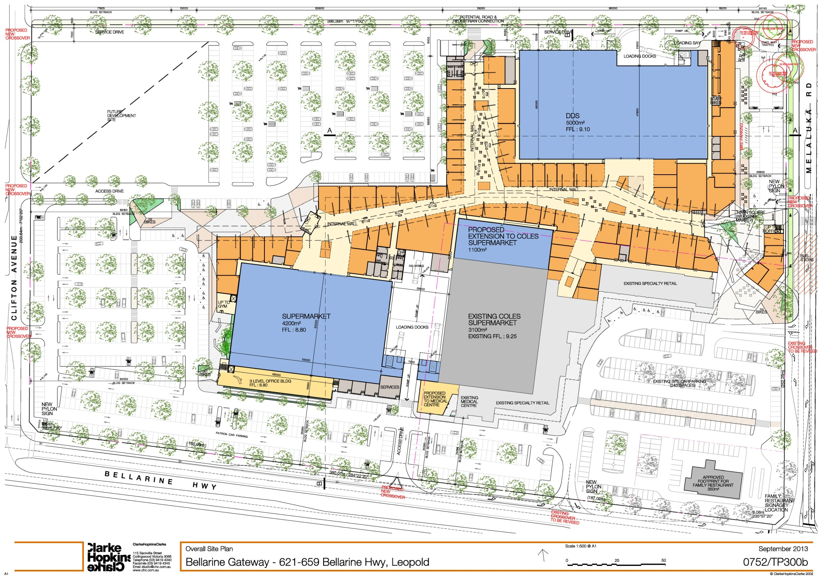
Figure 1.1

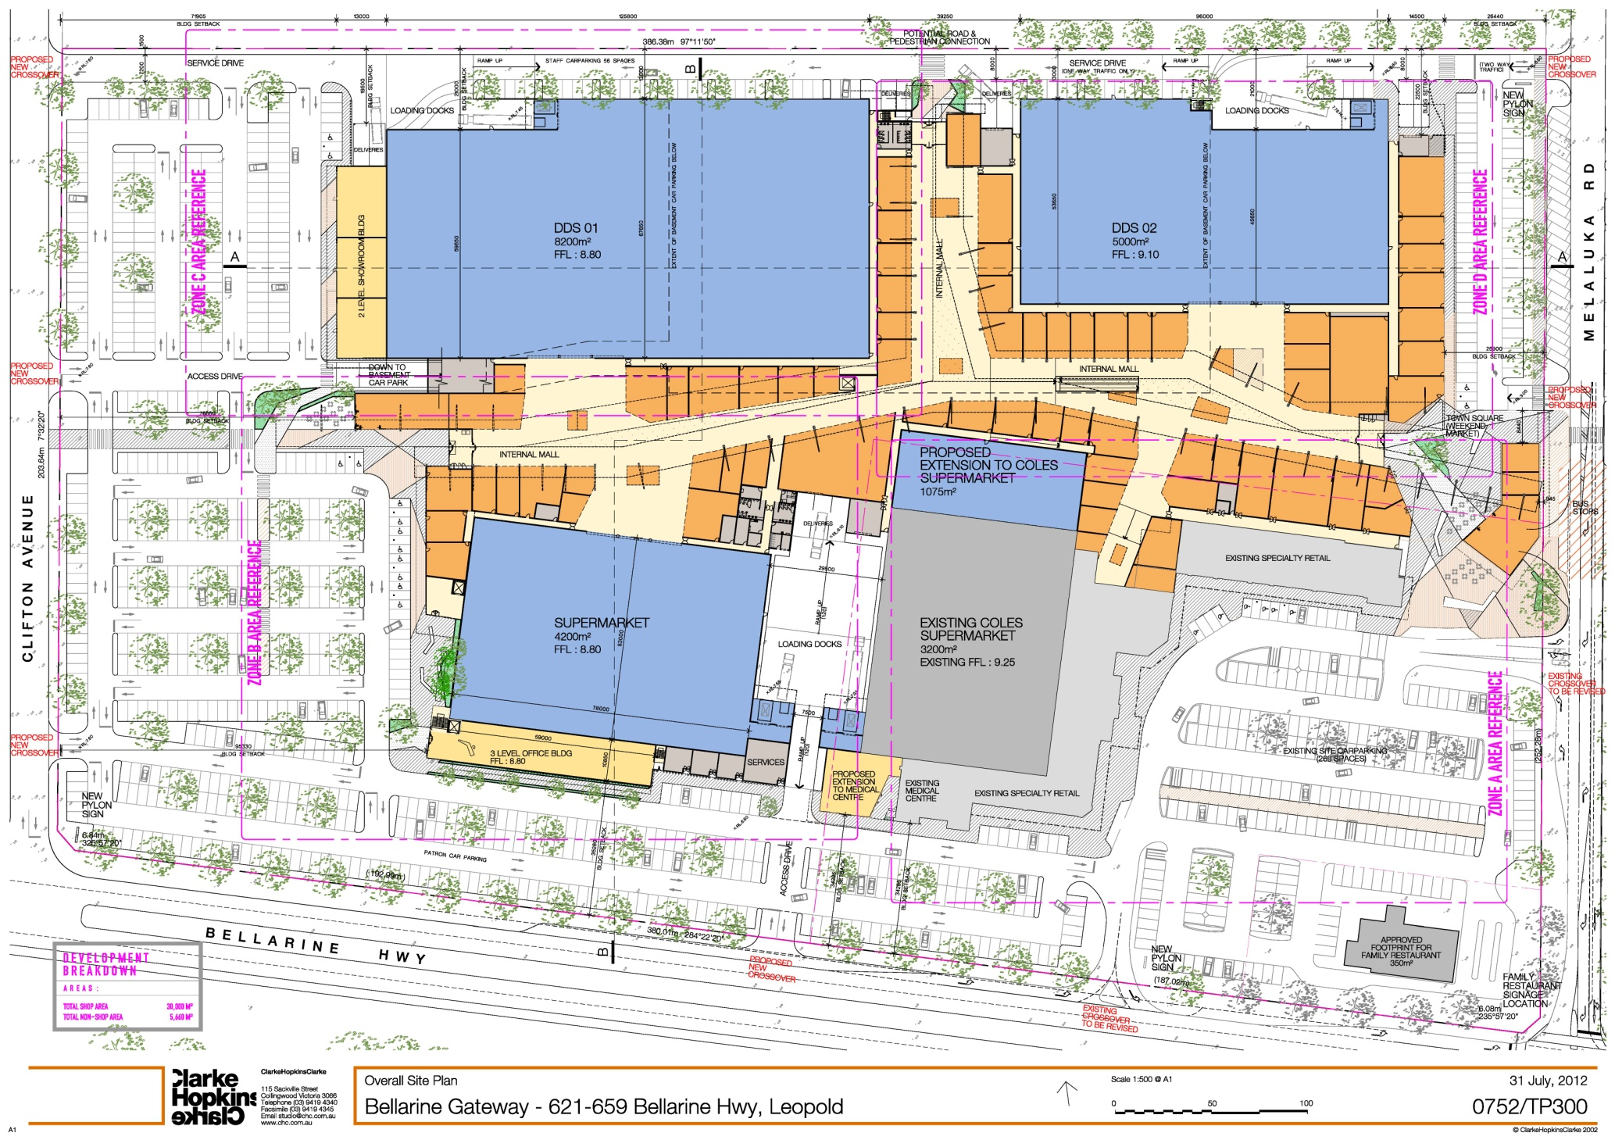
Figure 1.2

Section 2: Trade area analysis

This section of the report details the trade area that would be served by Gateway Plaza following its proposed expansion to sub-regional status. The population and retail spending levels within the trade area, as well as the demographic profile of trade area residents, are also included in this section.

2.1 Trade area definition
The extent of the trade area or catchment that is served by any shopping centre is determined by a number of key factors. These factors include the following:

- The most important factor that serves to determine the trade area of any particular centre is the scale and composition of that centre, and particularly the major traders that are included within it as compared with alternative competitive retail facilities. The layout and ambience/atmosphere of the centre, as well as the amount and quality of carparking, also determine the strength and attraction of a particular retail facility.
- The available road network and public transport system as they operate to affect the ease of access to a centre are also important factors impacting on the relative attractiveness of any retail facility.
- The proximity and attraction of other competitive retail centres also have an influence on a particular centre’s trade area. The location, composition, quality and scale of competitive retail facilities in the region are therefore also factors in establishing the extent of the trade area which a shopping centre is effectively able to serve.
- Significant physical barriers (e.g. freeways, rivers and railways) which are difficult to negotiate, or which take considerable time to cross, also determine the boundaries of the trade areas that are able to be served by specific centres.
The trade area defined for Gateway Plaza takes into consideration the following factors:

- The location of Gateway Plaza on the Bellarine Highway, which is the main traffic route from Geelong to Ocean Grove, Point Lonsdale and Queenscliff. This location ensures the centre is easily accessible for surrounding residents as well as for holidaymakers to the region.
- The proposed expansion of Gateway Plaza to sub-regional status, and the fact that it will be the only such centre on the Bellarine Peninsula.
- The location of the Geelong CBD 9.5 km west of Gateway Plaza, and the CBD’s role as the only regional shopping centre serving Geelong.
- The location of existing competitive shopping centres in the surrounding region, and particularly the supermarkets located in the major townships of the Bellarine Peninsula, as well as proposals for any future additions.
Given these factors, the trade area defined for Gateway Plaza includes a primary sector and three secondary sectors, as shown on Map 2.1 and described as follows:

- The primary sector incorporates Leopold and the immediately surrounding rural areas.
- The secondary east sector encompasses the towns of Drysdale, Clifton Springs, Portarlington and St Leonards.
- The secondary south-east sector includes the balance of the Bellarine Peninsula and incorporates Ocean Grove, Barwon Heads, Queenscliff and Point Lonsdale.
- The secondary west sector encompasses the easternmost Geelong suburbs of Newcomb, Whittington, Moolap and St Albans Park.

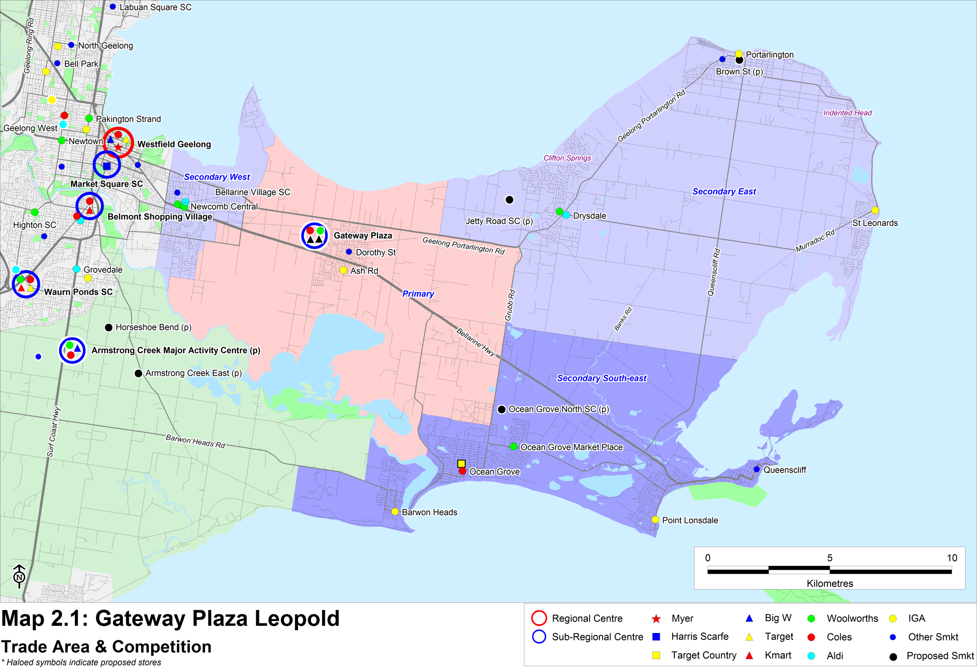

2.2 Trade area population
Table 2.1 attached details the recent and projected population levels within the Gateway Plaza main trade area. Population trends and forecasts for the trade area population have been based on the following:

- The 2001 and 2006 Censuses of Population and Housing.
- Population projections prepared by the Department of Health and Ageing, last revised in 2009.
- Forecast.id population projections prepared for the City of Geelong.
- Recent dwelling approvals data released by the Australian Bureau of Statistics (ABS).
- Development approvals for residential housing estates within the surrounding region, as well as discussions with various developers.
The trade area population is estimated at nearly 68,000 people at 2011, including 11,800 residents within the primary sector. The main trade area population is projected to increase to over 80,000 people by 2021, reflecting an average increase of 1.7% per annum over the forecast period.

The majority of the population growth in the main trade area is expected to be accommodated within Leopold and the Bellarine Peninsula (refer Map 2.2). The major residential estates in the surrounding area including the following:

- The largest residential estate in Leopold is Estuary by Villawood Properties, which has capacity for 650 dwellings. The estate is situated immediately south of the urban area of Leopold, on the eastern side of Melaluka Road. Discussions with the developer indicate that some 15 lots are being sold each month and the estate is expected to be fully developed by mid 2016.
- Other estates in the primary sector include Kensington Estate, which is located at the northern fringe of Leopold; the Moss Road estate, which is situated on the south-eastern intersection of Moss Road and the Geelong-Portarlington Road; and the proposed Bellarine Lakes Retirement Village in Moolap.
- The Jetty Road growth area is located immediately west of the existing Drysdale urban area and is planned to accommodate some 3,300 dwellings at capacity. A number of residential estates are currently underway in the eastern part of this growth area, including Bayview on the Bellarine, Baywater Estate, Curlewis Parks and Bellaview.
- A large parcel of land situated to the north of the existing urban area of Ocean Grove has been identified for future residential growth, and has a capacity for some 10,000 dwellings. The majority of this land is located between Grubb and Banks Roads, with the major estates currently underway including Kingston Downs North and Oakdene.
- The Point estate by Stockland is a major residential development at Point Lonsdale, with capacity for 600 dwellings, as well as 290 retirement residences. The estate is situated at the north-western fringe of the existing urban area of Point Lonsdale.

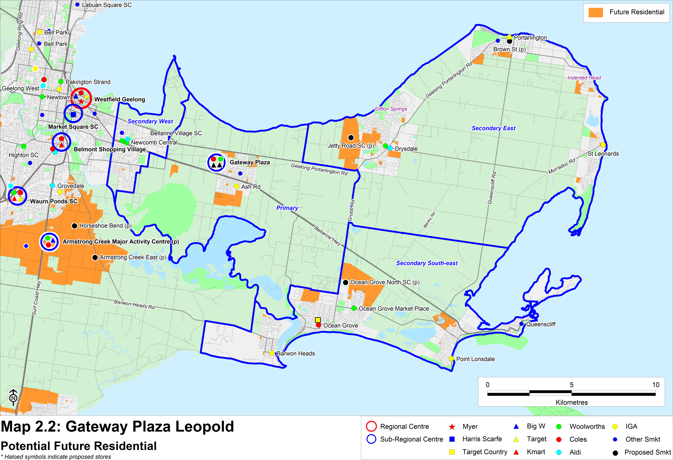

2.3 Socio-demographic profile
Table 2.2 and Chart 2.1 following detail the socio-demographic profile of the trade area population based on the results of the 2006 Census of Population and Housing. The key features of the trade area population at this time were as follows:

- The main trade area population has an older age profile compared with Geelong, with a higher than average proportion of residents aged 60 years and over. This is particularly evident in the secondary east sector.
- The average income levels of main trade area residents are slightly below the respective Geelong averages, though residents of the primary and secondary south-east sectors earn income levels which are above average.
- The overall home ownership level in the main trade area is above the Geelong average, and is particularly high in the primary and secondary east sectors.
- The trade area population has a below average representation of overseas born residents.
- The main trade area consists of a higher than average proportion of households comprised of couples without children, especially in the secondary east sector. More than half of the households of the primary sector consist of couples with dependent children, which shows the popularity of this area with young families.

2.4 Trade area retail spending
The estimated retail expenditure capacity of the Gateway Plaza main trade area population is sourced from MarketInfo, which is developed by Market Data Systems (MDS) and utilises a detailed micro simulation model of household expenditure behaviour for all residents of Australia. The model takes into account information from a wide variety of sources including the regular ABS Household Expenditure Surveys, national accounts data, Census data and other information. The MarketInfo estimates for spending behaviour prepared independently by MDS are commonly used by all parties in Economic Impact Assessments.

Chart 2.2 attached presents a comparison of the retail spending behaviour of main trade area residents with Geelong averages. The estimated level of total retail spending per person across the main trade area in 2011 is $12,063, some 1.2% above the Geelong average. Spending is slightly above average for both food (+0.7%) and non-food (+2.0%). All retail spending estimates detailed in this report include GST.

Table 2.3 following summarises the total retail spending capacity of the main trade area population by sector, for the period from 2011 to 2021. Spending forecasts presented in this analysis are expressed in constant 2010/11 dollars (i.e. excluding inflation).

Total retail spending generated by the main trade area population is currently estimated at $813 million and is projected to increase to over $1 billion by 2020, reflecting an average increase of 2.6% per annum in real terms. Over the forecast period, the retail spending capacity of the primary sector population is expected to increase solidly by 3% per annum in real terms, or by around $50 million in total to reach nearly $200 million by 2021.

Table 2.4 presents total retail spending by the main trade area population across key retail commodity groups. Take-home food and packaged liquor (FLG) spending by trade area residents (which is the key segment of the retail market for supermarkets) is estimated to increase by $118 million over the decade to reach nearly $500 million by 2021.

The combined spending capacity of the trade area population for the apparel, household goods, leisure and general retail categories (which is the key segment of the retail market for discount department stores) is estimated at $354 million in 2011. Over the forecast period to 2021, this spending market is expected to grow to $448 million, which is an increase of $94 million over the decade.

Section 3: Competitive context & retail demand

This section of the report reviews the competitive structure within the surrounding region. A supply and demand analysis of retail floorspace in the main trade area is also provided.

3.1 Competitive context
Table 3.1 below summarises the competitive context of the surrounding region, while the previous Map 2.1 shows the locations of the main competitive retail facilities. The provision of retail floorspace in each town is estimated based on a detailed inspection of the region by this office in April 2012.

Within the trade area
Retailer facilities in Leopold are currently limited to the existing Gateway Plaza shopping centre, as well as two small strip centres. The strip centres are located on Dorothy Street to the north of the Bellarine Highway and on Ash Road to the south of the highway. Both include small foodstores (each of 600 sq.m or less), and a limited number of convenience oriented specialty shops and services.

There are two supermarket based centres located in Newcomb in the secondary west sector, including:

- Newcomb Central, which is anchored by Woolworths and Aldi supermarkets and includes a total of 8,100 sq.m of retail floorspace.
- Bellarine Village Shopping Centre, which is located a short distance west of Newcomb Central and is also anchored by a Woolworths supermarket. The centre includes a Dan Murphy’s liquor outlet and 12 supporting specialty shops.

Most of the towns on the Bellarine Peninsula include either a supermarket or a smaller foodstore, together with a provision of mainly convenience oriented specialty shops and services. The following summarises the various provisions:

- Drysdale includes Drysdale Village, a Woolworths supermarket anchored shopping centre; a recently opened Aldi supermarket; and strip retailing along High Street and Clifton Springs Road.
- Ocean Grove is the largest town on the Bellarine Peninsula and also has the largest provision of retail floorspace, estimated at 17,000 sq.m. The Ocean Grove town centre includes a Coles supermarket as well as a range of retail facilities on The Terrace, while a small shopping centre is located immediately to the north and includes a Target Country store. Ocean Grove Marketplace is anchored by a Woolworths supermarket and is located in the north-eastern part of the town on Shell Road.
- Barwon Heads contains a small provision of strip retailing on Bridge Road and Hitchcock Avenue, including an IGA foodstore.
- Point Lonsdale includes a small IGA plus Liquor foodstore and a small provision of specialty shops and cafes, while the Queenscliff town centre is focused on Hesse Street and contains a small Foodworks foodstore together with supporting specialty stores and a number of cafes.
- Portarlington includes a small IGA foodstore and strip retailing along Newcombe Street, and St. Leonards offers a small provision of retail shops on Murradoc Road together with a new IGA supermarket.
One of the key points to note regarding the competitive context of the region, is that there is currently no discount department store located in the trade area, other than the small Target Country store at Ocean Grove. This is despite the fact that the trade area population is currently estimated at around 68,000 people. In non-metropolitan areas of Australia, there is typically one discount department store for every 30,000 to 35,000 residents. The absence of any major non-food store from the trade area indicates current strong pent-up demand for such traders. In addition, the demand for discount department stores will increase further in the future as the population of the region increases.
Beyond the trade area
Geelong CBD
Westfield Geelong is the largest and most significant retail element of the Geelong CBD, and is located on Malop Street. The centre contains 52,000 sq.m of retail floorspace and is anchored by a Myer department store, Target and Big W discount department stores, as well as a Coles supermarket. Market Square Shopping Centre is located opposite Westfield Geelong and includes 18,800 sq.m of retail floorspace, anchored by a small Harris Scarfe store. Other street based retailing is also provided along Ryrie Street, Moorabool Street and Malop Street.

Belmont
Belmont Shopping Village is a small sub-regional centre located on the southern side of the Barwon River and is anchored by a Kmart discount department store and a Coles supermarket. This centre is of minimal competitive relevance for Bellarine Peninsula residents, but offers the nearest Kmart store.

Proposed future competition
A number of supermarkets are proposed to be developed within the trade area to serve the population growth of the Bellarine Peninsula, described as follows:

- The Jetty Road growth area in Curlewis (west of Drysdale) is planned to incorporate a supermarket based shopping centre of up to 6,000 sq.m of floorspace. This is expected to be developed over the medium term once a sustainable population base in the area has been reached.
- A new shopping centre is to be developed over the medium term in the northern growth area of Ocean Grove, and is planned to include up to 7,000 sq.m of retail floorspace. The centre is expected to be anchored by a supermarket and also include a range of supporting specialty stores. The site for the centre is situated on the eastern side of Grubb Road, within the Kingston Downs Estate.
- A supermarket of 1,600 sq.m is proposed to be developed on Brown Street in Portarlington, and has recently received planning approval. The supermarket is expected to open by mid 2014.
Beyond the trade area, the proposed retail facilities are generally of minimal competitive relevance to Gateway Plaza, however the largest proposals including following:

- The major future growth corridor of Geelong is Armstrong Creek and a range of retail facilities are proposed to service this planned population growth. The largest centre will be the Armstrong Creek Major Activity Centre (MAC) which is proposed to be a sub-regional centre anchored by a Big W discount department store, as well as Coles and Woolworths supermarket.
- Waurn Ponds Shopping Centre is also proposed to be expanded, with plans to add 12,000 sq.m of retail floorspace including a Kmart discount department store. This proposed expansion would increase the retail floorspace of the centre to around 35,000 sq.m.

3.2 Retail floorspace supply and demand
This sub-section provides a supply and demand analysis of retail floorspace for the trade area. The amount of retail floorspace that is/will be required, in all centre types and all forms of retail outlets, to properly serve the Gateway Plaza trade area population can be estimated at various dates, based on the expected population and retail expenditure growth.

The estimated provision of retail floorspace throughout Australia is currently 2.1 sq.m per person. Historically, this provision has increased steadily, typically by 1.5%–2% per annum on average. Chart 3.1 below shows the trend in retail floorspace per capita for Australia over the period from 1986 - 2011.

The steady increase in retail floorspace per capita has reflected both supply and demand considerations. On the supply side, development trends within the retail industry has seen the introduction of new store types on an ongoing basis, to improve consumers amenity and shopping experience, but also to differentiate stores from the competition. On the demand side, real incomes of Australian residents have improved steadily over the years due to the generally increasing economic well being of the population, which have translated into their growing demands for an ever more diverse range of retail experiences.

Table 3.2 details the indicative demand and supply of retail floorspace that is considered appropriate to meet the growing needs of the population of the Gateway Plaza main trade area.

The analysis in Table 3.2 is described as follows:

- First, as the retail spend per capita by the trade area population is slightly lower than the Australian average, a benchmark level of retail floorspace per capita of 2.0 sq.m per person is applied (as compared with the current Australian average estimated at 2.1 sq.m per person). Although this average provision may well increase over time, as has been the case in the past, we have assumed this benchmark level remains constant to 2021, in order to avoid potentially over-estimating future demand.
- Adopting this approach, the current retail floorspace demand by trade area residents is calculated at around 136,000 sq.m. This figure is expected to increase considerably over the forecast period to over 160,000 sq.m by 2021, reflecting the strong population growth in the trade area.
- The tourism market also contributes to the overall retail floorspace demand, particularly the popular Bellarine Peninsula. The Economic Indicators Bulletin 2010/11, produced by the City of Greater Geelong, details that the peak overnight population included some 67,000 visitors over the summer period in 2011. The ‘year round’ equivalent resident population is calculated at 6,700 people, or demand for 13,400 sq.m of additional retail floorspace, which is nearly 10% of the floorspace demand by residents of the trade area. This is considered a conservative view, as the Bellarine Peninsula also has substantial visitation during other holiday periods such as Easter and on weekends.
- Obviously residents of the trade area direct a proportion of their retail expenditure to facilities located beyond the trade area, particularly to the Geelong CBD. The analysis allows for 20% of the total retail floorspace demand to be provided by retail facilities located in the Geelong CBD. Overall, the resultant retail floorspace demand in the Gateway Plaza main trade area is calculated at 119,520 sq.m in 2011.
- The existing retail floorspace provision within the Gateway Plaza main trade area is currently estimated at 75,000 sq.m (as detailed in the previous sub-section 3.1 of this report). Therefore, the analysis indicates that the current shortfall of retail floorspace provision within the trade area is around 44,500 sq.m. Allowing for the anticipated retail developments over the next 5 years (including the proposed expansion of Gateway Plaza), a retail floorspace shortfall of 13,878 sq.m is still anticipated within the trade area in 2016.
In summary, even allowing for the fact that trade area residents shop at retail facilities located outside the trade area for higher-order shopping needs, there would still be a shortfall of retail floorspace within the trade area following an expansion of Gateway Plaza. This indicates that the spending market generated by Gateway Plaza trade area population, together with the additional retail expenditure generated by tourism market, can support the retail developments proposed including the expansion to Gateway Plaza.

Section 4: Sales potential

This section of the report considers the sales potential for Gateway Plaza following its expansion to a sub-regional shopping centre (total for Stages 1 & 2).

The sales performance of any particular retail facility, be it an individual store or a collection of stores provided in a shopping centre, is determined by a combination of the following factors:

- The quality of the facility, with particular regard to the major trader/traders which anchor the centre; the strength of the tenancy mix relative to the needs of the catchment which it seeks to serve; the physical layout and ease of use; the level of accessibility and ease of parking; and the atmosphere/ambience of the centre.
- The size of the available catchment which the centre serves, which determines the upper limit to the likely sales potential achievable by any centre or store.
- The locations and strengths of competitive retail facilities and the degree to which these alternative facilities are able to effectively serve the needs of the population within the relevant trade area.
The estimation of sales potential for an expanded Gateway Plaza takes into consideration all of these factors.

The first step in quantifying the likely level of sales that an expanded Gateway Plaza can reasonably expect to achieve is to assess the sales potential for the proposed major tenants, including the discount department stores and supermarkets.

4.1 Discount department store sales potential
The estimates of sales potential for the proposed discount department stores in the total expanded Gateway Plaza (Stages 1 & 2) in 2015/16, in constant 2010/11 dollars and including GST, are as follows:
- Discount department store 1 (5,000 sq.m): $15 million; and
- Discount department store 2 (8,200 sq.m): $22.5 million.
The estimation of sales potential for the discount department stores firstly considers the appropriate expenditure market, which in this case is the combination of the apparel, household goods, leisure and general retail categories. The typical proportion of this expenditure directed to discount department stores is then assessed. Finally, the market shares of the spending market directed to discount department stores are estimated for each sector of the main trade area, while a proportion of business captured from beyond the trade area is also allowed for.

The sales estimates for the discount department stores are based on the following key points:

- There are currently no discount department stores located in the Gateway Plaza trade area, other than the small Target Country store at Ocean Grove. This is despite the population of the trade area estimated at nearly 68,000 in 2011, and projected to reach nearly 74,000 people by 2016. Typically in regional locations in Australia, there is one discount department store for every 30,000 – 35,000 residents. As an example, the City of Latrobe contains a population of around 77,000 people and includes four discount department stores (Kmart Moe, Big W and Target at Mid Valley Shopping Centre in Morwell and Kmart Traralgon). Therefore, there is clearly demand for two discount department stores within the Gateway Plaza trade area in the short to medium term.

There is also a below average provision of discount department store floorspace in the broader Geelong region. The five existing discount department stores provide only 150 sq.m of floorspace per 1,000 residents, compared with around 200 sq.m of such floorspace provided per 1,000 residents nationally in regional locations.
- Discount department stores generate the majority of their sales from the non-food retail expenditure categories of apparel, household goods, leisure and general retail. The retail expenditure capacity generated by the main trade area population in these categories is projected to increase by $94 million, in real terms, over the decade to 2021.
- The subject site is located on a high profile site on the Bellarine Highway, which is the main east-west traffic route in the region with high volumes of passing traffic. Gateway Plaza is also easily accessible for local residents of Leopold, and particularly for future residents of the Estuary residential estate being developed in the south of Leopold.
- Gateway Plaza is also ideally located to serve the Bellarine Peninsula, including both residents and the many visitors/holidaymakers attracted to the peninsula on weekends and over the holiday periods. The expanded Gateway Plaza would be the closest and most convenient sub-regional centre to the Bellarine Peninsula.

4.2 Supermarket sales potential
Gateway Plaza is proposed to be anchored by an expanded Coles supermarket of 4,200 sq.m, together with a second full scale supermarket of 4,200 sq.m. The estimates of sales potential for the proposed supermarkets at an expanded Gateway Plaza in 2015/16 (in constant 2010/11 dollars and including GST) are as follows:
- Coles: $32.5 million; and
- Second supermarket: $30 million.
The estimation of sales potential for the supermarkets firstly considers the appropriate expenditure market, which in this case is the take-home food and packaged liquor (FLG) market. The typical proportion of this expenditure directed to supermarkets is then assessed. Finally, the market shares of this retail expenditure market are estimated for each sector of the main trade area, while a proportion of business captured from beyond the trade area is also allowed for.
The sales for the supermarkets are based on the following key points:

- Supermarkets generate almost all of their sales from the take-home food, grocery and packaged liquor (FLG) expenditure market, which is detailed in Section 2 of this report. The available FLG spending generated by the main trade area population is estimated at $381 million at 2010/11, and is expected to increase to nearly $500 million by 2021.
- The available retail spending market of the primary sector population is projected to increase solidly by 3.0% per annum from 2011 to 2021 (in real terms). The primary sector population will provide the majority of the sales for the proposed Gateway Plaza supermarkets. Furthermore, the proposed residential developments in Leopold, and in the immediate surrounding area, will provide the supermarkets at Gateway Plaza with strong growth opportunities.
- In general, Australians direct around 70% – 80% of food and grocery spending to supermarket and major foodstores (i.e. grocery stores greater than 500 sq.m). This ratio does vary from location to location and is dependent upon the provision of supermarkets and foodstores within the particular area or region. The likely share directed to supermarkets is expected to be at the higher end of this range for the Gateway Plaza trade area population as there is a lower provision of fresh food options, such as major food markets, in the region.
- There is currently only one major supermarket in the primary sector, i.e. the existing Coles store at Gateway Plaza, while the population of the primary sector is estimated at 11,800 people. Typically, around 7,000 to 8,000 people are required to support a major supermarket, depending on specific circumstances. Two major supermarkets will be comfortably supportable at the Gateway Plaza site over the next few years, given that the population of the primary sector is forecast at more than 13,000 residents by 2016, and in addition the supermarkets would also serve the secondary sectors and visitors to the Bellarine Peninsula region, as previously outlined.
- The supermarkets would also benefit from status of Gateway Plaza as a future sub-regional centre, and the drawing power of the proposed discount department stores, particularly as it would be the only sub-regional centre located in the trade area.
- The competitive context of region is also taken in account in assessing the sales potential of the supermarkets at Gateway Plaza, and particularly the new supermarkets proposed for Curlewis and Ocean Grove.

4.3 Total centre sales potential
Table 4.1 outlines the estimated total centre sales potential for the expanded Gateway Plaza, taking into account the estimated sales potential for the major tenants which are to anchor the future sub-regional centre. The three mini-majors are expected to generate sales of $12.3 million in 2016, while the 8,684 sq.m of retail specialty space is projected to achieve sales of $52.7 million. Total centre sales potential is therefore estimated at $165 million in 2016 (in constant 2010/11 dollars).

The sales estimates for the expanded Gateway Plaza take into consideration the following key points:

- The estimated sales potential of the anchor tenants is a key factor in determining the overall sales potential of the proposed centre. The combination of major tenants is one of the main reasons for the majority of visitations to a shopping centre, and determines the ultimate sales potential of any centre.
- There is currently one mini-major at Gateway Plaza (Priceline Pharmacy). It is assumed that the expansion of the centre will include two additional mini-majors with combined floorspace of 900 sq.m. For the purposes of this analysis, it is assumed that the mini-majors will include a surf-wear retailer and a discount electronics outlet. In total, the three mini majors are expected to achieve sales of $12.3 million at a trading level of around $9,300 per sq.m on average.
- The estimated average trading level for the specialty shops reflects the likely tenant mix of the proposed expanded Gateway Plaza. This analysis assumes a typical sub-regional shopping centre mix of specialty shops, including the following:
- Food & liquor – fresh food shops including a green grocer, a bakery, a butcher, a chicken shop and a deli.
- Food catering – a food court including a mix of take-away food options, as well as a number of cafes and restaurants.
- Apparel – a range of apparel outlets with a focus on womens apparel.
- Household – a mix of household retailers and giftware shops.
- Leisure – a newsagent, a small books store, a music store and a computer gaming outlet.
- General – a discount variety store, florists, a toys shop and a number of mobile phone outlets.
- Retail services – including optometrists, beauty salons and hairdressers.
The trading levels achieved by specialty shops at an expanded Gateway Plaza are expected to range from up to $10,000 per sq.m for takeaway food outlets, to around $5,000 per sq.m for some apparel and homeware retailers. The average trading level across all specialty retailers at Gateway Plaza following its expansion is projected at just over $6,000 per sq.m.

4.4 Centre market shares
Table 4.2 presents the estimated market shares of available retail expenditure considered achievable by the expanded Gateway Plaza in 2015/16. The estimated market shares of total food and non-food retail spending are calculated based on the following key points:

- The total projected sales potential of each component of the expanded centre (majors, mini-majors and specialty stores) is split into food and non-food sales, taking account of the typical sales distribution for each retailer type.
- The total sales that are expected to be generated by the centre from each trade area sector are then estimated, taking into account the likely shopping patterns of trade area residents.
- The total available retail expenditure within each trade area sector is calculated, based on the MarketInfo estimates (refer Section 2).
- The estimated market shares expected to be achieved by the expanded centre, of both food and non-food expenditure in each trade area sector, are then calculated by dividing the estimated centre sales from each sector by the projected retail expenditure available in each sector.
The expanded centre is forecast to achieve an estimated market share of total retail spending of 43.7% from the primary sector population and an average of 9.8% across the three secondary sectors, resulting in a combined main trade area market share of 16.0%. In addition, an expanded Gateway Plaza is estimated to capture $17.9 million of retail spending from people residing beyond the main trade area, primarily from tourists visiting the Bellarine Peninsula.

This page has been intentionally left blank.

Section 5: Economic impact considerations

This section outlines the potential economic benefits and impacts that can be anticipated following the expansion of Gateway Plaza.

5.1 Economic and social benefits
The expansion of Gateway Plaza to sub-regional status is likely to result in a range of economic impacts. From a trading point of view, some impacts are likely to be experienced by some competitive facilities throughout and beyond the main trade area, and the likely extent of these trading impacts is considered further later in the report. On the other side of the equation, an expansion of the centre will result in a significant range of economic benefits, particularly for residents of the main trade area. The key positive impacts will include the following:

- Establishing Leopold as a key retail destination
The development of a sub-regional shopping centre at Leopold will significantly benefit the town, as well as the region overall. There is currently only a limited provision of retail facilities in Leopold, which is a major town that acts as the gateway to the Bellarine Peninsula. Currently residents of the Bellarine Peninsula must travel to Geelong, which is up to 30 km away by road, to access higher-order retail facilities.
- Addressing the current lack of discount department stores in the area
Typically a full-scale discount department store is provided in Australia for every 30,000 – 35,000 people in non-metropolitan locations. However, the Gateway Plaza trade area currently has no such discount department stores for a population estimated at 68,000 in 2011. Furthermore, this population is growing and is forecast to reach nearly 74,000 residents by 2016.
The addition of two future discount department stores to the trade area at an expanded Gateway Plaza will address this current underprovision. It will also introduce two discount department store operators to the trade area, which will provide residents with shopping choice and a far greater range of non-food products.
- Addressing the underprovision of supermarkets in the primary sector
In general, one full-scale supermarket can be supported in non-metropolitan Australia for every 7,000 to 8,000 residents. The primary sector currently includes only one supermarket (i.e. Coles at Gateway Plaza) and has a projected population base of over 13,000 residents by 2016. In addition, the supermarkets at Gateway Plaza would attract business from secondary sectors, as well as serving visitors to the region.
- Catering to the increased population in the trade area
The trade area population is expected to increase by more than 12,000 residents over the next decade, reaching a population base of more than 80,000 residents by 2021. This population growth will further add to the demand for additional retail floorspace on the Bellarine Peninsula.
- Greater shopping choice, convenience and amenity
The expansion of Gateway Plaza will offer a greater provision and a wider range of shopping alternatives for local residents, as well as for visitors to the region. The proposed addition of two discount department stores and a second supermarket will obviously add significantly to the centre’s offer, but furthermore, the additional majors will also facilitate a much greater range of specialty stores at the centre. This will significantly improve the range of retail facilities in the area, provided in a very convenient location.
In addition, the expanded centre will provide a greatly increased level of amenity for Bellarine Peninsula residents and visitors.
- Additional employment
The proposed expansion of Gateway Plaza will create a substantial number of additional jobs in the region, both for the construction and related industries during the construction phase, and for the economy generally once the centre is completed. This additional employment, which will obviously improve the self-containment of employment opportunities for peninsula residents, is discussed further later in this report.

5.2 Employment stimulus
Table 5.1 presents an estimate of the likely additional employment that would be generated by the retail component of the proposed expanded Gateway Plaza. Based on the amount and nature of floorspace to be incorporated in the proposed development, we estimate that 999 ongoing jobs will be created by the expansion of Gateway Plaza.

It may be argued that some job losses will occur at other centres as a result of the expansion of Gateway Plaza. In estimating the net employment opportunities, we have allowed for 5% of the additional employment that is likely to be created at Gateway Plaza to be absorbed in job losses at other centres, resulting in a projected net employment increase of 949 jobs.

The expansion of Gateway Plaza will also create a substantial number of additional jobs, both for the construction and related industries during the construction phase, and for the economy generally once the centre is completed.

Table 5.2 provides an estimation of both direct and indirect employment that would arise from the expansion of Gateway Plaza. Based on the estimated construction costs of the project of around $70 million, we consider that during the construction period of the project some 300 direct jobs will be created, with a further 480 jobs resulting from supplier induced multiplier effects during this period (based on the appropriate ABS input/output multipliers).

In addition, the estimated 949 new retail jobs in Gateway Plaza will result in a further 380 jobs created indirectly in the broader community, again based on ABS input/output multipliers. Jobs created include both full-time and part-time positions.

5.3 Consideration of trading impacts
A number of factors need to be taken into account in determining the likely broad trading impacts and subsequent consequences arising from the proposed expansion of Gateway Plaza, on other retail facilities both within and beyond the trade area. The following analysis presents an indicative projection of the anticipated impacts on other shopping centres in the region. Such projections can be considered indicative only for the simple reason that it is very difficult to predict with certainty the precise impact on any one retailer or any other centre that will result from the change of retail structure serving a particular region.

The impacted centre or retailer has a number of possible actions which it may be able to take that may mitigate the extent of the impact or may eliminate it all together. Expansions and improvements may be undertaken at other centres throughout the region, and all of those factors can change the nature of the impact of the new centre being developed.

It is much more reasonable for the purposes of impact analysis, therefore, to consider the likely broad changes in competitive circumstances, and in particular the changes in availability of retail spending for competitive centres, that can reasonably be expected to result from an expansion of Gateway Plaza to a sub-regional centre.

These broad changes effectively set the market conditions within which the competitive centres will operate as a result of this development, and reasonable conclusions can then be drawn about the possible impacts of these broad changes in market conditions.

Retailers within the main trade area
Table 5.3 details the broad trading impacts on trade area retailers that can be anticipated following the total proposed expansion of Gateway Plaza (Stages 1 & 2). In particular, the table outlines the growth in retail expenditure generated by the main trade area population, the estimated sales for Gateway Plaza, as well as estimated sales for other retailers located in the main trade area, with and without the proposed expansion. All figures are expressed in constant 2010/11 dollars and include GST.

Part 1 of the table summarises the forecast growth in the available retail spending market of the main trade area population, showing an increase from $813 million in 2010/11 to $919 million at 2015/16. In 2010/11, trade area retailers are estimated to have achieved sales of $579 million, with the remaining retail expenditure of trade area residents being directed to retail facilities located beyond the trade area. The net escape expenditure (actual escape expenditure less captured expenditure from visitors) is estimated at $233 million in 2010/11.

Part 2 presents the estimated sales of trade area retailers at 2010/11 and at 2015/16 assuming Gateway Plaza is expanded. In 2010/11, Gateway Plaza is estimated to be achieving sales of $46 million, while other Leopold retailers (i.e. on Dorothy Street and Ash Road) generate an estimated $13.7 million of retail sales. Other retailers in the remainder of the trade area are estimated to be achieving sales of $520 million (based on the provision of floorspace and estimated trading levels for the major traders and specialty shops).

In 2015/16, projected sales for an expanded Gateway Plaza are $165 million, while sales for other Leopold retailers and the remaining retailers in trade area are estimated at $14.4 million and $545.8 million respectively.

Part 3 of the table calculates the likely sales potential for retailers within the main trade area assuming Gateway Plaza is not expanded. Under this scenario, total sales for trade area retailers are estimated at $658 million in 2015/16.

Part 4 finally details the estimated average trading impact on retailers in the main trade area arising from the proposed expansion of Gateway Plaza. It is estimated that existing retail facilities in Leopold would be impacted by around $1.4 million or 8.7% in 2015/16, while other trade area retailers are estimated to be impacted by $44.2 million or 7.5%.

The following observations and conclusions can be drawn from the above analysis:

- The total available retail market is forecast to increase in real terms by $106 million over the 4 year period, which is an increase of 13.0% over the estimated retail market available in 2010/11.
- Net escape retail spending is expected to be reduced by $39.5 million following the expansion of Gateway Plaza. Net escape spending would still be substantial reflecting the general under provision of retail floorspace within the trade area, with local residents still expected to direct a significant proportion of retail expenditure to other facilities in the broader Geelong region, and particularly to the CBD.
- The other existing retail facilities in Leopold serve localised catchments, while Gateway Plaza will draw its business from throughout a much broader region. In our view, while these retailers may experience an initial trading impact of 8.7%, they will continue to effectively serve their respective local catchments.
- Other trade area retailers mostly consist most of supermarkets and strip centres in the towns of the Bellarine Peninsula and at Newcomb. These facilities will continue to serve their local communities and are estimated to be impacted by 7.5% should Gateway Plaza be expanded. Given the strong population forecast for the region, and particularly for the Bellarine Peninsula, sales potential for these retailers is still expected to grow on average by 5.0% over the next five years even if Gateway Plaza is expanded.
Retailers beyond the main trade area
The expansion of Gateway Plaza to a sub-regional centre may also have some impact on retailers located beyond the trade area, namely in Geelong. Table 5.4 details these broad trading impacts.

The following key points can be draw from the analysis in Table 5.4:

- Retailers in the Geelong CBD are estimated to be achieving sales of just over $572 million in 2010/11, with Belmont Shopping Village and Waurn Ponds Shopping Centre recording estimated sales of slightly over $101 million and $194 million respectively. These figures are estimated based on a range of sources including Big Guns 2012 by Shopping Centre News.
- Following the expansion of Gateway Plaza in 2015/16, the average trading impact on retailers in the Geelong CBD is assessed at 6.9% or around $44 million. The impacts on Belmont Shopping Village and Waurn Ponds Shopping Centre are considered to be lower, estimated at 5% and 1% respectively. This analysis assumes Waurn Ponds Shopping Centre is expanded by this time.
- The assessed impacts are considered to be reasonable and would not have any major implications to any of the above centres. In particular, the Geelong CBD is still assessed to grow by 5.3% over the 5 year period to 2015/16, even allowing for expansion of Gateway Plaza.

Summary
The above analysis demonstrates that the levels of impacts on existing retailers in the region from the total proposed expansion of Gateway Plaza would not have any major implications on their future viability. The analysis assumes the total development (Stages 1 & 2) is completed by 2015/16.

The development is now proposed to be staged, with Stage 1 planned to include one discount department store, as well as additional supermarket, mini-major, retail specialty and non-retail floorspace. Stage 2 is likely to be developed at a later date (i.e. beyond 2015/16) and include a second discount department store as well as some additional retail and showroom floorspace.

The proposed delay of Stage 2 will result in the impacts being lower than the figures estimated above in Tables 5.3 and 5.4, and particularly the potential impacts on the Geelong CBD would be lower given Stage 1 is proposed to include only one discount department store. Therefore, the potential impacts of Stage 1 of the proposed expansion of Gateway Plaza will clearly be within the normal and acceptable outcomes of improved competition.

In summary, the expansion of Gateway Plaza will greatly benefit the local community by significantly increasing shopping choice, and in particular providing higher-order shopping facilities for residents of Leopold, Newcomb and the Bellarine Peninsula, as well as visitors to the region. It will provide business opportunities for local residents, while also encouraging employment opportunities within the region. The impact on other retailers in the region is considered within reasonable bounds of normal competition and is not considered to threaten the viability of existing retailers





