
Combined Planning Scheme Amendment Request and Planning Permit Application
Rezone land from the Farming Zone to the Commercial 1
Zone and develop a Sub-Regional Activity Centre
Bellarine Gateway Plaza, Leopold
613-639 and 641-659 Bellarine Highway, Leopold
Gateway Plaza Leopold Pty Ltd
October 2013
0136740R1
www.erm.com

FINAL REPORT

Combined Planning Scheme Amendment Request and Planning Permit Application

Bellarine Gateway Plaza, Leopold
613-639 and 641-659 Bellarine Highway, Leopold

Rezone land from the Farming Zone to the Commercial 1 Zone and develop a Sub-Regional Activity Centre

October 2013

Reference: 0136740R1

CONTENTS
1 Introduction 1
2 Site and Locality 3
2.1 Subject Site 3
2.2 Locality 5
2.3 Transport 6
3 The Proposal 8
3.1 The Amendment 8
3.2 Planning Permit Application 9
3.2.1 Built Form and Layout 10
3.2.2 Vehicle Access, Loading and Parking 11
3.2.3 Pedestrian access 12
3.2.4 Vegetation Removal and Landscaping 12
3.2.5 Stormwater and Drainage 12
4 Planning Controls 13
4.1 State Planning Policy Framework 13
4.2 Municipal Strategic Statement 15
4.2.1 Municipal Strategic Statement 15
4.3 Local Planning Policies 16
4.4 Zoning and Overlay Controls 16
4.4.1 Zoning 16
4.4.2 Overlay Controls 17
4.5 Particular Provisions 17
4.5.1 Clause 52.06 - Car Parking 17
4.5.2 Clause 52.07 - Loading Bays 17
4.5.3 Clause 52.34 - Bicycle Facilities 17
4.6 Other Relevant Planning Documents 18
4.6.1 City of Greater Geelong Retail Strategy, Essential
Economics 18
4.6.2 Leopold Structure Plan, City of Greater Geelong,
March 2006 and September 2011 19
4.6.3 Draft Strategic Directions Report - Leopold
Sub-Regional Activity Centre Master Plan,
Beca Pty Ltd, December 2010 19
4.6.4 Leopold Urban Design Framework, City of Greater
Geelong, June 2011 20
5 Strategic Assessment of Amendments
(Ministers Direction No.11) 22
5.1 Why is an Amendment required? 22
5.2 Does the amendment implement the objectives of
planning and any environmental, social and economic
effects? 23
5.2.1 Objectives of Planning in Victoria 23
5.2.2 Environmental Effects 24
5.2.3 Social and Economic Effects 24
5.3 Does the Amendment Comply with the Requirements of
any other Minister’s Direction Applicable to the
Amendment? 25
5.4 Does the Amendment support or implement the State
Planning Policy Framework (SPPF)? 26
5.5 Does the Amendment support or implement the Local
Planning Policy Framework (LPPF), and specifically
the Municipal Strategic Statement (MSS)? 26
5.5.1 Local Planning Policy Framework 26
5.5.2 Reference Documents 27
5.6 Does the Amendment make proper use of the Victoria
Planning Provisions? 28
5.7 How does the Amendment address the views of any
relevant Agency? 28
5.8 What impact will the new planning provisions have
on the administrative costs of the responsible
authority? 28
6 Planning Permit Application Matters 29
6.1 Site Layout and Built Form 29
6.2 Amenity Considerations 30
6.3 Pedestrian Amenity 31
6.4 Traffic, Car Parking and Loading 31
6.5 Landscaping 32
6.6 Stormwater and Drainage 32
7 Conclusion 34

Introduction
Environmental Resources Management Australia (ERM) has been engaged by Lascorp Development Group (Aust) Pty Ltd (Lascorp) to prepare a planning report to accompany a combined planning scheme amendment request and planning permit application for the expansion of the Bellarine Gateway Plaza to a sub-regional scale.
The planning scheme amendment seeks to rezone the land at 613-639, Leopold from the Farming Zone (FZ) to the Commercial 1 Zone (C1Z) of the Greater Geelong Planning Scheme (the Scheme). It also seeks to amend the existing shop floor space ‘cap’ that is included in the C1Z Schedule from 5000 square metres to 30,650 square metres for the subject land only (ie not including the ‘Perez’ land to the north – if the Perez land is to be included in the C1Z then the total floorspace cap for the two sites should be 35,000 square metres).
The rezoning will enable the expansion of the existing centre to ultimately comprise up to a total floor area of 30,650 square metres This will elevate the role of the centre to a sub-regional activity centre.
Pursuant to Section 96A of the Planning and Environment Act 1987, a planning permit application is also included for the building and works associated with Stage 1 of the shopping centre expansion. This stage includes (amongst other things) a 1,000 square metre addition to the existing supermarket, an additional full-line supermarket (4,200 square metres), a new discount department store (5,000 square metres), additional speciality shops (5,725 square metres), offices (2,380 square metres), food and drink premises (579 square metres), a gymnasium (562 square metres), a ‘town square’ and shared car parking area including a basement car park.
In addition, a planning permit is required for the use of land for a restricted recreation facility (the gymnasium) and the removal of native vegetation.
In preparing this report a review has been undertaken of the Scheme as well as the Geelong Retail Strategy, the Leopold Structure Plan and the Urban Design Framework which were approved under Amendment C254 to the Scheme. This report outlines the strategic justification and planning merits of the proposed amendment and planning permit application pursuant to the relevant planning controls.
Leopold is a township located approximately 12 kilometres south east of the Geelong CBD and approximately 15 kilometres north west of Ocean Grove. It is regarded as the gateway to the Bellarine Peninsula and has been designated an urban growth area with the City of Greater Geelong’s Municipal Strategic Statement.
The City of Greater Geelong’s Retail Strategy and the Municipal Strategic Statement (MSS) identify Leopold as a potential sub-regional centre noting its ability to serve the entire Bellarine Peninsula without undermining Central Geelong’s core primary catchment. Further, approved Amendment C254 to the Scheme amends the MSS to recognise Leopold as a sub-regional centre.
This report finds that the proposed amendment is consistent with the key policies and objectives of the Scheme and based on a balanced assessment of relevant policy will result in a net community benefit for the Leopold area.
The following documents are lodged in support of this combined
amendment/ application:

- Architectural plans by Clarke Hopkins Clarke dated October 2013;
- Economic Impact Assessment by MacroPlan Dimasi dated October 2013;
- Ecological Assessment by Paul Kelly and Associates dated August 2012;
- Stormwater and Drainage Reports by Cardno dated 3 October 2013;
- Traffic Engineering Assessment by Traffix Group dated October 2013;
- Retail Planning report by BMDA Development Advisory; and
- Landscape Plan by John Patrick Landscape Architects Pty Ltd.

Site and Locality

Subject Site
The subject site comprises two parcels of land known as 613-639 and 641-659 Bellarine Highway, Leopold and is bounded by the Bellarine Highway to the south, Melaluka Road to the east and Clifton Avenue to the west (refer to Figures 1 and 2).
The combined parcels of land are broadly rectangular in shape with overall frontages of 380 metres to Bellarine Highway, 252 metres to Melaluka Road and 204 metres to Clifton Avenue. The land is generally flat and has an overall site area of approximately 8.98 hectares. The subject site is formally described as Lots 1 and 2 on Plan of Subdivision PS506060.
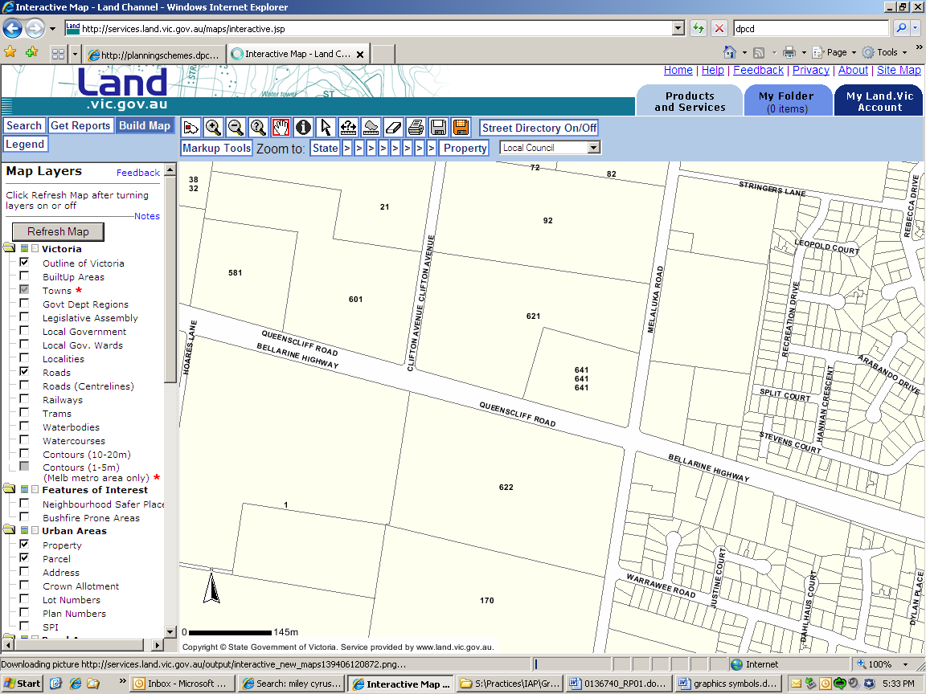
Figure 1: Cadastral Plan Source: Land Channel, 2011
Subject Site Scale: Unknown

N

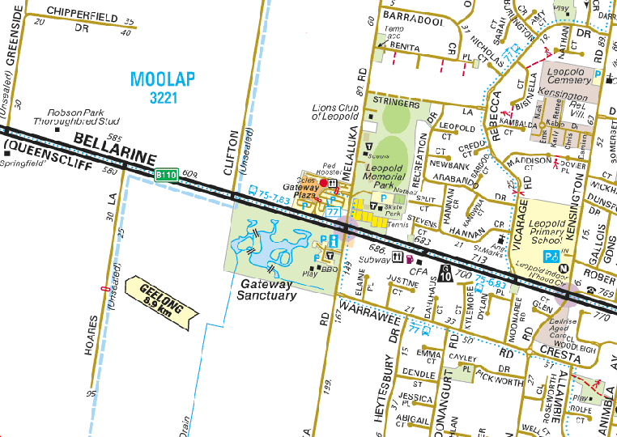
\

N
Figure 2: Locality Plan Source: Melways, 2011
Subject Site Scale: Unknown

The land at 613-639 Bellarine Highway is contained within the Farming Zone and has been largely cleared with the exception of a weatherboard dwelling and large shed located in the north east corner of the site, addressing Melaluka Road. A dam is located towards the Bellarine Highway frontage and the land is considered to have no ecological significance.
The land at 641-659 Bellarine Highway is contained with the Commerical 1 Zone and is currently occupied by the Gateway Plaza Shopping Centre, which was constructed by the permit applicant in 2007. The centre comprises a Coles Supermarket, various speciality stores and a medical centre. The buildings which comprise the existing shopping centre complex are modern in architectural form and are predominately single storey in height, with the exception of some double storey architectural elements.
The remainder of the site is occupied with car parking and landscaping, with and a McDonalds restaurant located within the south eastern corner of the site.
An aerial photograph of the subject site and surrounding area is provided at Figure 3 below.

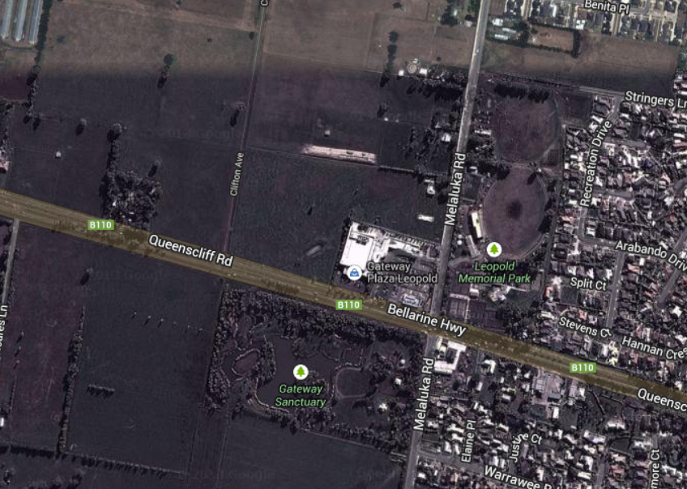

N

Figure 3: Aerial Photograph Source: Nearmap, 2011
Subject Site Scale: Unknown

Locality
The land surrounding the subject site is characterised by a mix of land uses, including residential development, rural residential land, recreational and sporting facilities, commercial and retail uses and protected reserves. Built form varies throughout the area with typically low rise residential development within existing urban areas and single storey buildings associated with the sporting facilities. The remainder of land surrounding the site is predominately rural residential in nature.
The site’s surrounds can be described as follows.
- Abutting the northern boundary of the site is 92-100 Melaluka Road, which is largely vacant rural land. A dwelling and outbuildings are located towards the Melaluka Road frontage and a long narrow dam adjoins the southern boundary. Further north of the site is rural living land, comprising large land holdings with single dwellings and are contained within the Farming Zone.
- The eastern side of Melaluka Road is occupied by the Leopold Memorial Park Recreation Reserve which comprises two sporting ovals, nine tennis courts, two netball courts, a skate park, various pavilions and buildings, and areas of car parking. Further east, is predominately residential development with dwellings typically single storey in height.
- Opposite the site, on the southern side of the Bellarine Highway, is the Gateway Sanctuary Reserve which comprises areas of native vegetation, a large lake/wetland area in the centre of the site along with a playground, BBQ facilities and public toilet facilities. This reserve acts as a wetland area that filters water flowing into Reedy Lake, further to the south west, and which forms part of a RAMSAR wetland site.
- Land to the south east of the subject site at 672-678 Bellarine Highway is occupied by ‘The Godfathers on Leopold’ Restaurant. Surrounding this property to the south and east is low density residential development.
Photographs of the site and the surrounding area are included overleaf.

Transport
The site is supported by a public transport route, comprising Bus Route No. 77 which operates along the Bellarine Highway past the subject site and connects the Leopold Township with the Geelong CBD. This service can be easily accessed from the subject site. There are a number of other bus services which also provide access between the site and Queenscliff, Wallington and Ocean Grove.

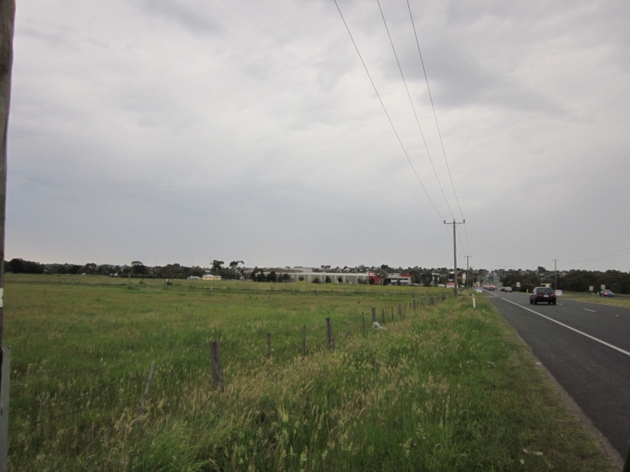
Photo 1 View of the subject site looking east along Bellarine Highway.

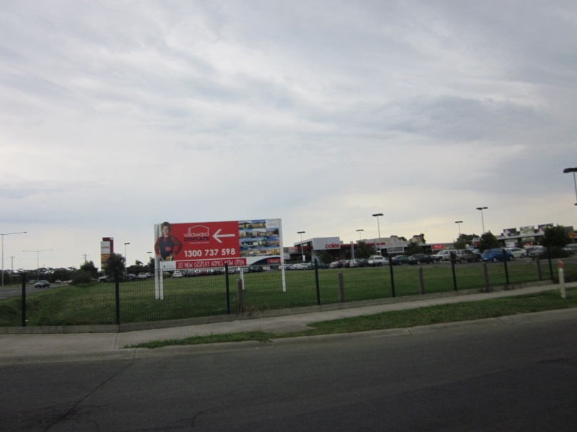
Photo 2 View of subject site looking west from Melaluka Road.

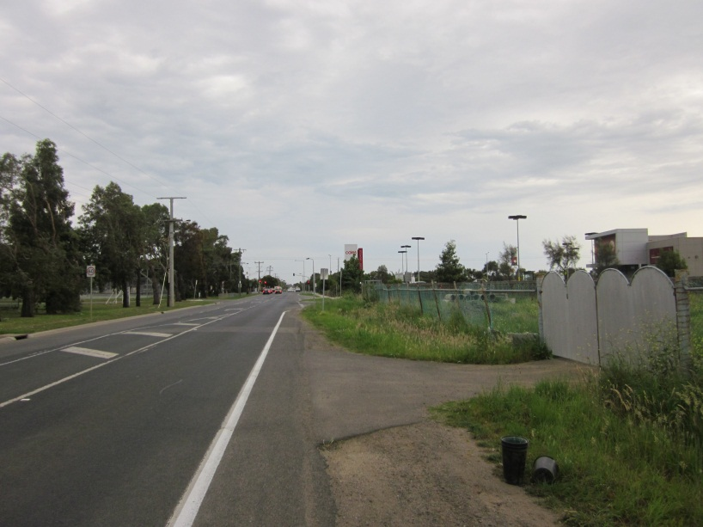
Photo 3 Looking south along Melaluka Road towards existing shopping centre.

The Proposal

The Amendment

It is proposed to rezone the land at 613-639 Bellarine Highway from the FZ to the C1Z, as illustrated below in Figures 4 and 5.
It is also proposed to amend the shop floor space ‘cap’ that is currently included in the C1Z Schedule for the existing activity centre from 5000 square metres to 30,650 square metres for the subject site only (which will need to be amended to 35,000 square metres if the Perez land is ultimately included in the C1Z and the two sites are combined within the Schedule).
Figure 4: Extract from existing Zoning Map Source: DPCD, 2011
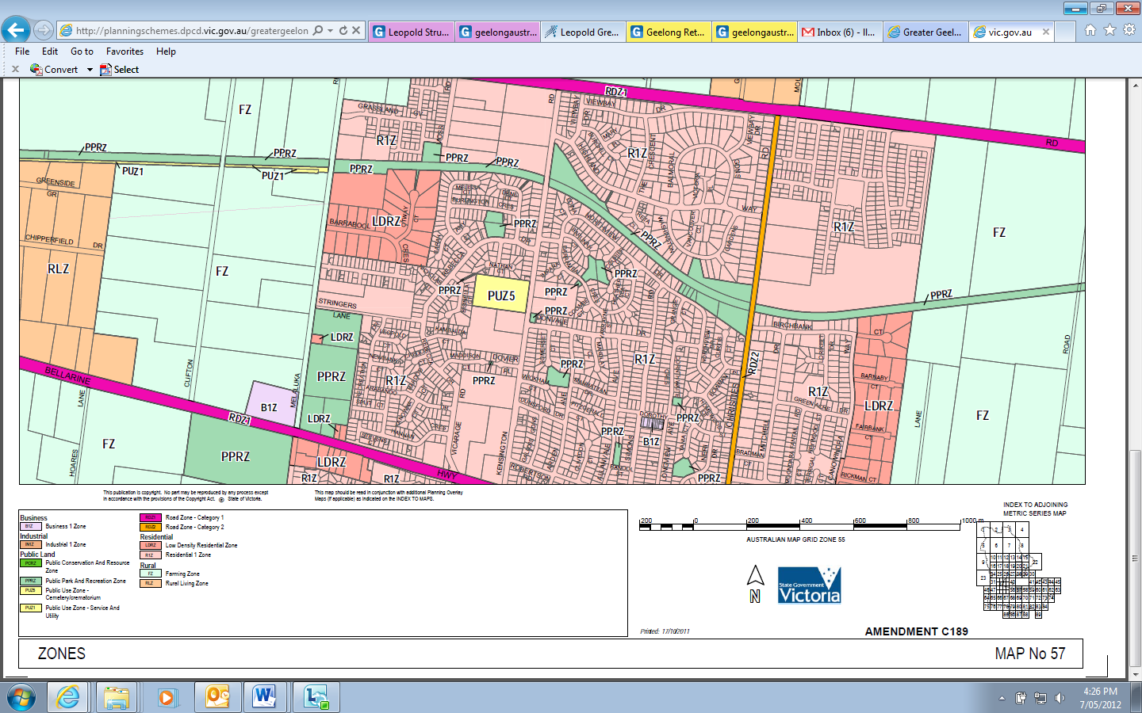
N

Subject Site Scale: Unknown
Figure 5: Proposed Zoning Map Source: DPCD, 2011
N

Subject Site Scale: Unknown
The purpose of the C1Z includes the following:
‘To create vibrant mixed use commercial centres for retail, office, business, entertainment and community uses.
To provide for residential uses at densities complementary to the role and scale of the commercial centre.’
Under the provisions of the Zone a planning permit is not required for a ‘shop’ use providing the combined leasable floor area for all shops does not exceed the amount specified in the Schedule to the Zone.
A planning permit is not required to use land for ‘office’ purposes (including medical centre) if the combined leasable floor area does not exceed the amount specified in the schedule to this zone. Given that there is no maximum floor area specified in the schedule, a planning permit is not required for the proposed office use.
A planning permit is however required under the provisions of the zone to use the land for the purposes of a restricted recreation facility (gymnasium).
In addition, planning approval is also required for the building and works associated with the whole of the activity centre when located within the C1Z.
It is noted that no changes are proposed to the MSS or Local Policies section of the Scheme as part of this Amendment.

Planning Permit Application
Pursuant to Section 96A of the Planning and Environment Act 1987, a planning permit is sought, in conjunction with the proposed rezoning, for the following. The permit application is for Stage 1 of the of the shopping centre expansion only. A separate permit application would be made in due course for any subsequent expansion of the centre.
Building and works associated with the expansion of the existing neighbourhood activity centre to a sub-regional size activity centre, for the use of land for office purposes (including an expansion to the existing medical centre), the use of land for a restricted recreation facility (gymnasium), as well as dispensation from the car parking provisions of Clause 56 of the Scheme and the removal of native vegetation.
The following sections provide an overview of what is proposed as part of the planning permit application.

Built Form and Layout
The proposal involves the following.
- Buildings and works associated with an additional 27,128 square metres of floor space, resulting in on overall floor area of 21,375 square metres of shop use at the site.
- The development of a town square area, directly abutting
Melaluka Road.
- The provision of a range of tenancies abutting the town square which are intended to fulfil a ‘local’ role, including takeaway food premises and restaurants.
- The development of a new discount department store.
- Expansion of the existing Coles Supermarket.
- The addition of a Woolworths Supermarket.
- The construction of a new east-west mall accommodating a range of speciality stores.
- The use and development of a gymnasium at first floor level adjacent to the western entry.
- The development of a three storey office building in the south west corner of the building with frontage to the Bellarine Highway.
The centre has been designed to fulfil a local, a town centre role at the eastern end of the centre where it abuts Melaluka Road and the sporting precinct, with the sub-regional role services located more centrally withinthe site.
The centre will be predominantly single storey with two and three storey built form (in-part) proposed along the eastern and western façade. In addition, the tenancy at the north east corner of the centre is expected to be a tavern with a first floor mezzanine area.
The eastern entry point has been designed to be a feature of the proposal comprising a large covered town square area and a feature entry based upon a ‘beehive’ theme with a restaurant incorporated as part of the entry feature.
The western entry point has also been the focus of careful design work utilising the same form of roofing as the town square and continuing the ‘beehive’ theme at the western end of the centre - whilst also incorporating seating and eating areas.
The two entries are linked via a meandering east-west internal mall area. The mall has been designed with a portal frame roof structure which is intended to provide a feeling of ‘openness’ to pedestrians, whilst maintaining the advantages associated with a temperature controlled enclosed area.
The building materials that are proposed have been selected to complement the form of the existing building whilst providing a more modern architectural response. Thus features of the building materials include timber styled cladding, expressed steel columns, metal screening battens, feature graphic glass and feature cladding.
Along with the eastern and western entry features, particular attention has been paid to the western and southern facades to ensure the centre will appear as an attractive and articulated form to passing traffic.
In particular, the three storey office building in the south west corner of the centre has been designed to ‘anchor’ that corner and to provide a string visual presence along the Bellarine Highway.

Vehicle Access, Loading and Parking
Vehicle access to the site for customers is proposed via three crossovers from Clifton Avenue (two access/egress points and one ‘left out’ only proposed), Melaluka Road (two new access/egress points proposed along with the retention of the existing access/egress point) and the existing left-in/left-out on the Bellarine Highway.
Access and egress for delivery vehicles is proposed as follows.
- A large loading dock is proposed between the supermarkets, accessed from the Bellarine Highway. The loading dock provides two loading bays for each supermarket, and provision to accommodate delivery vehicles associated with the proposed mini-major tenancies and specialty shops.
- A loading dock is proposed at the rear of the Discount Department Store to service this store, accessed via the new service road.
A total of 1412 at grade car parking spaces are proposed for the site. It is noted that particular attention has been paid to the car parking abutting the Melaluka Road frontage and the town square. It is acknowledged that for this area to be able to appropriately service the needs of local residents that there needs to be convenient car parking in proximity to the proposed takeaway food venue tenancies and restaurants.
Vehicle access, loading and car parking issues are all addressed in greater detail in the report that has been prepared by Traffix Group.

Pedestrian access
Careful consideration has been given to the need to provide appropriate pedestrian access to and from the site, particularly in relation to the adjoining recreation reserve area and the residential area of Leopold beyond.
The location of the town square and eastern entry to the centre has been located to align with the main pedestrian access point to the recreation reserve so that easy and safe access is available across Melaluka Road.
An east-west dedicated pedestrian link is also proposed from the western entry of the centre to Clifton Avenue.
Internal pedestrian connections have also been considered with covered walkways proposed around the perimeter of the centre. The potential need for pedestrian connections to the Perez land to the north has also been considered with a possible pedestrian link proposed to the north via the food court area.

Vegetation Removal and Landscaping
An ecological assessment has been carried out by Paul Kelly and Associates and has confirmed that the site does not contain any remnant patches of native vegetation but does contain dispersed plants of native grass and nine scattered indigenous trees. The assessment notes that the trees are ‘immature and do not make a significant contribution to achieving a sustainable biodiversity conservation outcome’. Accordingly, whilst a planning permit is required for the removal of native vegetation the assessment concludes that the proposed native vegetation removal represents a sustainable outcome providing the trees are appropriately offset.
In addition, an Arboricultural Assessment has been undertaken by Tree Response which identifies the health and expected longevity of the eight River Red Gums on the site. This report confirms that the River Red Gum located within the road reserve along the Melaluka Road frontage (shown as Tree number 1 on the Arboricultural Report) will be retained.
A landscape plan prepared by John Patrick Landscape Architects has also submitted as part of the application material.

Stormwater and Drainage
A Stormwater Management Plan has been prepared for the site by Cardno due to the sensitivities of the site in relation to drainage.
This is discussed in greater detail in Section 6.6 of this Report.

Planning Controls
This section of the report outlines the relevant policy context for the Amendment and includes a brief outline of the relevant components of the State Planning Policy Framework (SPPF), the Municipal Strategic Statement (MSS) and Local Planning Policy Framework (LPPF), and the appropriate zone and overlay controls.

State Planning Policy Framework
The State Planning Policy Framework (SPPF) of the Scheme seeks to ensure that land use and development planning policies in Victoria meet the objectives of planning in Victoria as set out in the Planning and Environment Act 1987.
Clause 11 provides specific objectives and strategies relating to ‘Settlement’. In particular Clause 11.01-2 ‘Activity Centre Planning’ highlights the objectives for development within and around Activity Centres. The objective of this clause is:
‘To encourage the concentration of major retail, residential, commercial, administrative, entertainment and cultural developments into activity centres which provide a variety of land uses and are highly accessible to the community.’
In relation to activity centres, this clause aims to ensure that such centres:
- ‘Improve access by walking, cycling and public transport to services and facilities for local and regional populations.
- Broaden the mix of uses in activity centres to include a range of services over longer hours appropriate to the type of centre and needs of the population served.
- Provide a focus for business, shopping, working, leisure and community facilities.
- Encourage economic activity and business synergies.
- Improve the social, economic and environmental performance and amenity of the centre.’
Clause 11.05 relates to ‘Regional Development’. The objective of the clause is:
‘To promote the sustainable growth and development of regional Victoria through a network of settlements identified in the Regional Victoria Settlement Framework plan.’
- This clause seeks to direct urban growth into major Regional cities, including Geelong, and in particular to deliver high quality settlements
Clause 15 ‘Built Environment and Heritage’ seeks ‘to ensure that all new land use and development appropriately responds to its landscape, valued built form and cultural context.’ This clause advances a number of strategies relating to urban design and built form including landmarks, views and vistas; context; public realm; architectural quality; and pedestrian spaces. Of particular relevance is the requirement that development should achieve architectural and urban design outcomes that contribute positively to local urban character and enhance the public realm while minimising detrimental impact on neighbouring properties.
Clause 15.01-4 relates to ‘Design for Safety’ and seeks ‘to ensure that the design of buildings, public spaces and the mix of activities contribute to safety and perceptions of safety.’

Clause 15.01-5 ‘Cultural Identity and Neighbourhood Character’ includes the objective ‘to ensure development responds to its context and reinforces special characteristics of local environment and place’.
Clause 17.01 ‘Commercial’ seeks to provide for a strong and innovative economy, where all sectors of the economy are recognised as being critical to economic prosperity. The objective of this clause seeks:
‘To encourage developments which meet community’s needs for retail, entertainment, office and other commercial services and provide net community benefit in relation to accessibility, efficient infrastructure use and the aggregation and sustainability of commercial facilities.’
The strategies under this clause encourage commercial activities to locate within planned activity centres and provide new convenience shopping facilities that meet the needs of the local population both within and immediately adjacent to, existing commercial centres.
Clause 18.01 ‘Integrated Transport’ aims to create a safe and sustainable transport system by integrating land-use and transport. In particular, Clause 18.01-1 specifies that access to developments should take advantage of all available modes of public transport and minimise impact on existing transport networks and the amenity of surrounding areas.
Clause 18.02-5 specifically relates to ‘Car Parking’ and seeks to ensure an adequate supply of car parking is provided that is appropriately designed and located.

Municipal Strategic Statement
Amendment C254 which proposed amendments to the Greater Geelong MSS to implement the principles and directions contained within the Leopold Structure Plan (September 2011) and Leopold Sub-Regional Activity Centre Urban Design Framework (June 2011), was gazetted by the Minister for Planning on 16 May 2013. The focus of the revised Structure Plan was to, amongst other matters, examine the role of Leopold as a sub-regional retail activity centre for the Bellarine Peninsula.

Municipal Strategic Statement
The following Clauses of the MSS are of relevance to the proposal.
Clause 21.02 contains Council’s ‘Sustainable Growth Framework’ and includes a statement that Council will set clear settlement boundaries and consolidate development within those boundaries in a managed way.
The ‘Municipal Framework Plan’ at Clause 21.04 recognises Leopold, and more specifically the subject site, as a sub-regional centre.
Clause 21.07-3 relates to ‘Retail’ land uses and includes as an objective to facilitate the development of vibrant and viable retail activity centres in accordance with the City of Greater Geelong Retail Activity Centre Hierarchy (map at Clause 21.07-8). The Clause contains a number of strategies and objectives focused on facilitating this outcome, and ensuring retail centres within the City of Greater Geelong provide a clear net community benefit.
The ‘City of Greater Geelong Retail Activity Centre Hierarchy’ at Clause 21.07-8 identifies Leopold, and more specifically the subject site, as being a sub-regional centre. It is noted that the Retail Strategy on which this policy is based is discussed in greater detail in the following section.
Clause 21.14 specifically relates to ‘The Bellarine Peninsula’. This clause notes that the Bellarine Peninsula has been identified as one of the fastest growing areas in the City of Greater Geelong, which is driven by the area’s attractiveness and proximity to Geelong. Relevant policy
objectives seek:
- ‘To facilitate the development of Ocean Grove, Drysdale/Clifton Springs and Leopold as hubs of development and service provision on the Bellarine Peninsula…
- To provide for sustainable industrial, commercial, retail, agriculture and tourism development in designated locations, to service the wider Bellarine community.’
This Clause incorporates the recommendations of the Leopold Structure Plan and Urban Design Framework, and includes the following strategies:
- ‘Support Leopold as a Sub Regional Retail Activity Centre for the Bellarine Peninsula, whilst providing local community, recreational and employment facilities to Leopold’s residents.
- Encourage the northerly expansion of the Sub Regional Retail Activity Centre, ensuring any development integrates with the existing centre and surrounding community facilities, and enhances its appearance
and functionality.’

Local Planning Policies
There is one local planning policy directly relevant to this proposal.
Clause 22.03 contains the ‘Assessment Criteria for Retail Planning Applications’ which are to be used as a basis for considering applications for new or expanded retail floorspace. This clause seeks to ensure that planning scheme amendments in or adjoining existing centres establish the retail need for the use and development proposed, and that applications will provide a clear net community benefit whilst ensuring no impact on the operation of the retail activity centres hierarchy.
The Clause outlines a series of matters which must be addressed as part of any retail proposal involving a key major tenant (such as a supermarket) or for a floor area expansion of over 2000 square metres to an
existing centre.

Zoning and Overlay Controls

Zoning
The north western portion of the subject site is currently included in the FZ pursuant to Clause 35.07. The purpose of the FZ includes the following:
- To provide for the use of land for agriculture.
- To encourage the retention of productive agricultural land.
- To ensure that non-agricultural uses, particularly dwellings, do not adversely affect the use of land for agriculture.
- To encourage use and development of land based on comprehensive and sustainable land management practices and infrastructure provision.
- To protect and enhance natural resources and the biodiversity of the area.’
Under the provisions of the FZ the use of land for a ‘retail premises’
is prohibited.

Overlay Controls
The subject site is not affected by any overlay controls.

Particular Provisions

Clause 52.06 - Car Parking
Table 1 at Clause 52.06-5 specifies the level of car parking required for particular uses and development.
A permit may be granted to reduce or waive the specified car parking rate having regard to the matters at Clause 52.06-6.
The statutory car parking rate for the proposed development in accordance with this Clause is 1,160 spaces. The proposal exceeds this amount and therefore a permit is not required.
which exceeds the statutory car parking rate.

Clause 52.07 - Loading Bays
Clause 52.07 deals with loading bays and states as its purpose:
“To set aside land for loading and unloading of commercial vehicles to prevent loss of amenity and adverse effect on traffic flow and road safety.”
This clause identifies requirements for loading bay areas and provides for dispensation from those requirements in some circumstances. The proposed loading facilities meet the requirements of this clause.

Clause 52.34 - Bicycle Facilities
Clause 52.34 sets out bicycle requirements for new land uses.
Bicycle parking is located along on the pavement area in front of the eastern most speciality stores along Melaluka Road and there is also ample capacity throughout the remainder of the development site for further bicycle spaces. The bicycle parking requirements for the development are discussed further in the Traffic Engineering Assessment, which concludes that adequate area is available on site to meet the requirements of this Clause.

Other Relevant Planning Documents

City of Greater Geelong Retail Strategy, Essential Economics
The City of Greater Geelong Retail Strategy (June 2006) is a reference document in the Scheme. Relevant objectives of the Strategy include:
- ‘To analyse retail development potential for the municipality to 2021;
- To identify the quantum and type of new retail floorspace that is supportable in the municipality;
- To identify the appropriate location and format of future retail development
- To consider Council and community viewpoints and concerns associated with retail planning and development.’
The Retail Strategy proposes a Retail Activity Centre Hierarchy to guide the future development of retailing in the City of Greater Geelong and introduces criteria for assessing retail development proposals within the municipality. Both of these recommendations are reflected in the MSS, as discussed earlier in this section.
Chapter 5 of the Retail Strategy identifies ‘Actions for specific centres in the retail hierarchy’. This Chapter recognises that ‘sub-regional centres’ contain shopping facilities which serve a sub-regional market and are characterised by the following:
- Typical catchment population of 40,000 – 80,000 people;
- Indicative retail floorspace ranging from 15,000 – 35,000 square metres;
- Generally supported by a discount department store and supermarket facilities;
- May involve non-retail functions such as a limited range of office, medical, community activities, cinema and business services.
In terms of Leopold, the Strategy recommends that further investigation of the existing neighbourhood centre (or subject site) be made to determine its potential as a location for a new sub-regional centre. Key advantages identified in the Strategy include:
- Available land (subject to flooding and drainage constraints) for potential retail and associated expansion.
- Ability to serve entire Bellarine Peninsula and reduction in travel requirements associated with accessing this type of centre;
- Appropriately separated from Central Geelong (8.5km) and forecasted population should be adequate to avoid undermining Central Geelong’s core primary catchment.

Leopold Structure Plan, City of Greater Geelong, March 2006 and September 2011
The Leopold Structure Plan (March 2006) is a reference document in the Scheme and outlines the policies and guidelines to be used as the basis for future decision making about the area. A revised Structure Plan (September 2011) was adopted by Council on 27 September 2011 with one focus being to examine the role of Leopold as a sub-regional activity centre for the Bellarine Peninsula.
The revised Leopold Structure Plan identifies, amongst other things, residential development opportunities within the Leopold Study Area and the form that such development should occur. It also examines appropriate locations for the expansion of commercial and community facilities and open space. Map 9 contains the Leopold Structure Plan and specifically identifies the subject site within the area where Council will ‘support rezoning to facilitate sub-regional centre.’
The Structure Plan suggests that the recommended ‘retail (shop) cap’ of 35,000 square metres be applied to the Leopold Sub-Regional Activity Centre in the Schedule to the C1Z. This recommendation is based on the Greater Geelong Retail Strategy (2006).
The Structure Plan also makes reference to the Urban Design Framework (UDF, June 2011) which was also adopted by Council on 27 September 2011 and has been developed to the guide the future development the sub-regional centre.
The UDF is discussed in more detail in Section 4.6.3 below, however the Structure Plan states that a rezoning application for the sub-regional centre should include a Development Plan Overlay to ‘ensure an integrated centre is achieved that generally meets the key objectives identified in the UDF.’
Lascorp would appreciate the opportunity to discuss this recommendation further with Council.

Draft Strategic Directions Report - Leopold Sub-Regional Activity Centre Master Plan, Beca Pty Ltd, December 2010
This Strategic Directions Report provides an overall planning framework for the development of the Leopold Sub-Regional Activity Centre and is intended to support the Leopold Sub-Regional Activity Centre Urban Design Framework and Leopold Recreation Reserve Master Plan.
The following vision is identified in relation to the centre:
‘In 2020 the Leopold Sub-Regional Activity Centre will be a vibrant civic hub serving the local community and the townships of the Bellarine Peninsula. It will be a self-sufficient centre, accommodating a broad range of land uses to meet its catchment’s need for retail, business, recreation and social functions.
The Leopold Sub-Regional Activity Centre will be developed in accordance with environmental sustainability principles. The Activity Centre will have an identifiable sense of place by integrating future development with its existing character of an ‘urban island’ within an unspoilt rural setting. It will be safe, connected and attractive to people of all ages.’
Key findings of the strategic analysis undertaken include:
- There is likely to be sufficient demand to accommodate expansion of the Gateway Plaza into a sub-regional activity centre over the period to 2021.
- Demand for retail facilities would include a discount department store, additional supermarket and speciality shops as well as wholesale trade and bulky goods retailing.
- There is likely to be demand for non-retail activities at the centre such as offices, community services, recreation, entertainment, wholesale trade and light industry, to foster multi-purpose trips.
- Total additional floorspace in the centre to 2021 could be in the order of 45,000 square metres.

Leopold Urban Design Framework, City of Greater Geelong, June 2011
The Urban Design Framework outlines the design vision and framework required for the expansion of the Gateway Plaza Shopping Centre to support a sub-regional retail catchment. The following five key strategies have been identified to foster long-term sustainable outcomes for the Leopold:
- ‘Establish a pedestrian friendly environment;
- Establish strong connections between the LSRAC and Leopold Township;
- Activate frontages along the Bellarine Highway and Melaluka Road;
- Establish a safe, legible urban structure; and
- Provide for a range of community amenities integrated through a strong landscape strategy.’
Two key design concepts and a series of overarching design principles for the future development of the centre have been considered as part of the framework. These two concepts relate to:
- Concept 1: continued commercial development north along Melaluka Road.
- Concept 2: continued development west along the Bellarine Highway.
- Other Relevant Planning Documents

Strategic Assessment of Amendments (Ministers Direction No.11)
A fundamental principle of the Victorian planning system is that planning schemes must be strategically based. The Strategic Assessment Guidelines support this principle by asking ‘What is the strategic basis for the amendment or proposal?’ as the first matter to be considered in assessing a planning scheme amendment. The following section responds to Minister’s Direction 11 – Strategic Assessment of Amendments.

Why is an Amendment required?
The north western portion of the subject site is currently included in the FZ.
As discussed in the previous section, under the provisions of the FZ the use of land for the purpose of a ‘shop’ is prohibited. Thus to facilitate the expansion of the existing activity centre to a sub-regional size, the land currently included in the FZ needs to be rezoned.
The C1Z is the most appropriate zone to use to facilitate the development of an activity centre. Accordingly it is proposed to rezone the site to the C1Z with a floorspace ‘cap’ in the Schedule to the Zone of 30,650 square metres (a figure which includes both the existing ‘shop’ floor area and that proposed by the expansion).
It is noted that the proposed expansion is expected to result in a net community benefit.
The interpretation of net community benefit with regard to retail proposals has been considered during many previous amendment processes and it usually involves an assessment of the balance of impacts relating to: strategic context; equitable access; public amenity; local character; and sustainability.
In relation to strategic context, the proposed development of the site for a sub-regional activity centre is supported by relevant planning policy (discussed further in this section of the report) and will ensure appropriate retail services and facilities are available both to the population of Leopold and to the broader Bellarine Peninsula community.
In relation to the four other matters it is considered that the proposal will, based on a balanced assessment of both positive and negative outcomes, result in an overall net community benefit, given the following.
- Equitable access. The proposed expansion will provide for significant additional retail and community facilities both to the residents of Leopold and the broader Bellarine Peninsula. The centre is easily accessed via the Bellarine Highway and is also accessed via public transport.
Pedestrian links are proposed to the adjoining recreation reserve and residential areas to ensure there is also easy access for local residents utilising the centre to meet weekly and convenience shopping requirements.
- Public Amenity. In terms of on-site public amenity, significant time has been spent designing the centre to provide both an active ‘main street’ interface along Melaluka Road, along with attractive entrances to the centre, ensuring high amenity and attractive public realm areas. In terms of off-site public amenity, there are likely to be minimal impacts given the separation of the site from adjoining residential areas and the care that has been taken in the design and layout to integrate the centre as much as possible with neighbouring recreation reserve.
- Local character. The expansion of the activity centre has been designed to ensure architectural and urban design outcomes that contribute positively to local urban character, appropriately reflect the built form of the existing neighbourhood centre and will enhance the public realm.
- Sustainability. The proposal will result in a significant number of additional jobs being created in the region, both for the construction and related industries during construction and for the economy generally once the centre is completed (refer to the Macro Plan Dimasi report for greater detail). This creation of jobs, along with the improved access to retail facilities and services that will become available to both Leopold and the broader Bellarine Peninsula, will all assist in the reduced travel times and increased convenience. From an environmental perspective this will assist in reducing the level of carbon emissions.

Does the amendment implement the objectives of planning and any environmental, social and economic effects?

Objectives of Planning in Victoria
The objectives of planning in Victoria, as outlined in the Act are as follows:
- ‘To provide for the fair, orderly, economic and sustainable use, and development of land;
- To provide for the protection of natural and man-made resources and the maintenance of ecological processes and genetic diversity;
- To secure a pleasant, efficient and safe working, living and recreational environment for all Victorians and visitors to Victoria;
- To conserve and enhance those buildings, areas or other places which are of scientific, aesthetic, architectural or historical interest, or otherwise of special cultural value;
- To protect public utilities and other assets and enable the orderly provision and co-ordination of public utilities and other facilities for the benefit of the community;
- To facilitate development in accordance with the objectives set out in paragraphs (a), (b), (c), (d) and (e);
- To balance the present and future interests of all Victorians.’
It is considered that the proposed Amendment will assist in implementing the above objectives of planning in Victoria.
The proposal will result in the fair, orderly and sustainable use of land that directly abuts an existing neighbourhood activity centre and that is well placed to serve a broader retail catchment than it currently does.
The location of the site on the edge of the Leopold township, directly abutting a major recreation facility and at the gateway to the Bellarine Peninsula means that it will provide improved access to retail and non-retail facilities at a local and regional level, helping to ensure a pleasant, efficient and safe working, living and recreational environment
for residents.

Environmental Effects
The proposed development is not expected to result in any significant environmental effects.
The site is vacant and contains very limited vegetation. Whilst a permit is required for native vegetation removal (relating to the removal of some immature River Red Gums), the ecological assessment that has been undertaken concludes that the trees are not significant and that off-set planting will result in an sustainable conservation outcome.
The site does not fall within an area considered to be of cultural
heritage significance.
In terms of stormwater and drainage issues, various drainage facilities are proposed to ensure that stormwater is appropriately managed and that run-off from the site is of an appropriate quality.

Social and Economic Effects
The proposed Amendment is expected to result in positive social and economic outcomes.
As discussed in previous sections the proposed expansion of the centre is expected to result in a significant number of new jobs being created both during the construction phase of the project and once the sub-regional centre is fully operational.
Thus the project will result in significant economic benefits both to the Leopold community, the Bellarine peninsula and at a broader State level.
The proposal is also expected to result in significant social benefits given:
- the provision of a ‘town square’ area at the eastern end of the centre, with direct access to the adjoining recreation reserve, and which will provide a range of ‘local’ convenience services including takeaway food outlets and restaurants which are not currently available in Leopold;
- the greater range of retail products and services that will be available to both the Leopold residents and residents of the Bellarine Peninsula in a conveniently accessible location as a result of the expanded existing supermarket, the proposed new supermarket, the two discount department stores and the range of speciality stores that are proposed;
- the provision of a number of other non-retail facilities including an expanded medical centre, the gymnasium and the office floorspace.

Does the Amendment Comply with the Requirements of any other Minister’s Direction Applicable to the Amendment?
The two relevant Directions are as follows:
- Minister’s Direction relating to the Form and Content of Planning Schemes;
- Minister’s Direction 11 – Strategic Assessment of Amendments.
The proposed amendment complies with both Directions, as follows.
- The form and content of the Amendment is consistent with the first Direction outlined above.
- This amendment is also consistent with Ministers Direction 11, as outlined in this section of this report.

Does the Amendment support or implement the State Planning Policy Framework (SPPF)?
The Amendment supports the relevant policies of the SPPF, as outlined below.
- The proposal seeks to expand an existing activity centre that will enable the provision of a concentration of retail, commercial, medical and recreational facilities in a highly accessible location with convenient access available via walking, cycling, public transport and private vehicle (Clauses 11, 17.01 and 18.01).
- Consistent with Clause 11.05, the Amendment will promote the sustainable growth of one of Victoria’s major regional cities and thus further promote the development of Regional Victoria.
- The Amendment will result in an expanded activity centre that will contribute positively to the local urban character and public realm through the provision of a new town square, activation to Melaluka Road and carefully designed interfaces to ensure appropriate and safe connections with surrounding land use (in particular, the recreation reserve to the east) (Clause 15).

Does the Amendment support or implement the Local Planning Policy Framework (LPPF), and specifically the Municipal Strategic Statement (MSS)?

Local Planning Policy Framework
The proposed Amendment responds appropriately to the policy directions contained in the MSS and Local Policies of the Scheme, given the following.
- The proposal will result in the development of a vibrant and viable activity centre that will result in a clear net community benefit (Clause 21.07-3).
- The Amendment will facilitate a sub-regional activity centre, which is specifically referred to at Clauses 21.04 and 21.07-8.
- The proposed expansion will result in the development of land that is consistent with the Leopold Structure Plan Map at Clause 21.14-8 which supports the subject site for a rezoning to facilitate the development of a sub-regional centre.
- In addition the proposal is consistent with the strategies outlined at Clause 21.14-2 for Leopold which makes specific reference to the development of area as a sub-regional activity centre that also provides local community, recreational and employment facilities to local residents.
- The Amendment takes into account the requirements of Clause 22.03 ‘Assessment Criteria for Retail Planning Applications’ and responds appropriately to the key information requirement of this clause including the economic analysis that is required for the expansion of centres involving key major tenants and a discussion of net community benefit.

Reference Documents
The proposed Amendment will also assist in the achievement of key policies and directions outlined in the various reference documents of the Scheme, as outlined below.
- The Amendment will facilitate a sub-regional activity centre, which is contemplated in City of Greater Geelong Retail Strategy (June 2006) where it is recommended that further investigation is undertaken of the existing Leopold Activity Centre to determine its suitability for expansion to a sub-regional size.
- The proposal will result in an expansion to the township boundary of Leopold as identified in Leopold Structure Plan 2011 which clearly identifies the subject site as a location where Council will support the rezoning of land to facilitate a sub-regional centre.
- The proposed Amendment will result in a retail floor area of 21,435 square metres, consistent with the findings of Leopold Structure Plan 2011 which suggests that a recommended shop ‘cap’ for the overall activity centre site (including the Perez land) should be 35,000 square metres.
- The proposed Amendment is also consistent with key recommendations of the Draft Strategic Directions Report – Leopold Sub-Regional Activity Centre Master Plan (December 2010). This document identifies that there is likely to be sufficient demand to accommodate expansion of the existing activity centre to a sub-regional size over the period to 2021. The document also identifies that up to 45,000 square metres of additional floorspace could be developed at the centre by 2021 (with this figure also including a bulky goods component).
- The proposal is also generally in accordance with key strategies of the Leopold Urban Design Framework (June 2011) in terms of proposing a pedestrian friendly environment, active frontages along Bellarine Highway and Melaluka Road and the provision of additional community facilities as part of the expansion. It is noted the layout proposed for the site as part of this Amendment/Application does differ to concepts included in the Framework. However, it is understood that these concepts have been revised as part of Council’s recent consideration of Amendment C254.

Does the Amendment make proper use of the Victoria Planning Provisions?
The Amendment makes appropriate use of the VPPs and the proposed rezoning of the land to the C1Z with a floorspace ‘cap’ will not result in any conflict or duplication of existing controls in the Scheme.

How does the Amendment address the views of any relevant Agency?
The amendment will not result in the need for any new referrals under Section 55 of the Planning and Environment Act 1987.

What impact will the new planning provisions have on the administrative costs of the responsible authority?
The new planning provisions will not have any impact on the administrative costs of the responsible authority.

Planning Permit Application Matters

Site Layout and Built Form
The layout and built form of the proposed sub-regional centre will ensure an attractive and articulated activity centre that will accommodate a range of shops and services responding to both the local needs of residents of Leopold, whilst also providing a range of broader sub-regional level services to residents of the Bellarine Peninsula.
The layout and design of the centre has been the subject of a number of design workshops and has had input from a range of consultants including specialist retail consultants and urban designers.
A key underlying philosophy in the preparation of the site layout plan and centre layout was to ensure that the centre would act as a focal point for the residents of Leopold. Further, that the sub-regional nature of the centre would not detract from its ability to also act as a town centre and to be appropriately integrated with the existing recreation reserve to the east.
As a result of this underlying philosophy, some of key design features that are reflected in the site layout emerged, as described below.
- The design of the centre to focus town centre type services at its eastern end, where it abuts the recreation reserve, including the development of a large town square area in this location to be connected to the reserve across Melaluka Road via a pedestrian crossing. The need for this town square area to be a feature of the centre resulted in the design of the contemporary ‘beehive’ entry feature, incorporating a restaurant within, at its eastern edge, with a large covered area extending into the centre.
- The provision of a range of tenancies abutting the town square area which are intended to fulfil a ‘local’ role, including takeaway food premises and restaurants.
- The treatment of Melaluka Road, where it abuts the town square area, on the basis of ‘Main Street’ design principles, to further encourage pedestrian connectivity and minimise car the dominance of cars in that location.
- The location of truck access ways and loading bays away from the town square area, to minimise where possible the number of trucks travelling through the pedestrian area. This resulted in the location of an east-west access road along the site’s northern boundary to service the discount department store and the food court area, in addition to a centralised loading are accessed via the Bellarine Highway servicing the remaining tenancies.

Another key philosophy that underlies the centre layout is the need to ensure that the central mall area provides a range of interesting experiences for shoppers and that it has a light and airy feel - to try and blur the boundaries between the inside and outside of the centre.
As a result of this design intent, a meandering east-west internal mall area is proposed, which has been carefully design to integrate with the existing built form on the site, and which incorporates a portal frame roof structure providing extensive natural light.
An additional desire that also influenced the site layout and design was the need to ensure that a mix of uses would be provided on the site – so that the centre is not just about retailing and responds appropriately to relevant State and Local policies seeking a range of uses at activity centres.
It was identified quite early in the planning process for the centre that it would be desirable to include office floor space at the centre as well as some recreational type uses such as a gymnasium.
Accordingly a gymnasium and three storey office building are both proposed at the western end of the centre, with exposure to the Bellarine Highway, ensuring they are visible and accessible both to Leopold residents in addition to the broader Bellarine Peninsula community.
In terms of the built form, the centre will be predominantly single storey with two and three storey built form proposed along the western façade and a number of large scale entry features and feature roofing.
The building materials that are proposed have been selected to complement the existing built form whilst providing a more modern architectural response. Thus features of the building materials include metal canopies, film graphics on glass, feature ‘bee-hive’ panels at both entries, painted metal screening battens and timber feature cladding to the office floorspace.
Particular attention has been paid to the western and southern facades of the building given their exposure to the Bellarine Highway and thus the high visibility of these elevations. As noted above, the three storey office building and the proposed gymnasium at first floor level will all ensure the centre has a strong and attractive visual presence when travelling east along the Bellarine Highway

Amenity Considerations
The proposed expansion of the centre to a sub-regional size will have minimal amenity impacts on surrounding land uses.
A key advantage of the site in terms of amenity impacts (which also applied when the original neighbourhood activity centre was proposed) is its location on the west side of Melaluka Road and thus its separation from any established residential development.
Whilst there is one existing dwelling located to the north of the site (within the FZ) there are no other dwellings in proximity to the site, with land to the west comprising farm land, land to the south comprising the Gateway Sanctuary wetlands and land to the east forming part of the
recreation reserve.
Thus any potential impacts as a result of noise from delivery vehicles or customers visiting the site will be minimal.

Pedestrian Amenity
A key consideration in the preparation of the site layout plan was the need for safe and convenient pedestrian access too and from the site and also within the site.
The pedestrian connection to the neighbouring recreation reserve has already been discussed and the proposal to put in place urban design measures to ensure a pedestrian friendly environment along Melaluka Road.
A pedestrian connection is also proposed to the adjacent property to the north, via the food court area, in anticipation of it ultimately being developed as part of the sub-regional centre.
In terms of internal connections on the site a series of walkways are proposed through the car park areas including north-south and east-west walkways in the western car park area as well as retention of the east-west walkway through the eastern (existing) car park area.

Traffic, Car Parking and Loading
The Traffic Engineering Assessment prepare by Traffix Group concludes as follows:
‘a) the proposed car parking provision meets the statutory requirements of those land uses outlined at Clause 52.06 with a surplus of 12 spaces,
b) the parking demand associated with the gymnasium will not exceed 12 spaces during the peak operating times of the other on-site land uses and accordingly the proposed parking provision is appropriate,
c) the proposed car parking layout is provided in accordance with the Australian Standards (AS/NZS 2890.1 and AS/NZS 2890.6) which meet or exceed the design standards set out in Clause 52.06 of the Greater Geelong Planning Scheme with good circulation and importantly will function well,
d) there is sufficient space available to provide bicycle parking in accordance with Clause 52.34 of the Greater Geelong Planning Scheme,
e) adequate provision has been made for loading and unloading of vehicles in accordance with the requirements of Clause 52.07 of the Greater Geelong Planning Scheme,
f) external road works to be undertaken include:
- a left-in/left-out crossover to Bellarine Highway able to accommodate commercial vehicles,
- an upgrade of Clifton Avenue between Bellarine Highway and the service road on the site’s northern boundary, and
- alterations on Melaluka Road adjacent to site to be agreed by Council and the developer.
g) traffic generated by the proposed development can be accommodated on the surrounding road network without any adverse impacts, and
h) there are no traffic engineering reasons why a permit should not be granted for the proposed mixed-use development at 621-659 Bellarine Highway in Leopold’

Landscaping
A Landscape Plan has been prepared by John Patrick Pty Ltd for the site and is submitted as part of the amendment/application.

Stormwater and Drainage
The Stormwater Report prepared by Cardno proposes a sedimentation basin and BiofiltaTM to the south of the development, on the western side of the Gateway Sanctuary to treat stormwater flow for the entire 6.5ha site area associated with the Bellarine Gateway Plaza and the land at No. 92-100 Melaluka Rd, which comprises 6.7ha in area. The proposed sedimentation and biofilta system has been designed by Cardno (in consultation with Council) to treat the site to exceed best practice guidelines.
The following conclusions are outlined in the report prepared by Cardno with respect to the proposed stormwater management strategy for the site and adjoining land at No. 92-100 Melaluka Road:
- ‘The proposed developments will not adversely affect the upstream and downstream drainage systems or cause nuisance to adjacent properties as the existing overland flow paths are maintained, and the current rate of discharge from the site to the external stormwater drainage system will be maintained up to the 1 in 100 year ARI flow.
- Stormwater flows generated from the two sites will be treated to exceed Best Practice environmental standards via the proposed 400m2 sedimentation Basin and 100m2 Biofilta.

- The detention system includes:
- Volume of approximately 4,100m3 for the 1 in 100 year ARI event will be provided by the sedimentation basin, located adjacent to the Gateway Sanctuary to the south of the site. The 4,100m3 detention volume and pumping rate of 6L/s from the proposed system is sufficient to handle the required detention volume and is constrained by the inlet invert level. Flows from the development site to the detention system will be conveyed via an underground pipe network within the development and overland flow paths towards the proposed three 600mm diameter culverts under the Bellarine Highway.
- The retarding basin will limit the post development of 1 in 100 year ARI flow to its predevelopment level from Bellarine Gateway Plaza only through the existing culvert.
- The Biofilta System requires two pumps. A submerged pump pit within the sedimentation basin will transfer flows to the Biofilta where the transfer/sustainability tank will collect the treated flow and a secondary pump within the tank will pump water to the legal point of discharge.’

Conclusion
The proposed rezoning of the subject site to the C1Z to facilitate the development of a sub-regional activity centre at Leopold is consistent with State and Local Planning Policies as well as relevant reference documents of the Scheme, and appropriately responds to Minister’s Direction No. 11 and the strategic assessment guidelines.
The potential for the Gateway Plaza neighbourhood activity centre to be expanded to a sub-regional size has been contemplated in policy for some time, with the Geelong Retail Strategy, in 2006, identifying the site as having the potential to address the anticipated future retail needs of the Bellarine Peninsula.
Indeed, economic impacts assessments carried out by consultants to both Council and the applicant in this matter have concluded that there is a need for a sub-regional centre on Bellarine Peninsula and that the Leopold site is appropriately located and able to accommodate the required range of services.
Accordingly it is submitted that the proposed amendment has strong strategic support and will result in an overall net community benefit both to the residents of Leopold and to the broader Bellarine Peninsula community.
In terms of the permit application component of the proposal relating to the Stage 1 works, the proposal will result in a well-designed and attractive sub-regional centre that appropriately responds to both the needs of the local Leopold community as well as the needs of the broader region. It will also allow for a subsequent expansion of the centre subject to a future planning permit.
The design of the centre to focus local type tenancies and land uses at its eastern end, including a striking entry feature and covered town square, with direct pedestrian access to the neighbouring recreation reserve, will provide an active community area that is currently not available in Leopold. The proposed treatment of Melaluka Road to provide a main street type environment will also further ensure a pedestrian friendly and local ‘feel’ to the eastern end of the centre.
The careful siting and design of the centre, including multi storey built form and articulated facades along the western and southern elevations will further ensure that the centre has a strong visual presence when travelling along the Bellarine Peninsula whilst also ensuring a range of activities are present on the site, not just retailing.
The proposed site layout also ensures that loading facilities and access ways will be appropriately located and separated form pedestrians as much as possible. Ample car parking and bicycle parking is also proposed for the site.
In conclusion it is respectfully requested that Council support this proposed planning scheme amendment and planning permit application and seek Ministerial approval to have the matter placed on public exhibition.
Environmental Resources Management Australia Pty Ltd
October 2013

