Bellarine Gateway Plaza, Leopold
Stormwater Management Plan

Job Number: CG120259
Prepared for Lascorp Development Group
30 September 2013



Cardno Victoria Pty Ltd
ABN 47 106 610 913
150 Oxford Street, Collingwood
Victoria 3066 Australia
Telephone: 03 8415 7777
Facsimile: 03 8415 7788
International: +61 3 8415 7777
victoria@cardno.com.au
www.cardno.com/victoria

Document Control
Version | Date | Description | Prepared | Reviewed | Principal Approval
Final Draft | Aug 2012 | SWMP | LN | YA | MN
Rev 1 | 04 Oct 2012 | SWMP | DB | MN
Rev 2 | 11 Apr 2013 | SWMP | DB | MN
Rev 3 | 5 Aug 2013 | SWMP | AN | EH
Rev 4 | 12 Sept 2013 | SWMP | EH | MN
Rev 5 | 01 Oct 2013 | SWMP | EH | MN

"© Cardno Victoria Pty Ltd All Rights Reserved. Copyright in the whole and every part of this document belongs to Cardno Victoria Pty Ltd and may not be used, sold, transferred, copied or reproduced in whole or in part in any manner or form or in or on any media to any person without the prior written consent of Cardno Victoria Pty Ltd.”

Table of Contents
1 Introduction 1
2 Site Characteristics 1
2.1 Location and Existing Land Use 1
2.2 Internal Lascorp drainage sub-catchments and existing drainage system 2
3 Development Proposal 4
3.1 92-100 Melaluka Rd 4
4 1 in 100 year ARI Flood Assessment 5
5 Stormwater Quantity Management – Precinct Assessment 8
5.1 Hydraulic Modelling 9
6 Stormwater Quality Management 14
6.1 Objectives 14
6.2 Proposed Treatment Measures 14
7 Conclusions 18

List of Tables
Table 1: Existing Drainage Invert Levels 3
Table 2: Detention Requirements for the 1 in 100 year ARI Flow 8

List of Figures
Figure 1: Locality Plan 2
Figure 2: Sub-catchment Areas and Existing Drainage System 3
Figure 3: Proposed Gateway Plaza Development 4
Figure 4: 1 in 100 year ARI Flood Mapping Map (Source: Cardno, 2007) 5
Figure 5: 1 in 100 year ARI Flood Mapping Map (Source: Cardno, 2007) 6
Figure 6: 1 in 100 year ARI Flood Mapping Map (Source: City of Greater Geelong, June 2011) 7
Figure 7: Assumed Stormwater Detention – Underground Tank 9
Figure 8: Proposed Stormwater Detention and Treatment Locations – Sedimentation Basin and Wetland 9
Figure 9: XP SWMM Network 10
Figure 10: Flow Rates for all Elements of the Drainage Network for the 1 in 10 year ARI 12
Figure 11: Inflow Hydrograph for the Site Detention System During a 1 in 100 Year Storm Event 13
Figure 12: Flow Rates for all Elements of the Drainage Network for the 1 in 100 Year Storm Event 14
Figure 13: Proposed sedimentation basin and wetland 17
Figure 14: MUSIC Model Layout and Output 18

Annexes
Annex 1: Drawings CG120259-C1002 (Layout Plan)

Introduction
Cardno was engaged by Lascorp Development Group in May 2012 to prepare a Stormwater Management Plan (SWMP) for the proposed Bellarine Gateway Plaza commercial activity centre in Leopold. Initially, the scope of work for this report was to consider the Lascorp site only with abutting land at 92-100 Melaluka Road excluded as it was owned by others and predominantly drained away from the subject site.

After the initial draft of this report was reviewed by Council and subsequent meetings held, it was agreed that the scope of drainage investigations should include the abutting land to the north as it formed part of the strategic development plan for the precinct and currently, flood runoff from 92-100 Melaluka Road is problematic.
This September 2013 version of the SWMP has excluded the stormwater runoff from the property to the north, at 92-100 Melaluka Rd due to uncertainty over the timing of future works on that site. However, the treatment system has been designed to be easily upgraded for future development at 92-100 Melaluka Rd.
Stormwater detention has been modelled within the respective site and also on the land adjacent to Gateway Sanctuary to the south side the Bellarine Highway. Expected on site detention volumes and pipe sizes have been proposed to match predevelopment discharge rates to convey water safely to the appropriate locations.
Outlet conditions under the Bellarine Highway are restrictive and land to the west along Clifton Avenue is known to flood. To alleviate this situation, it is proposed to construct a new crossing under the Bellarine Highway to service the Gateway Plaza precinct.
The proposal also provides for an innovative solution to water quality and flooding through the construction of a stormwater detention and treatment system through a sedimentation basin and Biofilta that will provide the following benefits:
- Meet Best Practice stormwater runoff targets for the entire precinct with the option in the future of including the new catchment flows from 92-100 Melaluka Road, thus ensuring that future development of the precinct does not need to accommodate a distributed WSUD system;
- Implements a stormwater treatment system that is simple and uses proven natural processes to treat the stormwater;
- Provides an aesthetically appealing stormwater treatment system that is incorporated naturally into the surrounding landscape;

Site Characteristics

Location and Existing Land Use
The primary subject site is located in the corner of Queenscliff Road and Melaluka Road, Leopold (Refer to Figure 1 below). The total site area is approximately 6.5ha and is currently zoned for business purposes with the gateway Plaza development already in operation at the corner of the Bellarine Highway and Melaluka Road.
The existing site at the location of the proposed commercial development, as shown in Figure 1, has previously been filled with material above the existing surface.
Figure 1: Locality Plan
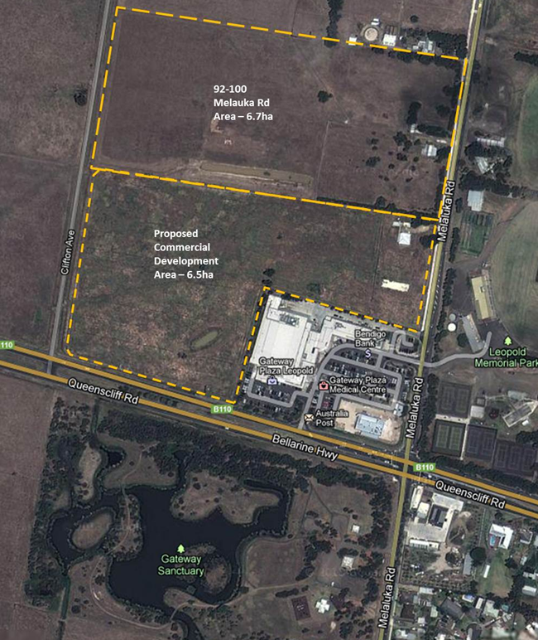

Internal Lascorp drainage sub-catchments and existing drainage system
Figure 2 below shows the internal sub-catchment areas and existing stormwater drainage system within and around the Lascorp site.
Figure 2: Sub-catchment Areas and Existing Drainage System
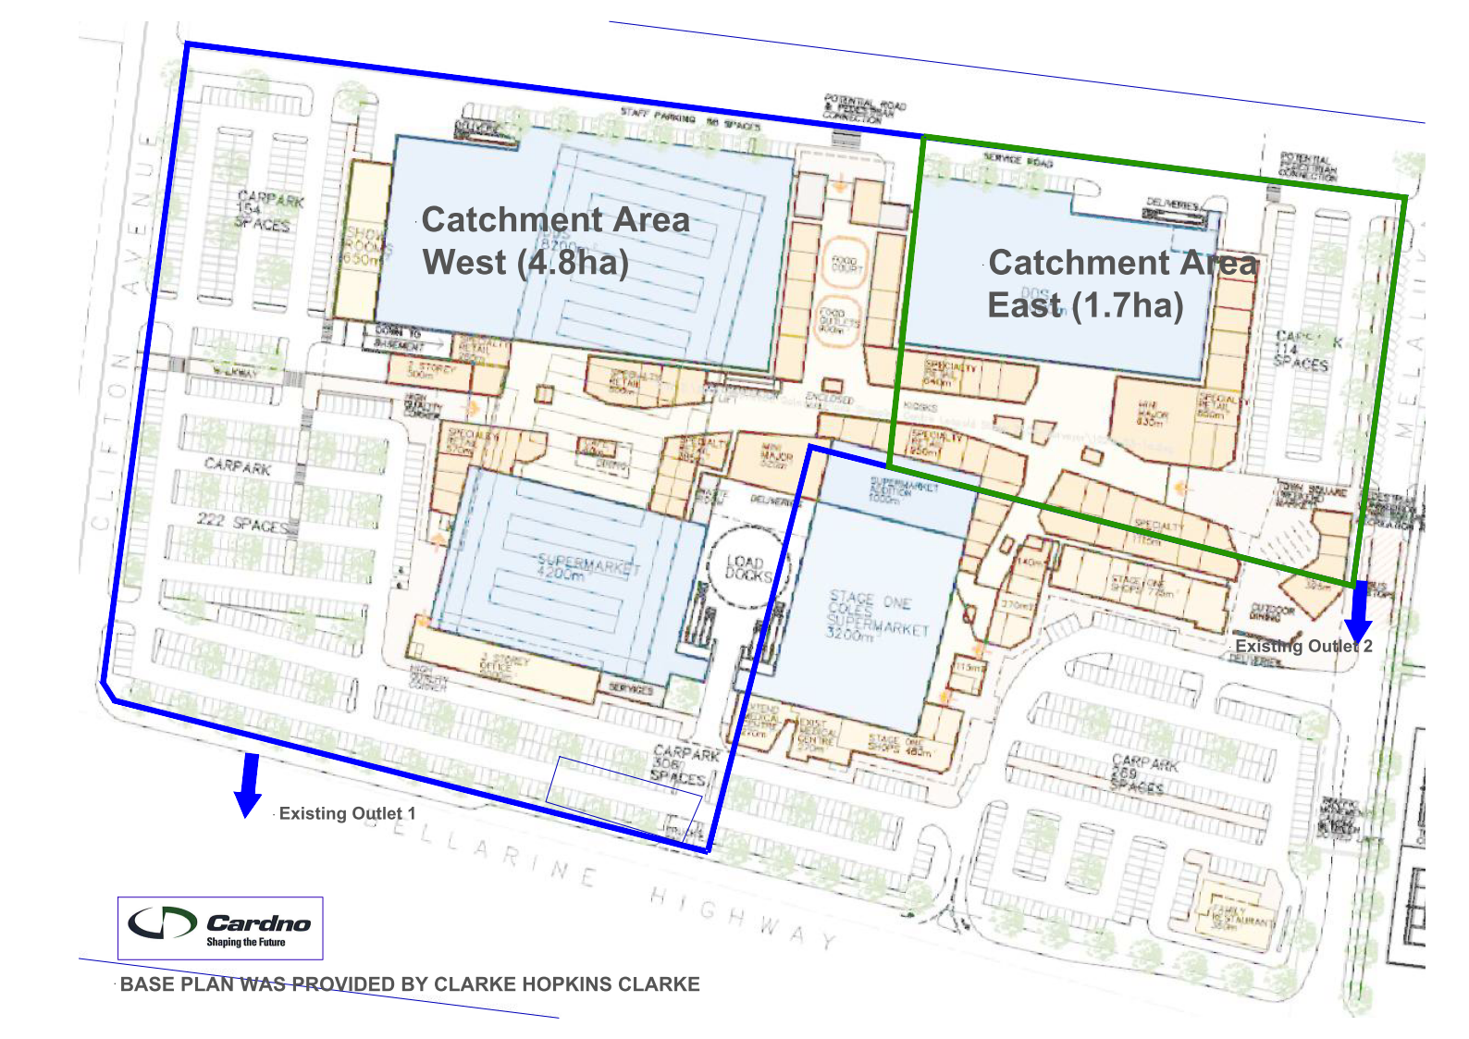
There is an existing box culvert to the south of the subject site running perpendicular to Bellarine Highway and to the west of the site parallel to Melaluka Road. These culverts discharge into the ‘Gateway Sanctuary’, which is a low depression formed into series of wetlands and serves as a general retardation basin. The site is not known to be a formal water quality treatment wetland.
The proposed development will discharge all stormwater to the western outlet, Outlet 1.
Details of Outlet 1 (Legal Point of Discharge) is presented in Table 1 below.
Table 1: Existing Drainage Invert Levels
Area (ha) | Existing Outlet | Culvert | IL
6.50 | 1 | 900x450 Box Culvert | 6.99

Development Proposal
It is proposed to develop the ‘Bellarine Gateway Plaza’ commercial activity centre, which includes supermarkets, specialty shops, restaurants, showrooms, medical centre, offices and a gymnasium. The proposed plaza layout is shown in Figure 3 below.

Figure 3: Proposed Gateway Plaza Development
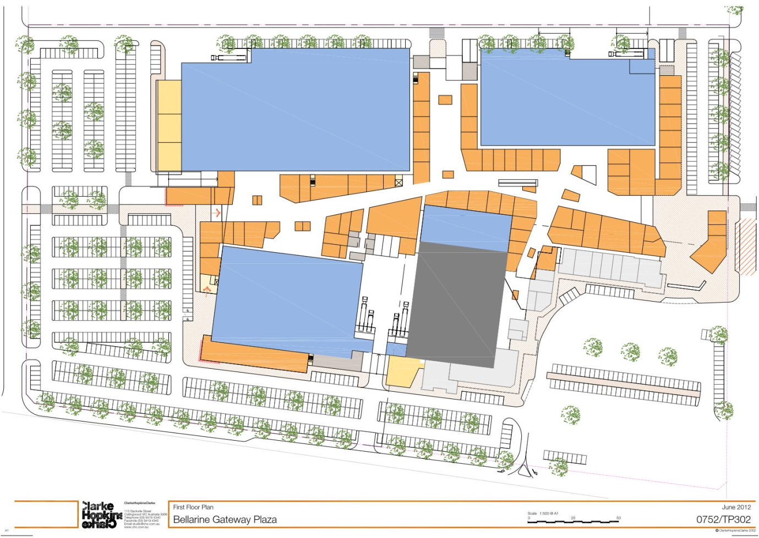

92-100 Melaluka Rd
The property to the north of the subject site currently lies on the boundary of two distinct catchments. Approximately the southern third of the site currently drains to the west and south via Clifton Ave. The flow passes under the Bellarine Highway via the existing 900x450mm culvert. The remaining northern two thirds of the site drain north towards Portarlington Rd. The City of Greater Geelong has indicated that the total runoff from the site, once it has been developed, will flow via Clifton Ave.

1 in 100 year ARI Flood Assessment
Cardno has previously prepared a flood investigation report for Melaluka Road in February 2007 which includes the area surrounding this site. The flood investigation carried out was focused on flows to the north of the site which predominantly flow north and away from the site. The catchment to the south of the study area, and including the Bellarine Gateway Plaza Commercial Activity Centre, was included in the hydrological model to enable analysis of any cross-catchment flows that may occur in rare flood events.
The catchment plan and the modelled flood depth plot from the Cardno report are included in Figure 4 and Figure 54 below respectively. The location of Gateway Plaza commercial activity centre in Figure 4 is included in sub-catchment BS. The site to the north is included in sub-catchments BS and AE.
Figure 4: 1 in 100 year ARI Flood Mapping Map (Source: Cardno, 2007)
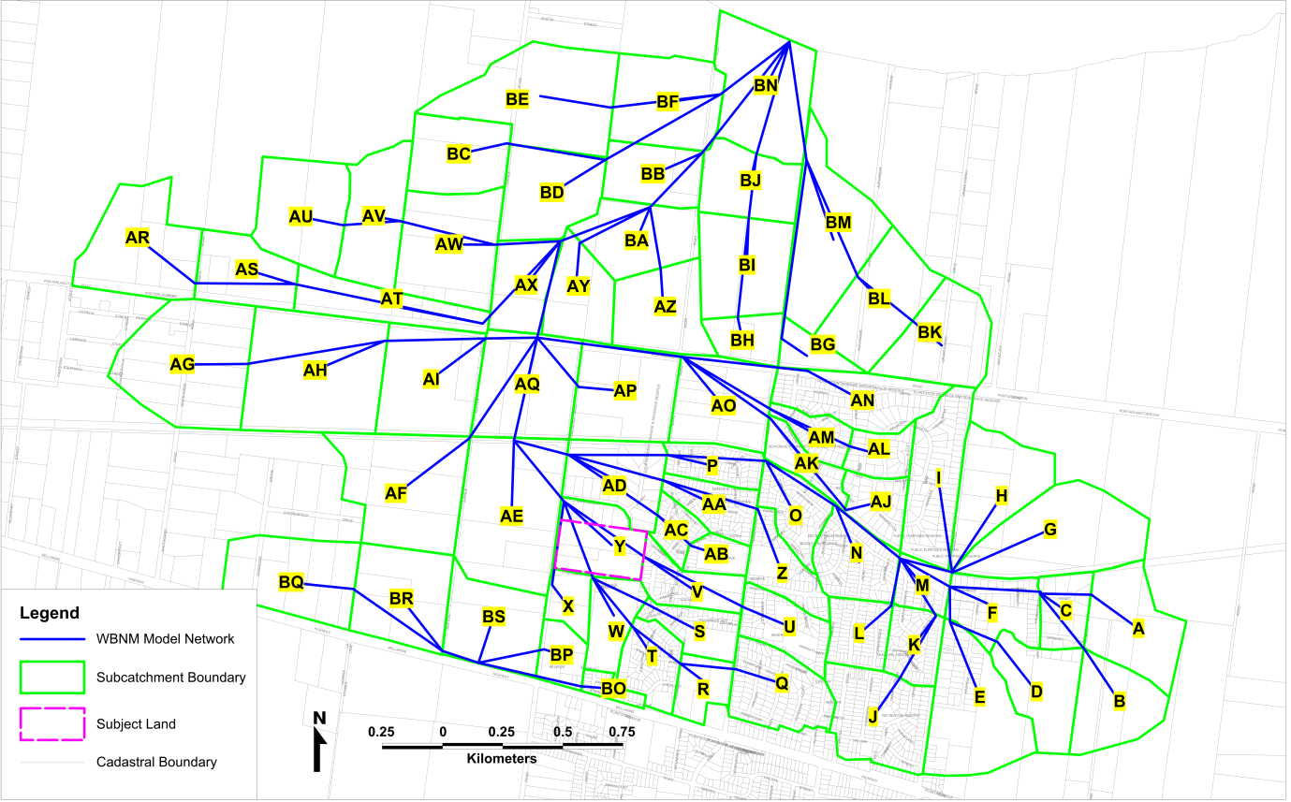
Note from previous flood modelling, there are external catchments which also affect the subject site from the east and west in sub catchments BQ, BR, BP and BO.
Figure 5 overleaf from the 2007 flood review shows that the Lascorp owned land is not affected by runoff from the abutting land to the north due to historical filling of the site; however there is currently significant flooding at the intersection of Clifton Avenue and Bellarine Highway due to limited existing culvert capacity.
Figure 5: 1 in 100 year ARI Flood Mapping Map (Source: Cardno, 2007)
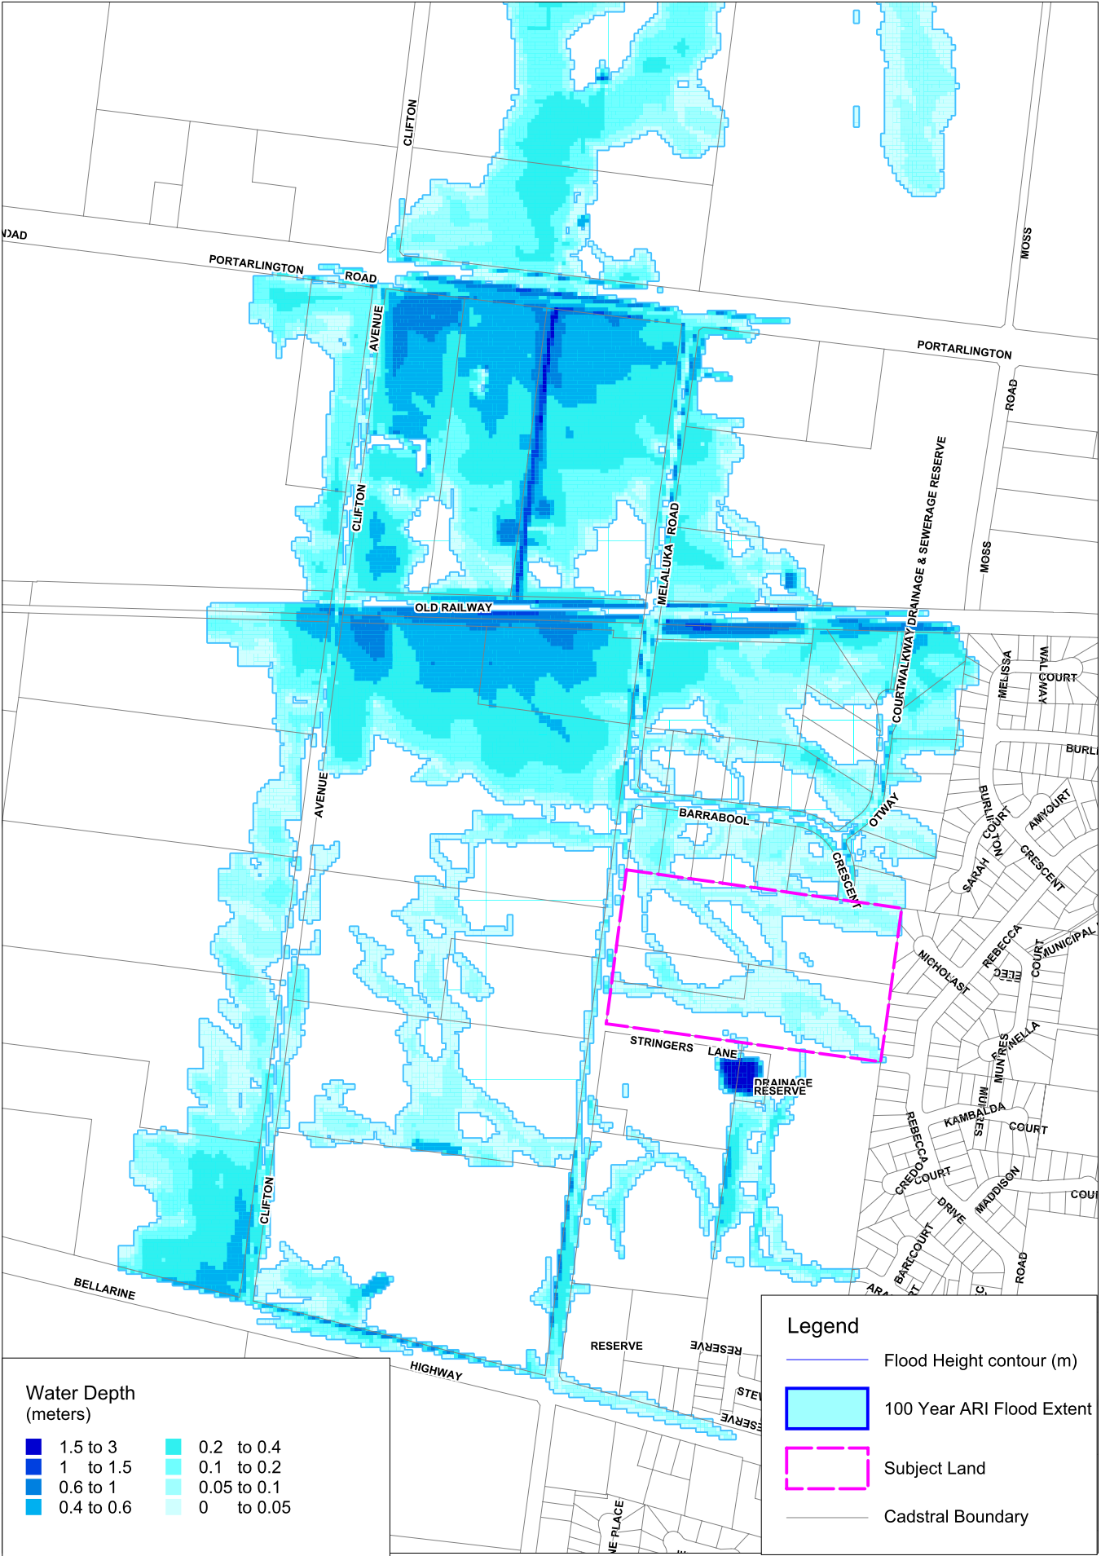
City of Greater Geelong prepared a ‘Leopold Structure Plan’ report in June 2011, which includes stormwater management for the area around the proposed Gateway Plaza and reads as follows (Refer to Figure 4 for the Flood Map):
The existing shopping centre site and the site directly abutting the centre was subject to filling a number of years ago. This fill raised the level of these sites above the level of surrounding land. The fill has subsequently displaced flood storage onto lots to the north and west and obstructed flood conveyance towards the Bellarine Highway (& Gateway Sanctuary) as shown by the map. As a result of this, flood waters and drainage flows within the southern sub-catchment now overflow more readily to the north and the drainage line discharging to Port Philip Bay at Moss Road.
Figure 6 shows the extent of 1 in 100 year ARI flood to the north and west of the subject site. The estimated overland flows paths are shown.
Figure 6: 1 in 100 year ARI Flood Mapping Map (Source: City of Greater Geelong, June 2011)
Proposed Bellarine Gateway Plaza

Estimated Overland Flow Path

Bellarine Highway
Clifton Ave
Council have agreed that the mapping shown above is not accurate and should not be relied upon. Hence, Cardno have adopted the 2007 model and used reliable up to date Lidar data to better reflect the flood conditions.
It is expected that there will be no external catchment flows running into the site. Flows from north of the development site discharge into an existing channel that runs across the site’s northern boundary in an East-West direction. These flows will then be diverted along Clifton Ave and Bellarine Highway, prior to being discharged into the ‘Gateway Sanctuary’, which is located to the south of the site.
The external catchment to the site flowing south past the Bellarine Highway has been included in our hydraulic model as discussed in more detail in Section 5 below.

Stormwater Quantity Management – Precinct Assessment
As indicated by Council the drainage investigations include the abutting land to the north and the current proposed development site. Hence the flows from the property to the north, 92-100 Melaluka Rd, have been incorporated into the investigation by determining the required detention and flow rates indicated by the 300kL storage tank and 600mm pipe. On top of this the detention volumes and pipe sizes have been proposed to match predevelopment discharge rates to allow for safe and reliable management of the sites stormwater.
All flows up to the 1 in 100 year ARI are to be conveyed beneath the Bellarine Highway through three 600mm diameter proposed culverts. Detailed design of the new culverts will illustrate interactions with services that run along the Bellarine Hwy and will contain syphon details if required. This will occur via overland flows and an on-site underground piped drainage system. This is designed to limit the peak outflow rate to the existing culvert under the Bellarine Highway such that it is no more than the pre-development peak outflow rate of 0.29m3/s for all external catchments.
Increasing flow capacity beneath the Bellarine Highway by the addition of the three proposed 600mm diameter culverts will also allow for greater capacity to handle flows from adjoining catchments and alleviate any problems of flooding on-site.
Stormwater flows from the site to the north, at 92-100 Melaluka Rd are assumed to be detained onsite and released at predevelopment levels of 0.35m3/s. This on-site detention is represented by a storage tank of size 300kL. The runoff from this site is assumed to travel via Clifton Av in an underground pipe network and under the Bellarine Highway via the new culverts proposed as part of this development.
All stormwater flows are proposed to be detained by an integrated Sedimentation/Retention Basin to the south of the site, adjacent to the existing Gateway Sanctuary. This system includes a sedimentation basin and retention basin which has the combined functionality of detention and initial treatment of stormwater prior to secondary treatment through a Biofilta.
Total storage for the proposed detention basin will be approximately 4,100m3 and is within the required detention volume to handle stormwater from the site. This storage capacity is due to the constraints of the inlet invert which ensures stormwater can be conveyed by gravity at a suitable grading to the detention basin and that the basin is graded up to existing levels of the site. The system will be located and excavated to the west of the Gateway Sanctuary.
A hydraulic model was developed to determine the detention volumes required to detain the peak discharge of the 1 in 10 and 1 in 100 year ARI events to the expected predevelopment levels.
The volumes required to detain these flows are shown in Table 2 below.

Table 2: Detention Requirements for the 1 in 100 year ARI Flow
Storm Frequency | Pre-developed (Site Only) | Post-developed (Site Only) | Buffer Detention Volume Required within Proposed Car Park | Detention Volume Required (South of Bellarine Highway)
1 in 10yr ARI | 0.18 m³/s | 0.13 m³/s | 0 m³ | ,3,200 m³
1 in 100yr ARI | 0.29 m³/s | 0.28 m³/s | 300 m³ | 4,100 m³

The proposed stormwater detention location is shown in Figure 7 below (Refer to Annex 1 for a larger scale of the proposed site development - Drawings C1001 and C1002).
Figure 7: Proposed Stormwater Detention and Treatment Locations – Sedimentation Basin and Biofilta
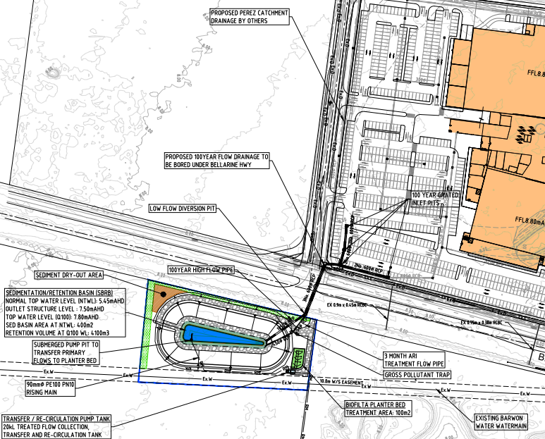

Hydraulic Modelling
Hydraulic modelling was carried out in the software package XP SWMM. XP SWMM is capable of computing catchment runoff hydrographs and routing them through a complex hydraulic network accounting for hydraulic losses, backwater effects and storage.
The hydraulic modelling has not taken into account the external catchments to the west of the development. These external catchments currently drain through the existing 450x900 RCBC under Bellarine Highway. Our proposal does not intend to utilise this culvert for the flow of stormwater in excess of the predevelopment levels.
The Gateway Plaza car park level is 8.25m AHD to allow hydraulic head to drive through the culvert.
The layout of the network modelled is shown in Figure 9.
Figure 8: XP SWMM Network
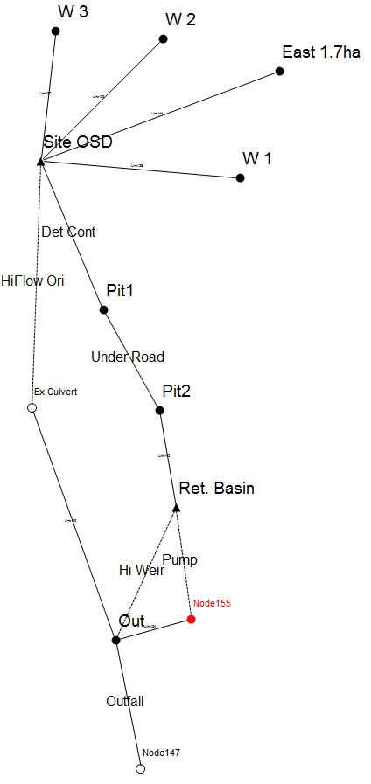
A detention system is proposed at the location adjacent to the Gateway Sanctuary to the south of the site. As outlined above in Figure 8 the detention system will consist of a 400m² sedimentation basin and 100m² planter bed with combined detention capacity of approximately 4,100m³. The total flow through the two proposed culverts is expected to be 0.8m³/s for the 100 year ARI. The stormwater carried by the proposed culverts is conveyed directly into the detention basin.
The Biofilta transfer/re-circulation tank outlet consists of a pump with a rising main to the legal point of discharge. The proposed pump and rising main is required to convey treated stormwater to the legal point of discharge, at an invert level of 6.99m AHD. The outlet pumping rate is 6 L/s. With a pump rate of 6 L/s the volume of the detention system utilised during operation is sufficient for the volume required to be detained.
Flows up to the 100 year ARI will also be detained on the surface of the proposed car park within the subject site to a maximum depth of 250mm. The total detained volume on the surface of the car park is 300kl.
Further refinement of pipe sizing and car park storage may be undertaken to limit the depth of temporary flooding in the car park by increasing the capacity of the new culvert under the Bellarine Highway. This will be addressed in detailed design in-conjunction with the civil works designers.
The peak flows for the post development drainage network for the 10 year ARI is shown in Figure 9 below.
Figure 9: Flow Rates for all Elements of the Drainage Network for the 1 in 10 year ARI
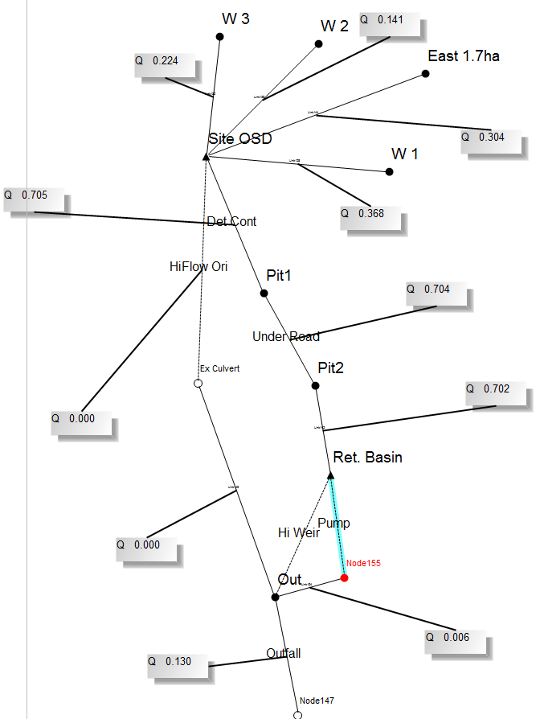

The 100 year ARI storage hydrograph and outflow hydrograph is shown in Figure 10 and Figure 11 below.
Figure 10: Stage Hydrograph for the Site Detention System during a 100 Year ARI Storm Event
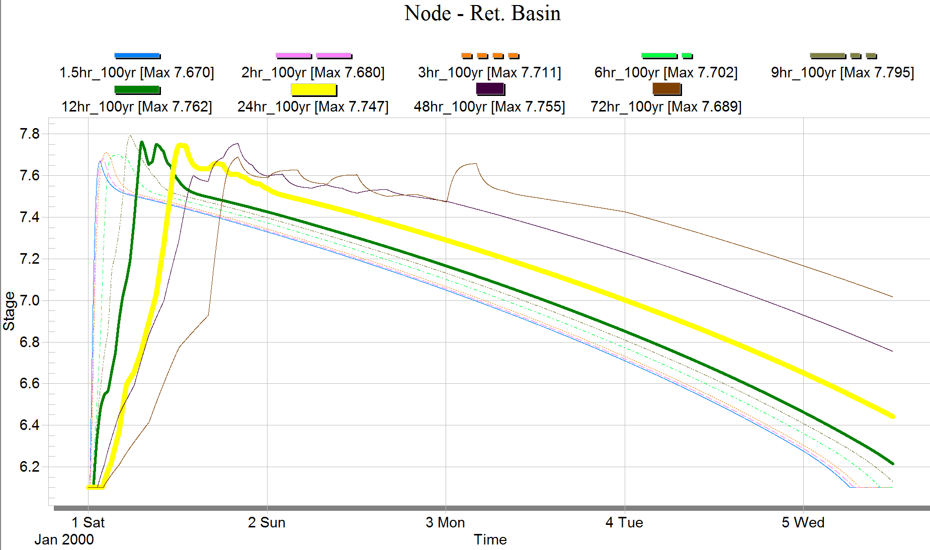
Figure 11: Outflow Hydrograph for the Site Detention System during a 100 Year ARI Storm Event
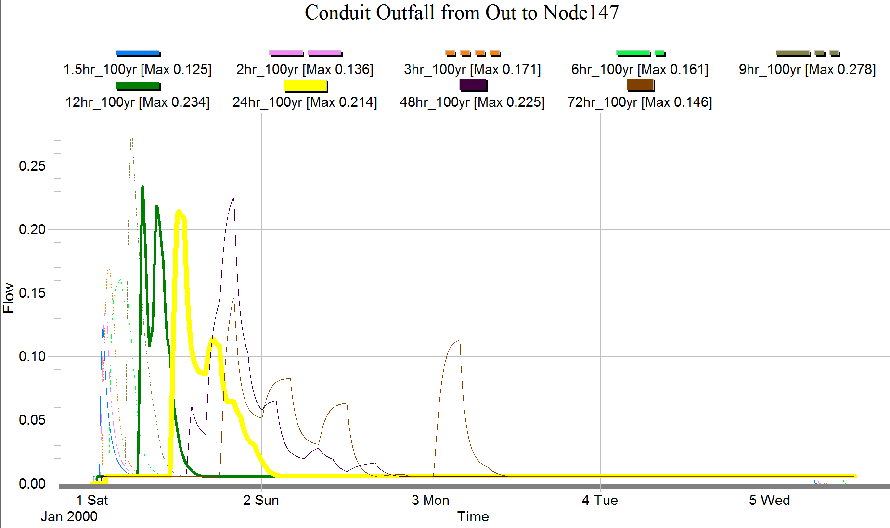

The peak flows for the post development drainage network for the 1 in 100 year ARI is shown below in Figure 12.
Figure 12: Flow Rates for all Elements of the Drainage Network for the 100 Year ARI Storm Event
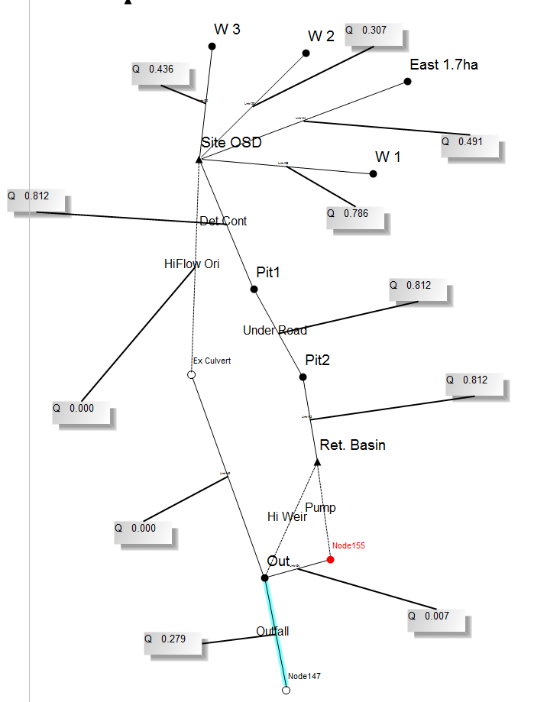

A schematic long section of the proposed detention network is included in Annex 1.

Flow up to 10 year ARI storm will be conveyed by an underground pipe network throughout the proposed development through the three proposed 600mm culverts and into the proposed detention system to the south of the Bellarine Highway.
Overland flow paths within the site will convey flows up to the 1 in 100 year ARI flow from the development to the detention system. The proposed road and car park levels will be regraded to provide these overland flow paths during detailed design. 100 year grated inlet pits have been included in the design as shown on C1001 to take all flows under the Bellarine Hwy.

Stormwater Quality Management

Objectives
The objective of the development with respect to stormwater quality is to treat the stormwater as such it can achieve environmental objectives as stated in Urban Stormwater Best Practice Environmental Management Guidelines (BPEMG). BPMEG objectives for stormwater quality improvement are as follows:
- Reduction of Total Suspended Solid (TSS) : 80%
- Reduction of Total Phosphorous (TP) : 45%
- Reduction of Total Nitrogen (TN) : 45%
- Reduction of Gross Pollutants (GP) : 70%

Proposed Treatment Measures
The model for Urban Stormwater Improvement Conceptualisation (MUSIC) V5 has been used to assess the water quality improvement measures for the development. The modelling was undertaken using City of Greater Geelong MUSIC Guidelines and rainfall from Geelong North Gauge, 1985 at 6min time step.
A sedimentation basin and BiofiltaTM is proposed to the south of the development, on the western side of the Gateway Sanctuary to treat stormwater flow for the entire 6.5ha site of Bellarine Gateway Plaza and 6.7ha site of the abutting 92-100 Melaluka Rd site. The sedimentation and biofilta system has been designed to treat the site to exceed best practice guidelines.
The topography and grades of the site constrains the basin inlet invert and hence NTWL, at 5.45m AHD, which allows for natural gravity-driven conveyance of stormwater to the detention and treatment system. A submerged pump pit within the sedimentation basin will transfer flows to the Biofilta through a rising main whereby a re-circulation/transfer tank will collect the treated flow and a secondary pump within the tank will pump treated stormwater to the legal point of discharge, at an invert level of 6.99m AHD.

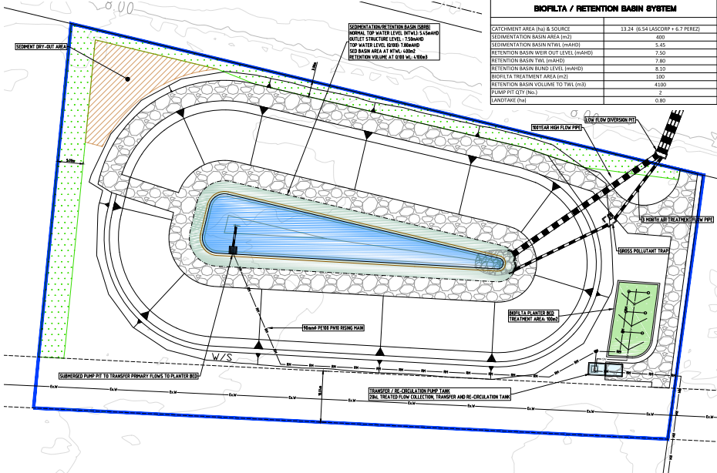
Figure 13: Proposed sedimentation/retention basin and Biofilta System

All stormwater runoff from the site will be conveyed to the 400m² sedimentation basin followed by the 41m² biofilta and will receive treatment within those water bodies. With this arrangement the total pollutant reduction for the development will exceed best practice guidelines as shown by Table 3. The overall treatment as modelled in MUSIC is shown in Figure 14 below.
Figure 14: MUSIC Model Layout and Output
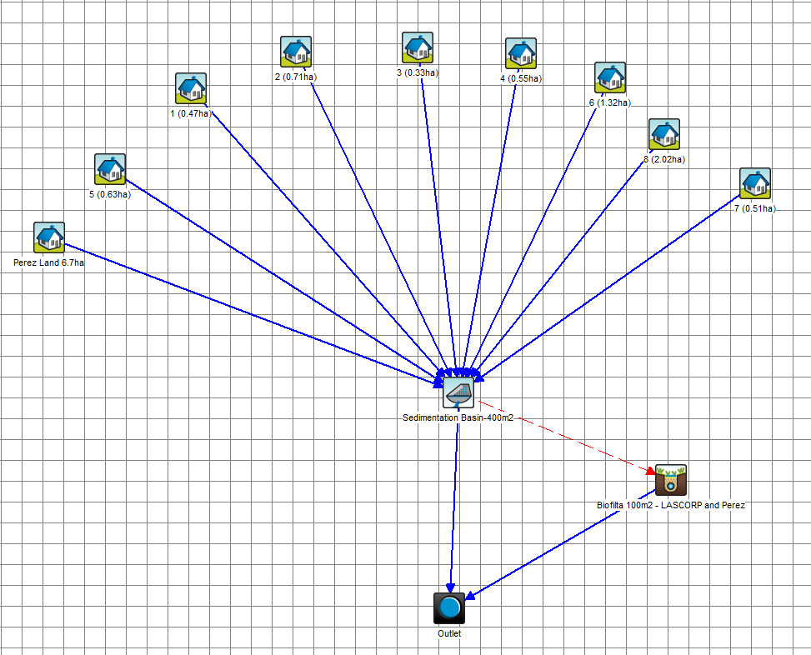

Table 3 MUSIC Model Results
Pollutant | Source | Residual | % Reduction
TSS | 5350kg/yr | 407kg/yr | 92.4
TP | 10.8kg/yr | 1.54kg/yr | 85.7
TN | 74.1kg/yr | 38.2kg/yr | 48.4

Maintenance of the proposed system including the basin, pumps, vegetation and rising mains will be undertaken through an agreement between Lascorp and Council.
The proposed system will incorporate aesthetics with functionality through detailed landscape plans to demonstrate that it is in keeping with the surrounding environment. Protected batters will be incorporated to provide the required storage level and required bank stability. A maintenance track will is also included to allow for easy maintenance access. The sedimentation basin and biofilta will be integrated into the landscape and will form part of the Sanctuary landscape through the landscaping plans.
The overall water quality benefits of this scheme are therefore:
- Exceeding Best Practice stormwater runoff targets for the Gateway Plaza precinct with the option of including the new catchment flows from 92-100 Melaluka Road in the future
- Implements a stormwater treatment system that is simple and uses proven natural processes to treat stormwater.
- Provides a treatment system that is able to be appreciated by users of the Sanctuary and landscaped to be integrated into the surrounding environment and will become part of the discovery experience for the site.
The proposed stormwater treatment location is shown in Drawing C1002 in Annex 1.

Conclusions
This stormwater management report provides a holistic management strategy for proposed development of the Gateway Plaza and 92-100 Melaluka Rd precincts.
The scheme provides for:
- The proposed developments will not adversely affect the upstream and downstream drainage systems or cause nuisance to adjacent properties as the existing overland flow paths are maintained, and the current rate of discharge from the site to the external stormwater drainage system will be maintained up to the 1 in 100 year ARI flow.
- Stormwater flows generated from the site will be treated to exceed Best Practice environmental standards via the proposed 400m² sedimentation and 100m² Biofilta.
- The detention system includes:
- Volume of approximately 4,100m³ for the 1 in 100 year ARI event will be provided by the sedimentation basin, located adjacent to the Gateway Sanctuary to the south of the site. The 4,100m³ detention volume and pumping rate of 6L/s from the proposed system is sufficient to handle the required detention volume and is constrained by the inlet invert level. Flows from the development site to the detention system will be conveyed via an underground pipe network within the development and overland flow paths towards the proposed three 600mm diameter culverts under the Bellarine Highway.
- The retarding basin will limit the post development of 1 in 100 year ARI flow to its pre-development level from Bellarine Gateway Plaza only through the existing culvert.
- The Biofilta System requires two pumps. A submerged pump pit within the sedimentation basin will transfer flows to the Biofilta and the transfer/sustainability tank will collect the treated flow and a secondary pump within the tank will pump water to the legal point of discharge due to the levels of the detention storage being constrained by the site grades and therefore detention inlet invert.

It is recommended that Council provide it’s in principle support for this drainage strategy, subject to detailed design plans being prepared and relevant Authority approvals being granted.

Annex 1:
Drawing CG120259-C1002 (Layout Plan)

