Proposed Leopold Sub-regional Activity Centre – Stage 1
Bellarine Highway, Leopold

Traffic Engineering Assessment

Prepared for

Lascorp Development Group Pty Ltd

October 2013
Our Reference: 12541R9167

Proposed Leopold Sub-regional Activity Centre – Stage 1
Bellarine Highway, Leopold

Traffic Engineering Assessment

Study Team: | Henry Turnbull  B.E. (Civil), M.I.E. Aust., M.I.T.E., F.V.P.E.L.A. | Brayden Capper  B.E. (Civil) Hons., Grad.I.E.Aust, M.A.I.T.P.M.
Released By: |   HENRY H TURNBULL  SIGNED |  | 15th October, 2013  DATE
Document Status:  COPYRIGHT: The ideas and material contained in this document are the property of Traffix Group (Traffix Group Pty Ltd – ABN 32 100 481 570, Traffix Survey Pty Ltd – ABN 57 120 461 510, Traffix Design Pty Ltd – ABN 41 060 899 443). Use or copying of this document in whole or in part without the written permission of Traffix Group constitutes an infringement of copyright.  LIMITATION: This report has been prepared on behalf of and for the exclusive use of Traffix Group’s client, and is subject to and issued in connection with the provisions of the agreement between Traffix Group and its client. Traffix Group accepts no liability or responsibility whatsoever for or in respect of any use of or reliance upon this report by any third party. | Draft until signed at release

Table of Contents
1 Introduction 2
2 Existing Conditions 2
2.1 The Site 2
2.2 Land Use 4
2.3 Road Network 5
2.4 Public Transport 5
3 The Proposal 6
3.1 Proposed Development 6
3.2 Access Arrangements & Parking Provision 7
4 Car Parking Provisions 8
4.1 Statutory Car Parking Requirements 8
4.2 Adequacy of Proposed Parking Provisions 10
4.3 Car Parking Layout Assessment 10
5 Bicycle Parking 11
6 Loading Arrangements 13
7 traffic Impact Assessment 15
7.1 Traffic Generation 15
7.2 Traffic Distribution 18
7.3 Traffic Impact 20
8 Conclusions 24

Introduction
Traffix Group has been engaged by Lascorp Development Group (Aust) Pty Ltd to undertake a traffic engineering assessment and to prepare a report for stage one of the proposed Sub-Regional Activity Centre on the Bellarine Highway in Leopold.
This report provides a traffic engineering assessment of the proposal, with particular attention to car parking and traffic generation impacts.

Existing Conditions

The Site
The subject site is located on the north side of the Bellarine Highway between Clifton Avenue and Melaluka Road.
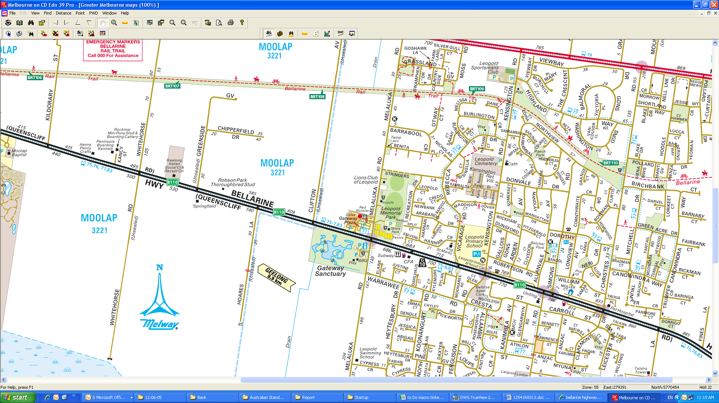
Reproduced with permission from Melway Publishing Pty Ltd.
Figure 1: Locality Plan
The subject site is comprised of two titles; 621-639 Bellarine Highway (Lot 2 on Plan PS506060) and 641-659 Bellarine Highway (Lot 1 on Plan PS506060).
The south-east portion of the site (1/PS506060) is occupied by the Bellarine Gateway Plaza, which includes a supermarket, specialty shops, bank and medical centre. The remainder of the site (2/PS506060) is occupied by a dwelling, outbuilding and grassed paddock.
The site has a south frontage to Bellarine Highway of 380.0 metres, a west frontage to Clifton Avenue of 203.6 metres, and an eastern frontage to Melaluka Road of 252.3 metres.
An aerial photograph of the site is shown in Figure 2 below.
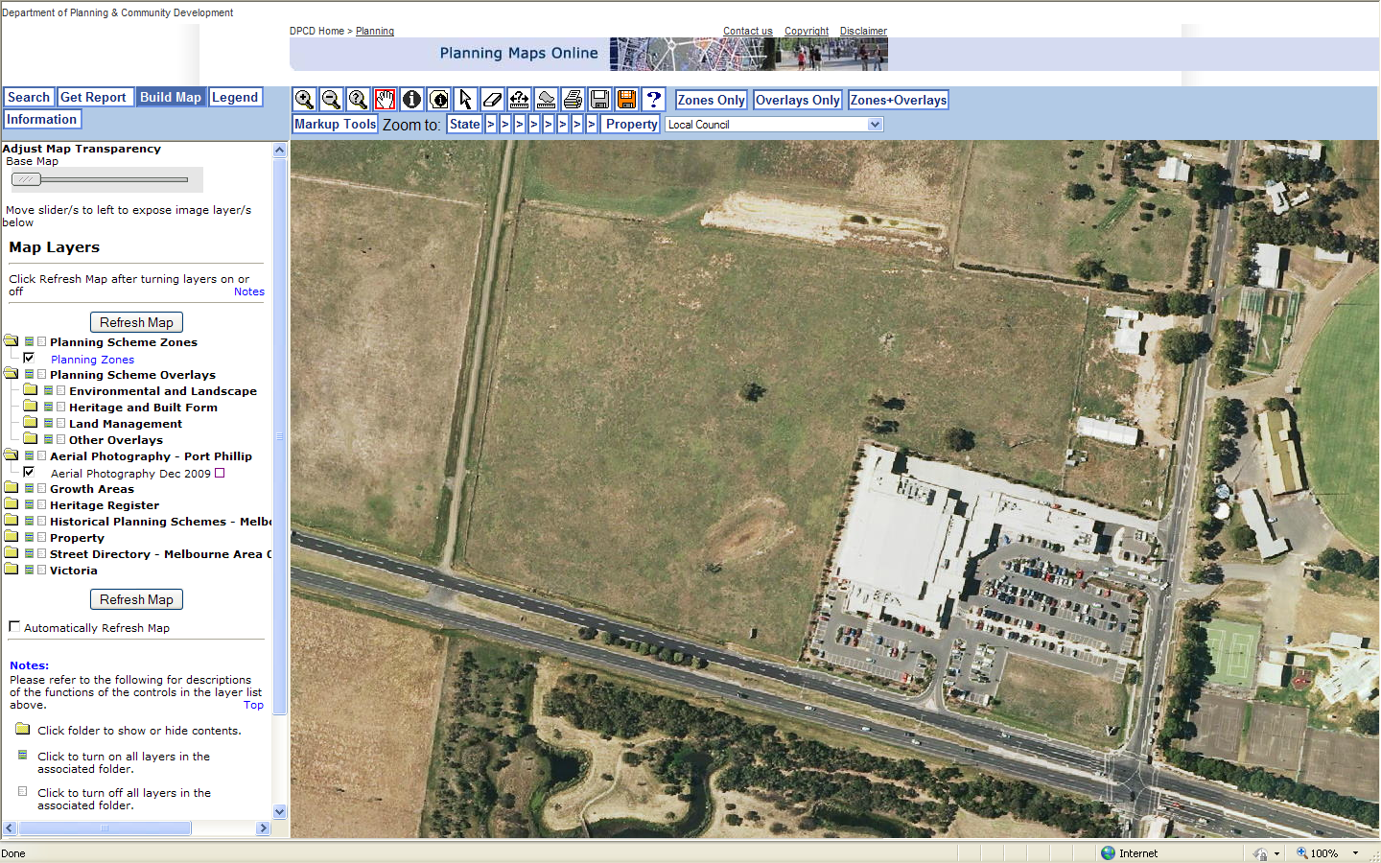
Figure 2: Subject Site - Aerial View

Land Use
The site is located partially within both a Commercial 1 Zone (shown on the map at Figure 3 as B1Z) and a Farming Zone (FZ) as shown in Figure 3 below.
Surrounding land uses include:
- Gateway Sanctuary is located to the south of the subject site,
- A sporting precinct (Leopold Memorial Park) is located to the east of the subject site, which includes sporting ovals, tennis courts, netball courts and a skate park,
- Residential development is located to the east and south-east of the subject site,
- Farming land is located to the north, west and south of the subject site, and
- Low density residential development is located further to the west of the site.
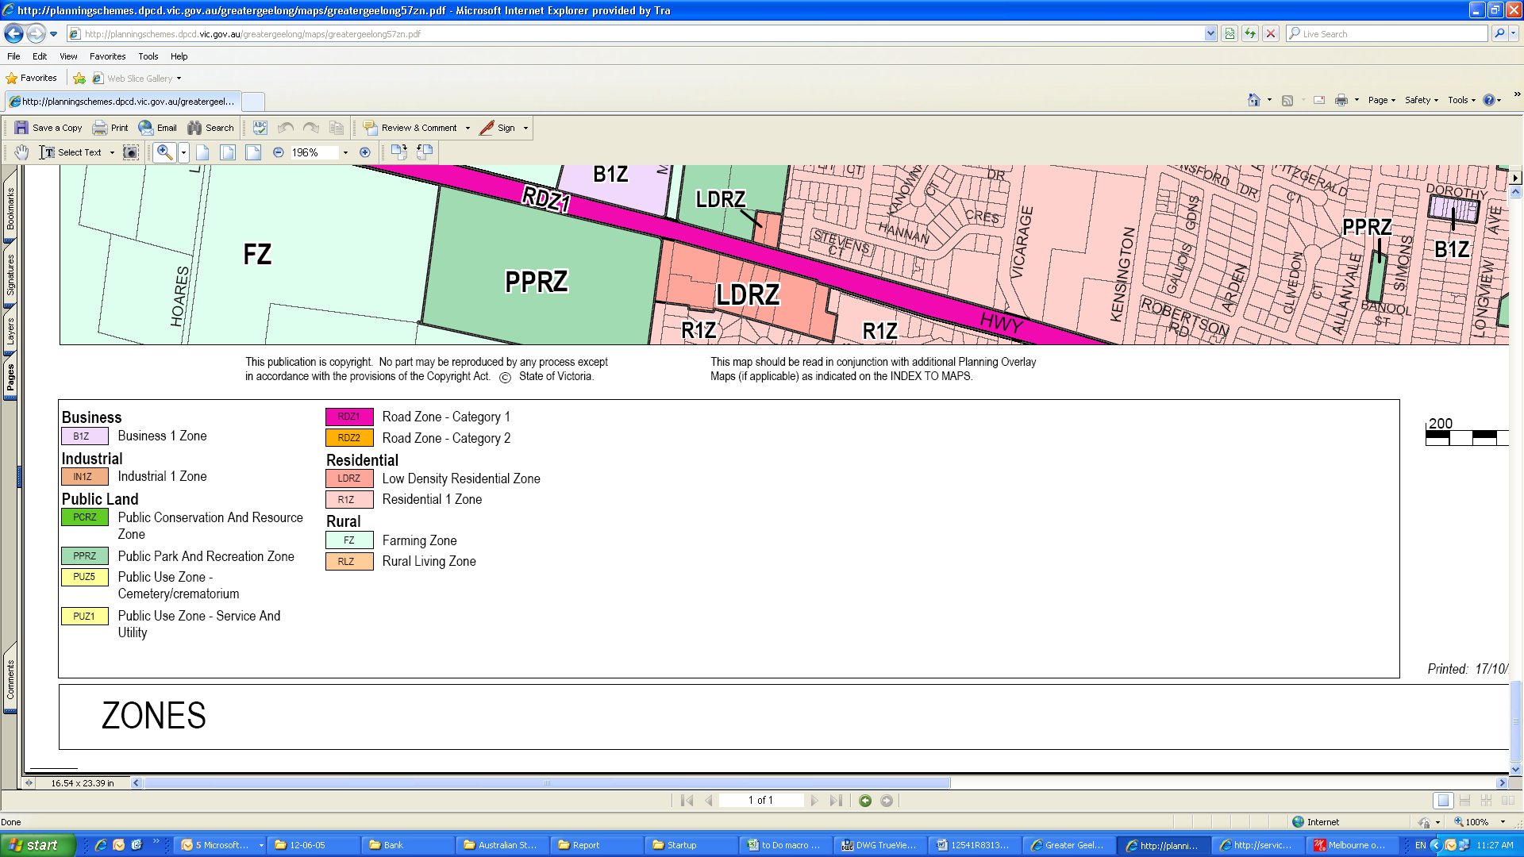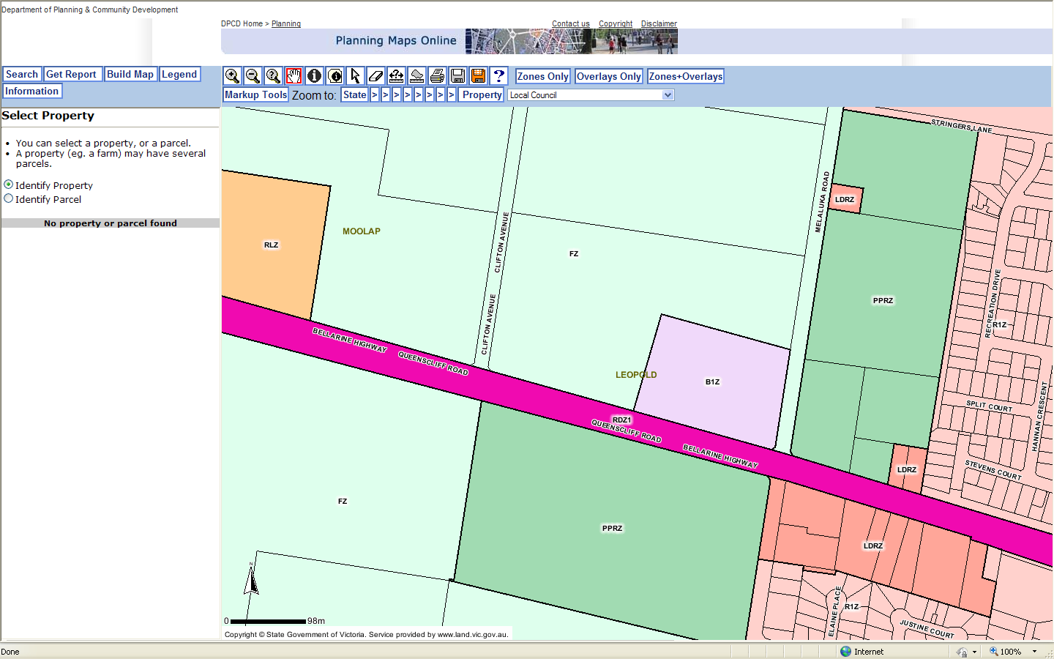

Source: Planning Schemes Online: www.dse.vic.gov.au
Figure 3: Land Use Zoning

Road Network
Bellarine Highway
Bellarine Highway is a state arterial road (Road Zone Category 1) and extends approximately 30km generally in an east-west direction between Geelong and Queenscliff.
In the vicinity of the site, Bellarine Highway is constructed with two traffic lanes in each direction separated by a 9.0 metre wide central median within a 40 metre road reservation.
A 70km/h speed limit applies on Bellarine Highway past the site.
Melaluka Road
Melaluka Road is a local access street, and extends approximately 4.8km between Geelong-Portarlington Road and a dead-end near Lake Connewarre.
In the vicinity of the site, Melaluka Road is constructed with a single traffic lane in each direction, within a 20 metre road reservation.
A 60km/h speed limit applies on Melaluka Road past the site.

Clifton Avenue
Clifton Avenue is a local access street, and extends approximately 3.1km between Geelong-Portarlington Road and a dead-end near Port Phillip Bay.
In the vicinity of the site, Clifton Avenue is a 3.5 metre (approx.) wide unsealed gravel road, within a 17.5 metre road reservation.
The 100km/h default rural speed limit applies on Clifton Road past the site.

Public Transport
The subject site is served by the following public transport services:
- Bus Route 75 provides to connection between Geelong Station and Queenscliff,
- Bus Route 76 provides to connection between Geelong Station and Queenscliff via Ocean Grove,
- Bus Route 77 provides to connection between Geelong Station and Leopold and provides a local loop service around the residential areas in Leopold, and
- Bus Route 83 provides to connection between Geelong Station and Ocean Grove via Wallington.

The Proposal

Proposed Development
The proposal is to redevelop the existing shopping centre into the Leopold Sub-Regional Activity Centre, in accordance with the schedule of uses set out in Table 1 below.
Table 1: Land Use Schedule – Stage 1
Use | Floor Area
Use | Existing | Proposed Increase | Proposed Total
Supermarket | 3,200 sq m | 5,200 sq m | 8,400 sq m
Shop (incl. specialty shops & mini-major) | 1,640 sq m | 6,625 sq m | 8,265 sq m
Post Office | 117 sq m | - | 117 sq m
Bank | 180 sq m | - | 180 sq m
Discount Department Store | - | 5,000 sq m | 5,000 sq m
Convenience Restaurant | 350 sq m | - | 350 sq m
Food and Drink Premises (Kiosks) | - | 255 sq m | 255 sq m
Non-Shop | - | 1,393 sq m | 1,393 sq m
Office | - | 2,380 sq m | 2,380 sq m
Medical Centre | 201 sq m | 270 sq m | 471 sq m
Restricted Recreation Facility (Gymnasium) | - | 720 sq m | 720 sq m
TOTAL | 5,688 sq m | 21,843 sq m | 27,531 sq m

Access Arrangements & Parking Provision
The existing shopping centre located on the south-east quarter of the site has an existing provision of 315 car spaces, including 33 car spaces associated with the approved convenience restaurant.
Access to the existing shopping centre is provided as follows:
- a left-in/left-out access point to Bellarine Highway providing access to the customer carpark,
- an access point to Melaluka Road catering for full turning movements providing access to the customer carpark, and
- a commercial vehicle crossover to Melaluka Road providing access to the loading bays along the north boundary of the existing shopping centre.
A total of 1,140 car parking spaces are proposed. The existing parking layout in the south-east quarter of the site will generally be retained, but with some minor alterations to integrate this parking area with the rest of the site.
Three new access points are proposed along Clifton Avenue, two of which will provide access to the car parking areas and the other will function as an egress from the service road at the top of the site.
An additional left-in/left-out access point will be located on Bellarine Highway approximately 90 metres west of the existing left-in/left-out access point (which is to be retained).
Two new access points are proposed on Melaluka Road which will provide access to a 50 space car park and the new service road at the north of the site. The existing access point to the customer car park will be retained; however the existing commercial vehicle crossover will be removed.
The following loading bays and delivery areas are proposed:
- A large loading dock located between the supermarkets access from the Bellarine Highway. The loading dock provides two loading bays for each supermarket with provision to accommodate semi-trailers, as well as an additional three loading bays with provision to accommodate 12.5m rigid trucks which could be used by the proposed mini-major tenancies and specialty shops.
- A loading dock located at the rear of the Discount Department Store accessed via the new service road, with provision to accommodate semi-trailers for the discount department store.
A copy of the proposed development plan is attached at Appendix A.

Car Parking Provisions

Statutory Car Parking Requirements
The statutory car parking requirements are set out at Clause 52.06 of the Greater Geelong Planning Scheme.
Table 1 at Clause 52.06-5 sets out the number of car parking spaces required for a use. Clause 52.06-5 states:
“Where the measure [...] for an existing use is increased, the car parking requirement only applies to the increase of use provided the existing number of car parking spaces is not reduced.”
In this instance the existing parking provision exceeds the statutory requirements of the existing uses, and accordingly we have assessed the statutory car parking requirement on the ultimate floor area of each use (i.e. including existing).
The number of car parking spaces required for the proposed development is shown in Table 2 below.
Table 2: Statutory Car Parking Requirements
Use | Floor Area | Rate | Requirement
Supermarket | 8,400 sq m | 5 spaces to each 100 sq m of leasable floor area | 420 spaces
Shop (incl. specialty shops & mini-major) | 8,265 sq m | 4 spaces to each 100 sq m of leasable floor area | 330 spaces
Post Office | 117 sq m | 4 spaces to each 100 sq m of leasable floor area | 4 spaces
Bank | 180 sq m | 3.5 spaces to each 100 sq m of net floor area² | 6 spaces
Department Store | 5,000 sq m | 4 spaces to each 100 sq m of leasable floor area | 200 spaces
Convenience Restaurant | 350 sq m | 0.3 spaces to each patron permitted¹ | 35 spaces
Food and Drink Premises (Kiosks) | 255 sq m | 4 spaces to each 100 sq m of leasable floor area | 10 spaces
Non-Shop | 1,393 sq m | 4 spaces to each 100 sq m of leasable floor area | 55 spaces
Office | 2,380 sq m | 3.5 spaces to each 100 sq m of net floor area | 83 spaces
Medical Centre | 471 sq m | 5 to the first person providing health services plus 3 to every other person providing health services³ | 17 spaces
Restricted Recreation Facility (Gymnasium) | 720 sq m | No Statutory Rate | -
Total |  |  | 1,160
¹Based on 2/3 of the floor area being available to the public and one patron per 2m² of public floor area.
²noting bank is nested under ‘office’ in the nesting diagrams at Clause 75
³based on our experience we would anticipate a medical centre of this size would have up to 5 persons providing health services
The proposal also has a total of 1,393 sq m of ‘non-shop’ uses, which will include a mixture of food and drink premises, office and restaurant floor space. We have conservatively adopted a nominal rate of 4 spaces per 100 sq m, which is equivalent to the food and drink premises rate and higher than the office rate. We note that a restaurant use has the potential to produce a parking rate larger than 4 per 100 sq m, however the peak parking demand associated with a restaurant is typically at dinner time and accordingly will be outside the peak times of the other on-site uses. Accordingly, we believe that adopting a rate of 4 spaces per 100 sq m for the ‘non-shop’ uses is appropriate in this instance.
Further, we note that there is no statutory parking rate for a ‘Restricted Recreation Facility’ listed at Clause 52.06. Clause 52.06 states that “where the use of the land is not specified...before a new use commences or the floor area or site area of an existing use is increased, car parking spaces must be provided to the satisfaction of the responsible authority”.
Accordingly, the site has a car parking requirement to provide 1,160 spaces plus additional spaces for the gymnasium to the satisfaction of the responsible authority.
We note that the site includes the provision of 1,171 spaces meeting the statutory car parking requirements of those uses listed at Clause 52.06 while allowing 11 spaces to be used by the gymnasium.
Given that the peak operating time of the gymnasium will be outside the peak operating time of the other uses at the site (the peak operation of a gymnasium is typically in the morning and in the evening, outside of work hours), we are confident that the remaining 11 spaces will be more than sufficient to cater for the parking demands associated with the gymnasium.
Accordingly, the proposed parking provision accords with Clause 52.06 requirements.

Adequacy of Proposed Parking Provisions
The proposed parking provision meets the statutory requirements of those land uses outlined at Clause 52.06 with an excess of 11 spaces.
We note that a gymnasium does not have a parking requirement outlined at Clause 52.06, however given that the typical peak operating times of a gymnasium occurs outside the peak operating times of the rest of the centre we are of the opinion that the remaining twelve spaces will be more than adequate to cater for this parking demand.
Accordingly, we are of the opinion that the proposed parking provisions are appropriate and in accordance with Clause 52.06 requirements.
We note that this report refers to Stage 1 of the Leopold Sub-Regional Activity Centre and further assessment of the parking requirements would have to be undertaken for Stage 2 and we understand that it is proposed to construct a basement car park to provide additional parking spaces at Stage 2.

Car Parking Layout Assessment
The car parking layout has been provided so as that it is in accordance with the Australian Standards (AS/NZS 2890.1 and AS/NZS 2890.6) and Clause 52.06 of the Planning Scheme.
Specifically, we note that each car parking space is a minimum of 5.4m long, 2.6m wide and accessed from a 6.4m aisle.
We are satisfied that each car parking space is accessible and that the proposed car parking layout will function well.

Bicycle Parking
Statutory bicycle parking requirements are set out at Clause 52.34 of the Greater Geelong Planning Scheme.
Clause 52.34-1 states “where the floor area occupied by an existing use is increased, the requirement for bicycle facilities only applies to the increased floor area of the use.”
The statutory bicycle parking requirements for the proposed development are shown in Table 7 below.
Table 3: Statutory Bicycle Parking Requirements
Use | Increase In Floor Area/ Number | Employee/ Resident Rate | Req. | Visitor/ Shopper/ Student Rate | Req.
Supermarket | 8,400 sq m | 1 to each 600 sq m of leasable floor area if the leasable floor area exceeds 1000 sq m | 14 | 1 to each 500 sq m of leasable floor area if the leasable floor area exceeds 1000 sq m | 17
Shop (incl. specialty shops & mini-major) | 8,225 sq m | 1 to each 600 sq m of leasable floor area if the leasable floor area exceeds 1000 sq m | 14 | 1 to each 500 sq m of leasable floor area if the leasable floor area exceeds 1000 sq m
Post Office | 117 sq m | 1 to each 300 sq m of leasable floor area | - | 1 to each 500 sq m of leasable floor area | -
Bank | 180 sq m | 1 to each 300 sq m of leasable floor area if the net floor area exceeds 1000 sq m | - | 1 to each 1,000 sq m of leasable floor area if the net floor area exceeds 1000 sq m | -
Discount Department Store | 5,000 sq m | 1 to each 600 sq m of leasable floor area if the leasable floor area exceeds 1000 sq m | 8 | 1 to each 500 sq m of leasable floor area if the leasable floor area exceeds 1000 sq m | 10
Convenience Restaurant | 350 sq m | 1 to each 25 sq m of floor area available to the public | 9 | 2 | 2
Food and Drink Premises (Kiosks) | 229 sq m | 1 to each 300 sq m of leasable floor area | 1 | 1 to each 500 sq m of leasable floor area | -
Non-Shop¹ | 1,419 sq m | 1 to each 300 sq m of leasable floor area | 5 | 1 to each 500 sq m of leasable floor area | 3
Office | 2,380 sq m | 1 to each 300 sq m of leasable floor area if the net floor area exceeds 1000 sq m | 8 | 1 to each 1,000 sq m of leasable floor area if the net floor area exceeds 1000 sq m | 3
Medical Centre | 471 sq m | 1 to each 8 practitioners | 1 | 1 to each 4 practitioners | 1
Minor Sports and Recreation Facility (Gymnasium)² | 562 sq m | 1 per 4 employees | 1 | 1 to each 200 sq m of net floor area | 3
Total |  |  | 61 |  | 39
¹as previously noted, ‘non-shop’ will include a mix of food and drink establishments, office and restaurant floor space. As both food and drink establishments and restaurants are nested under the broader use retail and retail has a higher bicycle parking requirement than office the bicycle parking rate for retail has been conservatively adopted.
²it has been assumed that no more than 4 employees will be in attendance at the gym at any one time.
The proposed development generates a requirement to provide 100 bicycle spaces, including 61 spaces for staff and 39 spaces for visitors.
Clause 52.34-3 states the following regarding the type of bicycle spaces that should be provided:
“A bicycle space for an employee or resident must be provided either in a bicycle locker or at a bicycle rail in a lockable compound.”
“A bicycle space for a visitor, shopper or student must be provided at a bicycle rail.”
The proposed development plan shows some bicycle rails provided around the site totalling 17 spaces. While numbers are not specifically annotated, it appears the facilities shown could cater for approximately 22 bicycles. Accordingly, the development falls short of statutory bicycle parking requirements.
We note that provision of staff bicycle parking could be provided in the back-of-house areas, particularly for the larger retail tenants (supermarkets, discount department stores and mini-majors). If staff bicycle parking is provided in a back-of-house area or a secure bicycle cage we recommend the use of the ‘Ned Kelly’ hanging bicycle rail, which allows rails to be spaced at 450mm centres when the rails are staggered vertically.
There is ample open space around the perimeter of the proposed shopping centre where additional visitor bicycle parking rails could be provided. We recommend the use of the ‘Flat Top’ bicycle parking rail, which allows rails to be spaced at 1.0m centres with two bicycles able to be parked on each rail. Groups of ‘Flat Top’ rails could be located near each of the pedestrian entrances to the proposed shopping centre.
A copy of the specification sheets for the ‘Ned Kelly’ and ‘Flat Top’ bicycle rails is attached at Appendix B.

Loading Arrangements
Statutory loading requirements are set out at Clause 52.07 of the Greater Geelong Planning Scheme. Clause 52.07 requires that a loading bay be provided in accordance with Table 8 below, if goods are manufactured, serviced, stored or sold on the site.
Table 4: Statutory Loading Requirements – Clause 52.07
Floor Area of Building | Minimum Loading Bay Dimensions
2,600 m² or less in single occupation | Area | 27.4 m²
2,600 m² or less in single occupation | Length | 7.6 metres
2,600 m² or less in single occupation | Width | 3.6 metres
2,600 m² or less in single occupation | Height Clearance | 4.0 metres
For every additional 1,800 m² or part | Additional 18 m²
With the exception of the medical centre, bank and office land uses each of the proposed tenancies generates a requirement to provide for loading under the provisions of Clause 52.07.
The following loading bays and delivery areas are proposed:
- a large loading dock located between ‘Zone A’ and ‘Zone B’ accessed via the new crossover to Bellarine Highway. The loading dock provides two loading bays for each supermarket with provision to accommodate semi-trailers, as well as an additional three loading bays with provision to accommodate 12.5m rigid trucks which could be used by the proposed mini-major tenancies and specialty shops,
- a loading dock located at the rear of the discount department store which will accommodate semi-trailers.
Each of the proposed loading docks has dimensions that exceed the minimum requirements set out under Clause 52.07.
All the specialty retail shop tenancies have access to the loading dock areas.
We have checked access to the loading docks using appropriate turning templates (including semi-trailer access to the supermarket and discount department store loading docks) and are satisfied that they are generally appropriate for providing adequate provision for loading and unloading on the site. AutoTURN diagrams showing these movements are attached at Appendix C.
We note however that the eastern entrance to the service road running along the northern end of the site should be widened by 1m on the north side to allow ease of truck access. This is shown in Figure 4 below. This can be addressed via permit condition, if required.
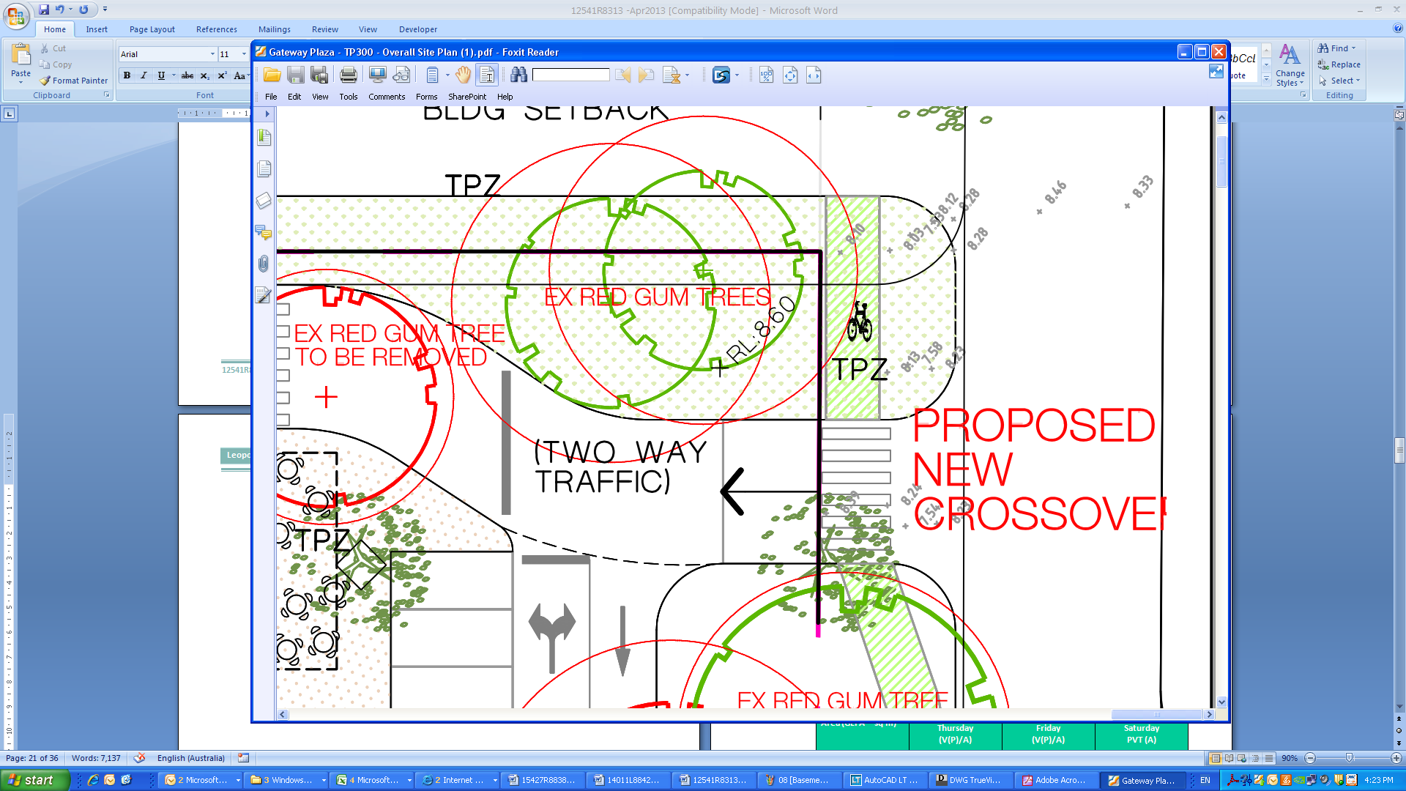
Figure 4: Service Road Entrance Amended Kerb Alignment
1m
Amended Kerb Alignment

traffic Impact Assessment

Traffic Generation
The RTA Guide to Traffic Generating Developments (2002) (RTA Guide) sets out traffic generation rates for a range of developments, based on survey data collected in New South Wales, and is generally regarded as a standard for metropolitan development characteristics.
Peak Hour Traffic Generation
The RTA Guide sets out the following average rates for calculating the peak hour traffic generation for shopping centres:
Table 5: RTA Guide - Average Peak Hour Traffic Generation Rates
Range in Total Floor Area (GLFA – sq m) | Peak Hour Generation Rate  (vehicles per 100 sq m GLFA)
Range in Total Floor Area (GLFA – sq m) | Thursday  (V(P)/A) | Friday  (V(P)/A) | Saturday  PVT (A)
0 – 10,000 | 12.3 | 12.5 | 16.3
10,000 – 20,000 | 7.6 | 6.2 | 7.5
20,000 – 30,000 | 5.9 | 5.6 | 7.5
30,000 – 40,000 | 4.6 | 3.7 | 6.1
Daily Traffic Generation
The RTA Guide sets out the following average rates for calculating the daily traffic generation for shopping centres:
Table 6: RTA Guide - Average Daily Traffic Generation Rates
Range in Total Floor Area (GLFA – sq m) | Daily Generation Rate – Thursday  (vehicles per 100 sq m GLFA)
0 – 10,000 | 121
10,000 – 20,000 | 78
20,000 – 30,000 | 63
30,000 – 40,000 | 50

Type of Traffic Generated
AustRoads Guide to Traffic Management Part 12 – Traffic Impacts of Development (2009) sets out a commentary on linked trips (Commentary 8). Table C8.1 sets out … ‘a typical example of the segmentation of traffic generation for shopping centres’, sourced from Queensland Department of Main Roads (2006). A copy of the table is shown below.
Table 7: Austroads - Segmentation of Traffic Generated for Shopping Centres
Development | Trip Segmentation
Development | New (%) | Diverted drop-in (%) | Undiverted drop-in (%)
Shopping centres  > 20,000 sq m | 63 | 18 | 19
Shopping centres  3,000 sq m - 20,000 sq m | 50 | 22 | 28
Shopping centres  < 3,000 sq m | 50 | 32 | 18
Fast food outlets | 40 | 25 | 35
The AustRoads Guide defines the three trip types as follows:
- New (unlinked) trips: these are trips attracted to the development and without the development would not have been made.
- Diverted (drop-in) trips: a linked trip from an origin to a destination that has made a significant network diversion to use the new development.
- Undiverted (drop-in) trips: a linked trip from an origin to a destination that previously passed the development site. It is also referred to as a pass-by trip and the new development is an intermediate stop on a trip that is made from an origin to a destination.
We note that the proportion of undiverted drop-in trips compared to diverted drop-in trips is likely to be higher for the proposed shopping centre due to its location and the surrounding road network (i.e. the proposed shopping centre is located in a regional area and there are fewer alternative arterial roads nearby for diverted trips to originate from than a metropolitan environment).
Summary
The number and type of trips generated by the existing and proposed total floor areas is summarised in Table 12 below.
Table 8: Traffic Generation
Timeframe | New Trips | Diverted Trips | Pass-by Trips | Total Trips
Trip Generation - Existing Floor Area
Peak Hour (Thursday  4:30pm – 5:30pm) | 350 | 154 | 196 | 700
Peak Hour (Friday  4:30pm – 5:30pm) | 356 | 156 | 199 | 711
Peak Hour (Saturday  11:00pm – 12:00pm) | 464 | 204 | 260 | 927
Daily  (Thursday) | 3,441 | 1,514 | 1,927 | 6,882
Trip Generation - Proposed Total Floor Area
Peak Hour (Thursday  4:30pm – 5:30pm) | 1,023 | 292 | 309 | 1,624
Peak Hour (Friday  4:30pm – 5:30pm) | 971 | 278 | 293 | 1,542
Peak Hour (Saturday  11:00pm – 12:00pm) | 1,301 | 372 | 392 | 2,065
Daily  (Thursday) | 10,927 | 3,122 | 3,295 | 17,345
Increase in Traffic Generation
Peak Hour (Thursday  4:30pm – 5:30pm) | 674 | 138 | 113 | 925
Peak Hour (Friday  4:30pm – 5:30pm) | 616 | 121 | 94 | 831
Peak Hour (Saturday  11:00pm – 12:00pm) | 837 | 168 | 133 | 1,138
Daily  (Thursday) | 7,486 | 1,608 | 1,368 | 10,462

Traffic Distribution
For the purpose of analysis, the following traffic distribution assumptions have been made for the road network peak hours, having regard to the site configuration, location and access opportunities:
- the weekday PM peak hour to be the critical peak, due to the coincidence with the road network PM peak hour. Further, the Thursday PM peak specifically will be modelled as it has the higher traffic generation of the Thursday or Friday peak periods.
- during the weekday PM peak hour:
- 50% of the trips generated will enter the site and 50% of trips will exit the site,
- of the ‘new’ trips, 30% will be generated from the west and 40% from the east on Bellarine Highway, and 30% from the north via Melaluka Road,
- of the ‘diverted’ trips, 40% will be generated from the west and 30% from the east on Bellarine Highway, and 30% from the north via Melaluka Road, and
- of the ‘pass-by’ trips, 60% will be generated from the west and 40% from the east on Bellarine Highway.
- eastbound (left turning) traffic entering/exiting on Bellarine Highway split as follows:, 40% turning left at Clifton Avenue, 30% turning left at the new crossover adjacent to the supermarkets, 20% turning left at the existing crossover, and 10% turning left at Melaluka Road.
- westbound (right turning) traffic entering on Bellarine Highway split as follows: 80% turning right at the Melaluka Road and 20% turning right at Clifton Avenue.
- westbound (right turning) traffic exiting on Bellarine Highway split as follows: 40% turning right at Clifton Avenue, 15% performing a U-turn at the Melaluka Road signals, and 45% turning right at the Melaluka Road.
- for the purposes of this assessment, traffic to/from the northern service road has been assumed negligible.
Based on the preceding assumptions, the site generated traffic movements are shown in Figure 5 below.

Figure 5: Site Generated Traffic Movements
The future turning movements at the Clifton Avenue/Bellarine Highway T-intersection are shown in Figure 6 below.

Figure 6: Clifton Avenue/Bellarine Highway T-intersection – PM Peak Hour Future Conditions
The future turning movements at the Melaluka Road/Bellarine Highway signalised cross-intersection are shown in Figure 7 below.

Figure 7: Melaluka Road/Bellarine Highway Cross-intersection – PM Peak Hour Future Conditions

Traffic Impact
Traffic volume information sourced from VicRoads indicates the following average annual two-way traffic volumes:
- Bellarine Highway (west side of intersection) – 18,000 vehicles per day
- Melaluka Road (north side of intersection) – 4,600 vehicles per day
Approximately 10% of this traffic occurs during the PM peak hour, i.e. 1,800 vehicles per hour, with two-thirds travelling eastbound and one-third travelling westbound.
Traffix Group have previously undertaken traffic counts in the neighbouring town of Wallington, located to the east of the site, in January 2010. The counts recorded a two-way traffic volume along Bellarine Highway of 1,636 vehicles during the PM peak hour. This traffic volume corresponds well to the information received from VicRoads.
Allowing for annual growth rate of 2% (compounded), we estimate the 2023 PM two-way peak flow on Bellarine Highway may be in the order of 2,200 vehicles per hour.

Bellarine Highway/Melaluka Road Signalised Intersection
The Bellarine Highway/Melaluka Road signalised intersection has been tested during the weekday PM peak hour, using the SIDRA intersection analysis program. The intersection has been tested using the existing layout and lane lengths.
The anticipated future traffic volumes at the Bellarine Highway/Melaluka Road signalised intersection are shown in Figure 8. For the purpose of analysis, an additional 25 movements have been added to each movement in or out of Melaluka Road in the peak hour (i.e. to simulate residential traffic movements).

Figure 8: Melaluka Road/Bellarine Highway Signalised Intersection
Estimated Future Volumes
The key outputs of SIDRA are Degree of Saturation (DOS), Average Delay and 95th Percentile Queue. For signalised intersections, a DOS of up to 0.90 is considered to be good operating conditions, with values above 0.95 considered to be poor operating conditions. Beyond a DOS of 1.00, queues and delays increase disproportionately.
The SIDRA output for the Bellarine Highway/Melaluka Road signalised intersection is summarised in Table 13 below, with full detail of the output attached at Appendix D.
Table 9: SIDRA Results – Bellarine Highway/Melaluca Road
Future Conditions PM Peak Hour
Approach | Future Conditions
Approach | DOS | Average Delay | 95th %ile Queue
Melaluka Road (S) | 0.544 | 69.6 sec | 22.5 m
Bellarine Highway (E) | 0.757 | 26.7 sec | 93.7 m
Melaluka Road (N) | 0.294 | 58.6 sec | 26.8 m
Bellarine Highway (W) | 0.794 | 26.4 sec | 268.2 m
Table 13 indicates that each leg of the intersection operates within the DOS range considered to be good operating conditions.
The critical movements are as follows:
- East approach: right turn into Melaluka Road, and
- North approach: right turn into Bellarine Highway.
On the east approach, the existing right turn lane is 125 metres long (incl. 25 metre taper). The SIDRA analysis indicates that the 95th percentile queue length for this movement would be in the order of 94 metres. Accordingly we are satisfied that the existing right turn lane should continue to function acceptably, with no remediation works for this approach required.
On the north approach, the existing right turn lane is 57 metres long (incl. 17 metre taper). The SIDRA results indicate that the 95th percentile queue length for this movement would be in the order of 27 metres. The taper section of the right turn lane is able to accommodate waiting vehicles for approximately 6 metres, providing a total storage length of 46 metres. Accordingly we are satisfied that the existing right turn lane should continue to function acceptably, with no remediation works for this approach required.
We are satisfied that the Bellarine Highway/Melaluka Road signalised intersection will operate within acceptable limits, with acceptable queues and delays during peak times.

Bellarine Highway/Clifton Avenue Unsignalised Intersection
The Bellarine Highway/Clifton Avenue intersection has been tested during the weekday PM peak hour, using the SIDRA intersection analysis program. The intersection has been assessed as an unsignalised stop-sign controlled intersection. For the purposes of this analysis separate right- and left-turn lanes have been assumed on Clifton Avenue and we note that the wide Bellarine Highway median allows vehicles to undertake a right-turn in two stages.
The anticipated future traffic volumes at the Bellarine Highway/Clifton Avenue signalised intersection are shown in Figure 9 below. We note additional movements on Clifton Avenue not associated with the shopping centre are expected to be negligible.

Figure 9: Clifton Avenue/Bellarine Highway T-intersection
Estimated Future Volumes
The key outputs of SIDRA are Degree of Saturation (DOS), Average Delay and 95th Percentile Queue. For signalised intersections, a DOS of up to 0.90 is considered to be good operating conditions, with values above 0.95 considered to be poor operating conditions. Beyond a DOS of 1.00, queues and delays increase disproportionately.
The SIDRA output for the Bellarine Highway/Clifton Avenue signalised intersection is summarised in Table 10 below, with full detail of the output attached at Appendix D.
Table 10: SIDRA Results – Bellarine Highway/Clifton Avenue
Future Conditions PM Peak Hour
Approach | Future Conditions
Approach | DOS | Average Delay | 95th %ile Queue
Bellarine Highway (E) | 0.221 | 1.2 sec | 4.6 m
Clifton Avenue (N) | 0.513 | 45.9 sec | 12.4 m
Bellarine Highway (W) | 0.419 | 0.3 sec | 0 m
Table 10 indicates that each leg of the intersection operates within the DOS range considered to be good operating conditions.
We note that in accordance with the recommended SIDRA analysis methodology, a ‘dummy leg’ was used in the analysis to reflect right turners from Clifton Avenue’s ability to undertake right turn movements in two stages. The 95th percentile queue for vehicles turning right from the median was 3.6m. As the median is in the order of 11m wide there is ample width to accommodate a queue of this size.
Accordingly, we are satisfied that the unsignalised Clifton Avenue/Bellarine Highway intersection can satisfactorily accommodate the anticipated traffic generation associated with the Leopold Sub-Regional Activity Centre – Stage 1. We note that further infrastructure upgrades may be required to accommodate Stage 2 of the centre however this issue will be addressed at such time as the Stage 2 plans are submitted.

Conclusions
Having visited the site, perused relevant documents and plans and undertaken an assessment of the traffic and car parking generation, we are of the opinion that:
- the proposed car parking provision meets the statutory requirements of those land uses outlined at Clause 52.06 with a surplus of 12 spaces,
- the parking demand associated with the gymnasium will not exceed 12 spaces during the peak operating times of the other on-site land uses and accordingly the proposed parking provision is appropriate,
- the proposed car parking layout is provided in accordance with the Australian Standards (AS/NZS 2890.1 and AS/NZS 2890.6) which meet or exceed the design standards set out in Clause 52.06 of the Greater Geelong Planning Scheme with good circulation and importantly will function well,
- there is sufficient space available to provide bicycle parking in accordance with Clause 52.34 of the Greater Geelong Planning Scheme,
- adequate provision has been made for loading and unloading of vehicles in accordance with the requirements of Clause 52.07 of the Greater Geelong Planning Scheme,
- external road works to be undertaken include:
- a left-in/left-out crossover to Bellarine Highway able to accommodate commercial vehicles,
- an upgrade of Clifton Avenue between Bellarine Highway and the service road on the site’s northern boundary, and
- alterations on Melaluka Road adjacent to site to be agreed by Council and the developer.
- traffic generated by the proposed development can be accommodated on the surrounding road network without any adverse impacts, and
- there are no traffic engineering reasons why a permit should not be granted for the proposed mixed-use development at 621-659 Bellarine Highway in Leopold.

Development Plans

Bicycle Parking Specifications

Bicycle Parking Specifications

Loading Bay Swept Path Diagrams

SIDRA Output

SIDRA Output

Functional Layout Plans

Certain spaces are slightly less than 5.4m long, however this only occurs in locations where it is possible for the car to overhang the kerb and accordingly these spaces are still in accordance with the Australian Standard.

