Amendment C299 – 77 – 79 Draper street & 128 – 130 Asbury Street east Ocean Grove - CONSIDERATION to exhibit
Portfolio: | Planning – Cr Macdonald
Source | Economic Development, Planning & Tourism – Strategic Implementation
General Manager: | Peter Bettess
Index Reference | Application: 299
Purpose
The purpose of this report is to seek Council approval to prepare and exhibit a planning scheme amendment applying to Council owned land at 77 – 79 Draper Street and 128 – 130 Asbury Street East, Ocean Grove.
Summary
- The Council is seeking the rezoning of 4 properties situated at 77-79 Draper Street and 128 – 130 Asbury Street East, Ocean Grove from Public Park and Recreation zone to Residential 3 zone. It is also proposed to extend the Design and Development Overlay (DDO14) over the land to be rezoned.
- These properties have been utilised for netball courts and a small clubroom which are no longer required following the construction of a new facility at the Shell Road Recreation Reserve. Each lot has an area of approximately 807 sq metres.
- A separate report to Council has been prepared which recommends that Council sell the land subject of this rezoning request.
- Following the rezoning of the land the Council intends to offer the land for sale as it is no longer required for recreational purposes. There is ample other land currently available for open space usage in the immediate area.
- The surrounding area is occupied by residential development other than the 2.4ha Memorial Reserve to the south.
- Advice has been sought from DTPLI (the Department of Transport, Planning and Local Infrastructure) regarding the new suite of Residential zones which came into effect on 15 July 2013. As Council is required to use one of the new zones, the General Residential zone is recommended for this amendment.
- As the land is no longer required by Council for recreational purposes, its rezoning to enable future residential development is considered to be appropriate.
Recommendation
That Council:
- Resolves to support the preparation and exhibition of Amendment C299 to the Greater Geelong Planning Scheme to:
- Rezone land at 77 – 79 Draper Street & 128 – 130 Asbury Street East, Ocean Grove, from Public Park and Recreational zone to General Residential Zone;
- Apply Design and Development Overlay 14 to the land being rezoned; and
- Request the Minister for Planning to authorise the preparation and exhibition of Amendment C299 to the Greater Geelong Planning Scheme.
Amendment C299 – 77 – 79 Draper street & 128 – 130 Asbury Street east Ocean Grove - CONSIDERATION to exhibit (CONT’D)
Background
The Council is seeking the rezoning of 4 properties situated at 77 – 79 Draper Street & 128 – 130 Asbury Street, Ocean Grove from Public Park and Recreation zone to Residential 3 zone. It is also proposed to extend Design and Development Overlay 14 (the 7.5 metres permit height trigger) over the land to be rezoned.
For many years these properties have been used for recreational purposes and are occupied by netball courts and a small clubrooms. The courts have protective mesh fencing on three sides and six pole mounted lights. Each of the 4 separately Titled lots is approximately 807 sq metres (total area 3228 sq metres).
As a result of the construction of the new netball facility at the Shell Road Recreation facility the old courts are no longer required. Following the rezoning of this land it is recommended that it be sold.
A separate report to Council has been prepared which recommends that Council sell the land subject of this rezoning request.
Appendix 1 shows the land subject of the rezoning application and existing zonings.
Appendix 2 shows the subject land and the surrounding area which is predominantly used for residential purposes other than the substantial Memorial Reserve (2.4ha) located on the south side of Draper Street opposite the subject land.
Discussion
The Ocean Grove Sporting Infrastructure Plan dated May 2010 proactively plans for the formal outdoor sporting needs of current and future residents of Ocean Grove, with particular emphasis on the town’s major active recreation reserves i.e. Shell Road, Collendina & Memorial Reserves.
As part of the background research, this report notes (page 17) that the Bellarine Peninsula Recreation and Leisure Needs Study 2005 refers to selling the old netball courts following their relocation to Shell Road to help offset the costs of the new facility developments. The Infrastructure Plan (page 34) also makes reference to the inadequate facilities and amenities at the existing site and the constraint on further development being wedged between residential properties.
An important factor in deciding whether to support the rezoning of land zoned for recreational purposes to residential is whether or not the immediate area will be adequately served with local open space. In this case, there is no shortage of open space in the immediate area with residents having easy access to:
- Memorial Park (2.4 ha) containing an oval and surrounding parkland, opposite the subject land.
- Arthur Powell Reserve (7000 sq m) containing tennis courts and surrounding parkland, approximately 100 metres to the east of the subject land.
As the subject land is no longer required for recreational purposes, its rezoning for future residential use is considered to be most appropriate and in conformity with the zoning and land use of the surrounding area. It is proposed to apply DDO14 (the 7.5 trigger) to also ensure consistency of planning controls with the surrounding area.

Amendment C299 – 77 – 79 Draper street & 128 – 130 Asbury Street east Ocean Grove - CONSIDERATION to exhibit (CONT’D)
Advice has been sought from DPCD regarding the new suite of Residential zones which came into effect on 15 July 2013. As Council is required to use one of the new zones, the General Residential zone is recommended for this amendment.
The subject land falls well outside the Increased Housing Diversity Area around the Ocean Grove town centre.
Environmental Implications
The proposed rezoning has no environmental implications.
Financial Implications
The proposed rezoning provides a positive financial outcome for Council in that it will enable it to sell land no longer required for recreational purposes.
Expenditure: Development of the land for residential purposes will not require any Council expenditure.
Policy/Legal/Statutory Implications
Under the Local Government Best Practice Guideline for the Sale and Exchange of Land, the Council is required to ensure that “….prior to being offered for sale, property should be appropriately zoned. This will ensure that the ultimate use of the land is determined by that zone and the highest possible sale price is achieved.”
The proposed amendment is not inconsistent with any State or Council planning policies. To the extent which these policies advocate the benefits of urban consolidation, this amendment will enable infill development to occur in a location which excellent accessibility to all urban facilities and services.
Alignment to City Plan
This proposal is consistent with the Community Wellbeing strategies of City Plan which are directed at delivering a network of open space and sporting facilities to keep people active. It is consistent with the Municipal Strategic Statement and Bellarine Peninsula Strategic Plan which are listed strategies in delivering community wellbeing priorities.
Officer Direct or Indirect Interest
No Council Officers have any direct or indirect interest, in accordance with Section 80 (c) of the Local Government Act to which this Amendment relates.
Risk Assessment
No risks have been identified regarding the rezoning of this land.
Social Considerations
There is ample existing remaining recreational land in the immediate neighbourhood to meet the requirements of surrounding residents.
The site is well located for infill residential development with good accessibility to the town’s community and commercial facilities and services.

Amendment C299 – 77 – 79 Draper street & 128 – 130 Asbury Street east Ocean Grove - CONSIDERATION to exhibit (CONT’D)
Human Rights Charter
The proposal does not impact on any human rights and responsibilities set out in the Charter. Planning legislation ensures an open community consultation process occurs enabling people to freely express their views and if necessary obtain a fair hearing before an Independent Panel.
Consultation and Communication
It is proposed that the Amendment be exhibited in accordance with the provisions of the Planning and Environment Act to provide for full public comment (and potentially referral to a Panel appointed by the Minister for Planning).
It is intended that direct written notification be provided to all adjoining and nearby property owners potentially affected by the Amendment.

Appendix 1 Existing Zones
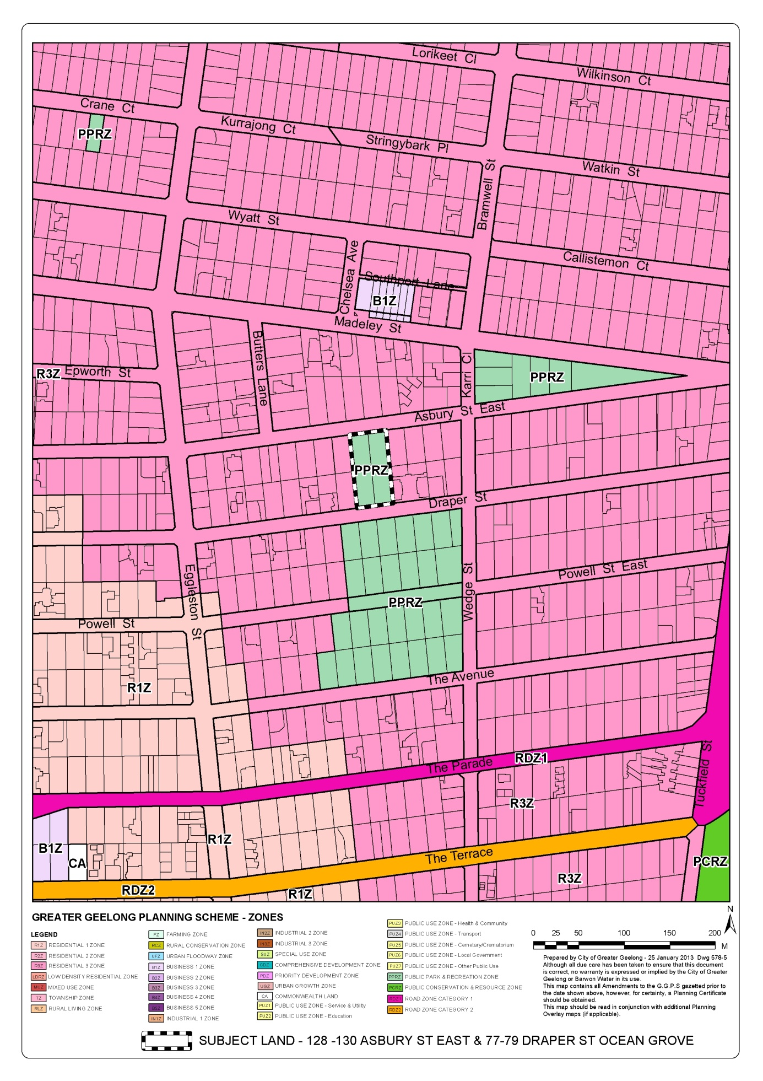
Appendix 2 – Aerial Photo
