rezoning application 302-306 Aberdeen Street, Manifold Heights
Portfolio: | Planning - Cr Macdonald
Source | Economic Development, Planning and Tourism - City Development
General Manager: | Peter Bettess
Index Reference | Application: C302
Purpose
The purpose of this report is to seek Council approval to proceed with the preparation and exhibition of Planning Scheme Amendment C302, subject to authorisation being obtained from the Minister for Planning.
Summary
- An application has been made by ERM Australia consultants on behalf of Coles Group Property, owner of the subject land.
- The application is for a rezoning only of land (in part) at 302-306 Aberdeen Street, Manifold Heights, from Residential 1 Zone to Commercial 1 Zone and to remove the Design and Development Overlay (Schedule 14) which also applies to the land.
- The site is currently occupied by a disused service station and located on the north-west corner of the Shannon Avenue and Aberdeen Street intersection.
- The zoning of the site is unusual in that half of the title (that half fronting Shannon Avenue) is in the Commercial 1 Zone while the rear portion is in the Residential 1 Zone. DDO14 applies to the residentially zoned portion of the site.
- It is accepted practice for zoning boundaries to follow title boundaries. This anomaly has featured in the new format Greater Geelong Planning Scheme since its inception in July 2000. The rezoning application seeks to correct this anomaly in the site’s zoning.
- A previous combined rezoning and planning permit application for a packaged liquor shop at the subject site was rejected by Council at its 24 November 2009 Council meeting due to concerns about the availability of liquor on all four corners of the Shannon Avenue/Aberdeen Street intersection.
- The same company continues to own the subject land today but have indicated they are no longer proceeding with the liquor outlet.
- This application seeks to only partially rezone the land. No permit application accompanies the amendment request.
- It is recommended that Council resolve to exhibit the proposed amendment, subject to obtaining the authorisation of the Minister for Planning.

rezoning application 302-306 Aberdeen Street, Manifold Heights (CONT’D)
Recommendation
That Council resolves to support the preparation and exhibition of Amendment C302 to the Greater Geelong Planning Scheme to rezone land (in part) situated at 302-306 Aberdeen Street, Manifold Heights, from Residential 1 Zone to Commercial 1 Zone and delete Design and Development Overlay – Schedule 14 from the part to the rezoned, subject to the authorisation of the Minister for Planning being obtained.
Background
On 7 August 2013 Council received a planning scheme amendment request from ERM Australia on behalf of Coles Group Property. The application proposed to rezone a portion of the land at 302-306 Aberdeen Street, Manifold Heights, from Residential 1 to Commercial 1 Zone and remove the Design and Development Overlay – Schedule 14 (DDO14) applying to the land.
The subject site consists of one title across the land and common practice is for zoning boundaries to follow title boundaries. Therefore the subject land is considered to have an anomaly in this instance.
A previous combined Planning Scheme Amendment (C209) and Planning Permit Application (PP793/2009 for a proposed packaged liquor shop) at the subject site was considered by Council on 24 November 2009. Council did not support the then officer recommendation to support the combined amendment/permit, rather resolving to reject the proposal. It was of concern to the Council at that time that the combined rezoning and planning permit would permit liquor outlets on all four corners of the Shannon Avenue and Aberdeen Street intersection.
This application does not seek approval for a packaged liquor shop – only the correction of the zoning anomaly is sought.
Subject Site and Locality
The subject land is located at 302-306 Aberdeen Street, Manifold Heights. It has an area of approximately 2,190 square metres and is located at the north western corner of the Shannon Avenue and Aberdeen Street intersection. The site is currently occupied by a discussed service station and warehouse which occupies the majority of the site. There is also a small portion of vacant land within the north western corner of the site.
The land surrounding the site is characterised by a mix of land uses, including retail, residential and commercial development. Built form varies throughout the area with low rise residential development within the existing urban areas and a range of single and double storey buildings associated with commercial/retail uses along Aberdeen Street and Shannon Avenue.
The site is part of the Shannon Avenue retail neighbourhood shopping centre and the abutting land to the north is developed with a drive through coffee outlet. To the west and north west are residential dwellings. To the south across Aberdeen Street is the Great Western Hotel, and a major supermarket and associated car parking is located to the South East. East of the site across Shannon Avenue is a range of commercial and retail uses including a medical and pathology centre. Appendix 1 shows the location of the site and locality. Appendix 2 shows the existing zoning of the area and Appendix 3 shows the proposed rezoning and deletion of DDO14.
rezoning application 302-306 Aberdeen Street, Manifold Heights (CONT’D)
Discussion
Anomalous Zoning
The zoning of the site is an anomaly as over half the title (that fronting Shannon Avenue) is in the Commercial 1 Zone while the rear portion is in the residential 1 Zone. A review of the history of the site reveals that the current zoning configuration dates back to the Geelong Region Interim Development Order maps of 1975-1981 and has remained unchanged since then. A planning permit was also issued in June 1979 allowing for the installation of underground petrol storage tanks. The portion of the land zoned Residential 1 Zone has been used for commercial purposes for a considerable period of time.
The existing zoning arrangement is considered to be anomalous and the 890 square metres of land proposed to be rezoned will facilitate the orderly planning of the area. The deletion of the Design and Development Overlay Schedule 14 is appropriate as it only applies to dwellings over 7.5 metres in areas with access to views.
Consistency with the Retail Strategy
The Greater Geelong Retail Strategy (June 2006) is a reference document in the Planning Scheme and provides a hierarchy of preferences for the location of new retail development. Preference is given to sites located within existing identified activity centres. If no sites are available within existing activity centres, the next preference is for ‘edge-of-centre’ sites. Given the subject site is in two zones, the proposed rezoning can be classified as both ‘in-centre’ and ‘out-of-centre’ development, and will extend the Commercial 1 zoned land west to the title boundary.
Despite this proposal intending to correct a zoning anomaly, it is relevant to establish that the site is appropriate for commercial zoning and future use. The rezoning is considered to be consistent with the principles and actions identified in the Retail Strategy, including supporting the retail hierarchy, to consolidate activities in Centres, to consolidate the network of local convenience centres and to ensure continuity of retail frontage where possible.
The Retail Strategy identifies the role of the Shannon Avenue centre in the hierarchy as a ‘Neighbourhood Centre’ which is defined as a “centre which provides for weekly (or more frequent) grocery shopping based around supermarket tenant. These centres have an indicative retail floor space range of 2,500m² to 10,000m². Future directions for this level of centre include: to retain the focus for convenience shopping facilities which are supported by the surrounding residential neighbourhood; where possible, promote main road frontage, accessibility by public transport and by cycling and walking; and encourage development in such a way that the visual functional environment of the centre is improved, so that they become vibrant focal points for the local communities they serve.
The Retail Strategy defines the site as the ‘Shannon Avenue (Newtown) Neighbourhood Centre’, being located approximately 3km to the west of the Central Geelong at the intersection of Shannon Avenue and Aberdeen Street. The centre is described as containing approximately 4,100m² of retail floor space, anchored by a Safeway supermarket (currently branded as Woolworths) and as primarily a convenience-based retail destination for local residents.

rezoning application 302-306 Aberdeen Street, Manifold Heights (CONT’D)
Main features and issues for this centre are stated: “The primary issue for this centre is the maintenance of a convenience retail offer in view of the competition from nearby larger centres at Pakington Street and to the north at Shannon Avenue (Geelong West). The supermarket remains a key to the function of this centre because of the customer traffic it generates for the other smaller traders in the centre”. It is considered that the proposed rezoning is consistent with the role and function of the Shannon Avenue (Newtown) Neighbourhood Centre as outlined in the Strategy.
The proposed increase in retail floor space is well within the designated range for a Neighbourhood Centre and will assist in maintaining the viability and competitiveness of the centre.
The Strategy acknowledges that the retail sector plays an important role in generating jobs and incomes, and that significant population growth is forecast for the Geelong region. Policies to promote higher density living close to activity centres and the identification of the Fyansford area for infill urban growth (located 2km to the west of the site) further support the need for new retail floor space as well as to enable the redevelopment and improvement of existing retail floor space.
Traffic/Road issues
Officers indicate that there are no specific requirements for the rezoning of part of the land. VicRoads has outlined requirements for any future planning permit application for use and development of the site, in particular for access to and egress from the site off the two major roads of Aberdeen Street and Shannon Avenue. These will need to be considered as part of any future permit application.
It is noted that no on-street car parking will be allowed for outside of the site in either of the adjoining major roads.
Future use of the site
This application does not seek approval for a packaged liquor shop (as previously applied for). Importantly, it is noted that under the provisions of Clause 52.27 of the Planning Scheme which relates to ‘licensed premises’, planning approval is required for a packaged liquor shop. This is a changed planning provision since the previous proposal was rejected by Council.
No representations from the applicant have been made about future use of the subject land.
The rezoning is supported from both an administrative perspective through the correction of an anomalous zoning situation and from a planning policy perspective through the support of the Retail Strategy.
The applicant sought to correct the anomaly in the zoning of the subject land pursuant to Section 20(2) of the Planning and Environment Act 1987. In accordance with the provisions of Section 20(2) of the Act, the Minister may grant an exemption from the notice requirements if the Minister considers that compliance with any part of those requirements is unwarranted, or that the interests of Victoria or any part of the Victoria make such an exemption appropriate. Although the subject land is considered to have and anomalous zoning, officers, given the history of the recent combined application for the land, support following the usual notification requirements for an amendment to correct this.

rezoning application 302-306 Aberdeen Street, Manifold Heights (CONT’D)
Environmental Implications
The proposed rezoning has no environmental implications. The previous combined amendment and permit application included the on-site environmental assessment conducted by Douglas Partners to provide an indication of the contamination status of the soils and groundwater. Based on the 32 soil samples taken across the site, no remedial earthworks are considered necessary and the existing soils are considered suitable for future commercial/retail use. A series of groundwater sampling was also conducted, with the Douglas Partners confirming that ground water condition of the site is no considered to warrant active remediation.
The EPA has commented that in light of this environmental site assessment the rezoning will not have any further impact on the beneficial uses of the site. It recommends that prior to any future development that Council reassess the suitability of the sire for the given application as a result of the findings of the Douglas Partners Report.
Officers confirm that noise from any future use impacting on adjacent residential use and any contaminated land from previous service station use, can be addressed with the planning permits for such use.
Financial Implications
There are no financial implications for Council arising from adopting the recommendations of this report.
Policy/Legal/Statutory Implications
State Planning Policy Framework
The State Planning Policy Framework generally encourages the development of a range of land uses which are complementary to surrounding areas. The proposed amendment seeks to rectify an anomaly in the zoning of this property to reflect the anticipated (previous and ongoing) future land use. This transparency of land use is consistent with the goals of the SPPF at clause 10.02 which seeks ‘to provide for the fair, orderly, economic and sustainable use and development of land’.
The proposal to rezone this portion of the site is also consistent with the ‘Activity Centre’ objectives of Clause 11.01 and 11.04-2 by clarifying the intent of this land parcel which will enable ‘appropriately located’ commercial land uses to utilise the site within an existing activity centre. In turn, this will provide certainty to the community and the local economy thereby meeting the requirements of Clause 17.01.
Local Planning Policy Framework
The rezoning will reflect and further support the status of land as a part of the Shannon Avenue (Newtown) Neighbourhood Centre by enabling the western portion of the site to be used for commercial land use purposes (an intention clearly contemplated in the past use of the site as a petrol station and its current designation under Clause 21.07.
The clarification of land use will further promote and enhance the development potential of the site for a commercial purpose, consistent with the objectives of a Neighbourhood Centre (Clause 21.07)

rezoning application 302-306 Aberdeen Street, Manifold Heights (CONT’D)
The increase in commercial land are (approximately 890m²) will be negligible on the broader context of the neighbourhood centre which currently contains approximately 4,100 square metres of retail floor space. The rezoning will not significantly alter how the land has previously been used (i.e. commercial).
Alignment to City Plan
The amendment aligns with the City Plan’s strategic direction, Growing our Economy, and the priority relating to ‘support existing businesses and encourage new and emerging growth sectors’. The amendment will rezone land which will facilitate sustainable development of an existing retail centre.
Officer Direct or Indirect Interest
No Council officers involved in the proposed rezoning have a direct or indirect interest in matters contained in this report.
Risk Assessment
No risks have been identified regarding the rezoning of this land.
Social Considerations
No adverse social impacts are expected to result from this amendment.
Human Rights Charter
The proposal does not impact on any human rights and responsibilities set out in the Charter. Planning legislation ensures an open community consultation process occurs enabling people to freely express their views and if necessary obtain a fair hearing before an Independent Panel.
Consultation and Communication
Officers held a pre-application meeting with the proponent on 26 June 2013 about the proposal to rezone the subject land that is in two zones. Officers provided comment on the plan and recommended that the zoning was anomalous and agreed to consider an application to rezone the land to Commercial 1 Zone.
Following receipt of the application, officer sought referral comments from internal Council departments and external referral agencies. To date there have been no significant strategic concerns raised. It is proposed that the Amendment be exhibited in accordance with the provisions of the Planning and Environment Act to provide for full public comment (and potentially referral to a Panel appointed by the Minister for Planning).
It is intended that direct written notification be provided to all adjoining and nearby property owners potentially affected by the Amendment

APPENDIX 1 – Site Location
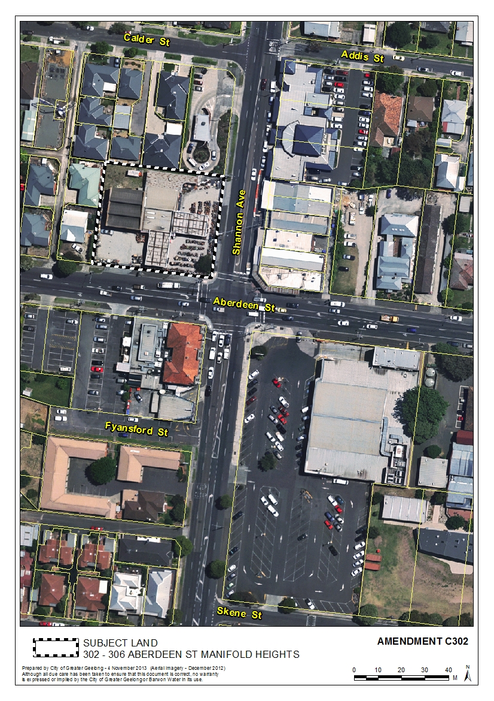

APPENDIX 2 – Current Zoning Plan
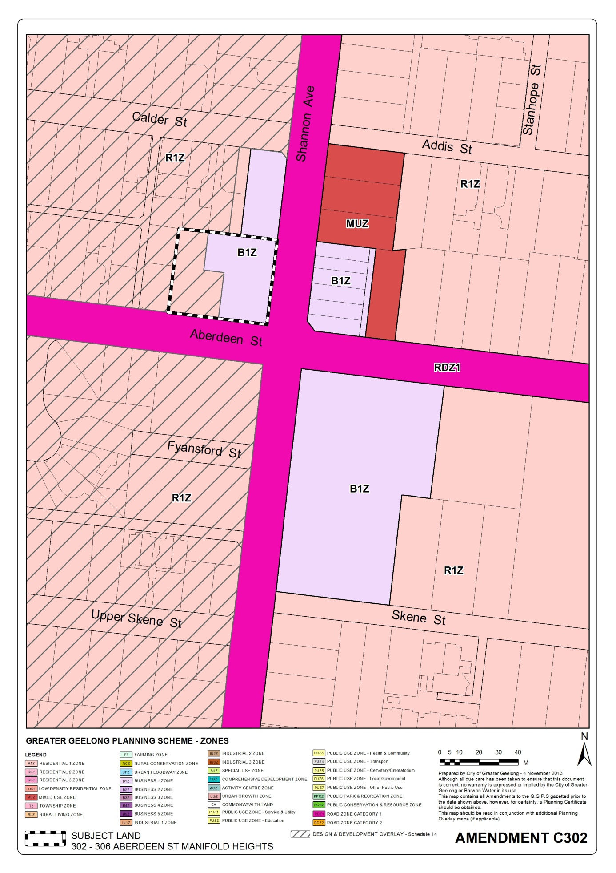

APPENDIX 3 – Proposed Zoning Change
