To: Peter Smith – Coordinator Strategic Implementation
From: Barry Gough
Subject: 28 - 68 Canterbury Road West Lara
Farming zone to General Residential zone
Index Reference: Project: Amendment C266
Reports Council & Other 2013
Subject: Delegated Decisions 2013

Summary
- The request to prepare the Amendment has been lodged by TGM on behalf of Point Cook Pty Ltd.
- The Amendment proposes to re-zone land from Farming zone (FZ) to General Residential zone (GRZ) and to apply the Special Building Overlay (SBO) together with a Schedule to the SBO (SBO2) to the re-zoned land and adjoining vacant Residential 1 zone (R1Z) land.
- The subject land is vacant, located within the Settlement Boundary identified in the Lara Structure Plan and surrounded by R1Z land, comprised of a mix of established and developing residential communities to the west, north and east.
- The application was accompanied by detailed supporting documentation, including a flooding and drainage study.
- It is recommended that exhibition of the Amendment be supported.
Recommendation
That Council, having considered all matters as required by Section 12 (2) of the Planning and Environment Act 1987, resolves to:
- support the preparation and exhibition of amendment C266 to the Greater Geelong Planning Scheme to
- rezone land at 50-68 Canterbury Road West, Lara from Farming Zone to General Residential Zone (GRZ); and
- apply the Special Building Overlay (SBO) together with a schedule to the SBO (SBO2) to the land at 26 – 68 Canterbury Road West, Lara; and
- Request the Minister for Planning to authorise the preparation and exhibition of Amendment C266 to the Greater Geelong Planning Scheme.
Background
The land which is to be re-zoned, 50 – 68 Canterbury Road West, is bounded to the west and north by the ‘Grand Lakes’ estate. The re-zoning will correct an anomaly which resulted from the then owner of the property not having wished to be considered for re-zoning as part of the Grand Lakes Amendment, C86.
The land at 26 – 48 is currently zoned Residential 1 (R1Z) but is presently unable to be drained as part of the adjoining subdivision.
Discussion
The application of the SBO to all of the affected land, together with the proposed street and drainage network which integrates with the Grand Lakes development, will ensure that all of the subject land can be developed in a safe and sustainable manner.
This ‘infill’ re-zoning will ensure the completion of a consistent and appropriate residential development form on this significant portion of the southern urban boundary of Lara.
Appendix 1 is an aerial photograph which shows the context of the amendment site in relation to the surrounding residential development to the north, east and west, and the land in the farming zone, on the south side of Canterbury Road West.
Appendix 2 shows that the land proposed to be re-zoned is located within the Settlement Boundary identified in the Lara Structure Plan.
Appendix 3 identifies the land which is to be re-zoned to GRZ, while Appendix 4 identifies the extent of the proposed application of the SBO2.
Environmental Implications
The amendment will not have any adverse effects on the environment. In particular, the application includes reports which show that there will be no adverse effects on surrounding land arising from flooding and drainage.
Financial Implications
The re-zoning of the land does not have any financial implications for Council.
Policy/Legal/Statutory Implications
There are no policy / legal / statutory implications associated with the re-zoning of the land consistent with the existing established adjoining land use.
Risk Assessment
The re-zoning of the land and application of the Special Building Overlay, together with a schedule which specifies minimum finished floor and surface levels, does not result in any risks to Council.
Social Considerations
The amendment will facilitate a number of positive social and economic outcomes including:
- Ensuring maintaining an adequate supply of residential land in Lara;
- Provision of economic development and employment; and
Efficient utilization of existing community infrastructure, services and facilities.
Consultation and Communication
It is proposed that this amendment be exhibited for public comment as required by the Planning & Environment Act.

Appendix 1
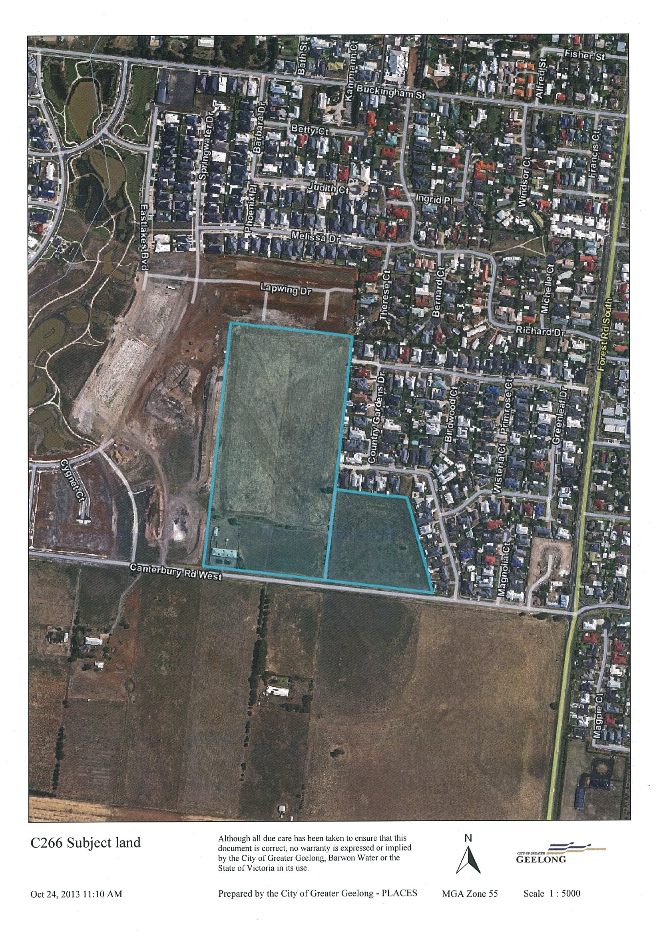

Appendix 2
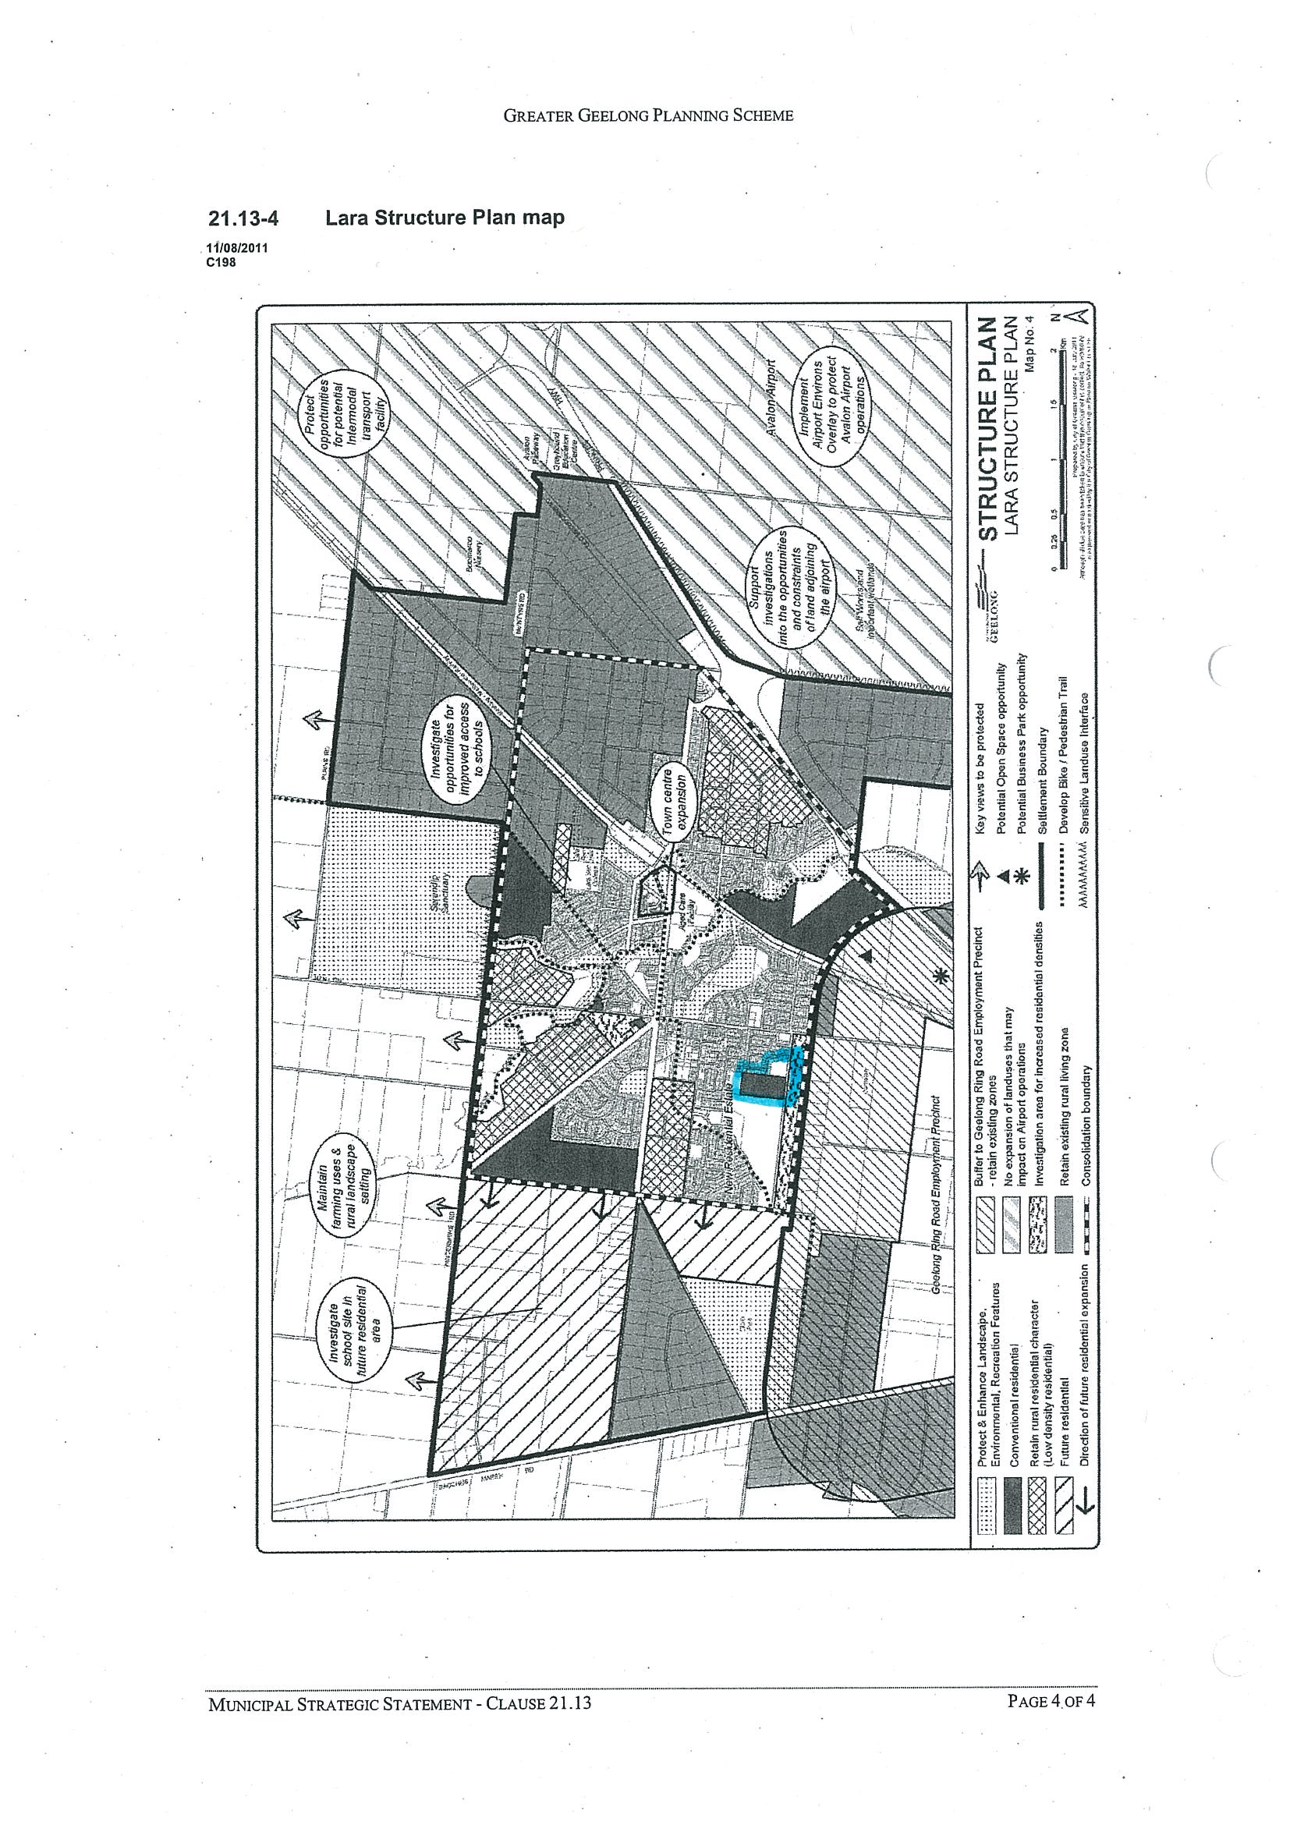

Appendix 3
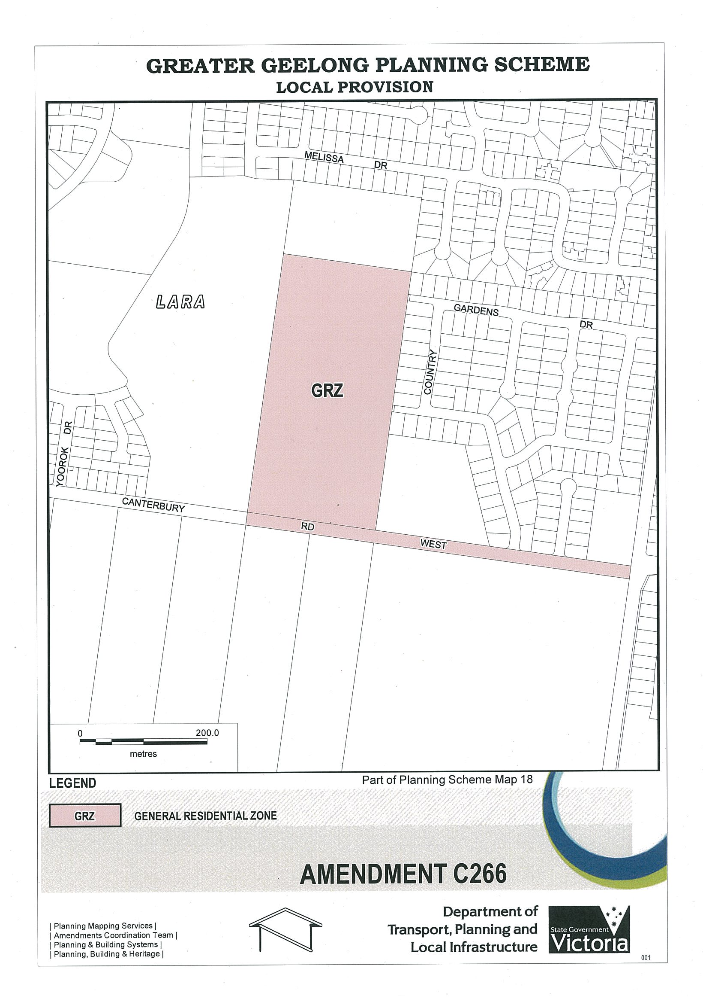

Appendix 4
