
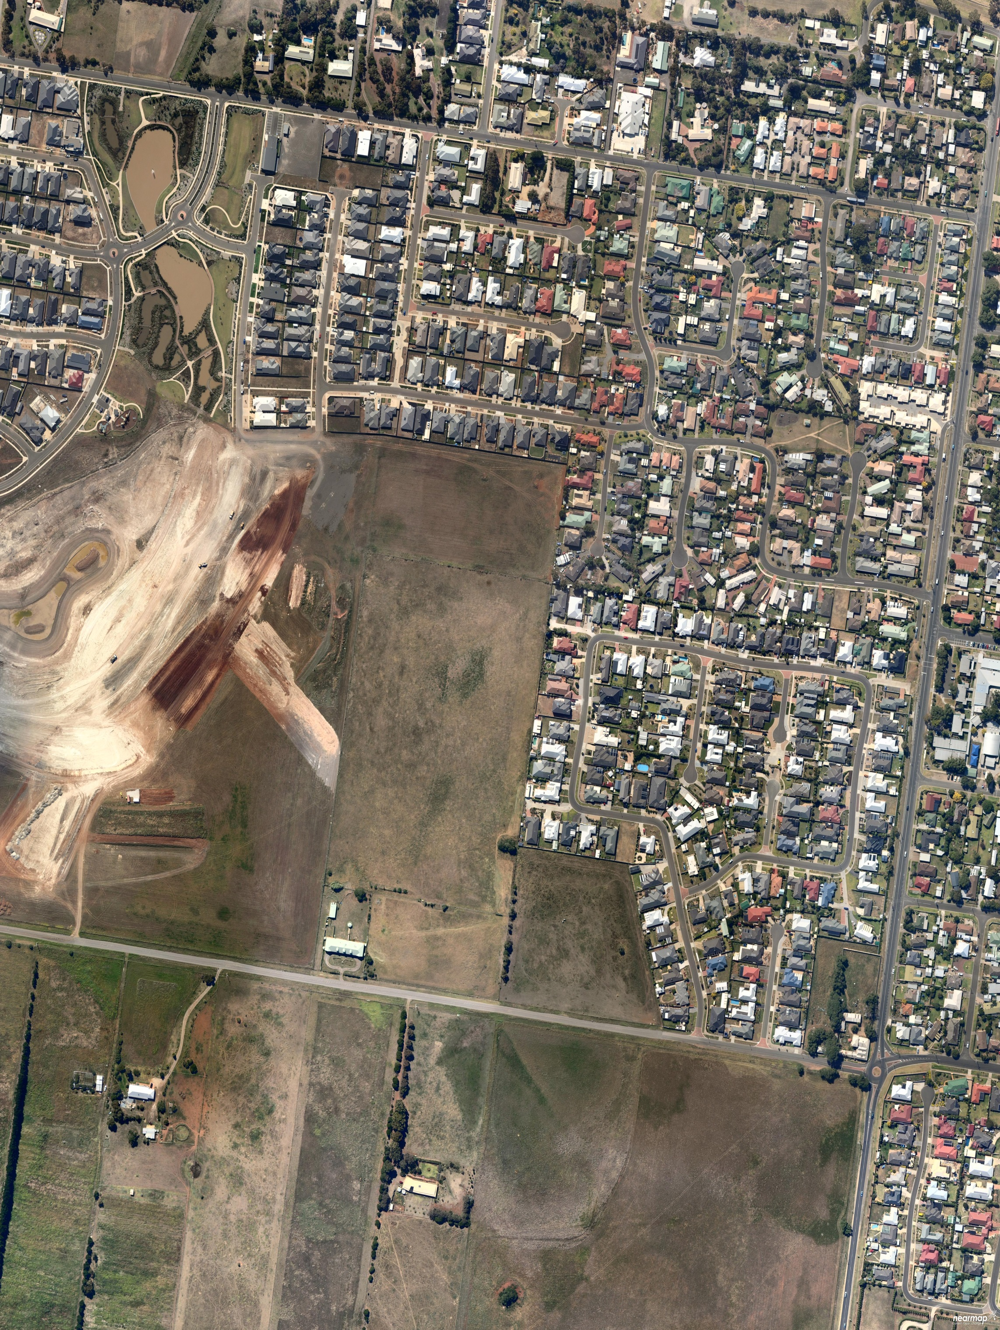


Planning Scheme Amendment Application C266

Combined Rezoning & Multi-Lot Subdivision

50 – 68 Canterbury Road West, Lara and 26 – 48 Canterbury Road West, Lara

July 2013



Prepared for:

Point Cook Pty Ltd

Prepared by:

TGM Group Pty Ltd
1/27-31 Myers Street (PO Box 1137)
Geelong Vic 3220
T 03 5202 4600
F 03 5202 4691
www.tgmgroup.com
ABN 11 125 568 461

Quality Information

Document Rezoning Request
Reference No. 10679-01
Date July 2013
Revision No. 2
Prepared by Chris Marshall
Reviewed by Chris Marshall

The information contained in this document produced by TGM Group Pty Ltd is solely for the use of the Client identified on the cover sheet for the purpose for which it has been prepared and TGM Group Pty Ltd undertakes no duty to or accepts any responsibility to any third party who may rely upon this document. All rights reserved. No section or element of this document may be removed from this document, reproduced, electronically stored or transmitted in any form without the written permission of TGM Group Pty Ltd.
Table of Contents

1. Introduction 4
2. background 5
3. Application overview 7
4. application rationale 7
5. Subject Site & Site context 8
6. current zoning 10
7. application details 11
8. zone provisions 15
8.1 Residential 1 Zone 15
9. Proposed ALTERNATIVE RESIDENTIAL zonES 17
10. proposed overlay 17
11 particular provisions 18
11.1 Public Open Space Contribution and Subdivision 18
11.2 Native Vegetation 19
11.3 Residential Subdivision 20
12 general provisions 20
12.1 Decision Guidelines 20
13 policy context 22
13.1 Planning and Environment Act 1987 22
13.2 State Planning Policy Framework 23
13.3 Local Planning Policy Framework 24
14 TECHNICAL ASSESSMENTS 25
15 CONCLUSION 26

Figure 1: Map 4 – Lara Structure Plan
Figure 2: Location Map
Figure 3: Aerial Plan
Figure 4: Current Zoning Map
Figure 5: Proposed Zoning Map
Figure 6: Integrated Plan of Subdivision
Figure 7: Proposed Plan of Subdivision
Figure 8: Proposed Schedule 2 to the Special Building Overlay
Figure 9: Public Open Space Map

Attachment 1 – Letter of Request from City of Greater Geelong
Attachment 2 – Aerial Plan
Attachment 3 – Current Zoning Plan
Attachment 4 – Proposed Zoning Plan
Attachment 5 – Integrated Plan of Subdivision
Attachment 6 – Proposed Staged Plan of Subdivision
Attachment 7 – Clause 56 Assessment
Attachment 8 – Schedule 2 to the Special Building Overlay
Attachment 9 – Vegetation and Net Gain Assessment, Mark Trengove Ecological Services
Attachment 10 – Cultural Heritage Management Plan, TerraCulture
Attachment 11 – Grand Lakes Modelling & Impact Report, Addendum No. 7, BMT WBM
Attachment 12 – Transport Impact Assessment, ESR Transport Planning
Attachment 13 – Amendment Documentation
- Introduction

TGM Group Pty Ltd has been engaged by Point Cook Pty Ltd, to submit Planning Scheme Amendment application C266 for the rezoning and staged subdivision of land at 50 – 68 Canterbury Road West, Lara, under Section 96A of the Planning and Environment Act 1987.

The subject land is located in south Lara at 50 – 68 Canterbury Road West and is 8.164 hectares in area. The land is within the Farming Zone under the Greater Geelong Planning Scheme with no overlays.

In accordance with the recommendations of the Lara Structure Plan 2011 and Clause 21.13 Structure Plan Map 4 of the Greater Geelong Planning Scheme Amendment C266 seeks approval to rezone the subject land from Farming Zone to Residential 1 Zone.

Part of proposed Amendment C266 also includes the introduction of a Schedule to the Special Building Overlay over the subject land and the adjoining Residential 1 Zone land at 26 – 48 Canterbury Road West, Lara. The proposed application of the schedule over this additional zoned land parcel is proposed at the request of the City of Greater Geelong (Attachment 1).

Amendment C266 also seeks approval for the granting of a planning permit for the staged multi lot subdivision of approximately 128 conventional sized residential allotments for the subject land at 50 – 68 Canterbury Road West.

This planning report has been prepared in support of Planning Scheme Amendment C266 consistent with the overarching State and Local Strategic Planning Policies and specific statutory planning provisions of the Greater Geelong Planning Scheme relevant to the rezoning and the future subdivision of this land.

The planning report also includes a number of technical reports that demonstrate the subject lands suitability and capability to facilitate future residential subdivision and development. The report is to be read in conjunction with these technical reports as attached to this application.

- background

Lara Structure Plan 2011

In 2009 the City of Greater Geelong commenced a review of the 2007 Lara Structure Plan under Planning Scheme Amendment C198. The purpose of the review was to identify the key strategic planning issues facing the town, including (among others) to articulate the preferred growth direction of the town, the location of the settlement boundary and opportunities for growth and appropriate planning controls. Part of the review also determined the Lara Settlement Boundary and land within the Boundary for short term and longer term residential growth as reflected the Lara Structure Plan Map 4. The outcomes of the review are reflected in the amended Lara Structure Plan 2011 as adopted by the City of Greater Geelong.

On 11 August 2011, the Minister for Planning approved Planning Scheme Amendment C198 which included the Lara Structure Plan 2011 and amendments to the Greater Geelong Planning Scheme consistent with the directions and policies of the Lara Structure Plan. These amendments included:

- Amending the Municipal Strategic Statement by replacing Clause 21.13 Lara to reflect the directions and policies of the Lara Structure Plan 2011.
- Inclusion of Lara Structure Plan Map 4.

The subject land is identified in both the Lara Structure Plan 2011 and Clause 21.13 Lara Structure Plan Map 4 for rezoning from the Farming Zone to the Residential 1 Zone. Under the Conventional Residential Development opportunities identified in the Lara Structure Plan 2011 (page 11) the lot at 50 Canterbury Road West is identified as forming part of the Grand Lakes Estate, however it was not rezoned as part of this estate. It recommended that:

‘this site be nominated appropriate to be rezoned from Farming to Residential Zone subject to a development plan overlay or other mechanism to ensure integration with the neighbouring residential areas and a resolution of drainage, open space, layout etc.’

Under Clause 21.13, Lara Structure Plan Map 4, the subject land (as indicated) is located in south Lara within the Settlement Boundary and is identified as Conventional Residential.
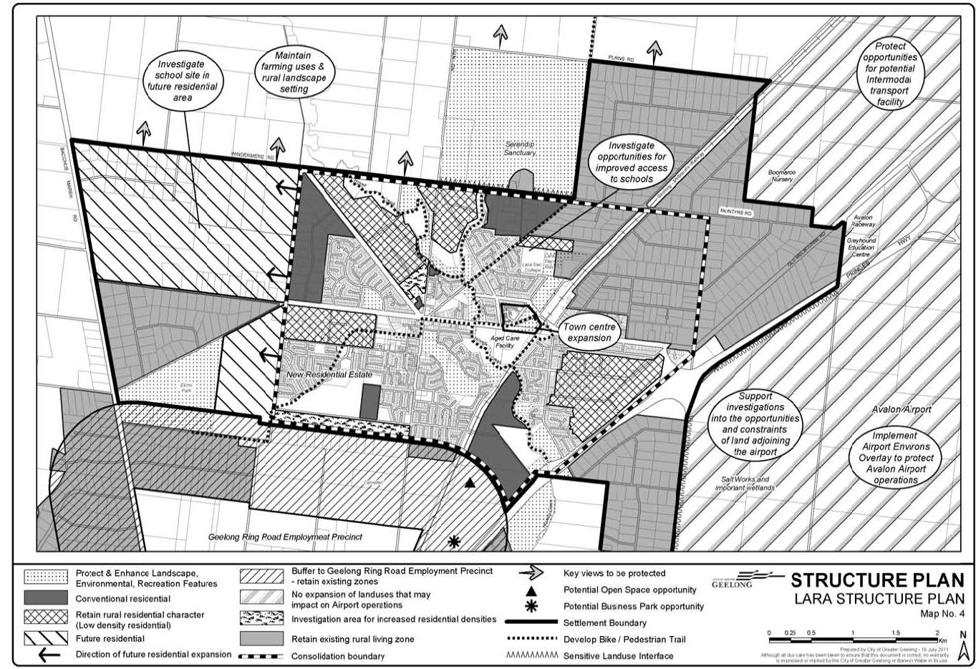

Figure 1: Map 4 – Lara Structure Plan Subject land

Comment: This rezoning and staged multi-subdivision application accords with the approved Lara Structure Plan 2011 and Clause 21.13 as it will:

- Contain residential growth within the Lara Settlement Boundary in accordance with Clause 21.13 Lara and as indicated in the Lara Structure Plan Map No. 4 of the Greater Geelong Planning Scheme.
- Support the development of areas identified for rezoning to Residential 1 and Low Density Residential in accordance with the Lara Structure Plan Map No. 4.
- Directs residential growth to an area recognised as suitable for conventional residential development due to its close location to all town services.

The proposed subdivision has been designed specifically to integrate with the surrounding established residential development and includes the following features:

- Integration of the proposed drainage design with the adjoining Grand Lakes Estate and surrounding land parcels as detailed in the Grand Lakes Hydraulic Modelling and Impact Report – Addendum No.6, May 2012.
- Integration of the proposed road network with the adjoining residential developments to the north and west.
- Pedestrian connection to the east to provide cycle and walking access to Forest Road.
- Application overview

This application seeks approval for Planning Scheme Amendment C266 under Section 96A of the Planning and Environment Act 1987 for the combined rezoning and subdivision of land at 50 – 68 Canterbury Road West, Lara. This application seeks to:

- Rezone the subject land from the Farming Zone to the Residential 1 Zone.
- Apply a Schedule 2 to the Special Building Overlay over the subject land.
- Undertake a staged multi-lot subdivision of the subject land in accordance with the planning provisions of the Greater Geelong Planning Scheme.

This application also seeks approval to apply a Schedule 2 to the Special Building Overlay over the adjoining land at 26 – 48 Canterbury Road West (Lot A PS443442), Lara at the request of the City of Greater Geelong. This land will be subject to a separate future subdivision application.

- application rationale

This application seeks approval for the combined rezoning and multi lot subdivision of the subject land at 50 – 68 Canterbury Road West, Lara, under Section 96A of the Planning and Environment Act. A Section 96A application is considered the most appropriate mechanism to undertake the rezoning and residential subdivision as:

- The land is relatively small in area at just over 8 hectares.
- The land is not subject to multiple numbers of land owners.
- The supporting technical reports attached to this application demonstrate the lands suitability and capability to be subdivided for residential use and development. No additional detailed investigations are considered necessary.
- The use of a Special Building Overlay has also been effectively applied to the adjoining Grand Lakes Estate and is also proposed to be applied to the subject land and the adjoining land at 26 – 48 Canterbury Road West to ensure a consistent integrated approach to flood and drainage management.
- The proposed plan of subdivision layout has been designed to integrate with the adjoining residential development.
- The proposed plan of subdivision layout accords with the relevant provisions of the Residential 1 Zone.
- The subdivision and development of the land can be appropriately managed via planning permit conditions. Any additional work such as detailed engineering designs will be managed via conditions on the proposed permit to the satisfaction of the responsible authority, which is the accepted planning process.
- A Section 96A combined application provides a significant degree of certainty regarding the final form of this subdivision and its proposed integration with adjoining uses.

The introduction of a Schedule 2 to the Special Building Overlay over the adjoining land at 26 – 48 Canterbury Road West is also considered an appropriate integration measure to ensure consistency with the subject land and the adjoining Grand Lakes Estate.

- Subject Site & Site context

The subject land is located in Lara which is a major township at the northern end of the City of Greater Geelong approximately 15 kilometres from central Geelong. Lara is identified as a growth area in the Geelong Urban Growth Strategy and the Municipal Strategic Statement of the Greater Geelong Planning Scheme. The subject land at 50 – 68 Canterbury Road West consists of 1 title, being Lot 1, Title Plan 60732C (formerly known as part of Portion C, Section 15, Parish of Moranghurk), Vol. 03423 Fol. 528. The adjoining land at 26 – 48 Canterbury Road West, Lara, consists of 1 title being Lot A, PS443442 (SBO only).

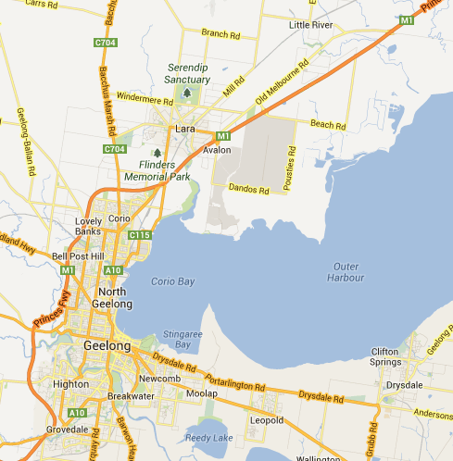
Figure 2: Location Map

The subject land is located within the Lara Settlement Boundary in southern Lara on the northern side of Canterbury Road West, adjoining the Grand Lakes Estate to the north and west and vacant Residential 1 Zone land to the east. Land located adjacent to the south of the subject land is in the Farming Zone identified in the Lara Structure Plan as ‘Investigation areas for increased residential densities’.
The subject land is rectangular in shape and approximately 8.164 hectares in area. The land forms part of the Canterbury Road West land area identified in the approved Lara Structure Plan 2011 for conventional residential development.

The majority of the land is vacant and utilised for agricultural purposes. A single storey brick house and associated outbuilding are located in the south-west corner of the site abutting Canterbury Road West. The land is also devoid of any significant native vegetation.

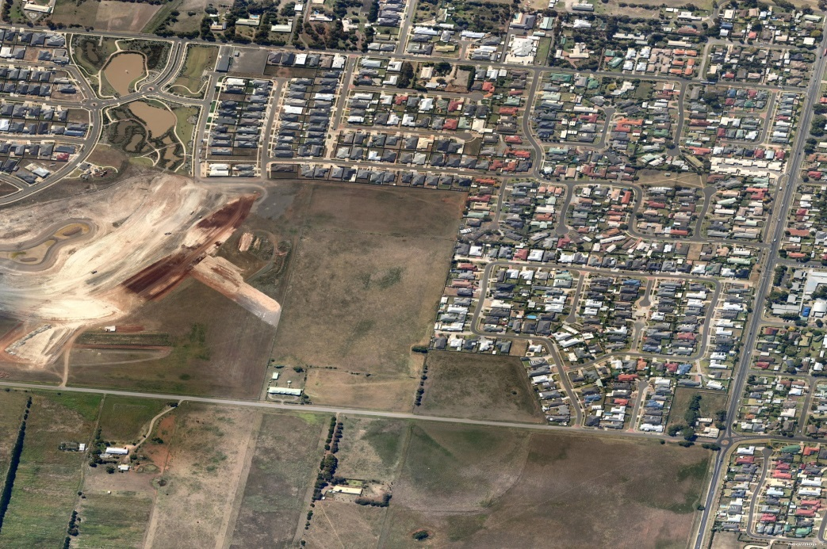

Subject land

26 – 48 Canterbury Road West, Lara

Figure 3: Aerial Plan (Attachment 2)

Canterbury Road West is an unsealed road with gravel shoulders and grassed verges until Country Garden Drive, where the road becomes bitumen with concrete guttering and footpaths on the north side.

As advised, this application also seeks approval to introduce a Schedule 2 to the Special Building Overlay over the adjoining land at 26 – 48 Canterbury Road West, Lara. This land is approximately 2.2 hectares, does not contain any buildings and has been historically used for grazing purposes.

- current zoning

The subject land at 50 – 68 Canterbury Road West is currently zoned Farming Zone (See Figure 4 – Zoning Plan). The purpose of this zone is to:
- To implement the State Planning Policy Framework and the Local Planning Policy Framework, including the Municipal Strategic Statement and local planning policies.
- To provide for the use of land for agriculture.
- To encourage the retention of productive agricultural land.
- To ensure that non-agricultural uses, particularly dwellings, do not adversely affect the use of land for agriculture.
- To encourage use and development of land based on comprehensive and sustainable land management practices and infrastructure provision.
- To protect and enhance natural resources and the biodiversity of the area.

Comment: The subject land is recommended for conventional residential development in the Lara Structure Plan 2011 and the planning policies of the Greater Geelong Planning Scheme. The land is not encouraged to be retained for agricultural use and has no significant natural or biodiversity values. The land is also located in an urban residential context within the settlement boundary of Lara. Farming zone land located to the south is within multiple land ownerships and is also recommended to be investigated for future urban expansion as illustrated in Figure 4.

Whilst the land is zoned for farming, the overall weight of planning policy and surrounding urban and future urban context is incongruent with the continued maintenance of this land for farming purposes under this zone.

Land at 26 – 48 Canterbury Road West is undeveloped land zoned as Residential 1 Zone land as illustrated in the current zoning map.

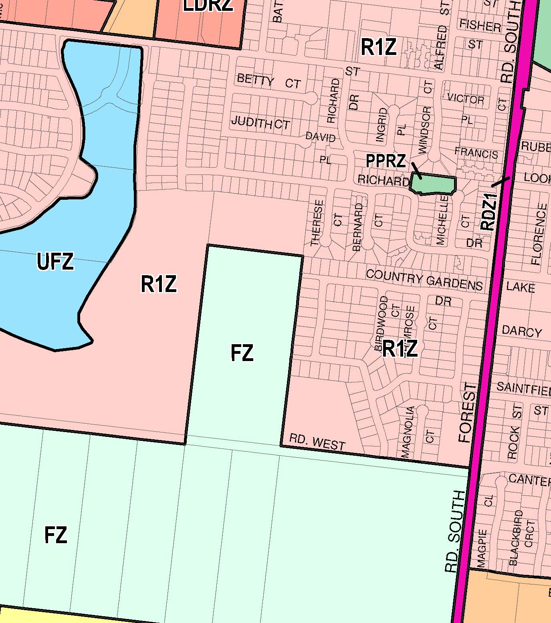
26 – 48 Canterbury Rd West
Subject Land
Figure 4: Current Zoning Map (Attachment 3)

- application details

In accordance with Section 96A of the Planning and Environment Act 1987 this application seeks approval for a combined planning scheme amendment and planning permit application.
The application seeks approval to:

- Rezone the subject land at 50 – 68 Canterbury Road West of approximately 8.164 hectares on the north side of Canterbury Road from Farming Zone to Residential 1 Zone;
- Apply a Schedule to the Special Building Overlay over the subject land and adjoining land at 26 – 48 Canterbury Road West, Lara; and
- Undertake a multi-lot subdivision of the subject land for a conventional residential development in accordance with the statutory planning provisions of the Greater Geelong Planning Scheme.

Figure 5: Proposed Zoning Map (Attachment 4)

This application has been prepared to provide the appropriate zone, development controls and detailed subdivision design for the future residential subdivision of the subject land at Canterbury Road West, Lara in accordance with the Greater Geelong Planning Scheme.

The proposed Residential 1 Zone will provide an appropriate opportunity to coherently integrate with the existing urban context of this area in Lara. This is illustrated in the proposed zoning map and the proposed plan of subdivision which exhibits an integrated road and pedestrian network to provide a seamless transition through to the adjoining residential estates. The proposed plan of subdivision has also been designed to integrate with the adjoining residential land and with the existing drainage network of the established Grand Lakes Estate as illustrated in the Integrated Plan of Subdivision below.

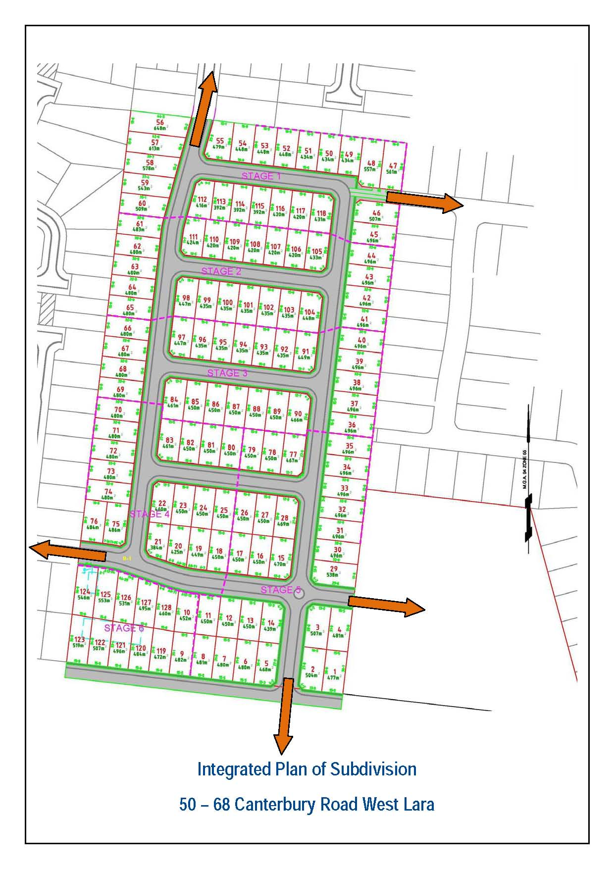
Figure 6: Integrated Plan of Subdivision (Attachment 5)

The proposed residential development will create approximately 128 conventional lots at approximately 12 lots per hectare. This lot density is considered to be congruent with the existing residential development to the east and north and is an appropriate density in Lara. The average lot size is 469m² and the lot range is indicated in the table below.

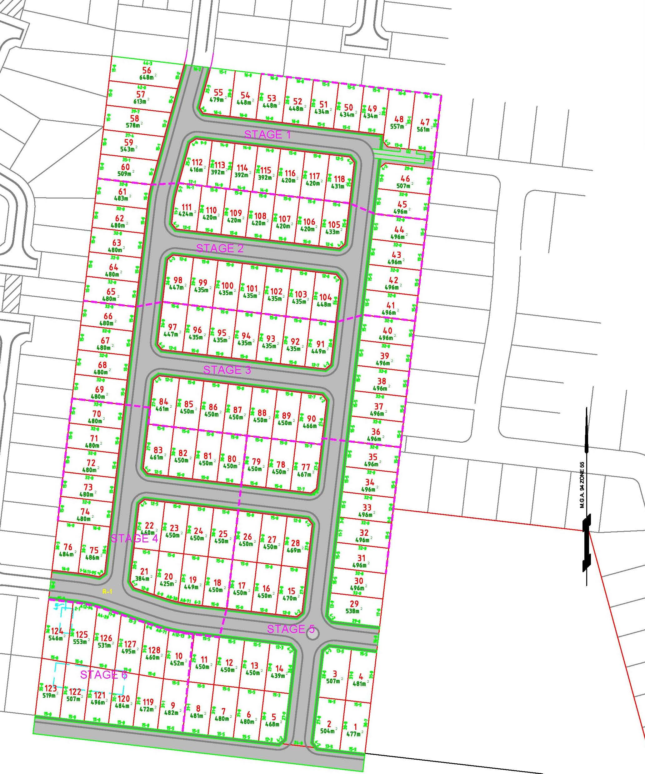
Figure 7: Proposed Plan of Subdivision (Attachment 6)

Area Range (m²) | No. of Lots | Proportion
301-400 | 1 | 1%
401-500 | 112 | 87%
501-600 | 14 | 11%
601-700 | 1 | 1%
 | 128 | 100%

The proposed staging plan has been designed to logically commence the subdivision of this land along the northern boundary where services are available including drainage infrastructure which has been upsized in the Grand Lakes Estate to facilitate the additional stormwater volumes.

- zone provisions

Residential 1 Zone

The subject site is proposed to be rezoned to Residential 1 Zone. The purpose of this zone is:

- To implement the State Planning Policy Framework and the Local Planning Policy Framework, including the Municipal Strategic Statement and local planning policies.
- To provide for residential development at a range of diversities with a variety of dwellings to meet the housing needs of all households.
- To encourage residential development that respects the neighbourhood character.
- In appropriate locations, to allow educational, recreational, religious, community and a limited range of other non-residential uses to serve local community needs.

Comment: An assessment of the application in response to the State Planning Policy Framework and the Local Planning Policy Framework and Local Policies is included in this report.

The rezoning and proposed subdivision of this land will create a variety of residential lot sizes from 384m² to 637m² which in turn will encourage the development of variety of dwellings to satisfy the varying housing demands of the Lara Community.

The subdivision layout has been specifically designed to integrate with and complement the adjoining residential development of the Grand Lakes Estate but also demonstrates integration with residential land to the north and east.

The subject land is also located close to schools, open space and within walking distance to community and commercial services, and is ideally suited for conventional residential development.

The proposed subdivision will be accessed via the existing local road network and Canterbury Road West which has the capacity to facilitate the estimated additional traffic volumes as confirmed in the ESR Transport Planning as attached to this report.

Subdivision
Under the provisions of Clause 32.01-2 of the Greater Geelong Planning Scheme, a planning permit is required to subdivide land within the Residential 1 Zone. There are no minimum lot size requirements, subdivisions must meet the relevant requirements of Clause 56 (Attachment 7).

- Must meet all of the objectives included in the clauses specified in the following table.
- Should meet all of the standards included in the clauses specified in the following table. STANDARDS TO BE
Class of subdivision | Objectives and standards to be met
60 or more lots | All except Clause 56.03-5.
16 – 59 lots | All except Clauses 56.03-1, 56.03-3, 56.03-5,  56.06-1 and 56.06-3
3 – 15 lots | All except Clauses 56.02-1, 56.03-1 to 56.03-4, 56.05-2, 56.06-1, 56.06-3 and 56.06-6.
2 lots | Clauses 56.03-5, 56.04-2, 56.04-3, 56.04-5, 56.06-8 to 56.09-2.

Comment: The application involves the proposed staged multi lot subdivision of approximately 128 lots. Therefore the application must meet all the requirements of Clause 56 except for Clause 56.03-5. A response to Clause 56 is attached as part of this planning permit application.

Decision guidelines
Before deciding on an application, in addition to the decision guidelines in Clause 65, the Responsible Authority must consider, as appropriate:

- The State Planning Policy Framework and the Local Planning Policy Framework, including the Municipal Strategic Statement and local planning policies.
- The objectives and standards of Clause 56.

Comment: The application is considered to accord with the decision guidelines of this clause which are addressed further in this planning report.

- Proposed ALTERNATIVE RESIDENTIAL zonES

Under the proposed reforms by Department of Planning and Community Development to the current zones, Residential 1 Zone may become General Residential Zone. The purpose of this zone is:

- To implement the State Planning Policy Framework and the Local Planning Policy Framework, including the Municipal Strategic Statement and local planning policies.
- To encourage development that respects the neighbourhood character of the area.
- To implement neighbourhood character policy and adopted neighbourhood character guidelines.
- To provide a diversity of housing types and moderate housing growth in locations offering good access to services and transport.
- To allow educational, recreational, religious, community and a limited range of other non-residential uses to serve local community needs in appropriate locations.

Comment: Whilst it is uncertain when the proposed amended zones will apply, it is considered that in this context, it is likely the proposed General Residential Zone will apply. The proposed rezoning and subdivision will provide a development outcome that accords with the purpose of the zone.

- proposed overlay

Clause 44.05 Special Building Overlay (SBO) is proposed to cover the subject site at 50 – 68 Canterbury Road West and also the adjoining site at 26 – 48 Canterbury Road West, Lara.

The purpose of this overlay includes:

- To implement the State Planning Policy Framework and the Local Planning Policy Framework, including the Municipal Strategic Statement and local planning policies.
- To identify land in urban areas liable to inundation by overland flows from the urban drainage system as determined by, or in consultation with, the floodplain management authority.
- To ensure that development maintains the free passage and temporary storage of floodwaters, minimises flood damage, is compatible with the flood hazard and local drainage conditions and will not cause any significant rise in flood level or flow velocity.
- To protect water quality in accordance with the provisions of relevant State Environment Protection Policies, particularly in accordance with Clauses 33 and 35 of the State Environment Protection Policy (Waters of Victoria).

A permit is required for buildings and works described in this overlay. This does not apply if a schedule to this overlay specifically states that a permit is not required.
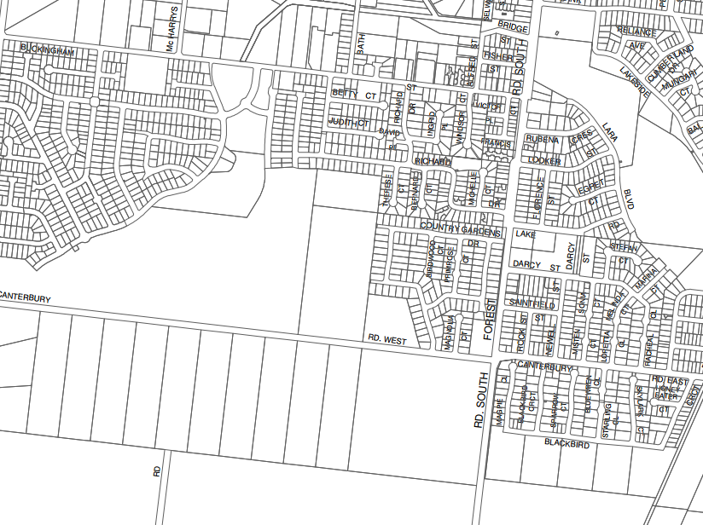
SBO 2
SBO 2
Figure 8: Proposed Schedule 2 to the Special Building Overlay

Comment: This application proposes an introduction of Schedule 2 to Clause 44.05 Special Building Overlay (Attachment 8) to detail the buildings and works proposed to be exempt from requiring a planning permit. It is proposed to apply Schedule 2 over both the subject land at 50 – 68 Canterbury Road West and the adjoining Residential 1 Zoned land at 26 – 48 Canterbury Road West, Lara. The proposed application of Schedule 2 is consistent with the application of Schedule 1 to the Special Building Overlay over the adjoining Grand Lakes Estate, where the Schedule has successfully been applied.

- particular provisions

Public Open Space Contribution and Subdivision

Under the provisions of Clause 52.01, a person who proposes to subdivide land must make a contribution to the council for public open space in an amount specified in the schedule to this clause (being a percentage of the land intended to be used for residential, industrial or commercial purposes, or a percentage of the site value of such land, or a combination of both). If no amount is specified, a contribution for public open space may still be required under Section 18 of the Subdivision Act 1988.

Comment: Under the Schedule to Clause 52.01 a 10% contribution open space is required for 10 lots or more. The proposed subdivision does not include any proposed open space as there is considered to be a number of open space opportunities surrounding this estate as illustrated in the map below. Therefore it is intended to pay Council the equivalent of 10% of the site value of land in lieu of providing an open space reserve.

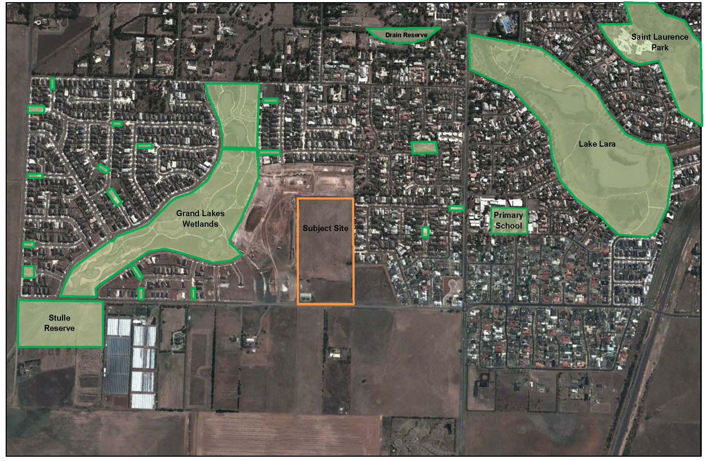
Figure 9: Public Open Space Map

Native Vegetation

Under the provisions of Clause 52.17-2, a permit is required to remove, destroy or lop native vegetation, including dead native vegetation. This does not apply:

- If the table to Clause 52.17-6 specifically states that a permit is not required.
- To the removal, destruction or lopping of native vegetation specified in the schedule to this clause.
- To an area specified in the schedule to this clause.

Comment: A Vegetation and Net Gain Assessment (Attachment 9) has been conducted on 50 – 68 Canterbury Road West by Mark Trengove Ecological Services. The Assessment has revealed that the site is rated as having negligible significance for biodiversity conservation. Therefore, there are no constraints under this Clause to subdivide and develop this land.

Residential Subdivision

Clause 56 of the Planning Scheme sets out various objectives and standards which Planning Permit applications for residential subdivision must meet.

Comment: Refer to the attached Clause 56 assessment for full details of all requirements relevant to this application.

- general provisions

Decision Guidelines

Under the provisions of Clause 65.02, before deciding on an application to subdivide land, the responsible authority must also consider, as appropriate:

- The suitability of the land for subdivision.
- The existing use and possible future development of the land and nearby land.
- The availability of subdivided land in the locality, and the need for the creation of further lots.
- The effect of development on the use or development of other land which has a common means of drainage.
- The subdivision pattern having regard to the physical characteristics of the land including existing vegetation.
- The density of the proposed development.
- The area and dimensions of each lot in the subdivision.
- The layout of roads having regard to their function and relationship to existing roads.
- The movement of pedestrians and vehicles throughout the subdivision and the ease of access to all lots.
- The provision and location of reserves for public open space and other community facilities.
- The staging of the subdivision.
- The design and siting of buildings having regard to safety and the risk of spread of fire.
- The provision of off-street parking.
- The provision and location of common property.
- The functions of any body corporate.
- The availability and provision of utility services, including water, sewerage, drainage, electricity and gas.
- If the land is not sewered and no provision has been made for the land to be sewered, the capacity of the land to treat and retain all sewage and sullage within the boundaries of each lot.
- Whether, in relation to subdivision plans, native vegetation can be protected through subdivision and siting of open space areas.

Comment: The subject land is considered to be suitable for conventional residential subdivision due to its location within the Lara Settlement Boundary and its location within a largely urban residential context. The land is proposed to be subdivided in an integrated manner with a common drainage scheme and pedestrian and road connections with the adjoining residential land. The proposed subdivision has been specifically designed in response to the stormwater management requirements of the land in an integrated manner with adjoining land.

The lot number and density are considered to accord with the overall density targets for infill residential development at this location having regard to the existing surrounding urban design features. The proposed staging plan is logically designed to commence the subdivision along the northern boundary where services are located.

The proposed road layout has been assessed as acceptable by ESR Transport Planning which provides a number of appropriate vehicle, cycle and pedestrian opportunities to access the subdivision. The proposed subdivision design also demonstrates appropriate linkages within and outside the subdivision to facilitate the orderly planning and development of this land. The proposed road network includes the provision of pedestrian paths and off street parking to each lot.

The land can be fully serviced to facilitate conventional residential development

The land does not contain any significant native flora and fauna species and a Cultural Heritage Management Plan (Attachment 10) has been approved for the land.

- policy context

The following planning policies must be considered in response to a combined planning scheme amendment and planning permit application:

- The objectives of Planning Victoria as set out in Section 4(1) of the Planning and Environment Act 1987;
- The State Planning Policy Framework of the Greater Geelong Planning Scheme; and
- The Local Planning Framework of the Greater Geelong Planning Scheme.

Planning and Environment Act 1987

Pursuant to Section 12(1)(a) of the Planning and Environment Act 1987, it is a duty of planning authorities to implement the following objectives of Planning Victoria as set out in Section 4(1) of the Planning and Environment Act 1987;

- to provide for the fair, orderly, economic and sustainable use, and development of land;
- to provide for the protection of natural and man-made resources and the maintenance of ecological processes and genetic diversity;
- to secure a pleasant, efficient and safe working, living and recreational environment for all Victorians and visitors to Victoria;
- to conserve and enhance those buildings, areas or other places which are of scientific, aesthetic, architectural or historical interest, or otherwise of special cultural value;
- to protect public utilities and other assets and enable the orderly provision and coordination of public utilities and other facilities for the benefit of the community;
- to facilitate development in accordance with the objectives set out in paragraphs (a), (b), (c), (d) and;
- to balance the present and future interests of all Victorians.

Comment: This proposed rezoning application accords with Section 4(1) of the Planning and Environment Act 1987 as it will provide for an orderly well planned residential subdivision on land identified by the Lara Structure Plan and Greater Geelong Planning Scheme for Residential 1 use and development. The technical reports and assessments in support of this application conclude that the residential use and development of this site is appropriate and the introduction of new housing and residents will provide economic and social stimulus in Lara consistent with its function as a designated growth area in the City of Greater Geelong.

State Planning Policy Framework

The proposed planning scheme amendment and subdivision is considered to be consistent with a range of State Planning Policies and supports its implementation by:

- Clause 11.02-1 Supply of Land - To ensure ongoing land supply supported by infrastructure.

- Clause 11.02-2 Planning For Growth Areas - Limiting the impact of urban development on non-urban areas by allowing development within a designated township boundary;

- Clause 15.01-1 Urban Design - To create urban environments that are safe, functional and provide good quality environments with a sense of place and cultural identity;

- Clause 15.03-2 Aboriginal Cultural Heritage – To ensure the protection and conservation of places of Aboriginal cultural heritage significance.

- Clause 16.01-1 Integrated Housing - Ensure housing developments are integrated with infrastructure and services, whether they are located in existing suburbs, growth areas or regional towns; and

- Clause 19.03-Stormwater Managing stormwater from the site through the incorporation of water-sensitive urban design techniques to reduce run-off and peak flows and integrate stormwater treatment into the landscape.

Comment: The proposed application is considered to accord with the above State Planning Policies as it proposes to rezone and subdivide land required to accommodate the residential demands in Lara within the approved Lara Settlement Boundary. The proposed subdivision has been designed to integrate with the surrounding residential land to create a functional high quality urban environment.

It is proposed to manage stormwater via an integrated scheme with adjoining land as indicated in the attached Grand Lakes Hydraulic Modelling and Impact Report – Addendum 7, July 2013 by BMT WBM (Attachment 11). In addition, this application includes an approved Cultural Heritage Management Plan for the subject land which does not impose any constraints on the future subdivision of this land.

Local Planning Policy Framework

The proposed application is considered to be consistent with a range of Local Planning Policies and supported by:

- Clause 21.06-2 Urban growth - The rezoning and development of a residential subdivision within a defined urban growth area and the provision of a mix of housing suited to the needs of a diverse range of household types.

- Clause 21.06-3 Urban consolidation - The encouragement of urban consolidation and encourage a range of development densities.

- Clause 21.06-4 Neighbourhood character - The development of land that seeks to ensure development appropriately responds to the existing character of the area.

- Clause 21.08 Development and community infrastructure - The need to provide for the efficient use of services and conservation of water.

- Clause 21.08-5 Accessibility - The need to facilitate the development of access opportunities for all members of the community.

Clause 21.13 Lara

The proposed application is also considered to accord with this policy as:

- The rezoning, subdivision and residential development of the subject land will maintain a compact urban form.
- The rezoning will ensure an adequate supply of appropriately zoned land.
- The proposed rezoning provides opportunity to integrate with the surrounding residentially zoned land.
- It will provide efficient and convenient integrated movement opportunities for vehicles, cyclists and pedestrians.
- It ensures sequential zoning and development in accordance with the Lara Structure Plan 2011.
- It will locate residential land close to educational, community and recreational facilities.

Comment: The proposed application is considered to accord with the above Local Planning Policies as it seeks approval to rezone and develop an integrated residential subdivision that will accommodate a range of housing types consistent with the surrounding neighbourhood character. The proposed subdivision includes a number of integration features to facilitate accessibility and an overall integrated storm water management strategy.

- TECHNICAL ASSESSMENTS

The following technical assessments have been undertaken of the subject site in response to the proposed rezoning and subdivision of this land.

- Vegetation and Net Gain Assessment by Mark Trengove Ecological Services, May 2013 (Attachment 9)

This report has revealed that the site is rated as having negligible significance for biodiversity conservation.

- Cultural Heritage Management Plan by TerraCulture, April 2012 (Attachment 10)

This Cultural Heritage Management Plan included a desktop, standard and complex assessment of the subject land. The assessment found one artifact of low scientific significance which has been removed and proposed for reburial. The Cultural Heritage Management Plan has been approved and there are no restrictions on the future subdivision of the subject land.

- Grand Lakes Hydraulic Modelling and Impact Report – Addendum No.7, BMT WBM, July 2013 (Attachment 11)

This report was commissioned to model how the flood and stormwater will be managed on the subject land and adjoining properties. This report demonstrates that the land can be subdivided in accordance with the proposed plan of subdivision based on an integrated floodplain management approach.

- Transport Impact Assessment Report, ESR Transport Planning, 7 June 2013 (Attachment 12)

This assessment was commissioned to assess the proposed road layout of the proposed plan of subdivision and its likely impact on traffic volumes having regard to existing volumes and the current capacity of the existing road network. In summary, the assessment has revealed that the proposed subdivision and residential development of this land is not expected to compromise the safe and efficient operation of the surrounding road network.

- CONCLUSION

In conclusion, it is considered that Planning Scheme Amendment C266 for the combined rezoning and subdivision application will facilitate the future use and development of the land in an integrated and orderly basis consistent with the Lara Structure Plan 2011, State and Local Policies of the Greater Geelong Planning Scheme and Objectives of Planning in Victoria.

The proposed application is also supported by a number of technical and environmental assessments that demonstrate the land’s capability to accommodate conventional residential development without adverse environmental effect. The proposed application of Schedule 2 of the Special Building Overlay over both land parcels will ensure an integrated flood and stormwater management approach.

The proposed use of the Residential 1 Zone and a Schedule to the Special Building Overlay are considered to be the most appropriate planning tools to implement the overall strategic objectives relevant to the location.

The proposed subdivision provides the appropriate additional detail that demonstrates how the ultimate development of this land accords with the relevant planning provisions of the Residential 1 Zone and demonstrates how this subdivision integrates within the surrounding urban residential setting.

………………………………
Chris Marshall
Manager – Town Planning

Attachment 1
Letter of Request from City of Greater Geelong
Attachment 2
Aerial Plan
Attachment 3
Current Zoning Plan
Attachment 4
Proposed Zoning Plan
Attachment 5
Integrated Plan of Subdivision
Attachment 6
Proposed Staged Plan of Subdivision
Attachment 7
Clause 56 Assessment
Attachment 8
Schedule 2 to the Special Building Overlay
Attachment 9
Vegetation and Net Gain Assessment
Mark Trengove Ecological Services
Attachment 10
Cultural Heritage Management Plan
TerraCulture
Attachment 11
Grand Lakes Modelling & Impact Report, Addendum No.7
BMT WBM
Attachment 12
Transport Impact Assessment
ESR Transport Planning
Attachment 13
Amendment Documentation

