
A part of BMT in Energy and Environment
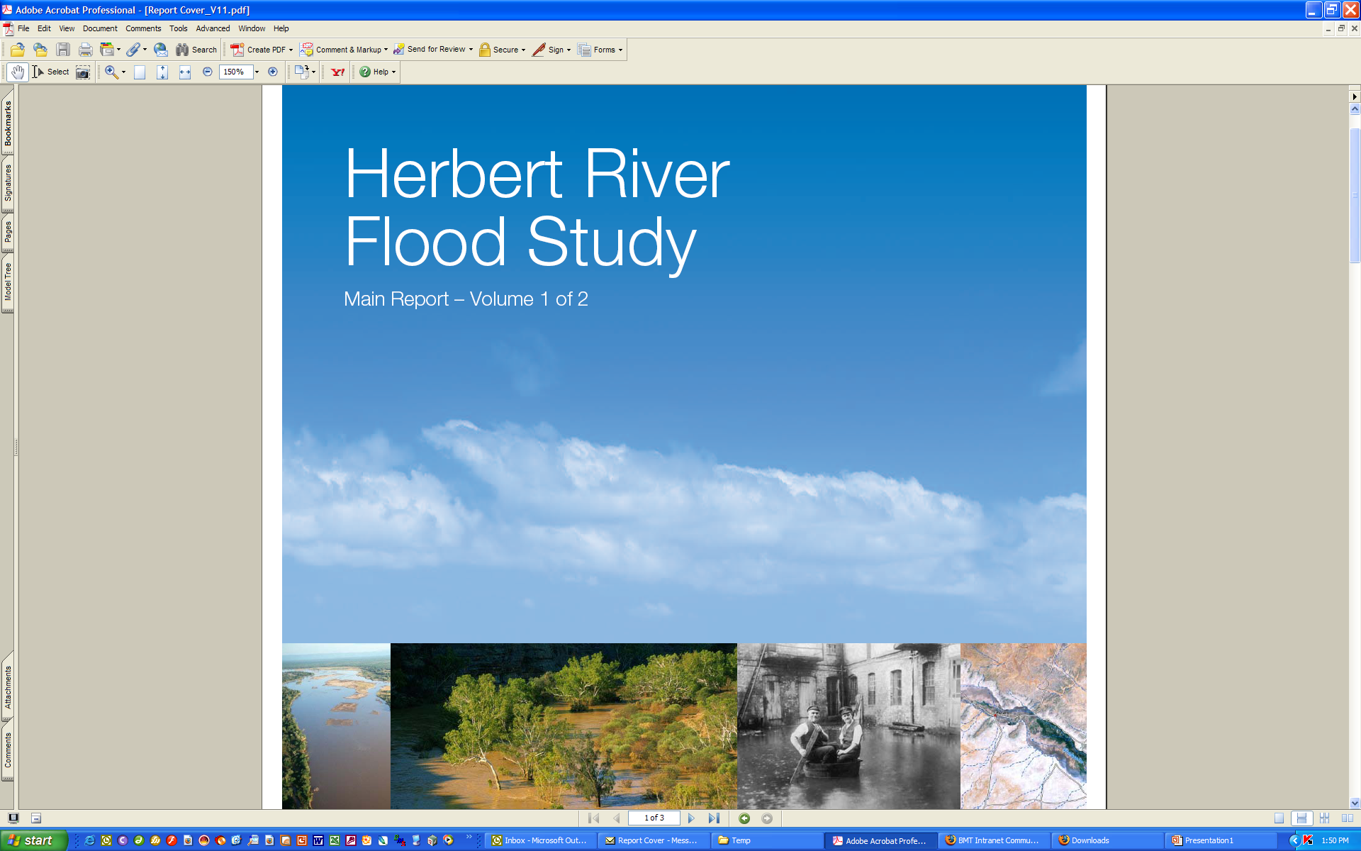
Grand Lakes Hydraulic Modelling and Impact Report - Addendum Number 7
R.M8709.002.01.ModellingReport.doc
July 2013

Grand Lakes
Hydraulic Modelling and Impact Report
Addendum Number 7

Prepared For: | TGM Group Pty Ltd, L.Bisinella Development Pty Ltd and Point Cook Land Pty Ltd
Prepared By: | BMT WBM Pty Ltd (Member of the BMT group of companies)

DOCUMENT CONTROL SHEET
Offices

Brisbane
Denver
Karratha
Melbourne
Newcastle
Sydney
Vancouver

BMT WBM Pty Ltd  BMT WBM Pty Ltd  Level 5, 99 King Street  MELBOURNE VIC 3000  Australia  PO Box 604  Collins Street West VIC 8007  Tel: +61 3 8620 6100  Fax: +61 3 8620 6105  ABN 54 010 830 421 007  www.bmtwbmpl.com.au | Document: | R.M8709.002.01.ModellingReport_ISSUED
 | Title: | Grand Lakes Regional Hydraulic Modelling and Impact Report – Addendum Number 6
 | Project Manager: | Mark Jempson
 | Author: | Mark Jempson
 | Client: | TGM Group Pty Ltd, L Bisinella Developments Pty Ltd and Point Cook Land Pty Ltd
 | Client Contact: | Peter Preece
 | Client Reference:
 | Synopsis: | Report detailing the methodology and findings of hydraulic modelling of the Grand Lakes development, Lara, Victoria.

REVISION/CHECKING HISTORY

REVISION  NUMBER | DATE | CHECKED BY |  | ISSUED BY
0 | 04/07/2013 | MAJ |  | JGL
1 | 04/07/2013 | MAJ |  | JGL | 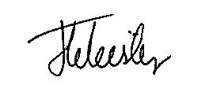

DISTRIBUTION

DESTINATION | REVISION
 | 0 | 1 | 2 | 3 | 4 | 5 | 6 | 7 | 8 | 9 | 10
TGM Group (PDF)  WBM File  WBM Library | 1  1  1 | 1  1  1

Contents

Contents i
List of Figures ii
List of Tables ii

1 Introduction 1-1
2 Data Set 2-1
3 Hydraulic Model Selection 3-1
4 Regional Hydraulic Modelling - Base Case 4-1
4.1 Hydraulic Model Layout and Coverage 4-1
4.2 Base Case Model Development 4-1
4.3 Regional Manning’s Roughness Values 4-3
4.4 Design Event Modelling 4-5
4.5 Regional Flood Model Verification 4-5
5 Regional Hydraulic Modelling - Grand Lakes Development 5-1
5.1 Regional Grand Lakes Model Layout and Coverage 5-1
5.2 Regional Grand Lakes Model Development 5-1
5.3 TUFLOW Boundary Conditions 5-4
5.4 Manning’s Roughness Values 5-4
5.5 Design Event Modelling 5-4
6 Local Hydraulic Modelling 6-1
6.1 Local Grand Lakes Model Layout and Coverage 6-1
6.2 Local Grand Lakes Model Development 6-1
6.3 TUFLOW Boundary Conditions 6-1
6.4 Manning’s Roughness Values 6-2
6.5 Design Event Modelling 6-2
7 Flood Mapping 7-1
7.1 Existing Conditions 7-1
7.2 Flood Impact Mapping 7-1
7.2.1 Discussion of Flood Impact Mapping 7-1
7.3 Flood Depth and Extent Mapping 7-1
7.3.1 Discussion of Flood Extent Mapping 7-2
7.3.2 Flood Levels within the Lake System 7-2
7.4 Flood Safety Mapping – Regional Grand Lakes Model 7-10
7.4.1 Discussion of Flood Safety Mapping 7-10
7.5 Flood Safety Mapping – Local Grand Lakes Model 7-10
7.5.1 Discussion of Flood Safety Mapping 7-10
8 Summary 8-1
9 References 9-1
List of Figures
Figure 1-1 Site Locality Map 1-2
Figure 4-1 Base Case Hydraulic Model Layout and Extent TUFLOW Boundary
Conditions 4-2
Figure 4-2 Manning’s Roughness Distribution 4-4
Figure 5-1 Details of Regional Grand Lakes Model 5-3
Figure 6-1 Details of Local Grand Lakes Model 6-3
Figure 7-1 10 Year ARI Existing Flood Extent 7-3
Figure 7-2 100 Year ARI Existing Flood Extent 7-4
Figure 7-3 Change in 100 Year ARI Peak Flood Height – Regional Model 7-5
Figure 7-4 Change in 10 Year ARI Peak Flood Height – Regional Model 7-6
Figure 7-5 Peak 100 Year ARI Flood Depth and Extent – Regional Model 7-7
Figure 7-6 Peak 10 Year ARI Flood Depth and Extent – Regional Model 7-8
Figure 7-7 Peak 100 Year ARI Flood Extent – Local Model 7-9
Figure 7-8 Depth Safety Map – Regional Model 7-11
Figure 7-9 Velocity Safety Map – Regional Model 7-12
Figure 7-10 Product of Depth and Velocity Safety Map – Regional Model 7-13
Figure 7-11 Depth Safety Map – Local Model 7-14
Figure 7-12 Velocity Safety Map – Local Model 7-15
Figure 7-13 Product of Depth and Velocity Safety Map – Local Model 7-16

List of Tables

Table 4-1 2D Domain Manning’s ‘n’ Coefficients 4-3
Table 6-1 2D Domain Manning’s ‘n’ Coefficients 6-2

Introduction
TGM is seeking approval, on behalf of L Bisinella Developments Pty Ltd and Point Cook Land Pty Ltd to extend the Grand Lakes residential development in Lara. Grand Lakes, which is currently under construction by L Bisinella Developments, is bounded to the north and to the south by Buckingham Street and Canterbury Road respectively and by O’Hallorans Street to the west as shown in Figure 1-1. Grand Lakes lies within the floodplain of two vegetated open drains which are referred to as Catchments 157H and 157J by the City of Greater Geelong (Council). BMT WBM previously prepared a number of hydraulic modelling reports in support of the Grand Lakes Development, the latest in May 2013 (BMT WBM, 2013).
The current proposal is to extend Grand Lakes by infilling the remaining two portions of land on the north side of Canterbury Road between Grand Lakes and the existing residential sub-divisions to the east. The proposed extension will drain into the lakes system and so it must be demonstrated that development in its entirety (the original Grand Lakes plus the infill) will have no negative impacts on flood levels, and that the flows along streets and floodways within the development satisfy safety requirements. In order to demonstrate that the extended Grand Lakes development satisfies these requirements BMT WBM has adopted and updated the modelling used in BMT WBM (2009) as follows:
- updated the regional two-dimensional (2D) TUFLOW flood model of the existing floodplain for the 100 and 10 year ARI events to provide improved representation of local inflow boundaries in the vicinity of the proposed infill development;
- updated the developed case model of the Grand Lakes development to include the proposed infill development;
- assessed the impacts of the proposed development upstream and downstream of the development site for the 100 and 10 year ARI events; and
- updated the fine scale 2D flood model to assess flows along streets and floodways to include the infill development to ensure that flood height and safety requirement are achieved.
This report presents the final modelling results using the latest design, including the infill development.
Although described as Addendum 7, this report is largely a reproduction of Addendum 6 (BMT WBM, 2013) that has been updated to reflect the final modelling results of the latest design. Because the infill development has been considered as part of the Grand Lakes development and impacts have been assessed using pre Grand Lakes conditions as the base case, references to Grand Lakes includes the infill development unless otherwise stated.

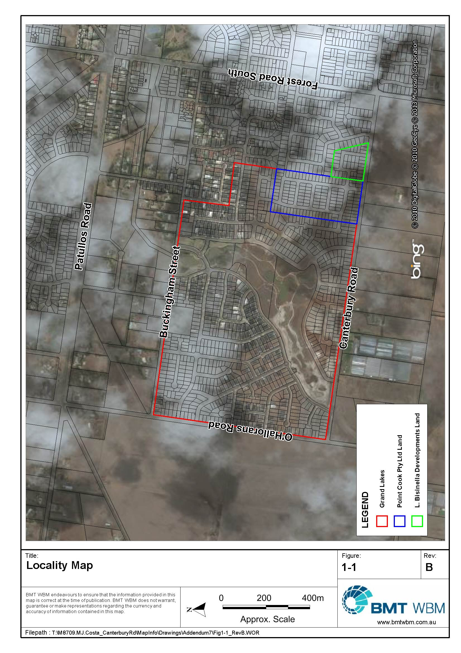
Figure 1-1 Site Locality Map

Data Set
The study drew upon a data set provided by Council and TGM. The data set included:
- digital aerial photography and cadastral property boundaries provided by CoGG;
- a catchment DTM developed from photogrammetry and field survey by SKM (1999);
- a RORB hydrologic model of the catchment developed by SKM (1999);
- a MIKE11 hydraulic model of the floodplain developed by SKM (1999);
- detailed feature survey of the existing Grand Lakes site collected by TGM;
- a Triangulated Irregular Network (TIN) representing proposed design surface levels of the development prepared by TGM (several iterations);
- details of the pipe drainage network proposed for the Grand Lakes development by TGM (several iterations);
- local runoff rates within the Grand Lakes development calculated by TGM as part of the minor drainage network design.

Hydraulic Model Selection
SKM (1999) simulated complex flooding across the study area using a quasi-2D MIKE11 model. To reliably represent these complex flooding characteristics and any changes caused by the proposed development, it was decided that a fully 2D modelling solution was required. Smaller drainage elements such as channels, culverts beneath roads and the proposed drainage network for the subdivision would need to be represented using 1D elements dynamically coupled to the fully 2D domain.
To meet these criteria, BMT WBM developed 1D-2D TUFLOW models to assess flooding behaviour within the proposed development and to assess potential impacts of the development on flood levels across the floodplain external to the site. BMT WBM have developed TUFLOW models for many flood mapping studies for the City of Greater Geelong and private developers.

Regional Hydraulic Modelling - Base Case

Hydraulic Model Layout and Coverage
A base case hydraulic model of the existing site and surrounds was developed to establish the existing 100 year ARI flood behaviour of the study area. The TUFLOW model boundary was extended sufficiently upstream of the Grand Lakes site to ensure that the complex distributions of flow in the floodplain upstream of the development were reliably modelled, and also to ensure that any flood impacts resulting from the development could be simulated within the model domain. It was not considered necessary to extend the TUFLOW model domain to the limits of SKMs MIKE11 model, and a smaller model domain has the benefit of reduced model run times. The model was also extended downstream of Buckingham Street to assess impacts of the proposed development on downstream flooding.
This model will be referred to as the regional Grand Lakes model from here on. A local Grand Lakes model was also developed to investigate flooding behaviour at a finer scale. This model is described in Section 6.
The proposed development, and MIKE11 and TUFLOW model domains are shown in Figure 4-1.

Base Case Model Development
The base case TUFLOW model was developed with a 5 m grid across the study area. The broader floodplain geometry was defined within the model by extracting ground surface elevations from a DTM produced by SKM (1999) at each TUFLOW grid point. TGM provided a high resolution DTM of the existing Grand Lakes site. This was used to define the geometry of the existing site in more detail.
1D elements were ‘carved’ through the 2D domain to represent the geometry of open channels and culverts. This process overcomes the limitation of modelling fine detail features with a 5 m fixed grid. Channel geometry was defined by producing cross sections from surveyed 3D breaklines. Structures within the floodplain mainly comprised culverts and road crossing embankments. Culvert details of were extracted from SKMs MIKE11 model and some additional survey obtained by TGM. Road crossing embankments were defined using breaklines to ensure that strings of highpoints define the geometry of the hydraulic control.
The 1D elements were dynamically nested within the 2D domain allowing for the interchange of water between the two model domains at every time step.
External TUFLOW model boundary conditions were generated from the MIKE11 model outputs at coincident locations, whilst internal boundary conditions were generated from the RAFTS model. The TUFLOW model required five inflow hydrograph boundaries at its upper extents, two water level boundaries at the downstream end of the model domain, and a number of internal flow boundaries representing local flows. For this latest modelling, some adjustments were made to positioning and distribution of the flow boundaries representing the local catchment to the south of Canterbury Road West. This was done to better represent the flow patterns in and around the proposed extension to Grand Lakes.
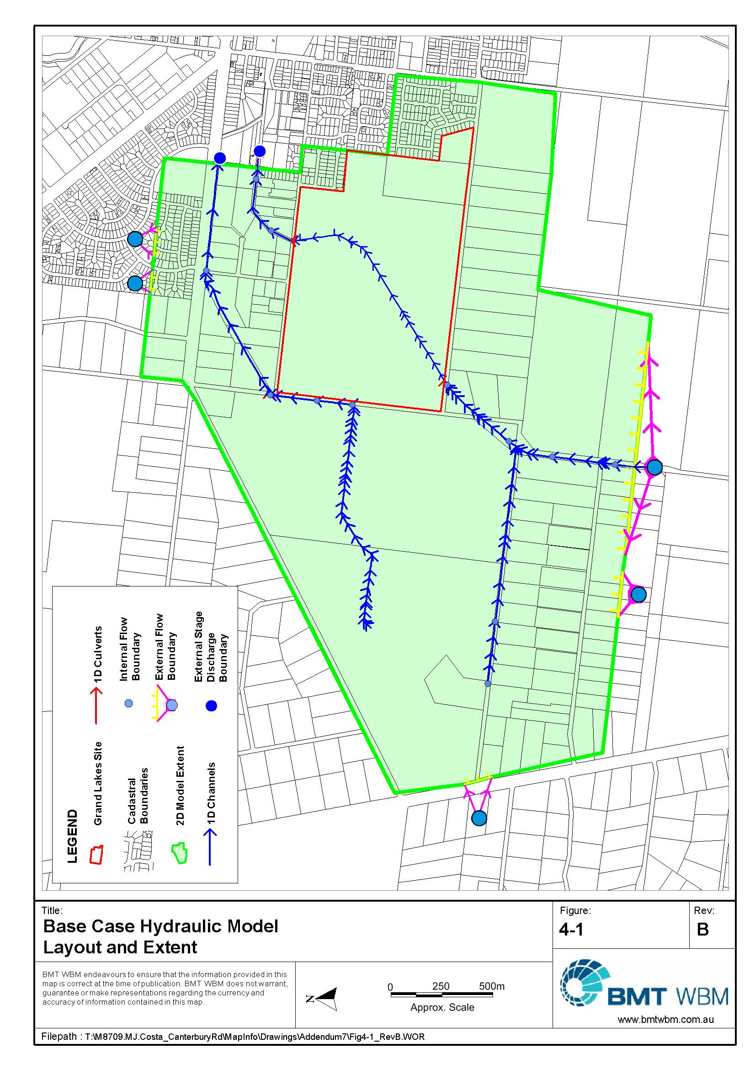
Figure 4-1 Base Case Hydraulic Model Layout and Extent TUFLOW Boundary Conditions
Downstream boundaries to the model were represented using a stage-discharge relationship that was calculated using conveyance data from the MIKE11 model coincident with the location of the TUFLOW boundaries.
Boundary condition locations and types are shown in Figure 4-1.

Regional Manning’s Roughness Values
All areas of the model must be assigned a surface roughness that is described by a Manning’s ‘n’ value. A single Manning’s ‘n’ value of 0.04 was adopted from the MIKE11 model for the un-maintained and vegetated open channels. The MIKE11 model also used a value of 0.04 for all floodplain sections. This was considered too coarse for the purposes of this modelling, and so areas of uniform roughness in the floodplain were selected by inspecting digital aerial photography. Standard values of Manning’s ‘n’ were selected from the literature. The adopted values are summarised in Table 4-1 and their distribution across the floodplain is shown in Figure 4-2.
Table 4-1 2D Domain Manning’s ‘n’ Coefficients
Land Use | Manning’s ‘n’
Floodplain | 0.06
New Residential | 0.2
Smaller Rural-Residential blocks | 0.04
Large rural-residential blocks | 0.04
Crops | 0.05
Road reserves | 0.025
Golf course | 0.05
Grassed reserve with some trees | 0.035
Water body | 0.02
Agricultural sheds | 0.2

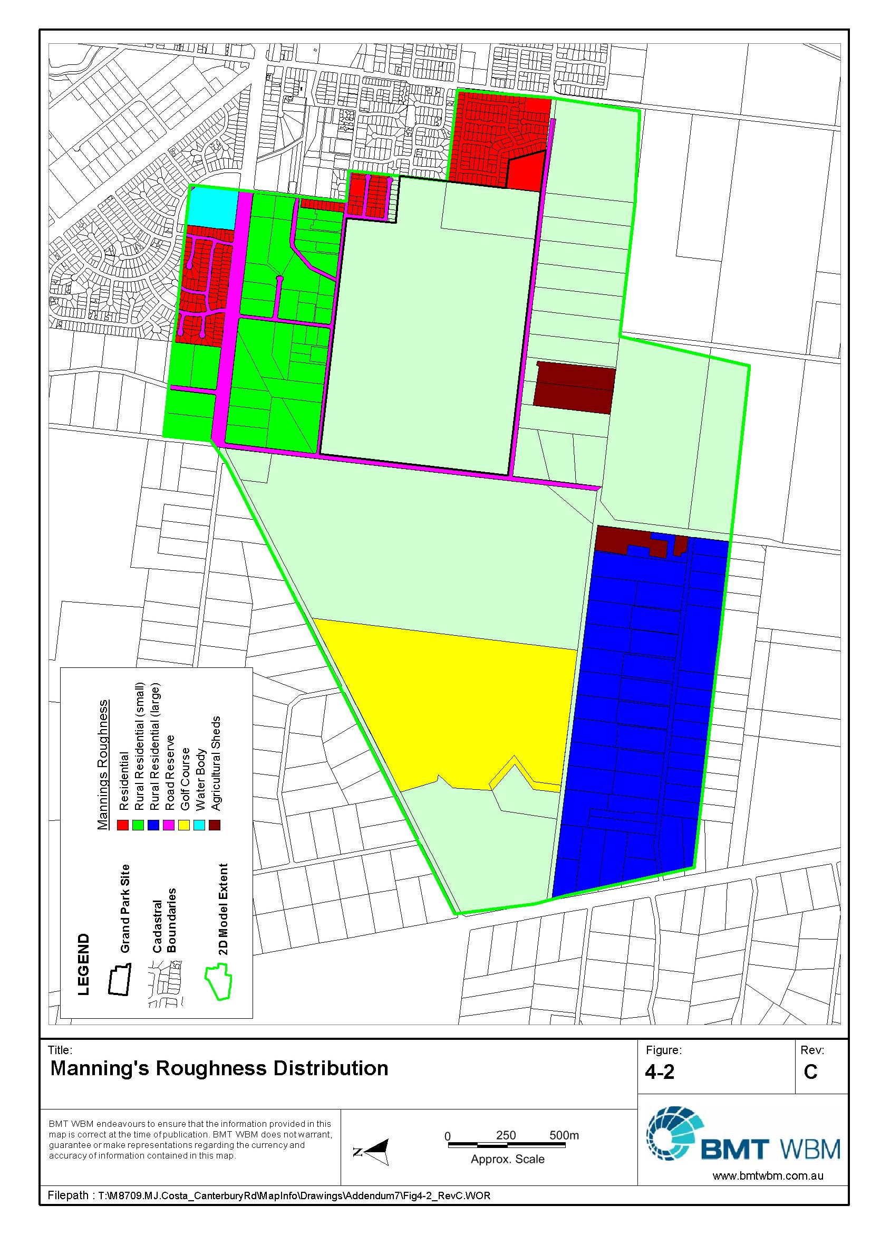
Figure 4-2 Manning’s Roughness Distribution

Design Event Modelling
Three different duration 100 year ARI design storm events were modelled in TUFLOW: 6, 9 and 12 hour events. The critical storm duration varied across the catchment, but the 12 hour storm was the critical duration in the vicinity of the Grand Lakes site. A peak flood height envelope was developed from the three durations and the peak envelope of flood levels mapped. The mapping is presented in Section 7. These events formed the basis for the assessment of the flood impacts from the proposed Grand Lakes development.

Regional Flood Model Verification
As no data was available to calibrate the hydraulic model, a sensitivity check was undertaken by comparing the flood extents generated with TUFLOW to the flood extents generated by SKM (1999). The flood extents were generally consistent across the catchment.

Regional Hydraulic Modelling - Grand Lakes Development

Regional Grand Lakes Model Layout and Coverage
The base case 100 year TUFLOW model was modified to incorporate the proposed Grand Lakes development. The development features a sub-division that incorporates:
- trunk drainage beneath roads;
- residential street floodways;
- drainage reserve floodways;
- retarding basin storages;
- provision of road access across the main floodway; and
- an upgrade of Buckingham Street.
The structure of the developed model showing proposed modifications as part of the Grand Lakes development are shown in Figure 5-1.

Regional Grand Lakes Model Development
The regional Grand Lakes model was developed by adding details of the proposed development to the regional base case model.
TGM provided a DTM that represented the design surface levels for the proposed development. This DTM was used by WBM to define the topography of the site within the regional hydraulic model. An iterative approach was then used to refine the design with WBM providing model flood model results (impacts and hazard) back to TGM for adjustment to the design surface.
TGM provided details of the proposed trunk drainage network for the development. This was incorporated in the model by dynamically nesting 1D elements within the 2D model to allow for the interchange of water between the overland and sub-surface flow at each time step. The pipe network was iteratively modified in combination with the changes to the DTM. The results presented in this report are based on DTMs provided to WBM on 6 December 2007, 18 December 2007 and 24 April 2013.
Drainage reserves requiring modelling in fine detail were built into the model by ‘carving’ 1D elements through the 2D model. Again the 1D elements were dynamically nested to allow interchange of flow between 1D and 2D domains.
Access roads crossing the lakes were incorporated into the topography of the model. Ten 2100 x 1500 mm rectangular box culverts were modelled beneath the East-West road embankment, and a 4/300 mm RCPs were modelled beneath the North-South access road. The RCBCs were represented with flow constrictions that allow the modelling of structures within the 2D domain and account for the losses attributed to friction, flow expansion and flow contraction.
During the initial iterations of the model for the expansion of the residential development on the Point Cook Land and L. Bisinella Developments’ sites, it was determined that an additional 750mm reinforced concrete pipe (RCP) would be required underneath Canterbury Road to help convey the upstream catchment into Grand Lakes. This additional pipe is located approximately 20 metres to the East of the existing culverts underneath Canterbury Road (near the intersection with O’Hallorans Road).

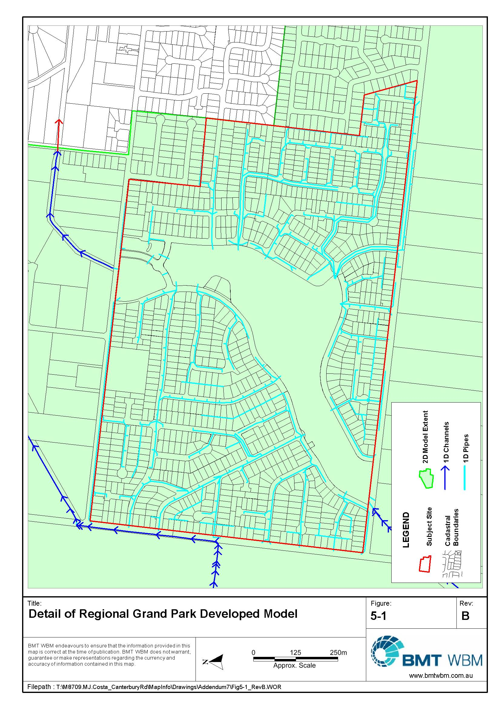
Figure 5-1 Details of Regional Grand Lakes Model

TUFLOW Boundary Conditions
The same boundaries used in base case modelling were used in the regional Grand Lakes model, with additional flow being applied to the trunk drainage network that is generated from the developed site. Hydrographs were extracted from the DRAINS model and 12d drainage model used by TGM to design the Grand Lakes trunk drainage network. For the three storm durations, local flows had significantly subsided by the time external flows had peaked at the site boundaries.

Manning’s Roughness Values
The same Manning’s roughness coefficients described in Section 4.3 were applied to the base case and regional Grand Lakes models.

Design Event Modelling
The same three duration 100 year ARI design storm events were modelled in both base case and regional Grand Lakes models. Additional flows were applied to the regional Grand Lakes model to account for additional flows being generated by the development.
A peak flood height envelope was developed from the three durations and the peak envelope flood surfaces mapped. The mapping is presented in Section 7. These events were compared to the base case modelling to assess the flood impacts from the proposed Grand Lakes development.
A 10 year ARI flood event was also analysed to provide a developed case flood extent for planning purposes, and also to check for impacts in a smaller event. As for the 100 year ARI event, boundary conditions were adopted from Council’s Mike11 and RAFTS models, whilst local flows from the proposed development were provided by TGM. This event was also run using the three durations.

Local Hydraulic Modelling

Local Grand Lakes Model Layout and Coverage
A separate local 1D-2D TUFLOW model of the development was established to assess flood safety within the site at a fine scale.
The TUFLOW model boundaries were at the extents of the proposed development and did not include any of the surrounding areas. By excluding the surrounding areas, simulation times were kept at workable durations. However; external inflows into the main flood channel and the outflow at the downstream extent of the model were included to assess the effects that a tailwater level may have on flows along the roads of the development.

Local Grand Lakes Model Development
A local TUFLOW model with 0.75 m grid was developed across the development site. The high resolution TUFLOW model allowed for the topography, including road crests and gutters, to be represented at a scale appropriate for the assessment of flood safety.
Details of the minor drainage network were provided by TGM and the entire pipe drainage network was incorporated into the model as 1d elements. The pipes were dynamically nested within the 2D domain to allow the interchange of flow between overland and sub-surface flow. This allowed a reliable assessment of the flows down streets and floodways. In this simulation it was assumed that the pits did not restrict the flow of water into the pipes, i.e., the pipe network itself was the limiting control, not the side entry pits or filed inlets.
Access roads crossing the main flood channel were modelled as a 2D flow constriction simulating the box culverts as described in Section 5.2.

TUFLOW Boundary Conditions
Boundary conditions to the TUFLOW model were supplied by the TGM group and consisted of peak flows for each of the sub-catchments within the development site. These peak sub-catchment flows were applied at the location of the field inlet or side entry pit for each respective sub-catchment throughout the development. The model was run under steady-state conditions with the peak flow applied at a constant value. This was a conservative approach, as it does not account for the varying times to peak flow that would occur through the development.
Inflow into the model from upstream was determined through the use the XP-RAFTS model for the region as developed by SKM. The XP-RAFTS model was run for the required critical duration and the peak flow determined. As with the other inflow boundaries, this peak flow was applied as a constant value (steady-state).
The downstream boundary for the model consisted of the stage-discharge relationship for the culverts located at the downstream extent of the model. The stage-discharge relationship was determined from the results of the broader TUFLOW model and the behaviour of this culvert during the larger events.
The locations of all inflow points within the TUFLOW model are shown in Figure 6-1.

Manning’s Roughness Values
Due the fine scale of the model, the definition of the Manning’s ‘n’ roughness values throughout the model could also be undertaken on a fine scale. The selection of roughness was undertaken using the supplied drawings from TGM and in particular the road and kerb alignments. The roadways, nature strips and footpaths were all identified and assigned a suitable Manning’s ‘n’ roughness value. The main flood channel, defined overland flow paths and the residential properties were also identified and assigned a suitable roughness value.
The adopted Manning’s ‘n’ values are presented in Table 6-1.
Table 6-1 2D Domain Manning’s ‘n’ Coefficients
Land use | Manning’s ‘n’
Asphalt | 0.015
Nature Strips | 0.025
Footpaths | 0.02
Floodway | 0.03
Main Floodway and Lakes | 0.03
Residential Properties | 0.2

Design Event Modelling
Peak local boundary condition inflows to the local Grand Lakes model were provided by TGM. Critical 100 year storm durations vary across the site between 10, 20 and 30 minutes. For the purposes of modelling local conditions an envelope of peak flows resulting from the three 100 year ARI storm durations was created and applied to the model as steady-state boundaries. The model was run for a sufficient period to allow flood levels to reached steady-state conditions where total flow into and out of the model had equalised.

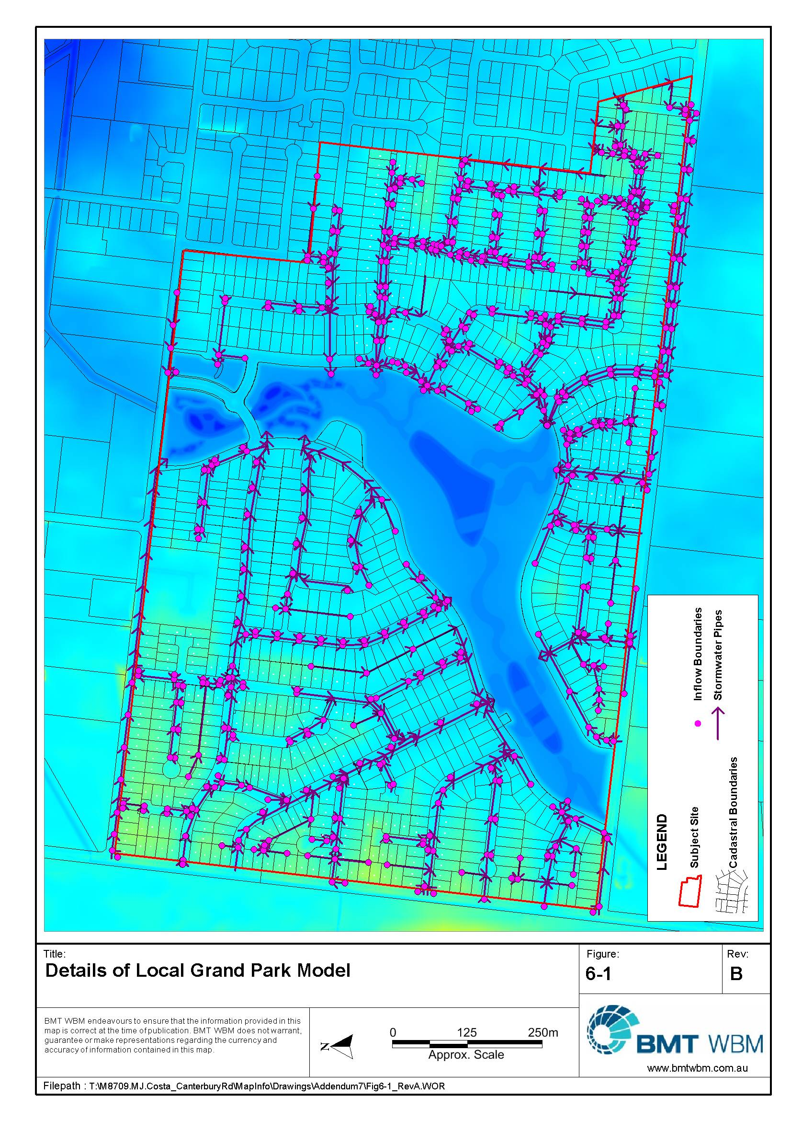
Figure 6-1 Details of Local Grand Lakes Model

Flood Mapping
TUFLOW produces a geo-referenced data set defining peak water levels throughout the model domain at the corners of its computational cells. For the regional model the peak flood level from each of the three storm durations was selected for each computational cell to generate an envelope of peak flood level. These data were imported into GIS to generate a digital model of the flood surface.

Existing Conditions
The regional TUFLOW flood model was initially used to determine the existing flood extents for both the 100 year and 10 year ARI flood events. These flood extent maps are presented in Figure 7-1 and Figure 7-2 respectively.

Flood Impact Mapping
Digital flood surfaces were created for the base case and developed (Grand Lakes) case, and the changes in peak flood height were calculated by subtracting the base case model peak flood heights from the Grand Lakes model flood heights at each TUFLOW grid cell. The change in peak 100 year ARI flood height was then colour contoured and mapped in Figure 7-3. The change in peak 10 year ARI flood height was also mapped and is shown in Figure 7-4.

Discussion of Flood Impact Mapping
The regional model indicates that the proposed development will not significantly increases in flood levels external to the site. There are reductions in flood level downstream and there are small areas along the western and southern boundaries (within the Canterbury Road reserve) of the development where there are increases in flood level of up to about 4 cm. The areas where there are increases are currently flood prone and there are no buildings within the area where the increase is shown. Further, the increases are nearly identical, in location and magnitude, to those shown in the previous Grand Lakes report (WBM, 2009) and accepted by Council. The current modelling is showing more extensive reductions downstream than shown in WBM (2009). A review of the flows through the models shows that the flow rates in the base case have changed marginally, most likely a result of the adjustment to the positioning of the flow boundaries referred to in Section 4.2.

Flood Depth and Extent Mapping
Envelopes of peak flood depth and extent from the regional Grand Lakes model was mapped for the 6, 9 and 12 hour 100 and 10 year ARI events. These are shown in Figure 7-5 and Figure 7-6. The peak flood depths and extent for the local model is shown in Figure 7-7.
Not shown on these figures is sheet flooding across the lots prior to reaching the street, or from overland “gap” flow, i.e., the runoff from the lots has exceeded the 10 year ARI capacity of the drainage network that is running through the lots and is flowing to the street. In a meeting with Council on 16 November 2005, it was agreed that inundation from this local runoff was not land subject to inundation, but that it would be prudent to set floor level controls.
In some areas the road reserve is at capacity during a 100 year ARI event. Although it is understood from TGM that fill levels will be at least 300 mm above the flood level, builders may still cut into the fill and cast the slab at below the freeboard level. Therefore it is recommended that floor level controls be considered in these locations.

Discussion of Flood Extent Mapping
The current flood extent modelling (shown in Figure 7-7), shows changed flooding patterns on a number of streets along the eastern edge of Grand Lakes. The design of these streets has been amended since the modelling presented in WBM (2009) to cater for the increased flows associated with the runoff from the additional stages along Canterbury Road.

Flood Levels within the Lake System
The modelling presented in BMT WBM (2009) determined flood levels within the lake system to be generally between 12.63 and 12.65 mAHD. The current modelling has determined the lake levels to be generally between 12.61 and 12.63 mAHD. The observed decrease of 0.02 metres is due to the adjustments made to the locations of the inflow boundaries south of Canterbury Road (as described in Section 4.2), resulting in minor changes to the peak flow through the lake system.
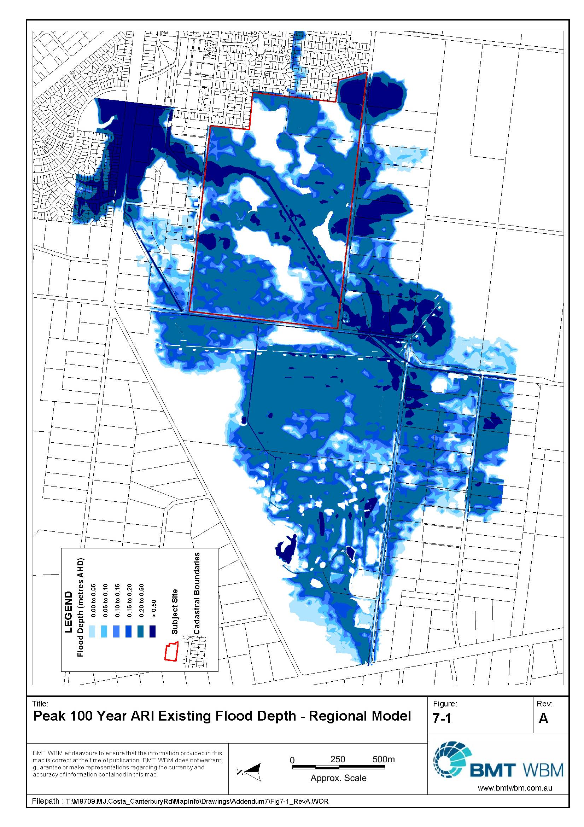
Figure 7-1 10 Year ARI Existing Flood Extent
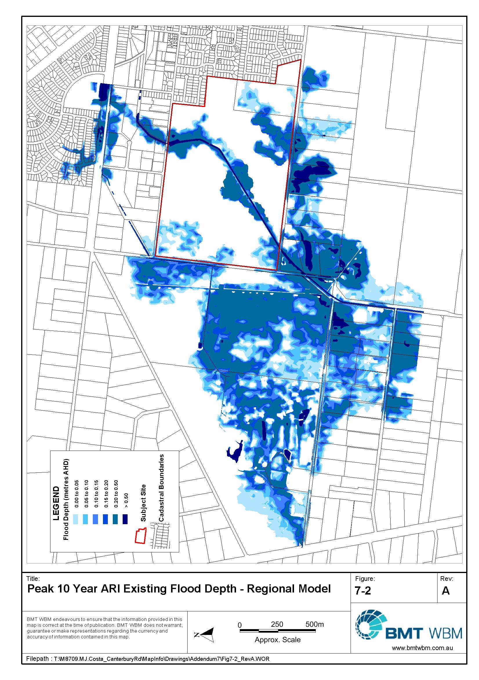
Figure 7-2 100 Year ARI Existing Flood Extent
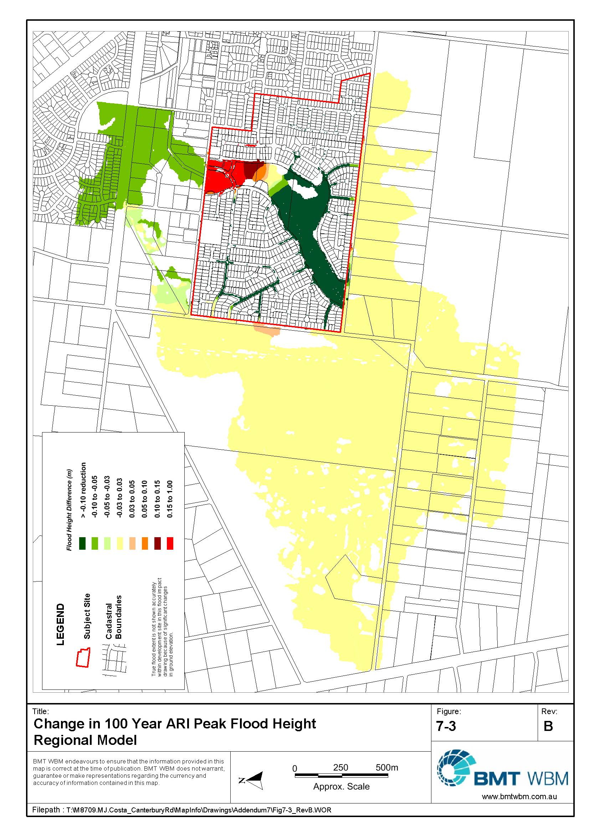
Figure 7-3 Change in 100 Year ARI Peak Flood Height – Regional Model
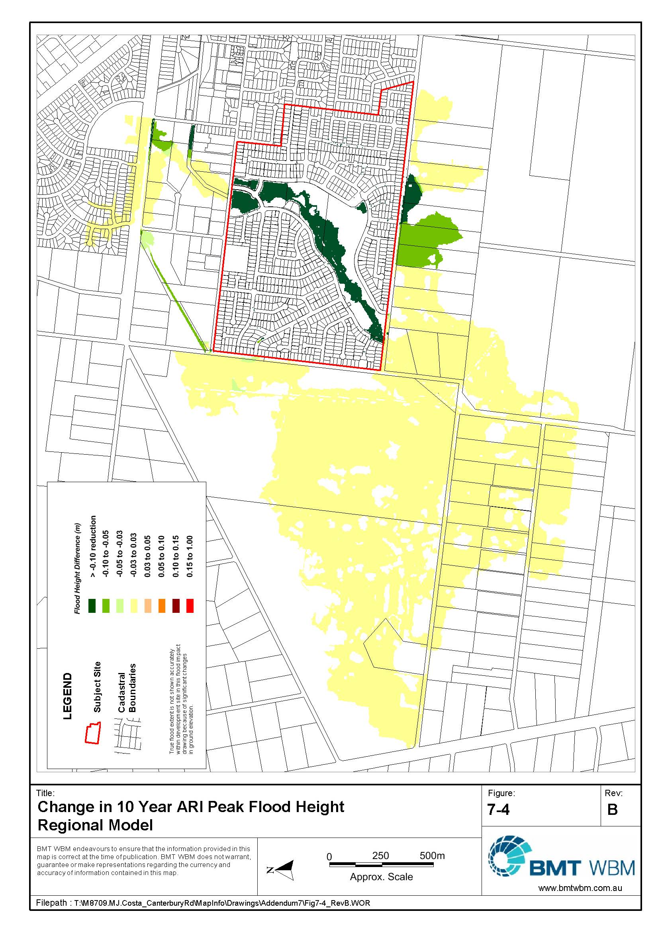
Figure 7-4 Change in 10 Year ARI Peak Flood Height – Regional Model
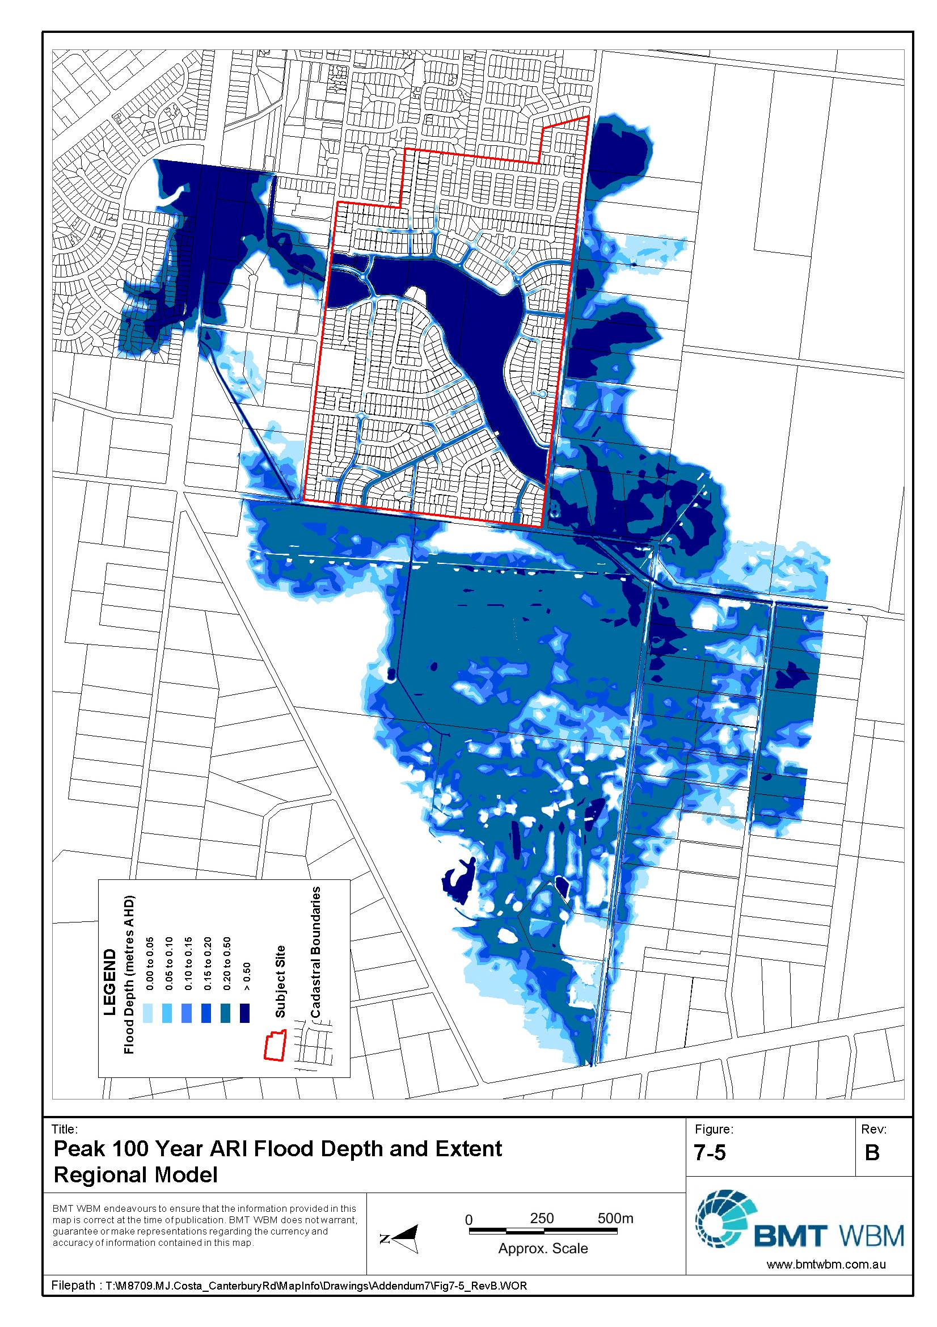
Figure 7-5 Peak 100 Year ARI Flood Depth and Extent – Regional Model
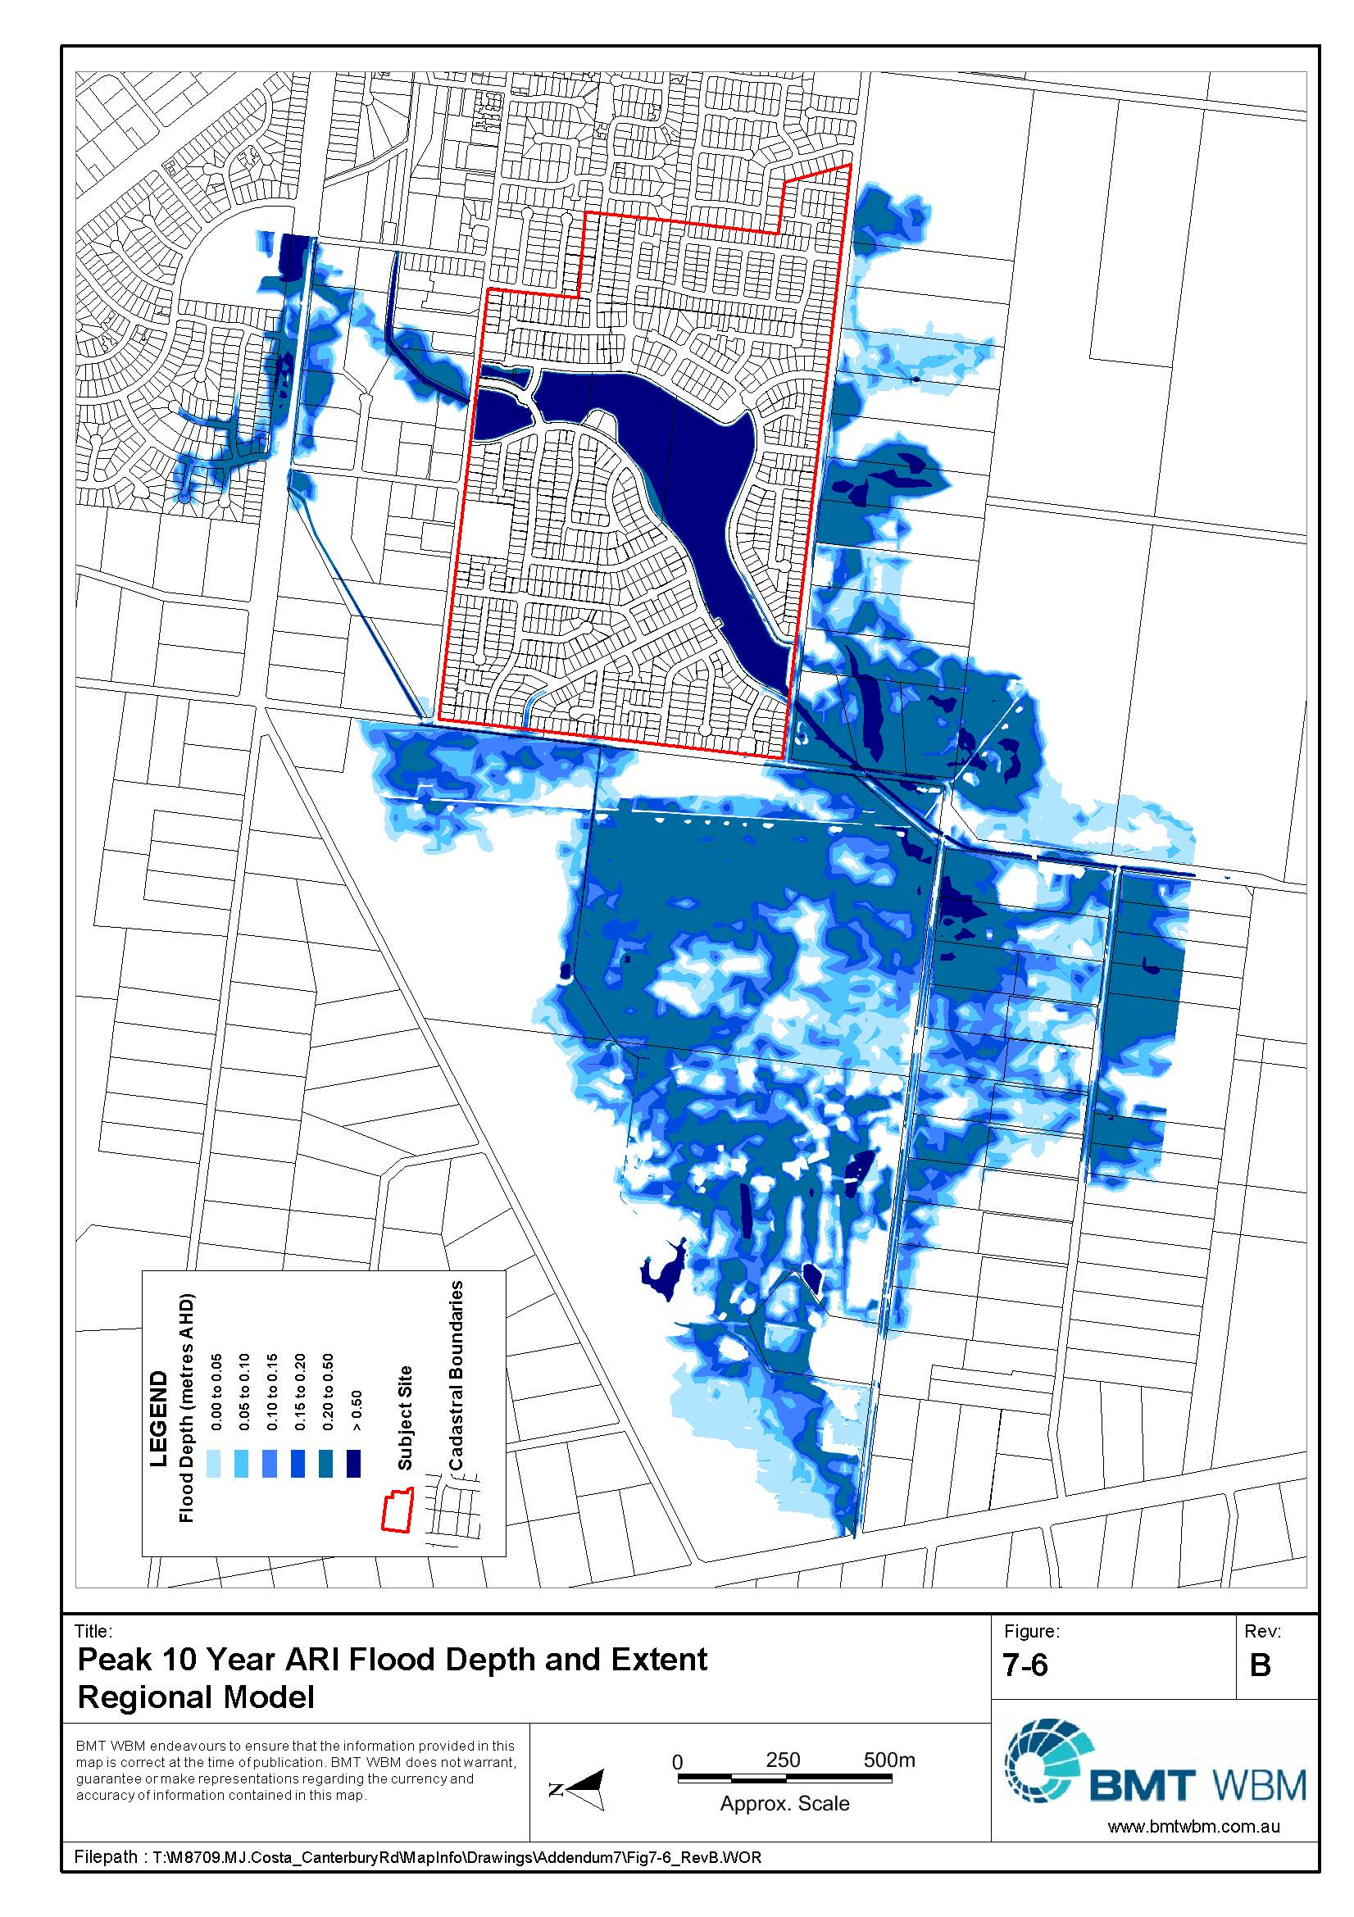
Figure 7-6 Peak 10 Year ARI Flood Depth and Extent – Regional Model
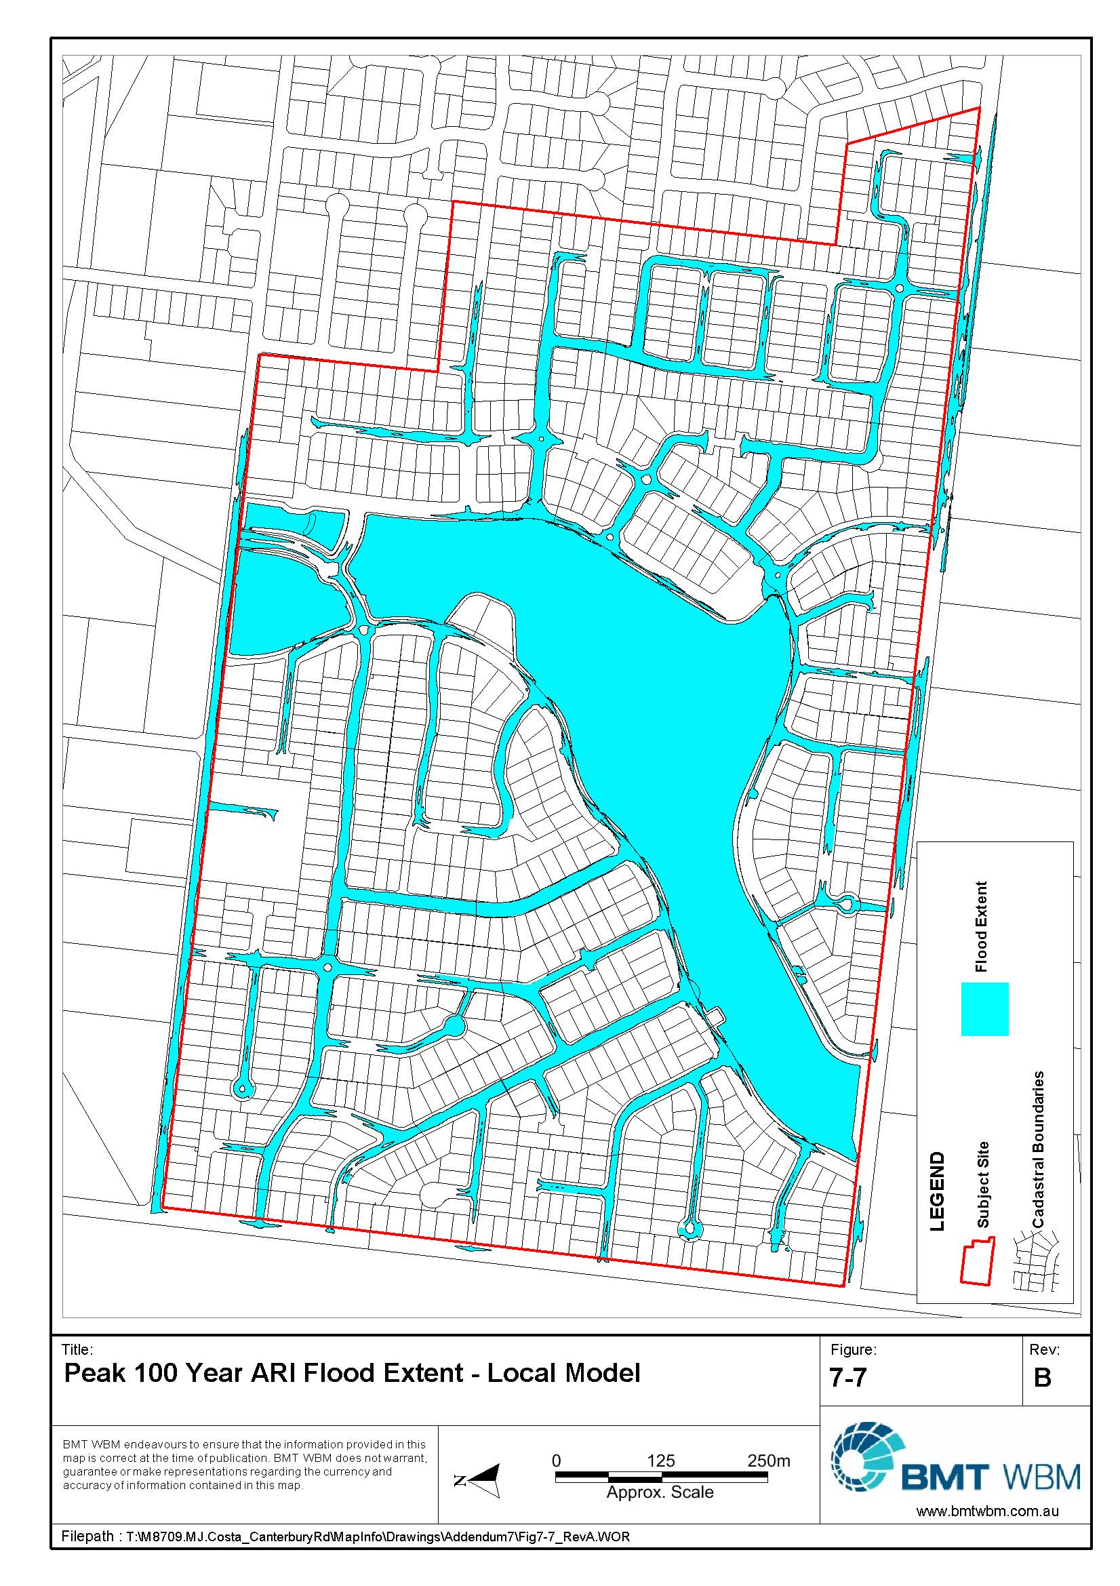
Figure 7-7 Peak 100 Year ARI Flood Extent – Local Model

Flood Safety Mapping – Regional Grand Lakes Model
Results of the regional Grand Lakes model were also mapped in terms of flood depth risk, flood velocity risk and flood depth velocity risk and are presented in Figure 7-8, Figure 7-9 and Figure 7-10 respectively.

Discussion of Flood Safety Mapping
As seen in Figure 7-8, Figure 7-9 and Figure 7-10 the development meets flooding criteria. WBM (2005) had shown a hazard problem over Buckingham Street, but this was overcome by raising the level of the street to prevent overtopping. This provides a benefit to the wider community by removing an existing hazard. To compensate for the loss of flow area over the road, the existing 2/1800 x 900 RCBC was increased to a 4/1800 x 900 RCBC. As was shown in Figure 7-4, this change has not affected flood levels downstream in the 100 year or 10 year ARI events.

Flood Safety Mapping – Local Grand Lakes Model
Melbourne Water’s Guidelines for Development in Flood Prone Areas stipulates that for a given site to be considered ‘safe’ it must meet the following three general criterions:
- Depth should be no more than 0.35m; and
- Velocity should be no more than 1.5 m/s; and
- The product of depth and velocity should be no more than 0.35 m²/s.
More detailed requirements relating to safety criteria are explained further in Appendix G of Melbourne Water’s Land Development Manual.
Results of the local Grand Lakes model were mapped in terms of flood depth risk, flood velocity risk and flood depth velocity risk and are presented in Figure 7-11 and Figure 7-12 Figure 7-13 respectively. In each of the figures, the safety criterion is only applied to the roads and properties within the development and not the large floodway and lake system. Depths within this floodway are exempt from the safety criteria because it is expected that people will perceive this area as flood prone and act accordingly. The Melbourne Water Land Development Manual state that floodways like this are exempt because the ‘visual nature and setting are clearly discernible to be an open waterway likely to be subject to flooding from time to time’.

Discussion of Flood Safety Mapping
As seen in Figure 7-11, Figure 7-12 and Figure 7-13, the proposed development meets the required criteria for all categories. The depth safety map, Figure 7-11, shows areas within road reserves where the 0.35 m depth criteria is exceeded. This occurs within the ‘dips’ of several ‘saw tooth’ roads. Appendix G of the Land Development Manual considers roadways of this type to be safe if the average depth across the road is less than or equal to 0.60 m and the average velocity*depth is less than 0.30 m²/s. For these locations, this criterion is met and consequently can be considered safe.
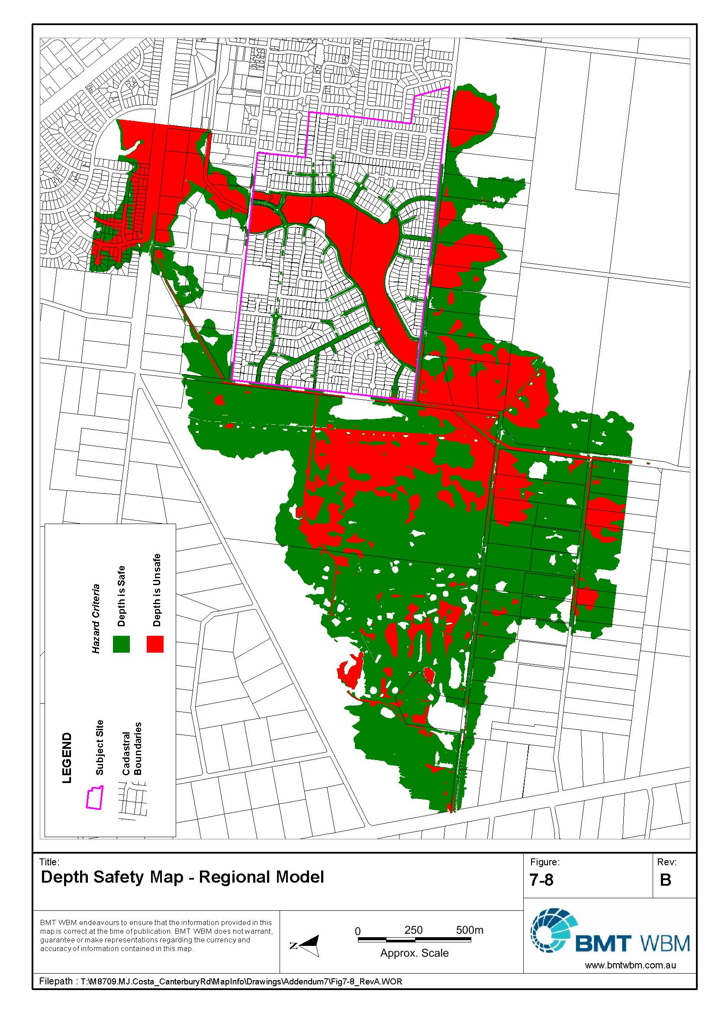
Figure 7-8 Depth Safety Map – Regional Model
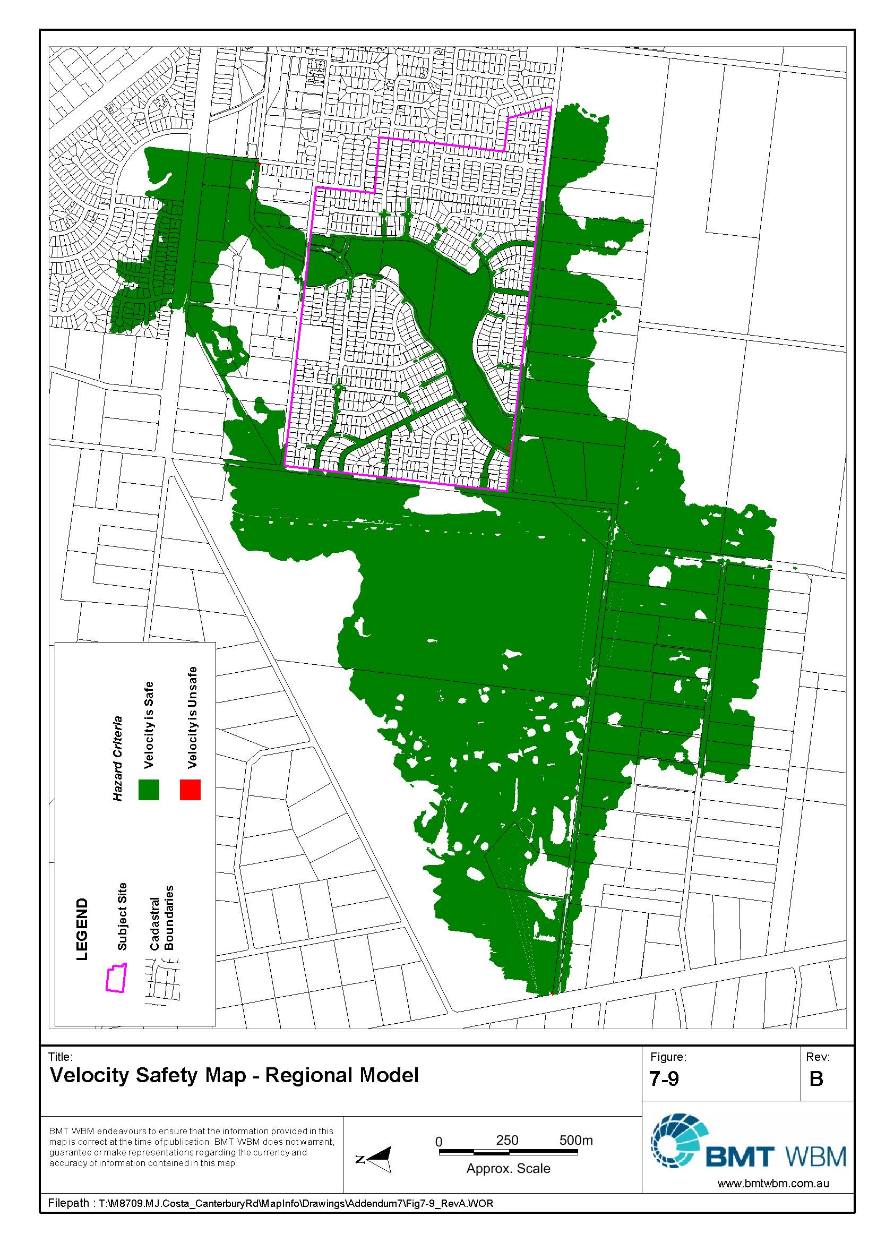
Figure 7-9 Velocity Safety Map – Regional Model
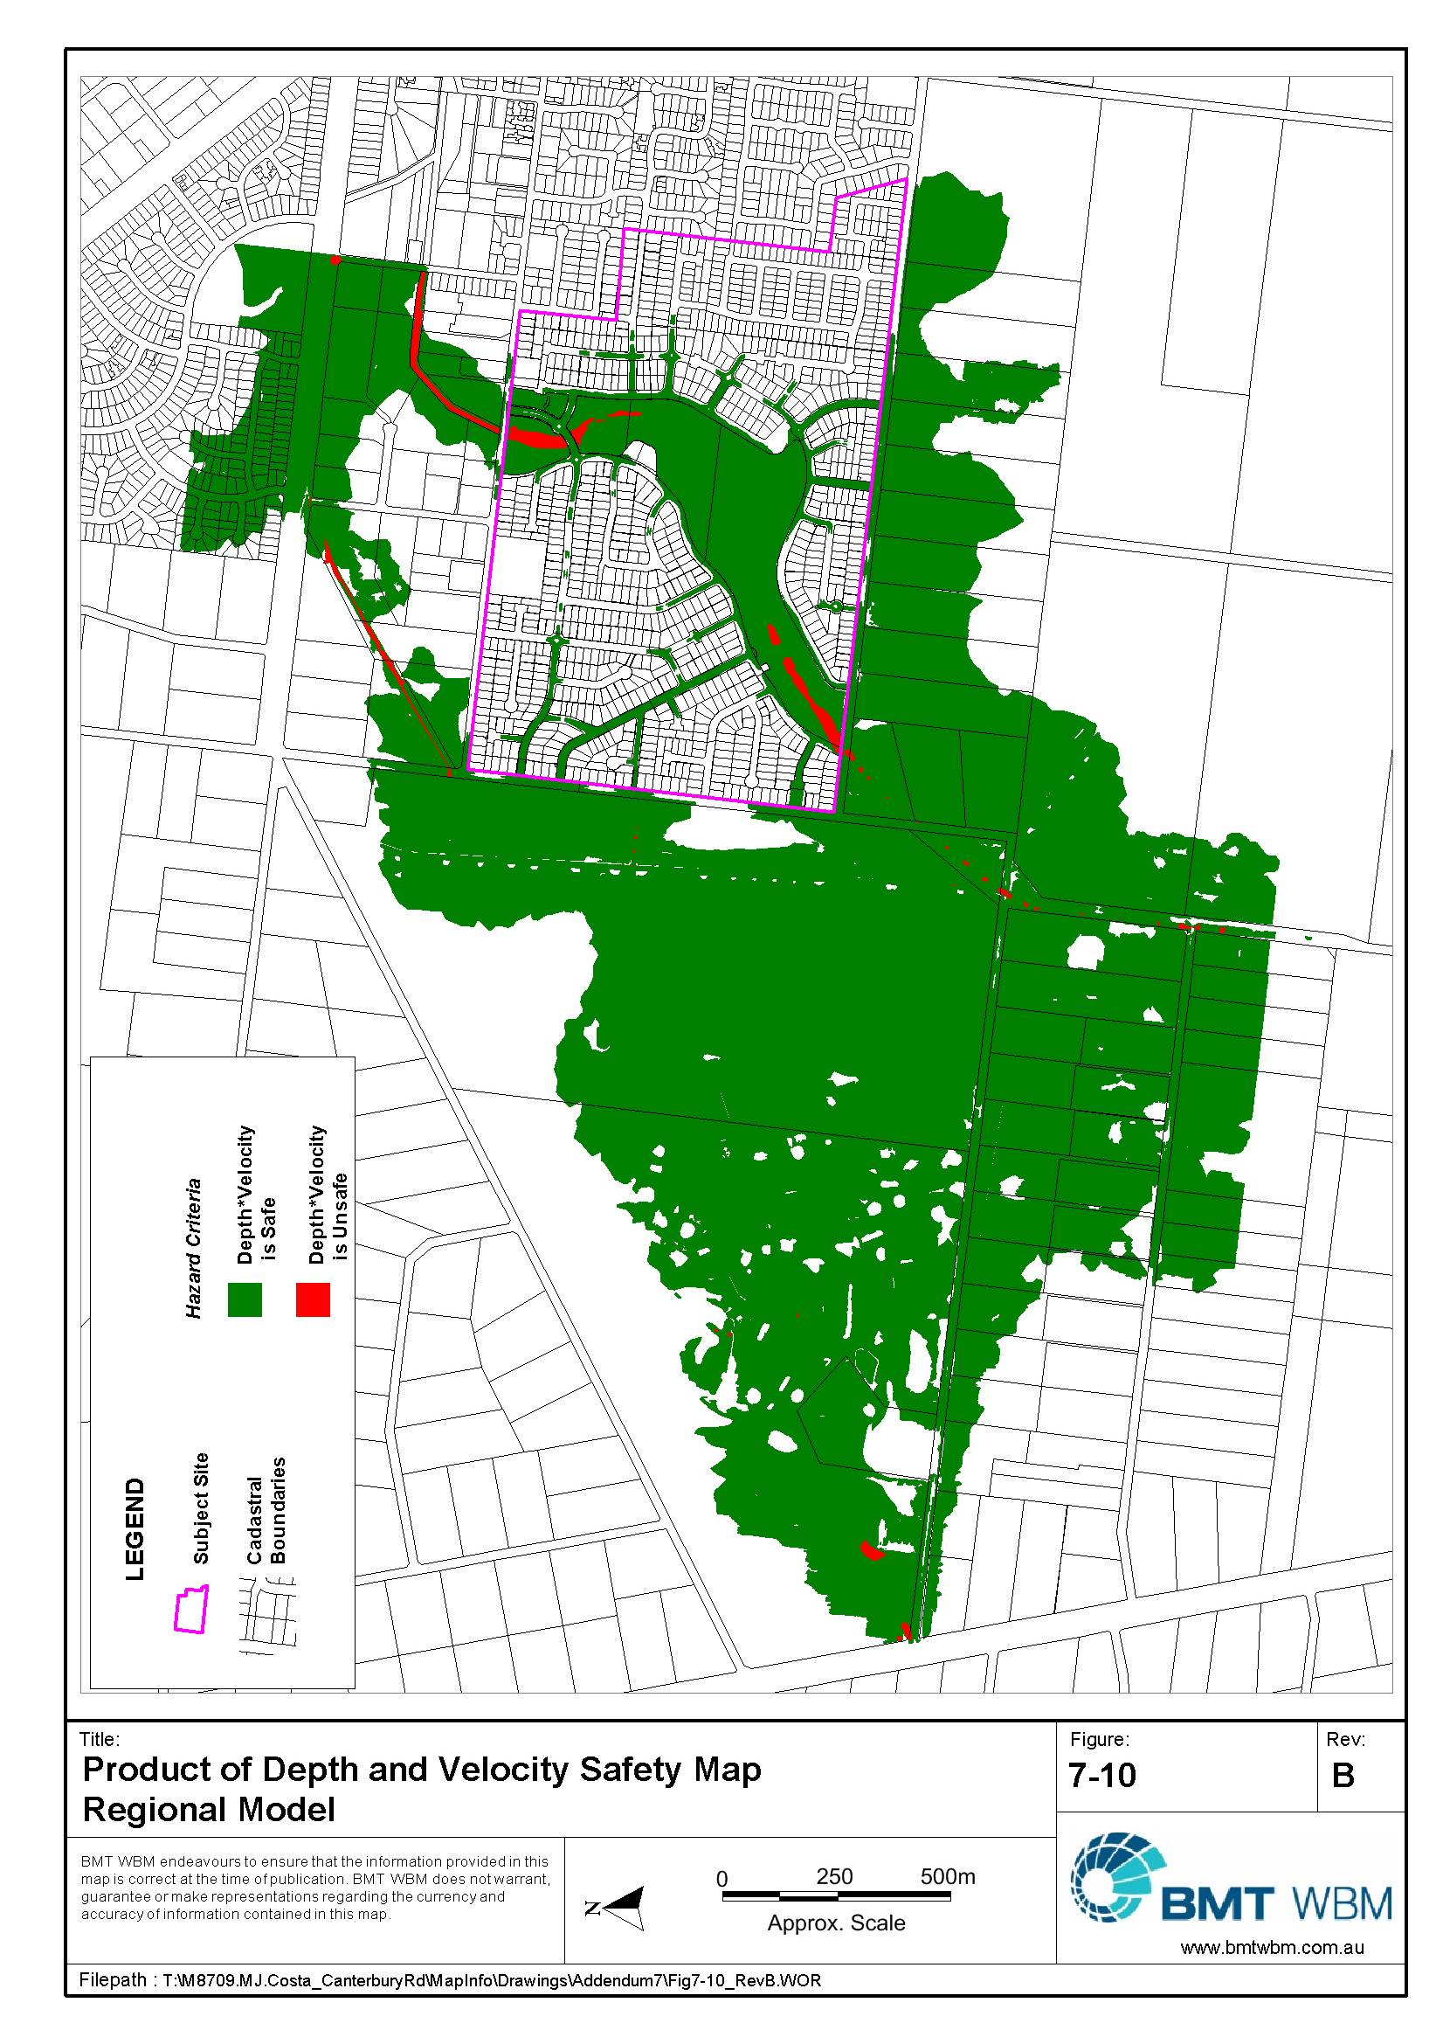
Figure 7-10 Product of Depth and Velocity Safety Map – Regional Model
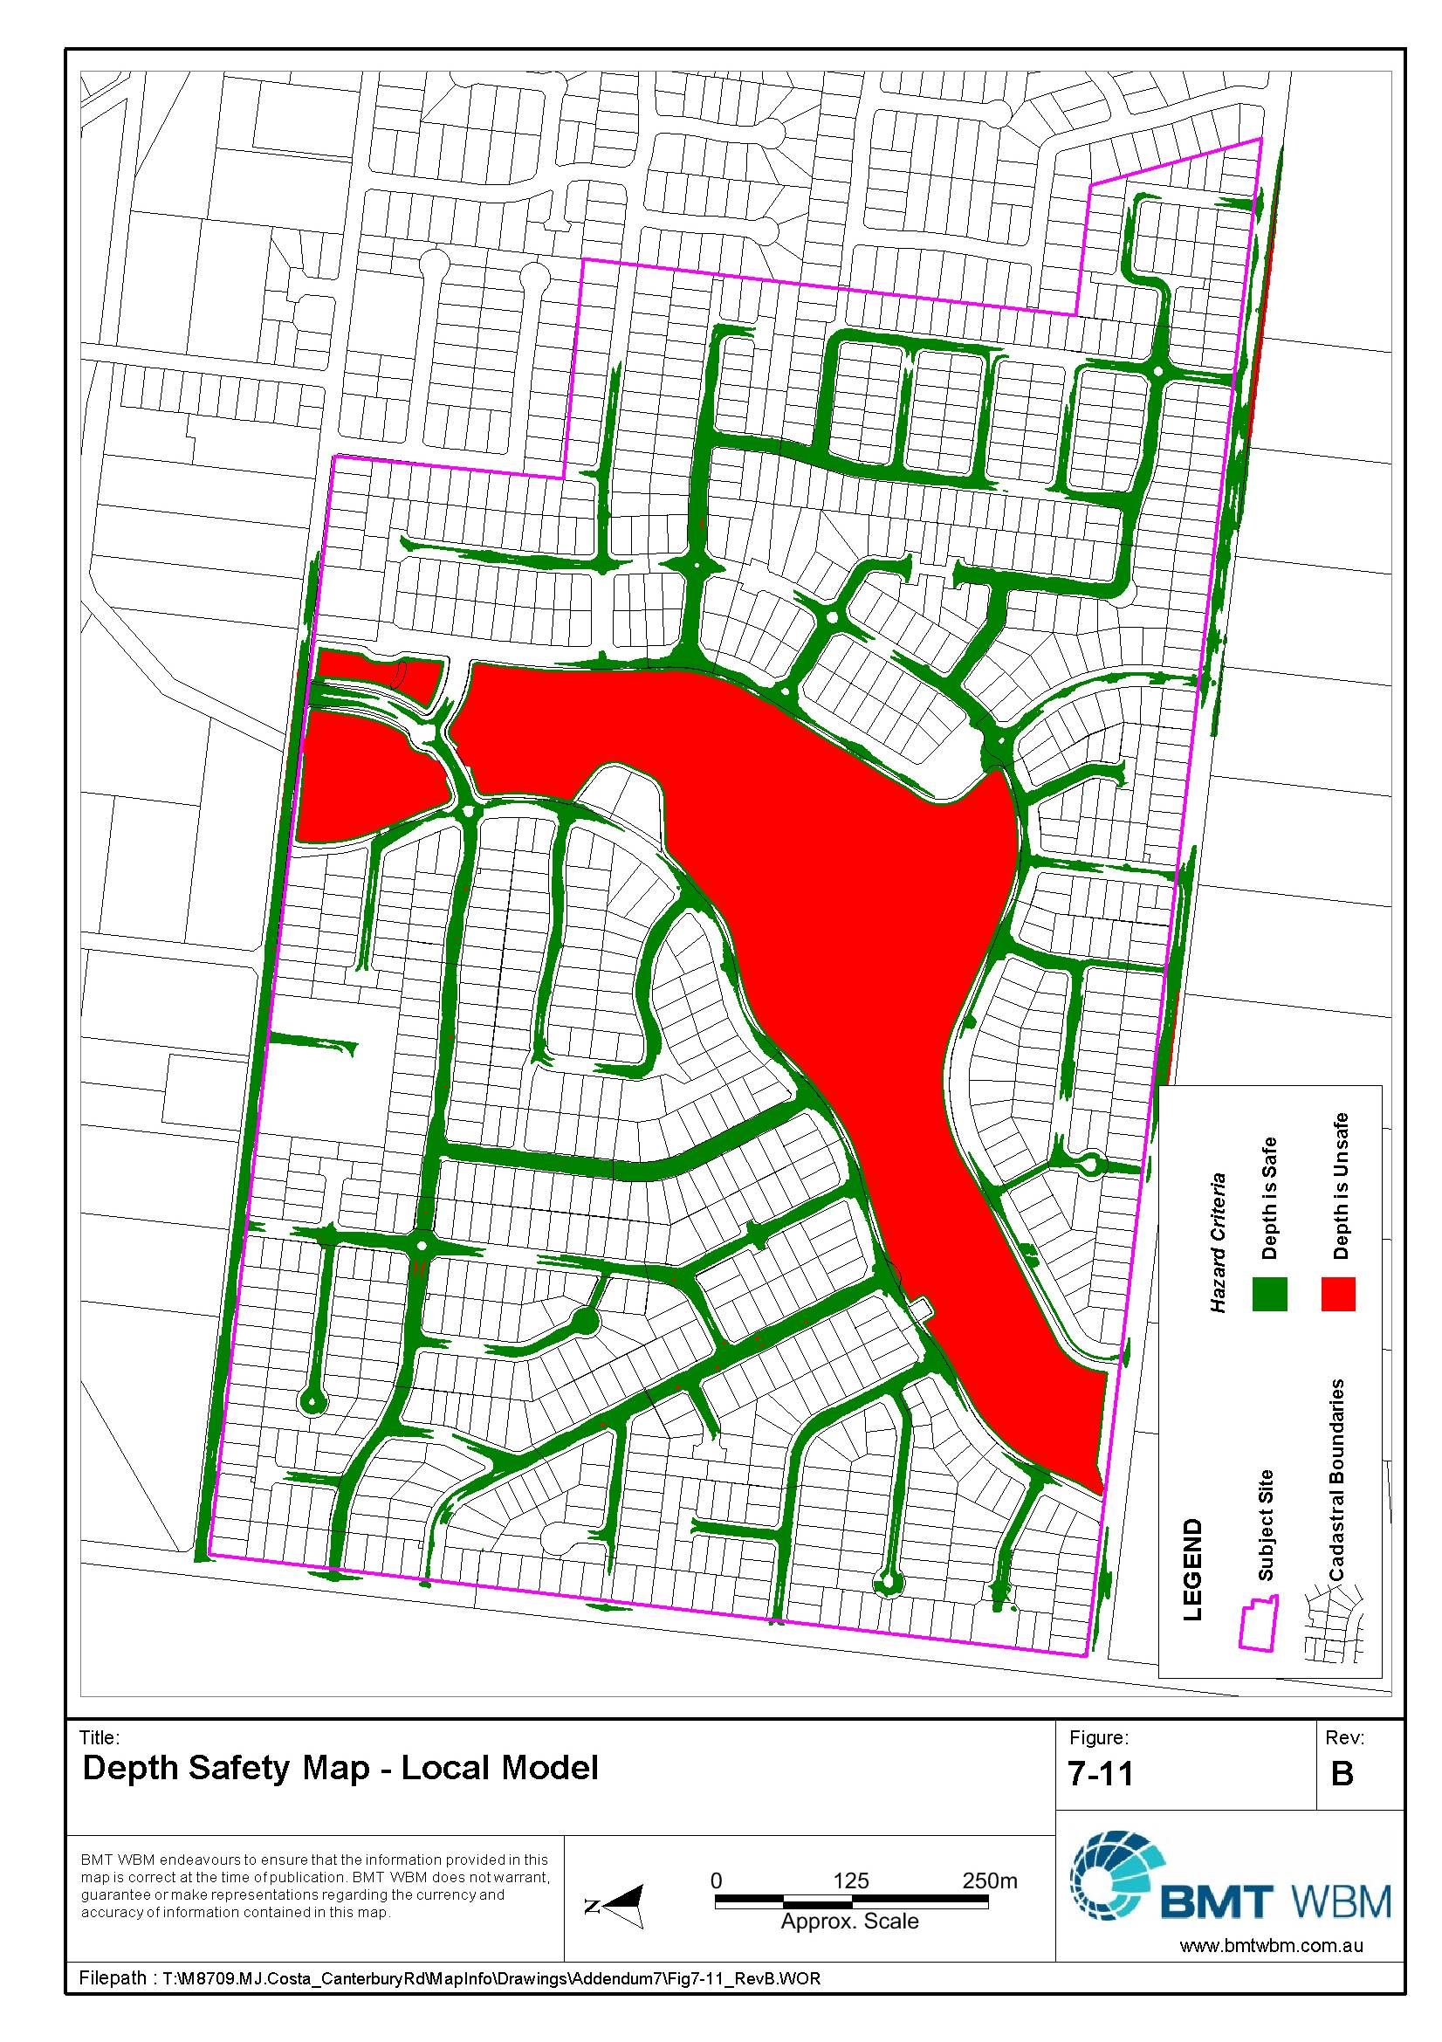
Figure 7-11 Depth Safety Map – Local Model
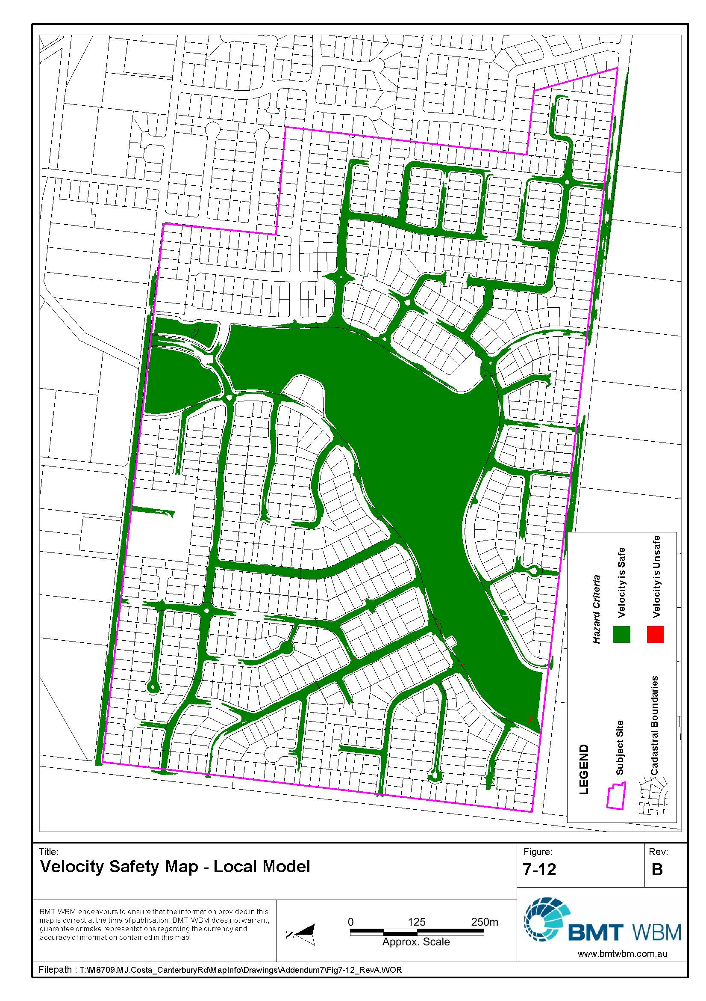
Figure 7-12 Velocity Safety Map – Local Model
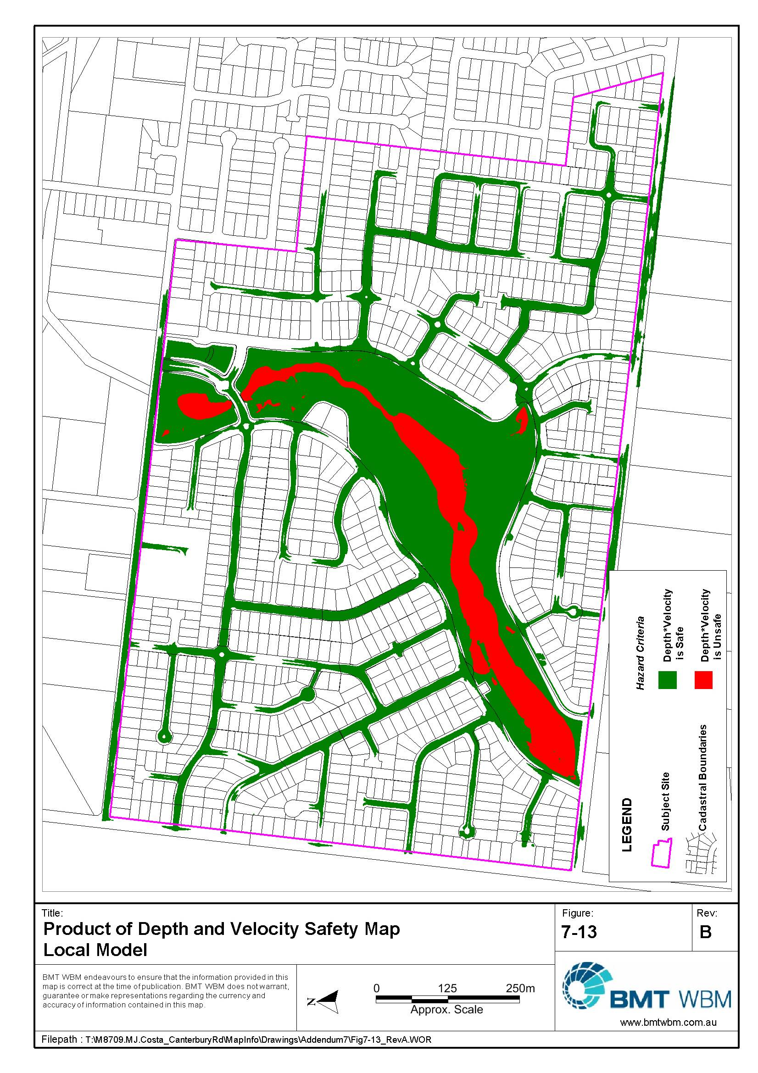
Figure 7-13 Product of Depth and Velocity Safety Map – Local Model

Summary
Two fully two-dimensional TUFLOW flood models have been developed to ensure that the proposed Grand Lakes residential development, and its Canterbury Road extension at Lara has no significant impact on flood levels external to the site (the regional model), and to ensure that the development meets Melbourne Water Guidelines for safety and egress during floods (local model).
Both models demonstrated that the proposed development can be constructed and meet the requirements for no significant flood impact and safety and egress during floods. .
Floor level controls have been recommended for consideration in areas where the street is at capacity in the 100 year ARI event. This will overcome the problems associated with builders cutting into the fill resulting in a reduction of the freeboard.

References
BMT WBM (2013), Grand Park Hydraulic Modelling Impact Report – Addendum Number 6, BMT WBM Pty Ltd, May 2013, Report No. R.M8709.001.00.ModellingReport.doc
WBM (2005), Grand Park Hydraulic Modelling Impact Report, WBM Pty Ltd, December 2005, Report No. R.M6884.002.001.ModellingReport.doc
WBM (2006ª), Grand Park Hydraulic Modelling Impact Report, WBM Pty Ltd, May 2006, Report No. R.6884.002.002.ModellingReport.doc
WBM (2006^{b}), Grand Park Hydraulic Modelling Impact Report - Addendum, WBM Pty Ltd, October 2006, Report No. R.6884.002.003.ModellingReport.doc
WBM (2006^{c}), Grand Park Hydraulic Modelling Impact Report – Addendum Number 2, WBM Pty Ltd, November 2006, Report No. R.6884.002.004.ModellingReport.doc
WBM (2006^{d}), Grand Park Hydraulic Modelling Impact Report – Addendum Number 3, WBM Pty Ltd, November 2006, Report No. R.6884.002.005.ModellingReport.doc
WBM (2007), Grand Park Hydraulic Modelling Impact Report – Addendum Number 4, WBM Pty Ltd, November 2006, Report No. R.6884.002.006.ModellingReport.doc
WBM (2009), Grand Park Hydraulic Modelling Impact Report – Addendum Number 5, WBM Pty Ltd, September 2009, Report No. R.6884.002.006.ModellingReport.doc


BMT WBM Brisbane | Level 8, 200 Creek Street Brisbane 4000  PO Box 203 Spring Hill QLD 4004  Tel +61 7 3831 6744 Fax +61 7 3832 3627  Email bmtwbm@bmtwbm.com.au  Web www.bmtwbm.com.au
BMT WBM Denver | 8200 S. Akron Street, Unit 120  Centennial Denver Colorado 80112 USA  Tel +1 303 792 9814 Fax +1 303 792 9742  Email denver@bmtwbm.com  Web www.bmtwbm.com.au
BMT WBM Mackay | Suite 1, 138 Wood Street Mackay 4740  PO Box 4447 Mackay QLD 4740  Tel +61 7 4953 5144 Fax +61 7 4953 5132  Email mackay@bmtwbm.com.au  Web www.bmtwbm.com.au
BMT WBM Melbourne | Level 5, 99 King Street Melbourne 3000  PO Box 604 Collins Street West VIC 8007  Tel +61 3 8620 6100 Fax +61 3 8620 6105  Email melbourne@bmtwbm.com.au  Web www.bmtwbm.com.au
BMT WBM Newcastle | 126 Belford Street Broadmeadow 2292  PO Box 266 Broadmeadow NSW 2292  Tel +61 2 4940 8882 Fax +61 2 4940 8887  Email newcastle@bmtwbm.com.au  Web www.bmtwbm.com.au
BMT WBM Perth |  | Suite 6, 29 Hood Street Subiaco 6008  Tel +61 8 9328 2029 Fax +61 8 9484 7588  Email perth@bmtwbm.com.au  Web www.bmtwbm.com.au
BMT WBM Sydney |  | Level 1, 256-258 Norton Street Leichhardt 2040  PO Box 194 Leichhardt NSW 2040  Tel +61 2 9713 4836 Fax +61 2 9713 4890  Email sydney@bmtwbm.com.au  Web www.bmtwbm.com.au
BMT WBM Vancouver |  | 401 611 Alexander Street Vancouver  British Columbia V6A 1E1 Canada  Tel +1 604 683 5777 Fax +1 604 608 3232  Email vancouver@bmtwbm.com  Web www.bmtwbm.com.au

