Proposed Residential Subdivision
50-68 Canterbury Road West, Lara

Transport Impact Assessment Report

18 June 2013


ESR Transport Planning Pty Ltd ABN 86 128 037 429 www.esrtp.com.au
15 Dawson Street South, Ballarat VIC 3350 | Email: drewm@esrtp.com.au | Phone: 0427 044 324

Contents
1 Introduction 3
1.1 Overview 3
1.2 Scope of This Report 3
1.3 Referenced Documents 3
1.4 Abbreviations Used in This Report 3
2 Existing Conditions 4
2.1 Site 4
2.2 Road Network 5
2.3 Traffic Volumes 6
2.4 Existing Intersection Operation 8
2.5 Accident History 8
2.6 Public Transport 9
2.7 Pedestrian and Cyclist Facilities 9
2.8 Lara Structure Plan 9
3 Proposed Development 13
4 Transport Network Design Review 14
4.1 Preamble 14
4.2 General 14
4.3 Road Hierarchy and Cross Sections 14
4.4 Access to Public Transport 15
4.5 Walking and Cycling 16
4.6 Intersections 16
4.7 Speed Management 17
5 Traffic Impact Assessment 18
5.1 Traffic Generation 18
5.2 Traffic Distribution 18
5.3 Post Development Traffic Volumes 19
5.4 Future Traffic Volume Growth 22
5.5 Post Development Intersection Operation 22
5.6 Traffic Impacts 23
6 Conclusions 24
Appendix A Sidra Analysis Results
Appendix B Plan of Subdivision

Introduction

Overview
Planning approval is currently being sought to subdivide land located at 50-68 Canterbury Road West in Lara for the purpose of residential development. To assist in the consideration of the development proposal, ESR Transport Planning has been engaged by Point Cook Pty Ltd to assess the transport implications of the proposal.

Scope of This Report
This report documents a transport impact assessment which investigates the following:
- Existing transport conditions in the vicinity of the site.
- The proposed transport network and connections to existing networks.
- Anticipated traffic movements generated by the proposed development.
- Traffic impacts of the proposed development.

Referenced Documents
The following references have been used during the preparation of this report:
- Plan of subdivision prepared by TGM Group, dated 17/06/13.
- Greater Geelong Planning Scheme.
- Lara Structure Plan, April 2011.
- Infrastructure Design Manual (IDM), Version 4, March 2013.
- G21 Integrated Public Transport Strategy, 2008.
- Guide to Traffic Generating Developments (Roads and Traffic Authority (RTA), 2002).
- Trip Generation Manual (Institute of Transportation Engineers (ITE), 9th Edition, 2012).
- Maps and aerial photography from Google Maps.

Abbreviations Used in This Report
- Council City of Greater Geelong Council
- DOS degree of saturation
- kph kilometres per hour
- m metres
- vph vehicles per hour
- vpd vehicles per day

Existing Conditions

Site
The rectangular shaped site is located on the north side of Canterbury Road West in the southwest region of Lara. Currently zoned for farming use, the site consists of a residential dwelling and grazing paddocks.
The Grand Lakes Estate is located north and west of the site. This residential estate was rezoned from farming use in 2008 and has since been progressively developed. Approximately 670 lots are currently titled with lots north of the site currently under construction. Upon completion, the estate is expected to have a total of approximately 792 lots.
Land immediately east of the site that is zoned residential 1 is currently vacant and therefore is a potential residential subdivision development site.
Land south of the site is zoned as farming use. The Lara Structure Plan recommends further investigation regarding possible residential development in the area between Canterbury Road West and the Heales Road Industrial Buffer.
Figure 2.1 Subject Site Locality Map

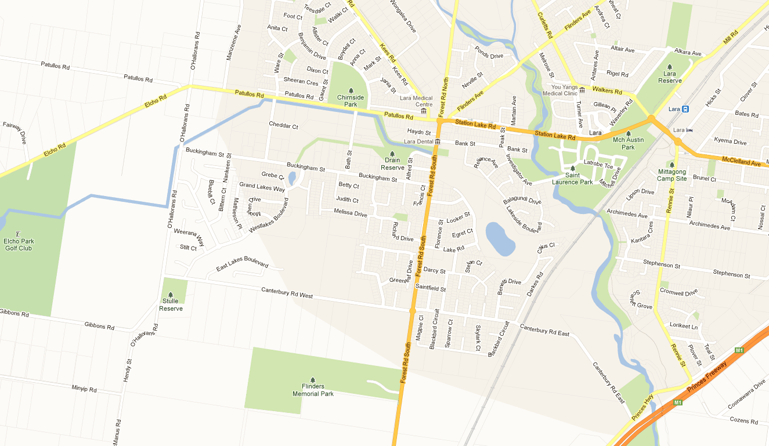
SITE
Figure 2.2 Subject Site and Surrounds Aerial Photo
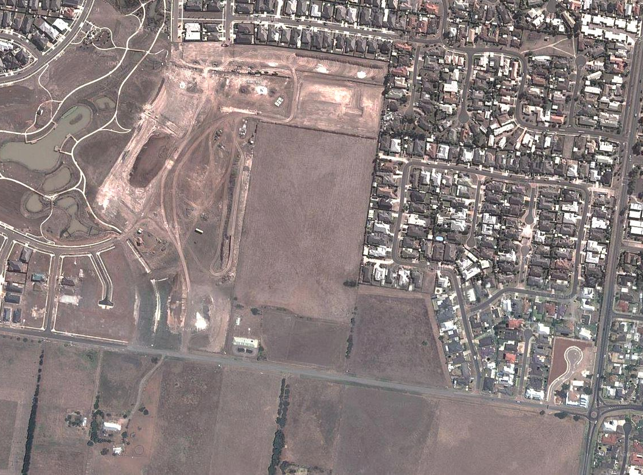
Grand Lakes Estate
Area currently
under construction
Vacant Res1
CANTERBURY ROAD WEST
FOREST ROAD SOUTH
SITE

Road Network
Canterbury Road West is classified as a local road and its cross section varies along its length depending on the type of adjacent land use. In the vicinity of the site where adjacent land is farming, a gravel carriageway accommodates two-way vehicular movement. To the east and west of the site where the road is adjacent residential properties, an asphalt carriageway accommodates two-way vehicular movement and on-street parking with a footpath provided on the north side of the roadway. Signage just east of the site specifies a 60kph speed limit to the east and 'End 60kph' speed limit to the west.
Forest Road South is an arterial road that provides a connection between Lara and Geelong. A roundabout controls movements at its intersection with Canterbury Road. North of the roundabout, it has an urban cross section with a single traffic lane in each direction, on-road bicycle lanes, kerbside parallel parking on the east side and bus stop parking on the west side. South of the roundabout, it has a rural cross section with a single traffic lane in each direction and gravel shoulders. In the vicinity of the roundabout a 60kph speed limit applies.
Canterbury Road East is classified as a secondary distributor road and has a 60kph speed limit. In the vicinity of Forest Road South it accommodates two-way traffic, kerbside car parking on both sides and a footpath on the south side.

Figure 2.3 Canterbury Road West  (facing west opposite site)  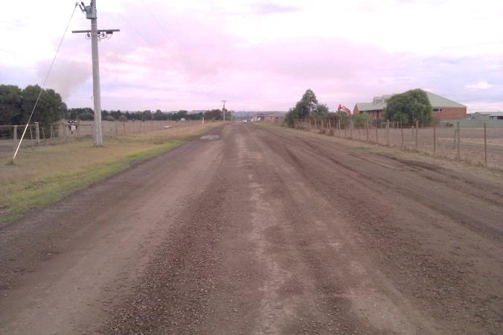  Subject Site | Figure 2.4 Canterbury Road West  (facing west opposite Grand Lakes Estate)  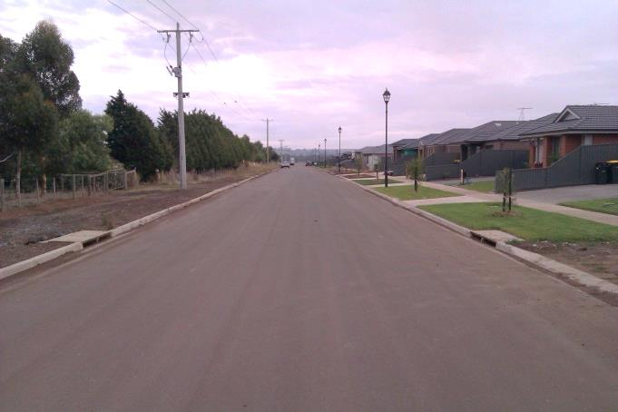
Figure 2.5 Canterbury Road West  (facing east to Forest Road roundabout)  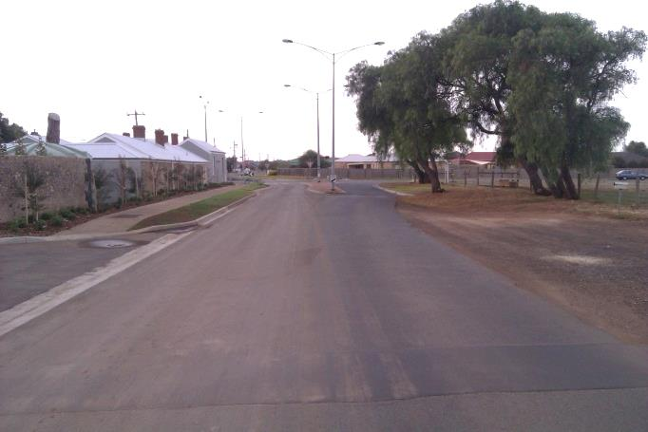 | Figure 2.6 Forest Road South  (facing south)  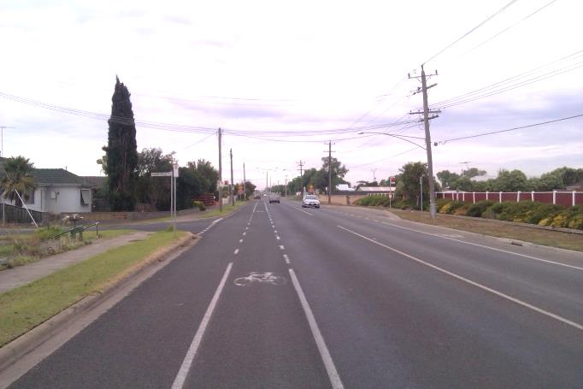

Traffic Volumes
A range of traffic volume data has been collated as follows:
- Annual average daily traffic volumes and commercial vehicle volumes on arterial roads published by VicRoads.
- Intersection turning movement survey at the Forest Road / Canterbury Road roundabout undertaken on Thursday 23/05/13 between the hours of 7:30am to 9:30am and 3:00pm to 6:00pm.
- AM and PM peak period (half hour to 45 minute) surveys on Canterbury Road West adjacent the site on Wednesday 22/05/13.
- Historic daily traffic volume data provided by Council.
Figure 2.7 shows the existing two-way daily traffic volumes derived from these sources while Figure's 2.8 and 2.9 set out AM and PM commuter peak hour volumes at the Forest Road / Canterbury Road roundabout and past the site's frontage.
Figure 2.7 Existing Daily Two-Way Traffic Volumes in Site's Vicinity
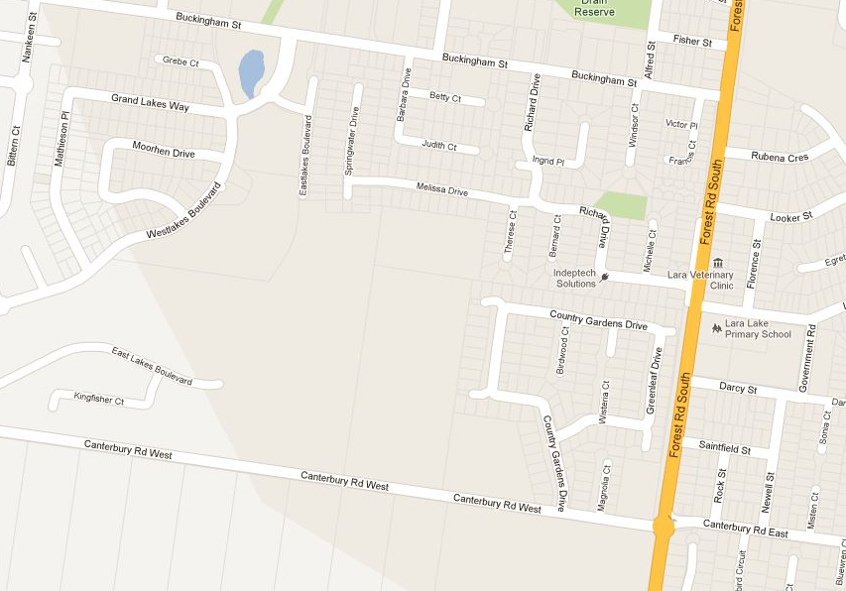
10,000 (5%CV)
1,100
2,100
2,900
2,400
SITE
Notes: (1) CV = Commercial Vehicles. (2) Where only peak period data is available a peak hour to daily ratio of 10% has been applied. (3) Where only historic data is available an annual growth rate of 2% has been applied.
Figure 2.8 Existing AM Peak Hour (8:00-9:00am) Traffic Volumes in Site's Vicinity
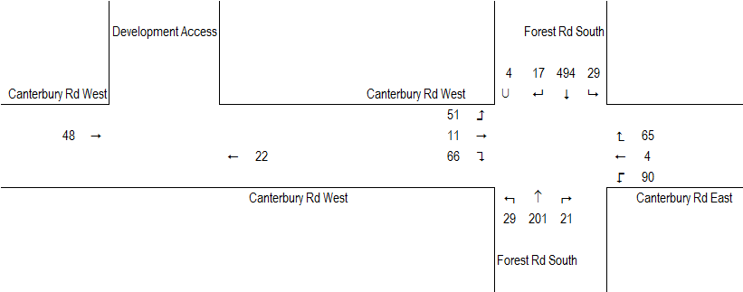
Figure 2.9 Existing PM Peak Hour (3:15-4:15pm) Traffic Volumes in Site's Vicinity
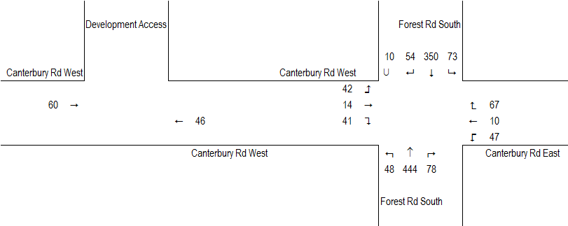

Existing Intersection Operation
The operational performance of the nearby Forest Road / Canterbury Road intersection has been analysed using Sidra Intersection computer software for the critical AM and PM commuter peak hours. Results are summarised in Table 2.1 with more detailed results in Appendix A.
Table 2.1 Sidra Intersection Analysis Results – Existing Conditions
Item |  | AM Peak |  |  | PM Peak
Item | DOS | Avg Delay | LOS | DOS | Avg Delay | LOS
Forest Rd / Canterbury Rd Existing Conditions | 0.38 | 11 | B | 0.50 | 11 | B

Table 2.1 indicates the Forest Road / Canterbury Road roundabout currently operates within typical performance standards providing a good level of service during peak times.

Accident History
A review of road accidents in the site's vicinity has been undertaken using VicRoads Crashstats database which includes details of all reported casualty accidents since 1987. The review investigated the full length of Canterbury Road West inclusive of end intersections for the last available five year period (01/01/07 to 31/12/11). In that time, 1 accident was reported being a single vehicle leaving the road mid-block. Therefore, this review provides no evidence of a fundamental road safety issue in the site's vicinity.

Public Transport
The Lara train station is located a travel distance of approximately 4km from the site.
Bus route 12 (Geelong – Lara) operates along Forest Road South approximately 400m from the site boundary, refer Figure 2.10 showing route map.
Figure 2.10 Extract of Bus Route 12 Map (Source: www.ptv.vic.gov.au)
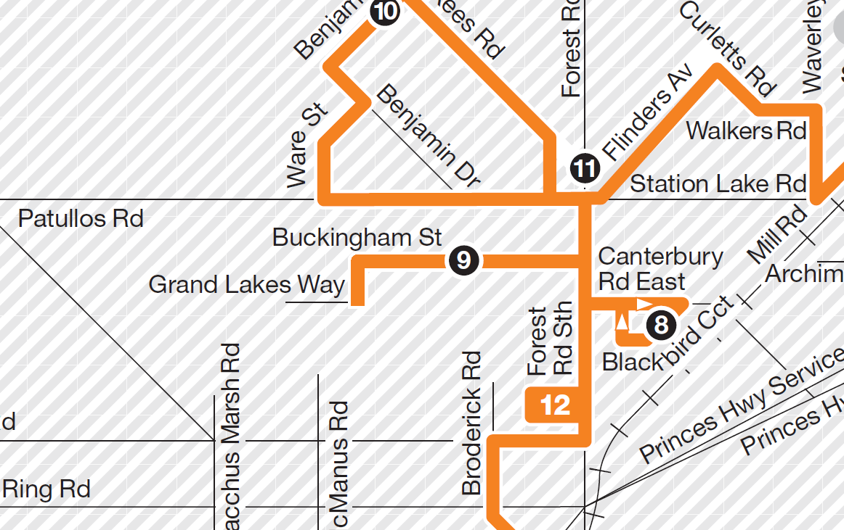

The G21 Integrated Public Transport Strategy provides a staged plan for the improvement of public transport within the G21 region. It recommends that route 12 be expanded to pick up other catchment areas, particularly identified growth areas.

Pedestrian and Cyclist Facilities
Footpaths are provided on the north side of Canterbury Road West adjacent residential areas. Within Grand Lakes Estate, local roads generally have footpaths on both sides and trails are provided along the wetlands open space. Local roads east of the site generally have footpaths on one side of the roadway. Forest Road South has on-road bicycle lanes north of Canterbury Road.

Lara Structure Plan
The Lara Structure Plan adopted in 2011 provides a strategic framework for the future planning and development of Lara. Items nominated in the Structure Plan relevant to the proposed development include the following:
- A recommendation that the site be nominated for rezoning to residential.
- Identification of an area south of Canterbury Road West and north of the Heales Road Industrial Buffer for further investigation regarding possible residential development.
- Proposed upgrade of Forest Road South to accommodate on-street parking, pedestrian refuges, bicycle lanes, 4 through lanes and truck turning lanes. Based on discussions with VicRoads, the duplication of Forest Road South is not part of any current project planning and its implementation is not expected in the short term future.

Figure 2.11 Lara Structure Plan
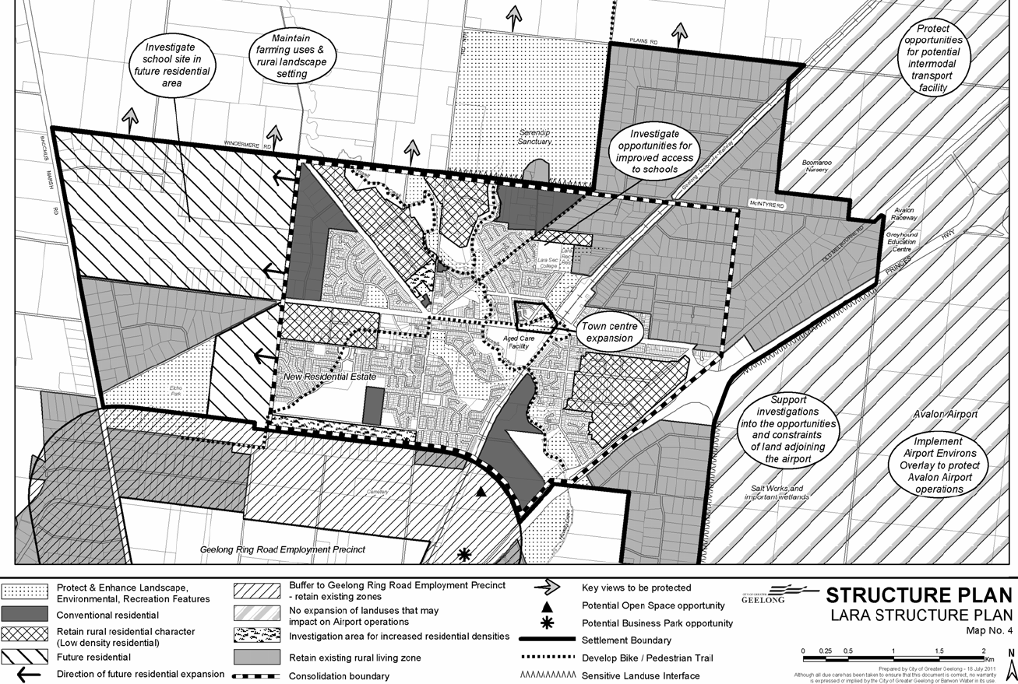
Figure 2.12 Lara Structure Plan Transport Management Plan
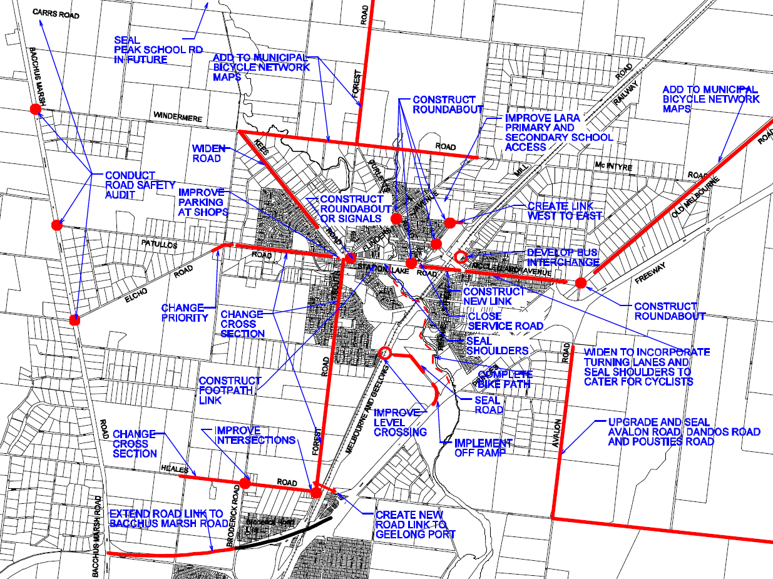

Proposed Development
Plans show a proposed development incorporating 128 residential dwelling lots and supporting transport network. The proposed road network is laid out in a grid configuration with a main access via Canterbury Road West. The road network also connects to Grand Lakes Estate to the north (area currently under construction) and to the west (future stage). The network will also provide for future connectivity to undeveloped land immediately east of the site. The development is likely to occur in stages over several years.
A copy of the plan of subdivision is attached in Appendix B.

Transport Network Design Review

Preamble
The transport network represented in the proposed development plan has been reviewed and findings are presented below. The review focused on the overarching principle of providing safe and efficient movement for all road users. The Greater Geelong Planning Scheme has been referred to as it provides specific guidance for new residential subdivisions. Other guideline documents include the Infrastructure Design Manual (IDM) which has been adopted by Council and various other transport planning texts such as Austroads publications.

General
In general the proposed road network is considered consistent with the objectives of the Planning Scheme as it is expected to provide direct, safe and convenient movement for all road users. The grid layout will be easily navigated and good connectivity is provided through various linkages to surrounding neighbourhoods.

Road Hierarchy and Cross Sections

Internal Roads
Almost all roads within the proposed development are expected to operate as local access streets. Development plans indicate that the road network will be predominately comprised of roads with a pavement width of approximately 7m set within either a 16m or 18m road reserve and footpaths provided on both sides.
One short section of roadway adjacent lot numbers 47-48 will function as an access lane and is shown with a 5m shared (vehicular, pedestrian, cyclist) pavement set within a 10m road reserve.
These cross sections are consistent with the Planning Scheme and Infrastructure Design Manual and are considered fit for purpose.

Canterbury Road West
Development plans show a footpath along Canterbury Road West adjacent lots on the north side and a 7m wide (approximate) carriageway.
Given recent development growth and the potential for future residential development along the south side of Canterbury Road West, it is likely that the roadway will function as a collector (distributor) road in future. The Planning Scheme and Infrastructure Design Manual specify collector streets with carriageways in the order of 11m width to accommodate a traffic lane in each direction clear of kerbside parking on both sides. The carriageway recently constructed to the west of the site adjacent Grand Lakes Estate is 9m wide (approximate) between kerbs while to the east of the site a 6.5m wide (approximate) carriageway is provided with kerbing on the north side only.
Given all of the above, it is recommended that Council review the role of Canterbury Road West and specify a future classification and cross section. A potential treatment as part of the proposed development is to construct a 9m wide (approximate) carriageway matching into the carriageway to the west that will accommodate a traffic lane in each direction clear of kerbside parking on the north side. Its design could make provision for the potential future widening of the carriageway on the south side to accommodate a parking lane should residential development occur on this side.
It is also recommended that a 60kph speed limit be implemented along the length of Canterbury Road West.

Access to Public Transport
Predominately route buses operate along the arterial and collector road networks to service neighbouring areas. Accordingly, it is considered unlikely that a bus route will be directed through the proposed development's local street network.
Currently bus route 12 operates along Forest Road South and Buckingham Street which are approximately 400m distance from the site's eastern and northern boundaries providing access to public transport services.
The G21 Integrated Public Transport Strategy recommends that route 12 be expanded to pick up identified growth areas. On this basis, it is anticipated that Canterbury Road West would form a likely route extension. If this occurs, residents within the proposed development will have a shorter distance to access public transport services.
Figure 4.1 Site Location Compared with Existing and Potential Future Bus Routes
~400m
Existing Bus Route 12
Potential Route Extension
LEGEND:
SITE
~400m
~400m

Walking and Cycling
All access streets within the proposed development are provided with footpaths on both sides of the road. These access streets are low volume, low speed traffic routes suitable for cyclists to share the road carriageway with vehicular movements.
The access lane adjacent lot numbers 47-48 has a shared (vehicular, pedestrian, cyclist) pavement similar to the Country Gardens Drive carriageway immediately east of the site's boundary. This road will provide an important pedestrian and cyclist route between the development and Country Gardens Drive (which connects to the Forest Road school crossing). Accordingly, a path linking the proposed access lane with the Country Gardens Drive carriageway is shown on development plans.

Intersections
The majority of intersections within the site are T intersections. There is 1 cross intersection and a roundabout is shown providing intersection control. The roundabout is considered an appropriate treatment and its dimensions are considered adequate for necessary vehicle movements based on swept path analysis. The swept path analysis indicated the roundabout will be able to accommodate a design vehicle up to an 8.8m rigid vehicle (all movements without using opposing lanes) and a checking vehicle up to a 12.5m rigid vehicle (some movements using opposing lanes).
Figure 4.2 Swept Path Diagram - 8.8m Vehicle Right Turn and 12.5m Vehicle Through Movement
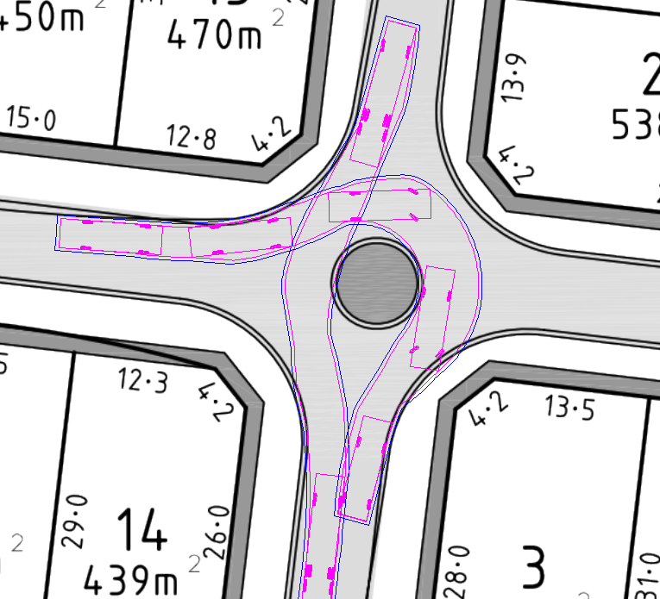

The site access intersection with Canterbury Road West will form a T intersection and a standard T intersection configuration with a single traffic lane in each direction similar to other T intersections along Canterbury Road West is considered appropriate.

Speed Management
The Planning Scheme states that street lengths should be 240m or less to manage vehicle speeds. With an extension into Grand Lakes Estate, the north-south aligned road adjacent lots 56-74 is likely to have a length in the order of 380m. It is therefore recommended that the detailed design of this roadway incorporate speed management infrastructure approximately half way along its length.

Traffic Impact Assessment

Traffic Generation
Guidance on the likely traffic generating characteristics of the proposed development has been sought from the Guide to Traffic Generating Developments (Roads and Traffic Authority (RTA), 2002) and Trip Generation (Institute of Transportation Engineers (ITE), 9th Edition, 2012). Based on these sources the following generation rates have been adopted for the purpose of analysis:
- AM peak hour, 0.85vph / lot, 25% entering, 75% exiting.
- PM peak hour, 1.0vph / lot, 65% entering, 35% exiting.
- Daily, 10vpd / lot, 50% entering, 50% exiting.
Accordingly, upon full development of the subject site, the following additional traffic movements could be anticipated:
- AM peak hour, 109vph (27vph entering, 82vph exiting).
- PM peak hour, 128vph (83vph entering, 45vph exiting).
- Daily, 1,280vpd (640vpd entering, 640vpd exiting).

Traffic Distribution
The direction in which vehicles travel to and from the site is influenced by a variety of factors including the site's location, configuration of the surrounding road network and trip purpose.
A review of 2011 census data indicates that approximately 20% of Lara residents that drive to work have a place of employment within Lara, 50% in Geelong and 30% in Melbourne. It is noted that this data is applicable to work trips only.
Existing traffic volumes on the surrounding road network also provide guidance on the directional distribution of traffic during commuter peak periods. At the Forest Road / Canterbury Road intersection, peak period surveys indicate traffic on Canterbury Road (east and west) have a directional distribution in the order of 46% to/from the north, 49% to/from the south and 5% straight through east/west-bound.
It is anticipated that Canterbury Road West will provide the most convenient route to/from the site for the majority of future residents while some residents in the northern part of the site are likely to find Buckingham Street a more convenient route.
Given all of the above, Figure 5.1 sets out the directional distributions adopted for analytical purposes.
Figure 5.1 Assumed Directional Distribution of Traffic to/from the Site
2%
SITE
2%
1%
12%
1%
40%
4%
38%

Post Development Traffic Volumes
Figure 5.2 shows the additional traffic volumes generated by the proposed development on the surrounding road network over a 24 hour period based on the analysis above. Figure 5.3 shows the resultant post development traffic volumes equated as existing volumes plus development traffic.
Figure 5.2 Additional Two-Way Traffic Volumes Generated by the Proposed Development - Daily
512
179

25

13

1050
25

SITE
13

154

487
51
Figure 5.3 Post Development Two-Way Traffic Volumes - Daily
10,490 (5%CV)
2,150
3,150
2,950
2,550
SITE
Notes: (1) Volumes have been rounded to the nearest 10vpd.
Figure's 5.2 and 5.3 indicate that the development proposal will increase traffic volumes on Canterbury Road West by approximately 1,050vpd with most of these vehicles then travelling north or southbound on Forest Road South. Relatively minor traffic volume increases are experienced within other parts of the surrounding road network.
Figure's 5.4 and 5.5 show the additional traffic volumes generated by the proposed development on Canterbury Road West between the site and Forest Road South during the AM and PM commuter peak hours. Figure's 5.6 and 5.7 show the resultant post development peak hour traffic volumes.
Figure 5.4 Additional Traffic Volumes Generated by the Proposed Development - AM Peak Hour
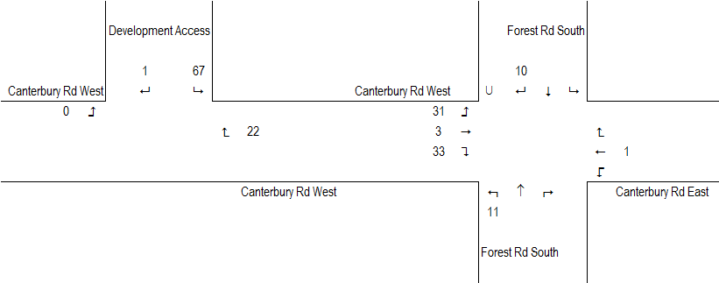
Figure 5.5 Additional Traffic Volumes Generated by the Proposed Development - PM Peak Hour
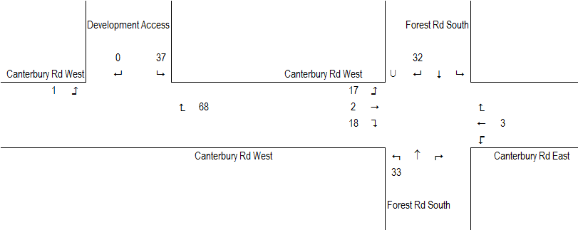

Figure 5.6 Post Development Two-Way Traffic Volumes - AM Peak Hour
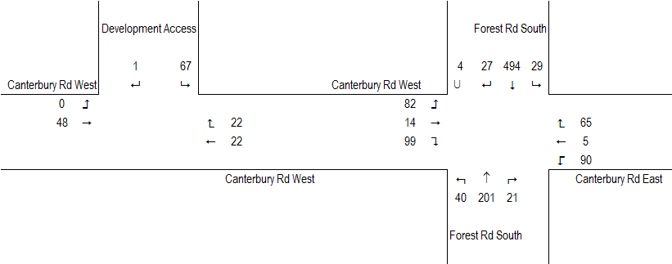
Figure 5.7 Post Development Two-Way Traffic Volumes - PM Peak Hour
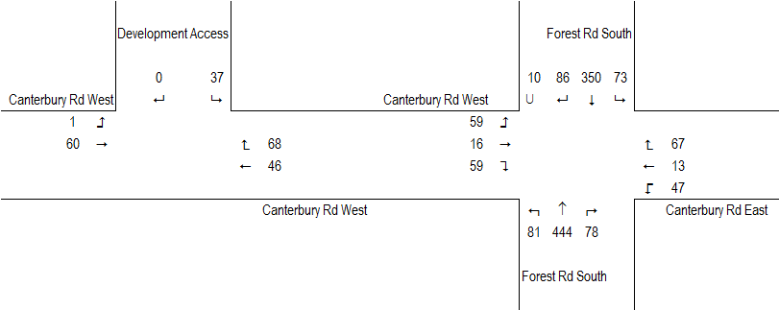

Future Traffic Volume Growth
As Lara's population grows so will traffic volumes on its road network. As anticipated by the Lara Structure Plan, it is likely that vacant land in the vicinity of the site will be developed over time. Areas of anticipated development include the final stages of Grand Lakes Estate, vacant Residential 1 zoned land immediately to the east of the site and land south of Canterbury Road West.
Taking into consideration the potential for further traffic volume increases, the traffic impact analysis below includes a scenario that factors up post development traffic volumes by an additional 10% for all roads except for volumes on Canterbury Road West that have been factored up by an additional 30%.

Post Development Intersection Operation
The operational performance of the Forest Road / Canterbury Road intersection and proposed site access to Canterbury Road West have been analysed using Sidra Intersection for the critical AM and PM commuter peak hours under post development traffic volume scenarios. Results are summarised in Table 5.1 with more detailed results in Appendix A. The intersection configuration adopted for the site access is a standard T intersection with a single traffic lane in each direction similar to other T intersections along Canterbury Road West.
Table 5.1 Sidra Intersection Analysis Results – Existing and Post Development Conditions
Item |  | AM Peak |  |  | PM Peak
Item | DOS | Avg Delay | LOS | DOS | Avg Delay | LOS
Forest Rd / Canterbury Rd
Existing | 0.38 | 11 | B | 0.50 | 11 | B
Post Development | 0.40 | 11 | B | 0.55 | 11 | B
Post Development +Growth | 0.47 | 11 | B | 0.65 | 12 | B
Canterbury Rd / Site Access
Post Development | 0.05 | 5 | N/A | 0.07 | 5 | N/A
Post Development +Growth | 0.05 | 5 | N/A | 0.08 | 5 | N/A
N/A: Intersection LOS not applicable for sign controlled intersections due to zero delays associated with through traffic.

Table 5.1 indicates that traffic generated by the proposed development will have a minimal impact on the operation of the Forest Road / Canterbury Road intersection. The intersection is expected to continue to operate within typical performance standards with the additional development traffic as well as further traffic increases due to other nearby development. These results are for the commuter peak periods and during other times of the day better operational performance could be expected.
Analysis also indicates that the site access intersection with a single lane in each direction will operate with very good performance levels during peak periods.

Traffic Impacts
The analysis undertaken as part of this report indicates that additional traffic volumes generated by the proposed development can be absorbed by the surrounding road network and that nearby intersections have further capacity for future growth.
Incorporating the recommendations in Section 4, the proposed subdivision road network and connections to existing infrastructure are considered fit for purpose and consistent with current design guidelines.
Accordingly, the proposed development is not expected to compromise the safe and efficient operation of the surrounding road network.

Conclusions
Based on the analysis and discussion contained within this report, the following conclusions have been made:
- The proposed subdivision road network is expected to provide direct, safe and convenient movement for all road users.
- The proposed development is expected to generate an additional 128 vehicle movements during the peak hour and 1,280 vehicle movements over a 24 hour period, the majority of this traffic is expected to enter and exit the site via Canterbury Road West and Forest Road South.
- Analysis indicates that traffic generated by the proposed development will have a minimal impact on the operation of the Forest Road / Canterbury Road intersection.
- The Forest Road / Canterbury Road intersection is expected to continue to operate within typical performance standards with the additional development traffic as well as further traffic increases due to other nearby development.
- The proposed development is not expected to compromise the safe and efficient operation of the surrounding road network.

Appendix A Sidra Analysis Results

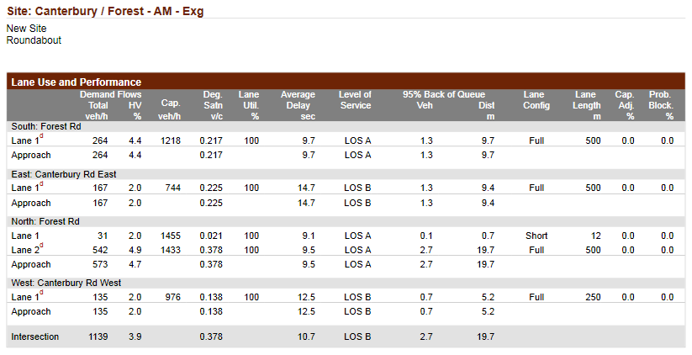

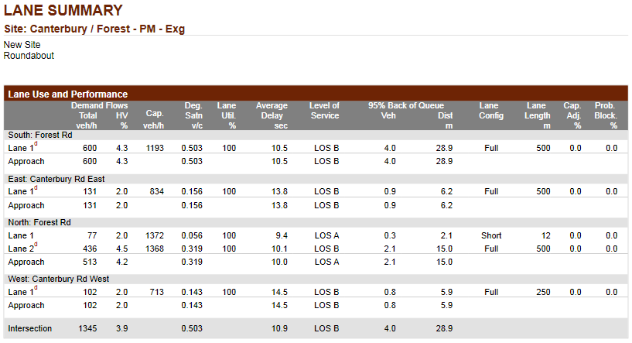

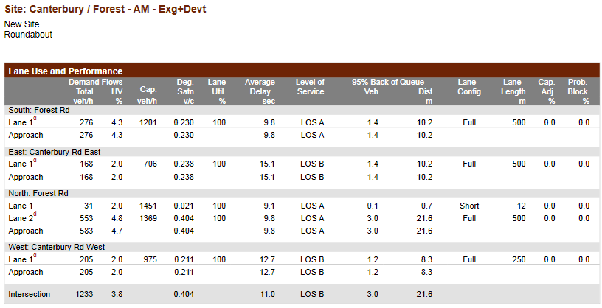

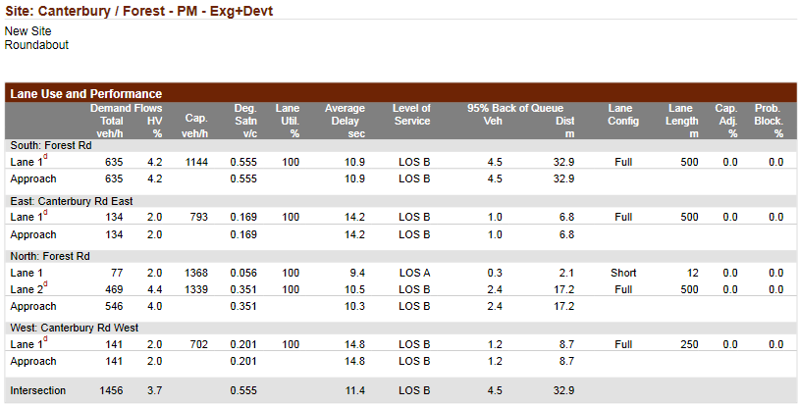

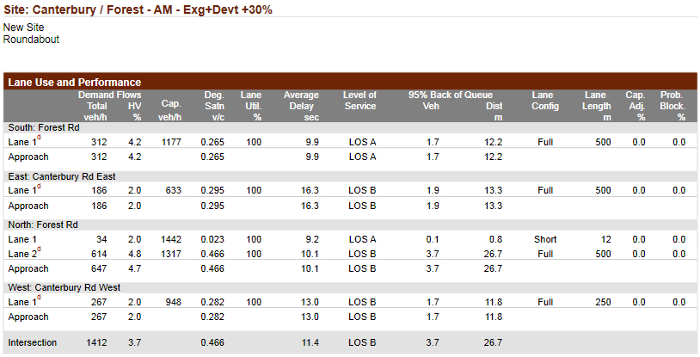

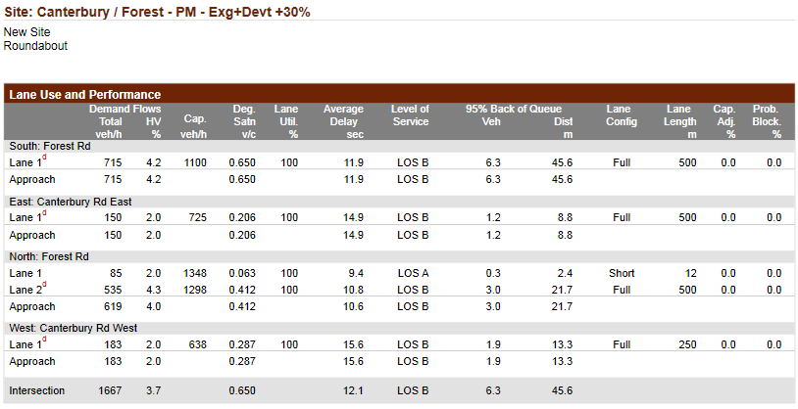

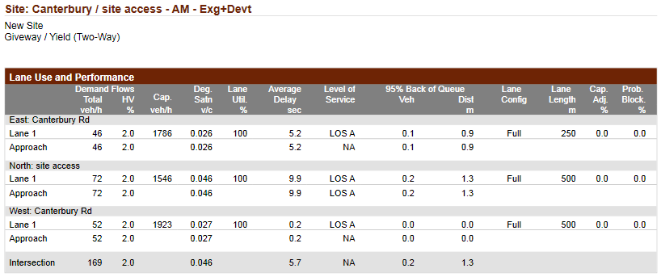

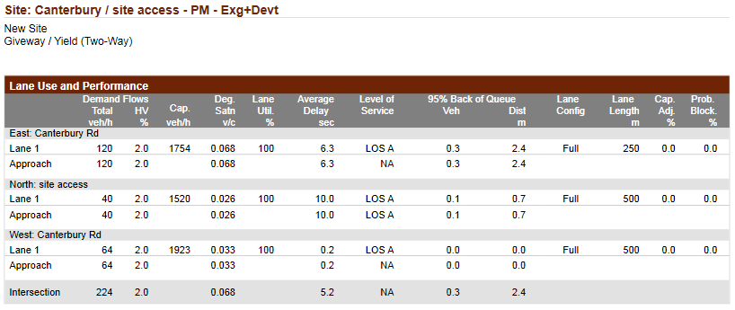

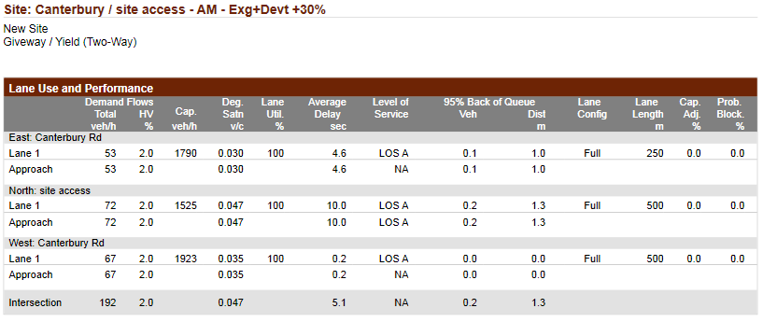

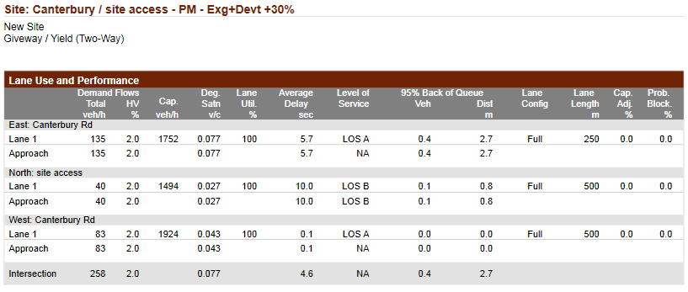

Appendix B Plan of Subdivision

Sidra Intersection, essentially a mathematical model for traffic analysis, can be used to evaluate and compare capacity, level of service and performance of alternative treatments involving signalised intersections, roundabouts and sign-controlled intersections. Results from a Sidra model include the following which are commonly used to assess intersection performance: - Degree of saturation (DOS): is the ratio of traffic volume to capacity, values less than 0.90 for signals and 0.80 for sign controlled intersections are typically used as minimum performance standards. - Number of vehicles to back of queue (95th percentile during time period analysed). - Average delay per vehicle. - Level of service (LOS): based on vehicle delays, where A indicates very small delays to F which indicates very large delays.

