50 Canterbury Road West

Lara

Vegetation

and

Net Gain Assessment

A Report to

Point Cook P/L

Prepared by
Mark Trengove Ecological Services
42 Aberdeen St Geelong West
PO Box 1502 Geelong 3220
mtrengove@pipeline.com.au
ph 03 52298087

May 27 2013

Contents

1 INTRODUCTION 4
1.1 Project Background 4
1.2 Objectives 4
1.3 Study Area 4
1.4 Proposed Development 4
2 METHODS 5
2.1 Taxonomy 5
2.2 Literature and Database Review 5
2.3 Field Survey 5
2.4 Limitations 5
2.5 Defining Significance 5
3 RESULTS 6
3.1 Ecological Vegetation Class 6
3.2 Flora 6
3.2.1 Indigenous Species 6
3.3 Vegetation Condition 7
3.4 Listed Significant Species 8
4 LEGISLATION AND GOVERNMENT POLICY 9
4.1 Commonwealth 9
4.1.1 Environment Protection and Biodiversity Conservation Act (1999) 9
4.1.2 Implications 9
4.2 Native Vegetation Management Framework 9
4.2.1 Net Gain 9
4.2.2 Defining and Assessing Native Vegetation 10
4.2.3 Habitat Hectares 10
4.2.4 Implications 10
5 CONCLUSIONS 11
Appendix 1 - ASSESSING CONSERVATION SIGNIFICANCE 12
6 REFERENCES 13
Map 1 Study Area location 14

Mark Trengove Ecological Services
42 Aberdeen St Geelong West
PO Box 1502 Geelong 3220
mtrengove@pipeline.com.au
ph 03 52298087

Copyright © Mark Trengove Ecological Services
This document is subject to copyright and may only be used for the purposes for which it was commissioned. The use of this document in whole or part without the permission of Mark Trengove Ecological Services is an infringement of copyright.

Disclaimer
Although Mark Trengove Ecological Services have taken all the necessary steps to ensure that an accurate document has been prepared, no liability is accepted for any damages or loss incurred as a result of reliance placed upon the report or its contents.

1 INTRODUCTION

1.1 Project Background

Land at 50 Canterbury Road West, Lara, is proposed to be developed for residential use. This report was commissioned by Point Cook P/L to assess the quantity and significance of any indigenous flora and fauna habitat that might be present in the subject site.

1.2 Objectives

The objectives of this investigation are to:

- Describe the flora values of the land.
- Evaluate the conservation significance of the land.
- Assess any potential impacts of the proposed development.
- Discuss the implications of relevant government policy and legislation.

1.3 Study Area

The study area is comprised of the land at 50 Canterbury Road West, Lara (approximately 8.1 ha), located within the City of Greater Geelong. The site is within the Victorian Volcanic Plains bioregion (NRE 2002) and is located within the Corangamite Catchment Management Authority region.

The site appears to have a history of agricultural disturbance. The site includes an existing residence and garden area.

The location of the study area is shown on Map 1.

1.4 Proposed Development

The proposed use is to create a residential development. It is anticipated that the proposed use will impact upon the entire study area.

2 METHODS

2.1 Taxonomy

Scientific names for plants follow the Census of Vascular Plants of Victoria (Walsh and Stasjic 2007). Common names for plants follow the Flora of Victoria Vols 2-4 (Walsh and Entwisle 1994-1999).

2.2 Literature and Database Review

Relevant literature and databases, including data from the Department of Sustainability and Environment (DSE website i) and the Technical Support Maps for Local Government Authorities (DSE 2003) were reviewed.

2.3 Field Survey

The site was inspected on foot on the 27th of May 2013. The entire site was traversed. Records were made of all indigenous vascular plant species. Records were made of the existing habitat values and dominant exotic vascular plant species.

2.4 Limitations

The assessment was conducted during autumn, a time of year that is suitable for the detection of most but not all flora species likely to occur on site. Due to the overwhelmingly degraded nature of the study area, the site inspection is considered to be sufficient to assess the ecological values of the site. As a result there are not considered to be any significant limitations to the study.

The survey includes only vascular flora. As Net Gain assessments were not required (refer to 4.2.4) non-vascular flora (mosses, lichens, fungi, etc) were not recorded. Fauna was not surveyed.

2.5 Defining Significance

A number of criteria are applied in order to assess the significance of flora species and vegetation communities. The definition of the criteria is detailed in Appendix 1.

3 RESULTS

3.1 Ecological Vegetation Class

Ecological Vegetation Classes (EVCs) are the primary level of classification of vegetation communities within Victoria. An EVC contains one or more plant (floristic) community, and represents a grouping of vegetation communities with broadly similar ecological attributes. Classification of EVCs in this report follows Oates and Taranto (2002).

The pre-1750 EVC mapping of the study area undertaken by DSE (DSE website i) indicates that the study area was comprised of EVC 132 Plains Grassland and ECV 125 Plains Grassy Wetland. EVC 132 Plains Grassland and ECV 125 Plains Grassy Wetland are both currently listed as ‘Endangered’ in the Victorian Volcanic Plain bioregion (DSE website ii- EVC Benchmarks -Victorian Volcanic Plains Bioregion). The current study records vegetation that accords with EVC 132 Plains Grassland.

3.2 Flora

3.2.1 Indigenous Species

A total of two indigenous plant species, were recorded from the study area. These plant species are of Local conservation significance.

Refer to Table 1 for a list of indigenous vascular plant species recorded during this survey. Refer to Table 2 for a list of dominant exotic vascular plant species recorded during this survey.

Table 1 Indigenous Species and Conservation Significance

Botanical Name | Common Name | Significance
Rytidospermum caespitosum | Common Wallaby-grass | Local
Rytidospermum racemosum | Slender Wallaby-grass | Local

Table 2 Dominant Exotic Plant Species Recorded May 27 50 Canterbury Road West

Botanical Name | Common Name
Cynodon dactylon | Couch Grass
Eucalyptus globulus | Blue Gum
Nassella neesiana | Chilean Needle-grass
Plantago lanceolata | Ribwort
Phalaris aquatica | Canary-grass
Lycium ferrocisimum | Boxthorn
Galenia pubescens | Blanket Weed

3.3 Vegetation Condition

The majority of the site carries exotic vegetation. The cover value of the indigenous vegetation is negligible (< 1%). The majority of the study area appears to have been de-rocked and disturbed at some time in the past and is currently fallow and lightly grazed. The remaining area (the existing residence and gardens) consists of exotic lawn and garden specimens.

This vegetation is assessed to be substantially modified as a result of repeated cultivation and grazing and is considered to be of low ecological value.

Several non-indigenous trees have been planted. The house area consists of exotic lawn and garden specimens.

Note that the adjacent Canterbury Rd West roadside reserve was also inspected and was found to carry entirely exotic vegetation, comprised of species recorded in Table 2.

3.4 Listed Significant Species

The DSE database (DSE Website i, ii) lists one significant plant species and two significant fauna species as occurring within the immediate vicinity of the study area (i.e. within 5 kilometres).

Due to the highly degraded and fragmented nature of the study area none of these three species are considered likely to occur within the study area (i.e. remaining 50 % quality habitat).

Refer to Table 2 for the listed significant species including a discussion of preferred habitat, likelihood of occurrence and response to the Framework requirements.

Table 2 Listed Significant Flora and Fauna Species and the Likelihood of Occurrence

Scientific Name | Common Name | Record this survey | Status | Steps | Best 50% | Preferred Habitat | Likelihood of occurrence
Tripogon lolliformis | Rye Beetle-grass | No | r | A-D-No | Remaining | grasslands | Highly modified habitat – Unlikely to occur
Perameles gunnii | Eastern Barred Bandicoot | No | e,E,  ffga | A-D-No | Remaining | grasslands | Highly modified habitat – Unlikely to occur
Sminthopsis crassicaudata | Fat-tailed Dunnart | No | n | A-D-No | Remaining | grasslands | Highly modified habitat – Unlikely to occur

r – rare (Victoria)
n – near threatened (Victoria)
e – endangered (Victoria)
E – endangered (Australia)
ffga – Flora and Fauna Guarantee Act listed (DSE website iii)

4 LEGISLATION AND GOVERNMENT POLICY

4.1 Commonwealth

4.1.1 Environment Protection and Biodiversity Conservation Act (1999)

The Environment Protection and Biodiversity Conservation (EPBC) Act (1999) was established to ‘promote the conservation of biodiversity by providing strong protection for listed species and communities in the Commonwealth and for protected areas, Ramsar sites, Commonwealth Reserves, conservation zones and World Heritage sites, etc’.

Natural Temperate Grassland of the Victorian Volcanic Plain is an ecological community that is listed as ‘Critically Endangered’ under the EPBC Act (EPBC Website i). The study area once carried vegetation that would have been considered part of this community.

4.1.2 Implications

Due to the degraded nature of the study area (i.e. less than 50% cover value) there are not considered to be any implications for the current proposal under the EPBC Act.

4.2 Native Vegetation Management Framework

4.2.1 Net Gain

Net Gain is the Victorian Government’s framework for achieving native vegetation ‘gains’ across the state. The framework is defined in the document ‘Victorian Native Vegetation Management - A Framework for Action the Framework)’ (DNRE 2002) and is achieved in conjunction with the Native Vegetation Plan for the Port Phillip and Westernport Region (Port Phillip and Western Port Native Draft Vegetation Plan -Port Phillip and Westernport Catchment Management Authority 2006). Net Gain is described as ‘the outcome for native vegetation and habitat where overall gains are greater than overall losses and where individual losses are avoided where possible. Losses and gains are determined by a combined quality/quantity measure and over a specified period of time. Gains may be either required offsets for permitted clearing actions or as a result of land holder and Government assisted efforts that are not associated with clearing’ (DNRE 2002).

The stated goal of the framework is to achieve:
A reversal, across the whole landscape, of the long-term decline in the extent and quality of native vegetation, leading to a Net Gain (DNRE 2002).

The three-step approach to net gain is to:
- avoid adverse impacts, particularly through vegetation clearance
- if impacts cannot be avoided, minimize impacts through appropriate consideration in the planning process
- identify appropriate offset options.

4.2.2 Defining and Assessing Native Vegetation

Native vegetation in Victoria has been defined by DSE as belonging to three categories. These are:

Remnant Patch
Remnant patches of remnant native vegetation are composed of indigenous plant species considered part of a clearly definable EVC. Such vegetation includes understorey species of greater than 25% total understorey cover (excluding bare ground), and/or indigenous canopy trees with at least 20% projected foliage canopy cover. Assessment of remnant patch vegetation utilized the Habitat Hectare method (see below).

Scattered Trees
Scattered trees comprise indigenous trees with projected foliage canopy cover of less than 20% and a total cover of indigenous species (excluding bare ground) of less than 25%.
Scattered trees are counted and their diameter at breast height (1.3m DBH). The class size of scattered trees (based on DBH) is determined by comparison to the relevant DSE EVC bioregional benchmark.

Modified Treeless Vegetation
This category includes treeless vegetation with greater than 25% total cover of indigenous species (excluding bare ground) but is dominated by a small number of opportunistic native species which were unlikely to have been dominant prior to a disturbance event (e.g. cropping).

Degraded Treeless Vegetation
Degraded treeless vegetation comprises all other vegetation. This category is comprised of treeless vegetation with less than 25% total cover of indigenous species.

4.2.3 Habitat Hectares

Habitat Hectares is an accounting method for measuring habitat quality and quantity that has been developed by DSE for Net Gain Assessment. The habitat hectares approach is site based. Each site, or patch, consists of one EVC and one vegetation condition class. It is therefore uniform within limits.

Each site has a habitat score of between 0 and 100, with extensive intact vegetation having a theoretical score of 100. The habitat score has ten components: large trees, tree canopy cover, understorey, weediness, recruitment, organic litter, logs, patch size, neighborhood context and distance to core area.

Each site has a habitat hectare value, where the habitat score is multiplied by the area in hectares. For example, 6 ha of vegetation with a habitat score of 50 equals 3 habitat hectares.

4.2.4 Implications

As the cover value of indigenous plant species is < 25%, the entire site is assessed to be ‘degraded treeless’ vegetation. Therefore there are no implications under State legislation.

5 CONCLUSIONS

The proposed residential development at 50 Canterbury Road West, Lara, that is the subject of this report, contains vegetation that is predominately exotic.

Two locally significant plant species (Wallaby-grass spp) were recorded for the study area at <1% cover value.

Consequently the site is rated as having negligible significance for biodiversity conservation.

The site does not to represent the best 50% remaining habitat for any of the three threatened species listed as occurring within the vicinity of the study area.

Although EVC 132: Plains Grassland is classed as ‘Endangered’ in Victoria and Natural Temperate Grassland of the Victorian Volcanic Plain is classed as “Critically Endangered’ in Australia, the vegetation of the study area is not of sufficient quality to create any implications for the relevant State (i.e. Native Vegetation Management Framework) or Commonwealth (i.e. EPBC Act) legislation.

The adjacent 50 Canterbury Road West roadside reserve was also surveyed and found to be comprised entirely of exotic plant species.

There are not considered to be any significant limitations to this study.

Appendix 1 - ASSESSING CONSERVATION SIGNIFICANCE

Conservation significance is assessed at a range of scales, including global, international, national, state, regional and local. Criteria used for determining the conservation significance of flora and fauna at national to local scales are presented below for botanical and zoological conservation significance.

Botanical Significance

National botanical significance applies to an area when it supports one or more of the following attributes:
a population of at least one nationally threatened plant species listed by Briggs and Leigh (1996) or plant species listed on the schedules to the Commonwealth Environment Protection and Biodiversity Conservation Act 1999.
A nationally threatened ecological community listed on the schedules of the Environment Protection and Biodiversity Conservation Act 1999.

State botanical significance applies to an area when it supports one or more of the following attributes:
A population of at least one plant species threatened in Victoria, as listed by Gullan et al. (1990), NRE (2000a) or more recently in the unpublished records of the Flora Information System (NRE), or on the schedules to the Victorian Flora and Fauna Guarantee Act 1988.
An ecological community considered threatened in Victoria through its listing on the schedules of the Flora and Fauna Guarantee Act 1988.

Regional botanical significance applies to an area that supports one or more of the following attributes:
Supports a population of one or more regionally depleted species defined in a valid regional assessment of biodiversity (eg. Regional Native Vegetation Plan, Environment Conservation Council Report or Comprehensive Regional Assessment documents).
An ecological vegetation class that is considered endangered or vulnerable in a particular bioregion (based on Conn 1993 and the Regional Native Vegetation Plan), in which case the area is of High Regional significance.
An ecological vegetation class that is considered depleted in a particular bioregion (based on Conn 1993 and the Regional Native Vegetation Plan), in which case it is of Regional significance.

Local botanical significance applies to all remnant native vegetation that does not meet the above criteria. In much of Victoria, and in particular in the Victorian Volcanic Plain bioregion, native vegetation has been so depleted by past clearing and disturbance that all remaining vegetation must be considered to be of at least local conservation significance.

6 REFERENCES

Corangamite Catchment Management Authority (2005) ‘Corangamite Native Vegetation Plan’ CCMA Website.

DNRE (2002) ‘Victoria’s Native Vegetation Management A Framework for Action’ DNRE, Melbourne.

DSE (2003) ‘Victoria’s Native Vegetation Management- A Framework For Action- Technical Support Maps’ (CD). DSE, Melbourne.

DSE (2007). ‘Native Vegetation Guide for assessment of referred planning permit applications’. DSE, Melbourne.

DSE Website i.
http://mapshare2.dse.vic.gov.au/MapShare2EXT/imf.jsp?site=bim

DSE Website ii. http://www.dse.vic.gov.au/dse/nrence.nsf/LinkView/A2A7B7D2CABBEE3CCA256F2B000257048062D358172E420C4A256DEA0012F71C

DSE Website iii.
http://www.dse.vic.gov.au/CA256F310024B628/0/B10DC61B8DF2A09FCA25760F0010DF1B/$File/Advisory+List+of+Threatened+Vert+Fauna+in+Victoria+-+2007+amended+11+august+2009.pdf

DSE Website iv.
http://www.dse.vic.gov.au/planningschemes/greatergeelong/maps/greatergeelong18eso.pdf

EPBC Website i.
http://www.environment.gov.au/cgi-bin/sprat/public/publicshowcommunity.pl?id=42&status=Critically%20Endangered

EPBC Website ii.
http://www.environment.gov.au/epbc/publications/pubs/ecological-communities-listing-approach-factsheet.pdf

Oates, A. & Taranto, M. (2001): ‘Vegetation mapping of the Port Phillip &Westernport region’ Arthur Rylah Institute for Environmental Research, DNRE, Victoria.

Parkes, D., Newell, G. & Cheal, D. (2003): ‘Assessing the quality of native vegetation: The habitat hectares approach. Parks, Flora & Fauna Division, DNRE, Victoria.

Walsh, N G and Stasjic, V (2007): ‘A Census of the Vascular Plants of Victoria’ Royal Botanic Gardens, Melbourne.

Walsh, N G & Entwisle, T (1994-1999): ‘Flora of Victoria Vol 2-4' Inkata Press, Melbourne.

Map 1 Study Area location

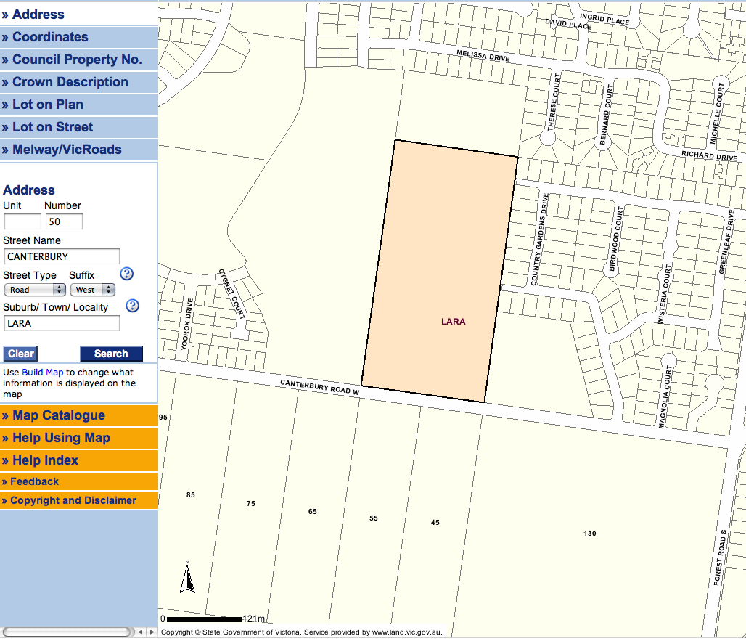

Map 1 Study area 50 Canterbury Road West, Lara shown in highlight.

