To: Peter Smith – Coordinator Strategic Implementation
From: Barry Gough – Strategic Planner
Subject: Rezoning at 3 - 5 Forest Road South, Lara from Residential 1 Zone to Commercial 1 Zone
Index Reference: Project: Amendment C303
Reports: Council & Other 2014
Subject: Delegated Decisions 32014

Summary
- The request to prepare the Amendment has been lodged by Fadgyas Planning Associates on behalf of S.C.G. Properties Pty Ltd, which is the owner of the land.
- The Amendment proposes to re-zone land from Residential 1 zone (R1Z) to Commercial 1 zone (C1Z).
- The subject land is occupied by recently constructed shops, adjacent to and opposite established shops and related businesses in the C1Z to the north and west. There are several established houses in the Residential 1 zone immediately to the south, beyond which is the Lara Swimming Pool.
- The application was accompanied by detailed supporting documentation.
- It is recommended that exhibition of the Amendment be supported.
Recommendation
That Council, having considered all matters as required by Section 12 (2) of the Planning and Environment Act 1987, resolves to:
- support the preparation and exhibition of amendment C303 to the Greater Geelong Planning Scheme to rezone land at 3-5 Forest Road South, Lara from Residential 1 Zone (R1Z) to Commercial 1 Zone (C1Z); and
- Request the Minister for Planning to authorise the preparation and exhibition of Amendment C303 to the Greater Geelong Planning Scheme.
Background
The subject land has been recently developed for Commercial use via a planning permit, consistent with the provisions of the Residential 1 zone.
Three - five Forest Road South, is bounded by existing Commercial 1 land to the north and Residential 1 land to the East and South.
The proposed re-zoning will bring the zoning into conformity with the purpose for which it has been developed.
Discussion
The subject site is the northern most of 4 property frontages in the Residenttial 1 zone, which end at the intersection of Bank Street and Forest Road. On the south side of Forest Road is the car park of the Lara Swimming Pool with the pool to the east and parkland to the south along Hovell’s Creek.
The land to be re-zoned could therefore be regarded as part of an ‘outlier’ of the Residential 1 zoned land on the eastern side of Forest Road south, rather than the natural underlying zone of this side of Forest Road South between Station Lake Road and Hovell’s Creek.
Appendix 1 is an aerial photograph which shows the context of the amendment site in relation to the surrounding residential development to the east and south and the commercial development to the north and east.
Appendix 2 identifies the land which is proposed to be re-zoned to C1Z in relation to the surrounding zoning.
Environmental Implications
The amendment will not have any adverse effects on the environment. The orientation of the recently development site has been designed to locate the car park adjacent to the existing commercial premises to the north and as far as possible from the residential units on the adjoining lot to the south. This will minimise any potential for adverse environmental impacts, especially with regard to car movements on the site.
Financial Implications
The re-zoning of this recently developed land does not have any financial implications for Council.
Policy/Legal/Statutory Implications
At clause 21.13-1 of the planning scheme, Key issues and influences, it is noted that:
“Retail and commercial expansion is required to meet the needs of local residents… “
Clause 21.13-2 Strategies includes the following:
“Limit the Patullos Road shopping strip to he existing Business 1 zoned land.”
Clause 22.03, Assessment Criteria for Retail Planning Applications, specifies selection criteria for the exercise of discretion in regard to applications in specified circumstances, including out-of-centre proposals. These criteria were required to be met at the time the permit was issued for the development of the existing commercial premises on the land.
Risk Assessment
The re-zoning of the land consistent with its recent development and existing use does not result in any risks to Council.
Social Considerations
The land has recently been redeveloped in a manner designed to meet community needs and expectations for the availability of services proximate to the surrounding residential community.
The re-zoning consistent with the nature of the redevelopment is not anticipated to generate any negative social impacts.
Consultation and Communication
It is proposed that this amendment be exhibited for public comment as required by the Planning & Environment Act.

Attachment 1

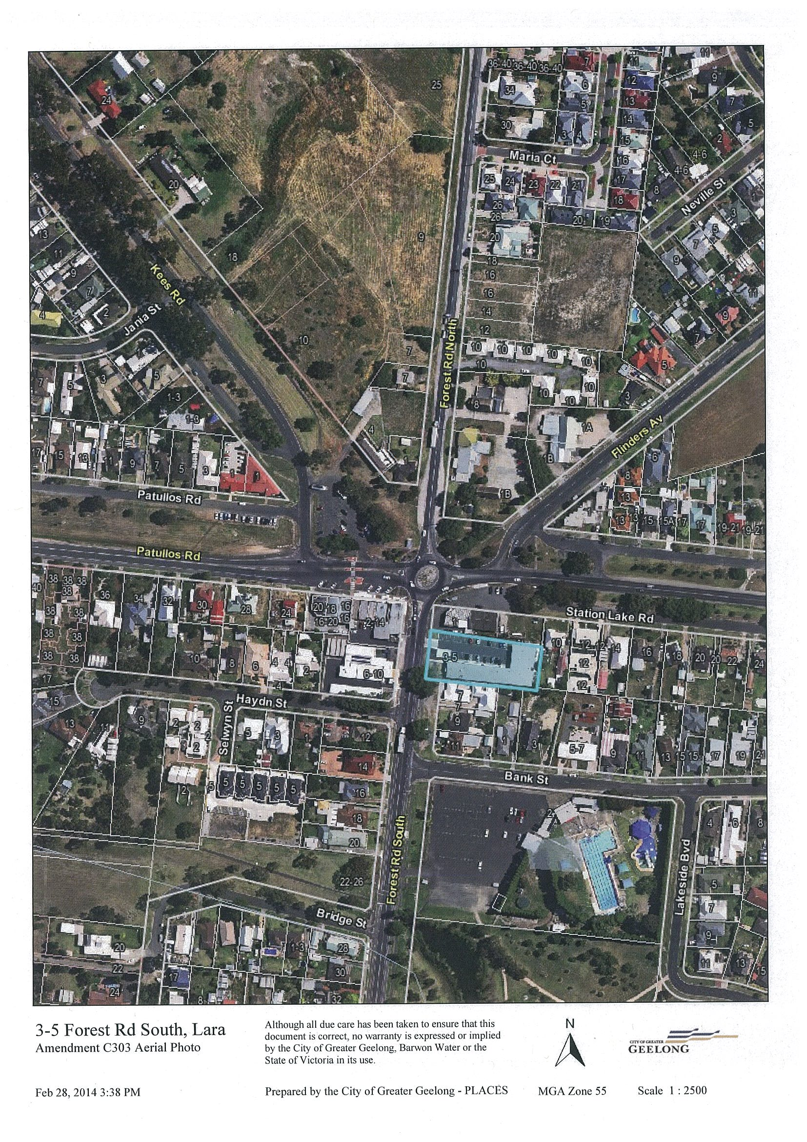

Attachment 2

