To: Peter Smith – Coordinator, Strategic Implementation
From: Peter Schembri – Snr Strategic Planner
Subject: Geelong Gateway Homemaker Centre Rezoning
File number: Amendment C282

Purpose
This report seeks Council approval (under delegation) to prepare and exhibit a planning scheme amendment to rezone the land at the Geelong Gateway Homemaker Centre to the Commercial 2 Zone.
Summary
- An amendment request was made by CBRE Town Planning on behalf of Kervale Investments Pty Ltd, the owner of land at 470-510 Princes Highway, Corio.
- The amendment proposes to rezone the proponents land title and all the land titles that make up the Geelong Gateway Homemaker Centre, to the Commercial 2 Zone.
- The Commercial 2 Zone will better reflect the current use of the land which is predominantly developed with bulky goods retailing.
- The proposal is supported by Clause 21.18 Corio Norlane of the Municipal Strategic Statement, which identifies the site for rezoning to the Commercial 2 Zone.
- In addition to the rezoning the Amendment will:
- Apply the Environmental Audit Overlay to the land being rezoned;
- Remove the Design and Development Overlay Schedule 20 from the land being rezoned; and
- Amend the Retail Activity Centre Hierarchy Map and Table at Clause 21.07-8 to show a new Homemaker Precinct and remove its current status as a Potential Homemaker Precinct.
- The Amendment is considered to the consistent with the State and Local Planning Policy Frameworks and has overwhelming strategic support.
- It is recommended that the Amendment be placed on public exhibition subject to authorisation from the Minister for Planning.
Recommendation
That Council, under delegation:
- Resolves to support the preparation and exhibition of Amendment C282 to the Greater Geelong Planning Scheme to:
- Rezone the land at 470-510 Princes Hwy, 452-458 Princes Hwy, 446-450 Princes Hwy, 420-444 Princes Hwy, 17-73 Railway Avenue, 2 School Road, 4-50 School Road, 17-19 School Road, 21-29 School Road and 70 School Road, all in Corio, from the Industrial 1 Zone and Industrial 3 Zone to the Commercial 2 Zone;

- Apply the Environmental Audit Overlay to the land being rezoned;

- Remove the Design and Development Overlay Schedule 20 from the land being rezoned; and

- Amend the Retail Activity Centre Hierarchy Map and Table at Clause 21.07-8 to show a new Homemaker Precinct and remove its current status as a Potential Homemaker Precinct.

- Request the Minister for Planning to authorise the preparation and exhibition of Amendment C282 to the Greater Geelong Planning Scheme.
Report
Background
In October 2013 CBRE Town Planning acting on behalf of Kervale Investments Pty Ltd lodged Amendment C282 to the Greater Geelong Planning Scheme. The Amendment seeks to rezone all the land known as the Geelong Gateway Homemaker Precinct to the Commercial 2 Zone.
Kervale Investments Pty Ltd is the owner of land located at 470-510 Princes Highway, Corio. The applicant has requested that the rezoning be applied to all properties that form the homemaker precinct. The precinct is partly in the Industrial 1 Zone and partly in the Industrial 3 Zone and developed with a mix of bulky goods retailing and services and industrial uses.
The land to which the rezoning applies is shown in the aerial map at Appendix 1. An existing zoning map is shown at Appendix 2.
The proposed rezoning map is shown at Appendix 3.
A profile of the Geelong Gateway Homemaker Precinct is shown in the following table:
Property Address | Land Use | Zone
470-510 Princes Hwy, Corio 3214 | Bulky Goods Retailing | IN3Z
452-458 Princes Hwy, Corio 3214 | Vacant | IN3Z
446-450 Princes Hwy, Corio 3214 | Service Station | IN3Z
420-444 Princes Hwy, Corio 3214 | Bulky Goods Retailing | IN1Z
17-73 Railway Avenue, Corio 3214 | Gas Works | IN1Z
2 School Road, Corio 3214 | Motor Vehicle Sales | IN1Z
4-50 School Road, Corio 3214 | Motor Vehicle Sales | IN1Z
17-19 School Road, Corio 3214 | Vacant | IN1Z
21-29 School Road, Corio 3214 | Vacant | IN1Z
70 School Road, Corio 3214 | Warehouse/Showroom | IN1Z

It is noted that an isolated Barwon Water utility installation is located on Railway Avenue within the homemaker precinct. The land area is 73 square metres and zoned Public Use Zone 1. This site does not form part of Amendment C282.
In addition to the rezoning request, the Amendment seeks to:
- Remove the Design and Development Overlay – Schedule 20 (DDO20) from the site.
- Amend the Retail Activity Centre Hierarchy Map and Table at Clause 21.07-8 of the Municipal Strategic Statement, to show the subject land as a Homemaker Precinct (instead of a ‘Potential Homemaker Precinct’ as currently shown).
Following the rezoning request, on 20 January 2014 Council officers wrote to the applicant advising of relevant matters not addressed in the submission as follows:
High-pressure gas pipeline
As previously advised, a high-pressure gas transmission pipeline to the Shell Refinery is located in close proximity to the Amendment land. We have written to the Department of State Development, Business and Innovation about Amendment C282 and seek to avoid the use of a s.173 agreement (as was the practice for a nearby amendment).
Environmental Audit Overlay
Minister’s Direction No.1 requires that in the preparation of an amendment which has the effect of allowing (whether or not subject to the grant of a permit) potentially contaminated land to be used for a sensitive use, a planning authority must satisfy itself that the environmental conditions of that land are or will be suitable for the sensitive use.
Rezoning industrial land to the Commercial 2 Zone requires consideration of potentially contaminated land. Our initial preference, following some basic investigation, is that all the land to be rezoned should also be applied with the EAO.

The Amendment therefore, will also seek to apply the Environmental Audit Overlay to the land being rezoned. Matters relating to the nearby high pressure gas pipeline are discussed below.
Discussion
Strategic planning merits
The existing industrial zoning is a relic of the former use of the land which was primarily as a buffer to the nearby Shell Refinery. There are also development permits that date back to the 1970s and 1980s for factory and warehouse uses by the former Shire of Corio.
The subject land currently provides for a variety of uses – the majority being bulky goods retailing and services. These include Harvey Norman, Fantastic Furniture, BCF, Derrimut Gymnasiums, Winter & Taylor Isuzu Trucks, Ultra Tune and a Caltex service station. There is a current planning permit application for United service station at 452-458 Princes Highway.
These uses are better suited to the Commercial 2 Zone, the purpose of which includes:
To implement the State Planning Policy Framework and the Local Planning Policy Framework, including the Municipal Strategic Statement and local planning policies.
To encourage commercial areas for offices, appropriate manufacturing and industries, bulky goods retailing, other retail uses, and associated business and commercial services.
Part of the subject land is owned by SPI Networks (Gas) Pty Ltd and used for gas processing and distribution. This use is not inconsistent with the purpose of the Commercial 2 Zone.
The site is identified in Clause 21.18 of the Municipal Strategic Statement for rezoning to the Commercial 2 Zone. Clause 21.18 is a local strategy for the Corio Norlane area and seeks to support major employers and to improve the role, function and presentation of retail activity centres. The site is also identified as a “Potential Homemaker Precinct” in the Retail Activity Centre Hierarchy Map and Table at Clause 21.07-8 of the Municipal Strategic Statement.
The removal of the DDO20 is appropriate as this design control only applies to industrial zones.
The Amendment therefore will bring forward Council’s preferred land use vision and zoning outcome for this area, and provide clarity for the future planning of the site. Given the current usage of the land and overwhelming strategic support for the proposal it is considered appropriate that the resolution to prepare and exhibit the Amendment be made under delegation.
Environmental Audit Overlay
As highlighted above in a letter addressed to the applicant, Ministerial Direction no. 1 requires that a planning authority must satisfy itself that the environmental conditions of the land are or will be suitable for sensitive uses.
Under Direction no. 1 “sensitive use” means a residential use, child care centre, a pre-school centre or primary school. Accommodation uses, other than Caretaker’s house, Motel and Residential hotel, are prohibited in the C2Z. While it is highly unlikely that the other sensitive uses would be established, the implementation of the Environmental Audit Overlay would require an assessment of the environmental conditions in any planning permit application.
High pressure gas pipeline
Amendment C247 recently rezoned land adjoining the Corio ALDI store to the Commercial 1 Zone. In a submission to that Amendment the Department of State Development, Business and Innovation (DSDBI) brought to Council’s attention a nearby high-pressure gas transmission pipeline (PL181), and that possible sensitive uses should consider the pipeline. The pipeline is located parallel to the railway reserve adjacent to the homemaker precinct and terminates at the SPI gas works on Railway Avenue.
Unlike in Amendment C247, this Amendment seeks to rezone the land to the Commercial 2 Zone, where there are no ‘as-of-right’ sensitive uses. This means that any future proposed sensitive use (that isn’t prohibited) would require a planning permit, giving the DSDBI an opportunity to be consulted.
Environmental Implications
There are no environmental implications as a result of the Amendment. Any potentially contaminated land issues would be addressed at such time that a ‘sensitive use’ is proposed.
Financial Implications
There are no financial implications for the Council.
Policy/Legal/Statutory Implications
Amendment C282 is consistent with Council’s Municipal Strategic Statement.
The Amendment seeks to change the City of Greater Geelong Retail Activity Centre Hierarchy contained in Clause 21.07-8 to include the site as a Homemaker Precinct in place of a ‘Proposed Homemaker Precinct’.
The Amendment will implement one of the actions of Clause 21.18 Corio Norlane by applying the Commercial 2 Zone and removing the DDO20 from the Geelong Gateway Homemaker Centre.
Alignment to City Plan
The Amendment supports the ‘Growing our Economy’ strategic direction of City Plan, by consolidating the role and function of the Geelong Gateway Homemaker Centre.
Officer Direct or Indirect Interest
No officers involved in this report have any direct or indirect interest In accordance with Sec 80 (c) of the Local Government Act.
Risk Assessment
Processing of this Amendment is considered to be a low level risk for Council.
Social Considerations
The amendment is not expected to generate any significant social impacts.
Human Rights Charter
The Amendment will not impact on any basic rights, freedoms and responsibilities as set out in the Charter. Planning legislation ensures an open community consultation process occurs, enabling people to freely express their views and if necessary obtain a fair hearing before an Independent Panel.
Communication
All landowners/occupiers directly affected by the Amendment were notified of the Council’s intention to prepare and exhibit Amendment C282.
The landowners/occupiers will be formally notified during the exhibition period, as well as notices published in the local newspapers and the Geelong Australia website.

Appendix 1 – Aerial Map

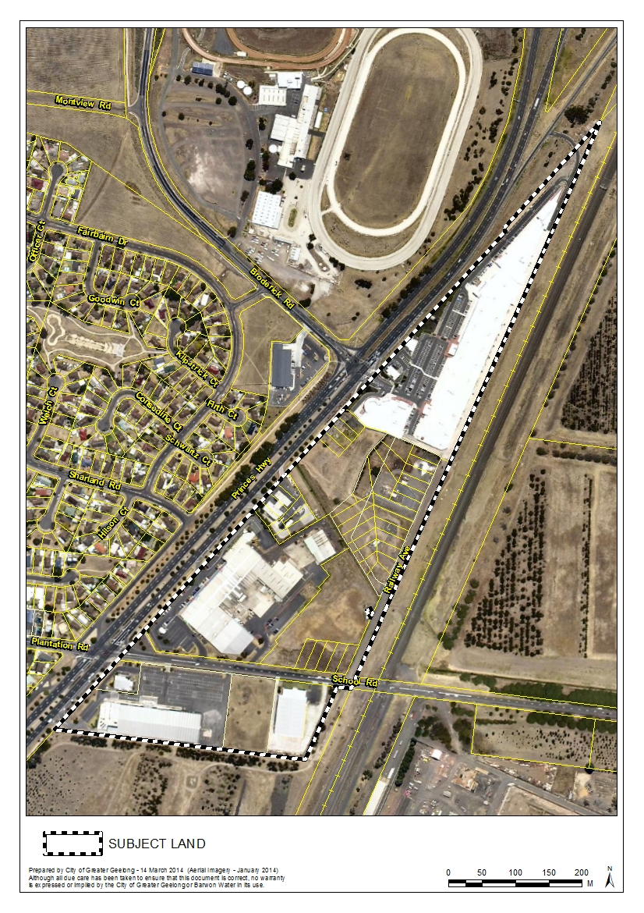

Appendix 2 – Existing Zoning Map

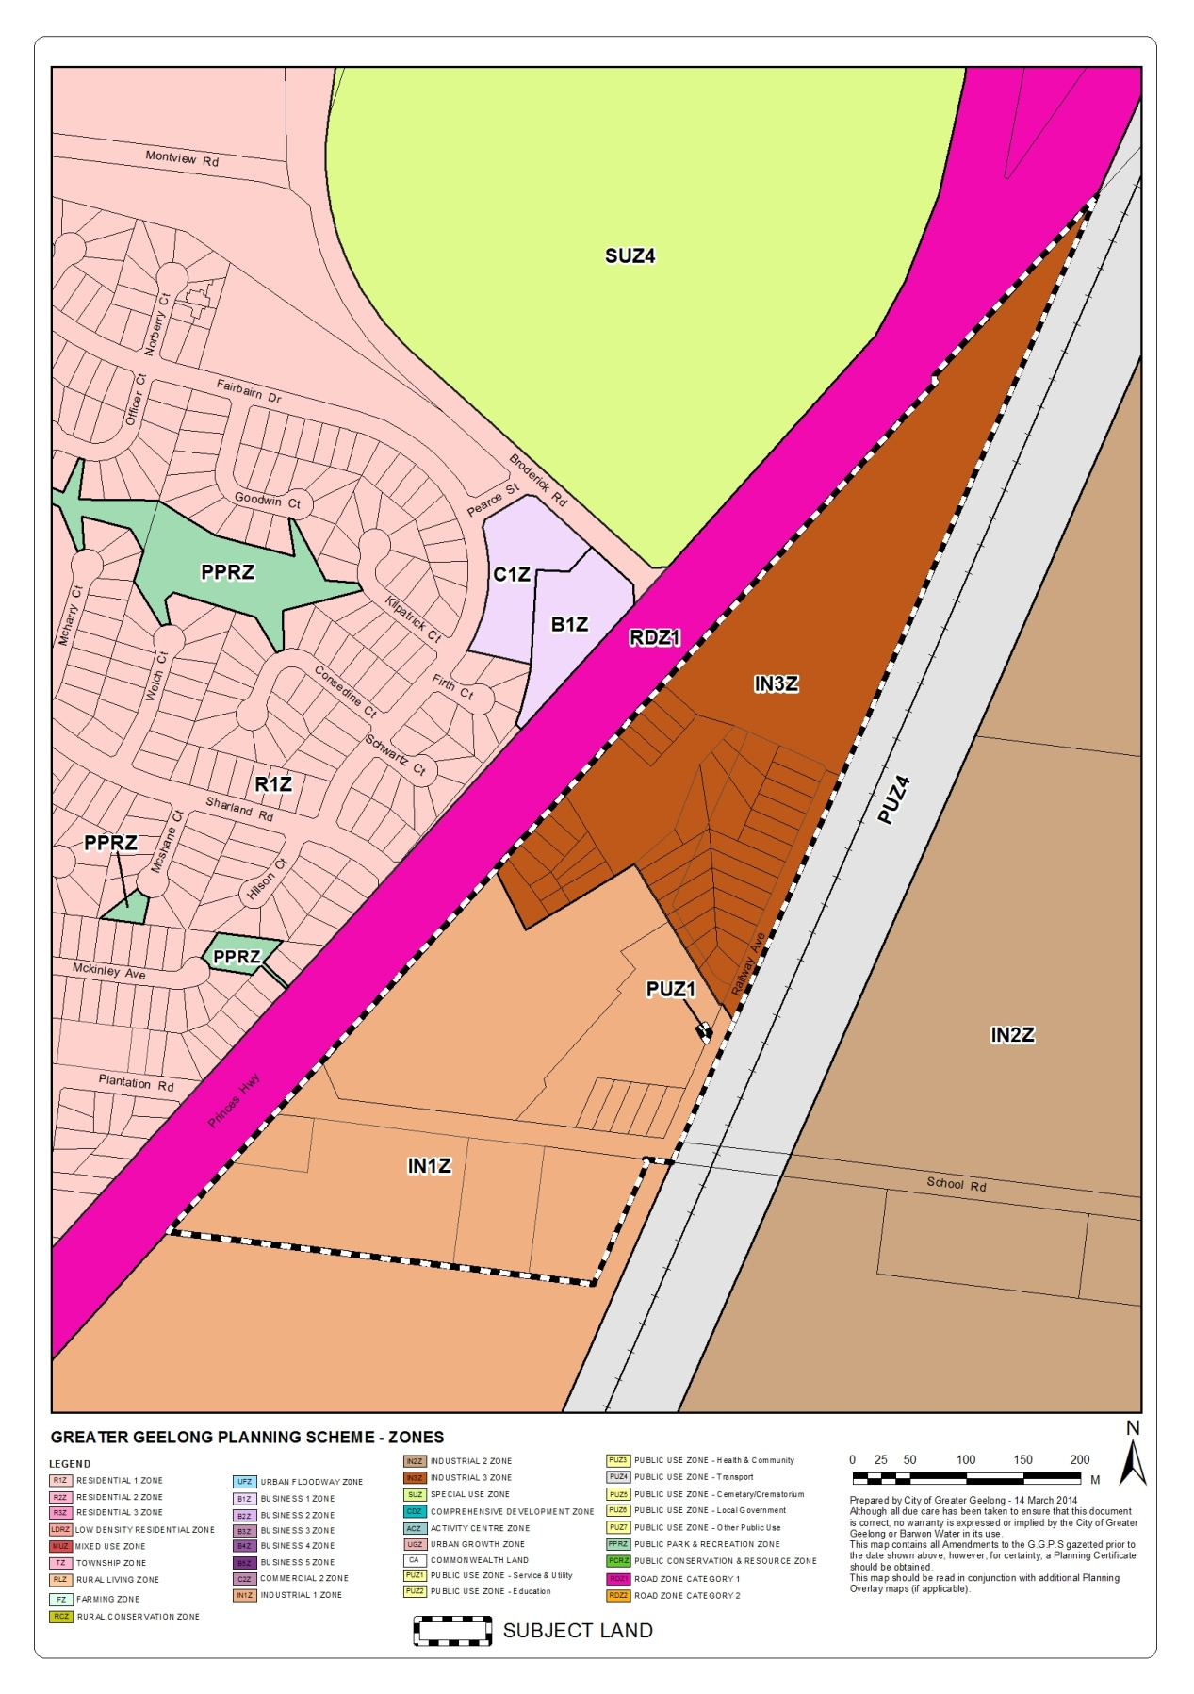

Appendix 3 – Proposed Rezoning Map

