Planning and Environment Act 1987

GREATER GEELONG PLANNING SCHEME

AMENDMENT C282

EXPLANATORY REPORT

Who is the planning authority?
This amendment has been prepared by the Greater Geelong City Council which is the planning authority for this amendment.
The amendment has been made by CBRE Town Planning on behalf of Kervale Investments Pty Ltd.

Land affected by the amendment
The amendment applies to all land that forms part of the Geelong Gateway Homemaker Precinct. The property addresses are; 470-510 Princes Hwy, 452-458 Princes Hwy, 446-450 Princes Hwy, 420-444 Princes Hwy, 17-73 Railway Avenue, 2 School Road, 4-50 School Road, 17-19 School Road, 21-29 School Road and 70 School Road, all in Corio.
The subject land is shown on the following map:
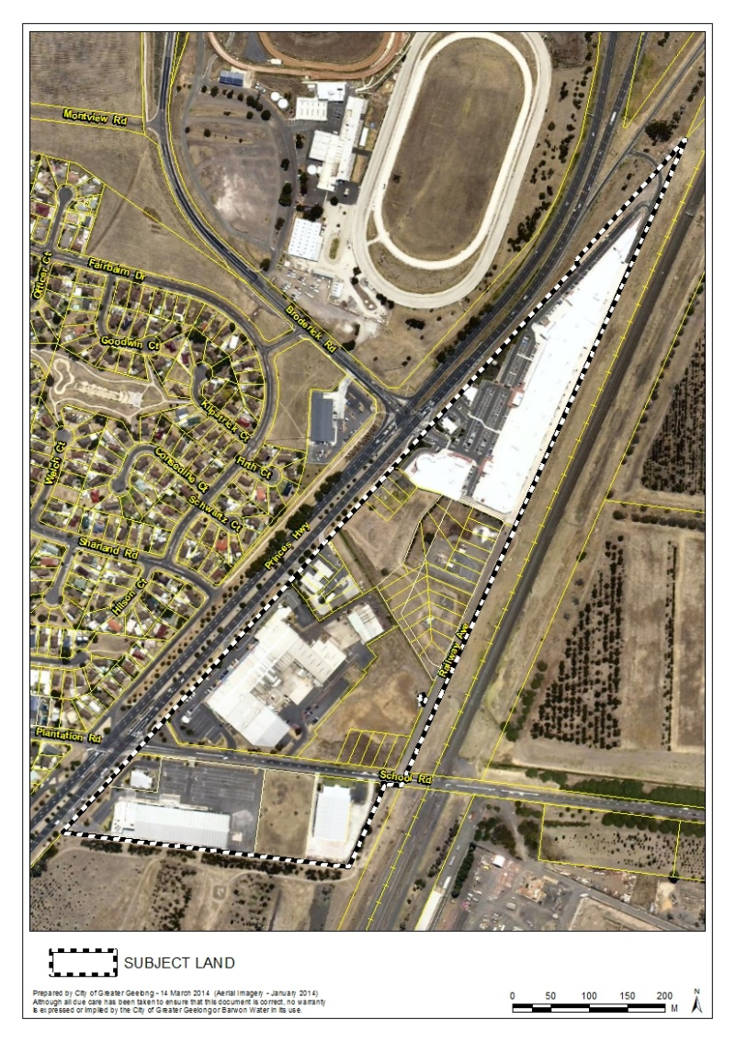
There is a small parcel of land located within the Amendment area owned and operated by Barwon Water that does not form part of the Amendment land. This parcel is zoned Public Use Zone 1 (Service & Utility).

What the amendment does
The amendment proposes to:
- Rezone the subject land from the Industrial 1 Zone and Industrial 3 Zone to the Commercial 2 Zone;
- Apply the Environmental Audit Overlay to the land being rezoned;
- Remove the Design and Development Overlay Schedule 20 from the land being rezoned; and
- Amend the Retail Activity Centre Hierarchy Map and Table at Clause 21.07-8 to show a new Homemaker Precinct and remove its current status as a Potential Homemaker Precinct.

Strategic assessment of the amendment

Why is the amendment required?
The established Geelong Gateway Homemaker Precinct has a history of being used for bulky goods retailing and associated commercial services. The amendment is a logical proposal that will remove the current industrial zonings and apply the Commercial 2 Zone (C2Z) to better reflect the underlying uses operating on the subject land.
The amendment is required to bring forward Council’s preferred land use vision for the Geelong Gateway Homemaker Precinct as stated in Clause 21.18 of the Greater Geelong Planning Scheme. The rezoning will provide clarity for the future planning of the site and support the sustainability of established businesses and encourage new investment.
The rezoning will also necessitate an amendment to the Retail Activity Centre Hierarchy Map and Table at Clause 21.07-8 of the Planning Scheme to show the subject land as a ‘Homemaker Precinct’. The Design and Development Overlay Schedule 20 will be removed as it should only apply to industrial land.

How does the amendment implement the objectives of planning in Victoria?

The objectives of planning in Victoria listed under Section 4(1) of the Planning and Environment Act 1987 contains the following:
- To provide for the fair, orderly, economic and sustainable use, and development of land;
- To secure a pleasant, efficient and safe working, living and recreational environment for all Victorians and visitors to Victoria;
- To facilitate development in accordance with the objectives set out [above].
The amendment implements these objectives by providing the most appropriate zone (i.e. the C2Z) to support the established businesses operating in the Geelong Gateway Homemaker Precinct.

How does the amendment address the environmental effects and any relevant social and economic effects?

Environmental Effects
The amendment will have no negative impact on the environment. The proposal does not seek any buildings and works and no vegetation is proposed to be removed.
The amendment ensures that potentially contaminated land is considered in any future proposal(s) for a ‘sensitive use’ by applying the Environmental Audit Overlay.
Economic Effects
The subject land was considered in the preparation of the Corio Norlane Structure Plan (CNSP), adopted by the Geelong Council in July 2012. The CNSP provides direction for key development sites and identifies appropriate planning controls to achieve desired outcomes, including private sector investment.
The Structure Plan identifies the site for rezoning to the Business 4 Zone (now C2Z), and illustrates this within the Corio Norlane Framework Plan. The economic effects of the rezoning will be to ensure that the Homemaker Precinct continues to be used for bulky goods retailing related uses, meeting the retail needs of the community. The amendment will help “future proof” the Precinct by applying a zoning which is reflective of the restricted retail premises operating on the site, and to support on-going viability and investment.

Social Effects
The amendment will bring about a range of social benefits through ensuring the sustainability of the Homemaker Precinct as a key provider of bulky goods retail with ancillary convenience services and employment for the region.

Does the amendment address relevant bushfire risk?
There are no relevant bushfire risks as a result of the proposed amendment or use. The site is not identified as being bushfire prone.

Does the amendment comply with the requirements of any Minister’s Direction applicable to the amendment?
Minister’s Direction No.1 requires that in the preparation of an amendment which has the effect of allowing (whether or not subject to the grant of a permit) potentially contaminated land to be used for a sensitive use, a planning authority must satisfy itself that the environmental conditions of that land are or will be suitable for the sensitive use.
Rezoning industrial land to the Commercial 2 Zone requires consideration of potentially contaminated land.
Under Direction no. 1 “sensitive use” means a residential use, child care centre, a pre-school centre or primary school. Accommodation uses, other than Caretaker’s house, Motel and Residential hotel, are prohibited in the C2Z. While it is highly unlikely that the other sensitive uses would be established, the implementation of the Environmental Audit Overlay would require an assessment of the environmental conditions in any planning permit application.
The amendment is also consistent with the Ministerial Direction on the Form and Content of Planning Schemes under section 7(5) of the Planning and Environment Act.

How does the amendment support or implement the State Planning Policy Framework and any adopted State policy?
The State Planning Policy Framework (SPPF) identifies various land use and development planning policies to meet the objectives of planning in Victoria as set out in Section 4 of the Act. The amendment is considered to be generally policy neutral as the rezoning will simply reflect what the current and planned use of the land is.
This approach is consistent with Clause 17.01-1 Business by encouraging the aggregation and sustainability of commercial facilities.

How does the amendment support or implement the Local Planning Policy Framework, and specifically the Municipal Strategic Statement?
The Municipal Strategic Statement (MSS) provides the main strategic directions for the planned use and development of the land in the municipality. The amendment is directly supported by Clause 21.18 Corio Norlane which seeks to apply the C2Z to the subject land.
The Amendment will also change the City of Greater Geelong Retail Activity Centre Hierarchy contained in Clause 21.07-8, to include the site as a Homemaker Precinct in place of a ‘Proposed Homemaker Precinct’.

Does the amendment make proper use of the Victoria Planning Provisions?
The proposed amendment makes proper use of the Victoria Planning Provisions (VPPs).
The amendment proposes to rezone the subject land to the Commercial 2 Zone, the purpose of which includes:
To encourage commercial areas for offices, appropriate manufacturing and industries, bulky goods retailing, other retail uses, and associated business and commercial services.
To ensure that uses do not affect the safety and amenity of adjacent, more sensitive uses.
The existing uses in the Homemaker Precinct, which primarily include trade supplies and restricted retail, are more appropriately located in the C2Z. These uses are classified as Section 1 uses under the zone.
The surrounding land to the south and east is used as buffer industrial land to the Shell Refinery and the site borders the Princes Highway and railway reserve. There are no safety or amenity impacts as a result of the rezoning to adjoining land uses.

How does the amendment address the views of any relevant agency?
The views of any affected agencies will be considered as part of the public exhibition process of the amendment.
Initial consultation with the Department of State Development, Business and Innovation regarding a nearby high-pressure gas transmission pipeline (PL181) has confirmed that the department and pipeline operator raise no concerns with the amendment.

Does the amendment address relevant requirements of the Transport Integration Act 2010?

There are no significant impacts on the transport system defined by the Transport Integration Act as a result of this amendment.

Resource and administrative costs

What impact will the new planning provisions have on the resource and administrative costs of the responsible authority?
Rezoning the land will have minimal impact on Council’s resource and administrative costs.

Panel hearing dates
In accordance with clause 4(2) of Ministerial Direction No.15 the following panel hearing dates have been set for this amendment:
- directions hearing: week of 11 August 2014
- panel hearing: week of 8 September 2014

Where you may inspect this Amendment
The above documents are available for public inspection, during office hours at: Greater Geelong City Council, Customer Service Centre, Ground Floor, 100 Brougham Street, Geelong.
The amendment is available for public inspection, free of charge, following places:
Greater Geelong City Council, Customer Service Centre, Ground Floor, 100 Brougham
Street. GEELONG – 8.00am to 5.00pm weekdays
‘Have Your Say’ section of the City’s website
www.geelongaustralia.com.au/council/yoursay
Department of Transport, Planning and Local Infrastructure website at: www.dpcd.vic.gov.au/planning/publicinspection

Further information
For further information about Amendment C282 please contact the Strategic Implementation
Unit at the City of Greater Geelong on (03) 5272 4820 or via email
strategicplanning@geelongcity.vic.gov.au

Written submissions
Submissions about Amendment C282 should be received by 9 June 2014 and addressed to:
The Coordinator
Strategic Implementation
City of Greater Geelong
either by mail to:
- PO Box 104, GEELONG VIC 3220
or by email to:
- strategicplanning@geelongcity.vic.gov.au

