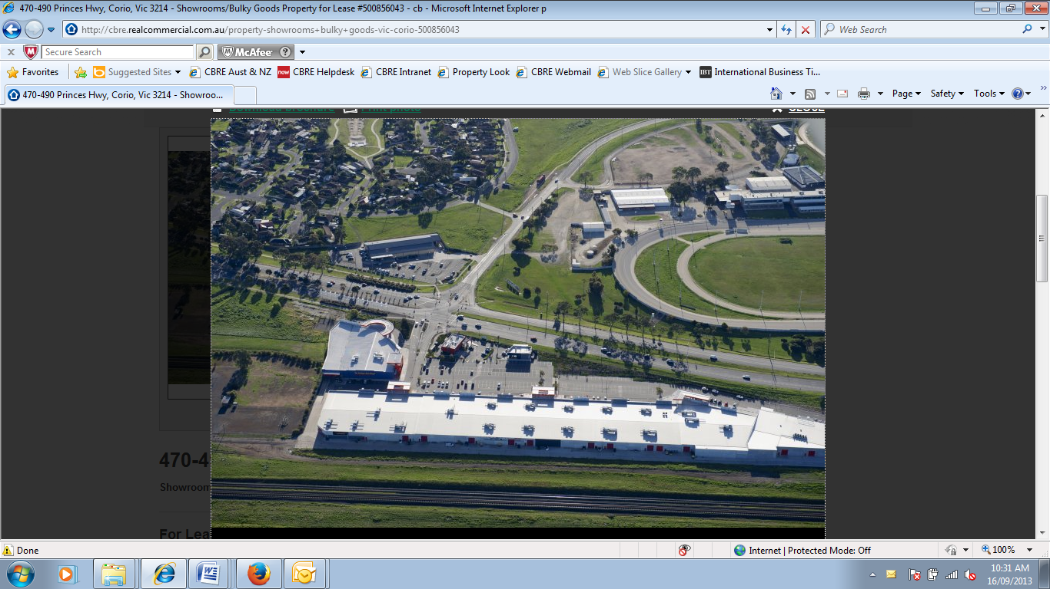

GEELONG HOMEMAKERS PRECINCT

PRINCES HIGHWAY

CORIO VIC

PLANNING SCHEME AMENDMENT REPORT

October 2013

PREPARED ON BEHALF OF

KERVALE INVESTMENTS PTY LTD

CONTENTS
1 INTRODUCTION 3
2 THE AMENDMENT 4
3 URBAN CONTEXT 5
3.1 SUBJECT SITE 5
3.2 SURROUNDING LAND 6
3.3 SURROUNDS 6
4 PLANNING POLICY CONTEXT 8
4.1 ZONING 8
4.2 OVERLAYS 9
4.3 STATE PLANNING POLICY FRAMEWORK 9
4.4 LOCAL PLANNING POLICY FRAMEWORK 10
4.5 OTHER RELEVANT POLICY & STRATEGIES 14
5 PLANNING CONSIDERATIONS AND STRATEGIC ANALYSIS 17
5.1 APPROPRIATENESS OF THE AMENDMENT 17
6 CONCLUSION 21

INTRODUCTION
This Planning Report has been prepared by CBRE Town Planning Pty Ltd on behalf of Kervale Investments Pty Ltd in support of a planning scheme amendment to rezone the respective land identified below in accordance with recommendations of the Corio Norlane Structure Plan 2012.
- Geelong Gateway Homemaker Centre, 470-510 Princes Hwy CORIO
- 452-458 Princes Hwy CORIO
- 446-450 Princes Hwy CORIO
- Harvey Norman, 420-444 Princes Hwy CORIO
- 17-73 Railway Avenue CORIO
- 2 School Road CORIO
- Bunnings, 4-50 School Road CORIO
- 17-19 School Road CORIO
- 21-29 School Road CORIO
- 70 School Road CORIO

The following report assesses the planning merits of the proposal and its consistency with the relevant state and local planning policy directions. The assessment demonstrates that the rezoning proposal is appropriate for the following reasons:
- The proposal is consistent with the key directions of Ministerial Direction 11 for the preparation of a planning scheme amendment, the major thrust of Melbourne 2030 and the Victorian Planning Provisions (VPP’s).
- The rezoning accords with the Local Policy Framework including the Municipal Strategic Statement, City of Greater Geelong’s Retail Policy and Corio Norlane Structure Plan 2012.
- The amendment will apply a more appropriate zoning relative to the existing land use activities on the site.
- The amendments meets all the relevant assessment criteria and will provide a demonstrable net community benefit.
This application is to be read in conjunction with the following supporting documentation:
- Appendix A: Certificate of Title
- Appendix B: Draft Planning Scheme Amendment Documentation

THE AMENDMENT
The Amendment seeks to:
- Rezone the subject land from Industrial 1 Zone/ Industrial 3 Zone to a Business 4 Zone (Commercial 2 Zone); and
- Remove the Design and Development Overlay – Schedule 20 (DDO20).
- Amend the Retail Activity Centre Hierarchy Map and Table at Clause 21.07-8 to show the subject land as a Homemaker Precinct.
The Amendment is required to implement the recommendations of the Corio Norlane Structure Plan July 2012 which identifies a need to rezone the Homemaker Centre and neighbouring sites from the current industrial zoning (Industrial 1 Zone/Industrial 3 Zone) to the Business 4 Zone to apply a zoning which more appropriately reflects the underlying land use activities currently operating on the subject land.
The site is predominately occupied by outlets offering bulky goods retailing.

The specific objectives of the Business 4 Zone (B4Z) are:
- To implement the State Planning Policy Framework and the Local Planning Policy Framework, including the Municipal Strategic Statement and local planning policies.

- To encourage the development of a mix of bulky goods retailing and manufacturing industry and their associated businesses services.

The specific objectives of the Commercial 2 Zone (C2Z) are:
- To encourage commercial areas for offices, appropriate manufacturing and industries, bulky goods retailing, other retail uses, and associated business and commercial services.

- To ensure that uses do not affect the safety and amenity of adjacent, more sensitive uses
There are many elements of the Business 4 Zone (Commercial 2 Zone), the Industrial 1 Zone and Industrial 3 Zone provisions which are comparable but a notable and pertinent difference is that a ‘restricted retail premises’ is ‘as of right’ (Section 1 use) under the B4Z, and presently requires a planning permit under the IN1Z/IN3Z.

URBAN CONTEXT

SUBJECT SITE
The subject site is located at the northern end of the urban area of Geelong and approximately 10km from the city centre. The land is irregular in shape with a total area of approximately 18.9ha. The Geelong Gate Homemaker Centre is identified in Plan of Consolidation 371271J (Volume 09902 Folio 662). The site is improved by the Geelong Gate Homemaker Centre which consists of approximately 18,000sqm of restrict retail floorspace with over 310 at grade car spaces. Existing tenants within the Homemaker Centre include: Fantastic Furniture; Dare Galley; Chemist Warehouse; Red Rooster; Souvlaki Hut, Plush Furniture and Early Settler. Figure 1 below illustrates the location of the site in Corio.
Other outlets located within the identified precinct proposed to be rezoned include restricted retail premises, Harvey Norman and Bunnings. And convenience restaurants Subway and Hungry Jacks.
Figure 1 - Location Map
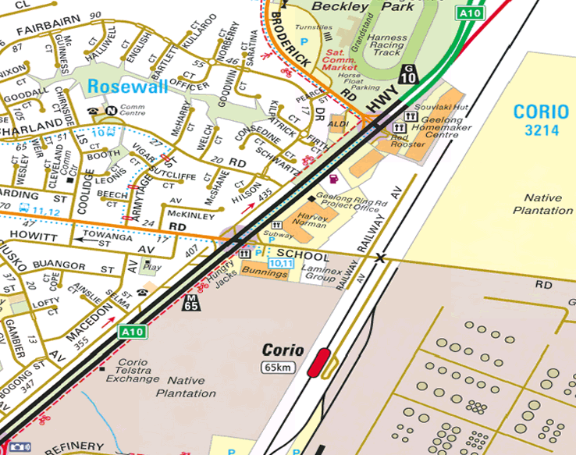
Source: www.street-directory.com.au

Primary vehicular access to the precinct is via the Princes Highway which is a major arterial road that provides a strategic link for road freight, tourism, farming and regional development from Geelong, and has provided improved access to the northern and southern regions of Greater Geelong.

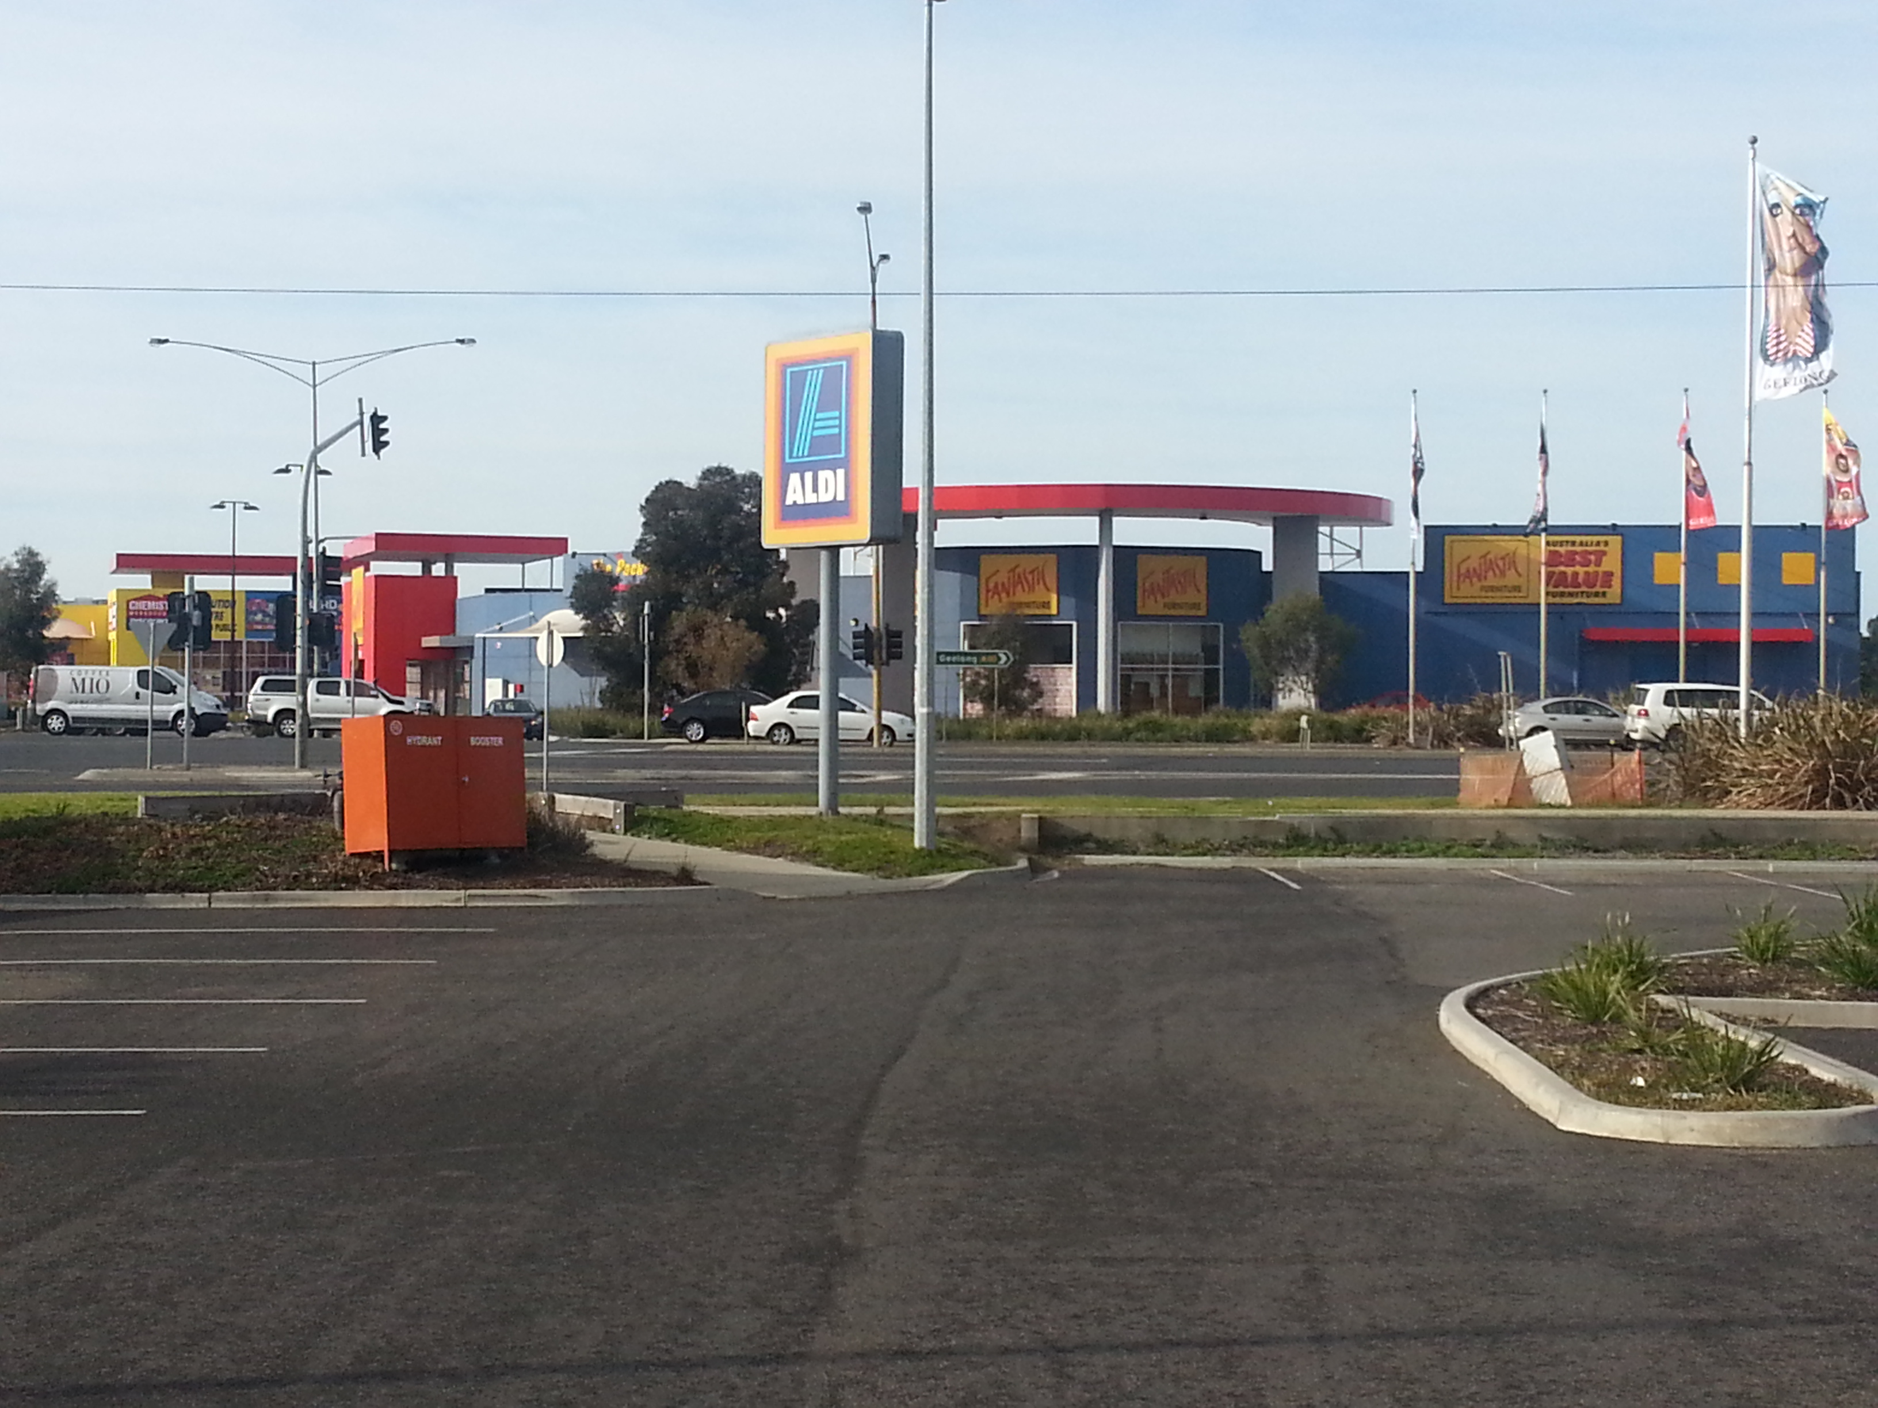Photo: Subject site

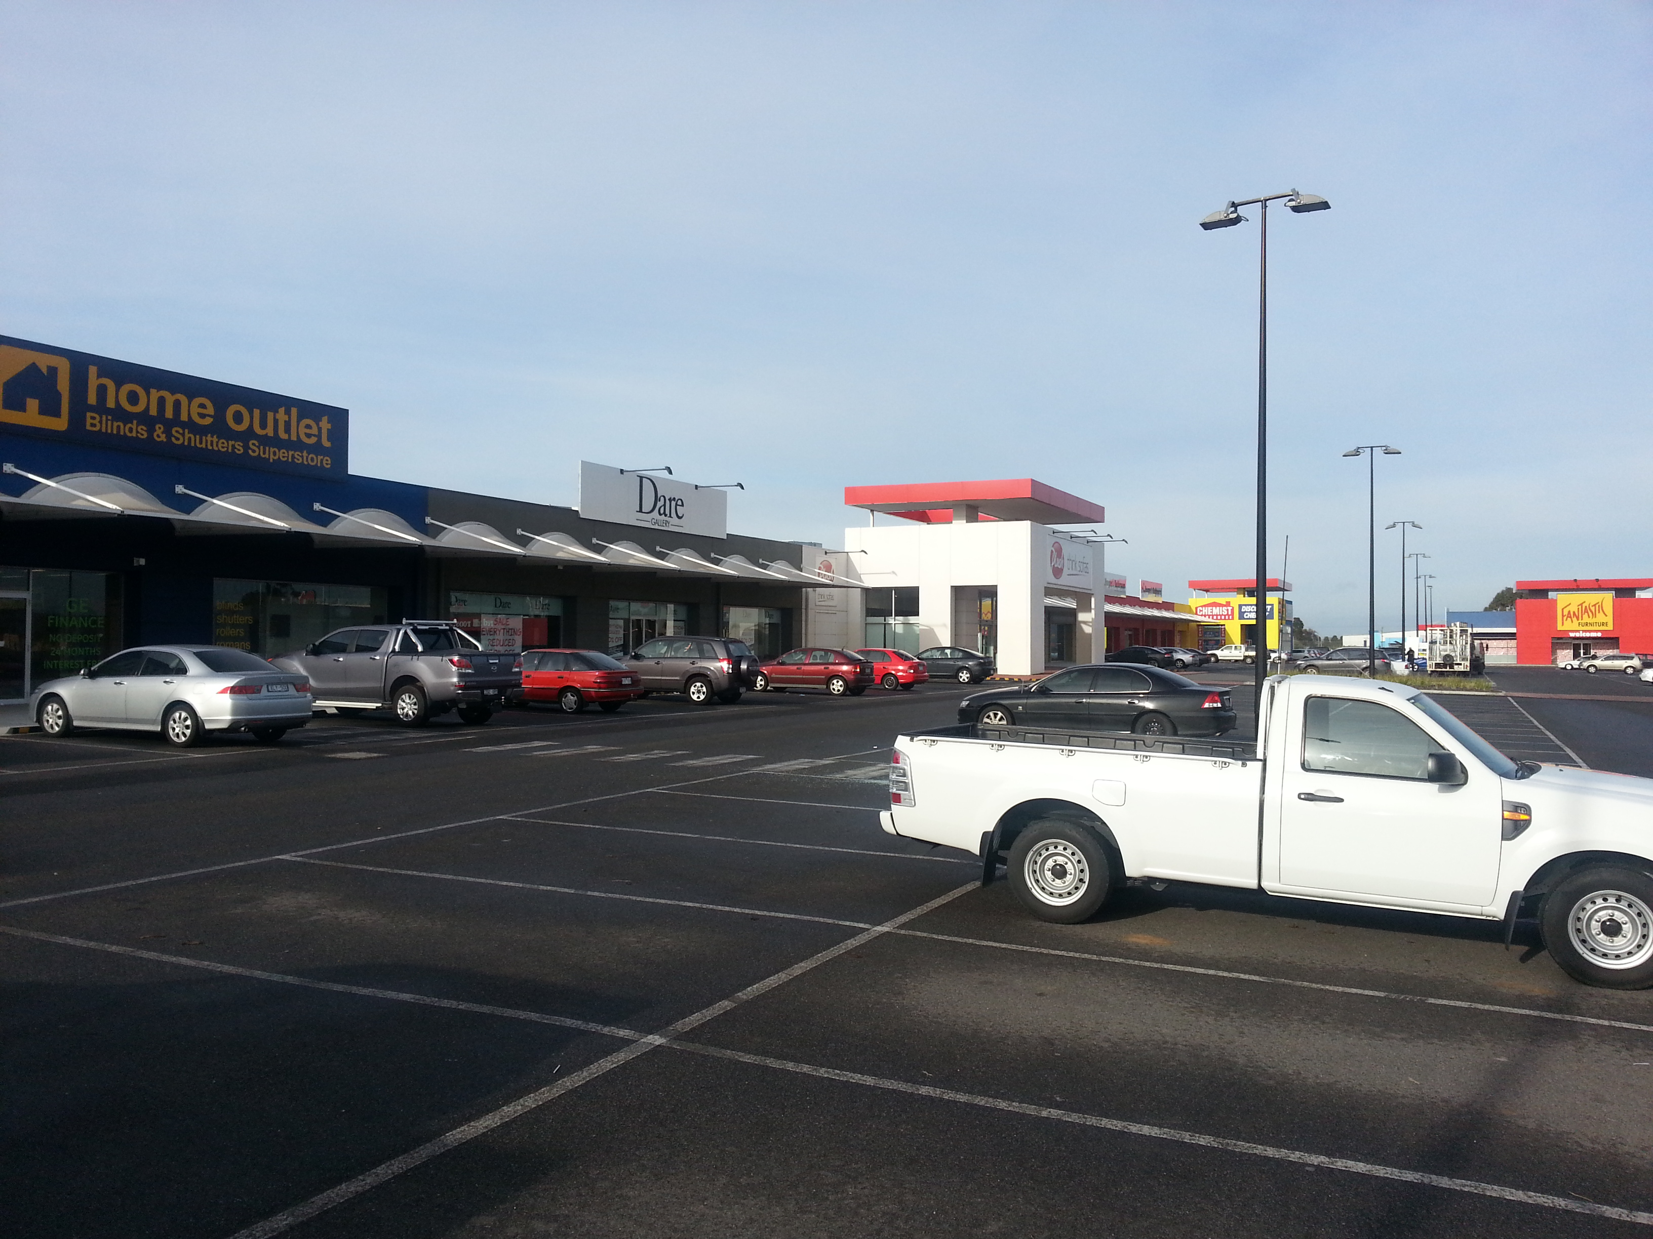Photo: Subject site

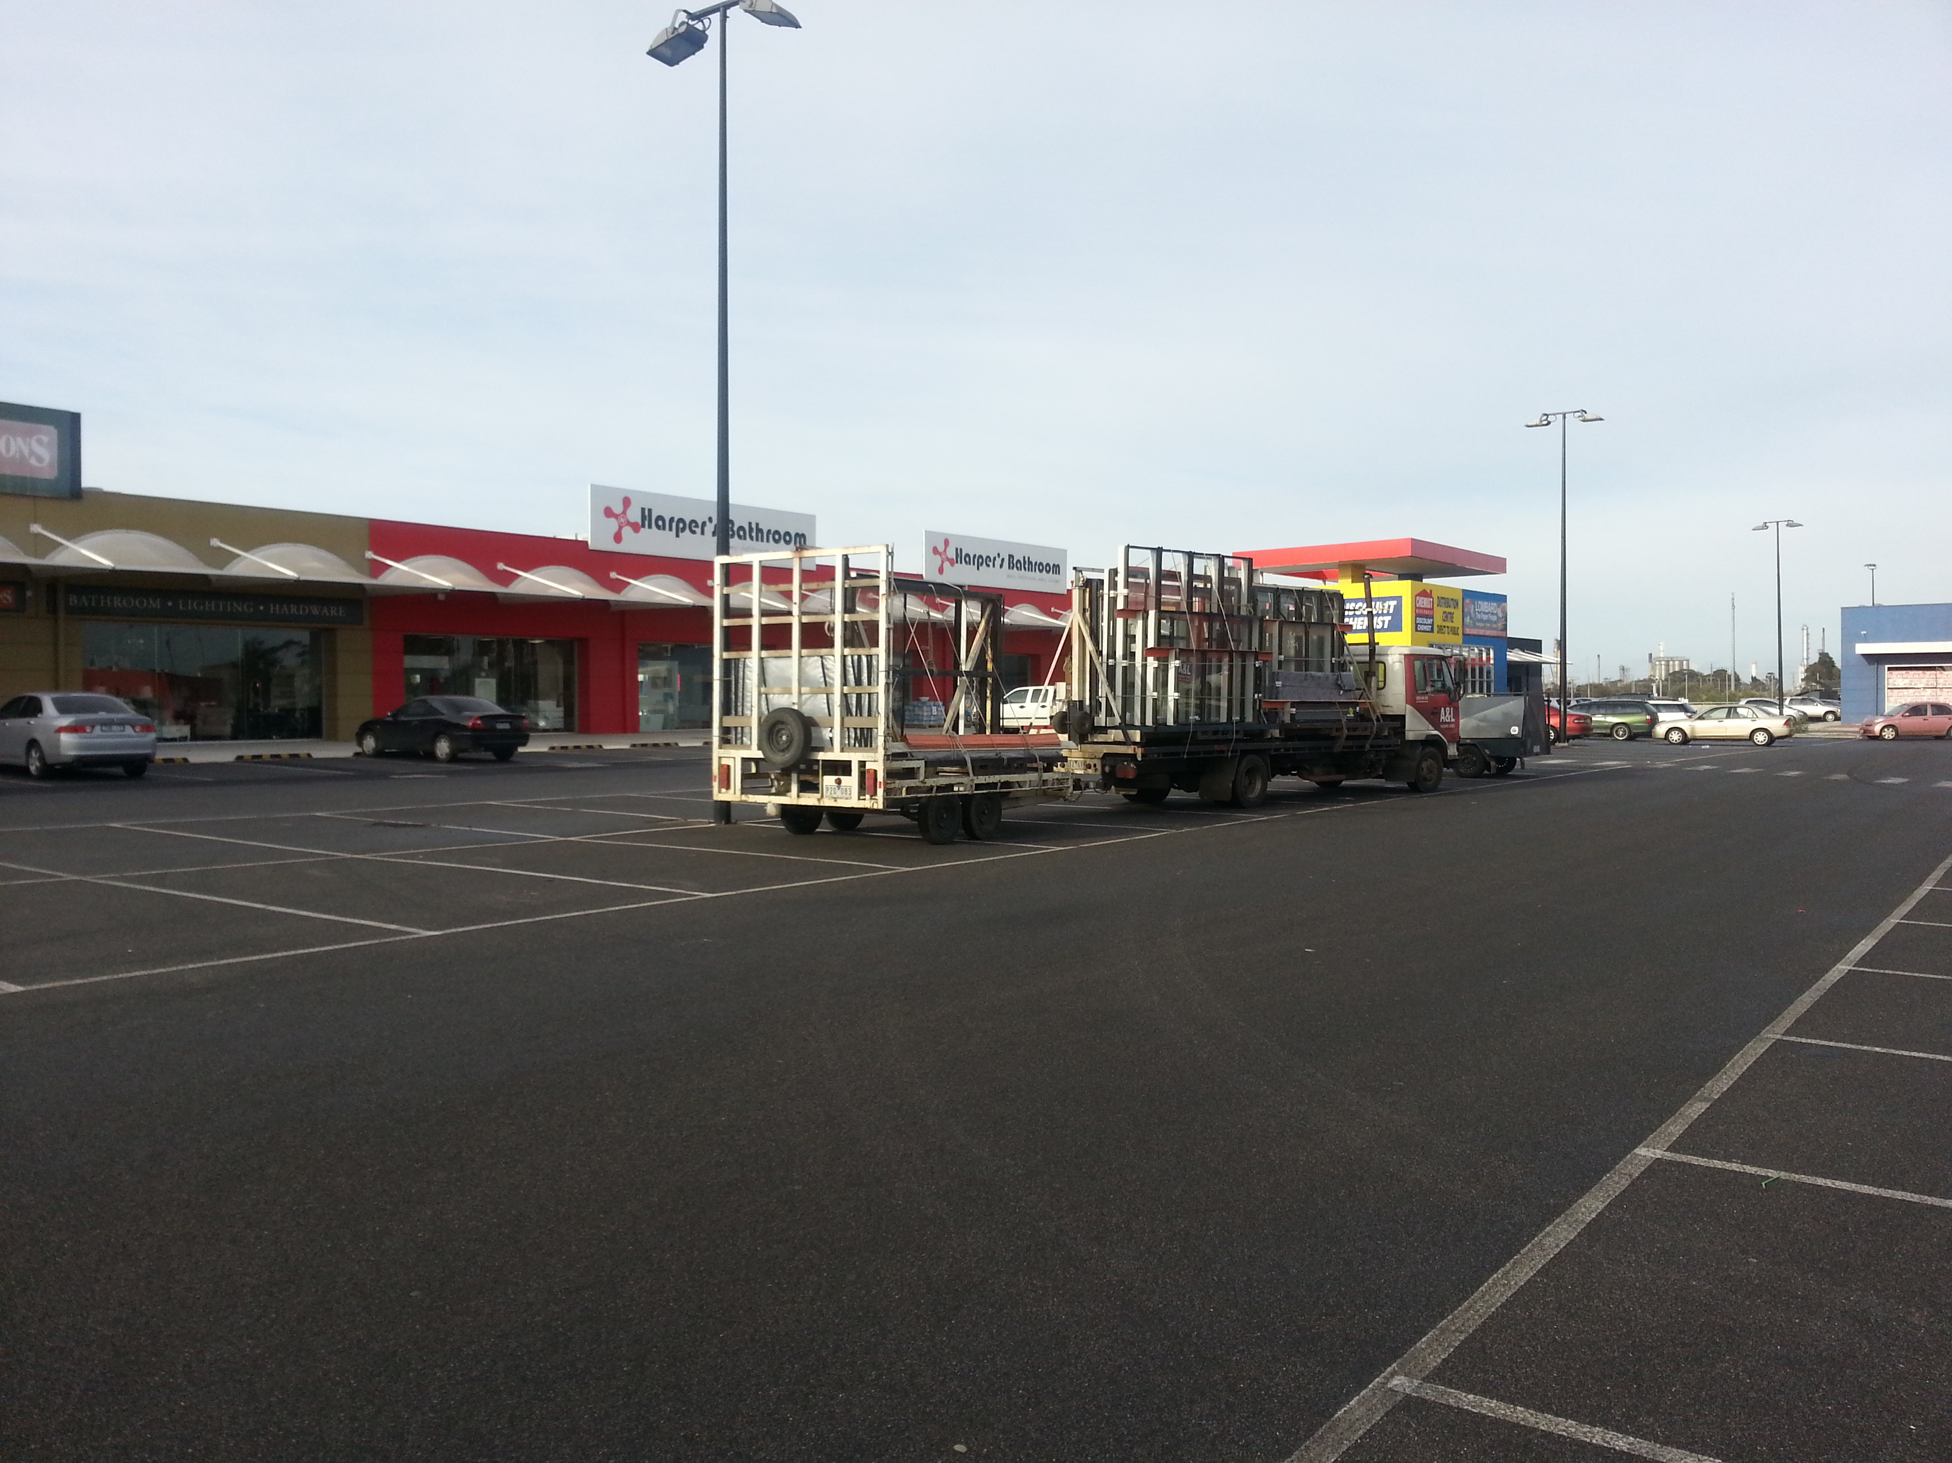Photo: Subject site (view to the north)

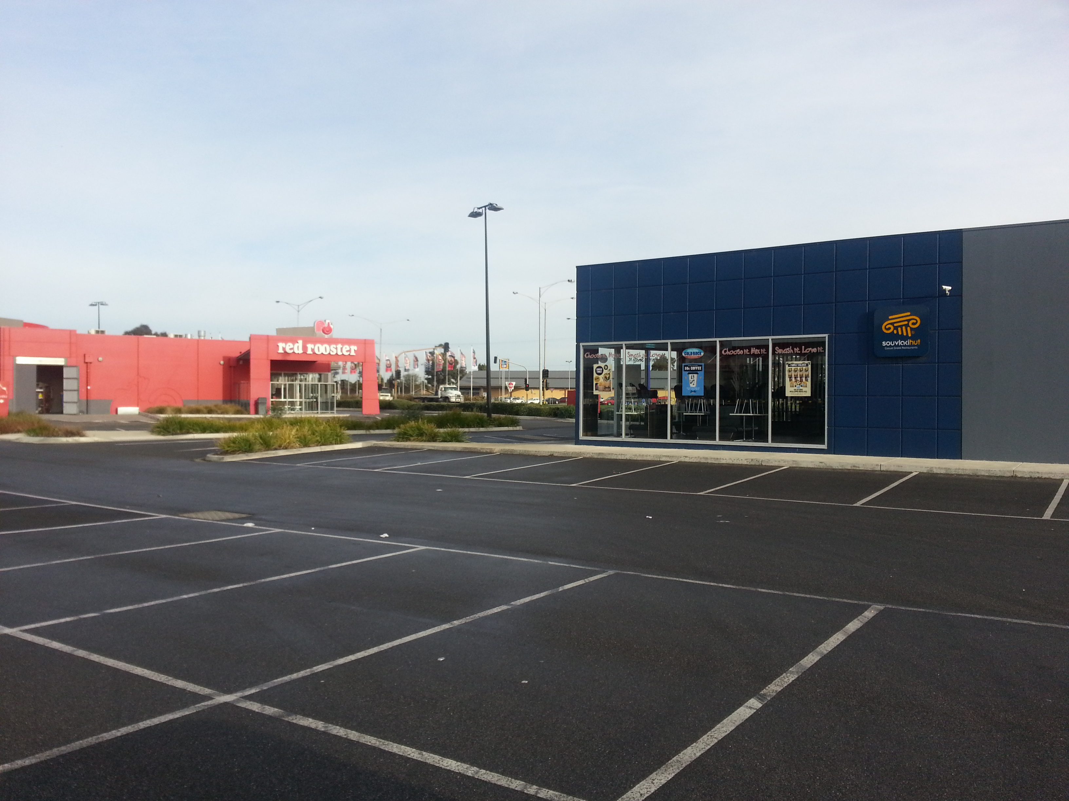Photo: Location of new convenience restaurants

SURROUNDING LAND

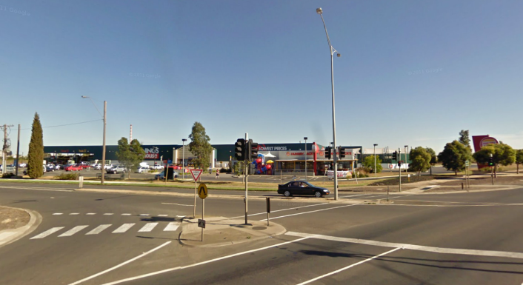
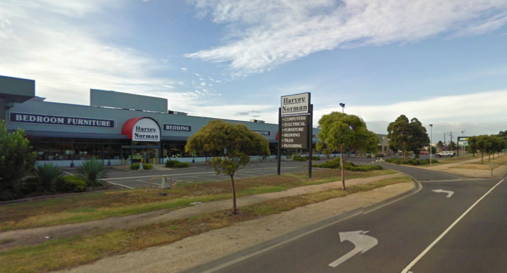

SURROUNDS
The site’s main interfaces are described below:
Photo: Subject site
Photo: Subject site
North – Princes Highway and the exit lane immediately abut the site to the north. The Geelong Harness and Greyhound tracks are located further north of Princes Highway.

East - Abutting the land to the east is the rail line which traverses between Melbourne and Warrnambool via Geelong and provides for both passenger and freight trains. Further east of the subject site is the New Corio Estate, which contains native grasslands, and adjoining this land is Geelong Grammar School.

West - Adjacent to the site to the west is a stand-alone Aldi supermarket which is surrounding by residential development.

South – Immediately to the south of the site is a native forestry plantation.

Figure 2 - Aerial overview
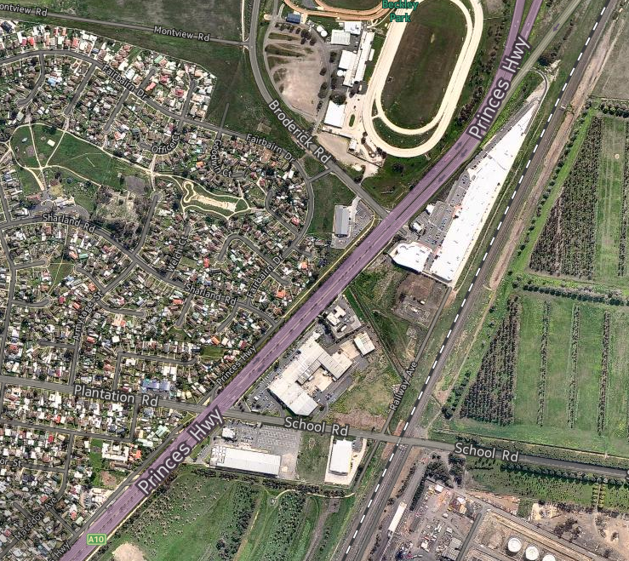Source: www.nearmap.com.au

PLANNING POLICY CONTEXT

ZONING
The subject site is zoned partially Industrial 1 Zone (IN1Z) and partially Industrial 3 Zone (IN3Z). Figure 3 below illustrates the zoning of the subject site and surrounds.
Figure 3: Zoning Map
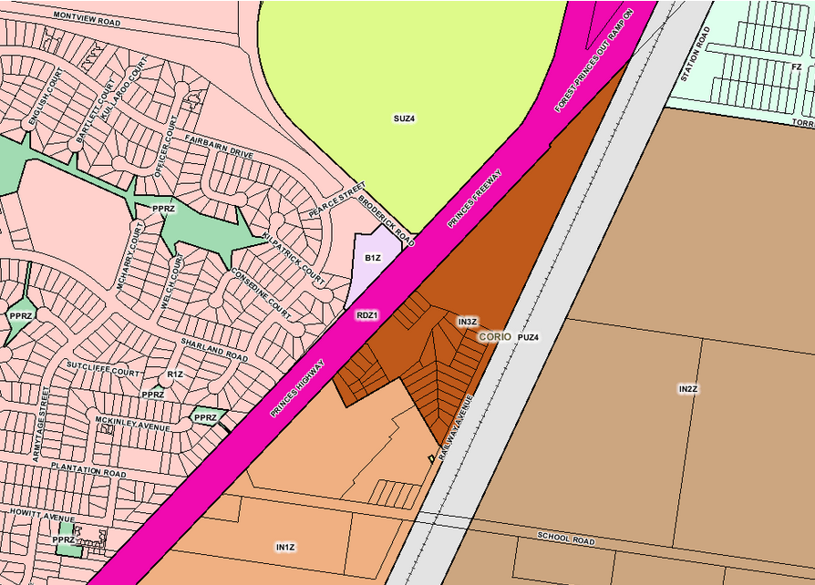
Pursuant to Clause 33.01 of the Greater Geelong Planning Scheme, the purpose of the Industrial 1 Zone is:
- To implement the State Planning Policy Framework and the Local Planning Policy Framework, including the Municipal Strategic Statement and local planning policies.
- To provide for manufacturing industry, the storage and distribution of goods and associated uses in a manner which does not affect the safety and amenity of local communities.

Pursuant to Clause 33.03 of the Greater Geelong Planning Scheme, the purpose of the Industrial 3 Zone is:
- To implement the State Planning Policy Framework and the Local Planning Policy Framework, including the Municipal Strategic Statement and local planning policies.

- To provide for industries and associated uses in specific areas where special consideration of the nature and impacts of industrial uses is required or to avoid inter-industry conflict.

- To provide a buffer between the Industrial 1 Zone or Industrial 2 Zone and local communities, which allows for industries and associated uses compatible with the nearby community.

- To allow limited retail opportunities including convenience shops, small scale supermarkets and associated shops in appropriate locations.

- To ensure that uses do not affect the safety and amenity of adjacent, more sensitive land uses.

OVERLAYS
The subject site is affected by Design and Development Overlay – Schedule 20 (DDO20). This Overlay outlines design objectives for development within the Industrial 1, 2 and 3 Zones.

STATE PLANNING POLICY FRAMEWORK
The State Planning Policy Framework (SPPF) seeks to ensure that overarching objectives in Victoria are adopted via local planning policy and planning mechanisms. The SPPF aims to promote a settlement policy that will “.....anticipate and respond to the needs of existing and future communities through provision of zoned and services land for housing, employment, recreation and open space, commercial and community facilities and infrastructure....”
The following are relevant to this rezoning:
- Clause 10 – Operation of the State Planning Policy Framework.
- Clause 11 – Settlement
- Clause 15 - Built Environment and Heritage
- Clause 17 - Economic development
- Clause 18 - Transport

The key policy imperatives of these clauses, as they relate to this Amendment can be summarised as follows:
- Clause 10 – Operation of State Planning Policy Framework
Clause 10 seeks to ensure that the objectives of planning in Victoria (as set out in Section 4 of the Planning and Environment Act 1987) are fostered through appropriate land use and development planning policies and practices which integrate relevant environmental, social and economic factors in the interests of net community benefit and sustainable development.
- Clause 11.01 Activity Centres & Clause 11.02 – Urban Growth
Specifically, this clause identifies the following relevant objectives:
- To build up activity centres as a focus for high-quality development, activity and living for the whole community by developing a network of activity centres.
- To encourage the concentration of major retail, residential, commercial, administrative, entertainment and cultural developments into activity centres which provide a variety of land uses and are highly accessible to the community.
- To ensure a sufficient supply of land is available for residential, commercial, retail, industrial, recreational, institutional and other community uses.
- To locate urban growth close to transport corridors and services and provide efficient and effective infrastructure to create benefits for sustainability while protecting primary production, major sources of raw materials and valued environmental areas.
Strategies to meet these objectives include:
- Ensure the ongoing provision of land and supporting infrastructure to support sustainable urban development.
- Create a network of mixed-use activity centres and develop an urban form based on Neighbourhood Principles.
Clause 11.02-3 specifically references the objective of ‘structure planning’ and the value of this work in …’facilitating the orderly development of urban areas.’ Relevant strategies of this clause promote:
- Effective planning and management of the land use and development of an area;
- Comprehensive planning for new areas as sustainable communities;
- Use of structure plans that:

- Take into account the strategic and physical context of the location.
- Provide the broad planning framework for an area as well as the more detailed planning requirements for neighbourhoods and precincts, where appropriate.

- Clause 15.01-1 (Urban design)
- Supports urban environments that are safe, functional and provide good quality environments with a sense of place and cultural identity.
- Clause 17 – Economic Development
This clause identifies that planning is to provide for a strong and innovative economy, where all sectors of the economy are critical to economic prosperity.
Objectives and strategies for Clause 17.01-1, Business, include:
- To encourage development which meet the communities’ needs for retail, entertainment, office and other commercial services and provides net community benefit in relation to accessibility, efficient infrastructure use and the aggregation and sustainability of commercial facilities.
- Locate commercial facilities in existing or planned activity centres.
- Provide new convenience shopping facilities to provide for the needs of the local population in new residential areas and within, or immediately adjacent to, existing commercial centres.
Clause 17.01-1 (Business) encourages development which meet the communities’ needs for retail, entertainment, office and other commercial services and provides net community benefit in relation to accessibility, efficient infrastructure use and the aggregation and sustainability of commercial facilities.

LOCAL PLANNING POLICY FRAMEWORK
The Local Planning Policy Framework (LPPF) is comprised of the Municipal Strategic Statement (MSS) and local planning policies. The sections of the LPPF contained within the Greater Geelong Planning Scheme relevant to the consideration of the Amendment are:
- Clause 21.02 – City of Greater Geelong Sustainable Growth Framework.
- Clause 21.03 – Objectives – Strategies – Implementation.
- Clause 21.04 – Municipal Framework Plan
- Clause 21.07 – Economic Development and Employment
- Clause 22.03 – Assessment Criteria for Retail Applications

4.4.1 MUNICIPAL STRATEGIC STATMENT (MSS)
The Municipal Strategic Statement (MSS) sets out the key strategic planning, land use and development objectives for the municipality. It also includes strategies and actions for achieving these objectives. We have reviewed the MSS within the Greater Geelong Planning Scheme and identify the following clauses are relevant to the proposal:
- Clause 21.02 – City of Greater Geelong Sustainable Growth Framework
The sustainable growth framework aims to ensure that the City of Greater Geelong meets the needs of the community without compromising the ability of future generations to meet their needs. Of particular relevance in ‘encouraging diversity in industry’ the framework requires planning to:
- Look for innovative ways to engage with the private sector.

- Encourage the development of collaborative, interdependent industry clusters.

- Provide a diverse range of high quality industrial and commercial land.

- Clause 21.04 – Municipal Framework Plan
The Municipal Framework Plan depicts the subject site as being located in the existing urban area.
- Clause 21.05 – Natural Environment
This Clause recognises that the municipality is rich in flora and fauna and seeks to ensure that land use enhances areas of native vegetation and other habitats.
- Clause 21.06 – Settlement and Housing
This Clause identifies that there is an environmental, economic and social imperative to reduce urban sprawl and improve accessibility to urban services, principally by consolidating urban development around places of activity and public transport infrastructure. All development should contribute positively to the quality of urban environment so that it may be enjoyed and respected by the existing and future community.
- Clause 21.07 ‘Economic Development and Employment’

At Clause 21.07 ‘Economic Development and Employment’, there is recognition that ‘there is increasing development pressure for sites located away from activity centres, particularly for bulky goods and other large format retail development types that seek large sites with the capacity for significant car parking.’ An objective under Retail (Clause 21.07-2) is: ‘To ensure all major retail developments, and out-of-centre developments, provide a clear net community benefit’.

Associated strategies include:
- Direct restricted retail (bulky goods) use and development to Central Geelong, the nominated homemaker precinct at Waurn Ponds, the Corio homemaker precinct subject to appropriate re-zoning and other homemaker and activity precincts as detailed in Clause 21.07-8.

- Require that applications for new centres establish the retail need for such use and development and demonstrate that there are no adverse impacts on the operation of the retail activity centre hierarchy.

Clause 21.07-8 provides a plan of the ‘City of Greater Geelong Retail Activity Centre Hierarchy’. This Amendment seeks to amend this plan to alter the status of Site 31 from a ‘Potential Homemaker Precinct’ to a ‘Homemaker Precinct’. A copy of the retail hierarchy map and associated hierarchy table are provided below.
Figure 4: Greater Geelong Planning Scheme Retail Activity Centre Hierarchy Map
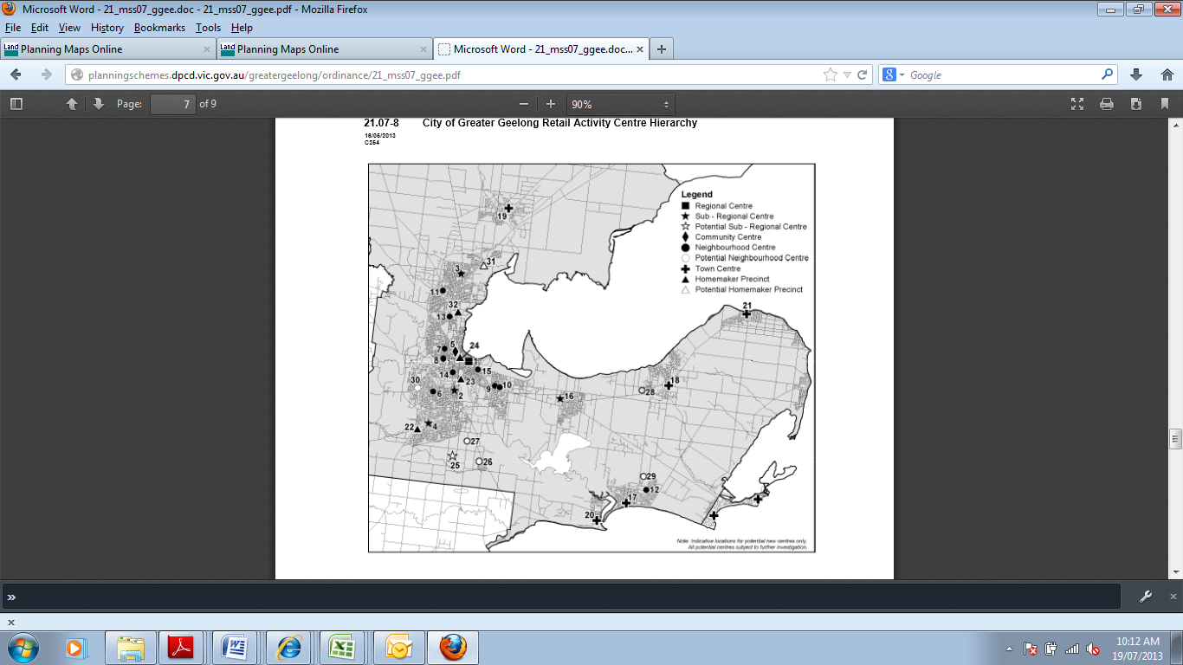

Table 1 - Greater Geelong Retail Activity Centre Hierarchy Table
CITY OF GREATER GEELONG RETAIL ACTIVITY CENTRE HIERARCHY
LEVEL IN HIERARCHY | IDENTIFIED CENTRES | INDICATIVE FLOORSPACE AND EXAMPLE KEY TENANTS
Regional Centre | Central Geelong (1) | More than 100,000 sqm  Department store, discount store(s), mini major(s), supermarket(s) and extensive range of specialities
Sub-regional centres | Belmont (2), Corio Village (3), Waurn Ponds (4) | 15,000 sqm to 35,000 sqm  Discount department store(s), mini major(s) supermarket(s) and specialties
Community Centre | Pakington Street (Geelong West) (5) | 10,000 sqm to 25,000 sqm  Supermarket(s), mini major(s) and specialities
Neighbourhood Centre | Highton (6), Shannon Avenue (Geelong West)(7), Shannon Avenue (Newtown)(8), Bellarine Village (9), Newcomb Central (10), Bell Post (11), Ocean Grove marketplace (12), Separation Street (13), Pakington Street (Newtown)(14), Geelong East (15), Leopold (16). | 2,500 sqm to 25,000 sqm  Supermarket (small or full line), primarily convenience orientated specialities.
Town Centres | Ocean Grove (Town Centre)(17), Drysdale (18), Lara (19), Barwon Heads (20), Portarlington (21). | 1,500 sqm to 15,000 sqm  Supermarket, mini major(s), specialties
Homemaker Precincts | Waurn Ponds (22), Moorabool/Fyans (23), Geelong West (24), North Geelong (33). | 5,000 sqm to 50,000 sqm  Large restricted retail type tenants
Potential Subregional Centres | Armstrong Creek (25), Leopold (32)
Potential Neighbourhood Centres | Armstrong Creek East (26), Armstrong Creek Horseshoe Bend Rd (27), Jetty Road Growth Area (28), Ocean Grove north east growth corridor (29), Wandana Heights (30).
Potential Homemaker Precincts | Corio (31)

Clause 21.07 also addresses the importance of Industry for ongoing employment and economic development in the Geelong region. It identifies the land to the north of the site and the Geelong Ring Road as the ‘North East Industrial Precinct’. This precinct is encouraged to attract national and regional scale industrial businesses. Objectives and strategies relating to industry seek to ensure an adequate supply of appropriately located industrial land; to facilitate well designed and serviced industrial development that provides a high level of amenity for workers and visitors; and to minimise land use conflicts.

4.4.2 LOCAL PLANNING POLICY FRAMEWORK
- Clause 22.03 ‘Assessment Criteria for Retail Planning Applications’
The local policy at Clause 22.03 ‘Assessment Criteria for Retail Planning Applications’ applies where a planning scheme amendment or planning Permit Application is required for a new or expanded provision of retail floorspace. The objectives of the policy are:
- To ensure that applications for new centres establish the retail need for such use and development and demonstrate that there are no adverse impacts on the operation of the retail activity centres hierarchy.
- To ensure that applications involving a planning scheme amendment in or adjoining existing activity centres clearly establish a retail need for such use and development and demonstrate that there are no adverse impacts on the operation of the retail activity centres hierarchy.
- To ensure all major retail use and development provide clear net community benefit.
- To allow/guide consideration of applications involving an increase in an identified floorspace cap, in order to accommodate the changing retail trends and retail demands.

OTHER RELEVANT POLICY & STRATEGIES

4.5.1 CORIO NORLANCE STRUCTURE PLAN 2012
The Corio Norlane Structure Plan (CNSP) was adopted on 24 July 2012. The CNSP was prepared by the City of Greater Geelong together with the Department of Planning and Community Development (DPCD), and was subject to public notification including two public information sessions. The Table within Section 3.2 (Implementation into the Planning Scheme) prescribes actions that require amendments to the Greater Geelong Planning Scheme to implement the Structure Plan and give it statutory weight. With regards to the subject land, the nominated actions are as follows:

- Amend the Retail Activity Centre Hierarchy Map and Table at Clause 21.07-8 to show: · a new Homemaker Precinct on Bacchus Marsh Road, Corio; · the Geelong Gateway Homemaker centre on Princes Highway as a Homemaker Precinct not ‘Potential Homemaker Precinct”;
- Rezone the Geelong Gateway Homemaker Centre from Industrial 3 Zone to Business 4 Zone.
- Remove the DDO20 from land to be rezoned from the IN3Z to the B4Z

Council resolved to adopt the CNSP and to request the Minister for Planning to prepare and approve a Section 20(4) Amendment (amendment without further notification) to incorporate the CNSP into the Planning Scheme. The Council’s request is currently under consideration. The Framework Plan below summarises the key strategies and directions for the Corio and Norlane area. This Plan will be used as the basis for a new strategy to be inserted into the Municipal Strategic Statement of the Greater Geelong Planning Scheme. It will guide future land use decisions for the area. As illustrated within the Corio Norlane Urban Framework Plan on the following page, the precinct is identified to be rezoned to the Business 4 Zone.

4.5.2 RETAIL REVIEW
The Retail Review Paper prepared by the Department of Planning and Community Development (DPCD) has been provided for discussion purposes and seeks to provide greater clarity in relation to the policy and statutory framework to assist in the consideration of retail proposals. The Paper recognises that competition and innovation in the retail sector are vital to bring about net community benefits from access to competitive prices, quality products and the widest range of goods and services.
In terms of restricted retail or ‘bulky goods’ the Retail Review recognises the importance of a diversity of retail uses in and around Activity Centres as well as in out of centre ‘cluster centres’. Generally, bulky goods are encouraged within business zones and in proximity to an existing or planned activity centre or retail/homemaker cluster. The current framework which allows for bulky goods to locate in industrial zones is under review as part of the Retail Review.

4.5.3 DRAFT GUIDELINES FOR BULKY GOODS
Issued by the DPCD in 2007, the Interim Design Guidelines for Large Format Retail Premises (“the guidelines”) seek to provide guidance on developing vibrant, high quality large format retail centres. The guidelines are not incorporated within any Planning Scheme and remain in an ‘interim’ status, however, they are considered to set out the State Government’s position regarding best practice in designing new, large format, retail developments.
The guidelines focus on four elements of design consideration:
- Urban context: highlights the importance of locating retail developments in appropriate locations, cognisant of state and local planning policy objectives.
- Equitable access: promotes design features which enable equitable access for persons of all abilities via a range of transport modes.
- Public amenity: seeks to ensure that retail development and associated public spaces provide visually attractive environments that enhance public convenience and comfort.
- Environmental sustainability: references the need to minimise the impacts that new buildings have on the environment both through the location of development and the design.
Each element incorporates a set of suggestions and requirements relating to the design of new, large format retail developments.

4.5.4 CITY OF GREATER GEELONG RETAIL STRATEGY
The determining objectives and criteria concerning ongoing development of retailing in the City of Greater Geelong are largely contained within the City of Greater Geelong Retail Strategy (June 2006). It provides a visionary strategy and objectives to assist Council and other stakeholders in their decision making, as well as supporting principles and actions.

In chapter 3 “Vision” and Objectives for this Strategy, under section 3.1. “The Vision”. It states:
“Geelong’s retail activity centre network will be developed in a way that promotes the vibrancy and sustainability of the activity centre hierarchy, is efficient and viable for traders and other businesses; generates employment and income opportunities; and functions in a manner which focuses on the needs off residents and visitors to the Region.” (P.11)
The stated objectives designed to assist in achieving this vision comprise the following:
- To promote economic development and job creation.
- To foster small business development.
- To encourage the development of interesting, viable and vibrant retail activity centres.
- To improve the range and quality of shopping and business services provided in activity centres and at other locations.
- To improve the amenity of the built environment in activity centres.
- To create safe and liveable activity centres.
- To encourage accessibility and sustainability as key feature of activity centre policy.
- To introduce activities such as housing and mixed use development at appropriate locations which support the role of activity centres.
Referring to chapter 4 “Principles and Actions to support the Strategy” under section 4.2 “Principles and Actions for Activity Centres”, the strategic policies are listed as:
- Support the retail activity centre hierarchy.
- Maximise the retention of retail expenditure through the provision of an efficient activity centre hierarchy.
- Consolidate activities in centres.
- Recognise the importance of Central Geelong
- Encourage a wide ix of activities in centres, where commercially viable.
- Consolidate the network of local convenience centres.
- Ensure the activity centre develop in an integrated fashion.
Of most relevance to the proposal, the Retail Strategy also states, in Chapter 5 in “Actions for Specific Centres in the Retail Hierarchy” under Section 5.9 “Homemaker Retail” that:
Homemaker retailing can be identified as occupying a stand-alone site, or several sites in a precinct, and may also be described as an integrated centre where such a location contains a range of comparison shopping (eg, bedding, whitegood, electrical goods) in an integrated shopping environment.

Homemaker retail is an increasingly popular retail form in the Australian market and its growth has been largely confined to out-of-centre locations. Out-of-centre locations are popular with this form of retail for the following reasons:

- Large, level sites to accommodate large format stores and on-site carparking.

- High exposure to passing traffic

- Convenient accessibility to the regional road network.

- Ability to easily accommodate the large-format tenancies required for this retail type

- Relatively low site costs compared with higher property costs in activity centres
Tangible benefits are associated with the creation of dedicated homemaker precincts or integrated centres, and include the following:

- Ability to serve a wide regional or sub-regional catchment;
- Ability to masterplan and guide appropriate development on a single site;
- Reduced pressure for excessive non-integrated “strip” or “ribbon” homemaker development scattered along major road frontages;
- Benefits of co-location lead to synergies with other homemaker retailers;
- Popular one-stop shopping destinations for shoppers wanting to browse and compare price, quality, range, etc; and
- Savings associated with the provision of shared parking and other infrastructure.

There is an increasing trend in the homemaker retail sector for the development of dedicated precincts or ‘homemaker centres’ in order to take advantage of these benefits of co-location. This is consistent with the maturing of the sector as a retail format, and is also being driven by a more structured approach to planning for homemaker development instead of ‘stand-alone sites’. Of most relevance to this proposal, the Strategic identifies the following future directions for Homemaker Retail centres:

- Ensure that, where necessary, land use transition to appropriate non-retail uses in existing homemaker precincts or sites (and which may become redundant over time) is facilitated.

- The sale of goods and services outside this definition will be ancillary only, and must not undermine the retail activity centre hierarchy.

PLANNING CONSIDERATIONS AND STRATEGIC ANALYSIS

APPROPRIATENESS OF THE AMENDMENT
The strategic assessment guidelines provide an appropriate framework for evaluation of the proposed planning scheme amendment. The following discussion provides an evaluation of the proposed amendment against the key requirements of the Minister’s Direction No. 11.

5.1.1 WHY IS THE AMENDMENT REQUIRED?
The Amendment is required to implement the recommendations of the Corio Norlane Structure Plan July 2012 which identifies a need to rezone the precinct from the current industrial zoning to the Business 4 Zone to apply a zoning which more appropriately reflects the underlying land use activities currently operating on the subject land. The subject site is located in an area currently zoned Industrial 1 Zone and Industrial 3 Zone, zones generally reserved for manufacturing and industry based land uses. The site is occupied by the Geelong Gate Homemaker Centre, Harvey Norman and Bunnings which offer bulky goods retailing and therefore is inconsistent with the underlying zoning.
It is considered that the rezoning of the land is necessary to ensure that zoning controls reflect the land use activities operating on the site, and current policy directions at both State and Local level. The proposed amendment to rezone the site to the C2Z (previously B4Z) strongly accords with the major thrust of Melbourne 2030, is consistent with the Victorian Planning Provisions (VPP’s), the LPPF including the City of Greater Geelong’s Retail Policy and Corio Norlane Structure Plan 2012.

5.1.2 HOW DOES THE AMENDMENT IMPLEMENT THE OBJECTIVES OF PLANNING IN VICTORIA?
The strategic basis for the proposed Amendment is underpinned by the State and Local Planning Policy Frameworks. An assessment of the Amendment proposal against the relevant strategic directions of the planning scheme confirms that the rezoning will further the aspects of these policy frameworks including the SPPF that relate to the provision of retail facilities and importance of recognising activity centre hierarchy at Clause 11 and 17 of the Planning Scheme.
Although the site is identified with Clause 21.07 as a ‘proposed homemaker precinct’, it is suggested within the Corio Norlane Structure Plan 2012 that it be promoted to the status of a ‘homemaker precinct’ given its physical existence. The amendment implements the objectives of planning in Victoria by providing the appropriate land use zoning to facilitate the fair, orderly, economic and sustainable use and development of the land.

5.1.4 DOES THE AMENDMENT ADEQUATELY ADDRESS ANY ENVIRONMENTAL EFFECTS?
There are no environmental effects arising from the proposed Amendment. The Homemaker Centre, Harvey Norman and Bunnings are currently existing and operating on the site and no concurrent planning approval is sought for buildings and works.

5.1.5 DOES THE AMENDMENT ADEQUATELY ADDRESS ANY SOCIAL AND ECONOMIC EFFECTS?
It is considered that the proposed Amendment will have positive social and economic impacts by strengthening the role of the precinct and ensuring its on-going viability as a key employer and provider of retailing and other services within Geelong.

5.1.6 DOES THE AMENDMENT COMPLY WITH THE REQUIREMENTS OF ANY OTHER MINISTER’S DIRECTION APPLICABLE TO THE AMENDMENT?
The requirements of Minister’s Direction No.11 Strategic Assessment of Amendments have taken into account in the preparation of this amendment and are addressed in this section of the report.

5.1.7 HOW DOES THE AMENDMENT SUPPORT OR IMPLEMENT THE STATE PLANNING POLICY FRAMEWORK AND ANY ADOPTED STATE POLICY?
The amendment is consistent with and implements the objectives of relevant State Planning Policy as described within Section 4.1 of this report.

5.1.8 HOW DOES THE AMENDMENT SUPPORT OR IMPLEMENT THE LOCAL PLANNING POLICY FRAMEWORK AND SPECIFICALLY THE MUNICIPAL STRATEGIC STATEMENT?
The amendment is consistent with and implements the objectives of relevant Local Planning Policy Framework and the Municipal Strategic Statement as described within Section 4.2 of this report.

In summary, the importance of employment within Geelong is identified within Council’s Local Planning Policy Framework at Clause 21.07 (Economic Development and Employment). This policy seeks to promote the “need to provide support for ongoing employment and economic development in the Geelong region”, and that whilst “Traditional manufacturing industries will continue to be key economic and employment drivers in the municipality, however at the same time the City’s economy will need to focus on emerging industry sectors that underpin economic development, prosperity and employment growth in the new economy.”

Retail Trade is the second largest employer within Geelong (behind Health Care & Social Assistance) accounting for 14.41% of the total workforce (11,325 people). Accepting this, it a paramount that Geelong’s retail sector is supported by continual growth to ensure that it remains strong and viable.

Any proposed future expansion of the Homemaker Precinct would provide for new employment growth and strengthen the employment base within Geelong. A greater retail offering will not only ensure that the retail sector remains a strong employer within the Township, but will create a more vibrant and dynamic retail centre. Under the current industrial zoning, there are limitations to the efficiency of any future expansion, and notable discord between the purpose of the zone and current land use activities operating on the site. A rezoning to the Commercial 2 Zone, which is a zoning aligned with restricted retail land uses, would protect and ensure the long term viability of the centre.

5.1.9 DOES THE AMENDMENT MAKE PROPER USE OF THE VICTORIAN PLANNING PROVISIONS?
The Victorian Planning Provisions (VPPs) present a suite of zonings which control land use and development, noting that each zone includes a description of its purpose.
The current industrial zoning applied to the site outlines a purpose to “provide for manufacturing industry, the storage and distribution of goods and associated uses in a manner which does not affect the safety and amenity of local communities” and to “provide for industries and associated uses in specific areas where special consideration of the nature and impacts of industrial uses is required or to avoid inter-industry conflict.” Whilst ‘restricted retail’ is a permissible use under the IN1 and IN3 zones, we consider that the current land use activities (i.e. bulky goods retail, food and drink premises, service station) operating on the subject land are inconsistent with the overarching purpose of the zone.
We consider the Business 4 Zone would more appropriately reflect the underlying land use activities operating at Geelong Gate. The overarching purpose of the B4Z is:

- To encourage the development of a mix of bulky goods retailing and manufacturing industry and their associated businesses services.

Under the new zoning regime, the B4Z has been replaced by the Commercial 2 Zone, which adopts a similar purpose:

- To encourage commercial areas for offices, appropriate manufacturing and industries, bulky goods retailing, other retail uses, and associated business and commercial services.

- To ensure that uses do not affect the safety and amenity of adjacent, more sensitive uses
To this end, we consider that there is merit is considering a future rezoning of the precinct to the Commercial 2 Zone, as this would better reflect the role of the Centre, as a provider of bulky goods retail. Importantly, the Commercial 2 Zone will allow for uses including ‘restricted retail’ and ‘trade supplies’ and ‘food and drink premises’ as of right.
Within Victoria, it is common planning practice to apply a Business 4 Zone to ‘bulky goods centres’. Whilst there is a more extensive list of centres currently under the B4Z (Commercial 2 Zone), we provide the following examples:
- Waurn Ponds Homemaker Centre (235 Princess Highway, Waurn Ponds)
- Roxburgh Plaza Homemaker Centre (Reservor Drive, Coolaroo)
- Highpoint Homemaker Centre and Harvey Norman Centre (Rosamond Road, Maribyrnong)
- Cranbourne Homemaker Centre (Cnr Thompsons Road and South Gippsland Highway, Cranbourne)
- Fountain Gate Super Centre (Cnr Cranbourne Road and Hallam Bypass/Monash Freeway, Narre Warren).

The amendment makes proper use of the Victorian Planning Provisions (VPP) by applying a Business 4 Zone (Commercial 2 Zone) which is consistent with the form and content of the VPPs to facilitate a bulky goods centre development.

The Commercial 2 Zone is a legitimate tool within the VPPs. This tool is an appropriate control for the subject land and will affirm the role of the centre as a Homemaker Centre consistent with State and Local planning policies, and Corio Structure Plan.

5.1.10 HOW DOES THE AMENDMENT ADDRESS THE VIEWS OF ANY RELEVANT AGENCY?
Given that the proposal does not seek to facilitate any buildings and works, and the Amendment seeks to apply an alternative zone, we don’t consider that any referrals to external agencies would be required.

5.1.11 SUMMARY
Overall it is considered that the proposed rezoning is consistent with the key directions of the Ministerial Direction 11 for the preparation of Planning Scheme Amendment and is consistent with the relevant planning policy and strategic objectives prescribed within the Greater Geelong Planning Scheme.

CONCLUSION
The proposed Planning Scheme Amendment is underpinned by a sound and supportive strategic planning framework and responds to those nominated actions prescribed within the Corio Norlane Structure Plan adopted by Council on 24 July 2012.
The Amendment will formally recognise the area as a Homemaker Precicnt within the LPPF and apply a zoning reflective of the underlying land use activities. The proposed removal of the DDO20 covering the site will be pertinent noting that this control relates only to Industrial zoned land.
Overall, the Amendment accords with the existing and proposed retail hierarchy; will ensure the on-going role of the precinct as a key provider of bulky goods retail; achieves a net community benefit by ensuring the on-going co-location of retail and community uses; and will strengthen the buffer between the existing industrial and residential land use activities.
For the above reasons, it is submitted that this proposed Planning Scheme Amendment request to the Greater Geelong Planning Scheme has significant merit and therefore should be supported.

APPENDIX A – TITLE INFORMATION

APPENDIX B – DRAFT PLANNING SCHEME AMENDMENT DOCUMENTATION

