Low Density Residential Zone – Minimum Lot Size Review

Summary

In July 2013, the Minister for Planning released a reform of planning zones across Victoria including the Low Density Residential Zone (LDRZ). Within the LDRZ the minister has reduced the minimum lot size from 0.4 hectares to 0.2 hectares where reticulated sewerage is available. Within the City of Greater Geelong there are 19 LDRZ areas. After reviewing the opportunities and constraints for each of these areas it is recommended that the minimum subdivision size for 5 of the 19 areas is reduced from 0.4 hectares to 0.2 hectares.

Background

The Low Density Zone (LDRZ) is typically located on the fringes of existing townships in the municipality that are constrained for conventional residential development by environmental or infrastructure limitations, particularly drainage. These properties are often valued for the lifestyle opportunities they provide and are, in conjunction with the Rural Living Zone, considered to provide a buffer between residential areas and farming land.
In June 2011 the Planning Minister commissioned the Victorian Planning System Ministerial Advisory Committee to examine all aspects of the planning system, including possible zone reform. The reforms proposed a number of changes including amending the Low Density Residential Zone (LDRZ) to allow a reduction in the minimum lot size from 0.4 hectares to 0.2 hectares in areas where sewer is available.
The draft changes did not provide Council with any opportunity to prevent areas that had access to sewer but had other significant constraints from having a reduced minimum subdivision area.
Council wrote to DPCD in April 2013 formally requesting that ‘the schedule to the LDRZ for Greater Geelong be amended to limit subdivision to 0.4 hectares for all lots’ as an interim measure to allow Council to undertake a proper investigation to fully test and assess the merits of reducing the lot size in particular locations.
The government released ‘Reformed Residential Zones for Victoria – A discussion paper on reforming Victoria’s Planning Zones’ in July 2013. This report considered the advisory committee’s recommendations and individual submissions and made changes to various zones, including changes to the LDRZ into the Victoria Planning Provisions. The change to the LDRZ included the introduction of a schedule which allows Council to designate the areas where a 0.4 hectare minimum should be maintained.

Introduction

The purpose of the Low Density Residential Zone is to provide for low-density residential development on lots which, in the absence of reticulated sewerage, can treat and retain all waste water.

The Greater Geelong municipality has approximately 1076 LDRZ lots across 19 different areas. Fifteen of these areas have access to sewer. Within these areas a total of 592 lots are over 0.4 hectares. The revised LDRZ provisions would allow a permit to be sought to further subdivide each lot into a minimum of 0.2 hectares.
In some instances the LDRZ has been applied to lots that are connected to reticulated sewerage but have flooding, drainage and significant vegetation issues. Given the constraints in these areas a reduction in the minimum lot size could have a significant impact. Further investigation of these areas is required to determine if further subdivision is suitable. Map 1 and 2 below show the location of the LDRZ areas within Greater Geelong.
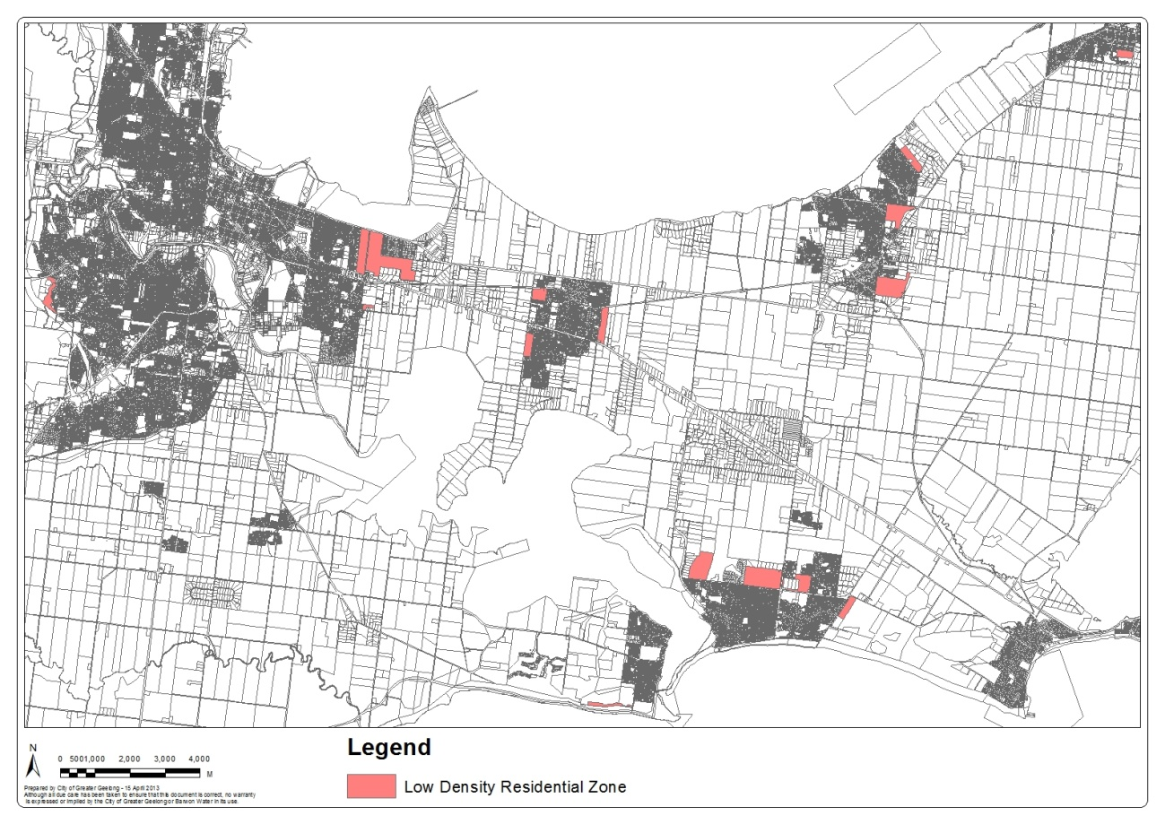
Map 1 – Location of the Low Density Residential Zone in Geelong and the Bellarine Peninsula
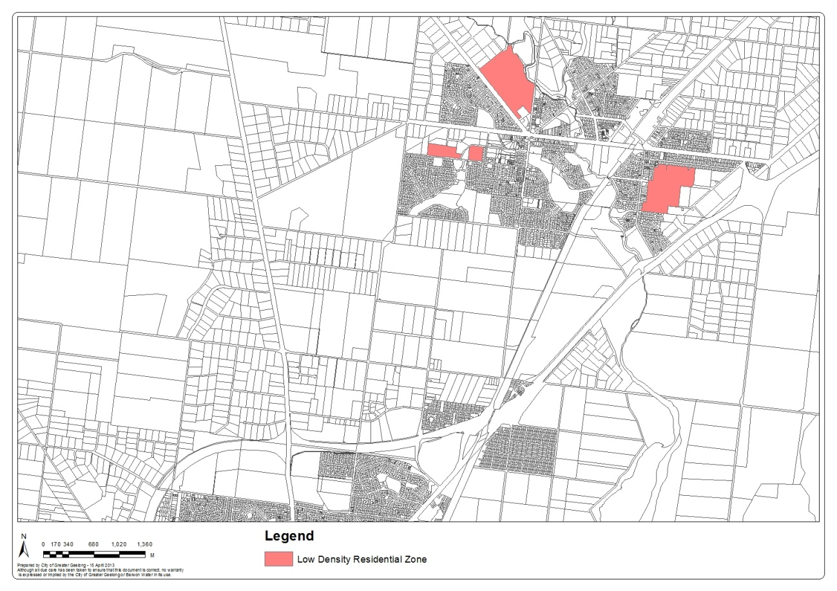
Map 2 – Location of the Low Density Residential Zone in Lara
Where sewer is not available the LDRZ will continue to require each new lot to be at least 0.4 hectare. Sewerage from these lots is disposed of using septic tanks. Environment Protection Authority guidelines relating to the use of septic tanks recommends a minimum lot size of 0.4 hectares to enable a site to adequately dispose of sewerage. Health and management issues can arise if unsewered lots are less than 0.4 hectares.

Methodology

This review aims to assist Council in understanding how a reduction in the minimum lot size might impact upon Low Density Zoned land within the municipality. The review will provide justification to maintain or reduce the minimum lot size within the LDRZ areas.
This report seeks to understand the opportunities and constraints within each of the LDRZ areas and to recommend where within the municipality there is capacity to reduce the minimum subdivision area to 0.2 hectares.
Each area has been reviewed in the context of existing State and Local Planning Policy, zoning and overlay controls, known drainage and flooding issues, fire prone land, existing lot sizes including the ability to further subdivide and the location of significant vegetation. The review also considered existing policy directions for each area where they have been included within the Planning Scheme or Structure Plans.
The consequences for allowing further subdivision of each area have been considered and a recommendation including justification has been provided for each area.

Planning Scheme Considerations

Zone

All land is located within the Low Density Residential Zone the purpose of which is to provide for low-density residential development on lots which, in the absence of reticulated sewerage, can treat and retain all waste water.

Overlays

The following overlay controls affect land within the LDRZ. A map which identifies the controls affecting each LDRZ area can be found in section 8 of this report.

Clause 42.01 – Environmental Significance Overlay

The purpose of Clause 42.01 of the Environmental Significance Overlay is to:

- Implement the State Planning Policy Framework and the Local Planning Policy Framework, including the Municipal Strategic Statement and local planning policies.
- Identify areas where the development of land may be affected by environmental constraints.
- Ensure that development is compatible with identified environmental values.

Clause 43.01 – Heritage Overlay

The purpose of Clause 43.01 of the Heritage Overlay is to:

- Implement the State Planning Policy Framework and the Local Planning Policy Framework, including the Municipal Strategic Statement and local planning policies.
- Conserve and enhance heritage places of natural or cultural significance.
- Conserve and enhance those elements which contribute to the significance of heritage places.
- Ensure that development does not adversely affect the significance of heritage places.
- Conserve specifically identified heritage places by allowing a use that would otherwise be prohibited if this will demonstrably assist with the conservation of the significance of the heritage place.

Clause 42.03 – Significant Landscape Overlay

The purpose of Clause 42.03 of the Significant Landscape Overlay is to:

- Implement the State Planning Policy Framework and the Local Planning Policy Framework, including the Municipal Strategic Statement and local planning policies.
- Identify significant landscapes.
- Conserve and enhance the character of significant landscapes.

The LDRZ in Barwon Heads is positioned on a coastal dune and therefore has significant environmental values.

Clause 42.02 – Vegetation Protection Overlay

The purpose of Clause 42.02 of the Vegetation Protection Overlay is to:

- Implement the State Planning Policy Framework and the Local Planning Policy Framework, including the Municipal Strategic Statement and local planning policies.
- Protect areas of significant vegetation.
- Ensure that development minimises loss of vegetation.
- Preserve existing trees and other vegetation.
- Recognise vegetation protection areas as locations of special significance, natural beauty, interest and importance.
- Maintain and enhance habitat and habitat corridors for indigenous fauna.
- Encourage the regeneration of native vegetation.

Clause 44.06 – Bushfire Management Overlay (Wildfire Management Overlay)

The purpose of Clause 44.06 of the Bushfire Management Overlay is to:

- Implement the State Planning Policy Framework and the Local Planning Policy Framework, including the Municipal Strategic Statement and local planning policies.
- Assist to strengthen community resilience to bushfire.
- Identify areas where the bushfire hazard requires specified bushfire protection measures for subdivision and buildings and works to be implemented.
- Ensure that the location, design and construction of development considers the need to implement bushfire protection measures.
- Ensure that development does not proceed unless the risk to life and property from bushfire can be reduced to an acceptable level.

Clause 45.01 – Public Acquisition Overlay

The purpose of Clause 45.01 of the Public Acquisition Overlay is to:

- Implement the State Planning Policy Framework and the Local Planning Policy Framework, including the Municipal Strategic Statement and local planning policies.
- Identify land which is proposed to be acquired by an authority
- Reserve land for a public purpose and to ensure that changes to the use or development of the land do not prejudice the purpose for which the land is to be acquired.

Clause 43.04 – Development Plan Overlay

The purpose of Clause 43.04 of the Development Plan Overlay is to:

- Implement the State Planning Policy Framework and the Local Planning Policy Framework, including the Municipal Strategic Statement and local planning policies.
- Identify areas which require the form and conditions of future use and development to be shown on a development plan before a permit can be granted to use or develop the land.
- To exempt an application from notice and review if it is generally in accordance with a development plan.

Clause 43.02 – Design and Development Overlay

The purpose of Clause 43.02 of the Design & Development Overlay is to:

- Implement the State Planning Policy Framework and the Local Planning Policy Framework, including the Municipal Strategic Statement and local planning policies.
- Identify areas which are affected by specific requirements relating to the design and built form of new development.

Clause 44.04 – Land Subject to Inundation Overlay

The purpose of Clause 44.03 of the Land Subject to Inundation Overlay is to:

- Implement the State Planning Policy Framework and the Local Planning Policy Framework, including the Municipal Strategic Statement and local planning policies.
- Identify land in a flood storage or flood fringe area affected by the 1 in 100 year flood or any other area determined by the floodplain management authority.
- Ensure that development maintains the free passage and temporary storage of floodwaters, minimises flood damage, is compatible with the flood hazard and local drainage conditions and will not cause any significant rise in flood level or flow velocity.
- Reflect any declarations under Division 4 of Part 10 of the Water Act, 1989 where a declaration has been made.
- Protect water quality in accordance with the provisions of relevant State Environment Protection Policies, and particularly in accordance with Clauses 33 and 35 of the State Environment Protection Policy (Waters of Victoria).

Clause 44.03 – Floodway Overlay

The purpose of Clause 44.03 of the Floodway Overlay is to:

- Implement the State Planning Policy Framework and the Local Planning Policy Framework, including the Municipal Strategic Statement and local planning policies.
- Identify waterways, major floodpaths, drainage depressions and high hazard areas which have the greatest risk and frequency of being affected by flooding.
- Ensure that any development maintains the free passage and temporary storage of floodwater, minimises flood damage and is compatible with flood hazard, local drainage conditions and the minimisation of soil erosion, sedimentation and silting.
- Reflect any declarations under Division 4 of Part 10 of the Water Act, 1989 if a declaration has been made.
- Protect water quality and waterways as natural resources in accordance with the provisions of relevant State Environment Protection Policies, and particularly in accordance with Clauses 33 and 35 of the State Environment Protection Policy (Waters of Victoria).

Clause 44.05 – Special Building Overlay

The purpose of Clause 44.05 of the Special Building Overlay is to:

- Implement the State Planning Policy Framework and the Local Planning Policy Framework, including the Municipal Strategic Statement and local planning policies.
- Identify land in urban areas liable to inundation by overland flows from the urban drainage system as determined by, or in consultation with, the floodplain management authority.
- Ensure that development maintains the free passage and temporary storage of floodwaters, minimises flood damage, is compatible with the flood hazard and local drainage conditions and will not cause any significant rise in flood level or flow velocity.
- Protect water quality in accordance with the provisions of relevant State Environment Protection Policies, particularly in accordance with Clauses 33 and 35 of the State Environment Protection Policy (Waters of Victoria).

Planning Policy

There are a number of existing policies within the Geelong Planning Scheme relating to LDRZ land. A summary of the relevant policy is listed below:

State Planning Policy Framework

12.01-2 - Native Vegetation Management

Objective

- To achieve a net gain in the extent and quality of native vegetation.

Strategies

- Apply the three step process as set out by Victoria’s Native Vegetation Management – a Framework for Action. These are:
- Step 1: As a priority, avoid adverse impacts on native vegetation, particularly through clearance.

If the removal of native vegetation can not be avoided:
- Step 2: Minimise impacts through appropriate consideration in the planning process and expert input to project design or management; and
- Step 3: Identify appropriate offset options.

13.02-1 - Floodplain Management

Objective

To assist the protection of:
- Life, property and community infrastructure from flood hazard.
- The natural flood carrying capacity of rivers, streams and floodways.
- The flood storage function of floodplains and waterways.
- Floodplain areas of environmental significance or of importance to river health.

Strategies

- Identify land affected by flooding, including floodway areas, as verified by the relevant floodplain management authority, in Planning Scheme maps. Land affected by flooding is land inundate by the 1 in 100 year flood event or as determined by the floodplain management authority.
- Avoid intensifying the impacts of flooding through inappropriately located uses and developments.
- Locate emergency and community facilities (including hospitals, ambulance stations, police stations, fire stations, residential aged care facilities, communication facilities, transport facilities, community shelters and schools) outside the 1 in 100 year floodplain and, where possible, at levels above the height of the probable maximum flood.
- Locate developments and uses which involve the storage or disposal of environmentally hazardous industrial and agricultural chemicals or wastes and other dangerous goods (including intensive animal industries and sewage treatment plants) must not be located on floodplains unless site design and management is such that potential contact between such substances and floodwaters is prevented, without affecting the flood carrying and flood storage functions of the floodplain.

13.05-1 – Bushfire Planning Strategies and Principles

Objective

- To assist to strengthen community resilience to bushfire.

Strategies

Overreaching strategies include;

- Prioritise the protection of human life over other policy considerations in planning and decision-making in areas at risk from bushfire.
- Where appropriate, apply the precautionary principle to planning and decision-making when assessing the risk to life, property and community infrastructure from bushfire.
- Bushfire hazard identification and risk assessment strategies
- Apply the best available science to identify vegetation, topographic and climatic conditions that create a bushfire hazard.
- Assess the risk to life, property and community infrastructure from bushfire at a regional municipal and local scale.
- Identify in Planning Schemes areas where the bushfire hazard requires that:
  - Consideration needs to be given to the location, design and construction of new development and the implementation of bushfire protection measures.
  - Development should not proceed unless the risk to life and property from bushfire can be reduced to an acceptable level.

Strategic and settlement planning strategies

- Ensure that strategic and settlement planning assists with strengthening community resilience to bushfire.
- Consult with the relevant fire authority early in the strategic and settlement plan making process and implement appropriate bushfire protection measures.
- Ensure that planning to create or expand a settlement in an area at risk from bushfire:
- Addresses the risk at both the local and broader context.
- Reduces the risk to future residents, property and community infrastructure from bushfire to an acceptable level.
- Ensures any biodiversity and environmental objectives specified in the planning scheme are compatible with planned bushfire protection measures.
- Ensures the risk to existing residents, property and community infrastructure from bushfire will not increase as a result of future land use and development.
- Ensure future residents can readily implement and manage bushfire protection measures within their own properties.

Planning Scheme implementation strategies

- Specify in Planning Schemes the requirements and standards for assessing whether the risk to a proposed development from bushfire is acceptable and the conditions under which new development may be permitted.
- Ensure that Planning Schemes, in particular the Municipal Strategic Statement, Local Planning Policies and zones applying to land, provide for use and development of land in a manner compatible with the risk from bushfire.
- Ensure that Planning Schemes support bushfire management and prevention and emergency services actions and activities.
- Ensure that Planning Schemes do not prevent the creation of required defendable space around existing development through the removal and management of vegetation.

Development control strategies

- In area identified in the Planning Scheme as being affected by the bushfire hazard, require a site-based assessment to be undertaken to identify appropriate bushfire protection measures for development that has the potential to put people, property or community infrastructure at risk from bushfire.

- Only permit new development where:

- The risk to human life, property and community infrastructure from bushfire can be reduced to an acceptable level.
- Bushfire protection measures, including the siting, design and construction of buildings, vegetation management, water supply and access and egress can be readily implemented and managed within the property.
- The risk to existing residents, property and community infrastructure from bushfire is not increased.

- When assessing a planning permit application for a single dwelling in an established urban or township residential area, consider the need for a localised response to the bushfire risk and consider any relevant existing or planned State or local bushfire management and prevention actions that may affect the level of on-site response needed.

Local Planning Policy Framework

Key policies affecting LDRZ in Geelong include:

21.05-2 - Waterways

The objective of Clause 21.05-2 of the Municipal Strategic Statement is to:

- Protect, maintain and enhance waterways, rivers, wetlands and groundwater.
- Protect connectivity between waterways and wetlands.
- Reduce the amount of runoff from urban development and improve the quality of stormwater runoff entering waterways, estuarine and marine waters.

Strategies

- Ensure that land use and development avoids isolating wetlands and provides for connective water flows and vegetative links.
- Ensure waterways and wetlands are not drained or adversely affected as a result of development.
- Ensure development provides for appropriate buffer setbacks and fencing to waterways and wetlands.
- Ensure identified groundwater catchments are protected from surface contamination.
- Effectively manage stormwater runoff from development.

21.05-3 - Biodiversity

The objective of Clause 21.05-3 of the Municipal Strategic Statement is to:

- Protect, maintain and enhance the biodiversity of the municipality.

Strategies

- Ensure that land use and development enhances areas of native vegetation and other habitats.
- Ensure that land use and development minimises the fragmentation of areas of native vegetation and other habitats.
- Ensure habitats of indigenous species are protected from the impacts of land use and development.
- Ensure that land use and development does not aggravate existing salinity impacts or lead to the generation of newly affected areas, particularly through rising groundwater levels.

21.05-7 – Flooding

The objective of Clause 21.05-7 of the Municipal Strategic Statement is to:

- Protect floodplains.
- Minimise the potential for damage and risks to public safety and property from flooding.

Strategies

- Ensure that land use and development is compatible with flood prone land.
- Discourage land use and development in floodplains where flood function may be impaired.
- Recognise flood hazards associated with waterways and ensure the free passage of water whilst protecting development from flooding impacts.

21.05-8 – Wildfire

The objective of Clause 21.05-8 of the Municipal Strategic Statement is to:

- Minimise the impacts of wildfire

Strategies

- Identify areas at risk of wildfire.
- Ensure that development in identified areas considers the impacts of wildfire.

21.06-4 - Neighbourhood Character

The objective of Clause 21.06-4 of the Municipal Strategic Statement is to:

- Manage the impact of urban change on existing neighbourhoods.
- Ensure that new development responds to the existing neighbourhood character.
- Protect areas with a significant garden character.

Strategies

- Ensure that development is responsive to the established character of the area.
- Support medium density housing in the Residential 3 Zone in accordance with the schedule to the zone.
- Acknowledge that neighbourhood character in the Increased Housing Diversity Areas and in Residential 2 Zones will adapt and evolve over time, particularly within and on the edges of activity centres, where land use and development will intensify.
- Allow for appropriate transition between residential zones.
- Ensure that development on the edges of Residential 1 and Residential 2 Zones is responsive to and respectful of the neighbourhood character in any adjoining Residential 3 Zone.
- Support the redevelopment of dwellings owned by the Office of Housing, as part of urban renewal initiatives.
- Retain existing vegetation wherever possible, particularly vegetation that contributes to the municipality’s tree canopy.
- Avoid gated communities.
- Maintain the character of the Rural Living and Low Density Residential Zoned areas.

21.04 - Bellarine Peninsula

This policy looks specifically at Council’s land use directions for the Bellarine Peninsula. This policy includes all the recommendations from the various structure plans for each of the townships on the Bellarine. Where land use direction has been provided within a Structure Plan for areas within or adjacent to the LDRZ further discussion has been included in section 8 of this report.

22.04 - Discretionary Uses in Rural Living and Low Density Residential Areas.

This policy applies to use and development applications in the Rural Living and Low Density Residential Zones. This policy summarises why the LDRZ has been used in various locations throughout greater Geelong;

The Low Density Residential Zone provides for low density residential development on lots with an area of around 0.4 hectares. The zone has been provided at selected locations as a means of preserving identified environmental characteristics such as high-quality vegetation or to ensure effective disposal of either wastewater or stormwater drainage. Low density residential locations are often constrained by servicing issues.

The policy seeks to protect the character of the LDRZ areas and minimise the number of dwellings within the LDRZ by limiting one dwelling to each lot.

Referral Advice

Referral comments were received from Council’s Engineering Department and Barwon Water in response to a potential reduction in lot size for LDRZ areas within Greater Geelong. A summary of their response is provided below and area specific advice is provided within the section 8 of this report

Engineering Department

In summary the Engineering Department have advised:

It is considered expectations of how LDRZ lots may develop will remain the same no matter the lot size i.e. typically large house footprint, extensive shedding and/or recreation facilities (pool, tennis court). Increased lot density can therefore result in significant increases in site coverage, resulting in increased runoff and additional demand on the drainage system.

Many of the areas in question are older subdivisions that have developed on an ad-hoc basis with little regard for land capability based on topography, soil characteristics and natural drainage patterns. The existing drainage systems are rudimentary, consisting of earth swales / cut off drains, directing overland flows to similar low capacity table drains in the road reserve. This is based on an historic ‘rule of thumb’ that developed lots ≥0.4ha can generally mimic natural conditions, which assumes sufficient buffers between dwellings to dissipate concentrated flows and significant unpaved areas for infiltration. Flood mapping has been undertaken in parts of the municipality, with known problem areas and/or those likely to develop given priority. It should be noted that areas not designated flood prone are not necessarily flood free.

In recognition of owner expectations outlined above, Engineering has insisted on underground drainage to urban standard in recent LDRZ subdivisions, based on an average 0.4ha lot size (as previously permitted in the LDRZ).

Further subdivision of lots may expose Council to undertaking downstream works where it is not desirable or otherwise warranted. Drainage/flood studies carried out to date have shown that attempting to retrofit mitigation measures into areas with limited vacant land for basins, etc. have significant capital cost for little real benefit. Any works are unlikely to completely eradicate problems.

Barwon Water

Overall Barwon Water generally supports the City of Greater Geelong’s (CoGG) submissions which requested that ‘a schedule be introduced tot eh LDRZ to maintain the current minimum lot size at 4,000sqm with the opportunity to reduce this to 2,000sqm in particular areas’ where there is strategic justification.

Barwon Water’s policy with respect to Low Density Residential Development is that, “subdivisions creating lots with sizes up to and including 4,000sqm must be provided with reticulated sewerage services unless the subdivision is too remote from the Barwon Water Sewerage system.” Therefore the proposed reduction to 2,000sqm where sewer is available is generally acceptable to Barwon Water.

Barwon Water’s main concern would be for areas where sewerage is not available. A reduction in lot size could lead to an increase of subdivision applications. This could lead to increased pressure to service these areas with reticulated sewerage.

In certain areas, smaller lots (<4,000sqm) without reticulated sewerage can experience problems with on site domestic wastewater management. In those cases, reticulated sewerage can often be the first assumed solution (the ‘easy solution) to any pollution problem. To ensure the lot size does not contribute to the problem, requests to reduce the minimum lot size to 0.2 hectares should be rejected for all areas where sewerage is unavailable.

Barwon Water has no plans to provide sewer to any existing unsewered LDRZ areas. Should developers wish to subdivide these areas to 0.2ha, thus necessitating sewerage, this would need to be carried out at the developers cost. If sewerage is not provided, further subdivision should not be permitted.

Areas which are sewered, may require additional sewer extensions to facilitate the increase in density to 2,000sqm. Again these sewer extensions would need to be funded by the developer.

Therefore, from a servicing point of view, Barwon Water supports the Council’s position seeking strategic justification and confirmation of sewerage provisions prior to allowing LDRZ to reduce the minimum lot size from 4,000sqm to 2,000sqm.

Relationship Between Planning and Building Regulations

Flooding controls
Council and the Corrangamite Catchment Management Authority have conducted a number of flood studies across the municipality which investigated flooding from waterways and the capacity of or need for drainage infrastructure. These areas are considered to be designated flood areas under the Building Regulations. Council is currently in the process of reviewing its designated flood areas and incorporating these areas into the Geelong Planning Scheme as a Special Building Overlay to make them more easily identifiable for the community.
Bush Fire Prone Land
In the Building Regulations there is provision for councils to designate Bushfire Prone Areas (BPA). The BPA was initially created by placing a 100 metre buffer around areas that have high density tree coverage, such as State Forests and National Parks. In 2010 the State Government declared over 90 per cent of the state of Victoria to be classed as a Bushfire Prone Area.
The State Government are currently reviewing the BPA areas in the context of the Bush Fire Management Overlay within the Planning System to ensure a greater consistency between building and planning regulations.
The BPA place design specific requirements on new buildings and extensions to buildings, to protect life and property from wildfire. If the BPA requirements are met they do not necessarily prevent new buildings including dwellings from being built or extended in a BPA.
If a site is also affected by a Bushfire Management Overlay under the Geelong Planning Scheme, a planning permit is typically required for a new building or extension. A number of additional considerations including the siting, access to and from a site, vegetation typology etc is also taken into consideration. A planning permit may support or refuse a new building within a Wildfire Management Overlay.

Discussion

Each of the LDRZ areas is discussed below including a description of the area, a list of opportunities and constraints, a map showing any planning controls affecting the site and surrounding area and a recommendation regarding a future minimum lot size.

Barwon Heads

Stephens Parade

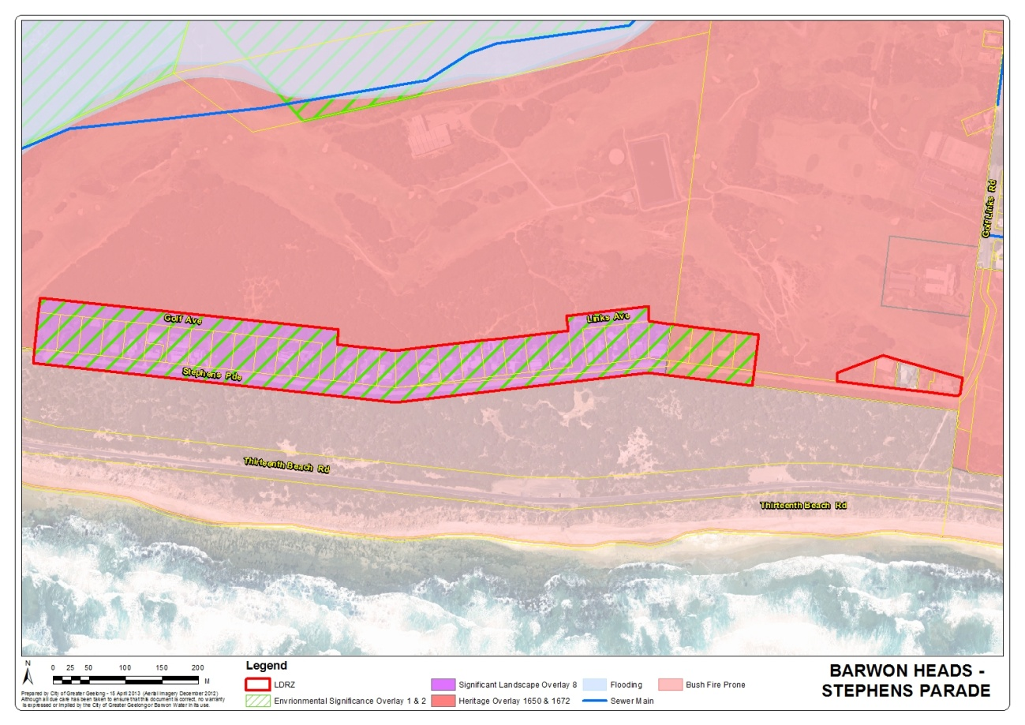
Map 3 – Barwon Heads - Stephens Parade

This area is located along the costal dunes at the southern end of Barwon Heads, south of the Barwon Heads Golf Course. The area consists of 37 lots all of which are less than 0.2 hectares in area and could not be further subdivided. The area is affected by a number of Environmental Overlay controls to protect the coastal dune system. A Heritage Overlay also affects properties surrounding and on the east side of the area. A large amount of significant vegetation is present. The area is located within a Bushfire Prone Area under the Building Regulations but is not affected by a Bushfire Management Overlay within the Planning Scheme.

Councils Engineering Department has advised that there is no underground drainage system and that the natural drainage pattern appears to be through the adjacent golf course.

Barwon Water has advised that the area is not sewered.

All lots are less than 0.2 hectares and therefore would automatically prevent further subdivision of land

Recommendation

Maintain a minimum subdivision area of 0.4 hectares.

Clifton Springs

Tanderra Court
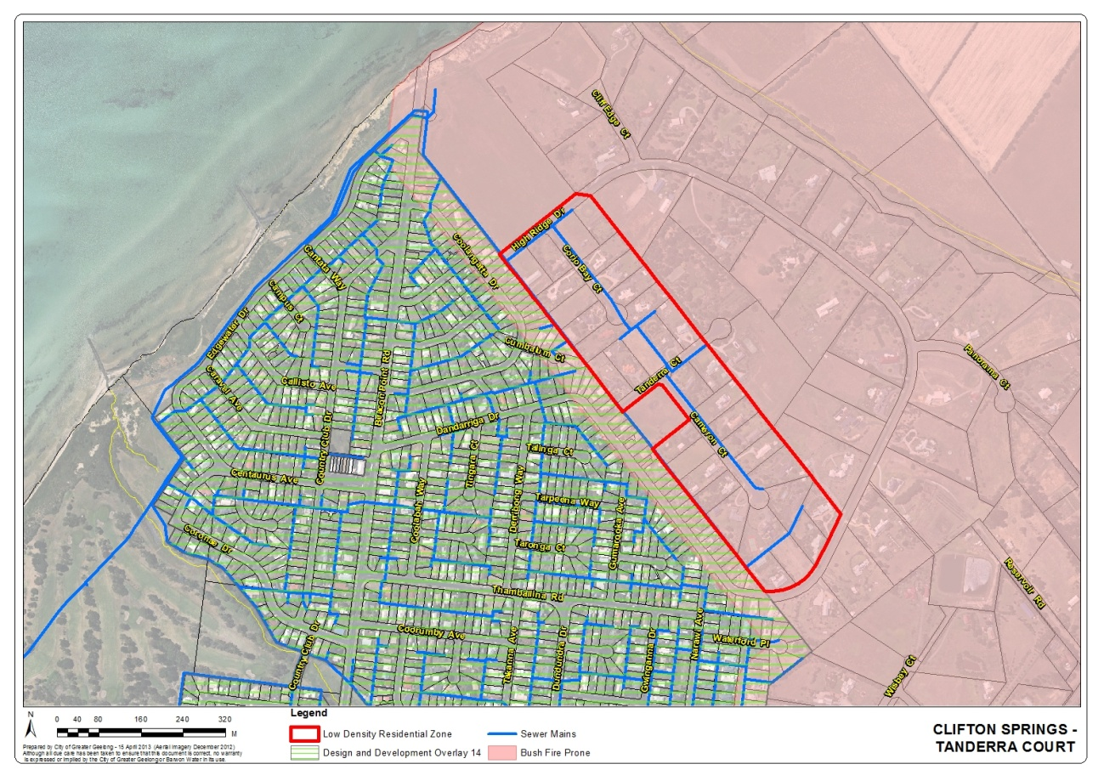
Map 4 – Clifton Springs - Tanderra Court

The LDRZ area is located in the north east corner of Clifton Springs. The area is surrounded by conventional residential land to the south west and Rural Living Zoned land to the north east. The area consists of 36 lots, 10 of which are over 0.4 hectares in area and could be further subdivided. The area is located within a Bushfire Prone Area under the Building Regulations but is not affected by a Bush Fire Management Overlay within the Planning Scheme. There appears to be pockets of native vegetation however the majority appears to be planted vegetation. Battleaxe lot configurations would be the most likely outcome if the minimum subdivision area was reduced.

Councils Engineering Department have raised no objection to the minimum lot size being reduced to 0.2 hectares.

Barwon Water has advised that the area is sewered and has raised no objection to the minimum lot size being reduced to 0.2 hectares.

There are considered to be minimal impacts in this area should the minimum lot size be reduced to 0.2 hectares.

Recommendation

The minimum subdivision area for each lot to be created is reduced to 0.2 hectares.

Drysdale

Cemetery Road
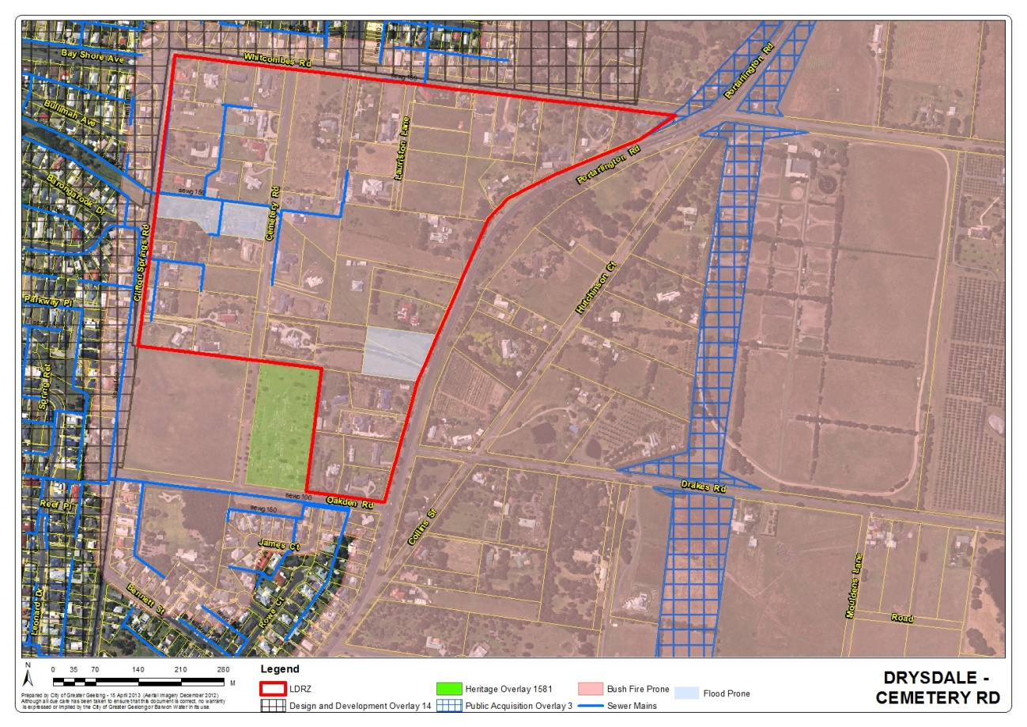
Map 5 – Drysdale - Cemetery Road East and West

The Cemetery Road LDRZ is located approximately 1km north of the Drysdale Town Centre. The area consists of 62 Properties of which 42 are over 0.4 hectares in area and could be further subdivided. The area is well established with only 4 vacant lots remaining. There are two larger lots (1.7ha & 2ha) which may provide an opportunity to achieve a consolidated subdivision outcome. There are 4 parcels of land that are flood prone but the wider area is not affected by flooding. The area is nominated as a Bushfire Prone Area under the Building Regulations but is not affected by a Bushfire Management Overlay under the Planning Scheme. There is no significant vegetation other than planted vegetation. Battleaxe lot configurations would be the most likely outcome if the minimum subdivision area was reduced.

Councils Engineering Department have raised no objection to the minimum lot size being reduced to 0.2 hectares.

Barwon Water has advised the area is partially connected to sewer. No objection is raised to a reduced lot size for land west of Cemetery Road however Barwon Water has not supported a reduction on the east side of Cemetery Road because there is limited room for additional sewers.

Recommendation

Land West of Cemetery Road – The minimum subdivision area for each lot to be created be reduced to 0.2 hectares.

Land East of Cemetery Road – Maintain a minimum subdivision area of 0.4 hectares.

Huntingdon Street

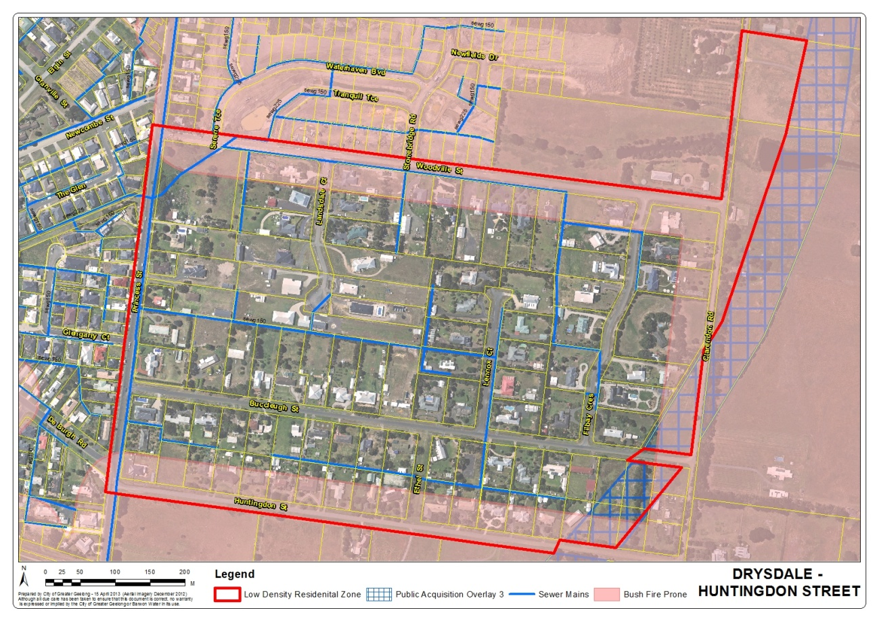
Map 6 – Drysdale - Huntingdon Street

This area is located on the western edge of the Drysdale. The area consists of 103 lots, 48 of which are over 0.4 hectares could be further subdivided if the minimum lot size was reduced. The majority of lots have access to sewer. Land on the edge of the LDRZ is nominated as a Bushfire Prone Area under the Building Regulations but is not affected by a Bush Fire Management Overlay under the Planning Scheme

If the minimum lot size was reduced to 0.2 hectares there would be a number of lots which could be subdivided in half. This could lead to numerous battleaxe subdivision configurations.

Councils Engineering Department have advised that the area between Newcomb Street and DeBurgh Road (located east of the LDRZ) is known to flood although it has not been officially mapped. The existing road layout and drainage system have been designed to accommodate an average of 0.4 hectare lots. The Engineering Department have recommended that the area retain a 0.4 hectare subdivision area because of these issues.

Barwon Water has raised no objection to the subdivision area being reduced to 0.2 hectares.

If the area was further subdivided there would be cumulative drainage impacts on the surrounding catchment and therefore the area should maintain a 0.4 hectare minimum.

Recommendation

Maintain a minimum subdivision area of 0.4 hectares.

Lara

Archimedes Avenue

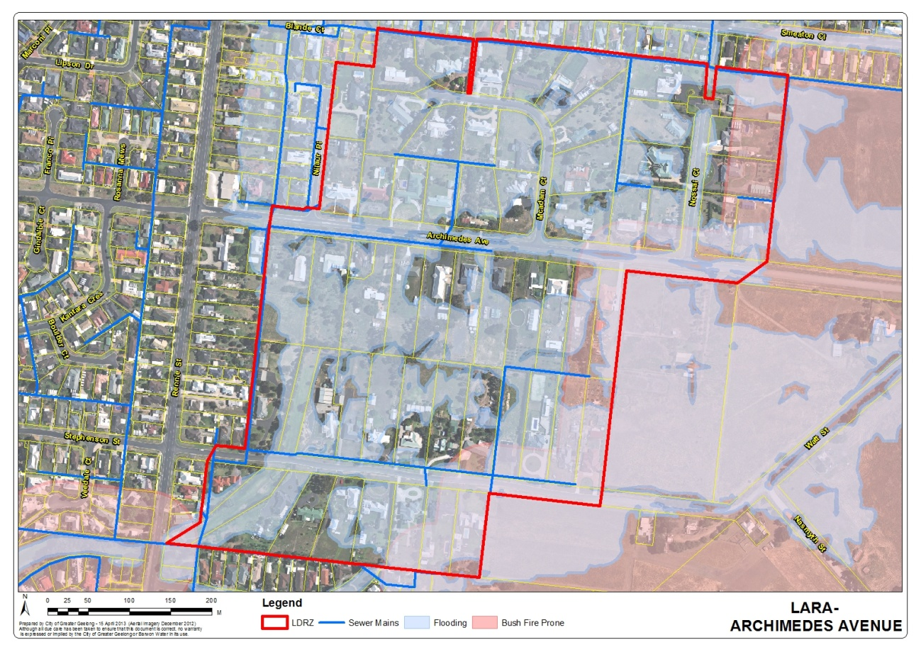
Map 7 – Lara - Archimedes Ave

This LDRZ area is located south east of the town centre. The Lara Structure Plan nominates the area as ‘retain for low density character’. Of the 66 lots within this area 40 of them are greater than 0.4 hectares and could be further subdivided if the subdivision area was reduced. Subdivision of land is likely to create battleaxe shaped allotments. The area is connected to sewer but is significantly affected by flooding. Land located to the west of the LDRZ is nominated as a Bushfire Prone Area under the Building Regulations but is not affected by a Bush Fire Management Overlay under the Planning Scheme

Councils Engineering Department have advised that the area is flat with a lack of overland flow paths. There is difficulty in draining this area.

Barwon Water has advised the area is connected to sewer and have raised no objection to the minimum lot size being reduced to 0.2 hectares.

Given the drainage and flooding issues within this area it is recommended the minimum lot size remain at 0.4 hectares.

Recommendation

Maintain a minimum subdivision area of 0.4 hectares.

Kees Road

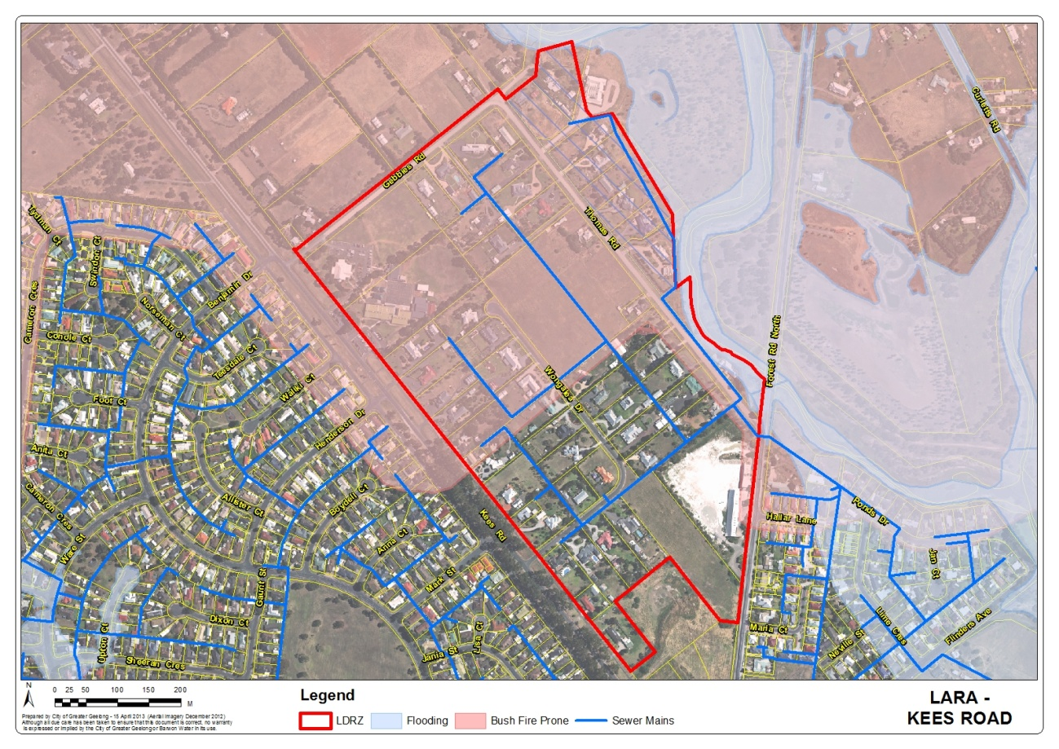
Map 8 – Lara - Kees Road

This area is located to the north east of Kees Road in Lara. Of the 63 properties located within this area 44 of them are greater than 0.4 hectares in area and could be further subdivided if the minimum lot area was reduced.

Land within the north-eastern corner of the area is flood prone (Thomas Street). The north western section of the LDRZ is nominated as a Bushfire Prone Area under the Building Regulations but is not affected by a Bush Fire Management Overlay under the Planning Scheme

There are some environmental sites within the area, two of which are located within the school grounds and one along the Kees Road roadside.

Council Engineering Department have advised that the area is generally flat and contains a lack of overland flow paths. There may be capacity in places to accommodate further subdivision of land.

Barwon Water has advised that sewer is available and has no objection to the minimum lot size being reduced to 0.2 hectares.

There are no significant issues to prevent the further subdivision of land.

Recommendation

The minimum subdivision area for each lot to be created is reduced to 0.2 hectares.

McHarrys Road

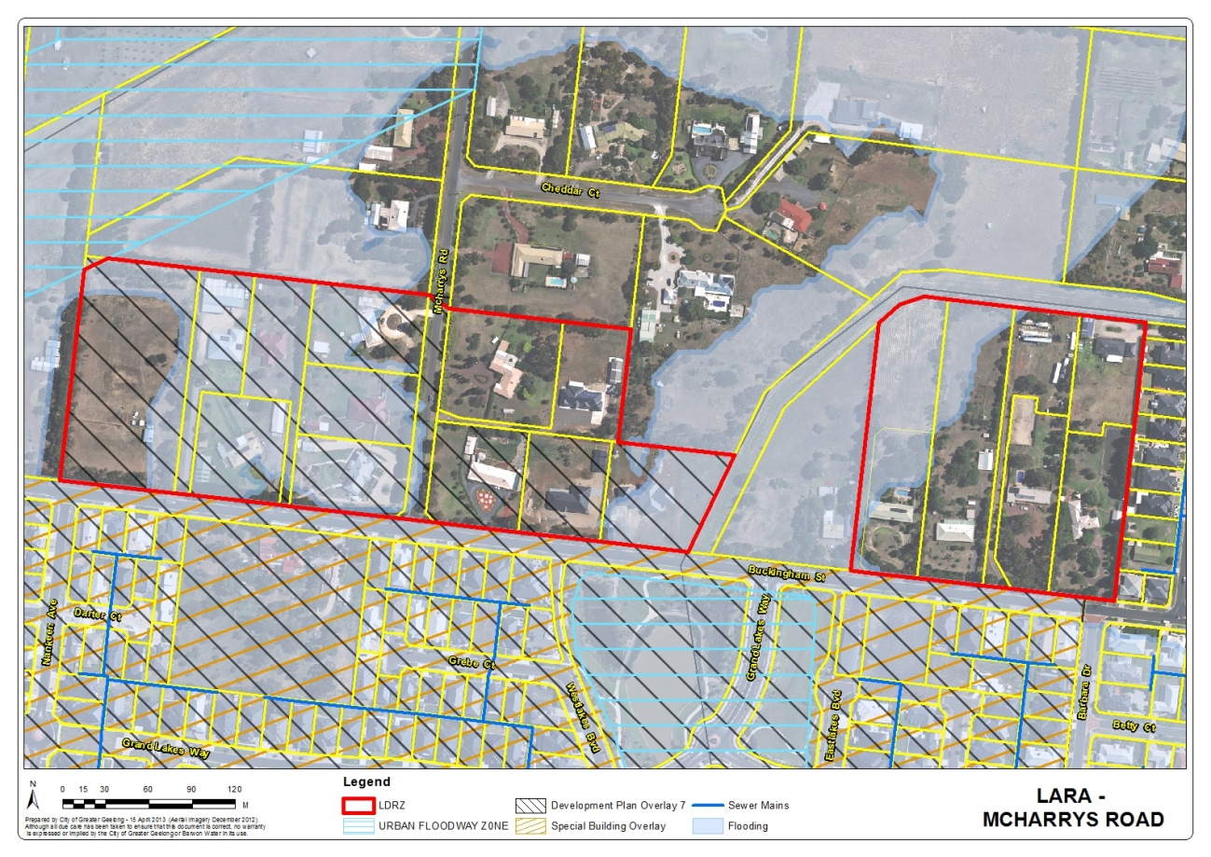
Map 9 – Lara – McHarrys Road

This area is located to the west of the township of Lara, and south of Patullos Road. The Lara Structure Plan nominates the area as ‘retain low density character’. There are 18 lots within this area and all lots are over 0.4 hectares in area. Five lots have already been subdivided via a battleaxe arrangement. Around 50% of the properties are nominated as flood prone.

Council’s Engineering Department have advised that the Elcho Drain which is adjacent to this area is known to flood. There is also a wide ranging flood extent due to flat grades. Historically the area has developed with wide drainage and floodway easements to cater for major flows. It is recommended that the 0.4 hectare minimum be retained.

Barwon Water has advised that the area is not sewered and therefore recommends that the area retain a minimum 0.4 hectare subdivision area.

As this area is not sewered it would not meet the requirements set out in the LDRZ for a reduced subdivision area.

Recommendation

Maintain a minimum subdivision area of 0.4 hectares.

Leopold

Barrabool Crescent
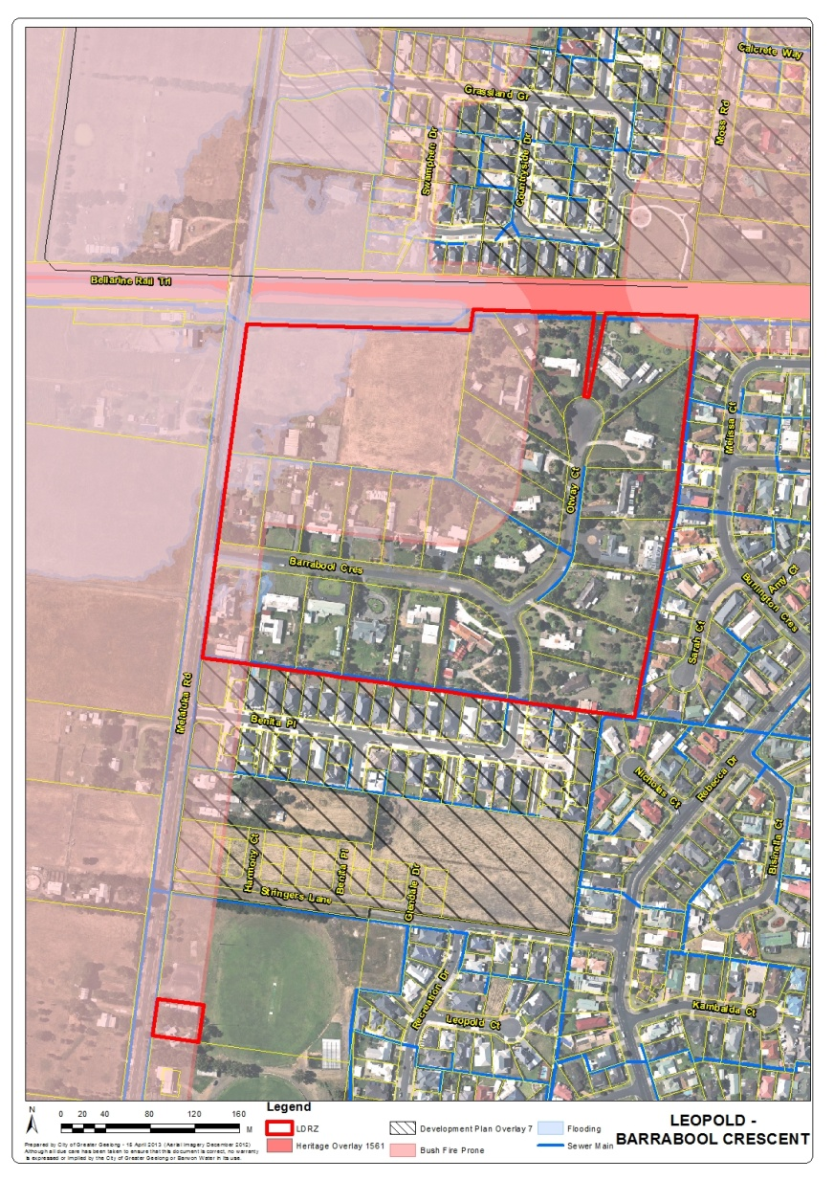
Map 10 – Leopold – Barrabool Crescent

This area is located on Melaluka Road between the Bellarine Hwy and Portarlington Road. The heritage listed Bellarine Rail trail is located directly to the north of the area. The Leopold Structure Plan has nominated this area as a future ‘Urban consolidation opportunity subject to further investigation’. This would involve investigation into possible drainage solutions for the overall area. Of the 25 lots within this area 9 of them are over 0.4 hectares in area and could be further subdivided if the minimum area was reduced. There is one large allotment of 2.5 hectares which could be subdivided into a minimum of 6 lots. The lots which have frontage to Melaluka Road are nominated as flood prone with one of these lots being a childcare centre. Part of the area is also nominated as a Bushfire Prone Area under the Building Regulations but is not affected by a Bush Fire Management Overlay under the Planning Scheme

There is also a small parcel of land located at 103 Melaluka Road. This site is 1382 sqm in area and could not be further subdivided.

Council’s Engineering Department have advised that the area is generally flat, with a traditional rural drainage system. There is difficulty in providing a new drainage system through surrounding farming zoned land. It is recommended that the minimum subdivision area remain at 0.4 hectares.

Barwon Water has advised that the area is connected to sewer and have raised no objection to the minimum subdivision area being reduced to 0.2 hectares.

Given the drainage issues within this area it is recommended the minimum lot size remain at 0.4 hectares.

Recommendation

Maintain a minimum subdivision area of 0.4 hectares.

Canowindra Way

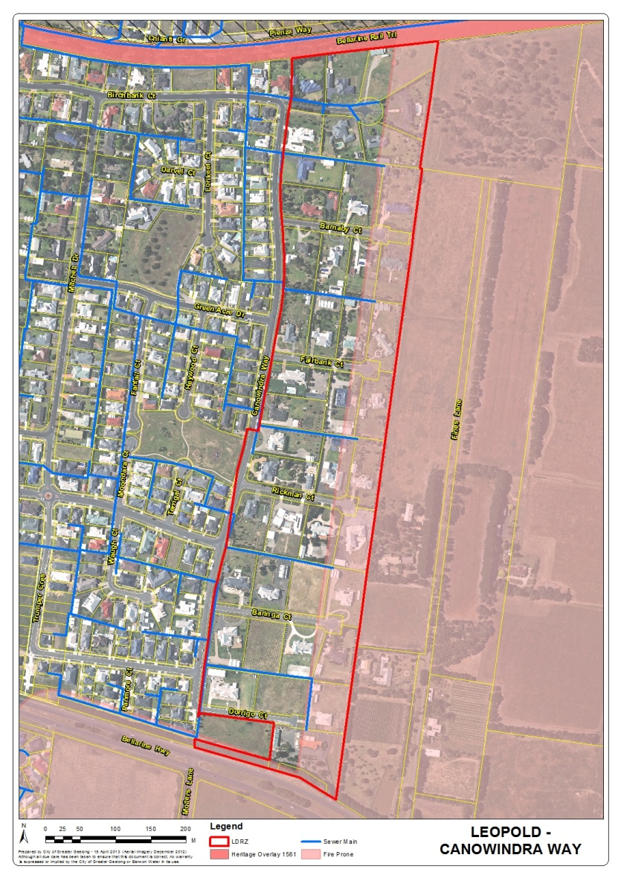
Map 11 – Leopold – Canowindra Way

Canowindra Way is located on the eastern edge of Leopold, on the northern side of the Bellarine Highway. The Leopold Structure Plan recommends the retention of the LDRZ in this location. There are 43 properties in this location and 29 of them are over 0.4 hectares in area and could be further subdivided if the minimum subdivision area was reduced. Part of the area is also nominated as a Bushfire Prone Area under the Building Regulations but is not affected by a Bush Fire Management Overlay under the Planning Scheme

Council’s Engineering Department has advised that the area was originally subdivided in 2001-2004. The drainage system was designed to accommodate 0.4 hectare lots and any increase in density would require a redesign of the overall drainage system which would require further investigation including an area for a drainage basin.

Barwon Water has advised that the area is sewered and have raised no objection to the minimum lot area being reduced to 0.2 hectares.

Given the drainage issues within this area it is recommended the minimum lot size remain at 0.4 hectares.

Recommendation

Maintain a minimum subdivision area of 0.4 hectares.

Melaluka Rd
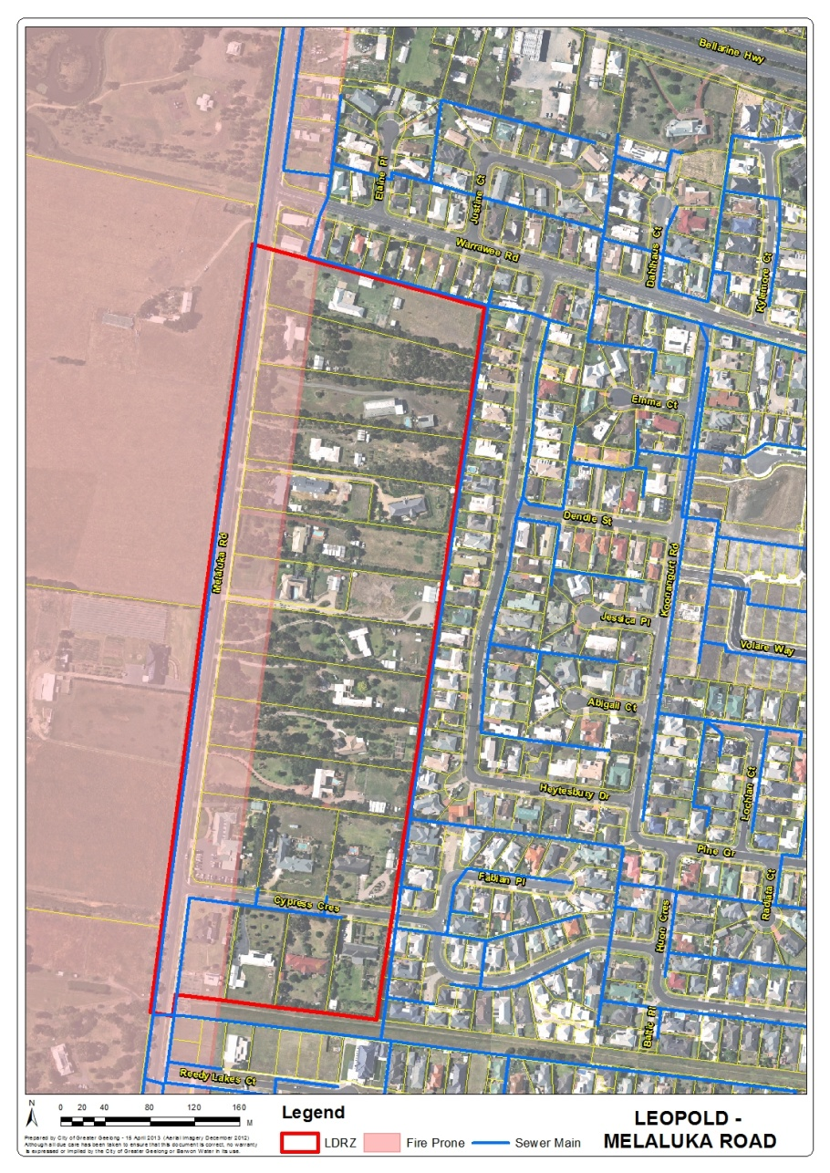
Map 12 – Leopold – Melaluka Road

This area is located south of the Bellarine Highway. The area consists of 20 properties 16 of which are over 0.4 hectares in area and could be further subdivided if the minimum area was reduced. This area has been nominated in the Leopold Structure Plan as an ‘Urban consolidation opportunity subject to further investigation’. Further investigation of this area would include an assessment of drainage and consolidation opportunities. Further subdivision of land could potentially result in numerous battleaxe configured allotments. Part of the area is also nominated as a Bushfire Prone Area under the Building Regulations but is not affected by a Bush Fire Management Overlay under the Planning Scheme

Council Engineering Department have advised that the area has a rural drainage system which discharges to Reedy Lake. Further Investigation into a drainage solution for the area would need to be considered before lots could be further subdivided.

Barwon Water has advised that the area is not sewered however there is sewerage pipes within Melaluka Road and therefore the area could be connected to sewer. Barwon Water has no objection to the minimum subdivision area being reduced.

Given the drainage issues within this area it is recommended the minimum lot size remain at 0.4 hectares.

Recommendation

Maintain a minimum subdivision area of 0.4 hectares.

Moolap

Coppards Road East and West

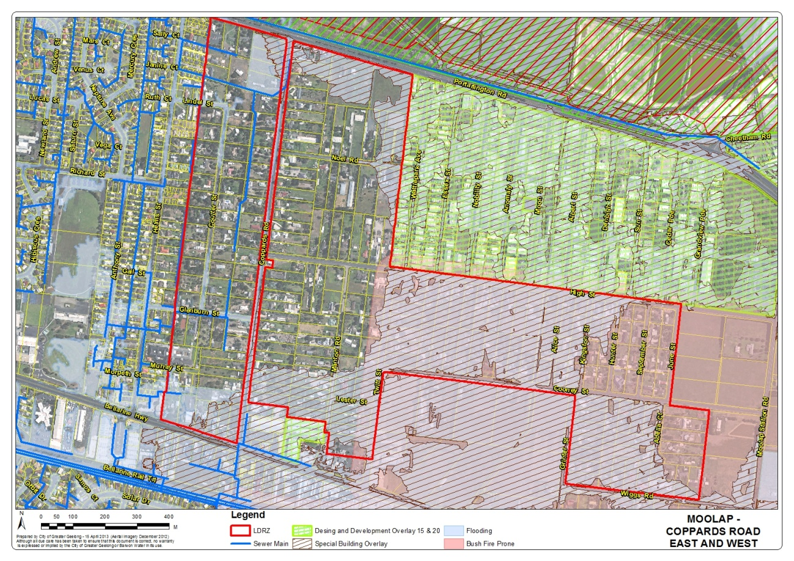
Map 13 – Moolap – Coppards Road East and West

The Coppards Road area is located to the east of residential Geelong and provides a buffer between residential Geelong and the industrial areas of Moolap. Of the 264 lots within the area, 195 of them are over 0.4 hectares and would be able to be further subdivided if the minimum subdivision area was reduced to 0.2 hectares. The Eastern Boundary Review investigated the location of the Urban Growth Boundary on the eastern side of Geelong. It was recommended that this area remain outside the growth boundary of urban Geelong due to drainage and flooding constraints as well as proximity to industrial areas of Moolap. A large portion of the area west of Coppards Road is affected by a Special Building Overlay because of inadequate stormwater drainage infrastructure. Part of the area is also nominated as a Bushfire Prone Area under the Building Regulations but is not affected by a Bush Fire Management Overlay under the Planning Scheme

Council Engineering Department have advised that the area is generally flat with limited capacity in the existing drainage infrastructure. A flood study identified that flood mitigation options are limited in Coppards Road West with limited measures to reduce flood impacts on LDRZ lots

Barwon Water has advised that there is sewer available to properties within Coppards Road West and no objection is raised to reducing the minimum lot size. However there is no sewer available to properties to the east of Coppards Road and there is significant costs and environmental health issues associated with providing sewerage to this area.

Given the drainage, flooding and sewerage issues within this area it is recommended the minimum lot size remain at 0.4 hectares.

Recommendation

Maintain a minimum subdivision area of 0.4 hectares for both Coppards Road East and West.

Wilashal Place

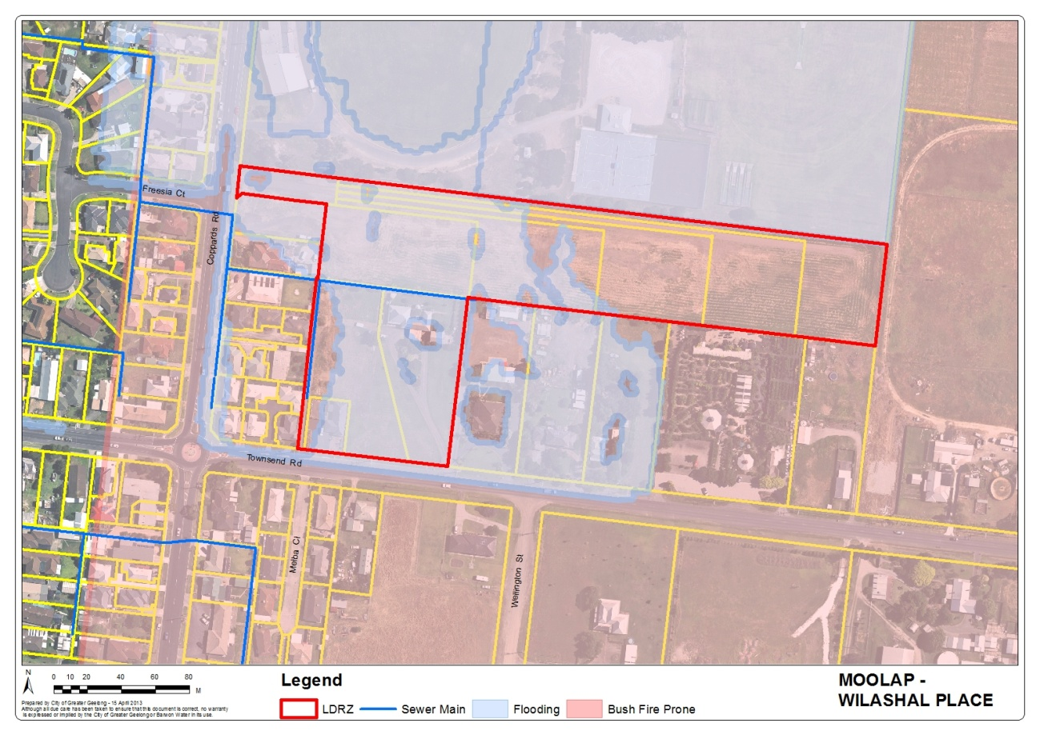
Map 14 – Moolap – Wilashal Place

Wilashal Place is located south of the Bellarine Highway and consists of 8 allotments one of which has recently been subdivided. With the exception of 183 Townsend Road, each lot within this LDRZ area is at least 0.4 hectares and could be further subdivided if the minimum subdivision area was reduced to 0.2 hectares. The area is also nominated as a Bushfire Prone Area under the Building Regulations but is not affected by a Bush Fire Management Overlay under the Planning Scheme

Councils Engineering Department have recently approved drainage for the area based on the most recent subdivision any increase in density in this area could impact on drainage within the area.

Barwon Water has advised the area is connected to sewer and have raised no objection to the minimum subdivision area being reduced to 0.2 hectares.

The recent subdivision in this area has created an unusual subdivision layout, with 5 lots accessible via a small section of common property branching into a narrow but very long accessway for each lot. These lots could be further subdivided and this would raise concern with being able to clearly identify an entry to each property as well as impacts on drainage. Given these issues it is recommended the minimum lot size remain at 0.4 hectares.

Recommendation

Maintain a minimum subdivision area of 0.4 hectares.

Ocean Grove

Bonnyvale Road

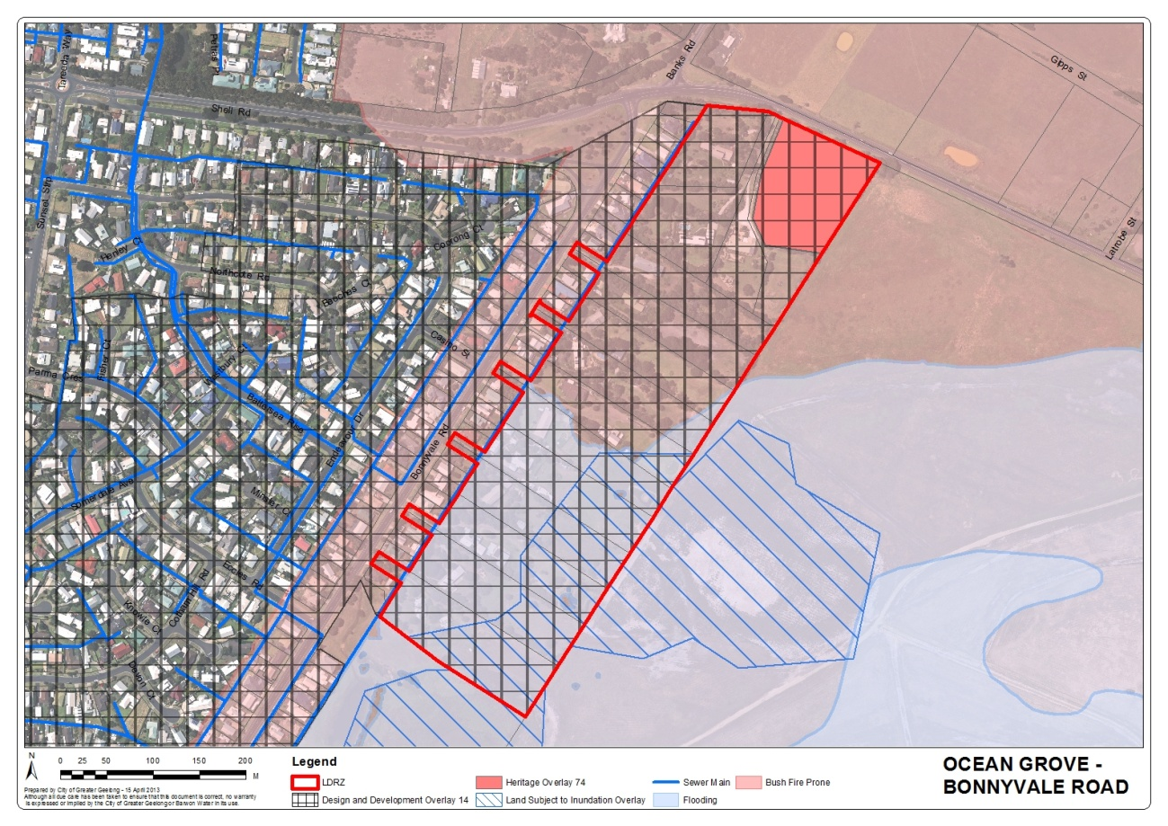
Map 15 – Ocean Grove – Bonnyvale Road

The area is located on the south eastern edge of Ocean Grove. The area consists of 16 lots all of which are over 0.4 hectares in area and could be further subdivided if the minimum lot size was reduced to 0.2 hectares. The area is vegetated with some pockets of significant vegetation particularly at the rear of properties. Approximately 50% of properties are affected by flooding and the Land Subject to Inundation Overlay. All properties are affected by the Design and Development Overlay 14 which relate to view sharing. The area is also nominated as a Bushfire Prone Area under the Building Regulations but is not affected by a Bush Fire Management Overlay under the Planning Scheme

Councils Engineering Department have advised the area is serviced by a rural drainage system. The area is low lying and adjacent drainage channels drain towards the urban south eastern drain in Ocean Grove. There are also wide drainage easements covering swampy areas toward rear boundary. It is recommended the area maintain a 0.4 hectare minimum subdivision area.
Barwon Water has advised this area is not connected to sewer. The area drains to the east away from existing system. It would require a new dedicated pipeline to service this area which could be cost prohibitive.

Given the drainage and sewerage issues within this area it is recommended the minimum lot size remain at 0.4 hectares.

Recommendation

Maintain a minimum 0.4 hectare subdivision area.

Belle Vue Drive

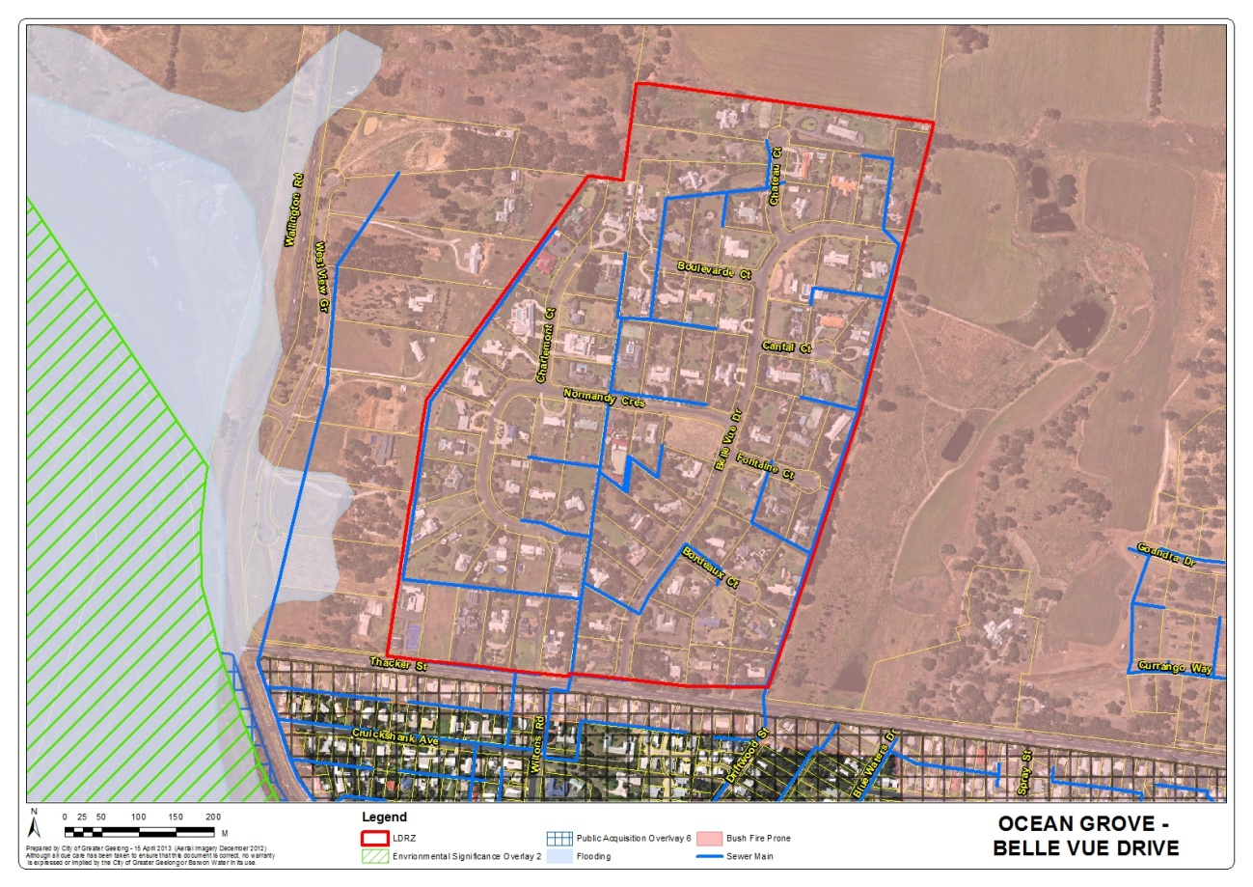
Map 16 – Ocean Grove – Belle Vue Drive

This area is located in the North West corner of Ocean Grove. The Ocean Grove Structure Plan does not recommend the further subdivision of this land for ‘conventional’ residential densities given existing drainage issues and the proximity to environmental values. Of the 88 properties within this area 54 of them are over 0.4 hectares in area and could be further subdivided if the minimum subdivision area was reduced. The area is also nominated as a Bushfire Prone Area under the Building Regulations but is not affected by a Bush Fire Management Overlay under the Planning Scheme.

Councils Engineering Department has advised the area partially drains to Blue Waters Lake located to the south west of the area. There is underground and surface drainage infrastructure present which is likely to have been constructed in the 1980’s. The drainage system has limited capacity. It is recommended that the area maintain a 0.4 hectare minimum.

Barwon Water has advised the area has access to sewer and no objection has been raised to the minimum lot size being reduced to 0.2 hectares.

Given the drainage issues within this area it is recommended the minimum lot size remain at 0.4 hectares.

Recommendation

Maintain a minimum 0.4 hectare subdivision area.

Coolamon Close
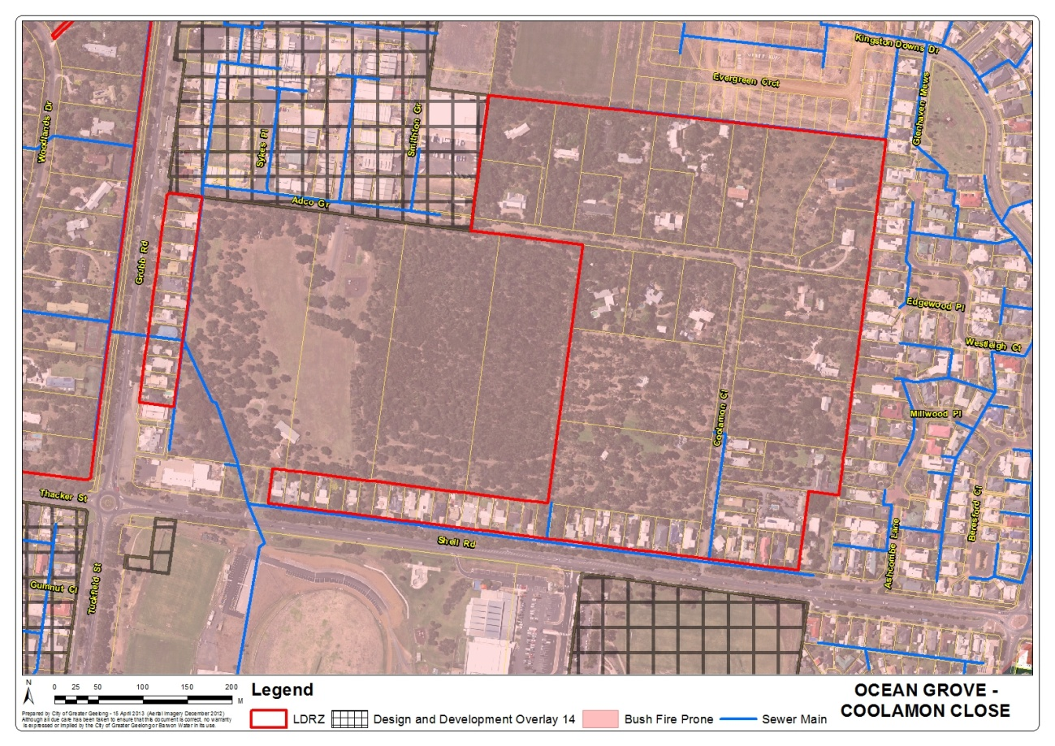
Map 17 – Ocean Grove – Coolamon Close

This area is located directly north of the Ocean Grove Aquatic Centre, on the corner of Shell Road and Grubb Road. There are approximately 76 lots within this area and 20 of them are over 0.4 hectares in area and could be further subdivided if the minimum subdivision area was reduced to 0.2 hectares. Lots fronting Shell and Grubb Roads are typically less than 1000sqm. This area is heavily vegetated with some significant vegetation making further subdivision of the large lots difficult. Given the large amount of vegetation the area is also nominated as a Bushfire Prone Area under the Building Regulations but is not affected by a Bush Fire Management Overlay under the Planning Scheme

Council Engineering Department has advised that the area has a rural type drainage system, and Coolamon Road is unsealed. It is recommended that the area maintain a 0.4 hectare minimum.

Barwon Water has advised that the area is only partly sewered and that there are infrastructure constraints. Barwon Water has recommended the area maintain a 0.4 hectare subdivision minimum.

Given the drainage and sewerage issues within this area it is recommended the minimum lot size remain at 0.4 hectares.

Recommendation

Maintain a minimum 0.4 hectare subdivision area.

Woodlands

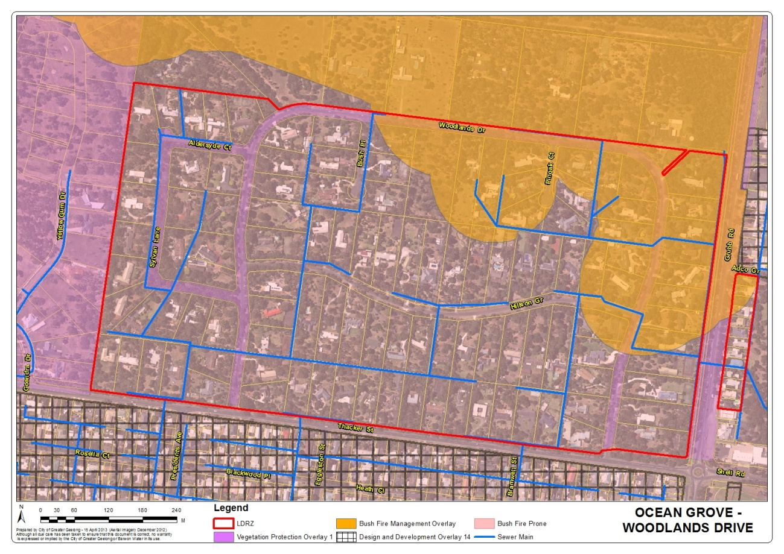
Map 18 – Ocean Grove – Woodlands Drive

This are is located on the corner of Thacker Street and Grubb Road. The area consists of 115 lots of which 100 are over 0.4 hectare in area and could be further subdivided if the minimum subdivision area was reduced. The area is heavily vegetated and a Vegetation Protection Overlay is located within the roadside reserves. The north east corner of the area is partially affected by a Bush Fire Management Overlay and the whole area is Bushfire Prone.

Councils Engineering Department have advised that the area drains to Blue Waters Lake located to the south west of the area. There are ongoing drainage maintenance issues within estate due to the existing vegetation. It is recommended that the area maintain a minimum 0.4 hectare subdivision area.

Barwon Water has advised that the area is connected to sewer and there is capacity within the existing sewerage system to accommodate smaller lot sizes. Barwon Water have raised no objection to the minimum lot size being reduced to 0.2 hectares

Given the drainage issues within this area it is recommended the minimum lot size remain at 0.4 hectares.

Recommendation

Maintain a minimum 0.4 hectare subdivision area.

Portarlington

Smythe Street
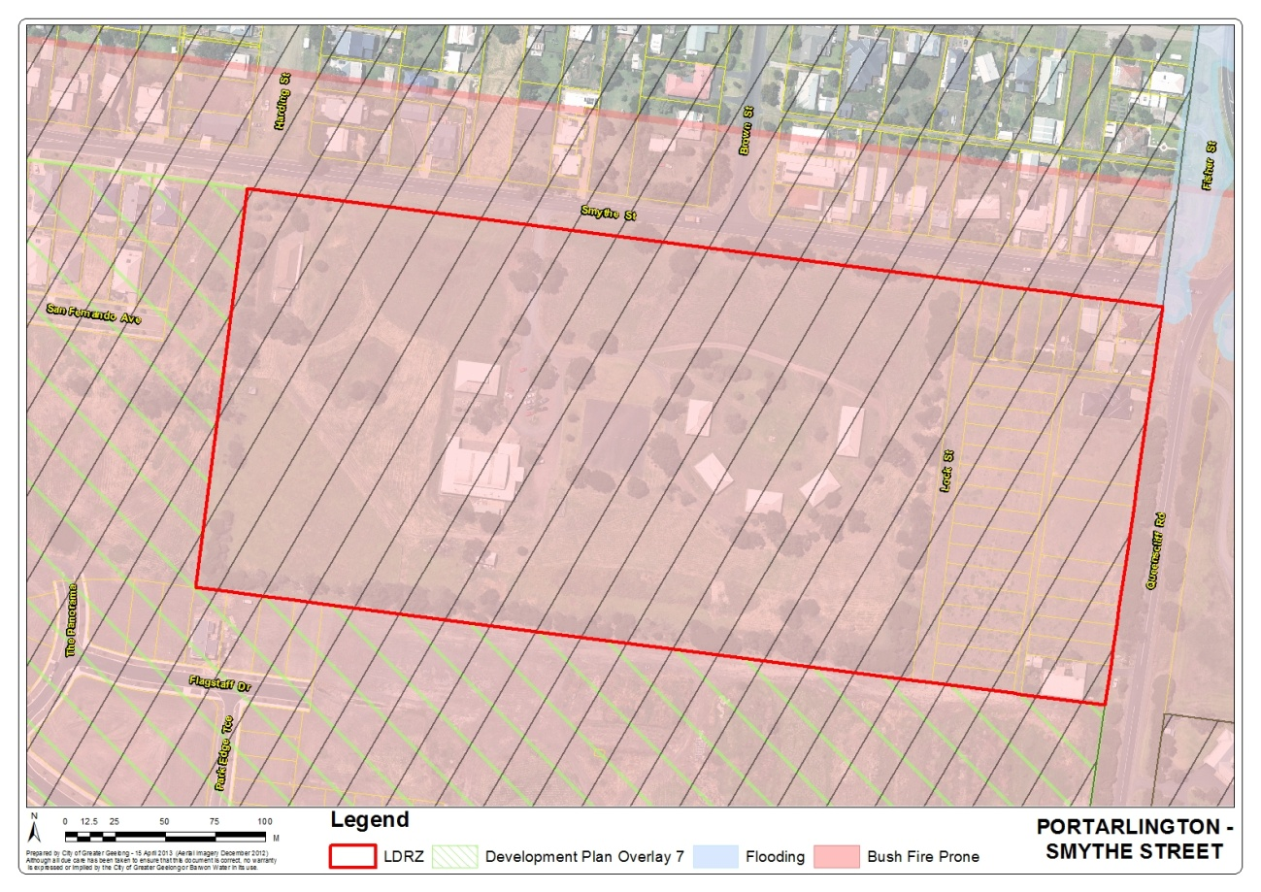
Map 19 – Portarlington – Smythe Street

This area is located on the corner of Smythe Street and Queenscliff Road in Portarlington. This area consists of the ‘Portarlington Holiday Units and Pool’ and an additional 3 properties located along the eastern boundary of the area. The eastern edge of the site has been previously subdivided into a number of smaller lots between 350 and 440sqm although these lots are only in 3 land holdings. The area is also nominated as a Bushfire Prone Area under the Building Regulations but is not affected by a Bush Fire Management Overlay under the Planning Scheme.

The minimum lot size could be reduced to 0.2 hectares in area, however long term the area would be better utilised for more intensive residential development. This issue would need to be considered as part of the next Structure Plan review.

Councils Engineering Department have advised that this large site is not serviced internally and that the site could impact on drainage downstream which is under capacity. The Portarlington East Drainage/Flood Study has been carried out and has identified localised flooding immediately downstream in Queenscliff Rd and Fisher Street. The site is large enough to provide a future drainage solution.

Barwon Water has advised that the area is partially sewered but it is not connected throughout the whole area. A future developer would need to fund upgrades to the existing sewerage network. No objection is raised to the minimum subdivision area being reduced to 0.2 hectares.
Given the ability to provide adequate drainage and sewerage to the area it is recommended the minimum lot size be reduced to 0.2 hectares.

Recommendation

Reduce the minimum subdivision area to 0.2 hectares.

Wandana Heights

City View Drive

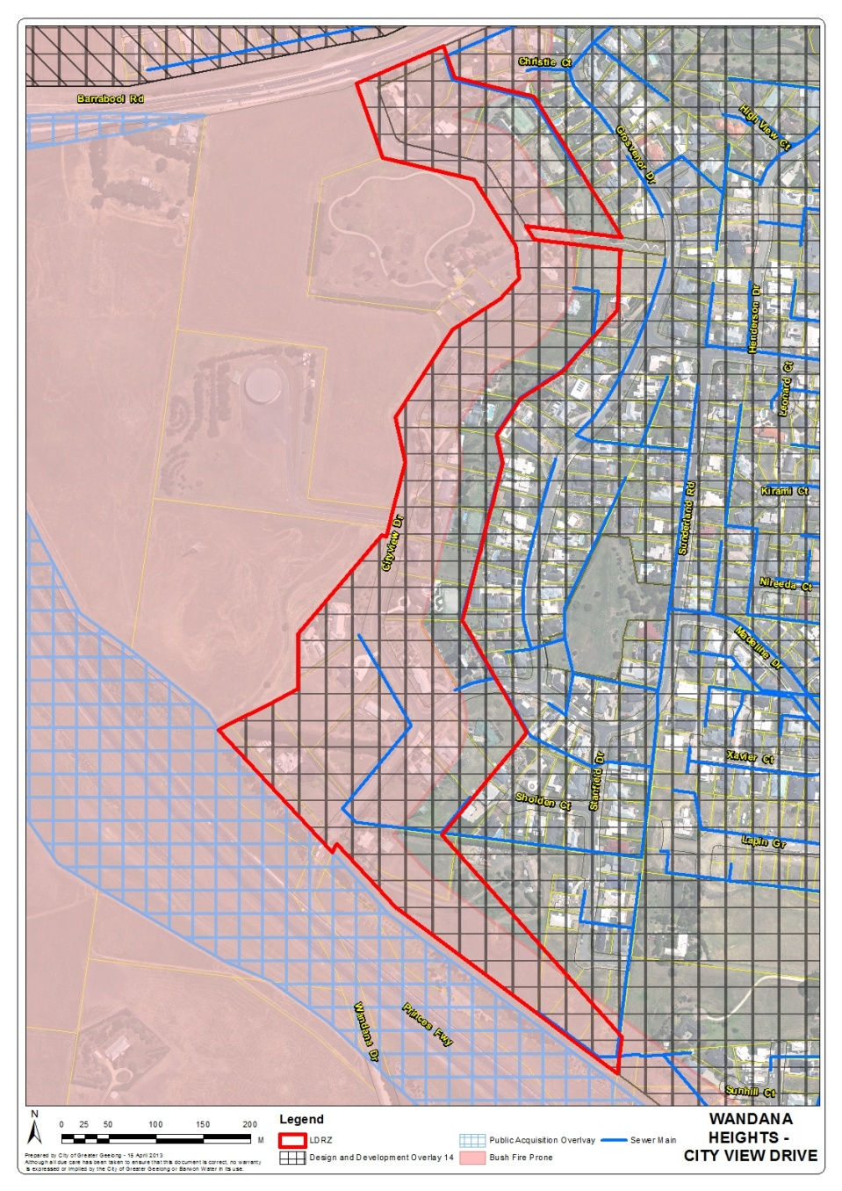
Map 20 – Wandana Heights – City View Drive

This area is located on the western edge of Geelong adjacent to the Geelong Ring Road. This area is located along a ridgeline with steep, sloping blocks. The area consists of 32 lots of which 13 are over 0.4 hectares and could be further subdivided if the minimum lot size was reduced. Some of the larger lots may be difficult to further subdivide given the sloping nature of the sites. The area is also partially nominated as a Bushfire Prone Area under the Building Regulations but is not affected by a Bush Fire Management Overlay under the Planning Scheme. The area is affected by a Design and Development Overlay 14 because the area has significant views towards the Barrabool Hills, Geelong and the bay.

Councils Engineering Department has advised the catchment is currently being flood mapped although mapping will not extend this far up the hill. The study may identify mitigation works on the downstream main drainage assets. No objection is raised to the minimum subdivision area being reduced to 0.2 hectares.

Barwon Water has advised that the area is sewered and has raised no objection to the minimum subdivision area being reduced to 0.2 hectares.

Given the ability to provide adequate drainage and sewerage to the area it is recommended the minimum lot size be reduced to 0.2 hectares.

Recommendation

Reduce the minimum subdivision area to 0.2 hectares.

Overall Recommendations

The following table is a summary of recommendations for each of the LDRZ areas.

LOCATION | RECOMMENDED SUBDIVISION AREA
LOCATION | 0.2 Hectares | 0.4 Hectares
Barwon Heads
Stephens Parade
Clifton Springs
Tanderra Crt
Drysdale
Cemetery Road - East
Cemetery Road - West
Huntingdon Street
Lara
Archimedes Ave
Kees Rd
McHarrys Rd
Leopold
Barrabool Cres
Canowindra Way
Melaluka Rd
Moolap
Coppards Road – East
Coppards Road - West
Wilashal Pl
Ocean Grove
Bonnyvale Rd
Belle Vue Dr
Coolamon Cl
Woodlands
Portarlington
Smythe St
Wandana Heights
City View Dr
Table 1 – Overall Recommendations

Implementation

It is recommended that a schedule be introduced into the LDRZ based on the details in Table 1. There will be some areas that have access to reticulated sewerage, but will maintain a 0.4 hectare subdivision area due to inadequate drainage infrastructure. If there is interest from landholders to subdivide these areas in the future, further investigation into the merits of reducing the lot size could be undertaken. This should be done for a whole LDRZ area not on a site by site basis to ensure that drainage and lot layout is appropriately addressed. If there is a strategic basis for this change a subsequent Planning Scheme amendment can be sought.

There is concern that in locations where the minimum lot size is reduced to 0.2 hectares it will result in numerous battleaxe lot configurations (one lot behind the other). This often creates narrow street frontages and long driveways for the new lot(s) that can then be hard to identify from the street. To ensure access to new allotments can be easily and safely identified it is recommended that Clause 22.04 Discretionary Uses in Rural Living and Low Density Residential Areas be amended to require lots to have a minimum street frontage and driveway width of 4 metres. This width will also be wide enough to accommodate a fire truck and other emergency vehicles.

It is recommended that the title to Clause 22.04 be amended from Discretionary Uses in Rural Living and Low Density Residential Areas to Development in Rural Living and Low Density Residential Areas.

In areas where the minimum subdivision area is to be reduced some drainage assets may still require upgrades. Councils Engineering Department will need to consider this issue on a site by site basis when a planning application has been lodged with Council. Conditions on a planning permit may require a land owner to undertake works or contribute to drainage improvements within the area.

Conclusion

The LDRZ within Geelong generally has significant drainage, vegetation and flooding issues. The drainage infrastructure for these areas has typically been designed to accommodate average lots sizes of 0.4 hectares. To allow the minimum subdivision area to be reduced to 0.2 hectares across all of the LDRZ areas within Geelong would have significant drainage impacts for the broader catchment areas.

Several LDRZ areas are connected or able to be connected to reticulated sewerage however other constrains including drainage and the presence of vegetation have made further subdivision of these areas undesirable. Drainage studies would need to be undertaken for each area to determine an appropriate drainage solution before further subdivision could be supported.

Based on the analysis contained within this report it is recommended that the schedule to the LDRZ be amended to allow 5 of the LDRZ areas as identified in Table 1, to be further subdivided. It is also recommended that minor changes be made to Clause 22.04 - Discretionary Uses in Rural Living and Low Density Residential Areas to guide further subdivision within these areas.

