Amendment C297- Permit 765/2013
Coles Proposal for Drysdale
Review of Economic Assessment
For City of Greater Geelong
Tim Nott

February 2014

Table of Contents
1 Introduction 1
2 The Proposal by Coles Property Group 2
3 The Planning Context 3
3.1 Planning Strategies for Drysdale 3
3.2 The Geelong Retail Strategy 6
4 Economic Impact Analysis – the Report by Macroplan Dimasi 8
5 Alternative Retail Impact Analysis 11
5.1 The Extent of the Trade Area 11
5.2 Population and Retail Spending 12
1.1 Retail Spending by Visitors 13
5.3 Retail Sales 14
1.2 Current Balance of Retail Supply and Demand 15
5.4 The Activity Centre Hierarchy 15
5.5 Retail Development Potential 17
5.5.1 Population forecasts 17
5.5.2 Change in retail spending 18
5.5.3 The Internet 19
5.5.4 Changes in the Activity Centre Network 20
5.5.5 Summary of Assumptions Affecting Retail Development 23
5.6 Future Balance of Retail Supply and Demand 24
5.6.1 Without the Coles Development 24
5.6.2 The Proposed Coles Development 24
5.6.3 Retail Balance with the Coles Development 25
5.6.4 Scenarios for Food and Grocery Provision in the Drysdale Trade Area 26
1.3 Impact on Existing Centres 27
5.7 Potential to Mitigate Impacts 29
5.8 Net Community Benefits 29
5.9 A Note on the Drysdale Structure Plan 30
6 Summary 31
2 Sources 33

Report Data
Version | Date | Approved By | Sent to
Preliminary Draft | 31/12/2013 | TN | Peter Schembri, City of Greater Geelong
Final | 3 February 2014 | TN | Peter Schembri, City of Greater Geelong

Prepared by:
Tim Nott
economic analysis + strategy
ABN: 29 590 304 665

20 Scotia Street
West Preston
Victoria 3072
Australia

Tel: 0401 993 451
Email: tim@timnott.com.au
Web: www.timnott.com.au

Note
This report has been prepared for the City of Greater Geelong. No responsibility is taken for its use by third parties. The assessment in this report has relied on consultant estimates and forecasts as well as on primary and secondary data from a variety of Government and commercial sources. In parts, the analysis has relied on reasonable assumptions. However the reader should bear in mind that there is no certainty in predicting the future.

Review of Proposal for Coles Supermarket in Drysdale
Economic Impact Assessment

Introduction
Coles Property Group is proposing to develop a full line supermarket in Murradoc Road, Drysdale. In order to accommodate this development part of the site needs to be rezoned from the Commercial 2 Zone to the Commercial 1 Zone. Accordingly a planning scheme amendment and permit application has been lodged with City of Greater Geelong (the Council).
Part of the decision-making on this proposal is likely to centre on its economic impact. The proponent has commissioned an economic impact assessment by Macroplan Dimasi (Macroplan Dimasi, 2013) which accompanied the application.
Council is the responsible authority for the amendment and application. It has commissioned me to provide an independent review of the likely economic impact of the proposal. This present report provides that review. I have previously provided a retail economic assessment that informed the development of the Drysdale/Clifton Springs Structure Plan. I am therefore familiar with the site and the development characteristics of the area.
This report provides:
- A brief description of the proposed supermarket development
- A summary of the planning policy guiding development of the Drysdale town centre
- A brief review of how the report by Macroplan Dimasi meets the requirements of the Geelong Retail Strategy in providing an impact assessment of the proposed development
- An alternative retail analysis and impact assessment
A summary of findings is provided at the end of the report.

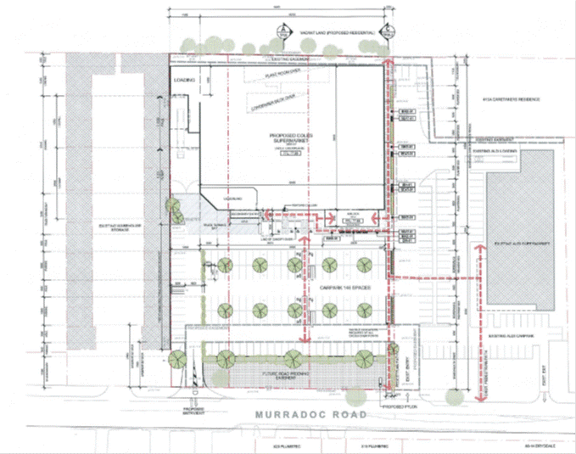
The Proposal by Coles Property Group
The Coles Property Group proposes to develop a supermarket and liquor store of 3,892 square metres and associated car-parking on a site at 24-32 Murradoc Road, Drysdale. The layout of the facility is shown in the diagram below.
Figure 1: Proposed Coles Supermarket Development, Drysdale
Source: i2C for Coles Property Group

The site on Murradoc Road is adjacent to an existing Aldi supermarket and it appears that parking will effectively be shared between the two stores. The land is currently zoned Commercial 1 and Commercial 2. The land zoned Commercial 2 is part of a larger precinct on Murradoc Road which accommodates light industrial, storage and large format sales outlets.
The proposed development would be on the edge of the existing town centre precinct, as shown in Figures 2 and 3 on subsequent pages of this report.

The Planning Context

Planning Strategies for Drysdale
Development in Drysdale town centre is guided by two planning strategies. The oldest of these is the Drysdale/Clifton Springs Structure Plan (City of Greater Geelong, 2010). This was informed in part by planning analysis undertaken by Hansen Partnership and retail analysis undertaken by me in 2008 (Nott, 2008). The Structure Plan identifies the need for additional food and grocery provision to cater for the growing population of the Drysdale trade area. Several potential sites were identified for a new supermarket, including the area on Murradoc Road where Aldi have subsequently located and partly where Coles is now proposing to develop.
The Structure Plan noted the following in relation to the likely retail demand in Drysdale at the time.
Including the provision of an additional supermarket the economic analysis identified the need for 9,700 square metres of additional retail/commercial floor space by 2021 and up to 14,000 square metres by 2031. Additional food and grocery floor space could be provided in a number of formats, including, one large supermarket, two medium sized supermarkets, a medium sized supermarket and specialty stores or a market with a variety of small food and grocery stores. The provision of a small to medium sized supermarket would provide the most immediate benefits and would be viable soon if not immediately. A large supermarket may not be viable for some time (at least not without impacts on the existing centre and other activity centres such as Jetty Road and Portarlington). The centre would be unlikely to support both a medium sized supermarket and another full line supermarket within the life of this Structure Plan.
This suggests if ALDI goes ahead on the Murradoc Rd site this would be the short term option satisfied and a large super market would not be required for some time. (City of Greater Geelong, 2010)
The Structure Plan is summarised in the diagram below.
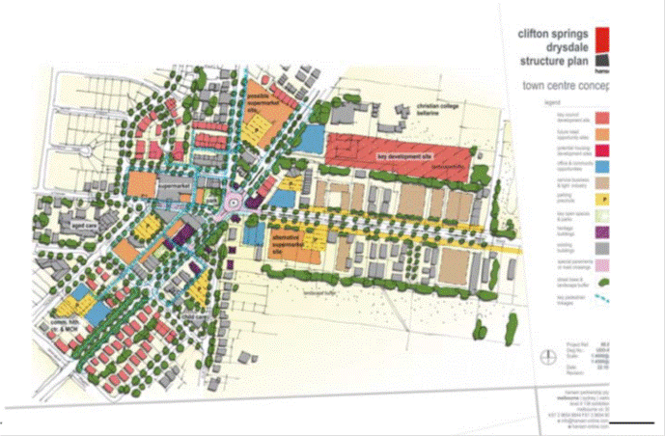
Source: City of Greater Geelong, 2010
Figure 2: Drysdale/Clifton Springs Structure Plan
Proposed Coles Development

The Structure Plan was followed in August 2012 by the Drysdale Urban Design Framework (City of Greater Geelong, 2012). This concentrated on providing a planning framework for the Drysdale town centre. The Urban Design Framework (UDF) is summarised in the diagram overleaf. Notably, the site proposed by the Coles Property Group has been broadly identified in the UDF as a preferred location for a supermarket (see note 15 on the diagram). The UDF relied on the analysis of retail supply and demand completed by Tim Nott four years earlier.

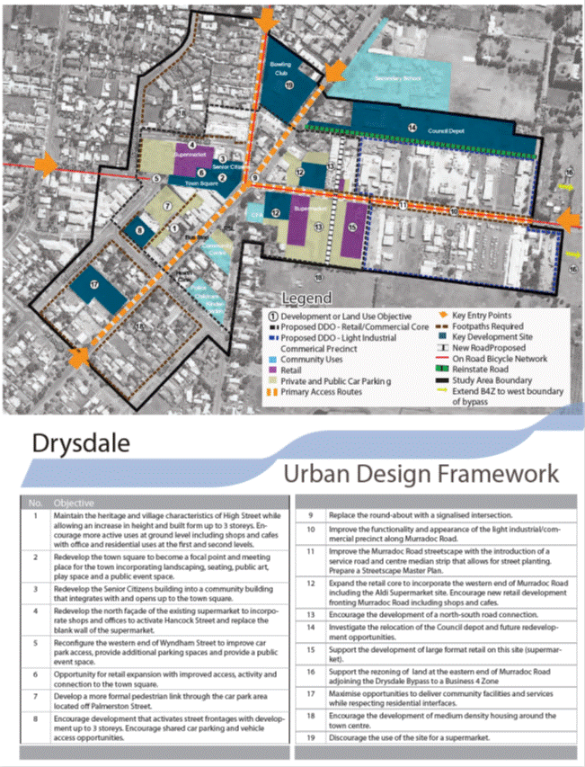
Source: City of Greater Geelong, 2012
Figure 3: Drysdale Urban Design Framework

The Geelong Retail Strategy
The Geelong Retail Strategy (Essential Economics, 2006) sets out the economic impact information required of proponents of major new retail developments. This has been translated, with minor amendments, into the Planning Scheme (City of Greater Geelong, 2010 – Clause 22.03)

An economic impact assessment should be provided for:
- New major retail development involving 2,000m2 or more in gross leasable floor area.
- Proposals involving a key major tenant such as a supermarket.
- Out-of-centre proposals.
- Applications relating to an increase in an existing floor space cap.
The responsible authority may waive a requirement to prepare an economic impact assessment.
The assessment criteria in the planning scheme highlight the information that is required of a significant new retail development:
General
- Amount of retail floorspace (in m2).
- Number of retail tenancies and sizes.
- Type of retail floorspace (eg, supermarket; discount department store, etc).
- Other non-retail components where applicable.
- Assessment of the proposals compliance with the recommendations of the City of Greater Geelong Retail Strategy 2006, including any specific recommendations for the centre.
- Supporting evidence of retail demand.
- Assessment of any likely impact on existing or planned (i.e. approved) retail facilities.
- Description of anticipated benefits to community (measurable and non-measurable).
- Estimated contribution to employment (in both construction and retail operation), and noting the flow-on effects (although these generally accrue to a wider area, including the State and national economies).
- Overall contribution to net community benefit.
Retail Demand:
- The need or demand for new or expanded retail floorspace provision to serve the identified catchment.
- The current catchment population level, and the forecast population and retail spending growth rate for the next 5 and 10 years.
- The extent to which the proposal will draw trade from beyond the catchment, and from passing trade.
- Whether the proposed or expanded retail provision would mean an expansion in the
- Size of the catchment of that centre.
Retail Supply:
- The existing supply of retail floorspace serving the catchment, by type.
- Details of any other proposals for new or expanded retail development in the catchment or beyond, which could have an effect on the viability of the proposal.
- The main features of the existing hierarchy of retail centres which serve the catchment, and show where the proposed retail floorspace would fit into the Greater Geelong retail activity centre hierarchy as detailed in Clause 21.07-8 of the Municipal Strategic Statement.
- Evidence as to the extent to which the existing supply of retail floorspace is adequate to meet existing and foreseeable demand levels over the next 5 and 10 years.
- Whether there are any existing retail gaps in merchandise/services which the proposal will fill.
- Details, where required by the responsible authority, on any relevant alternative sites to the proposed site, and demonstrate why the proposed site is the preferred site for the proposal.
Escape Spending:
- Estimates of existing levels of escape spending from the catchment and indicate how the proposal will address this issue.
- Estimates on the share of this escape spending that could reasonably be retained by the proposal.
- Impact On Existing Retail Facilities
- Assessment of the expected trading effect on existing retail facilities if the proposal was approved.
- Demonstration of the extent to which the proposal is expected to lead to an overall improvement in the provision of retail facilities to the catchment population, and highlight the potential for retaining spending that would otherwise escape to other centres.
- Assessment of the estimated employment impact of the proposal, including potential loss of employment at centres which may be negatively impacted by the proposal.
Net Community Benefit
Assessment of the contribution of the proposed development to Net Community Benefit, including but not limited to the following considerations:
- Employment generation (or loss) during construction and operation.
- Impact on shopper’s retail choice and availability of goods and services.
- Impacts on overall levels of vibrancy and sustainability of existing centres servicing the catchment and in the proposed new centre.
- Contribution to increased levels of public transport use.
- Contribution to enhancing levels of liveability, social interaction and other community related goals.
(City of Greater Geelong, 2010, clause 22.03)
These are the key criteria that need to be addressed by the economic impact analysis, which is addressed in the following section.

Economic Impact Analysis – the Report by Macroplan Dimasi
The economic impact analysis of the proposed Coles development at Drysdale by Macroplan Dimasi provides a wide-ranging review of the retail development issues. The following table compares the economic impact analysis requirements of the Retail Strategy for a significant retail development proposal with what has actually been provided.

How has Macroplan Dimasi responded to the requirements of the Greater Geelong Planning Scheme?
Requirements of the Greater Geelong Planning Scheme | Analysis provided by Macroplan Dimasi
Description of proposal, including floorspace, retail type and number of tenancies | Provided in section 1
Retail demand in the catchment to support proposal | Provided in section 4.2
Catchment population and spending growth over the coming ten years | Provided in section 2 Trade Area Analysis
Extent to which the development will draw trade from beyond the catchment | Sales from beyond the trade area have been estimated at 20% of the total (table 4.2)
Would the development expand the size of the catchment for the centre? | The catchment area remains the same before and after the development
Indicate existing supply of retail floorspace | Existing and proposed supermarket floorspace outlined in table 3.1 – schedule of competing supermarket facilities
Detail proposals for new or expanded floorspace | Proposed facilities identified in section 3 Competition
Identify the existing hierarchy of retail centres that serve the catchment and how the new development would fit within that hierarchy | The centres are identified in sections 2 and 3; several maps identify a sub-regional centre at Leopold but there is no text that identifies a hierarchy, nor how the Coles proposal will affect the role of Drysdale in the hierarchy
Provide evidence about whether the existing floorspace is adequate for the next 10 years | Not provided explicitly but is implicit in the assessment of the market for the new facility
Identify whether there are gaps in the retail market that the development will fill | As above
If required, provide details on alternative sites for the development proposal | These details have not been required since the site is one identified by the UDF for the purpose of a supermarket
Quantify escape spending and how this will change with the proposed development | Escape spending in supermarket food and grocery segment estimated at 35% in 2012 reducing to 25% when the development opens in 2015 (see table 4.1)
Estimate how trading levels at existing retail facilities will be affected by the new proposal | Average trading levels in supermarkets throughout the trade area are provided in table 4.1 (supermarket capacity assessment) and table 4.3 (trading impact assessment); a one-off impact on the turnover of other supermarkets in the trade area of $9.1 million or 12.8% of trade is expected
Highlight the retail benefits to the catchment population and the retention of escape spending | Provided in sections 4 Supermarket Potential, and 5 Net Community Benefit
Estimate the employment impact of the proposal, including jobs that may be lost in affected centres | Provided in section 5; 192 ongoing jobs, with a net gain of 182 jobs; however, affected centres have not been nominated
Assess net community benefit (jobs, improved service, vibrancy of the centre, improved viability of public transport, liveability of the area and other community goods) | Provided in section 5

In most respects, Macroplan Dimasi has addressed the questions raised by the checklist for new developments outlined in the Retail Strategy. However, there is one key omission; the assessment does not estimate the impact on particular centres. This means that it is difficult to understand how the proposal will affect the hierarchy of activity centres serving the Drysdale district and whether any particular centres are at risk of losing their role with a consequent loss of service to affected residents.
The method of analysis used by Macroplan Dimasi is most suited to testing the market viability of the proposed development. Whilst this is an important component of the necessary assessment it is not the only aspect of the development that requires investigation. As it stands, the assessment does not address the existing hierarchy of centres and the flow of resident spending to different levels of the centre hierarchy. In consequence it is difficult to assess how particular centres will be affected by the proposed development and the likely impact on the jobs and services of particular parts of the local community.
The following sections provide an alternative analysis which addresses the issue of impact on centres more directly. This analysis also highlights some areas of difference with the findings of the Macroplan Dimasi report.

Alternative Retail Impact Analysis
Here I provide an alternative impact assessment which looks at whether or not there is notional space in the market for the proposed development given the existing retail network; my analysis then reviews the likely impact on other centres in the network. The key to the impact assessment is whether or not other centres will have a significantly diminished role and how important that might be to the jobs and services available to residents and visitors, and therefore the net community benefit. The steps involved are:
- Identify the trade area
- Estimate retail spending pool of residents
- Identify the existing supply of retail floorspace and estimate retail sales
- Identify the present balance between supply and demand
- Project supply and demand to 2016, which I expect would be the first year of operation of the new supermarket
- Estimate the origin of the sales to the new supermarket and identify the likely impacts on the affected centres in the network
- Provide a commentary on the net community benefit

The Extent of the Trade Area
The trade area of an activity centre is the area from which it gets most of its sales; the area from which residents naturally visit the centre to obtain particular goods and services. At the boundary of the trade area, residents may choose from two or more centres that provide equivalent services. The extent of a trade area is influenced mainly by the location of competing centres and the travel patterns of residents.
The precise boundaries are usually set by the analyst to coincide with convenient statistical areas. There is nothing wrong with the trade area set by Macroplan Dimasi. However, the following analysis uses the latest standard statistical areas for which data is readily available.
In this case, the trade area has been set with reference to the location of surrounding centres that have significant supermarkets and the boundaries of the Statistical Area 2s (SA2s) of Clifton Springs and Portarlington.
The trade area used in this report is illustrated in Figure 4 overleaf.
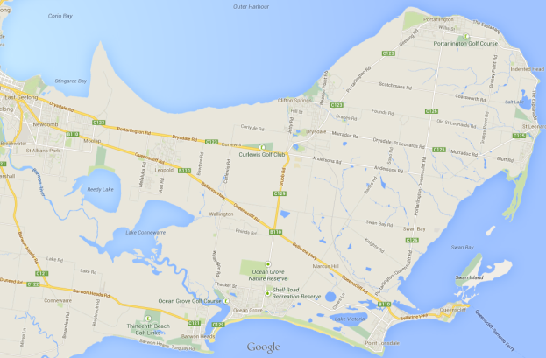Source: base map from Google Maps
Figure 4: Existing supermarket retail centres on the Bellarine Peninsula and the trade area of Drysdale town centre

Surrounding centres that define the Drysdale trade area are Leopold, Ocean Grove town centre and Ocean Grove Marketplace (Shell Road). All these centres have substantial supermarkets.
Whilst Drysdale has some provision of non-food goods, most residents would travel to Ocean Grove or to centres in urban Geelong for comparison shopping (clothes, furniture, electrical goods etc).

Population and Retail Spending
The population of the trade area defined above differs only slightly from that in the Macroplan Dimasi report (18,740 here in 2012 compared with 18,880 in the trade area identified by Macroplan Dimasi).
I have adopted the estimates of retail spending per person in the trade area provided by Macroplan Dimasi, which have been sourced from Market Data Systems. The figures have been updated to 2013 and are shown in the table below. The table also provides an estimate of how much is spent in bricks and mortar shops and how much online (see later sections for a discussion of this).

Estimate of retail spending, Drysdale trade area, 2013
Retail type | Retail spending per person | Total retail spending | Retail spending in shops
 | $ | $m | % | $m
Food, groceries and liquor | $5,879 | $113.0 | 98% | $110.8
Non-food | $5,197 | $99.9 | 91% | $90.9
Food service | $853 | $16.4 | 99% | $16.2
Retail services | $271 | $5.2 | 60% | $3.1
Total retail | $12,201 | $234.5 | 94% | $221.0
Source: Tim Nott

Total retail spending by trade area residents is estimated at $235 million in 2013. Of this, 94% or $221 million is spent in shops, with the remainder spent online.

Retail Spending by Visitors
Local shops also benefit from spending by visitors to the area, including:
- People staying in holiday homes
- People staying in commercial accommodation such as the hotel and bed and breakfast establishments
- Campers and caravanners
- Day trippers
- People staying with friends and relatives
- People who are working in the area temporarily
It is possible to calculate the order of magnitude of the likely visitor spending pool by considering that
- 33% of dwellings in the trade area were unoccupied at the last Census and the great majority of these are holiday homes, likely to generate in the vicinity of 0.6 million visitor nights per year, with each visitor spending around $63 per night on average on retail goods and services (calculated from Tourism Research Australia, National Visitor Survey, December 2012)
- The area has a range of commercial accommodation including hotels, motels and caravan parks
- The area receives a proportion of the estimated 5.6 million day-trippers that visit the Great Ocean Road tourism region each year (Tourism Victoria, Great Ocean Road Market Profile, year ending December 2011) each of whom spend around $60 on average on retail goods and services and food service (calculated from Tourism Research Australia, National Visitor Survey, December 2012)
Using these figures, total retail spending by visitors to the trade area is likely to be around $40-$50 million per year. This is approximately 15% to 18% of the total retail spending pool (that is, retail spending by residents and visitors). However, visitors spend are likely to make a very high proportion of their expenditure in the trade area. In this report, retail spending by visitors to the trade area is estimated to account for 25% of all sales in the local shops.

Retail Sales
Retail sales are calculated here by estimating the retail floorspace (updating existing surveys with information from Council) and estimating the average retail turnover density (RTD - sales per square metre of floorspace). The RTD estimates have been built up over a number of years through work for retailers as well as review of available statistics and shopping centre estimates.
The following table provides an estimate of floorspace, RTD and retail sales to the shops in the trade area.
[The sales estimates are based on average figures for their category and for the types of shops involved; it may be that some shops are trading well above the average for their category. If this were true of the supermarkets, for example, the sales for the food and groceries category and for the trade area as a whole would be under-estimated. Nevertheless, it is important for the subsequent analysis that average figures are used in order to understand the potential for growth. Using higher figures would under-estimate the development potential and could entrench a situation in which one retailer was able to derive higher than average returns at the expense of competition in the centre.]

- Estimate of retail floorspace and sales, Drysdale trade area, 2013
 | Food, groceries and liquor | Non-food | Food service | Retail services | Total retail
Floorspace | sq m | sq m | sq m | sq m | sq m
Drysdale Town Centre | 5,130 | 3,260 | 1,250 | 680 | 10,320
Portarlington | 2,473 | 1,170 | 1,410 | 240 | 5,293
St Leonards | 1,171 | 784 | 443 | 0 | 2,398
Elsewhere in the trade area | 120 | 0 | 400 | 0 | 520
Total trade area | 8,894 | 5,214 | 3,503 | 920 | 18,531
Retail turnover density | $/sq m | $/sq m | $/sq m | $/sq m
Drysdale Town Centre | $8,600 | $5,200 | $4,900 | $4,000 | $6,800
Portarlington | $8,700 | $5,000 | $4,900 | $4,000 | $6,700
St Leonards | $7,800 | $4,700 | $4,500 | $4,000 | $6,200
Elsewhere in the trade area | $6,500 | $4,700 | $4,500 | $4,000 | $5,000
Sales | $m | $m | $m | $m | $m
Drysdale Town Centre | $44.1 | $17.0 | $6.1 | $2.7 | $69.9
Portarlington | $21.5 | $5.9 | $6.9 | $1.0 | $35.2
St Leonards | $9.1 | $3.7 | $2.0 | $0.0 | $14.8
Elsewhere in the trade area | $0.8 | $0.0 | $1.8 | $0.0 | $2.6
Total trade area | $75.5 | $26.5 | $16.8 | $3.7 | $122.5
Source: Tim Nott
Current annual retail sales in the trade area are $123 million. Approximately 57% of this was in the sale of food and groceries, reflecting the type of local neighbourhood activity centres present in the trade area.

Current Balance of Retail Supply and Demand
The following table provides an estimate of the current balance between supply and demand for retail floorspace in the trade area.
The calculation here assumes that sales to visitors are around 25% of all sales in trade area shops.

- Balance between supply and demand for retail floorspace, Drysdale trade area, 2013
Retail category | Sales at MTA shops | Sales to visitors |  | Sales to residents | Retail spending in shops by residents | Escape spending
 | $m | % | $m | $m | $m | $m | %
Food, groceries and liquor | $75.5 | 18% | $13.6 | $61.9 | $110.8 | $48.8 | 44%
Non-food | $26.5 | 35% | $9.3 | $17.2 | $90.9 | $73.7 | 81%
Food service | $16.8 | 40% | $6.7 | $10.1 | $16.2 | $6.1 | 38%
Retail services | $3.7 | 20% | $0.7 | $2.9 | $3.1 | $0.2 | 6%
Total retail | $122.5 | 25% | $30.3 | $92.2 | $221.0 | $128.8 | 58%
Source: Tim Nott

This analysis suggests that the trade area captures 42% of resident spending, with 58% ($129 million per year) “escaping” to centres outside the trade area – to Leopold, Ocean Grove, the Geelong CBD and other centres in urban Geelong as well as further afield. In the food and groceries segment, important for this analysis of supermarket potential, the expenditure retained in the trade area is 56%. The following sub-section assesses whether this is a reasonable share.

The Activity Centre Hierarchy
The notion of an activity centre hierarchy, with activity centres of different size and scope providing services for communities of different sizes is still relevant to retail planning. It allows for rational investment decisions by retailers and others; it provides clarity about the kinds of services that residents can expect; and it allows for a more sustainable urban development in rapidly growing areas.
The table below provides the centre hierarchy used here. It is a modified form of the hierarchy used in the Geelong Retail Strategy produced by Essential Economics in 2006.

- Revised activity centre hierarchy for the Geelong region
Centre type | Relevant example | Typical catchment threshold | Typical floorspace | Typical share of trade area spending
 |  | persons | sq m | %
Capital City | Melbourne CBD | 1 million + | 300,000 | 5%
Regional Centre | Geelong CBD | 100,000+ | 100,000 | 20%-35%
Sub-regional centre | Waurn Ponds | 50,000+ | 15,000 to 50,000 | 15% to 30%
 | Belmont
 | Corio
Community Centre | Pakington Street | 20,000+ | 12,000 to 25,000 | 25% to 35%
 | Ocean Grove
Town/Neighbourhood Centre | Leopold | 8,000+ | 4,000 to 12,000 | 25% to 35%
 | Drysdale
Small Town/Neighbourhood Centre | Dorothy St, Leopold | 2,000+ | 1,000 to 4,000 | 10% to 20%
 | Portarlington
 | Point Lonsdale
Local Centre | Indented Head | 1,000+ | up to 1,000 | 2 to 5%
Bulky goods outlets | Princes Highway | 50,000 to 100,000 | 5,000 to 50,000 | 5% to 10%
Source: Tim Nott

Not every area is served by each level in the activity centre hierarchy. However, it can be seen from the table that, for example:
- an area with neighbourhood centres and a series of local centres would be likely to capture 30% to 50% of spending by residents of the trade area
- an area with a sub-regional centre and a series of smaller centres would be likely to capture 50% to 65% of available spending
The Drysdale trade area presently contains a significant neighbourhood centre (Drysdale town centre), two smaller neighbourhood centres – Portarlington and St Leonards - and a local centre (Indented Head). Other things being equal, the retail network in the trade area would be expected to capture 40%-50% of resident spending. The capture of 42% is therefore at the lower end of the expected range. There are several likely reasons for this, including:
- The largest supermarket in the area is the Woolworths store at Drysdale, which is less than 2,800 sq m at a time when full-line supermarkets are likely to be 3,200 sq m or more. Many residents may choose to seek out the larger supermarket facilities outside the trade area.
- There are larger supermarket facilities at Leopold and Ocean Grove, which are very accessible to trade area residents as well as in the centres in urban Geelong where residents must travel in any case to undertake most of their comparison goods shopping.
Typically, neighbourhood centres capture 55% to 75% of resident spending in food and groceries. At Drysdale, the estimated capture is only 56%, at the lower end of this range. This does indicate a potential demand for more food and grocery provision.
The following section looks at how this situation is likely to change in the future.

Retail Development Potential
The future retail development potential of Drysdale Town Centre will depend on a variety of factors including:
- General economic conditions (that is, retail demand will vary according to the business cycle)
- Changes in population and resident spending
- Changes in the activity centre network
- Changes in retail industry organisation such as the growth of internet shopping
- Policy requirements of Council and State Government
For the purposes of this report, general economic conditions are assumed to remain stable, with growth in GDP averaging 2% to 3% per year. In addition, whilst there have been zoning policy changes introduced by State Government that affect retailing, none of these are especially relevant for Drysdale. The other factors are examined briefly here.

Population forecasts
Small area forecasts for population growth have been prepared for Council by .id consulting. The forecast areas do not correspond precisely to the SA2s used by the ABS. Here, the growth rate of the main forecast areas covering the trade area has been used to generate a growth rate for the trade area. The results of the population forecast are illustrated in the following chart.

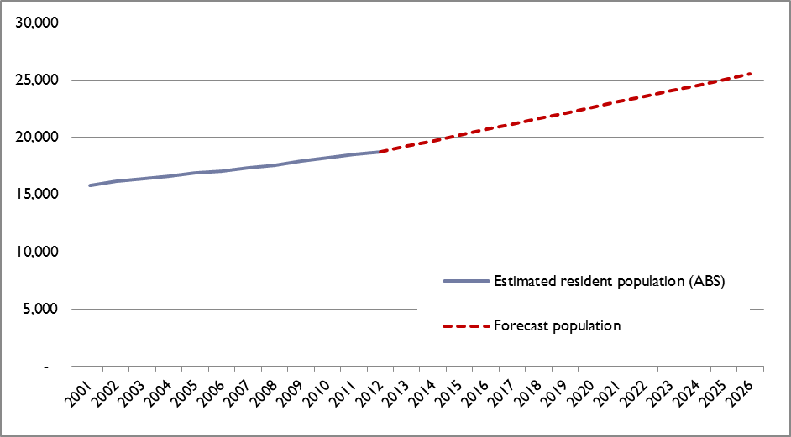Source: ABS, 2013; .id consulting, 2013; Tim Nott
Figure 5: Drysdale trade area population, 2001 to 2026

By 2016, the population of the trade area is forecast to be 20,746. The population is expected to grow to 25,548 by 2026. Between 2012 and 2026, the population is expected to grow by 2.2% per year on average. This compares with a growth rate of 1.5% per year on average between 2001 and 2012. The growth rate is expected to accelerate as a result of new residential developments, particularly around Drysdale (mainly the Jetty Road growth area), St Leonards and Portarlington. The urban land supply in the trade area is shown in the figure below.
My forecast population figures are broadly similar to those used by Macroplan Dimasi, which anticipates a population of 25,830 by 2026.

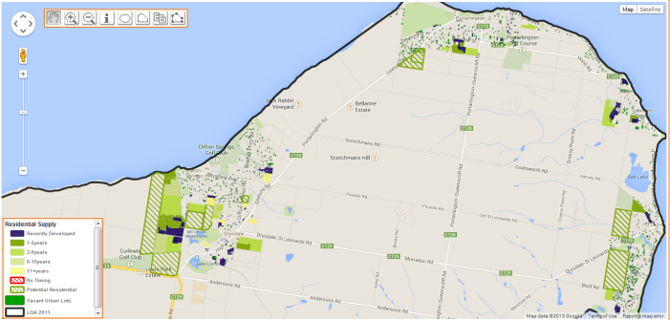Source: Spatial Economics, 2013
Figure 6: Urban land supply, North Bellarine as at 2012

Change in retail spending
The total spending estimates are shown in the table below, based on the forecast population outlined above. These spending estimates assume that there will be real growth in resident spending of 1% per year over the forecast period, which is in line with long term averages (and is broadly consistent with growth expected in the Macroplan Dimasi report). The estimates further assume that the balance in spending between various retail categories will remain unchanged from the present.

- Annual retail spending by residents of the Drysdale trade area, 2013 to 2026
Retail type | 2013 | 2016 | 2021 | 2026
 | $ | $ | $ | $
Spending per person
Food, groceries and liquor | $5,879 | $6,057 | $6,366 | $6,691
Non-food | $5,197 | $5,355 | $5,628 | $5,915
Food service | $853 | $879 | $924 | $971
Retail services | $271 | $279 | $293 | $308
Total retail | $12,201 | $12,570 | $13,212 | $13,886
Trade area population | 19,223 | 20,746 | 23,125 | 25,548
Total spending | 2013 | 2016 | 2021 | 2026
 | $m | $m | $m | $m
Food, groceries and liquor | $113.0 | $125.7 | $147.2 | $170.9
Non-food | $99.9 | $111.1 | $130.1 | $151.1
Food service | $16.4 | $18.2 | $21.4 | $24.8
Retail services | $5.2 | $5.8 | $6.8 | $7.9
Total retail | $234.5 | $260.8 | $305.5 | $354.7
Source: Macroplan Dimasi; Tim Nott; constant 2013 dollars

Total annual retail spending by residents of the trade area is forecast to grow from $235 million in 2013 to $355 million by 2026. The spending on the food, groceries and liquor segment is predicted to rise from $113 million to $171 million over the period.
Source: PWC/Frost & Sullivan, 2012 (excludes cafes and restuarants)
Figure 7: Forecast of online retail expenditure

The Internet
Various pundits, including the founder of Amazon.com, have suggested that online retailing in mature economies will gradually achieve 15% of all retail sales. However, other commentators have suggested that, with mass customisation in fashion, improvements in online food ordering, and more widespread adoption of online technology, online retailing could approach 50% of total sales. For the moment this seems unlikely; nevertheless, online retail sales appear set to grow substantially from around 6% currently (see graphic).
It is increasingly likely that retailers will have an online presence so that the distinction between real and virtual shops will become blurred. This may mean that chain stores take up less shop space and more space in industrial areas for packing and distribution. Independent stores with an online presence may use more of their store space for fulfilling orders and less for display purposes.

In centres such as Drysdale, online shopping will affect mainly the grocery shopping of residents – and only then if home delivery of groceries can be made attractive. In other respects, Drysdale will be somewhat protected from online competition because of the nature of the local offering and the local demand. The centre offers convenience shopping as well as food catering, all activities typically not undertaken online. This role of the Drysdale centre is likely to continue, although residents will spend more online over time. This report assumes that by 2016, 9% of total resident retail spending will be via the internet and by 2026, 15% of spending will be undertaken online. The forecast spending in shops is shown in the table below.

Retail spending in bricks and mortar shops, Drysdale trade area
Retail type | 2013 | 2016 | 2021 | 2026
 | $m | $m | $m | $m
Food, groceries and liquor | $110.8 | $119.4 | $135.4 | $153.8
Non-food | $90.9 | $97.8 | $109.3 | $120.9
Food service | $16.2 | $17.9 | $20.5 | $23.6
Retail services | $3.1 | $3.5 | $4.1 | $4.7
Retail spending in shops | $221.0 | $238.5 | $269.3 | $303.0
Share of total retail spending | 94% | 91% | 88% | 85%
Source: Tim Nott

Changes in the Activity Centre Network
Within the trade area
Within the trade area, as well as the proposed Coles development, a new neighbourhood activity centre is planned at Jetty Road in Drysdale to service the Jetty Road growth area. The size of these developments is summarised in the table below.

Proposed retail developments, Drysdale trade area, as at 2013 (square metres)
Proposed retail developments | Supermarket | Other retail | Total
Jetty Road NAC | 3,200 | 1,244 | 4,444
Coles, Drysdale | 3,892 | 0 | 3,892
Total | 7,092 | 1,244 | 8,336
Source: Plans by Coles Property Group and Clarke Hopkins Clarke

The Jetty Road NAC has been planned for some years and is in the approved Jetty Road Growth Area Structure Plan (City of Greater Geelong, 2007). The NAC was granted a planning permit in January 2013, with approved plans for 4,444 sq m of retail space comprising a supermarket centre with a small internal mall. The developers of the NAC have plans for further retail space (approximately 2,000 sq m) to create a street-based centre at Jetty Road.
The developers of the surrounding residential land expect that the centre will be open by 2015 as the promotional material below makes clear.
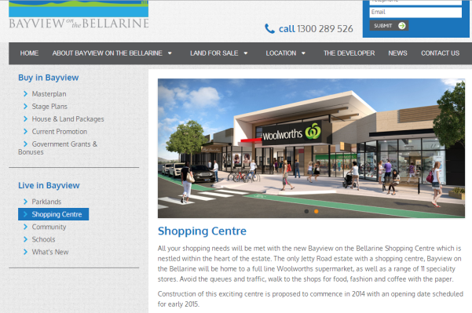Source: http://www.bvbellarine.com.au/shopping-center.html
Figure 8: Promotional material for Jetty Road SC

However, the market for the centre is not yet in place within the Jetty Road Growth Area; only 458 lots have been constructed in the growth area to date since development started in December 2011 according to Council records. A supermarket of the size contemplated here would normally require a catchment of at least 3,000 households or 10,000 people. At 230 lots per year, this would take at least another 11 years.
In the chart below, I have estimated the trade area population for a supermarket facility at the Jetty Road NAC, taking into account the growth area and some nearby parts of Drysdale/Clifton Springs. This trade area might be described as the “natural catchment” of the NAC taking into account the Drysdale town centre to the east. I have also superimposed the normal catchments for supermarkets of various sizes.

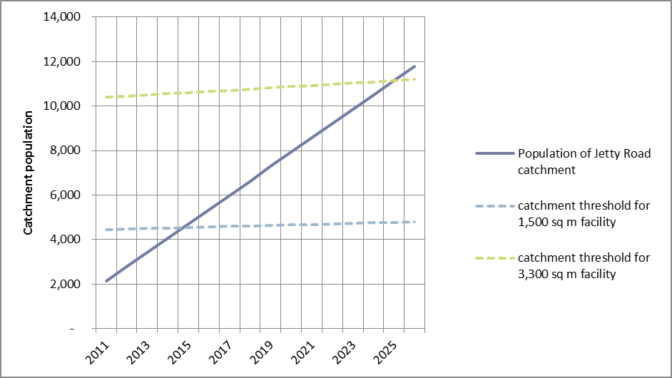Source: Tim Nott
Figure 9: Estimated population growth in the Jetty Road NAC catchment

Even allowing for development of the shopping centre sometime in advance of demand in order to establish a market, it is difficult to see the natural catchment of the Jetty Road centre being large enough to warrant development in less than seven years. It would be possible to support earlier development of a centre with a much smaller supermarket but this would require a further permit. (In this context, I note that Woolworths, the identified operator of the supermarket at the Jetty Road centre, is trialling a smaller format supermarket of 1,500 sq m at Portarlington. Such a supermarket would probably be viable in Jetty Road from 2015/2016.)
Nevertheless, the Jetty Road NAC has been approved with a significant supermarket. In order to be viable, the facility as presently planned will need to capture trade from a broad swathe of Clifton Springs, Drysdale and beyond; that is, it will effectively need to share the trade area of the town centre. The supermarket at Jetty Road would be the largest in the Drysdale trade area (excluding the proposed Coles development) which would likely be attractive to many people in the catchment. However, many residents would have to choose to travel further to visit Jetty Road than the Drysdale Town Centre.
From a policy viewpoint, this situation is not ideal since the Jetty Road NAC is intended to service the growth area on the western edge of the township and not to usurp the wider role of the town centre. Nevertheless, the commercial reality is that the Jetty Road NAC, as presently planned, and the Drysdale town centre would compete strongly.
The Macroplan Dimasi report suggests that,
With the current growth rate of the Jetty Road growth area it may be at least 10 years until the Jetty Road area has sufficient residents to establish its (own) supermarket anchored centre (p12)
The Macroplan Dimasi impact analysis measures the impact of the proposed Coles development in its first year of operation, assumed to be 2015. This is standard practice in impact assessment. However, it is also a requirement of the planning scheme that the impact on planned as well as existing centres should be identified. Because of the assumption that the Jetty Road centre will be developed well after the proposed Coles supermarket, impacts on the Jetty Road centre have been ignored by Macroplan Dimasi.
In this instance, there is a need to model various scenarios to understand the likely impact of the proposed development on existing and planned activity centres.

Outside the trade area
Residents of the Drysdale trade area will form part of the trade area for the approved expansion of the Leopold Gateway Centre which will become a sub-regional activity centre over the next few years. The Leopold Centre will contain approximately 22,000 sq m of retail space, including a discount department store (DDS), two large supermarkets and specialty stores, some of which will provide food and groceries. The additional food and grocery space at Leopold will amount to at least 5,000 sq m compared with the present.
The Macroplan Dimasi report notes the likely expansion at Leopold but suggests that this will not affect the Drysdale trade area particularly and the report does not take the expansion into account in the impact analysis. However, I suggest, on the contrary, that the planned growth at Leopold will have an impact on the Drysdale trade area and will set some limits on the potential for expansion of food and grocery facilities in the trade area. A previous report by Macroplan Dimasi (2012) for the proponent of the Gateway Plaza expansion suggests that the retailers of the Gateway Plaza trade area, which includes all of the Drysdale trade area, will experience a collective loss of 7.7% of trade when the new facilities open. Now that the Gateway Plaza proponent has reduced the scale of the development somewhat, the impact on the trade area would be proportionately smaller – perhaps around 5.5% of sales. Following from own review of the Macroplan Dimasi work for Council (Tim Nott, 2013), I anticipate that the impact on the Drysdale town centre would be 6%-7% decline in sales, other things being equal.

Summary of Assumptions Affecting Retail Development
Following the previous discussion, the analysis here makes the following assumptions:
- General economic conditions will remain moderately positive over the study period. That is, while there may be some periods of recession, economic growth will average 2-3% per year in Australia.
- Drysdale town centre will continue to perform the role of a neighbourhood/town centre throughout the study period for the trade area defined in this report.
- By 2016, the population of the trade area will be 20,746 with a total retail spending of $260.1 million per year. Of this, 91% or $238.5 million will be spent in shops rather than online.
- By 2026, the population of the trade area will be 25,830 with a total retail spending of $354.7 million per year. Of this, 85% or $303 million will be spent in shops rather than online.
- The approved Jetty Road Neighbourhood Activity Centre will have its first full year of operation in the form currently approved in 2016.
- The sub-regional Bellarine Gateway shopping centre in Leopold will be open from 2016.
- Retailers will become more competitive and efficient over the period, with sales per square metre of floorspace increasing by 0.5% per year.
- Visitors will continue to contribute 18% of food and grocery sales throughout the study period.
These assumptions are conservative; that is, they anticipate little change from the existing situation or established trends. The real unfolding picture will undoubtedly be different in subtle and, possibly, substantial ways. Monitoring and review of these assumptions is required to keep the analysis up to date.

Future Balance of Retail Supply and Demand

Without the Coles Development
The following table uses the assumptions above to provide an estimate of the future balance of supply and demand in the food and groceries retail segment in the Drysdale trade area. In this case, the scenario provides a base case without the Coles development but with the approved Gateway Plaza expansion (in 2016) and the Jetty Road NAC (in 2016).
I have made the following further assumptions:
- the Gateway Plaza expansion will result in a transfer of sales from Drysdale equivalent to 6.5% of food and grocery sales in 2016
- The Jetty Road NAC will contain 3,600 sq m of floorspace providing food and groceries, including a 3,200 sq m supermarket. The centre should achieve annual sales of food and groceries of $34.4 million by 2016.

Escape spending, food and grocery segment, Drysdale trade area, without the Coles development, 2013 to 2026 (2013 prices)
 | Sales at MTA shops | Sales to visitors |  | Sales to residents | Total spending by residents | Escape spending
 | $m | % | $m | $m | $m | $m | %
2013 | $75.5 | 18% | $13.6 | $61.9 | $110.8 | $48.8 | 44%
2016 | $106.1 | 18% | $19.1 | $87.0 | $119.4 | $32.4 | 27%
2021 | $108.7 | 18% | $19.6 | $89.2 | $135.4 | $46.3 | 34%
2026 | $111.5 | 18% | $20.1 | $91.4 | $153.8 | $62.4 | 41%
Source: Tim Nott (2013 prices)

Without the Coles development, food and grocery escape spending from the trade area decreases significantly to 27% once the Jetty Road NAC is opened and gradually increases thereafter, reaching 41% by 2026. This is what might be expected in a typical neighbourhood activity centre catchment where the range of escape spending is normally 25% to 45% in this segment.
The trade area can comfortably absorb the additional food and grocery provision delivered by the Jetty Road NAC.

The Proposed Coles Development
I anticipate that the supermarket development proposed by the Coles Property Group would have a nominal turnover of $37.5 million in its first full year of operation, which is assumed to be 2016. This is based on floorspace of 3,892 sq m and average sales per square metre of $9,500 in 2013, rising by 0.5% per year as retailers become more efficient. This level of turnover is typical of a supermarket operated by one of the two largest operators (Coles and Woolworths) and represents a reasonable level of turnover in a competitive environment.
I note that the Macroplan Dimasi report suggests that the level of turnover at the proposed Coles supermarket would be $8,170 per square metre, whilst the existing supermarkets would trade at $8,900 per square metre. In my view, this is an unlikely picture of the ongoing state of grocery sales in Drysdale, for the following reasons:
- Even if the new Coles store starts off at $8,170 per square metre, this is below the target level of turnover for major supermarkets and would likely quickly trend upwards (other things being equal)
- The Coles store would be the largest supermarket in the trade area and would likely be able to attract the largest number of customers because of its ability to carry a greater range of goods
- A new store with the most up-to-date facilities would naturally be more attractive than an existing store that may have lacked investment for some time
For these reasons I believe that the Coles store would soon be likely to trade at least at the level of the other supermarkets in the trade area.
The analysis here first provides a picture of what would occur if all the retail facilities traded at the typical levels identified earlier.

Retail Balance with the Coles Development
The following table provides an estimate of the balance of supply and demand in the Drysdale trade area in the food and grocery segment with the proposed Coles development. In this scenario, the Jetty Road NAC is still expected to open in 2016. I have made the further assumptions that the Coles development will have its first full year of operation in 2016 and will have sales of $37.5 million in that year.

Notional escape spending, food and grocery segment, Drysdale trade area, with the Coles development, 2013 to 2026 (2013 prices)
 | Sales at MTA shops | Sales to visitors |  | Sales to residents | Total spending by residents | Escape spending
 | $m | % | $m | $m | $m | $m | %
2013 | $75.5 | 18% | $13.6 | $61.9 | $110.8 | $48.8 | 44%
2016 | $143.6 | 18% | $25.8 | $117.7 | $119.4 | $1.6 | 1%
2021 | $147.2 | 18% | $26.5 | $120.7 | $135.4 | $14.7 | 11%
2026 | $150.9 | 18% | $27.2 | $123.8 | $153.8 | $30.1 | 20%
Source: Tim Nott
With the Coles development, under the assumptions outlined above, escape spending from the trade area would reduce to only 1% in 2016 rising gradually to 20% by 2026. These figures are unrealistically low, given that many residents will continue to travel outside the trade area to shop at Leopold and the many centres in urban Geelong. Consequently, if the two supermarkets are developed as planned, the food and grocery segment throughout the trade is likely to experience a very low level of turnover. If both developments were to be operational by 2016, and if the trade area was able to retain a more realistic 75% of the food and grocery segment, then the average sales per square metre at food and grocery outlets in the trade area would fall to $6,700, well below the expected range for most major supermarket operators. Alternatively, other floorspace in the trade area could close. Given the balance of population and the network of existing centres in the trade area, any closures would most affect primarily the Drysdale town centre (as well as Jetty Road). The other centres in the network serve the discrete communities of Portarlington, St Leonards etc, and none of these centres are oversized for their community. The existing food and grocery traders in Drysdale comprise the Woolworths and Aldi supermarkets, several milk bars/small grocers and a small number of specialty food outlets and bottle shops. A significant portion of this floorspace would need to close to allow the two new proposed supermarkets to trade at normal levels.

Scenarios for Food and Grocery Provision in the Drysdale Trade Area
Given the outcome described above, it seems at least possible that the major players involved would adjust their investment programs. The chart below provides several scenarios for the development of food and grocery services in the Drysdale trade area. It describes the retention of resident spending on food and groceries in the area over the period from 2013 to 2026 under a variety of conditions.
- Scenario 1 charts the share of resident spending on food and groceries that is retained in the trade area without the Coles development but with the impact of Leopold Gateway Plaza (2016) and the Jetty Road NAC (2016)
- Scenario 2 introduces the Coles development (2016)
- Scenario 3 shows the share of resident spending retained if the Coles development is delayed to 2026
- Scenario 4 shows the share of resident spending if the food and grocery offering at the Jetty Road NAC is reduced to 1,800 sq m (including supermarket and specialty shops)
All these scenarios are compared with the typical neighbourhood centre catchment in which 55%-75% of resident spending on food and groceries is retained.
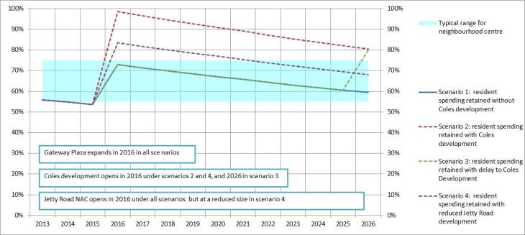
Figure 10: Notional retention of resident spending on food and groceries in the Drysdale trade area under various scenarios, 2013 to 2026
Source: Tim Nott

Looking at the chart above, it is clear, given there will always be some escape spending, that there is insufficient room in the market for both the Coles and Jetty Road developments to occur in 2016 and for both developments to achieve a typical level of sales per square metre (scenario 2). As discussed above, it is unlikely that the trade area can realistically retain more than around 75% of spending in the food and grocery segment, in which case the turnover per square metre would be more like $6,700 on average.
Looking at scenario 3, it appears likely that there would be room for the Coles development by 2026, with only a small initial reduction in typical sales per square metre in food and groceries in the trade area.
In scenario 4, I have assumed that the food and grocery provision at Jetty Road is only 1,800 sq m. This scenario would probably be supportable with an initial reduction in turnover levels which would gradually return to typical levels with growth in the trade area population and spending. Under this scenario, there would be room to expand the food and grocery provision at Jetty Road as the population in the growth area increased. (And this scenario would ensure that the role of the Jetty Road NAC was, as intended in the structure plan, a neighbourhood centre to service the growth area and not the wider Drysdale trade area.)
More scenarios could be produced but the chart shows a number of key points:
- Without either development, food and grocery provision in the trade area will very soon drop below acceptable levels
- If only one of the proposed developments is constructed, demand will be satisfied in the short to medium term, but there is likely to be room for the other proposed development in the mid-2020s
- With both the proposed developments, the trade area would have to retain an unrealistic market share of food and grocery spending; in reality average turnover levels in the segment would have to drop to levels that would normally be unacceptable to the two main supermarket operators (initially to around $6,700 by my calculations) or significant existing provision in Drysdale would need to close
- There are low impact solutions that allow development at both proposed sites but these would require a substantial reduction in the floorspace of one or both proposed developments

Impact on Existing Centres
The Macroplan-Dimasi report estimates that trade area retailers will suffer a decline in trade of 12.8% following the Coles development. However, the Planning Scheme requires that the economic impact assessment describes the impact on existing and planned centres. The following assessment assumes that the Jetty Road NAC will be developed as promised by the owners, with its first full year of operation in 2016.
Conclusions about the impact on other centres, particularly in this case where there are a number of other centres, will be imprecise. Many factors will affect the outcome including:
- the loyalty of existing customers to the affected centres/retailers
- the ability of retailers in affected centres to respond to competition
- changing travel patterns of residents
- general economic conditions
The following table provides an estimate of the impact of the proposed Coles development on centres within the trade area and the rest of Geelong. It looks in particular at which centres the sales at Coles would be drawn from; that is, if Coles was not built, where would trade area residents purchase their food and groceries? The total sales at Coles Drysdale are estimated at $37.5 million in 2016. I have assumed that these sales are drawn from other centres:
- in proportion to the scale of the food and grocery offering at each centre, and
- in inverse proportion to the distance from Drysdale.
That is, the impact will be felt most by the centres that have large food and grocery offering and which are closest to Drysdale.

Impact of Coles Drysdale on retail sales in surrounding activity centres, 2016 ($2013)
Centre | Sales at existing centres without Coles development | Share of sales at Coles Drysdale that would otherwise have gone to this centre | Change of sales at each centre | Sales to existing retailers with Coles development | Proportional impact on total  retail sales of centre | Notional transfer of eft jobs to Coles development
 | $m | % | $m |  | % | no.
Drysdale | $64.3 | 37% | -$13.9 | $50.4 | -22% | -50
Jetty Road NAC | $38.8 | 17% | -$6.3 | $32.4 | -16% | -23
Portarlington | $35.8 | 2% | -$0.7 | $35.0 | -2% | -3
St Leonards | $15.0 | 1% | -$0.3 | $14.8 | -2% | -1
Leopold | $138.5 | 16% | -$6.0 | $132.5 | -4% | -21
Newcomb | $135.8 | 7% | -$2.5 | $133.3 | -2% | -9
Geelong City Centre | $646.4 | 7% | -$2.7 | $643.7 | 0% | -10
Belmont | $107.6 | 2% | -$0.8 | $106.8 | -1% | -3
Waurn Ponds | $285.7 | 4% | -$1.6 | $284.1 | -1% | -6
Other Geelong |  | 7% | -$2.6 |  |  | -9
Total |  | 100% | -$37.5 |  |  | -134
Source: Tim Nott
Note: The existing sales at Drysdale take into account the likely loss of sales to the expanded Gateway Plaza at Leopold; figures in constant $2013 dollars; other Geelong includes Ocean Grove, Pakington Street, Corio Plaza etc; notional loss of employment has been calculated using $0.28 million in sales per equivalent full time (eft) job .

Apart from the impacts on retailers in Drysdale itself, the highest level of impact appears to be at the planned Jetty Road NAC, where retailers would suffer a loss of trade of 16%. Proportional losses at other centres appear to be relatively minor.
There is no particular level of impact that is considered “beyond the pale” in retail planning. However, in Panel hearings and at VCAT, impacts on turnover of 10%-15% or more are considered significant. It is this level of impact that is well above the normal competitive fluctuations in retail trade and which might challenge the role of a centre and its ability to deliver the expected service to the residents of its trade area. Any impact at or above this level must be carefully weighed in the balance of net community benefit. The existing food and grocery retailers in Drysdale itself and in the planned Jetty Road NAC are expected to suffer a loss of trade above this threshold.
In Drysdale, the centre as a whole would expand its sales from a notional $64 million to $89 million in 2016 if the Coles development takes place, although it may experience significant rearrangement of its food and grocery offering. (This assumes that the existing operators are trading at typical levels. To the extent that they are currently “overtrading”, then there would be a reduction in the extra sales achieved as a result of the Coles development. There would be, nevertheless, a benefit arising from the introduction of more competition and greater choice in the local market.)
The trading impact on Jetty Road would be entirely negative. In my view, the Coles development in the Drysdale town centre would be in a better position to capture the spending of the trade area because of its more central location and because it is the larger of the two proposed supermarkets. This may mean that:
- the Jetty Road NAC does not go ahead in its present form or for some years; or
- whilst the Jetty Road supermarket opens as planned, the NAC may not be able to sustain specialty food stores such as a baker, butcher, greengrocer etc; as a consequence, shop units in the development may remain vacant, with adverse consequences on investor confidence and community development

Potential to Mitigate Impacts
The most serious adverse impacts of the Coles supermarket proposal for Drysdale are on the approved Jetty Road NAC and on existing food and grocery traders in the Drysdale town centre.
There may be options to mitigate the trading impacts of the Coles proposal by adjusting the development timeframes and sizes of the respective proposals. For example:
- Reduce the size of the food and grocery provision at either Jetty Road NAC or Coles development to something in the range of 1,500 sq m to 1,800 sq m
- Delay the Coles development, with each year’s delay resulting in a better trading outcome for the existing and planned food and grocery operators
- Assist the change-over of affected shops in Drysdale, Jetty Road and elsewhere from food and grocery provision to non-food or service establishments
From the viewpoint of activity centre policy, the most appropriate solution would be to reduce the size of the Jetty Road NAC so that it served only the Jetty Road Growth Area and surrounds, thereby preserving the role of the Drysdale town centre and the key centre for the trade area.

Net Community Benefits
The likely form of the net community benefits of the Coles proposal are well set out in the report by Macroplan Dimasi, although I disagree with the scale of the benefits identified.
The Coles proposal will reduce the level of escape spending from the Drysdale trade area, meaning that local residents will not have to travel so far, so often for their shopping. This will result in travel time savings, reduce energy use and create more local jobs. However, most of these benefits would be achieved by the planned expansion of retail floorspace at Jetty Road.
The proposed Coles development will improve the level of competition in the local food and grocery sector since there is presently no Coles within the trade area (although there is a Coles at Leopold nearby).
The proposed development would strengthen the Drysdale town centre, making that centre more attractive to shoppers and reinforcing the hierarchy of centres in the trade area.
Should the Jetty Road NAC be significantly delayed (because, for example, the investors feel that the NAC is not in a good location to attract a substantial share of its trade from beyond the growth area) then the Coles development would satisfy the demand that is undoubtedly present and growing.
Whilst the development would generate net job growth, I believe the number of jobs has been substantially overstated. Although the total number of jobs attributable to the new supermarket may well be 192 or so (134 equivalent full time), a large part of the trade at the facility will be transferred from other shops throughout Greater Geelong, particularly as the existing floorspace and the planned floorspace at Jetty Road will very nearly cater for all demand. In this instance, I believe that the net growth in jobs is proportional to the difference between the floorspace of the Coles development and the floorspace of the Jetty Road development. This is equivalent to a net growth of approximately 15 jobs. The remaining jobs at the supermarket will be lost from other centres as indicated in table 9. Nonetheless, a net gain of 15 jobs is a positive outcome for the area. In addition, there are temporary jobs in constructing the new supermarket. These are likely to number 42 equivalent full-time jobs for one year.

A Note on the Drysdale Structure Plan
I have been asked to comment on whether the economic analysis supporting the Drysdale Structure Plan (2010) is still valid.
The analysis of retail supply and demand presented in this report provides an update of the earlier economic analysis. The earlier report estimated that there was potential for 6,600 sq m of additional retailing in Drysdale town centre between 2008 and 2031, which could include supermarket facilities. This is broadly consistent with the analysis presented here.
The work for the structure plan did not specifically examine the supply and demand case for the Jetty Road NAC which was taken as given. With the Jetty Road NAC assumed to be in place, the earlier report noted that
The (Drysdale town) centre would be unlikely to support both a medium sized supermarket and another full line supermarket within the life of this Structure Plan. (City of Greater Geelong, 2010)
It continues to be the case that the demand for a new full-line supermarket is some way off if the Jetty Road NAC proceeds as planned. Whether the provision of a new supermarket is “unlikely” will be up to the planning authority.

Summary
- Coles Property Group is proposing to develop a full line supermarket of 3,892 square metres in Murradoc Road, Drysdale. In order to accommodate this development part of the site needs to be rezoned from the Commercial 2 Zone to the Commercial 1 Zone. Accordingly a planning scheme amendment and planning permit application has been lodged with Council.

- Macroplan Dimasi has prepared an economic impact assessment report of the proposed development for the proponent. The report finds that there is sufficient market demand to accommodate the proposed new supermarket and that it will generate net community benefits in terms of employment and improved service to residents of the Bellarine Peninsula.

- I have reviewed the report by Macroplan Dimasi against the requirements of the Geelong Retail Strategy for providing impact assessments of new retail developments in the area. I have found that the report is generally compliant, with the main exceptions being that the report does not clearly identify how the proposal will affect the hierarchy of centres nor how individual centres are likely to be affected by the proposal. In addition, the report by Macroplan Dimasi does not assess the effect of the proposal on the approved but not yet constructed neighbourhood activity centre (NAC) in the Jetty Road Growth Area. Macroplan Dimasi has assumed that the Jetty Road NAC will not be constructed for at least ten years.

- I have prepared an alternative impact assessment in this report. I have assumed that the Jetty Road NAC and the proposed Coles development would have their first full year of operation in 2016 and I have provided detail about the likely impact on individual centres in the local and regional network.

- The present retail supply and demand situation in the Drysdale trade area indicates that there is now demand for a new full line supermarket. This would be satisfied to a very large extent by the planned NAC at Jetty Road. The planned Woolworths supermarket at Jetty Road, at 3,200 square metres, would be the largest supermarket in the trade area (without the proposed Coles development). The developers anticipate that this supermarket will open in mid-2015. Because the Jetty Road Growth Area is far from fully established, in order to be viable, the supermarket would need to serve the whole of the Drysdale trade area, effectively competing at the same level as the Drysdale town centre. This is not the outcome intended by the original Jetty Road Structure Plan, which envisaged that the Neighbourhood Activity Centre would serve mainly the Jetty Road Growth Area. However, a permit has been granted for the development to provide 4,400 square metres of retail floorspace including the supermarket and specialty stores.

- If both the Coles development and the Jetty Road NAC were opened at around the same time, the food and grocery segment in the Drysdale trade area would suffer from very low sales per square metre by comparison with typical levels for major supermarkets. This would be likely to cause significant reorganisation of retail space in the trade area, with potential closures of food and grocery stores, particularly in Drysdale. The prospect of this situation may cause the developers of the approved Jetty Road NAC to reconsider their investment. (In a comparison between the two competing supermarkets, I anticipate that shoppers would be more likely to visit the Coles store because it is in the existing town centre, with a broad range of stores nearby; it is slightly larger; and it is more accessible to more people in the trade area.)

- The Coles proposal does not appear likely to challenge the role of existing centres in the trade area or elsewhere. The proposal will affect retail sales in surrounding centres, particularly Portarlington, Leopold and St Leonards. However, I estimate that in each case the loss of sales would be less than 5% of total sales, which is well within the 10%-15% loss that is usually considered significant.

- The impact of the Coles proposal on existing food and grocery facilities in Drysdale itself would be severe with potential for a loss of 35% in sales (and 22% of retail sales for the centre as a whole). However, including the Coles development as part of the mix, the retail sales in the centre would rise from $64 million per year to $89 million. The role of Drysdale as a large town centre would be maintained even though there may be some individual store closures.

- I estimate that the Jetty Road NAC would suffer a loss of around 16% in total retail sales compared with what is currently anticipated. This is significant and could mean that the investment as currently planned would not proceed.

- In my view the net gain in ongoing jobs as a result of the Coles proposal would be around 15, with total full time equivalent jobs of 134. The remaining jobs would effectively be transferred from other food and grocery providers in the district.

- To mitigate the impact of the Coles development, it may be possible to stage the growth of the activity centre serving the Jetty Road Growth Area, starting with a local centre and developing a supermarket facility in increments to match the growing neighbourhood demand. This would at least provide some service for Jetty Road residents.

- The retail assessment presented here updates that provided for the Drysdale Clifton Springs Structure Plan in 2008. However, the two are broadly consistent; that is, there is only sufficient demand for one additional full-line supermarket in the Drysdale trade area in the short to medium term.

Sources

ABS, 2012, Regional Population Growth Australian, Canberra
ABS, 2012a, Census of Population and Housing 2011, Canberra
ABS, 2012b, Retail Trade Australia, Canberra
ABS, 2012c, Consumer Price Index, Canberra
Burg, Gerald, 2013, NAB Business Research and Insights, online resource
City of Greater Geelong, 2007, Jetty Road Growth Area Structure Plan, Geelong
City of Greater Geelong, 2010, Drysdale Clifton Springs Structure Plan, Geelong
City of Greater Geelong, 2013, Greater Geelong Planning Scheme, via http://planningschemes.dpcd.vic.gov.au/greatergeelong/home.html
Forecast .id, 2013, http://forecast2.id.com.au/Default.aspx?id=326&pg=5000
Spatial Economics, 2013, G21 Land Supply Monitor, accessed via http://g21.spatialeconomics.com.au/
MDS Market Data Systems, 2006, Market Info, Gold Coast
Macroplan Dimasi, 2012, Gateway Plaza Leopold, Vic – Economic Impact Assessment for Future Expansion, for Malaluka Commercial Pty Ltd
Macroplan Dimasi, 2013, Drysdale Vic, Supermarket Economic Impact Assessment, for Coles Property Group
PWC/Frost & Sullivan, 2012, Digital Media Research 2012, online resource
Tim Nott, 2008, Drysdale/Clifton Springs Structure Plan - Economic Issues, for Hansen Partnership and City of Greater Geelong

