Drysdale, VIC

Supermarket Economic Impact Assessment

May 2014

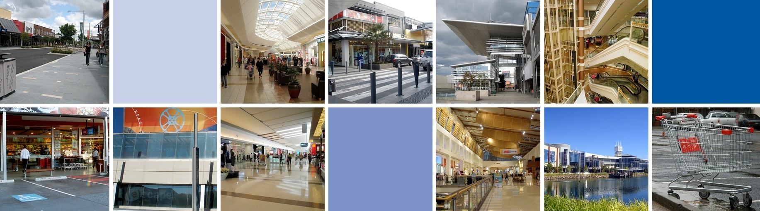

MacroPlan Dimasi

MELBOURNE  Level 4  356 Collins Street  Melbourne VIC 3000  (03) 9600 0500 | SYDNEY  Level 4  39 Martin Place  Sydney NSW 2000  (02) 9221 5211
BRISBANE  Level 15  111 Eagle Street  Brisbane QLD 4000  (07) 3221 8166 | PERTH  Ground Floor  12 St Georges Terrace  Perth WA 6000  (08) 9225 7200

Prepared for: Coles Property Group

MacroPlan Dimasi staff responsible for this report:
Joel Taylor, General Manager
Alexander O’Reilly, Analyst
Jake McKinnon, Analyst

Table of contents

Introduction i
Section 1: Site location and proposed development 1
1.1 Regional & local context 1
1.2 Planning environment 4
1.3 Proposed development 6
Section 2: Trade area analysis 8
2.1 Trade area definition 8
2.2 Trade area population 10
2.3 Socio-demographic profile 14
2.4 Trade area retail spending 18
Section 3: Competition 21
Section 4: Supermarket potential 25
4.1 Supermarket floorspace provision per 1,000 residents 25
4.2 Supermarket retail potential 28
4.3 Consideration of broad trading impacts 32
4.4 Supermarket trade areas 34
Section 5: Net community benefit 37
5.1 Economic and social benefits 37
5.2 Conclusion 40
Section 6: Review of economic assessment 41
6.1 Support for economic conclusions 41
6.2 Alternative economic conclusions 42
6.3 Overall economic conclusions 42
6.4 Response to economic conclusions 44

This page has been intentionally left blank.

Introduction

This report presents an independent assessment of the demand and market scope for the proposed development of a Coles supermarket located in Drysdale.

The report has been prepared in accordance with instructions received from Coles Property and is structured in seven sections as follows:

- Section 1 provides a description of the site, including its location and context within the surrounding region, as well as outlining the relevant planning framework as it relates to the centre. The proposed development of the supermarket is also detailed.
- Section 2 examines the trade area which is relevant to this proposal, including current and projected population and retail spending levels within the trade area.
- Section 3 examines the current and future competitive retail facilities within the surrounding region, and thus the competitive environment which Drysdale faces and will face in the future.
- Section 4 outlines our assessment of the sales capacity and potential for supermarkets within Drysdale.
- Section 5 presents an economic assessment for the proposed store, including considering the likely trading impacts on other supermarkets throughout the surrounding region, as well as the employment and other effects of the proposed development.
- Section 7 highlights the findings of Tim Nott’s review of the January 2013 version of this report. This section reinforces our findings that the Coles proposal creates greater competition and community benefits than the Jetty Road NAC development.

This page has been intentionally left blank

Section 1: Site location and proposed development

This section of the report details the location of the proposed supermarket in Drysdale and the local and regional contexts of the site. The relevant planning environment is reviewed, and the proposed site plans are also detailed.

1.1 Regional & local context
The proposed Drysdale supermarket will be a standalone supermarket located within the Drysdale township, adjacent to the existing Aldi store. Drysdale is a satellite town located approximately 20 km east of the Geelong Central Business District (CBD) and is a popular location within the Bellarine Peninsula (refer to Map 1.1).

The proposed supermarket will occupy a site on Murradoc Road, which is one of the main roads linking Drysdale with St Leonards. Murradoc Road also adjoins Portarlington-Queenscliff Road linking Portarlington residents to Drysdale. The proposed supermarket is surrounded by predominantly retail as well as commercial and bulky goods land to the east. (refer to Map 1.2)

The Bellarine Peninsula is a popular tourist destination, particularly for residents of Melbourne during the weekend and over the summer holiday period. Furthermore, strong population growth continues to occur on the Bellarine Peninsula, with Curlewis being identified as a key growth area (west of the Drysdale urban area) as well as Ocean Grove and Leopold.

Drysdale is currently serviced by a Woolworth’s supermarket at Drysdale Village to the west of the site; and an Aldi supermarket located adjacent to the proposed store. Surrounding areas such as Portarlington and St Leonards are currently served by small supermarkets and convenience stores.

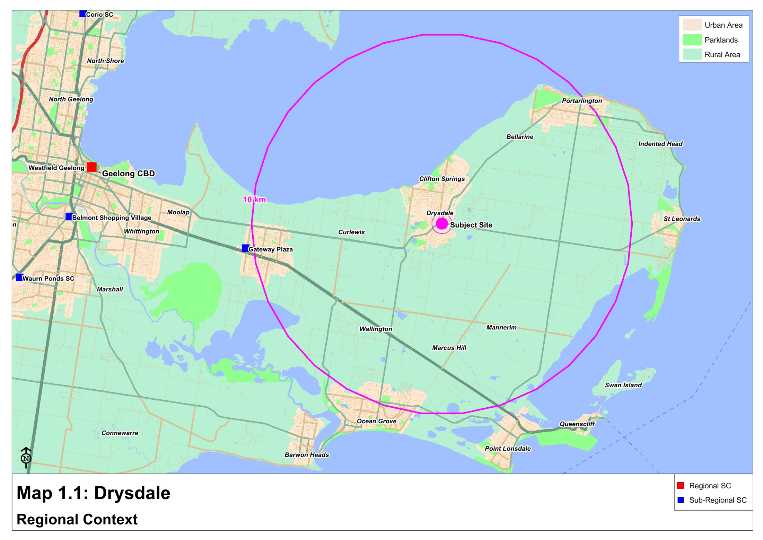

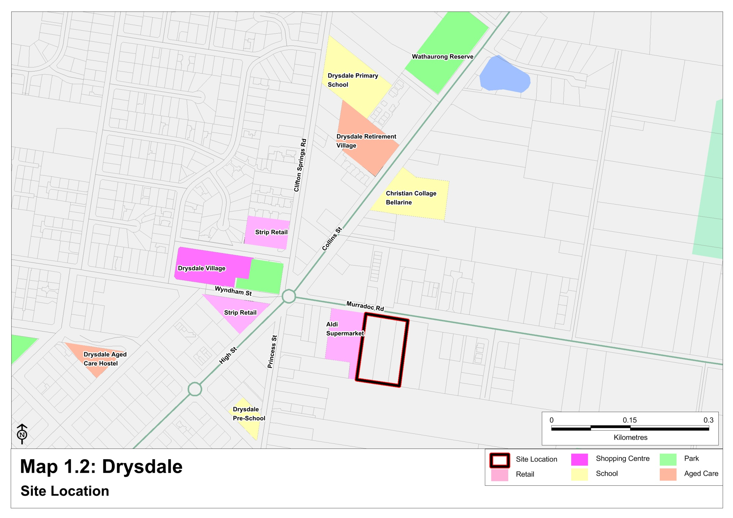

1.2 Planning environment
The Drysdale Clifton Springs Structure Plan (the Structure Plan) was adopted by the City of Greater Geelong in September 2010. The purpose of the Structure Plan is to provide a strategic framework and vision for the future planning and development of Drysdale and Clifton Springs. The vision of the Structure Plan is to be delivered by:

- Providing opportunities for better utilisation of existing business zoned land and limited expansion of the shopping centre, in a manner which retains its country town character and is respectful of its heritage elements;
- Identifying traffic improvements to key routes including advocating for a future By-Pass;
- Providing for local tourism and employment opportunities.
The Structure Plan also states that Drysdale Clifton Springs is a town that has high growth capacity and as such it has been designated as one of the urban growth areas for the Bellarine Peninsula. The Structure Plan draws on a number of previous reports including:
- The Jetty Road Urban Growth Area Plan 2007
- Melbourne 2030
- City of Greater Geelong Housing Diversity Strategy 2007
- City of Greater Geelong Rural Land Use Strategy 2006
- Bellarine Peninsula Strategic Plan 2006-2016
- Geelong Retail Strategy 2006
The Structure Plan identified the need to improve the functionality and layout of the Drysdale Town Centre given the town is expected to grow by approximately 13,913 people over the next 20 to 30 years.

The Draft Drysdale Urban Design Framework (UDF), June 2012 facilitates the development of the Drysdale Town Centre by providing direction in relation to:

- Efficient utilisation of existing business zoned land and maximising site development opportunities.
- Building forms which contribute to a desired heritage and village characteristics;
- Concepts for key development sites within the Centre.
The Draft Drysdale UDF specifically recommends the development of a full line supermarket along Murradoc Road, in addition to the Aldi store. Reasons for this recommendation are as follows:

- The land is currently vacant and will result in a natural transition of business uses further towards the east of the town centre.
- The site was considered better able to accommodate a full line supermarket and provide an appropriate interface with Aldi and Murradoc Road by providing a large shared car parking space.
- The investigation revealed an opportunity to create a possible north-south road connection into the new residential estate to the south (Drysdale Walk), which would provide a new street to limit any impact on the existing street network of Drysdale.
- The site is also considered an appropriate location for a supermarket because of the long term role Murradoc Road will place as an entrance to the town due to the Drysdale Bypass.

1.3 Proposed development
The proposed development consists of a standalone 3,892 sq.m supermarket (including liquor) with car parking for 146 vehicles. The proposed store is situated adjacent to the Aldi supermarket and will assist in extending the town centre further to the east along Murradoc Road. The proposed development includes:

- Sufficient car parking of 158 spaces, including 4 disabled parks.
- Two vehicle entry and exit points along Murradoc Road.
- One pedestrian pathway along Murradoc Road.
- The loading dock situated on the eastern side of the supermarket.
Figure 1.1 below illustrates the proposed layout of the supermarket.

Figure 1.1

Section 2: Trade area analysis

This section of the report details the trade area that would be served by the proposed Drysdale supermarket, including current and projected population and spending levels, as well as the socio-demographic profile of the trade area population.

2.1 Trade area definition
The Drysdale trade area has been defined taking into account the following key determining factors:

- The location of the proposed Drysdale supermarket on Murradoc Road, which is the main traffic route from St Leonards into Drysdale. The site is also located in the centre of Drysdale township marking it easily accessible for surrounding residents as well as for the holidaymakers to the region.

- The development of the proposed supermarket in close proximity to the existing Woolworths and Aldi supermarkets serving the trade area.

- The location, role and function of competitive supermarkets within the Bellarine Peninsula, as well as proposals for any future additions.

Given these factors, the trade area defined for the proposed Drysdale supermarket includes a main trade area, as shown on Map 2.1, The Main trade area acknowledges that Drysdale is currently one of the key centres serving the Bellarine Peninsula, and particularly the townships of Drysdale, Clifton Springs, Curlewis, Bellarine, Portarlington and St Leonards.

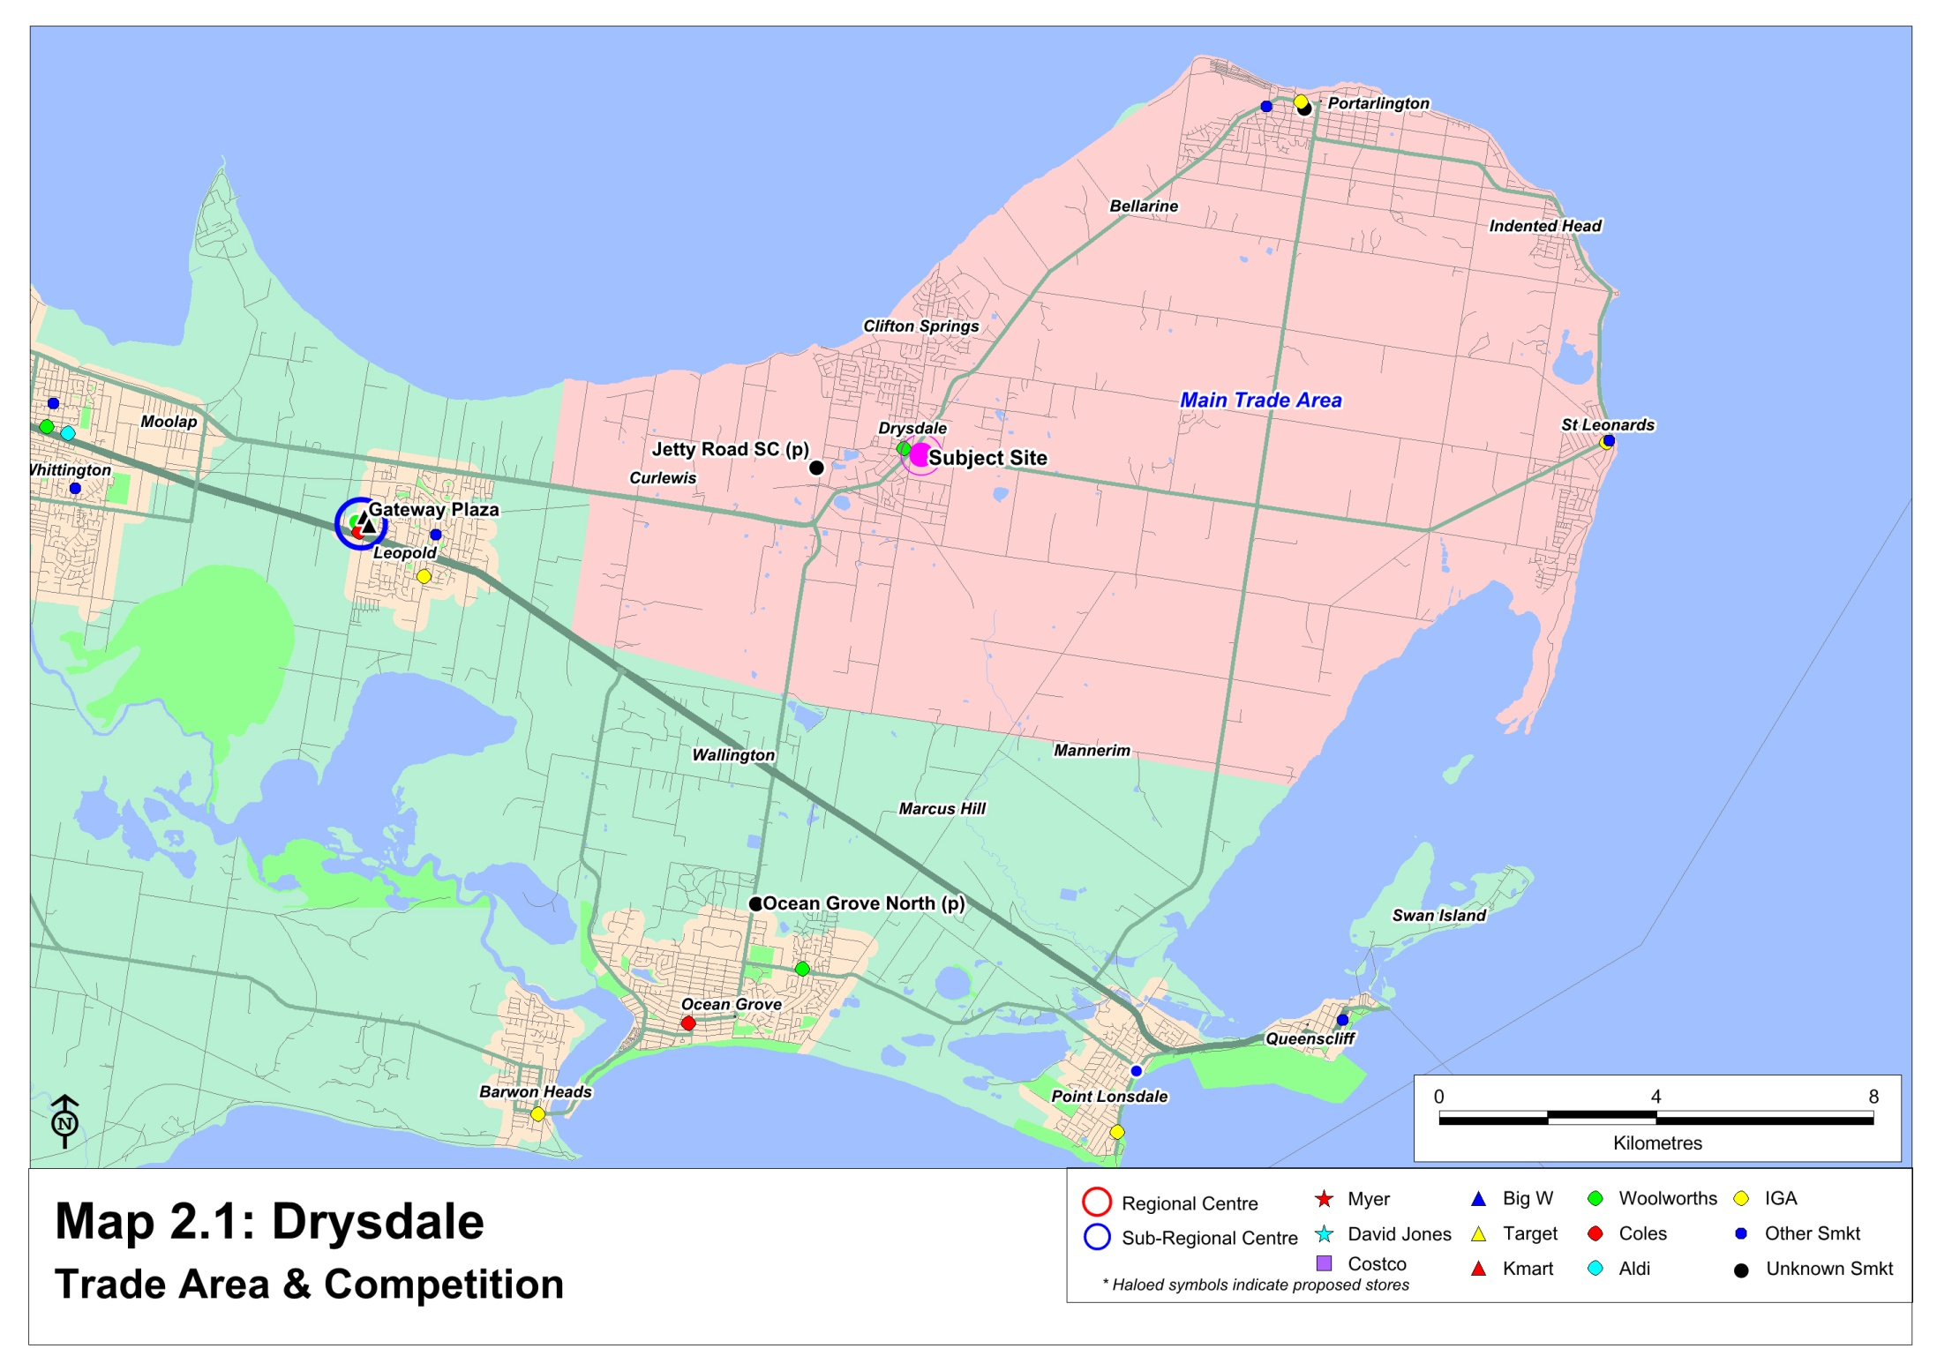

2.2 Trade area population
Table 2.1 attached details the recent and projected population levels within the Drysdale main trade area. Population trends and forecasts for the trade area population have been based on the following:

- The recently released 2011 Census of Population and Housing by the Australian Bureau of Statistics (ABS).
- Population projections prepared by the Department of Health and Ageing, last revised in 2009.
- Forecast.id population projections prepared for the City of Geelong, which were updated in April 2012.
- Investigations of residential development throughout the region, undertaken by this office.
- Discussions and site visits of surrounding residential developments, including residential estates within the Jetty Road growth area.
As shown, the current main trade area population is estimated at around 18,900 people at 2012 and therefore offers a sizeable local catchment. On this basis, the main trade area population is projected to increase by some 400-550 people per annum on average over the period to 2026 reaching a total catchment of around 25,800 people. This reflects an average increase of 2.3% per annum over the forecast period.

The majority of the population growth in the main trade area is expected to be accommodated within Drysdale / Curlewis and the Bellarine Peninsula (refer Map 2.2). The major residential estates in the surrounding area including the following:

- One of the residential developments in Drysdale is Woodville Street Estate, which has capacity for around 200 dwellings. The estate is situated immediately south of the proposed site. Other developments within the Drysdale area include Central Road East with 95 dwellings, Wyndham Thomas has 125 dwellings and Chevy Avenue has 93 dwellings.
- Other estates in the main trade area include Seabreeze Estate, Seachange Estate and Edwards Point which are located within St Leonards; the Arlington Rise estate, which is situated in Portarlington; and Flinders View Drive and Ada Thomas in Clifton Springs.
- The Jetty Road growth area is located immediately west of the existing Drysdale urban area and is planned to accommodate some 3,300 dwellings at capacity. A number of residential estates are currently underway in the eastern part of this growth area, including Bayview on the Bellarine, Baywater Estate, Curlewis Parks, Coriyule Estate and Bellaview.
Jetty Road Growth Area
The Jetty Road growth area is an important growth area on the Bellarine Peninsula approximately 310ha located immediately to the west of Clifton Springs and immediately to the north west of Drysdale. The Jetty Road growth area is bound by Jetty Road to the east, McDermott Road to the west, Port Phillip Bay to the north and Geelong-Portarlington Road to the south.

The intent for the Jetty Road growth area is to accommodate a large proportion of the growth forecast for the Bellarine Peninsula. This growth is expected to be 3,300 dwellings when fully developed with a population in excess of 8,000 people.

The 2011 ABS census records 99 dwellings and a total of 223 people living in the Jetty Road growth area. This is significantly below the projected growth of the Jetty Road Urban Growth Plan September 2008 which projected an initial provision of approximately 600 lots would be taken up by 2010, with a further 600 lots provided to 2015 and approximately 840 lots provided to 2022.

Whilst there is a supermarket proposed to establish within this growth area over time, on current development patterns a supermarket anchored centre in this growth area is likely some time off. A major supermarket generally requires around 3,000 households before it is developed. With the current growth rate of the Jetty Road growth area it may be at least 10 years until the Jetty Road area has sufficient residents to establish a supermarket-anchored centre.

However, residents within this growth area will continue to have convenient access to supermarket and retail facilities within the Drysdale town centre, located only 2km or around 3 minutes’ drive for existing and future residents.

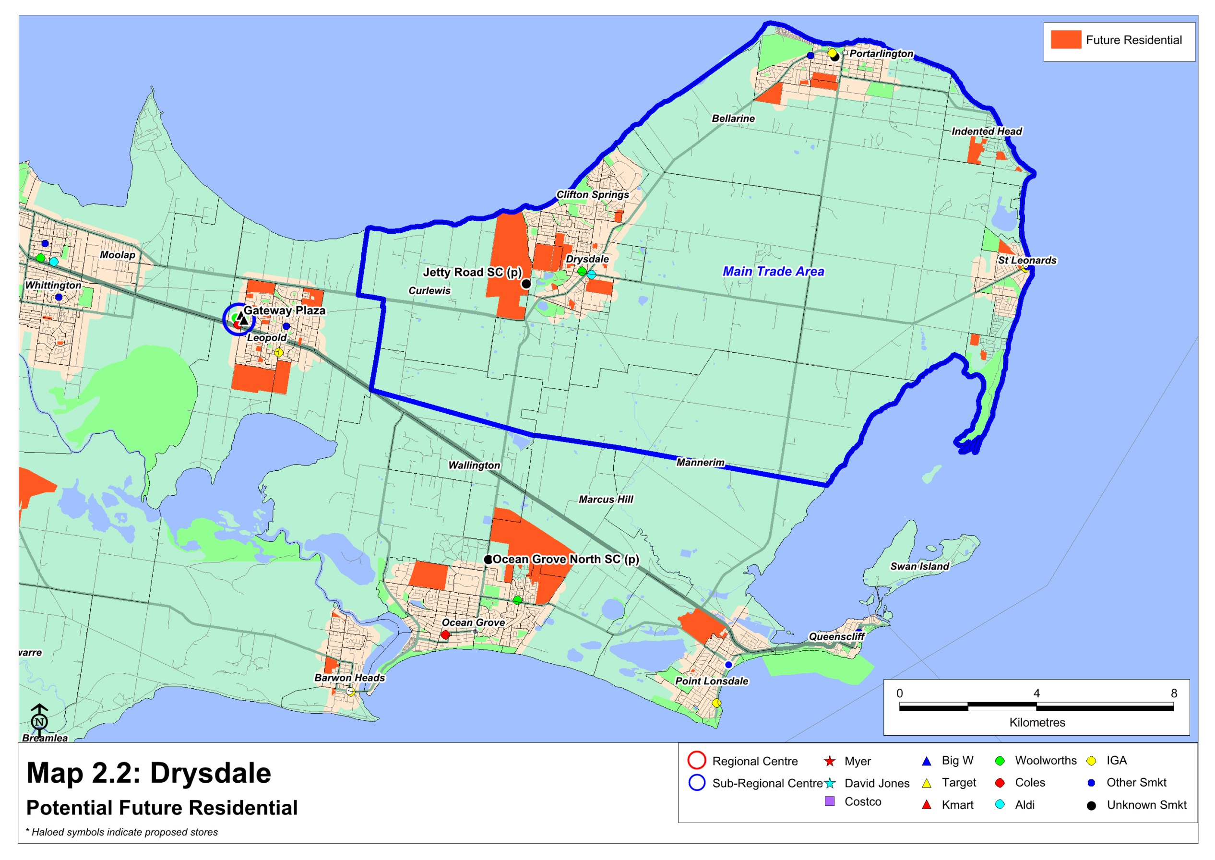

2.3 Socio-demographic profile
Table 2.2 and Chart 2.1 following detail the socio-demographic profile of the main trade area population, compared with the respective benchmarks for Geelong and Australia. The data is sourced from the 2011 Census of Population & Housing, and key points to note include the following:

- The main trade area population has an older age profile compared with Geelong, with a higher than average proportion of residents aged 60 years and over.
- The average income levels of main trade area residents are slightly below on both a per capita and household basis to the respective Geelong averages.
- The overall home ownership level in the main trade area is above the Geelong average.
- The main trade area population has a below average representation of overseas born residents.
- The main trade area consists of a higher than average proportion of households comprised of couples without children.

In addition to the current resident population within the trade area, there is also a significant level of visitors, tourists and holiday makers to the region.

Chart 2.2 following details the percentage of unoccupied dwellings in the main trade area compared to various benchmarks including Geelong & Metropolitan Melbourne as well as Torquay another popular tourist destination.

The number of unoccupied dwellings in the main trade area is significantly higher than both the Geelong and Metropolitan Melbourne benchmarks due to the popularity of the Bellarine Peninsula with holiday homes. This results in existing and proposed supermarkets within the trade area to generate a significant level of sales from beyond the resident population, particularly during peak periods where supermarkets may be operating at above capacity levels. It is estimated that the beyond trade share for supermarkets within the trade catchment could range from 20% - 30%. This is attributed to visitors, tourists and holiday homes, which on the Bellarine Peninsula during peak periods (summer, particularly during the 6 week of the Christmas school holidays) can account for up to 62% (67,825) of the peak overnight population. This compares with non-tourist areas where beyond trade accounts for only 10% - 15% of sales.

2.4 Trade area retail spending
The estimated retail expenditure capacity of the Drysdale main trade area population is sourced from MarketInfo, which is developed by Market Data Systems (MDS) and utilises a detailed micro simulation model of household expenditure behaviour for all residents of Australia. The model takes into account information from a wide variety of sources including the regular ABS Household Expenditure Surveys, national accounts data, Census data and other information. The MarketInfo estimates for spending behaviour prepared independently by MDS are commonly used by all parties in economic assessments.

Chart 2.3 attached presents a comparison of the retail spending behaviour of main trade area residents with Geelong averages. The estimated level of total retail spending per person across the main trade area is $12,092, generally in line with the Geelong average. Spending is slightly above average for food (+0.1%) and slightly below for non-food (-0.8%). All retail spending estimates detailed in this report include GST.

Table 2.3 following summarises the total retail spending capacity of the main trade area population, for the period from 2012 to 2026. Spending forecasts presented in this analysis are expressed in constant dollars (i.e. excluding inflation) to understand the real potential for all operators within the trade area.

Based on this and allowing for population growth as identified in the section 2.2, total retail spending generated by the main trade area population is currently estimated at $226 million and is projected to increase to over $342 million by 2026, reflecting an average increase of 3.0% per annum in real terms.

Table 2.4 then presents total retail spending by the main trade area population across key retail commodity groups. Take-home food and packaged liquor (FLG) spending by trade area residents (which is the key segment of the retail market for supermarkets) is estimated to increase by $57 million over the same period to reach nearly $165 million by 2026.

Section 3: Competition

This section of the report reviews the competitive structure within the surrounding region. Table 3.1 below summarises the competitive context of the surrounding region, while the previous Map 2.1 shows the locations of the main competitive retail facilities.

Within the trade area
Retail facilities in Drysdale are currently limited to the existing Drysdale Village and Aldi stores, as well as two small strip centres. The strip centres are located on High Street to centre of town and on Clifton Springs Road to the north of the town centre. Both include a limited number of convenience oriented specialty shops and services.

There are two small IGA supermarkets (380 sq.m and 300 sq.m) and strip retailing along Newcombe Street in Portarlington to the north east of the proposed supermarket servicing the convenience needs of the residents.

St. Leonards also offers a small provision of retail shops on Murradoc Road together with a small Foodworks & liquor store and a new IGA supermarket.

A Woolworths supermarket of 1,533 sq.m has been developed on Brown Street in Portarlington, and has recently opened (November 2013). The supermarket provides a mid-sized facility and serves the local and visitor market.

Beyond the trade area
Most of the towns throughout the Bellarine Peninsula include either a supermarket or a smaller foodstore, together with a provision of mainly convenience oriented specialty shops and services. The following summarises the various provisions:

- Ocean Grove is the largest town on the Bellarine Peninsula and also provides the largest provision of retail floorspace, estimated at 17,000 sq.m. The Ocean Grove town centre includes a Coles supermarket as well as a range of retail facilities on The Terrace, while a small shopping centre is located immediately to the north and includes a Target Country store. Ocean Grove Marketplace is anchored by a Woolworths supermarket and is located in the north-eastern part of the town on Shell Road.
- Barwon Heads contains a small provision of strip retailing on Bridge Road and Hitchcock Avenue, including an IGA foodstore.
- Point Lonsdale includes a small IGA plus Liquor foodstore and a small provision of specialty shops and cafes, while the Queenscliff town centre is focused on Hesse Street and contains a small Foodworks foodstore together with supporting specialty stores and a number of cafes.
Proposed future competition
There are a number of supermarkets that are proposed to be developed within the trade area to serve the population growth, described as follows:

- The Jetty Road growth area in Curlewis (west of Drysdale) is planned to incorporate a 3,200 sq.m supermarket in a shopping centre comprising up to 6,000 sq.m of floorspace.
Beyond the trade area, the proposed retail facilities are generally of minimal competitive relevance to Drysdale however includes the following:

- A new shopping centre is to be developed over the medium term in the northern growth area of Ocean Grove, and is currently planned to include up to 7,000 sq.m of retail floorspace. The centre is likely to be anchored by a supermarket and also include a range of supporting specialty stores. The site for the centre is situated on the eastern side of Grubb Road, within the Kingston Downs Estate.
- Leopold currently serves as a neighbourhood shopping centre and is approved to provide for discount department store/s, a second supermarket, and a range of other retail and non-retail facilities. Based on previous work completed by MacroPlan Dimasi the undersupply of retail floorspace exceeds the supply additions from this development.

Section 4: Supermarket potential

This section of the report presents the sales capacity and potential for supermarkets within Drysdale. The performance of any particular retail facility, be it an individual store or a collection of stores, is determined by a combination of the following factors:

- The quality of the facility, with particular regard to the major trader / traders which anchor the centre; the strength of the tenancy mix relative to the needs of the catchment which it seeks to serve; the physical layout and ease of use; the level of accessibility and ease of parking; and the atmosphere/ambience of the centre.
- The size of the available catchment which the centre serves, which determines the upper limit to the likely sales potential achievable by any centre or store.
- The locations and strengths of competitive retail facilities and the degree to which these alternative facilities are able to effectively serve the needs of the population within the relevant trade area.
The estimation of sales capacity and potential for within Drysdale takes into consideration all of these factors.

4.1 Supermarket floorspace provision per 1,000 residents
The current and proposed level of supermarket floorspace within the trade area provides an important indication of the potential for a greater level of service and supermarket floorspace within the trade area.

The estimated provision of supermarket floorspace per 1,000 residents throughout Australia at present is around 320 - 350 sq.m. There are no official figures measuring retail floorspace on a national basis, with the Australian Bureau of Statistics having ceased the 5-yearly Retail Census in 1991/92.

However, having regard to data previously available from retail censuses, and also allowing for the amounts of retail floorspace which have been built over the past 15 years, a figure in the range of 320 – 350 sq.m is a robust estimate, with the this level of provision is estimated to have increased by 1% – 1.5% annually over the last 20 years. However, in developing urban areas, the average can be closer to 400 - 450 sq.m per 1,000 residents.

The steady increase in retail floorspace per capita has been driven by both supply and demand factors. On the demand side, the real incomes of Australian residents have improved steadily over this period, due to the robust health of the Australian economy. Increases in real incomes have translated into growing demand for retail goods and services.

On the supply side, development trends within the retail industry have seen new store types introduced on an ongoing basis to improve consumers’ amenity and shopping experience, as well as to differentiate stores from the competition. Supermarkets have got larger and shopping centres have steadily increased in size.

Based on the analysis presented in Section 2, the current resident population within the Drysdale trade area is estimated at around 19,000 residents, with existing supermarket floorspace in the trade area at around 5,700 sq.m, the current supermarket floorspace provision per 1,000 residents is around 300 sq.m in the Drysdale trade area.

Given the continued population growth and accessibility throughout the region, we estimate the potential supermarket floorspace per 1,000 residents should be at least 400 - 500 sq.m in Drysdale, if not higher to ensure capacity of supermarkets to serve residents and visitors during peak holiday periods.

A slightly higher than average provision in Drysdale is not only supportable but also necessary because in such locations there is usually a minimal representation of alternative fresh food retail outlets – the preferences of residents are geared to supermarkets far more than is the case in built up metropolitan areas.

A higher than average provision can also be attributed in a market where all major supermarket tenants are represented. Currently, there is no Coles supermarket within the trade area, with the nearest Coles store being located in Leopold and Ocean Grove. The development of a Coles store in Drysdale will result in all major competitive operators being represented in the trade area, which may in turn create a more competitive market and allow for a higher than average provision of supermarket floorspace due to this competition.

4.2 Supermarket retail potential
The following analysis presents a projection of the estimated supermarket potential within the main trade area.
It is reasonable for the purposes of this analysis, therefore, to consider the likely broad changes in competitive circumstances, and in particular the changes in availability of retail spending for all Drysdale supermarkets, that can reasonably be expected to result from the development of the proposed Coles supermarket, and then estimate the potential for the store.
These broad changes effectively set the market conditions within which the competitive supermarkets will operate as a result of this development, and reasonable conclusions can then be drawn about the possible broad changes on market conditions.
Table 4.1 illustrates the estimated supermarket potential for all trade area supermarkets, both with and without the proposed Coles development as assumed in 2018 at 3,892 sq.m of supermarket floorspace (including liquor).
The estimation of sales potential for the supermarkets firstly considers the appropriate expenditure market, which in this case is the take-home food and grocery (F&G) market. The typical proportion of this expenditure directed to supermarkets is then assessed. Finally, the market shares of this retail expenditure market are estimated for each sector of the main trade area, while a proportion of business captured from beyond the trade area is also allowed for.
The estimated potential sales for the supermarkets with the main trade area are based on the following key points:

- Supermarkets generate almost all of their sales from the take-home food and grocery (F&L) expenditure market, which is detailed in Section 2 of this report. The available F&G spending generated by the main trade area population is currently estimated at $109 million at 2014, and is expected to increase to nearly $165 million by 2026.
- The available retail spending market of the main trade area population is projected to increase solidly by 3.0% per annum from 2012 to 2026 (in real terms).
- In general, Australians direct around 70% – 80% of food and grocery spending to supermarkets. This ratio does vary from location to location and is dependent upon the provision of supermarkets within the particular area or region. The likely share directed to supermarkets is expected to be at the higher end of this range for the Drysdale main trade area population as there is a lower provision of fresh food options, such as major food markets, in the region.
- Overall, we consider that at least 65% of the total F&G spend is currently retained within the trade area, and with the proposed Portarlington supermarket (assumed in 2014) and proposed Coles Drysdale (assumed in 2018), we forecast this could increase to 75%. The remaining 25%-35% represents expenditure which would escape (in net terms) to facilities located outside the main trade area, such as at Leopold or Geelong.
- Additionally, an estimated 25% of total supermarket sales are likely to be generated from beyond the defined trade area reflecting visitors and passing trade, this beyond trade area spending is driven largely by tourism in the area. During peak tourism overnight population numbers more than double, and on average each visitor spends $164 per day, of which 5.4% is directed towards supermarket spending. A further 7.5% general merchandise (i.e. non-food and grocery items generally provided for within supermarket). Once again, the proposed stores are likely to slightly increase these figures.
The steps detailed above allow the calculation of the annual estimates of food and grocery spending available to main trade area supermarkets.
On this basis, the current food and grocery spending available to supermarkets is estimated at $83.5 million and is projected to increase to $111.4 million in 2018 when the proposed store is assumed to be fully operational.
The indicative average trading figures shown in table 4.1 also highlight the relative strength of the trade area, with all supermarkets estimated to be currently trading at a very healthy $14,429 per sq.m, and forecast to remain at $9,680 by 2015 with the introduction of the Woolworths supermarket, then at $7,863 with the introduction of the Coles supermarket.
The primary conclusion, therefore, is that a substantial volume of food and grocery expenditure which is directed to the various supermarket facilities serving trade area residents, both within and outside the trade area boundaries.
The total volume of food and grocery expenditure in Drysdale is growing significantly year on year, driven by steady population growth, visitor/holiday maker spend and by some real growth in retail expenditure capacity per person.
Table 4.2 then details our estimated sales potential of the proposed Coles supermarket at Drysdale introduced in 2018. Forecast sales are expressed including GST.
Such projections are estimated given the difficult to predict with certainty the precise sales capture and draw from existing supermarkets (i.e. transfer from nearby Woolworths and Aldi stores and Coles Leopold) that will result from the change of retail structure serving the region.
Overall, we consider that at least 25% of the main trade area resident spend to supermarkets will be directed to the proposed Coles supermarket once its completion in 2018. With the addition of some beyond trade and generally merchandise, the total sales potential for the proposed Coles Drysdale is estimated at $27.8 million or $7,644 per sq.m in 2018. The ultimate sales potential for the proposed Coles store will obviously depend on the store design, layout and accessibility.

4.3 Consideration of broad trading impacts
The nature of impacts and the response of retailers in a normal competitive environment is a pertinent point to understanding likely trading impacts. MacroPlan has reviewed the relevant supermarket locations used by trade area residents to determine the extent of the impact of a new supermarket. We note that the distribution of supermarket turnover within the development is considered separately based on maintain sustainable trading levels as detailed in section 4.2.

The impacts represent a diversion of trade from competing locations to the proposed development. These impacts reflect a one-off effect on supermarkets and following this impact, supermarkets would be expected to continue to experience growth in line with the market growth forecast for the area.

As indicated in the table above, existing supermarkets are estimated to be trading at a very healthy $9,124 per sq.m. Even with the proposed supermarkets at Jetty Road and Coles Drysdale, the existing supermarkets are forecast to trade on average at around $8,000 per sq.m. Accordingly, the impacts estimated are not detrimental to the future of any of the existing supermarkets, as $7,500 per sq.m is considered acceptable and a sustainable trading level.

Furthermore, the estimated impacts represent a theoretical impact, with the actual impact on existing traders highly dependent on the success and operation of each store. It is highly probable that a successful operator, such as the existing trade area supermarkets, will retain a high proportion of existing sales, with the implied impact likely to be less. Of course, if existing customers are not satisfied with their current supermarket experience, they are likely to alter their shopping habits to a new store.

In general, the supermarket facilities within the trade area and in the surrounding region are understood to trade strongly, and therefore any impacts which are experienced would not be expected to affect the ongoing viability of any operators.
Some trading impacts would be experienced by the existing supermarket operators outside the trade area. In all likelihood the greatest at the existing Coles store in Leopold, given brand loyalty such an operator achieved, with relatively small impacts on other operators. How this translates from a trade catchment perspective is explored in the following section.

4.4 Supermarket trade areas
Drysdale, and the greater Bellarine Peninsula, have a range of supermarkets with individual catchments. An analysis of supermarket trade area catchments for the proposed Jetty Road Woolworths and the proposed Coles Drysdale has been illustrated on the following page.

Coles catchment (Drysdale)
Given the low provision of full-line stores in the Bellarine Peninsula, the catchment for the full-line Coles store (3,892 sq.m) is significant. Residents in the catchment (including those as far as Portarlington and St Leonards) will save 25km in their trip to the closest full-line supermarket when Coles Drysdale is available.

The Coles store at Drysdale will be their only representation in the area (eastern portion of the Bellarine Peninsula), with the closest Coles stores over 10km in distance. Those residents who prefer the Coles brand will have a reduced drive for their weekly shopping needs.

The location of the proposed Coles Drysdale store is conveniently located in the heart of town, meaning residents from coastal townships such as Portarlington, Indented Head and St Leonards can easily access the store.

Woolworths catchment (Jetty Road)
It is understood that the proposed supermarket at Jetty Road is 3,200 sq.m. A supermarket of this size will effectively duplicate the offer of the existing Woolworths in Drysdale of 2,757 sq.m. Given the scale and location of the Jetty Road proposal, its trade area is relatively small and predominantly targeted towards servicing future residents in proximate new development areas.

In summary, the catchment analysis of both proposed stores highlights significant differences. The benefits of each store are illustrated on the following map, with the magnitude of benefits correlated to the size of each catchment. On this basis, the Coles Drysdale store provides new services, competition and convenience with a substantial benefit to Drysdale and the greater Bellarine Peninsula.

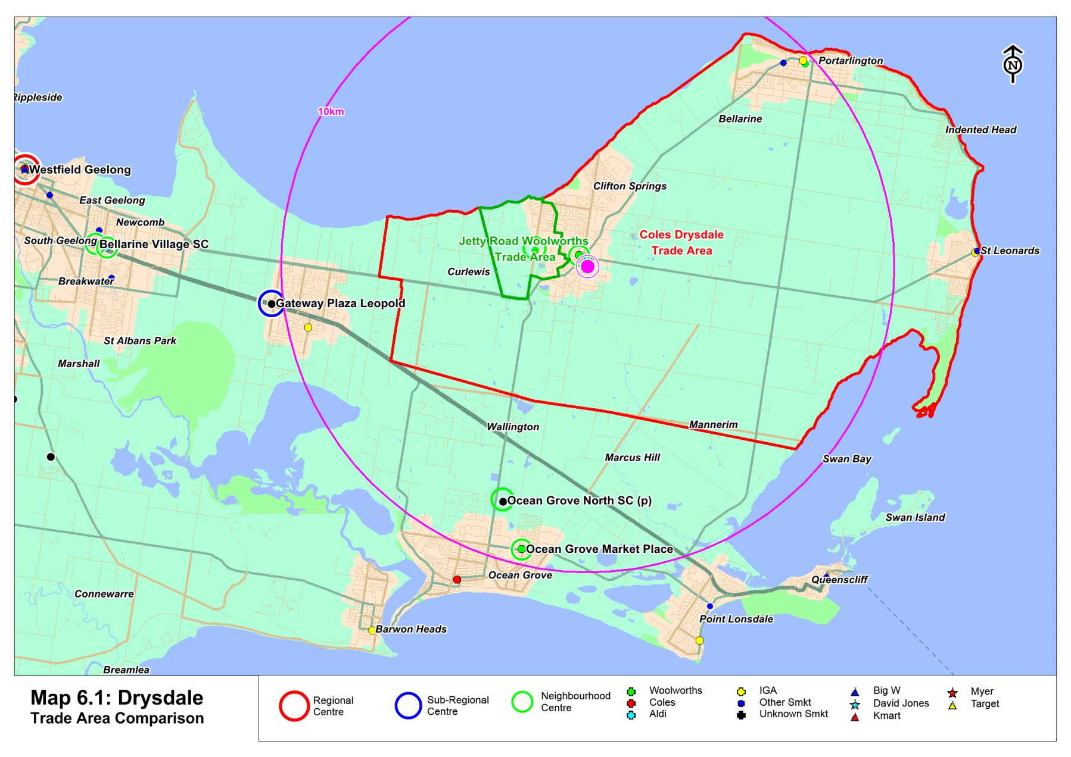

Section 5: Net community benefits

This section outlines the potential economic benefits that can be anticipated following the development of the proposed Drysdale supermarket.

5.1 Economic and social benefits
The introduction of an additional supermarket in Drysdale is likely to result in a range of economic impacts. From a trading point of view, some impacts are likely to be experienced by some competitive facilities throughout and beyond the main trade area (as detailed in section 4.3).

On the other side of the equation, an inclusion of another supermarket operator will result in a significant range of economic benefits. The key positive impacts will include the following:

Catering to the increased population in the trade area

The trade area population is expected to increase by around 7,000 residents over the next 15 years, reaching a population base of more than 26,000 residents by 2026. This population growth will further add to the demand for additional supermarket floorspace on the Bellarine Peninsula.

Greater shopping choice, convenience and amenity

The introduction of a full offer Coles supermarket will provide a greater provision and a wider range of shopping alternatives for local residents, as well as for visitors to the region. The addition of the proposed store will significantly improve the range of supermarkets in the area, provided in a convenient location within the centre of Drysdale.

Many supermarket operators have a range of exclusive line items they sell, hence the introduction of a Coles operator will allow trade area residents access to these lines.

In addition, the additional supermarket will provide a greatly increased level of amenity for the trade area residents and visitors, in line with the achievement of Council strategy such as the Drysdale Urban Development Framework.

Achieving Draft Drysdale UDF outcomes

The development of the proposed Drysdale supermarket will support the direction of the Draft Drysdale UDF, June 2012 for the following reasons:

- The development will assist in the natural transition of business uses further towards the east of the town centre.
- The development will provide an appropriate interface with existing retail facilities such as the Aldi on Murradoc Road by providing a large shared car parking space.
- The development will also assist in the long term role of Murradoc Road as an entrance to the town due to the Drysdale Bypass

Additional employment

The proposed development of Drysdale supermarket will create a number of additional jobs in the region, both for construction and related industries during the construction phase, and for the economy generally once the centre in completed.
Table 5.1 presents an estimate of the likely additional employment that would be generated by the retail component of the proposed Drysdale supermarket. Based on the amount and nature of floorspace to be incorporated in the proposed development, we estimate that 194 ongoing jobs will be created by the proposed supermarket.

It may be argued that some job losses will occur at other centres as a result of the proposed Drysdale supermarket. In estimating the net employment opportunities, we have allowed for 5% of the additional employment that is likely to be created at the proposed supermarket to be absorbed in job losses at other centres, resulting in a projected net employment increase of 185 jobs.

The development of the proposed Drysdale supermarket will also create a substantial number of additional jobs, both for the construction and related industries during the construction phase, and for the economy generally once the supermarket is completed.

5.2 Conclusion
This report has demonstrated the economic and social benefits that are likely to arise from the proposed Coles Drysdale significantly outweigh any impacts that may occur on commercial competitors. These benefits can be further summarised as follows:

- Further establishing and cementing the Drysdale Town Centre as a strong weekly shopping destination serving the Bellarine Peninsula.
- Allowing the town centre to consolidate its retail offer in a co-located and convenience manner.
- The provision of additional floorspace will cater for the forecast population growth within the main trade area.
- Addressing the under provision of supermarket floorspace in the trade area, particularly the lack of representation for a Coles branded supermarket.
- Increased convenience and amenity for the population of the main trade area, in addition to the high level of visitor/tourist and holiday homemakers in the area.
- Ensuring sufficient retail floorspace is made available to meet demand and town centre competition is encouraged.
- A reduction in vehicle kilometres travelled as people are able to access an increased range of retail options (including Coles).
- Stimulating additional employment opportunities and future salary and wage earnings in the local area.
- The proposed Coles Drysdale seeks to achieve the outcomes stipulated in The Draft Drysdale Urban Design Framework (UDF).
Against these benefits, some impacts are projected for existing supermarket operators, as well as for other Bellarine and Geelong supermarket operators more generally. These impacts, however, are not considered likely to threaten the ongoing viability of these existing retailers. Thus, it can be concluded that a significant net community benefit will result from the proposed development of a Coles supermarket in Drysdale.

Section 6: Review of economic assessment

City of Greater Geelong commissioned Tim Nott to provide an independent review of the likely economic impact of the proposal. This included a review of how the January 2013 version of this report (MacroPlan Dimasi) met the requirements of the Geelong Retail Strategy in providing an impact assessment of the proposal.

6.1 Support for economic conclusions
Tim Nott’s review states clear support for MacroPlan Dimasi’s report, as detailed below.
Comments:
- In most respects, MacroPlan Dimasi has addressed the questions raised by the checklist for new developments outlined in the Retail Strategy. (Page 10)
- The method of analysis used by MacroPlan Dimasi is most suited to testing the market viability of the proposed development. (Page 10)
- There is nothing wrong with the trade area set by MacroPlan Dimasi. (Page 11)
- The population of the trade area defined above differs only slightly from that in the MacroPlan Dimasi report. (Page 12).
- My forecast population figures are broadly similar to those used by MacroPlan Dimasi. (Page 18)
- [An assumption of real growth in resident spending of 1% per year] … is broadly consistent with growth expected in the MacroPlan Dimasi report. (Page 18)

6.2 Alternative economic conclusions
Tim Nott’s review also notes some additional economic information to our 2013 version.
Comments:
- The assessment does not estimate the impact on particular centres. This means that it is difficult to understand how the proposal will affect the hierarchy of activity centres serving the Drysdale district and whether any particular centres are at risk of losing their role with a consequent loss of service to affected residents. (Page 10)
- The assessment does not address the existing hierarchy of centres and the flow of resident spending to different levels of the centre hierarchy. In consequence it is difficult to assess how particular centres will be affected by the proposed development and the likely impact on the jobs and services of particular parts of the local community. (Page 10)
- The likely form of the net community benefits of the Coles proposal are well set out in the report by MacroPlan Dimasi, although I disagree with the scale of the benefits identified. (Page 29)

We note that Nott provided these additional components to support his full recommendation which is summarised in the conclusions below.

6.3 Overall economic conclusions
As a summary, Nott’s report concludes that while some information differs between his approach and that provided by MacroPlan Dimasi, the Coles proposal has strong economic justification over the Jetty Road NAC.

Comments:
- In scenario 4, I have assumed that the food and grocery provision at Jetty Road is only 1,800 sq.m. This scenario would probably be supportable with an initial reduction in turnover levels which would gradually return to typical levels with growth in the trade area population and spending. Under this scenario, there would be room to expand the food and grocery provision at Jetty Road as the population in the growth area increased (and this scenario would ensure that the role of the Jetty Road NAC was, as intended in the structure plan, a neighbourhood centre to service the growth area and not the wider Drysdale trade area). (Page 27)
- There would be, nevertheless, a benefit arising from the introduction of more competition and greater choice in the local market. (Page 28)
- In my view, the Coles development in the Drysdale town centre would be in a better position to capture the spending of the trade area because of its more central location and because it is the larger of the two proposed supermarkets. This may mean that:
  - The Jetty Road NAC does not go ahead in its present form or for some years; or
  - Whilst the Jetty Road supermarket opens as planned, the NAC may not be able to sustain specialty food stores such as a baker, butcher, greengrocer etc.; as a consequence, shop units in the development may remain vacant, with adverse consequences on investor confidence and community development. (Page 29)
- From the viewpoint of activity centre policy, the most appropriate solution would be to reduce the size of the Jetty Road NAC so that it served only the Jetty Road Growth Area and surrounds, thereby preserving the role of the Drysdale town centre and the key centre for the trade area. (Page 29)
- Because the Jetty Road Growth Area is far from fully established, in order to be viable, the supermarket would need to service the whole of the Drysdale trade area, effectively competing at the same level as the Drysdale town centre. This is not the outcome intended by the original Jetty Road Structure Plan, which envisaged that the Neighbourhood Activity Centre would serve mainly the Jetty Road Growth Area. (Page 31)
- In a comparison between the two competing supermarkets, I anticipate that shoppers would be more likely to visit the Coles store because it is in the existing town centre, with a broad range of stores nearby; it is slightly larger; and it is more accessible to more people in the trade area. (Page 31)
- The Coles proposal does not appear likely to challenge the role of existing centres in the trade area of elsewhere. The proposal will affect retail sales in surrounding centres, particularly Portarlington, Leopold and St Leonard. However, I estimate that in each case the loss of sales would be less than 5% of total sales, which is well within the 10%-15% loss that is usually considered significant. (Page 31)
- The impact of the Coles proposal on existing food and grocery facilities in Drysdale itself would be severe with potential for a loss of 35% in sales (a 22% of retail sales for the centre as a whole). However, including the Coles development as part of the mix, the retail sales in the centre would rise from $64 million per year to $89 million. The role of Drysdale as a large town centre would be maintained even though there may be some individual store closures. (Page 31)

6.4 Response to economic conclusions
We note that the approved Jetty Road NAC size stated in Nott’s report is 4,444 sq.m including a 3,200 sq.m Woolworths supermarket. This being the case, the impact on trade in the area could be managed in line with Nott’s suggestion of a 1,800 sq.m NAC at Jetty Road. Nott’s recommendation (Page 29) highlights potential to mitigate impacts:

There may be options to mitigate the trading impacts of the Coles proposal by adjusting the development timeframes and sizes of the respective proposals. For example:
- Reduce the size of the food and grocery provision at either Jetty Road NAC or Coles development to something in the range of 1,500 sq.m to 1,800 sq.m.
[underline added]

The above provides a basis to justify the development of Coles subject to the Jetty Road NAC being at a reduced size (anecdotally advised by City of Geelong Council) providing that the centre does not alter the centres hierarchy (i.e. a full-line supermarket).



Economic Indicators. Geelong: Open for Business, Bulletin 2013.

