Coles, 24-26, 28-30 & 32 Murradoc Rd, Drysdale
Stormwater Management Plan

Job Number: CG130621
Prepared for Coles Development Group



Cardno Victoria Pty Ltd
ABN 47 106 610 913
150 Oxford Street, Collingwood
Victoria 3066 Australia
Telephone: 03 8415 7777
Facsimile: 03 8415 7788
International: +61 3 8415 7777
victoria@cardno.com.au
www.cardno.com/victoria

Document Control
Version | Date | Description | Prepared | Reviewed | Principal Approval
Rev 1 | Sept 2013 | SWMP - Draft | CB | HL | HL
Rev 2 | Feb 2014 | SWMP - Final | CB | HL | HL
Rev 3 | Feb 2014 | SWMP – Final | CB | HL | HL

"© Cardno Victoria Pty Ltd All Rights Reserved. Copyright in the whole and every part of this document belongs to Cardno Victoria Pty Ltd and may not be used, sold, transferred, copied or reproduced in whole or in part in any manner or form or in or on any media to any person without the prior written consent of Cardno Victoria Pty Ltd.”

Table of Contents
1 Introduction 3
2 Site Characteristics 4
2.1 Location and Existing Land Use 4
2.2 Existing Site Drainage 6
3 Development Proposal 6
3.1 External Catchments 7
4 100 year ARI Flood Assessment 9
5 Stormwater Quality Management 9
5.1 Objectives 9
5.2 Proposed Treatment Measures 9
5.3 Construction Lineal Bioretention Treatment Bed and 100 year ARI Overland Flow Path 12
6 Stormwater Detention 13
6.1 Site Analysis 13
6.2 Proposed Detention Systems 13
7 Conclusions 13

List of Tables
Table 1: Detention Requirements for the 10 year ARI Flow 13

List of Figures
Figure 1: Locality Plan 4
Figure 2: Site Contour Plan 5
Figure 3: Existing Site Drainage 6
Figure 4: Proposed Coles Development 6
Figure 5: External Catchment Discharging To Site 7
Figure 6: COGG Flood Map 8
Figure 9: MUSIC Model Results 10
Figure 10: Bioretention Lineal Treatment bed (Shown As Green) 11
Figure 11: Bioretention Lineal Treatment bed Section (For Treatment Bed Only) 11
Figure 12: Example Boardwalk 12
Figure 13: Example Boardwalk Section 12

Annexes
Annex 1: Drawing CG130621-C1001 (Layout Plan)

Introduction
Cardno was engaged by Coles Development Group in Sept 2013 to prepare a Site Stormwater Management Plan (SSMP) for the proposed Coles commercial activity centre at 24-26, 28-30 & 32 Murradoc Rd Drysdale. The scope of work for this report is in response to City of Greater Geelong Planning Permit Referral App No 765/2013 C297 dated 05 August 2013 and in particular the items outlined in the report as follows:

- Demonstrate how the proposed Coles development meets each of the drainage related objectives, principles, strategies and polices within the CGG Planning Scheme SPPF, LPPF (MSS and Local Planning Policies) and the Planning and Environment Act.

- The Following report has been prepared to demonstrate the feasibility of proposed development while satisfies the above planning objectives and includes the following information:
  - Site analysis – survey, existing drainage system in and adjacent to the site, existing services, constraints.
  - Location of any waterway corridors, drainage lines, vegetation or bushland.
  - Conceptual drainage design or functional drainage design for the development including layout plans, design details and calculations.
  - Approximate location of pits, pipe sizes, grades and discharge outlet details.
  - On-site detention system and/or retention
  - Details of proposed cut and fill

The abutting / adjoining Aldi development has been excluded from the following site analysis as it drains away from the subject site to a separate discharge outlet via a site specific detention system.
Stormwater detention has been modelled within the Coles subject site only. Expected on site detention volumes and pipe sizes have been proposed to match predevelopment discharge rates to convey water safely to the appropriate location to the existing DN525/DN600 stormwater drain located along the southern boundary of the site noted as Council’s preferred legal point of discharge.
As noted in the Planning Permit Referral the site currently conveys overland flows from the Murradoc Road at the north of the site to the adjoining Central Walk estate to the south via a gully in the centre of the development site, it is proposed that these flows will be redirected through the site in a combination of below ground pipe and above ground bio treatment channel that will provide detention during high site flows and runoff treatment for minor site flows while providing as an overland flow path for less frequent major external flows. This bio treatment channel will provide the following benefits / prerequisites:
- Meet Best Practice stormwater runoff targets for the entire site with the option in the future of including the new road widening (immediate catchment) flows from Murradoc Road.
- Implements a stormwater treatment system that is simple and uses proven natural processes to treat the stormwater while reducing solar thermal mass by splitting the potential urban heat island by introducing a green spine to the hot western façade of the building;
- Provides an aesthetically appealing stormwater treatment system that is incorporated naturally into the surrounding landscape and includes a boardwalk feel;

Site Characteristics

Location and Existing Land Use
The primary subject site is located at 28-30 & 32 Murradoc Rd Drysdale (Refer to Figure 1 below). The total site area is approximately 1.06ha and is currently zoned for business purposes with the Aldi development already in operation at the adjoining site to the west.
The existing site at the location of the proposed commercial development, as shown in Figure 1, has a 2.0m fall from Murradoc Road frontage to the Central Walk estate to rear of the property at the southern boundary.
The site contains a natural depression or flat gully through the centre of the site that receives water from the greater catchment area to the north east of Murradoc Road and conveys the water to the Central Walk estate to south of the subject property (Refer to Figure 2 below)
Figure 1: Locality Plan

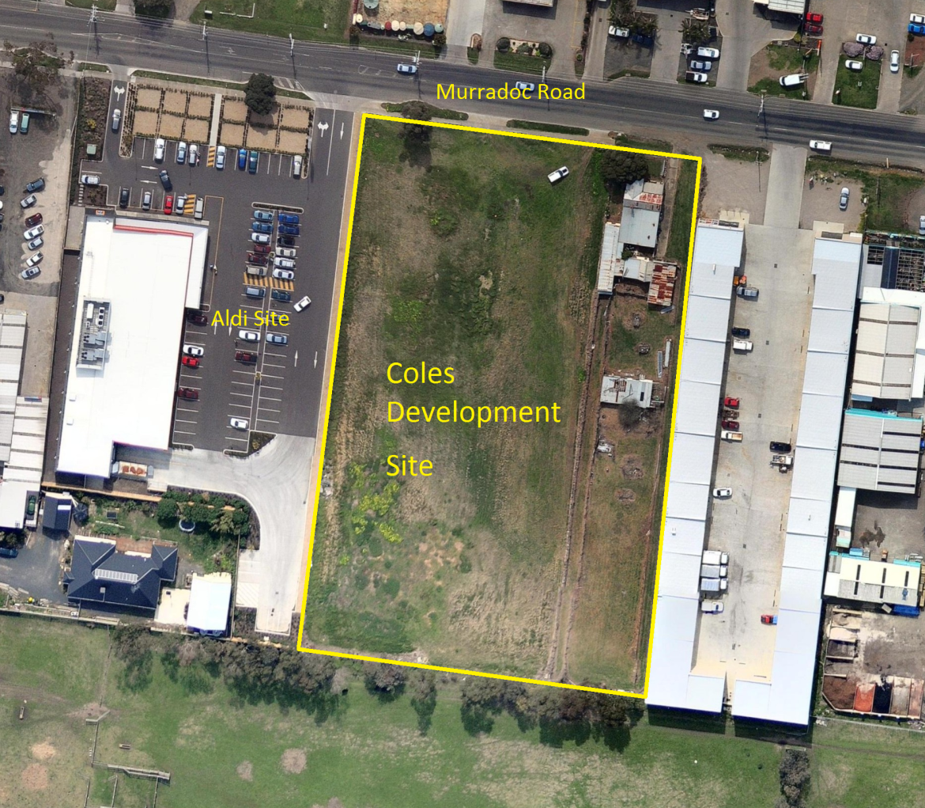

Figure 2: Site Contour Plan

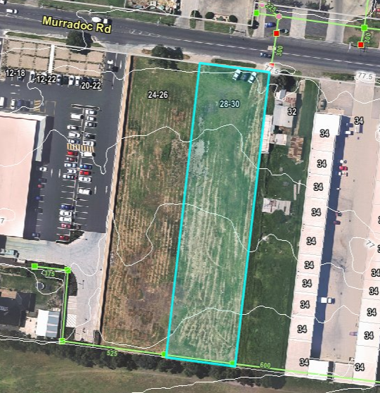

Existing Site Drainage
Figure 3 below shows the existing adjoining stormwater drainage system within and around the site. The nominated legal point of discharge for the site is the existing DN525/DN600 pipe located along the southern boundary with existing pits shown located at the corner of lots 24-26 & 28-30.
Figure 3: Existing Site Drainage
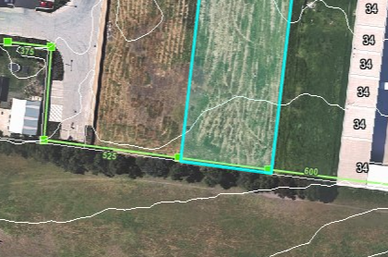
The proposed development will discharge all stormwater to the DN525 at the western corner of the site.

Development Proposal
It is proposed to develop the site for a Coles supermarket. The proposed Coles layout is shown in Figure 4 below.
Figure 4: Proposed Coles Development
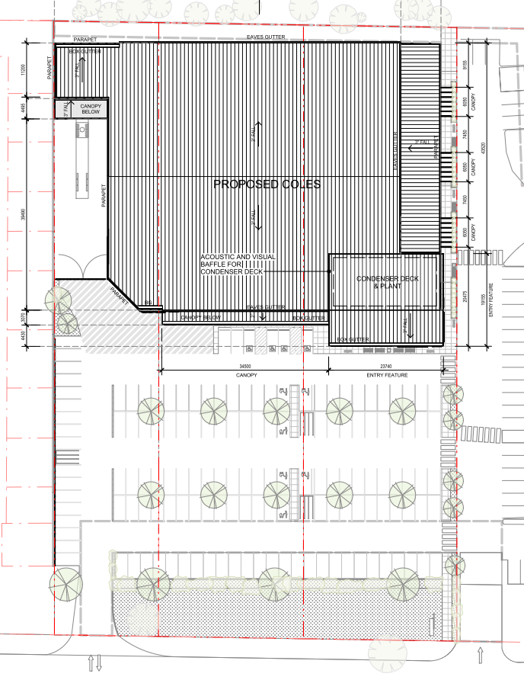

External Catchments
The external catchment that currently discharges through the property is to the north of the subject site and extends to the east and west along Murradoc Road based on Lidar information.The catchment is predominately major open space occupied by small farm allotments and some industrial style lots facing Murradoc Road immediately adjacent the Coles site.
The City of Greater Geelong has indicated that the minor storm runoff from the upstream catchment, once it has been developed, will flow via Murradoc Road as part of the road upgrade widening proposal.
The existing drainage network in the vicinity of the site is designed to capture minor storm events from Murradoc Road and the surrounding area and conveys resulting flows up to a 10 Year event away from the existing properties and the subject site. The main drainage to the front of the site DN525 extends along the opposite side of Murradoc Road heading away from the site to the east prior to heading south under the road and extending through an easement containing DN825 between No. 36 & 38 Murradoc Road. See Figure 5.
The existing drainage currently draining the subject site is the existing DN525/DN600 pipe located along the southern boundary with existing pits shown located at the corner of lots 24-26 & 28-30. This drain heads to the east where it connects with the drainage system from Murradoc Road where it continues as a DN975 past Mortimer Street. See Figure 5.
Figure 5: External Catchment Discharging To Site
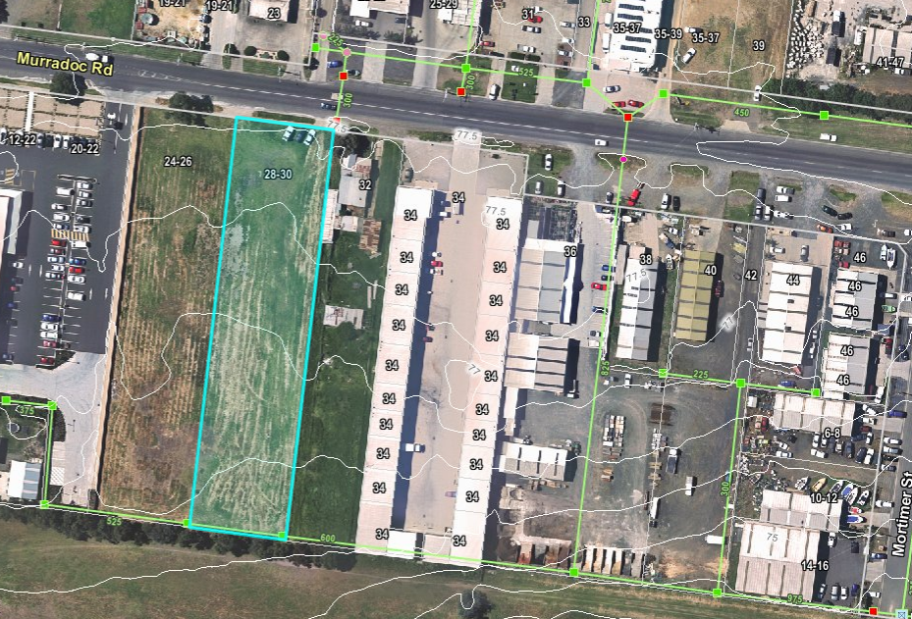
Figure 6: COGG Flood Map
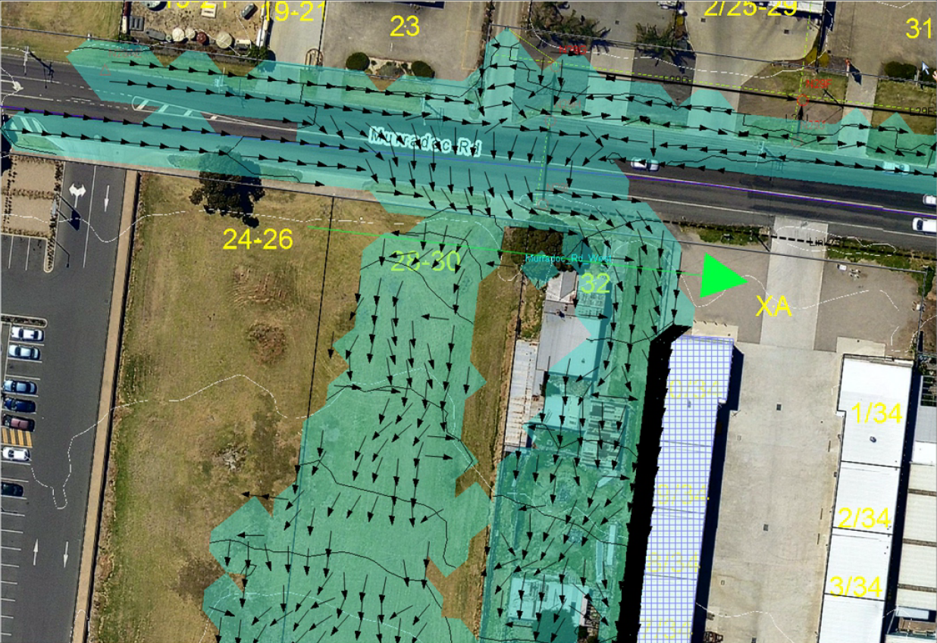

100 year ARI Flood Assessment
Based on the future upgrade road widening works to Murradoc Road it is assumed that all minor storm flows up to and including the 10 year ARI will be redirected away from the site to the existing drainage network located within Murradoc Road With the remaining over land flows discharging through the Coles site.
The calculated flows through the site for the 100yr ARI peak flow as provided by COGG are 0.54m³/sec. See Figure 6.

Stormwater Quality Management

Objectives
The objective of the development with respect to stormwater quality is to treat the stormwater as such it can achieve environmental objectives as stated in Urban Stormwater Best Practice Environmental Management Guidelines (BPEMG). BPMEG objectives for stormwater quality improvement are as follows:
- Reduction of Total Suspended Solid (TSS) : 80%
- Reduction of Total Phosphorous (TP) : 45%
- Reduction of Total Nitrogen (TN) : 45%
- Reduction of Gross Pollutants (GP) : 70%

Proposed Treatment Measures
The model for Urban Stormwater Improvement Conceptualisation (MUSIC) V5 has been used to assess the water quality improvement measures for the development. The modelling was undertaken using City of Greater Geelong MUSIC Guidelines and rainfall from Geelong North Gauge, 1985 at 6min time step.
To achieve best practice levels in accordance with the CGG requirements the following treatment system proposal incorporates a bioretention lineal treatment bed / channel system to receive low flows from the site only, utilising a 3-month flow (Q_{3-month}) of 0.059 m³/s. Flows above the 3-month will be conveyed downstream by via a combination of below ground drainage for up to the 10 year ARI and for the 100 year ARI flows resulting from the upstream catchment and from within the site will be directed to the rear easement via the treatment channel.
MUSIC Modelling has been used to determine the required size for sufficient treatment of the sites stormwater. The model was established using the City of Greater Geelong MUSIC Guidelines. From this exercise the minimum size required is a 50 m long swale with 30 m² inset bioretention system. This treatment system achieves treatment effectiveness as shown in the Figure 7 below, and hence meeting Best Practice Environmental Management Guidelines for total suspended solids, total phosphorus and total nitrogen removal.
Figure 7: MUSIC Model Results
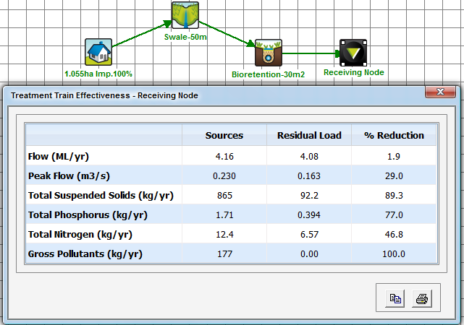
The key parameters of the bioretention swale are as follows:
Parameter
Swale Depth | 0.3m
Vegetation Height | 0.25m
Swale Grade | 1.7%
Bioretention Filter Media Depth | 0.5m
Bioretention Filter Media | Sandy Loam

The selection of this system is suitable for this site considering the current site plan and available space, with the bioretention swale system to be located along the western boundary of the site (right-hand side of the site in the figure 8 below).

Figure 8: Bioretention Lineal Treatment bed (Shown As Green)
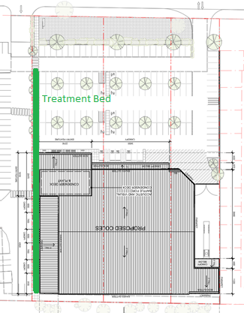

A schematic cross-section of the proposed bioretention swale is shown below.
Figure 9: Bioretention Lineal Treatment bed Section (For Treatment Bed Only)
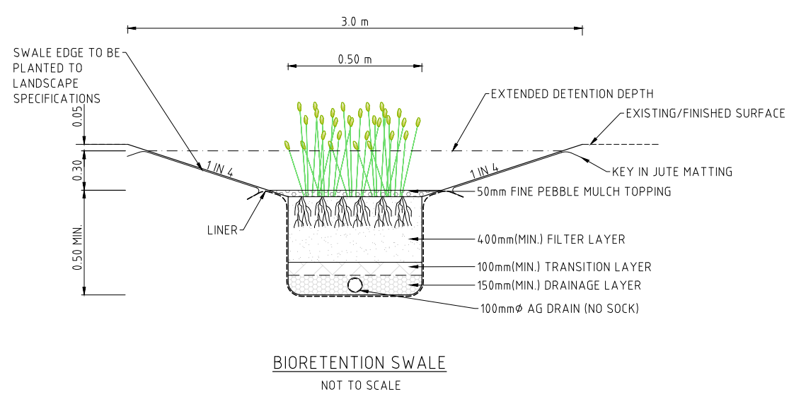
In summary, a bioretention swale of length 35m with a bottom width of 0.8m will meet the Best Practices Guide lines for Water Quality for the site.

Construction Lineal Bioretention Treatment Bed and 100 year ARI Overland Flow Path
The location nominated for the lineal bioretention treatment bed and overland flow path is along the proposed link path connecting to the adjoining Central Walk estate. The overland flows are to be directed from the car park area to the treatment channel and conveyed to the easement at the rear of the property. To enable the construction of the required link path and channel to convey the overland flows a boardwalk type construction is proposed, see Figure 10. The proposed boardwalk / treatment bed provides an aesthetically appealing stormwater treatment system that is incorporated naturally into the surrounding landscape and includes a boardwalk feel that would be in context with the greater peninsular area. Refer Figure 11 for typical section.
Figure 10: Example Boardwalk
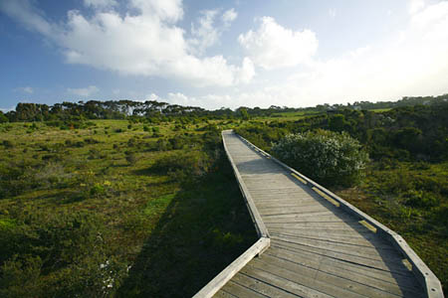
Figure 11: Example Boardwalk Section
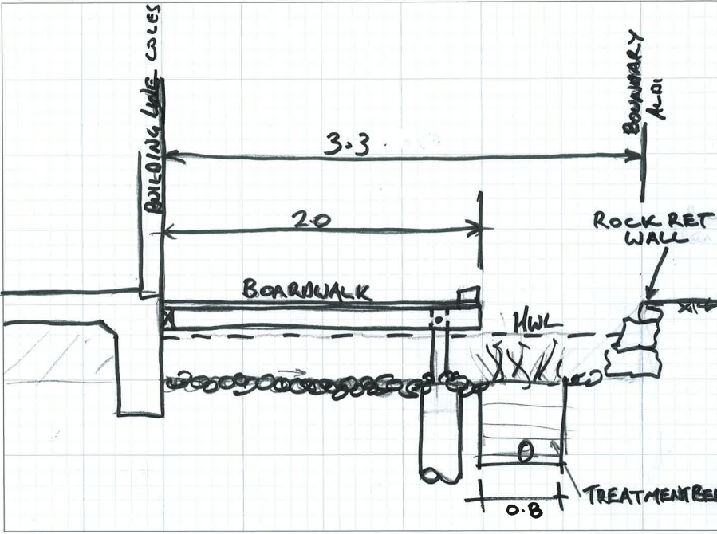

Stormwater Detention

Site Analysis
Based on a site area of 10600m2 and a 10 year permissible site discharge at predevelopment levels the required detention parameters are as follows:
Existing Site Area 10600m2
Run-off coefficient Weighted Ex 0.30
Proposed Site Area 10600m2
Run-off coefficient Weighted Prop 0.9
Required volumes and discharge rates as per Table 1 below.
Table 1: Detention Requirements for the 10 year ARI Flow
Storm Frequency | Pre-developed | Post-developed (total detention basin outflow) | Detention Volume Required within treatment Bed | Detention Volume Required Below Ground
10yr ARI | 0.064 m³/s | 0.064 m³/s | 85.8 m³ | 7.0 m³

Proposed Detention Systems
The proposed detention system is to be a combination of above ground storage located in the biotreatment channel and below ground pipe located under the proposed boardwalk. (Refer to Annex 1 for a larger scale of the proposed site development - Drawing C1001)

Conclusions
This stormwater management for this site provides a combined approach for the treatment of stormwater and overland flow conveyance through the utilisation of the 3.3 wide reserve between the existing Aldi car park and the proposed Coles building where a channel sized to cater for the 100 year ARI will be constructed with a low flow channel area containing the treatment bed, this will allow for a timber Boardwalk to be constructed above maintaining the link walk as a required in the CGG planning report.

Annex 1:
Drawing CG130621-C1001 (Layout Plan)

