

Prepared for
Coles

22 May 2014


Traffic and Transport Assessment

Proposed Supermarket, Drysdale

CG120668

Traffic and Transport Assessment

Proposed Supermarket, Drysdale

CG120668

Document Information
Prepared for Coles
Project Name Proposed Supermarket, Drysdale
File Reference CG120668REP002.docx
Job Reference CG120668
Date 22 May 2014
Contact Information
Cardno Victoria Pty Ltd
Trading as Cardno
ABN 47 106 610 913

150 Oxford Street, Collingwood
Victoria 3066 Australia

Telephone: (03) 8415 7777
Facsimile: (03) 8415 7788
International: +61 3 8415 7777

victoria@cardno.com.au
www.cardno.com
Document Control
Version | Date | Author | Author Initials | Reviewer | Reviewer Initials
F02 | 22/05/14 | Julian Stone |  | Andrew Carr

© Cardno. Copyright in the whole and every part of this document belongs to Cardno and may not be used, sold, transferred, copied or reproduced in whole or in part in any manner or form or in or on any media to any person other than by agreement with Cardno.
This document is produced by Cardno solely for the benefit and use by the client in accordance with the terms of the engagement. Cardno does not and shall not assume any responsibility or liability whatsoever to any third party arising out of any use or reliance by any third party on the content of this document.

Table of Contents
1 Introduction 1
2 Background and Existing Conditions 1
2.1 Location and Land Use 1
2.2 Road Network 2
2.2.1 Murradoc Road (Drysdale - St Leonards Road) 2
2.3 Traffic Volumes 3
2.3.2 Intersection Analysis 4
2.4 Public Transport 5
3 Proposed Development 6
3.1 General 6
3.2 Car Parking and Loading 6
3.3 Vehicle and Pedestrian Access 6
4 Design Considerations 7
4.1 Car Parking and Access 7
4.2 Garbage Collection and Loading 7
5 Loading Considerations 7
6 Bicycle Parking Considerations 8
7 Car Parking Considerations 8
7.1 Car Parking Requirements – Clause 52.06 8
7.2 Case Study Data 8
7.3 Adequacy of Proposed Parking Provision 9
8 Traffic Considerations 9
8.1 Traffic Generation 9
8.2 Traffic Distribution 9
8.3 Traffic Impact 10
8.3.1 Intersection Analysis 10
9 Conclusions 11
Appendices
- Loading Vehicle Swept paths

Tables
Table 2-1 Murradoc Road Traffic Volumes 4
Table 2-2 Rating of Degrees of Saturation 4
Table 2-3 SIDRA Intersection Analysis Summary 5
Table 7-1 Planning Scheme Car Parking Requirements – Clause 52.06-5 8
Table 7-2 Supermarket Parking Survey Summary 9
Table 8-1 SIDRA Intersection Analysis Summary 10
Figures
Figure 2-1 Site Location 1
Figure 2-2 Murradoc Road, looking east towards the subject site 2
Figure 2-3 Murradoc Road, looking west from the subject site 2
Figure 2-4 Murradoc Road/Collins Street/Clifton-Springs Road/High Street Turning Movement Count 3
Figure 3-1 Proposed Car Parking, Loading Area and Access 6
Figure 8-1 Anticipated Development Generated PM Peak Hour Volumes 10

Introduction
Cardno was retained by Coles to undertake a traffic and transport assessment of the proposed Drysdale Supermarket to be located at 26 to 32 Murradoc Road, Drysdale.
In the course of preparing this assessment, the subject site and its environs have been inspected, plans of the development examined, and all relevant traffic and parking data collected and analysed.

Background and Existing Conditions

Location and Land Use
The subject site is located on the south side of Murradoc Road in Drysdale, as shown in Figure 2-1.
          - Site Location
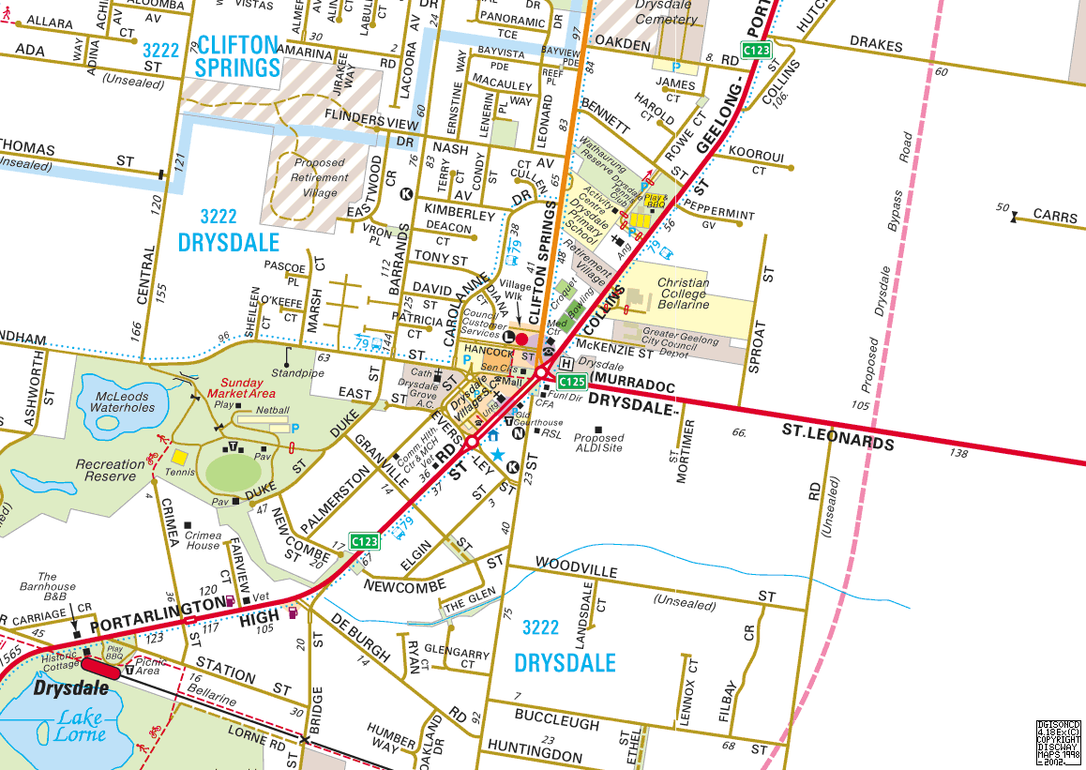
Subject Site
The subject site is currently over three blocks. The east block has a dilapidated dwelling, while the remaining two blocks are vacant. The site has a total of around four vehicle crossings to Murradoc Road. An existing ALDI super market with car park is located immediately adjacent the site to the west.
Land uses surrounding the site, extending along Murradoc Road, are generally commercial developments. A residential estate is proposed to the immediate south.
The two west blocks of the subject site are located mainly within a Business 1 Zone (B1Z), with the east part block within a Business 4 Zone (B4Z), as specified within the Greater Geelong Planning Scheme.

Road Network

Murradoc Road (Drysdale - St Leonards Road)
Murradoc Road, also known as Drysdale - St Leonards Road, is orientated in a general east-west direction between Drysdale and St Leonards. It is identified as a Road Zone-Category 1, under the control of VicRoads.
The road consists of a single carriageway with one lane of traffic in either direction, with kerb side parking provided within the vicinity of the site, as shown in Figure 2-2 and Figure 2-3.
          - Murradoc Road, looking east towards the subject site
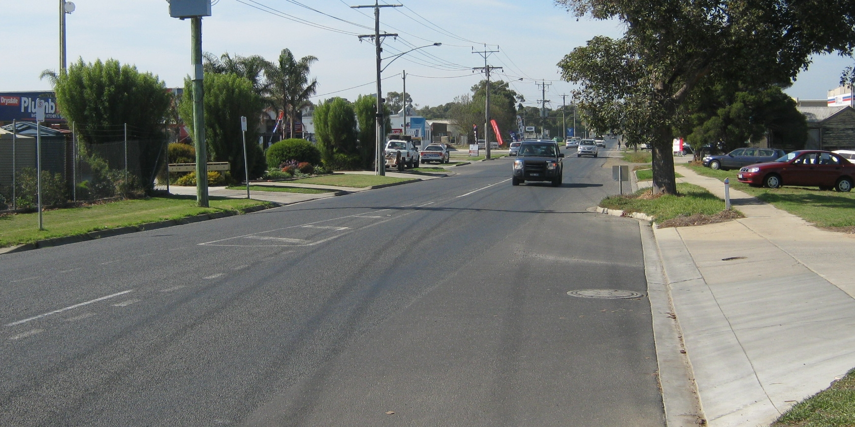
          - Murradoc Road, looking west from the subject site
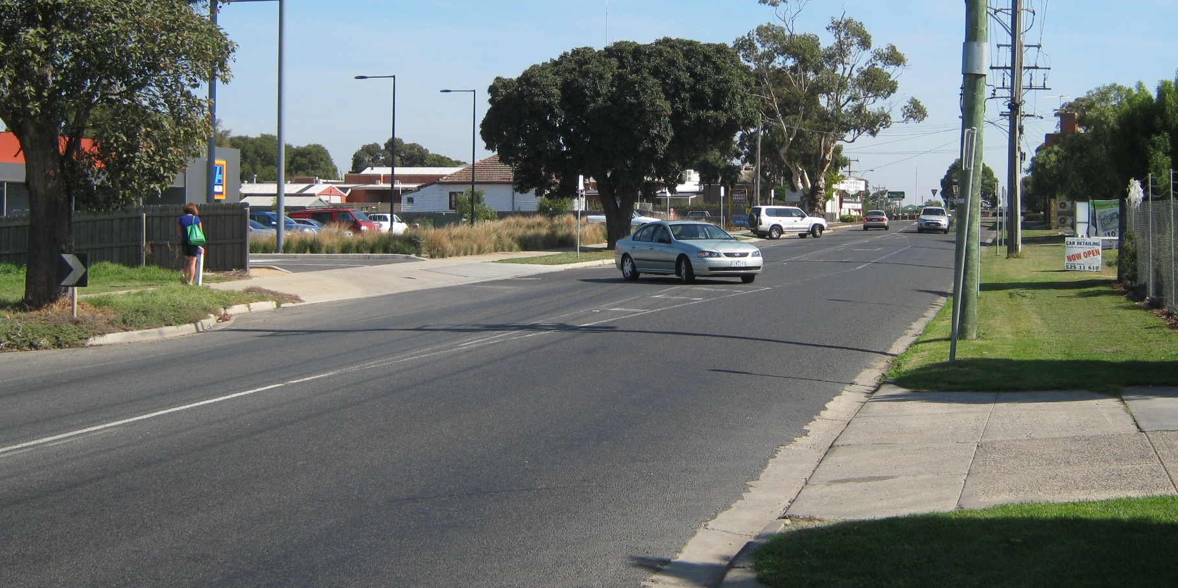
The intersection of Murradoc Road with Collins Street/High Street is controlled via a roundabout.

Traffic Volumes
In order to determine the existing operation of the surrounding road network and in particular the operation of the intersection between Murradoc Road, Collins Street, Clifton Springs Road and High Street, Trans Traffic Surveys, on behalf of Cardno, were commissioned to collect traffic volumes at this intersection.
The traffic volume count was undertaken for the period of 2:30pm to 7:00pm, on the 10th October 2012. The peak hour for traffic at the roundabout was identified to begin at 3:15pm. The turning movement counts during that peak hour are shown in Figure 2-4.
          - Murradoc Road/Collins Street/Clifton-Springs Road/High Street Turning Movement Count
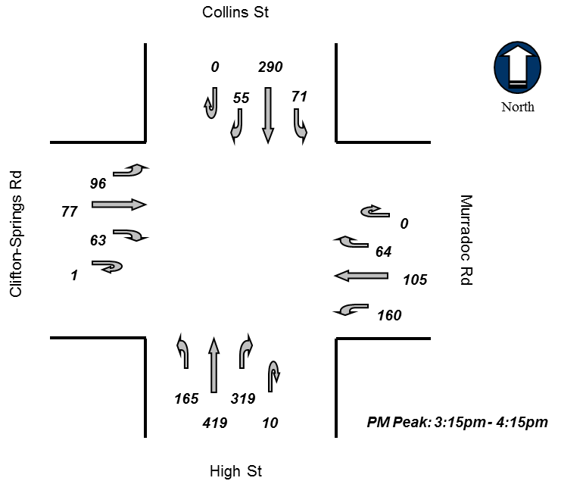
Further to this turning movement count, Trans Traffic Surveys were also commissioned to collect seven day traffic volume data for Murradoc Road. The count was undertaken from Friday 12th October 2012 through to Friday 19th October 2012. The results of the survey are shown in Table 2-1.

            - Murradoc Road Traffic Volumes
 |  |  | Direction of Travel
 |  |  | Combined | Westbound | Eastbound
Traffic Volume :  (Vehicles/Day) |  | Weekdays Average | 7,460 | 3,700 | 3,760
 |  | 7 Day Average | 7,032 | 3,494 | 3,538
Weekday  Peak hour start | AM | 11:00 | 647 | 331 | 316
Weekday  Peak hour start | PM | 15:00 | 668 | 322 | 353
Speeds :  (Km/Hr) |  | 85th Percentile | 56.3 | 56.6 | 56.1
 |  | Average | 52.0 | 52.8 | 51.1
Classification % : |  | Light Vehicles up to 5.5m | 91.0% | 90.0% | 92.0%
As shown in Table 2-1, the peak hour for traffic on Murradoc Road occurs at 11:00am for the AM period and at 3:00pm for the PM period. These volumes during the peak hour are consistent with the peak hour volumes identified in the turning movement count shown in Figure 2-4.

Intersection Analysis
In order to assess the existing operation of the Murradoc Road/Collins Street/Clifton-Springs Road/High Street roundabout an analysis has been undertaken.
SIDRA was utilised to analyse the performance of the intersection in conjunction with typical parameters for unsignalised intersections and the collected volumes. This computer package, originally developed by the Australian Road Research Board, provides information about the capacity of an intersection in terms of a range of parameters, as described below.
Degree of Saturation (D.O.S.) is the ratio of the volume of traffic observed making a particular movement compared to the maximum capacity for that movement. Various values of degree of saturation and their rating are shown in Table 2-2.
            - Rating of Degrees of Saturation
D.O.S. | Rating
Up to 0.6 | Excellent
0.6 to 0.7 | Very Good
0.7 to 0.8 | Good
0.8 to 0.9 | Fair
0.9 to 1.0 | Poor
Above 1.0 | Very Poor
The 95th Percentile (95%ile) Queue represents the maximum queue length, in metres, that can be expected in 95% of observed queue lengths in the peak hour; and
Average Delay is the delay time, in seconds, which can be expected over all vehicles making a particular movement in the peak hour.
The results of the SIDRA Intersection analysis are summarised in Table 2-3.

            - SIDRA Intersection Analysis Summary
 | Approach | Degree of Saturation | 95th%ile Queue | Average Delay
PM Peak  (3:15pm) | Collins Street | 0.299 | 14.5 m | 8.4 sec
PM Peak  (3:15pm) | Clifton Springs Road | 0.377 | 19.5 m | 13.2 sec
PM Peak  (3:15pm) | High Street | 0.538 | 32.2 m | 8.8 sec
PM Peak  (3:15pm) | Murradoc Road | 0.348 | 16.5 m | 9.2 sec
Intersection |  | 0.538 | 32.2 m | 9.3 sec
The SIDRA analysis indicates that the roundabout is currently operating with an ‘excellent’ rating.

Public Transport
Drysdale is provided with public transport in the form of three regional bus services. The bus services are provided as:
- Route 78 – Drysdale to Clifton Springs
- Route 79 – Geelong to S Leonards, via Leopold and Drysdale
- Route 81 – Drysdale to Ocean Grove
The nearest bus stop to the subject site for these services is located within the Drysdale Village Shopping Centre, which is approximately 300 metres west of the site.

Proposed Development

General
It is proposed to develop a Coles supermarket on the site with a floor area of approximately 3,892 square metres, as shown by the plans prepared by i2C Town Planning.

Car Parking and Loading
There are 146 car parking spaces proposed within an at grade car park, inclusive of four disabled access spaces.
A designated loading area is located on the eastern side of the supermarket building, designed to accommodate semi-trailer truck access.

Vehicle and Pedestrian Access
Vehicle access for the proposed development is made via an entry/exit point to Murradoc Road, as well as three separate points of vehicle access that serve to integrate the development with the existing ALDI car park which abuts to the west.
The redundant Murradoc Road crossovers are to be removed, and kerb and channel is to be reinstated.
A pedestrian footpath is located along the western boundary of the site, oriented north-south from the Murradoc Road site frontage. This pedestrian linkage extends to the south boundary.
The access points and parking areas are detailed in Figure 3-1.
          - Proposed Car Parking, Loading Area and Access
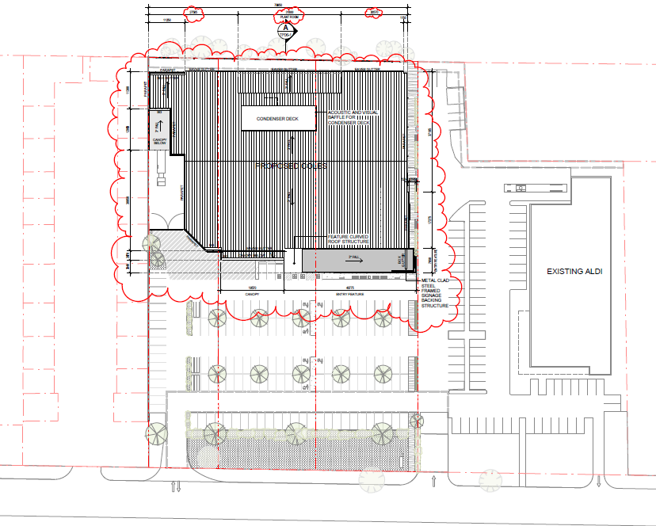
Car Parking
Loading Area
Vehicle Access
Pedestrian Access
ALDI Supermarket
N
Coles Supermarket

Design Considerations

Car Parking and Access
The car park and access design has been assessed against the requirements of the Greater Geelong Planning Scheme and the Australian Standard for off-street car parking (AS/NZS 2890.1).
All general car parking spaces exceed the minimum dimension requirements of the Greater Geelong Planning Scheme, being at least 2.6 metres wide and 4.9 metres long, with an access aisle width of at least 6.4 metres.
The disabled spaces have been located in close proximity to the supermarket access. The spaces are provided with dimensions of 2.4 metres wide, 5.5 metres long and include the provision of a dedicated shared space adjacent to each space, in accordance with the Australian Standard for off-street parking for people with disabilities (AS/NZS2890.6:2009).

Garbage Collection and Loading
Garbage collection and loading are to take place within the designated loading area, east of the supermarket.
Swept paths have been prepared to show access to this loading area for a semi-trailer truck.
The ramp down to the loading area has a gradient of 1:23 over 27.0 metres, which satisfies the requirements of the Australian Standard for off-street commercial vehicle facilities (AS 2890.2-2002).
Within the final 20 metres of the loading area there is a maximum grade of 1:100, which is in accordance with both Australian Standard and Coles’ requirements.

Loading Considerations
Clause 52.07 of the Greater Geelong Planning Scheme outlines the requirements for the loading and unloading of vehicles. It specifies that:
No building or works may be constructed for the manufacture, servicing, storage or sale of goods or materials unless:
- Space is provided on the land for loading and unloading vehicles as specified in Table 1;
- The driveway to the loading bay is at least 3.6 metres wide;
- The driveway that provides access to the loading bay is at least 3.6 metres wide.
- A permit may be granted to reduce or waive these requirements if either
- The land area is insufficient; or
- Adequate provision is made for loading and unloading vehicles to the satisfaction of the responsible authority.
Table 1: Planning Scheme Loading Requirements – Clause 52.07
Floor Area of Building | Minimum Loading Bay Dimensions
2,600 m² or less in single operation | Area | 27.4 m²
2,600 m² or less in single operation | Length | 7.6 m
2,600 m² or less in single operation | Width | 3.6 m
2,600 m² or less in single operation | Height clearance | 4.0 m
For every additional 1,800 m² or part | Additional 18 m²
Considering the above, the proposed 3,892 square metres of retail floor area produces a requirement for a loading area of at least 45.4 square metres.
The proposed loading area with a width of 10 metres and length of 20 metres exceeds these minimum requirements.

Bicycle Parking Considerations
Clause 52.34 of the Greater Geelong Planning Scheme specifies the following bicycle parking provision requirements for a ‘shop’ use which is considered to best represent a supermarket.
- One space per 600m² of leasable floor area for employees;
- One space per 500m² of leasable floor area for visitors.
The proposed supermarket with floor area of 3,892 square metres therefore has a statutory requirement to provide a total of 14 bicycle parking spaces, inclusive of six spaces for employees and eight spaces for visitors.
The proposed development is to provide parking for 14 bicycle spaces in accordance with the Greater Geelong Planning Scheme.

Car Parking Considerations

Car Parking Requirements – Clause 52.06
Clause 52.06 of the Greater Geelong Planning Scheme specifies the following parking provision requirements for a ‘supermarket’ use.
            - Planning Scheme Car Parking Requirements – Clause 52.06-5
Use | Area/ No. | Rate | Car Parking Measure | Total
Supermarket | 3,892 m² | 5 | to each 100 sqm of leasable floor area | 194 spaces
Considering the Planning Scheme requirements, a total of 194 parking spaces should be provided for the development.
Furthermore Clause 52.06-6 states that a reduced or waived requirement for car spaces may be justified, based on an assessment of the following:
- The car parking demand likely to be generated by the use; having regard to:
  - Multi-purpose trips within an area;
  - The availability of public transport in the locality;
  - The convenience of pedestrian and cyclist access to the site;
  - The provision of bicycle parking and end of trip facilities for cyclists;
  - The anticipated car ownership rates of likely or proposed occupants (residents or employees);
  - Any empirical assessment or case study.

Case Study Data
Cardno and other consultancies have undertaken parking surveys at a number of supermarkets around Melbourne and country Victoria. The results of those surveys from supermarkets, which are considered to operate in a similar area to Drysdale, are shown in Table 7-2.

            - Supermarket Parking Survey Summary
Store | Floor Area | Day Surveyed | Peak Parking Rate | Time
Wonthaggi Safeway | 4,234 m² | Saturday | 3.76 | 11:30am
Healesville Walk | 4,931 m² | Friday  Saturday | 3.97  3.50 | 10:30am  11:30am
Rye Safeway | 3,810 m² | Saturday | 3.10 | 12:30pm
Average |  |  | 3.58

Adequacy of Proposed Parking Provision
Based on the case study data detailed above, it has been adopted that the proposed supermarket will generate a demand for parking at a rate of 3.7 spaces per 100 square metres of floor area. This rate of 3.7 spaces per 100 square metres is greater than the average peak demand of 3.58 spaces per 100 square metres shown in the case study data.
The proposed car parking provision of 146 spaces exceeds the expected demand of the supermarket (3.7 x 3892/100 = 144) and is therefore considered appropriate.
It is also noted that overflow car parking may be accommodated on-street at the frontage of the site however this is not relied upon for this application. Furthermore, the car park design is integrated with the existing Aldi car park, however this application does not rely on the availability of the Aldi parking.

Traffic Considerations

Traffic Generation
The impact of shopping centre traffic on the adjacent road network is usually most critical during the evening commuter peak period when shopping centre traffic combines with commuter traffic to produce the greatest volume on the surrounding road network.
Based on case study data held by Cardno, and for the purpose of this assessment, it has been adopted that the supermarket will generate traffic during the afternoon peak at a rate of 11 vehicle movements per 100 square metres. Traffic is generally evenly distributed between inbound and outbound traffic during the afternoon peak.
The proposed supermarket with floor area of 3,892 square metres is therefore anticipated to generate 428 traffic movements, consisting of 214 inbound and 214 outbound movements.

Traffic Distribution
Given the sites location with regard to the surrounding Drysdale area it is considered that traffic will be distributed as follows:
- Murradoc Road – East 30%
- Murradoc Road – West 70%
  - Collins Street – North 14%
  - Clifton Springs Road – West 14%
  - High Street – South 42%
Vehicle movements to and from the site will be predominantly made via either the proposed new access or the shared access point on the ALDI site. For the purpose of this assessment it has been adopted that 2/3rds of the traffic to/from the east will use the proposed new access with 1/3rd to use the ALDI access, while 2/3rds of the traffic to/from the west will use the ALDI access with 1/3rd to use the proposed new access.
Based on this traffic distribution, the anticipated traffic generated by the site during the PM peak period is shown in Figure 8-1.
          - Anticipated Development Generated PM Peak Hour Volumes

Traffic Impact
The traffic movements generated by the site, detailed above, indicate that the peak movement will be the right turn into the ALDI access from Murradoc Road and the left turn from the ALDI access onto Murradoc Road. These two manoeuvres are both expected to generate 100 vehicle movements each. This level of traffic generation equates to an average of just over 3 vehicle movements every 2 minutes during the PM peak hour period. This level of traffic generation is considered to be low in traffic engineering terms and is expected to have no significant effect on traffic conditions.

Intersection Analysis
Considering the expected traffic generation and distribution by the proposed development, the future operation of the intersection between Murradoc Road, Collins Street, Clifton Springs Road and High Street was analysed using SIDRA Intersection.
The results of the SIDRA Intersection analysis are summarised in Table 8-1.
            - SIDRA Intersection Analysis Summary
 | Approach | Existing |  |  | Future
 |  | D.O.S. | 95th%ile Q | Av. Delay | D.O.S. | 95th%ile Q | Av. Delay
PM Peak | Collins Street | 0.299 | 14.5 m | 8.4 sec | 0.336 | 18.2 m | 9.3 sec
PM Peak | Clifton Springs Road | 0.377 | 19.5 m | 13.2 sec | 0.524 | 35.3 m | 18.8 sec
PM Peak | High Street | 0.538 | 32.2 m | 8.8 sec | 0.637 | 45.4 m | 9.9 sec
PM Peak | Murradoc Road | 0.348 | 16.5 m | 9.2 sec | 0.512 | 30.0 m | 10.1 sec
Intersection |  | 0.538 | 32.2 m | 9.3 sec | 0.635 | 0.637 | 45.4 m
The results of the SIDRA Intersection analysis for the future volumes indicate that the intersection will continue to operate within capacity and with a rating of ‘very good’.

Conclusions
Based on the foregoing it is concluded that;
- It is proposed to develop the site for the purpose of a Coles’ supermarket with an approximate floor area of 3,892 square metres. The proposal includes an at-grade car park with 146 spaces, accessed from Murradoc Road and the adjoining ALDI supermarket site;
- The car park and access arrangements have been assessed and comply with the requirements of the Australian Standards and Greater Geelong Planning Scheme;
- The provision of 146 parking spaces accommodates the anticipated peak parking requirements;
- The proposed development is to provide parking for 14 bicycle spaces in accordance with the Greater Geelong Planning Scheme.
- The loading area provided satisfies the requirements of Clause 52.07 of the Planning Scheme;
- The level of traffic generated by the proposal is considered to be low in traffic engineering terms and is expected to have no significant effect on traffic conditions;
- The SIDRA analysis undertaken indicates that the intersection between Murradoc Road, Collins Street, Clifton Springs Road and High Street will continue to operate well within capacity.
Proposed Supermarket, Drysdale

APPENDIX

Loading Vehicle Swept paths

