


Flora and Fauna Assessment and

No Net Loss Analysis Recommendations, 35 Hams Road and 151-229 Anglesea Road
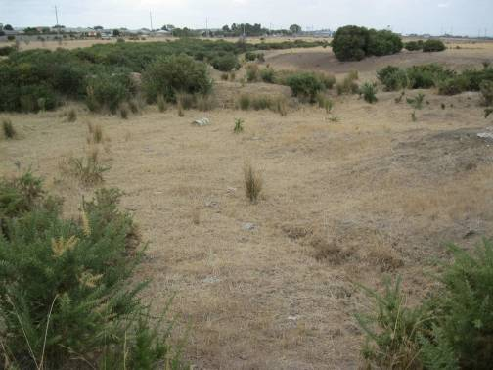Waurn Ponds.

10 April 2014



Flora and Fauna Assessment and No Net Loss Analysis Recommendations, 35 Hams Road and 151-229 Anglesea Road, Waurn Ponds.

10 April 2014

Report by James Kidman Mapping by Karen McGregor

PRACTICAL ECOLOGY Pty Ltd
ACN: 082 911 377 ABN: 88 082 911 377
PO Box 228 Preston VIC 3072
(2B Stott Street Preston Vic 3072) P: 9484 1555F: 9484 9133
www.practicalecology.com.au

Acknowledgments: Charlotte Townson Field Assessment

Prepared for: | Randah Jordan | PE project number: | SME 1467
Contact: | Randah Jordan | Associate Planner  SMEC Urban  Level 10, 71 Queens Road, Melbourne,  VIC 3004, Australia  T +61 3 9869 0820 | F +61 3 9869  0900 | M +61 411699551  randah.jordan@smec.com | PE file location: | R:\Geelong Greater\35 Hams Rd HHa  NNL and 151-229 Anglesea Rd, Waurn Ponds\Report……

Version notes
Version | Date | Reviewer:
0.1 | 19/03/2014 | Alice Ewing
0.1 | 10/04/2014 | Randah Jordan

Draft for client review Client Draft review

© Copyright
Unless otherwise agreed in writing, this report is the intellectual property of Practical Ecology Pty Ltd. It is designed to be used exclusively by the person or organisation that commissioned it. Permission must be sought prior to reproduction of any portion of this document, and every effort made to ensure proper referencing of this document.

1. | INTRODUCTION | Contents | 5
1.1 | Project Scope |  | 5
1.2 | Subject Site |  | 6
1.2.1 | Site description |  | 6
1.2.2 | Adjacent land |  | 6
1.2.3 | Zoning and Overlays |  | 6
2. | METHODS |  | 7

  - Site assessment 7
  - Vegetation Categorisation, Classification and Quality 7
    - Vegetation Categories 7
    - Ecological Vegetation Classes 8
    - Vegetation Quality Assessment 8
    - Large Old Trees 8
  - Flora 8
    - Plant taxonomy 8
    - Existing information 8
    - Flora survey 9
    - Plant identification 9
    - Limitations of flora survey 9
  - Fauna 9
    - Fauna taxonomy 9
    - Existing information 9
    - New information 9
  - Potentially occurring rare or threatened species 10
  - Mapping 10
- RESULTS 11
  - Vegetation Categorisation, Classification and Quality 11
    - Habitat Zone 1 (HZ1a-d) 11
    - Habitat Zone 2 (HZ2a-d) 12
    - Scattered Trees 13
    - Habitat hectare assessment 13
3.2 Flora 14
3.2.1 State or nationally significant flora 14
3.3 Fauna 14
3.3.1 State or nationally significant fauna 15
- RELEVANT POLICY AND LEGISLATION 17
  - Environment Protection and Biodiversity Conservation Act 17
  - Flora and Fauna Guarantee Act 1988 17
  - Planning Scheme 18
    - State Planning Policy Framework 18
    - Zoning 19
    - Overlays 19
    - Particular Provisions – Clause 52.17 20
  - Catchment and Land Protection Act 1994 20
- DEVELOPMENT PROPOSAL 22
- NO NET LOSS ANALYSIS RECOMMENDATIONS 23
  - Risk-based Pathway 23
    - Location risk 24
    - Proposed losses from re-zoning and subsequent development 24
    - High Risk-based Pathway 25
  - Minimising impacts to biodiversity 25
  - Biodiversity Assessment Report 26
  - Offset Strategy 26
6.4.1 SOURCING NATIVE VEGETATION (OFFSET) CREDITS 27
6.5 Summary 29
- REFERENCES 30
APPENDICES
Appendix 1. Flora recorded at study site 32
Appendix 2. Potentially occurring significant flora species 34
Appendix 3. Potentially occurring significant fauna species 35
Appendix 4. Biodiversity assessment report provided by DEPI Transition Support (DEPI 2014d) 43
Appendix 5. Maps 54

TABLES
Table 1. Criteria for potential occurrence of significant species 10
Table 2. Bioregional Conservation Status for Extant EVCs at Study Site 11
Table 3. Habitat hectare assessment 13
Table 4. Summary of flora species recorded 14
Table 5. Declared Noxious weeds occurring within the Study Area 21
Table 6. Determining risk-based pathway 23
Table 7. Risk-based pathways for proposed vegetation removal on site 25
Table 8. Summary of marked native vegetation 26
Table 9. Offsets required if all vegetation is cleared 26
Table 10. Potentially occurring State and Nationally Significant flora species within 5 km (VBA 2014) 34
Table 11. Potentially occurring State and Nationally Significant fauna species 35

FIGURES
Figure 1. Site Location Map, 35 Hams Road, Waurn Ponds (map generated from Google Earth Pro) 6
Figure 2. Habitat Zone One looking north from within HZ1b 12
Figure 3. Habitat Zone Two looking east from edge of HZ2a 12
Figure 4. Cattle trampling fringing and aquatic vegetation within non-native wetland 15
Figure 5. Location risk at subject site 24

MAPS
Map 1. Existing conditions 54

INTRODUCTION

Practical Ecology Pty Ltd was commissioned by Melissa Griffin of SMEC urban to prepare a Flora and Fauna Assessment and recommendations to inform a Net Gain Analysis for 35 Hams Road and 151-229 Anglesea Road, Waurn Ponds.

An original due diligence assessment conducted by Practical Ecology in May 2012 revealed areas of vegetation that may have required offsets if cleared. Due to recent changes in legislation and comments received from Greater Geelong City Council, an assessment of the site to document the ecological conditions in relation to new legislation has been undertaken. This report was sought in support of a proposal to re-zone the site, from Farming Zone (FZ) to Residential Zone (RZ).

Project Scope

The scope of works includes

    - A review of biodiversity information including:

      - relevant legislation and planning permit requirements

      - reviewing ecological databases such as DEPI’s VBA

      - DEPI’s biodiversity interactive mapping

    - the compilation of a list of all vascular plants, including an assessment of their biological significance, recorded in the development site (and other bushland areas as appropriate) during the site visit

    - determination of habitat zones, undertake a habitat hectare assessment and determine the condition score, and/or scattered trees as required by the Biodiversity Assessment Guidelines (DEPI 2013)

    - a review of vegetation and habitat condition determined by Nance (2012) based on describing different qualities of remnant and exotic vegetation and types of weed infestation

    - photographs of the remnant vegetation (likely to be) proposed for removal

    - a description of the existing and/or original Ecological Vegetation Classes found within the site

    - mapping any areas that may provide habitat for significant species.

    - a review of relevant literature, fauna and flora records and habitat conditions on the site to determine the likelihood of the presence of nationally significant flora and fauna.

    - Undertake a brief No Net Loss Analysis to determine vegetation losses associated with the rezoning of the site.

    - Provide recommendations on the rezoning and actions that can be undertaken to avoid vegetation and habitat removal.

    - the provision of mapping to illustrate existing conditions.

Subject Site

Site description

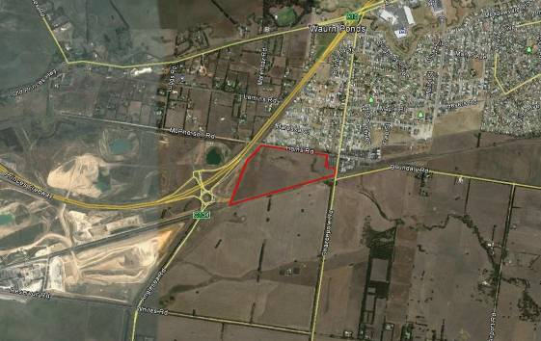The study site consists of two Lots: 35 Hams Road and 151-229 Anglesea Road, Waurn Ponds (Figure 1). The site is approximately 27 ha in area, is currently used for grazing and contains several internal fences, sheds and dams. Grassland vegetation covers most of the property, with several areas containing weed infestations. The site falls within the Otway Plain bioregion.

Figure 1. Site Location Map, 35 Hams Road and 151-229 Anglesea Road, Waurn Ponds

Adjacent land

The adjacent land to the south and east contains similar vegetation to that which is on site. However, these areas are subject to different zoning: Special Use Zone (SUZ) to the south (and West) and Urban Growth Zone (UGZ) directly to the east. Residential development exists to the north of the site within a Residential 1 Zone (R1Z)) and, to the north-west, low density development is present within a Rural Living Zone (RLZ). The Princes Freeway extension has recently been constructed along the western boundary of the site. A regional railway reserve exists immediately to the south of the site.

Zoning and Overlays

The site is zoned Farming Zone (FZ) and is subject to the following overlay and areas:

      - Public Acquisition Overlay (PAO) (confined to the western portion of the site); and

      - is within an Area of Aboriginal Cultural Heritage Sensitivity (AACHS).

METHODS

Site assessment

A site assessment was undertaken by Practical Ecology staff on 27th February 2014, involving

    - consideration and mapping of existing conditions

    - mapping and assessing vegetation as per DSE’s habitat hectare methodology

    - the compilation of a list of vascular plants observed across the study site

    - consideration of the site’s habitat values for threatened fauna and flora.

Vegetation Categorisation, Classification and Quality

Vegetation was assessed for its categorisation according to Permitted clearing of native vegetation – Biodiversity assessment guidelines (Department of Environment & Primary Industries 2013), then its Ecological Vegetation Class and finally, quality, as determined through a Habitat Hectare assessment.

Vegetation Categories

Vegetation in the study area was surveyed for categorisation as per the definitions within Permitted clearing of native vegetation – Biodiversity assessment guidelines (Department of Environment & Primary Industries 2013):

      - Native Vegetation
Native Vegetation as per the Victorian Planning Provisions (Clause 72): plants which are indigenous to Victoria, including trees shrubs, herbs and grasses.

      - Remnant Vegetation

Remnant patch of native vegetation is either:

        - an area of vegetation where at least 25% of the total perennial understorey plant cover is native

        - any area with three or more native canopy trees where the canopy foliage cover is at least 20 % of the area

      - Scattered tree:

A scattered tree is a native canopy tree that does not form part of a remnant patch. A canopy tree is a mature tree that is greater than 3 m in height and is normally found in the upper layer of a vegetation type.

Ecological Vegetation Classes

Ecological Vegetation Classes (EVCs) are a method of systematic organisation of plant communities into common types that occur in similar environmental conditions throughout Victoria. Each vegetation type is identified on the basis of its floristic composition (the plant species present), vegetation structure (woodland, grassland, saltmarsh), landform (gully, foothill, plain) and environmental characteristics (soil type, climate).

DEPI EVC mapping (DEPI 2014a) was accessed to assess the EVC likely to occur on the study area. EVCs were then identified in the field according to observable attributes including dominant and characteristic species consistent with the benchmark descriptions (DEPI 2014b).

Vegetation Quality Assessment

A habitat hectare assessment was undertaken to determine the condition of areas of native vegetation. This methodology is outlined in Vegetation Quality Assessment Manual-Guidelines for Applying the Habitat Hectares Scoring Method (DSE 2004). The habitat hectare method involves making visual and quantitative assessments on various characteristics of native vegetation according to established criteria that are set against an optimum benchmark.

This process begins with the identification of the EVC. Each EVC has a benchmark of optimal values relating to the vegetation conditions. In addition the ecological landscape context is scored, this is assessable via the DEPI Biodiversity Interactive Map (DEPI 2014a). If a site meets or exceeds all benchmark criteria it will receive a total score of 100 %.

Large Old Trees

Large Old Tree (LOT) is a tree with a DBH equal to, or greater than, the large tree diameter as specified in the relevant EVC benchmark.

Flora

Plant taxonomy

Plant taxonomy used in this report are generally in accordance with Walsh & Stajsic (Walsh and Stajsic 2008) and/or Flora Information System (Viridans Biological Databases 2013b).

Existing information

Existing database records on the Victorian Biodiversity Atlas (VBA) for a five kilometre radius around the study area was obtained from the online database (DEPI 2014c). Species habitat modelling information was obtained from the DEPI Transition Support (DEPI 2014d).

Flora survey

During the assessment, the study area was inspected on foot. A species list (or defined area list) for indigenous or naturalised flora (i.e. not including planted species) over the entire study site was compiled. No systematic surveys were undertaken during this study.

Plant identification

Species that could not be identified in the field were recorded to the nearest possible family or genera. These were then collected as per the protocols associated with Practical Ecology’s Flora and Fauna Guarantee (FFG) Act 1988 permit (No. 10006484) for the collection of plant material. In order to assist in the identification of some flora, major features of the specimens were collected where possible, including leaves, parts of branches, fruit and/or flowers.

Limitations of flora survey

The following considerations should be made regarding the limitations of the flora survey:

      - it was undertaken in late summer which is not the optimal time for plant identification. Many grass species had set seed and did not contain seed material that would normally aid in identification

      - it is expected that some other species, particularly orchid, lily and other herbaceous species that can only be observed for a limited period of time may not have been recorded during the present assessment

      - flora surveys were undertaken over a short period of time

Fauna

Fauna taxonomy

Animal taxonomy is consistent with the Victorian Fauna Database (Viridans Biological Databases 2013a).

Existing information

Existing information on the Victorian Biodiversity Atlas (VBA) for a five kilometre radius around the study site was obtained from the online database (DEPI 2014c). Species habitat modelling information was obtained from the DEPI Transition Support (DEPI 2014d).

New information

The main focus in regards to fauna was to undertake a habitat assessment. The habitat assessment relies upon making judgements on the suitability of habitat present within the study site for any significant species recorded on existing databases.

Potentially occurring rare or threatened species

Database information was used to determine likelihood of occurrence of rare or threatened species that occur or are predicted to occur within five kilometres of the study area. In determining this ‘likelihood of occurrence’ and utilisation of the study area by national or state significant flora and fauna, the following factors were considered:

    - the conservation status of the species and its distribution;

    - previous recordings of species in the local area;

    - date of last record;

    - the habitat requirements of individual species;

    - the physical attributes of the site, such as topography, geology, soils, aspect and other habitat features such as trees with hollows, the presence of rocks or boulders, logs on the ground;

    - the history of land use at the study site; and

    - how fragmented and modified is the environment surrounding the study site.

A basic matrix that describes the justification for the likelihood of occurrence is presented in Table 1.

Table 1. Criteria for potential occurrence of significant species

Likelihood of occurrence | Criteria
Nil | Species known to be extinct in local area and/or absent from the site.
Low | Unsuitable habitat at study site; or habitat conditions intermediate and records very limited and dated; or if it were present, it is highly likely to have been observed on site.
Medium | Habitat conditions are intermediate, and/or optimal habitat conditions for species but local r ecords limited or dated and/or if it were present, it is not likely to have been observed on site.
High | Optimal habitat conditions for species or species recorded at site, or intermediate habitat conditions but extensive local records and/or if it were present, it is not likely to have been observed on site.

Mapped data for species distributions was obtained from DEPI Transition Support (DEPI 2014d). This information sets out the list of rare or threatened species habitats mapped at the site, beyond those species for which the impact is above the specific offset threshold.

Mapping

Geographical positioning data collection in the field for the purposes of map display was carried out using a combination of a handheld GPS device, aerial photography and existing site survey plans. Determination of vegetation boundaries was undertaken using a combination of GPS data and ground-truthing with aerial photography. Due to inaccuracy with GPS data, the mapping should be considered approximate only.

RESULTS

Vegetation Categorisation, Classification and Quality

Vegetation across the site was in very poor condition. The dry conditions during the site assessment may have contributed to a lower detection of plant diversity, however the degradation of the site could be determined from a number of factors, including: the high cover of weedy species (established Gorse *Ulex europaeus, African Boxthorn *Lycium ferocissimum, Chilean Needle-grass *Nassella neesiana, Cane Needle-grass
*Nassella hyalina and many grassy and herbaceous weeds), the lack of remnant vegetation (limited to
colonising grasses) and the long history of grazing.

Native vegetation was mapped on site due to areas of native vegetation exceeding 25 % in foliage cover. Two EVCs were determined to exist across the site: Grassy Woodland (EVC 127) and Creekline Grassy Woodland (EVC 68). These zones had a patchy distribution across the site and were limited to two paddocks and the drainage line, running west to east, along the centre of the site. The flora within these patches consisted of very limited diversity and contained only a few opportunistic species in most instances. Map 1 indicates the distribution of the two Habitat Zones and the scattered distribution of individual patches across the site.

The EVC’s on site and their bioregional conservation status are indicated in Table 2 below.

Table 2. Bioregional Conservation Status for Extant EVCs at Study Site.

EVC No. | EVC | Bioregional Conservation Status
127 | Grassy Woodland | Endangered
68 | Creekline Grassy Woodland | Endangered

Habitat Zone 1 (HZ1a-d)

Habitat Zone One consists of degraded Grassy Woodland (EVC 127) with little diversity (Figure 2). Four separate patches were identified on site, zones HZ1a-HZ1d. Indigenous species HZ1 included: Common Wallaby-grass Rytidosperma caespitosum, Slender Wallaby-grass Rytidosperma racemosum var. racemosum, the occasional Finger Rush Juncus subsecundus and a small patch of Spear Grass Austrostipa spp. that were not able to be identified due to insufficient plant material. Native vegetation cover was between 25 % and up to 80 % in some areas.

Weedy species within this zone included: Brown-top Bent *Agrostis capillaris and Ribwort *Plantago lanceolata
which had the highest cover. Squirrel-tail Fescue *Vulpia bromoides, Spear Thistle *Cirsium vulgare, Cocksfoot
*Dactylis glomerata, and Toowoomba Canary-grass *Phalaris aquatica were also common within this zone.

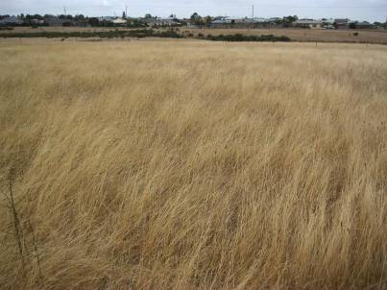Figure 2. Habitat Zone One looking north from within HZ1b

Habitat Zone 2 (HZ2a-d)

Habitat Zone Two was confined to areas that held water along the drainage line (Figure 3). This included the permanent waterbody (HZ2a) and three other patches that were damp, but did not contain free waterbodies at the time of assessment.

All of these patches contained a high cover of Common Spike-sedge Eleocharis acuta and scattered occurrences of Pale Rush Juncus pallidus and Finger Rush. The larger waterbody also contained Water Milfoil Myriophyllum spp. and Swamp Lily Ottelia ovalifolia subsp. ovalifolia.

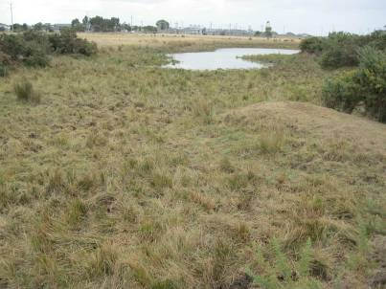Weeds within this zone included patchy invasions of Water Couch *Paspalum distichum and Gorse was prevalent along the fringes of the patches and across much of the extent of the drainage line.

Figure 3. Habitat Zone Two looking east from edge of HZ2a

Scattered Trees

No Scattered Trees were observed to occur within the site during the site inspection. The closest trees to the site were observed within the railway reserve to the south of the site.

Habitat hectare assessment

Table 3 below presents the results of the Habitat hectare assessments carried out on site.

Table 3. Habitat hectare assessment

Habitat Zone |  |  | 1 | 2
Bioregion |  |  | OR | OR
EVC Name (initials) |  |  | GW | CGW
EVC Number |  |  | 175 | 68
EVC Conservation Status |  |  | E | E
Size of Zones (ha) |  |  | 4.550 | 0.282
 |  | Max Score | Score | Score
Site Condition | Large Old Trees | 10 | 0 | 0
Site Condition | Canopy Cover | 5 | 0 | 0
Site Condition | Understorey | 25 | 5 | 5
Site Condition | Lack of Weeds | 15 | 4 | 7
Site Condition | Recruitment | 10 | 0 | 0
Site Condition | Organic Litter | 5 | 4 | 5
Site Condition | Logs | 5 | 0 | 0
Site Condition | EVC  Standardiser |  | 1 | 1
Site Condition | Standardised Site Score | 75 | 13 | 17
Landscape value | Patch Size | 25 | 1 | 1
Landscape value | Neighbourhood | 25 | 1 | 1
Landscape value | Distance to Core | 25 | 1 | 1
Habitat points |  | 100 | 14 | 18
Habitat Score (habitat  points/100) |  | 0.## | 0.14 | 0.18

3.2 Flora

A total of 45 plant taxa were recorded in the study area during this survey of which 11 were indigenous (24 %) and 34 (76 %) were introduced. Appendix 1 lists all flora recorded within the study site. Table 4 below summarises plant taxa recorded in the study area during this survey.

Table 4. Summary of flora species recorded

Flora Status | Number of Taxa
Indigenous vascular species | 11
Exotic species | 34
TOTAL | 45

3.2.1 State or nationally significant flora

No species of state or national significance were recorded on-site.

A search for state or nationally significant flora species recorded within 5km of the site area in VBA (DEPI 2014c) revealed one species, Bellarine Yellow-gum Eucalyptus leucoxylon subsp. bellarinensis (Appendix 2).

This species was considered to have a low likelihood of occurrence due to no individuals being observed on site in conjunction with the site’s highly degraded vegetation condition.

Modelled Habitat Importance for Flora

DEPI habitat-modelling revealed three species that are considered to have habitat present on site: Clover Glycine Glycine latrobeana, Austral Crane's-bill Geranium solanderi var. solanderi s.s., and Pale Swamp Everlasting Coronidium scorpioides 'aff. rutidolepis (Lowland Swamp) (Appendix 2; Appendix 4).

All three species do not have any records within 5 km of the study site. Habitat within the site is highly degraded and the large numbers of rabbits and stocking of cattle provide intense grazing pressure. Herbs are often the first to disappear from areas under such conditions. All three of these species are considered to have a low likelihood of occurring on site.

Fauna

The main focus with regards to fauna during the assessment was the consideration of the site’s potential to provide fauna habitat. The habitat observed within the site included:

    - Bare soil

    - Wallaby, Needle and Spear Grass species present

    - Soil cracks

    - Some shrubs (although exotic)

    - Freshwater waterbodies

    - Wet depressions

    - Fringing aquatic vegetation

Vegetation on site provides some habitat for fauna, however, much of this is degraded. Some foraging habitat exists for birds of prey, although the grassy vegetation preferred by many of their prey species is sparse. The primary food source for birds of prey in this region would be rabbits, rats and mice.

Cracks in the soil are present which may provide shelter for lizards and frogs. Wallaby, Needle and Spear grasses provide good food for Golden Sun Moth Synemon plana larvae and bare soil provides available spaces for this species to breed and lay eggs. The many Gorse plants across the site provide some habitat for bird species, however, they may also provide harbour for pest animals such as foxes, feral cats and rabbits. Apart from one Plum tree, there were no trees identified across the site that could provide nesting habitat or hollows for birds, or other fauna.

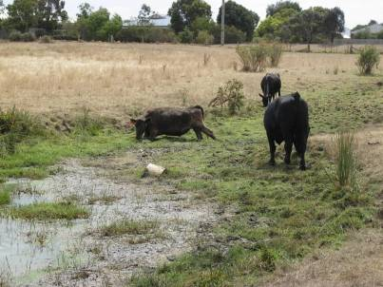Cattle have trampled within, and surrounding, the moist depressions and existing dam, providing unsuitable conditions for a range of native fauna to feed and spawn (frogs/fish) (Figure 4). These areas of vegetation were dominated by Spike Sedge with little to no other diversity. The cover of aquatic vegetation within the dam was less than 1 %, with the dam being muddy at the time of the assessment.

Figure 4. Cattle trampling fringing and aquatic vegetation within non-native wetland

3.3.1 State or nationally significant fauna

No fauna of state or national significance was recorded during the site inspection.

A total of 13 state or nationally significant fauna species are recorded within a five kilometre radius of the study area in the VBA (DEPI 2014c). Details of these species are given in Appendix 3. Two of these species are considered to have a moderate likelihood of using the habitat on-site: Baillon’s Crake Porzana pusilla palustris and the Growling Grass Frog Litoria raniformis.

The likelihood of these species utilising the site was considered moderate due to the degraded nature of the wetland areas. The persistence of frogs and tadpoles within the fringing vegetation would be moderate due to cattle trampling the vegetation.

The Baillon’s Crake generally inhabits freshwater wetlands and floodwaters which usually contain floating plants or tall emergent vegetation; both of these types of vegetation are effectively absent from the site. The Baillon's Crake feeds in shallow water, mud and emergent aquatic plants and has been found to nest in clumps or tussocks of vegetation surrounded by water. While some of this habitat does exist on site, it is highly degraded.

Modelled Habitat Importance for Fauna

DEPI habitat-modelling revealed 23 species in which habitat has been mapped on site (Appendix 3). In addition to the two species listed as having a moderate likelihood of occurrence on site from the VBA, Golden Sun Moth (GSM) habitat has been mapped on site (DEPI 2014d). The Golden Sun Moth is considered to have only a moderate likelihood of occurring on site, due to the presence of some degraded habitat and no local records (Appendix 3).

RELEVANT POLICY AND LEGISLATION

The following section explores relevant policy and legislation pertaining to ecology from the national level through to the local level.

Environment Protection and Biodiversity Conservation Act

The EPBC Act 1999 applies to sites where proposed developments or projects may have a significant impact on matters of national environmental significance.

Under the EPBC Act, a proponent must refer proposed actions that may require approval to the Commonwealth Environment Minister (or delegate). The Minister then decides which assessment and reporting option is applied. The Minister may approve a ‘controlled action’ allowing the development to proceed provided conditions are applied to mitigate significant impacts protected by this Act. The most likely consideration of the EPBC Act on site would be in regards to the removal of habitat for a species listed under the EPBC Act. It was determined that no species listed under the EPBC Act were considered to have a high likelihood of occurrence on site.

Development within the study site is not likely to have a significant impact on species, nor any other matters of environmental significance protected under this Act.

Flora and Fauna Guarantee Act 1988

The Flora and Fauna Guarantee Act 1988 (FFG Act) was legislated to ensure the continued survival of all Victorian species of flora and fauna and all Victorian communities of plants and animals. The FFG Act provides a number of ways to help achieve its objectives including:

    - listing of threatened taxa, communities of flora or fauna and potentially threatening processes, and creation of Action Statements and Management Plans for all listed taxa communities of flora or fauna and processes

- declaration of a Critical Habitat if the habitat is critical for the survival of a species or a community of flora or fauna, if listed as Critical Habitat, the Minister for Environment may then make an Interim Conservation Order (ICO) to conserve the Critical Habitat

- protection of flora and fauna through listing offences such as penalties relating to not following an ICO and taking, trading in, keeping, moving or processing protected flora without a licence. Although this does not apply to taking listed flora species from private land.

The Department of Environment and Primary Industries is the referral authority for matters under the FFG Act.

Relevance to proposal

There are no specific legislated prescriptions under the FFG Act related to Potentially Threatening Processes occurring on this site.

The FFG Act does not apply to any listed flora and fauna species occurring on private land, unless it is listed as critical habitat, which this site is not. It is considered unlikely the proposal will have a significant impact on species listed under this Act.

Planning Scheme

The Planning and Environment Act 1997 establishes the framework for planning the use, development and protection of land in Victoria in the present and long-term interests of all Victorians. This includes providing the structure for and administering the implementation of Planning Schemes. The following section considers relevant sections of the Planning Scheme.

State Planning Policy Framework

Clause 12 Environmental and Landscape Values

Clause 12 of the Planning Scheme recognises that planning:

      - should help to protect the health of ecological systems and the biodiversity they support (including ecosystems, habitats, species and genetic diversity) and conserve areas with identified environmental and landscape values.

      - must implement environmental principles for ecologically sustainable development that have been established by international and national agreements.

      - should protect sites and features of nature conservation, biodiversity, geological or landscape value. Clauses of particular relevance include:
      - Clause 12.01-1 Protection of biodiversity

      - Clause 12.01-2 Native vegetation management Relevance to proposal
The objectives of these clauses, which are considered in the body of this report, relate to avoiding and minimising impacts to biodiversity. Given the lack of intact native vegetation on site, attempts to conserve these areas of native vegetation could be seen as dubious, when put in context with achieving broad, Council- wide environmental and landscape value benefits.

Clause 13 Environmental Risks

This clause recognises that planning should adopt a best practice environmental management and risk management approach which aims to avoid or minimise environmental degradation and hazards. This includes consideration of:

      - climate change

      - floodplains

      - soil degradation

      - erosion and landslip

      - noise and air

      - air quality

      - bushfire Clause 13.05-1 Bushfire
This clause seeks to assist to strengthen community resilience to bushfire. The overarching strategy is to
‘prioritise the protection of human life over other policy considerations in planning and decision-making in areas at risk from bushfire and to apply the precautionary principle in decision making’.

Relevance to proposal

Any proposed development of the site will need to ensure that the above factors are considered. Incorporation of the existing drainage line into a design proposal will need to carefully consider hydrology, soil degradation and erosion to satisfy the objectives of this clause.

As the site is within a Bushfire Prone Area (BPA) appropriate siting of dwellings and allotments in order to achieve appropriate setbacks from unmanaged vegetation will be required.

Zoning

The proposal aims to re-zone the site from FZ to RZ. Consideration of vegetation legislation is discussed in relation to Clauses 12, 13, and 52.17. At this stage of the proposal, the actual re-zoning of the land will not affect vegetation on site. The change in land-use from FZ to RZ may be beneficial to any retained areas of vegetation, due to reduction, or elimination of grazing and trampling pressure.

Overlays

The site is subject to the following overlays:

      - Public Acquisition Overlay (PAO); and

      - contains areas of Aboriginal Cultural Heritage Significance (AACHS)

Public Acquisition Overlay (PAO3)

The purpose of this overlay is to reserve land for a public purpose and to ensure that changes to the use or development of the land do not prejudice the purpose for which the land is to be acquired. PAO3 refers to a VicRoads Proposed Road - Category 1.

No development should occur within this zone due to the objectives and future intended use of this land as outlined under this overlay.

Areas of Aboriginal Cultural Heritage Sensitivity (AACHS)

Areas of Aboriginal Cultural Heritage Sensitivity are outlined along the drainage line within the site. This site was one of the last areas where the Wathaurong local indigenous people lived in this region. A stone monument just to the south east of this site pays tribute to this group of aborigines, who were given a one acre block to live upon in 1861.

If significant works are to be undertaken within any of the identified areas of significance then a Cultural Heritage Management Plan (CHMP) will need to be prepared to guide works on the site.

The results of such a plan will outline where areas of significance are, provide management guidelines for any works and areas where works are to be avoided. A ‘significant disturbance’ is any activity that disturbs the top layer of soil, including digging, grading and ripping.

Particular Provisions – Clause 52.17

Under Clause 52.17 a permit is required to remove, destroy or lop native vegetation on sites greater than 0.4 hectares. Clause 52.17 requires a planning permit for the removal of native vegetation (exceptions apply). The purpose of the provision (amongst others) is to minimise impacts on Victoria’s biodiversity from the removal of native vegetation, and to protect and manage native vegetation, to minimise land and water degradation.

Application requirements and decision guidelines are listed within the Clause. Applications may fall into a low, moderate or high risk pathway depending on the location and extent of vegetation removed. The application requirements and decisions depend on the relevant risk pathway. Referral to DEPI under Clause 66.02 may be required for an application to remove native vegetation; e.g. if clearing is greater than 0.5 ha or the application follows the high-risk pathway.

Subdivisions that create allotments of greater than 0.4 ha in area will not need a permit to remove vegetation. Subsequent permits will need to be attained to remove vegetation within each respective lot. These losses in vegetation will, therefore, not be created at the subdivision stage but further down the track, when landowners intend to build on each lot. This may create additional costs for landowners who intend to purchase and build on a lot; offsets will likely be required to be sourced off-site. If lots are created that are less than 0.4 ha in size then offsets for vegetation loss will need to be procured at the subdivision stage.

It is recommended that vegetation losses be considered at the re-zoning stage. This will involve planning the design layout to incorporate offsets into the site, preferably along the drainage line. This will also minimise vegetation losses along the drainage line and further degrade habitat which may support significant species.

Catchment and Land Protection Act 1994

The study area supports four weeds that are declared noxious under the Catchment and Land Protection (CaLP) Act 1994. Plants occurring on this list are known to or have the potential to result in detrimental environmental or economic impact. It is the requirement of landowners to control weeds listed under this Act that occur on their site.

Under the CaLP Act, declared noxious weeds are categorised into four groups depending on their known and potential impact, and the specific circumstances for each region. These categories are:

    - State Prohibited Weeds (S) are either currently absent in Victoria or are restricted enough to be eradicated. The Victorian Government is responsible for their control.

    - Regionally Prohibited Weeds (P) in the Corangamite Catchment Management Authority (CMA) area these weeds are not necessarily widespread but have the potential to become widespread. It is expected that weeds that meet this criteria can be eradicated from the region. For weeds considered to be Regionally Prohibited it is the responsibility of the land owner to control these weeds on their land but not on adjacent roadside reserves.

    - Regionally Controlled Weeds (C) are usually widespread but it is important to prevent further spread.
It is the responsibility of the landowner to control these weeds on their property and on adjacent
roadside reserves.

    - Restricted Weeds (R) include plants that pose unacceptable risk of spreading in the State or other Australian states and are considered to be a serious threat to primary production, Crown land, the environment and/or community health if they were traded in Victoria. Trade in these weeds and there propagules, either as plants, seeds or contaminants in other material is prohibited.

The follow table lists the declared noxious weeds observed on site (which occurs within the Corangamite region).

Table 5. Declared Noxious weeds occurring within the Study Area

Scientific Name | Common Name | Control Category
*Cirsium vulgare | Spear Thistle | R
*Lycium ferocissimum | African Boxthorn | C
*Nassella neesiana | Chilean Needle-grass | R
*Nassella trichotoma | Serrated Tussock | C
*Rosa rubiginosa | Sweet Briar | C
*Ulex europaeus | Gorse | C

Weed infestations should be controlled where areas of open space are to be created. A weed management program will need to be prepared to manage weeds across areas of open space and any areas where offsets are to be established. This should include areas along the drainage line.

Weed seed should not be spread onto, or out of, the site during construction works. This requirement should be included in any weed management program that is prepared for the site.

Development proposal

The current proposal for the study site is to re-zone 35 Hams Road and 151-229 Anglesea Road, Waurn Ponds from Farming Zone to Residential Zone. As this report was commissioned to support the concept design phase of the re-zoning, vegetation losses are yet to be determined. This report seeks to outline areas which may contain sensitive ecological constraints relating to the development of the site. Recommendations are provided to aid decisions based on locating allotments, infrastructure, open space and the retention of ecological values on-site.

No Net Loss Analysis Recommendations

This section explores the requirements under clause 52.17 for the removal of native vegetation on site. A formal No Net Loss Analysis has not been undertaken, however, the different components are considered and recommendations have been provided. This has been undertaken in order to understand and design the most ecologically sensitive concept plan for the re-zoning, in consideration of the obligations under Clause 52.17.

A permit is required to remove native vegetation on the site as per Clause 52.17 of the Planning Scheme.

The objective for the permitted clearing of native vegetation is that it results in no net loss to Victoria’s biodiversity. Thus where native vegetation is permitted to be removed, an offset is to be provided in a manner that makes a contribution to Victoria’s biodiversity that is equivalent to the contribution made by the native vegetation to be removed.

Risk-based Pathway

An application to remove, destroy or lop native vegetation must be classified as one of the following risk- based pathways:

    - low

    - moderate

    - high
as defined in the Permitted clearing of native vegetation – Biodiversity assessment guidelines (DEPI 2013a). The application requirements and decision guidelines in Clause 52.17 must be applied in accordance with the
classified pathway.

To determine the risk-based pathway, the following risks are considered in relation to the native vegetation proposed to be removed:

    - the location risk

    - the extent risk

Table 6. Determining risk-based pathway
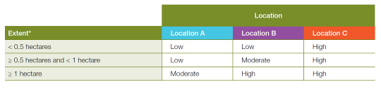

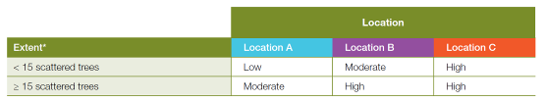

Source: Table 3 and 4, Permitted clearing of native vegetation - Biodiversity assessment guidelines (DEPI 2013a)

Location risk

The location risk has been determined by DEPI for all locations in Victoria. Native vegetation will be in either location A, B or C.

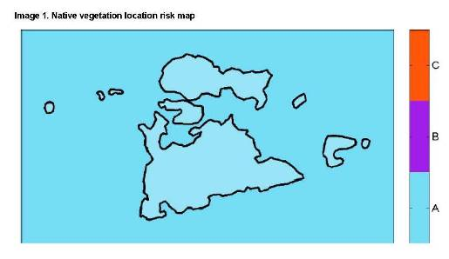Vegetation at the subject site is located in location ‘A’ as shown in the Figure 5 below

Figure 5. Location risk at subject site
Source: DEPI Transition Support (DEPI 2014d).

Proposed losses from re-zoning and subsequent development

The losses that are likely to occur across the site will be within the degraded Grassy Woodland vegetation (HZ1; Map 1). These areas are of low priority for conservation and the protection of an offset elsewhere, or increasing vegetation quality and habitat along the drainage line would be a better ecological outcome than leaving it in its current state.

Residential development should avoid areas in close proximity to the drainage line.

Development of all other areas across the site is not likely to impact on any significant ecological values.

High Risk-based Pathway

The Native Vegetation Location Risk Map, V2 (Figure 5), determines the site as being within location ‘A’. The area of clearing proposed for the site is likely to be greater than 1.0 ha. Therefore, the proposed clearing within the site is determined to have a risk based pathway of ‘Moderate’, see Table 7, below.

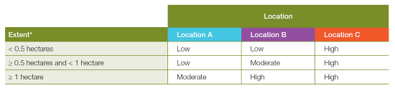Table 7. Risk-based pathways for proposed vegetation removal on site

Source: Table 3 – Permitted clearing of native vegetation Biodiversity assessment guidelines (DEPI 2013a).

Vegetation removal on-site is likely to be within the moderate risk based pathway. An application must include:

      - A statement outlining what steps have been taken to minimise the impacts of the removal of native vegetation on biodiversity.

      - An assessment of whether the proposed removal of native vegetation will have a significant impact on Victoria’s biodiversity, with specific regard to the proportional impact on habitat for any rare or threatened species.

      - An offset strategy that details how a compliant offset will be secured to offset the biodiversity impacts of the removal of native vegetation.

The following sections briefly comment on these requirements.

Minimising impacts to biodiversity

A moderate risk-based pathway application must provide a statement outlining what steps have been taken, to ensure that impacts on biodiversity from the removal of native vegetation have been minimised. The steps taken should have regard to the contribution the native vegetation to be removed, and the native vegetation to be retained, makes to biodiversity. Some guiding recommendations into the design of the concept plan to fulfil this requirement are as follows:

    - Attempt to incorporate existing patches of vegetation into areas of open space

    - Avoid designing buildings or works that impact on the drainage line

    - Avoid placing lots and/or dwellings too close to vegetation that may need to be subsequently cleared to accommodate defendable space requirements under the BPA

    - Avoid excessive earthworks within and adjacent to the drainage line

    - Avoid creating situations that may increase erosion

Biodiversity Assessment Report

The Biodiversity Assessment Report provided by DEPI Transition Support (DEPI 2014d) summarises the extent of potential vegetation removal on site. Site data has been sent to DEPI who have assessed this base data and produced a report on the values of the site. This report has been generated in order to gain an understanding of the likely impacts and offset requirements of potential future clearing on site. A summary is given in Table 8, below, and the full report is provided in Appendix 4.

Table 8. Summary of marked native vegetation

Summary Item | Result
Risk-based pathway | Moderate
Total extent | 4.833 ha
Remnant patches | 4.833 ha
Scattered trees | 0 trees
Location risk | A
Strategic biodiversity score of all marked native vegetation | 0.386

If a permit is granted to remove all of the marked native vegetation, a requirement to obtain a native vegetation offset will be included in the permit conditions. The offset must meet the following requirements (Table 9):

Table 9. Offsets required if all vegetation is cleared

Offset type | General offset
General offset amount (general  biodiversity equivalence units) | 0.392 general units
General offset attributes
Vicinity | Corangamite Catchment Management Authority (CMA) or the Local Municipal  District where clearing takes place
Minimum strategic biodiversity  score | 0.308

The Biodiversity Impact and Offset Report (BIOR) has outlined that only a general offset amount is required for the removal of all vegetation on site. This implies that removal of this vegetation and habitat is not likely to cause a significant impact to the decline of the species listed in the BIOR.

Offset Strategy

As defined by DEPI (2013a) applications that follow the moderate risk-based pathway must include an offset strategy in the application for a permit to remove native vegetation.

Offsets can be either:

    - First party – located on land owned by the landholder who is proposing to remove the native vegetation

    - Third party – located on land owned by a third party

Depending on the outcomes of the concept design, there may be scope to locate the offsets on-site and incorporate them into enhancement works along the drainage line.

Minimum requirements for revegetation offsets must be met in order to be eligible for an offset. The following requirements must be met:

    - Revegetation must be done in accordance with the minimum planting standard specified in Appendix 2 of the Native Vegetation Gain Scoring Manual – version 1 (DEPI 2013b) and revegetation sites must meet the following size requirements:

      - At least 1 hectare in size

      - Have an average width of at least 20 metres

      - Have a perimeter to area ratio of 1:20. Perimeter to area ratio can be calculated by dividing the area (metres2) by the perimeter (metres).

In addition, a ten-year offset plan must be prepared for the offset site.

After a brief analysis of the likely gains from revegetation offsets, an area of between 6.5 to 12 ha would be required to offset the total vegetation losses on site. In addition, any proposed building envelopes will require appropriate setbacks to areas of revegetation or retained vegetation on site if the vegetation is considered classifiable vegetation. That is, if it does not constitute excludable vegetation under AS3959. Therefore, if an area of revegetation greater than 1 ha in area is proposed on site then dwellings will need appropriate setbacks and require BAL ratings accordingly.

It is recommended that ecological enhancement works be undertaken along the drainage line that do not create areas of classifiable vegetation. Revegetation offsets, if intended to be created on site, may not account for the total offset required. Therefore, offsets for the loss of vegetation on site are recommended to be sourced off site, through native vegetation credit traders.

6.4.1 SOURCING NATIVE VEGETATION (OFFSET) CREDITS

There are several methods for acquiring Native Vegetation Credits when they are not available on your development site, although all credits need to fulfil the offset requirement criteria to offset permitted losses (Table 9). The following sections briefly present methods available.

Creating credits through protection and management of native vegetation

If you own other land parcels or are aware of other land parcels where the owners would be interested in providing credits; credits can be achieved through protection and rehabilitation of native vegetation. Rehabilitation of existing vegetation as offsets for native vegetation needs to occur for a ten year period, and protection of vegetation in perpetuity.

Purchasing offset credits

Where proponents do not have or know of land available to create the required offset gains, it may be easiest to purchase existing credits directly from a credit holder. A credit holder is someone who has or is preparing to create offset credits through the methods described above and is now looking to sell them to planning permit proponents who require them.

BushBroker, operated by the DEPI, facilitates the location of sites that could generate Native Vegetation Credits to be provided as offsets for clearing elsewhere. The proposed third party offset site must meet the required offset requirements of the vegetation losses.

Credits in the form of habitat hectares are able to be purchased from a third party landowner. The transaction is between the purchases and offset providing and as such price negation is between these parties but facilitated by DEPI. Additional expenses include DEPI charges to facilitate the transaction.

For further information on BushBroker, contact the DEPI Customer Service Centre on 136 186 or visit the DEPI website at: www.depi.vic.gov.au/nativevegetation. BushBroker Information Sheets are also available on the website. Native Vegetation credits are also available through independent accredited bodies, such as Trust for Nature.

Summary

This report has outlined relevant considerations for the rezoning of the site in relation to relevant native vegetation legislation. The following points and recommendations summarise the findings of this assessment:

Summary of Findings

    - The site contained patches of low quality vegetation with little habitat value for significant species

    - There was a high cover of invasive weeds across the site

    - The drainage line contains the most environmentally sensitive areas within the site and requires careful consideration to avoid adverse impacts at the design stage

Summary of Recommendations

    - As the site is within a Bushfire Prone Area (BPA) appropriate sighting of dwellings and allotments in order to achieve appropriate setbacks from unmanaged vegetation will be required.

    - No development should occur within the PAO due to the objectives and future intended use of this land as outlined under this overlay.

    - Attempt to incorporate existing patches of remnant indigenous vegetation into areas of open space

    - Avoid designing buildings or works that impact on the drainage line

    - Avoid placing lots and/or dwellings too close to vegetation that may need to be subsequently cleared to accommodate defendable space requirements under the BPA

    - Avoid excessive earthworks within and adjacent to the drainage line

    - Avoid creating situations that may increase erosion

    - Consider the need to meet the minimum area and dimension requirements for offset plantings, if offsets are to be located on site

    - It is recommended that ecological enhancement works be undertaken along the drainage line that do not create areas of classifiable vegetation.

    - Revegetation offsets, if intended to be created on site, may not account for the total offset required.
Therefore, offsets for the loss of vegetation on site are recommended to be sourced off site, through native vegetation credit traders.

    - Weed infestations should be controlled where areas of open space are to be created. A weed management program will need to be prepared to manage weeds across areas of open space and any areas where offsets are to be established. This should include areas along the drainage line.

    - Weed seed should not be spread onto, or out of, the site during construction works. This requirement should be included in any weed management program that is prepared for the site.

REFERENCES

Allen, G. R., Midgley, S. H. & Allen, M. (2002) Field Guide to the Freshwater Fishes of Australia. Western Australian Museum, Perth.
and the Arts. Accessed via: http://www.environment.gov.au/cgi- bin/sprat/public/sprat.pl

Australian Plants Society Maroondah (2001) Flora of DSE (2003) Bellarine Yellow Gum - Euclyptus

Melbourne. 3rd edn. Hyland House,
Melbourne.

Department of Environment & Primary Industries (2013) Biodiversity Assessment Guidelines.

leucoxylon subsp. bellarinensis Action
Statement No. 180. Department of
Sustainability and Environment, East
Melbourne, Victoria.

Victorian Government Department of DSE (2004) Vegetation Quality Assessment Manual -

Environment & Primary Industries, Melbourne.

DEPI (2013a) Biodiversity Assessment Guidelines Department of Environment and Primary Industries, Government of Victoria, Melbourne.

DEPI (2013b) Native Vegetation Gain Scoring Manual.
Department of Environment and Primary
Industries, Government of Victoria, Melbourne.

Guidelines for applying the habitat hectares
scoring method, Version 1.3. Department of
Sustainability and Environment, East
Melbourne, Victoria.

DSE (2013) Advisory list of threatened vertebrate fauna in Victoria. Department of Sustainability and Environment, State Government of Victoria, East Melbourne.

DEPI (2014a) Biodiversity Interactive Maps. Department Halse, S. A., Pearson, G. B., Hassell, C., Collins, P.,

of Environment and Primary Industries,
Government of Victoria. Accessed via: http://mapshare2.dse.vic.gov.au/MapShare2E XT/imf.jsp?site=bim

DEPI (2014b) Ecological Vegetation Class (EVC)
Scanlon, M. D. & Minton, C. D. T. (2005) Mandora Marsh, north-western Australia, an arid-zone wetland maintaining continental populations of waterbirds. Emu, 105, pp. 115- 125.

Benchmarks for each Bioregion. Department of Hamer, A. & Organ, A. (2006) Distribution, Habitat Use

Environment and Primary Industries,
Government of Victoria. Accessed via:
http://www.dse.vic.gov.au/conservation-and- environment/native-vegetation-groups-for- victoria/ecological-vegetation-class-evc- benchmarks-by-bioregion

and Movement Patterns of the Growling Grass
Frog Litoria raniformis throughout the
Pakenham Area, Pakenham, Victoria. Report
for Department of Sustainability and
Environment by Ecology Partners Pty Ltd, Brunswick, Victoria.

DEPI (2014c) Victorian Biodiversity Atlas. Department Heard, G. W., Robertson, P. & Scroggie, M. (2004) The

of Environment and Primary Industries,
Government of Victoria. Accessed via: https://vba.dse.vic.gov.au

DEPI (2014d) DEPI Transition Support. Email: nativevegetation.support@depi.vic.gov.au.
ecology and conservation status of the Growling Grass Frog Litoria raniformis within the Merri Creek corridor. Wildlife Profiles Pty.
Ltd. and Arthur Rylah Institute for Environmental Research.

Department of Environment and Primary Hero, J.-M., Littlejohn, M. & Marantelli, G. (1991)

Industries.

DEWHA (2010) Species Profile and Threats Database.
Department of Environment Water Heritage

Frogwatch Field Guide to Victorian Frogs.
Department of Conservation and Environment,
Melbourne.

Higgins, P. J. & Davies, S. J. J. F. (eds.) (1996) Rogers, D. I. (1990) Hardhead Aythya australis. IN

Handbook of Australian, New Zealand and
Antartic: Birds Snipe to Pigeons. Oxford
University Press, Melbourne.

Higgins, P. J. (ed.) (1999) Handbook of Australian, New
Marchant, S. & Higgins, P. J. Handbook of

Australian, New Zealand & Antarctic Birds:
Ratites to Ducks. Oxford University Press,
Melbourne.

Zealand and Antarctic Birds: Parrots to Swift Parrot Recovery Team (2001) Swift Parrot

Dollarbird. Oxford University Press, South
Melbourne, Victoria.
Recovery Plan. Department of Primary
Industries, Water and Environment, Hobart.

Higgins, P. J., Peter, J. M. & Steele, W. K. (eds.) (2001) Tyler, M. J. & Knight, F. (2009) Field Guide to the Frogs

Handbook of Australian, New Zealand and
Antarctic Birds: Tyrant-flycatchers to Chats.
Oxford University Press, South Melbourne,
Victoria.

Marchant, S. & Higgins, P. J. (1990) Handbook of Australian, New Zealand and Antarctic birds - Volume 1 Ratites to Ducks. Oxford University Press, Melbourne.

Marchant, S. & Higgins, P. J. (1993) Handbook of Australian, New Zealand and Antarctic Birds - Volume 2 Raptors to Lapwings. Handbook of
of Australia. CSIRO Publishing, Collingwood,
Victoria.

Viridans Biological Databases (2013a) Victorian Fauna Database (VFD) August 2013, Viridans Biological Databases Pty Ltd, East Bentleigh, Victoria.

Viridans Biological Databases (2013b) Flora Information System (FIS) August 2013, Viridans Biological Databases Pty Ltd, East Bentleigh, Victoria.

Australian, New Zealand and Antarctic Birds. Walsh, N. G. & Entwisle, T. J. (1996) Flora of Victoria:

Melbourne University Press, Melbourne, pp. 123-551.

Dicotyledons Winteraceae to Myrtaceae. Inkata
Press, Melbourne.

Menkhorst, P. & Knight, F. (2001) A Field Guide to the Walsh, N. G. & Entwisle, T. J. (1999) Flora of Victoria:

Mammals of Australia. 1st edn. Oxford
University Press, Melbourne.

Dicotyledons Cornaceae to Asteraceae. Inkata
Press.

Museum Victoria (2006) Melbourne's Wildlife: A field Walsh, N. G. & Stajsic, V. (2008) A Census of the

guide to the fauna of Greater Melbourne.
CSIRO Publishing, Collingwood, Melbourne.

O'Dwyer, C. & Attiwill, P. M. (2000) Restoration of a
Vascular Plants of Victoria. 8 edn. Royal
Botanic Gardens Melbourne, Melbourne,
Victoria.

Native Grassland as Habitat for the Golden Sun Wilson, S. & Swan, G. (2008) A Complete Guide to

Moth Synemon plana Walker (Lepidoptera;
Castniidae) at Mount Piper, Australia. Restor
Ecology, 8, pp. 170-174.

Paull, D. J. (2008) Southern Brown Bandicoot Isoodon obesulus. IN Dyck, V. & Strahan, R. The Mammals of Australia. 3rd edn. Reed New Holland, Sydney.

Pizzey, G. & Knight, F. (2007) The Field Guide to the Birds of Australia. 8th edn. Harper Collins Publishers, Sydney.

Reptiles of Australia - Second Edition. Reed
New Holland, Sydney.

Appendix 1. Flora recorded at study site

Flora species recorded in the study area during fieldwork.
- denotes exotic species # denotes native species extended beyond natural range

MONOCOTYLEDONS
Cyperaceae
  - Cyperus eragrostis Drain Flat-sedge
Eleocharis acuta Common Spike-sedge
Hydrocharitaceae
Ottelia ovalifolia subsp. ovalifolia Swamp Lily
Juncaceae
  - Juncus articulatus subsp. articulatus Jointed Rush
Juncus bufonius Toad Rush
Juncus pallidus Pale Rush
Juncus subsecundus Finger Rush
Poaceae
Austrostipa spp. Spear Grass
  - Avena barbata Bearded Oat
  - Bromus rubens Red Brome
  - Cenchrus clandestinus Kikuyu

Cynodon dactylon var. dactylon Couch
  - Cynosurus echinatus Rough Dog's-tail
  - Dactylis glomerata Cocksfoot
  - Holcus lanatus Yorkshire Fog
  - Hordeum secalinum Knotted Barley-grass
Lachnagrostis filiformis s.l. Common Blown-grass
  - Lolium perenne Perennial Rye-grass
  - Nassella hyalina Cane Needle-grass
  - Nassella neesiana Chilean Needle-grass
  - Nassella trichotoma Serrated Tussock
  - Paspalum dilatatum Paspalum
  - Paspalum distichum Water Couch
  - Phalaris aquatica Toowoomba Canary-grass
Rytidosperma caespitosum Common Wallaby-grass
Rytidosperma racemosum var. racemosum Slender Wallaby-grass
  - Sporobolus africanus Rat-tail Grass
  - Vulpia bromoides Squirrel-tail Fescue
DICOTYLEDONS
Asteraceae
  - Cirsium vulgare Spear Thistle
  - Helminthotheca echioides Ox-tongue
  - Leontodon taraxacoides subsp. taraxacoides Hairy Hawkbit
  - Sonchus asper s.l. Rough Sow-thistle
  - Sonchus oleraceus Common Sow-thistle
Brassicaceae
  - Hirschfeldia incana Buchan Weed
Caryophyllaceae
  - Sagina procumbens Spreading Pearlwort

Fabaceae
  - Lotus angustissimus Slender Bird's-foot Trefoil
  - Trifolium angustifolium var. angustifolium Narrow-leaf Clover
  - Ulex europaeus Gorse
Haloragaceae
Myriophyllum spp. Water Milfoil
Lythraceae
Lythrum hyssopifolia Small Loosestrife
Plantaginaceae
  - Plantago lanceolata Ribwort
Polygonaceae
  - Rumex pulcher subsp. pulcher Fiddle Dock
Rosaceae
  - Prunus spp. Prunus
  - Rosa rubiginosa Sweet Briar
Solanaceae
  - Lycium ferocissimum African Box-thorn

Appendix 2. Potentially occurring significant flora species

Table 10. Potentially occurring State and Nationally Significant flora species within 5 km (VBA 2014)

Status Code

Victorian Rare or Threatened Species (VROTS) (DEPI 2013) EX: Extinct, RX: Regionally Extinct, WX: Extinct in the Wild,
CR: Critically Endangered, EN: Endangered, VU: Vulnerable, NT: Near
Threatened, DD: Data Deficient
EPBC Act 1999 conservation status
EX: Extinct, CR: Critically endangered, EN: Endangered, VU: Vulnerable and CD: Conservation dependant.
FFG Act 1988 status
L: Listed, N: Nominated, I: Invalid or ineligible and D: Delisted

EPBC | FFG | VROT | Scientific name | Common name | Source Database | No. records | Date last record | Likelihood of occurrence | Habitat/species notes | Likelihood Reasoning

Eucalyptus leucoxylon subsp.
f e
bellarinensis
Bellarine Yellow- gum

winter. (DSE 2003)
 |  |  |  |  |  | Widespread, infrequent populations in
V f v Glycine latrobeana | Clover Glycine | DEPI | 0 | none | Low | southern Victoria (Walsh and Entwisle  1996). Plains Grassland and Woodlands in
 |  |  |  |  |  | moist well drained soils (Australian Plants

No records within 5km, very degraded habitat on site, high herbivore
 |  |  |  | Endemic to Victoria. The Bellarine
 |  |  |  | Peninsula supports the only known
 |  |  |  | locations of this subspecies. It occurs in | None recorded on site.
VBA | 6 | 2010 | Low | dry coastal and near coastal habitats and | Unlikely that species
 |  |  |  | in the Grassy Woodland EVC. It prefers | was overlooked
 |  |  |  | heavy clay soils that are waterlogged in

pressure
Society Maroondah 2001).

Geranium solanderi var.
v
solanderi s.s.

Austral Crane's- bill

DEPI 0 none Low
An uncommon species of damp to dryish usually sheltered sites in grassy woodlands. ften along drainage line or in seepage areas
No records within 5km, very degraded habitat on site, high herbivore

(Walsh and Entwisle 1999, p. 224). pressure
 |  |  |  | Moist well drained sites in open grassy | No records within 5km,
 |  |  |  | forest or woodland. Frequent, widespread | very degraded habitat
DEPI | 0 | none | Low | populations across much of Victoria, | on site, high herbivore
 |  |  |  | excluding the north-west (Walsh and | pressure habitat on

Coronidium scorpioides 'aff.
v
rutidolepis (Lowland Swamp
Pale Swamp Everlasting

Entwisle 1999). site

Appendix 3. Potentially occurring significant fauna species

Table 11. Potentially occurring State and Nationally Significant fauna species

Status Code

International Treaty
JAMBA / CAMBA, ROKAMBA and/or Bonn Convention Listed Species Migratory/Marine (EPBC Act)
M1: Migratory Listed Species under the EPBC Act; M2: Marine Listed Species under the EPBC Act. EPBC Act 1999 conservation status
EX: Extinct, CR: Critically endangered, EN: Endangered, VU: Vulnerable and CD: Conservation dependant.
Int Treaty Mig/Mar EPBC  FFG VROT | No. local records | Date last record | Likelihood occurrence | Habitat | Likelihood Reasoning

FFG Act 1988 status
L: Listed, N: Nominated, I: Invalid or ineligible and D: Delisted Victorian Rare or Threatened Species (VROTS) (DSE 2013)
EX: Extinct, RX: Regionally Extinct, WX: Extinct in the Wild,
CR: Critically Endangered, EN: Endangered, VU: Vulnerable, NT: Near
Threatened, DD: Data Deficient
*database records are from the Victorian Biodiversity Atlas (VBA) or from DEPI Transition Support (DEPI)

Scientific name
Common name

Database*

L VU
Accipiter novaehollandiae novaehollandiae

Grey Goshawk
 |  |  |  | The Grey Goshawk has a stronghold in Victoria,
 |  |  |  | particularly the white form, in the Otway Ranges,
 |  |  |  | where wet forests and gullies containing Mountain | Has the
 |  |  |  | Grey Gum adjoin partly cleared farmlands. They | potential to
VBA/DEPI | 2 | 2001 | Low | occur in lower densities in similar habitats in the | use the site for
 |  |  |  | Strzelecki Ranges, Gippsland Plains and Otway Plains. | foraging, low
 |  |  |  | Elsewhere in the State they are occasionally seen in | quality habitat
 |  |  |  | woodlands, dry forests, suburban parks and wooded

farmlands (Marchant and Higgins 1993).
The Australasian Shoveler occurs mainly on large well vegetated wetlands and lakes, occasionally including

VU Anas rhynchotis

Australasian Shoveler

DEPI 0 none Low
areas with saline waters. Populations are found in
higher numbers on permanent, well-vegetated
freshwater swamps with areas of open water. This
species nests in grass nests on the ground, usually in
dense cover and near water (Marchant and Higgins
No records
within 5km,
degraded
habitat on site

1990; Pizzey and Knight 2007).

Scientific name
Common name

Database*

L EN Ardea intermedia

Intermediate Egret

DEPI 0 none Low
The Intermediate Egret occurs in the shallows of mainly grassy inland wetlands, flooded pastures or grasslands. They only occasionally visit coastal wetlands and are generally rare in Victoria. They are sometimes seen foraging in pastures with grazing cattle. This species builds platform nests which are built in trees in riverine forest, swamp woodland and

No records within 5km, degraded habitat on site

mangroves (Pizzey and Knight 2007).
Eastern Great Egret is widespread in Australia and has been observed in a wide range of wetland habitats including swamps and marshes; margins of

C, M1,
J M2

L VU Ardea modesta

Eastern Great Egret

VBA/DEPI 1 1974 Low
rivers and lakes; damp or flooded grasslands, pastures or agricultural lands; reservoirs; sewage treatment ponds; drainage channels; salt pans and salt lakes; salt marshes; estuarine mudflats, tidal streams; mangrove swamps; coastal lagoons; and
Low number of
records within
5km, degraded habitat on site

offshore reefs (DEWHA 2010).
Int Treaty Mig/Mar EPBC  FFG VROT | No. local records | Date last record | Likelihood occurrence | Habitat | Likelihood Reasoning

Hardheads inhabit deep to shallow wetlands with open water and fringing emergent vegetation (Pizzey and Knight 2007). The species feeds by diving in deep water and occasionally by dabbling just under the water surface (Rogers 1990). Nests are built in
VU Aythya australis | Hardhead | DEPI | 0 | none | Low | thick vegetation (e.g. reeds, lignum, cumbungi), usually over water (Halse et al. 2005; Rogers 1990). These birds are most common in the wetland | No records within 5km, degraded
 |  |  |  |  |  | systems of inland Australia (Halse et al. 2005). Birds  do visit Victoria from these areas in spring and | habitat on  site
 |  |  |  |  |  | summer, returning as the northern wetlands is
replenished by rain (Halse et al. 2005). However,
some birds are present in Victoria all year round
 |  |  |  |  |  | depending on the suitability of the wetland (Pizzey

and Knight 2007).

Scientific name
Common name

Database*

VU Biziura lobata Musk Duck VBA/DEPI 1 1974 Low

Usually seen in small numbers on the deep waters of well vegetated fresh to saline lakes, swamps and occasionally shallow inlets and bays. Nests formed in low vegetation in areas sheltered by surrounding vegetation (Marchant and Higgins 1990; Pizzey and Knight 2007).
Low number of records within 5km, no recent records, degraded habitat on

site
This species is part nocturnal and forages over water

EN L EN

Botaurus poiciloptilus

Australasian Bittern

VBA/DEPI 1 1974 Low
in dense cover, sometimes from platforms in wetland vegetation. Habitat is usually tall reedbeds, sedges, rushes, cumbungi or lignum. Also occurs on rice fields, drains in tussocky paddocks and occasionally on saltmarshes and brackish wetlands. Nests are shallow saucers on trampled water plants (Pizzey and
Low number of
records within 5km, no recent records, degraded habitat on
site

Knight 2007).
No records

L VU
Calamanthus pyrrhopygius
Chestnut-
rumped
Heathwren

DEPI 0 none Low
Found in heathy woodlands, scrublands and
box/ironbark forests in coastal south east Australia
(Pizzey and Knight 2007).
within 5km, no habitat on

site
The Black Falcon has a stronghold in inland Australia. Most Victorian records come from the lowlands and

VU Falco subniger Black Falcon DEPI 0 none Low
only occasionally from the foothills. It occurs mainly over croplands, grasslands and wooded farmlands. To catch flushed prey, they sweep low over croplands and grasslands and are often attracted by smoke from grassfires and late-summer burning off. This species nests in trees in old stick-nests of other birds (Marchant and Higgins 1993; Pizzey and Knight
Has the
potential to use the site for foraging, low quality habitat, no records within 5km

2007).

VU L EN Galaxiella pusilla

Dwarf Galaxias

DEPI 0 none Low
Occurs in vegetated margins of slow-flowing coastal creek backwaters, drains and swamps, often with dense aquatic macrophytes. Ephemeral sites require
No records within 5km, degraded

seasonal flooding and linkages to other more habitat on
Int Treaty Mig/Mar EPBC  FFG VROT | No. local records | Date last record | Likelihood occurrence | Habitat | Likelihood Reasoning

Scientific name
Common name

Database*

permanent populations for population replenishment, therefore wetland connectivity may be critical to survival. They occur across most of southern Victoria, however are sparse in the landscape and more abundant in the south-east of the state, most specifcally in Mornington Peninsula & Western Port areas (Allen et al. 2002; Museum
Int Treaty Mig/Mar EPBC  FFG VROT | No. local records | Date last record | Likelihood occurrence | Habitat | Likelihood Reasoning

site

Victoria 2006).
The Painted Honeyeater is a summer migrants to Victoria. They are generally found to inhabit box- ironbark, Broad-leaved Peppermint and Red
 |  |  |  | Stringybark forests and box-buloke woodlands in the | No records
 |  |  |  | northern foothills of the great Divide. May also occur | within 5km,
DEPI | 0 | none | Low | in Red Ironbark, Red Box forests in southern Victoria. | degraded
 |  |  |  | They are occasionally found along Murray River valley | habitat on
 |  |  |  | to Hattah-Kulkyne NP where they inhabit Black Box | site
 |  |  |  | woodlands. This species is usually found in open
 |  |  |  | stands of old eucalypts that are infested with

L VU Grantiella picta
Painted Honeyeater

mistletoes (Higgins et al. 2001).
The Southern Brown Bandicoot is both active during

EN L NT

Isoodon obesulus obesulus
Southern Brown Bandicoot

VBA 1 1981 Low
the day and night. It is found in forest, heath and shrub communities. It shelters in a nest of vegetation beneath dense cover, it eats fungi, tubers and
Low number of
local records,
no suitable habitat on site

arthropods (Menkhorst and Knight 2001; Paull 2008).
Occurs mainly in dense emergent vegetation in freshwater swamps, lakes and watercourses, where
 |  |  |  |  |  | forage in shallow water or from supporting emergent | No records
 |  |  |  |  |  | or aquatic vegetation over deep water. Tolerate | within 5km,
EN | Ixobrychus dubius Little Bittern | DEPI | 0 | none | Low | brackish-saline waters in mangrove swamps, Juncus-  dominated saltmarsh, and wooded margins of coastal | degraded  habitat on
 |  |  |  |  |  | lagoons. Nests in densely vegetated freshwater | site
 |  |  |  |  |  | wetlands; invariably over water; in sedge, reeds or

rush, either in pure stands or interspersed in

Scientific name
Common name

Database*

woodland thickets. Most records from the Murray-
Int Treaty Mig/Mar EPBC  FFG VROT | No. local records | Date last record | Likelihood occurrence | Habitat | Likelihood Reasoning

Darling Basin (Marchant and Higgins 1990, p. 1040).
The Swift Parrot is a winter migrant to Victoria (Swift Parrot Recovery Team 2001). Arriving from their breeding areas in Tasmania, however small numbers of non-breeding birds may remain here during summer (Higgins 1999; Swift Parrot Recovery Team
2001). They are nomadic, and follow the flowering of

EN L EN Lathamus discolor Swift Parrot VBA 6 1996 Low
trees and psyllid infestations. In Victoria their distribution is centred on box-ironbark forests, but they are often seen in town parks and occur sporadically elsewhere in dry forests, dry woodlands and wooded farmlands but are seldom seen in treeless areas, rainforests or wet forests (Higgins 1999; Pizzey and Knight 2007). Feed mainly in winter-flowering plants, especially Red Ironbarks and ornamental trees and shrubs (Higgins 1999; Swift
No trees on
site, low quality foraging habitat.

Parrot Recovery Team 2001).
Inhabits densely vegetated, fresh, brackish or saline

L VU Lewinia pectoralis Lewin's Rail DEPI 0 none Low
wetlands, usually with areas of standing water. Use long tussocky grass, reeds, rushes, sedges or bracken and are occasionally found amongst tangled clumps of weeds such as Blackberries and Lantana
No records within 5km, degraded habitat on site

(Marchant and Higgins 1993).
The species often inhabits water bodies with a

VU L EN Litoria raniformis

Growling Grass Frog

VBA/DEPI 1 1788 Low
diverse assemblage of aquatic vegetation, including emergent species such as sedges (Gahnia spp.), submergent species such as curly pondweed (Potamogeton spp.), floating species such as water ribbon (Triglochin spp.) and filamentous algae (Hamer and Organ 2006; Heard et al. 2004). The aquatic vegetation provides sites for male frogs to
No recent
records, degraded habitat on site
– may be present during
seasonal movement

call from, sites for eggs to be deposited and

Scientific name
Common name

Database*

relatively safe development, and food and shelter for tadpoles. Dense submergent vegetation is especially important to protect eggs and tadpoles from predation (Heard et al. 2004). However, it is also known to occur in ditches, dams and swamps or sheltering under discarded debris near those sites
Int Treaty Mig/Mar EPBC  FFG VROT | No. local records | Date last record | Likelihood occurrence | Habitat | Likelihood Reasoning

(Tyler and Knight 2009, pp. 38-39).
Found in heathlands, woodlands, forests; tropical

L VU Lophoictinia isura

Square-tailed Kite

DEPI 0 none Low
and sub tropical rainforest; timbered watercourses;
hills and gorges. Nest are large and loose made of
sticks 15-25m up in leafy tree. Range in coastal and
sub-coastal south east Australia including Murray
No records
within 5km, no
suitable
habitat

River region in SA. (Pizzey and Knight 2007)

VU L VU

Nannoperca obscura

Yarra Pigmy Perch

VBA 3 1989 Low
Inhabits small lakes and streams, preferring habitats with flowing water and abundant aquatic vegetation for shelter. It is found in coastal drainages from
No suitable habitat on site, low number of

southern SA to Frankston, Victoria (Allen et al. 2002). local records
Has the
 |  |  |  |  | Occurs in dry woodlands, wooded farmlands and dry | potential to
 |  |  |  |  | forests in the 500-800mm annual rainfall zone and | use the site for
Barking Owl | VBA/DEPI | 1 | 1993 | Low | extend into semi-arid areas in River Red Gum forests | foraging, no
 |  |  |  |  | along the Murray River. Hollow dependent species | habitat, one
 |  |  |  |  | (Higgins 1999; Pizzey and Knight 2007). | record within

L EN
Ninox connivens connivens

5km
This species inhabits deep, permanent, well- vegetated swamps, but at times (especially in winter)

L EN Oxyura australis

Blue-billed Duck

VBA/DEPI 14 1978 Low
may occur in large numbers on large open wetlands. The Blue-billed Duck catches food while diving or
occasionally by feeding from the water surface. Their nests are built on trampled swamp vegetation around the base of established stands of reeds/rushes, often over water or on small islands (Marchant and Higgins
Many outdated
local records,
habitat not
well vegetated,
degraded habitat

1990; Pizzey and Knight 2007).

Scientific name
Common name

Database*

L VU

Porzana pusilla palustris

Baillon's Crake

VBA/DEPI 6 1985

Low- Moderate
This species returns to northern Victoria in spring, but few details on migration. It inhabits freshwater wetlands and floodwaters usually containing floating plants or tall emergent vegetation. The Baillon's Crake feeds in shallow water, mud and emergent aquatic plants. It has been found to nest in clumps or tussocks of vegetation surrounded by water (Marchant and Higgins 1993; Pizzey and Knight

Many local records, degraded habitat

2007).
No records

Pseudemoia
VU
rawlinsoni
Glossy Grass Skink

DEPI 0 none Low
Inhabits swamp and lake edges, salt-marshes and
boggy creeks with dense vegetation (Wilson and
Swan 2008).
within 5km, degraded

habitat
Frequent dry forest, woodland, shrubland and grassland; sheltering under leaf-litter and other

L EN

Pseudophryne bibronii

Brown Toadlet

DEPI 0 none Low
debris in moist soaks and depressions. Eggs are spawned in shallow burrows (or nets) under litter, in low areas, near water, that will later be flooded. Tadpoles are aquatic in ponds, flooded grassland and
No records
within 5km,
degraded
habitat

roadside ditches (Hero et al. 1991).
The Southern Toadlet can be found in dry forest,

Pseudophryne
VU
semimarmorata

Southern Toadlet

DEPI 0 none Low
woodland, shrubland, grassland and heaths. It shelters under leaf litter and other debris in moist soaks and depressions. Their eggs are spawned in
shallow burrows under organic litter in low areas
No records within 5km, degraded
habitat

close to water (Hero et al. 1991).
Eastern coastal Australia from Gladstone in Qld to South Gippsland and Melbourne in Vic, rare influxes

VU L VU

Pteropus poliocephalus

Grey-headed Flying-fox

VBA 1 1973 Low
further west and south. Rarely more than 200km inland. In warmer months gathers in very large camps, usually in dense forest in gullies; population more dispersed in winter. Size of camps fluctuates in
Outdated
record within
5km, no habitat on site

response to local food supplies; in south numbers
Int Treaty Mig/Mar EPBC  FFG VROT | No. local records | Date last record | Likelihood occurrence | Habitat | Likelihood Reasoning

Scientific name
Common name

Database*

fluctuate in regular pattern, being highest in late summer-autumn and lowest in winter (Menkhorst
Int Treaty Mig/Mar EPBC  FFG VROT | No. local records | Date last record | Likelihood occurrence | Habitat | Likelihood Reasoning

and Knight 2001).
Mostly sheltered coastal embayments, including harbours, lagoons, inlets, bays, estuaries and on

VU L EN

Sternula nereis nereis

Fairy Tern VBA 1 1974 Low
ocean beaches. Also fresh or saline near-coastal
terrestrial wetlands, including lakes and salt-ponds. Nests above high-water mark on sheltered beaches, spits, bars, banks and ridges, usually of sand but also of shell-grit or coral; either on mainland or on
Low number of
outdated local
records, degraded
habitat

inshore islands (Higgins and Davies 1996).
It is generally found in temperate grasslands and open grassy woodlands where the ground layer is

CR L EN Synemon plana

Golden Sun Moth

DEPI 0 none

Low - Moderate
dominated by native Wallaby Grass. Optimal habitat is dominated by wallaby grasses Austrodanthonia
spp with an open tussock structure. It has also been recorded in grasslands dominated by Kangaroo Grass Themeda triandra and exotic dominated grasslands
No records within 5km,
degraded habitat on site

(i.e. Chilean Needlegrass)(O'Dwyer and Attiwill 2000).

No records within 5km, no suitable
 |  |  |  |  |  |  | Occurs in well-timbered areas, from dry woodlands
EN | Varanus varius | Lace Monitor | DEPI | 0 | none | Low | to cool temperate southern forests. Arboreal,  ascending large trees when disturbed. Forages
 |  |  |  |  |  |  | widely. Clutches of eggs are laid in arboreal or

habitat
terrestrial termite mounds (Wilson and Swan 2008).

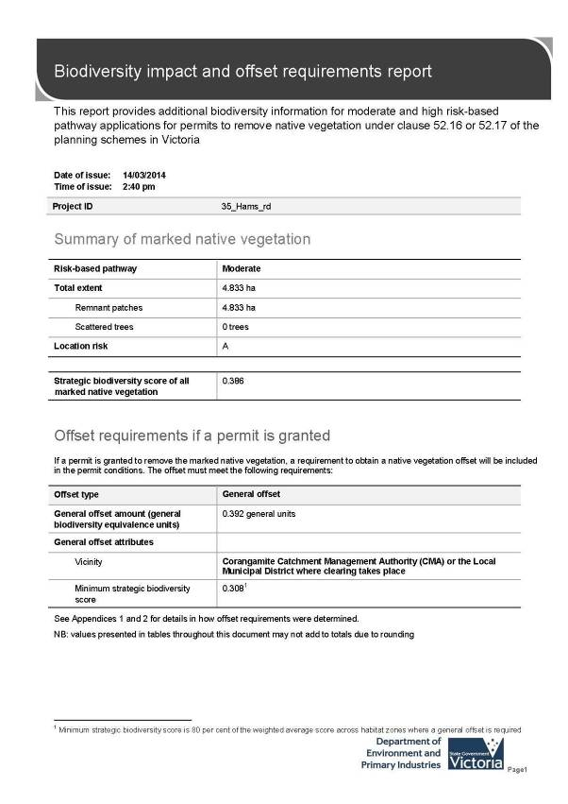

Appendix 4. Biodiversity assessment report provided by
DEPI Transition Support (DEPI 2014d).


Next steps

This proposal to remove native vegetation must meet the application requirements of the moderate risk-based pathway and it will be assessed under the moderate risk-based pathway .

If you wish to remove the marked native vegetation you are required to apply for a permit from your local council.
The biodiversity assessment report from NVIM and this biodiversity impact and offset report should be submitted with your application for a permit to remove native vegetation you plan to remove, lop or destroy.

The Biodiversity assessment report generated by the tool within NVIM provides the following information :
The location of the site where native vegetation is to be removed .
The area of the patch of native vegetation and/or the number of any scattered trees to be removed.
Maps or plans containing information set out in the Permitted clearing of native vegetation - Biodiversity assessment guidelines
The risk-based pathway of the application for a permit to remove native vegetation

This report provides the following information to meet application requirements for a permit to remove native vegetation :
Confirmation of the risk-based pathway of the application for a permit to remove native vegetation The strategic biodiversity score of the native vegetation to be removed
Information to inform the assessment of whether the proposed removal of native vegetation will have a significant impact on Victoria's biodiversity, with specific regard to the proportional impact on habitat for any rare or threatened species.
The offset requirements should a permit be granted to remove native vegetation .

Additional application requirements must be provided with an application for a permit to remove native vegetation in the moderate or high risk-based pathways . These include:
A habitat hectare assessment report of the native vegetation that is to be removed
A statement outlining what steps have been taken to ensure that impacts on biodiversity from the removal of native vegetation have been minimised
An offset strategy that details how a compliant offset will be secured to offset the biodiversity impacts of the removal of native vegetation .

Refer to the Permitted clearing of native vegetation- Biodiversity assessment guidelines and for a full list and details of application requirements .

©The State of Victoria Department of Environment and Primary Industries 2013 This publication is copyright. No part may be reproduced by any process ex cept in accordance w th the provisions of the Copyright Ad 1968

Authorised by the V ictorian Government , 8 NichaIson Street. East Melbourne .

For more information contact the DEPI Customer Service Centre 136 186
Disclaimer
This publication may be of assistance to you but the State of V ictoria and its employee s do not guarantee that the publication is withoutflawof any kind or is wholly appropriate for your particular purposes and therefore disclaims all liability for any error , loss or other consequence which may arise lrom you relying on
any information in this publication

Obtaining this publication doe s not guarantee that an application will meet the requirements of clauses 52 .16 or 52 . 17 al the Victoria Pia nning Provisions or that a permit to remove native v egetation w ll be granted .

No!Wthstanding anything else contained in this publication , you must ensure that you comply wth all relevant laws, legislation, awards or orders and that you obtain and comply wth all permits, approvals and the like that affect, are
applicabIe or are necessary to undertake any action to remove, lop or destroy or otherwise deal w th any native vegetation or that apply to matters wthin the
sc ope of clauses 52 .16 or5 2 .17 of the Victo ria Planning Provisions

WWvV .depi.vie.gov.au

Page2

Appendix 1 - Biodiversity impact of removal of native vegetation

Habitat hectares

Habitat hectares are calculated for each habitat zone within your proposal using the extent and condition scores in the GIS data you provided .

Habitat zone | Site assessed condition score | Extent (ha) | Habitat hectares
HZ1a | 0.140 | 1.143 | 0 .160
HZ1b | 0.140 | 3.158 | 0 .442
HZ2a | 0.140 | 0.227 | 0 .032
HZ1c | 0.140 | 0.034 | 0 .005
HZ1d | 0.140 | 0.197 | 0 .028
HZ1e | 0.140 | 0.018 | 0 .003
HZ2d | 0.180 | 0.027 | 0 .005
HZ2c | 0.180 | 0.012 | 0.002
HZ2b | 0.180 | 0.016 | 0 .003
TOTAL |  |  | I 0.679

Impacts on rare or threatened species habitat above specific offset threshold

The specific-general offset test was applied to your proposal. The test determines ifthe proposed removal of native vegetation has a proportional impact on any rare or threatened species habitats above the specific offset threshold. The threshold is set at
0.005 per cent of the total habitat for a species. When the proportional impact is above the specific offset threshold a specific
offset for that species' habitat is required.

The specific-general offset test found your proposal does not have a proportional impact on any rare or threatened species' habitats above the specific offset threshold . No specific offsets are required. A general offset is required as set out below .

Page3

Clearing site biodiversity equivalence score(s)

The general biodiversity equivalence score for the habitat zone (s) is calculated by multiplying the habitat hectares by the strategic biodiversity score .

Habitat zone | Habitat hectares | strategic biodiversity score | General biodiversity equivalence score (GBES)
HZ1a | 0.160 | 0.396 | 0 .063
HZ1b | 0.442 | 0.362 | 0.160
HZ2a | 0.032 | 0.480 | 0 .015
HZ1c | 0.005 | 0.547 | 0 .003
HZ1d | 0.028 | 0.575 | 0.016
HZ1e | 0.003 | 0.614 | 0 .002
HZ2d | 0.005 | 0.343 | 0 .002
HZ2c | 0.002 | 0.100 | 0 .000
HZ2b | 0.003 | 0.302 | 0 .001

Page4

Mapped rare or threatened species' habitats on site

This table sets out the list of rare or threatened species' habitats mapped at the site beyond those species for which the impact is above the specific offset threshold . These species habitats do not require a specific offset according to the specific-general offset test .

Species number | Species common name | Species scientific name
10045 | Lewin's Rail | Lewinia pectoralis pectoralis
10050 | Baillon's Crake | Porzana pusilla palustris
10186 | Intermediate Egret | Ardea intermedia
10187 | Eastern Great Egret | Ardea modesta
10195 | Little Bittern | lxobrychus minutus dubius
10197 | Australasian Bittern | Botaurus poiciloptilus
10212 | Australasian Shoveler | Anas rhynchotis
10215 | Hardhead | Aythya australis
10216 | Blue-billed Duck | Oxyura australis
10217 | Musk Duck | Biziura lobata
10220 | Grey Goshawk | Accipiter novaehollandiae novaehollandiae
10230 | Square-tailed Kite | Lophoictinia isura
10238 | Black Falcon | Falco subniger
10246 | Barking Owl | Ninox connivens connivens
10498 | Chestnut-rumped Heathwren | Calamanthus pyrrhopygius
10598 | Painted Honeyeater | Grantiella picta
12283 | Lace Monitor | Varanus varius
12683 | Glossy Grass Skink | Pseudemoia rawlinsoni
13117 | Brown Toadlet | Pseudophryne bibronii
13125 | Southern Toadlet | Pseudophryne semimarmorata
13207 | Growling Grass Frog | Litoria raniformis
15021 | Golden Sun Moth | Synemon plana
4701 | Dwarf Galaxias | Galaxiella pusilla
501456 | Clover Glycine | Glycine latrobeana
502145 | Giant Honey-myrtle | Melaleuca armillaris subsp . armillaris
504655 | Pale Swamp Everlasting | Coronidium scorpioides 'aff. rutidolepis (Lowland  Swamps)' variant
505337 | Austral Crane's-bill | Geranium solanderi var . solanderi s.s.

Page5

Appendix 2 - Offset requirements detail

If a permit is granted to remove the marked native vegetation the permit condition will include the requirement to obtain a native vegetation offset.

To calculate the required offset amount required the biodiversity equivalence scores are aggregated to the proposal level and multiplied by the relevant risk multiplier .

Offsets also have required attributes :
General offsets must be located in the same Catchment Management Authority (CMA) boundary or Local Municipal District (local council) as the clearing and must have a minimum strategic biodiversity score of 80 per cent of the clearing.2

The offset requirements for your proposal are as follows :

Offset type | Cleanng site biodiversity equivalence score | Risk multiplier | Offset requirements  ._ -
Offset type | Cleanng site biodiversity equivalence score | Risk multiplier | Offset amount (biodiversity equivalence units) | Offset attnbutes
General | 0.262 GBES | 1.5 | 0.392 general units | Offset must be within Corangamite CMA orthe same Municipal District as the vegetation removal  Offset must have a minimum strategic biodiversity score of0.308

2 Strategic biodiversity score is a we ighted average across habitat zones where a general of fset is required

Page6

Appendix 3 - Images of marked native vegetation

Image 1. Native vegetation location risk map

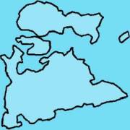c

0

Image 2. strategic biodiversity score map

f?o

B

A

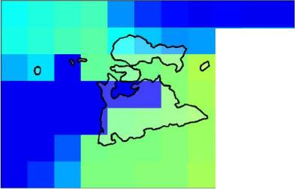0.9

0.8

0.7

0.6
(?o 0.5
0.4

0.3

0.2

0.1
n

Page7

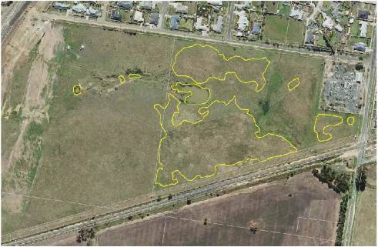Image 3. Aerial photograph showing marked native vegetation

Page8

Glossary

Condition score

Dispersed habitat

General biodiversity equivalence score

General offset amount

General offset attributes

Habitat hectares
This is the site-assessed condition score for the native vegetation . Each habitat zone in the clearing proposal is assigned a condition score according to the habitat hectare assessment method. This information has been provided by or on behalf of the applicant in the GIS file .

A dispersed species habitat is a habitat for a rare or threatened species whose habitat is spread over a relatively broad geographic area greater than 2,000 hectares.

The general biodiversity equivalence score quantifies the relative overall contribution that the native vegetation to be removed makes to Victoria 's biodiversity . The general biodiversity equivalence score is calculated as follows :

General biodiversity equivalence scure
= habitat hectares X strategic biodiversity score

This is calculated by multiplying the general biodiversity equivalence score of the native vegetation to be removed by the risk factor for general offsets . This number is expressed in general biodiversity equivalence units and is the amount of offset that is required to be provided should the application be approved . This offset requirement will be a condition to the permit for the removal of native vegetation .

Risk adjusted general biodiversity equivalence scure
= general biodiversity equivalence score clearing X 1. 5

General offset must be located in the same Catchment Management Authority boundary or Municipal District (local council) as the clearing site. They must also have a strategic biodiversity score that is at least 80 per cent of the score of the clearing site.

Habitat hectares is a site-based measure that combines extent and condition of native vegetation . The habitat hectares of native vegetation is equal to the current condition of the vegetation (condition score) multiplied by the extent of native vegetation . Habitat hectares can be calculated for a remnant patch or for scattered trees or a combination of these two vegetation types. This value is calculated for each habitat zone using the following formula :

Habitat hectares = total extent ( hectares) X condition score

Habitat importance score The habitat importance score is a measure of the importance of the habitat located on a site for a particular rare or threatened species . The habitat importance score for a species is a weighted average value calculated from the habitat importance map for that species . The habitat importance score is calculated for each habitat zone where the habitat importace map indicates that species habitat occurs.

Habitat zone Habitat zone is a discrete contiguous area of antive vegetation that :
is of a single Ecological Vegetation Class has the same measured condition .

Page9

Highly localised habitat

Minimum strategic biodiversity score

Offset risk factor

Offset type

Proportional impact on species

Specific offset amount
A highly localised habitat is habitat for a rare or threatened species that is spread across a very restricted area (less than 2,000 hectares) . This can also be applied to a similarly limited sub-habitat that is disproportionately important for a wide-ranging rare or threatened species . Highly localised habitats have the highest habitat importance score (1) for all locations where they are present.

The minimum strategic biodiversity score is an attribute for a general offset.
The strategic biodiversity score of the offset site must be at least 80 per cent of the strategic biodiversity score of the native vegetation to be removed. This is to en sure offsets are located in areas with a strategic value that is comparable to, or better than, the native vegetation to be removed. Where a specific and general offset is required, the minimum strategic biodiversity score relates only to the habitat zones that require the general offset.

There is a risk that the gain from undertaking the offset will not adequately compensate for the loss from the removal of native vegetation. If this were to occur , despite obtaining an offset, the overall impact from removing native vegetation would result in a loss in the contribution that native vegetation makes to Victoria 's biodiversity .
To address the risk of offsets failing , an offset risk factor is applied to the calculated loss to biodiversity value from removing native vegetation .

Risk factor for general of {sets = 1. 5

Risk factor for specific off set= 2

The specific-general offset test determines the offset type required.
When the specific-general offset test determines that the native vegetation removal will have an impact on one or more rare or threatened species habitat above the set threshold of 0.005 per cent, a specific offset is required. This test is done at the permit application level.
A general offset is required when a proposal to remove native vegetation is not deemed, by application of the specific- general offset test , to have an impact on any habitat for any rare or threatened species above the set threshold of 0.005 per cent. All habitat zones that do not require a specific offset will require a general offset.

This is the outcome of the specific-general offset test . The specific-general offset test is calculated across the entire proposal for each species on the native vegetation permitted clearing species list. If the proportional impact on a species is above the set threshold of 0 .005 per cent then a specific offset is required for that species .

The specific offset amount is calculated by multiplying the specific biodiversity equivalence score of the native vegetation to be removed by the risk factor for specific offsets. This number is expressed in specific biodiversity equivalence units and is the amount of offset that is required to be provided should the application be approved . This offset requirement will be a con dition to the permit for the removal of native vegetation.

Risk adjusted specific biodiversi ty equivalence score
= specific biodiversity equivalence score clearing X 2

Page 10

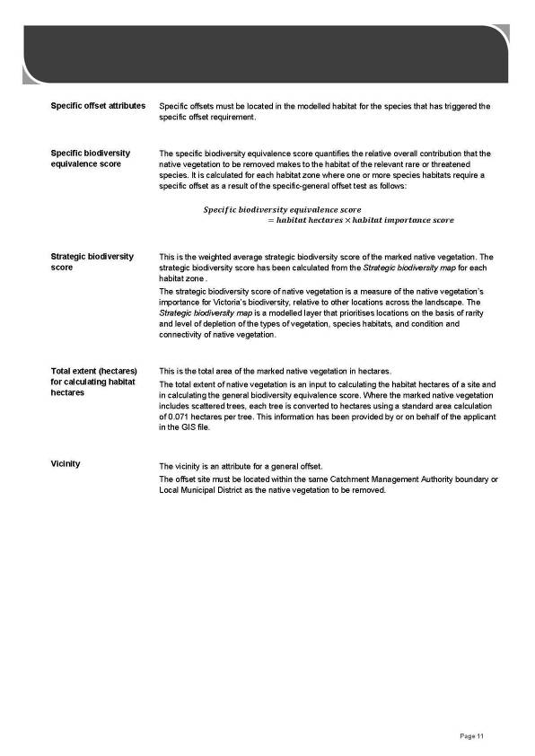

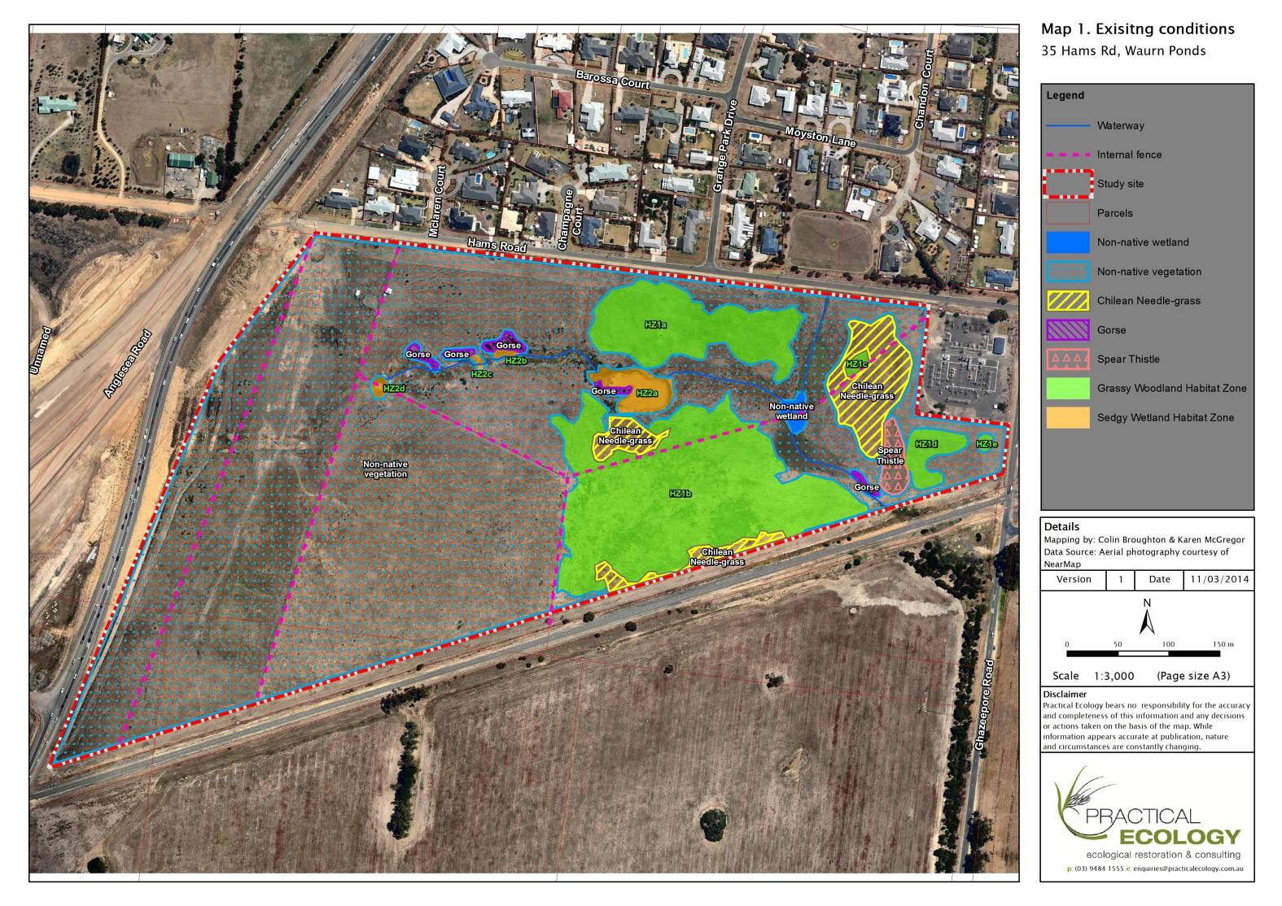

F&F and NNLA for35 Hams Road and 151-229 Anglesea Road, Waurn Ponds

Appendix 5. Maps

Map 1. Existing conditions

54

