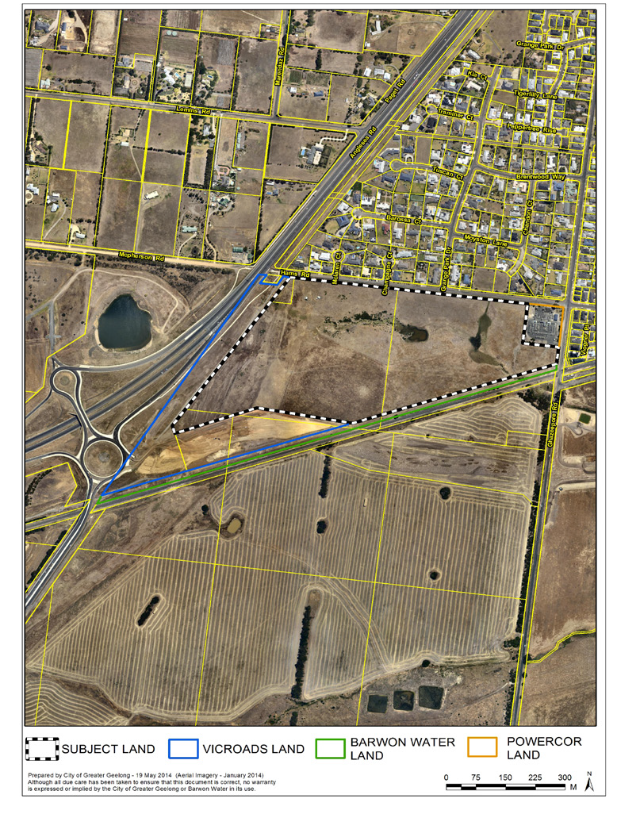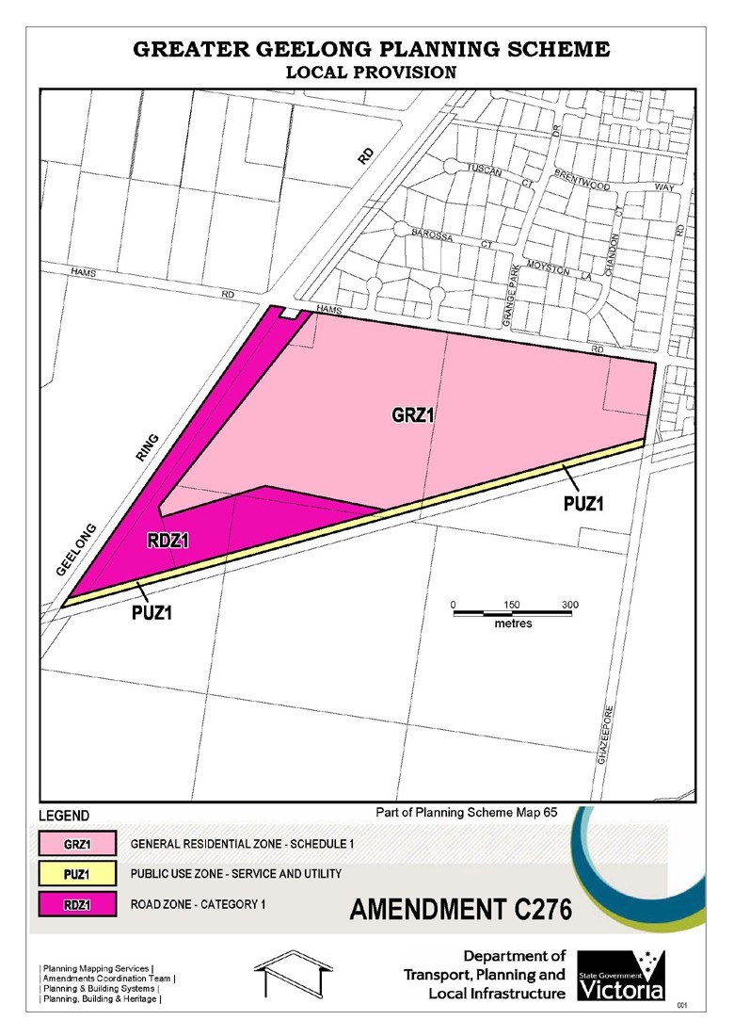
C276

Hams Road & Anglesea Road, Waurn Ponds
Land at Hams Road and Anglesea
Road, Waurn Ponds, is approximately
24 hectares and is currently in the
Farming Zone.
The landowners, Echin Pty Ltd. and Waurn Ponds Trust, are seeking a rezoning of the land for residential pur- poses, known as Amendment C276.
On 24 June 2014, Council resolved to support the public exhibition of Amend- ment C276 to the Greater Geelong Planning Scheme.

What land is affected?

The subject land to be rezoned for resi- dential purposes is:

• 35 Hams Road

• 151-229 Anglesea Road

The amendment also affects land within the Geelong Ring Road reserve (Sec- tions 4B & 4C), the Powercor substation at 25 Hams Road and Barwon Water owned land between the subject land and railway. (See aerial plan below).
Other amendments to the planning
scheme include:
What is likely to be developed?
The rezoning of the land for residential purposes will provide for:
•
A new Development Plan Over-
lay applied to 35 Hams Road and
151-229 Anglesea Road- to help coordinate the subdivision and de- velopment of the land for residential purposes.

Rezone the Powercor substation from Farming Zone to General Residential Zone (Schedule 1)- to remove a remnant piece of Farming Zone.

Rezone part of the Geelong Ring Road (Sections 4B & 4C) from Farming Zone to Road Zone Cat- egory 1- to reflect the use of the land for transport purposes.

Rezone Barwon Water land from
Farming Zone to Public Use Zone
1- to reflect its public use.

Delete the Public Acquisition Over- lay from the Geelong Ring Road (Sections 4B & 4C) and the land to be rezoned for residential purpos- es- to remove a redundant planning control.
•
A range of housing types and densi-
ties.
Public open space in the form of a linear reserve, which will include the retention of the natural west-east waterway and a shared pedestrian/ bicycle path along the waterway connecting to the existing road and shared path network.
Upgrading works to Hams Road and Ghazeepore Road.
New intersection arrangement at the Hams Road and Ghazeepore Road junction.
Contributions towards local commu- nity infrastructure.
•
•
•
•
•
•
•
Can I make a submission to C276?
Yes. Submissions should be received by: Monday 8 September 2014 and addressed to:

The Coordinator
Strategic Implementation
City of Greater Geelong
•
Either by:
•
post to - PO Box 104, GEELONG
VIC 3220
email to - strategicplanning@gee- longcity.vic.gov.au
•
Where can I go for more informa-
tion?
The amendment is available for viewing at:
•
Council offices, 100 Brougham St,
Geelong;
Waurn Ponds Library, 140 Pioneer
Rd, Geelong;
“Have your Say” section of Coun- cil’s website at www.geelon- gaustralia.com.au; and
DTPLI website at www.dtpli.vic.gov. au/publicinspection
•
•
What is Amendment C276?

The main element of the amendment
proposes to rezone 35 Hams Road and
151-229 Anglesea Road, Waurn Ponds, from Farming Zone to General Residen- tial Zone (Schedule 1).
•
You can call us on 5272 4820 or email:
strategicplanning@geelongcity.vic.gov. au for assistance.
WWW.GEELONGAUSTRALIA.COM.AU

