Proposed Rezoning at 35 Hams Road and 151-229 Anglesea Road, Waurn Ponds: Cultural Heritage Assessment

Sponsor: Date: 22nd of April 2014

Cultural Heritage Advisor: Matthew Barker Author: Matthew Barker



Disclaimer

The information contained in this CHA references information contained in government heritage databases and similar sources and is, to the best knowledge of Benchmark Heritage Management Pty Ltd, true and correct at the time of report production. While this CHA contains a summary of information it does not provide, nor does it intend to provide, an in-depth summary and assessment of all available research materials in relation to the Activity Area. Benchmark Heritage Management Pty Ltd does not accept liability for errors or omissions referenced in primary or secondary sources.

Any opinions expressed in this CHA are those of Benchmark Heritage Management Pty Ltd and do not represent those of any third parties. However, Benchmark Heritage Management Pty Ltd will not be held responsible for opinions or actions which may be expressed by dissenting persons or organisations.

Copyright Notice

This report is copyright. Any intellectual property therein remains the property of Benchmark Heritage Management P/L and SMEC Urban P/L. Under the Copyright Act, no part of this report may be reproduced without prior written permission from SMEC Urban P/L.

Abbreviations

ACHP: Aboriginal Cultural Heritage Place BHM: Benchmark Heritage Management CHMP: Cultural Heritage Management Plan WAC: Wathaurong Aboriginal Corporation

Executive Summary

Activity, Location

The Study Area is located at 35 Hams Road and 151-229 Anglesea Road, Waurn Ponds, Victoria and covers an approximate area of 25ha (250000m²) known as the Municipality of the City of Greater Geelong at Waurn Ponds, Parish of Barrabool, Lot 1 on TP77822 and Lot 3 on PS644553. The Study Area is located in Zone 54.

Results of Assessment: Desktop

In summarising our current knowledge of the geographic region in which the Study Area is located, the following predictive statements should be taken into account:

- There are no registered Aboriginal Cultural Heritage Places located in the Study Area;
- There has been no previous archaeological assessment of the Study Area;
- Previous archaeological assessments in the region have indicated that Aboriginal archaeological sites within the region are likely to comprise stone artefacts in surface exposures and shallow subsurface deposits on elevated landforms (e.g. hill tops, hill slopes) overlooking watercourses;
- There is potential for higher density stone artefacts to occur in intact soil deposits closer to the Armstrong Creek West Branch;
- There would have been a range of plant, animal and mineral resources available for Indigenous people living in, or in the region of, the Study Area;
- Artefact scatters are the most likely predominant site type;
- The Study Area was most likely subject to both burning episodes prior to European settlement and after during land clearance. The latter in particular would have had a significant effect on the soils. Thus any surface sites existing at the time are likely to have been highly disturbed and distributed;
- Artefacts made on a variety of material including silcrete, quartz and quartzite, and lesser quantities of coastal flint; and
- Microliths indicative of the Australian Small Tool Tradition, and generally associated with the past 5000 years of Aboriginal occupation, may be present.

Other forms of Aboriginal cultural heritage (e.g. scarred trees, burials or mounds) are unlikely to occur in the Study Area given the clearance of all native vegetation and intensive agricultural activity during the nineteenth century.

Results of Assessment: Archaeological Survey

A systematic surface survey of the Study Area was undertaken on the 6th of March 2014. The archaeological survey was undertaken by cultural heritage advisor Matthew Barker of BHM P/L.

No Indigenous archaeological sites were identified within the Study Area during the field investigation (this includes artefact scatters, scarred trees, caves, cave entrances and rock shelters).

The results of the archaeological survey indicate that the Study Area comprises land that is potentially sensitive to Aboriginal archaeological sites and is a landform that previous studies within the vicinity of the study area have shown to contain Aboriginal cultural material. The area within 100m of the west branch of Armstrong Creek (Map 4) is considered to be of moderate to high archaeological sensitivity with the remainder of low potential sensitivity.

Recommendations

Based on the results of the archaeological assessment, the following management recommendations are made for land comprising the Study Area.

Recommendation 1

No further archaeological assessment is required for rezoning of the study area. A Cultural Heritage Management Plan must be undertaken for future development of the study area.

Under the Aboriginal Heritage Act 2006 and in accordance with the Aboriginal Heritage Regulations 2007 a mandatory Cultural Heritage Management Plan (CHMP) is required for the proposed activity, because:

- The study area contains an area of Cultural Heritage Sensitivity identified as land within 200 metres of a waterway (Aboriginal Heritage Regulations 2007, Part 2, Div 3, Reg. 23(1)).

- The proposed activity is a high impact activity (Aboriginal Heritage Regulations 2007, Part 2, Div 5, Reg. 46. Residential and commercial subdivisions are high impact activities.

The purpose of the CHMP is to identify and assess the nature, extent and significance of Aboriginal sites, objects and cultural heritage values within the subject land and to provide mitigation, protection and contingency procedures to manage those values before, during and after development of the land.

In accordance with Section 61 of the Aboriginal Heritage Act (2006), the following mandatory matters are considered by this CHMP:

- Whether the activity will be conducted in a way that avoids harm to Aboriginal cultural heritage;
- If it does not appear to be possible to conduct the activity in a way that avoids harm to Aboriginal cultural heritage, whether the activity will be conducted in a way that minimises harm to Aboriginal cultural heritage; and
- Any specific measures required for the management of Aboriginal cultural heritage likely to be affected by the activity, both during and after the activity.

Recommendation 2

A suggested methodology for the CHMP will involve the following process:

- Submit an Notice of Intent to Aboriginal Affairs Victoria and the WAC;
- Present the results of the desktop assessment to the WAC;
- Undertake a comprehensive archaeological survey of study area with WAC representatives;
- Discuss the results of the survey with the WAC;

- Devise an appropriate strategy for a complex assessment (subsurface testing) in consultation with the WAC;
- Discuss the results of the complex assessment with the WAC;
- Manage any sites in consultation with the WAC; and
- Manage future heritage values in consultation with the WAC (such as interpretive signage).

European Heritage

There are no historic sites within the study area. The study area is considered to have very low potential sensitivity for historic archaeological sites. No further investigation is required.

Table of Contents
Abbreviations iii
Part 1 - Assessment 1
1.0 Introduction 1
Location of the Study Area 1
Details of Cultural Heritage Advisor 1
Registered Aboriginal Party (RAP) with Responsibility for the Study Area 1
2.0 Activity Description 4
3.0 Extent of the Study Area Covered by the Management Plan 5
  - Aboriginal Cultural Heritage Assessment 6
  - Desktop Assessment 6
Search of the Victorian Aboriginal Heritage Register 6
The Geographic Region 6
Registered Aboriginal Places in the Geographic Region 7
Previous Works in the Geographic Region Relevant to the Study Area 7
Historical and Ethno-historical Accounts of the Geographic Region 11
The Landforms and Geomorphology of the Study Area 13
The Environmental Determinants of the Study Area 14
Land Use History Relevant to the Study Area 15
Conclusions from the Desktop Assessment 16
  - Archaeological Survey 18
Archaeological survey Methodology 18
Results of Ground Survey 18
Ground Surface Visibility and Effective Survey Coverage 24
Conclusions of the Ground Survey 25
Part 2 – Cultural Heritage Management Recommendations 26
  - Specific Cultural Heritage Management Requirements 26
  - Aboriginal Heritage 26
  - European Heritage 28
References 29
Appendices 32
Appendix 1: Glossary 33

Maps

Map 1: Study Area Location-Regional Context 2
Map 2: Study Area Location-Local Context 3
Map 3: Aerial View of Study Area 5
Map 4: Survey Area 19

Plates

Plate 1: View of the study area from western boundary (M. Barker 6/3/14), facing east. 20
Plate 2: View of the Study Area showing gently sloping land from northeast corner (M. Barker 6/3/14), facing west. 21

Plate 3: View of the dam in the centre east of the Study Area (M. Barker 6/3/14), facing southwest 21
Plate 4: View of drainage line in centre east (M. Barker 6/3/14), facing west. 22

Plate 5: View of the dammed section of Armstrong Creek West Branch in the centre east of the Study Area (M. Barker 6/3/14), facing west 22
Plate 6: View of dry bed and banks of Armstrong Creek West Branch in the centre of the Study Area (M. Barker 6/3/14), facing west 23
Plate 7: View of rabbit burrows in the alluvial banks of Armstrong Creek West Branch in the centre of the Study Area (M. Barker 6/3/14), facing west 23

Plate 8: View of creek bed of Armstrong Creek West Branch in the centre of the Study Area (M. Barker 6/3/14), facing west 24

Part 1 - Assessment

1.0 Introduction

This Cultural Heritage Assessment (CHA) has been prepared for the property located at 35 Hams Road and 151-229 Anglesea Road, Waurn Ponds, herein referred to as the Study Area (see Maps 1 and 2). A Glossary of Terms is included as Appendix 1.

Location of the Study Area

The Study Area is located at 35 Hams Road and 151-229 Anglesea Road, Waurn Ponds, Victoria and covers an approximate area of 25ha (250000m²) known as the Municipality of the City of Greater Geelong at Waurn Ponds, Parish of Barrabool, Lot 1 on TP77822 and Lot 3 on PS644553. The Study Area is located in Zone 54.

The Study Area is situated within the Geelong suburb of Waurn Ponds, which lies approximately 70km southwest of the Melbourne CBD (see Map 1 and 2).

Details of Cultural Heritage Advisor

The Cultural Heritage Advisor who has undertaken this CHA is Matthew Barker. Matthew holds a BA Hons [Archaeology] from La Trobe University and has had nine years’ experience working in the field of Aboriginal archaeology.

Registered Aboriginal Party (RAP) with Responsibility for the Study Area

The Wathaurung Aboriginal Corporation (WAC) is the Registered Aboriginal Party (RAP) for the study area.

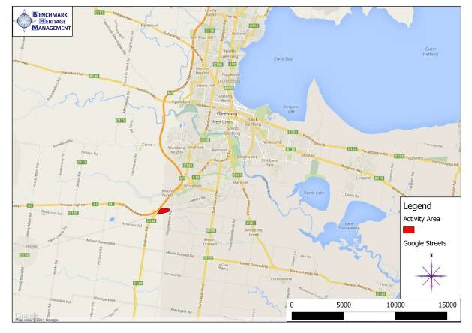

Map 1: Study Area Location-Regional Context

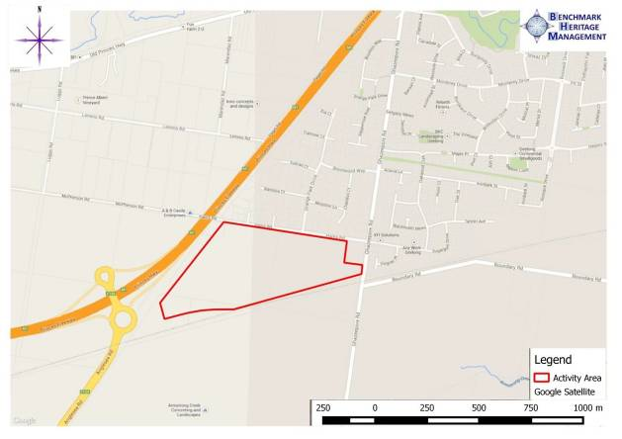

Map 2: Study Area Location-Local Context

2.0 Activity Description

The proposed activity at 35 Hams Road and 151-229 Anglesea Road, Waurn Ponds is for a rezoning for a proposed residential subdivision.

This activity is the beginning of a development process that will involve some degree of soil disturbance to both surface and buried land surfaces, and it is not possible for development to take place within the Study Area in a way that will avoid harm to Indigenous cultural heritage should any such material be found to exist on the property.

3.0 Extent of the Study Area Covered by the Management Plan

The Study Area is located at 35 Hams Road and 151-229 Anglesea Road, Waurn Ponds, Victoria and covers an approximate area of 25ha (250000m²) known as the Municipality of the City of Greater Geelong at Waurn Ponds, Parish of Barrabool, Lot 1 on TP77822 and Lot 3 on PS644553. The Study Area is located in Zone 54.

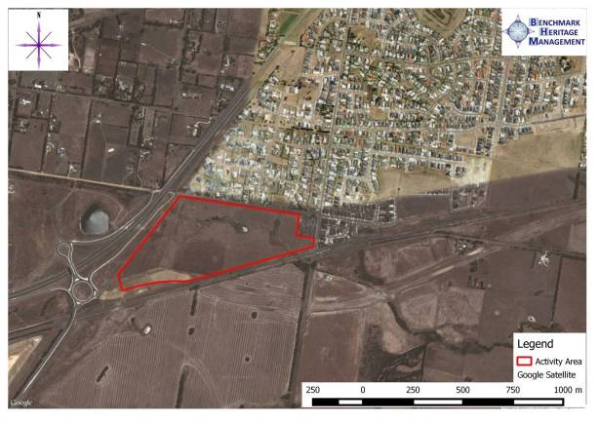

Map 3: Aerial View of Study Area

The Study Area comprises an irregular block of land fronting Hams Road in Waurn Ponds (see Map 3). The land contains a single landform element identified as “Pxj” (GeoVic Map Code) on the DPI geological interactive maps.

The entire Study Area has been cleared of Indigenous vegetation (Map 3).

4.0Aboriginal Cultural Heritage Assessment

Desktop Assessment

This section contains the results of the desktop assessment. The aim of the desktop assessment was to produce an archaeological site prediction model, which would assist in the design of the fieldwork, the interpretation of the fieldwork results, the assessment of cultural significance and the design of the management recommendations. The desktop assessment involved:

    - Identification and determination of the geographic region that the Study Area is situated within and its relationship to Aboriginal Cultural Heritage;
    - An assessment of the environmental determinants within the geographic region including landforms and geology, water sources, climate, flora and fauna and
implications for Aboriginal site distribution;
    - Ethnohistorical and historical Aboriginal occupation within the geographical region;
    - Review of land use history within the Study Area;
    - Review of reports and published works concerning Aboriginal cultural history relevant to the geographic region;
    - Search of the Victorian Aboriginal Heritage Register;
    - Other information the Cultural Heritage Advisor considers necessary or convenient in determining the nature of Aboriginal occupation within the geographic region and the
Study Area

This information was used to produce an archaeological site prediction model. The site prediction model assists in determining the type of archaeological sites which may potentially occur within the Study Area, the possible contents of these sites, the possible past use of the landscape by Aboriginal people and the likely extent of ground disturbance to archaeological sites. The information provided by the site prediction model is used constructively in designing the survey strategy, by, for example, allowing the field team to target areas which have a high probability of containing archaeological sites. No obstacles were encountered during the preparation of this desktop assessment.

Search of the Victorian Aboriginal Heritage Register

The Victorian Aboriginal Heritage Register (VAHR) on-line database maintained by Aboriginal Affairs Victoria was searched to identify any previously registered Indigenous archaeological sites within the Study Area and surrounding geographic region, as well as the results of previous archaeological assessments. The Register was accessed on the 27th of February 2014.

The Geographic Region

The geographic region in which the Study Area is located is defined by the distinct underlying geology of Waurn Ponds.

Registered Aboriginal Places in the Geographic Region

The Study Area has not been subject to previous archaeological assessment and no Aboriginal Cultural Heritage Places are located on the property, however many Indigenous sites have been recorded in the surrounding geographic region. There are 23 registered Aboriginal Cultural Heritage Places within the geographic region all comprising artefact scatters.

There are no historical (post contact) references to Aboriginal occupation within the geographic region. The closest known historical place to the Study Area is the Mt Duneed Reserve (Aboriginal Historic Place 7.1-6) adjacent to Ghazeepore Road along Armstrong Creek (only 150m south of the study area), where local Aboriginal people were known to have camped during the 1860s, indicating that Aboriginal populations inhabited the region prior to and during European contact.

Previous Works in the Geographic Region Relevant to the Study Area

Regional Investigations

Bellarine Peninsula: Archaeological Site Assessment and Management Activity (Rhoads 1986)

This archaeological assessment of the Bellarine Peninsula was undertaken for the Victorian Archaeological Survey in order to provide information to assist in the management and conservation of Aboriginal places on the Bellarine Peninsula. The study area consisted of the Shire of Bellarine, City of South Barwon and the Borough of Queenscliff (approximately 50,000 ha), including the current activity area. The assessment was undertaken in two stages. Stockton undertook Stage 1 of this project, involving a coastal field survey, over a six month period. The aim was to understand the distribution of places on the Peninsula. Although Stockton identified 77 Aboriginal places during the survey, a report was not completed (Rhoads 1986: 7-56).

Rhoads undertook Stage 2 of this project. The aims of this stage were to identify significant Aboriginal places and areas of archaeological potential, and assess archaeological places in the Drysdale/Clifton Springs area. Pedestrian and vehicle surveys, carried out over 19 days, resulted in the identification of 15 Aboriginal places, mostly on the Bellarine Peninsula to the east of the activity area. Rhoads targeted reserves, dirt tracks, surface exposures and road cut exposures covering approximately 75% of the Bellarine Peninsula’s thoroughfares. The density of Aboriginal places inland was estimated to be 1 place per 6 km² (cf. Richards & Jordan 1995: 142), compared with 1 per km on the coast (Rhoads 1986: 56).

Smaller Scale Investigations

Rhodes (1999) conducted an archaeological survey of a 2.9 ha property within the Deakin University Waurn Ponds campus for proposed student accommodation, c.1.1km north of the current study area. The study area was located 145m north of Waurn Ponds Creek and characterised by parkland, containing a row of cypress pine trees. Imported landfill was also noted in some parts of the study area (Rhodes 1999: 1-2). One Aboriginal place was identified

during the field survey (VAHR 7721-0419) consisting of a marine chert core and a broken quartzite flake located near the intersection of Nicol South Drive and Reserve Road. Rhodes noted that marine chert would have been brought in to the area, or traded from the coast, while the quartzite artefact, most likely used for wood working, was made on locally available material (Rhodes 1999:13). Rhodes (1999: 12-15) determined that while both artefacts were identified in a disturbed context, they were not brought into the study area with fill, and rather, most likely represented the remains of a larger Aboriginal place that had since been destroyed by agricultural land use practices. The study area was considered to have provided a suitable camping location for Aboriginal people, overlooking Waurn Ponds Creek and a swamp 150 m to the south. The study area was determined to have potential to contain additional stone artefacts in disturbed subsurface deposits. Rhodes (1999a:1-2) conducted a place inspection of stone artefacts that were identified during monitoring of works within the vicinity of VAHR 7721-0419. These comprised four silcrete cores, four silcrete flakes and a broken quartz flake identified in black/brown clay loam up to 400 mm below the ground surface. Charcoal was identified in association with the artefacts, which was later determined to be non-cultural in origin. The high proportion of cores within the assemblage was interpreted as representing a stone working site rather than a camp site, with a camp site possibly located further up the hill slope to the north.
It was determined that the additional stone artefacts represented part of VAHR 7721-0149 had been dispersed by circular ploughing, and that the artefact scatter was unlikely to extend any further south or east. Deposits in which this cultural material was identified contained introduced fill and gravel, indicating that the area has been subject to extensive soil mixing as a result of ploughing and university development works (Rhodes 1999a:1-3).

Paynter and Marshall (2003) conducted a cultural heritage assessment of a parcel of land on the corner of the Princes Hwy and Rossack Drive at Waurn Ponds, c. 700 m east of the activity area. The report identified that registered Aboriginal places within the region are generally stone artefact scatters associated with the Waurn Ponds Creek floodplain and surrounding elevated land overlooking the creek, however Aboriginal scars on River Red Gums and burials may also occur (Paynter and Marshall 2003:1-14). A field survey was undertaken, however due to the long pasture grass, ground surface visibility was very poor. One Aboriginal place was identified during the field survey (VAHR 7721-0576) associated with disturbed clay soil redeposited on the ground surface by the construction of Rossack Drive and the installation of an electricity easement, indicating that artefacts were derived from subsurface deposits. Artefacts comprised 16 flakes and angular fragments made on quartz and silcrete (Paynter and Marshall 2003:16-17). A program of subsurface testing, in the form of rotary hoe transects, was undertaken across the study area to determine the nature and extent of surface stone artefacts. A total of nine transects were excavated across the study area, ranging from 100 to 200 m in length. Transects were examined for artefacts and sample sieving undertaken every 20
- An additional 12 stone artefacts were identified within proximity to VAHR 7721-0576 and included in this registration. Two additional stone artefacts were located within the western section of the study area and registered as VAHR 7721-0604. Both Aboriginal places were considered to be of low archaeological significance and were not in situ, having been disturbed by prior land use practices and infrastructure construction (Paynter and Marshall 2003:17-20).

Weaver (2001) conducted a field survey of a 10 ha property to the east of Ghazeepore Road at Waurn Ponds for a proposed residential development. The study area was characterised by pastoral land comprising an extant house, outbuildings and pine windrow, with Waurn Ponds Creek forming the northern boundary. The property formed part of a dairy complex and has been extensively disturbed by prior land use practices (Weaver 2001:1-3). One Aboriginal place (VAHR 7721-0461) was identified during the field survey, comprising four stone artefacts located on the inner slope of a dam bank within the south west corner of the study area. Artefacts comprised three flaked pieces and a broken blade made on silcrete, quartz and quartzite. These artefacts were not in situ and were rated as having low archaeological significance (Weaver 2001:10). Weaver (2001:10) concluded that Aboriginal stone artefacts occur in the Waurn Ponds Creek valley between 50-300 m from the creek banks and are likely to occur in undisturbed alluvial deposits below areas that have been built up with fill during more recent development.

Kaskadanis (2008) undertook a cultural heritage assessment for Section 4A of the Geelong Ring Road, extending from the Princes Hwy at Waurn Ponds to Anglesea Road located c.250 m east of the activity area. The study area is characterised by cleared undulating land that was formerly used for agricultural practices (Kaskadanis 2008:1-9). The desktop review determined that all registered Aboriginal places within a 1 km radius of the study area comprised stone artefact scatters, most likely influenced by the presence of Waurn Ponds Creek. The review also established that the entire study area had been subject to some degree of disturbance by prior agricultural land use activities, as well as the more recent installation of major services (e.g. sewer, gas and water), adversely affecting the integrity of the ground (Kaskadanis 2008:11-12, 20-21). No field survey was undertaken as part of the assessment, however a subsurface investigation proceeded utilising a variety of methods, including excavation pits and shovel test pits, geotechnical test pits and machine transects. The placement of subsurface testing pits/transects was 'judgement based', and sampled various landforms in the activity area. A total of 93 subsurface testing locations were excavated across the study area, recovering 61 stone artefacts from six Aboriginal places (VAHR 7721-0844 – 7721-0849). The study area was changed during the process of the investigation, which resulted in VAHR 77210844 – 7721- 0846, to occur outside of the study area. As a result the assessment report only discusses the three Aboriginal places occurring within the revised study area (Kaskadanis 2008:25-29).

  - VAHR 7721-0847 – 27 stone artefacts including complete and broken flakes, flaking debris, a backed blade and a core were identified at this Aboriginal place. The Aboriginal place is located on a hill slope overlooking Waurn Ponds Creek to the south and west, and would have provided a good vantage point over the area. Artefacts were not identified in situ, and were recovered from a maximum depth of 200 mm, often in association with metal debris. The Aboriginal place had been impacted by ploughing, which had vertically displaced artefacts. The presence of a backed blade was considered indicative of the Australian Small Tool Tradition, generally associated with the past 5000 years of Aboriginal occupation (Kaskadanis 2008:30-31, 38).

  - VAHR 7721-0848 – 14 stone artefacts including complete and broken flakes, flaking debris, a broken tool and a core were identified at this Aboriginal place. The Aboriginal place is located on a hill slope overlooking Waurn Ponds Creek to the south and west, and would have provided a good vantage point over the area. Artefacts were not identified in situ, and were recovered from a maximum depth of 200 mm, often in association with metal debris. The Aboriginal place had been impacted by ploughing, which had vertically displaced artefacts (Kaskadanis 2008:33-34).
  - VAHR 7721-0849 – 4 stone artefacts including broken flakes, flaking debris, and a core were identified at this Aboriginal place. The Aboriginal place is located on a lower hill slope overlooking Waurn Ponds Creek to the south and west. Artefacts were not identified in situ, and were recovered from a maximum depth of 100 mm, often in
association with brick debris, possibly overlying clay fill (Kaskadanis 2008:34).

Based on these results, Kaskadanis (2008:41-42) identified the following characteristics common across all three Aboriginal places:

- Archaeological deposits have experienced some degree of ground disturbance such as historical land-use practices (e.g. clearance of native vegetation, ploughing/ grazing activities). Such activities may have ‘re-distributed’ stone artefacts on the landscape;
- Results of the complex assessment indicate that the site stratigraphy associated with these sites are shallow and that soil profiles are uniform, i.e., no distinctive texture boundaries with no distinctive layers that would be considered ‘occupation’ layers; and,
- In addition to the absence of any distinctive occupational layers, all of these sites are low- density artefact scatters with no distinctive stone-knapping or butchery sites, i.e., primary (in situ) archaeological deposits.

In 2007, Terra Culture undertook archaeological investigations of the Geelong Regional Baseball Centre and surrounding parklands. Marshall (2007) conducted an archaeological survey of part of the Pioneer Road reserve on the eastern bank of Waurn Ponds Creek at the Geelong and East Belmont Saints Baseball Clubs on Pioneer Road (approximately 2 km east of the current activity area). This assessment was required for the construction of a new baseball field to allow the existing complex to be removed for the construction of the proposed Waurn Ponds Leisurelink Aquatic Centre. Two low density artefact scatters were recorded during the survey (VAHR 7721- 0828, VAHR 7721-0829).

Marshall and Hyett (2007) undertook archaeological investigation of the proposed Waurn Ponds Leisurelink Aquatic Centre at the corner of Colac Road and Pioneer Road at Waurn Ponds (formerly the Geelong Regional Baseball Centre). Despite high numbers of artefacts being recovered during the original construction of the Baseball Centre, no Aboriginal cultural material was identified by Marshall and Hyett (2007, 13).
Waurn Ponds Shopping Centre

In 2007 Terra Culture undertook an archaeological assessment on the site of a proposed retail park, service station and associated car parking facilities on the Princes Highway in Waurn

Ponds, adjacent to the Town and Country Shopping World, and approximately 2 km east of the current activity area. A stratified subsurface sampling program identified two Aboriginal cultural heritage places; both are low-density stone artefact scatters (VAHR 7721-0869, VAHR 7721-0895) and each is located on a low rise associated with a minor tributary of the Waurn Ponds Creek. Due to the long history of pastoral activities within this area neither site was considered in situ and as a result is deemed to be of low scientific significance (Marshall et al. 2008).

Marshall and Toscano (2009) undertook an archaeological assessment of a proposed retirement village in Waurn Ponds. The property is located on the Princes Highway adjacent to the proposed Waurn Ponds Shopping Centre (archaeologically assessed in 2008, see Marshall et al. 2008). Within the original survey area seven Aboriginal cultural heritage places were identified; all artefact scatters associated with the banks and terraces of Waurn Ponds Creek (VAHR 7721- 0865, VAHR 7721-0867, VAHR 7721-0868, VAHR 7721-0907, VAHR 7721-0908, VAHR 7721-
0909, VAHR 7721-0910). Each site was assessed for its scientific significance and, as a result of these findings, the proposed site boundary was realigned and the development plans significantly altered to preserve three of these sites (VAHR 7721-0865, VAHR 77210867, VAHR 7721-0868). The remaining four sites were not considered significant enough to warrant further change to the development.

O’Reilly et al. (2010) completed a CHMP for 140 ha of a much larger residential development at Armstrong Creek (more than 1km to the southeast of the activity area). The property was largely situated on volcanic plains dissected by the alluvial and marshy margins of Armstrong Creek. The evaluation determined that the activity would impact on nine Aboriginal cultural heritage places (VAHR 7721-0992, VAHR 7721-0985, VAHR 7721-0986, VAHR 7721-0987, VAHR
7721-0988, VAHR 7721-0989, VAHR 77210991, VAHR 7721-0993, VAHR 7721-0994), three of
which were deemed of moderate scientific significance and thus in need of salvage (VAHR 7721-0985, VAHR 7721-0986, VAHR 7721-0992). One of these three sites (VAHR 7721-0992)
was a high density artefact scatter, and mitigation measures were initiated in order to protect 1 ha of the highest density areas of the site.

Historical and Ethno-historical Accounts of the Geographic Region

The desktop assessment must include a review of historical and ethnohistorical accounts of Aboriginal occupation in the geographic region identified in section 4.2 (r.57(1)(d)). Therefore, a review of the historical and ethnohistorical accounts of Aboriginal occupation within the geographic region has been undertaken.

The Study Area is located within the Wada wurrung language group, who occupied the area of South Central Victoria situated between Beaufort and Port Phillip Bay (Clark 1990, Fig. 11). The study area is located in a region that may have been frequented by two distinct Wada wurrung clans, the Bengalat balug and Wada wurrung balug.

  - The Bengalat balug are described as occupying land encompassing Indented Head (Clark 1990, 316-7). The word Bengala was the Aboriginal word for Indented Head and Bengalat balug means ‘people of Indented Head’. In his 1835 journal, William Todd gave the names of five male members of the Bengalat balug and noted that they had seven wives and fifteen children between them (Clark 1990, 317).
  - The Wada wurrung balug are described as occupying the Barrabool Hills, south west of Geelong, and the area south to the coast (Clark 1990, 330-4). It is not clear how much of the Bellarine Peninsula can be considered Wada wurrung balug land, though Tindale (1974) includes most of the peninsula with this clan. The escaped convict William Buckley was adopted into the Wada wurrung balug after he was recognised as the resuscitated Murrangurk, a member of the clan long since dead (Clark 1990, 331).
Buckley remained with the clan from 1803 until 1835. In 1860, John Garratt reported that the Wada wurrung balug had a good shelter hut erected at Duneed, 5km south of the activity area.

George Armytage, an early landholder in the Geelong area, noted that the Wada wurrung depended upon fishing in the summer and autumn periods and hunting and the plant food murnong in the winter and spring periods (in Bride 1969, 173). The uneven distribution of particular resources, such as greenstone for ground-edge axes, resulted in a trade and exchange network between different clan groups across the study region. For example, the Wada wurrung attended meetings at Mount Noorat and at Mirrewuae Swamp (approximately 140 and 160 km west of Geelong, respectively). Dawson (1881) described such trade at Mount Noorat.

“…the Aborigines from the Geelong district brought the best stones for making axes and a kind of wattle gum celebrated for its adhesiveness. The Geelong gum is so useful in fixing handles of stone axes and splinters of flint in gum and for cementing the joins of bark buckets, that it is carried in large lumps all over the Western District. (Dawson 1881, 78)”.

Anne Drysdale, the owner of Boronggook Station, which is located south of Geelong near Lake Connewarre, reported seeing Aboriginal people in the forest between Corio and her homestead on 18th August, 1841 (Brown 1958, 84). However, in October 1841, she reported that ‘There have been very few natives here since we came, & these only passing…’ (Brown 1958, 114). In November of the same year Drysdale reported having fish that were caught in the Barwon River by Aboriginal people. They reportedly caught large quantities in the river beside the station (Clark 1990, 291).

In 1861, the surviving Wada wurrung were gathered onto a parcel of land at Mt Duneed, known as the Duneed Aboriginal Reserve, on which a ‘shelter hut’ had been installed (Clark 1990, 300). The remnant population, which at that time appears to have numbered eleven people, were encouraged to stay at the Duneed Reserve and were prohibited from staying in the Geelong Township after sundown. There is considerable historic detail on the fate of particular individuals. The Duneed Aboriginal Reserve is located approximately 150m south of the current

Study Area and has always been considered to be of high social significance by local Aboriginal communities.

It is thought that the Wada wurrung balug were the clan who adopted William Buckley in 1803 (Clark 1990: 331). Robinson considered that the Wada wurrung balug exercised considerable influence over other clans in the eastern section of the Western District (Clark 1990:). Located around Geelong, the Wada wurrung balug were highly exposed to Europeans in the early days of Victorian settlement, and members of the clan were being employed by settlers to collect stray stock and cut wood from as early as about 1839 (Clark 1990: 331-332). This contact led to the rapid demise of traditional lifeways and indeed to the Wada wurrung balug themselves. Recorded to number 300 people in 1837, by 1853 there were only 17 surviving clan members. The survivors refused to occupy a reserve set up along the Barwon River at Buntingdale, as it was not in their territory (Clark 1990: 293, 332). The last full-blood male of the clan reportedly died in 1885 (Brownhill 1955, in Clark 1990: 333).

This summary of Aboriginal behaviour patterns within the study region during the mid- nineteenth century indicates that occupation in the region was undertaken on a seasonal basis, characterised by temporary encampments shifting between resource-rich zones at different times of the year. Large campsites were often placed close to rivers and creeks. Such camps were generally occupied by smaller family groups for a few days, or longer in resource-rich areas. Camps were shifted regularly to take advantage of foods as they came into season. Camps and travel routes were also located to take advantage of resources such as stone for making tools. In the western district, silcrete outcrops would have been exploited for tool- making material. Physical evidence of such activities would have been left behind as stone working debris and discards at quarry and camp sites.

The Landforms and Geomorphology of the Study Area

The Study Area is located in the Western Plains geomorphic unit, characterised by undulating sedimentary plains generally comprising marine sands deposited by the retreating Pliocene sea
(1.6 - 5 million years ago). These plains have been dissected by water bodies such as Waurn Ponds Creek, exposing the underlying Oligocene age limestone and marl, and allowing the development of Holocene alluvial silts (Robinson et.al. 2003: 1-32).

The study area and surrounding hills comprise the Jan Juc Formation, containing calcareous clays, marine marls, and limestone dating to a marine incursion around 4 million years ago (Oligocene). Sediments laid down during this cycle comprise calcareous soils exposed by the weathering of limestone and marl exposed along the valleys. Soils have yellow-brown calcareous sodic texture contrast soils, and are coarse in structure (DPI 2014).

The Study Area comprises the shallow valley of Armstrong Creek West Branch and has sustained ground disturbance caused by a number of processes, including a complete clearance of natural vegetation.

The Environmental Determinants of the Study Area

Climate

Temperature averages at nearby Geelong indicate a cold to hot maximum average of 6.8°C in July to 22.9°C in February. Minimum average temperatures throughout the year range from 6.8°C in July to 13.9°C in February. The annual average rainfall for the area is 687mm. These climate conditions would have placed no restrictions on Indigenous or European occupation of the area (LCC 1991).

Water Sources

Sources of fresh water exist in the Study Area. Armstrong Creek West Branch traverses the study area.

Description of Existing and Pre-Contact Vegetation

The Study Area lies within a single Ecological Vegetation Community (EVC) within the Study Area prior to 1750; EVC Name: Grassy Woodland, EVC No: 175. Grassy Woodland (EVC 175); a variable open eucalypt woodland to 15 m tall or occasionally Sheoak woodland to 10 m tall over a diverse ground layer of grasses and herbs. The shrub component is usually sparse. It occurs on sites with moderate fertility on gentle slopes or undulating hills on a range of geologies.

Burning activity by Aboriginal people may also have influenced the increase in biodiversity that occurred during the period (Aitken and Kershaw 1993: 78). Burning served to open the area for access, facilitate new growth, and flush out animals for hunting.

The existing vegetation of the Study Area bears no resemblance to the description of above. The only vegetation is dense grass and bushes around the west branch of Armstrong Creek. No remnant native vegetation remains within the Study Area. There are no native trees on the subject land.

Information on Fauna of the Study Area

Resources available to the Wada wurrung would have been both considerable and varied, with a wide range of plant, animal and coastal resources available close to the Study Area. Some of the animal resources utilised were: echidna, swamp rat, black wallaby, brushtail and ringtail possum, brown mouse, wombat, kangaroos and potentially forty species of birds (Sullivan 1981: 141). Birds, such as emu and bustards, were also eaten, as were bird eggs. Birds were caught with throwing sticks or in traps. Fish and eels were important resources and were speared in rivers or caught in nets (Thomas cited in Sullivan 1981: 24). Although use of the hook and line was observed, it is likely that this was a practice resulting from contact with sealers (Sullivan 1981: 24). There would have been variations in staple species diversity and abundance within the surrounding region and this in addition to seasonality would have influenced site location and frequency of occupation (Walsh 1987).

Plant foods were extensively exploited and included berries, fungi, roots, tubers, bulbs, leaves, and pith from fleshy plants, seeds and sap. Gum was also collected from the wattle and stored in known locations for seasons when food was less abundant (Thomas cited in Sullivan 1981: 25). Some of the plant resources that were utilised by Aboriginal people, and would have been available within the immediate area, include: wattle gum, sea celery, coastal banksia, angular pigface, pink bindweed, white correa, ruby saltbush, seaberry saltbush, coast beard‐heath and climbing lignum (Sullivan 1981: Appendix 2).

Stone Resources

No stone resources and outcrops suitable for the manufacture of stone tools are found within the Study Area.

Land Use History Relevant to the Study Area

In 1836 the first wave of squatters arrived. In 1837, in response to a petition from local settlers wanting protection from the Aborigines, the Governor of the colony, Governor Bourke, appointed Captain Foster Fyans to the Magistracy and ‘instructed the Surveyor General of New South Wales to lay out two townships in Geelong – one near the bay the other near the river’. Hoddle reserved the land at the junction between the Moorabool and Barwon Rivers for this town but the bridge further upstream became the focus of settlement. Fyans was also appointed to issue pasturing licenses in the area, the first official recognition that Geelong existed. A town was surveyed between the Barwon River and Corio Bay and the town of Geelong officially came into existence on 26th October 1838, though the first sale of town lots was not held until February 1839. Large parcels of land were purchased from the Crown from 1840 onwards.

Shire of Barrabool

The municipalities of Highton, Grovedale and Waurn Ponds are located in the Shire of Barrabool, which stretches from the Barwon River to the north and south toward Lorne along the Great Ocean Road. These settlements were located predominantly along major waterways such as the Barwon River and local creeks including Waurn Ponds Creek and Thompson Creek. The most attractive land within the Barrabool shire was located along Waurn Ponds Creek, with land to the southwest considered too rough to settle (Wynd 1992: 9). John Charles Dark was one of the earliest pastoralists in the Barrabool shire area, developing a sheep run in 1836 near today’s Pollocksford. A surveyor who had worked in Tasmania prior to coming to Port Philip Bay, Dark left the area a year later but was rapidly followed by Captain Frederick Dewing and William Roadknight, who settled to the east of Pollocksford along the Barwon River (Wynd 1992: 7-8). The introduction of squatters into the area was characterised by the occupation of large pastoral runs close to major rivers and creeks. By 1842 most of the available land within the Barrabool Shire was occupied, with squatters now moving further south to areas previously deemed unappealing, predominantly scrub land (Pescott 1985: 28). Dr. Alexander Thompson also settled in the area during late 1836, developing “Thompson’s Old Station” close to the junction of the Barwon and Moorabool rivers. By 1840 he had moved south of the township of

Geelong, purchasing 640 acres of land east of the Barwon River and creating the homestead he named ‘Kardinia’, as well as another run extending south from the Barwon River to Spring Creek. Parish of Barrabool The first sale of divided lots within the Barrabool shire occurred in 1840 and continued until the mid 1850s. The sale was of 25 blocks of varying sizes of land in the newly defined Barrabool parish, located between the Barwon River and Waurn Ponds Creek, with land in the Barrabool hills proving particularly popular. The shire was slowly divided into eight parishes, although by 1847 only the parishes of Barrabool, Duneed, Modewarre, and Gnarwarre were mapped and proclaimed. The remaining shires were slowly divided up and sold over the next 30 years. A census for the Parish of Barrabool in 1854 shows a total population of 857 and commented on the variety of immigrant populations inhabiting the area (Wynd 1992: 16). This shift in land ownership and sale put considerable pressure on squatters in the area who were forced to relinquish the land or buy it from the government. Much of the land within the Parish of Barrabool was bought by speculators and subsequently sold or leased to settlers and pastoralists. This created an area between the Barwon River and Waurn Ponds chain of ponds that was predominantly agricultural, with large farms located on both sides of the Barwon River. Barrabool maintained a reputation as a farming area where it was common to subdivide larger farms into smaller holdings to maintain agricultural growth and development in wheat, oats, and hay production (Wynd 1992: 21-22). Waurn Ponds One of the largest homesteads in Waurn Ponds was the Claremont estate. Built in the 1850s, the property included 245 acres of land between the Geelong-Colac Railway line and Waurn Ponds Creek. The homestead had been built with bricks that were baked in a kiln on the property in 1857 and contained a farm, dairy, fruit and vegetables. The property was sold in the 1880s to the Baum family who grew fruit and vegetables.

European settlement would have significantly impacted on Aboriginal archaeological sites in the Study Area. Past land use together with the clearing of the original vegetation means that any surface lithic site would now retain little spatial or temporal integrity and as such have reduced scientific significance.

Specific Land Use History

As the Study Area was in an EVC in which woodland was the dominant type, the removal of this native vegetation would have caused a great deal of ground disturbance.

Conclusions from the Desktop Assessment

Overall, the geographic region of which the Study Area forms a part has been subject to thorough and in-depth cultural heritage investigation. Based on the results of previous archaeological assessments carried out within the geographic region and the distribution of registered Aboriginal places, the Desktop Assessment established that there is a potential for Aboriginal cultural heritage to occur in the activity area.

In summarising our current knowledge of the geographic region in which the Study Area is located, the following predictive statements should be taken into account:

- There are no registered Aboriginal Cultural Heritage Places located in the Study Area;
- There has been no previous archaeological assessment of the Study Area;
- Previous archaeological assessments in the region have indicated that Aboriginal archaeological sites within the region are likely to comprise stone artefacts in surface exposures and shallow subsurface deposits on elevated landforms (e.g. hill tops, hill slopes) overlooking watercourses;
- There is potential for higher density stone artefacts to occur in intact soil deposits closer to Armstrong Creek;
- There would have been a range of plant, animal and mineral resources available for Indigenous people living in, or in the region of, the Study Area;
- Artefact scatters are the most likely predominant site type.
- The Study Area was most likely subject to both burning episodes prior to European settlement and after during land clearance. The latter in particular would have had a significant effect on the soils. Thus any surface sites existing at the time are likely to have been highly disturbed and distributed.
- Artefacts made on a variety of material including silcrete, quartz and quartzite, and lesser quantities of coastal flint.
- Microliths indicative of the Australian Small Tool Tradition, and generally associated with the past 5000 years of Aboriginal occupation, may be present.
- Other forms of Aboriginal cultural heritage (e.g. scarred trees, burials or mounds) are unlikely to occur in the Study Area given the clearance of all native vegetation and
intensive agricultural activity during the nineteenth century.

Archaeological Survey

The aims of the archaeological survey were to:

    - Attempt to identify Aboriginal cultural heritage;
    - Undertake consultation with representative(s) of the RAP applicants;
    - Identify any areas of potential archaeological sensitivity deposit (that may require sub- surface testing) and; and
    - Document the extent of significant ground disturbance in the Study Area.

Archaeological survey Methodology

Focus was concentrated on areas of high ground surface visibility. All mature indigenous trees were inspected to determine if they were culturally scarred. Areas of potential archaeological sensitivity/deposits and significant ground disturbance were recorded. Ground surface visibility and surface exposure was recorded in order to determine the effective ground survey coverage. There were no significant constraints to carrying out the survey.

Results of Ground Survey

A systematic surface survey of the Study Area was undertaken on the 6th of March 2014. The survey was undertaken by cultural heritage advisor Matthew Barker of BHM P/L.

The property comprises the Study Area shown in Map 4. The Study Area comprises open grazing land that slopes gently down to the west branch of Armstrong Creek in the centre of the study area (Plates 1-8 in Table 1). All parts of the study area have been cleared of the original native vegetation and most of the Study Area has been used for agricultural purposes since at least the 1850s. No remnant native vegetation remains in the Study Area.

No Indigenous archaeological sites were identified within the Study Area during the field investigation (this includes artefact scatters, scarred trees, caves, cave entrances and rock shelters).

The absence of any evidence for Indigenous cultural sites may be due to the Study Area having incurred disturbance in the past, including the clearance of native vegetation.

Initially the entire property would have been cleared of native vegetation. This would have contributed to soil erosion and the movement of any Aboriginal cultural material that may have existed on the ground surface; thus the removal of topsoils and the destruction of any surface or near surface Aboriginal cultural materials.

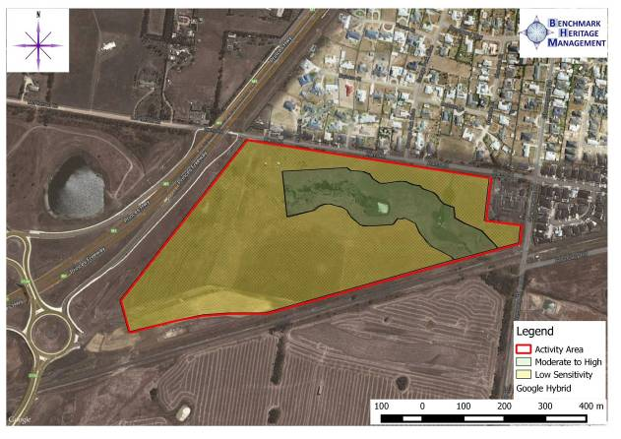

Map 4: Survey Area

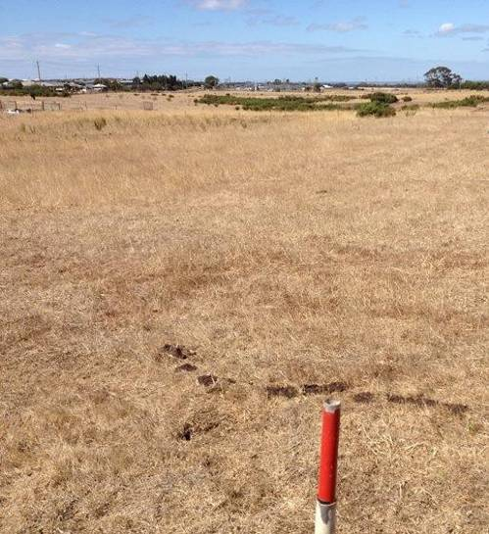Table 1: Photographs from Archaeological Survey

Plate 1: View of the study area from western boundary (M. Barker 6/3/14),
facing east.

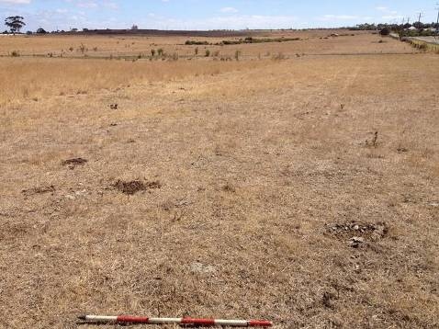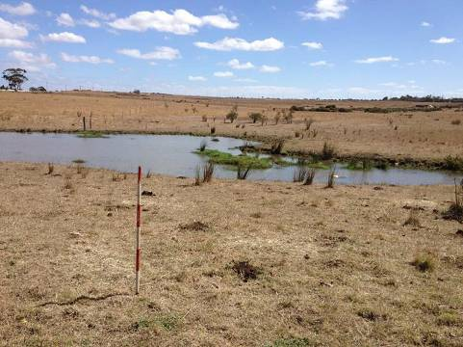
Plate 2: View of the Study Area showing gently sloping land from northeast corner (M. Barker 6/3/14),
facing west.

Plate 3: View of the dam in the centre east of the Study Area (M. Barker 6/3/14),
facing southwest

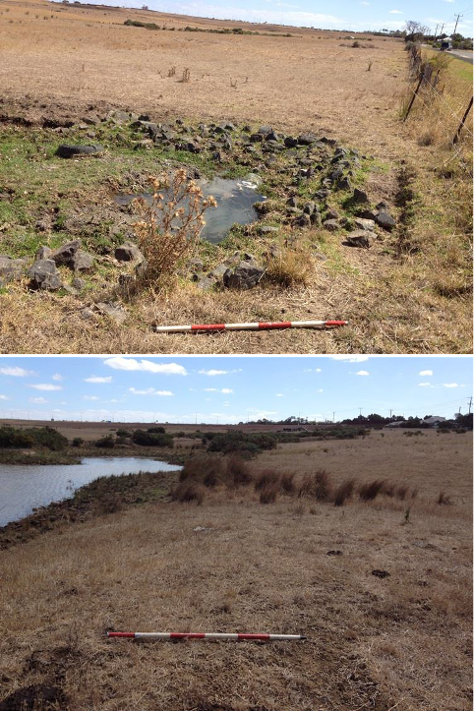
Plate 4: View of drainage line in centre east (M. Barker 6/3/14),
facing west.

Plate 5: View of the dammed section of Armstrong Creek West Branch in the centre east of the Study Area (M. Barker 6/3/14),
facing west

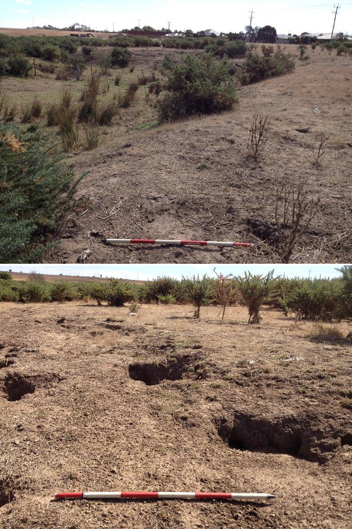
Plate 6: View of dry bed and banks of Armstrong Creek West Branch in the centre of the Study Area (M. Barker 6/3/14),
facing west

Plate 7: View of rabbit burrows in the alluvial banks of Armstrong Creek West Branch in the centre of the Study Area (M. Barker 6/3/14),
facing west

Plate 8: View of creek bed of Armstrong Creek West Branch in the centre of the Study Area (M. Barker 6/3/14),
facing west

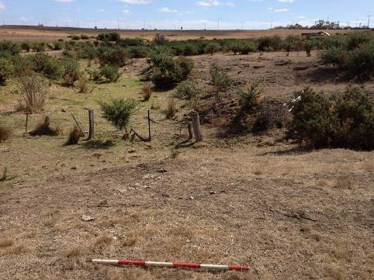Ground Surface Visibility and Effective Survey Coverage

Effective coverage is quantified to account for ground surface visibility and exposure limitations to survey coverage, and gives a good estimate of the actual proportion of the Study Area investigated.

Ground surface visibility is a major factor in obscuring archaeological materials, and can be defined as how much of the surface is visible and what other factors (such as vegetation, gravels or leaf litter) may limit the detection of archaeological materials (Burke and Smith 2004). The higher the level of ground surface visibility, the more likely it is that Aboriginal cultural material can be identified; therefore a good level of ground surface visibility enables a better representation of places than areas where the ground surface is obscured (Ellender and Weaver 1994).

Ellender and Weaver (1994) attempted to quantify ground surface visibility for a 1m² area:

    - 0-5%: Unable to see soil;
    - 5-10%: Occasional glimpse of soil;
    - 10-20%: Occasional patch of bare ground;
    - 20-50%: Frequent patches of bare ground;
    - 50-70%: About half the ground bare;
    - 75-100%: More than half the bare ground; ploughed fields.

Ground surface visibility in the majority of the Study Area (Plates 1-5 in Table 1) was low (10%), and therefore there was little possibility of identifying archaeological deposits on the surface. It is estimated that the effective survey coverage was less than 10%. Ground surface visibility was higher (20-30%) on the northern bank the Armstrong Creek tributary (Plates 6-8) which has been subject to considerable exposure due to grazing and rabbit burrows allowing for a greater effective survey coverage of between 20-30%.

Conclusions of the Ground Survey

The results of the archaeological survey indicate that the Study Area comprises land that is potentially sensitive to Aboriginal archaeological sites and is a landform that previous studies within the vicinity of the study area have shown to contain Aboriginal cultural material. The area within 100m of the west branch of Armstrong Creek (Map 4) is considered to be of moderate to high archaeological sensitivity with the remainder of low potential sensitivity.

Part 2 – Cultural Heritage Management Recommendations

5.0 Specific Cultural Heritage Management Requirements

Based on the results of the archaeological assessment, the following management recommendations are made for land comprising the Study Area.

Aboriginal Heritage

Under Sections 27-28 of the Aboriginal Heritage Act (2006) it is an offence to knowingly carry out an Act that harms Aboriginal cultural heritage or to knowingly carry out an Act likely to harm Aboriginal cultural heritage, including Aboriginal archaeological sites. In some circumstances, the Act requires the preparation of a Cultural Heritage Management Plan (CHMP) where a proposed activity is a high impact activity, as specified in the Aboriginal Heritage Regulations 2007 and where that activity occurs in an area of cultural heritage sensitivity defined in the Regulations. The purpose of a CHMP is to either demonstrate that an activity will not harm Aboriginal cultural heritage or to mitigate the impacts of an activity on Aboriginal cultural heritage.

A CHMP is an Aboriginal heritage assessment which must be prepared to standards prescribed in the Aboriginal Heritage Regulations 2007. The Aboriginal Heritage Act 2006 provides blanket protection for all Aboriginal cultural heritage in Victoria. There are substantial penalties under the Act for knowingly undertaking an activity which harms or is likely to harm Aboriginal cultural heritage.

When the assessment described above is completed, a CHMP must be prepared according to a format prescribed in the Aboriginal Heritage Regulations 2007. When completed, the CHMP must be submitted for evaluation. If a planning permit is required for an activity, approval cannot be granted until the CHMP has been completed and evaluated'. Where no RAPs have been appointed, AAV will still seek the opinion of Aboriginal Community Organisations who have applied to become RAPs when evaluating the CHMP. For this reason, it is strongly advisable to consult with RAP applicants, even if no RAP has been appointed. Where an approval is issued for a CHMP, the management recommendations for Aboriginal cultural heritage contained in the CHMP, are binding on the proponent for the lifetime of the project (activity).

Recommendation 1

No further archaeological assessment is required for rezoning of the study area. A Cultural Heritage Management Plan must be undertaken for future development of the study area.

Under the Aboriginal Heritage Act 2006 and in accordance with the Aboriginal Heritage Regulations 2007 a mandatory Cultural Heritage Management Plan (CHMP) is required for the proposed activity, because:

    - The study area contains an area of Cultural Heritage Sensitivity identified as land within 200 metres of a waterway (Aboriginal Heritage Regulations 2007, Part 2, Div 3, Reg. 23(1)); and

    - The proposed activity is a high impact activity (Aboriginal Heritage Regulations 2007, Part 2, Div 5, Reg 46. Residential and commercial subdivisions are high impact activities.

The purpose of the CHMP is to identify and assess the nature, extent and significance of Aboriginal sites, objects and cultural heritage values within the subject land and to provide mitigation, protection and contingency procedures to manage those values before, during and after development of the land.

In accordance with Section 61 of the Aboriginal Heritage Act (2006), the following mandatory matters are considered by this CHMP:

    - Whether the activity will be conducted in a way that avoids harm to Aboriginal cultural heritage;
    - If it does not appear to be possible to conduct the activity in a way that avoids harm to Aboriginal cultural heritage, whether the activity will be conducted in a way that
minimises harm to Aboriginal cultural heritage; and
    - Any specific measures required for the management of Aboriginal cultural heritage likely to be affected by the activity, both during and after the activity.

Recommendation 2

A suggested methodology for the CHMP will involve the following process:

    - Submit an Notice of Intent to Aboriginal Affairs Victoria and the WAC;
    - Present the results of the desktop assessment to the WAC;
    - Undertake a comprehensive archaeological survey of the proposed alignment with WAC representatives;
    - Discuss the results of the survey with the WAC;
    - Devise an appropriate strategy for a complex assessment (subsurface testing) in consultation with the WAC;
    - Discuss the results of the complex assessment with the WAC;
    - Manage any sites in consultation with the WAC; and
    - Manage future heritage values in consultation with the WAC (such as interpretive signage).

European Heritage

There are no historic sites within the study area. The study area is considered to have very low potential sensitivity for historic archaeological sites. No further investigation is required.

References

Aboriginal Heritage Act 2006 Aboriginal Heritage Regulations 2007 Aboriginal Affairs Victoria 2007a
Guide to Preparing Aboriginal Cultural Heritage Management Plans.

Aitken, D. L. and A.P. Kershaw 1993.
Holocene vegetation and environmental history of Cranbourne Botanic Garden, Victoria. Proceedings of the Royal Society of Victoria 105(1): 67-80.

Barwick, D.E. 1984
‘Mapping the Past: an Atlas of Victorian Clans 1835-1904. Part 1.’ Aboriginal History: 1-2.

Bunce, D. 1858.
Extracts from previous works presented as evidence in 'Report of the Select Committee of the Legislative Council on the Aborigines', 1858-59, in Victorian Legislative Council, Votes and Proceedings, Government Printer.

Clark, I. 1990
‘Aboriginal Languages and Clans’ Monash University Publications in Geography No. 37. Coutts, P.J.F. 1981
Coastal archaeology of Victoria Part 1: The morphology of coastal archaeological sites.
Proceedings of the Royal Society of Victoria 92(1):67-80.

Coutts, P.J.F and D.C Witter 1976
Sites of Special Scientific Interest in the Victorian Coastal Region: Archaeology.

Ellender, I. and F. Weaver. 1994.
An Archaeological Survey of Port Phillip Bay. Manuscript held by Aboriginal Affairs Victoria. Unpublished report to the Australian Heritage Commission and Aboriginal Affairs Victoria.

Goulding, M. 1988.
Aboriginal Occupation of the Melbourne Area, District 2. Land Conservation Council. Haydon, G.H. 1846.

Five years experience in Australia. Felix, London.

Jamieson, R. 1853.
Letter in Bride, T.F. (ed.) Letters from Victorian Pioneers, Heinemann, Melbourne 1969: 89-90.

LCC 1991
The Melbourne Area District 2. Land Conservation Council: Melbourne.

McCrae, G. 1934
Georgiana’s Journal – Melbourne a hundred years ago. (ed. H. McCrae) (Angus & Robertson, Melbourne)

Murphy, A. 1997.
An Overview of the Aboriginal Archaeology within the ‘Casey Foothills’, Narre Warren North and Harkaway. Report to the City of Casey.

Presland, G. 1994.
Aboriginal Melbourne. The Lost Land of the Kulin People. McPhee Gribble Publishers, Victoria.

Smyth, R. B. 1878.
The Aborigines of Victoria and other Parts of Australia and Tasmania (2 vols.). Government Printer, Melbourne

Spillane, E.A 1971
‘Aboriginal Relics on the Mornington Peninsula’ Victorian Naturalist 88: 337-341.

Spillane, E.A. 1974
An Aboriginal Camp at Portsea. Victorian Naturalist Vol 9, pp 181-191.

Sullivan, H. 1981
An Archaeological Survey of the Mornington Peninsula, Victoria. Ministry for Conservation, Victoria.

Sutherland, M.A. 1888
Victoria and its metropolis – past andpresent. McCarron, Bird and Co. Publishers, Melbourne. Vol 1. pp. 39.

Thomas, W. 1838-67, William Thomas Papers, 1838-67. Uncatalogued MSS Set 214,
Items 1-24, Mitchell Library, Sydney. Willis, J.H. 1955

Robert Brown’s Bass Strait journal of April/ May 1802 (Embracing landings from the Investigator at King Island and Port Phillip). Transcribed by J.H. Willis and C.I. Skewes. Muelleria: an Australian Journal of Botany 1: 46–51.

Appendices

Appendix 1: Glossary

A
Angular fragment: A piece of stone that is blocky or angular, not flake-like.

Archaeology: The study of the remains of past human activity.

Area of Archaeological Sensitivity: A part of the landscape that contains demonstrated occurrences of cultural material. The precise level of sensitivity will depend on the density and significance of the material.

Artefact scatter: A surface scatter of cultural material. Aboriginal artefact scatters are defined as being the occurrence of five or more items of cultural material within an area of about 100m2 (Aboriginal Affairs Victoria 1993). Artefact scatters are often the only physical remains of places where people have lived camped, prepared and eaten meals and worked.

B
BP: Before Present. The present is defined as 1950.

Backed blade (geometric microlith): Backing is the process by which one or more margins contain consistent retouch opposite to the sharp working edge. A backed blade is a blade flake that has been abruptly retouched along one or more margins opposite the sharp working edge. Backed pieces include backed blades and geometric microliths. Backed blades are a feature of the Australian Small Tool Tradition dating from between 5,000 and 1,000 years ago in southern Australia (Mulvaney 1975).

Blade: A stone flake that is at least twice as long as it is wide.

Burial: Usually a sub-surface pit containing human remains and sometimes associated artefacts.

C
Core: A stone piece from which a flake has been removed by percussion (striking it) or by pressure. It is identified by the presence of flake scars showing the negative attributes of flakes, from where flakes have been removed.

E
Ethnography: The scientific description of living cultures.

Exposure: Refers to the degree to which the sub-surface of the land can be observed. This may be influenced by natural processes such as wind erosion or the character of the native vegetation, and by land use practices, such as ploughing or grading. It is generally expressed in terms of the percentage of the sub-surface visible for an observer on foot.

F
Flake: A stone piece removed from a core by percussion (striking it) or by pressure. It is identified by the presence of a striking platform and bulb of percussion, not usually found on a naturally shattered stone.

Formal tool: An artefact that has been shaped by flaking, including retouch, or grinding to a predetermined form for use as a tool. Formal tools include scrapers, backed pieces and axes.

G
GDA94 or Geocentric Datum of Australia 1994: A system of latitudes and longitudes, or
east and north coordinates, centred at the centre of the earth's mass. GDA94 is compatible with modern positioning techniques such as the Global Positioning System (GPS). It supersedes older coordinate systems (AGD66, AGD84). GDA94 is based on a global framework, the IERS Terrestrial Reference Frame (ITRF), but is fixed to a number of reference points in Australia. GDA94 is the Victorian Government Standard and spatial coordinates for excavations, transects and places in CHMP documents.

H
Hearth: an organic sub-surface feature; it indicates a place where Aboriginal people cooked food. The remains of a hearth are usually identifiable by the presence of charcoal and sometimes clay balls (like brick fragments) and hearth stones. Remains of burnt bone or shell are sometimes preserved within a hearth.

Holocene, recent or postglacial period: The time from the end of the Pleistocene Ice Age (c. 10,300 BP) to the present day.

I
In situ: A description of any cultural material that lies undisturbed in its original point of deposition.

L
Land System: Description for an area of land based on an assessment of a series of environmental characteristics including geology, geomorphology, climate, soils and vegetation

M
Midden: Shell middens vary widely in size composition and complexity. Deposits vary in complexity, they range from being homogenous to finely stratified deposits. Material which may be found in middens includes different shell species, stone artefacts, hearths and animal bones.

Q
Quarry (stone/ochre source): A place where stone or ochre is exposed and has been extracted by Aboriginal people. The rock types most commonly quarried for artefact
manufacture in Victoria include silcrete, quartz, quartzite, chert and fine-grained volcanics such as greenstone.

Quartz: A mineral composed of silica with an irregular fracture pattern. Quartz used in artefact manufacture is generally semi-translucent, although it varies from milky white to glassy. Glassy quartz can be used for conchoidal flaking, but poorer quality material is more commonly used for block fracturing techniques. Quartz can be derived from waterworn pebble, crystalline or vein.

P
Pleistocene: The dates for the beginning and end of the Pleistocene generally correspond with the last Ice Age. That is from 3.5 to 1.3 million years ago. The period ends with the gradual retreat of the ice sheets, which reached their present conditions around 10,300 BP.

Pre-contact: Before contact with non-Aboriginal people.

Post-contact: After contact with non-Aboriginal people.

R
Raw material: Organic or inorganic matter that has not been processed by people.

Registered Aboriginal Cultural Heritage Places: These are Aboriginal sites registered on the Victorian Aboriginal Heritage Register (VAHR).

Regolith: The mantle of unconsolidated soil/sediments/weathered rock materials forming the surface of the land that rests upon the bedrock.

S
Scarred trees: Aboriginal derived scars are distinct from naturally occurring scars by their oval or symmetrical shape and occasional presence of steel, or more rarely, stone axe marks on the scar's surface. Other types of scarring include toeholds cut in the trunks or branches of trees for climbing purposes and removal of bark to indicate the presence of burials in the area. Generally, scars occur on River red gums (Eucalyptus camaldulensis) or grey box (E. microcarpa) trees. River red gums are usually found along the margins of rivers, creeks and swamps with grey box on near and far floodplains. Size and shape of the scar depended on the use for which the bark was intended. For example, bark was used for a variety of dishes and containers, shields, canoes
and construction of huts.

Significance: The importance of a heritage place or place for aesthetic, historic, scientific or social values for past, present or future generations.

Silcrete: Soil, clay or sand sediments that have silicified under basalt through groundwater percolation. It ranges in texture from very fine grained to coarse grained. At one extreme it is cryptocrystalline with very few clasts. It generally has characteristic yellow streaks of titanium oxide that occur within a grey and less commonly reddish background. Used for flaked stone artefacts.

Spit: Refers to an arbitrarily defined strata of soil removed during excavation.

Stratification: The way in which soil forms in layers.

Stratified deposit: Material that has been laid down, over time, in distinguishable layers.

Stratigraphy: The study of soil stratification (layers) and deposition.

Stone Artefact: A piece of stone that has been formed by Aboriginal people to be used as a tool or is a by-product of Aboriginal stone tool manufacturing activities. Stone artefacts can be flaked such as points and scrapers or ground such as axes and grinding stones.

T
Tool: A stone flake that has undergone secondary flaking or retouch.

Transect: A fixed path along which one excavates or records archaeological remains.

V
Victorian Aboriginal Heritage Register: A list of all registered Aboriginal cultural heritage places (Aboriginal Places) in Victoria.

Visibility: Refers to the degree to which the surface of the ground can be observed. This may be influenced by natural processes such as wind erosion or the character of the native vegetation, and by land use practices, such as ploughing or grading. It is generally expressed in terms of the percentage of the ground surface visible for an observer on foot.

REFERENCES

Aboriginal Affairs Victoria 1997 Guidelines for Conducting and Reporting upon Archaeological Surveys in Victoria. AAV, Melbourne.
Mulvaney, DJ 1975 The Prehistory of Australia. Harmondsworth, Penguin. Holdaway, S & N Stern
2004 A Record in Stone: the Study of Australia’s Flaked Stone Artefacts.
Museum Victoria and Aboriginal Studies Press, Australian Institute of Aboriginal and Torres Strait Islander Studies, Canberra.

38

