

35 Hams Road & 151-229 Anglesea Road

Waurn Ponds

Preliminary Transport Assessment

JUNE 2014

TABLE OF CONTENTS
- INTRODUCTION 2
  - BACKGROUND 2
- PROPOSED DEVELOPMENT 3
  - PRELIMINARY DEVELOPMENT PLAN 4
  - LAND USE 4
- ARMSTRONG CREEK WEST PRECINCT STRUCTURE PLAN (PSP) 5
- EXISTING CONDITIONS ASSESSMENT 6
  - EXISTING ROAD NETWORK 6
  - EXISTING TRAFFIC VOLUMES 9
  - CASUALTY ACCIDENT STATISTICS 9
  - PUBLIC TRANSPORT 10
  - ACTIVE TRANSPORT 11
- FUTURE ACCESS POINTS 13
- FUTURE ROAD NETWORK IMPROVEMENTS 15
  - ROAD IMPROVEMENTS 15
  - INTERSECTION IMPROVEMENTS 15
  - PEDESTRIAN/ CYCLIST IMPROVEMENTS 15
- MAJOR ROAD INFRASTRUCTURE IMPROVEMENTS 16
  - BAANIP BOULEVARD 16
  - LOCAL ROADS 17
- CONCLUSIONS 18
Appendix A Concept Plan
Appendix B Armstrong Creek West Precinct Structure Plan Area Appendix C Baanip Boulevard Conceptual Plans

Introduction

Background

SMEC Australia Pty Ltd (SMEC) has been engaged by Echin C/- Australian Property Partnership and Waurn Ponds Trust to conduct a Preliminary Transport Assessment for the site located at 35 Hams Road & 151-229 Anglesea Road, Waurn Ponds, Victoria.

The aim of this Preliminary Transport Assessment is to assess the level of risk associated with the future development of this site. Risk in the context of this report is defined as the impact that potential future road network improvements may have on the viability of the development and the impact the development will have on the current operation of the road network.

The assessment will focus on any future road and intersection upgrades that may be attributable to the site and for which developer contributions may be sought.

The following documentation was provided or obtained by the consultant to assist in the assessment:

+ Concept Plan (Revision E), SMEC Urban, June 2014;

+ VicRoads SmartRoads traffic volume data, June 2013;

+ VicRoads Geelong Ring Road Section 4C (Anglesea Road to Surf Coast Highway), August 2012; and

+ Armstrong Creek West Precinct – Transport Assessment, GTA Consultants, November 2011.

Proposed Development

The subject site is made up of two parcels of land; 35 Hams Road & 151-229 Anglesea Road and is located in the south-west corner of an established residential area immediately south of Hams Road in Waurn Ponds. The subject site is bounded by Hams Road to the north, Ghazeepore Road to the east, the Geelong Ring Road and Anglesea Road to the west and the Warrnambool–Geelong Railway line to the south. The subject site is currently zoned as farming land (FZ).

The site is located within close proximity and easy access to major road networks including the newly constructed Geelong Ring Road and the Princes Highway. Refer Figure 1 for the site location.

The site is located approximately 11.5km south-west from Geelong town centre.

Subject Site

151-229 Anglesea Road 35 Hams Road

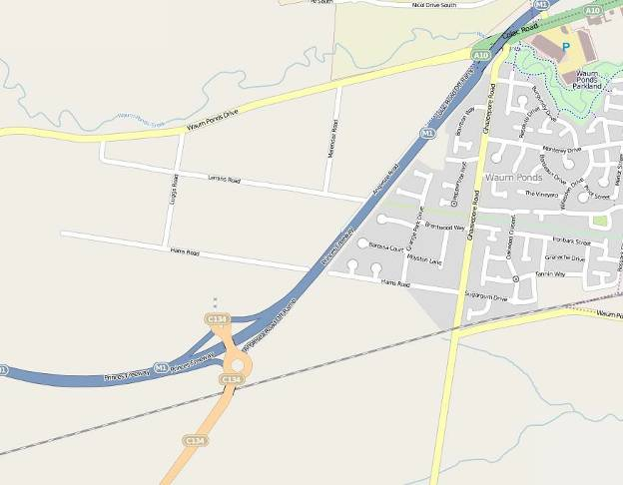Figure 1 - Locality Plan (image reproduced with permission from Open Street Maps)

Preliminary Development Plan

A copy of the site Concept Plan (Revision E) for the proposed development site is provided in Appendix A. Features of the development site include:
+ Vehicular access provided from Hams Road and Ghazeepore Road;

+ Truncation of Hams Road west of the development site;

+ Existing Powercor Waurn Ponds Terminal Station located on the north-east corner of the site; and

+ The Warrnambool-Geelong Railway line running in a north-east to south-west direction along the southern boundary of the site.

Land Use

The proposed development site is located in Farming Zone (FZ). Key land uses surrounding the site include:

+ Residential Zone 1 (R1Z) to the north and east;

+ Special Use Zone (SUZ7) to the south and west;

+ Urban Growth Zone (UGZ3) to the east;

+ Road Zone (RDZ1) for the Geelong Ring Road to the west; and

+ Public Use Zone (PUZ4) for the Warrnambool-Geelong railway line to the south.

Figure 2 shows the existing land use plan.

Subject Site

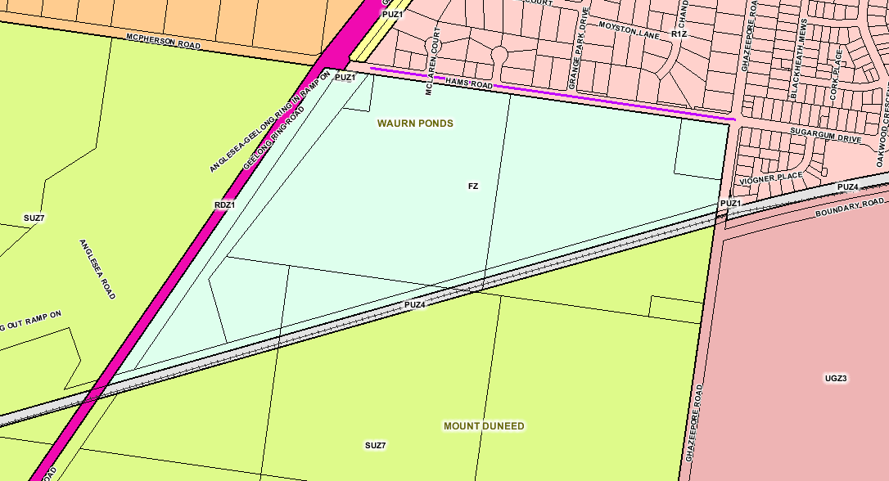Figure 2 - Land use plan (source: http://services.land.vic.gov.au/maps/pmo)

Armstrong Creek West Precinct Structure Plan (PSP)

The Armstrong Creek Growth Area is the largest growth area in Victoria, comprising of approximately 2,500 hectares of developable land. The Armstrong Creek Growth Area will:

+ Provide housing for between 55,000 to 65,000 people;

+ Provide approximately 22,000 residential homes;

+ Provide approximately 22,000 jobs; and

+ Provide a sustainable community, with a focus on walkability, public transport provision and sustainable living.

Within the Armstrong Creek Growth Area, the west precinct has been earmarked for future residential development and will feature a mixture of conventional, medium and high density residential lots combined with retail, educational, recreational and community facilities. To achieve this vision, the Armstrong Creek West PSP has been developed.

The Armstrong Creek West PSP covers an area of approximately 528 hectares. The area is bounded by the Warrnambool-Geelong railway line to the north, Ghazeepore Road to the west, Whites and Feehans Road to the south and the Surf Coast Highway to the east.

To support the vision of the Armstrong Creek Growth Area, the Armstrong Creek West PSP includes the provision of active transport infrastructure, including on-road and off-road pedestrian and cyclists paths. Of interest to this site is the key active transport infrastructure upgrades identified in the PSP. These include;

+ The Geelong Ring Road Shared Path;

+ Shared path along both side of Armstrong Creek; and

+ Greenways proposed along Airport Road and Boundary Road.

The Armstrong Creek West PSP also identifies key road and public transport infrastructure upgrades required to provide a permeable road network suitable to cater for the expected growth in traffic demand. Of interest to this site are the key road and public transport infrastructure upgrades identified in the PSP. These include;

+ Inclusion of a new train station precinct;

+ Inclusion of the Baanip Boulevard connection; and

+ Possible realignment of Anglesea Road.

The development site does not fall within limits of the Armstrong Creek PSP area; however the north-west corner of the Armstrong Creek PSP is directly opposite the development site. It is therefore expected that the development site will benefit from the nominated road, public transport and active transport infrastructure upgrades as identified in the Armstrong Creek West PSP.

Refer to Appendix B for a copy of the Armstrong Creek West Precinct Structure Plan.

Existing Conditions Assessment

Existing Road Network

A review of the proposed future development site, Hams Road, Ghazeepore Road and the surrounding road network was undertaken to assess the general operational characteristics of the abutting road network.

An inspection of the proposed development site including Hams Road and Ghazeepore Road was undertaken on Wednesday 17 July 2013, between the hours of 11:30am and 12:30pm.

Hams Road

Hams Road is a sealed two-lane, two-way undivided local road which runs in an east-west direction. It consists of an 8.0m wide carriageway, made up of two traffic lanes and an unsealed shoulder on the southern edge of the carriageway. Kerb and channel is present on the northern edge of the carriageway adjacent to the residential properties while an open drain is present on the southern edge of the carriageway.

The road alignment is straight and flat with a slight incline towards the east where it forms the western leg of the unsignalised intersection of Ghazeepore Road/ Hams Road.

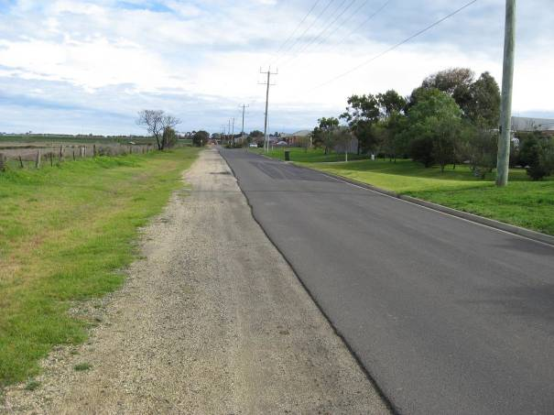The posted speed limit on Hams Road is 50km/h.

Photo 1 - Hams Road, looking west

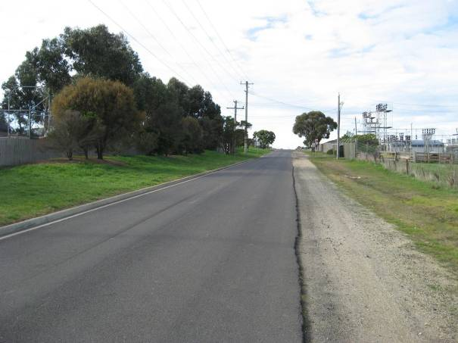Photo 2 - Hams Road, looking east

Ghazeepore Road

Ghazeepore Road is a sealed two-lane, two-way undivided local road which runs in a north-south direction. It consists of a 9.0m wide carriageway, made up of two traffic lanes and an unsealed shoulder on the western edge of the carriageway. Kerb and channel is present on the eastern edge of the carriageway adjacent to the residential properties while an open drain is present on the western edge of the carriageway.

The road alignment is straight and flat with a moderate incline towards the north where it forms the southern leg of the unsignalised intersection of Ghazeepore Road/ Hams Road.

The posted speed limit on Ghazeepore Road is 60km/h.

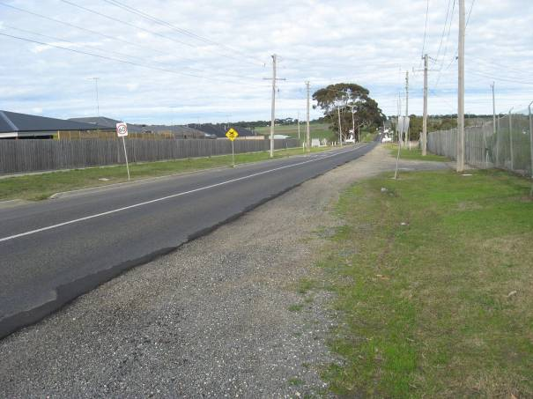Photo 3 - Ghazeepore Road, looking south

Existing Traffic Volumes
Photo 4 - Ghazeepore Road, looking north

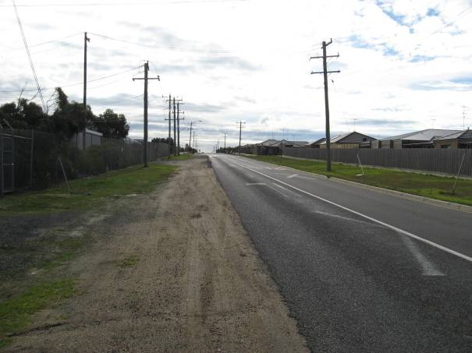
Hams Road and Ghazeepore Road are both local roads under the control and management of the City of Greater Geelong Council (“the Council”). There is limited existing traffic volume data available for these roads. The only available traffic data obtained from Council include:

+ Ghazeepore Road – 3,000 vpd. (March 2013)

Due to the fact that Hams Road is currently truncated to the west, it is anticipated that the current traffic volumes along Hams Road would be very low. Hams Road only services a small catchment of residential dwellings to the north.

Casualty Accident Statistics

VicRoads’ Crashstats database indicates that one (1) casualty crash has been recorded in the vicinity of the site in the five-year period between January 2007 and December 2012.

The crash occurred at the Ghazeepore Rd/ Sugergum Drive/ Hams Road intersection. This crash occurred in April 2011 and was an ‘off-path’ accident (run off the road).

Public Transport

The subject site is serviced reasonably well by public transport to cater for the residential catchment north of Hams Road.

Train

Marshall Train Station is located approximately 5.0km north-east of the development site. Currently, there are 21 weekday services between Melbourne and Geelong and 24 weekday services between Geelong and Melbourne. There are also 3 weekday services running between Melbourne and Mount Gambier via Geelong and Warrnambool. There are 14 services between Melbourne and Warrnambool and 21 weekday services between Warrnambool and Melbourne.

Bus

Bus Route 14 (Geelong City–Waurn Ponds–Deakin University) is the closest bus service to operate within the vicinity of the development site. Refer Figure 3 for a summary of the bus route in the vicinity of the development site.

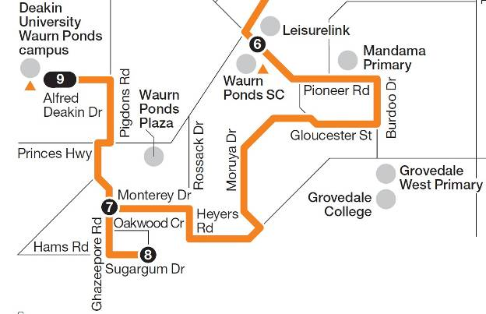The closest bus stop is located on Hams Road the north-east corner of the development site, approximately 20m west of the Ghazeepore Road/ Hams Road intersection.

Figure 3 - Bus Route 14 (source http://ptv.vic.gov.au)

Active Transport

Walking

There are limited pedestrian footpaths located in the vicinity of the development site. Footpaths are not provided along the length of Hams Road along the frontage of the proposed development site. Footpaths are only provided at the following locations:

+ Both sides of Ghazeepore Road, north of Hams Road;

+ Eastern side of Ghazeepore Road, south of Hams Road; and

+ Both sides of Sugergum Road.

Cycling

There are no formal on-road bicycle lanes within close proximity of the proposed development site. Commuter cycling has not been identified as a significant mode of transport in this area.

The Waurn Ponds bicycle trail is a formalised off-road bicycle trail that follows the Waurn Ponds Creek. This trail starts near Ghazeepore Road and runs through the Waurn Ponds Valley Parkland to Belmont. The trail passes through the local public and community amenities such as the Waurn Ponds Shopping Centre, Geelong Regional Baseball Centre, Skateboard Park and South Barwon Reserve giving off-road access to these locations.

Shared Use Path

As part of the Geelong Ring Road duplication, a shared use path has recently been constructed to promote and encourage active transport in the vicinity of the development site. The shared used path runs along the Geelong Ring Road and Anglesea Road off-ramp. The path currently terminates at the western section of Hams Road.

The shared use path also provides connectivity to the area west of the Geelong Ring Road via an underpass, which has also been recently constructed at the western section of Hams Road. Although this area is yet to be developed, it is anticipated that this area will be subject to significant development in the future. Currently the shared use paths converge at the western section of Hams Road. It is anticipated that this shared use path will continue along the Geelong Ring Road north of Hams Road.

Photo 5 shows the recently constructed the shared use paths at the western section of Hams Road.

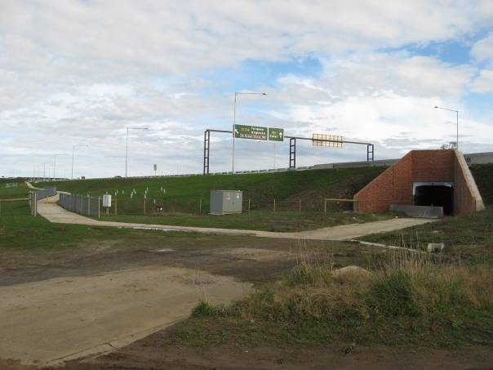Photo 5 - Shared Use Path

Future Access Points

There are currently no formal access points to the subject site from Hams Road or Ghazeepore Road. Access to the site is possible from either or all of these roads.

The road alignment of Hams road is straight and flat, refer Photo 6. It would be anticipated that providing future access point/s along this section of road is possible and would accord with the minimum safe intersection sight distance requirements as specified in the Austroads Guidelines.

The road alignment of Ghazeepore Road is straight and flat. It would be anticipated that providing future access point along this section of road would is possible and would accord to the minimum safe intersection sight distance required as specified in the Austroads Guidelines.

It should be noted that there is limited space for a site access point along Ghazeepore Road due to the location of the Waurn Ponds Terminal Station and the Warrnambool-Geelong Railway line along the frontage of the site. Refer Photo 6

The exact location of these access points will be further investigated for safety and operational effects once a proposed master plan is developed for the site.

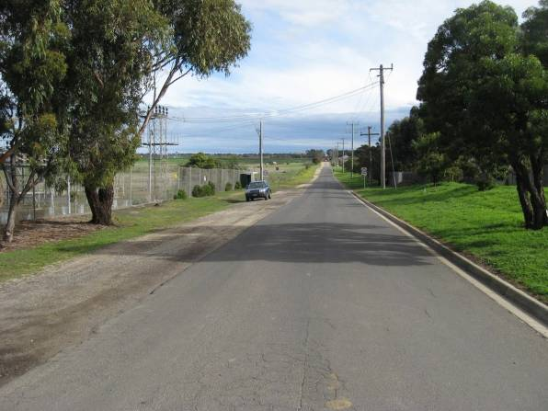Ghazeepore Road provides connectivity to the Princes Highway to the north. Direct access to the newly constructed Geelong Ring Road can be sought from the Princes Highway. As such, it is possible to conclude that the site will provide for suitable connectivity to all of the existing road network including the Princes Freeway and the Geelong Ring Road.

Photo 6 - Hams Road, future site access locations

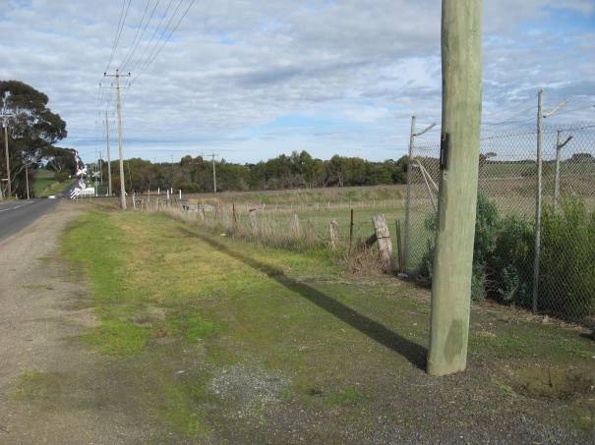Photo 7 - Ghazeepore Road, future site access location

Future Road Network Improvements

Road Improvements

Provisions for road network upgrades to Hams Road and Ghazeepore Road in the form of road widening along the frontage of the development site will be required. The cost of the road upgrade for the certain sections of Hams Road and Ghazeepore Road may be borne by the client.

Intersection Improvements

Our previous experience with similar residential developments in semi-rural areas indicates that the existing intersection arrangement of Ghazeepore Road/ Hams Road may not have sufficient spare capacity to cater for the additional traffic demand generated from the proposed future residential development. As such, an intersection upgrade may be required to improve the overall traffic operational efficiency, intersection capacity and safety at the site.

The type of intersection upgrade arrangement (Channelised or Auxiliary) or potentially a roundabout will be able to be determined once the site’s traffic generation rates are calculated and the future site access location/s are finalised. These calculations and access point locations will be undertaken during the Traffic Impact Assessment phase of the study.

With regard to the existing intersections along Hams Road accessing the residential properties to the north, it is anticipated that no upgrade works will be required as it is anticipated that these intersections will carry minimal additional traffic owing to the proposed development site.

The cost of the intersection upgrades will be borne by the client if these upgrades are warranted and are required to improve the overall traffic operational efficiency, intersection capacity and safety.

Pedestrian/ Cyclist Improvements

Provisions for future pedestrian footpaths and/or cycle paths should be considered to allow for the safe and effective movement of pedestrian and cyclist around the development site.

From a strategic context, providing permeable pedestrian and cycle links connecting the site to the surrounding road network should be incorporated into the development to supplement any future structure plan developed for the surrounding area.

Major Road Infrastructure Improvements

SMEC has had informal discussions with VicRoads – South Western Region Planning team and the Geelong Ring Road Major Project Office with regard to proposed future arterial road network improvements in the vicinity of the subject site. VicRoads advises the following:

+ The Geelong Ring Road is in its final stages of construction;

+ The Baanip Boulevard Project tender documents will be issued in the latter half of 2013; and

+ Other than the proposed Baanip Boulevard Project, VicRoads are not planning any other infrastructure/ network improvements at this stage.

There is no modal priority assigned to the road network surrounding the subject site as the ‘VicRoads approved Road Use Hierarchy’ maps do not extend to this region. It is not anticipated that these plans will be extended to incorporate the development site in the immediate future.

There are no Local of State Government commitments to upgrade the Warrnambool-Geelong railway line in the future.

Baanip Boulevard

The Baanip Boulevard Project (formerly known as Geelong Ring Road Section 4C) is a 4.5 kilometre arterial road and will provide a vital connection within the Armstrong Creek Urban Growth Area and surrounding district. VicRoads is expecting to issue tender documents for the project in the latter part of 2013, with works to start on the ground towards the end of the year.

Baanip Boulevard will be a two-lane, two-way single carriageway urban road, and will connect into the existing Geelong Ring Road Freeway interchange at the Anglesea Road roundabout, travel over the Warrnambool- Geelong railway line, with a new signalised intersection at Ghazeepore Road. Ultimately, a second carriageway may be constructed to the north of the Baanip Boulevard carriageway, however the timeframe for this future duplication is unknown to date and may be some time in the future.

Ghazeepore Road will have a new signalised intersection with Baanip Boulevard to the south of the railway level crossing. Council expects that Ghazeepore Road will be upgraded on both approaches to the intersection as part of these works.

As part of the Baanip Boulevard Project, there are future proposals to construct a new railway station precinct to the east of Ghazeepore Road. This precinct will not be constructed as part of the Baanip Boulevard Project; however it has been earmarked for future construction by other parties. This train station precinct has been identified in the Armstrong Creek West PSP. The timeframe of this future railway precinct is unknown to date and may be some time in the future.

Baanip Boulevard will be delivered by VicRoads, with construction works expected to commence in late 2013 for completion in 2016. Refer to Appendix C for the general alignment plans for the Baanip Boulevard Project.

Local Roads

SMEC has had informal discussions with the Council – Planning and Strategy team with regard to proposed future local road network improvements adjacent to the subject site.

There is an expectation from the Council that the client will be required to construct and widen Ghazeepore Road and Hams Road as a result of the expected increase in traffic demand generated by the proposed development.

With the advent of the Powercor Waurn Ponds Terminal Station, it is anticipated that there will be an increase in the number of traffic and pedestrian movements between Hams Road and Sugergum Drive. To improve the safety at this intersection to cater for the increase in traffic movements, Council have indicated that they would expect that a roundabout with pedestrian refuges will be constructed as part of the subdivision permit conditions.

Conclusions

Our traffic and transport engineering findings for this Preliminary Transport Assessment of 35 Hams Road & 151-229 Anglesea Road, Waurn Ponds is as follows:

+ A Traffic Impact Assessment should be undertaken to determine traffic generation rates, access arrangements and the intersection treatments required;

+ Access to the site is possible from either or all of the roads fronting the site; i.e. Hams Road and Ghazeepore Road. There is however limited opportunity for a site access point along Ghazeepore Road due to the location of the Waurn Ponds Terminal Station and the Warrnambool-Geelong Railway line;

+ Provisions for local road widening and an upgrade of Hams Road and Ghazeepore Road along the frontage to the development site will be required;

+ Intersection upgrades in the vicinity of the development site may be required;

+ Provisions for future pedestrian footpaths and/or cycle paths will need to be considered;

+ The construction of the Baanip Boulevard Project will provide significant benefits to the development site;

+ The Armstrong Creek West PSP identifies key road, public transport and active transport infrastructure improves which will improve the local amenities surrounding the site; and

+ The development site will benefited from the nominated infrastructure upgrade identified in the Armstrong Creek West PSP.

The proposed development of 35 Hams Road & 151-229 Anglesea Road, Waurn Ponds will have an impact on the existing road network. However these impacts are minor and will not prevent the Council from issuing a planning permit, given that all of the likely impacts identified can be effectively mitigated.

It is therefore recommended that the development site investigations proceed to the next stage and that a Traffic Impact Assessment report be produced to support any planning application, including recommendations including recommendations on funding arrangements of the proposed road network upgrades.

Rev No. | Date | Prepared by | Reviewed by | Approved by
A | 23/07/13 | M De Marco | D Hitchins | D Hitchins
B | 31/07/13 | M De Marco | D Hitchins | D Hitchins
C | 19/08/13 | M De Marco | D Hitchins | D Hitchins
D | 04/10/13 | M De Marco | D Hitchins | D Hitchins
E | 10/06/14 | M De Marco | R Jordan | R Jordan

Our Reference:

3004968

Contact for further information:

Derrick Hitchins National Sector Leader Transport Planning SMEC Australia Pty Ltd
(03) 9514 1562
0408 230 710
derrick.hitchins@smec.com

© Snowy Mountains Engineering Corporation
(SMEC Australia Pty Ltd)

The information within this document produced by SMEC Australia is solely for the use of the Client identified on the cover sheet for the purpose for which it has been prepared. SMEC Australia undertakes no duty to or accepts any responsibility to any third party who may rely upon this document. All rights reserved. No section or element of this document may be removed from this document, reproduced, electronically stored or transmitted in any form without the written permission of SMEC Australia.

Appendix A – Concept Plan

LEGEND
Subject Site
Potential Open Space including Waterway, Water Treatment and Retardation
Potential Standard Density Residential
Potential Shared Path
Buffer around Powercor Terminal

POWERCOR WAURN PONDS TERMINAL STATION

Concept Plan
W

Hams Road, Waurn Ponds

Revision Date Description Checked
 |  |  |  | rev.: E | may be subject to change as a result of formal | © smec australia pty ltd
0 | 25 | 50 | 75m | drawn: DS/JM checked: RJ | Council/Authority advice, detailed site investigations  and confirmation by survey | abn 47 065 475 149  trading as smec urban

Scale: 1:2500 @ A3
ref.: 3410685P
please note:
planning & urban design

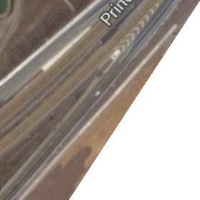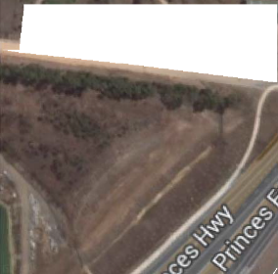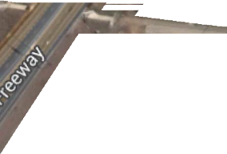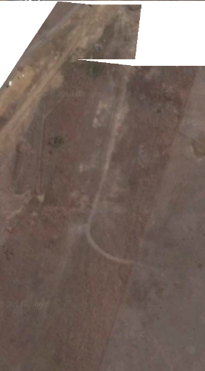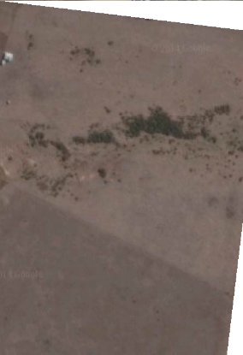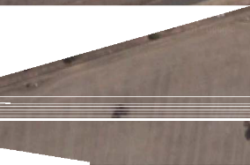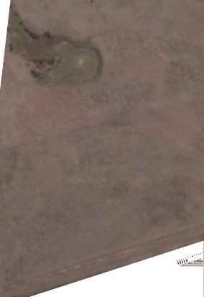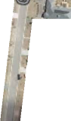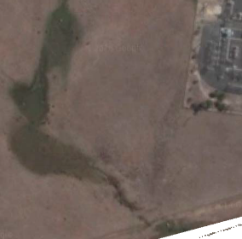D 23/05/14
MB
O
-G
EEL
O
N
G
R
A
IL
W
A
Y

E 27/05/14
Simplication of development and link areas. Update of Title Boundaries
RJ / 23/05/14 RJ / 27/05/14
date: 28 May 2014
This plan is based on preliminary information only and
melbourne - tel 9869 0800

Appendix B – Armstrong Creek West Precinct Structure Plan Area

Whrtes Roed

SES

Et{TW.

use

rN cetffiES
MUNrN C0t.4PLEX

C1.TION
JHA'< S'TATION BLIC OPEN SPACE C'ffllE ()PEN sPACE
NcuMBOU!D oPOI SPJ'Ce
OMINAGE ,t.N0 C()NSER'.JAT10N)

Pl.SSoPCN sAACC: WAlERWA'fSANODRAiMAGE

PR0p05ED -4C RI G
DRESER-JATION
SURt' co>Sf t·11G"N'A'< I SOUUo"'\/AAI>

CONNECTOR

-- s1R()HG CREEK
---

OS
-- 1:H>O'ft!AA FLQOOL.INE

Q'fliER
RETAINEDVEGETATION
(.REfER'fO N'/PP FOR oEfAILS)

- l(EV L

•••· sER'.JICE RC>.'DS

••• GAA'JULROADS
- ttERfTAGE sm:.s
/4Rft< auff'ER

- • • sl-\AAED ACCESS
(300M FROM 6()UNDAA")

Q 1NTER$ECT10N (SIGtWJSED)
MAC tMJORACfM'NCL

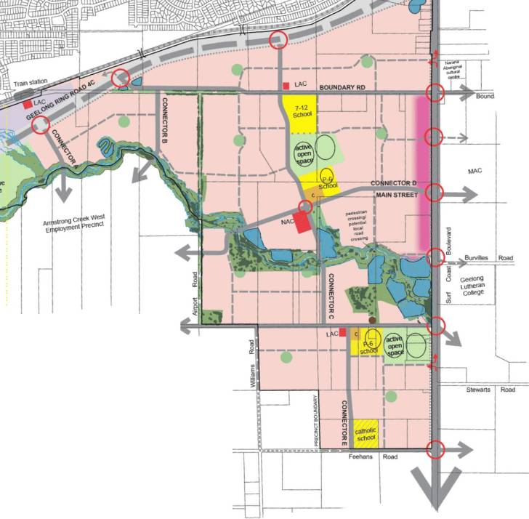1Nn:RSECTION (\£fTIN-LEFT QVT)

.-- fWIJHA'< UNEN«' PR<>p()SE.D STATION

peoE.$TRW'I <:NEPI'l-SS
NAC NEIGH80URl'4()00 ACTNIT'< caflRE

LAC Loc>J..ACTM"N Ct

Appendix C – Baanip Boulevard Conceptual Plan

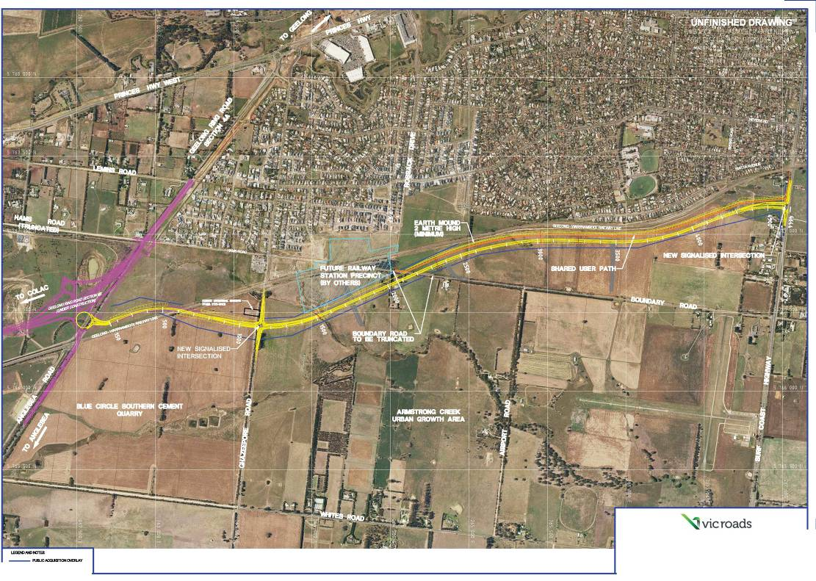

=USEPATl-t
GEELONG RING ROAD SECTION 4C ANGLESEA ROAD TO SURF COAST HIGHWl\Y
AVGV$T2012 -FOH Qte'.Y
0 100 200
SCALE. Of METRES

