Planning and Environment Act 1987

greater geelong PLANNING SCHEME

AMENDMENT C276

EXPLANATORY REPORT

Who is the planning authority?
This amendment has been prepared by the City of Greater Geelong Council, which is the planning authority for this amendment.
The amendment has been made at the request of SMEC Urban consulting group on behalf of the proponents, Waurn Ponds Trust and Echin Pty Ltd.

Land affected by the amendment
The amendment applies to: 25 Hams Road, Waurn Ponds (Powercor substation); 35 Hams Road, Waurn Ponds, and 151-229 Anglesea Road, Waurn Ponds (Subject land); VicRoads land (Geelong Ring Road Sections 4B and 4C); Barwon Water land.
The land shown as “Subject land” in the map below is under two ownerships, being Waurn Ponds Trust (35 Hams Road, Waurn Ponds) and Echin Pty Ltd. (151-229 Anglesea Road, Waurn Ponds).

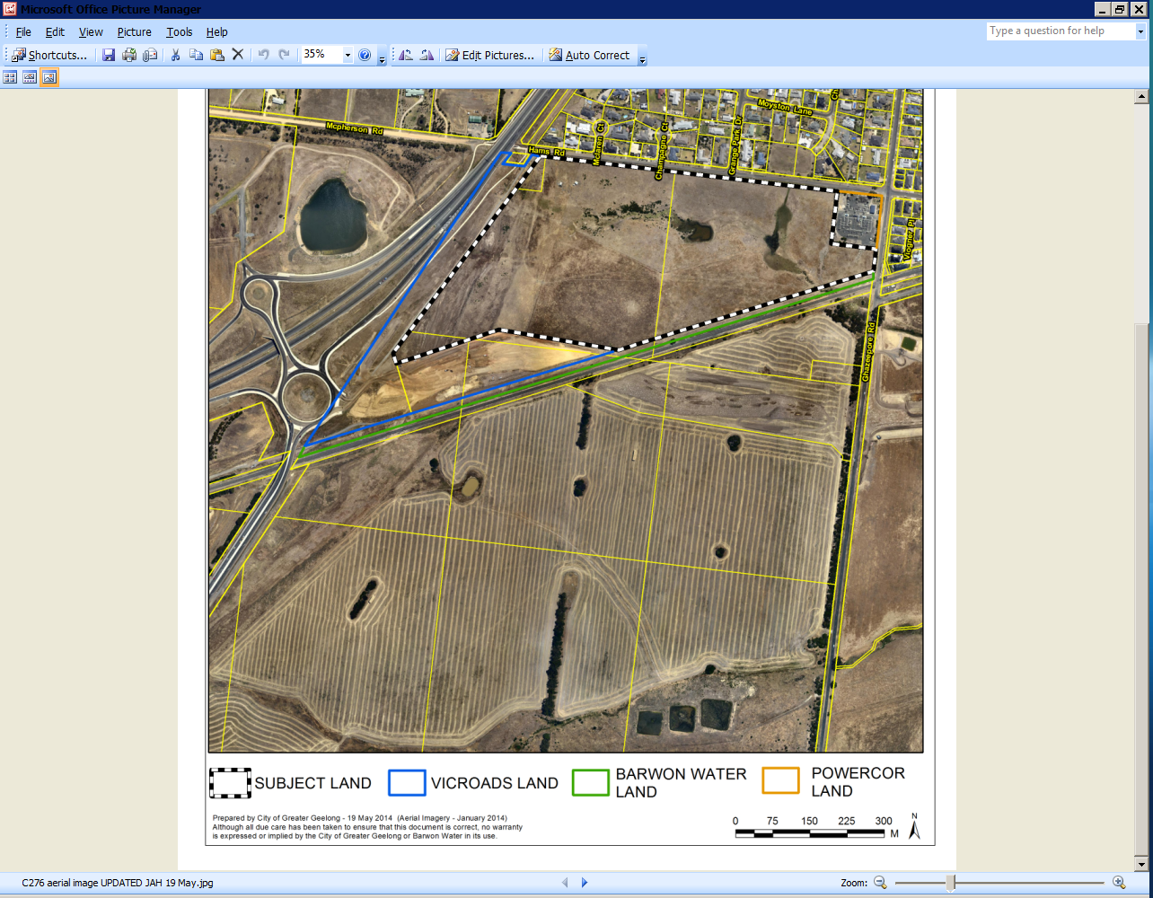

What the amendment does
The amendment proposes to rezone land at 35 Hams Road and 151-229 Anglesea Road, Waurn Ponds, from Farming Zone to General Residential Zone (Schedule 1) and apply the Development Plan Overlay to the land to be rezoned for residential purposes.
The amendment also includes a number of consequential zoning and overlay changes to land within the VicRoads road reserve (Geelong Ring Road Sections 4B and 4C), land at 25 Hams Road, Waurn Ponds, and Barwon Water land adjacent to the southern boundary of the land to be rezoned for residential purposes, including the deletion of redundant planning controls, the Public Acquisition Overlay 3 (PAO3).
More specifically, the amendment proposes to amend Planning Scheme Maps No.s 65, 65DPO, 65PAO as follows:
- Rezone land at 25 Hams Road, 35 Hams Road and 151-229 Anglesea Road, Waurn Ponds, from Farming Zone to General Residential Zone (Schedule 1).
- Apply Clause 43.04 Development Plan Overlay to land at 35 Hams Road and 151-229 Anglesea Road, Waurn Ponds.
- Rezone land within the VicRoads road reserve (Geelong Ring Road Sections 4B and 4C) adjoining 151-229 Anglesea Road, Waurn Ponds, from Farming Zone to Road Zone Category 1.
- Rezone land within the Barwon Water reserve located between land at 35 Hams Road and 151-229 Anglesea Road, Waurn Ponds and the Geelong/Warrnambool railway line from Farming Zone to Public Use Zone 1.
- Delete Public Acquisition Overlay 3 (Clause 45.01) from the 151-229 Anglesea Road, Waurn Ponds, and land within the VicRoads road reservation (Section 4B and 4C) adjoining 151-229 Anglesea Road.

Strategic assessment of the amendment

Why is the amendment required?
The amendment is required to facilitate the use of the land at 35 Hams Road and 151-229 Anglesea Road, Waurn Ponds, for residential purposes. The amendment will rezone the land from the Farming Zone to the General Residential Zone (Schedule 1). It will also apply the Development Plan Overlay on the land to establish a development framework for future subdivision and development.
Consequential zoning changes are required to remove what would be a remnant piece of Farming Zone land at 25 Hams Road, Waurn Ponds. This land is used as an electricity substation. Further zoning changes are proposed including the rezoning of land within the VicRoads road reservation (Geelong Ring Road Sections 4B and 4C) to Road Zone Category 1 to reflect the current land use. The redundant Public Acquisition Overlay 3 will also be removed from this land and part of the land proposed for residential use. Barwon Water land will also be rezoned to the Public Use Zone 1 to accurately reflect the ownership/land use of the area.
The land to be rezoned for residential purposes is identified in the adopted Armstrong Creek Urban Growth Plan (Adopted May 2008) as having potential for future residential use, subject to the confirmation of the link road alignment (known as Geelong Ring Road Section 4C) and any amenity issues created by the new road. The G21 Regional Plan (April 2013) and the G21 Residential Land Supply Monitoring Project (October 2013) are also important considerations. The G21 Regional Plan seeks to minimise the continued expansion of the urban footprint and provides for a mix of infill development and targeted new development areas in suitable locations. The G21 Residential Land Supply Monitoring Project identifies the site as ‘potential residential’ land.
The amendment will result in the rezoning of a piece of Farming Zone land located in a largely urban context and which is not suitable for intensive agricultural activities. The land can also be considered an infill opportunity that will consolidate the existing urban areas and make efficient use of existing community and physical infrastructure.
The amendment will result in a net community benefit by providing a variety of housing types, rehabilitation of the designated waterway and additional public open space, including a shared pathway along the waterway, pedestrian and cycle links and a contribution towards regional community infrastructure. The land to be rezoned for residential purposes is also close to the Armstrong Creek Urban Growth Area (West precinct), which will provide for extensive residential development and associated land uses, including regional active open space along Ghazeepore Road. A new rail station is also being constructed at Rossack Drive, which will provide additional modes of transport to residents and future residents in the area.
The amendment will result in a good planning outcome.

How does the amendment implement the objectives of planning in Victoria?
The amendment implements the objectives set out in section 4 of the Planning and Environment Act 1987 in so far as it will:
- Provide for the fair, orderly, economic and sustainable use, and development of land;
- Secure a pleasant, efficient and safe working, living and recreational environment for all Victorians and visitors to Victoria.
- Balance the present and future interests of all Victorians

How does the amendment address any environmental, social and economic effects?
Environment Effects
There are a number of environmental issues that affect the subject land to be rezoned for residential purposes. The majority of these issues can be mitigated through on-site or external measures.
Noise
The land to be rezoned for residential purposes is proximate to the Geelong Ring Road Sections 4B and 4C, Ghazeepore Road, the Geelong/Warrnambool railway line and the Powercor substation.
No noise measures are required in response to the proximity of the site to the Geelong Ring Road (Section 4B) to the west. The new Geelong Ring Road Section 4C (Baanip Blvd), which is currently under construction, will require consideration during the approval of the development plan. An acoustic survey (noise assessment) will be required upon completion of the new road to determine the traffic noise levels and potential impact on housing to be located along the boundary between the two uses. For properties adjoining Ghazeepore Road, mitigation measures will be required in the form of acoustic fencing to ensure noise levels from the road do not have an adverse impact on the amenity of future residents. Consideration will need to be given to noise arising from the Geelong/Warrnambool rail line to the south of the site, such as acoustic fencing and/or the detailed design of dwellings in terms of siting and location habitable rooms (bedrooms).
The interface between the Powercor substation can be addressed during the preparation of the Development Plan.
SP AusNet gas pipeline
SP AusNet operates a high pressure gas pipeline that runs parallel to the western boundary of the land to be rezoned for residential purposes. The gas pipeline is located within the Geelong Rind Road reservation. The high pressure gas pipeline has associated safety buffer requirements.
A safety management workshop was undertaken between key stakeholders to determine what impact the gas pipeline might have on the rezoning of the land for residential purposes. The workshop gave detailed consideration to the threats identified for the section of pipeline under review in the safety management study. The general conclusions stated that all threats identified have either been determined as ‘non-credible’ or have been ‘controlled’. No threats required failure analysis or risk assessment. The workshop also outlined a number of Actions that require to be implemented by various stakeholders. A total of 5 Actions are required to ensure that additional design and procedural measures are incorporated. Council, as Planning Authority, is required to action a number of these during the rezoning stage and future detailed design of the land to be rezoned for residential use. These include a requirement of Council to refer any detailed design plans to SP AusNet for works proximate to the pipeline. This requirement can be achieved through the schedule to the Development Plan Overlay.
Boral Quarry
The site is located proximate to the Boral limestone quarry.
Quarrying with blasting
Rock blasting for limestone extraction has not yet commenced on the Boral land south of the subject land. However, for quarrying activities with blasting, a preliminary assessment of the effects of the future blasting on the site has been undertaken. The assessment concluded that quarrying activities with blasting will be limited to part of the Boral quarry in excess of 800 metres from the southern boundary of the land to be rezoned for residential purposes. The 800 metre estimate is well beyond the general 500 metres required between blasting and sensitive uses (residential development).
The assessment also concluded that ground vibrations that are predicted to occur from blasting at the subject land are considered to be below the DSDBI guidelines limits.
Quarrying without blasting
For quarrying activities ‘without blasting’, a 250 metre separation distance will affect part of the subject land. This is based on Boral’s current Works Authority. However, the Works Authority is likely to be amended in the future based on the acquisition of the northern part of the Boral land holding by VicRoads for the Geelong Ring Road Section 4C and additional buffer requirements between the quarry and the new road relating to the impact of quarrying activities on the visibility of future road users. This in turn will significantly reduce the extent of the buffer on the subject land.
Construction of the Baanip Boulevard (Geelong Ring Road 4C) will be of a nature that forms a potential physical barrier between the air emissions generated by the quarry (both blasting and non-blasting activities). Landscaping will also be implemented on both sides of the new road, which will is likely to contribute to reducing any air, dust and noise concerns generated by the Boral quarry.
Until the Boral Works Authority has been amended to reflect the new alignment of the VicRoads Geelong Ring Road Section 4C, the EPA advises that the 250 metre separation distance should be maintained between the subject land and Boral’s current Works Authority.
The schedule to the Development Plan Overlay will include wording to reflect the existing separation buffer affecting the subject land and the associated guidance in relation to assessing residual air emissions from industrial activities.
Designated Waterway
A tributary of the Armstrong Creek traverses the land to be rezoned for residential purposes. The tributary is a designated waterway and consequently, is subject to the provisions of Water Act 1989 enforced by the Corangamite Catchment Management Authority. The natural west-east waterway will be retained through the subject land and rehabilitated. Vegetation buffers will be required on both sides of the waterway at a minimum 20 metres from a nominated point (yet to be determined). The vegetation buffers contribute towards the 10% public open space requirement where the land is not encumbered. The retention of the waterway will result in a good environmental outcome.
Native vegetation/Biodiversity
The subject land contains patches of low quality native vegetation with little habitat value for significant species. The drainage line (natural west-east waterway) contains the most environmentally sensitive areas within the site and requires careful consideration to avoid adverse impacts at the detailed design stage.
Notwithstanding the low quality of native vegetation contained on the subject land, the future residential subdivision of the land will require native vegetation off-sets to be provided. A permit to remove the native vegetation will be required. The total extent of native vegetation that is likely to be removed is 4.833ha. Only a general offset amount is required for the removal of the native vegetation.
The report recommends that off-set requirements be delivered off-site. There are several methods for acquiring native vegetation credits to deliver off-site requirements. This is a matter that can be dealt during the application to remove native vegetation.
Cultural heritage
The subject land is located within an area of cultural heritage sensitivity as it is located within 200m of Armstrong Creek. The site is also proximate to the Duneed Aboriginal Reserve located to the south-east. A heritage assessment was undertaken to inform the rezoning application. A Cultural Heritage Management Plan (CHMP) will be required prior to subdividing the land but is not necessary for the rezoning.
Drainage
The proposed Surface Water Management Strategy (SWMS) is intrinsically linked to the retention of the waterway.
The SWMS allows for the retention of the designated waterway, which will convey stormwater run-off through the subject land, into the downstream catchment. The works will discharge to the existing culvert under the railway line and then under Ghazeepore Road into the Armstrong Creek West Precinct. The waterway will be formalised as part of future residential development and will form part of the riparian corridor reserve. Two retarding basins are also to be established along the waterway. Both the waterway and retarding basins will ensure site runoff is retarded to pre-development flows. The SWMS states that the hydraulic flood modelling results show that with the functional design in place, peak outflow limits and flood level targets are effectively achieved with full development of the site- all events up to and including the 1 in 100 year flood event can be fully contained within the proposed drainage basins and importantly, outside the railway reserve. (The estimated peak flows along the open waterway will be maintained at 3 m³/s in the 1 in 100 year flood event.)
A number of off-site works will be necessary to facilitate the outflows from the site.
Social and Economic Effects
There are no foreseen adverse social impacts as a consequence of rezoning the land for residential purposes or as a result of the consequential and anomaly zone changes that form part of the Amendment.
Positive social impacts will be provided through the development of the subject land in so far as providing a range of housing types and densities, retention and rehabilitation of the natural west-east waterway, including the provision of a linear open space reserve along the waterway and a shared path public connecting to the existing pedestrian and cycle network. A financial contribution will also be paid by the proponent towards regional community infrastructure.
The future development of the site is likely to result in the creation of construction jobs and associated employment based opportunities.

Does the amendment address relevant bushfire risk?
Bushfire and grassfire risk is expected to be minimal for this development given the existing urbanisation of the area and physical infrastructure such as road and rail network.
Specific bushfire construction standards apply in designated bushfire prone areas in Victoria. These bushfire construction requirements are aimed at improving bushfire protection for residential buildings. The ‘Bushfire Prone Area’ mapping maintained by the State Government identifies the subject land to be included in a Bushfire Prone Area. Relevant construction standards and preventative measures (including roadside vegetation management measures) will be determined in consultation with the Country Fire Authority during the planning permit stage.

Does the amendment comply with the requirements of any Minister’s Direction applicable to the amendment?
The amendment is consistent with the Ministerial Direction on the Form and Content of Planning Schemes under section 7(5) of the Planning and Environment Act 1987.
The amendment is affected by the Minister’s Direction No.1- Strategic Assessment of Amendments under section 12 of the Planning and Environment Act 1987 and complies with this direction.
The amendment is affected by Ministerial Direction No. 15- The Planning Scheme Amendment process and complies with this Direction.

How does the amendment support or implement the State Planning Policy Framework and any adopted State policy?
The amendment is consistent with the following Clauses of the State Planning Policy Framework (SPPF):
Clause 11.02-1 Supply of urban land
Clause 11.02-1 seeks to ensure a sufficient supply of land is available for a number of land uses, including residential. To achieve this objective, it is necessary to ensure the ongoing provision of land supporting infrastructure to support sustainable urban development. The proposed rezoning application can facilitate this objective.
Clause 12 Environmental and Landscape Values
Clause 12 seeks to ensure that permitted clearing of native vegetation results in no net loss in the contribution made by native vegetation to Victoria’s biodiversity. The removal of native vegetation from the subject land will not result in a net loss in the contribution. Through the assessment of the permit application to remove native vegetation, the loss of on-site native vegetation can be mitigated by off-setting and providing for off-site native vegetation.
Clause 16 Housing
The Amendment supports this clause by seeking to rezone under-utilised and unsustainable farming land to allow for residential uses. It will logically consolidate the existing urban area and will facilitate a range of housing options in close proximity to existing community facilities, activity centres and a future railway corridor. The future development of the land will deliver a range of housing choice, lot sizes and densities that can be established and detailed through the Development Plan process.
Clause 18 Transport
The Amendment supports this clause by rezoning land with good access to the existing road public transport network, including the existing pedestrian and cycle network. With the construction of the new railway station at Rossack Drive, the land to be rezoned for residential purposes is proximate to this new facility, which will provide alternative and more sustainable modes of transport to future residents.
The future use of the land for residential purposes is unlikely to have an adverse impact on the existing road network. A number of off-site works will be required to upgrade the existing network. Once implemented, these will meet the needs of both existing and future residents.

How does the amendment support or implement the Local Planning Policy Framework, and specifically the Municipal Strategic Statement?

The amendment is consistent with the following Clauses of the Local Planning Policy Framework (LPPF) and Municipal Strategic Statement (MSS):
Clause 21.06 Settlement and Housing

Clause 21.06 discusses the importance of urban consolidation unless otherwise directed to designated growth areas. Locating development in areas that are well serviced and that have the capacity to accommodate sustainable development. The rezoning of the site from Farming Zone to General Residential 1 Zone will assist in meeting urban consolidation objectives. The site is clearly contained by existing and proposed infrastructure to the south and west. The rezoning of the site will effectively lead to the development of a greenfield site contained within an otherwise urban area.

Does the amendment make proper use of the Victoria Planning Provisions?
The Amendment makes proper use of the Victorian Planning provisions in so far as:
- Applying the General Residential Zone (Schedule 1) to the land to be used for residential purposes.
- Applying the General Residential Zone (Schedule 1) to the Powercor substation, which is defined as a minor utility installation in the Planning Scheme and consequently, permit applications for buildings and works will be exempt.
- Applying the Road Zone Category 1 to land within the Geelong Ring Road Sections 4B and 4C.
- Applying the Public Use Zone 1 to land owned by Barwon Water.

How does the amendment address the views of any relevant agency?

The proponent and Council have worked closely with a number of agencies during the pre-application stage. As part of the formal exhibition of the amendment, relevant agencies will be notified and requested to be provide comments on the exhibited documents, which will ensure an inclusive process.

Does the amendment address relevant requirements of the Transport Integration Act 2010?
There are no significant impacts on the transport system as defined by the Transport Integration Act 2010. The amendment is supported by a traffic report, which outlines the road infrastructure required as a result of the residential development of the subject land. The schedule to the Development Plan Overlay will require a traffic management report to be prepared to provide a more detailed assessment of the road infrastructure requirements.

Resource and administrative costs

What impact will the new planning provisions have on the resource and administrative costs of the responsible authority?

The proposed amendment will trigger an increase in planning permit applications as a result of the new planning controls. However, the amendment will not pose unreasonable resource and administrative costs on Council in its normal capacity as the Responsible Authority.

Where you may inspect this Amendment
The amendment is available for public inspection, free of charge, during office hours at the following places:

Greater Geelong City Council, Customer Service Centre, Ground Floor, 100 Brougham Street. GEELONG– 8.00am to 5.00pm weekdays
Waurn Ponds Library, Customer Service Centre, 140 Pioneer Road, WAURN PONDS- 10.00am to 2.00pm weekdays
‘Have a Say’ section of the City’s website www.geelongaustralia.com.au/council/yoursay
Department of Transport, Planning, and Local Infrastructure website at http://www.dpcd.vic.gov.au/planning/publicinspection.

Submissions
Any person who may be affected by the amendment may make a submission to the planning authority. Submissions about the amendment must be received by 8 September 2014.
A submission must be sent to:

The Coordinator
Strategic Implementation
City of Greater Geelong

either by mail to:
- PO Box 104, GEELONG VIC 3220; or by email to:
- strategicplanning@geelongcity.vic.gov.au

Panel hearing dates
In accordance with clause 4(2) of Ministerial Direction No.15 the following panel hearing dates have been set for this amendment:
- directions hearing: wk commencing 17 November 2014
- panel hearing: wk commencing 15 December 2014

