

MINUTES

ORDINARY MEETING OF COUNCIL

Tuesday, 9 July 2013

Held at the
Council Conference and Reception Centre
City Hall, Little Malop Street, Geelong
commencing at 7.00p.m.

COUNCIL:

Cr. K. Fagg (G21 Geelong Regional Alliance, Governance Regional Cities,
- Mayor Women in Community Life)

Cr. T. Ansett (Windermere) (Heritage, Rural Communities)
Cr. L. Ellis (Coryule) (Coastal Communities, Infrastructure, Parks and Gardens)
Cr. J. Farrell (Beangala) (Community Safety, Education and Youth)
Cr. K. Fisher (Corio) (Community Development)
Cr. B. Harwood (Kardinia) (Enterprise Geelong)
Cr. M. Heagney (Brownbill) (Arts and Culture, Central Geelong)
Cr. J. Irvine (Austin) (Sport and Recreation)
Cr. E. Kontelj (Cowie) (Aboriginal Affairs, Multicultural Affairs)
Cr. Dr. S. Kontelj (Kildare) (Finance)
Cr. R. Macdonald (Cheetham) (Major Projects, Planning, Knowledge Economy)
Cr. R. Nelson (Deakin) (Major Events, Tourism)
Cr. A. Richards (Buckley) (Environment & Sustainability, Transport, Primary Industries)

MINUTES OF THE ORDINARY MEETING
OF THE GREATER GEELONG CITY COUNCIL
HELD AT THE COUNCIL CONFERENCE AND RECEPTION CENTRE
CITY HALL, LITTLE MALOP STREET, GEELONG
TUESDAY, 9 JULY 2013
COMMENCING AT 7.00 P.M.
PRESENT: Cr K Fagg (Chair), Crs T Ansett, L Ellis, J Farrell, K Fisher,
B Harwood, M Heagney, R Macdonald, E Kontelj,
*Crs Farrell and Macdonald entered the room at 7.03pm

Also present: S Griffin (Chief Executive Officer), J Wall (General Manager Corporate Services), P Bettess (General Manager Economic Development, Planning and Tourism), B Gaudion (Acting General Manager City Services),
J McMahon (General Manager Community Services), D Frost (General Manager Projects, Recreation and Central Geelong), J Brown (Manager Administration and Governance), R Bourke (Governance Co ordinator),
J Merlo (Co ordinator Communication and Marketing)

OPENING: The Mayor declared the meeting open at 7.00pm
ACKNOWLEDGEMENTS:
The Mayor acknowledged that we are here today on the land of the Wathaurong People and we pay our respects to Aboriginal elders past and present.
APOLOGIES: Crs J Irvine, S Kontelj, R Nelson

CONFIRMATION OF MINUTES:

Cr Macdonald moved, Cr Ellis seconded -
That the Minutes of the Ordinary Meeting held on 25 June 2013 be confirmed and signed.
Carried.

2. Amendment C203 Trethowan avenue / ocean GRAND drive ocean grove
Portfolio: Planning - Cr Macdonald
Source: City Development – Strategic Implementation
General Manager: Peter Bettess
Index Reference: Subject: Council Reports 2013, Application: 203
Summary
- An application has been made by St Quentin Consulting on behalf of the North East Ocean Grove Subdivision Group to rezone 22 properties totalling 45 ha from Rural Living to Residential 1 together with an accompanying Development Plan Overlay. The subject land is west of Banks Road, north of Shell Road immediately east of The Parks Estate in Ocean Grove.
- Advice is being sought from DPCD regarding the new suite of Residential Zones which come into effect on 1 July 2013. If Council is required to use one of the new zones, the General Residential Zone is recommended for this amendment.
- A satisfactory ODP has been prepared for the whole area. A model template Section 173 Agreement, which will form the basis for Agreements to be entered into with all land owners to formalise developer contribution arrangements, is also being prepared.
- As part of the rezoning, the accompanying Development Plan Overlay will ensure that the development proceeds in a logical manner in accordance with the agreed ODP.
- This area falls into two catchments, one draining to the north east (8 properties, 19 ha), the other to the west (14 properties 26 ha). At this stage it is only in the western catchment that active developer interest exists which will assist in the delivery of local infrastructure requirements. Development of the north eastern catchment will be dependent upon Barwon Water constructing a new sewerage pump station, scheduled for 2016/2017.
- The rezoning of this area is consistent with adopted Council planning policies and provides an opportunity to contribute to urban consolidation given its close proximity to a range of community and commercial services and facilities nearby in Shell Road.

Cr Macdonald moved, Cr Heagney seconded -
That Council:
- resolves to support the preparation and exhibition of Amendment C203 to the Greater Geelong Planning Scheme to:
  - Rezone land in Shell and Banks Road and Trethowan Avenue / Ocean Grand Drive Ocean Grove as identified in this report from Rural Living zone to Residential 1 zone (or the General Residential Zone – whichever is applicable at the time); and
  - Apply a Development Plan Overlay to the land being rezoned subject to the finalisation of amendment documentation, model template Section 173 Agreement and accompanying Infrastructure Plan to Council’s satisfaction.
2) requests the Minister for Planning to Authorise the preparation of Amendment C203; and
3) resolves to exhibit the draft model template Section 173 Agreement accompanying the amendment documentation as outlined in this report.
Carried.
Report
Background
An application has been made by St Quentin Consulting on behalf of the North East Ocean Grove Subdivision Group to rezone 22 properties totalling 45 ha from Rural Living to Residential 1 together with an accompanying Development Plan Overlay. The subject land is west of Banks Road, north of Shell Road, immediately east of The Parks estate in Ocean Grove.
Appendix 1 shows the land subject of the rezoning application and existing zonings. The vast majority of the lots (each approx. 2 ha) are individually owned and used for rural residential purposes. They have been substantially cleared of native vegetation apart from scattered remnant trees and some intact indigenous vegetation within the Banks Road roadside reserve. Appendix 2 is an aerial photo of the subject land and surrounding area.
The application has been accompanied by specialist planning, vegetation, aboriginal cultural heritage, traffic and engineering reports together with a draft outline development plan for the area.
Since this application was originally submitted to Council there have been extensive discussions and negotiations with the applicant and their consultants about the outline development plan and delivery by the developer(s) of the necessary community infrastructure in a timely manner. In this area these arrangements have been complicated by the relatively large number of individual property owners and the need to fairly and equally apportion developer contribution costs among the individual landowners.
Identified infrastructure requirements include:
- Provision of 2 stormwater retarding basins
- Provision of 2 local parks (10% of the overall area)
- Upgrade of Banks Road intersections with Trethowan Avenue and Ocean Grand Drive.
- $900 per dwelling community infrastructure levy.
The proponents understand that Section 173 Agreements are required to be signed by all landowners which encapsulate these arrangements.
At the request of Council, the applicants consultants have prepared a draft Infrastructure Plan which sets out in detail the costs of delivering the above infrastructure items and apportioning these costs equitably amongst the 22 landowners.

Discussion
This Rural Living zoned area has been identified in both the 1993 and 2007 adopted Ocean Grove Structure Plans as a future conventional residential area. The 2007 Structure Plan describes this area as follows:
“The Rural Living zoned area incorporating Ocean Grand Drive and Trethowan Avenue provides an opportunity to make a moderate contribution to urban consolidation given proximity to existing and proposed residential areas to the north and west and availability of services.
The fragmented nature of land ownership will however require the development of an Outline Development Plan (ODP) prior to rezoning to residential (with a Development Plan Overlay based on the ODP) to coordinate broad development principles including street networks, protection of scattered vegetation, open space and linkages, a north south road link between Shell Road and the northern growth area, and a low density treatment to Banks Road. This area is not considered a high priority for Council and support for rezoning will be dependent on local residential capacity to coordinate the development of an Outline Development Plan and prepare a rezoning proposal supported by environmental, traffic, cultural and urban design assessments.”
From a strategic planning viewpoint there is strong State and Council policy justification to support this proposed rezoning.
The subject land falls into two catchments as follows:
- The north eastern catchment (8 properties approx 19 ha) which drains into the adjoining undeveloped Kingston Downs estate. This area will require provision of a stormwater retarding basin and a local Park comprising 10% of the catchment area.
- The western catchment (14 properties approx 26 ha) which drains into the adjoining developed Parks estate. This area also requires provision of a stormwater retarding basin and local park.
An outline development plan has been prepared by the applicant’s consultants including both catchments which generally meets Council’s requirements for the future development of this area. This has formed the basis of a detailed Development Plan Overlay which sets out all planning, engineering and environmental issues to be addressed as part of the development of this land. Appendix 3 is the draft Development Plan Overlay Schedule which includes the Outline Development Plan.
Negotiations with the applicant and their consultants had been aimed at ensuring the retarding basins and local parklands are provided by the developer as part of the development process and not left to Council to provide and construct at a later time. In the western catchment the retarding basin will be provided by the developer in the first stage of development; however the multiplicity of owners has made delivery of other infrastructure items less certain. In these circumstances, the draft S173 Agreement which has been prepared to apply to all property owners provides the option of Council accepting monetary contributions and delivering the infrastructure. It is proposed that this draft model template be exhibited with the Amendment documentation and that owners be required to sign their individual Agreements before the Amendment is eventually approved.
All landowners in the area have been advised about these proposed arrangements and the amendment process.

Development in the north eastern catchment will be dependent upon Barwon Water constructing a new sewer pump station, scheduled for 2016/2017. As a result at this stage there appears to have been limited immediate interest in development within this catchment.
Environmental Implications
The proposed rezoning and subsequent residential development is not expected to result in any adverse environmental impacts.
The Development Plan Overlay schedule includes requirements relating to protection of remnant vegetation and management of stormwater to prevent downstream pollution.
Financial Implications
All necessary new infrastructure or improvements to existing infrastructure will be funded by developers/land owners as described in this report.
Policy/Legal/Statutory Implications
The Amendment is consistent with the State Planning Policy Framework and the Local Planning Policy Framework, as follows:
- State Planning Policy Framework. The Amendment implements the objectives and strategies of Clause 11 Settlement, (in particular Urban Growth Clause 11.02, Open Space Clause 11.03 and Regional Development Clause 11.05), Clause 15 Built Environment & Heritage, Clause 16 Housing and Clause 19 Infrastructure.
- Local Planning Policy Framework. Clause 21.06 Settlement & Housing identifies Ocean Grove as one of the city’s designated primary urban growth areas. Clause 21.14 The Bellarine Peninsula sets out objectives and strategies for development of the Peninsula and each of the towns as contained in the adopted Structure Plans.
As this report indicates, the proposed rezoning is consistent with the adopted 2007 Ocean Grove Structure Plan and as such is consistent with Clause 21.14 of the LPPF.
The Amendment is also consistent with a range of other environmental, infrastructure, developer contributions and open space policies contained in the M.S.S.
Advice is being sought from DPCD regarding the new suite of Residential Zones which come into effect on 1 July 2013. If Council is required to use on of the new zones, the General Residential Zone is recommended for this amendment.
Officer Direct or Indirect Interest
No Council Officers have any direct or indirect interest, in accordance with Section 80 (C) of the Local Government Act to which this Amendment relates.
Risk Assessment
The proposed Amendment is not expected to expose Council to any risk of liability beyond that usually associated with facilitating greenfield development.
Social Considerations
The Ocean Grove Structure Plan, upon which this Amendment is based, has thoroughly addressed the social implications of identifying areas for future growth.
The subject land is centrally located close to some of the town’s major community, retail and educational facilities.
Communication
It is proposed that the Amendment be exhibited in accordance with the provisions of the Planning and Environment Act to provide for full public comment (and potentially referred to an Independent Panel appointed by the Minister for Planning).
It is intended that direct written notification will be provided to all properties within the existing Rural Living zone and all affected adjoining and opposite property owners.

Appendix 1 – Existing Zonings
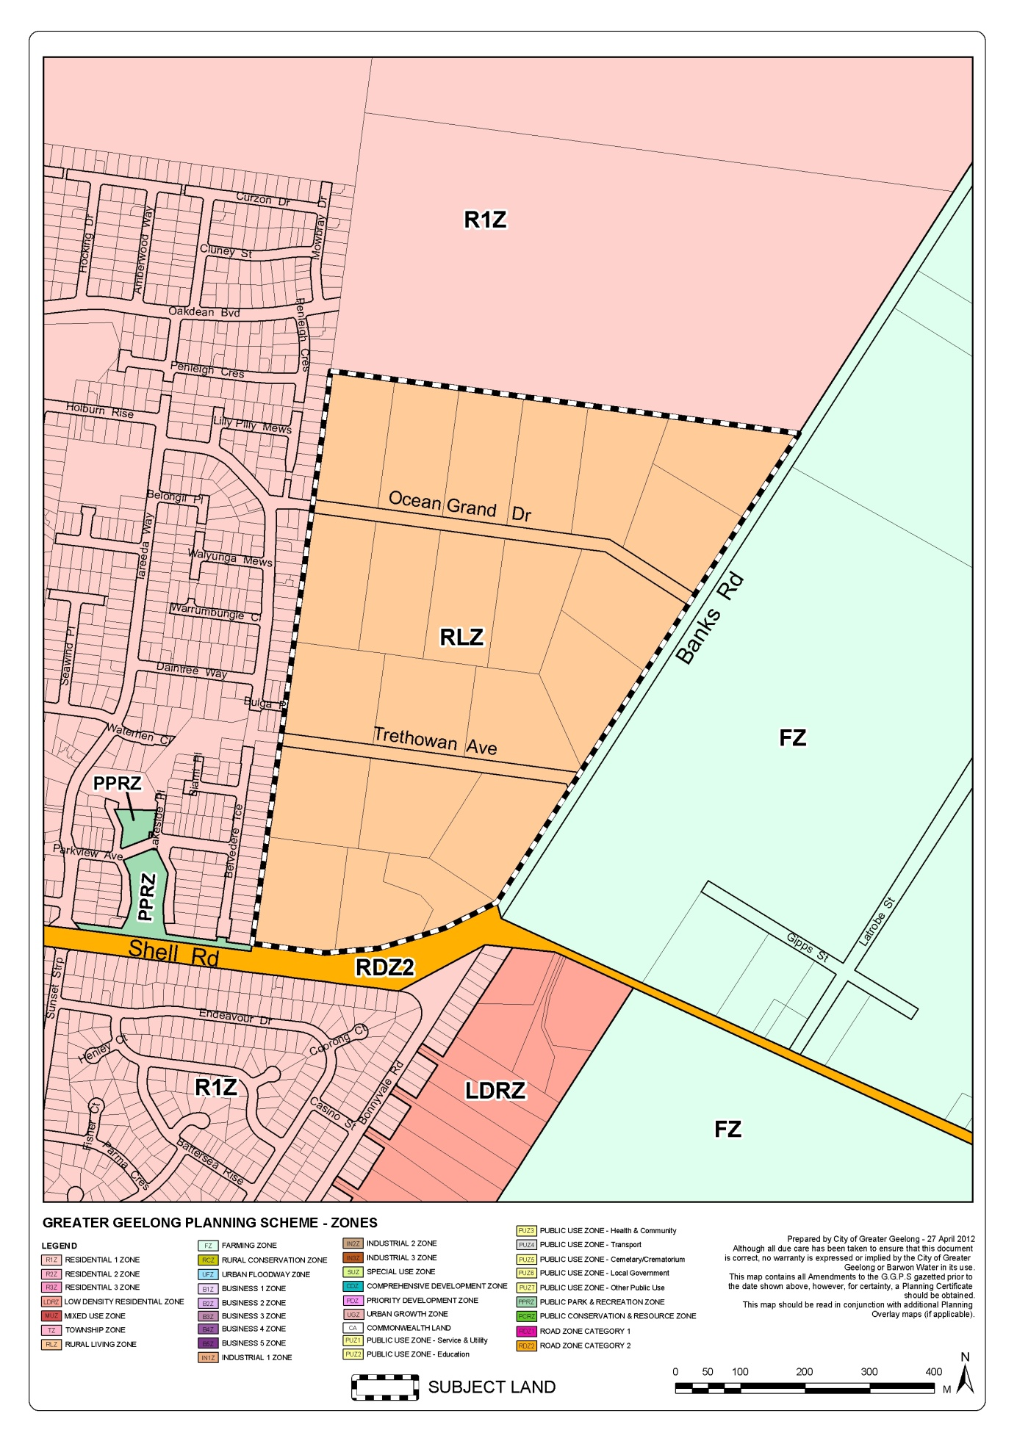
Appendix 2 – Aerial Photograph
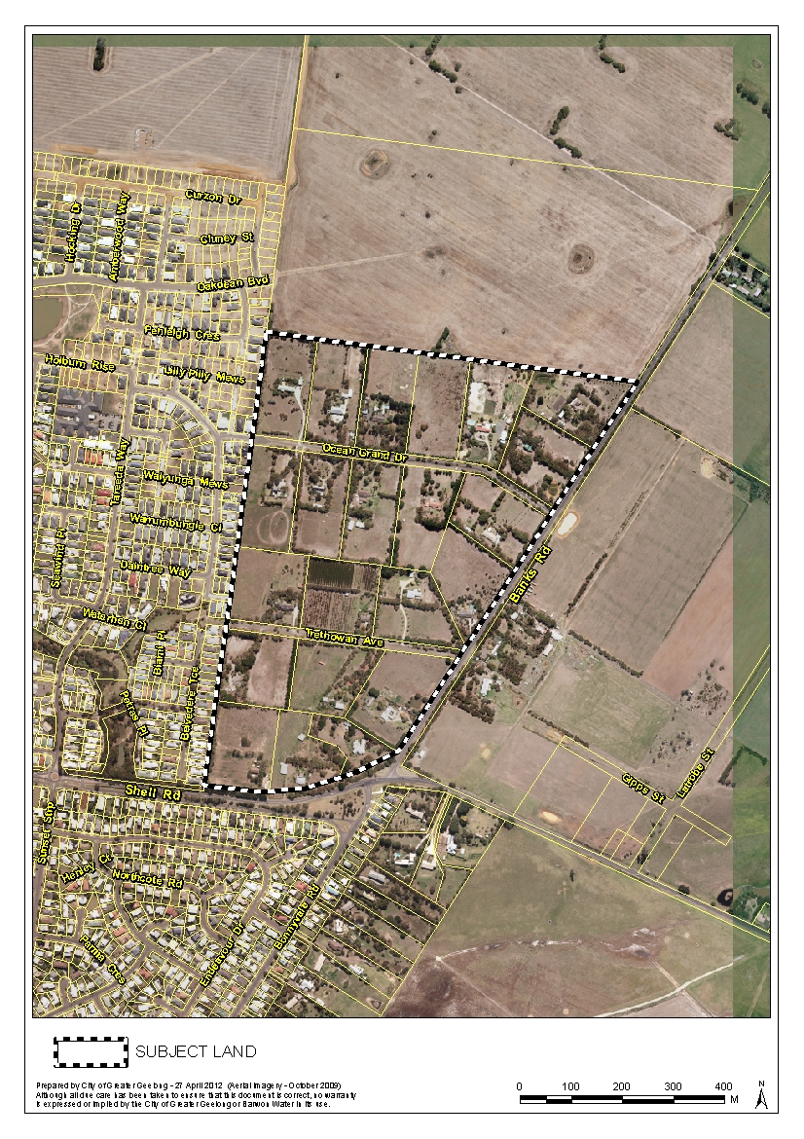
Appendix 3 – DPO Schedule
SCHEDULE 26 TO THE DEVELOPMENT PLAN OVERLAY
24/02/2011
C103

Shown on the planning scheme map as DPO26
TRETHOWAN AVENUE/OCEAN GRAND DRIVE OCEAN GROVE
This Schedule applies to the area generally north of Shell Road, west of Banks Road incorporating properties in Trethowan Avenue and Ocean Grand Drive, Ocean Grove.
The aim of this Schedule is to ensure that development occurs in accordance with broad development principles as shown in the Trethowan Avenue/Ocean Grand Drive Outline Development Plan 2012 and to ensure delivery of essential community infrastructure as set out in the North East Ocean Grove Infrastructure Plan. .
1.0 Requirement before a permit is granted
--/--/20
C203
A permit may be granted before a development plan has been prepared for the following:
- The construction of one dwelling and associated out buildings on any lot existing at the approval date provided it is the only dwelling on the lot.
- Any buildings and works associated with the use of the land for agriculture.
- Extensions or alterations to existing buildings and works.
2.0 Conditions and requirements for permits
--/--/20--
C203

A permit must contain conditions or requirements which give effect to the provisions and requirements of the approved North East Ocean Grove Infrastructure Plan and the approved Development Plan.
A permit for subdivision must contain a condition which requires the owner to enter into an agreement with the Responsible Authority pursuant to Section 173 of the Planning and Environment Act 1987 to provide development contributions for:
- Road and Drainage Works;
- Open Space Works;
- Community Infrastructure;
as outlined in the approved Development Plan and North East Ocean Grove Infrastructure Plan.
3.0 Requirements for development plan
--/--/20
C203
A separate Development Plan may be prepared and approved which addresses the relevant requirements for the western catchment only.
The Development Plan must be generally in accordance with Trethowan Avenue/Ocean Grand Drive Outline Development Plan, and include the following:
An Urban Design Masterplan that includes:-
- The location of all proposed land uses including roads, public open space and drainage reserves.
- Contours of land at 0.5m intervals.
- The general subdivision layout including location and distribution of lots showing a variety of lot sizes and densities to encourage a range of housing types and other compatible land uses.
- A subdivision design which provides a positive identity and contributes to the amenity and safety of Banks Road and Shell Road by ensuring all development addresses these road frontages (and does not back onto or provide screen fencing along these roads).
- A walking and cycling network which will:
- Provide a pedestrian and cycle access through the development from established residential areas to the west connecting to proposed walking and cycling tracks in future residential areas to the north.
- Within the development area, provide an interconnected and continuous network of safe, efficient and convenient footpaths, shared paths and cycle lanes.
- Provide a continuous pedestrian/cycle path along the Banks Road/Shell Road frontages of the site.
A Road Network and Traffic Management Plan complying with any VicRoads requirements that includes:-
- An internal road network that provides for a high level of access within the development for all vehicular and non vehicular traffic and which responds to the topography of the site.
- No new road access to Banks Road and the creation of no new lot access to Banks Road.
- Details of the Trethowan Avenue/Banks Road and Ocean Grand Drive/Banks Road upgraded intersection treatments.
- Proposed future road connections between the development area and residential areas to the north and west.
- A road layout and alignment, subject to detailed design, that is consistent with the engineering standards applied in the existing subdivisions in the area.
- Traffic Management controls for the internal road network.
- Removal of the temporary road barrier which prevents vehicular access through to Daintree Way.
A Stormwater Drainage Masterplan that takes an integrated approach to stormwater system management, is designed with reference to the whole of the catchment and includes:
- Reference to:
- WSUD Engineering Procedures: Stormwater, CSIRO Publishing, 2005;
- Clause 56.07 of the Greater Geelong Planning Scheme.
- City of Greater Geelong Stormwater Management Plan, 2002.
- A Drainage Feasibility Study which analyses the sub-catchment with appropriate hydrological and hydraulic modelling, to determine urban stormwater management strategies to the satisfaction of the Responsible Authority. Strategies shall be based on limiting flows and runoff volumes to the downstream drainage system, drainage lines, waterways and water bodies to ensure no adverse impact.
- A Water Sensitive Urban Design that:
- Demonstrates the methods of collection, treatment and disposal of stormwater run-off in an environmentally acceptable manner including as appropriate, provision of detention and water quality treatment.
- Utilises the MUSIC (Model for Stormwater Improvement Conceptualisation) program to measure the benefits and performance outcomes incorporated into the plan.
- Provides for the safe overflows paths for the 1% ARI and considers the impact of the >1% ARI event.
An Open Space and Landscape Masterplan that includes:
- An Open Space Contribution equal to 10% of the developable residential land or in-lieu cash payment or combination of both. Encumbered land shall not be credited as Public Open Space including land required for the future retarding basin.
- Details of all existing vegetation to be retained and those trees to be removed.
- Details of protection measures to be applied to all individuals species of indigenous Swamp Gum, Manna Gum and Drooping Sheoak.
- Details of plant species to be used to create distinctive precincts for public open space areas (including shared pathways) and road reserves including extensive use of local indigenous species within open space areas and where suitable, within nature strips as streets throughout the development.
- Landscaping treatments to provide an attractive entrance to Ocean Grove along the Shell Road and Banks Road frontages using local indigenous species which complements and enhances the existing indigenous vegetation.
- Plans for all open space areas showing the location of proposed improvements including playgrounds, pedestrian and cycle paths, earthworks, seats, bollards, fencing, landscaping, irrigation systems, drinking fountains, drainage lines and detention basins.
- Provision for the early construction of a park utilising the southern portion of the Trethowan Avenue retarding basin site and the existing road reserve, incorporating a children’s playground.
4.0 Decision Guidelines
--/--/20
C203

In considering whether or not to approve or amend a development plan, the responsible authority must consider:
- The requirements of this schedule.
- The State and Local Planning Policy Framework.
- The Trethowan Avenue/Ocean Grand Drive Outline Development Plan 2012 in Clause 5.0.
- The views of any relevant Government Department, Statutory or servicing authority.

5.0 Trethowan Avenue/Ocean Grand Drive Outline Development Plan

--/--/20
C203

