

TRETHOWAN AVENUE SHARED

INFRASTRUCTURE FUNDING PLAN

JUNE 2014


389 St Georges Road NORTH FITZROY VIC 3068 Phone (03) 9482 3888 | Fax (03) 9482 3933
www.urbanenterprise.com.au

Authors

Todd Denham Paul Shipp

Reviewed by Matt Ainsaar

© Copyright, Urban Enterprise Pty Ltd, August 2008.

This work is copyright. Apart from any use as permitted under Copyright Act 1963, no part may be reproduced without written permission of Urban Enterprise Pty Ltd.

Document Information

Filename: Trethowan Avenue Shared Infrastructure Funding Plan 20140618 FINAL.docx

Last Saved: 23 June 2014 5:36 PM Last Printed: 23 June 2014 5:45 PM File Size: 6413 kb
Disclaimer
Neither Urban Enterprise Pty. Ltd. nor any member or employee of Urban Enterprise Pty. Ltd. takes responsibility in any way whatsoever to any person or organisation (other than that for which this report has been prepared) in respect of the information set out in this report, including any errors or omissions therein. In the course of our preparation of this report, projections have been prepared on the basis of assumptions and methodology which have been described in the report. It is possible that some of the assumptions underlying the projections may change. Nevertheless, the professional judgement of the members and employees of Urban Enterprise Pty. Ltd. have been applied in making these assumptions, such that they constitute an understandable basis for estimates and projections. Beyond this, to the extent that the assumptions do not materialise, the estimates and projections of achievable results may vary.

SUMMARY OF CONTRIBUTIONS 4
- INTRODUCTION 5
  - BACKGROUND 5
  - PURPOSE 5
  - SUPPORTING DOCUMENTS 5
- STUDY AREA 2
  - LOCATION 2
  - PLANNING CONTEXT 3
  - LAND OWNERSHIP 3
  - INFRASTRUCTURE CHARGE AREAS 5
  - LAND BUDGET 6
- SHARED INFRASTRUCTURE 7
  - OVERVIEW 7
  - PUBLIC OPEN SPACE 7
  - LAND VALUATION 7
  - INFRASTRUCTURE ITEMS 7
- COST APPORTIONMENT AND LEVY CALCULATION 10
  - OVERVIEW 10
  - COST APPORTIONMENT 10
  - LEVY CALCULATION 10
  - STANDARDS OF PROVISION 13
- IMPLEMENTATION AND ADMINISTRATION 14
  - SECTION 173 AGREEMENT 14
  - INDEXATION 14
  - COLLECTION OF LEVIES 14
  - METHOD OF PROVISION 15
5.6. PLANNING COSTS (ITEM O_1) 17
APPENDIX A OUTLINE DEVELOPMENT PLAN 18
APPENDIX B TRETHOWAN AVE, OCEAN GROVE RESERVE LANDSCAPE CONCEPT PLANS 19
APPENDIX C DRAINAGE & SEWERAGE MAJOR INFRASTRUCTURE ASSESSMENT, NORTH-EAST OCEAN GROVE 20 APPENDIX D PROPOSED REZONING – BANKS ROAD, OCEAN GROVE - TRAFFIC ENGINEERING ADVICE 21
APPENDIX E LAND VALUATION REPORT 22

Table 1 shows a summary of contributions payable for subdivision within each Charge Area within the Trethowan Avenue Development Plan Area.

For details of infrastructure items to be funded under this plan and how the contributions were calculated, please refer to the relevant sections of this Shared Infrastructure Funding Plan.

TABLE 1 SUMMARY OF CONTRIBUTIONS

Charge Area | Net Developable Area (Ha) | Total Project Cost Apportioned to Charge Area | Development Infrastructure Levy (per Ha)
1 | 35.70 | $7,050,415 | $179,889
2 | 3.68 | $6,714,864 | $170,491

  - BACKGROUND

This Shared Infrastructure Funding Plan (SIFP) relates to land known as the Trethowan Avenue Development Plan Area (Development Plan Area) in north-east Ocean Grove. A detailed description of the Development Plan Area and surrounding land uses is provided in Section 2.

The SIFP identifies key infrastructure to be provided to support subdivision of the Development Plan Area. The SIFP will form the basis for agreements between the City of Greater Geelong (Council) and all landowners in the Development Plan Area under section 173 of the Planning and Environment Act (s173 Agreements) which formalise infrastructure delivery and development contributions arrangements.

The SIFP has been developed based on technical reports prepared for the Development Plan Area, and concepts and principles for infrastructure delivery and development contributions as discussed, workshopped and agreed with Council.

  - PURPOSE

The SIFP has been prepared to guide the delivery of shared infrastructure in the Development Plan Area by:

    - Identifying the land parcels which are to be developed and quantifying the area and likely development yield of each parcel;

    - Identifying shared infrastructure required to support development;

    - Identifying the specifications, costs and justification for each item;

    - Apportioning costs to each catchment area in the Development Plan Area, and calculating levies payable to ensure delivery of shared infrastructure;

    - Identifying any additional infrastructure items that are to be provided by specific landowners;

    - Describing the mechanisms by which the SIFP will be implemented, including collection of levies, delivery of infrastructure, responsibilities for works in-kind and administration of the document (such as indexation); and

    - Provide clear principles regarding obligation of developers to deliver and/or facilitate works.

The SIFP will be used to inform a Section 173 Agreement which will formalise arrangements for infrastructure delivery between Council and each land owner in the Study Area.

  - SUPPORTING DOCUMENTS

The following supporting documents were prepared to support the proposed rezoning and subdivision of the Development Plan Area and have been used to inform the preparation of the SIFP:

    - Draft Development Plan (see Appendix A);

    - Trethowan Avenue Ocean Grove Reserve Landscape Concept Plans (see Appendix B);

    - Drainage & Sewerage Major Infrastructure Assessment, North-East Ocean Grove (see Appendix C);

    - Proposed Rezoning – Banks Road, Ocean Grove - Traffic Engineering Advice (see Appendix D);

    - Valuation Report, 802-820 Banks Road, 22-30 and 27-39 Trethowan Avenue Ocean Grove, Westlink Consulting (see Appendix E).

STUDY AREA

  - LOCATION

The Development Plan Area is located at the north-eastern edge of the township of Ocean Grove, Victoria as shown in Figure 1.

The Development Plan Area is bounded by Shell Road to the south, Banks Road to the east, existing residential development (known as the Parks Estate) to the west and part of the Ocean Grove Growth Area (future residential development known as Kingston Downs) to the north as shown in Figure 1.

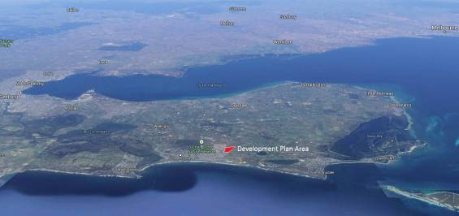FIGURE 1 DEVELOPMENT AREA LOCATION

Melbourne

Geelong

Ocean Grove

Kingston Downs (Ocean Grove Growth Area)

The Parks

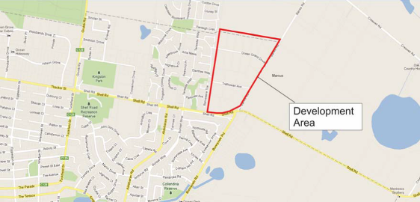Source: Google Maps, annotated by Urban Enterprise.

  - PLANNING CONTEXT

The Development Plan Area is currently within the Rural Living Zone (RLZ). It is proposed that the land is rezoned to Residential 1 Zone to facilitate subdivision and development.

Land immediately to the north of the Development Plan Area is within the designated Ocean Grove Growth Area. This land is in the Residential 1 Zone and is subject to Development Plan Overlay Schedule 22 (DPO 22).

Land to the west and south of the Development Plan Area is also within the Residential 1 Zone and is fully developed. Land to the east across Banks Road is within the Farming Zone.

FIGURE 2 PLANNING ZONES

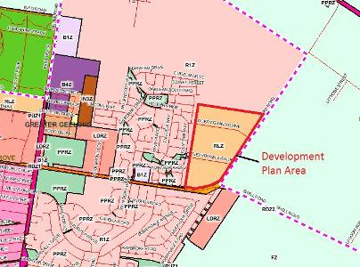

Source: Planning Maps Online, annotated by Urban Enterprise.

  - LAND OWNERSHIP

The study area comprises 22 parcels of land in private ownership ranging in area from 1ha to 2.4 ha. The total area of parcels within the study area is approximately 43.6 hectares.

Table 2 shows the address and plan number of each property within the study area and Figure 3 shows the location of each property.

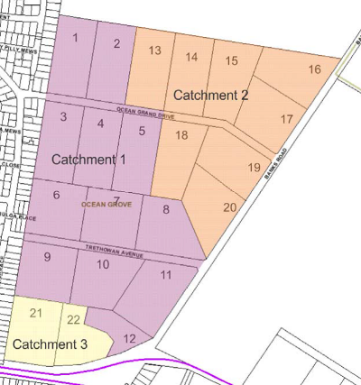FIGURE 3 LOT MAP, NUMBERS AND DETAILS

TRETHOWAN AVENUE SHARED INFRASTRUCTURE FUNDING PLAN
SHARED INFRASTRUCTURE FUNDING PLAN
TABLE 2 LOT DETAILS

 | Lot Reference  # | Address | Lot and Plan No. | Drainage Catchment
 | 1 | 60 Ocean Grand Drive | L1 LP93928 | 1
 | 2 | 50 Ocean Grand Drive | L2 LP93928 | 1
 | 3 | 55 Ocean Grand Drive | L8 LP93928 | 1
 | 4 | 45 Ocean Grand Drive | L9 LP93928 | 1
 | 5 | 35 Ocean Grand Drive | L10 LP93928 | 1
 | 6 | 30 Trethowan Avenue | L16 LP93928 | 1
 | 7 | 20 Trethowan Avenue | L15 LP93928 | 1
 | 8 | 10 Trethowan Avenue | L14 LP93928 | 1
 | 9 | 35 Trethowan Avenue | L17 LP93928 | 1
 | 10 | 15 Trethowan Avenue | L18 LP93928 | 1
 | 11 | 880 Banks Road | L19 LP93054 | 1
 | 12 | 197 Shell Road | L2 PS413830 | 1
 | 13 | 40 Ocean Grand Drive | L3 LP93928 | 2
 | 14 | 30 Ocean Grand Drive | L4 LP93928 | 2
 | 15 | 20 Ocean Grand Drive | L5 LP93928 | 2
 | 16 | 820 Banks Rd | L6 LP93928 | 2
 | 17 | 830 Banks Rd | L7 LP93054 | 2
 | 18 | 25 Ocean Grand Drive | L11 LP93928 | 2
 | 19 | 840 Banks Road | L12 LP93054 | 2
 | 20 | 860 Banks Road | L13 LP93054 | 2
 | 21 | 185 Shell Road | L1 PS41830 | 3
 | 22 | 195 Shell Road | L21 LP93054 | 3

4 URBAN ENTERPRISE PTY LTD
JUNE 2014

  - INFRASTRUCTURE CHARGE AREAS

For the purposes of cost apportionment, the Development Plan Area has been divided into 2 charge areas as follows:

    - Charge Area 1: includes land which is within the northern and southern drainage catchments and require access via new intersections to be constructed on Banks Road;

    - Charge Area 2: includes land which is within the southern drainage catchment but does not require access via Banks Road.

These Charge Areas were defined with regard to the Drainage & Sewerage Major Infrastructure Assessment (Attachment 4) and access requirements from Banks Road.

The infrastructure usage nexus is outlined in Table 3. Charge Area boundaries are shown in Figure 4.

TABLE 3 INFRASTRUCTURE USAGE NEXUS

Charge area | Drainage | Intersections | Open Space | Community Facilities | Planning
1 | Yes (Catchment 1 & 2) | Yes | Yes | Yes | Yes
2 | Yes (Catchment 3) | No | Yes | Yes | Yes

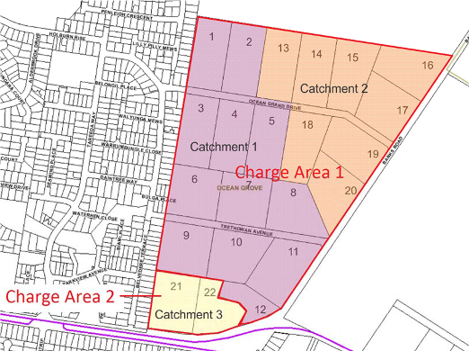FIGURE 4 CHARGE AREAS

  - LAND BUDGET

Table 4 provides a summary of the land budget of the Development Plan Area by Charge Area. Net Developable Area (NDA) is calculated by deducting land required for drainage and public open space purposes from the overall lot area.

TABLE 4 LAND BUDGET

Charge Area | Total Area | Land to be acquired for drainage | Gross Developable Area | Public Open Space | Net Developable Area
Charge Area 1 | 39.940 | 0.743 | 39.197 | 3.494 | 35.703
Charge Area 2 | 3.683 | 0.000 | 3.683 | 0.000 | 3.683
Total | 43.623 | 0.743 | 42.880 | 3.494 | 39.386

Note: all areas are shown in hectares.

SHARED INFRASTRUCTURE

  - OVERVIEW

Based on the various technical reports prepared and discussions with Council officers, a range of shared infrastructure items have been identified which are required to support development of the Development Plan Area.

A number of the infrastructure items to be funded through this SIFP are included as ‘shared’ infrastructure due to the highly fragmented land ownership pattern and the likely need for Council to collect funds, accrue sufficient funds from multiple smaller subdivisions to deliver items such as open space reserves.

Shared infrastructure identified generally falls within the following categories:

    - Road intersections;

    - Open Space land and improvements;

    - Drainage works and land; and

    - Community facility and planning contributions.

  - PUBLIC OPEN SPACE

A public open space contribution is to be made equivalent to 10% of the developable area to meet the requirements of Clause 52.01 of the Planning Scheme. It is proposed that this requirement will be satisfied through a combination of land and cash in-lieu.

The land budget shows that 3.643 ha of public open space will be provided within the Development Plan Area, which equates to 8.5% of the developable area. The remaining 1.5% contribution (equivalent to 0.645ha of land) will be satisfied through a cash contribution. This cash contribution is included as an infrastructure item (OS_3) in Table 5.

  - LAND VALUATION

Land to be acquired for infrastructure in this SIFP has been independently valued by Westlink Consulting (see Appendix F for details). Land was valued using the before and after approach, having regard to the specific location of infrastructure items of land to be acquired and the circumstances of the affected lots.

The ‘before’ value of $1m per hectare shown in the valuation report has been adopted for the purposes of calculating the value of item OS_3 (cash in-lieu of public open space).

  - INFRASTRUCTURE ITEMS

Table 5 provides details of each infrastructure to be funded by this SIFP. Additional details of these projects are included in the relevant attachments.

The location of each item is shown in Figure 5.

TABLE 5 SHARED INFRASTRUCTURE ITEMS

Item No. | Item | Description | Cost | Trigger for Provision | Costing source
Roads and Intersections
RD_1 | Road Construction  - POS 1 (Catchment 1) | Road construction around POS Reserve 1 (half of total construction cost only) | $323,047 | Road provision to occur upon subdivision of Lot | Peter Berry & Associates Civil Engineers (2011), indexed to Jun 2013.
RD_2 | Road Construction  - POS 2 (Catchment 2) | Road construction around POS Reserve 2 (half total construction cost only) | $182,133 | Road provision to occur upon subdivision of Lot | Peter Berry & Associates Civil Engineers (2011), indexed to Jun 2013
RD_3 | Road Intersection- Banks Road and Ocean Grand Drive | Design and upgrade the ‘T’ intersection of Banks Road and Ocean Grand Drive to include a short linemarked right turn lane. Includes design, project and traffic management, possible service relocation and contingency. | $167,775 | After the first 12 ha of land (NDA) in the catchment is subdivided. | VicRoads/O'Brien Traffic dated 6/9/2010, indexed to Jun 2013.
RD_4 | Road Intersection- Banks Road and Trethowan Avenue | Design and upgrade the ‘T’ intersection of Banks Road and Trethowan Avenue to include a short linemarked right turn lane. Includes design, project and traffic management, possible service relocation and contingency. | $167,775 | After the first 10 ha of land (NDA) in the catchment is subdivided. | VicRoads/O'Brien Traffic dated 6/9/2010., indexed to Jun 2013.
Open Space - Land, Cash in-lieu of land, and Improvements
LA_1 | Land for Public Open Space Reserve 1 | Land acquisition for POS Reserve 1 (Catchment 1), including Lot 6 (0.583ha) and Lot 9 (1.133ha). | $1,430,794 | Provision to be guaranteed to the satisfaction of Council prior to subdivision | Westlink Valuation Report (2013)
OS_1a | Landscaping - POS Reserve 1 | Landscaping works to public open space reserve 1 and around Bio-Retention Basin 1. | $255,258 | Landscaping to occur upon subdivision of Lot | Mexted Rimmer dated 8/6/11
OS_1b | Playground - | Construction of local playground in POS Reserve 1 (Catchment 1), minimum size 0.5 ha. | $48,995 | To be determined by Open Spac e and Landscape Masterplan. | Mexted Rimmer dated 8/6/11
LA_2 | Land for Public Open Space Reserve 2 | Land acquisition for POS Reserve 2 (Catchment 2), Lot 16 (1.778ha). | $1,689,100 | Provision to be guaranteed to the satisfaction of Council prior to subdivision | Westlink Valuation report (2013)
OS_2a | Landscaping - POS Reserve 2 | Landscaping works to public open space reserve 2 and around Bio-Retention Basin 2. | $253,785 | Landscaping to occur upon subdivision of Lot | Mexted Rimmer dated 8/6/11
OS_2b | Playground - | Construction of local playground in POS Reserve 2 (Catchment 2), minimum size 0.5 ha. | $48,995 | To be determined by Open Spac e and Landscape Masterplan. | Mexted Rimmer dated 8/6/11
OS_3 | Cash in-lieu of public open space shortfall | Cash in-lieu of public open space shortfall, equivalent to 0.404ha of land. | $404,104 | To be paid as part of the overall development contribution prior to Statement of Compliance. | Westlink Valuation Report (2013). Quantum based on 10% public open space requirement of Clause 52.01.
Drainage - Land and Construction
LA_3 | Land for Bio- Retention Basin 1 | Land required for Bio- Retention Basin 1 - Lot 6 (0.472ha). | $385,206 | Required for the first subdivision of the catchment | Land Area: Peter Berry  & Associates Civil Engineers.

Item No. | Item | Description | Cost | Trigger for Provision | Costing source
DR_1 | Bio-Retention Basin 1 | Construction of a Bio- Retention Basin to 1:100 flood levels. (0.310 ha) | $515,512 | Required for the first subdivision of the catchment | Peter Berry & Associates Civil Engineers.
LA_4 | Land for Bio- Retention Basin 2 | Land acquisition for Bio- Retention Basin 2 - Lot 16 (0.271ha). | $257,450 | Required for the first subdivision of the catchment | Land Area: Peter Berry  & Associates Civil Engineers. Includes drainage reserves.
DR_2 | Bio-Retention Basin 2 | Construction of a Bio- Retention Basin to 1:100 flood levels. | $305,686 | Required for the first subdivision of the catchment | Peter Berry & Associates Civil Engineers.
Community Infrastructure and Planning Costs
C_1 | Community Infrastructure Levy | Community Infrastructure Levy payable for all dwellings | $424,800 | Payable upon subdivision approval. | Based on $900 per dwelling, 472 dwellings total. (July $2012)
P_1 | Planning costs | Planning costs associated with rezoning. | $190,000 | Payable at subdivision. Credits for previous payments will be applied. | NEOG Subdivision Group Spreadshe et of Costs
 | Total |  | $7,050,415

FIGURE 5 LOCATION OF INFRASTRUCTURE ITEMS

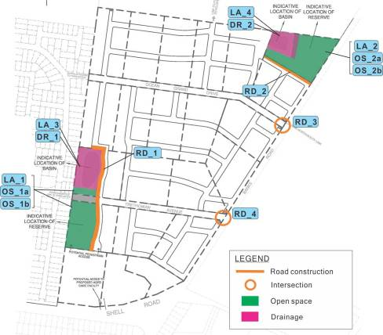

COST APPORTIONMENT AND LEVY

CALCULATION

  - OVERVIEW

This section provides details on how the cost of infrastructure items have been apportioned across the various catchments and lots, and how the overall development contributions levies have been calculated.

  - COST APPORTIONMENT

As introduced in Section 2.4, charge areas have been established to align with the usage of infrastructure to be funded by this plan. Charge Areas were defined with regard to the Drainage & Sewerage Major Infrastructure Assessment (Appendix 4) and access requirements from Banks Road.

All charge areas are required to contribute equally to the open space, community and planning items.

The cost of each infrastructure item has been apportioned to both Charge Areas on the basis of Net Developable Area with the exception of the Banks Road intersections, which are apportioned to Charge Area 1 only (development of land in Charge Area 2 will not require access from Banks Road).

  - LEVY CALCULATION

The cost of each infrastructure items has been converted into a development contributions levy by dividing the total item cost by the number of demand units (hectares of Net Developable Area) in the Charge Areas to which the cost of the item is apportioned.

All costs are shown in July 2013 values.

Table 6 shows the calculation of levies for each infrastructure item. Table 7 shows the development contributions payable per lot.

TABLE 6 COST APPORTIONMENT AND LEVY CALCULATION

Item ID | Item | Contributing charge areas | Demand Units (NDA ha) | Item Cost | Levy per demand unit (NDA ha) | Levy per hectare of NDA |  | Index
 |  |  |  |  |  | Charge Area 1 | Charge Area 2 | Index
RD_1 | Road Construction - POS 1 (Catchment 1) | All | 39.386 | $323,047 | $8,202.17 | $8,202.17 | $8,202.17 | Road and Bridge
RD_2 | Road Construction - POS 2 (Catchment 2) | All | 39.386 | $182,133 | $4,624.37 | $4,624.37 | $4,624.37 | Road and Bridge
RD_3 | Road Intersection-Banks Road and Ocean Grand Drive | 1 | 35.703 | $167,775 | $4,699.26 | $4,699.26 | $0.00 | Road and Bridge
RD_4 | Road Intersection-Banks Road and Trethowan Avenue | 1 | 35.703 | $167,775 | $4,699.26 | $4,699.26 | $0.00 | Road and Bridge
LA_1 | Land for Public Open Space Reserve 1 (Catchment 1) | All | 39.386 | $1,430,794 | $36,327.91 | $36,327.91 | $36,327.91 | Annual revaluation
OS_1a | Landscaping - POS Reserve 1 (catchment 1) | All | 39.386 | $255,258 | $6,481.01 | $6,481.01 | $6,481.01 | Road and Bridge
OS_1b | Playground - Catchment 1 | All | 39.386 | $48,995 | $1,243.98 | $1,243.98 | $1,243.98 | Road and Bridge
LA_2 | Land for Public Open Space Reserve 2 (Catchment 2) | All | 39.386 | $1,689,100 | $42,886.30 | $42,886.30 | $42,886.30 | Annual revaluation
OS_2a | Landscaping - POS Reserve 2 (catchment 2) | All | 39.386 | $253,785 | $6,443.61 | $6,443.61 | $6,443.61 | Road and Bridge
OS_2b | Playground - Catchment 2 | All | 39.386 | $48,995 | $1,243.98 | $1,243.98 | $1,243.98 | Road and Bridge
OS_3 | Cash in-lieu of public open space shortfall | All | 39.386 | $404,104 | $10,260.20 | $10,260.20 | $10,260.20 | Annual revaluation
LA_3 | Land for Bio-Retention Basin 1 | All | 39.386 | $385,206 | $9,780.38 | $9,780.38 | $9,780.38 | Annual revaluation
DR_1 | Bio-Retention Basin 1 | All | 39.386 | $515,512 | $13,088.86 | $13,088.86 | $13,088.86 | Road and Bridge
LA_4 | Land for Bio-Retention Basin 2 | All | 39.386 | $257,450 | $6,536.66 | $6,536.66 | $6,536.66 | Annual revaluation
DR_2 | Bio-Retention Basin 2 | All | 39.386 | $305,686 | $7,761.37 | $7,761.37 | $7,761.37 | Road and Bridge
C_1 | Community Infrastructure Levy | All | 39.386 | $424,800 | $10,785.68 | $10,785.68 | $10,785.68 | Building Construction
P_1 | Planning costs | All | 39.386 | $190,000 | $4,824.11 | $4,824.11 | $4,824.11 | Building Construction
Total |  |  |  | $7,050,415 |  | $179,889.11 | $170,490.59

TABLE 7 CONTRIBUTION PER LOT

Charge Area | Lot ID | Address | Parcel Area | Land for drainage | GDA | Public Open Space | NDA | Levy per ha NDA | Contribution
1 | 1 | 60 Ocean Grand Drive | 2.024 | 0.000 | 2.024 | 0.000 | 2.024 | $179,889.11 | $364,095.55
1 | 2 | 50 Ocean Grand Drive | 2.024 | 0.000 | 2.024 | 0.000 | 2.024 | $179,889.11 | $364,095.55
1 | 3 | 55 Ocean Grand Drive | 2.018 | 0.000 | 2.018 | 0.000 | 2.018 | $179,889.11 | $363,016.22
1 | 4 | 45 Ocean Grand Drive | 2.024 | 0.000 | 2.024 | 0.000 | 2.024 | $179,889.11 | $364,095.55
1 | 5 | 35 Ocean Grand Drive | 2.024 | 0.000 | 2.024 | 0.000 | 2.024 | $179,889.11 | $364,095.55
1 | 6 | 30 Trethowan Avenue | 2.026 | 0.472 | 1.554 | 0.583 | 0.971 | $179,889.11 | $174,602.17
1 | 7 | 20 Trethowan Avenue | 2.024 | 0.000 | 2.024 | 0.000 | 2.024 | $179,889.11 | $364,095.55
1 | 8 | 10 Trethowan Avenue | 2.024 | 0.000 | 2.024 | 0.000 | 2.024 | $179,889.11 | $364,095.55
1 | 9 | 35 Trethowan Avenue | 2.024 | 0.000 | 2.024 | 1.133 | 0.891 | $179,889.11 | $160,268.60
1 | 10 | 15 Trethowan Avenue | 2.024 | 0.000 | 2.024 | 0.000 | 2.024 | $179,889.11 | $364,095.55
1 | 11 | 880 Banks Road | 2.354 | 0.000 | 2.354 | 0.000 | 2.354 | $179,889.11 | $423,458.96
1 | 12 | 197 Shell Road | 1.000 | 0.000 | 1.000 | 0.000 | 1.000 | $179,889.11 | $179,889.11
1 | 13 | 40 Ocean Grand Drive | 2.024 | 0.000 | 2.024 | 0.000 | 2.024 | $179,889.11 | $364,095.55
1 | 14 | 30 Ocean Grand Drive | 2.024 | 0.000 | 2.024 | 0.000 | 2.024 | $179,889.11 | $364,095.55
1 | 15 | 20 Ocean Grand Drive | 2.135 | 0.000 | 2.135 | 0.000 | 2.135 | $179,889.11 | $384,063.24
1 | 16 | 820 Banks Rd | 2.049 | 0.271 | 1.778 | 1.778 | 0.000 | $179,889.11 | $0.00
1 | 17 | 830 Banks Rd | 2.043 | 0.000 | 2.043 | 0.000 | 2.043 | $179,889.11 | $367,513.44
1 | 18 | 25 Ocean Grand Drive | 2.024 | 0.000 | 2.024 | 0.000 | 2.024 | $179,889.11 | $364,095.55
1 | 19 | 840 Banks Road | 2.024 | 0.000 | 2.024 | 0.000 | 2.024 | $179,889.11 | $364,095.55
1 | 20 | 860 Banks Road | 2.027 | 0.000 | 2.027 | 0.000 | 2.027 | $179,889.11 | $364,635.22
2 | 21 | 185 Shell Road | 2.116 | 0.000 | 2.116 | 0.000 | 2.116 | $170,490.59 | $360,758.10
2 | 22 | 195 Shell Road | 1.567 | 0.000 | 1.567 | 0.000 | 1.567 | $170,490.59 | $267,158.76
TOTAL |  |  | 43.623 | 0.743 | 42.880 | 3.494 | 39.386 |  | $7,050,414.87

  - STANDARDS OF PROVISION

The following standards of provision are required for local infrastructure. This section specifically identifies the standards of provision that have been agreed where relevant with Council, and will be supported by the Final Approved Ash Road Development Plan.

    - Public open space reserves are to be improved to the standards and inclusions specified in Appendix C. These improvement items have been agreed with Council.

    - The standard of the upgrade to the intersections of Banks Road and Ocean Grand Drive and Banks Road and Trethowan Avenue is specified in Appendix D;

    - Internal roads to be constructed in accordance with clause 56 of the Planning Scheme;

    - Construction of drainage basins and stormwater management will be provided in accordance with the Peter Berry report included in Appendix C This includes construction of:

      - A drainage basin in the western section of the study area (Catchment 1) with a detention volume of 5,974 m3; and

      - A drainage basin in the northern section of the study area (Catchment 2) with a detention volume of 2,920m3.

TRETHOWAN AVENUE SHARED INFRASTRUCTURE FUNDING PLAN
SHARED INFRASTRUCTURE FUNDING PLAN
13 URBAN ENTERPRISE PTY LTD
JUNE 2014

IMPLEMENTATION AND ADMINISTRATION

  - SECTION 173 AGREEMENT

This SIFP will be implemented through s173 agreements with each landowner in the Development Plan Area. Each agreement will be based on a model agreement prepared by Council, and describe the implementation principles of this plan, while also including details regarding levies payable for the relevant lot, the infrastructure items to be funded, and the administrative and legal provisions contained within the SIFP and delivery of infrastructure over time.

  - INDEXATION

Land values and construction costs listed are in July 2013 dollars. They will be indexed annually according to the following method.

All levies and costs must be adjusted as follows:

    - In relation to the costs associated with all infrastructure items other than land, the cost must be adjusted and the contribution amounts recalculated according to the following method:

      - The capital costs of each infrastructure item must be adjusted by reference to the Producer Price Indexes Australia, Victoria (Table 17 Output of the Construction industries, subdivision and class index numbers - Road and Bridge Construction
Victoria (for roads, bridges, trails, drainage and open space items) and Building Construction Victoria (for buildings, Community Infrastructure Levy and Planning Costs) published by the ABS (Series 6427.0) or similar index

      - The revised infrastructure costs and the adjustment of the contributions must be calculated as at 1 July in each year.

    - In relation to the cost of land to be acquired (or calculation of cash in-lieu), the agreed land value must be adjusted by adopting a revised land value for each parcel to be acquired based on the same valuation principles.

      - The revised land value and the adjustment of the contributions must be calculated as of 1 July in each year.

All Development Contribution Levies will be published on Council’s website within 14 days of 1st July each year.

  - COLLECTION OF LEVIES

Levies will be collected by the City of Greater Geelong as follows:

    - For the subdivision of land, not more than 21 days prior to the issue of a Statement of Compliance under the Subdivision Act 1988 in respect of the subdivision creating any new lot;

    - In relation to the development of commercial land (or residential land not requiring subdivision), a planning permit condition must require the payment of the development contribution prior to the commencement of works unless there is an agreement with the

Responsible Authority to secure the payment of the development contribution by some other means or other timeframe.

A statement of compliance must not be issued until the development infrastructure levy is paid (or equivalent works are provided in-kind).

Funds collected will be held in a specific council reserve account in accordance with the provisions of the Planning and Environment Act (1987). All monies held in this account will be used solely for the provision of infrastructure as itemised in this SIFP.

Council will be responsible for ongoing accounting and indexation of this SIFP.

  - METHOD OF PROVISION

Responsibility for the delivery of infrastructure works as described primarily resides with the developers of the land. as a works in-kind project with a credit provided against their development contribution, subject to the agreement of the Council.

It is the developer’s responsibility to facilitate the delivery of all Infrastructure Projects required to service the development of the subject land. In exceptional circumstances, and provided the Developer has demonstrated to Councils satisfaction that it has made all reasonable endeavours to facilitate delivery of the Infrastructure Projects based on the below criteria:

- Council will only facilitate an Infrastructure Project at a time when Council determines there are sufficient funds in Councils infrastructure contributions account, collected under the Trethowan Avenue Final Shared Infrastructure Funding Plan, to meet the cost of delivering the Infrastructure Project(s); and Councils delivery of any infrastructure Project will be subject to:

  - Councils normal budgetary cycles; and

  - Normal legislative processes and timeframes for any acquisition of land required to facilitate the Infrastructure Project.

Council may enter into Section 173 Agreements, confirming specific credit and project timing with landowners to formalise details of infrastructure items to be provided in-kind. All infrastructure items can be provided in-kind under this agreement, excluding items OS_3 Cash in-lieu of public open space shortfall and C_1 Community Infrastructure Levy.

In determining whether to agree to the provision of works in lieu of cash the Responsible Authority will have regard to the following:

    - Only works or land identified in the SIFP can be provided in lieu of cash;

    - Detailed design must be approved by the Responsible Authority and generally accord with the standards outlined unless agreed by the Responsible Authority and the developer; and

    - The construction of works must be completed to the satisfaction of the Responsible Authority.

Where the Responsible Authority agrees that works are to be provided by a developer in lieu of cash contributions:

    - The credit for the works provided shall equal the value identified in the SIFP taking into account the impact of indexation;

    - The value of works provided in accordance with the principles outlined above, will be offset against the development contributions liable to be paid by the developer;

    - The developer will not be required to make cash payments for contributions until the value of any credits for the provision of agreed works-in-kind are exhausted;

    - Where credit for works-in-kind can’t be offset against future levy payments, the developer shall be reimbursed by the Responsible Authority for any excess credit at the conclusion of the development of the subject land;

    - Where a developer chooses to bring forward works ahead of the scheduled time in the SIFP, this can be done provided the impact on the SIFP is cost and revenue neutral;

    - Where a developer is in credit against their development contributions liability, this credit will be indexed annually in accordance with the annual increase in the Development Contributions Levy.

LAND
The provision of land identified in this SIFP is suitable as works in-kind to off-set against a developer’s development contribution. As with works-in-kind, the provision of land would be outlined in an agreement between the developer and the Responsible Authority pursuant to Section 173 of the Planning and Environment Act (1987). The value of the off-set for providing land will equal the value shown in the SIFP, subject to indexation.

5.6. PLANNING COSTS (ITEM O_1)

Where a land owner has made a financial contribution towards the planning cost item (P_1) they will be ‘credited’ (subject to indexation) the equivalent percentage of the final cost at the time of subdivision. See Table 8 for a list of the land owners and their contribution.

TABLE 8 CONTRIBUTIONS TO PLANNING COSTS

Lot# Total Contribution made to item
1 | $10,100
2 | $10,475
3 | $10,100
4 | $1,450
5 | $0
6 | $7,150
7 | $2,000
8 | $42,934
9 | $1,950
10 | $10,100
11 | $2,950
12 | $100
13 | $3,350
14 | $10,100
15 | $10,100
16 | $10,100
17 | $7,600
18 | $0
19 | $0
20 | $0
21 | $6,950
22 | $4,450
Total Contributions made | $151,959
Additional Fees projected (incl. consultant fees, Council Panel Hearing costs, Consultant Panel Hearing costs, Council fees and Contingency) | $38,000
Total + Additional Cost | $189,959

APPENDIX A OUTLINE DEVELOPMENT PLAN

TRETHOWAN AVENUE DEVELOPMENT PLAN AREA
SHARED INFRASTRUCTURE FUNDING PLAN
- URBAN ENTERPRISE PTY LTD
APRIL 2014

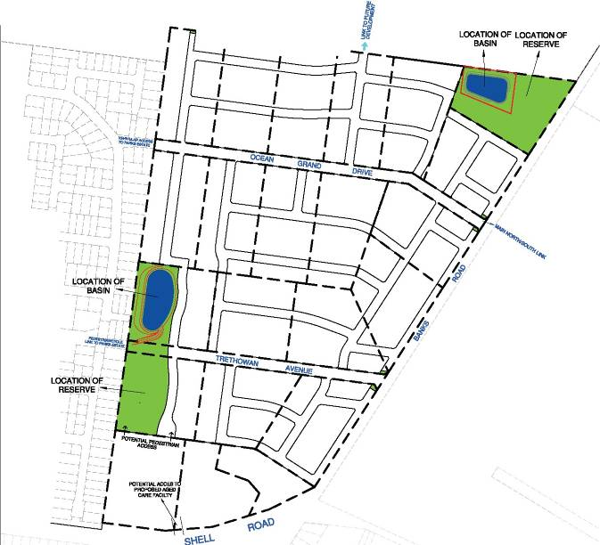
--- -r ..... --- -r - --r
!ils::_9 IN
51 UTTI.E FYANS STREIT,
P.O. BOX 919, GEELONG 3220
TELEPHONE (03) 5201 1811 FAX (03) 5229 2909
This plan has been prepared to support a Town Planning Application to subdivide land and should not be used for any other purpose. It is subject to Approval by Council and may be amended without notice.  This note is an integral part of this plan. | DEVELOPMENT PLAN N-E OCEAN GROVE OCEAN GROVE | SCALE LEVEL DATUM  1:4000
 | DEVELOPMENT PLAN N-E OCEAN GROVE OCEAN GROVE | TITLE REF.  VOL FOL
 | DEVELOPMENT PLAN N-E OCEAN GROVE OCEAN GROVE | PLAN DRAWN SURVEY REF. VER.  26/02114 9467 11

A3

APPENDIX B TRETHOWAN AVE, OCEAN GROVE RESERVE LANDSCAPE CONCEPT PLANS

TRETHOWAN AVENUE DEVELOPMENT PLAN AREA
SHARED INFRASTRUCTURE FUNDING PLAN
- URBAN ENTERPRISE PTY LTD
APRIL 2014

North Reserve
Refer L1

Basin : 0.271Ha

Public Open Space 1.779 Ha

Drainage Reserve

West Reserve
1 in 100 yr. F.L

lic Open Space
0.583 Ha
lic Open Space
0.149 Ha

Public Open Space
1.133 Ha

basin 1 Basin : 0.472 Ha

Key Plan
Public Open
Space
0.583 Ha

Legend

Reserve Trees:

Street trees.

Acacia implexa (Lightwood)

Allocasuarina verticillata (Drooping Sheoak)

Allocasuarina littoralis (Black Sheoak)

Banksia marginata (Silver Banksia)

Eucalyptus leucoxylon ssp. bellarinensis (Bellarine Yellow Gum)

Eucalyptus ovata (Swamp Gum)

Eucalyptus viminalis (Manna Gum)

Groundcover planting at path junctions.
- Dianella brevicaulis (Coast Flax Lily)

Drinking fountain.

Public Open
Space
0.149 Ha

stage 1 landscaping
-total area:
12040.4m2

stage 2 landscaping
-total area:
11330.7m2

Public Open Space
1.133 Ha

Multi-age Playground (Approx. 150m²) with swing, rocker/spinner & climbing combination

Existing trees (approx. locations) to be retained where possible. Subject to arboricultural assessment.
Existing trees to be removed. (approx. locations)

Grassed area (Kikuyu sprigs with Rye
Pu Grass hydroseed oversown).

2.5m wide compacted gravel path (150mm crushed rock base with 50mm depth 7mm minus rock dust topping).
Square W.C. post and single rail bollards (gap every 3 bays nominally)

Square W.C. post individual bollards (1500 gaps)

Seating.

Bike rack.

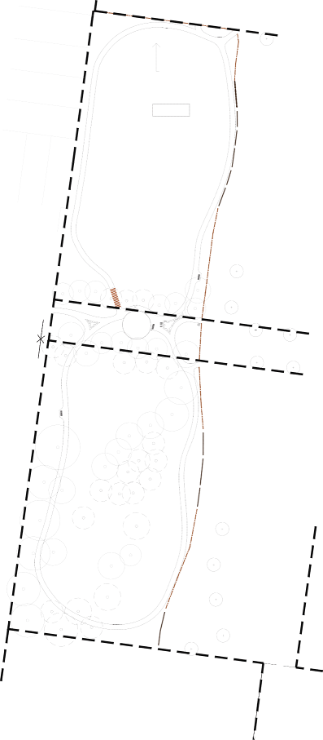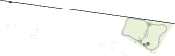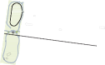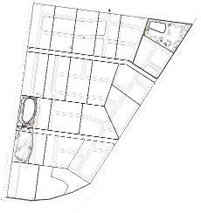

Rubbish bin.

Notes
- Trees to be no closer than 3m to path, bollards & other infrastructure.
- Compacted gravel 'mowing strip', (600mm wide x 75mm depth) installed under bollards.

Link to future reserve

basin 2 1 in 100 yr. F.L

Basin : 0.271Ha

Public Open Space 1.779 Ha

Multi-age Playground (Approx. 150m²) with swing, rocker/spinner & climbing combination

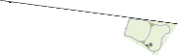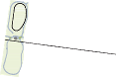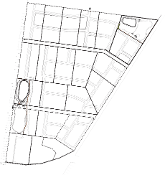North Reserve
Legend
Reserve Trees:

Acacia implexa (Lightwood)

Eucalyptus leucoxylon ssp. bellarinensis (Bellarine Yellow Gum)

Grassed area (Kikuya sprigs with Rye
Open Space Grass hydroseed oversown).

2.5m wide compacted gravel path (150mm crushed rock base with 50mm depth 7mm minus rock dust topping).
Square W.C. post and single rail bollards (gap every 3 bays nominally)

* Drinking fountain.

West Reserve
Refer L2

lic Open Space
0.583 Ha
lic Open Space
0.149 Ha

Public Open Space
  - Ha

Drainage Reserve
Basin : 0.271Ha

Public Open Space 1.779 Ha

Allocasuarina verticillata (Drooping Sheoak)

Allocasuarina littoralis (Black Sheoak)

Banksia marginata (Silver Banksia)

Street trees.

Eucalyptus ovata (Swamp Gum)

Eucalyptus viminalis (Manna Gum)



Square W.C. post individual bollards (1500 gaps)



Groundcover planting at path junctions.
    - Dianella brevicaulis (Coast Flax Lily)

Seating.



Bike rack.

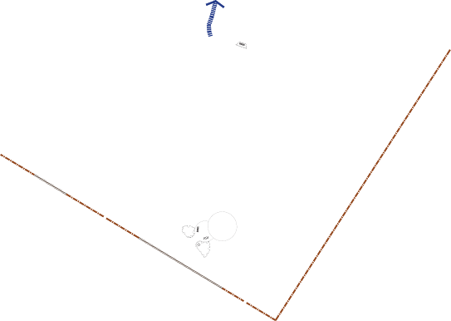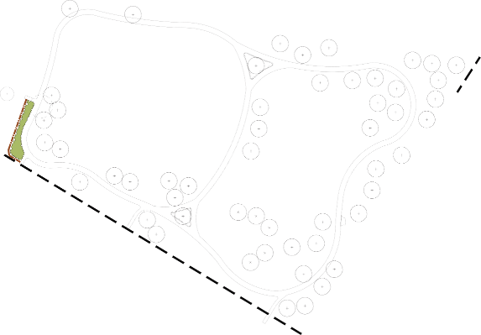

Key Plan
Not to scale

Existing trees (approx. locations) to be retained where possible. Subject to arboricultural assessment.
Existing trees to be removed. (approx. locations)

Notes
      - Trees to be no closer than 3m to path, bollards & other infrastructure.
      - Compacted gravel 'mowing strip', (600mm wide x 75mm depth) installed under bollards.

Rubbish bin.

APPENDIX C DRAINAGE & SEWERAGE MAJOR INFRASTRUCTURE ASSESSMENT, NORTH-EAST OCEAN GROVE

TRETHOWAN AVENUE DEVELOPMENT PLAN AREA
SHARED INFRASTRUCTURE FUNDING PLAN
- URBAN ENTERPRISE PTY LTD
APRIL 2014

Drainage & Sewerage Major Infrastructure Assessment North-East Ocean Grove
Developer Contributions Levy

Introduction -

Provision of major infrastructure became the focus of this report the reasons for which will evolve throughout.

Background -

We originally undertook a Drainage & Services investigation which lead to a report in December 2008.

The resultant summary is still valid.

As a result, an amended Outline Development Plan indicating a revised road network (excluding a lot layout) and stormwater treatment components were added; Appendix 1.

Council advised that a 173 Agreement was their preferred instrument for dealing with Developer Contributions and we were required to provide the information relating to both sewer and drainage infrastructure for the development site based on the abovementioned plan.

We were asked to determine the following:-

  - The drainage & sewerage infrastructure items required,

  - The required standard of each infrastructure item,

  - The cost of each infrastructure item,

  - The anticipated usage and associated cost apportionment (ie. internal and external) of each infrastructure item, and

  - The appropriate “triggers” for the provision of each infrastructure item.

Initial Enquiries & Responses -

We spoke with both Council and Barwon Water, the authorities for drainage and sewer/water respectively, to reaffirm the parameters we needed to consider in addressing the above matters.

- Council confirmed that retarding basins and Water Sensitive Urban Design (WSUD) would be required on the site.

In the case of the Western Catchment through The Parks Estate, the basin size has been based on retardation back to pre-development flows and in any final permit wording you should be careful to avoid Council making rezoning incumbent upon solving downstream problems.

The North-Eastern Catchment will, as previously advised, be part of a series of drainage basins within this development and Kingston Downs Estate to the north and will retard to pre-development runoff.

- Sewerage

We made inquiries of Barwon Water as to their strategy for the area, and they confirmed their previously received response (Appendix 2) represents their current intention for the general area and the directions sewer will take within this development and beyond.

There is scope, depending upon how development progresses, for minor boundary alterations, but even these may have to be reversed due to limited downstream (through The Parks) capacity.

- Water

It is worthwhile reiterating Barwon Water’s comments regarding this asset from an email received in December 2008, and that is –

“The Trethowan Ave area can be supplied with water mostly from the LL system. This would require the extension of a 300 & 225 main which would be financed by BW as shared assets. This is different from previous advice. The small area in the NW corner would need to be supplied from a HL source. This could be the new OG North PS system if that was available or if the development proceeds more quickly it could be supplied from the existing HL system to the west.”

Finally in order to carry out an analysis of the drainage and sewerage requirements, we and ultimately Council, required a detailed feature survey to be able to assess the proposed road and drainage network.

This was provided for all but 4 lots indicated with an asterisk (Appendix 3) in the particularly difficult flat area adjacent to Shell and Banks Roads.

For the purpose of our work, we integrated contours from other sources into the supplied feature survey.

Responses Approach -

- Road Network

The road layout shown in Appendix 1 needs to function as an overflow path for stormwater together with any piped drainage, to direct flows to the retarding basins.

To that end, preliminary grading of the road network was undertaken which confirmed the overflow network capable of transferring flows to the basins as indicated in Appendix 3.

- Drainage

We have determined that we can command most of the flat areas adjacent to Shell Road & Banks Road back to the Trethowan Avenue Basin with only a minor remaining area falling to Banks/Shell Roads.

We have calculated the volumes of the basins required and given the contours, provided a footprint for each of the basin for incorporation into a final Outline Development Plan.

The Western Catchment basin will also act as a bioretention basin and will cater for the WSUD requirements for the catchment falling to Banks/Shell Roads.

- Sewer

Although no lot layout was available, we have confirmed the area nominated by Barwon Water that can be commanded from the nominated Parks sewer outlet.

We have adjusted the location of the boundary line north of Ocean Grand Drive to include an entire holding rather than half as shown in Appendix 2.

The remaining north-eastern section cannot develop before the Banks Road Pump Station and Rising Main is constructed in 2016/2017.

That apart, development of the adjoining Kingston Downs Estate would need to have progressed to the northern boundary to provide a gravity outlet and alignment north to the Pump Station.

The Pump Station Project will be funded and constructed by Barwon Water.

- Water

Likewise the extension required will be financed by Barwon Water as mentioned above.

Infrastructure Items -

- Road Construction

Apart from the intersections with Banks Road and any possible upgrade within (dealt with by others elsewhere), internal road costs are not different from one stage to the next.

Some stages however may be disadvantaged by “singled sidedness”, for instance beside the drainage reserve or public open space or parallel to Banks Road.

These may need to be included in any final assessment, although to arrive at an exactly equal road layout is impossible when retrofitting an area such as this.

- Drainage

As stormwater runoff from the areas remote from retarding basins is transferred downstream, pipe sizes become greater.

In the Western Catchment this is not such a concern as by the time pipe sizes begin to increase, the contours come into play to keep their further enlargement in check.

The north-eastern catchment is relatively flat and pipes sizes as we head north will increase.

Without a final layout and even more detailed design, actual sizes cannot be determined.

However the various subcatchment areas and directions involved and length to the basin should keep these pipe sizes within reason.

For these reasons the internal pipe network is not a costed infrastructure item in this exercise.

The items to be costed in this exercise are the bioretention basins, drainage reserve/WSUD elements and northern retarding basin.

As well the cost of the areas required for each will need to be assessed by others.

- Sewer

Sewer within these stages are expected to be 150mm diameter throughout and provided development occurs in a sequential manner, no individual parcel will be disadvantaged save for the comments relating to layout mentioned above.

- Water

Water will also be a combination of 100-225mm diameter mains the difference in cost between which is minimal.

Question Responses -

Prior to dealing with the answer to the specific questions we make the following general comments.

  - The north-west catchment has two problems.

- The drainage out of the retarding basin is approximately 1.5 metres deep.

This would require downstream easement or discharge rights and placement of external drainage were it to develop prior the downstream subdivision.

- More critically it has no reticulated sewer outfall or ultimate discharge point (sewer pumping station) until constructed in 2016/2017.

  - The western catchment has both drainage and sewerage outfall points “adjacent”

Ideally development would commence from the western boundary and proceed east.

- Major Infrastructure Items Required

  - Drainage

1.1(i) Western Catchment

Appendix 3 indicates the volume and land area required in order to construct the bioretention basin.

The basin invert is over-excavated and refilled with a more “porous” material and interwoven by agriculture drainage which performs and satisfies The Water Sensitive Urban Design requirement for this and the Shell/Banks Road catchments.

1.1(ii) North-East Catchment

Appendix 3 indicates the footprint and required land area to enclose a retarding basin for this catchment.

The basin invert is over-excavated and refilled with a more “porous” material and interwoven by agriculture drainage which performs and satisfies The Water Sensitive Urban Design requirement for this catchment.

1.1(iii)Bank Road Catchment

The “not commanded” comment relates to drainage and that it will be discharged to the existing Bank Road outfall drainage network.
It can be seen that its proportion to the original catchment area is 22%. We are suggesting that the original rural runoff equates to the
developed state and that no retarding is necessary.

WSUD is offset in the bioretention basin to cater for this area’s discharge being untreated.

  - Sewer

1.2 (i) Western Catchment

This includes and caters for the majority of the area “not commanded” by drainage.

This entire area can gravitate back to sewer outfall location in The Parks shown on Appendix 3.

1.2 (ii) North-East Catchment

Would require the construction of a sewer pumping station within the Kingston Downs Estate and rely on it bringing reticulated sewer south to this development’s northern boundary to provide a sewer outfall.

If this development area wished to proceed earlier, it may be possible to provide a temporary pumping station and rising main back to The Parks (est $400K) or pay bring forward costs to Barwon Water for the overall pumping station and rising main (est $1.2M).

This latter option would still require easements through Kingston Downs and the placement of hundreds of metres of reticulation sewers.

- Required Standard of Infrastructure Items

  - Drainage

The basin designs will need to satisfy the City of Greater Geelong and have regard to embankment slopes, internal grading, ten and 100 year piped outlets and an overland floodway route.

The figures attached to Appendix 3 would enable Council to verify the basin size proposals.

  - Sewerage

These works would be carried out in accordance with Barwon Water’s standards and in the case of the pumping station and rising main by the Authority itself.

- Cost of Infrastructure Items

  - Drainage

3.1(i) Western Catchment

This basin, apart from storing excess stormwater runoff, will have filter media in its base.

The cost for these works are assessed on currently received figures and allowed at $250K as shown in the table on Appendix 3.

The outfall works are estimated at $60K on the basis of expected outfall, both low and major outflow events.

3.2(ii) North-East Catchment

The cost of the drainage reserve works are minimal in that it represents an earthworks item for the creation of effectively an open drain.

The basin however represents a cost of approximately $143K based on recent similar constructions.

An amount of $52K has been allowed for the piped drainage features within the base, but this is more of an estimate given the final outcome is unknown.

Irrespective in all of the costing items an amount should be determined, perhaps initially on the higher side and in any agreement be subject to CPI.

This hopefully would keep pace with construction costs and allow a rebate to stakeholders in the course.

Reimbursements within any agreement are for easier to perform than requiring additional sums after the event.

  - Sewer

The major infrastructure costs associated with this overall development relates to the north-east catchment and this will ultimately be borne by Barwon Water.

The proviso is, that the area’s development is delayed to coincide with the above works, as well as development within the Kingston Downs Estate bringing reticulation to the northern boundary.

Any “out of sequence” development would incur the previously mentioned sums and be applicable to the members of this catchment.

- Usage & Cost Apportionment

  - Drainage

Both catchments would be responsible for the major infrastructure which has been the focus of this report.

Ordinarily this is shared on a per hectare basis, but a different mechanism may be proposed by Urban Enterprise once other infrastructure items are included in an overall package.

The “not commanded” drainage catchment should contribute to the Western Catchment solution in that the majority of its runoff is commanded back to that area’s retarding bioretention basin, allowing an unretarded area to discharge directly to Banks Road. As well, the basin satisfies this catchment’s WSUD requirement.

  - Sewerage

No major infrastructure item applies to the overall area; except possibly the north-east catchment should it wish to proceed “out of sequence”.

Then the cost to do so would fall to that area’s stakeholders, again on a per hectare basis.

- Infrastructure Triggers

  - Drainage

5.1(i) West Catchment

This area can proceed immediately, although due to downstream flooding the construction of the bioretention basin would be required from the outset.

The argument to Council would be that in placing basins and retarding back to predevelopment flows, no drainage levies should apply to this overall development.

Given that each holding is approximately 2 hectares and that drainage levies are currently around $11,000 per hectare, a commitment by the majority of landowners would be required to initiate development in this catchment.

5.1(ii) North-East Catchment

This area is less problematic than the former catchment in that it discharges to undeveloped area.

It would require easement/discharge rights downstream and would require some sediment entrapment.

Development from a drainage perspective, would begin in the north- west corner of the catchment as this represents the higher ground and ability to “daylight” piped drainage.

All of this however seems academic, as the provision of an economically viable sewer outlet would seem to rule out this catchment in the short to medium term.

  - Sewerage

5.2(i) Western Catchment

This is adjacent to the nominated sewer outfall location; see Appendix 3.

Logically this catchment should develop in and around the basin site utilizing Trethowan Avenue and Ocean Grand Drive as accesses to an internal road network.

Beginning further away (Banks Road) is possible, but would require the placement of a reticulated connection to the nominated sewer point in The Parks.

Under Barwon Water’s Developer works process, the placement of sewer and indeed water reticulation is totally at the developer’s expense with no reimbursement.

This would not preclude however, an independent cost sharing agreement to be negotiated with other benefiting landowners.

5.2(ii) North-East Catchment

As referred to above the trigger for this area seems some 6-8 years away.

- Conclusion

No allowance has been made for internal roads, drains, sewer or water mains or indeed that development may proceed in an arbitrary manner and as such only major infrastructure items are addressed.

One aspect of major infrastructure is the land area taken up by the major drainage elements.

We have identified their size for inclusion and assessment by others into an overall developer contribution scheme.

It would appear that all but the north-east catchment could proceed as soon as the current process is finalized, but that the north-east catchment would be delayed due to the lack of a sewer outlet.

Should internal development require placement of Barwon Water assets through or past other landowners, individual cost sharing arrangement can be made.

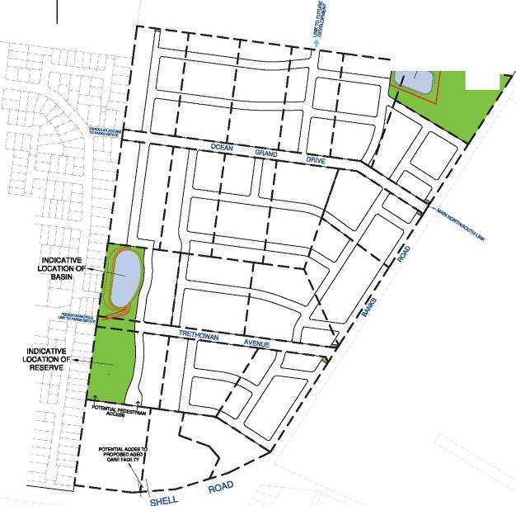
Appendix 1

INDICATIVE INDICATIVE LOCATION OF LOCATION OF
BASIN RESERVE
' -f -
1••sT. QUENTIN
•••Surveyors 0 Town PLtnner,. Devtlopment Consulttm::s
54 CORIO STREET, P.O. BOX 919, GEEWNG 3220
TELEPHONE (03) 5229 2011 FAX (03) 5 2 29 2909
This plan has been prepared to support aTown Planning Application to subdivide land and should mrt be used fer any other purpose. It is subject to Approval by council and may be amended without notice.  This note is an integral part of this plan. | DEVELOPMENT PLAN N-E OCEAN GROVE OCEAN GROVE | SCALE LEVEL DATUM  1:4000
 | DEVELOPMENT PLAN N-E OCEAN GROVE OCEAN GROVE | TITLE REF.  VOL. FOL.
 | DEVELOPMENT PLAN N-E OCEAN GROVE OCEAN GROVE | PLAN DRAWN SURVEY REF. VER.  20/08/13 9467 10

A3

APPENDIX 2

(( A\ J Barwon
Water

Our Ref: Your Ref:
Enquiries To:
60/061/13778 (2)
C203 Application IMC:ld Judy Phllllps

September 1, 2009

Mr Ian McCartney
Senior Strategic Planner City of Greater Geelong OX22063
GEELONG

Dear Ian

Re: REZONING REQUEST· SHELL & BANKS ROAD, OCEAN GROVE

Thank you for your letter received 5 August 2009 regarding the above proposal. Barwon Water has undertaken Investigations regarding the provision of water supply and sewerage services to this area in conjunction with the Ocean Grove north development area. I can confirm that with the construction of additional Infrastructure by the developer and Barwon Water these services can be provided to the area.

Water Supply

The water servicing information contained within St Quentin's submission dated 18 December 2008 (Barwon Water- Final Response) Is unchanged.

Sewerage Strategy

Please note that Barwon Water has revised the sewerage strategy for this land from that contained In the applicants submission following receipt of more accurate contour information. The current sewer servicing strategy is detailed below.

An area of approximately 27 Ha located in the south-west of the proposed development will drain Into the existing 300mm sewer located at approximately No.2 Bulga Place. The remainder of the development, comprising of 19 Ha will drain to the north via a new pump station located at the low point on Banks Road, as shown In Figures 2 and 3 attached. The Banks Road Pump Station and Rising Main project has been allowed for In Barwon Water's Capital Works Program and Is scheduled for the 2016/17 financial year.

Should you require any further information please contact Judy Phillips, Development Officer, on 5226 9142 at the South Geelong office.
Yours faithfully


tf. Paul Booth Manager
Customer Services

Encl:

CC St Quentin

;<,.,.;.t:·::·;:":/'«f: t: Y:' ...-'.:r·:·:'.x :;:-:·: -:.;: r · ·;:_():·::-.-···! ·::•?\' -.·,'f-.::.•::n<::/:: c=:_:: \'.-'.·.;-.···..., ...,:.': .i''· ·"·i·"::i ::"·': '.',_.'_•.- ·- ...i .,: ..-, ._.,; : .•. ·· . ' . ,.. >::,

- · :. • · :. . ' '· Oa1wo11Regibn\Va1e1Corpo1a1ion . 61,. G Ryric S1ron1.ri,ccl1111g.1!1ctona ..
TrlorMnc 13006.S6001
F i1co m1lc 1031 221.8230
 | · :.:..: | ·...

· . .-· >: ·:...;', .' .. •, '·:
fiQ tyJG. 4.8.31651 ;· '.: :'. ·:. _:' r.o' in .,3220
Oo 6
9:licelo
o.
V'.ct
o'.
;:}:?; L:< :: : rr ..:..
- ·"·)::..A..)·:>:;·.=\d:;/:.·:i" ::· - - ;;:;-;·: _:'.:·!· ; f.P:: t, it:.. ;u.·": \:'..:·<-.;·.;.:·.
, • , · · :;
• . · .'i
.;·-..: ·):< :,._ · ; . , . :··1

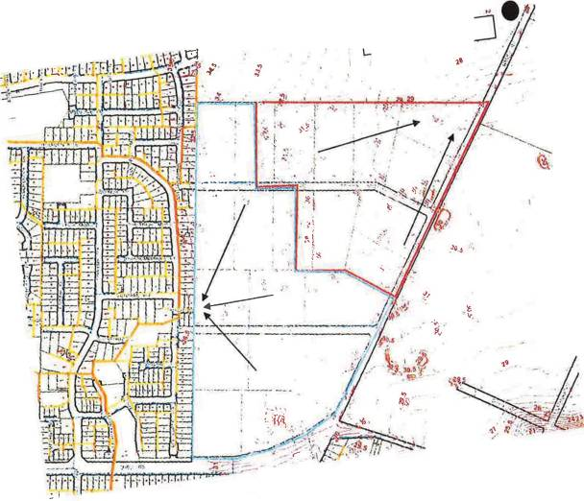

Future pump station

' I

..--....-:.:. ·

figU!e 2- Qeve\opmenl Sewe1age concept

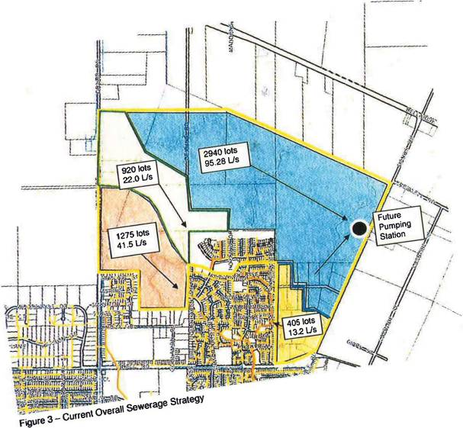

I

r

Appendix 3

Note:

- 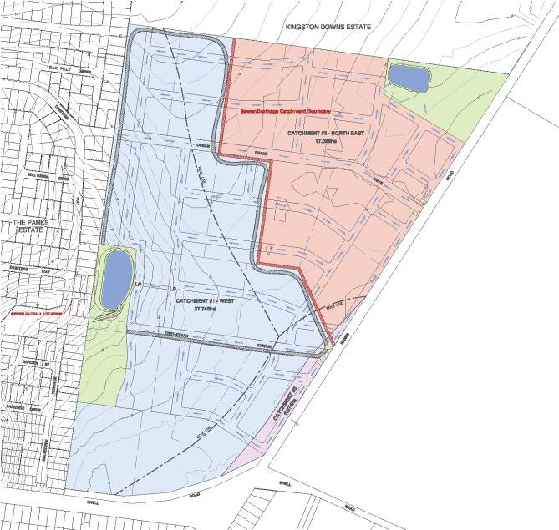CONTOUR INTERVAL· 0.50 m

-- - PIPED & OVERFLOW DRAINAGE ROUTE

CATCHMENTe1-WEST
Development AinnlJ = 19.533 ...
P,01= 0.2711
1=24.52mln.
hm = 75.71 mm/hr
Q1•• 1.117c:mn-

-DevelOpment
=:l7.745tm
=1.117cu­
C.aa=0.70
a-S-"-•51174Cm
CATCHMENTe2 - NORTH EAST

Pre-lleftlapment
AouMll = 21.840 Ila P1m=0.ZT11 1=25..511ml,.
h1111=73.83 """"''
Qim •1.211cu,,_.

-opment
·17.lllllha
Q...i = 1.211cu­
C.m:0.70
-S..,.R.,..t =2920 Cm

Blo--lan9vatBm
=:l7.745tm
"-1-(l')•O.IO
e-s.-Ano.1.40%
*""...........
--"-.2331 Sm
--Ano=1.1115tm
ea.t.$484,000

•Caolll •19 GST-1111lva
Blo--lans...tom
=17.oe8h•
-..........(1)=0.tlD
e-S..-"'-=1.40%
(M'llolll .........
--.....,....1-Sm
--Ano.0.7115 ha
l)td...111 ............-J
ea.t.$287,000

..CPI Melbaumo 175.11June2011
catchment
C.tchmenl # 1- West | 19.533 | 27.745
Caldlmenl 2 - North | 21.840 | 17.089
C8tchmenl # 3- Nol Comnmnded | 4A35 | 0.974

........_Area-(lla) -

b

SCALE (@A1)- 1:2000
SCALE (@ A3) - 1:4000

# Eael

  - [3Peter Berry & Associates Pty. Ltd.
Civil Engineers

STORMWATER MANAGEMENT PLAN BANKS ROAD SUBDIVISION
OCEAN GROVE

APPENDIX D PROPOSED REZONING – BANKS ROAD, OCEAN GROVE - TRAFFIC ENGINEERING ADVICE

TRETHOWAN AVENUE DEVELOPMENT PLAN AREA
SHARED INFRASTRUCTURE FUNDING PLAN
- URBAN ENTERPRISE PTY LTD
APRIL 2014

6 September 2010

Chris Mason
North-west Ocean Grove Subdivision Group C/o St. Quentin Consulting
PO Box 38
OCEAN GROVE VIC 3226

Dear Amy
Suite 2, 22 Gillman Street Hawthorn East, Victoria 3123
T: (61 3) 9811 3111
F: (61 3) 9811 3131
W: obrientraffic.com

Re: Proposed Rezoning - Banks Road, Ocean Grove - Traffic Engineering Advice

I refer to your request for additional traffic engineering advice for the above proposed rezoning of land on Banks Road, Ocean Grove.

We have inspected the subject site, reviewed our previous traffic report for Ocean Grove, prepared concept layout plans for external works, and estimated costs of such works. Our assessment of the traffic issues in the area is as follows:

Location

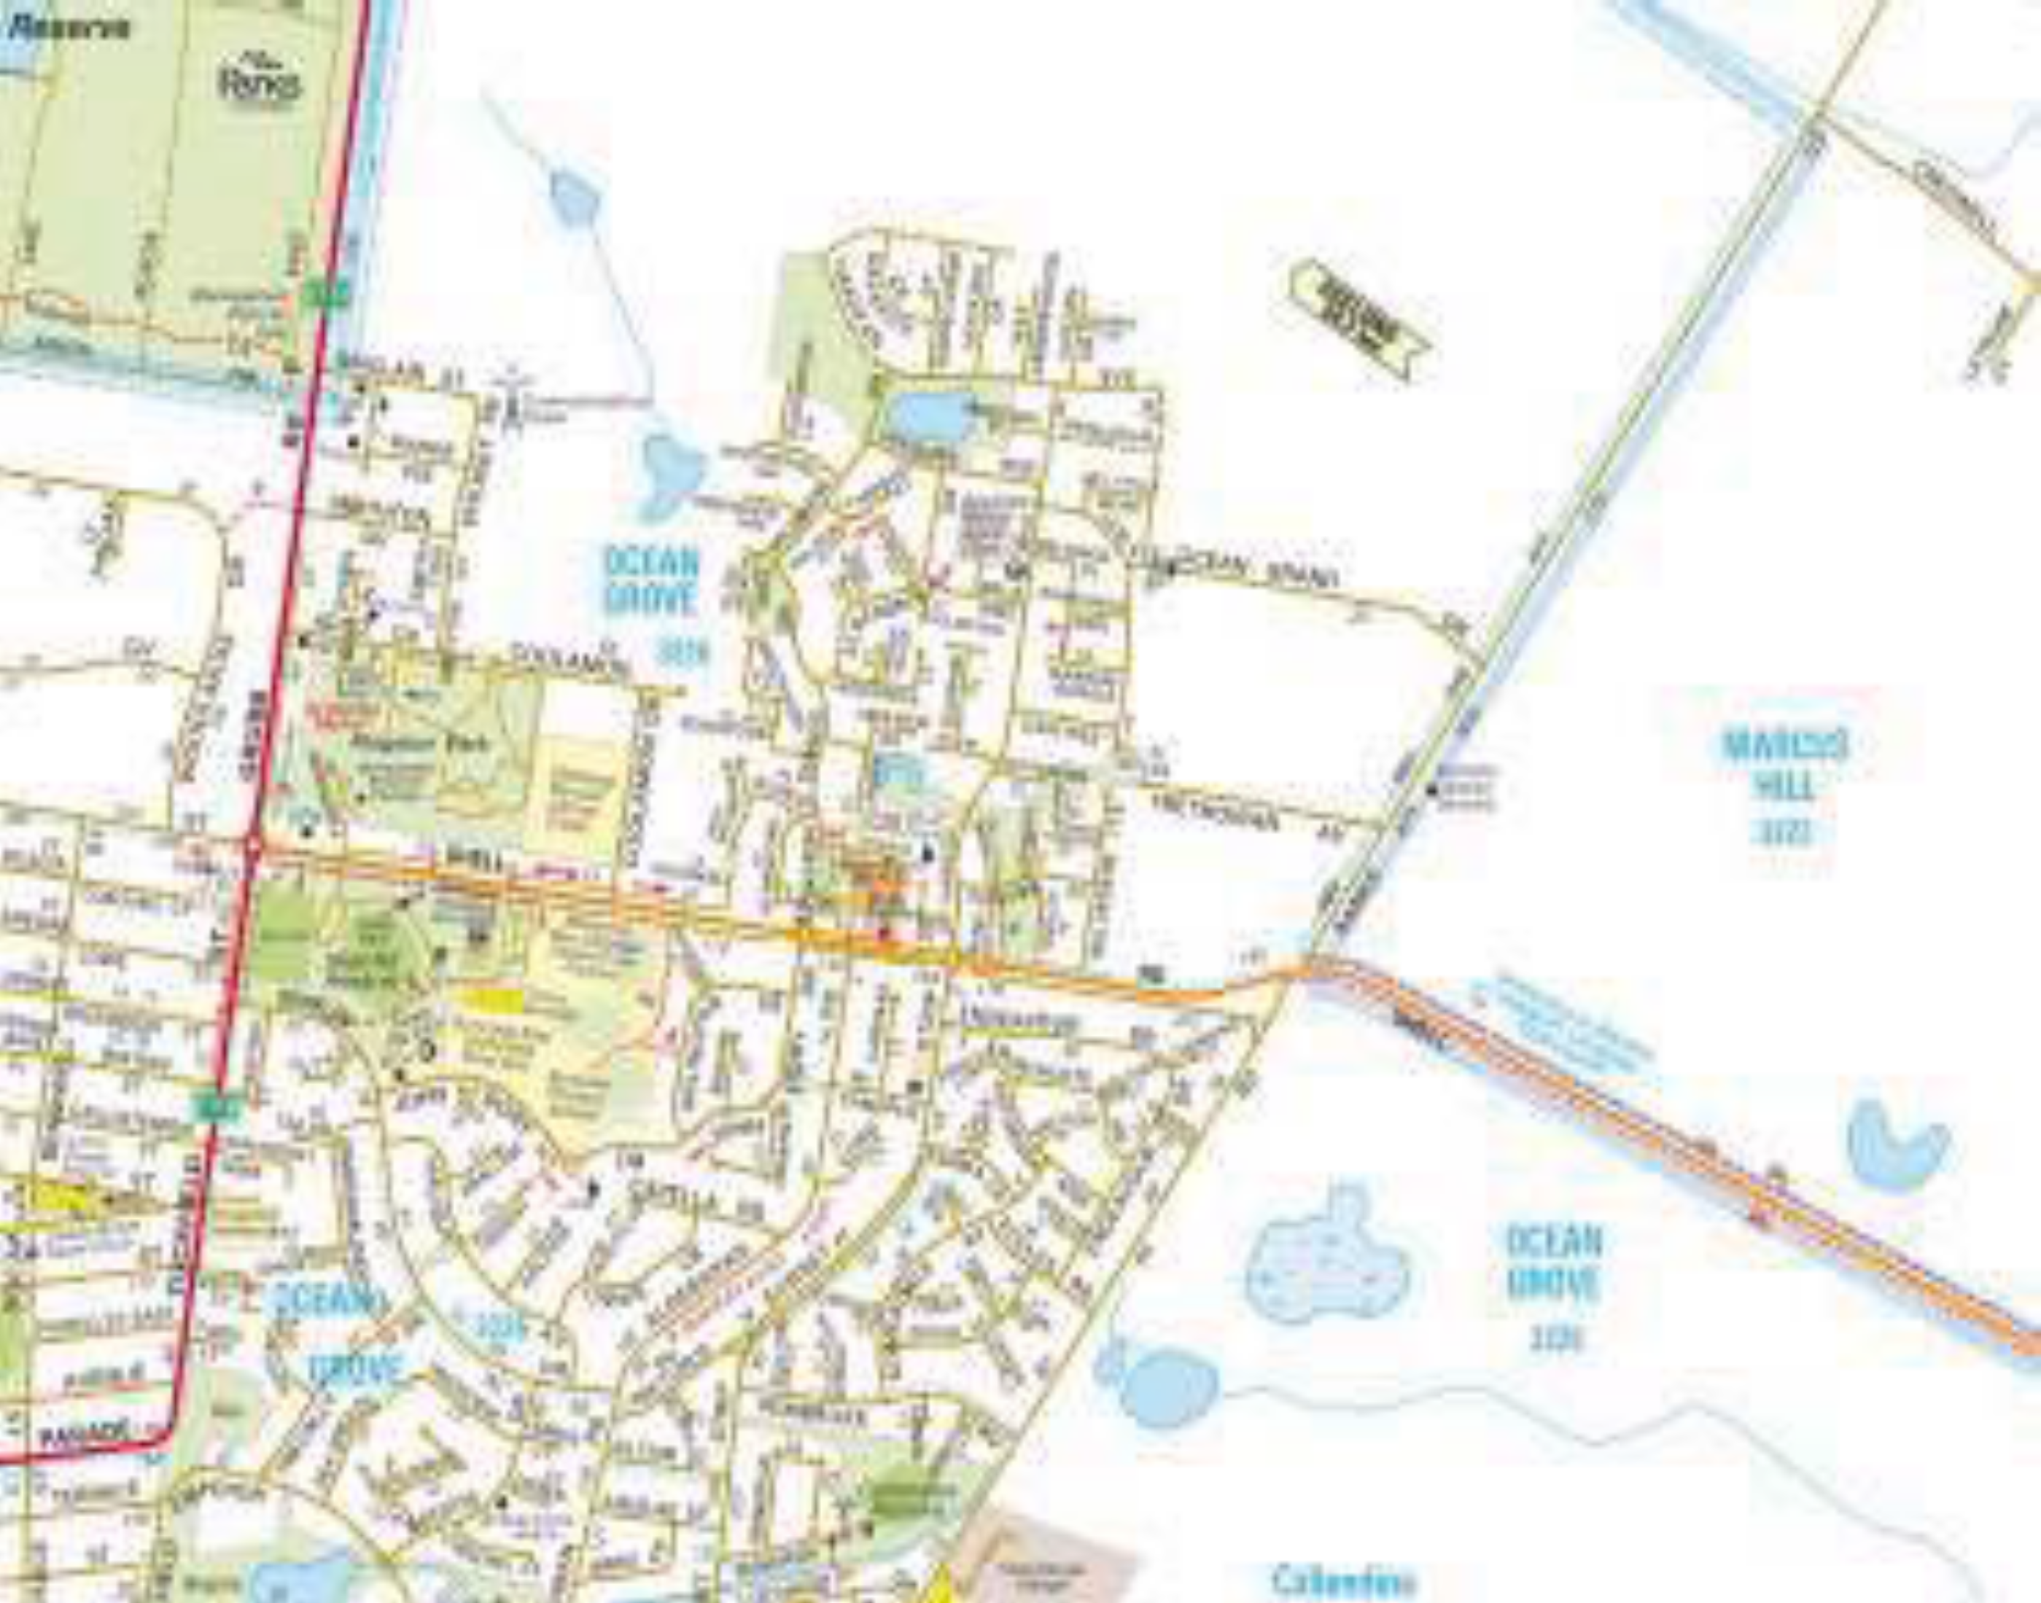The subject site is located in the north-western portion of Ocean Grove, bounded to the north by Ocean Grand Drive, to the south by Shell Road, to the east by Banks Road and to the west by Belvedere Terrace and Daintree Way. Figure 1 shows a map of the subject site and streets in the surrounding area.

N

NDREW O NBOW

N
N
N

NDREW O NBOW

COPYRIGHT MELWAY PUBLISHING PTY. LTD. REPRODUCED WITH PERMISSION
Figu e 1: Location of Subject Site

TRAFFIC ENGINEERING TRAFFIC PLANNING ROAD SAFETY TRAFFIC IMPACT ASSESSMENTS TRANSPORT PLANNING
ANDREW O’BRIEN & ASSOCIATES PTY LTD ABN: 55 007 006 037

Road Network

Shell Road is a Major Council Road that is oriented in an east-west direction. It is the continuation of Thacker Street in the west, becoming Shell Road at Grubb Road and continues to the east towards Point Lonsdale. In the vicinity of the subject site, Shell Road is an undivided roadway providing a traffic lane in each direction with sealed shoulders. Indented, paved bus stops are provided on both sides of Shell Road west of Banks Road.

East of Banks Road, Shell Road has a posted speed limit of 100 km/h which reduces to 80 km/h within approximately 50 metres of Banks Road. Photos 1 and 2 show Shell Road from the intersection with Banks Road.

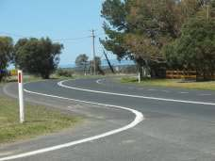

Photo 1: Shell Road at Banks Road Facing East

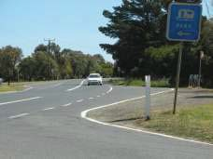Photo 2: Shell Road at Banks Road Facing West

Banks Road is classified in the 2009 Melways as a local road, however in the vicinity of the subject site it operates as a local arterial roadway. Banks Road is oriented in a north-south direction and runs from Andersons Road to the north to Shell Road to the south where it becomes Bonnyvale Road.

In the vicinity of the subject site, Banks Road is an undivided roadway providing a single traffic lane in each direction with narrow sealed shoulders.

North of Shell Road, Banks Road has a posted speed limit of 100 km/h which reduces to 80 km/h within approximately 80 metres of Shell Road. Photos 3 and 4 show Banks Road from the intersection with Ocean Grand Drive. Photo 5 shows Banks Road at Trethowan Avenue and Photo 6 shows Banks Road just prior to Shell Road.

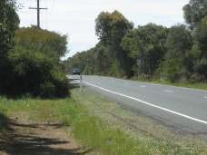

Photo 3: Banks Road at Ocean G and D ive Facing No th

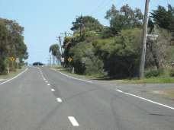

Photo 5: Banks Road at T ethowan Avenue Facing South

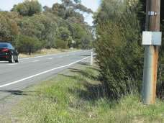Photo 4: Banks Road at Ocean G and D ive Facing South

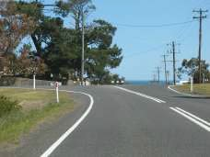

Photo 6: Banks Road nea Shell Road Facing South

Ocean Grand Drive and Trethowan Avenue are both local roads that run west from Banks Road. Currently Ocean Grand Drive does not connect through to Dantree Way, however it is anticipated that this will occur with construction of residential properties to the west. Photos 7 and 8 show Ocean Grand Drive and Photos 9 and 10 show Trethowan Avenue.

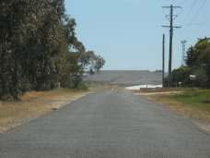

Photo 7: Ocean G and D ive Facing East

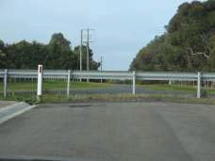Photo 8: Ocean G and D ive Facing West

Photo 9: T ethowan Avenue Facing East

Photo 10: T ethowan Avenue Facing West

Collision History

A review of VicRoads "crashstats" database for the last 5 years of available data (1 April 2004 to 30 March 2009) indicated that there were no recorded casualty crashes along any roads abutting the subject site.

Traffic Volumes

Enquires with Greater Geelong City Council's Traffic Engineering department determined that an automatic tube count was conducted in February 2010 on Banks Road approximately 400 metres north of Ocean Grand Drive within the 100km/h section. The automatic tube count indicated an average weekday vehicle volume of 1,602 vehicles per day with an 85th percentile speed of 101.5km/h.

Vehicle Access Options to Shell and Banks Roads

Shell Road between Banks Road and Grubb Road is vehicle access controlled. Currently three vehicle access points are provided to Shell Road from the subject site, these access points could be retained under the subdivision, however, the access points should remain only for single residential dwellings. Due to the alignment of Shell Road, it is recommended that no additional vehicle access is provided to Shell Road.

In addition, we do not support the provision of any service road along Shell Road as they have operational issues and can be a safety hazard.

Along Banks Road it is recommended that the majority of vehicle access is provided via Trethowan Avenue and Ocean Grand Drive. A small number of larger lots could have individual access to Banks Road as long as they are provided with the opportunity to enter and exit the lot in a forward direction.

Traffic Generation

The subject site is currently subdivided into 22 lots. Applying a conservative rate of 10 trips per lot per day results in traffic generation of up to 220 vehicle trips per day.
From our calculations the area of the subject site is approximately 46 hectares. Assuming a density of between 12 and 15 lots per hectare, between 550 and 700 lots could be accommodated on the subject site. These lots are likely to generate between 5,500 and 7,000 trips per day.

Assuming the following:

- under the subdivision at least 15 lots will have direct vehicle access to Shell Road or Banks Road generating approximately 150 vehicles per day;

- approximately 1,500 vehicles per day would utilise the connection of Ocean Grand Drive to Daintree Way; and

- all other generated traffic is evenly distributed between Ocean Grand Drive and Trethowan Avenue.

It is estimated that a between 2,000 and 2,500 vehicles would access Ocean Grand Drive and Trethowan Avenue per day. During the peak hours this would translate to between 200 and 250 vehicles per hour. These daily volumes can be accommodated by access streets that have an environmental capacity of up to 3,000 vehicles per day. It is considered that the Banks Road intersections with Ocean Grand Drive and Trethowan Avenue could facilitate these volumes.

The proposed subdivision would likely contribute 2,500 vehicles per day to the north-east and 2,500 vehicles per day to the south-west on Banks Road.

N
N
N

I&TSC

I&TSC

I&TSC

I&TSC

ISCP

P IS YLO: 5B0W OY7 6 W::B3F G63M: uL65 L0 NiWYY uL65

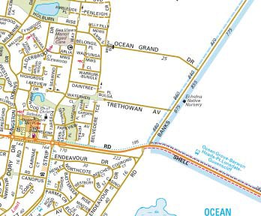Figu e 2: Likely Daily T affic Gene ation

N

I&SCC
I&TSC

I&TSC I&TSC
I&TSC

ISCP

P IS YLO: 5B0W OY7 6 W::B3F G63M: uL65 L0 NiWYY uL65

Internal Connections

To encourage vehicle access towards Banks Road rather than through the existing residential development to the east, it is recommended that any north-south internal roadway be focused as close as possible to Banks Road. For Ocean Grand Drive the connection should be east of the 'kink' in the roadway as shown in Figure 3.

N

tL::BRYW B3OW036Y 0L65e67
L33W OBL3:

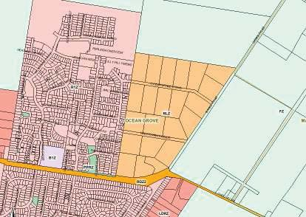Figu e 3: Possible Inte nal Roadway Connections

NN

tL::BRYW B3OW036Y 0L65e67
L33W OBL3:

Improvements to External Roadways

Banks Road & Ocean Grand Drive & Trethowan Avenue

It is recommended that consideration be given to providing a right turn lane on the approach to Ocean Grand Drive and Trethowan Avenue at Banks Road. Given the likely increase in traffic volumes along Banks Road, a short linemarked right turn is considered most appropriate.

Conceptual plans of linemarked right turn lanes meeting Austroads Guide to Road Design --4A into Ocean Grand Drive and Trethowan Avenue are shown in Appendix A Based on the survey plans provided, the proposed right turn lanes can be accommodated within the existing road reserve for Banks Road.

Based on VicRoads current cost estimate spreadsheets it is estimated that the right turn lanes would likely cost $144,540 each to construct. This figure makes provision for detailed design, project & traffic management, possible service relocation and a 10 percent contingency. Costing details are provided in Appendix B.

Triggers for Roadway Improvements

Right turn lanes into Ocean Grand Drive and Trethowan Avenue will be warranted after the majority of the lots with the proposed subdivision are developed as shown in Figure 4.

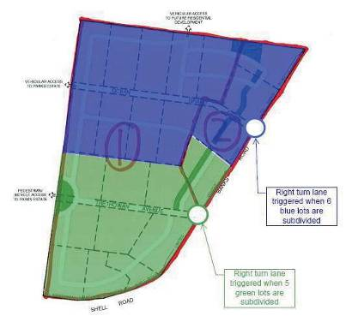Figu e 4: T igge s fo Right Tu n T eatments

If you require any further information, please contact me on 9811-3111. Yours sincerely
O'BRIEN TRAFFIC

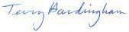
Terry Hardingham Director

11460let2

Appendix A

Costing Details

Provision of right turn lane on Banks Road

D | REW O’B &SCSTOPOCB | YL:550
7 | 6O3FTC SCG MCuO3BFTSBFWC | Yi:t00
e | 2FBO &SCSTOPOCB: 2,lOEuF3FWC SCG mESaaF’ eWCBEWn | Yrr:i00
6 | 6ESFCSTO | Yt:000
H | 2OEuF’O wOnW’SBFWC | Yrt:000
h | RSuOPOCB eWC3BE,’BFWC | Yo5:t00
s | RSuOPOCB &SEVFCT3 c wWSG h,ECFB,EO | Y1:t5(
) | 2BEOOB 9FT8BFCT | Yr5:Lt0
M | r0b ’WCBFCTOC’f | Yr1:r.0

mOmD9 eO2m
Yr..:t1(

Appendix B

Linemarked Right Turn Lanes

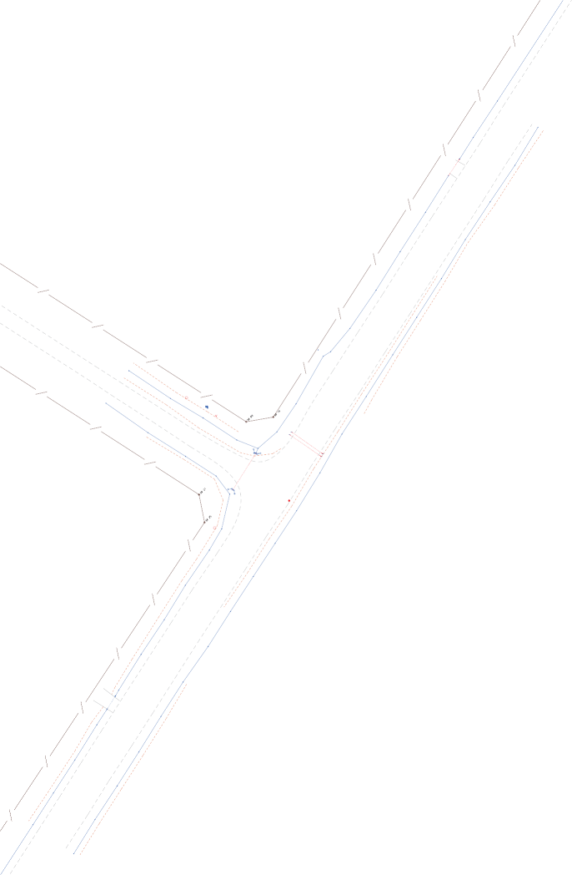

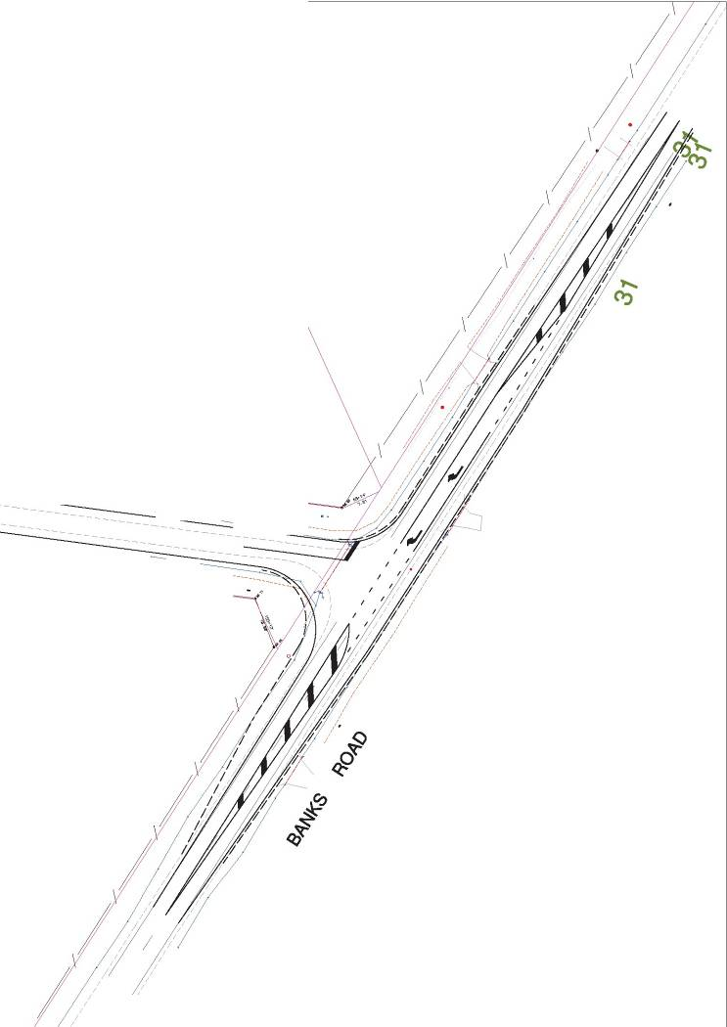

AVENUE

----------- • -------------
-------------

- -------------------

APPENDIX E LAND VALUATION REPORT

TRETHOWAN AVENUE DEVELOPMENT PLAN AREA
SHARED INFRASTRUCTURE FUNDING PLAN
- URBAN ENTERPRISE PTY LTD
APRIL 2014

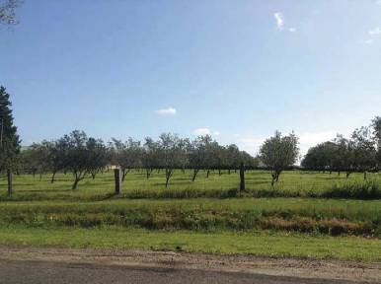 | VALUATION  REPORT  802-820 Banks Road,  22-30 and 27-39  Trethowan Avenue Ocean Grove Vic 3226  1st July 2013


CONTENTS

- EXECUTIVE SUMMARY 4
  - Instruction Overview 4
  - Property Overview 4
  - Value Assessments 5
- INTRODUCTION 6
  - Instructing Parties 6
  - Purpose of Report 6
  - Definition of Market Value 6
  - Date of Inspection 7
  - Date of Valuation 7
  - Interest Valued 7
  - Summary of Assumption and Limitations 7
- TITLE DETAILS 8
  - Legal Description 8
- LAND PARTICULARS 10
  - Land Description 10
  - Site Identification 13
  - Services 13
- TOWN PLANNING 14
- LOCATION 17
- ENVIRONMENTAL ISSUES 18
  - Site Contamination 18
  - Occupational Health & Safety 18
  - Pest Infestations 18
  - Right To Review 18
  - Sites Of Heritage Or Cultural Significance 18
- INDIVIDUAL PROPERTY IMPROVEMENTS 19
  - General Description 19
- MARKET ANALYSIS 22
  - Subject Property Considerations 22
- MARKET OVERVIEW 23
  - General Economic Overview 23
  - Australian Dollar 23
  - Interest Rates 24
  - Unemployment 24
  - Inflation 24
  - Business Confidence 25
- RESIDENTIAL PROPERTY MARKET 26
  - General Overview of Geelong Residential Sector 26
  - Auction Clearance Rate 27
  - Private Sector Housing Approvals 27
  - Housing Finance 27
  - Ocean Grove Local Market 27
- VALUATION RATIONALE 28
  - Comparable Sales Analysis 28
  - Residential 1 Zone value Assessment 30
- VALUATION FOR LAND ACQUISITION 33
  - Land to be Acquired 33
- DECLARATIONS 38
  - Pecuniary Interest 38
  - Market Movement 38
  - Structural Disclaimer 38
  - Goods And Services Tax (GST) 38
  - Market Value 39

APPENDICES

EXECUTIVE SUMMARY

1.1 INSTRUCTION OVERVIEW

Address of Properties: 802-820 Banks Road, Ocean Grove VIC 3226

22-30 Trethowan Avenue, Ocean Grove VIC 3226 27-39 Trethowan Avenue, Ocean Grove VIC 3226
Our Reference: 4322

Instructed By: Mr Rob Anderson Coordinator Urban Growth Area Planning City of Greater Geelong
131 Myers Street, Geelong

Mr John O’Shannassy
jjoshannassy@bigpond.com

Instruction: We have been instructed to determine the market value of land required for future drainage reserves and public open space using the ‘Before and After’ valuation approach, assuming the land is unencumbered, zoned Residential 1 and does not require further services to be extended beyond the trunk infrastructure.

This valuation may only be relied upon by the instructing parties as shown above. The report has been prepared for the private and confidential use of the above parties and it should not be reproduced in whole or in part or relied upon for any other purpose or by any party other than the instructing party as shown above without express written authority by Westlink Consulting.

1.2 PROPERTY OVERVIEW

Description: The subject properties comprise three lots being used for rural residential
purposes, known as:

  - 802 - 820 Banks Road, Ocean Grove VIC

  - 22 – 30 Trethowan Avenue, Ocean Grove VIC

  - 27 - 39 Trethowan Avenue, Ocean Grove VIC

Land Areas:

Property | Land Area (ha)
802-820 Banks Road, Ocean Grove | 2.049
22-30 Trethowan Avenue, Ocean Grove | 2.026
27-39 Trethowan Avenue, Ocean Grove | 2.024

Zoning: Rural Living Zone (RLZ) to be rezoned Residential 1

Date of Valuation: 1st July 2013

1.3 VALUE ASSESSMENTS

Our assessments are as follows for the ‘‘Before and After’’ basis. These values are subject to the assumptions and qualifications included within this valuation. We have assessed the ‘Before’ and ‘After’ scenarios to identify an indicative loss of value for the land to be acquired for public open space and drainage reserves in the North East Ocean Grove development area. Key assumptions are that all lots are zoned Residential 1 and are considered unencumbered for the purposes of this assessment.

Property | Land Area (ha) | Land to be Acquired | Land Area (ha) After | Before | After Acquisition | Value of land acquired
802-820 Banks Road, Ocean Grove | 2.049 | 2.049 | 0 | $1,946,550 | $0 | $1,946,550
22-30 Trethowan Avenue, Ocean Grove | 2.026 | 1.055 | 0.971 | $2,026,000 | $1,165,000 | $861,000
27-39 Trethowan Avenue, Ocean Grove | 2.024 | 1.133 | 0.891 | $2,024,000 | $1,069,000 | $955,000

Valuer:


Dr Georgia Warren-Myers AAPI No. 63389 Brian Robinson AAPI No. 62215
Certified Practising Valuer Certified Practising Valuer
Westlink Consulting Westlink Consulting


Disclaimer: This Executive Summary should only be read in conjunction with our formal report and valuation attached and is subject to the general and specific qualifications, assumptions, conditions and limitations included within and at the rear of the report.

2.1 INSTRUCTING P A RTIES

Mr Rob Anderson
Coordinator Urban Growth Area Planning City of Greater Geelong
131 Myers Street, Geelong

Mr John O’Shannassy

jjoshannassy@bigpond.com

2.2 PURPOSE OF REPORT

We have been instructed by Mr Rob Anderson of City of Greater Geelong and Mr John O’Shannassy to determine the market value of land set aside for future public purposes being drainage reserves and public open space utilising the ‘Before and After’ land valuation approach, under a highest and best use assumption of a Residential 1 Zone and does not require further services to be extended beyond the trunk infrastructure. The land valuations for the drainage reserves and public open space reserves in question should assume the land required for these public assets as being unencumbered. The properties being valued are:

- 802-820 Banks Road, Ocean Grove VIC (known hereafter as 820 Banks Road)

- 22 – 30 Trethowan Avenue, Ocean Grove VIC (known hereafter as 30 Trethowan Avenue)

- 27 - 39 Trethowan Avenue, Ocean Grove VIC (known hereafter as 35 Trethowan Avenue)

The report is not to be relied upon by any other person or for any other purpose. We accept no liability to third parties nor do we contemplate that this report will be relied upon by third parties. We invite other parties who may come into possession of this report to seek our written consent prior to them relying on this report. We reserve our right to withhold consent or to review the contents of this report in the event that our consent is sought.

2.3 D E FINITION OF M A RKET VALUE

In accordance with the standard established by the Australian Property Institute, we have adopted the following definition of Market Value:

“Market Value is the estimated amount for which an asset should exchange on the date of valuation between a willing buyer and a willing seller in an arm’s length transaction, after proper marketing, wherein the parties had each acted knowledgeably, prudently, and without compulsion.”

This definition of market value assumes:

- A willing, but not anxious buyer and seller

- A reasonable period within which to negotiate the sale having regard to the nature and situation of the property and state of the market for the same property.

- That the property was readily exposed to the market

- That no account is taken of the value or other advantage or benefit additional to market value, to the buyer incidental to ownership of the property being valued.

2.4 DATE OF INSPECTION

6th January 2014 802 - 820 Banks Road, Ocean Grove and 10th January 2014 30 and 35 Trethowan Avenue, Ocean Grove were inspected, we specifically assume that the properties are the same as at the 1 July 2013.

Note: 30 Trethowan Avenue was only externally inspected.

2.5 DATE OF VALUATION

1st July 2013.

2.6 INTEREST V A LUED

We have been instructed to provide a market assessment of the individual parcels aforementioned, owned by various land owners, in accordance with instructions received from Mr John O’Shannassy and Mr Rob Anderson of City of Greater Geelong.

In making this assessment, we have been instructed to provide a market value of the subject properties utilising a ‘Before and After’ approach to ascertain the market value of the proposed acquisition of portions of land for public purposes.

2.7 SUMMARY OF A SSUMPTION A N D LIMITAT I ONS

This valuation is based on the following assumptions:

  - The properties inspected on the 6th and 10th January 2014 were in the same condition as at the 1st July 2013;

  - The sales that have occurred post 1st July 2013 are in-line with the market and we believe representative of the current market as at 1 July 2013.

  - In this valuation no ‘compensation’ has been assessed for business disturbance associated with businesses currently being conducted on the land. Likewise, no allowance has been made for legal and other costs (including solatium),

  - All services are assumed to be accessible and connected, as per council instructions;

  - As the proposed future purpose of the properties is to be developed into a residential subdivision, current easements associated with drainage are assumed to be irrelevant as this will be re-constructed in the design for the subdivision.

If any of these assumptions is proved incorrect, this may have a material impact on the value of the subject property. We reserve the right to review this valuation in the event that any assumption we have made proves to be incorrect.

TITLE DETAILS

3.1 LEGAL DESCRIPTION

The properties are described as follows:

802-820 Banks Road, Ocean Grove
Lot 6 on Plan of Subdivision LP093928 more; fully described within Certificate of Title Volume 08956 Folio 914. The Registered Joint Proprietors are Robert Ian and Deaneille Lucia Sheather both of 12 Aries Court, Ocean
Grove.

The properties inspected appeared to be the same as detailed in the above title information and have been verified by street address.

22-30 Trethowan Avenue, Ocean Grove

Lot 16 on Plan of Subdivision 093928; more fully described within Certificate of Title Volume 08956 Folio 921.

The Registered Proprietor as Tenants in Common as to 1 of a total of 2 equal undivided shares is Gordon Eric and Gay Rosemary Vickers both of 16 Trethowan Avenue, Marcus Hill.

27-39 Trethowan Avenue, Ocean Grove
Lot 17 on Plan of Subdivision LP093928 more; fully described within Certificate of Title Volume 08956 Folio 922. The Registered Joint Proprietors are Andrew Joseph and Rosemarie Hagebols both of 27-39 Trethowan Avenue,
Marcus Hill.

Caveat noted on Lot 16 of LP093928 – John O’Shannassy (30 Trethowan Avenue). Mortgages exist on all properties; refer to titles in appendices for details. Easements & Encumbrances – Lot 6, 16, and 17
For purposes of this valuation we specifically assume that at the time of valuation there were no easements or
encumbrances on the title that affected the value of the property. Several small drainage easements have been noted below, however, in light of the future development of this area the impact of these current drainage easements is seen to be negligible. Council have instructed us to assess the value of the land as unencumbered.

Furthermore we assume that the titles are free and marketable and that there are no title, fencing or building encroachments on, over or to the subject properties.

The above information has been obtained from recent Title searches dated 13 January 2014 and it reveals that dealings with the Titles’ Activity in the last 125 days are stated to be: Nil.

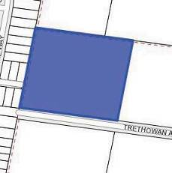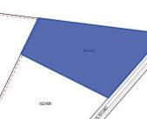Drainage easements were found on several of the properties:

802-820 Banks Road, Ocean Grove, drainage easement on the western boundary. | 27-39 Trethowan Avenue, Ocean Grove drainage easement on the western side boundary. | 22-30 Trethowan Avenue, Ocean Grove has a drainage easement along the northern and western boundaries.

LAND PARTICULARS

4.1 LAN D DESCRIPTION

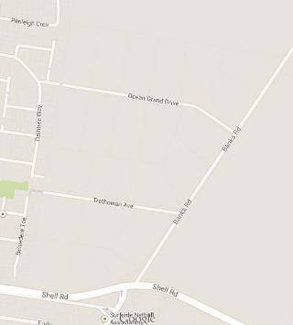The proposed development area is located on the west side of Banks Road and abuts existing residential development on the west boundary. To the north there is vacant land which is already rezoned Residential 1 and is currently in the process of being developed with lots available for sale, as part of the ‘Future Kingston Banks Road Estate’. To the east on the other side of Banks Road are rural living and farming properties. To the south is Shell Road, a major thoroughfare through Ocean Grove that connects to Point Lonsdale. The land has a very gradual fall to the west and the south, overall relatively level topography. The top north east corner of the area is very flat. There are three proposed catchment areas and this will influence the timing of the development.

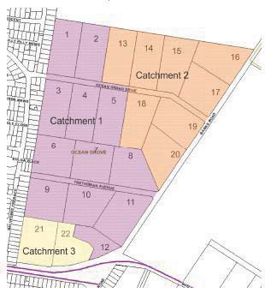

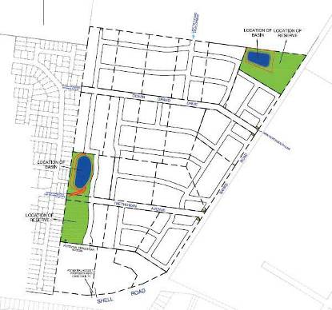

802-820 Banks Road, Ocean Grove

Shape | Irregular | 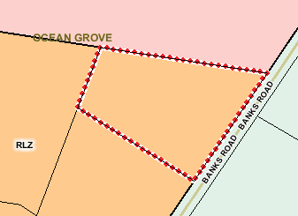
Northern Boundary | 201.65 metres
Eastern Boundaries- frontage Banks Road | 156.22 metres
Southern Boundary | 164.54 metres
Western Boundary | 77.45 metres
Total Site Area | 2.049 hectares
Topography | Level
Access | Vehicle access from Banks Road.

22-30 Trethowan Avenue, Ocean Grove

Shape | Regular | 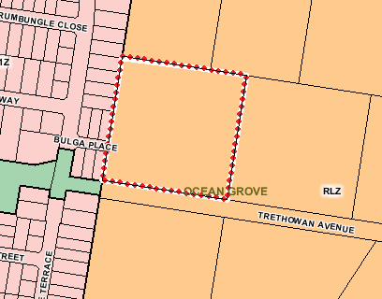
Northern Boundary | 142.07 metres
Eastern Boundary | 142.23 metres
Southern Boundary – frontage to Trethowan Avenue | 142.71 metres
Western Boundary | 1422.22 metres
Total Site Area | 2.026 hectares
Topography | Level
Access | Vehicle access from Trethowan Avenue

27-39 Trethowan Avenue, Ocean Grove

Shape | Regular | 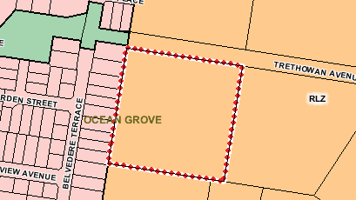
Northern Boundary – frontage to Trethowan Avenue | 142.27 metres
Eastern Boundary | 142.24 metres
Southern Boundary | 126.07 metres
Western Boundary | 158.41 metres
Total Site Area | 2.024 hectares
Topography | Level
Access | Vehicle access from Trethowan Avenue

4.2 SITE IDENTIFICATION

The author of this report is not a qualified and registered surveyor. We have not sighted or been provided with a current survey report. Westlink Consulting’s inspection revealed no apparent encroachment on, or by, the property.

This valuation is made on the assumption that there are no encroachments on, or by, the property. This should be confirmed by a current survey report and/or advice from a registered surveyor. If any encroachment or other affectations are noted on the survey report, Westlink Consulting should be advised immediately in order to reassess any affect this may have on value.

4.3 SERVICES

This valuation is made on the assumption that services including electricity, drainage, water, sewer and telecommunications are connected to the subject properties.

TOWN PLANNING

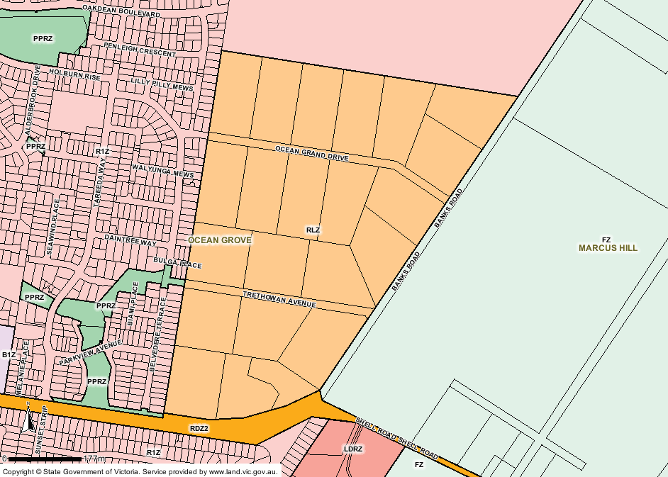The Geelong Planning Scheme indicates that all three properties are situated within a Rural Living Zone (RLZ).

The Purpose of the Rural Living Zone is:

  - To implement the State Planning Policy Framework and the Local Planning Policy Framework, including the Municipal Strategic Statement and local planning policies.

  - To provide for residential use in a rural environment.

  - To provide for agricultural land uses which do not adversely affect the amenity of surrounding land uses.

  - To protect and enhance the natural resources, biodiversity and landscape and heritage values of the area.

  - To encourage use and development of land based on comprehensive and sustainable land management practices and infrastructure provision

The subject properties are being rezoned to Residential 1 Zone as part of the Ocean Grove Structure Plan (adopted the 27th February 2007) as shown in red in the figure below, the purpose of the Residential 1 Zone is:

  - To implement the State Planning Policy Framework and the Local Planning Policy Framework, including the Municipal Strategic Statement and local planning policies.

  - To provide for residential development at a range of densities with a variety of dwellings to meet the housing needs of all households.

  - To encourage residential development that respects the neighbourhood character.

  - In appropriate locations, to allow educational, recreational, religious, community and a limited range of other non-residential uses to serve local community needs.

Planning controls in Victoria are currently being extensively modified. Replacement or modification of the existing zones is occurring progressively throughout all municipalities, with changes proposed to the residential zones and regulations. The intention of the Government is to see a consolidation of the process with fewer zones, particularly in the residential areas. These changes are to be implemented by all Councils prior to 30 June 2014.

The impact on standard residential accommodation is expected to be limited although there will be some areas where the new zones improve or reduce use or development options and thus, impact on the value. Furthermore, we are analysing sales which are / have been transacted within the 'old' planning scheme to be applied for valuations under the 'new' planning scheme, and we caution that the applicability of these sales is somewhat subjective.

The current residential zones will be consolidated into: Residential Growth Zone, General Residential Zone and Neighbourhood Residential Zone. Consequently, when the rezoning for the subject site occurs, likely within the next 12 to 18 months, the site will be zoned General Residential. General Residential will be used in most residential areas with moderate growth and diversity of housing and be consistent with the existing neighbourhood character. Consequently, this means a mixture of single dwellings, dual occupancies with some villa units and in limited circumstances town houses, where appropriate.

The planning information set out in this report has been obtained by reference to the Department of Sustainability and Environment’s Planning Schemes Online website. We have relied upon this information in assessing the value of this property. Should further confirmation be required, we recommend that formal searches and enquiries be undertaken and if the information obtained differs to that detailed above, the report should be referred back to Westlink for reassessment.

An excerpt from the 2007 Ocean Grove Structure Plan identifies the subject development site to provide 436 Lots as shown in the graphic below. However, we have been recently advised by Council that the current proposal is for the subject development to be 12 lots per hectare.

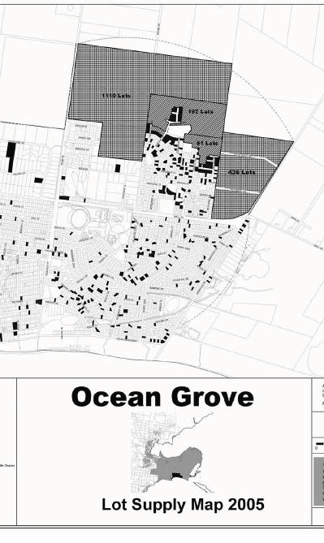

LOCATION

802 -820 Banks Road

22 - 30 Trethowan Avenue

27 -39 Trethowan Avenue

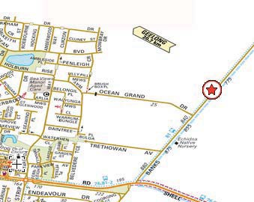The subject property is located in the expanding township of Ocean Grove approximately 23 kilometres to the south-east of Geelong and 97 kilometres south-west of the Melbourne CBD via road. Ocean Grove forms part of the Greater Geelong Local Government Area and is a developing mixed use residential, retail and commercial area.

Ocean Grove is characterised by a mix of houses, earlier classes dating 1960-1990 as well as several recent estate developments dating early 2000 and onwards. Properties surrounding the subject site comprise a mix of existing residential, vacant land, rural living and an established residential estate to the west and a new developing residential estate to the north. The subject properties are 1.5km to the local retail shopping centre comprising a Woolworths, Caltex petrol station and other specialty stores situated on Shell Road.

Ocean Grove Primary School is located approximately 3.5 kilometres west and Geelong Hospital is approximately 22 kilometres to the north-west.

The subject sites:

- 802 - 820 Banks Road is located on the west side of Banks Road, and comprises relatively level topography and irregular shaped;
- 22 - 30 Trethowan Avenue is located on the northern side of Trethowan Avenue and 27 - 39 Trethowan
Avenue is located on the southern side, these properties comprise predominantly level topography with a slight slope to the western boundary and are regular shaped parcels of land.

Banks Road and Trethowan Avenue are rough bitumen surface carriageways, with gravel edges and open channels. Banks Road turns onto Shell Road giving access to Ocean Grove.

The nearest train is South Geelong Railway Station, approximately 24 kilometres to the north-west. Additionally, there are ample bus stops in Ocean Grove.

ENVIRONMENTAL ISSUES

7.1 SITE CONTAMIN ATION

The Priority Sites Register issued by the Environmental Protection Authority indicates that the Authority is unaware of the existence of any site contamination over the subject property. Whilst our inspection of the site surface confirms the results of this enquiry, we have not investigated the site beneath the surface or undertaken vegetation or soil sampling. This valuation is therefore subject to a satisfactory site assessment report from environmental consultants.

7.2 OCCUPATIONAL HEALTH & SAFETY

We have visually inspected the readily exposed parts of the improvements. There was no asbestos apparent from our visual inspection of the property. We must point out that we are not experts in this area and therefore, in the absence of an environmental consultant’s report concerning the presence of any asbestos fibre within the subject property, this valuation is made on the assumption that there is no health risk from asbestos within the property. Should it subsequently transpire that an expert report establishes that there is an asbestos related health risk we reserve the right to review this valuation.

This valuation has been undertaken on the assumption that the subject property complies with the requirements of the Victorian Occupational Health and Safety (Asbestos) Regulations 2003 in this regard.

This valuation is based on the assumption that there is no asbestos present. If such an assumption is proved incorrect, this may have an adverse effect on the value of the subject property. Westlink Consulting recommends that an asbestos inspection be conducted to confirm this. We therefore recommend that until such inspection is performed and considered by us, no reliance should be placed on this valuation report.

7.3 P E ST INFESTATIONS

Visual inspection of the subject improvements did not reveal any apparent pest infestation, however this should be confirmed by a certified pest control firm. This valuation is made on the assumption that there are no pest infestation present; if this proves to be incorrect Westlink reserves the right to review the valuation.

7.4 RIGHT TO REVIEW

The right is reserved to review and if necessary vary the valuation figure if any contamination or other environmental hazard or matter of significance is found to exist.

Should subsequent professional advice prove environmental or other significant issues exist on site we reserve the right to review our valuation figure as necessary.

7.5 SITES OF HERITAGE OR CULTURAL SIGNIFICANCE

We have searched the online Registers of the National Trust of Victoria and the Victorian Heritage Database. The subject property was not located on these Registers. However, we cannot categorically state that the subject property is not of historical significance. We have further assumed that the property is not and will not be considered to have historical or aboriginal significance by any of the relevant Government Authorities or special interest groups.

INDIVIDUAL PROPERTY IMPROVEMENTS

8.1 GENERAL DESCRIPTION

802 - 820 Banks Road

Use: Currently used as rural lifestyle.

Legal Description: All of the land contained within Lot 6 on Plan of Subdivision LP093928.

Based on our preliminary investigations it appears that the property is affected by what appears to be a drainage easements along the western boundary.

Site Description: The subject, referred to as 802 - 820 Banks Road, Ocean Grove, comprises one
lot of 2.049 hectares.

The site is an irregular shape with relatively flat topography.

Zoning: The property is currently zoned ‘Rural Living’ (RLZ) under the City of Greater Geelong Planning Scheme. Under the Ocean Grove Structure Plan (Adopted 27th February 2007) the property is to be rezoned Residential 1 and will likely have a Design and Development Overlay.

Services: We understand all usual rural area services are available to the land and as instructed by council assume standard services are available to the land.

Improvements: There are improvements situated on the land, a three bedroom brick veneer
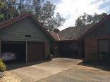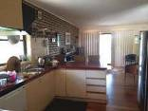home built in 1976 of 157 sqm in average condition with a double car garage, decking and verandah. The house is currently occupied. There are several additional sheds on the land, with a tennis court and basic landscaping

.

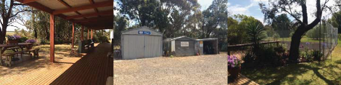

Inspection photos: 6th January 2014 3pm.

22 - 30 Trethowan Avenue, Ocean Grove

Use: Currently used as rural lifestyle.

Legal Description: All of the land contained within Lot 16 on Plan of Subdivision LP093928.

Based on our preliminary investigations it appears that the property is affected by what appears to be a drainage easements along the western and northern boundaries.

Site Description: The subject, referred to as 30 Trethowan Avenue, Ocean Grove, comprises
one lot of 2.026 hectares.

The site is a regular shape with relatively flat topography, and a slight slope towards the western boundary.

Zoning: The property is currently zoned ‘Rural Living’ (RLZ) under the City of Greater Geelong Planning Scheme. Under the Ocean Grove Structure Plan (Adopted 27th February 2007) the property is to be rezoned Residential 1 and will likely have a Design and Development Overlay.

Services: We understand all usual rural area services are available to the land and as instructed by council assume standard services are available to the land.

Improvements: There are improvements situated on the land, a three bedroom 1976 brick
veneer home of 220sqm in above average condition with a double car garage. The house is currently occupied. There is an additional shed on the land, and is landscaped.

(Note: Dwelling only externally inspected with permission of the tenant).

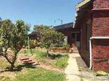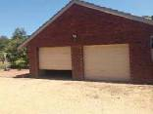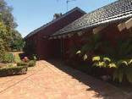

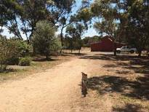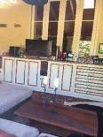
Inspection photos: 10th January 2014 1:25pm.

27 - 39 Trethowan Avenue, Ocean Grove

Use: Currently used as rural lifestyle.

Legal Description: All of the land contained within Lot 17 on Plan of Subdivision LP093928.

Site Description: The subject, referred to as 27-39 Trethowan Avenue, Ocean Grove, comprises
one lot of 2.024 hectares.

Based on our preliminary investigations it appears that the property is affected by what appears to be a drainage easements along the western boundary.

The site is a regular shape with relatively flat topography and a slight slope towards the western boundary.

Zoning: The property is currently zoned ‘Rural Living’ (RLZ) under the City of Greater Geelong Planning Scheme. Under the Ocean Grove Structure Plan (Adopted 27th February 2007) the property is to be rezoned Residential 1 and will likely have a Design and Development Overlay.

Services: We understand all usual rural area services are available to the land and as instructed by council assume standard services are available to the land.

Improvements: There are improvements situated on the land, a three bedroom brick veneer
home built in 1973 of 146sqm in below average condition. The house is currently occupied. There are several additional sheds on the land and the land has been fenced into paddocks for livestock.

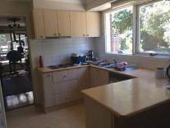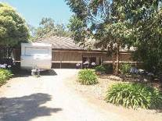

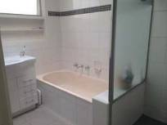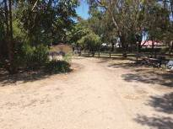
Inspection photos: 10th January 2014 1pm.



MARKET ANALYSIS

9.1 SUBJECT PROPERTY CONSIDERATIONS

The subject properties comprise three separate land parcels each with their own improvements generally being a dwelling and associated improvements, fronting either Banks Road or Trethowan Avenue, Ocean Grove. These properties are part of a larger development proposal comprising 22 existing lots, the subject properties are being examined in this case due to the proposed acquisition of land required for public purposes (public open space and retention basins) in the proposed development. They are located on the fringe of residential development in the Ocean Grove area.

Currently, the majority of properties are used for lifestyle or hobby farms. 35 Trethowan Avenue has several horses and the property is consequently divided into paddocks for this purpose. Currently zoned Rural Living, these properties are to be rezoned Residential 1 under the Ocean Grove Structure Plan and form a medium-high density residential subdivision. This will then align the North East Ocean Grove development properties with the neighbouring residential properties to the west (established) and north (subdivision in the process of commencing and currently under development).

The total site is ideal for residential development, with a relatively flat topography over the whole area, few existing dwellings and limited foliage to be removed for development to occur.

The proposed development area is approximately 43.6 hectares, with the anticipation of achieving a yield of at least 436 residential Lots (figure from 2005 lot analysis in the Ocean Grove Structure Plan 2007), current discussions with the planning department at Council suggest that this will be higher, with an indication that a density of 12 lots per hectare will be achieved.

The Ocean Grove Structure Plan has identified expansion of Ocean Grove to the north of Shell Road, this can already be seen in action with the subdivisions along Grubb Road, in behind the shopping centre and also north of the subject on Banks Road. There will be an abundant supply of land in the short to medium term within the north Ocean Grove area, softening potential growth in land values in the short to medium term give current market dynamics.

Sales within the Ocean Grove area of large parcels appropriate for subdivision range in price points, however, it is expected the closer a parcel is to being rezoned and developed that the value of the land will strengthen. Since the release of the structure plan, parcels within the subject development have sold at a range of values, with the upper end $900,000 - $950,000 per hectare for rural living zoned land with known future development potential. Smaller parcels within the Ocean Grove central area have achieved $1.9million per hectare for residential infill sites, whilst in Barwon Heads infill sites are achieving $4 million per hectare. Due to the nature of being infill sites, these are smaller than the subject properties considered and are also significantly better located south of Shell Road in the established area of Ocean Grove.

As there are limited broadhectare sales within the Ocean Grove area, the broader Bellarine Peninsula has been examined. A pattern is evident in the values associated with these transaction, the significance of being zoned Residential 1 or timing of development for an Urban Growth zoned property, has a strong relationship with the premium associated with the prices achieved. However, the Armstrong Creek precinct (in-land) and other areas along the northern side of the Bellarine Peninsula do have different premiums to the seaside like locations of Ocean Grove, Barwon Heads, Torquay and Point Lonsdale. Enquiries have indicated that a planning amendment application has been underway for some years, and could be rezoned within the year, consequently, this puts the time horizon for development of the subject to 12-18 months at the earliest.

MARKET OVERVIEW

  - Gross Domestic Product (GDP) growth expected to be below trend (around 2.5%) over 2013

  - Cash rate target dropped by 25 basis points to its lowest ever rate of 2.5%

  - Inflation measured by CPI rose 2.5% for the 12 months ending June 2013

  - Unemployment has risen to around 5.7%

10.1 GENERAL ECONOMIC O V E R VIEW

Moderate growth in the global economy has continued, though indicators have been somewhat mixed in recent months. Growth in the Chinese economy was a bit slower in the March quarter, but over the past year or so has been in line with the Chinese authorities' stated target. Infrastructure investment and demand for residential property continue to be important drivers of growth. In Japan, there is increased optimism regarding the outlook for the economy following fiscal and monetary policy initiatives, with measures of sentiment and forward-looking indicators of activity improving in early 2013. Elsewhere in East Asia, growth has generally eased a little in recent months following a noticeable pick-up in the December quarter. The US economy continues to grow at a moderate rate, notwithstanding the ongoing effects of fiscal consolidation. Information available to date suggests that the gradual improvement in US economic activity has not stalled following the cuts to public expenditure that came into force in early March. The Euro area remains in recession and the unemployment rate across the region is high. The weak state of some key private sector balance sheets and government finances will weigh on activity in the Euro area for some time and leave economies vulnerable to further adverse shocks. In recent months, there has been a decline in inflation in most regions of the World. Monetary policy settings globally are very accommodative.

The outlook for global economic activity is little changed. World GDP is expected to grow at a bit over 3.25% in 2013, slightly below its long-run average, before picking up to 4% in 2014. Growth in China is expected to remain around the rates seen in the second half of last year and provide a measure of support to activity in East Asia. The outlook in Japan has improved, while other advanced economies are expected to experience only a gradual improvement in economic conditions. Growth of Australia's major trading partners is expected to continue to exceed that of the World, reflecting the faster growth of Australia's trading partners in Asia.

The Australian economy grew at an around trend pace over 2012. Growth was a bit below trend in the second half of the year, with growth of consumption slowing and public demand recording a sizeable contraction. For the March quarter, growth in consumer spending looks to have recovered, with a strong pick-up in retail sales early in the year and measures of consumer sentiment above their long-run average. Sales of motor vehicles to households have declined over recent months, but remain at a high level following substantial increases last year.

10.2 A U S T RALIAN DOLLAR

Global developments including the tightening of short-term liquidity in China and the rise in global bond yields have contributed to a further depreciation in the Australian dollar. On a trade-weighted basis, the Australian dollar was around 12% below the high reached in early April and close to its lowest level since September 2010. Overall, domestic financial markets viewed the lower exchange rate as reducing the need for monetary policy to be eased further, with the market at the time of the meeting attaching a 25% probability of a decline in the cash rate occurring in July, with only a single reduction expected by the end of the year.

The average daily Trade Weighted Index of 72.12 for June represents another significant decrease from the May figure of 75.67, when compared to the April figure of 78.84. For the month of June, the average US dollar daily closing price of the Australian dollar has dropped approximately 4.9 cents to 0.94 US dollars; this is in stark contrast to the January 2013 figure of 1.05 US dollars.

10.3 INTEREST RATES

The decision reached on the 6th August by the RBA regarding the target cash rate was for it to be reduced by 25 basis points to its lowest ever level at 2.5%. The rate remained unchanged in September 2013.

Recent information suggested that the economy was growing at a below trend pace. Indicators of consumer spending had been soft. Borrowing for housing had picked up, as had dwelling prices, and there had been an increase in leading indicators of dwelling construction, but to date this had been moderate rather than strong. Employment growth was continuing, but at a pace below the rate of growth of the labour force, and unemployment had tended to rise. Inflation remained low and, allowing for the effects of the introduction of the carbon price, was around the bottom of the target range. Wages growth was slowing.

On balance, with growth expected to remain below trend for longer and inflation to remain within the target even with the effects of a lower exchange rate, the bank concluded that a lower level of the cash rate would better contribute to achieving sustainable growth in demand consistent with the inflation target. Given the exchange rate adjustment that was occurring, and with the substantial degree of monetary stimulus already in place, members assessed the current stance of policy to be appropriate for the time being. The Board also judged that the inflation outlook, although slightly higher because of the exchange rate depreciation, could still provide some scope for further easing, should that be required to support demand.

10.4 UNEMPLOYMENT

The unemployment rate has increased to 5.7% for the month of June. The unemployment rate has slowly steadily increased since June last year when a rate of 5.1% was recorded.

Labour market conditions remained somewhat subdued. While changes in employment had been volatile from month to month, year-ended growth, at a little over 1%, continued to be below population growth. Overall, unemployment had been on a gradual upward trend over the past year or so, even though the unemployment rate ticked down to 5.5% in May. Average hours worked declined further in May and were at a two-year low. Over the past few months, employment growth had been strongest in New South Wales and South Australia. Employment had been flat to declining in Queensland and Western Australia, consistent with a decline in demand associated with mining-related activity in those states. Forward-looking indicators of labour demand implied only modest growth in employment in the months ahead.

10.5 INFLATION

Consumer price inflation slowed in the March quarter. The low quarterly outcome (0.1% on a seasonally adjusted basis) was partly attributable to falls in the volatile prices of fruit, vegetables and automotive fuel. It also reflected a decline in prices for a broad range of tradable items, particularly for consumer durables. These declines have occurred despite the relative stability of the exchange rate over the past couple of years and highlight the pressures on domestic costs and margins relevant to tradable goods and services. In contrast, non- tradable inflation has increased a little over the past year, although part of this reflects the introduction of the carbon price (and changes to the private health insurance rebate). The various measures suggest that underlying inflation was a little under 0.5% in the March quarter, which was a touch softer than had been expected, and a little under 2.5% on a year-ended basis.

10.6 BUSINESS CONFIDENCE

The June NAB Business Confidence Survey paints a worrying picture of the Australian economy; business conditions slumped in June to their lowest level since May 2009. Weaker trading conditions and profitability combined with still poor employment conditions drove business conditions lower, with each of these indicators remaining well below average levels. Conditions deteriorated heavily in mining, retail and manufacturing (despite a tumbling Australian dollar). Weak forward indicators – including forward orders, stocks, capacity utilisation and employment conditions – remain concerning and suggest little improvement in near-term demand.

Business confidence lifted marginally in June, but remained lackluster. The falling Australian dollar appears to have done little to lift spirits, with concerns about global economic conditions likely to be weighing. Overall weakness in domestic economy also likely to be worrying firms. Federal government reshuffle occurred during the final days of survey period, but the survey provides little indication about how sentiment may have been affected. Overall, the NAB Business Confidence Survey implies underlying demand growth and GDP (6-monthly annualised) of around 2.5% in the June quarter. Our wholesale leading indicator suggests a modest improvement in near-term activity, at best.

SOURCE: RESERVE BANK OF AUSTRALIA, NATIONAL BANK OF AUSTRALIA

Residential Property Market

  - Melbourne median house price rises by 2.4% for the June 2013 Quarter

  - Regional Victoria median house price dropped by 0.8% in the June 2013 Quarter

  - Auction clearance rate for June was 70%, which has seen a subsequent increase in September 2013

  - 3.3% increase in Housing Price Index for year ending June 2013

  - 1.2% increase in value of finance obtained for June 2013

  - Decrease in vacancy rate to 2.70% for regional Victoria and 2.9% in Melbourne as of September 2013

11.1 GENERAL OVERVIEW OF GEELONG RESIDENTIAL SECTOR

Geelong house prices have demonstrated no change over the last quarter ending June 2013, remaining at
$385,000. This is a similar trend seen in other regional centres in Victoria like Bendigo and Ballarat. However, the capital growth noted in the past five years (2008 – 2013) for the area equates to 30%, significantly larger than the regional average of 16.8%.

The median price change since June 2012 to 2013 was an annual change of 1.2%, demonstrating only slight movement within the market for Geelong. This is considerably below the annual change in the Melbourne metropolitan median house price of 8.4%. In comparison to regional centres, Bendigo demonstrated a positive annual change of 3.3%, and Ballarat 0.9%, however, regional Victoria as a whole demonstrated a negative annual change of 0.6%.

Areas within the Geelong region, particularly within the central Geelong area have demonstrated an uplift in value as a result of land scarcity and close proximity to central activity centres. Key areas of growth are in the broader Geelong area is focused on the urban growth areas, in particular residential development of new housing estates located in Lara, Highton, Waurn Ponds, Leopold, Armstrong Creek, Drysdale, Ocean Grove and Curlewis. Land within these areas is in relative abundance due to the significant number of land releases happening within these areas. These new residential land estates bring further planned commercial infrastructure and ensure areas are well supported and community requirements are met.

Unemployment within the region has remained stable at 6.5% in the June quarter. Local employment markets are having an impact of the confidence in the Geelong residential market, with the recent announcement that the Ford Geelong production plant will close in October 2016 along with other pessimism surrounding other major employers in the region like Shell and Alcoa. This has potentially been a factor in the market that has led to a reduction in sales in the region. The five-year average per annum was circa 5,000 house and units sales, however, in the last 12 months ending May 2013 it is anticipated sales have dropped to 3,800, 26% lower than the five-year average. However, recent news relating to the NDIS headquarters to be set up in Geelong and the expansion of Deakin University are going to provide a significant and sustained flow of new jobs into the market, consequently mitigating negative changes in other sectors.

The future outlook for the Geelong area is to remain stable due to the increase focus on the Geelong region as an affordable lifestyle alternative to Melbourne. Increased improvement in transport links to the city and the expanding residential development of the area are providing strong drivers for future growth within area.

11.2 AUCTION CLEARANCE R A TE

The Greater Geelong auction clearance rate for the year ending May 2013 compared to previous years is 58% lower than the five-year average of 62%. However, recent renewed optimism in Melbourne and Australian residential markets in September 2013 indicates there may be a positive turn of direction for the residential market.

11.3 PRIVATE SECTOR HOUSING APPROVALS

In the Greater Geelong area there were 1,900 new building approvals for the 12 months ending May 2013. This is a 6% increase above the five-year average for Private Sector Housing Approvals.

11.4 HOUSING FINANCE

Figures released by the ABS indicate that the value of housing commitments rose 1.2% from May to June 2013. The value of housing commitments for June 2013 was $23.69 billion, compared to the 12 month rolling average of $21.78 billion per month.

11.5 OCEAN GROVE LOCAL MARKET

The median value of Ocean Grove house market has hovered around the $430,000 to $500,000 throughout 2012 and 2013, and currently sits at $491,500. Compared to the Greater Geelong median house price, Ocean Grove has maintained a relatively stable level since 2011. New development is happening within several regions in Ocean Grove with land prices starting at $175,000 in the Oakdene Estate (off Grubb Road), $169,500 in the Kingston estate for compact blocks and new house and land packages ranging from $300,000 to $400,000. Allotments closer to the beach start around the $350,000 price point.

Broad hectare sales are presently dominated by sales within the Armstrong Creek region.

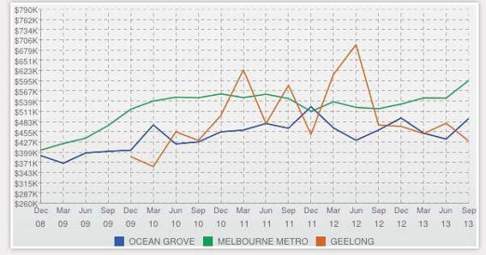

Source: www.realestateview.com.au 13/1/2014

VALUATION RATIONALE

We consider that direct comparison on a rate per hectare of land area provide the best indicator of value. In making this assessment, we have been asked to provide a value for each property.

12.1 COMP ARABLE SALES ANA L YSIS

In referring to sales information detailed within this report, we have relied on a range of external sources including publicly available information (newspapers, statements by public companies), subscription to information databases and information generally provided verbally by others such as estate agents, property managers, property valuers and consultants. We have not had access to original source material such as contracts of sale.

Although we have no reason to doubt the validity of the information provided to us, and we have relied on this information in good faith, we are unable to state with certainty that the information which we have relied on is consistent with the contractual arrangements between the relevant parties. Furthermore, we make no warranty as to the maintenance of this information in relation to market volatility, beyond the date of valuation.

A summary of the Comparable Sales Analysis used in arriving at our valuations, the following Residential 1 and Urban Growth zoned sites have been analysed:

No | Land Area (Hectares) | Sale Date | Sale Price | Zoning | Building | Added Value Imp’ts | Analysed Sale
 |  |  |  |  | Area | Added Value Imp’ts | $/ha (Land)
1 | 2-6 Tyntynder Close, Armstrong Creek
2 | An irregular shaped parcel of land within the Warrilily Estate in Armstrong Creek. The site is flat and has new residential homes surrounding the site. Purchased by the Roman Catholic Trusts Corporation this site has been identified as a future school site.
2 | 2.8 | Apr-13 | $2,900,000 | UGZ2 | - | - | $1,035,714
2 | 614-620 Torquay Road, Armstrong Creek
3 | Residential development site within the Armstrong Creek East Precinct purchased by TLC Homes. Advertised with potential for 35 allotments (STCA) and located on the corner of Torquay and Stewarts Roads. Improved with five-bedroom brick dwelling constructed circa 1998 that adds some short-term value to the land
3 | 2.023 | Oct-12 | $1,500,000 | UGZ2 | 300 | $100,000 | $692,042
3 | 359-363 Horseshoe Bend Road, Armstrong Creek
4 | Residential site located within the Horseshoe Bend Precinct. Property was not advertised with any development potential and was improved with a good-quality, three-bedroom weatherboard dwelling constructed circa 2004, which adds some value to the land
4 | 0.822 | Jan-12 | $850,000 | UGZ | 265 | $150,000 | $851,582
4 | 83-89 Melaluka Road, Leopold
5 | Vacant fringe development site with frontage to both Melaluka Road and Stringers Lane. An adjoining 3.7ha development site has been recently developed with a mixture of medium-density dwellings and higher density townhouses.
5 | 2.868 | Nov-11 | $2,500,000 | R1Z | - | - | $871,688
5 | 86-90 Central Road, Clifton Springs
 | Corner residential allotment with permits for a staged multi lot subdivision. Sold with dwelling in average condition that will be removed. Topography is relatively even and suitable for development.
 | 0.8174 | Mar-11 | $800,000 | R1Z | 209 | $0 | $978,712.99

No Land Area (Hectares)

Sale Date Sale Price Zoning Building
Added Value Imp’ts

Analysed Sale

- 94-116 Central Road, Clifton Springs
Level corner residential allotment with permits for a staged multi lot subdivision. Sold with sizeable dwelling in relatively good condition that would be removed for multi-lot development.
2.453 Mar-11 $1,800,000 R1Z 205 $0 $733,795.35
- 99-113 Jetty Road, Clifton Springs
A regular shaped parcel of land on a corner allotment. Topography is relatively even and suitable for development. Property is located on the fringe of residential development on the south side of Clifton Springs
1.6898 Mar-11 $1,125,000 R1Z $0 $665,759.26
- 31-41 Sparrowvale Road, Charlemont
‘L’-shaped property located within the future North East Industrial Precinct. Property has level topography with considerable frontage to the unmade Sparrowvale Road and secondary frontages to Tannery Road and Brearleys Lane. Approx. 2 hectares of the property fronting Brearleys Lane is affected by Environmental Significance (ESO) and Floodway (FO) overlays.
12.119 Dec-11 $5,060,000 UGZ1 - - $417,526
- 41-99 Burvilles Road, Armstrong Creek
Designated medium-high density development site directly adjoining the Activity Centre and located on the corner of Burvilles and Barwarre Roads. Designated in the Horseshoe Bend precinct with possible future public transport interchange and passive parkland. Property was back on the market in late 2012 with limited interest. Improved with 1980’s dwelling that adds limited short-term value to the land.
16.13 Dec-11 $7,650,000 UGZ 222 $100,000 $468,072
- 71-77 Seabank Drive, Barwon Heads
Corner residential allotment opposite public park in central Barwon Heads.
0.2846 Dec-08 $1,150,000 R1Z - - $4,040,759
- 79 - 87 Tuckfield Street, Ocean Grove
Development infill site in central Ocean Grove on the Dysdale Ocean Grove Road.
0.543 Jan-08 $1,050,000 R1Z - - $1,933,702
- 92-120 Sheepwash Road, Barwon Heads
Development site near the Barwon Heads River, however located away from the bridge and town centre, subsequently land has been developed by purchaser.
3.4891 Dec-09 $6,350,000 R3Z - - $1,819,954
- 46 Grossmans Road, Torquay
Main road frontage R1Z site which has St Theresa Catholic Primary school on western boundary, and existing P-9 state school opposite. Relatively flat, well suited to subdivision and expected to be developed to a minimum 18 lots per hectare.
1.0 Oct-10 $1,350,000 R1Z - - $1,350,000
- 30 Illawong Drive, Corner Briody Drive, Torquay
Low density residential site adjoining R1Z zoned land, in a slightly elevated position. Sealed road frontage on two sides and some potential for views from Briody Drive frontage lots. Sale includes existing residence.
1.0 Feb-10 $1,400,000 LDR - - $1,400,000

Comment: The broad hectare sales of Residential 1 zoned land is limited, consequently, we have included sales that are located within Urban Growth Zones that anticipate a residential rezoning in the future. Consequently, the sales prices attributed to the land varies dependent on the likely development timeline, for example, land that is in the UGZ that will be rezoned imminently, will command a higher price than another property with the same zone, but is not expected to be rezoned for 5 – 10 years. In considering the comparable sales we have had been mindful of the likely development timeframes of the sales. The analysis has also made reference to and taken into account in our analysis the likelihood of the short term value the improvement may add to the property.

The majority of these sales are located inland on the Bellarine Peninsula, rather than in seaside towns or areas, the premium noted in residential lot transactions for parcels say in Armstrong Creek are very different to those prices achieved in Torquay, Ocean Grove and Point Lonsdale.

Further sales from the area around Ocean Grove and within Ocean Grove of comparable sizes to the subject have been identified, some of which, are sales located within the proposed development. Furthermore, it is apparent the premium among these sales between the parcels of land located inland versus properties located within the one of the seaside areas. Also note that these sales are predominately Rural Living Zone and Farming Zone.

Address | Land Area (ha) | Zone | Last Sale Price |  | $/ha |  | Sale Date
197-199 Shell Road, Ocean Grove VIC 3226 | 1 | RLZ | $ | 950,000 | $ | 950,000 | 16-Jul-07
42-50 Ocean Grand Drive, Ocean Grove VIC 3226 | 2.0241 | RLZ | $ | 815,000 | $ | 402,648 | 07-Apr-08
652-670 Wallington Road, Wallington VIC 3222 | 4.3752 | RLZ | $ | 1,300,000 | $ | 297,129 | 07-May-08
51-59 Ocean Grand Drive, Ocean Grove VIC 3226 | 2.0234 | RLZ | $ | 1,000,000 | $ | 494,218 | 12-Dec-08
191-195 Shell Road, Ocean Grove VIC 3226 | 1.5664 | RLZ | $ | 1,100,000 | $ | 702,247 | 02-Mar-09
181-189 Shell Road, Ocean Grove VIC 3226 | 2.1164 | RLZ | $ | 750,000 | $ | 354,375 | 18-Mar-09
42 Hardings Road, Wallington VIC 3222 | 4.1469 | FZ | $ | 960,000 | $ | 231,498 | 17-Nov-09
210-260 Charlemount Road, Connewarre | 5.6641 | UGZ2 | $ | 2,750,000 | $ | 485,514 | 01-May-10
72-90 Hardings Road, Wallington VIC 3221 | 5.92928 | FZ | $ | 825,000 | $ | 139,140 | 05-Jul-10
262-280 Grubb Road, Wallington VIC 3221 | 8.7614 | FZ | $ | 1,820,000 | $ | 207,729 | 18-Aug-10
46-50 Hardings Road, Wallington VIC 3221 | 3.551 | FZ | $ | 945,000 | $ | 266,122 | 04-Jan-11
12-20 Trethowan Avenue, Ocean Grove VIC 3226 | 2.0241 | RLZ | $ | 1,250,000 | $ | 617,558 | 10-Mar-11
151-179 Geelong Road, Portarlington VIC 3223 | 1.5247 | FZ | $ | 899,000 | $ | 589,624 | 15-Apr-11
52-60 Ocean Grand Drive, Ocean Grove VIC 3226 | 2.0243 | RLZ | $ | 1,800,000 | $ | 889,196 | 21-Oct-11

12.2 RESIDENTIAL 1 ZONE V A L U E ASSESSMENT

Direct Comparison – Rate per Hectare of Land Area

We consider that direct comparison on a rate per hectare of land area provide the best indicator of value. In making this assessment, we have been instructed to provide a market value of the subject properties under a Residential 1 Zone. In making this assessment, we have been asked to provide a value for each property. For this valuation where the properties are zoned Residential 1, we have made the assumption that the subject properties will comprise part of the larger subdivision development, however, we have allocated a value to each land parcel.

In determining our market value of the properties under the proposed new zone ‘Residential 1’, we considered broad hectare properties that are allocated for subdivision and medium density residential development in Ocean Grove and surrounding areas. In particular we note the following comparable sales:

- 46 Grossmans Road, Torquay, a one hectare parcel zoned Residential 1 located opposite the State School and adjacent the Catholic primary school, sold in 2010 for $1,350,000, demonstrating a rate of
$1,350,000 per hectare. Overall this is a superior location, and a smaller lot, however the situation of this parcel in relation to key retail services in Torquay assists in setting the upper benchmark for Residential 1 zoned land.

- 2-6 Tyntynder Close, Armstrong Creek is an infill parcel within the Warralily Estate, with finished roads and all services available was sold in April 2013 for $2,900,000 for a 2.8 hectare plot of land, which exhibits a rate of $1,035,714 per hectare. This rate we believe reflects the current ability of this lot to be utilised or built upon immediately with all services available.

- 52-60 Ocean Grand Drive Ocean Grove, also part of the proposed development, demonstrated a rate of
$889,196 in October 2011.

- 83-89 Melaluka Road, Leopold, fringe development site adjacent to other residential development sold in November 2011 for $2,500,000 for 2.868 hectares demonstrating a rate of $871,688/hectare.

- 79-87 Tuckfield Road in Ocean Grove, demonstrated a rate of $1,933,702 and is an infill development site, smaller than the subject properties, it is well located within Ocean Grove and demonstrates the upper end for prime residential development land within the area.

- 86-90 Central Road, Clifton Springs, is a corner allotment zoned R1Z to be developed for residential subdivision, sold in March 2011, for 0.8174 hectares demonstrating a rate of $978,712/hectare.

- 614 – 620 Torquay Road, Armstrong Creek sold in October 2012 for $1,500,000 and is currently located within an Urban Growth Zone, indicating residential development potential. A dwelling is currently adding short-term value to the land. This sale established a rate of $692,042/ hectare for 2.023 hectares after consideration of the improvements,

- A smaller site at 359-363 Horseshoe Bend Road, Armstrong Creek as sold in January 2012, comprising flat pasture land and a three bedroom weatherboard dwelling (circa 2004), which adds some value to the land. After consideration of the improvements this sale revealed an analysed rate of
$851,582/hectare for the 0.822 hectare site.

The range in the analysed rates per hectare varies notably, and has a strong relationship with timing of rezoning or development potential of the land, also whether the property is located in a rural setting inland Bellarine, or whether it is coastal. Consequently in assessing rates for the subject properties, we have taken into consideration the zoning, timing of the properties as a residential development and the premium associated with coastal living.

After careful consideration of the sales evidence we have adopted a land value rate of $1,000,000 per hectare, for the Trethowan Avenue properties under a Residential 1 Zone control. We have adopted a slightly lower rate for Banks Road, given that it is more distant from existing developed land.

Thus the assessed before values of the subject properties is:

 | Area | Assessed Value
Property | Before | Rate per hectare | Value Before
802 - 820 Banks Road, Ocean Grove | 2.049 | $950,000 | $1,946,550
22 - 30 Trethowan Avenue, Ocean Grove | 2.026 | $1,000,000 | $2,026,000
27 -39 Trethowan Avenue, Ocean Grove | 2.024 | $1,000,000 | $2,024,000

VALUATION FOR LAND ACQUISITION

13.1 LAND TO BE ACQUIRED
As per the instructions from Mr John O’Shannassy and Mr Rob Anderson of City of Greater Geelong, we have been asked to assess the properties using a ‘Before and After’ land valuation process to determine the change in value of the lots where land has been acquired by council for public purposes.

In this particular case, as part of the proposed rezoning to Residential 1 and the subsequent subdivision and development of this area as a whole, several drainage reserves and public open space reserves are required. This land will be acquired by the council as part of the development process.

As shown on the map below provided by Mr John O’Shannassy, there are two drainage reserves, one on the north-eastern corner of the proposed development, and the other on the western side as shown on plan below, in addition to several public open space reserves highlighted in green.

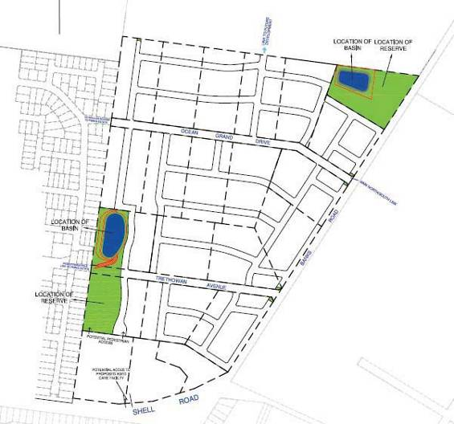

The north-east retention basin and open space reserve is now to be completely located within the parcel known as 802 - 820 Banks Road (known as 820 Banks Road), shown in red, as per discussion with John O’Shannassy on the 7th January 2014 and subsequent changes to the plans received on 4th March 2014, the entirety of 820 Banks Road, will be acquired for a basin and public open space. Therefore a total acquisition of the 2.049 hectare parcel
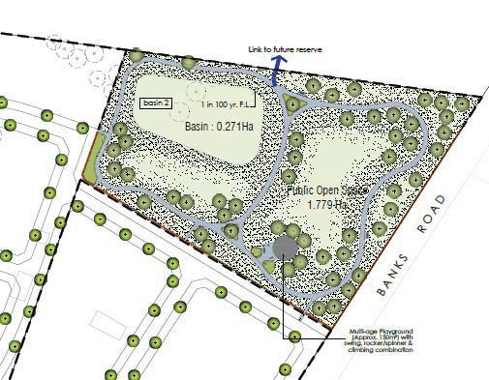known as 802-820 Banks Road.

The western retention basin and open space reserve is distributed over two parcels, 22 - 30 Trethowan Avenue (shown in Blue) and 27 – 39 Trethowan Avenue (shown in Red).

The land to be acquired at 22-30 Trethowan Avenue is highlighted in blue on the excerpt from the proposed landscape drawings for the development.

The land to be acquired from 22 - 30 Trethowan Avenue, Ocean Grove comprises:
- Basin 0.472 ha
- Reserve 0.583 ha
Creating a total of 1.055 ha to be acquired.

The remaining parcel of land, has road frontage to Trethowan Avenue, and also has a substantial dwelling which is not affected by the acquisition. Analysis of the market for retaining the existing dwelling on the land, demonstrated that the underlying value of the land for development is considered to outweigh the value of retaining the dwelling on the site.

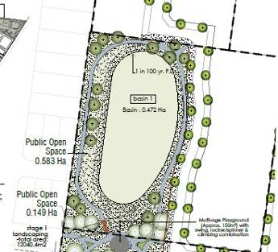Thus the rate selected for 22-30 Trethowan Avenue is $1,200,000 per hectare.

The land to be acquired at 27-39 Trethowan Avenue is highlighted in red on the excerpt from the proposed landscape drawings for the development.

The land to be acquired from 27 - 39 Trethowan Avenue, Ocean Grove comprises:
- Reserve 1.133 ha
Creating a total of 1.133 ha to be acquired.

The dwelling on this particular parcel will be acquired to make way for the public open space reserve. The remaining parcel of land, has road frontage to Trethowan Avenue, and will as part of the future subdivision have road frontage along the western side. As a result, we have had reference to sales of land of around a hectare in size and consideration of the additional value achieved through further subdivision of lots to the rear.

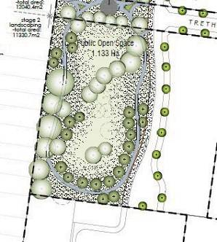Thus the rate selected for 27-39 Trethowan Avenue is $1,200,000 per hectare.

As per the figures provided by Mr John O’Shannassy, in the landscape concept drawings dated 1/10/2013, and further discussions with the aforementioned on the 7th January 2014, and the revised landscape plans on the 4th March 2014, the following areas for drainage and public open space are deducted from the areas of the subject properties:

Property | Land Area (ha) | Drainage Basin (ha) | Public Open Space (ha) | Total Land Acquired | Land Remaining (ha)
802-820 Banks Road, Ocean Grove | 2.049 | 0.27 | 1.779 | 2.049 | 0
22-30 Trethowan Avenue, Ocean Grove | 2.026 | 0.472 | 0.583 | 1.055 | 0.971
27-39 Trethowan Avenue, Ocean Grove | 2.024 |  | 1.133 | 1.133 | 0.891

Valuation Rationale: In assessing the value of the lots on a ‘Before and After’ basis, we have assumed as instructed that the lots are zoned Residential 1. In making our assessment we have assessed the lots on an individual basis using the direct comparison approach, taking into account similar sized and zoned properties, as detailed above. The valuation of these properties is based on a rate per hectare.

Comments: A portion of the subject land has been identified as being required for two drainage reserves and several public open space acquisitions by council on the aforementioned properties, areas as per table above.

Date of Valuation: 1 July 2013

Valuation: After careful consideration of the sales evidence we advise that a fair and reasonable indicative land value rate is:

Property | Land Area (ha) | Land to be Acquired | Land Area (ha) After | Before | After Acquisition | Value of land acquired
802-820 Banks Road, Ocean Grove | 2.049 | 2.049 | 0 | $1,946,550 | $0 | $1,946,550
22-30 Trethowan Avenue, Ocean Grove | 2.026 | 1.055 | 0.971 | $2,026,000 | $1,165,000 | $861,000
27-39 Trethowan Avenue, Ocean Grove | 2.024 | 1.133 | 0.891 | $2,024,000 | $1,069,000 | $955,000

* ‘Before and After’ acquisition values have been rounded for reporting purposes The above values are net or exclusive of Goods and Services Tax (GST)

DECLARATIONS

14.1 PECUNIARY I N TEREST

Neither Westlink Consulting nor its directors or staff have any pecuniary interest in the subject property, nor do they have a connection with the borrowers nor any business entity with which they are associated.

14.2 MARKET MOVEMENT

This valuation is current as at the date of valuation only. The value assessed herein may change significantly and unexpectedly over a relatively short period (including as a result of general market movements or factors specific to the particular property).

We do not accept liability for losses arising from such subsequent changes in value.

Without limiting the generality of the above comment, we do not assume any responsibility or accept any liability where the valuation is relied upon after the expiration of ninety (90) days from the date of the valuation, or such earlier date if you become aware of any factors that have any effect on the valuation.

14.3 STRUCTURAL D ISCLAI MER

We have carried out a visual inspection of exposed and readily accessible areas of the improvements as described in the report. However we are not building and/or structural engineering experts. As such, we are unable to advise or comment on the structural integrity or soundness of the improvements.

We have not sighted a qualified engineer’s structural survey of the improvements, or its plant and equipment. We are not building construction and/or structural engineering experts, and are therefore unable to certify as to the structural soundness of the improvements. Prospective purchasers would need to make their own enquiries in this regard.

We have not sighted a structural report on the property nor have we inspected unexposed or inaccessible portions of the premises. We therefore cannot comment on the structural integrity, defect, rot or infestation of the improvements nor can we comment on any construction material such as asbestos or other materials now considered hazardous.

14.4 GOODS AND SERVICES T A X (GST)

In analysing the sales and/or leasing evidence referred to herein, we have attempted to ascertain whether or not the sale price/rental is inclusive or exclusive of Goods and Services Tax (GST).

Where we have not been able to verify whether or not GST is included in the sale price or rental, we have assumed that the sales price or the rental is exclusive of GST. Should this not be the case for any particular sale or letting used as evidence, we reserve the right to reconsider our valuation.

The value expressed in this report is exclusive of GST. However, GST implications may arise depending on the intended use of the property and/or the status of the parties to any transaction involving the property. We are not GST or tax experts. The client should therefore obtain its own independent advice concerning any GST implications that may arise in respect of the property. If GST implications do arise, this report should be referred back to Westlink Consulting for consideration, and if necessary, amendment.

14.5 MARKET VALUE

Subject to all qualifications and assumptions contained within the body of this report, we assess the Market Value of the properties required for acquisition in the North East Ocean Grove Development, Ocean Grove the following properties’ market value as at 1 July 2013:

Property | Land Area (ha) | Land to be Acquired | Land Area (ha) After | Before | After Acquisition | Value of land acquired
802-820 Banks Road, Ocean Grove | 2.049 | 2.049 | 0 | $1,946,550 | $0 | $1,946,550
22-30 Trethowan Avenue, Ocean Grove | 2.026 | 1.055 | 0.971 | $2,026,000 | $1,165,000 | $861,000
27-39 Trethowan Avenue, Ocean Grove | 2.024 | 1.133 | 0.891 | $2,024,000 | $1,069,000 | $955,000
* ‘Before and After’ acquisition values have been rounded for reporting purposes

The above values are net or exclusive of Goods and Services Tax (GST)

This valuation has been prepared for the City of Greater Geelong and Mr John O’Shannassy for the aforementioned purpose.

Westlink Consulting does not accept responsibility to any third party, nor there be any reliance on this report by any third party other than the person to whom it is addressed. Neither the whole, nor any part of it, may be published in any document, statement circular or otherwise, or in any communication with a third party, without the prior written consent of Westlink Consulting as to the form and content in which it appears.

Valuer:



Dr Georgia Warren- Myers AAPI No.63389 Brian Robinson AAPI No. 62215
Certified Practising Valuer Certified Practising Valuer
Westlink Consulting Westlink Consulting

APPENDICES

APPENDIXONE:LETTEROFINSTRUCTION

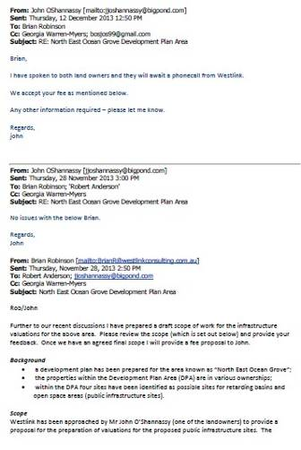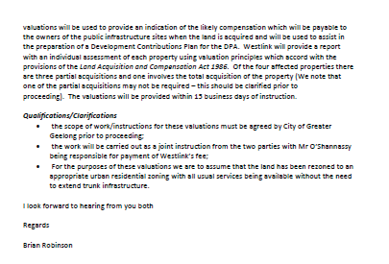

APPENDIXTWO:TITLES

