Amendment C312

Implementation of the St Leonards
Structure Plan Review
The vision for St Leonards is that it will
continue its role as a coastal village providing for sustainable growth of residential and commercial uses in a way which respects and enhances its coastal setting, rural and environmental landscape values.
Has the St Leonards Structure Plan
been adopted by Council?
After a community and stakeholder con- sultation program in April/May 2012, a revised Structure Plan was presented to Council at its 25 February 2014 meet- ing, where the document was adopted.
Can I make a submission to C312?
Yes. Submissions to Amendment C312 should be received by Monday 8 Sep- tember 2014 and addressed to:

The Coordinator, Strategic Implementa- tion, City of Greater Geelong, by:
•
post to - PO Box 104, GEELONG
VIC 3220 or
email to - strategicplanning@gee- longcity.vic.gov.au
The St Leonards Structure Plan 2006
was reviewed by Council as part of its
5 year review cycle. This culminated in the completion of the St Leonards Structure Plan 2014.

Amendment C312 seeks to implement
the key recommendations identified in the Structure Plan into the Greater Geelong Planning Scheme.
What is Amendment C312?

Amendment C312 is changing the Greater Geelong Planning Scheme to formally implement the key recommen- dations of the St Leonards Structure Plan 2014. The Local Planning Policy will be updated to reflect the new objec- tives and strategies for St Leonards.

The major change recommended by the St Leonards Structure Plan 2014 is to rezone land on the western edge of the Township for residential development. These areas are identified as Growth Area 1 and Growth Area 2 on the St Leonards Structure Plan Map.

Does Amendment C312 rezone the
Growth Areas?

No. The two growth areas will be considered for rezoning to the General Residential Zone through separate planning scheme amendments. Both amendments will be placed on public exhibition for comment.
•
Where can I go for more informa-
tion?
The amendment is available for viewing at the following centres:
•
City of Greater Geelong 100
Brougham Street Geelong
City of Greater Geelong 18-20
Hancock Street Drysdale (inside the library)
St Leonards Community Meeting
Space 1377 Murradoc Road (10am-
3pm Tue, Wed, Thurs)
What is the St Leonards Structure
Plan?

The St Leonards Structure Plan 2014 is a strategic framework for the future de- velopment of the Township. The Struc- ture Plan sets out a shared community, stakeholder and government vision for the area. It identifies strategies and ac- tions to be achieved for St Leonards in regards to population growth, retailing and community facilities, open space planning and environmental protection and enhancement.
•
•
You can also go to the “Have Your Say”
section of our website at www.geelon- gaustralia.com.au/council/yoursay or
the Department of Planning’s website at www.dtpli.vic.gov.au
For further assistance call us on 5272
4496 or email: strategicplanning@gee- longcity.vic.gov.au
Key Objectives for St Leonards Township
mercial use within St Leonards and direct service business
and industrial development to other designated locations.

Support the ongoing upgrading of open space, leisure and recreation areas undertaken for and on behalf of public land managers including provision of pedestrian/cycle linkages.

Encourage retention and enhancement of existing vegeta- tion on private land, roadsides and reserves using locally indigenous plantings.

Support the ongoing management and sensitive develop- ment of the foreshore, Salt Lagoon Wildlife Reserve and Ed- wards Point State Faunal Reserve by public land managers.

Retain the existing Rural Zones outside the Settlement
Boundary.

Undertake a minor review of the St Leonards Structure Plan
2014 in 10 years to update policy context and review the retail needs of the town.
•
Ensure that urban development does not occur outside the
defined Settlement Boundary as shown on the accompanying
St Leonards Structure Plan Map.

Support new residential development in Growth Area 1 and Growth Area 2 as shown on the accompanying map consist- ent with the Subdivision Development Principles identified in the Structure Plan.

Encourage appropriate infill residential development where drainage and servicing issues can be addressed and which ensures urban development does not encroach onto or have an adverse effect on significant environmental features.

Support a mix of housing types, particularly around the Town
Centre.

Support further investigation and the development of an Early
Years Learning Facility within St Leonards.

Make no provision for additional land to be rezoned for com-
•
•
•
•
•
•
•
•
•
•
WWW.GEELONGAUSTRALIA.COM.AU

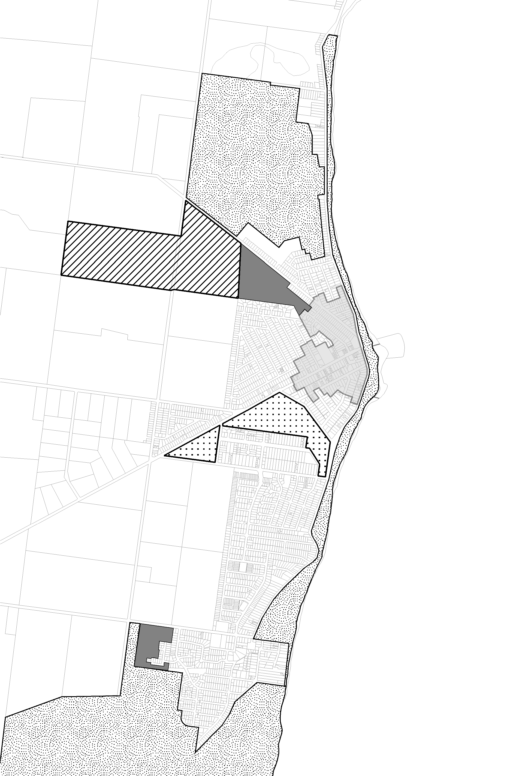
St
Leonards Structure Plan
Map
ST.LEONARDS
STRUCTURE PLAN MAP

Legend
retain as rural break
to Indented Head
SETTLEMENT BOUNDARY
protect
for scenic and ecological values
SHORT TERM R ESIDENTIAL GROWTH
ST LEONARDS GOLF COURSE
ENHANCE SIGNIFICANT RECREATION AREA
PROTEC T AND ENHANCE AREAS OF SIGNIFICAN T LANDSCAPE, ENVIRONMENTAL AND RECREATION VALUE
INCR EASED HOUSING DIVERSITY AREA
Salt Lagoon
Wildlife Reserve
KEY VIEWS TO BE PROTECTED AND ENHANCED
ENHANCE PIER - FORESHORE TOWN CENTRE FOCUS AND
LINKAGE
É É É É É SENSITIVE RESIDENTIAL INTERFACE
! ! ! ! ! ENHANCE / RETAIN LOCAL
Golf Course
PEDESTRIAN / CYCLE LINKAGES
FUTURE COMMUNITY USE
^
VEGETATION AND
HABITAT CORRIDOR
REZONE GENERAL
RESIDENTIAL
GROWTH AREA 1
^
protect rural land for resource and scenic values
consolidate town centre
GROWTH AREA 2
protect
protect
for scenic and
for scenic and ecological values
ecological values
N
0 100 200
400
600
800
M
Prepared by city of Greater Geelong - 6 June 2014
Although all due care has been taken to ensure that this docum ent is correct, no warranty
!
WWW.GEELONGAUSTRALIA.COM.AU
! ! ! ! ! ! ! ! ! ! ! ! ! ! ! ! ! ! ! !
É É É É
É
! !
É É É É
É
!
!

is expressed or im plied by the City of Greater Geelong or Barwon Water in its use.

