Planning and Environment Act 1987

GREATER GEELONG PLANNING SCHEME

AMENDMENT C312

EXPLANATORY REPORT

Who is the planning authority?
This amendment has been prepared by the Greater Geelong City Council which is the planning authority for this amendment.

Land affected by the amendment
The amendment applies to all the land identified in the St Leonards Structure Plan Study Area, as shown on the following map:
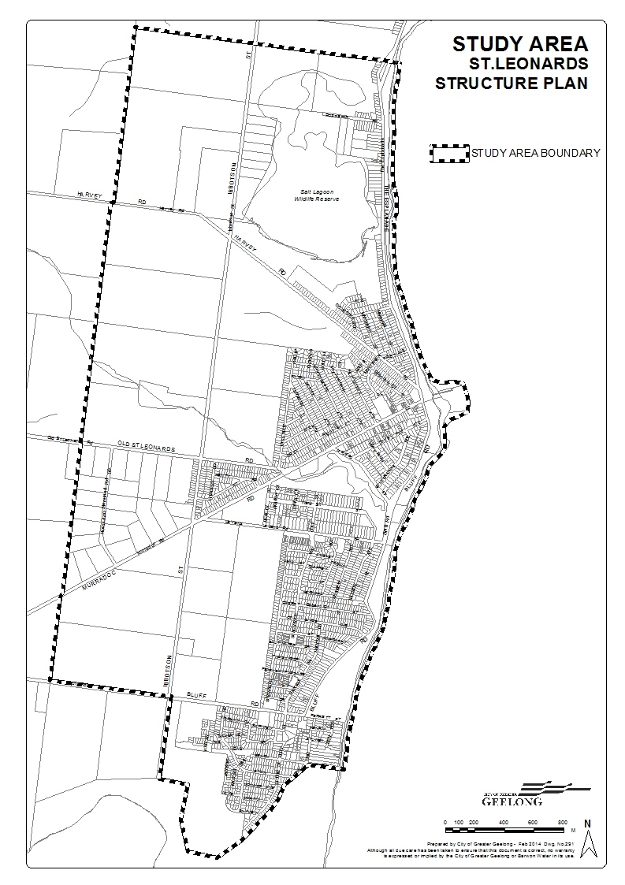

What the amendment does
The amendment reflects the review of the 2006 St Leonards Structure Plan. The St Leonards Structure Plan is a strategic framework for the future development of the township. The review of the 2006 Structure Plan culminated in Council adopting the St Leonards Structure Plan February 2014.

The Structure Plan supports the nomination of a clear settlement boundary, consolidation of the town centre, and the protection of the surrounding rural landscape and conservation reserves, as well as the town’s coastal setting. No additional land has been identified for future residential growth beyond the established settlement boundary.

The major change to result from this amendment is that the farming zoned land designated for potential long term residential growth in the map at Clause 21.14-4 will now be identified for rezoning to the General Residential Zone.

The amendment will:
- Replace the existing Municipal Strategic Statement for The Bellarine Peninsula at Clause 21.14 with an updated clause that will include the land use directions and policies identified in the adopted St Leonards Structure Plan February 2014.

Strategic assessment of the amendment

Why is the amendment required?
The 2006 St Leonards Structure Plan specified a minor review period of 5 years. Since the adoption of the 2006 Structure Plan a number of Planning policies and Council plans have changed or been amended. This includes a complete review of Council’s Municipal Strategic Statement as well as the preparation of a number of master plans relating to the recreation reserves and foreshore areas.
This review has built upon the current structure plan but has been amended to include updated State and Local Planning Polices, population growth, lot supply and dwelling construction rates, the location of the settlement boundary, environmental and social considerations including further service provisions for the township and a future review period.
The 2006 Structure Plan sought to protect two large tracts of land (known as Area 1 and Area 2) located to the west of the existing township, for potential long term residential growth. The St Leonards Structure Plan February 2014 now supports the rezoning of these areas to the General Residential Zone Schedule 1 subject to consideration of a planning scheme amendment(s).
The review of the Structure Plan has identified the need for an Early Years Learning Facility within the St Leonards community. The 2014 Structure Plan recommends that an agreement be entered into with the developers of Growth Areas 1 and 2 to require funds to be contributed to support the delivery of this facility in the medium term.
The amendment therefore is required to introduce into the Municipal Strategic Statement the updated strategic directions and land use policies for St Leonards that have been developed in the preparation of the new Structure Plan. In order for these to have statutory weight in the consideration of rezoning requests and planning permit applications, it is necessary for a new local policy for St Leonards to be prepared and implemented in the Greater Geelong Planning Scheme.

How does the amendment implement the objectives of planning in Victoria?
The amendment is consistent with the objectives of planning in Victoria.
The proposed changes to the Municipal Strategic Statement clause identifies and addresses the key strategic planning issues facing St Leonards and provides for fair, orderly, economic and sustainable use and development to balance the present and future interests of those living, working and visiting the township.

How does the amendment address any environmental, social and economic effects?
The revised Municipal Strategic Statement clause clearly outlines the future development potential of the township and immediately surrounding areas. Protection and enhancement of areas of environmental significance, such as the coastal foreshore, the Salt Lagoon Wildlife Reserve, Edwards Point State Faunal Reserve and Bellarine rural landscapes will be strengthened by the amendment.
The amendment will have positive social and economic effects on the community as it provides greater certainty and direction for future residential and commercial development. The amendment also identifies the need for an Early Years Learning Facility within the township

Does the amendment address relevant bushfire risk?
The amendment identifies land for future residential development on the western edge of St Leonards. Separate planning scheme amendments to rezone this land will need to consider bushfire risk, in consultation with Council’s Municipal Fire Prevention Officer and the County Fire Authority

Does the amendment comply with the requirements of any Minister’s Direction applicable to the amendment?
The Amendment is consistent with the Ministerial Direction on the Form and Content of Planning Schemes under section 7(5) of the Act.
The Amendment is also consistent with Ministerial Direction 11 Strategic Assessment of Amendments as the Explanatory Report includes all requirements to be met

How does the amendment support or implement the State Planning Policy Framework and any adopted State policy?
The Amendment supports a number of State policies, particularly Clause 11 – Settlement. The Clause requires planning authorities to facilitate the orderly development of urban areas through the preparation of strategic plans.
Clause 11.05 outlines strategies to promote regional development, including that settlements are planned in accordance with any relevant regional growth plan and that coastal towns identify a clear settlement boundary and avoid linear urban sprawl along the coastal edge. The G21 Regional Growth Plan identifies that St Leonards be limited to the identified structure plan settlement boundary – which includes Area 1 and Area 2 for urban growth.
The Structure Plan lists State policies that have been considered in the preparation of the Plan. Key policies include: Clause 12 Environmental and Landscape Values; Clause 13 Environmental Risks; Clause 16 Housing; and Clause 19 Infrastructure.

How does the amendment support or implement the Local Planning Policy Framework, and specifically the Municipal Strategic Statement?
During the preparation and adoption of the St Leonards Structure Plan 2014 full consideration was given to all adopted Council policies, many of which are incorporated into the Municipal Strategic Statement. In particular, the 2006 Structure Plan called for a review in five years to assess lot supply, additional urban growth needs and associated community infrastructure.
Amendment C312 will implement the recommendations of the St Leonards Structure Plan February 2014 and include the Plan as a reference document in Clause 21.14 The Bellarine Peninsula.
Clause 21.14 also states a number of strategies for St Leonards that relate specifically to the recommendations of the Structure Plan and this Amendment C312:
- Protect rural and coastal environments from inappropriate urban encroachment.
- Ensure land use and development proceeds generally in accordance with the St Leonards Structure Plan Map at Clause 21.14-4.
- Support the development of an appropriately located community centre.
- Support the on-going management, enhancement and sensitive development of the foreshore, Salt Lagoon Wildlife Reserve and Edwards Point State Faunal Reserve.

Does the amendment make proper use of the Victoria Planning Provisions?
The Amendment makes proper use of the Victoria Planning Provisions by using a local strategy in the Greater Geelong Planning Scheme to articulate the preferred future land use directions for the St Leonards Township, including the location of a settlement boundary and identification of appropriate planning controls.

How does the amendment address the views of any relevant agency?
The views of any affected agencies were considered during the preparation of the St Leonards Structure Plan February 2014.

Does the amendment address relevant requirements of the Transport Integration Act 2010?
There are no significant impacts on the transport system defined by the Transport Integration Act as a result of this amendment.

Resource and administrative costs

What impact will the new planning provisions have on the resource and administrative costs of the responsible authority?
The amendment will have minimal impact on Council’s resource and administrative costs.

Where you may inspect this Amendment
The amendment is available for public inspection, free of charge, during office hours at the following places:
Greater Geelong City Council, Customer Service Centre, Ground Floor, 100 Brougham Street. GEELONG – 8.00am to 5.00pm weekdays
Greater Geelong City Council, St Leonards Community Meeting Space, 1377 Murradoc Road – 10.00am to 3.00pm Tuesday, Wednesday & Thursday.
Greater Geelong City Council, Customer Service Centre, 18-20 Hancock Street DRYSDALE (inside the library) – 9.00am to 5.00pm weekdays
‘Have Your Say’ section of the City’s website www.geelongaustralia.com.au/council/yoursay
The amendment can also be inspected free of charge at the Department of Transport, Planning, and Local Infrastructure website at www.dtpli.vic.gov.au/publicinspection .

Submissions
Any person who may be affected by the amendment may make a submission to the planning authority. Submissions about the amendment must be received by Monday 8 September 2014.

A submission must be sent to:

The Coordinator
Strategic Implementation
City of Greater Geelong
either by mail to:
- PO Box 104, GEELONG VIC 3220

or by email to:
strategicplanning@geelongcity.vic.gov.au

Panel hearing dates
In accordance with clause 4(2) of Ministerial Direction No.15 the following panel hearing dates have been set for this amendment:
- Directions Hearing: Week of 17 November 2014
- Panel Hearing: Week of 8 December 2014
Further information
For further information about Amendment C312 please contact the Strategic Implementation Unit at the City of Greater Geelong on (03) 5272 4820 or via email strategicplanning@geelongcity.vic.gov.au

