Adopted ST LEONARDS STRUCTURE PLAN
Prepared by the City of Greater Geelong
February 2014
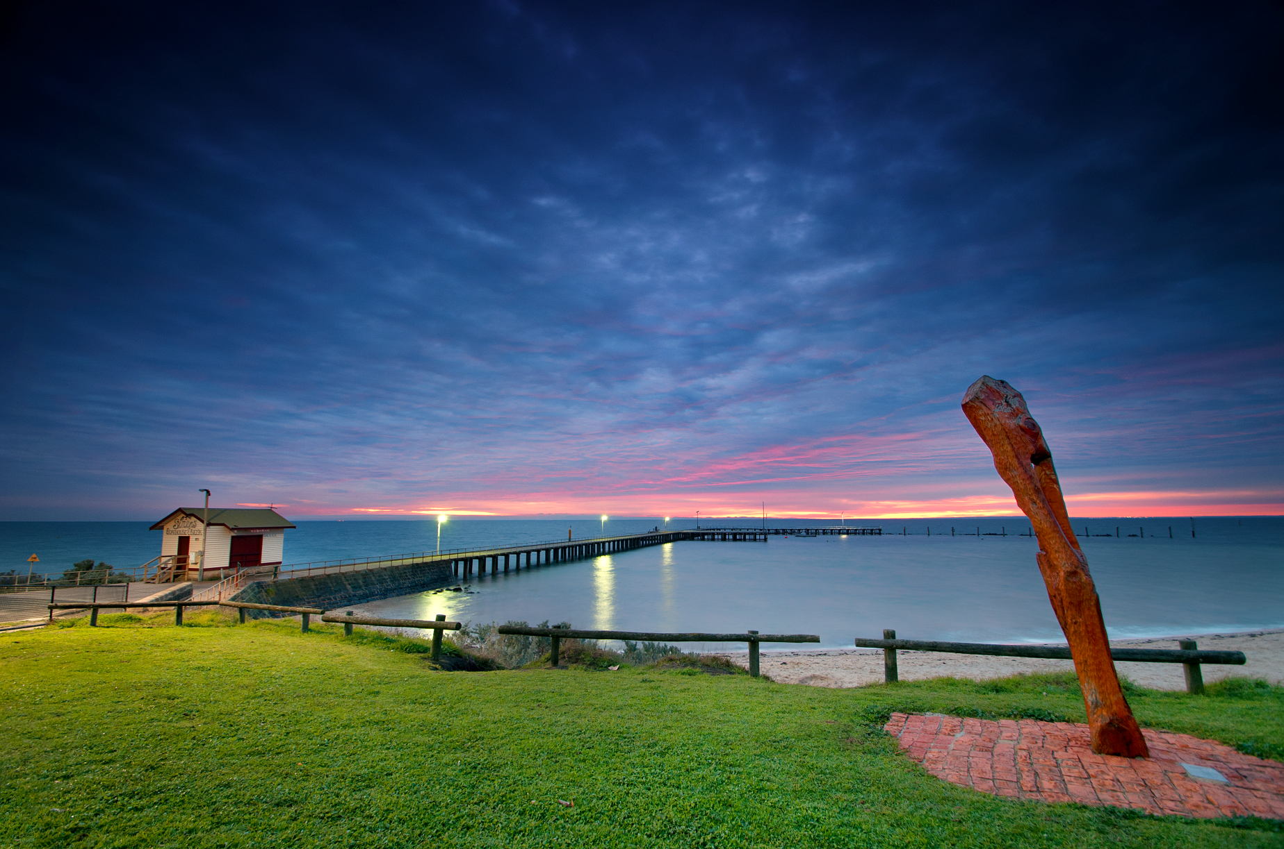

Contents
PART A STRUCTURE PLAN 1
Introduction 1
Purpose of the Structure Plan 1
How will this plan be used? 1
Plan Components 1
The Study Area 2
Key Influences 4
Policy Context 4
Natural and Urban Environment 4
Demographics and Social Profile 5
Township Facilities and Services 5
Transport and Physical Infrastructure 5
Township Growth and Residential Lot Supply 5
The Plan 6
Vision 6
Role of the Township 6
Principles and Directions 6

PART B IMPLEMENTATION AND REVIEW 14
Implementation of the St Leonards Structure Plan 14
Subdivision Development Principles 15
Review of Structure Plan 16
Directions for Future Growth 16

PART C BACKGROUND REPORT 17
Introduction 17
Background 17
Location 17
Indigenous Heritage 17
Role of the Township 18
History 21
Policy Context 22
Key Strategies and Local Strategic Studies 22
Coastal 22
Environment 29
Urban Growth and Land Use Planning 31
Community Development 37
Economic and Infrastructure 38
Open Space and Recreation 40
Planning Scheme Provisions 42
Key Influences 48
Natural and Urban Environment 49
Natural Environment 49
Urban Environment 52
Residential Character 55
Key Influences 57
Demographics & Social Profile 58
Population 58
Age Structure 59
Dwellings & Household Size 60
Labour Force & Income 60
Population Projection 2021-2031 63
Key Influences 65
Township Facilities & Services 66
Local Community Services and Facilities 66
Town Centre 66
Social and Community Services 67
Access to Transport 73
Emergency Services 73
Public Realm, Open Space, Leisure and Recreation Facilities 73
Key Influences 77
Physical and Transport Infrastructure 78
Physical Infrastructure 78
Transport Infrastructure 82
Key Influences 86
Township Growth and Residential Lot Supply 87
Township Growth 87
Residential Lot Supply 88
Existing Growth Opportunities 91
Planning Policy and Projected Demand 94
Release of Land 99
Early Years Learning Facility 100
Development Guidelines for Growth Areas 102
Key Influences 103
References 104

List of Maps

 | Title | Page Number
Map 1 | Study Area | 3
Map 2 | Structure Plan | 13
Map 3 | Locality Plan | 19
Map 4 | Regional Plan | 20
Map 5 | Significant Landscape and Environmental Features | 51
Map 6 | Urban Environment | 53
Map 7 | Existing Community, Recreation and Open Space Facilities | 76
Map 8 | Flood and Sea level Rise | 81
Map 9 | Key Routes and Entrances | 83
Map 10 | Transport Network | 85

List of Figures

 | Title | Page Number
Figure 1 | St Leonards Increased Housing Diversity Area | 36
Figure 2 | Age Structure of St Leonards (2011) | 59
Figure 3 | Household Size (2001) | 60
Figure 4 | Hierarchy of Service Delivery on the Northern Bellarine | 68
Figure 5 | St Leonards Lake Reserve Pavilion | 71
Figure 6 | Urban Vacant Lots and Residential Supply – St Leonards 2013 | 89
Figure 7 | Dwelling Construction 2005-2012 | 90
Figure 8 | Residential Land Supply Areas – St Leonards | 96
Figure 9 | Residential Lot Potential by Supply Type, March 2013 – Portarlington | 98
Figure 10 | Residential Lot Potential by Supply Type, March 2013 – Drysdale-Clifton Springs | 98
Figure 11 | Residential Lot Potential by Supply Type, March 2013 – Indented Head | 99

List of Tables

 | Title | Page Number
Table 1 | Implementation and Review Plan | 14
Table 2 | State and Local Planning Polices | 42
Table 3 | Zones | 46
Table 4 | Overlays | 47
Table 5 | Permanent Population Estimate at June 2012 | 58
Table 6 | Peak Overnight Population 2012 | 59
Table 7 | Index of Relative Socio-Economic Disadvantage | 62
Table 8 | Population Projections 2021-2031 | 63
Table 9 | Projected Population by Age Cohort for St Leonards – Indented Head ‘id. Forecast’ 2013 | 64
Table 10 | Kindergarten Attendance | 69
Table 11 | Existing Children’s Services - Indented Head, Portarlington, St Leonards | 73
Table 12 | Residential Supply - St Leonards | 90
Table 13 | Urban Vacant Lots - St Leonards | 90
Table 14 | St Leonards Residential Building Permit Activity 2003-13 | 91
Table 15 | Residential Lot Potential by Supply Type, March 2013 | 91
Table 16 | Year Supply of Vacant Urban Land | 92
Table 17 | Years Supply Based on 12.5 Lots per hectare | 93
Table 18 | Land Supply Based on Growth Rate Scenarios | 94
Table 19 | Residential Lot Potential by Supply Type, March 2013 – Northern Bellarine | 97
Table 20 | Residential Land Supply – Northern Bellarine | 97

PART A STRUCTURE PLAN

Introduction

Purpose of the Structure Plan
The St Leonards Structure Plan is a strategic framework for the future development of the township.
The purpose of the Structure Plan is to identify the key strategic planning issues facing the township, including community aspirations and needs, and to articulate the preferred future directions, including the location of a Settlement Boundary and the identification of appropriate planning controls.

How will this plan be used?
The Structure Plan is primarily a tool to be used by the City of Greater Geelong to determine the application of local planning policy, planning zones and overlays and the consideration of applications for planning permits and rezoning. Council will also reference the document when considering the future roll out of infrastructure and services.
Through its implementation, the Plan will create greater certainty for the residents and landowners regarding the future directions of the township over the next ten years.

Plan Components
The Structure Plan contains three parts, Part A “Structure Plan”, Part B “Implementation & Review” and Part C “Background Report”.
Part A contains the Structure Plan, which includes principles and directions in response to the key influences identified in the background report, for each of the following key themes:
    - Urban Growth
- Infrastructure
- Housing
- Natural Environment
- Economic Development and Employment
- Rural Areas
Part B contains a program for implementing the Structure Plan including details relating to subdivision development principles, the application of overlay controls and the undertaking of other strategic work, including review of this Structure Plan.
Part C provides the foundation and contextual information for the Structure Plan and identifies the issues, opportunities and constraints facing the township, under the following headings:
    - Policy Context
    - Natural and Urban Environment
    - Demographics & Social Profile
    - Township Facilities and Services
    - Transport and Physical Infrastructure
    - Township Growth and Residential Lot Supply

The Study Area
For the purposes of the Structure Plan, Map 1 identifies the boundaries of the study area. The study area extends beyond the existing urban area of St Leonards to consider the role and future use of land to the west of the existing urban zones and the rural interface.
Study Area – Map 1
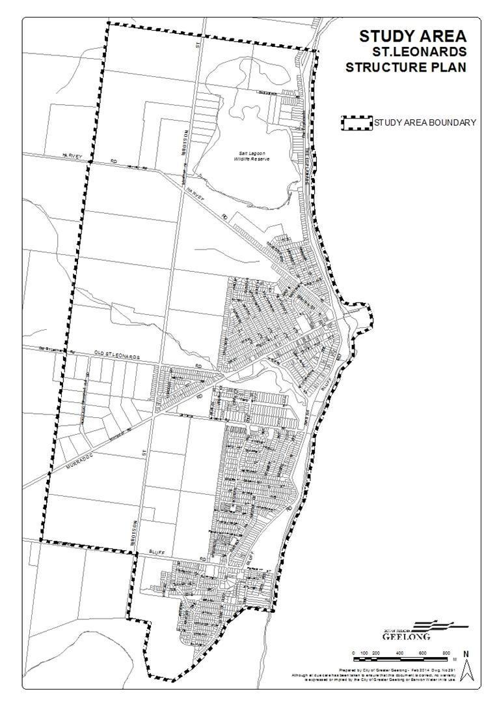

Key Influences
The background report identifies and discusses in detail key issues, opportunities and constraints under the following headings which assist in determining the key directions of the Structure Plan.

Policy Context
- St Leonards is not a designated growth location for conventional residential or rural residential growth within Council’s Municipal Strategic Statement or within the G21 Regional Growth Plan;
- There is a need to nominate a clear growth boundary and provide for a compact urban form;
- Various sensitive environments and landscape features need to be protected and enhanced as appropriate;
- There is strong State and Local Planning Policy direction for:
- the protection of coastal environments;
- the protection of rural environments and agricultural activities;
- Opportunities exist for enhancement of open space, recreational facilities and linkages;
- There is a need to ensure retail growth is consistent with the established retail hierarchy but which also provides for incremental growth as appropriate;
- There is a need to provide community facilities commensurate with community needs and sustainability of service provision.

Natural and Urban Environment
- Enhancement and protection of significant landscape and sensitive environmental setting;
- The need to appropriately manage the environment and landscape to conserve and protect Aboriginal cultural heritage values;
- Support for on-going management by public land managers of significant landscape and environmental features;
- Opportunity to protect and enhance key views and vistas;
- Opportunity to enhance and identify a preferred character for the commercial centre with the development of an Overlay and Local Policy which establishes broad principles and directions relating to built form and land use;
- Opportunity to strengthen the commercial centre and inter-relationship with Pier- Foreshore precinct;
- Opportunity to strengthen character of township through streetscape works encapsulated within the St Leonards UDF;
- Opportunity to control form of development along the foreshore-coastal urban edge;
- Need for further strategic assessment to support the introduction of additional design and/or landscape planning controls over Lower Bluff area;
- Ensure new subdivision development responds to key landscape setting, environmental constraints and prevailing township character.

Demographics and Social Profile
- High proportion of older residents and residents living alone requiring significant levels of community and social services;
- High dwelling vacancy rate and seasonal influx of large numbers of non-permanent residents and holiday-makers;
- Low labour force participation rate and household income;
- Car reliant population;
- Area of high socio-economic disadvantage;
- Need to provide for a greater range of housing choice.

Township Facilities and Services
- Single retail centre which provides for basic community needs;
- Reliance on region-wide social and community service provision;
- Opportunity to support provision of a Community Centre to provide improved social, community and health services;
- Opportunity to support recommendations of previous studies to enhance open space and recreation areas and further develop and improve linkages between existing range of recreational facilities.

Transport and Physical Infrastructure
- Identified urban stormwater runoff threats to sensitive environments and sub-catchments and need for further studies to be undertaken;
- Limited public transport coverage, both within and external to the township;
- Opportunity to improve the limited pedestrian and bicycle linkages throughout the township and within open space areas.

Township Growth and Residential Lot Supply
- Historically slow take-up of land;
- Substantial amount of residential zoned lot supply available within existing township;
- Existing pressure to expand western edge of township to convert rural land to residential use;
- Opportunities to consolidate short term residential growth with redevelopment of the golf course.

The Plan

Vision
St Leonards will continue its role as a coastal village providing for sustainable growth of residential land and commercial uses in a way which respects and enhances its coastal setting, rural and environmental landscape values.

Role of the Township
St Leonards primary role has traditionally been as a seaside holiday village, serving a small permanent population. The town is not identified as a growth location within Council’s Urban Growth or Rural Residential strategies for residential or rural residential development, nor as a location for extensive commercial or business activity.
The sensitive coastal, environmental and rural setting of the township and associated State and Local Planning Policies preclude extensive township growth, while local services and facilities are limited to those which provide for daily needs and requirements.

Principles and Directions
The structure plan identifies principles (objectives) and directions (strategies) relating to the key planning themes:
- Urban Growth
- Infrastructure
- Housing
- Natural Environment
- Economic Development and Employment
- Rural Areas

Urban Growth

The existing identified residential lot supply is more than sufficient to meet anticipated housing demand and the projected population over the next 15 years. Given the identified key influences, including a sensitive environmental setting and State and Local Government directions to maintain a compact urban form, it is appropriate to retain the existing Settlement Boundary in its current location.
The nominated Settlement Boundary has been delineated to provide distinct urban- rural/environmental interfaces as follows:
- The northern boundary is located between the Salt Lagoon Wildlife Reserve and the existing residential zoned properties so as to ensure continued protection of the ephemeral edge of the lagoon and provide a ‘rural break’ between Indented Head and St Leonards.
- The southern boundary is located between the existing residential zone and Edwards Point State Faunal Reserve. Any further residential development to the south west is considered inappropriate as it would irreversibly harm this important environmental and landscape feature;
- The western boundary aligns with the eastern side of Ibbotson Street and includes the residential land on Harvey Road (previously the St Leonards Golf Course) and the existing residential land to the north of Murradoc Road between the two growth areas. A vegetation and habit corridor will be required along the eastern side of Ibbotson Street to maintain a clear separation between the township and the adjacent farming land to the west. The corridor will also provide a connection between the northern and southern environmental reserves.
- The east boundary is formed by the natural landscape feature of the foreshore.
Principles
- To protect the unique character of St Leonards as a small coastal village located within a sensitive environmental and significant landscape setting.
- To maintain a compact urban form and avoid linear sprawl along the coast.

Directions
- Ensure that urban development does not occur outside the defined Settlement Boundary as shown on the accompanying St Leonards Structure Plan Map;
- Support new residential development in the growth areas shown on the accompanying St Leonards Structure Plan Map;
- Encourage appropriate infill residential development in residential zones where drainage and servicing issues can be addressed and which ensures urban development does not encroach onto or have an adverse effect on significant environmental features.

Infrastructure

The release of residential land within St Leonards will place additional pressure on existing infrastructure and community services particularly drainage and the need for an Early Years Learning Facility.
St Leonards, like many established suburbs has aging drainage infrastructure which has not been designed to accommodate significant increases in residential densities. New development including infill and greenfield, will need to consider the potential impacts on the established drainage system to ensure there are no adverse impacts on water quality and drainage infrastructure. Drainage Feasibility Reports, Flood Impact Studies and Water Quality Reports may be required before rezoning or planning permission is granted for new residential development.
Impacts on the St Leonards foreshore and infrastructure as a result of climate change will continue to be an issue. Coastal action plans will help guide the protection of existing assets along the coast. New development will be required to undertake coastal hazard vulnerability assessments for a possible sea level rise of 0.8 metres by 2100 taking into consideration the effects of tides, storm surges, coastal processes and local conditions such as topography and geology.
The Structure Plan supports the rezoning of growth areas 1 and 2 as shown on the Structure Plan map. The release of this land combined with existing broad hectare and vacant land, will provide between 25 and 33 years supply of residential land for the township. The rezoning of this land to residential will provide certainty regarding the long term size of the St Leonards township and allow Council and other service providers to plan for any changes to the service and infrastructure needs of the town.
This Structure Plan has identified a need for an Early Years Learning Facility within the township to support a growing number of young families and to improve travel distances to this type of service in a community where there is limited public transport and a high Index and Relative Socio-Economic Disadvantage. The Structure plan has identified 4 possible sites within the township for an Early Years Learning Facility. Further investigation into the suitability, design, costing and timing for delivery of this service will need to be undertaken as the population of the town increases. To equitably assist with infrastructure funding, the City of Greater Geelong has resolved to implement either Development Contributions Plans (DCP’s) or 173 agreements over the two growth areas. A DCP is a statutory tool used to levy the proponents of new development for fair contributions towards specific, pre-scheduled infrastructure items. A 173 Agreement is an agreement made under section 173 of the Planning and Enviornment Act between Council and a third party.
St Leonards is well serviced by passive and active recreation space which is well utilised by both the St Leonards and Indented Head communities. The Bellarine Bayside Foreshore Master Plan and the Charles McCarthy and Lake Reserve Recreation Plan makes a number of recommendations to improve the existing passive and active recreation spaces within the town. The plans also seek to improve pedestrian linkages throughout the town and along the foreshore. Bellarine Bayside Foreshore Committee of Management, the City of Greater Geelong and the community will need to work together to deliver many of the outcomes recommended within these plans.
The St Leonards UDF provides a number of recommendations relating to the enhancement and improvement of the existing road, recreation and open space areas. Some of these actions have been completed including the town centre streetscape works and walking trail around Lake Reserve. Other actions will be completed as part of the development of the two growth areas.
The Bellarine Peninsula Community Service Plan 2006-2016 established a plan for improved community and social service provision within the township. This plan has among other things recognised the need for a community centre. A community meeting space has been provided within the town centre in Blanche Street. This centre is well utilised by the community for a variety of different social and educational needs.
Principles
- To encourage the provision of a range of social and community services commensurate with the size and role of the township;
- To provide an improved transport and movement network, including pedestrian and cyclist linkages.

Directions
- Support further investigation of and the development of an Early Years Learning Facility within St Leonards.
- Support the ongoing upgrading of open space, leisure and recreation areas undertaken for and on behalf of public land managers including provision of pedestrian/bicycle linkages.

Housing

There continues to be a high number of older person’s resident within St Leonards and it is expected that this number will continue to increase over time. Housing styles which suit older persons and which are located in close proximity to existing services and facilities are required to meet these needs. Further concentration of development in the urban area will occur as existing housing stock is redeveloped. This may have flow of effects including improvements to public transport and additional retail type services within the town centre.
The release of new growth areas in the past have resulted in an increase in the number of young families within the area. It is expected that this trend would continue with the release of additional residential land. It is important that these growth fronts provide for a range of lot sizes to accommodate the needs of a range of different household types.
A number of design and development controls have been implemented into the Geelong Planning Scheme to guide development within the town centre and along the foreshore area. These controls will continue to ensure new development is respectful of existing neighbourhood character and provide opportunities for view sharing.
Principles
- To ensure that future housing development provides for a variety of housing sizes and types and complements the character of St Leonards.
Directions
- Encourage subdivision development to accord with the Subdivision Development Principles identified in the St Leonards Structure Plan;
- Encourage development which is consistent with the objectives and strategies contained within the Design and Development Overlays affecting the town centre and foreshore area.
- Support a mix of housing types, particularly around the town centre, including the provision of housing choices designed for elderly persons.

Natural Environment

The surrounding landscape features of St Leonards play significant roles; providing intrinsic habitat and biodiversity values to the local and wider environment and establishing the identity of the township and community.
Importantly, the environment and landscape hold significant values relating to Aboriginal cultural heritage, particularly the coastal area, and there is a strong need to appropriately protect and manage these values.
The designation of a Settlement Boundary to exclude the key environmental features from urban development will assist in the protection of these areas. The continued application of the Environmental Significance Overlay to the Salt Lagoon Wildlife Reserve and Edwards Point State Faunal Reserve and the Vegetation Protection Overlay to significant roadsides and linear reserves is supported to ensure the on-going protection of their identified environmental values.
The protection of the Murradoc Hill landscape is strongly supported, not only by the St Leonards community but also by the other communities on the Bellarine Peninsula. The communities view this landscape as being intrinsic to the character of the individual townships, given the natural backdrop it provides and the views which are available to and from this feature. Significant Landscape Overlays have been applied to areas surrounding the Murradoc Hills and along the Swan Bay foreshore to help protect these valuable landscape features.
Other key landscape features are managed by public land managers, such as the Bellarine Bayside Foreshore Committee of Management, Parks Victoria and the City of Greater Geelong. On-going maintenance by these agencies will ensure that these areas are protected in the long-term.
Stormwater from the township drains towards either the Salt Lake or St Leonards Lake. No new drainage outlets to the bay are currently permitted and any new development will be required to drain to existing catchments. Drainage reports for new development will need to consider how these connections can be achieved to assure minimal impact upon drainage assets and the water quality of the catchments. Council will also need to further investigate the drainage situation to quantify the extent of drainage problems and identify mitigation measures.
Subdivision Development Principles are identified in the Implementation and Review section which encourage appropriate stormwater treatment and re-use, as well as maintenance of downstream stormwater flows to pre-development levels.
Principles
- Protect the landscape character of the town and ecological sensitivity of the surrounding environment.

Directions
- Support the on-going management, enhancement and sensitive development of the foreshore, Salt Lagoon Wildlife Reserve and Edwards Point State Faunal Reserve by public land managers;
- Provide for the appropriate protection of Aboriginal cultural heritage values;
- Encourage retention and enhancement of existing vegetation on private land, roadsides and reserves using locally indigenous plantings;
- Ensure that development adjacent to Areas of Significant Landscape, Environment & Recreation as shown on the attached Structure Plan is undertaken in a manner which complements and does not adversely impact upon these features;
- Encourage subdivision development which meets the stormwater and landscaping principles outlined in the Subdivision Development Principles;
- Protect and enhance key vistas and view lines to the coast and environmental features as identified in the attached St Leonards Structure Plan Map;

Economic Development and Employment

The existing commercial centre should remain the sole focus for commercial development within St Leonards, to foster vitality and avoid fragmentation of uses and activities. This area is the main activity precinct for the township, in conjunction with the St Leonards Lake Reserve and the pier area, and should remain as a community focal point.
An Economic Report on the St Leonards Town Centre was carried out on Councils behalf by Tim Nott – Economist, as input into the Structure Plan. The report suggested that St Leonards would need between 1000 and 4000sqm of land by 2031 to accommodate the long term growth projections of the town. Given that there are existing vacant sites within the commercial centre, there is no immediate need to rezone land for commercial purposes as part of this review. The Implementation and Review section of this report indicates that a review of the retail situation in the town centre should occur within 10 years to determine if additional commercial land is required.
There is scope within the existing commercial centre to provide for an improved range of uses and services within the established town centre to cater for the daily service requirements of the township. The Structure Plan supports the development of a focal building comprising retail and tourist related activities on the corner of Bluff and Murradoc Roads which will improve the integration of the town centre and the Pier-Foreshore area.
The policies of the Greater Geelong Planning Scheme do not encourage the provision of land for industrial or service business use within St Leonards. If the demand for a service, such as a petrol station, is established, such a facility could be accommodated subject to a planning permit application within the existing land use zonings, provided access to a Road Zone is available. Furthermore, the existing land use zonings allow the use of residential properties for small scale home businesses, provided such uses meet the relevant Council guidelines.
In accordance with directions included within State and Local Planning Policies and strategies, the community will continue to rely on the supply of industrial zoned land in Portarlington, Drysdale and Ocean Grove, for industrial and service business facilities. The sustainable development of the town centre and enhancement of the pier area as a community-tourist focus will provide some localised employment benefits.
Principles
- To consolidate commercial activity and development to the existing town centre so as to develop a thriving and vibrant town centre;
- To encourage the contemporary development of the town centre which enhances it’s coastal and environmental setting.
Directions
- Make no provision for additional land to be rezoned for commercial, service business or industrial uses within St Leonards and direct service business and industrial development to other designated locations identified in the Local Planning Policy Framework;
- Encourage infill development and redevelopment of existing sites within the established town centre;
- Support a mix of commercial, community and entertainment uses within the town centre which meet the daily needs of the community and encourages street life and tourist visitation;
- Support accommodation uses, above ground level retail floor space, which fulfil parking and access requirements;
- Encourage a contemporary built form in the town centre which complements the coastal setting and which maintains the lineal nature and existing scale of buildings in accordance with the established Design and Development Overlay controls.
- Support the development of a focal building at the south west corner of Murradoc and Bluff Roads comprising retail and tourist related activities;
- Support the integration of the town centre and Pier-Foreshore area.
Rural Areas

Retention of the Bellarine Peninsula as a predominantly rural area, with distinctly defined townships, is a key tenet of Council’s Municipal Strategic Framework. A clearly defined settlement boundary will ensure that this occurs, preventing the need to nominate any future rezoning of rural land to residential land for in excess of 15 years. In accordance with State and Local Planning policies and strategies, no provision is made for rural residential development.
Those properties which are located directly to the north of the Salt Lagoon Wildlife Reserve, are zoned Rural Conservation Zone (Schedule 7) and Farming Zone, are outside the Settlement Boundary. The significant environmental and landscape constraints render this area unsuitable for intense urban development. Retaining this land for rural purposes, with its scenic landscape qualities, maintains the non-urban break between St Leonards and Indented Head and allows for the protection of the ecological values of the lagoon.
Principles
- To ensure the preservation of the surrounding rural landscape and setting of St Leonards.
Directions
- Retain the existing Rural Zones outside the Settlement Boundary.
- Ensure any land use activities within Farming Zone retain an agricultural focus and preserve the rural, environmental and landscape qualities;
- Ensure any land use activities within Farming Zone east of Ibbotson Street do not compromise opportunities for longer term urban growth;
- Direct rural residential growth to designated locations within the municipality outside of St Leonards.

The above principles and directions for each of the key themes are summarised on the Structure Plan Map 2.
Structure Plan – Map 2
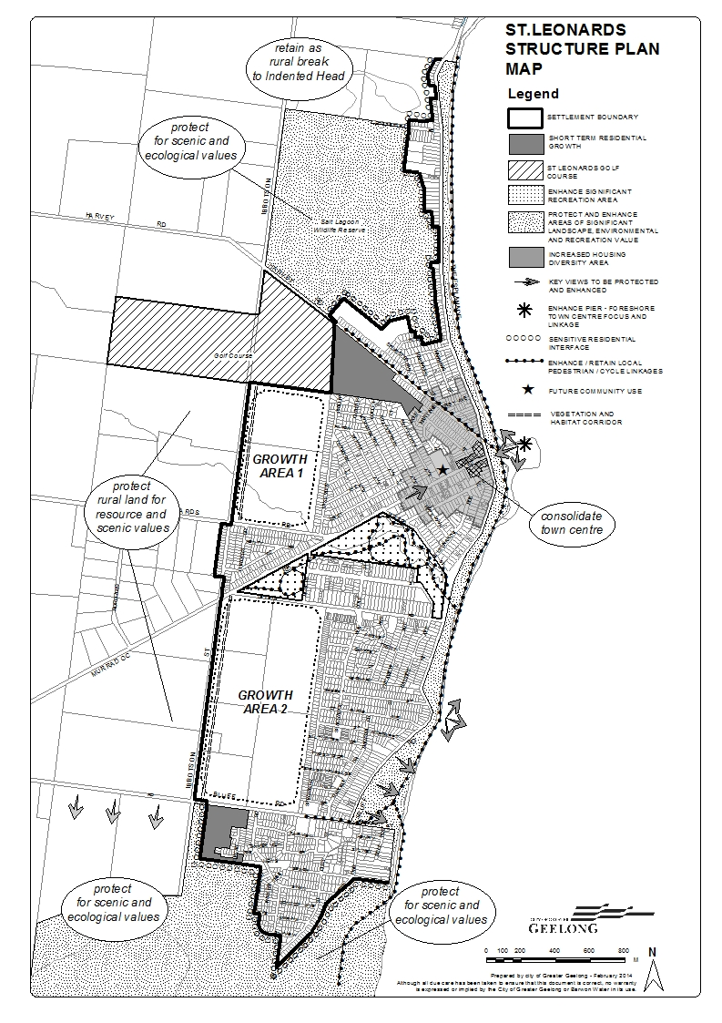

PART B IMPLEMENTATION AND REVIEW

Implementation of the St Leonards Structure Plan
This Structure Plan provides a framework for development in St Leonards over the next ten to fifteen years with identified policies and strategies to provide a basis for future decision-making.
The Implementation and Review Section identifies review provisions and key Planning Scheme alterations, or supporting strategic work, necessary to attain the principles and directions identified in the Structure Plan including:
- Introduction of Planning Policy:
- Further strategic work required to support additional planning controls;
- Other Actions critical to attaining key principles directions.
Table 1 – Implementation and Review Plan
Implementation and Review Plan
Using policy and the exercise of discretion | Apply a planning policy which reflects the directions and principles of Part A of the St Leonards Structure Plan, including the Structure Plan as a reference document, in the Greater Geelong Planning Scheme.
Undertaking further strategic work | - Review the St Leonards Structure Plan when significant changes are made to State or Local Planning Policy relating to the need to release additional residential land.  - Review the retail needs of the town in 10 years to determine if there is a need to rezone additional commercial land adjacent to the town centre.
Other Actions | - Support the rezoning of land identified for long term urban growth to a residential zone subject to consideration of a planning scheme amendment.  - Undertake a study relating to stormwater drainage and flooding in and around the Town Centre, within designated growth locations and established residential areas to identify mitigation and infrastructure measures.  - Work with Bellarine Bayside to help develop plans for areas identified as “Special Investigation Areas” within the Bellarine Bayside Foreshore Masterplan.

Subdivision Development Principles
It is recommended that the land identified within the Structure Plan map as areas 1 and 2 be rezoned to a General Residential Zone Schedule 1 (previously Residential 1) with a Development Contributions Plan Overlay and/or 173 agreement. Council should consider applying a Developer Contributions Plan Overlay and/or using 173 Agreement to provide additional guidance around the delivery of infrastructure.
Development Plan Overlay
The Development Plan should generally require the following:
- An Urban Design Masterplan that includes:
- A general subdivision layout including streets, drainage reserves, open space for permeability, distribution of land uses and interface treatments with adjoining residential zoned properties.
- A concept design and layout of Ibbotson Street to include an ecological corridor as identified in the St Leonards Urban Design Framework 2006
- New road and pedestrian connections from the new subdivision areas into the adjacent residential and open space areas.
- The retention of significant vegetation.
- A staging plan.
- A concept landscape plan. The concept plan for area 1 must show the creek bed area connecting with St Leonards Lake Reserve.
- A Road Network and Traffic Management Plan that investigates:
  - the interface with Murradoc Road, Ibbotson Street, Leviens Road, Old St Leonards Road as well as abutting residential areas.
  - Traffic mitigation measures to improve access adjacent to the growth areas.
  - Permeability and connectivity for pedestrians and cyclists throughout the development and integrated where practicable with existing and proposed landscaped open space and pedestrian/bicycle linkages.
- Physical infrastructure proposed in the Urban Design Masterplan shall meet Council standards or if not defined, be subject to the approval of Council and be generally in accordance with the following:
  - City of Greater Geelong adopted Infrastructure Development Guidelines (IDG) 2010
  - City of Greater Geelong adopted Infrastructure Design Manual (IDM) 2010
- A staging plan that identifies the stages by which the development of the land may proceed, identifying the infrastructure required to facilitate development
- Site Stormwater Management Plan (SSMP) consisting of:
- Drainage Feasibility Report
- Water Quality Impact Report
- Flood Impact Report
Developer Contributions Overlay and/or 173 Agreement
To help deliver an identified Early Years Learning Facility within St Leonards the use of a Developer Contribution Plan Overlay and/or a 173 agreement should be considered as part of a rezoning process;
The Developer Contributions Plan Overlay should generally meet the requirements of Clause 45.06 - Development Contribution Plan Overlay of the Greater Geelong Planning Scheme. A Developer Contributions Plan sets out the timing for developer contributions which can include works in kind, land or funds and in this instance linked to an agreed community infrastructure project - an Early Years Learning Facility.
A 173 agreement is an agreement under section 173 of the Planning and Environment Act. The agreement is typically between a developer and Council. In this instance the 173 agreement would specify a requirement to deliver or contribute to the matters identified within the Developer Contribution Plan Overlay, or if no overlay is applied to the land a commitment to deliver the infrastructure identified through the rezoning process. In both instances the agreement should also include, a developer contribution towards an Early Years Learning Facility, including a substantial up front payment to help provide for the timely delivery of this service.

Review of Structure Plan
This Structure Plan supports the release of all remaining land identified for future residential development within the established Settlement Boundary. The release of this land will provide between 25 and 33 years supply of land for the St Leonards Township. This supply is considered sufficient to accommodate the long term future growth needs of the township and no additional land has been identified for future residential growth.
St Leonards is not a designated growth area within the City of Greater Geelong and therefore the timing to review the Structure Plan should reflect this. A minor review of the Structure Plan should occur in 10 years to update policy context and review the retail needs of the town. It is recommended that a full review of the St Leonards Structure Plan only occur if there is a significant change to State or Local Policy that would result in the need for additional residential zoned land within St Leonards

Directions for Future Growth
This Structure Plan supports the rezoning of all remaining land within the settlement boundary. The release of this land will create 25-33 years supply of residential land within the established settlement boundary. This is considered sufficient to accommodate the long term growth requirements of the township. Therefore no additional land has been identified for future residential growth beyond the established settlement boundary.

PART C BACKGROUND REPORT

Introduction

Background
The development and planning of St Leonards has been guided by the 2006 St Leonards Structure Plan. Many of the recommendations to come out of that Plan have been implemented including the rezoning of the golf course, implementation of Design and Development Overlay controls as well as a number of recommendations from the St Leonards Urban Design Framework 2006.
The role of the Structure Plan is to identify the key strategic planning issues and opportunities facing the township and articulate the preferred future directions, including the location of a Settlement Boundary, future residential and commercial growth and future community service provision, as well as identifying appropriate planning controls.

Location
St Leonards is situated at the eastern most tip of the Bellarine Peninsula, located approximately 30 kilometers east of Geelong. Map 3 and Map 4 indicate the location of St Leonards in the context of the rest of the municipality and within the Bellarine Peninsula.
The township lies between Indented Head and Swan Bay, with its foreshore reserve stretching along its eastern frontage to Port Phillip Bay. The northern and southern boundaries of St Leonards are formed by two significant nature reserves, the Salt Lagoon Wildlife Reserve to the north and Edwards Point State Faunal Reserve to the south. Murradoc Road is the main entrance to the town from Geelong, with the commercial node focused around the intersection of Murradoc Road and The Esplanade, opposite the pier/foreshore area.
The township stretches along a north-south axis following the coast line, with the Charles McCarthy Memorial Oval and St Leonards Lake Reserve dividing the township in two. These reserves provide a range of leisure and recreation activities for the township.
Situated to the west of the established township lies the flat agricultural pastures of the Bellarine Peninsula.

Indigenous Heritage
Aborigines of the Wathaurong tribe, whose territory stretched between the Werribee River and the Otway Ranges, occupied the land before European settlement. The St Leonards area was inhabited by the Bengalat balug (Clan).
The regulations of the new Aboriginal Heritage Act specify the circumstances in which a Cultural Heritage Management Plan (CHMP) is required for an activity or class of activity, which is specified as ‘high impact’ in areas of Aboriginal cultural sensitivity and also prescribes standards for the preparation of such plans. Advice from Aboriginal Affairs Victoria (AAV) will be essential to ascertain when and if a CHMP is required for different activities and for different areas. According to the Municipal Association of Victoria ‘in essence, if an activity is both in an area of cultural heritage sensitivity and is a high impact activity on land not previously significantly disturbed, it will require a CHMP before any planning permit can be determined’.
Significantly for St Leonards, Cultural Heritage Sensitive Areas under the regulations include, but are not limited to, the following:
- Registered cultural heritage place or land within 50 metres of a registered place;
- Waterways (& within 200m) unless subject to significant ground disturbance;
- Prior waterways (& within 200m);
- Ancient lakes (& within 200m);
- Greenstone outcrops unless subject to significant ground disturbance.

The location of St Leonards adjacent to Port Phillip Bay and Swan Bay means that large tracks of land are considered to be areas of Cultural Heritage and would require a cultural Heritage Management Plan (CHMP) to be prepared before development could occur. Council has completed a CHMP as part of the St Leonards Lake and Charles McCarthy Reserve Master Plan and a further CHMP has been prepared by the Bellarine Bayside Foreshore Committee for the St Leonards Foreshore area.

Role of the Township
St Leonards primary role has traditionally been as a seaside holiday village, serving a small permanent population. The township has grown incrementally since 2006 however the township has remained a popular holiday destination.
The City of Greater Geelong through the Municipal Strategic Statement has identified areas for future urban growth based on their ability to offer the greatest net benefit to the Geelong community, where they can be appropriately serviced and which have the capacity to accommodate sustainable development. On the Bellarine Peninsula this includes the townships of Drysdale – Clifton Springs, Ocean Grove and Leopold.

The G21 regional growth plan has built upon Council’s existing policies including Structure Plans and has not identified St Leonards as a growth area within Geelong.

Locality Plan – Map 3
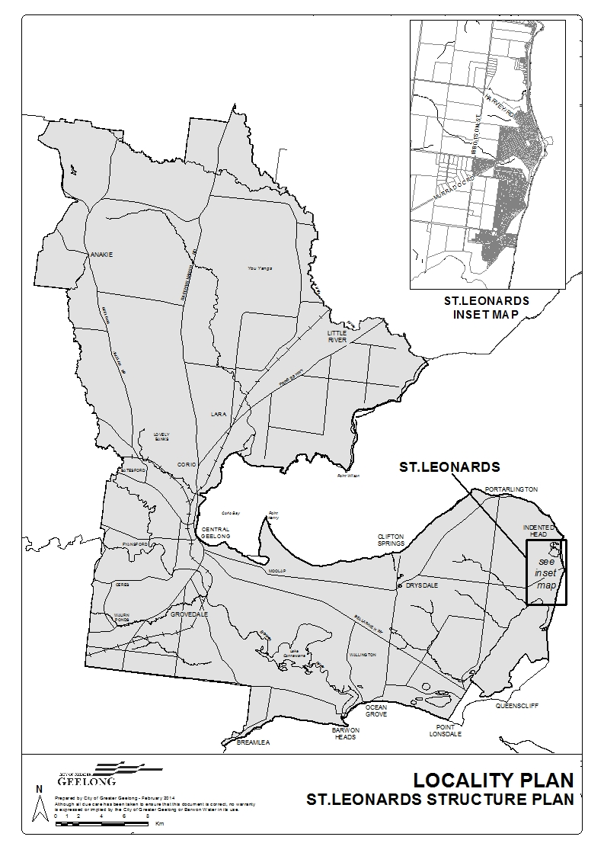
Regional Plan – Map 4
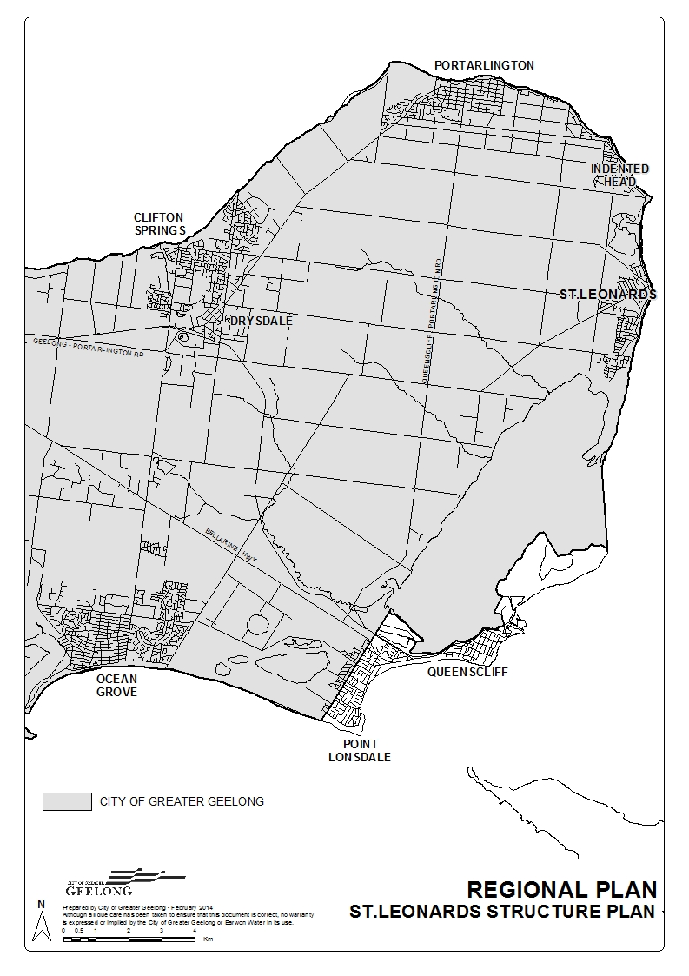

History
The township was formerly known as St Leonards-on-the-Bay, first established as a village reserve in 1850.
The original inhabitants of the area were the Wathaurong people and the first known European to live in the area was William Buckley, who was befriended by a clan of the Wathaurong Tribe in 1804. William Buckley lived with the Wathaurong Tribe for more than thirty years, before coming across John Batman’s encampment in 1835, which is said to have been located at the southern boundary of Harvey Park in St Leonards, although there is some debate over the encampments location. John Batman had sailed from Launceston and anchored in Port Phillip Bay off St Leonards in search of pastoral country. After anchoring off St Leonards, John Batman continued his voyage onto the Yarra River.
Following a Crown Survey in 1849 the first government land sale occurred in 1857. The early development of St Leonards is attributed to Captain George Ward Cole, who established a fire-wood trade in 1855 and constructed a pier. Captain Cole purchased 779 acres of land encompassing St Leonards and Indented Head and exploited the heavily timbered land selling firewood to Melbourne. Workers originally lived in tents until the first houses were built in 1857. The St Leonards Hotel was built in 1858 and from that point onwards the township was focused around the pier and pub.
Timber and farm produce were shipped to Melbourne from the pier, however given the sparseness of the landscape the timber industry ceased in the 1870’s. Other industries in the area included a leather tannery and brick-making, all since closed. Fishing also became an important industry as did tourism, initially associated with Bay Steamers delivering ‘day-trippers’ to the Hotel. The decline of the industrial base saw the township become a quiet, informal coastal village with a focus on holiday homes, fishing and camping, which prevails to this day.

Policy Context
St Leonards is located within the municipality of the City of Greater Geelong and is affected by various policies and strategies formulated by the State Government and Council. The following policies have specific relevance to St Leonards and have guided the development of this Structure Plan.

Key Strategies and Local Strategic Studies

Coastal
Victorian Coastal Strategy 2008

The VCS 2008 builds on the principles and actions of the last two strategies and identifies and responds to three significant issues affecting Victoria's coast that require specific attention:
- Climate Change
- Population and Growth
- Marine Ecological Integrity
The Victorian Coastal Strategy 2008 provides a comprehensive integrated management framework for the coast of Victoria. It is established under the Coastal Management Act 1995. The Act directs the Victorian Coastal Strategy to provide for long-term planning of the Victorian coast for the next 100 years and beyond.
The purpose of the strategy is to provide:
1. A vision for the planning, management and use of coastal, estuarine and marine environments
2. The government's policy commitment for coastal, estuarine and marine environments
3. A framework for the development and implementation of other specific strategies and plans such as Coastal Action Plans, management plans and planning schemes
4. A guide for exercising discretion by decision-makers, where appropriate.

A hierarchy of principles sets the foundation of the strategy. The hierarchy of principles provides the basis for a series of policies and actions to guide planning, management and decision-making on coastal private and Crown land, as well as in coastal catchments, estuarine and marine waters. The Hierarchy of principles include:
- Provide for the protection of significant environmental and cultural values.
- Undertake integrated planning and provide clear direction for the future.
- Ensure the sustainable use of natural coastal resources.
- Ensure development on the coast is located within existing modified and resilient environments where the demand for development is evident and the impact can be managed.

This strategy gives direction for planning and managing the impacts of activities on and in the:
- marine environment - includes the near shore marine environment, the seabed and waters out to the state limit or 5.5 kilometres.
- foreshore - or coastal Crown land 200 metres from the high water mark
- coastal hinterland - on private and Crown land directly influenced by the sea or directly influencing the coastline and land within critical views of the foreshore and near shore environment
- catchments - feeding rivers and drainage systems and including estuaries

The strategy addresses all activities or processes that may impact on coastal and marine areas.

Coastal Spaces Recommendations Report (Department of Sustainability &
Environment, April 2006)

The Coastal Spaces Recommendations Report is the product of a joint project between the Victorian Coastal Council and the Department of Sustainability & Environment (DSE), to assist coastal councils protect the character of coastal townships and the open spaces between towns along the coast. The major aims of Coastal Spaces are to improve both strategic planning for sustainable development in coastal Victoria and the application of planning tools in coastal areas.

The Report contains the following key recommendations:
- Reaffirm the Government’s commitment to direct urban development to existing settlements.
- Establish settlement boundaries through planning schemes.
- Protect non-urban coastal landscapes by implementing the Coastal Spaces Landscape Assessment Study and applying the new rural zones.
- Target priority for infrastructure and innovative solutions in environmental hotspots where the provisions for potable water and reticulated sewerage services are not present.
- Encourage tourism investment and products that are sensitive to coastal settings and meets regional needs. Tourism proposals outside settlements must be of high quality, well designed and sited, add value to the coastal experience and be distinguishable from residential proposals.
- Establish clear planning policy that discourages disturbance of Coastal Acid Sulphate Soils.
- Establish a more comprehensive approach to asset management on public land through effective levels of service framework.
- Promote on-going regional coordination and communication mechanisms to maximise knowledge transfer and practice around coastal change management and planning.

Coastal Spaces recognises that climate change is expected to have implications for Victoria’s coastal areas including:
- Rising sea levels combined with higher temperatures and changes to wind and storm patterns which are expected to increase the potential for erosion and damage to coastal infrastructure, and intensify pressure on biodiversity assets.
- Production of more intense low pressure systems off Victoria’s coast causing a greater number of extreme storm events and storm surges. Parts of Victoria’s coast are more vulnerable to storm surge events, with low lying, sandy shorelines and low lying areas adjacent to estuaries and waterways at most risk.

With increasing pressure for residential and other developments in coastal regions, there is a pressing need to fully consider the risks related to climate change as part of the planning assessment process.

The report identifies that (p.9)

“Whilst limited information is available on the likely impacts of climate change specific to the Victorian coast, current estimates indicate sea levels will rise up to 55cm by 2070. Storm surges and potential estuarine flooding in storm conditions will result in further effective increase in areas affected by flooding. Not all areas of the coast are the same and therefore the level of risk and likely patterns of impact and change will vary.”

The report also recommends that (p.9):

“Notwithstanding the need for more detailed information to assess the impacts of climate change, it should be standard practice to adopt a Precautionary Principle approach when planning for areas likely to be vulnerable to climate change effects, such as estuaries, sandy shorelines and other low lying sites… Whilst the existing Victorian Coastal Strategy2002 advocates that development should be well set back from the coastline, a conscious change is required to ensure that future subdivision and development approvals actually achieve this, and more importantly, are located away from low lying coastal areas”.

(Note: The Precautionary Principle advocates taking action now despite a level of uncertainty, to minimise future risks. This principle may lead to a decision not to take action or proceed with a proposal because of a high level of uncertainty about beneficial outcomes).

Coastal Spaces Landscape Assessment Study – State Overview Report (September 2006)

The Coastal Spaces Landscape Assessment Study is a comprehensive assessment of visual and scenic amenity along the Victorian coast, and its focus is the identification of the visually significant landscapes of Victoria's non-urban coastline.

This Study provides a thorough assessment of landscape characteristics and identification of visually significant landscapes on the Victorian coastline including the Bellarine Peninsula.
The study identifies four Landscape Character Types and Areas for the Bellarine Peninsula.
St Leonards is located in the following Landscape Character Type Area:
Bay Slopes and Flats - Landscape Character Area 1.1: Bay Slopes and Flats

This Character Area is low-sloping and occasionally gently undulating, with open expansive views east to Port Phillip Bay and Swan Bay. Open paddocks are dissected by exotic conifer windbreaks and native vegetation in roadside reserves which contain views in parts. At the coastal edge, the landform is very flat with low-energy beaches, salt lakes and some minor cliffs no more than five metres high at Indented Head. Swan Bay is a significant natural feature on the eastern edge of approximately half the Character Area, while to the north, coastal townships including St Leonards and Indented Head extend inland for some distance on the flats. Further inland there is a low density of built elements with homesteads and farm sheds often exposed in large paddocks.

Amendment C177 to the Greater Geelong Planning Scheme (approved 24 February 2011) applied a Significant Landscape Overlay to facilitate the protection of coastal landscapes that had been identified as regionally significant within the Coastal Spaces Landscape Assessment Study. This included the Swan Bay and Murradoc Hill areas surrounding St Leonards, noted for their scenic topographic qualities.

Landscape Setting Types for the Victorian Coast May 1998

This document aims to provide an understanding of the coastal landscape by identifying significant features and characteristics of various sections of the coast. This area is within the “Rural flat and Undulating with features” setting type (between Geelong and Swan Bay) p16. The land form tends to be generally flat and undulating with pasture and small to medium sized towns. Swan Bay and the surrounding Bellarine Hills form a major feature.
This setting type is identified as being under pressure from an expanding urban Geelong, with many townships becoming dormitory suburbs. Consolidated development is favoured to minimise landscape impacts.
Siting and Design Guidelines for Structures on the Victorian Coast May 1998

This document provides specific guidelines for appropriate building siting and design treatments along the coast to respond to landscape, environmental and view considerations.
The Guidelines are presented in three categories, as follows:
- Functional Guidelines
These deal with utilitarian aspects of development and seek to ensure the efficient use of the limited resources of the coast.

- Cultural and Aesthetic Guidelines
These deal with cultural issues and the appearance of structures, but include other facilities such as carparks and the way they relate physically and visually to their surroundings.

- Ecological Guidelines
These deal with the impact of development on coastal ecosystems.

Corio Bay Coastal Action Plan (CAP) April 2005

Coastal Action Plans play a key role in the implementation of the Victorian Coastal Strategy (VCS) and are developed in accordance with the Coastal Management Act 1995. The purpose of a Coastal Action Plan (CAP) is to enable the broader principles and priorities of the VCS to be further developed and applied at a regional or local level.
The City of Greater Geelong and the Central Coastal Board have undertaken the preparation of a CAP for Corio Bay and part of the Port Phillip Bay coastal foreshore areas. As with the VCS, the Corio Bay Coastal Action Plan 2005 is referenced in the Local Planning Policy Framework of the Greater Geelong Planning Scheme, to guide the planning authority when considering use and development proposals in coastal areas. St Leonards falls within ‘Precinct One – St Leonards (SL).
This precinct extends from Edwards Point in the south, past St Leonards to the northern boundary of the Salt Lagoon Nature Conservation Park. The precinct includes part of the Port Phillip Heads Marine Park – Swan Bay, Edwards Point Wildlife Reserve and The Bluff.

Five Year Review – Corio Bay Coastal Action Plan
Under the provisions of the Coastal Management Act 1995, a CAP must be reviewed five years after its release. The review has been undertaken in two parts: an assessment of the status of the actions in the CAP and an evaluation of the CAP’s effectiveness as a sub-regional planning document.

The review found that the majority of actions in the Corio Bay CAP have been either implemented or amalgamated in a range of other planning instruments. The actions that have not been completed are either progressing, not started (because they require funding) or are recommended for change of wording or change of lead agent.

There are no outstanding actions relating to the St Leonards area.

RAMSAR Convention of Wetlands 1971

The Ramsar Convention on Wetlands is an intergovernmental treaty which provides the framework for national action and international cooperation for the conservation and wise use of wetlands and their resources. It was adopted in the Iranian city of Ramsar in 1971 and came into force in 1975. It is the only global environmental treaty that deals with a particular ecosystem (Source: www.ramsar.org).
The Swan Bay component of the Port Phillip Heads Marine National Park to the south of St Leonards is included on the RAMSAR list, as part of Port Phillip Bay and Bellarine Peninsula Site Listing.
Port Phillip Bay (Western Shoreline) & Bellarine Peninsula Ramsar Site Strategic Management Plan

The Strategic Management Plan (SMP) for the Port Phillip Bay (Western Shoreline) and Bellarine Peninsula Ramsar site is an integral component of a program to develop a comprehensive management framework for Victoria’s Wetlands of International Importance (or ‘Ramsar sites’) listed under the Convention on Wetlands (Ramsar, Iran, 1971) (Source: Strategic Management Plan).
The purpose of the SMP for the Port Phillip Bay Ramsar site is to facilitate conservation and wise use of the site, to maintain, and where practical restore, the recognised ecological values of the Ramsar wetland.
Together with the risks affecting the entire Ramsar site, those key risks identified in the SMP affecting Swan Bay, include:
- Grazing
- Pollution
- Pest plants and animals
- Resource Utilisation
- Recreation & Tourism
- Erosion

The SMP for the Port Phillip Bay Ramsar site provides management agencies and stakeholders with a framework and the necessary information to ensure that decisions regarding land use and development are made with full regard for wetland values in environmental, social and economic terms.
Northern Bellarine Foreshore Plan 2012

The Victorian Coastal Management Act (1995) requires committees of management for Crown land coastal reserves to develop coastal management plans for land under their control. The Bellarine Bayside Foreshore Committee of Management (BBFCM) are the committee of management for the foreshore area of the Northern Bellarine between Portarlington and St Leonards.

The Foreshore Plan includes a vision, the goals, objectives and actions that will give effect to the vision, and a business plan outlining the work program and budget to implement the first three years of the Plan. The Foreshore Plan will guide development on the Northern Bellarine over the next 15-20 years. A master plan to guide the location and development of specific projects along the foreshore will be produced as an accompanying document.

The vision is for the northern Bellarine foreshore to be:
- an attractive, tranquil and safe coastal environment that reflects the heritage and distinctive character of Portarlington, Indented Head and St Leonards
- connected by a well-used coastal trail with opportunities to experience the natural ecology and delight in the beauty and atmosphere of the foreshore landscape
- a rich source of recreational and coastal experiences to engage and enhance the wellbeing of people living and working locally, and visiting the area for affordable holidays
- a place where the need to protect and restore our fragile coast and adapt to the challenges of environmental change is finely balanced with social, cultural and economic opportunities
- a place that is treasured and cared for, where communities have pride, and visitors feel welcome
- a place where local people, community groups, businesses and government agencies work together to plan, care for and enhance the foreshore.

Northern Bellarine Foreshore Master Plan

The Northern Bellarine Foreshore Master Plan maps out the projects and improvements to deliver the vision for the foreshore outlined in the Northern Bellarine Foreshore Plan 2012. The vision seeks to create a foreshore that is attractive and cared for, reflecting the distinctive character of the towns of Portarlington, Indented Head and St Leonards.
The Master Plan has been prepared for the BBFCM which is responsible for managing the 17 kilometres of foreshore and 200 hectares of land which make up the northern Bellarine foreshore.
The Master Plan will specifically guide the work of BBFCM over the next three years, after which time it will be reviewed. The Master Plan includes:
- a series of maps for the entire foreshore that illustrate the location and design intent of proposals to improve, protect and maintain the foreshore.
- Special Investigation Areas that require a more holistic and integrated approach to the planning and design of works to improve and protect the foreshore
- The Coastal Trail Project that describes the key objectives, alignment and recommended treatments for the Coastal Trail including guidelines for its design and use
- Activity and Recreation Nodes that locate the position and boundaries of the activity and recreation nodes to be further developed along the northern Bellarine foreshore
- Design guidelines for the development of projects and on-going maintenance.
Improvements to the St Leonards foreshore area are identified on maps 22 through to 29. These maps identify improvements such as:
- The development of a coastal trail including sealed and unseal sections
- Erosion treatments to foreshore area
- Protection of vegetation and revegetation of areas
- Development of viewing platforms and seating
- New and improved fencing
- Parking improvements
- New and improved signage
- Improved access (such as stairs) to the beach
- Up grade to camping area
The master plan also identifies special investigations areas/priority projects. St Leonards has two such areas:
St Leonards Placemaking Project
The St Leonards Placemaking Project is to be further investigated to upgrade the activity node provide better connection between the shopping area, foreshore and beach.
St Leonard Boat Ramp
The St Leonards Boat Ramp area requires further planning to upgrade the boat ramp area, provide facilities to support fishing and boating activities, protect the coastal ecology and improve traffic management, parking and pedestrian and cycle connectivity along the Coastal Trail.
The plan also identifies 8 Activity and Recreation Nodes (pg 66) along the St Leonard Foreshore. These nodes delineate activity and recreation nodes to concentrate new development and activities in defined locations so that the balance of the foreshore can be landscape dominant.
Swan Bay Catchment Action Plan 2002-2007

The Swan Bay Integrated Catchment Action Plan was developed to address the major environmental, land and waterways management issues across the Swan Bay catchment through combined government, industry and community action. The key issues identified are:
- Protection and improvement of rural waterways and their water quality;
- Urban stormwater quality issues;
- The protection, enhancement and linking of all remnant vegetation;
- Pest plants and animals;
- Sustainable Agricultural Practices; and
- Community Awareness and Participation.

The Plan establishes strategic actions to address these key issues and is administered by the Swan Bay Integrated Catchment Management Committee. Parks Victoria is the management agency for Swan Bay as part of the Port Phillip Heads Marine National Park.
Victorian Climate Change Adaptation Plan

Victoria’s first Climate Change Adaptation Plan sets out how the Victorian Government is managing the risks of a changing climate to our assets, essential infrastructure and services such as our waterways, our transport systems, and our healthcare and emergency response systems. It was tabled in Parliament by the Minister for Environment and Climate Change, the Hon. Ryan Smith MP, on Tuesday 19 March 2013.
The plan recognises that we all have a role to plan in increasing our resilience to climate risks – all levels of government, business and communities – and provides guidance on roles and responsibilities.
The plan sets out six key strategies to build Victoria’s climate resilience, providing a new framework for adaptation planning across the Victorian Government:
- Managing risks to public assets and services
- Managing risks to natural assets and natural resource-based industries
- Building disaster resilience and integrated emergency management
- Improving access to research and information for decision making
- Supporting private sector adaptation
- Strengthening partnerships with local government and communities.
The plan highlights adaptation action in Victoria’s regions, and showcases state and local government as well as private sector action underway to build climate resilience.
City of Greater Geelong – Climate Change Adaptation Strategy

The Adaptation Strategy aims to prepare Council and the broader Greater Geelong community for climate change impacts. It is designed to foster an understanding of how climate change is likely to affect the region and to assist Council in prioritising short and long term adaptation actions.
Council’s strategic objectives for adaptation are to:
- Lead the City of Greater Geelong community in adapting appropriately to climate change.
- Build awareness and understanding of climate change across Council and within the community.
- Acknowledge the links between climate change and other challenges and opportunities for the City of Greater Geelong.
- Plan for decisions that remain viable under the widest possible range of climate futures.
- Use lessons from the results of past decisions to inform better decisions in the future.
- Link with others to drive understanding of and action on climate change adaptation.
- Implement solutions that:
a. are cost effective
b. are transparent and defensible
c. recognise the needs of vulnerable groups
d. ensure equitable outcomes.

Future Coasts Program
The Future Coasts Program is led by the Victorian Government. Climate change projections forecast that sea levels are likely to rise over the coming century. In Victoria this may result in increased risks to coastal areas from storm surges, flooding and erosion.
The Future Coasts Program has identified areas within St Leonards, particularly along the foreshore area that may be affected by sea level rise and storm surges.

Environment
City of Greater Geelong Environment Management Strategy (EMS) 2006-2011

The aim of the EMS is to actively promote sustainability in all the actions and activities undertaken by the City. The EMS includes an Action Plan, which comprises an assessment of the issues affecting key themes, including:
- Biodiversity Management;
- Sustainable Agriculture;
- Coastal & Marine;
- Waterways & Wetlands;
- Air Quality;
- Resource Use;
- Waste, Recycling and Reuse and;
- Urban Settlements.

The Strategy establishes the City’s environmental and sustainability policy framework. The Geelong Sustainability Framework establishes the City’s approach to sustainable development and sound environmental management.
Edwards Point State Faunal Reserve, which is located on the southern fringe of St Leonards, is highlighted as a major refuge for vertebrate fauna within the municipality. It should be noted, that the Strategy did not identify all sites of biodiversity significance in the area.
City of Greater Geelong Biodiversity Strategy

The vision of this strategy is for the City to be a place “within which biodiversity plays an important role, where the right of future generations to healthy, complete and vibrant biodiversity is entrenched, and to be a City that actively protects its biological wealth and prioritises long term responsibility over short-term gains”.
A number of Strategic Objectives are identified in order to ensure the long term protection and enhancement of biodiversity in Geelong. These strategic objectives include:
- Primary Biodiversity Conservation – protection of formal conservation areas, waterways, coastal areas and wetlands and threatened indigenous vegetation recognising the importance of ecological systems, corridors and links.
- Secondary Biodiversity Conservation – the role that general open space and protection of native and some exotic vegetation may play in the enhancement and protection of biodiversity, linkage functions and greenhouse reduction opportunities.
- Biodiversity planning and legal protection – The need for appropriate planning controls, incentives, zoning and policies to safe-guard biodiversity.

City of Greater Geelong Stormwater Management Plan 2003

The Stormwater Management Plan 2003 has been developed to guide Council in improving the environmental management of stormwater. The plan identifies key threats facing stormwater quality and its management.
The Plan identified a number of sub-catchments within the municipality, with the township of St Leonards being located within the Portarlington sub-catchment. This catchment is described as:
“a large, predominantly rural subcatchment that comprises the north eastern portion of the Bellarine Peninsula, which drains into the Very Highly valued receiving environment of Port Phillip. The High marine and foreshore habitat value in this subcatchment is primarily associated with Salt Lagoon, as it provides salt marsh, scrubland and lagoon habitat to a wide range of taxa and communities. The Very High property and tourism values reflect the Very High recreational and visual and landscape amenity associated with the foreshore region”.
Corangamite Regional Catchment Strategy 2013-2019

The Corangamite Regional Catchment Strategy 2013–2019 provides a vision for the integrated management of natural resources in the Corangamite region. It is a blueprint for catchment health in the future and builds on the achievements and lessons from the past.
This RCS has been prepared under the provisions of the Catchment and Land Protection Act 1994 (Vic.). It has been developed in accordance with the requirements of Commonwealth and State legislation and policies relating to biodiversity, land and water resources. The content of the RCS has been informed by guidelines from the Victorian Catchment Management Council and the Department of Environment and Primary Industries.

Decision making by the planning authority must have regard to this strategy as required by the State and Local Planning Policy Framework of the Greater Geelong Planning Scheme at Clauses 14.02 Water and 21.05 Natural Environment.

Urban Growth and Land Use Planning
Guidelines for land use development
In 2008, the Department of Transport released the Public Transport Guidelines for Land Use and Development as an information resource for councils, developers and consultants. The guidelines aim to facilitate walking, cycling and public transport in new urban and regional developments.
Purpose of the guidelines
The guidelines show how development and infrastructure can be designed to encourage walking, cycling and the use of public transport. They emphasis that:
- safety is a critical (for example, the Victorian Government policy discourages new level crossings and they are unlikely to receive approval)
- public transport, walking and cycling should be given priority
- careful design will deliver an efficient transport network, improving service speeds and reliability
- proposals should be designed to expedite, not impede, public transport.
The guidelines will deliver broad community benefits, by:
- encouraging sustainable travel options
- alleviating traffic congestion
- improving urban amenity, connectivity and accessibility between communities, workplaces and urban centres.
What the guidelines cover
The guidelines set out design principles and provide advice on where to access detailed public transport and planning information. This includes advice on trains, trams, buses and interchanges. There is particular advice on:
- bus routes in new subdivisions
- road design
- walking and cycling
- design requirements for public transport infrastructure such as stops and parking facilities
- Disability Discrimination Act requirements for public transport.
Melbourne 2030

Melbourne 2030 is the State Government’s planning strategy for metropolitan Melbourne and its surrounding region for the next thirty years. One of the core directions of the strategy is to develop Metropolitan Melbourne and the surrounding regional cites as a network of cities to provide a choice of places to live, establish businesses and find employment
This is to be achieved through implementation of the following strategies
- Planning and supporting regional centres of Geelong, Ballarat, Bendigo and the towns of the Latrobe Valley that are close to Metropolitan Melbourne as viable alternative urban locations to Metropolitan Melbourne.
- Ensuring that infrastructure services are in place so that Geelong, Ballarat, Bendigo and the towns of the Latrobe Valley and their surrounding regions are able to take advantage of opportunities for growth that will accrue from improved linkages to Metropolitan Melbourne.
- Encouraging planning for regional areas and cities that:
- Delivers an adequate supply of land for housing and industry to meet forecast growth.
- Ensures that new development is supported by strong transport links that provide an appropriate choice of travel.
- Limits the impact of urban development on non-urban areas and supports development in those areas that can accommodate growth.
- Protects conservation and heritage values and the surrounding natural resource base.
- Develops and reinforces the distinctive roles and character of each city.
- Fosters the development of towns around the regional cities that are on regional transport routes.
- To control development in rural areas to protect agriculture and avoid inappropriate rural residential development by:
- Reducing the proportion of new housing development provided in rural areas and encouraging the consolidation in existing settlements where investment in physical and community infrastructure and services has already been made.
- Ensuring planning for rural living avoids or significantly reduces adverse economic, social and environmental impacts by:
- Maintaining the long-term sustainable use and management of existing natural resource attributes in activities such as agricultural production.
- Protecting existing landscape values and environmental qualities such as water quality, native vegetation, biodiversity and habitat.
- Minimising or avoiding property servicing costs carried by local and State governments.
- Discouraging development of isolated small lots in rural zones from use for rural living or other incompatible uses.
- Encouraging consolidation of existing isolated small lots in rural zones.

Melbourne@5 million

Melbourne @ 5 million provides policy initiatives that are complementary to the directions of Melbourne 2030 and the two documents should be considered together. Melbourne @ 5 million is an important refinement to some of the key directions of Melbourne 2030. The policy covers transport planning, developing multiple major activity centres, identifying employment corridors, identifying how to accommodate growth in established, growth and investigation areas and infrastructure provision.
Ready for Tomorrow, A Blueprint for Regional and Rural Victoria, 2010

This is a plan for growth and development of regional cities and centres as Victoria’s population grows. Regional cities, centres, towns and communities will be networked with each other and the regions around them. Over time regional cities will develop improved connections with each other and with their hinterlands.
Five strategies have been identified including: investing in skills and young people; backing jobs and industry; building infrastructure & connecting communities; supporting the regional and rural way of life and planning better regions – a new partnership. Each strategy contains a suite of actions, including initiatives to help grow regional industries and create jobs; programs to build the skills of the regional workforce through better education and training opportunities for young people; new investment in vital regional infrastructure; and specific support to preserve the culture and amenity of the small towns that give regional Victoria much of its distinctive character.
Geelong is identified as a major regional city for urban growth.
G21 Geelong Region Plan – a sustainable growth strategy (Report 1, October 2005 & Report 2, December 2005)

The Geelong Region Plan is an on-going joint project between the G21 Geelong Region Alliance (G21), State Government and the five local government authorities of the G21 Region (Greater Geelong, Queenscliffe, Surf Coast, Golden Plains and Colac-Otway).
The purpose of the Plan is to:
- provide a long term land use strategy for sustainable development in the region to 2051;
- identify regional infrastructure requirements;
- provide a framework for the management of population growth and related economic, social and environmental change; and
- develop implementation strategies and monitoring programs.

The stages involved in developing the Plan include:
Stage 1 – Regional Context
Stage 2 – Regional Analysis and Issues
Stage 3 – Formulation of the Plan
The Regional Context report released in October 2005 presents the output of Stage 1. It provides an analysis of the regional context within which the G21 Region exists and examines the ‘inter-regional’ relationship. It provides key information in a summary form that aims to provide:
- an overview of the region;
- past and present indicators and information that is relevant to the preparation of a land use strategy; and
- an outlook in relation to key trends that are relevant to the preparation of a land use strategy.

Report Two, Understanding the Region & Challenges for the Future, builds on the work in Report One. As with the first report, this report represents background research developed with the purpose of using the data to identify Challenges and Opportunities facing the Region over the next 40 to 50 years
G21 Regional Growth Plan

The G21 Regional Growth Plan (Growth Plan) manages growth and land use pressures to 2050. It pulls together the strategic land use and growth planning already done across the region including the G21 Geelong Region Plan and builds on this to identify where future residential and employment growth will occur. It also identifies the key infrastructure required to manage and support this growth.

The key directions of the Growth Plan include:
- directing residential growth to urban Geelong, including higher density housing at key nodes such as central Geelong and the Fyans Street precinct and supporting urban regeneration projects in areas such as Corio/Norlane
- supporting the growth of district towns and areas on major transport corridors including Armstrong Creek, Bannockburn, Drysdale/Clifton Springs, Colac, Lara, Leopold, Ocean Grove and Torquay/Jan Juc
- strategically growing the towns of Colac and Winchelsea
- identifying two Further Investigation Areas – Lovely Banks/Bell Post Hill and Batesford/ Fyansford – to accommodate the medium to long term growth of Geelong
- strengthening the economy and creating jobs – in the above centres; in tourism and agricultural activity nodes; at Geelong Port, Avalon Airport and Geelong Ring Road Employment Precinct (GREP); in identified employment nodes at Deakin University/Marcus Oldham College, Highton; and through other G21 Priority Projects.

The Urban Growth Plan reinforces the role of Structure Plans as the key policy document to provide more detailed growth planning for townships, including St Leonards.
G21 Regional Growth Plan – Implementation Plan

The G21 Regional Growth Plan provides a strategic land use and growth framework to manage population growth of the region to 500,000 by 2050. The Implementation Plan aims to build on the work of the Growth Plan by:

- identifying the critical infrastructure required to support housing and employment growth
- providing land supply data and incentives for achieving adequate and diverse housing options
- identifying key considerations for the planning of longer term growth areas.

The Implementation Plan seeks to do this in the context of the G21 Vision and the Growth Plan’s principles and recommended directions.

St Leonards Urban Design Framework 2006

The St Leonards Urban Design Framework 2006 (UDF) sought to provide a shared vision to guide the physical and spatial change of the township over ten years. The UDF looks at key sites, the movement network and built form.
The UDF made the following key recommendations:
- Provide a continuous landscape and heritage trail which links the entire foreshore, Edwards Point, the St Leonards Lake Reserve and adjoining reserves, and the future open space / ecological corridor at Ibbotson Street.
- Protect the important views and vistas and provide viewing platforms to take advantage of panoramic views.
- Implement a Foreshore / Pier Area Concept which better integrates the town centre and the pier / foreshore area, promotes the pier entrance as a focus for pedestrian activity, provides a connected foreshore trail, softens the asphalt car park with landscaping and creates stronger links to the coastal setting.
- Work with VicRoads to reduce vehicle speeds in and around the town centre to make it a safer environment for pedestrians.
- In the case of future growth, creation of an open space and ecological corridor at the future western edge of town (Ibbotson Street) with the option of encompassing the established vegetation within the golf course land. It will provide a habitat link between the Salt Lagoon Wildlife Reserve and Swan Bay, a public open space corridor with pedestrian trails, and a green vegetated edge to the town.
- Implement planting schemes at the Murradoc Road entry and The Esplanade entry to St Leonards to build on the existing roadside vegetation themes and provide a green break to the urban edge of town.

City of Greater Geelong Housing Diversity Strategy 2007

The Housing Diversity Strategy recommends that residential areas which are within 400 metres of an identified activity centre should be subject to Increased Housing Diversity. It recommends that areas identified for Increased Housing Diversity should:
- Encourage increased residential densities, particularly within defined business zones and immediately adjoining business zones where mixed use and higher use of residential land can support the concepts of urban villages and activity centre planning. This may include the redevelopment of under-utilised commercial and industrial sites to provide additional housing. The intensity and scale of such development will need to be in keeping with the scale of individual centres;
- Acknowledge that residential character in these areas will adapt and evolve over time, particularly close to the centre of business areas;
- Ensure that greater consideration is given to the existing and preferred residential character (as defined by the Greater Geelong Residential Character Study – Precinct Brochures - 2001) at the edges of Increased Housing Diversity Areas (IHDA), where the existing and preferred character of adjoining incremental change areas will dominate;
- Promote greater use of walking and non private vehicle transport through design of new development that supports safe and accessible pedestrian environments to and through activity centres and Increased Housing Diversity Areas.

The St Leonards Town centre has been identified as an increased housing diversity area (IHDA).

Figure 1 - St Leonards Increased Housing Diversity Area
Amendment C300- Reformed Residential Zones

The State Government has released new residential zones for Victoria. The new residential zones- Residential Growth Zone, General Residential Zone and Neighbourhood Residential Zone- will replace the existing Residential 1, 2 and 3 Zones. The new residential zones will better respond to present-day requirements and give greater clarity about the type of development that can be expected in any residential area.
The City of Greater Geelong is currently implementing amendment C300 to the Greater Geelong Planning Scheme. Amendment C300 will implement the Residential Growth Zone, General Residential Zone and Neighbourhood Residential Zone into the Planning Scheme. The amendment will make consequential changes to the Planning Scheme including the Local Planning Policy Framework, Planning Overlays and Incorporated Documents
The proposed changes to the St Leonards township include the conversion of the Residential 3 Zone to the General Residential Zone Schedule 2 and the Residential 1 or IHDA to the Residential Growth Zone Schedule 3.
A local planning policy has also been drafted to guide development within the IHDA. The draft local planning policy relating to the St Leonards IHDA states;
Development will integrate with the landscape and respond to natural features, vegetation, topography and the coastal location. Coastal style architecture will dominate with the sue of varied natural and lightweight materials, articulation of facades and higher building elements to capture views.
City of Greater Geelong Rural Land Use Strategy 2006

The purpose of the Rural Land Use Strategy is to establish a new policy regime for appropriately regulating rural land use and development in the context of changing agricultural practices and continued rural land development pressures. It identifies key directions in relation to the application of the State Government’s new Rural Zones and planning policies for the rural areas, including policies for animal keeping and training, dwellings and subdivisions, and tourism development in rural areas.
A number of key issues and findings are identified in the Strategy, including:
- Rural land has values and opportunities over and above agricultural values.
- Importance of protecting opportunities for agricultural activities that can contribute to the regional economy.
- Recognising the value of the rural areas and the farming landscape to the liveability of Geelong, wellbeing of the community and the ability to attract tourists and visitors.
The vision for the Peninsula (including St Leonards) outlined in the Strategy is to maintain it as an agricultural/farming area as these activities contribute to the unique landscape and character of this area, the regional agricultural economy, the liveability of Geelong, community wellbeing and the ability to attract tourists and visitors to the municipality.

Community Development
Bellarine Peninsula Strategic Plan 2006-2016

The Bellarine Peninsula Strategic Planning Project 2006-2016 aims to respond to local communities’ aspirations to proactively and sustainably manage the range of pressures that are present on the Bellarine Peninsula. The project has built upon existing plans for the Peninsula and its townships. It undertakes consultation and communication approaches to develop a strong framework for future planning and provision of services and infrastructure.
The Bellarine Peninsula Strategic Plan produced:
- A snapshot of how we currently use land in the townships and rural areas of the Bellarine Peninsula;
- Current and projected population characteristics;
- A social service plan for each township and for the Peninsula overall;
- Unique visions for each of the townships on the Bellarine Peninsula; and
- An integrated vision for a healthy and sustainable community on the Bellarine Peninsula.

St Leonards Community Vision 2006 – 2016
As part of developing the Bellarine Peninsula Strategic Plan the St Leonards community developed a Community Vision. This vision was developed through two public forums; 13 local committee meetings; and public circulation of a draft vision. The St Leonards Community Vision 2006 – 2016 identifies key strengths and concerns raised through previous urban design work, including:
St Leonards Key Community Strengths:
- A seaside village lifestyle; a self sufficient community committed to its unique heritage and environment; proximity to all services.

St Leonards Key Community Concerns:
- Protecting the natural environment; controlling township density and height; promoting a viable tourism industry whilst also protecting the character of the town.

The Community Vision 2006 – 2016 describes St Leonards as:
“…a self sufficient community committed to its unique heritage and environment. With a seaside village lifestyle but with proximity to all services, people come to raise families, live a sea-change, retire, and to enjoy a daytrip, a weekend away, or a holiday at any time of the year”.
Progress Audit of the Implementation of the Bellarine Peninsula Strategic Plan 2006-2016

Since its adoption in June 2006 the BPSP has been utilised by Council as a key planning and reference document for determining Council priorities and actions on the Bellarine Peninsula. The BPSP is also widely used by community organisations, other levels of government, individuals, business and local communities who are interested and active in planning, providing services or addressing community priorities.

Draft Children’s Services Infrastructure Plan – City of Greater Geelong April 2013

This plan aims to determine the demand for children’s services and infrastructure across the City of Greater Geelong between 2013 and 2030. The plan identifies current and future needs and provides recommendations regarding short, medium and long term infrastructure provision.

This plan is in a draft stage and has not been adopted by Council.

Economic and Infrastructure
Geelong Transport Strategy December 2003

The Geelong Transport Strategy was prepared to provide clear direction on the development and management of existing and emerging transport issues in the city over the next decade.
The Strategy recommends specific measures for the Bellarine Peninsula, including the construction of a regional public transport interchange in Drysdale. Another action proposed is the review of the bus service routes and timetables to the eastern Bellarine Peninsula townships, to provide improved services.
The Strategy also includes general measures to be considered when developing new residential subdivisions, including the design of the road networks to accommodate buses and a transport network catering for pedestrian and bicycle movements.
Geelong Economic Development Strategy 2005-2010

The Geelong Economic Development Strategy provides a framework for Council activities in economic development by identifying priority actions for the next five years. The Strategy encourages the pursuit of activities that will maximise the Region’s competitive advantages, encourage investment and secure employment opportunities for the future. The following six Strategic Growth Sectors are identified in the Strategy, with prioritised actions and objectives for each Sector:
- Knowledge, Innovation and Research
- Advanced Manufacturing
- Health
- Tourism
- Small, Micro And Home Based Business
- Food and Horticulture

Geelong Otway Tourism Strategic Business Plans

Focuses on strategies to achieve a sustainable industry and visitor experience, address the seasonal nature of visitation and long term tourism industry viability, increasing visitor expenditure and length of stay. Tourism trends for the region include:
- Tourism growth in the region is strong despite stagnant domestic market growth and employment growth in accommodation businesses
- Improvements in length of stay and off peak visitation
- ‘Going to the beach’ remains a strong activity with some shift to commercial and indoor activities (eating out, shopping etc)
- Area seen as ‘holiday’ area as opposed to a day trip destination
- Increased use of visitor information centres
- Over supply of some accommodation styles
- Increasing demand for experiential and education holiday experiences
- Visitor satisfaction eroded through overcrowding during the summer period.

The Plan has the role of establishing tourism on the Bellarine Peninsula by representing the tourism industry, provide advice and set strategic direction by achieving a range of goals including:
- Visitor services – including improve tourism signage and develop adequate visitor amenities
- Industry development
- Product development – encourage development of new tourism attractions and accommodation, touring routes and support infrastructure.

Geelong Retail Strategy 2006

The foundation of the Strategy is to support the established retail hierarchy within the municipality to provide for a viable and accessible retail sector having regard to population growth, socio-economic and demographic characteristics, retailing trends and growth in new residential areas.
The purpose of the Retail Strategy is to provide direction for the development and planning of retail uses within the municipality. It was formulated having regard to population growth, socio-economic and demographic characteristics, retailing trends and growth in new residential areas. The foundation of the Strategy is to support the established retail hierarchy within the municipality to provide for a viable and accessible retail sector.
The retail strategy has not reviewed the existing centre at St Leonards, however since the strategy was developed the town centre now boasts a larger supermarket (1000sqm) and additional specialty retail (200sqm) which is likely to have changed the retail spending habits of the town.
Based on the retail definitions within the existing strategy the St Leonards retail area would be defined as a Town Centre, where Town Centres:
“generally fulfils (sic) the role of convenience centre, and are based around their offer of food retailing, and usually have a supermarket as a main tenant. However, in the Geelong Region many of these town centres have a significant nonpermanent and tourist population that is seasonally based, and which means that the centres are able to support a higher degree of retailing than would otherwise be the case, especially in tourist market lines (surf clothing, souvenirs, cafés and restaurants, etc).

Open Space and Recreation
Cycling into the Future 2013-23
The Victorian Government's cycling strategy, Cycling into the Future 2013-23, recognises the important role that cycling plays in our state – as part of the transport system, as an enjoyable recreation activity, a healthy form of exercise and a tourism draw card.
For the first time in Victoria, Cycling into the Future 2013-23 will take a holistic approach to cycling by considering the needs of transport and recreational cyclists, as well as metropolitan and regional requirements.
It aims to make it easier for people to get out on their bikes and safer for people who already ride. It will improve the well-being of all Victorians, create better places to live, support a stronger economy and generate jobs and contribute to a healthier environment.
The cycling strategy will:
- improve our understanding about opportunities to increase cycling so we can make more informed decisions
- make it easier to deliver cycling infrastructure, facilities and events by streamlining the processes for planning and approvals
- reduce safety risks and help people feel more confident about riding their bikes
- identify opportunities to support local economies through cycling
- target investment in a strategic way in areas it will make the most difference.
Cycling in Victoria is on the rise
- More than 1 million Victorians ride a bike each week
- Cycling for recreation has grown by more than 2 per cent each year (2001- 2011)
- Trips to work by bike have grown by 5 per cent each year (2001-2011)
- Cycling in Melbourne has grown 23 per cent (2005-2011)
City of Greater Geelong Study of Open Space Networks 2001

This Study provides an analysis of the existing open space within the municipality and aims to identify future uses for open space and linkages between open space areas, to maximise their relevance and accessibility to the community.
St Leonards is located within the Peninsula Zone, which is all of the land on the Bellarine Peninsula, east of Moolap. In regard to this Zone, the Study noted that connectivity between the small villages dotted along the foreshore is limited, creating a sense of isolation between each settlement. This “isolated” nature forms part of the character of each town, together with a strong connection to the foreshore and the sea. The Study stated that it is this appreciation of the landscape setting which directs the strategy for open space provision/opportunities within the region.
The recommended actions for the zone relevant to St Leonards, Portarlington and Indented Head are:
- Completion of a high quality Linear and Linkage route around the coastline between the three towns and onward to the west to Clifton Springs, Leopold and Geelong and southward to Point Lonsdale and Queenscliff.
- Enhance the coastal reserve between the three towns so to improve its secondary role for Landscape and Amenity and Conservation and Habitat purposes.
- Develop Linear and Linkage routes to the inner, rural areas and farming country of the Bellarine Peninsula.
- Protect the landscape, amenity and village character of each of the towns through policies of urban consolidation.
- Enhance high quality Informal Parks in or close to the centre of each township for visitor use such as Harvey Park in St Leonards.
- Pursue the further theme development of existing coastal parks at Indented Head and St Leonards focusing on the Batman and Buckley stories and sponsor the development of special events surrounding these.
- Develop foreshore parks in accordance with approved landscape management plans of the Bellarine Bayside Foreshore Committee of Management.

City of Greater Geelong Bellarine Peninsula Recreation & Leisure Needs Study 2005

This Study was undertaken on behalf of the City of Greater Geelong to investigate and quantify the recreation, open space and leisure needs of the current and future Peninsula communities, and to provide a broad direction on future resource allocation for the area. The Study concluded that the township is well serviced by existing open space and a variety of recreational facilities.
It identified the recent surge in residential building activity within St Leonards and concluded that the incorporation of quality open space reserves within the Sea Change Estate would adequately provide for the immediate needs of new residents, and to a lesser extent those from the surrounding area.
The Study makes various recommendations in relation to open space, its features and linkages throughout the township, based on the content of the St Leonards Urban Design Framework. It also recommends improvement or additions to existing recreation facilities and linkages within the township:
The St Leonards Lake and Charles McCarthy Reserve Master Plan – October 2011

The St. Leonards Lake and Charles McCarthy Reserve Master Plan aims to provide both Council and the St Leonards community with a realistic, staged plan for improvements to this important recreation node.

The reserves play host to sports in the form of cricket, football (soccer) and netball which is currently inactive but historically played here. The reserves also provide community access to tennis courts, bocce as well as providing other built structures such as playgrounds, barbecue, public toilets and skate park.

The master plan reflects the needs of both sporting and community use with a balanced approach to providing improved infrastructure that assists clubs and residents.

Greater Geelong Public Art Strategy - Executive Summary

The Public Art Strategy has been developed in recognition that the City of Greater Geelong has a long history and a strong ongoing commitment to commissioning artworks for public spaces across the Municipality.
Purpose
The City has a significant Public Places Art Collection [the Collection] of artworks and monuments – one of the largest in Victoria – in its parks, foreshores and streets and Council wishes to guide the ongoing maintenance of existing artwork and the strategic commissioning of new artwork.
Art can play a key role in creating quality public places, telling local stories and expressing civic pride. Public art has a further role to play developing cohesive communities and enhancing cultural identity. The role of art in urban design, place making and spatial activation is also widely recognised for community benefits of: increased public safety; an improved sense of community connection, ownership and care for the civic environment; community confidence; and increased levels of use resulting in greater passive surveillance of public facilities. Public art benefits will contribute to Council’s objectives established in its City Plan and the cultural vision for the City of Greater Geelong as stated in its Cultural Strategy Creativity: '…to be a regional cultural centre of innovation and excellence.'

Planning Scheme Provisions
Many of the strategies and guidelines detailed above form part of the Greater Geelong Planning Scheme, and are included as reference documents to guide the exercise of discretion when considering applications for uses and/or development within St Leonards.
The key State and Local Planning Policies, together with the zone/overlay provisions are summarised in Tables 2, 3 and 4.
Table 2 - State and Local Planning Polices
Clause | Key Objectives & Provisions | Implications for the study area.
11:  Settlement | Seeks to anticipate and respond to the needs of existing and future communities through provision of zoned and serviced land for housing, employment, recreation and open space, commercial and community facilities and infrastructure. | Relates to urban growth and land supply, regional development, structure plans.
12:  Environment and Landscape Values | Planning should help to protect the health of ecological systems and the biodiversity they support (including ecosystems, habitats, species and genetic diversity) and conserve areas with identified environmental and landscape values. | Relates to native vegetation, water quality and landscapes particularly in relation to urban growth.
13: Environmental Risks | Planning should adopt a best practice environmental management and risk management approach which aims to avoid or minimise environmental degradation and hazards.  Planning should identify and manage the potential for the environment, and environmental changes, to impact upon the economic, environmental or social well-being of society. | Relates to areas that could be affected by climate change, flooding and soil degradation.
14.01:  Natural Resource Management | Planning is to assist in the conservation and wise use of natural resources including energy, water, land, stone and minerals to support both environmental quality and sustainable development. | Protect productive farmland, protect waterways and water quality.
15:  Built Environment and Heritage | Planning should ensure all new land use and development appropriately responds to its landscape, valued built form and cultural context, and protect places and sites with significant heritage, architectural, aesthetic, scientific and cultural value. | Ensure quality designed communities through the implementation of principles in relation to subdivision, urban design, safety, character etc.
16:  Housing | Planning should provide for housing diversity, and ensure the efficient provision of supporting infrastructure, access to services and affordability.  Development of rural living and rural residential areas restricted by application of Ministerial Direction No 6. | Provides for housing to be located in appropriate areas.  Recommendations relating to future residential and rural residential development must be consistent with state policy.
17:  Economic  Development | Establishes a framework for the development of activity centres, protection of productive agricultural land and development of appropriate tourism opportunities. | Any recommendations relating to the further development of the retail area must be consistent with the broader municipal/regional retail hierarchy. Provides opportunity to establish objectives and policy relating to improvements to town centres and development of tourism based facilities commensurate with the scale and role of the town.
18:  Transport | Establishes objectives for the provision of physical and community infrastructure. | Infrastructure provision must be efficient, sustainable and relate to key needs.
19:  Infrastructure | Establishes a framework for ensuring high quality urban design and architecture. | Urban design and architecture must reflect the characteristics, aspirations and cultural identity.
21.05:  Natural Environment | The municipality includes a rich diversity of flora and fauna, including rare and unique species and communities, major waterways, large coastal areas and complex freshwater and marine wetlands. | Urban development should consider and minimise impacts on waterways, water quality, native vegetation, flooding etc.
21.06:  Settlement and Housing | Between 2006 and 2031, it is estimated that the municipality will need to accommodate an additional 63,000 persons. This level of population growth will generate demand for approximately 41,000 new dwellings. | St Leonards is not a designated growth area within the City of Greater Geelong, however the 2006 Structure Plan has identified an area for future residential development within the Settlement Boundary.  New subdivisions target 15 dwellings per hectare.  Increase housing density should be encouraged around the St Leonards Town centre which has been identified as an increased housing diversity area within the Housing Diversity Strategy 2007.
21.07:  Economic Development and Employment | The provision of high quality living, working and recreational environments is critical to attracting and retaining highly skilled people and the businesses in which they work. | Ensure that new retail development is directed to activity centres and is consistent with the role and function described in the Retail Activity Centre Hierarchy. The role of the St Leonards centre whilst not defined within the City of Greater Geelong Retail Strategy could be defined as a town centre.  Support the development of food, horticulture and viticulture industries in appropriate locations, particularly on the Bellarine Peninsula.
21.08:  Development and Community Infrastructure | Establishes the need to provide social and community infrastructure and other key infrastructure such as utilities, roads, rail, port, public transport in an efficient and timely manner | Ensure that development and community infrastructure is provided in a sustainable and timely manner in all areas, with particular regard to the servicing of new communities in new urban growth areas and large urban infill areas.  St Leonards has limited community infrastructure and relies on neighbouring townships of Portarlington and Drysdale for services.
21.14:  The Bellarine Peninsula | The Bellarine Peninsula is one of the fastest growing areas in Geelong. Population growth is being driven by the relaxed lifestyle destination within close proximity to urban Geelong. Managing urban growth will be critical to retaining the Peninsula’s identity and attributes. | Support a mix of retail, commercial, community and entertainment uses within the town centre.  Encourage development which respects the coastal landscape setting of St Leonards by:  Providing reasonable sharing of views of the coast and foreshore.  Promoting contemporary design that reflects the existing scale, setbacks, spacing, forms and materials of the buildings in the locality.  Ensuring that development allows for the protection of significant vegetation and/or planting around buildings and has minimal impact on roadside vegetation.  Support the development of an appropriately located community centre.  Support the on-going management, enhancement and sensitive development of the foreshore, Salt Lagoon Wildlife Reserve and Edwards Point State Faunal Reserve.  Protect the scenic qualities of Murradoc Hill and Swan Bay.  Support the development of a focal building, comprising retail and tourist related activities, at the south west corner of Murradoc and Bluff Roads.  Integrate the town centre and pier-foreshore area.
22.01:  Discretionary Uses in Residential Areas | Protecting of the amenity of the City’s residential areas requires a balance between the need for goods and services that serve local residents and workers and the potential for negative impacts on residential amenity. | Non-residential uses are located so as to benefit and be convenient to local residents.  Non-residential uses generally be encouraged to locate on sites which have access to a Road Zone.
22.03  Assessment criteria for Retail Planning Applications | This policy applies where a planning scheme amendment or planning permit application is required for new or expanded provision of retail floor space. | To ensure that applications for new centres establish the retail need for such use and development and demonstrate that there are no adverse impacts on the operation of the retail activity centres hierarchy.
22.09:  Cultural Heritage | This policy applies to all properties covered by a Heritage Overlay. | The policy provides direction to Council when considering planning permit application for buildings and works within the Heritage Overlay. The policy requires the consideration of impacts on heritage.

Table 3 - Zones
 | Zones
Residential 1 Zone  (R1Z) | Land within a 400m walking distance of the town centre is zoned Residential 1. The main purpose of this zone is to provide for residential development at a range of densities with a variety of dwellings to meet the housing needs of all households.
Residential 3 Zone | The majority of land with the township is zoned Residential 3. The main purpose of this zone is to provide residential development that respects neighbourhood character and to provide development at a range of densities with a variety of dwelling types.
Farming Zone (FZ) | The majority of the land beyond the residential township is zoned FZ. The purpose of this zone is to provide for the sustainable use of land for extensive animal husbandry and crop raising.
Commercial 1 Zone  (previously Business 1 Zone)  (B1Z) | The town centre is zoned Commercial 1. The purpose of this zone is to create vibrant mixed use commercial centres for retail, office, business, entertainment and community uses and to provide for residential uses at densities complementary to the role and scale of the commercial centre.
Public Park and  Recreation Zone  (PPRZ) | The towns public open space areas are zoned PPRZ. These areas include the foreshore and the Lake and McCarthy Reserves. The purpose of this zone is to recognize areas for public recreation and open space, protect and conserve areas of significance where appropriate and to provide for commercial uses where appropriate.
Public Conservation  and Resource Zone  (PCRZ) | Area around Salt Lagoon is zoned PCRZ. The purpose of this zone is to protect and conserve the natural environment and natural processes for their historic, scientific, landscape, habitat or cultural values, to provide facilities which assist in public education and interpretation of the natural environment with minimal degradation of the natural environment or natural processes and to provide for appropriate resource based uses.
Rural Conservation Zone 7 (RCZ) | The properties directly north of the Salt Lagoon are location within the RCZ. The zone has been applied to protect the Lake from residential encroachment and to maintain the floodwater overflow and sea channel.
Road Zone (RDZ1) | Murradoc Road and The Esplanade are the main roads in into St Leonards. The purpose of the zone is to identify significant existing roads and identify land which has been acquired for a significant proposed road.

Table 4 - Overlays
 | Overlays
Design and Development Overlay – Schedule 14 (DDO 14) | The DDO affects all residential land with the exception of land directly abutting the foreshore. The purpose of the DDO is to ensure that the siting, height and visual bulk of dwellings achieves a reasonable sharing of views between properties to significant landscape features
Design and Development Overlay – Schedule 19 (DDO 19) | The DDO 19 applies to the residential land facing the foreshore area.  The purpose of the DDO19 is to guide development along the foreshore area to ensure there is opportunity for view sharing and that development is consistent with the spacing and setting of dwellings and the coastal theme of the area.
Design and Development Overlay – Schedule 24 (DDO 24) | The DDO 24 applies to land with the town centre. The purpose of the DDO 24 is to protect views and the character of the town and to improve the environment within the town centre.
Development Plan Overlay Schedule 19 | This overlay affects the St Leonards Golf Course. A Development Plan was approved for the St Leonards Gold Course on 9 August 2013 which supports the development of 143 lots.
Heritage Overlay (HO) | There are 4 heritage sites in St Leonards including the primary school, former post office building, Edina Cottage (residence) and St Pauls Anglican Church.
Environmental Significance Overlay – Schedule 2 (ESO2) | This overlay applies to the Salt Lagoon area. The purpose of the overlay is:  - To conserve and protect areas of flora and fauna habitat and geological and natural interest.  - To ensure that development does not impact on the environmental significance of the land.  - To ensure that siting and design of any buildings and works maintains the environmental integrity of the land.
Vegetation Protection Overlay – Schedule 1 (VPO1) | This overlay affects Murradoc and Harvey Roads. The overlay triggers a planning permit requirement for the removal, destruction or lopping of any vegetation. The objectives of the overlay are:  - To protect areas of significant indigenous vegetation.  - To maintain habitat corridors for indigenous flora and fauna.  - To ensure that all development and works minimise the loss of indigenous vegetation.

Key Influences
- St Leonards is not a designated growth location for conventional residential or rural residential growth within Council’s Municipal Strategic Statement or the G21 Regional Growth Plan;
- There is a need to nominate a clear growth boundary and provide for a compact urban form;
- Various sensitive environments and landscape features need to be protected and enhanced as appropriate;
- There is strong State and Local Planning Policy direction for:
- the protection of coastal environments;
- the protection of rural environments and agricultural activities;
- enhancement of design and built form of the township through the provision of existing overlay controls;
- Opportunities exist for enhancement of open space, recreational facilities and linkages;
- There is a need to support incremental retail growth.
- There is a need to provide community facilities commensurate with community needs and sustainability of service provision.

Natural and Urban Environment
The character of St Leonards is defined by its key landscape attributes: Port Phillip Bay, the foreshore, the rural hinterlands and the reserves. The values of these key attributes are significant not only to the local and wider environment, but are intrinsic to the identity of the township and the community.
The environment of St Leonards provides significant values and associations with Aboriginal history. The following is an excerpt from the St Leonards UDF, describing the importance of the natural environment to Indigenous heritage:
“The natural features in and around St Leonards, particularly along the coastline itself, represent important places of Indigenous memory and culture. Protection of natural features and maintenance of natural habitats may generally be seen as positive steps in respecting and conserving these associations. Koori communities are reluctant to identify specific locations warranting protection, unless they face a definite threat”.

Natural Environment
Key Environmental Features

Three of the town’s edges are formed by significant natural features, Port Phillip Bay and the foreshore to the east, the Salt Lagoon Wildlife Reserve and its wetlands to the north and Edwards Point State Faunal Reserve and Swan Bay to the south, further illustrated on Map 5 – Significant Landscape and Environmental Features.
Port Phillip Bay and the foreshore run along the entire eastern edge of the town, providing a natural barrier to development. These features not only form a focus and connection to the sea for the township, but also provide significant scenic, recreational and environmental values. The area is included within the Corio Bay Coastal Action Plan, which provides direction on issues affecting the area and objectives for future management and development.
To the north of the township is the Salt Lagoon Wildlife Reserve, a shallow, highly saline, sub-coastal lagoon surrounded by saltmarsh vegetation with an associated salt meadow. This lagoon forms part of the Swan Bay system of wetlands and marine environments. The area is recognised for the diversity of bird species that visit or nest in the saltmarsh vegetation. According to the Parks Victoria publication Fauna of the Bellarine Peninsula (Technical Series No. 10),
“41 species of waterbirds have been recorded from the lagoon, with dabbling waterfowl and waders being the dominant waterbirds. The lagoon supports 16 species of waterbirds in numbers which are significant at national, state or regional levels, have special conservation status, or are listed in international treaties. It contains potential habitat for Orange-bellied Parrots, and is of national significance for Common Greenshanks”.
The Salt Lagoon Wildlife Reserve is surrounded on its eastern and southern fringes by urban development, with undeveloped land to the north and west. Further to the north lies Indented Head.
The southern boundary of the town is formed by the Edwards Point State Faunal Reserve, which was established in 1971 to protect the natural vegetation and significant wildlife present in the area. The sand spit and small island of Edwards Point provides shelter to the shallow water and salt marsh of Swan Bay, part of the Port Phillip Heads Marine National Park. Swan Bay is included on the RAMSAR Convention list, as part of the Port Phillip Bay and Bellarine Peninsula Site Listing.
Several vegetation communities exist within Edwards Point State Faunal Reserve, providing habitat to a number of bird and animal species. Grass, rush and sedge species are abundant on the landward edges of the salt marsh, with Coast Tea-Tree and Sea-berry saltbush dominating the central area of the spit. This habitat continues into adjoining private land within the Lower Bluff area.
The western edge of the town is formed by the flat, agricultural pastures of the eastern Bellarine Peninsula, with dense shelterbelts and remnant roadside and creek vegetation. This landscape feature contributes significantly to the town’s identity as a small coastal village surrounded by rural land.
Within the established township, there are a number of important environment and landscape features, including the avenues of Cypresses along the foreshore and Lower Bluff Road and the small public parks dotted around the township. The open park of the St Leonards Lake Reserve is located in the centre of town, along the natural creek corridor which originates to the west. This reserve contains a number of active and passive recreational areas, including the Len Trewin Reserve and the Bowling Club.
The landscape attributes of the St Leonards Golf Course contribute to the character of the township, with a considerable amount of vegetation and an atmosphere of open space adjacent to the established residential area.
Key Views and Vistas

A number of key views and vistas are found throughout the township that further enhances the coastal meets rural character of the township. The following views and vistas were identified in the St Leonards UDF and BBFCM Master Plan:
- The foreshore reserve and Port Phillip Bay from Bluff Road, The Esplanade and Murradoc Road.
- The township from the Murradoc Road entry and the pier.
- The Salt Lagoon Wildlife Reserve from The Esplanade.
- The roadside and golf course vegetation from Harvey Road.
- Charles McCarthy Reserve from Murradoc Road.
- Port Phillip Bay from St Leonards Lake Reserve.
- Swan Bay from Bluff Road.
Although located outside of the Study Area, the Murradoc Hill landscape is considered to be an important feature for the area, setting the backdrop and providing significant views of the peninsula townships.

Significant Landscape and Environmental Features – Map 5
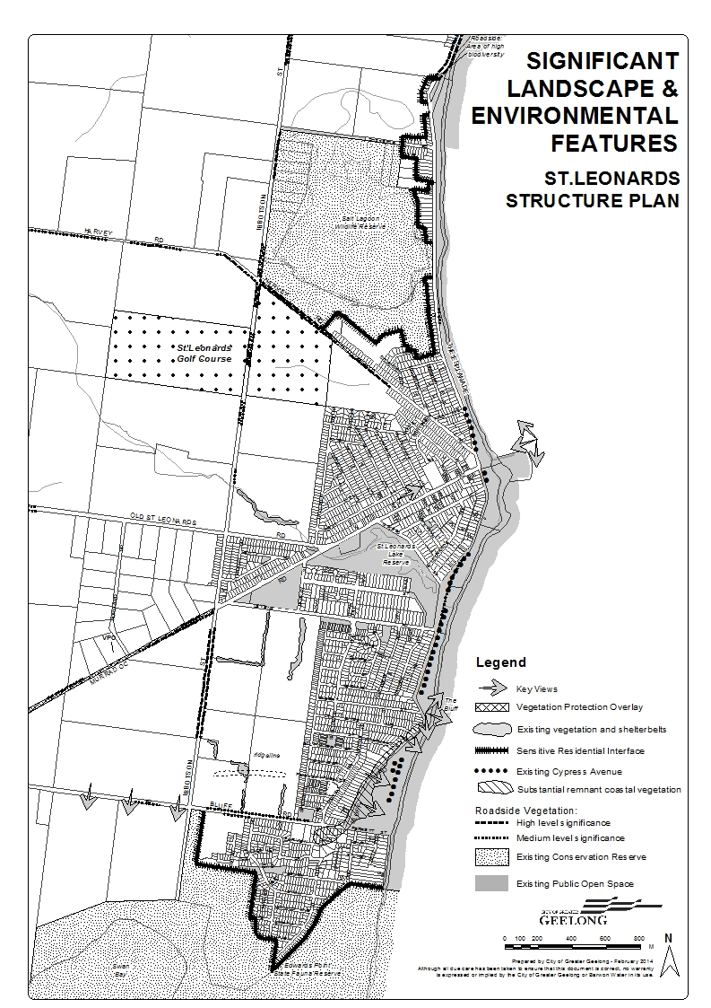

Management of Land within St Leonards

Public land including crown land within St Leonards is managed by a number of government and non government organisations. The organisations include City of Greater Geelong, Bellarine Bayside Foreshore Committee of Management, Department of Environment and Primary Industries and Parks Victoria.
Management of Environmental Assets

BBFCOM management of the foreshore is undertaken in accordance with their Northern Bellarine Foreshore Plan 2012 and the Northern Bellarine Master Plan 2012, which have recently been approved by the Department of Environment and Primary Industries. The Foreshore Master plan makes a number of recommendations relating to planned works to help manage existing and future assets on the foreshore.

On-going management of Edwards Point State Faunal Reserve and the Salt Lagoon Wildlife Reserve in accordance with Nature Conservation Regulations, as undertaken by Parks Victoria will continue in the future.
The City of Greater Geelong's Health Services Unit is responsible for the coordination of a Mosquito Management Program, which is a combination of ongoing monitoring and treatment of mosquito breeding sites. Given the attributes of the landscape in and around the township, Council has recognised that both St Leonards and Indented Head are often impacted by mosquito activity. Through the Management Program sites which are being monitored and treated in and around the township include St Leonards Lake, the Salt Lagoon, Edwards Point wetlands, Swan Bay North wetlands, and wetlands to the rear of Cliff Street.

Urban Environment
The urban environment of St Leonards is dominated by housing, which is located along each of the main approaches to the town, with a single commercial centre adjacent to the foreshore. The Urban Environment is illustrated on Map 6.
The Urban Environment – Map 6
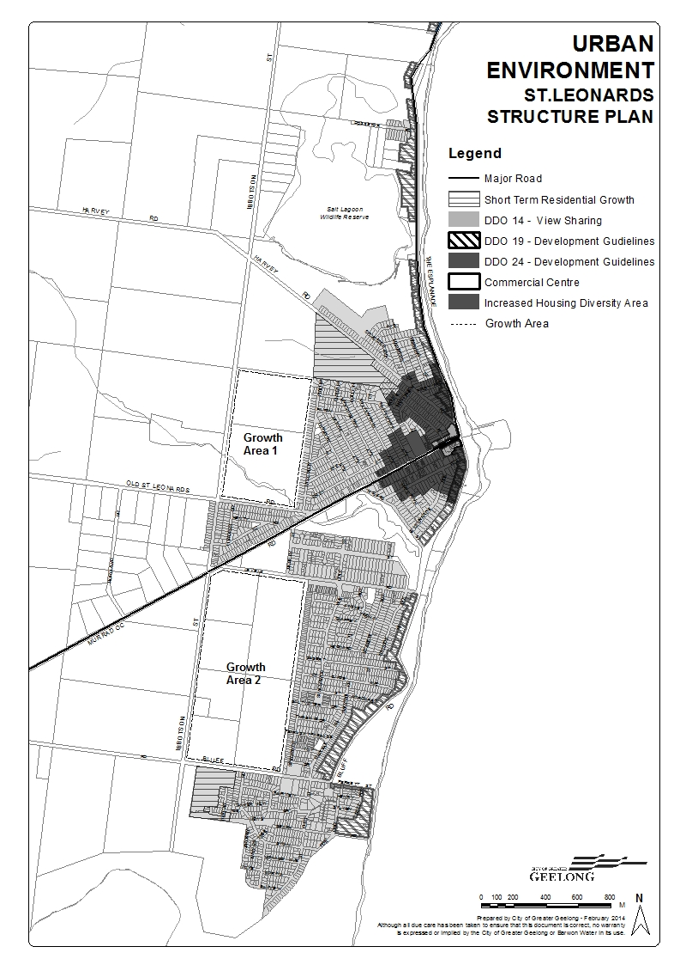
Town Centre

St Leonards is provided with a single commercial centre in Murradoc Road, which adjoins the pier and foreshore area. No land is currently designated for industrial or service business uses within the township.
The town centre includes a newly constructed supermarket (1000m2), takeaway food shops, a bakery, a hotel and a number of other specialty shops. The centre fulfils a convenience shopping role, with a limited range of essential retail and commercial services. There currently exist a number of vacant sites within the commercial centre which are zoned for commercial/business purposes.
On street car parking is provided in Murradoc Road, in conjunction with a Council owned car park adjacent to the supermarket, informal car parking is available on privately owned land at the entrance to the centre on the south east corner of Murradoc Road and Bluff Road. There is also a parking area within the pier/foreshore area which is managed by Bellarine Bayside. As occurs in other townships on the Bellarine Peninsula, these car parking areas are often at capacity during the holiday periods.
The commercial centre contains varied building styles and setbacks. One consistent element is the low-scale of buildings, with the focal point of the centre being the Hotel on the corner of The Esplanade and Murradoc Road.
A recommendation of the 2006 Structure Plan was to apply a Design and Development Overlay over the town centre. DDO24 was applied to the town centre in January 2010. The DDO guides the future development of the centre in accordance with the recommendations from the 2006 St Leonards UDF.
The Pier

The Pier is managed by Parks Victoria and lies at the intersection of the three main roads The Esplanade, Murradoc Road and Bluff Road. This area also provides a large car park managed by BBFCOM and Harvey Park managed by Council. The car park within the pier area provides for overflow parking for the town centre.
The Northern Bellarine Foreshore Master Plan and the St Leonards UDF seek to provide guidance around the development of the town centre, Pier and foreshore area;
UDF
The St Leonards UDF completed in 2006 and includes a Foreshore/Pier Concept Plan which details potential improvements including enhancement of:
- Pedestrian linkages to and within the pier area;
- Car parking layout; and
- Landscaping and fencing.

Streetscape works to the Murradoc Road and The Esplanade intersection have been completed and further recommendations around changes to the car parking and Pier area would need to be refined and discussed with Bellarine Bayside and Parks Victoria. The further refinement and implementation of this plan is broadly supported by the Structure Plan although ultimately Bellarine Bayside are responsible for the management of this area.
Northern Bellarine Foreshore Master Plan
The Master plan recommends a place making project to further investigate and upgrade the activity node, providing better connections between the shopping area, foreshore and the beach.
The objectives of the plan are generally consistent with the UDF although further collaboration between Council departments and Bellarine Bayside would be required to develop a more refined strategy. Council does not have any plans to make further streetscape changes to the town centre given the works carried out under the 2006 St Leonards UDF.

Streetscapes
The St Leonards UDF recommended a number of implementation actions with regard to general streetscape works such as improved entries to the township, a vegetation corridor along Ibbotson Street and the retention of un-made roads, where appropriate. The actions have been completed within the town centre area with other actions to be implemented when new development adjacent to those areas occurs.

Residential Character
The township of St Leonards has a distinct seaside character due to the style of housing and spacious setting surrounding the established parts of the township. The majority of subdivisions within the established part of St Leonards have wide grass verges with no footpaths or curb and channelling. There are typically no front fences and the boundaries of most properties appear to extend to the roadside. Housing is a mix of single and two storey dwellings predominately set back from boundaries.

Community input into the 2006 Structure Plan raised concern over the level of change occurring within St Leonards particularly along the foreshore and surrounding Lower Bluff Road. The 2006 structure plan recommended development controls be applied to the Lower Bluff area and along the foreshore to improve the appearance of new development. A review of the development controls within the locations has been under taken;
The Esplanade and Bluff Road: Foreshore Frontage/Coastal Edge
A recommendation from the 2006 Structure Plan was to improve the appearance of the residential development facing onto the foreshore area to ensure the modest scale, open seaside identity of the township was maintained. A Design and Development Overlay Schedule 19 has been applied to all residential foreshore land within the township. The objective of the DDO19 seeks to ensure there is opportunity for view sharing and development is consistent with the spacing and setting of dwellings and the coastal theme of the area.
Lower Bluff Residential Area
The 2006 Structure Plan identified two residential growth fronts within St Leonards. The Bluff Heights Estate, located south of Lower Bluff Road and the Sea Change Estate, located north of Lower Bluff Road. Since the 2006 Structure Plan was prepared residential development within the two growth fronts has significantly progressed. Streets within the Bluff Heights and the Sea Change Estate have taken on a more contemporary appearance as a result of changes to subdivision and open space requirements.
The 2006 Structure Plan recommended a landscape assessment be carried out for the Lower Bluff area to look at vegetation protection and preferred built form outcomes. The Lower Bluff area consists of an established pocket of housing adjacent to the coast and more recently established housing slightly further inland. There is visually a clear distinction between the two areas. Since the implementation of the 2006 Structure Plan Council has:
- Reviewed the Design and Development Overlay 14 (DDO14). The DDO 14 provides guidance around the sharing of views to significant features. The review sought to remove the DDO14 from locations where there were no views. The DDO14 has remained over residential land within the Lower Bluff area.
- Implemented the Coastal Spaces Landscape Assessment Study. This was a review conducted by the State Government of the visual and scenic amenity along the Victorian coast. The study provided a thorough assessment of landscape characteristics and identification of visually significant landscapes including the Lower Bluff Area. Significant Landscape Overlays (SLO) were applied to 5 locations across the Bellarine Peninsula. The SLO seeks to protect locally significant views and vistas that contribute to the landscape and to protect coastal vegetation when viewed from the coast. The non urban components of the St Leonards coastline were considered to have local landscape significance. However this area was not recommended for an SLO.
- Applied a Design and Development Overlay Schedule 19 over land directly abutting the foreshore area. This DDO guide’s development along the foreshore area to ensure there is opportunity for view sharing and to ensure development is consistent with the spacing and setting of dwellings and the coastal theme of the area.
The completion of the above projects are considered to meet the further work requirements of the 2006 St Leonards Structure Plan and additional overlay controls are not required.
Existing Subdivision Opportunities
There are presently two growth fronts within St Leonards:
The Golf Course – Harvey Road
The re-zoning of the St Leonards Golf Course was a recommendation of the 2006 Structure Plan. The St Leonards Golf Course has been rezoned from Special Use Zone 3 (Golf Course) to a Residential 3 Zone, a Development Plan Overlay Schedule 19 was also applied to the land to guide future subdivision applications.
A Development Plan was approved for the St Leonards Golf Course on 9 August 2013 which supports the development of 143 lots. A planning application has been lodged with the City of Greater Geelong for the subdivision of land.
The Lower Bluff – Swan View Estate
This estate is located on the south east corner of Bluff Road and Ibbotson Street. The estate consists of 102 lots ranging in size from 353m2 to 639m2.

Key Influences

- Continued protection of significant landscape and sensitive environmental setting;
- The need to appropriately manage the environment and landscape to conserve and protect Aboriginal cultural heritage values;
- Support for on-going management by public land managers of significant landscape and environmental features;
- Opportunity to protect and enhance key views and vistas;
- Opportunity to strengthen the commercial centre and inter-relationship with Pier- Foreshore precinct;
- Opportunity to strengthen character of township through streetscape works encapsulated within the St Leonards UDF;
- Opportunity to control form of development along the foreshore-coastal urban edge;
- Need for further strategic assessment to support the introduction of additional design and/or landscape planning controls over Lower Bluff area;
- Ensure new subdivision development responds to key landscape setting, environmental constraints and prevailing township character.

Demographics & Social Profile

Population
Past Population Growth

Data from the Australian Bureau of Statistics census demonstrates that during the period between 2006 and 2011 the population of St Leonards grew from 1621 persons to 2000 persons which equates to an additional 379 people, an average annual change of 3.8%.
Estimated Population in 2013

The population of St Leonards as of June 2013 is estimated to be 2090 persons. This figure is illustrated in Table 5 below and is derived by calculating the number of dwelling approvals since the 2011 census, the average household size for the township and reviewing the occupancy rate in 2011 which was 59.1%.
Table 5 – Permanent Population Estimate at June 2012
Total population at 2011 Census | 2000
Total Number of Dwellings 2011 Census | 2093
Number of Occupied Dwellings at 2011 Census (40.9%) | 855
Average Household Size in St Leonards | 2.2
Additional dwelling approvals issued between Census 2011 to June 2013 | June 2012 = 64  June 2013 = 37  Total 101
Additional Permanently occupied Dwellings June 2013 (New Dwellings (101) – Vacancy Rate (59.1%) | 41
Additional Population 2011-2013 (Permanently Occupied Dwellings (41) X Average Household Size (2.2) | 90
Estimated Permanent population at June 2013 (Population at Census 2011 + Additional Population @ June 2013) | 2090  (2000 + 90)
(note figures are rounded)
Peak Population

As a coastal township St Leonards experiences a high dwelling vacancy rate. 2011 Census data indicates a vacancy rate of 59.1% on census night. This suggests that there are a large number of holiday homes within the township. St Leonards has traditionally had a high vacancy rate. In 1981, 63.3% and in 1991 60.2% of homes were vacant.
A significant number of tourist and holiday makers visit St Leonards each summer, which can impact considerably on the resident population and retail provision for the township. The estimated peak overnight population for the township over the Christmas school holiday period from December 2012 to January 2013 is 10364 people. This figure is illustrated in Table 6 below and provides a snapshot of the distribution of tourist/holiday maker accommodation.

Table 6 – Peak Overnight Population 2012
Permanent Population in 2012 | Population Holiday Homes | Population Caravan Parks or Camping Sites | Population Hotels, Motels, Units & B&Bs | Peak Overnight Population
2086 | 7043 | 1235 | 0 | 10364
(Source: Geelong Economic Indicators Bulletin 2012)

Age Structure
Census data provides information on the demographics of the township including age distribution. There is a significant proportion of the population within St Leonards over the age of 50. In 2011, approximately 54.7% of the town’s population was aged 50 years and over, significantly higher than the same age cohort for the Geelong municipality where 35% of the population is aged 50 years and over (Economic Indicators Bulletin 2012).
Persons aged between 35 and 49 represent 16% of the population, with those persons aged between 25-34 representing 6.8% of the population.
Persons aged between 0 to 24 years represent 19% of the population of St Leonards, a significant difference when compared to the same population range for the Geelong municipality (32%) figure 2 below illustrates the age structure of the St Leonards population.
Figure 2 – Age Structure of St Leonards (2011)

Source: ABS 2011
This data demonstrates that the township is characterised by older persons, and when considered in conjunction with labour force statistics detailed below, a large proportion of whom are likely to be retired or semi-retired

Dwellings & Household Size
The number of private dwellings in St Leonards at the 2011 Census was 2093, with 855 occupied and 1238 unoccupied. This equated to an estimated vacancy rate of 59.1% for the township, commensurate with its historic role as a holiday maker/holiday home destination.
Of the Occupied Private Dwellings within St Leonards in 2011, 48.7% were recorded as being fully owned and only 22.6% being purchased. The level of home ownership in St Leonards is higher when compared to the Geelong municipality where 36.2% of homes were owned fully. The remainder of the occupied housing stock in the township was either privately rented (26%) or not stated (2.7%).
The average household size in St Leonards is 2.2 persons, with the 2011 Census revealing that 66.7% of the households were family households. This average household size is slightly lower than the average for the rest of the municipality at 2.4 persons. 27.4% of house holds were single person households. The proportion of single person households in St Leonards is slightly lower than the proportion evident across the municipality, where 30.6% of households consist of sole person households.
Figure 3 – Household Size (2001)

Source: ABS 2011

Labour Force & Income
ABS Census data identifies the “labour force” as consisting of persons aged 15 years and over who are employed, or those who do not have a job but are actively looking for work. Theoretically, persons not in the labour force include people below the age specified for measuring the economically active population (15 years) and older people who have retired from the workforce.
There were 704 people who reported being in the labour force in the week before Census night in St Leonards. Of these 50.0% were employed full time, 33.8% were employed part-time and 8.4% were unemployed. In comparison, there were 101,031 people who reported being in the labour force in the week before Census night in Greater Geelong (C) Local Government Areas (LGA). Of these 55.8% were employed full time, 32.6% were employed part-time and 5.6% were unemployed. The unemployment rate within St Leonards is higher than in the Greater Geelong LGA.
There were 2000 people resident within St Leonards according to the 2011 census, 296 of these people were under 15 years of age and a further 704 indicated they were in the work force. This suggests there are 408 people retired or not looking for work within St Leonards or 20.4% of people.
In comparison there were 210,875 people resident within the Greater Geelong LGA on census night 2011. Of these people 27, 254 (18.4%) were under the age of 15 and a further 101,031 people reported to be within the work force. This would suggest that there are 82,590 people retired or not looking for work within the Greater Geelong Local Government Area or 39.19% of people.
The median age of people employed full time is 45 and part time is 49, in comparison to the Greater Geelong LGA where the median age of people employed full time is 41 and part time is 40. This suggests there are a higher number of older people still participating within the work force within St Leonards.
A review of the industry categories for those persons employed in St Leonards reveals that in 2011 the most prominent category was Technicians and Trade Workers 17%, Professional 14.9%, Labourers 14.1%, Sale Workers 12.7%, Community and Personal Service Workers 11.3%, Clerical and Administrative Workers 11%, Managers 10.8% and Machinery Operators and Drivers 5.6%.
The median personal income for people aged 15 years and over in St Leonards was $391, within the Greater Geelong LGA $517, and Victoria $561.
Journey to Work

The data collected by the ABS in 2011 demonstrated that the dominant mode of travel to work for residents of St Leonards is the private car, either as driver or as passenger 71.7%. 2.6% of the population “walked only” to work, indicating that it is highly probable that the majority of residents of St Leonards travel outside the town for employment. This is in line with the data relating to the employment of St Leonards residents, which indicates a significant proportion are employed in industries not present in the township.
Socio-Economic Index

Below are the SEIFA measures of Relative Socio-economic Disadvantage for the year 2011, which have been prepared by the Australian Bureau of Statistics This index weighs conditions such as incomes, educational attainment, occupations, housing ownership, English fluency and unemployment, as recorded by the 2011 Census, to produce a single overall measure of relative social and economic disadvantage. It provides a general view of the relative level of disadvantage in one area compared to others and is used to advocate for an area based on its level of disadvantage.

Table 7 - Index of Relative Socio-Economic Disadvantage
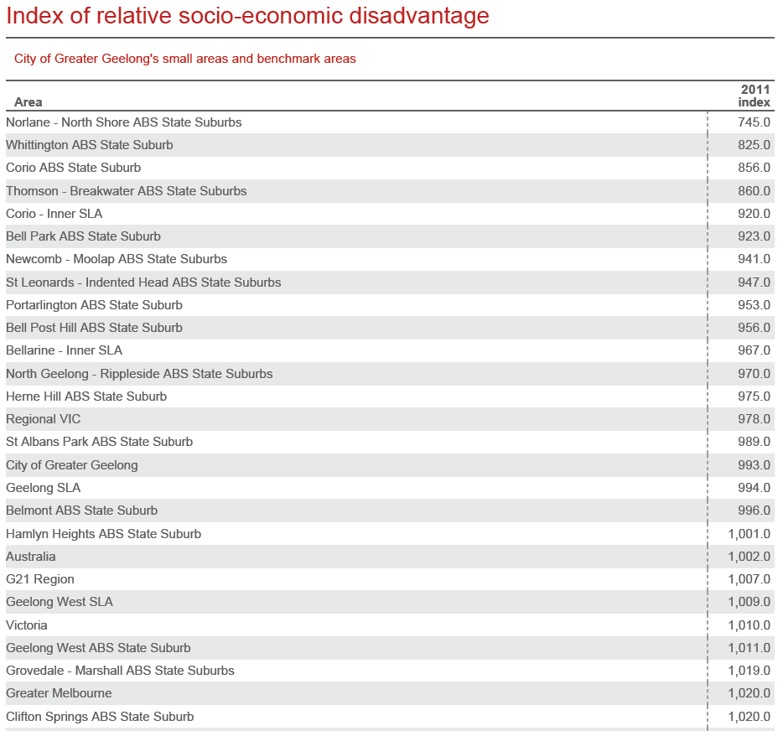
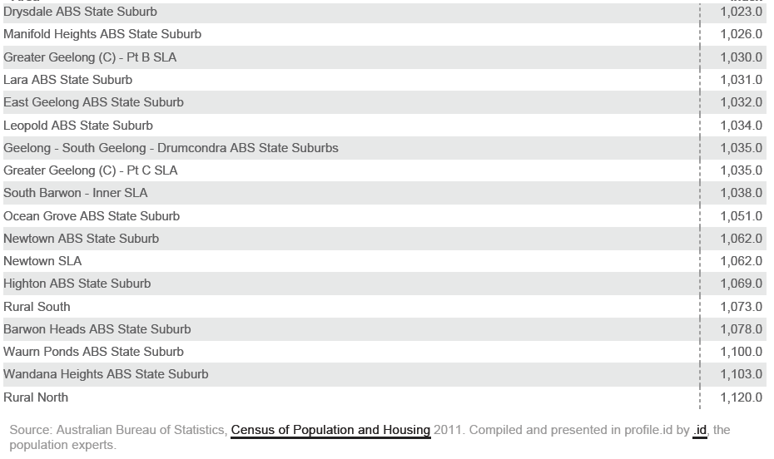
High scores on the Index of Relative Socio-Economic Disadvantage occur when the area has few families of low income and few people with little training and in unskilled occupations. Low scores on the index occur when the area has many low income families and people with little training and in unskilled occupations.
The Australian average is set at 1,000. According to SEIFA, 2011, the City of Greater Geelong is relatively disadvantaged municipality in overall terms with a SEIFA score of 992.9. However, there are significant pockets of disadvantage within the municipality; most notably Norlane, North Shore, Whittington, Breakwater and Thomson all have SEIFA scores below 900, indicating there is considerable disadvantage within these areas. St Leonards – Indented Head is relatively disadvantaged with a score of 946.9. (7th most disadvantaged suburb in CoGG). Both St Leonards and Indented Head are situated in the 2nd decile of relative socio economic disadvantage (SEIFA).
Australian Early Development Index 2012 (AEDI) measures childhood development across five domains: physical health and wellbeing, social competence, emotional maturity, language and cognitive skills, and communication skills and general knowledge.
Across the municipality St Leonards/Indented Head children have higher than average rates of vulnerability. 37% of children are identified as developmentally vulnerable in one or more domains of the AEDI compared with 18.8% of the City of Greater Geelong community; this points to a significant level of developmental vulnerability in St Leonards and Indented Head compared with the rest of the municipality. Therefore enhancing local access to early years and parenting support services is particularly important to achieve as soon as possible.

Population Projection 2021-2031
The projected population of St Leonards in 2021 is 2394 persons, as demonstrated within the table below.
Table 8 – Population Projections 2021-2031
Total population at 2011 Census | 2000
Number of Dwellings at 2011 Census | 2093
Average Household Size in St Leonards | 2.2
Dwelling occupancy rate based on 2011 census (unoccupied 59.1%) | 40.1%
Average No. of dwelling approvals per year | 62
No. of additional dwellings between 2011 and 2021 = 62*10 | 620
No. of occupied dwellings 2093+620*40.9% | 1088
Estimated Population in 2021 based on total No. of dwellings x Average Household Size (2.2) | 2394

There has been a strong association with the use of dwellings for holiday homes within St Leonards and it is expected that this trend will continue into the future. The above table therefore assumes that 59.1% of all new dwellings that are constructed will be unoccupied, based on 2011 census data.
The table below identifies population projections for the St Leonards – Indented Head area up until the year 2031 based on age co-horts. (Note: In 2011 the population of Indented Head was 921 people.)

Table 9 – Projected Population by Age Cohort for St Leonards – Indented Head ‘id. Forecast’ 2013
Age structure | Number 2011 | Percent 2011 | Number 2021 | Percent 2021 | Number 2031 | Percent 2031
0-4 years | 168 | 5.4 | 157 | 4.1 | 171 | 4
5-9 years | 142 | 4.6 | 172 | 4.5 | 190 | 4.4
10-14 years | 166 | 5.4 | 196 | 5.2 | 201 | 4.7
15-19 years | 124 | 4 | 143 | 3.8 | 162 | 3.8
20-24 years | 98 | 3.2 | 128 | 3.4 | 145 | 3.4
25-29 years | 111 | 3.6 | 141 | 3.7 | 153 | 3.5
30-34 years | 121 | 3.9 | 152 | 4 | 167 | 3.9
35-39 years | 163 | 5.3 | 208 | 5.5 | 228 | 5.3
40-44 years | 187 | 6.1 | 250 | 6.6 | 275 | 6.4
45-49 years | 175 | 5.7 | 257 | 6.8 | 293 | 6.8
50-54 years | 208 | 6.7 | 272 | 7.2 | 320 | 7.4
55-59 years | 271 | 8.8 | 317 | 8.4 | 383 | 8.9
60-64 years | 318 | 10.3 | 380 | 10 | 440 | 10.2
65-69 years | 279 | 9 | 351 | 9.3 | 396 | 9.2
70-74 years | 202 | 6.5 | 255 | 6.7 | 303 | 7
75-79 years | 165 | 5.3 | 182 | 4.8 | 228 | 5.3
80-84 years | 129 | 4.2 | 119 | 3.1 | 148 | 3.4
85 years and over | 61 | 2 | 105 | 2.8 | 109 | 2.5
Total | 3088 | 100 | 3785 | 99.9 | 4312 | 100

It is expected that St Leonards will continue to have a high proportion of people aged 50 years and over.

Key Influences
- High proportion of older residents and residents living alone requiring significant levels of community and social services;
- High dwelling vacancy rate and seasonal influx of large numbers of non-permanent residents and holiday-makers;
- Low labour force participation rate and household income;
- Car reliant population;
- Area of high socio-economic disadvantage;
- Need to provide for a greater range of housing choice.

Township Facilities & Services
The local services and facilities within a township are central to bringing people together and supporting a sense of community.
St Leonards is relatively well provided with a range of open space and recreation facilities, with the large majority of the community and social services provided within adjacent townships.

Local Community Services and Facilities
The following is a list of the key local facilities available within the township of St Leonards, also shown on Map 7:
- Murradoc Road town centre
- St Leonards Memorial Hall
- Primary School
- Two Churches
- Country Fire Authority Station
- Postal Agency
- Hotel
- Community meeting space – Blanche Street
- Mens Shed
- Sporting Pavilion at Len Trewin Reserve.
- Bowling Club

Many of these facilities also service the township of Indented Head.

Town Centre
Economic Assessment

The City of Greater Geelong engaged Tim Nott - Economic Analysis and Strategy to review the service needs of the St Leonards Town Centre based on a population increase from the potential release of additional broad hectare land for residential purposes. The review considered changes in demand for services within the town centre and whether the centre has the capacity to accommodate likely growth. In summary report recommends;
St Leonards town centre serves as the main activity centre for the township of St Leonards and the surrounding district. The town centre has a central location for the township but does not have extensive exposure to the foreshore. It has a total floor space of 4,000 sq m, of which around 2,400 sq m is providing retail goods and services.
The retail function of the centre is as a small neighbourhood service which is bolstered by demand from visitors. The centre caters for the convenience retail needs of its trade area with a small supermarket and a limited range of specialty shops and cafés.
The retail catchment area for the centre is defined by the surrounding network of centres. In this report the population of the catchment has been estimated at 2,590 in 2012. Retail sales at the centre are estimated at $14.5 million in 2012, 56% of which comes from people living in the catchment and 44% from visitors living outside the catchment. The annual retail spending of catchment residents in shops is estimated at $30 million, with 27% of this being spent at St Leonards town centre. Most of the remaining 73%, or $22 million, “escapes” from the catchment to larger centres such as Drysdale, Leopold and Geelong.
This report provides three scenarios for future residential development in the trade area. These are based on a survey of housing land and allotments recently undertaken by Spatial Economics for the G21 Councils. The scenarios identify potential for between 4,100 and 5,100 dwellings in the St Leonards trade area at full development. This leads to a resident population of between 4,500 and 5,500 people in the trade area at full development. Full development is assumed here to be achieved by 2031 under any scenario.
Using a number of conservative assumptions (that is, that conditions will remain broadly the same as at present), demand for retail floor space at full development is forecast to be between 4,100 and 5,100 sq m. This will require growth of between 1,700 and 2,700 sq m compared with the present.
Demand for non-retail space has been estimated here at 40% of the total town centre activity space (and this excludes schools and dwellings).
At full development, taking car-parking into account and assuming some upper level commercial development, the town centre will need find additional land of between 5,300 and 8,400 sq m.
Current vacant land in the town centre totals around 3,100 sq m. It may also be possible to use sites that are currently developed more efficiently to gain additional land (and this might include the existing hotel site). In all, the commercially zoned land of the town centre may need to expand by between 1,200 and 4,300 sq m to accommodate the required activity forecast at full development.
There is potential to undertake incremental expansions of the town centre by rezoning lots in the adjacent housing areas on Blanche Street, Bluff Road and Murradoc Road. More extensive expansion may be possible along Murradoc Road, taking 4-5 housing allotments on the south side of the road or through relocation of the Catholic Church and use of the front part of their allotment (5,000 sq m) for commercial purposes. Whichever option is deemed most appropriate, early action is required in order to protect the ability to develop a town centre that is walkable and has continuous active frontages.
Ongoing monitoring of the assumptions and scenarios developed in this report is required.
Recommendation
The need to grow the commercial area of St Leonards is not immediate. There are 2 significant vacant sites within the township, 1355-1365 Murradoc Road and 1-2 Bluff Road. There is also scope to redevelop the pub given the large amount of vacant land on the northern side of the site. There is no immediate demand to rezone land adjacent to the town centre for future commercial growth based on the population growth of the town. It is recommended that a further review of the commercial centre occur within 10 years to determine if the demand for an expansion of the town centre is required.

Social and Community Services
Due to geography and population density, the Northern Bellarine presents the City of Greater Geelong with a set of unique circumstances for service provision in relation to community services.

Figure 4 - Hierarchy of Service Delivery on the Northern Bellarine

Sub Regional Centre

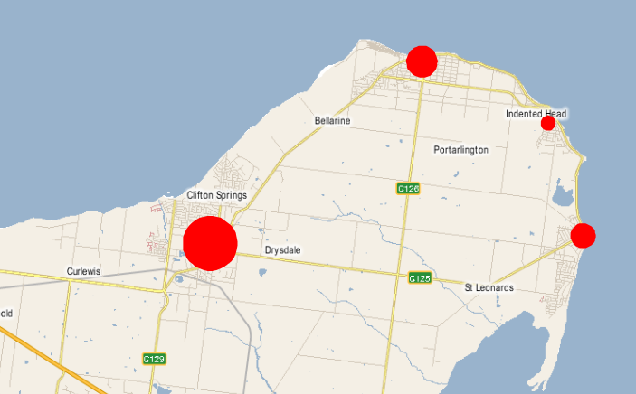

There is a clear hierarchy of townships in the Northern Bellarine which is reflected in the services and facilities offered (Figure 4). Drysdale performs the role of a sub-regional centre and is situated as the ‘gateway’ to the other townships (Portarlington, Indented Head and St Leonards). Therefore Drysdale is a natural service centre for higher order services and facilities that require a larger population threshold.
Drysdale provides a range of services to the smaller population centres including secondary schools, a branch library, health and aged care services. Portarlington also provides services to Indented Head and St Leonards (e.g. early years – kindergarten program, toy library). St Leonards in turn provides a local primary school, sporting clubs and a sporting reserve whereas Indented Heads does not have the population to support much in the way of localised social infrastructure.
Social and community services are provided to the population of St Leonards, with many based externally and provided on a region-wide basis. These include Children’s and Aged Care services, such as Home Help, Youth Services, Meals on Wheels and a Mobile Library.
Bellarine Community Health
Bellarine Community Health provides a wide range of services including medical, nursing and home-based allied health, youth, maternal and child health and adult day programs, including socialisation, respite and rehabilitation.
Since the 2006 Structure Plan was prepared Bellarine Community Health no longer operate out of St Leonards and now provide services within the nearby townships of Portarlington and Drysdale. Bellarine Community Health have advised that they do not having any plans to invest any new capital funds into St Leonards and is not expecting to make any significant changes to the current services it provides to the people of St Leonards. Given the projected population growth within the Northern Bellarine, Bellarine Community Health has advised that they expect to be able to meet demand for services.

Early Childhood Services
There is a playgroup which operates from the St Leonards Primary School however maternal and child health, pre-school and kindergarten facilities are located in nearby townships of Portarlington and Drysdale-Clifton Springs. Recent growth within the Northern Bellarine has resulted in these centres reaching capacity with limited or no ability to expand. Any increase in population within St Leonards and the surrounding townships will place additional pressure on these services.
Family Services have recently reviewed 2014 kindergarten enrolments in relation to St Leonards and the data illustrates that families are currently required to travel some distance to access relevant services. A round trip to attend kindergarten at Portarlington from St Leonards for three sessions per week is about 66 kms, without access to a car this trip is made more difficult due to the limited public transport options available within the town.
Table 10 – Kindergarten Attendance
 | Where children are coming from to attend Kindergarten 2014
Kindergarten | St Leonards | Indented Head | Total
Beacon Point (Clifton Springs) | 1 | 0 | 1
Portarlington | 9 | 14 | 23
Drysdale | 7 | 1 | 8
Clifton Springs | 2 | 0 | 2
Total | 19 | 15 | 34

As previously stated St Leonards has a high level of developmentally vulnerable children. Enhancing access to early years and parenting support services for St Leonards and Indented Head is considered important to improve the level of vulnerability within the town.
Education Facilities

St Leonards is provided with a single primary school located close to the centre of town in Murradoc Road. Eighty five students were enrolled at the St Leonards Primary School in the 2012 school year. The primary school services both St Leonards and the Indented Head community.
Due to new residential development occurring within St Leonards the primary school has had an increase in the number of children attending the primary school. However a number of children that reside in St Leonards attend primary school in Portarlington and Drysdale, due in part to an association with the kinder programs at these locations and the working location of parents.
The primary school operates a play group from a portable building at the rear of the school. This facility is well utilised by parents in the area. The facility is managed by the primary school with help from the City of Greater Geelong and the wider community.
The primary school has capacity for up to 120 children and given the projected number of school aged children in 2031 of approximately 391 children (table 9), the school has capacity to accommodate a large proportion of this increase, assuming some children will continue to attend school in Drysdale and Portarlington. It is not necessary for this Structure Plan to designate future areas for educational purposes or consider availability of land for primary school facilities.
Council has liaised with the Department of Education and Early Childhood Development about the future educational requirements in and around St Leonards and it has not indicated a need for any additional schools in the township.
The Northern Bellarine is well serviced by primary and secondary schools. Portarlington has a primary school, which is within 10 kilometres of St Leonards, with campuses of the Bellarine Secondary College in Drysdale and Ocean Grove, both within 20 kilometres of the township. There are also a number of private secondary colleges within Drysdale. It is envisaged that the schools outside of the township will adequately service the school aged population of St Leonards.
Community Space

Since the 2006 Structure Plan was implemented Council has leased a community meeting space within the town centre located at 1377 Murradoc Rd. This space is managed through the SpringDale Neighbourhood Centre and offers the community a meeting space. The meeting space consisting of three areas; small meeting room seating approximately 8 people, a foyer area/meeting room with seating for approximately 20 people. The centre offers a range of activities including computer and craft courses. The centre is well utilised.
The St Leonards Lake and Charles McCarthy Reserve Master Plan has also identified possible upgrades to the existing community buildings within the St Leonards Lake Reserve. The master plan seeks to maximise the use of this important community building by creating an adaptable space for a range of community activities that could expand to uses outside traditional sporting activities.

Figure 5 - St Leonards Lake Reserve Pavilion
Source: St Leonards Lake and McCarthy Reserve Master Plan, Oct 2011, CoGG
Bellarine Peninsula Community Service Plan (BCSP) 2006-2016

The Bellarine Peninsula Community Service Plan 2006-2016, has been prepared by the City of Greater Geelong Social Planning Unit to provide an integrated Community Service response for the townships and rural areas of the Bellarine Peninsula.
The Plan includes:
- Current and projected populations and their composition for each township and rural areas.
- A summary of current and projected social service provision.
- An understanding and analysis of community needs both now and into the future.
- Action Plans to address identified needs.
In planning for future community services for St Leonards the draft Plan considered a number of previous studies undertaken within the area and identified the following:
Key Community Service issues:
- High number of older year households
- Significant proportion of lower income households
- St Leonards repeatedly ranked as a disadvantaged area.

Identified need for:
- Local parent support activities
- Informal occasional care and after school care
- Activities for pre- teenage children
- Employment options for young people
- Confidential health services for young people
- Accessible health services for older years
- Multi-purpose community centre.
Based on the above issues, the projected population within the critical age cohorts and community input, the following recommendations were developed for future community service planning in St Leonards:
- Recommendation 1: Work with St Leonards Primary School, GP’s and Bellarine Community Health to promote availability of family services
- Recommendation 2: Progress discussions about community centre design and location
- Recommendation 3: Work with St Leonards community to seek external funding to develop virtual neighbourhood house to improve accessibility and use of existing services and facilities and encourage community building
- Recommendation 4: Develop dialogue with St Leonards Retirees Association with a view to improving services to older residents in St Leonards
- Recommendation 5: Develop electronic Community Directory for St Leonards, available in hard copy for local area
- Recommendation 6: Work with St Leonards community to include community service information in new residents kit
- Recommendation 7: Assist St Leonards community application for Volunteer Support Grant
Audit of Report
A recent audit of the plan has been carried out. The progress of the key recommendations from the plan has been reported to Council. In relation to St Leonards the following community infrastructure issues have been completed:
- Creation of a community meeting space in Blanche St (Recommendation 2 and 3)
- Masterplan undertaken for the recreation reserve (Recommendation 2 and 3)
- Feasibility study undertaken for a community hub (based at the recreation reserve) and hub concept developed. (Recommendation 2 and 3)
- Construction of a men’s shed (including the incorporation of change rooms, toilets and umpires rooms for sporting activities) added to the reserve hall. (Recommendation 2 and 3)
Draft Children’s Services Plan

Council is currently developing the Draft Children’s Services Infrastructure Plan (2013) which makes the following recommendation in relation to St Leonards ‘subject to future growth and potential new sub-division development, examine requirements for children’s service facilities’
Within Indented Head, Portarlington and St Leonards there are 2 Council owned facilities in which early years operate and 2 non Council owned facilities
The following Children’s services are located within Indented Head, Portarlington and St Leonards

Table 11 - Existing Children’s Services – Indented Head, Portarlington, St Leonards
Service Type | Number of Services
Kindergarten | 1
Long Day Care | 0
Maternal & Child Health Care Centre | 1
Occasional Care | 0
Outside School Hours Care | 1
Playgroup | 3
Toy Library | 1
Total | 7

The plan shows that there has been a 30.8% increase in children aged between 0-14 years within St Leonards between 2001 and the 2011 census. This has placed additional pressure on the Kindergarten in Portarlington. The plan recommends that an Early Years Learning Facility would be required for St Leonards if the identified growth areas were to develop.

Access to Transport

Council’s Community Development Unit has been involved in a number of transport related projects on the Bellarine (Building Better Connections: A Journey, 2013) and this work has highlighted the inadequacy of public transport options and the absence of a petrol station (nearest is Drysdale) and how this impacts on the local community particularly the elderly and there ability to access services. This issue becomes critical when there is a substantial population increase over holiday periods. A petrol station located within a coastal township on the Northern Bellarine would significantly improve transportation options for this community.

Emergency Services

Emergency services such as police and ambulance are provided to St Leonards on a region wide basis. The twenty-four hour police station in Ocean Grove serves the peninsula townships, including St Leonards, in conjunction with the station in Drysdale, Portarlington and Queenscliff. Ambulance services to St Leonards are based out of branches in Ocean Grove and Drysdale and the State Emergency Service operates a unit within the peninsula, co-located with the ambulance branch in Drysdale.
Rural Ambulance Victoria and the Victorian Police have advised that they have no future plans to locate branches within St Leonards and that the expected growth of the town over the next ten years can be appropriately serviced by their existing branches on the peninsula.
The Country Fire Authority (CFA) operates a volunteer brigade in St Leonards. The CFA station is located in Dudley Parade and is part of the Bellarine Group of Fire Brigades.

Public Realm, Open Space, Leisure and Recreation Facilities

A number of public leisure and recreation facilities are offered in St Leonards. The majority of these facilities are concentrated in the core of the township, along Murradoc Road and within the St Leonards Lake Reserve. Given the town’s water based focus, a number of facilities are also located along the foreshore.
Small reserves of public open space are located within the residential areas with the two large conservation reserves of the Salt Lagoon Wildlife Reserve and Edwards Point State Faunal Reserve forming the north and south extremities of the town. The bay provides opportunities for a range of water recreation activities including swimming, boating and fishing.
The following is a list of the leisure and recreation facilities within the township, further illustrated in Map 7.
- Privately Owned Golf Course
- Skate Park Facilities
- Sports Pavilion and Hall
- Tennis Courts
- Netball Courts
- Bowling Club
- Two Sports Reserves
- St Leonards Lake Reserve
- The Foreshore (including the pier, playground and camping and bbq areas)
- Conservation reserves: Salt Lagoon Wildlife Reserve and Edwards Point State Faunal Reserve
- Boat Ramp.
- Yacht Club and Motor Squadron

Improvements to Open Space, Leisure and Recreation Facilities

Three studies have been previously undertaken by, or on behalf of, Council which have identified potential improvements in relation to open space, leisure and recreation provision and their linkages within the township. This Structure Plan broadly supports the key actions of those previous studies as detailed below.
St Leonards UDF

The St Leonards UDF recommends a number of key actions and opportunities to improve existing community and recreational infrastructure within the township. In summary, the key actions include:
- Increased planting of indigenous vegetation;
- Upgrading and/or replacement of structures;
- Minimising structures and unnecessary signage;
- Provision of interpretative/education material at key landscape sites;
- Investigation of the provision of viewing platforms at key viewing sites; and
- Implementation of a Concept Plan for the Pier and Foreshore area and preparation of Master Plan/Landscape Plan for the St Leonards Lake Reserve and adjoining reserves.
Bellarine Peninsula Leisure & Recreation Needs Study 2005

The Bellarine Peninsula Leisure & Recreation Needs Study concluded that the town was adequately serviced by a range of leisure and recreation facilities, but did recommend some improvements to existing facilities.
Key actions include:
- Support the establishment of a soccer club based at the Lake Reserve with access to existing pavilion facilities and the establishment of an adequate training/playing pitch.
- Develop a walking track around St Leonards Lake Reserve including a connection to the foreshore; to be developed in the context of the Landscape Concept Plan for this site.
- Resolve/transfer management responsibilities between City of Greater Geelong and Bellarine Bayside for Harvey Park and The Esplanade car park area.
- Provide a safe pedestrian crossing over Leviens Road in the vicinity of the Sea Change Estate. Install a footpath on the northern side of Leviens Road to form a pedestrian connection to Charles McCarthy Reserve.
- Monitor the demand for active sporting use of Charles McCarthy Reserve and review the existing skate facilities to enhance user experience and ensure appropriate skill challenges and options are provided.

St Leonards Lake and Charles McCarthy Reserve Master Plan

This study as mentioned previously investigated the existing and future needs of this important recreation facility within the St Leonards area. Key recommendations include but are not limited to:
- Works to main pavilion to make it more versatile
- Improvements to BBQ and seating facilities
- Creation of a walking trail around St Leonards Lake
- Use of public art in park
- Redevelop and improve skate park, netball/tennis courts, and soccer facilities.
- New plantings
- Improved safety around the park.

Tourist and Holiday Accommodation

As with the majority of the leisure and recreation facilities, tourist and holiday accommodation is focussed around the town centre and the St Leonards Lake Reserve, further illustrated on Map 7.
There are two caravan and camping facilities:
- BBFCM have two areas along the St Leonards Foreshore. Area 3 consists of 115 sites and Area 4 18 sites.
- The St Leonards Caravan Park is location at 99 Leviens Road provides 96 Sites a large majority of which are ‘annual site’ with two cabins.
The St Leonards Hotel, on the corner of Murradoc Road and The Esplanade, offers ten rooms above the hotel overlooking the pier and foreshore area. A number of other properties within the township are offered for holiday rentals, with a small amount of bed and breakfast accommodation.

Existing Community, Recreation and Open Space Facilities - Map 7
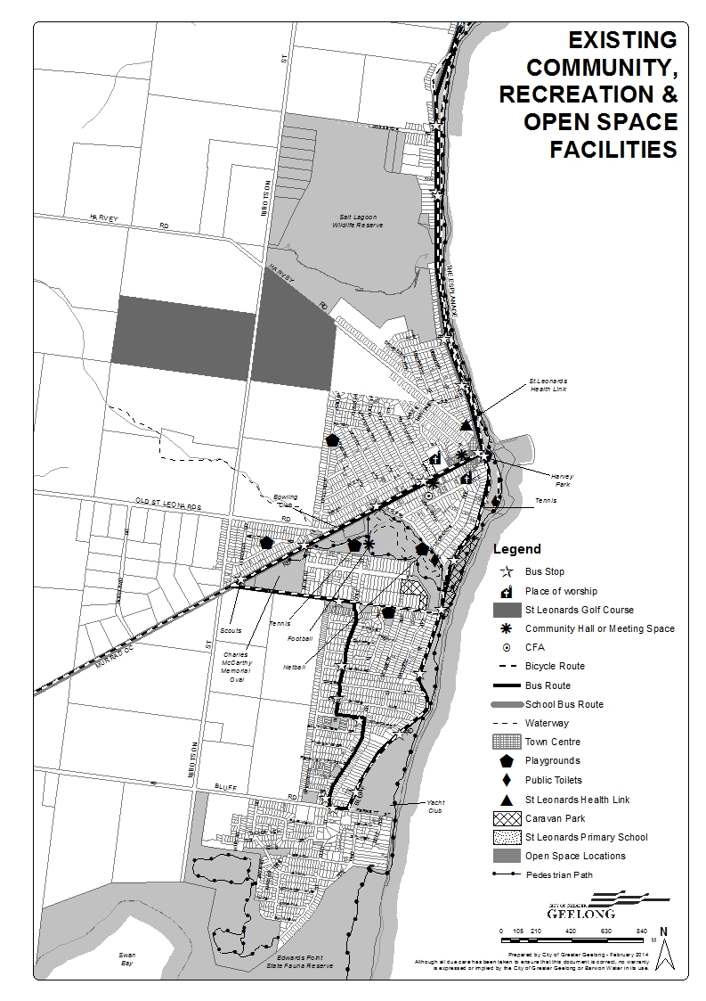

Key Influences
- Single retail centre which provides for basic community needs;
- Reliance on region-wide social and community service provision;
- Opportunity to support provision of a Community Centre to provide improved social, community and health services;
- Opportunity to support recommendations of previous studies to enhance open space and recreation areas and further develop and improve linkages between existing range of recreational facilities.

Physical and Transport Infrastructure

Physical Infrastructure
Water Supply

The township is gravity fed its water from the Portarlington Basins, located in Tower Road, Portarlington. The service travels along Tower Road, through Indented Head, via The Esplanade and into St Leonards. The reticulation water mains branch off this transfer, supplying both Indented Head and St Leonards. There is currently sufficient potable water capacity to cater for minor additional Greenfield and infill development in St Leonards from this main.
Barwon Water have advised to improve security of supply and provide capacity for large scale urban growth, Barwon Water has been progressively upgrading the water supply system with the construction of a second water feeder pipe from Portarlington to Indented Head and St Leonards. The most recent upgrade in 2010 saw the construction of a pipeline from Tower Road Portarlington to Indented Heads. The proposed future upgrades to St Leonards are to occur in two stages. Referred to as stages 3 and 4
Stage 3 – New pipeline from Batman Road Indented Head, via Grassy Point Road and Harvey Road. This would cater for the northern growth area.
Stage 4 – new pipeline from Harvey Road, via Ibbotson Street to Leviens Road. This would cater for the southern growth area.
The construction of these assets will depend on the progression of development in St Leonards. The investment require for stages 3 and 4 is estimated to be $10 million
Sewer

The St Leonards existing system is a conventional sewerage system serviced by a series of gravity sewers, pump stations and pressure mains. Two pump stations, one in the north and one in the south of town, collect flows from the existing residential development in the north and south and transfers to Portarlington pump station No. 6. This pump station then transfers all flows from St Leonards, Portarlington and Indented Head to the Portarlington Water Reclamation Plant.
In 2007 Barwon Water undertook a study on the Bellarine Peninsula to determine required upgrades to the sewer system associated with growth to 2045. The report assumed future residential development in the three areas considered in the St Leonards Structure Plan. Three pump stations were identified for upgrades associated with the growth in St Leonards.
Gravity sewers adjacent to the three identified development areas generally have capacity, however as mentioned above three downstream pump stations and some collector pipes would ne3ed to be upgraded to service this growth. The investment required in sewerage assets is likely to be in the order of $6 million.
Recycled Water

The Portarlington Water Recycling Plan produces Class C recycled water which is fully allocated to existing customers in the region, including the Portarlington Golf Course and several vineyards. Class C recycled was can only be used for agriculture and restricted open space irrigation and hence there are no current plans to expand this reuse system to areas at present. Therefore further recycled water servicing is not available for the growth areas in St Leonards.
Storm-water and Catchment Issues

As identified within the City of Greater Geelong Stormwater Management Plan the area of St Leonards is located within the sub-catchment of Portarlington and on the north eastern fringe of the Swan Bay sub-catchment.
The recognised stormwater threats for these catchments are:
- Residential runoff containing a range of pollutants, including elevated sediment, nutrient and litter loads.
- Elevated sediment loads, due to the clearance and disturbance of soils associated with land and infrastructure development.
- Building site runoff.
- Agriculture Land Use Runoff.

Management techniques recommended by the Strategy to minimise the impacts of stormwater pollution and to protect the values of the receiving environment include new planning guidelines, community education and the development by Council of sediment and erosion control plans and environmental management plans, to be implemented when planning for new urban areas.
Impacts on existing Infrastructure

The established residential areas of St Leonards, have limited drainage infrastructure including aged infrastructure. The potential for increased growth within St Leonards within the designated growth areas and through infill development will require proper investigation into the effects from climate change, the proposed design of any drainage system and its impacts on existing infrastructure as well as water quality management. Further studies should be undertaken to consider these issues.
Flooding

St Leonards is located adjacent to the three significant waterways of Swan Bay and the Salt Lagoon and the man made lake at St Leonards Lake Reserve. This results in the area being subject to flooding events.
Other issues that could possibly affect the flood levels beyond those areas identified within map 8 relate to aging infrastructure and pressure from greenfield and infill development. An analysis of existing drainage system shortfalls should be undertaken to determine future flooding impacts on the township.
Climate Change

The impacts of climate change are already being experienced, generating a new series of risks for organisations and the community. Climate change is a complex problem that requires a new integrated and collaborative risk management approach. St Leonards will be affected by climate change including storm surges and sea level rise. Areas adjacent to the coast, including Salt Lagoon, Swan Bay, St Leonards Lake and the foreshore area will be the most affected by climate change. New development particularly land within growth areas 1 and 2 will need to consider the impacts of climate change given stormwater will drain into these areas. Local Coastal Hazard Assessments will be required as part of rezoning applications this may result in the need to limit development in some locations, raise the future floor levels of buildings and design drainage systems to take into account the impacts of connecting to existing drainage systems.
Council will need to undertake more work to identify vital triggers for when it may be necessary to determine a future course of action for parts of the township affected by climate change including the ‘do nothing, retreat, protect’ approach.
The Victorian Coastal Inundation Dataset was developed as part of the Department of Sustainability and Environment's Future Coasts program. It was released in June 2012 by the Minister for Environment and Climate Change in the form of PDF maps for use by the general public. Map 8 shows the extent of projected inundation on the Victorian coastline as a result of possible sea level rise and storm tides. It is intended to be viewed and used at catchment to regional scale and can be used to inform activities such as statewide and regional adaptation planning, statewide and regional risk management and strategic land use planning, and the development of documents such as Regional Growth Plans, Regional Catchment Strategies and Coastal Action Plans. It is not suitable for assessing the potential impacts of sea level rise on individual properties or structures.

Flood and Sea Level Rise Mapping - Map 8
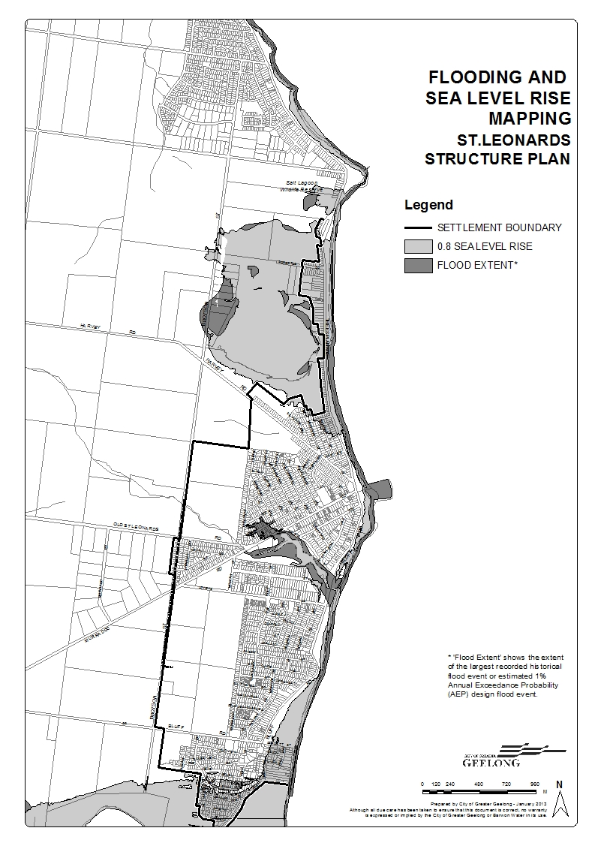

Transport Infrastructure
The transport network within St Leonards is focused on road based movements, with a lack of formal pedestrian paths and linkages between the open space areas. The foreshore area provides a focus for pedestrian activity between the southern and northern sections of the township.
Roads

The township of St Leonards is accessed via three main roads, refer to map 10.
Murradoc Road is the main entry point to the town and provides direct access to the centre and the pier/foreshore area. This road collects the majority of motorists from Geelong and Melbourne and other townships which lie to the west of St Leonards. The Esplanade provides access to the northern section of the town (north of Murradoc Road) and collects traffic from Portarlington and Indented Head. Bluff Road originates from Murradoc Road in the west and provides direct access to the Lower Bluff area and the southern residential area of the township.
Murradoc Road is classified as a secondary arterial road in the Geelong Transport Strategy and serves as the principle access road into the town. As with Bluff Road and The Esplanade, Murradoc Road is a single carriageway. VicRoads has recently undertaken safety upgrades along Murradoc Road, through the installation of barriers along sections of the road reserve.
Traffic levels on the major roads in St Leonards are low for most of the year, reflecting the small permanent population and its location at the tip of the Bellarine Peninsula. VicRoads have advised there are no planned major upgrades/improvements to the road network both within and to the township.
Key Routes and Entrances - Map 9
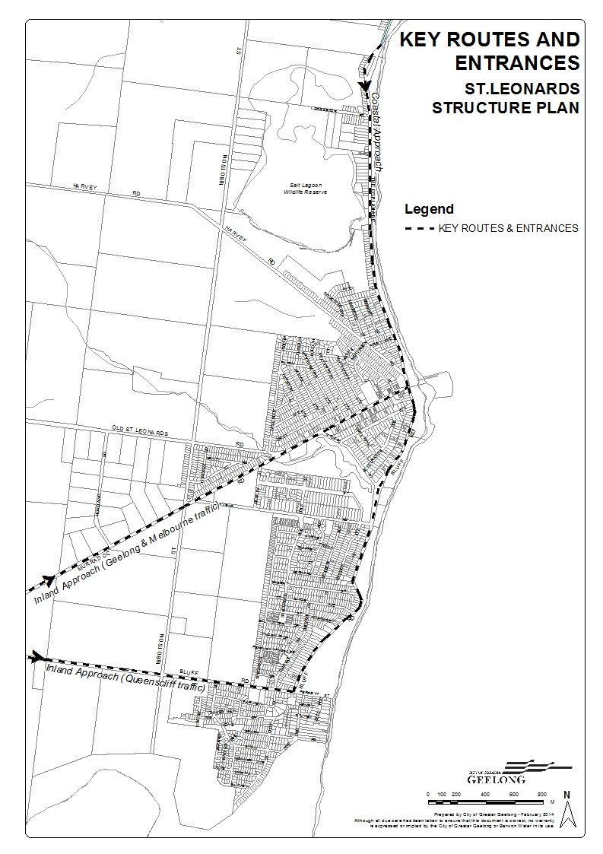
Public Transport

Public transport in St Leonards is limited to a bus service to and from Geelong as detailed in map 10.
The bus services to and from Geelong run between the hours of 5.20am to 10pm Monday Friday, with limited services on Saturdays and Sundays. The service operates via Portarlington and Drysdale/Clifton Springs with St Leonards being the end of the line.
The bus route through St Leonards was revised in September 2006 to provide improved access to the service for those residents in the southern part of the town. This revised route travels along The Esplanade, Bluff Road, Mainsail Drive, Leviens Road and Murradoc Road.
The Department of Transport, Planning and Local Infrastructure and Public Transport Victoria have noted that as St Leonards forms the ‘end of the line’ for bus services operating to that part of the Bellarine Peninsula, there is some flexibility in routing services within the township.
Providing an extension of the bus route to new greenfield subdivisions should be considered at the time of rezoning to enable new roads to be designed to accommodate buses in accordance with the ‘Public Transport Guidelines for Land Use and Development 2008’
Pedestrian and Bicycle Network

The majority of residential streets in St Leonards have no formal pedestrian paths, wide grassy verges and a lack of kerb and channel.
A pedestrian path extends along most of the foreshore, providing a connection to Indented Head. This path terminates in the vicinity of the yacht club at the Lower Bluff area and does not connect to the walking trail within the Edwards Point State Faunal Reserve. There are also several other connection gaps in the trail making access along the foreshore area difficult in some locations.
The alignment of the foreshore path across the pier area is not clearly delineated and the use of this path is typically for recreational purposes, given its location within the foreshore
The BBFMC Master Plan seeks to create a connected foreshore trail which will significantly improve pedestrian access along the St Leonards Foreshore.
Council’s cycling strategy has identified opportunities to create areas of on road and off road cycling paths. Refer to Map 10 for the proposed locations of the bicycle network.
The recent development of the supermarket has maintained the informal link from the car park area through the Anglican Church grounds. The retention of this informal link was supported within the 2006 UDF.
The St Leonards Lake and McCarthy Reserve Master Plan have recommended a formal pedestrian trail around the St Leonards Lake. The construction of this trail was completed in April 2012.
The UDF has also identified the location of future pedestrian trails (pg34) and the retention of existing laneways. The future pedestrian trails extend into the future growth areas and it is likely that these trails would be developed in conjunction with the growth areas. There is an opportunity to provide a good connection between the St Leonards Lake and the dried creek bed located in the northern growth area. The Structure Plan generally supports this outcome.
Transport Network - Map 10
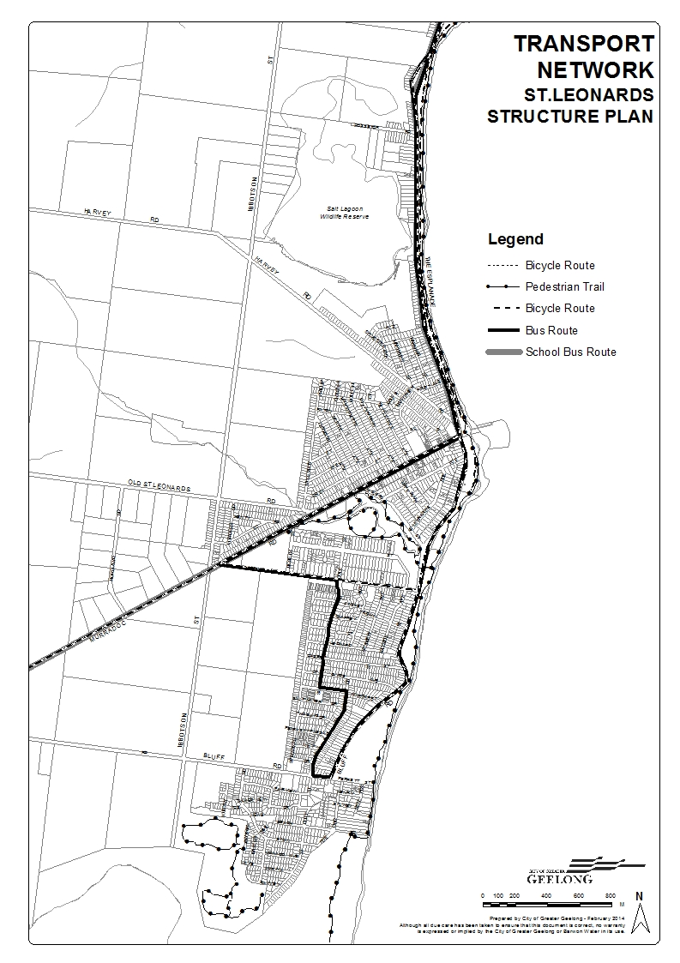

Key Influences
- Identified urban stormwater runoff threats to sensitive environments and sub-catchments and need for further studies to be undertaken;
- Limited public transport coverage, both within and external to the township;
- Opportunity to improve the limited pedestrian and bicycle linkages throughout the township and within open space areas.
- Council will need to undertake more work to identify vital triggers for when it may be necessary to determine a future course of action for parts of the township affected by climate change including the ‘do nothing, retreat, protect’ approach.

Township Growth and Residential Lot Supply

Township Growth
The urban boundary of St Leonards had changed very little up until the mid to late 1980’s. Since that time the size and growth of the town has increased significantly. There have been 4 growth fronts within St Leonards.
Bluff Heights Estate (Currently known as the Swan View Estate)

The largest extension to the urban area of the township was the rezoning of 23 hectares of land to the south of Bluff Road, now known as the “Bluff Heights Estate”. This area was zoned Reserved Residential and Special Use – Caravan Park prior to 1981 and in 2000, with the introduction of the new format planning schemes, was converted to a Residential 1 Zone.
The planning permit allowing the first stage of subdivision and creation of the Bluff Heights Estate was issued around the mid to late 1980’s. Between 1988 and 1990 three stages of this subdivision were completed. The total area of “Bluff Heights” prior to subdivision was approximately 23 hectares, with the first 3 stages of the subdivision resulting in conventional lots sizes ranging from 650 square metres to 1,125 square metres.
The latest release of land within this estate is the Swan View Estate which will accommodate a further 102 lots. This development will be the final release of existing residential zoned land within this estate.
Land Surrounding Salt Lagoon Wildlife Reserve

The rezoning of land adjacent to the Salt Lagoon Wildlife Reserve, north of Harvey Road, occurred in 1993. This amendment rezoned the area surrounding the lagoon from Rural Natural Features to Public Open Space, with 5.1 hectares of land on the north eastern side of Harvey Road rezoned to Reserved Residential. A Preservation Order Overlay formed part of this Amendment, to require the proper consideration of impacts on the sensitive environment, if the land was subdivided and the development of buildings occurred. This zoning was converted to Residential 1, with an Environmental Significance Overlay in 2000.
St Leonards Golf Course

Within the established township the only significant addition of residential zoned land to occur prior to 1988, was in the area previously utilised for the St Leonards Golf Course, between Blanche Street and Wattletree Avenue. This part of the golf course land was rezoned from Special Uses – Golf Course to Reserved Residential, converted to Residential 1 in 2000.
The 2006 Structure Plan supported a further request by the St Leonards Golf Course to re-zone 11 hectares of land in the eastern portion of the golf course from Special Use Zone to Residential. The Structure Plan also supported the expansion of the golf course, west of Ibbotson Street to accommodate the land lost to residential.
The redevelopment and re-configuration of the golf course land has now occurred and Council is currently considering a planning application for the subdivision of land at the eastern end of the golf course. This area will eventually accommodate 143 residential lots.
Sea Change Estate

Planning approval was granted in late 2001 to develop the Sea Change Estate. This area had been zoned for residential purposes prior to 1975. The total area of the “Sea Change Estate”, prior to subdivision, was 34 hectares and its subdivision resulted in lots sizes ranging from 300 square metres to 1,165 square metres. The development of this estate is complete, although there remain a high number of undeveloped lots within the estate.
Re-Zoning Requests

There have been two requests made to rezone land east of Ibbotson Street from the Farming Zone to a Residential Zone. The 2006 Structure Plan did not support the rezoning of this land. It was considered that there was sufficient capacity within the existing residential zoned land to accommodate the growth of the township between 2006 and 2016.
The 2006 Structure Plan sought to protect this land for long term residential growth with a recommendation that this position be re-examined as part of a future review. Council therefore recommended that this land remain outside the settlement boundary.
Upon approval of the 2006 Structure Plan, the then Minister for Planning made changes to the Structure Plan map which forms part of Council Municipal Strategic Statement at Clause 21.14 of the Geelong Planning Scheme, to include the long term growth areas within the township settlement boundary, but did not recommend any changes be made to the Structure Plan or timing for release of this land.

Residential Lot Supply
As part of the G21 Regional Growth Plan and the G21 Implementation plan, an online Land Supply Reporting and Monitoring tool has been developed using residential and industrial land supply data collected as part of the plan. The tool has been developed on behalf of G21 by Spatial Economics. Land supply data contained within this Structure Plan has been derived from this tool and the associated report.
Residential Lot Supply

Figure 6 shows the location of existing zoned residential land and potential unzoned residential areas. There are 333 vacant urban lots across the township with the majority of vacant lots situated within the Sea Change Estate and the Bluff Heights Estate.
This map shows the two growth fronts at the Swan View Estate and the St Leonards Golf Course. The data indicates that the timing for release of land within the Swan View Estate is estimated to be 3-5 years and the Golf Course is within 1-2 years. It is important to note that timing identified in the land supply report map is purely indicative of anticipated release timing (typically overstated) and not a reflection of years supply or adequacy of supply.
In reality, the first stage of the Swan View Estate is currently on the market however planning approval for the Golf Course site is yet is be approved at the time of writing this plan.
Table 11 and 12 show the timing for release of land and location of vacant lots within St Leonards.

Figure 6 - Urban Vacant Lots and Residential Supply – St Leonards 2013
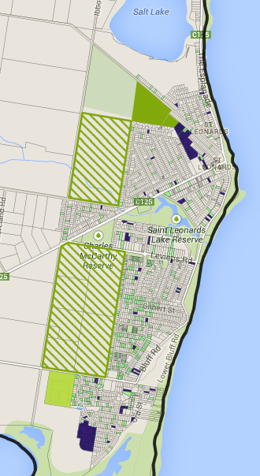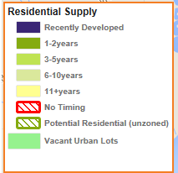

Table 12 - Residential Supply - St Leonards
Suburb | Average Annual Lot Production July 2006 to March 2013 | 1-2 years | 3-5 years | 6-10 years | 11+ years | No Timing | Total Zoned (lots) | Potential Residential (unzoned) | Total (lots)
St Leonards (Vic.) | 28 | 105 | 85 | 0 | 0 | 0 | 190 | 0 | 190
Total | 28 | 105 | 85 | 0 | 0 | 0 | 190 | 1403 | 1593
Source: Spatial Economics – Land Supply and Monitoring Tool 2013
Table 13 - Urban Vacant Lots – St Leonards
Suburb | Less than 500 sqm | 500-800 sqm | 800 to 1200 sqm | 1200 to 2000 sqm | 2000 to 5000 sqm | Total Lots
St Leonards (vic.) | 97 | 191 | 31 | 11 | 3 | 333
Total | 97 | 191 | 31 | 11 | 3 | 333
Source: Spatial Economics – Land Supply and Monitoring Tool 2013
Figure 7 - Dwelling Construction 2005-2012
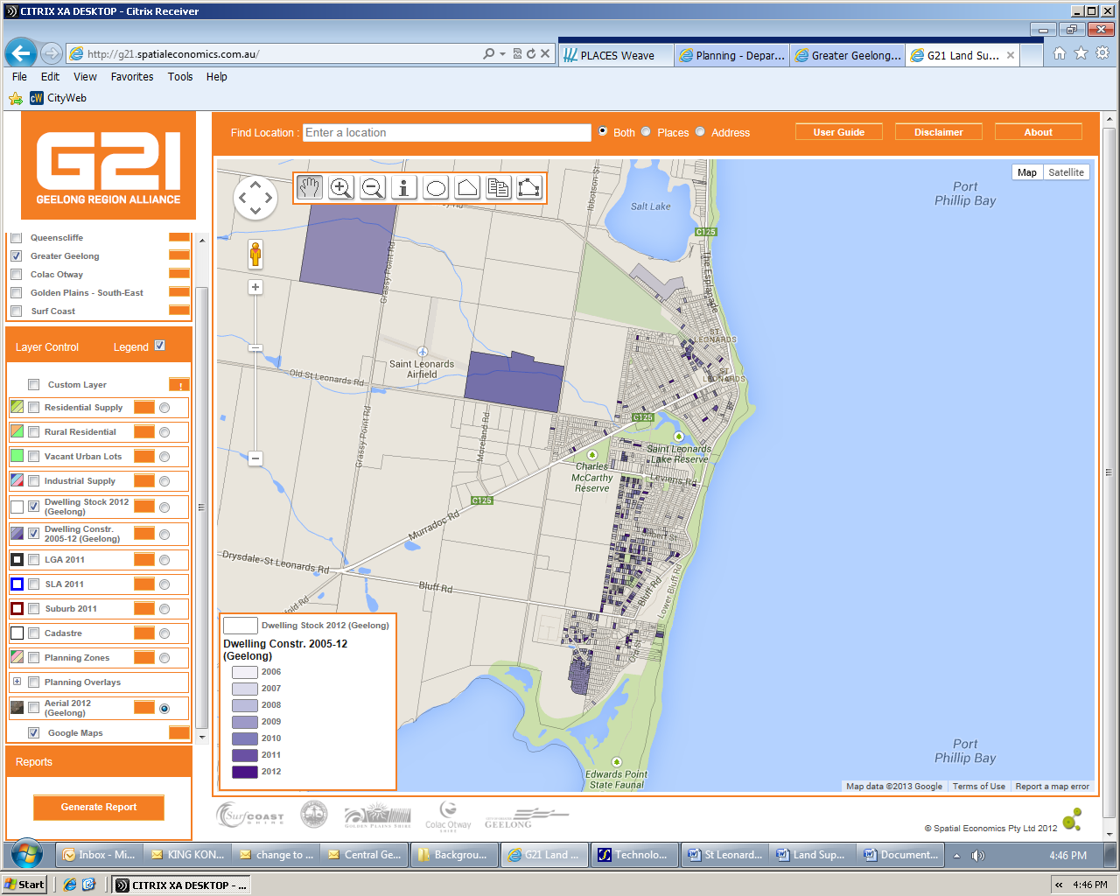
Figure 7 shows where dwellings have been constructed since 2005. The main concentration of development has been in the Sea Change Estate and the southern portion of the Bluff Heights Estate.

Existing Growth Opportunities
Table 14 shows a 10 year time span of dwelling approvals in St Leonards and demonstrates a general increase in the number of dwellings constructed each year, with a peak in the 2010-11 financial year of 88 dwellings. In the 2012-13 financial year, the number of new dwellings constructed was reduced by 42%. This is most likely a result of there being no growth fronts within St Leonards at that time.
Table 14 – St Leonards Residential Building Permit Activity 2003-13
Year | 2003/04 | 2004/05 | 2005/06 | 2006/07 | 2007/08
No.  Approved | 76 | 59 | 47 | 43 | 67
Year | 2009/10 | 2010/11 | 2011/12 | 2012/13 | TOTAL | Average No. Dwelling per year
No.  Approved | 88 | 75 | 64 | 37 | 620 | 62
(Economic Indicators Bulleting 2005-2012, CoGG Building Department)
The G21 Residential Land Supply and Monitoring Project have identified the following lot potential based on various land supply categories. (refer to Figure 7 above)
Table 15 - Residential Lot Potential by Supply Type, March 2013
Region/Urban Centre/LGA | Broad hectare | Major Infill | Potential Residential (unzoned) | Vacant ‘Urban’ Lots | Rural Residential | Total Lots
St Leonards | 190 | 0 | 1403  (average 12.5 lots per Hectare) | 339# | 0 | 1932
St Leonards (approved development) | 245* |  |  |  |  | 245
*This figure is based on a review of current development approvals for broad hectare land and is considered more relevant than the G21 Residential Land Supply and Monitoring figure
# This figure includes 6 lots within Indented Head.
The G21 Residential Land Monitoring Report defines the above categories as;
Broad hectare is defined as new development on Greenfield sites (sites that have not been used for urban development previously or previously subdivided for normal density development), typically on the fringe of the established urban areas.
Major Infill is defined as undeveloped land or sites identified for redevelopment within the existing urban area, zoned for residential development, and parent lot or existing lot greater than 5,000sqm and with an expected lot/dwelling yield greater than 10.
Minor Infill is defined as vacant land within the existing urban area or within broadhectare land release areas, zoned for residential development, and existing lot sized less than 5,000sqm.
Future (potential) Residential is land identified by the relevant municipal authority for future residential development and current zoning not supportive of ‘normal density’ residential development. Land which has an ‘Urban Growth Zone’ applied, and a precinct structure plan has not yet been approved , falls into this category.
Rural Residential is defined through the zoning, in particular Low Density Rural Residential (LDRZ) and Rural Living (RLZ) zones.
To determine the years of residential growth this lot supply will sustain, it is necessary to calculate the rate of lot take-up through an analysis of residential building approvals in St Leonards over time.
There are three possible growth scenarios within St Leonards based on broad hectare, vacant urban “infill”, and land availability (future supply).
Broad Hectare Land Supply
It is reasonable to assume similar or higher development patterns will occur within the identified broad hectare land. Based on the 245 lots currently identified this would create 4 years land supply with 62 dwellings being constructed each year. If for comparison the higher growth rate of 88 dwelling per year (2009/10 figure) was considered this would reduce the lot supply to 3 years.
Vacant Urban Lot Supply
It is not considered realistic to expect development of vacant urban land to occur at the same rate as lots within broad hectare sites. This theory is supported by the 42% decrease in dwelling approvals in the 2012/13 financial year, where there was no or limited broad hectare land for sale within the township.
The take up rate for development of infill land within St Leonards is harder to predict. There are a number of factors which impact on the development timing of existing lots including the purchase of land for retirement or a future holiday home, whether broad hectare land is also available making the on-sale of land more competitive, purchase price of land making land banking possible (land may be more affordable than other coastal locations), planned development i.e. commercial, tourist attractions, job opportunities etc which attract more people to an area encouraging growth
Table 16 shows the average take up rates of vacant urban land between 2005 and 2013. Based on this calculation there is currently 6 years supply of vacant urban land. Due to the prevailing trend of properties being purchased for future retirement or holiday homes there is an expectation that while broad hectare land is available there will be an ever changing number of vacant urban lots within the township.
Table 16 - Year Supply of Vacant Urban Land
Year | 2005 | 2013 | Difference | Average take up rate per year 2005-2013 | Years Supply
No. of Vacant Lots | 794 | 333 | 461 | 461/8 = 58 | 333/58 = 6
Source: 2006 Structure Plan and Land Supply Monitoring Tool

Future Residential Land Supply

There are two areas identified within the 2006 Structure Plan for long term residential growth. Area 1 is located between Lake View Crescent, Old St Leonards Road and Ibbotson Street. Area 2 is located between Bluff Road, Ibbotson Street and Leviens Road. The rezoning of this land was not supported within the previous Structure Plan given the land supply available within the township at that time. Area 1 was identified as the first priority for development given its proximity to the town centre and infrastructure connections.
The G21 Residential Land Supply Monitoring Report identifies a total yield of 1403 lots within the two growth areas. This equates to an average of 12.5 dwellings per hectare. This figure was considered to be a conservative estimate of lot yield based on site constraints and previous development densities within the surrounding area.
A review of different development scenarios has been considered in Table 17. Low growth is considered to be the average dwelling approval rate for the last 10 years. If new growth fronts become available within the township it is expected that growth rates would increase. The high growth rate is the peak growth rate that occurred over the last 10 years (2009/10 financial year).
Table 17 - Years Supply Based on 12.5 Lots per hectare
Scenario | Number of lots | Low Growth | High Growth
Growth Location |  | Years Supply @ 62 dwellings / yr | Years Supply @ 88 dwelling / yr
Area 1 – 38.7 Hectares | 484 | 8 | 6
Area 2 – 73.5 Hectares | 919 | 15 | 10
Total Number of Years | 1403 | 23 | 16
*Figures Rounded

Land Supply within St Leonards
Table 18 - Land Supply Based on Growth Rate Scenarios
Location | Low Growth @ 62 lots per yr | High Growth @ 88 lots per yr
Broad Hectare Land  245 lots | 4 | 3
12.5 Lots per Hectare - Area 1 = 484 | 8 | 6
12.5 Lots per Hectare - Area 2 = 919 | 15 | 10
Vacant Urban Land - 333 lots | 6 | 6
Supply = Broad Hectare + Vacant Urban + Area 1 | 18 | 15
Supply = Broad Hectare + Vacant Urban + Area 1+2 | 33 | 25
Note: Figures Rounded

Years Supply - Area 1

There would be approximately 18 years supply of land using a low growth rate scenario or 15 years using a high growth rate if only land within area 1 was rezoned (including broad hectare and vacant urban land).
Land within area 1 would need to be rezoned to residential before dwelling construction could commence. This process can take between 2 and 3 years. Therefore it is reasonable to assume that existing land supply within the town would be in the vicinity of 1-2 years before any future residential land was released for sale. This would reduce the land supply to between 13-15 years and provide a single growth front for St Leonards.
Years Supply - Area 1 and 2

There would be approximately 33 years supply of land using a low growth rate scenario or 25 years using a high growth rate if land within both growth areas was rezoned (including broad hectare and vacant urban land).
Again this time frame would be reduced by 2-3 years due to time taken to re-zone land.

Planning Policy and Projected Demand

A number of changes have occurred within St Leonards and more broadly across planning policy relating to residential growth.
Planning Policy in relation to the supply of future residential land is identified at Clause 11.02-1- Urban Growth - Supply of Urban Land. The objective of this clause is to;
Plan to accommodate projected population growth over at least a 15 year period and provide clear direction on locations where growth should occur. Residential land supply will be considered on a municipal basis, rather than a town-by-town basis.

An analysis of land and dwelling supply within Geelong and the Bellarine Peninsula is provided below;

The G21 Residential Land Supply Monitoring Report has considered the data published within the ‘Victoria in Future 2012’ (VIF 2012), the State Governments’ population projections undertaken by the Department of Transport, Planning and Local Infrastructure (DTPLI) to determine future demand for dwellings within Greater Geelong.
In Summary
Projected dwelling requirements sourced from VIF 2012 indicate that from 2011 to 2031 there will be a total dwelling requirement of 46,663 (2,333 average per annum).
As measured from 2011 to 2031, the average annual projected demand by Region within the municipality of Geelong is:
- Geelong Urban: 1,667 dwellings per annum; and
- Bellarine Peninsula: 667 dwelling per annum.
Projected dwelling requirements based on a total municipal 2.5% population growth scenario from 2011 to 2031, it is estimated that there will be a total dwelling requirement of 76,539 (3,827 per annum).
As measured from 2011 to 2031, the average annual projected demand by Region within the municipality of Geelong is:
- Geelong Urban: 2,691 dwellings per annum; and
- Bellarine Peninsula: 1,136 dwellings per annum
The above dwelling requirements equate to an average annual 3.0% dwelling growth rate.
and
It is considered that there is no need for additional broadhectare residential land stocks across the municipal area of Geelong and its composite regions. Based on existing lot production trends ad dwelling projections contained within VIF 2012, there is over 25 years of broadhectare land supply.
Assuming a rapid escalation of the projected population growth rate (2.5% per annum to 2031), the years of broadhectare land supply declines to a total of 22 years.
In terms of existing zoned stocks of residential broadhectare land, based on trend lot construction, there is sufficient broadhectare residential land stocks to satisfy over 25 years of demand. This reduces to 19 years of supply based on State Government population projections and 12 years based on a 2.5% population growth scenario.
It is considered highly unlikely that the 2.5% population growth scenario will in the short to medium term be realised based on existing and recent rates of growth.
Note: The above assumptions exclude vacant urban land figures
Figure 8 shows the residential land supply areas considered as part of this analysis for the St Leonards area.

Figure 8 - Residential Land Supply Areas – St Leonards
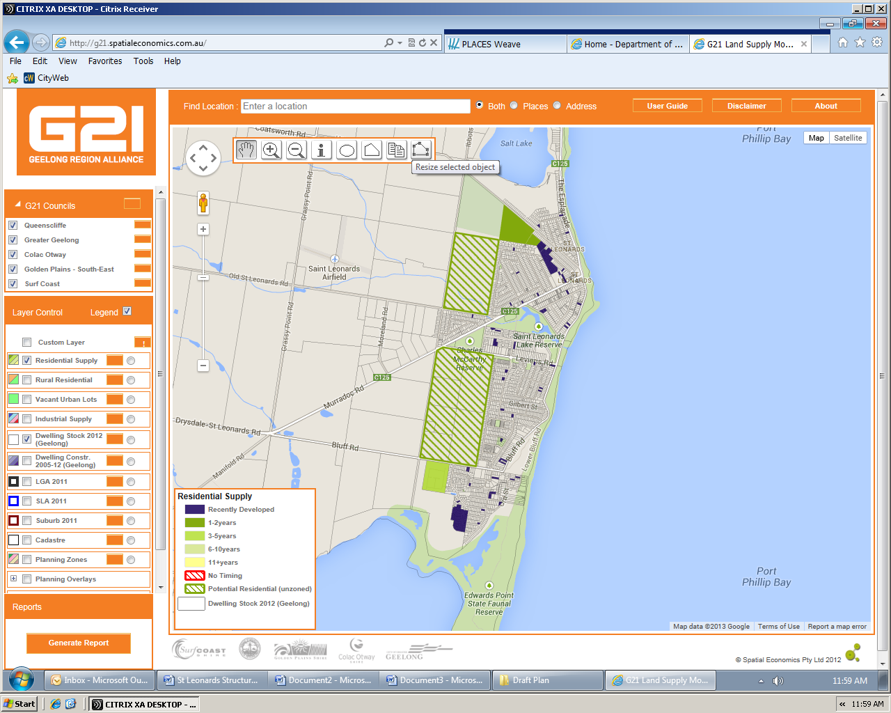
Geelong and the Bellarine both have in excess of 15 years land supply based on trends in lot construction, VIF 2012 projections and a 2.5% population growth scenario.
St Leonards forms part of the Northern Bellarine Peninsula, this area it is considered to have a different catchment to other larger townships on the Bellarine because of its proximity to Port Phillip Bay, linked road connections to and from Geelong, connections to Drysdale as a main retail and service provider and the presence of smaller townships which provide a different lifestyle choice. A snap shot of land supply across the Northern Bellarine (tables 18 and 19 and Maps 13, 14 and 15) reveals Drysdale-Clifton Springs has up to 66 years supply of land identified for residential growth (this figure it expected to reduce as the number of land sales within the Jetty Road Growth area continue to increase), whilst the smaller townships have between 4 and 25 years. Overall the Northern Bellarine has sufficient land identified within existing Structure Plans to accommodate longer term (15 years+) residential growth.

Table 19 - Residential Lot Potential by Supply Type, March 2013 – Northern Bellarine
Region/Urban Centre/LGA | Broad hectare | Major Infill | Potential Residential (unzoned) | Vacant ‘Urban’ Lots | Rural Residential | Total Lots
Drysdale-Clifton Springs | 2770 | 0 | 2295 | 467 | 35 | 5567
Portarlington | 361 | 0 | 280 | 309 | 12 | 962
Indented Head | 214 | 0 | 0 | 196 | 0 | 410
St Leonards | 245 *recent approvals | 0 | 1403 | 333# | 0 | 1981

Table 20 - Residential Land Supply – Northern Bellarine
Location | Average Building Approval  2003-13 | Peak Building Approval  2003-13 | Total Lots (excluding Vacant Urban Lots and Rural Res) | Years Supply  Average approval rate | Years Supply  Using Peak Approval | Overall Total Lots | Years Supply  Average approval rate | Years Supply  Using Peak Approval
Drysdale-Clifton Springs | 84 | 137 20007/08 | 5065 | 60 | 37 | 5567 | 66 | 41
Portarlington | 49 | 70  2003/04 | 641 | 14 | 10 | 962 | 31 | 14
Indented Head | 31 | 49  2009/10 | 214 | 7 | 4 | 410 | 13 | 8
St Leonards | 62 | 88  2009/10 | 1648 | 26 | 19 | 1981 | 33 | 25
* Figures Rounded
Figure 9 - Residential Lot Potential by Supply Type, March 2013 - Portarlington
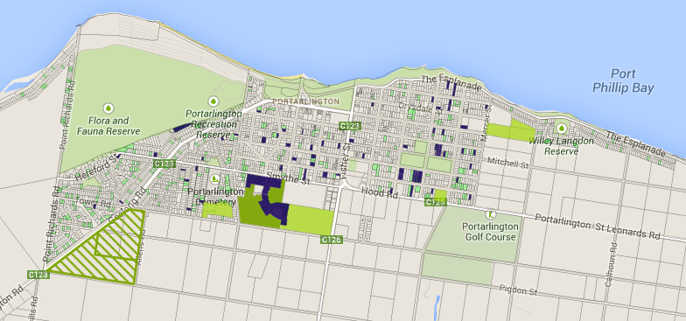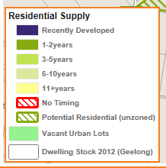

Figure 10 - Residential Lot Potential by Supply Type, March 2013 – Drysdale-Clifton Springs
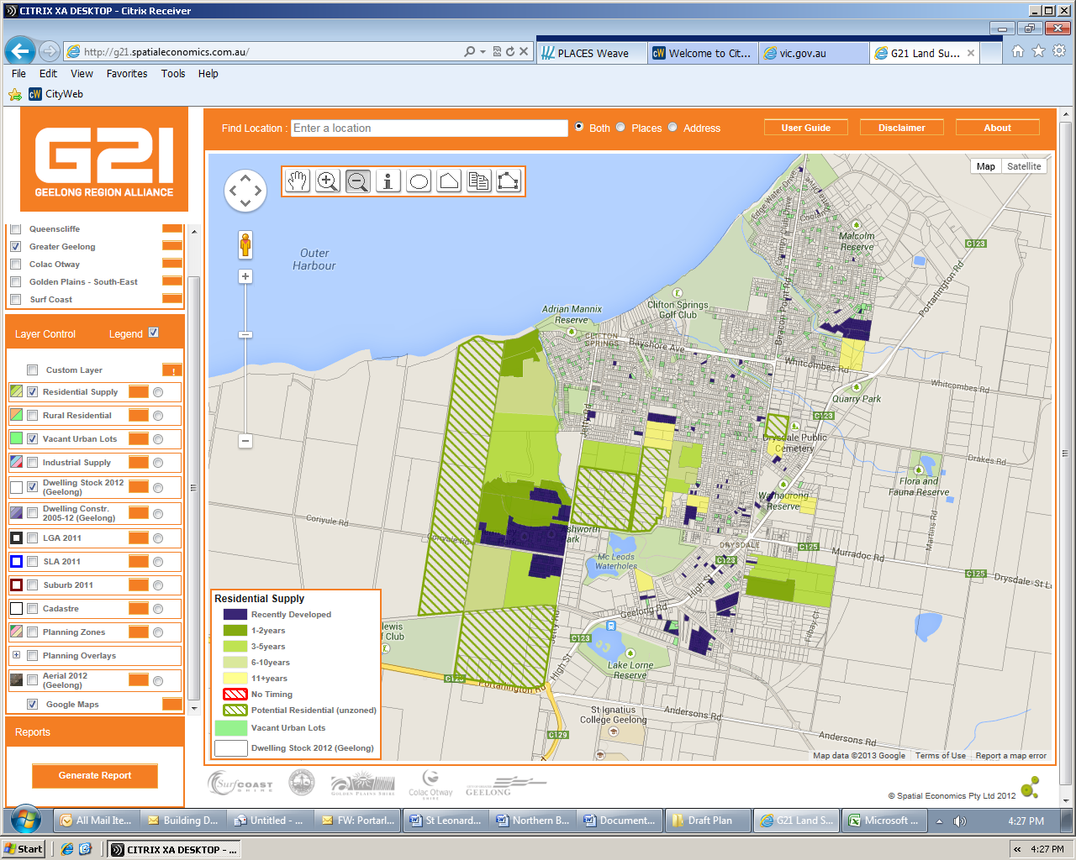

Figure 11 - Residential Lot Potential by Supply Type, March 2013 – Indented Head
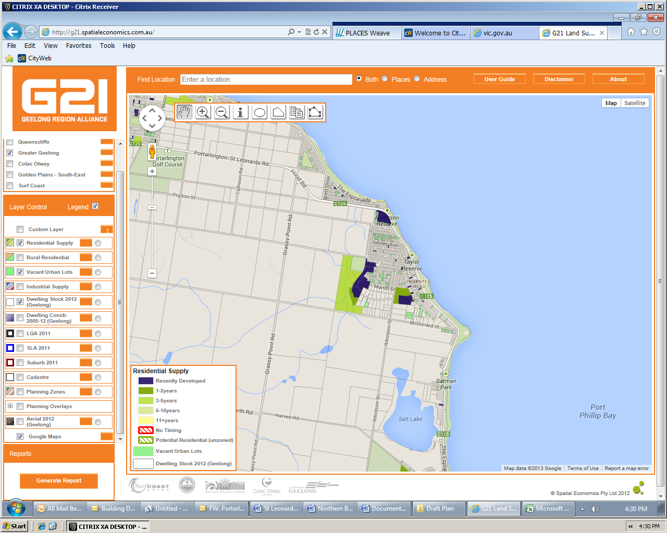

Release of Land
There is sufficient land identified across the Bellarine Peninsula including the Northern Bellarine to accommodate long term future growth (15+ years). It is however important to consider the timing for release of land to ensure adequate services and infrastructure can be provided to the townships across the Bellarine.
The strategic justification to include land within the settlement boundary of the town was completed as part of the 2006 Structure Plan. This review seeks to consider the timing for release of land located within the settlement boundary.
It is recommended that both areas designated for long term growth be rezoned to residential as part of a single planning scheme amendment. In considering the rezoning of both parcels there is an ability to stage the development in a sequential order, ensure open space and facilities are delivered appropriately, the cost and timing for the upgrading of Ibbotson Street and providing other infrastructure can be better managed and developer contributions could be provider earlier in the development phase.
The release of both areas simultaneously could also create competition in the market place, increasing development rates by capitalising on the marketing of two separate areas. This could have flow on effects to the wider town encouraging businesses to grow or establish within the town centre based on an assurance about the future population of the town.
Releasing two growth areas instead of one would also prevent one developer from controlling the market. This could ultimately increase lot diversity by encouraging developers to provide a slightly different estate and lot type in a more competitive market place.
The rezoning of all land within the settlement boundary will provide certainly for the town in relation its future size allowing Council and other service providers to appropriately plan for this growth.
The release of new residential land will increase pressure on existing community services. It is reasonable for the developers of this land to contribute towards improving the service provision for the community. This Structure Plan has identified a need for an Early Years Learning Facility within St Leonards and it is recommended that developer funds contribute to this facility.

Early Years Learning Facility

St Leonards relies heavily on Drysdale-Clifton Springs and to a lesser extent Portarlington for the daily service needs of the town including retail, children’s services (childcare, kindergarten and education), emergency services and health related services. St Leonards is well serviced with passive and active recreation services by way of Lake Reserve and McCarthy Reserve and the foreshore area.
Council’s Community Development Department have advised that families with young children currently commute to Portarlington or Drysdale for maternal child health services, kinder, school etc. which without access to a car is difficult due to the isolation of the town and the limited access to public transport. St Leonards has also been identified as an area of disadvantage according to the SEIFA measures of Relative Socio-economic Disadvantage. This is based on conditions such as incomes, educational attainment, occupations, housing ownership, English fluency and unemployment.
The Draft Children’s Services Infrastructure Plan identifies a need to provide an Early Years Learning Facility within St Leonards and any increase in population will further increase this need. An ‘Enhanced Early Years Learning Facility’ should include a double room kindergarten, 2 consulting rooms, ancillary spaces for kitchen, toilets, office, storage, waiting room, out door playground areas, possibly a multi-purpose room, and off street parking. The location needs to be highly visible and accessible, close to public transport, and preferably located in close proximity to or integrated with other complementary services such as: primary schools, community health, community centre, library etc. The area required to build a new centre would be approximately 1,000-1,500 sqm.
There is a benefit to both the existing and future population of St Leonards if an Early Years Learning Facility could be delivered within the next 10 years. Funding from developer contributions would help to reduce the time frame for delivery of this facility.
Preferred Site for Early Years Learning Facility

To deliver an Early Years Learning Facility within St Leonards a combination of Developer, Council and State Government funding would be required. A timeframe for the delivery of this facility would be 5 to 10 years providing a suitable site and funding could be achieved.
Growth Areas

Land could be set aside within the growth area for an Early Years Learning Facility however it would be isolated from the existing primary school and community meeting spaces which typically have strong links to an Early Years Learning Facility. The growth areas are located on the edge of St Leonards and would be difficult to access without a car. If land could be provided in a more central location, developer contributions would be better used in the construction phase of a building rather than a land contribution.
Lake Reserve Sporting Pavilion

The Charles McCarthy and Lake Reserve Recreation Master Plan recommended that the existing sporting pavilion at the Lake Reserve, be converted into a shared space incorporating both community and sporting club facilities (see figure 5.) The proposed layout of this facility could accommodate a maternal child health and a community meeting space. However this space may be more difficult to develop for a kindergarten. Part of the site is flood prone and therefore the existing building is elevated from the ground making it difficult to meet access requirements for the building including connections to a children’s outdoor play area. There are also concerns with amalgamating an Early Years Learning centre with the sporting clubs that currently use the pavilion because of existing liquor licences.
An alternative area on the reserve could be the under utilised tennis courts which are located on the Charles McCarthy Reserve opposite the sports Pavilion. This site is already managed by Council and therefore the cost to establish the facility would not need to include the purchase of land.
Further investigation would need to be undertaken to accurately determine the possibility of converting part of the sports pavilion and depending on this outcome further investigation may also be required into the possibility of developing the tennis court area.
Whilst the reserve could provide an appropriate site for an Early Years Learning Facility, the site is isolated from the town centre and the growth areas and does not have direct access to a bus route or the primary school. There are also challengers with combining the existing sporting facilities and a children’s facility.
36 Dudley Parade and 1336 Murradoc Road - Existing CFA Site

Council owns land at 36 Dudley Parade, St Leonards. This site is currently leased to the CFA, however the CFA have advised that in the long term they plan to relocate their facility to Drysdale. This site is approximately 1012 sqm in area. To the rear of this site is 1336 Murradoc Road. This site is currently vacant, in private ownership and is 1012sqm in area. Separating the two sites is a 3m wide right of way. The site on Murradoc Road is within 60 metres of the St Leonards Primary School, 250 metres of the town centre and is located on the bus route.
The two sites combined total 2024sqm and is large enough to accommodate an Early Years Learning Facility. The shape of the site is long and narrow making building design more difficult. The existing right of way also creates a barrier between the two sites and ideally would need to be permanently closed to create a better connection between the two sites. This may impact on access to surrounding properties and would require further investigation. Council would also need to purchase the site at 1336 Murradoc Road to secure enough land to build the facility. The CFA have not provided a time frame for relocation making it difficult to plan for an Early Years Learning Facility on this site.
The site is in a good location close to the town centre, school and public transport, but may be too narrow to provide a good layout and design outcome for an Early Years Learning Facility. If a site for an Early Years Learning Facility has not be identified at the time the CFA relocates its facilities and if the land at 1336 Murradoc Road is still vacant, Council should further investigate the use of this site for an Early Years Learning Facility.
Priority Site – 1339-1345 Murradoc Road - St Leonards Primary School and Catholic Church
The St Leonards primary school is located west of the town centre, on Murradoc Road. The Primary School site is approximately 0.55 hectares in area with limited scope to grow within the existing grounds. Currently the school utilises the rear of the adjacent Catholic Church site for a school oval and car parking. The church site is large (1.2 hectares) and with the exception of the church building, it is underutilised by the Catholic Church.
This is the preferred location for an Early Years Learning Facility. The site is located close to the town centre, large enough to accommodate the facility, on a designate bus route, and could be integrated with the primary school.
Further investigation into the potential of the site to deliver an Early Years Learning Facility would be required. Council would need to work with the Department of Education and the Catholic Church to negotiate the purchase of part or all of the site.

Development Guidelines for Growth Areas

As identified, there is a need for an Early Years Learning Facility within the St Leonards area. The release of new residential land will increase pressure on existing community services. It is reasonable for the developers of this land to contribute towards improving the service provision for the community.
It is recommended that the land identified within the Structure Plan map as areas 1 and 2 be rezoned to a General Residential Zone Schedule 1 (previously Residential 1) with a Development Contributions Plan Overlay and/or 173 agreement. Council should consider applying a Developer Contributions Plan Overlay and/or using 173 Agreement to provide additional guidance around the delivery of infrastructure.
Development Plan Overlay
The Development Plan should generally require the following:
- An Urban Design Masterplan that includes:
- A general subdivision layout including streets, drainage reserves, open space for permeability, distribution of land uses and interface treatments with adjoining residential zoned properties.
- A concept design and layout of Ibbotson Street to include an ecological corridor as identified in the St Leonards Urban Design Framework 2006
- New road and pedestrian connections from the new subdivision areas into the adjacent residential and open space areas.
- The retention of significant vegetation.
- A staging plan.
- A concept landscape plan. The concept plan for area 1 must show the creek bed area connecting with St Leonards Lake Reserve.
- A Road Network and Traffic Management Plan that investigates:
  - the interface with Murradoc Road, Ibbotson Street, Leviens Road, Old St Leonards Road as well as abutting residential areas.
  - Traffic mitigation measures to improve access adjacent to the growth areas.
  - Permeability and connectivity for pedestrians and cyclists throughout the development and integrated where practicable with existing and proposed landscaped open space and pedestrian/bicycle linkages.
- Physical infrastructure proposed in the Urban Design Masterplan shall meet Council standards or if not defined, be subject to the approval of Council and be generally in accordance with the following:
  - City of Greater Geelong adopted Infrastructure Development Guidelines (IDG) 2010
  - City of Greater Geelong adopted Infrastructure Design Manual (IDM) 2010
- A staging plan that identifies the stages by which the development of the land may proceed, identifying the infrastructure required to facilitate development
- Site Stormwater Management Plan (SSMP) consisting of:
- Drainage Feasibility Report
- Water Quality Impact Report
- Flood Impact Report
Developer Contributions Overlay and/or 173 Agreement
To help deliver an identified Early Years Learning Facility within St Leonards the use of a Developer Contribution Plan Overlay and/or a 173 agreement should be considered as part of a rezoning process;
The Developer Contributions Plan Overlay should generally meet the requirements of Clause 45.06 - Development Contribution Plan Overlay of the Greater Geelong Planning Scheme. A Developer Contributions Plan sets out the timing for developer contributions which can include works in kind, land or funds and in this instance linked to an agreed community infrastructure project - an Early Years Learning Facility.
A 173 agreement is an agreement under section 173 of the Planning and Environment Act. The agreement is typically between a developer and Council. In this instance the 173 agreement would specify a requirement to deliver or contribute to the matters identified within the Developer Contribution Plan Overlay, or if no overlay is applied to the land a commitment to deliver the infrastructure identified through the rezoning process. In both instances the agreement should also include, a developer contribution towards an Early Years Learning Facility, including a substantial up front payment to help provide for the timely delivery of this service.

Key Influences
- In excess of 15 years land supply within St Leonards and across the Northern Bellarine.
- An identified need for an Early Years Learning Facility within the St Leonards area.
- Recommendation to re-zone remaining land within the settlement boundary.

References
In addition to the strategies referenced in Part C - Structure Plan Background, the development of the structure Plan has also been informed by the following report:
- Town Centre Economic Assessment – St Leonards Structure Plan, Tim Nott economic analysis + strategy, 2013

The Bellarine Historical Society Inc. 2002. St Leonards Timeline (online), Available at http://www.zades.com.au/bellhs/sltimel.html.
Bellarine Heritage Study Vol 2 – Environmental History Huddle, Howe, Lewis Francis, 1996
http://www.rch.org.au/aedi/ accessed 3 Sept 2013

