AMENDMENT C306

Curletts Road area, Lara

Land in the Curletts Road area com- prises multiple privately owned lots. The affected land is approximately 31 hectares and is currently in the Rural Living Zone.

TGM Group Ltd. has submitted an ap- plication to Council seeking to rezone the land for low density residential development purposes. This application is known as Amendment C306.

On 22 July 2014, Council resolved to support the public exhibition of Amend- ment C306 to the Greater Geelong Planning Scheme.

What land is affected?

The affected land is:

• 10, 20, 30, 40, 46, 50, 50, 60 Oster-
lund Court

• 72-76, 75, 78, 80, 82, 84, 85, 95,
105,125 Curletts Road

• 90, 110, 120, 130, 145 Forest Road North

- 235, 245 Windermere Road (See reverse for Aerial Plan) What is Amendment C306?
The amendment proposes to rezone land in the Curletts Road area from Rural Living Zone (RLZ) to Low Density Residential Zone (LDRZ).
The amendment will also apply a Design and Development Overlay (DDO34). This will help coordinate the subdivision design of the land for low density residential development.

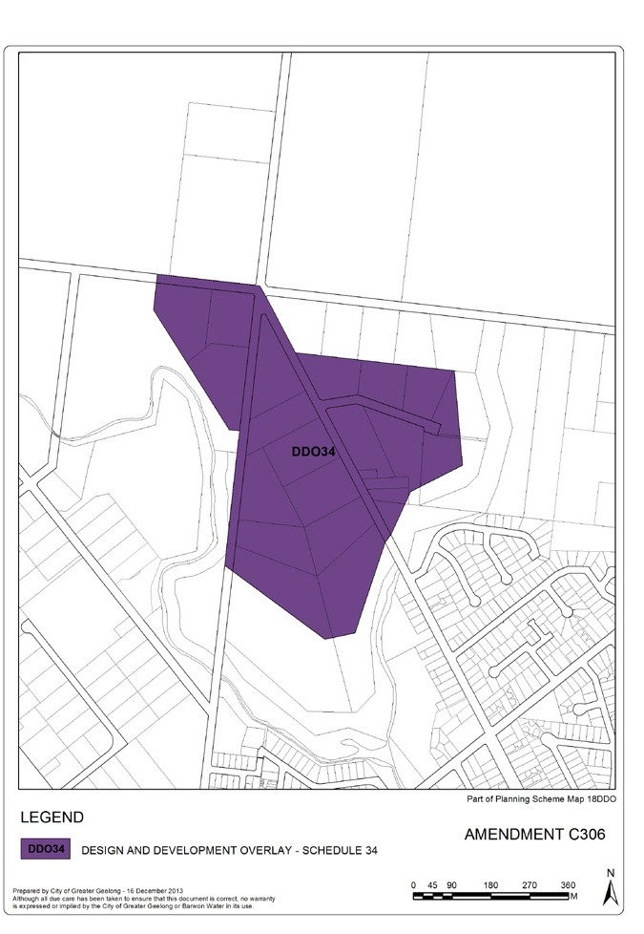What happens after the land is re- zoned?

The rezoning will enable landowners to subdivide their properties to a minimum lot size of 4,000 sq.metres (0.4ha).

Future permit applications for subdivi- sion will need to respond to the design objectives and requirements of the Design and Development Overlay Schedule 34.

The design objectives include:

- To subdivide in an orderly man- ner reflective of the purpose of the zone.
- To acknowledge the rural-edge character of the area.
- To ensure that subdivision responds to environmental and physical fea- tures of the land.

Can I make a submission to C306?
Yes. Submissions to Amendment C306 should be received by: Monday 20 October 2014 and addressed to:
The Coordinator Strategic Implementation City of Greater Geelong

Either by:

- post to - PO Box 104, GEELONG VIC 3220
- email to - strategicplanning@gee- longcity.vic.gov.au

Where can I go for more informa- tion?
The amendment is available for viewing at the following centres:
- City of Greater Geelong Council of- fices, 100 Brougham St, Geelong;
- Lara Library, 5 Walkers Road, Lara You can also go to the “Have Your Say”
section of Council’s website at www.
geelongaustralia.com.au or the Depart- ment of Planning’s website at www. dtpli.vic.gov.au
For further assistance, call us on 5272 4192 or email: strategicplanning@ geelongcity.vic.gov.au

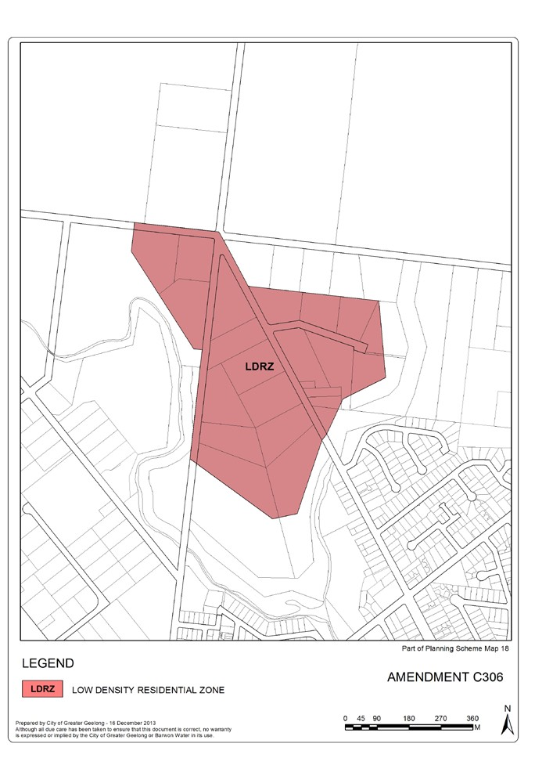

WWW.GEELONGAUSTRALIA.COM.AU

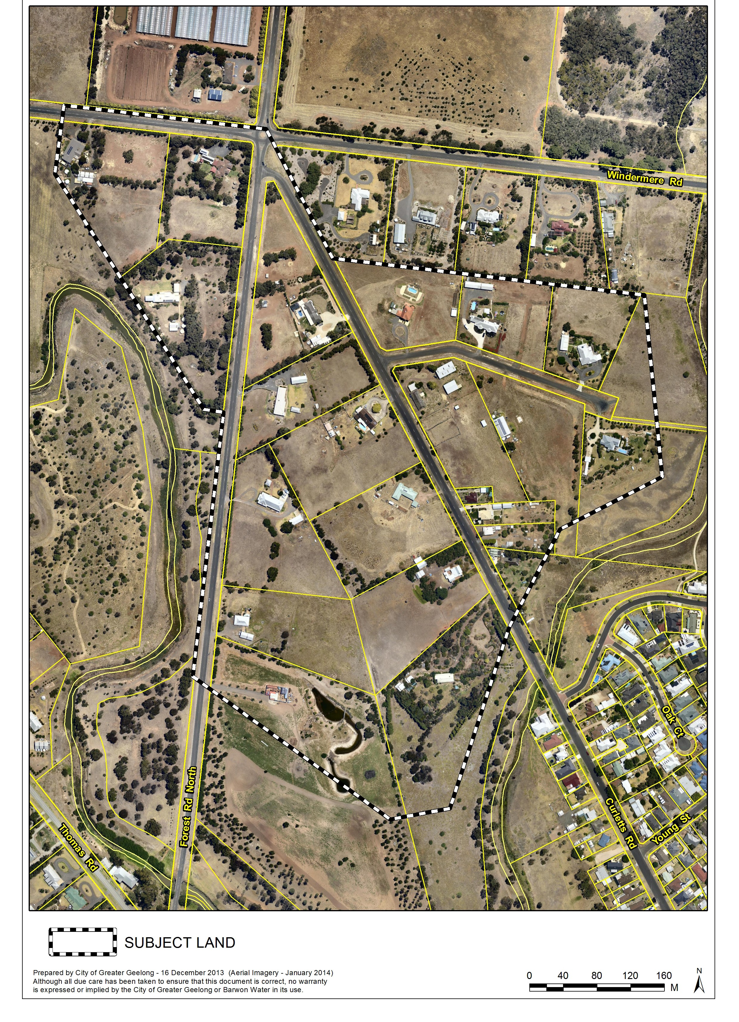Subject land at Curletts Road area, Lara

WWW.GEELONGAUSTRALIA.COM.AU

