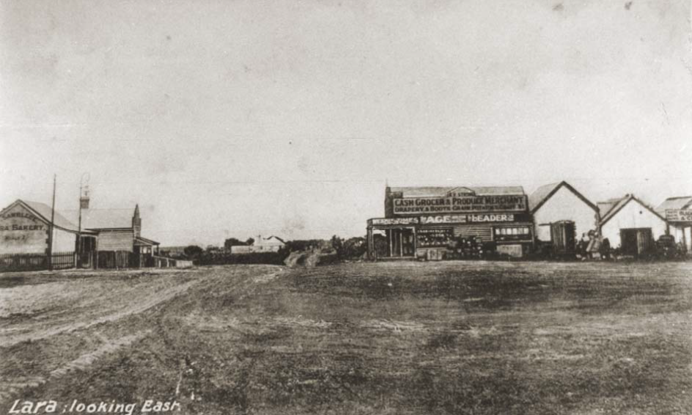

The Report
(Draft Document)

Volume 1

Prepared By

Dr David Rowe, Authentic Heritage Services Pty Ltd
& Wendy Jacobs, Architect & Heritage Consultant

February 2013

THE REPORT

(Draft Document) VOLUME ONE

Commissioned & Funded by

City of Greater Geelong

Prepared By

Dr David Rowe, Authentic Heritage Services Pty Ltd
&
Wendy Jacobs: Architect & Heritage Consultant

Support Staff:

Pam Jennings, Authentic Heritage Services Pty Ltd

February 2013

Cover Photo: Sixways, Lara, looking south, c.1909. Source: GRS 1263, Geelong Heritage Centre.

TABLE OF CONTENTS
Executive Summary ii
SECTION 1
1.0 Introduction
1.1 The Study Team 1
1.2 Acknowledgments 1
1.3 Project Background & Aim 2
1.4 The Study Area 3
1.5 Terminology 3

SECTION 2
2.0 Methodology
2.1 Fieldwork 4
2.2 Historical Research 5
2.3 Comparative Analyses 5
2.4 Heritage Citations 5
2.5 Thematic Environmental History 5
2.6 Consultation 6

SECTION 3
3.0 Heritage Places
3.1 Introduction 6
3.2 Places of Local Significance 6
3.3 Ruinous Places 7
3.4 Places of Historic Interest 7

SECTION 4
4.0 Assessment of Significance
4.1 Basis of Assessment Criteria 8
4.2 Significance, Condition & Integrity Levels & Thresholds 9

SECTION 5
5.0 Recommendations
5.1 Heritage Overlays 16
5.1.1 Individual Heritage Overlays 16
5.1.2 Additional Heritage Controls in Schedule to Heritage Overlay 16
5.1.3 Reference Documents 17
5.2 Victorian Heritage Inventory 18
5.2.1 Updates to Ruins already on the Victorian Heritage Inventory 18
5.2.2 Additional Ruins for the Victorian Heritage Inventory 18
5.3 HERMES 18
5.4 Thematic History 18

SECTION 6
6.0 Appendices
6.01 Lara Heritage Review Phase 2 Project Proposal
6.02 Australia ICOMOS Burra Charter
6.03 Illustrated List of Places Assessed
6.04 VPP Practice Note: Applying the Heritage Overlay

Executive Summary
1.0 Introduction
The City of Greater Geelong commissioned Dr David Rowe, Authentic Heritage Services Pty Ltd and Wendy Jacobs, Architect and Heritage Consultant, to undertake phase 2 of the Lara Heritage Review on 9 October 2012. Pam Jennings of Authentic Heritage Services Pty Ltd has provided research support.

This Report (Volume 1) provides details about the methodology, significance assessment, criteria and thresholds adopted and also gives recommendations for implementing the study results. A list of the heritage places where heritage citations have been prepared is provided in Section 3.

Volume 2 of the project is a Thematic Environmental History. Although not part of the project brief, the History was prepared to give a more specific historical context for the assessment of heritage places identified in the Lara Heritage Review phase 1 (July 2012) by RBA Architects and Conservation Consultants.

Volume 3 consists of the Heritage Citations for each of the heritage places assessed as part of the phase 2 study.

2.0 Project Background & Aim
Background
In 2000, David Rowe and Lorraine Huddle of Authentic Heritage Services Pty Ltd completed the
‘Greater Geelong Outer Areas Heritage Study Stage 2’ for the City of Greater Geelong. This heritage
study included the Anakie, Avalon, Lara, Little River and Lovely Banks areas. Volume 12 of the study
comprises heritage citations for places in Lara and Lara Lake but no planning amendment has been carried out to include the places as heritage overlays

On 11 July 2012, the City of Greater Geelong engaged RBA Architects and Conservation Consultants Pty Ltd to carry out Phase 1 of a review of the surviving heritage places identified in the Outer Areas Heritage Study 2000. The Phase 1 review recommended that sites categorized in the review as “yes”, “probably” and “no” places proceed to a second phase of the project for further research and investigation.

The Phase 1 Review recommended the following:

• 26 places for inclusion in the Schedule to the Heritage Overlay.
• 14 places requiring further research and/or investigation to determine an appropriate level of significance.
• 15 places that were not worthy of being included in the Schedule to the Heritage Overlay.

Project Aim for Phase 2
The aim of the Phase 2 project was to assess and document the 40 “yes” and “probably” places
identified in Phase 1 Review – and the Bills Trough in Rennie Street ‐ for inclusion in the Schedule to
the Heritage Overlay, Victorian Heritage Register or the Victorian Heritage Inventory.

Heritage Places
3.1 Introduction
Of the places considered in this study, 24 of the 41 have been assessed as having local significance and warranting inclusion as individual heritage overlays in the Greater Geelong Planning Scheme. Another three places are identified as warranting inclusion on the Victorian Heritage Inventory, with five ruins already on the Victorian Heritage Inventory having updated assessments. Overall, a total of 32 heritage citations have been prepared. Two citations have included places that had multiple citations in the Outer Areas Heritage Study (the Avenue of Honour and Memorial Gates and Fencing, the Wesleyan Chapel buildings at 1B Flinders Avenue and Laurence Park cottage and stables, 125 Buckingham Street, being included as single citations respectively).

An illustrated list of all places in the Heritage Review is given as Appendix 6.03.

3.2 Places of Local Significance
The following is the list of places of local significance warranting inclusion as heritage overlays in the Greater Geelong Planning Scheme. These places are considered to meet the relevant significance criteria and thresholds, and are especially associated with historic themes outlined in the Thematic Environmental History.

Anakie
• 785 Bacchus Marsh Road, Anakie – House (Site 36).
• 450 Staceys Road, Anakie – Roselea (Site 54).

Lara
• 125 Buckingham Street, Lara – Laurence Park (Sites 42 & 43).
• 29 Curletts Road, Lara – Holy Trinity Church of England Tower & Lintel Stone (Site 4).
• 85 Curletts Road, Lara – Cottage (Site 5).
• 1B Flinders Avenue, Lara – Pioneers’ Memorial Cairn (Site 8).
• 1B Flinders Avenue, Lara – Lara Uniting Church Complex (Sites 7 & 9).
• 450 Flinders Avenue, Lara – The Pines (Site 12).
• 31‐45 Forest Road South, Lara – Limella Cottage (Site 18).
• 49‐51 Forest Road South, Lara – Cottage (Site 19).
• 110‐120 Forest Road South, Lara – Lake Bank Hotel (Site 20).
• 155 Forest Road South, Lara – Clover Hill (Site 21).
• 80 Gebbies Road, Lara – Cottage Complex (Site 47).
• 30 Hicks Street, Lara – Cottage & Dairy Outbuilding (Site 24).
• 295 Patullos Road, Lara – Lochnaben (Site 52).
• 170 Peak School Road, Lara – Tallaranie Homestead (Site 26).
• 8 Rennie Street, Lara – Former Shire Engineer’s Residence (Site 28).
• Cnr Walker & Rennie Streets, Lara – Bills Trough (Site 56).
• Walkers Road, Lara – Avenues of Honour, Cypresses & Memorial Gates & Fencing (Sites 31
& 32).
• 14 Walkers Road, Lara – Waverley (Site 33).
• 11 Waverley Road, Lara – Lara Community Centre (former Presbyterian Church) (Site 34).
• 10 Windermere Road, Lara – Glenoe (Site 35).

Little River
• 25 Branch Road, Little River – Former Duck Ponds Parsonage & School (Site 2).

Lovely Banks
• 75 Staceys Road, Lovely Banks – Kia Ora (Site 53).

3.3 Ruinous Places
3.3.1 Ruins for the Victorian Heritage Inventory
The following ruins are especially associated with historic themes outlined in the Thematic
Environmental History and should be included on the Victorian Heritage Inventory:

• 220 Hams Lane, Anakie – Lara Hill House & Outbuilding Ruins (Site 38).
• 60 Branch Road, Lara – Cottage Ruins (Site 3).
• 270 Peak School Road, Lara – Dairy Ruin (Site 25).

3.3.2 Ruins already included on the Victorian Heritage Inventory
The following ruins are already included on the Victorian Heritage Inventory. Updated heritage
assessments have been completed and the Inventory could be refreshed to reflect the updates:

• 575 Flinders Avenue, Lara – Cottage Ruins (Site 13).
• 25 Blairs Road, Lara – Ruins (formerly Blairgowrie) (Site 39).
• 105 Blairs Road, Lara – Lime Burning Site (Site 41).
• 120 Duggans Road, Lara – House & Outbuilding Ruins (Site 44).
• 370 Windermere Road, Lara – Ruins (Site 40).

3.4 Places of Historic Interest
The following places were not considered to meet the relevant heritage criteria and thresholds for inclusion as heritage overlays, but have some historical interest to the Lara area. Some of these places are included in the Thematic History.

• 45 Forest Road North, Lara – Lara Lime Company (Site 14).
• 35 Gebbies Road, Lara – Cottage (Site 46).
• 14 Hicks Street, Lara – Lara General Store (Site 22).
• 24 Patullos Road, Lara – Cottage (Site 49).
• 32 Patullos Road, Lara – House (Site 50).

4.0 Recommendations
4.1 Heritage Overlays
4.1.1 Individual Heritage Overlays
It is recommended that the 24 places identified as having local heritage significance are included as
heritage overlays in the Schedule to the Heritage Overlay in the Greater Geelong Planning Scheme,
through a planning scheme amendment. These places are:

Anakie
• 785 Bacchus Marsh Road, Anakie – House (Site 36).
• 450 Staceys Road, Anakie – Roselea (Site 54).

Lara
• 125 Buckingham Street, Lara – Laurence Park (Sites 42 & 43).
• 29 Curletts Road, Lara – Holy Trinity Church of England Tower & Lintel Stone (Site 4).

• 85 Curletts Road, Lara – Cottage (Site 5).
• 1B Flinders Avenue, Lara – Pioneers’ Memorial Cairn (Site 8).
• 1B Flinders Avenue, Lara – Lara Uniting Church Complex (Sites 7 & 9).
• 450 Flinders Avenue, Lara – The Pines (Site 12).
• 31‐45 Forest Road South, Lara – Limella Cottage (Site 18).
• 49‐51 Forest Road South, Lara – Cottage (Site 19).
• 110‐120 Forest Road South, Lara – Lake Bank Hotel (Site 20).
• 155 Forest Road South, Lara – Clover Hill (Site 21).
• 80 Gebbies Road, Lara – Cottage Complex (Site 47).
• 30 Hicks Street, Lara – Cottage & Dairy Outbuilding (Site 24).
• 295 Patullos Road, Lara – Lochnaben (Site 52).
• 170 Peak School Road, Lara – Tallaranie Homestead (Site 26).
• 8 Rennie Street, Lara – Former Shire Engineer’s Residence (Site 28).
• Cnr Walker & Rennie Streets, Lara – Bills Trough (Site 56).
• Walkers Road, Lara – Avenues of Honour, Cypresses & Memorial Gates & Fencing (Sites 31
& 32).
• 14 Walkers Road, Lara – Waverley (Site 33).
• 11 Waverley Road, Lara – Lara Community Centre (former Presbyterian Church) (Site 34).
• 10 Windermere Road, Lara – Glenoe (Site 35).

Little River
• 25 Branch Road, Little River – Former Duck Ponds Parsonage & School (Site 2).

Lovely Banks
• 75 Staceys Road, Lovely Banks – Kia Ora (Site 53).

4.1.2 Additional Heritage Controls in the Schedule to the Heritage Overlay
External Paint Controls
It is recommended that those identified face brick and masonry places, including some rendered
masonry places, are included in the Schedule to the Heritage Overlay with external paint controls.
Although Clause 43.01‐1 of the Greater Geelong Planning Scheme already requires a planning
permit to externally paint an unpainted surface, the inclusion of external paint controls for the following places is consistent with other similar places already in the Schedule to the Heritage
Overlay. These places are:

• 125 Buckingham Street, Lara – Laurence Park (Sites 42 & 43).
• 29 Curletts Road, Lara – Holy Trinity Church of England Tower & Lintel Stone (Site 4).
• 85 Curletts Road, Lara – Cottage (Site 5).
• 1B Flinders Avenue, Lara – Pioneers’ Memorial Cairn (Site 8).
• 1B Flinders Avenue, Lara – Lara Uniting Church Complex (Sites 7 & 9).
• 110‐120 Forest Road South, Lara – Lake Bank Hotel (Site 20).
• 155 Forest Road South, Lara – Clover Hill (Site 21).
• 80 Gebbies Road, Lara – Cottage Complex (Site 47).
• Cnr Walker & Rennie Streets, Lara – Bills Trough (Site 56).
• 25 Branch Road, Little River – Former Duck Ponds Parsonage & School (Site 2).

Tree Controls
It is recommended that the following six places be included in the Schedule to the Heritage Overlay
with tree controls, given that trees are considered to contribute to significance of these places:

• 125 Buckingham Street, Lara – Laurence Park (Sites 42 & 43).
• 31‐45 Forest Road South, Lara – Limella Cottage (Site 18).
• 49‐51 Forest Road South, Lara – Cottage (Site 19).
• 110‐120 Forest Road South, Lara – Lake Bank Hotel (Site 20).
• 80 Gebbies Road, Lara – Cottage Complex (Site 47).
• Walkers Road, Lara – Avenues of Honour, Cypresses & Memorial Gates & Fencing (Sites 31
& 32).

Incorporated Plans
It is recommended that Incorporated Plans are prepared for the following places:

• 29 Curletts Road, Lara – Holy Trinity Church of England Tower & Lintel Stone (Site 4). The Incorporated Plan could exempt other fabric (apart from the Church Tower and Lintel Stone) from the need for planning permit under the heritage overlay for any buildings and works.
• 1B Flinders Avenue, Lara – Lara Uniting Church Complex (Sites 7 & 9). The Incorporated Plan could exempt the later 20th century Church building from the need for planning permits for external alterations that are 2 m clear of the historic buildings.

4.1.3 Reference Documents
It is recommended that the Lara Heritage Review Phase 2 (including Volumes 1, 2 and 3) are
included as Reference Documents in Clause 22.09 of the Greater Geelong Planning Scheme.

4.2 Victorian Heritage Inventory
4.2.1 Updates to Ruins already on the Victorian Heritage Inventory
It is recommended that Heritage Victoria is advised of updates to the assessments of the following
ruins, so that the Victorian Heritage Inventory may be refreshed:

• 25 Blairs Road, Lara – Ruins (formerly Blairgowrie) (Site 39).
• 105 Blairs Road, Lara – Lime Burning Site (Site 41).
• 120 Duggans Road, Lara – House & Outbuilding Ruins (Site 44).
• 575 Flinders Avenue, Lara – Cottage Ruins (Site 13).
• 370 Windermere Road, Lara – Ruins (Site 40).

4.2.2 Additional Ruins for the Victorian Heritage Inventory
It is recommended that Heritage Victoria is advised of the following assessments for inclusion on
the Victorian Heritage Inventory:

• 220 Hams Lane, Anakie – Lara Hill House & Outbuilding Ruins (Site 38).
• 60 Branch Road, Lara – Cottage Ruins (Site 3).
• 270 Peak School Road, Lara – Dairy Ruin (Site 25).

4.3 HERMES
It is recommended that if a planning scheme amendment is gazetted for the inclusion of the identified places as heritage overlays in the Planning Scheme, that the heritage citations for each place are included in the HERMES database so that the information may be accessed through the Victorian Heritage Database and Council’s website (Heritage Places Database).

It is therefore recommended that Council staff or the Heritage Advisor be provided with resources to include the data in HERMES at the time of the gazettal of the planning scheme amendment.

4.4 Thematic History
It is recommended that Council consider the publication of the Thematic Environmental History (either as a formal publication or electronically on Council’s website). The Thematic History provides a valuable understanding of Lara’s post‐contact cultural history.

1.0 Introduction

The City of Greater Geelong commissioned Dr David Rowe, Authentic Heritage Services Pty Ltd and Wendy Jacobs, Architect and Heritage Consultant, to undertake phase 2 of the Lara Heritage Review on 9 October 2012. This Report (Volume 1) provides details about the methodology, significance assessment, criteria and thresholds adopted and also provides recommendations for implementing the study results. A list of the heritage places where heritage citations have been prepared is provided in Section 3.

Volume 2 of the project is a Thematic Environmental History. Although not part of the project brief, the History was prepared to give a more specific historical context for the assessment of heritage places identified in the Lara Heritage Review phase 1 (July
2012) by RBA Architects and Conservation Consultants.

Volume 3 consists of the Heritage Citations for each of the heritage places assessed as part of the phase 2 study. Proposed heritage overlays accompany each of the heritage assessments, having been prepared by the City of Greater Geelong.

All illustrations and photographs used in this heritage study are for research and guidance purposes only. Any commercial reproduction of these illustrations and photos will require Copyright clearance from the respective owners.

The Consultants recommend that this Study be implemented within two years. If the Study has not been implemented within that time frame, it is recommended that the Study be peer‐reviewed to take account of any changes in condition and integrity of particular heritage places, changes in planning regulations and Council policies. The study should subsequently be updated as necessary.

1.1 The Study Team
The study team was as follows:

• Dr David Rowe, Authentic Heritage Services Pty Ltd – author.

• Wendy Jacobs, Architect & Heritage Consultant – reviewer.

• Pam Jennings, Authentic Heritage Services Pty Ltd – researcher.

1.2 Acknowledgments

The Consultants sincerely appreciated the assistance and support received throughout the course of the Study. Particular appreciation is given to:

• Terry Demeo, Manager, Planning Strategy & Economic Development, City of
Greater Geelong.
• Jessica Hurse, Strategic Planner, Planning Strategy, City of Greater Geelong.
• Karen Wild, City of Greater Geelong.
• Alan Dawson, Maintenance Officer Trees, City of Greater Geelong.
• Mark Beasley, Geelong Heritage Centre.
• Melody McDonald, Geelong Heritage Centre.
• Jenny Kelly, Lara Heritage and Historical Inc.

• Andrea Dahlstrom, Lara.
• Joan Wilks, Lara.
• Lily Kee, Lara.
• L. & C. Harding, Lara.
• Alan & Suzanne Wilks, Lara.
• Andrew McNeill, Lara.
• Bruce Challoner, Curator, Lara RSL Sub‐Branch.
• Marion Taylor, descendant Maxwell and Robert Bell of Lara.

1.3 Project Background & Aim
Background
In April 2000, David Rowe and Lorraine Huddle of Authentic Heritage Services Pty Ltd
completed the ‘Greater Geelong Outer Areas Heritage Study Stage 2’ for the City of
Greater Geelong. This heritage study included the Anakie, Avalon, Lara, Little River
and Lovely Banks areas. Volume 12 of the study comprises heritage citations for places in Lara and Lara Lake. Since 2000, the City of Greater Geelong has gradually
implemented parts of the Outer Areas Heritage Study through Planning Scheme amendments for the inclusion of heritage overlays. These amendments have not included the Lara area.

Volume 12 of the Outer Areas Heritage Study identified 72 places of significance in the Lara area and its environs. Of this total, 56 places were considered to have local significance, with eight places having regional significance and three places of state significance. By 2012, 10 of the places identified in the heritage study had been demolished (according to a desk top survey carried out by planning staff at the City of Greater Geelong). Six heritage places were already included in the Schedule to the Heritage Overlay and all except one (former Corio Shire Hall) were on the Victorian Heritage Register. Five of these places were already on the Register at the time of the preparation of the Outer Areas Heritage Study, with Hume and Hovell Monument being added to the Register in later years. Also subsequent to the Outer Areas Heritage Study was the inclusion of two dry stone walls in Clause 52.37 (Post Boxes and Dry Stone Walls) of the Greater Geelong Planning Scheme, to ensure their conservation.

On 11 July 2012, the City of Greater Geelong engaged RBA Architects and Conservation Consultants Pty Ltd to carry out Phase 1 of a review of the surviving heritage places identified in the Outer Areas Heritage Study 2000. The Phase 1 review recommended that sites categorized in the review as “yes”, “probably” and “no” places:

… should proceed to phase 2 of the project, that is a citation be prepared. During the course of undertaking further research, and hopefully a site inspection where necessary, it will become apparent whether the ‘probably’ sites meet a threshold level of significance to warrant inclusion in the Schedule to the Heritage Overlay, or not. Obviously, it would not be necessary to undertake any further work on the sites categorized as ‘no.’

The Phase 1 Review recommended the following:

• 26 places for inclusion in the Schedule to the Heritage Overlay.
• 14 places requiring further research and/or investigation to determine an appropriate level of significance.

• 15 places that were not worthy of being included in the Schedule to the
Heritage Overlay.

Project Aim for Phase 2
The aim of the Phase 2 project was to assess and document the 40 “yes” and
“probably” places identified in Phase 1 Review – and the Bills Trough in Rennie Street ‐
for inclusion in the Schedule to the Heritage Overlay, Victorian Heritage Register or the
Victorian Heritage Inventory.

1.4 The Study Area

The Study Area comprised the township of Lara and surrounds and parts of Anakie, Avalon, Little River and Lovely Banks as shown in the study area map below:

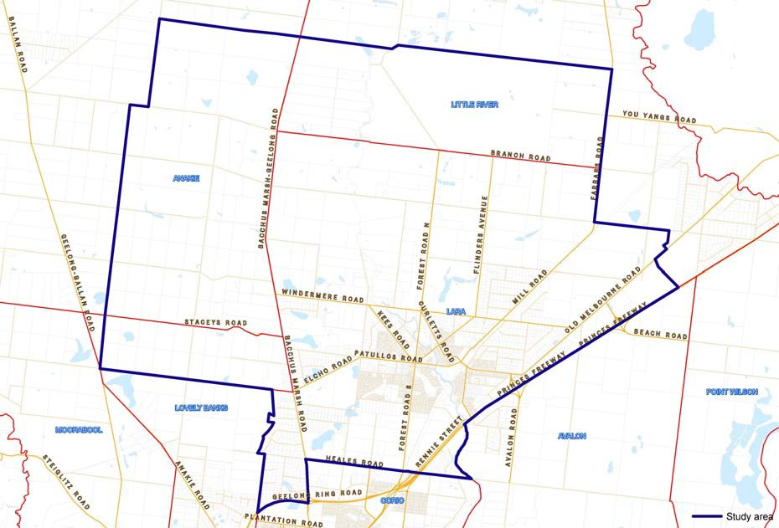
Source: City of Greater Geelong

1.5 Terminology

The terminology of The Burra Charter: The Australia ICOMOS Charter for Places of Cultural Significance (November 1999) is used throughout this study. Refer to Appendix 6.02 for a copy of the Burra Charter. The identification and documentation of potential post‐contact places of cultural significance has been interpreted using the definitions provided in the Burra Charter. Some of the critical definitions identified in the Burra Charter and used in this study are:

Article 1.1: Place means site, area, building or other work, group of buildings or other works, and may include components, contents, spaces and views. Explanatory Notes: The concept of place should be broadly interpreted. The elements described in Article 1.1 may include

memorials, trees, gardens, parks, places of historical events, urban areas, towns, industrial places, archaeological sites and spiritual and religious places.

Article 1.2: Cultural significance means aesthetic, historic, scientific, social or spiritual value for past, present or future generations. Cultural significance is embodied in the place itself, its fabric, setting, use, associations, meanings, records, related places and related objects. Places may have a range of values for different individuals or groups. Explanatory Notes: The term cultural significance is synonymous with heritage significance and cultural heritage value. Cultural significance may change as a result of the continuing history of the place. Understanding of cultural significance may change as a result of new information.

2.0 Methodology
The Lara Heritage Review Phase 2 has involved fieldwork, historical research, comparative analysis and written heritage assessments (and a peer review of these assessments). The Project Proposal for Phase 2 of the Review, as accepted by the City of Greater Geelong on 9 October 2012, is provided as Appendix 6.01. It gives a more detailed account of the tasks involved.

Although not part of the project, a Thematic Environmental History was also prepared at no additional cost to Council.

2.1 Fieldwork
The initial basis to the assessment of the heritage citations included in this heritage study was fieldwork. The fieldwork methodology used was as follows:

• All “yes” and “probably” places identified in the Phase 1 Review list were revisited and re‐photographed. After a brief review, a number of the places were not considered to meet the relevant assessment criteria and thresholds identified in Section 4. An illustrated list of all places investigated is given as Appendix 6.03.

• On‐site access to four properties was permitted by owners for brief fieldwork purposes. This resulted from four properties being outlined as requiring access in the Phase 1 Review. One of these properties could not be visited due to unforeseen circumstances with the owners. Another property (in addition to the other four places) was accessed with permission from the owner. These properties were:

‐ Site 19: 49‐51 Forest Road South.
‐ Site 26: 170 Peak School Road.
‐ Site 46: 35 Gebbies Road.
‐ Site 47: 80 Gebbies Road.

• Most properties were viewed from the public realm, with photographs taken of each.

• A limitation of the project was that site access was not gained for all rural properties with outbuildings. There may be some places with outbuildings of heritage value that could not be identified from the public realm.

2.2 Historical Research
2.2.1 Individual Heritage Places
Considerable historical research was carried out by the authors and researchers of
Authentic Heritage Services Pty Ltd as part of the preparation of the Outer Areas
Heritage Study in 1998‐2000. Random checks of the historical details from this study
were made for some of the places assessed. Given the greater availability of historical information online, considerable additional research was carried out. Visits to the
Public Record Office, Geelong Heritage Centre, State Library Victoria and Land Victoria (Department of Sustainability and Environment) were also made to obtain further primary and secondary documentary material.

2.2.2 Thematic Environmental History
Substantial historical research was carried out in preparation of the Thematic
Environmental History. Historical maps, photographs and other information specific to
the relevant historic themes were included.

2.3 Comparative Analyses
Comparative analyses were carried out for all of the heritage places where citations were prepared, using an architectural and/or historical context, and where necessary, a scientific or social context.

2.4 Heritage Citations
Heritage citations were prepared for each of the heritage places. The draft citations were also peer‐reviewed prior to being provided to Council.

Heritage overlay maps for each of the identified heritage places were prepared by the
City of Greater Geelong in consultation with the consultants.

2.5 Thematic Environmental History
Although an Environmental History was prepared as part of the Outer Areas Heritage Study (2000), a Thematic Environmental History specific to the Lara area was considered important in providing a more relevant historic and thematic basis for the Phase 2 Review.

Based on Victoria’s Framework of Historical Themes published by the Heritage Council of Victoria in February 2010, and tailored to accord with the specific history of Lara, the Thematic History:

• Outlines the key historic themes relevant to the Lara area and surrounds.

• Provides information about some of the key places of significance in the Lara area under the relevant historic themes. These themes are illustrated with photographs, maps and plans where possible.

• Provides a context for comparative analysis of individual heritage places assessed as part of the project.

2.6 Consultation
Formal community consultation was outside the scope of the project. However, limited consultations were carried out with some property owners (particularly some owners where on‐site access had been sought), the Lara RSL Sub‐branch and other individuals with historical information.

The City of Greater Geelong also published the preparation of the Phase 2 Review in City News (in the Geelong Advertiser newspaper) and in the Lara Happenings newsletter (issue 23, 17 November 2012). The City of Greater Geelong also initiated a media release on 19 November 2012. These notifications and the media release gave details of the study and sought historical photographs and other historical information to aid the project. Contact was also made with Lara Heritage and History Inc.

It is anticipated that consultation will affected owners and others interested in the project will occur after the informal exhibition of the draft of the Phase 2 Review.

3.0 Heritage Places
3.1 Introduction
Of the places considered in this study, 24 of the 41 have been assessed as having local significance and warranting inclusion as individual heritage overlays in the Greater Geelong Planning Scheme. Another three places are identified as warranting inclusion on the Victorian Heritage Inventory, with five ruins already on the Victorian Heritage Inventory having updated assessments. Overall, a total of 32 heritage citations have been prepared. Two citations have included places that had multiple citations in the Outer Areas Heritage Study (the Avenue of Honour and Memorial Gates and Fencing, the Wesleyan Chapel buildings at 1B Flinders Avenue and Laurence Park cottage and stables, 125 Buckingham Street, being included as single citations respectively).

An illustrated list of all places in the Heritage Review is given as Appendix 6.03.

3.2 Places of Local Significance
The following is the list of places of local significance warranting inclusion as heritage overlays in the Greater Geelong Planning Scheme. These places are considered to meet the relevant significance criteria and thresholds, and are especially associated with historic themes outlined in the Thematic Environmental History.

Anakie
• 785 Bacchus Marsh Road, Anakie – House (Site 36).
• 450 Staceys Road, Anakie – Roselea (Site 54).

Lara
• 125 Buckingham Street, Lara – Laurence Park (Sites 42 & 43).
• 29 Curletts Road, Lara – Holy Trinity Church of England Tower & Lintel Stone
(Site 4).
• 85 Curletts Road, Lara – Cottage (Site 5).
• 1B Flinders Avenue, Lara – Pioneers’ Memorial Cairn (Site 8).
• 1B Flinders Avenue, Lara – Lara Uniting Church Complex (Sites 7 & 9).
• 450 Flinders Avenue, Lara – The Pines (Site 12).
• 31‐45 Forest Road South, Lara – Limella Cottage (Site 18).

• 49‐51 Forest Road South, Lara – Cottage (Site 19).
• 110‐120 Forest Road South, Lara – Lake Bank Hotel (Site 20).
• 155 Forest Road South, Lara – Clover Hill (Site 21).
• 80 Gebbies Road, Lara – Cottage Complex (Site 47).
• 30 Hicks Street, Lara – Cottage & Dairy Outbuilding (Site 24).
• 295 Patullos Road, Lara – Lochnaben (Site 52).
• 170 Peak School Road, Lara – Tallaranie Homestead (Site 26).
• 8 Rennie Street, Lara – Former Shire Engineer’s Residence (Site 28).
• Cnr Walker & Rennie Streets, Lara – Bills Trough (Site 56).
• Walkers Road, Lara – Avenues of Honour, Cypresses & Memorial Gates & Fencing (Sites 31 & 32).
• 14 Walkers Road, Lara – Waverley (Site 33).
• 11 Waverley Road, Lara – Lara Community Centre (former Presbyterian
Church) (Site 34).
• 10 Windermere Road, Lara – Glenoe (Site 35).

Little River
• 25 Branch Road, Little River – Former Duck Ponds Parsonage & School (Site 2).

Lovely Banks
• 75 Staceys Road, Lovely Banks – Kia Ora (Site 53).

3.3 Ruinous Places
3.3.1 Ruins for the Victorian Heritage Inventory
The following ruins are especially associated with historic themes outlined in the
Thematic Environmental History and should be included on the Victorian Heritage
Inventory:

• 220 Hams Lane, Anakie – Lara Hill House & Outbuilding Ruins (Site 38).
• 60 Branch Road, Lara – Cottage Ruins (Site 3).
• 270 Peak School Road, Lara – Dairy Ruin (Site 25).

3.3.2 Ruins already included on the Victorian Heritage Inventory
The following ruins are already included on the Victorian Heritage Inventory. Updated
heritage assessments have been completed and the Inventory could be refreshed to
reflect the updates:

• 25 Blairs Road, Lara – Ruins (formerly Blairgowrie) (Site 39).
• 105 Blairs Road, Lara – Lime Burning Site (Site 41).
• 120 Duggans Road, Lara – House & Outbuilding Ruins (Site 44).
• 575 Flinders Avenue, Lara – Cottage Ruins (Site 13).
• 370 Windermere Road, Lara – Ruins (Site 40).

3.4 Places of Historic Interest
The following places were not considered to meet the relevant heritage criteria and thresholds for inclusion as heritage overlays, but have some historical interest to the Lara area. Some of these places are included in the Thematic History.

• 45 Forest Road North, Lara – Lara Lime Company (Site 14).
• 35 Gebbies Road, Lara – Cottage (Site 46).

• 14 Hicks Street, Lara – Lara General Store (Site 22).
• 24 Patullos Road, Lara – Cottage (Site 49).
• 32 Patullos Road, Lara – House (Site 50).

4.0 Assessment of Significance
4.1 Basis of Assessment Criteria

The Lara Heritage Review Phase 2 has been prepared in accordance with the VPP Practice Note 01: Applying the Heritage Overlay (revised September 2012) (Appendix
6.04). The Practice Note states:

“The heritage process leading to the identification of the place needs to clearly justify the significance of the place as a basis for its inclusion in the Heritage Overlay. The documentation for each place shall include a statement of significance that clearly establishes the importance of the place and addresses the heritage criteria.”

The following heritage criteria listed in the Practice Note were adopted as part of the assessment of heritage places in the Lara Heritage Review:

Criterion A: Importance to the course or pattern of our cultural or natural history (historical significance).

Criterion B: Possession of uncommon rare or endangered aspects of our cultural or natural history (rarity).

Criterion C: Potential to yield information that will contribute to an understanding of our cultural or natural history (research potential).

Criterion D: Importance in demonstrating the principal characteristics of a class of cultural or natural places or environments (representativeness).

Criterion E: Importance in exhibiting particular aesthetic characteristics
(aesthetic significance).

Criterion F: Importance in demonstrating a high degree of creative or technical achievement at a particular period (technical significance).

Criterion G: Strong or special association with a particular community or cultural group for social, cultural or spiritual reasons. This includes the significance of a place to Indigenous peoples as part of their continuing and developing cultural traditions (social significance).

Criterion H: Special association with the life or works of a person, or group of persons, of importance in our history (associative significance).

In addition, the more detailed Assessment Criteria adopted by the Australian Heritage Commission for the Register of the National Estate (which has formed the basis to the criteria outlined in the Practice Note) have formed a foundation to the heritage assessment,1 as have the principles of the Australia ICOMOS Burra Charter.

1 The use of the more detailed Australian Heritage Commission Criteria is considered to be valid, given that the VPP Practice Note: Applying the Heritage Overlay (revised September 2012) states: “The adoption of

4.2 Significance, Condition & Integrity Levels and Thresholds
In addition to the recognition of the heritage values of the Burra Charter and the assessment criteria outlined in the VPP Practice Note, significance, condition and integrity thresholds were also prepared to determine the level of significance for each heritage place and whether they warranted a heritage overlay.

In relation to significance thresholds, the Practice Note states:

“The thresholds to be applied in the assessment of significance shall be ‘State Significance’ and ‘Local Significance’. ‘Local Significance’ includes those places that are important to a particular community or locality … “

A more definitive matrix of how the Burra Charter values, VPP Practice Note Criteria, Australian Heritage Commission Criteria and Thresholds Levels have been employed in this study is as follows:

the above [2012] criteria does not diminish heritage assessment work undertaken before 2012 using older versions of criteria.”

BURRA CHARTER  VALUES | PRACTICE NOTE CRITERIA | AHC CRITERIA INCLUSION GUIDELINES  (slightly modified for local assessments) | SIGNIFICANCE THRESHOLDS
Aesthetic &/or  Architectural Value: Places where consideration is given to form, scale, colour, texture and material of the fabric. | Criterion B: Possession of uncommon  rare or endangered aspects of our cultural or natural history (rarity).  Criterion D: Importance in demonstrating the principal characteristics of a class of cultural or natural places or environments (representativeness).  Criterion E: Importance in exhibiting particular aesthetic characteristics (aesthetic significance).  Criterion F: Importance in demonstrating a high degree of creative or technical achievement at a particular period (technical significance). | AHC B.2:  Scarcity may be the result of historical process (ie. few of such places were ever made) or of subsequent destruction or decay. Rarity in some cases may apply to the survival of the combination of characteristics and the place as a whole may lack integrity.  AHC D.2:  A place must clearly represent the period, method of construction, techniques, way of life, etc. of its Type. A place may be significant because it is characteristic of either an unusual, or a widely practiced Type, style, or method of construction. It may have been innovative or influential, or it may have been traditional or vernacular; the significance of the place is determined by considering it within its context.  A place may be considered if one or more of the following apply:  • It can be regarded as a particularly good example of its Type, by virtue of the combination of characteristics most indicative of the Type, or a significant variant of the Type equally well;  • It is one of number of similar places which are all good examples of a Type, but has a higher value by virtue of its integrity, condition, association with other significant places or setting;  • It is part of a group of places which collectively include a range or variation within a Type;  • It represents the seminal or optimal development of | STATE THRESHOLD:  Places which are considered significant to the State of Victoria and are worthy for inclusion on the Victorian Heritage Register. These places are the most outstanding examples either aesthetically, architecturally, historically, scientifically or socially. The place meets this threshold if it has outstanding and/or unique aesthetic and technical value/s, is highly intact and has been compared to similar places on the Victorian Heritage Register, and/or has unique historical associations with events or persons in the history of the community and Shire, the importance or which are considered to stretch beyond local municipal boundaries.  LOCAL THRESHOLD:  Places which are considered individually significant to a local area. The Greater Geelong municipality is defined by a number of urban and rural settings of varying historical developments and cultural identities that are not necessarily related to each other. Traditional municipal boundaries have changed, but the cultural identities of the different local communities that comprise the municipality are largely idiosyncratic. These heritage places are considered to have had a significant impact in shaping the cultural, architectural, historical and/or social identity of the local community and where applicable, have been compared to other places of State or Local significance (or potential

BURRA CHARTER  VALUES | PRACTICE NOTE CRITERIA | AHC CRITERIA INCLUSION GUIDELINES  (slightly modified for local assessments) | SIGNIFICANCE THRESHOLDS
 |  | the Type.  AHC E.1:  A place is eligible if it articulates so fully a particular concept of design that it expresses an aesthetic ideal (eg. A place which epitomizes the design principles of an architectural style, landscape ideal, etc.) or if the place, because of its aesthetic characteristics, is held in high esteem by the community.  To be eligible, a place must have a high degree of integrity so that it fully reflects the aesthetic qualities for which it is nominated.  AHC F.1:  A place is eligible if it demonstrates clearly a particularly appropriate solution to a technical problem using or expanding upon established technology, or developing new technology, that solution being outstanding due to its conceptual strength. This might occur, for example, in the fields of engineering, architecture, industrial design, landscape design, etc.  A place may be considered to be outstandingly creative if it results from the innovative departure from established norms in some field of design or the arts.  To be eligible, a place must have a high degree of integrity so that it fully reflects the aesthetic or technical qualities for which it is nominated. | significance). They are considered to have  sufficient significance to warrant a heritage overlay in the Greater Geelong Planning Scheme.

BURRA CHARTER  VALUES | PRACTICE NOTE CRITERIA | AHC CRITERIA INCLUSION GUIDELINES  (slightly modified for local assessments) | SIGNIFICANCE THRESHOLDS
Historic Value:  Places that have influenced or have been influenced by an historic figure, event, phase or activity. For any given place the significance will be greater where evidence of the association or event survives insitu, or where the settings are substantially intact, than where it has been changed or evidence does not survive. | Criterion A: Importance to the  course or pattern of our cultural or natural history (historical significance).  Criterion C: Potential to yield information that will contribute to an understanding of our cultural or natural history (research potential).  Criterion H: Special association with the life or works of a person, or group of persons, of importance in our history (associative significance). | AHC A.4:  Places associated with events or developments which contribute to or reflect the long‐terms changes in Shire or local history.  Places representing “landmark” cultural phases in the evolving pattern of Shire or local history.  A place eligible for its association with a significant scientific theory must have a clear and important relationship to the development of that theory or its early application in the Shire or locality.  A place eligible for its history of science associations must have a strong connection with the work of an historically significant scientific figure or with an historically significant scientific exploration/undertaking, or methodological development.  AHC C.2:  A place with archaeological deposits may be eligible if it can be shown that the deposits are likely to contain evidence of technological, architectural, or cultural value, that evidence not being available through other research techniques. The nature of this research should be specified.  A building or engineering item may be eligible if its research value can be defined. For example, a building exhibiting a local variation on a standard design or construction technique may be eligible if study could yield important information such as how local materials

BURRA CHARTER  VALUES | PRACTICE NOTE CRITERIA | AHC CRITERIA INCLUSION GUIDELINES  (slightly modified for local assessments) | SIGNIFICANCE THRESHOLDS
and construction expertise affect the evolution of local
building development, if this information is not available through documentary research.

AHC H.1:
The person’s contribution must be established sufficiently by historical documentation or other firm evidence, and the association of a person with the place established clearly in a similar way.

A building designed by a prominent architect may be eligible under this criterion if it expresses a particular phase of the individual’s career or exhibits aspects reflecting a particular idea or theme of her/his craft. It is possible that several places may represent different aspects of the productive life of an important person. Similarly, several examples of a person’s work may be considered because a different combination of criteria are satisfied.

In general, the association between person and place needs to be of long duration, or needs to be particularly significant in the person’s productive life.

Places which contain fabric that is a direct result of the person’s activity or activities, or where the place can be demonstrated to have influenced the person’s life or works, are eligible, and such places are more eligible than places which lack such direct and personal associations.

BURRA CHARTER  VALUES | PRACTICE NOTE CRITERIA | AHC CRITERIA INCLUSION GUIDELINES  (slightly modified for local assessments) | SIGNIFICANCE THRESHOLDS
Scientific Value:  Places where data clearly indicates its rarity, quality or representativeness. | Criterion F: Importance in  demonstrating a high degree of creative or technical achievement at a particular period (technical significance). | AHC F.1:  A place is eligible if it demonstrates clearly a particularly appropriate solution to a technical problem using or expanding upon established technology, or developing new technology, that solution being outstanding due to its conceptual strength. This might occur, for example, in the fields of engineering, architecture, industrial design, landscape design, etc.  A place may be considered to be outstandingly creative if it results from the innovative departure from established norms in some field of design or the arts.  To be eligible, a place must have a high degree of integrity so that it fully reflects the aesthetic or technical qualities for which it is nominated.
Social Value:  Places that have a focus on spiritual, political, national or other cultural sentiment to a majority or minority group. | Criterion G: Strong or special  association with a particular community or cultural group for social, cultural or spiritual reasons. This includes the significance of a place to Indigenous peoples as part of their continuing and developing cultural traditions (social significance). | AHC G.1:  Places which are held in high esteem by the Shire or local community or a segment of it, that esteem being demonstrated and special. The value to the community must be beyond normal regard felt by a community for its familiar surroundings.  It is necessary to demonstrate that the strong association between a community and place is of a social or cultural nature, and not simply a local assessment of some other value more correctly assessed against another criterion.

Condition Thresholds

• Excellent Condition (no deterioration of fabric noticeable).
• Good Condition (minor deterioration of fabric noticeable).
• Fair Condition (deterioration of fabric noticeable).
• Poor Condition (deterioration of fabric very noticeable, with possible structural deterioration as well).
• Ruins (small elements of original character & appearance only identified through remaining building ruins).

Integrity Thresholds
Thresholds
• Substantially Intact (either completely intact or a small number minor modifications noticeable).
• Moderately Intact (original character & appearance clearly discernible, but a number of minor modifications noticeable).
• Altered (original character & appearance discernible but alterations to some original fabric such as doors and window openings and verandah noticeable).
• Substantially Altered/Low Integrity (original character & appearance only partly discernible – multiple changes noticeable to the exterior).
• Ruinous (ruinous fabric surviving only).

Building Fabric
The integrity of places (when viewed from the public realm) may include to varying degrees
the following such that the place is discernible to its creation date (or creation dates):

• Overall form & composition.
• Construction materials.
• Building details.
• Verandahs.
• Visible windows and doors.
• Front Fencing
• Outbuildings

The integrity of landscaped settings, spaces and views may also have been considered.

Additions
Places with additions may continue to have significance if:
• The additions have been identified as contributing to the significance of the building or place (the additions being significant).

• The additions have no significance but are recessive and do not dominate over the building.

Relocated Places
Relocated places may also have significance if they have direct associations to specific historical themes identified in the Thematic Environmental History.

5.0 Recommendations
5.1 Heritage Overlays
5.1.1 Individual Heritage Overlays
It is recommended that the 24 places identified as having local heritage significance
are included as heritage overlays in the Schedule to the Heritage Overlay in the
Greater Geelong Planning Scheme, through a planning scheme amendment. These
places are:

Anakie
• 785 Bacchus Marsh Road, Anakie – House (Site 36).
• 450 Staceys Road, Anakie – Roselea (Site 54).

Lara
• 125 Buckingham Street, Lara – Laurence Park (Sites 42 & 43).
• 29 Curletts Road, Lara – Holy Trinity Church of England Tower & Lintel Stone
(Site 4).
• 85 Curletts Road, Lara – Cottage (Site 5).
• 1B Flinders Avenue, Lara – Pioneers’ Memorial Cairn (Site 8).
• 1B Flinders Avenue, Lara – Lara Uniting Church Complex (Sites 7 & 9).
• 450 Flinders Avenue, Lara – The Pines (Site 12).
• 31‐45 Forest Road South, Lara – Limella Cottage (Site 18).
• 49‐51 Forest Road South, Lara – Cottage (Site 19).
• 110‐120 Forest Road South, Lara – Lake Bank Hotel (Site 20).
• 155 Forest Road South, Lara – Clover Hill (Site 21).
• 80 Gebbies Road, Lara – Cottage Complex (Site 47).
• 30 Hicks Street, Lara – Cottage & Dairy Outbuilding (Site 24).
• 295 Patullos Road, Lara – Lochnaben (Site 52).
• 170 Peak School Road, Lara – Tallaranie Homestead (Site 26).
• 8 Rennie Street, Lara – Former Shire Engineer’s Residence (Site 28).
• Cnr Walker & Rennie Streets, Lara – Bills Trough (Site 56).
• Walkers Road, Lara – Avenues of Honour, Cypresses & Memorial Gates & Fencing (Sites 31 & 32).
• 14 Walkers Road, Lara – Waverley (Site 33).
• 11 Waverley Road, Lara – Lara Community Centre (former Presbyterian
Church) (Site 34).
• 10 Windermere Road, Lara – Glenoe (Site 35).

Little River
• 25 Branch Road, Little River – Former Duck Ponds Parsonage & School (Site 2).

Lovely Banks
• 75 Staceys Road, Lovely Banks – Kia Ora (Site 53).

5.1.2 Additional Heritage Controls in the Schedule to the Heritage Overlay
External Paint Controls
It is recommended that those identified face brick and masonry places, including specific rendered masonry places, are included in the Schedule to the Heritage Overlay
with external paint controls. Although Clause 43.01‐1 of the Greater Geelong Planning
Scheme already requires a planning permit to externally paint an unpainted surface,

the inclusion of external paint controls for the following places is consistent with other similar places already in the Schedule to the Heritage Overlay. These places are:

• 125 Buckingham Street, Lara – Laurence Park (Sites 42 & 43).
• 29 Curletts Road, Lara – Holy Trinity Church of England Tower & Lintel Stone
(Site 4).
• 85 Curletts Road, Lara – Cottage (Site 5).
• 1B Flinders Avenue, Lara – Pioneers’ Memorial Cairn (Site 8).
• 1B Flinders Avenue, Lara – Lara Uniting Church Complex (Sites 7 & 9).
• 110‐120 Forest Road South, Lara – Lake Bank Hotel (Site 20).
• 155 Forest Road South, Lara – Clover Hill (Site 21).
• 80 Gebbies Road, Lara – Cottage Complex (Site 47).
• Cnr Walker & Rennie Streets, Lara – Bills Trough (Site 56).
• 25 Branch Road, Little River – Former Duck Ponds Parsonage & School (Site 2).

Tree Controls
It is recommended that the following six places be included in the Schedule to the
Heritage Overlay with tree controls, given that trees are considered to contribute to
significance of these places:

• 125 Buckingham Street, Lara – Laurence Park (Sites 42 & 43).
• 31‐45 Forest Road South, Lara – Limella Cottage (Site 18).
• 49‐51 Forest Road South, Lara – Cottage (Site 19).
• 110‐120 Forest Road South, Lara – Lake Bank Hotel (Site 20).
• 80 Gebbies Road, Lara – Cottage Complex (Site 47).
• Walkers Road, Lara – Avenues of Honour, Cypresses & Memorial Gates & Fencing (Sites 31 & 32).

Incorporated Plans
It is recommended that Incorporated Plans are prepared for the following places:

• 29 Curletts Road, Lara – Holy Trinity Church of England Tower & Lintel Stone (Site 4). The Incorporated Plan could exempt other fabric (apart from the Church Tower and Lintel Stone) from the need for a planning permit under the heritage overlay for any buildings and works.
• 1B Flinders Avenue, Lara – Lara Uniting Church Complex (Sites 7 & 9). The Incorporated Plan could exempt the later 20th century Church building from the need for planning permits for external alterations that are 2 m clear of the historic buildings.

5.1.3 Reference Documents
It is recommended that the Lara Heritage Review Phase 2 (including Volumes 1,2 and
3) are included as Reference Documents in Clause 22.09 of the Greater Geelong
Planning Scheme.

5.2 Victorian Heritage Inventory
5.2.1 Updates to Ruins already on the Victorian Heritage Inventory
It is recommended that Heritage Victoria is advised of updates to the assessments of
the following ruins, so that the Victorian Heritage Inventory may be refreshed:

• 25 Blairs Road, Lara – Ruins (formerly Blairgowrie) (Site 39).
• 105 Blairs Road, Lara – Lime Burning Site (Site 41).
• 120 Duggans Road, Lara – House & Outbuilding Ruins (Site 44).
• 575 Flinders Avenue, Lara – Cottage Ruins (Site 13).
• 370 Windermere Road, Lara – Ruins (Site 40).

5.2.2 Additional Ruins for the Victorian Heritage Inventory
It is recommended that Heritage Victoria is advised of the following assessments for
inclusion on the Victorian Heritage Inventory:

• 220 Hams Lane, Anakie – Lara Hill House & Outbuilding Ruins (Site 38).
• 60 Branch Road, Lara – Cottage Ruins (Site 3).
• 270 Peak School Road, Lara – Dairy Ruin (Site 25).

5.3 HERMES
It is recommended that if a planning scheme amendment is gazetted for the inclusion of the identified places as heritage overlays in the Planning Scheme, that the heritage citations for each place are included in the HERMES database so that the information may be accessed through the Victorian Heritage Database and Council’s website (Heritage Places Database).

It is therefore recommended that Council staff or the Heritage Advisor be provided with resources to include the data in HERMES at the time of the gazettal of the planning scheme amendment.

5.4 Thematic History
It is recommended that Council consider the publication of the Thematic Environmental History (either as a formal publication or electronically on Council’s website). The Thematic History provides a valuable understanding of Lara’s post‐ contact cultural history.

6.01 Lara Heritage Review Phase 2 Project Proposal

Authentic Heritage Services Pty Ltd
ABN 81 088 389 851

Dr David Rowe B.A. (Arch), B.Arch. (Hons.), PhD (Arch.)
Ph: (03) 5248 6990 E: rowe@ah-services.com.au
Postal Address: PO Box 9169, St. Albans Park, Geelong, Victoria, 3219

28 September 2012

Ms Jessica Hurse Strategic Planner Planning Strategy
City of Greater Geelong
PO Box 104
Geelong 3220

Re: Lara Heritage Review Phase 2

Dear Jessica,

Thank you for the opportunity to formalise our proposal to carry out Phase 2 of the Lara Heritage
Review. Our preparation of the project, personnel involved and fee is outlined below.

Preparation of the Report
The Lara Heritage Review will be authored by David Rowe, and peer‐reviewed by Wendy Jacobs,
Architect and Heritage Consultant. The basis of the heritage places to be reviewed is the Lara Heritage Review Phase 1 by RBA Architects & Conservation Consultants. It lists 26 “Yes” sites that have been determined as being worthy for heritage overlays and 14 “Probably” sites that are probably worthy of inclusion as heritage overlays subject to further research and/or investigation. This project therefore allows for the review of 40 heritage places, together with the Bills Trough in Rennie Street (I have previously authored a citation that can be reformatted for inclusion in the Review).

The project will include the following:

• Fieldwork: this will be carried out by David Rowe and Wendy Jacobs for all 40 heritage places. The fieldwork will be undertaken from the street/property boundaries, except for four properties where access to the site will be required. These properties are:

‐ House, 51 Forest Street South, Lara.
‐ Cottage, 35 Gebbies Road, Lara.
‐ ‘Kia Ora’, 75 Staceys Road, Lovely Banks.
‐ ‘Tallaranie’ Homestead, 170 Peak School Road, Lara.

It is anticipated that Council will assist in the organisation of these site visits with the owners
(assuming that the owners are willing for us to visit).

• Historical Research: We have confidence that the historical research carried out for the Lara‐Lovely Banks portions of the ‘Greater Geelong Outer Areas Heritage Study Stage 2’ (1998‐2000) is accurate and that it remains applicable for use in this Review. A random

check of the historical details for some of these places will be carried by Pam Jennings out to confirm their accuracy and if necessary, the histories will be corrected.

The concentration of additional historical research by Pam Jennings will be given to the 14 “probably” places identified in the Lara Heritage Review Phase 1, together an analysis of readily available material at the Geelong Heritage Centre, Public Record Office Victoria and in the consultants’ private collection. Online information from Trove (Historical Newspapers) will also be accessed to flesh out any addition information on the 40 properties identified in the Review.

• Refreshing Existing Assessments: David Rowe will refresh the 40 existing heritage citations in the ‘Greater Geelong Outer Areas Heritage Study Stage 2’, (these places were originally authored by David Rowe in this study). The work will largely involve reviewing (and where necessary upgrading) the description (including condition and integrity) and history of each place, and preparing new statements of significance based on the VPP Practice Note 01: Applying the Heritage Overlay (revised September 2012).

• Introductory Report: David Rowe will prepare an Introductory Report outlining the aims, methodology, significance thresholds, levels of significance and recommendations for heritage overlays as part of the Review.

• Peer Review: Wendy Jacobs will review all the refreshed assessments and will liaise with
David Rowe about any necessary changes prior to the drafts being provided to Council.

• Inclusion of Assessments in Hermes: after Council has approved the final heritage assessments, Pam Jennings will download the information into Hermes (with the publication flags changed to “no” so that the information is not publicly available but ready for changing to yes at the appropriate time).

Fee
Our fixed fee of ……………………………………………………………………. This fee includes one draft electronic copy and one final electronic copy of the Review.

Exclusions
The project has the following exclusions:

• Provision for meetings.
• Provision for community consultation (consultation will occur with the four owners where access to their properties is required, together with any ad hoc enquiries received during the preparation of the project).
• Provision of heritage overlay maps (it is anticipated that these maps for each place will be supplied by Council for inclusion in the Report).
• Scanned versions of the images in the Outer Areas Heritage Study (it is anticipated that Council will scan these photographs so that they can be supplied for inclusion in the Report).
• Other Specialist practitioners that may be required such as Horticulturists, Engineers and
Archaeologists.
• Printed copies of the Report.

Milestone Timetable
It has been the standard practice of David Rowe and Wendy Jacobs to prepare a draft version of a Heritage Studies as if they were the final document. This gives the client an appreciation of all aspects of the report that can be discussed and any changes or issues negotiated for the final draft.
It is estimated that this project would be carried out over a 6 month period (this accounts for the
‘Christmas closedown’ period in December‐January). A likely commencement date is 16 October
2012, with sets of draft assessments provided throughout the duration of the Review.

The anticipated milestone timetable is as follows:

Milestone One
16 October 2012
• Commence fieldwork and historical research.
Payment of 10% of Project Budget

Milestone Two
18 December 2012
• Provision of 15 draft heritage assessments.
Payment of 20% of Project Budget

Milestone Three
13 February 2013
• Provision of 15 draft heritage assessments.
Payment of 20% of Project Budget

Milestone Four
12 March 2013
• Provision of 10 draft heritage assessments.
Payment of 20% of Project Budget

Milestone Five
16 April 2013
• Provision of draft Introductory Report
Payment of 20% of Project Budget

Milestone Six
• Final version of the Lara Heritage Review Phase 2 provided two weeks after receiving comments from Council on the draft Report.
Payment of 10% of Project Budget

We hope that this proposal meets your requirements and expectations. Please do not hesitate to contact us if you have any queries. Acceptance in writing of this proposal would be appreciated.

Yours sincerely,

Dr David Rowe
Director

Lara Heritage Review Phase 2. Draft. February 2013 Appendices

6.02 Australia ICOMOS Burra Charter

Dr David Rowe: Authentic He ritage Services Pty Ltd & We ndy Jacobs: Architect & Heritage Consulta nt

The Burra Charter

(The Australia ICOMOS Charter for Places of Cultural Significance)

Preamble

Considering the International Charter for the Conservation and Restoration of Monuments and Sites (Venice 1964), and the Resolutions of the 5th General Assembly of the International Council on Monuments and Sites (ICOMOS) (Moscow 1978), the Burra Charter was adopted by Australia ICOMOS (the Australian
National Committee of ICOMOS) on 19 August 1979 at
Burra, South Australia. Revisions were adopted on 23
February 1981, 23 April 1988 and 26 November 1999.

The Burra Charter provides guidance for the conservation and management of places of cultural significance
(cultural heritage places), and is based on the knowledge and experience of Australia ICOMOS members.

Conservation is an integral part of the management of places of cultural significance and is an ongoing responsibility.

Who is the Charter for?

The Charter sets a standard of practice for those who provide advice, make decisions about, or undertake works to places of cultural significance, including owners, managers and custodians.

Using the Charter

The Charter should be read as a whole. Many articles are interdependent. Articles in the Conser vation Principles section are often further developed in the Conservation Processes and Conser vation Practice sections. Headings have been included for ease of reading but do not form part of the Charter.

The Charter is self-contained, but aspects of its use and application are further explained in the following Australia ICOMOS documents:

• Guidelines to the Burra Charter: Cultural
Significance;
• Guidelines to the Burra Charter: Conservation Policy;

• Guidelines to the Burra Charter: Procedures for
Undertaking Studies and Reports;

• Code on the Ethics of Coexistence in Conserving
Significant Places.

What places does the Char ter apply to?

The Charter can be applied to all types of places of cultural significance including natural, indigenous and historic places with cultural values.

The standards of other organisations may also be relevant. These include the Australian Natural Heritage Charter
and the Draft Guidelines for the Protection, Management and Use of Aboriginal and Torres Strait Islander Cultural Heritage Places.

Why conserve?

Places of cultural significance enrich people’s lives, often providing a deep and inspirational sense of connection to community and landscape, to the past and to lived experiences. They are historical records, that are important as tangible expressions of Australian identity and experience. Places of cultural significance reflect the diversity of our communities, telling us about who we are and the past that has formed us and the Australian landscape. They are irreplaceable and precious.
These places of cultural significance must be conserved for present and future generations.

The Burra Charter advocates a cautious approach to change: do as much as necessary to care for the place and to make it useable, but otherwise change it as little as possible so that its cultural significance is retained.

The Burra Charter, 1999 A u s t r a l i a I C O M O S I n c 1

Articles

Article 1. Definitions

For the purposes of this Charter:

1.1 Place means site, area, land, landscape, building or other work, group of buildings or other works, and may include components, contents, spaces and views.

1.2 Cultural significance means aesthetic, historic, scientific, social or spiritual value for past, present or future generations.

Cultural significance is embodied in the place itself, its fabric, setting, use, associations, meanings, records, related places and related objects.

Places may have a range of values for different individuals or groups.

1.3 Fabric means all the physical material of the place including components, fixtures, contents, and objects.

1.4 Conservation means all the processes of looking after a place so as to retain its cultural significance.

1.5 Maintenance means the continuous protective care of the fabric and setting of a place, and is to be distinguished from repair. Repair involves restoration or reconstruction.

1.6 Preservation means maintaining the fabric of a place in its existing state and retarding deterioration.

1.7 Restoration means returning the existing fabric of a place to a known earlier state by removing accretions or by reassembling existing components without the introduction of new material.

1.8 Reconstruction means returning a place to a known earlier state and is distinguished from restoration by the introduction of new material into the fabric.

1.9 Adaptation means modifying a place to suit the existing use or a proposed use.
1.10 Use means the functions of a place, as well as the activities and practices that may occur at the place.

1.11 Compatible use means a use which respects the cultural significance of a
place. Such a use involves no, or minimal, impact on cultural significance.

1.12 Setting means the area around a place, which may include the visual catchment.

1.13 Related place means a place that contributes to the cultural significance of another place.
Explanatory Notes

The concept of place should be broadly interpreted. The elements described in Article
1.1 may include memorials, trees, gardens,
parks, places of historical events, urban areas, towns, industrial places, archaeological sites and spiritual and religious places.

The term cultural significance is synonymous with heritage significance and cultural
heritage value.

Cultural significance may change as a result of the continuing history of the place.

Understanding of cultural significance may change as a result of new information.

Fabric includes building interiors and sub- surface remains, as well as excavated material.

Fabric may define spaces and these may be important elements of the significance of the place.

The distinctions referred to, for example in relation to roof gutters, are:

• maintenance — regular inspection and cleaning of gutters;
• repair involving restoration — returning of dislodged gutters;
• repair involving reconstruction —
replacing decayed gutters.

It is recognised that all places and their components change over time at varying rates.

New material may include recycled material salvaged from other places. This should not be to the detriment of any place of cultural significance.

2 A u s t r a l i a I C O M O S I n c The Burra Charter, 1999

Articles Explanatory Notes

1.14 Related object means an object that contributes to the cultural significance
of a place but is not at the place.

1.15 Associations mean the special connections that exist between people and a place.

Associations may include social or spiritual values and cultural responsibilities for a place.

1.16 Meanings denote what a place signifies, indicates, evokes or expresses. Meanings generally relate to intangible aspects such as symbolic qualities and memories.

1.17 Interpretation means all the ways of presenting the cultural significance of a place.

Conservation Principles

Article 2. Conservation and management

2.1 Places of cultural significance should be conser ved.

2.2 The aim of conservation is to retain the cultural significance of a place.

2.3 Conservation is an integral part of good management of places of cultural significance.

2.4 Places of cultural significance should be safeguarded and not put at risk or left in a vulnerable state.

Article 3. Cautious approach

3.1 Conservation is based on a respect for the existing fabric, use, associations and meanings. It requires a cautious approach of changing as much as necessary but as little as possible.

3.2 Changes to a place should not distort the physical or other evidence it provides, nor be based on conjecture.

Article 4. Knowledge, skills and techniques

4.1 Conservation should make use of all the knowledge, skills and disciplines which can contribute to the study and care of the place.

4.2 Traditional techniques and materials are preferred for the conservation of significant fabric. In some circumstances modern techniques and materials which offer substantial conser vation benefits may be appropriate.
Interpretation may be a combination of the treatment of the fabric (e.g. maintenance, restoration, reconstruction); the use of and activities at the place; and the use of introduced explanatory material.

The traces of additions, alterations and earlier treatments to the fabric of a place are
evidence of its history and uses which may be
part of its significance. Conservation action should assist and not impede their understanding.

The use of modern materials and techniques must be supported by firm scientific evidence or by a body of experience.

The Burra Charter, 1999 A u s t r a l i a I CO M O S I n c 3

Articles Explanatory Notes

Article 5. Values

5.1 Conservation of a place should identify and take into consideration all aspects of cultural and natural significance without unwarranted emphasis on any one value at the expense of others.

5.2 Relative degrees of cultural significance may lead to different conservation
actions at a place.

Article 6. Burra Charter process

6.1 The cultural significance of a place and other issues affecting its future are best understood by a sequence of collecting and analysing information before making decisions. Understanding cultural significance comes first, then development of policy and finally management of the place in accordance with the policy.

6.2 The policy for managing a place must be based on an understanding of its
cultural significance.

6.3 Policy development should also include consideration of other factors affecting the future of a place such as the owner’s needs, resources, external constraints and its physical condition.

Conservation of places with natural significance is explained in the Australian Natural Heritage Charter. This Charter defines natural significance to mean the importance of ecosystems, biological diversity and geodiversity for their existence value, or for present or future generations in terms of their scientific, social, aesthetic and life- support value.

A cautious approach is needed, as understanding of cultural significance may change. This article should not be used to justify actions which do not retain cultural significance.

The Burra Charter process, or sequence of investigations, decisions and actions, is illustrated in the accompanying flowchart.

Article 7. Use

7.1 Where the use of a place is of cultural significance it should be retained.

7.2 A place should have a compatible use. The policy should identify a use or combination of uses or constraints on uses that retain the cultural significance of the place. New use of a place should involve minimal change, to significant fabric and use;
should respect associations and meanings; and where appropriate should provide for
continuation of practices which contribute to the cultural significance of the place.

Article 8. Setting

Conservation requires the retention of an appropriate visual setting and other relationships that contribute to the cultural significance of the place.

New construction, demolition, intrusions or other changes which would adversely affect the setting or relationships are not appropriate.

Aspects of the visual setting may include use, siting, bulk, form, scale, character, colour, texture and materials.

Other relationships, such as historical connections, may contribute to interpretation, appreciation, enjoyment or experience of the place.

4 A u s t r a l i a I C O M O S I n c The Burra Charter, 1999

Articles Explanatory Notes

Article 9. Location

9.1 The physical location of a place is part of its cultural significance. A building, work or other component of a place should remain in its historical location. Relocation is generally unacceptable unless this is the sole practical means of ensuring its survival.

9.2 Some buildings, works or other components of places were designed to be readily removable or already have a history of relocation. Provided such buildings, works or other components do not have significant links with their present location, removal may be appropriate.

9.3 If any building, work or other component is moved, it should be moved to an appropriate location and given an appropriate use. Such action should not be to the detriment of any place of cultural significance.

Article 10. Contents

Contents, fixtures and objects which contribute to the cultural significance of a place should be retained at that place. Their removal is unacceptable unless it is: the sole means of ensuring their security and preservation; on a temporary basis for treatment or exhibition; for cultural reasons; for health and safety; or to protect the place. Such contents, fixtures and objects should be returned where circumstances permit and it is culturally appropriate.

Article 11. Related places and objects

The contribution which related places and related objects make to the cultural significance of the place should be retained.

Article 12. Participation

Conservation, interpretation and management of a place should provide for the participation of people for whom the place has special associations and meanings, or who have social, spiritual or other cultural responsibilities for the place.

Article 13. Co-existence of cultural values

Co-existence of cultural values should be recognised, respected and encouraged, especially in cases where they conflict.

For some places, conflicting cultural values may affect policy development and management decisions. In this article, the term cultural values refers to those beliefs which are important to a cultural group, including but not limited to political, religious, spiritual and moral beliefs. This is broader than values associated with cultural significance.

The Burra Charter, 1999 A u s t r a l i a I C O M O S I n c 5

Articles Explanatory Notes

Conservation Processes

Article 14. Conservation processes

Conservation may, according to circumstance, include the processes of: retention or reintroduction of a use; retention of associations and meanings; maintenance, preservation, restoration, reconstruction, adaptation and interpretation; and will commonly include a combination of more than one of these.

Article 15. Change

15.1 Change may be necessary to retain cultural significance, but is undesirable where it reduces cultural significance. The amount of change to a place should be guided by the cultural significance of the place and its appropriate interpretation.

15.2 Changes which reduce cultural significance should be reversible, and be reversed when circumstances permit.

15.3 Demolition of significant fabric of a place is generally not acceptable.
However, in some cases minor demolition may be appropriate as part of conservation. Removed significant fabric should be reinstated when circumstances permit.

15.4 The contributions of all aspects of cultural significance of a place should be respected. If a place includes fabric, uses, associations or meanings of different periods, or different aspects of cultural significance, emphasising or interpreting one period or aspect at the expense of another can only be justified when what is left out, removed or diminished is of slight cultural significance and that which is emphasised or interpreted is of much
greater cultural significance.

Article 16. Maintenance

Maintenance is fundamental to conservation and should be undertaken wher e fabric is of cultural significance and its maintenance is necessary to retain that cultural significance.

There may be circumstances where no action is required to achieve conservation.

When change is being considered, a range of options should be explored to seek the option which minimises the reduction of cultural significance.

Reversible changes should be considered temporary. Non-reversible change should only be used as a last resort and should not prevent future conservation action.

6 Au s t r a l i a I C O M O S I n c The Burra Charter, 1999

Articles Explanatory Notes

Article 17. Preservation

Preservation is appropriate where the existing fabric or its condition constitutes evidence of cultural significance, or where insufficient evidence is available to allow other conservation processes to be carried out.

Article 18. Restoration and reconstruction

Restoration and reconstruction should reveal culturally significant aspects of the place.

Article 19. Restoration

Restoration is appropriate only if there is sufficient evidence of an earlier state of the fabric.

Article 20. Reconstruction

20.1 Reconstruction is appropriate only where a place is incomplete through damage or alteration, and only where there is sufficient evidence to reproduce an earlier state of the fabric. In rare cases, reconstruction may also be appropriate as part of a use or practice that retains the cultural significance of the place.

20.2 Reconstruction should be identifiable on close inspection or through additional interpretation.

Article 21. Adaptation

21.1 Adaptation is acceptable only where the adaptation has minimal impact on the cultural significance of the place.

21.2 Adaptation should involve minimal change to significant fabric, achieved only after considering alternatives.

Article 22. New work

22.1 New work such as additions to the place may be acceptable where it does not distort or obscure the cultural significance of the place, or detract from its interpretation and appreciation.

22.2 New work should be readily identifiable as such.

Preservation protects fabric without obscuring the evidence of its construction and use. The process should always be applied:

• where the evidence of the fabric is of such significance that it should not be altered;
• where insufficient investigation has been carried out to permit policy decisions
to be taken in accord with Articles 26 to 28.

New work (e.g. stabilisation) may be carried out in association with preser vation when
its purpose is the physical protection of the fabric and when it is consistent with Article 22.

Adaptation may involve the introduction of new services, or a new use, or changes to safeguard the place.

New work may be sympathetic if its siting, bulk, form, scale, character, colour, texture and material are similar to the existing fabric, but imitation should be avoided.

The Burra Charter, 1999 A u s t r a l i a I C O M O S I n c 7

Articles Explanatory Notes

Article 23. Conserving use

Continuing, modifying or reinstating a significant use may be appropriate and preferred forms of conservation.

Article 24. Retaining associations and meanings

24.1 Significant associations between people and a place should be respected, retained and not obscured. Opportunities for the interpretation, commemoration and celebration of these associations should be investigated and implemented.

24.2 Significant meanings, including spiritual values, of a place should be respected. Opportunities for the continuation or revival of these meanings should be investigated and implemented.

Article 25. Interpretation

The cultural significance of many places is not readily apparent, and should be explained by interpretation. Interpretation should enhance understanding and enjoyment, and be culturally appropriate.

Conservation Practice

Article 26. Applying the Burra Charter process

26.1 Work on a place should be preceded by studies to understand the place which should include analysis of physical, documentary, oral and other evidence, drawing on appropriate knowledge, skills and disciplines.

26.2 Written statements of cultural significance and policy for the place should be prepared, justified and accompanied by supporting evidence. The statements of significance and policy should be incorporated into a management plan for the place.

26.3 Groups and individuals with associations with a place as well as those involved in its management should be provided with opportunities to contribute to and participate in understanding the cultural significance of the place. Where appropriate they should also have opportunities to participate in its conservation and management.

Article 27. Managing change

27.1 The impact of proposed changes on the cultural significance of a place should be analysed with reference to the statement of significance and the policy for managing the place. It may be necessary to modify proposed changes following analysis to better retain cultural significance.

27.2 Existing fabric, use, associations and meanings should be adequately recorded before any changes are made to the place.

These may require changes to significant
fabric but they should be minimised. In some cases, continuing a significant use or practice may involve substantial new work.

For many places associations will be linked to use.

The results of studies should be up to date, regularly reviewed and revised as necessar y.

Statements of significance and policy should be kept up to date by regular review and revision as necessary. The management plan may deal with other matters related to the management of the place.

8 A u s t r a l i a IC O M O S I n c The Burra Charter, 1999

Articles Explanatory Notes

Article 28. Disturbance of fabric

28.1 Disturbance of significant fabric for study, or to obtain evidence, should
be minimised. Study of a place by any disturbance of the fabric, including archaeological excavation, should only be undertaken to provide data essential for decisions on the conservation of the place, or to obtain important evidence about to be lost or made inaccessible.

28.2 Investigation of a place which requires disturbance of the fabric, apart from that necessary to make decisions, may be appropriate provided that it is consistent with the policy for the place. Such investigation should be based on important research questions which have potential to substantially add to knowledge, which cannot be answered in other ways and which minimises disturbance of significant fabric.

Article 29. Responsibility for decisions

The organisations and individuals responsible for management decisions should be named and specific responsibility taken for each such decision.

Article 30. Direction, supervision and implementation

Competent direction and supervision should be maintained at all stages, and any changes should be implemented by people with appropriate knowledge and skills.

Article 31. Documenting evidence and decisions

A log of new evidence and additional decisions should be kept.

Article 32. Records

32.1 The records associated with the conservation of a place should be placed in a permanent archive and made publicly available, subject to requirements of security and privacy, and where this is culturally appropriate.
32.2 Records about the history of a place should be protected and made publicly available, subject to requirements of security and privacy, and where this is culturally appropriate.

Article 33. Removed fabric

Significant fabric which has been remo ved from a place including contents, fixtures and objects, should be catalogued, and protected in accordance with its cultural significance.

Where possible and culturally appropriate, remo ved significant fabric including contents, fixtures and objects, should be kept at the place.

Article 34. Resources

Adequate resources should be pr ovided for conservation.

Words in italics are defined in Article 1.

The best conservation often involves the least work and can be inexpensive.

The Burra Charter, 1999 A us t r a l i a I C O M O S I n c 9

The Burra Charter Process

Sequence of investigations, decisions and actions

IDENTIFY PLACE AND ASSOCIATIONS Secure the place and make it safe

GATHER AND RECORD INFORMATION ABOUT THE PLACE  SUFFICIENT TO UNDERSTAND SIGNIFICANCE 
Documentar y Oral Physical

ASSESS SIGNIFICANCE  PREPARE A STATEMENT OF SIGNIFICANCE 

IDENTIFY OBLIGATIONS ARISING FROM SIGNIFICANCE  GATHER INFORMATION ABOUT OTHER FACTORS 
AFFECTING THE FUTURE OF THE PLACE
Owner/manager’s needs and resources
External factors Physical condition

DEVELOP POLICY
Identify options 
Consider options and test their impact on significance 

PREPARE A STATEMENT OF POLICY 


MANAGE PLACE IN ACCORDANCE WITH POLICY Develop strategies
Implement strategies through a management plan
 Record place prior to any change

MONITOR AND REVIEW

10 A u s t r a l i a I C O M O S I n c The Burra Charter, 1999

Lara Heritage Review Phase 2. Draft. February 2013 Appendices

6.03 Illustrated list of Places Assessed

Dr David Rowe: Authentic He ritage Services Pty Ltd & We ndy Jacobs: Architect & Heritage Consulta nt

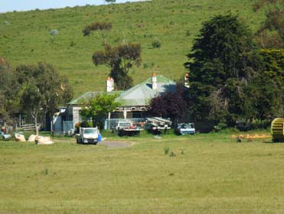Site 36 785 Bacchus Marsh Road, Anakie

House

See Heritage Citation

References

Heritage Significance Citation Prepared Yes
Recommended for HO Yes

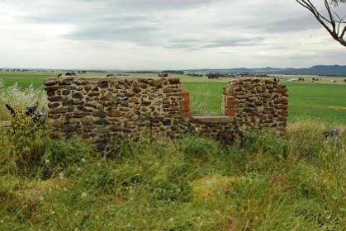Site 38 220 Hams Lane, Anakie

Lara Hill House & Outbuilding Ruins

See Heritage Citation.
Recommended for the Victorian Heritage Inventory.

References

Heritage Significance Citation Prepared Yes

Site 54 450 Staceys Road, Anakie

Roselea

See Heritage Citation.

References
Recommended for HO No

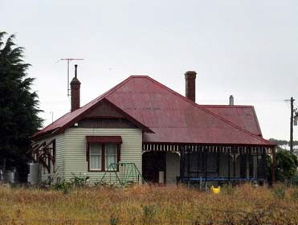Heritage Significance Citation Prepared Yes
Recommended for HO Yes

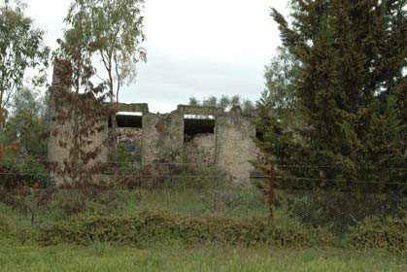Site 39 025 Blairs Road, Lara

Ruins (formerly Blairgowrie)

See Heritage Citation.
Recommended for the Victorian Heritage Inventory.

References

Heritage Significance Citation Prepared Yes
Recommended for HO No

Limeburning Site

See Heritage Citation.
Recommended for the Victorian Heritage Inventory.

References

Heritage Significance Citation Prepared Yes
Recommended for HO No

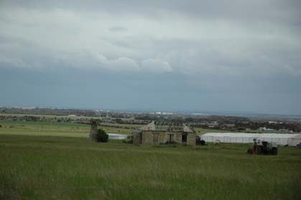Site 03 60 Branch Road, Lara

Ruins

See Heritage Citation. Recommended for Victorian
Heritage Inventory only.

References

Heritage Significance Citation Prepared Yes
Recommended for HO No

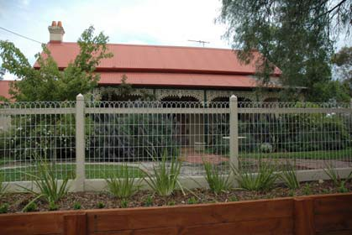Site 42 & 43 125 Buckingham Street, Lara Laurence Park Dwelling & Stables See Heritage Citation.

References

Heritage Significance Citation Prepared Yes
Recommended for HO Yes

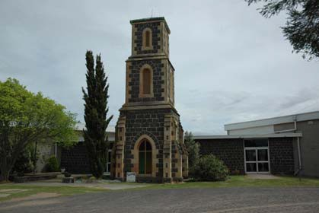Site 04 29 Curletts Road, Lara

Holy Trinity Church of England Tower & Lintel stone
See Heritage Citation.

References

Heritage Significance Citation Prepared Yes
Recommended for HO Yes

Cottage & Outbuilding

See Heritage Citation.

References

Heritage Significance Citation Prepared Yes
Recommended for HO Yes

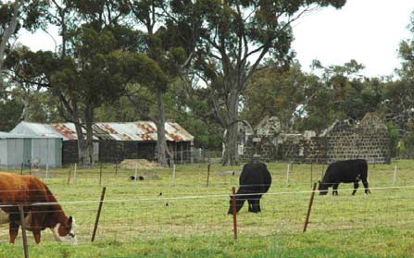Site 44 120 Duggans Lane, Lara

House & Outbuilding Ruins

See Heritage Citation.
Recommended for the Victorian Heritage Inventory.

References

Heritage Significance Citation Prepared Yes

Site 08 1B Flinders Avenue, Lara Pioneers' Memorial Cairn See Heritage Citation.

References
Recommended for HO No

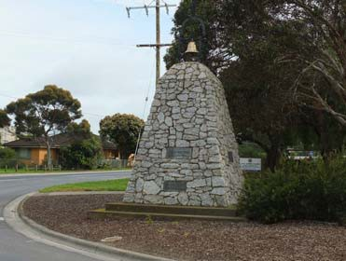Heritage Significance Citation Prepared Yes

Site 07 & 09 1B Flinders Avenue, Lara Lara Uniting Church Complex See Heritage Citation.

References
Recommended for HO Yes

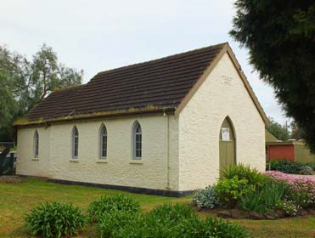Heritage Significance Citation Prepared Yes
Recommended for HO Yes

The Pines

See Heritage Citation.

References

Heritage Significance Citation Prepared Yes
Recommended for HO Yes

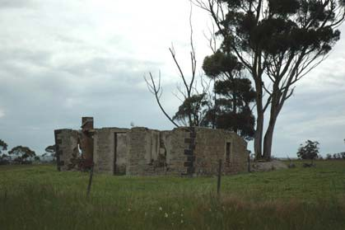Site 13 575 Flinders Avenue, Lara

Cottage Ruins

See Heritage Citation.
Recommended for Victorian Heritage Inventory Only.

References

Heritage Significance Citation Prepared Yes
Recommended for HO No

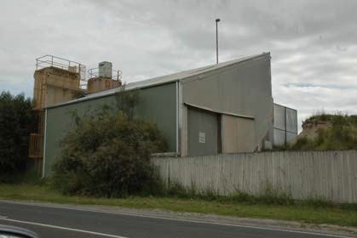Site 14 45 Forest Road North, Lara

Lara Lime Company

Historic interest only - first established in 1894-94 by James Spalding, the former Lara Lime Company is largely comprised of 20th century buildings today
(when viewed from the public realm).

References Spalding, The Lara Lime Company 1874-1974, Geelong Heritage Centre.

Heritage Significance Citation Prepared No

Site 18 031 Forest Road South, Lara

House

See Heritage Citation.

References
Recommended for HO No

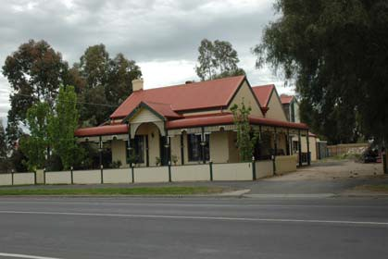Heritage Significance Citation Prepared Yes
Recommended for HO Yes

House

See Heritage Citation.

References

Heritage Significance Citation Prepared Yes
Recommended for HO Yes

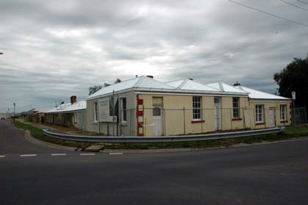Site 20 120 Forest Road South, Lara House (fmr Lake Bank Hotel) See Heritage Citation.

References

Heritage Significance Citation Prepared Yes
Recommended for HO Yes

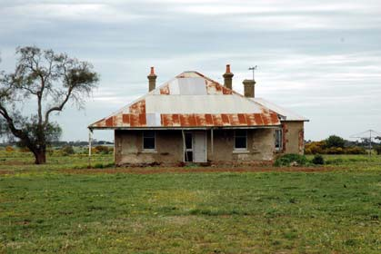Site 21 155 Forest Road South, Lara

Clover Hill Farm

See Heritage Citation.

References

Heritage Significance Citation Prepared Yes
Recommended for HO Yes

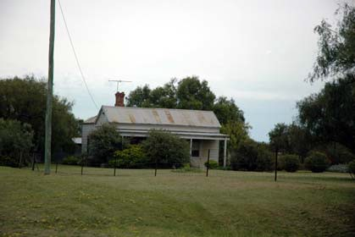Site 46 35 Gebbies Road, Lara

Cottage

Historical interest only. Cottage possibly built in c.1870s for J.E. Meyrick & extended at the front in the 1890s when owned by William
&/or Hezekiah Foot. The wall cladding, front door & verandah posts
have been introduced. The cottage has low integrity. There appear to be no over-arching significant historical associations embodied in the
surviving early fabric.

References

Heritage Significance Citation Prepared No
Recommended for HO No

Cottage complex

See Heritage Citation.

References

Heritage Significance Citation Prepared Yes
Recommended for HO Yes

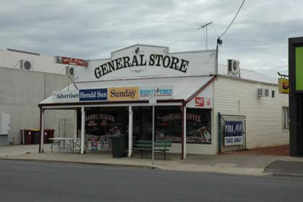Site 22 14 Hicks Street, Lara

Lara General Store

Historic interest only - built in c.1918 by the Spalding brothers & first leased to Rupert Gillett, hairdresser. The roof cladding, metal wall cladding
& aluminium framed shopfront windows and doors have been introduced (with central ingo removed). The building therefore has low integrity although it is a rare surviving commercial building in Lara.

References Corio Shire Books,1918, 1919-20, 1921-22, 1922-23. Mathieson, ‘My Reflections on 77
Years in Lara’, pp.35-36, Budd, Delaney & Grainger, From Duckponds to Lara.

Heritage Significance Citation Prepared No

Site 24 30 Hicks Street, Lara House & Dairy Outbuilding See Heritage Citation.

References

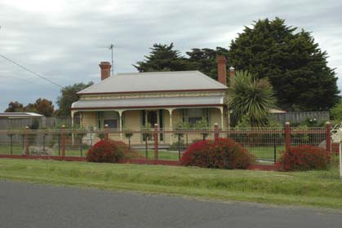Recommended for HO No

Heritage Significance Citation Prepared Yes

Site 49 24 Patullos Road, Lara

Cottage

Historic interest only - possibly constructed in the
1870s, the dwelling was relocated to this site by A.J. Spalding in c.1920-21. The integrity has been
diminished by the loss of the front verandah.
Recommended for HO Yes

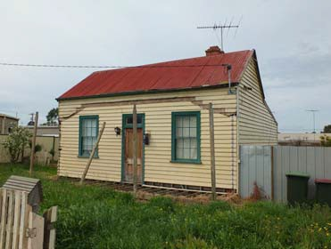References Shire of Corio Rate Books, 1919-20, 1920-21, 1921-22, 1926-27, Geelong Heritage
Centre. Interview by Darcy Seller with Reg Spalding, Lara, November, 1999.

Heritage Significance Citation Prepared No

Recommended for HO No

Historic interest only - the Edwardian dwelling was built in c.1905 for A.J. Spalding. Since 2000, a garage has been constructed at the side and additions built at the rear. There appear to be no over-arching significant
historical associations.

References Shire of Corio Rate Books, 1895, 1900, 1904-05, 1908-09, Geelong Heritage Centre, A.W. Mathieson, My Reflections on 77 Years in Lara, p.32.

Heritage Significance Citation Prepared No

Site 52 295 Patullos Road, Lara

Lochnoben

See Heritage Citation.

References

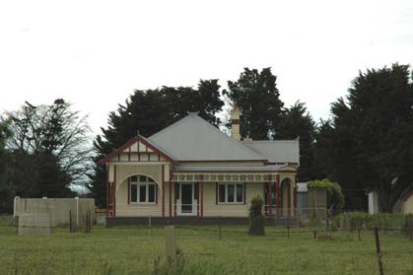Recommended for HO No

Heritage Significance Citation Prepared Yes
Recommended for HO Yes

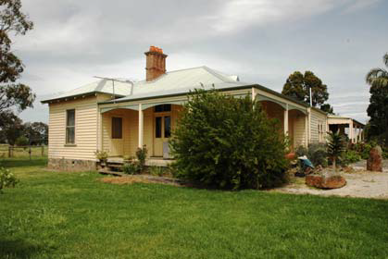Site 26 170 Peak School Road, Lara

Tallaranie Homestead

See Heritage Citation.

References

Heritage Significance Citation Prepared Yes
Recommended for HO Yes

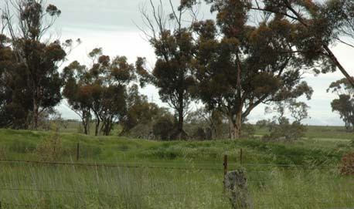Site 25 270 Peak School Road, Lara

Dairy Ruin

See Heritage Citation.
Recommended for Victorian Heritage Inventory only.

References

Heritage Significance Citation Prepared Yes
Recommended for HO No

Historical interest only - dwelling appears to have been built c.1910 and relocated to existing site in 1936 for the
Corio Shire. From the front, the Edwardian roof forms,
windows and verandah are intact, although the overall three dimensional integrity has been diminished recently
with rear additions. There appear to be no over-arching
significant historical associations.

References Shire of Corio Rate Books, 1933-34, 1936, 1945, 1954, 1957, Geelong Heritage Centre.
Sands & McDougall’s Directory of Victoria, 1934, 1956.

Heritage Significance Citation Prepared No

Site 28 8 Rennie Street, Lara

House

See Heritage Citation.

References

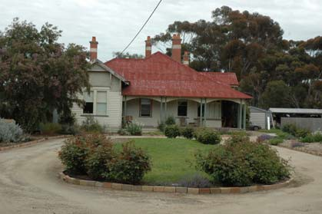Recommended for HO No

Heritage Significance Citation Prepared Yes
Recommended for HO Yes

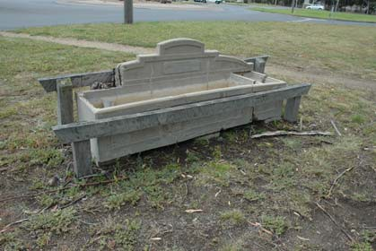Site 56 Cnr Walker & Rennie Streets, Lara

Bills Trough

See Heritage Citation.

References

Heritage Significance Citation Prepared Yes
Recommended for HO Yes

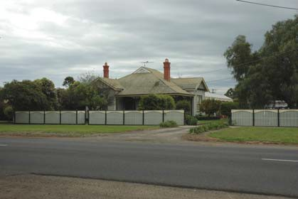Site 33 14 Walkers Road, Lara

Waverley

See Heritage Citation.

References

Heritage Significance Citation Prepared Yes
Recommended for HO Yes

Avenues of Honour, Cypresses &
Memorial Gates & Fencing

See Heritage Citation for WW1 and WW2 Avenues of
Honour and Lara & District War Memorial Gates.

References

Heritage Significance Citation Prepared Yes
Recommended for HO Yes

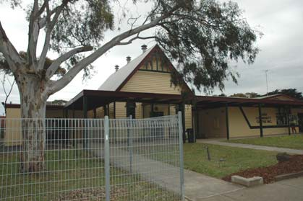Site 34 11 Waverley Road, Lara

Lara Community Centre (former Pres. Church)
See Heritage Citation.

References

Heritage Significance Citation Prepared Yes
Recommended for HO Yes

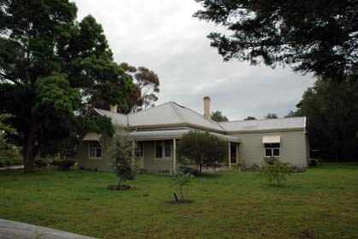Site 35 10 Windermere Road, Lara

Glenoe

See Heritage Citation.

References

Heritage Significance Citation Prepared Yes
Recommended for HO Yes

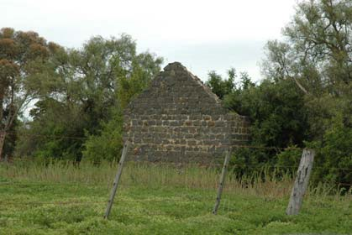Site 40 370 Windermere Road, Lara

Ruins

See Heritage Citation.
Recommended for the Victorian Heritage Inventory.

References

Heritage Significance Citation Prepared Yes
Recommended for HO No

Former Duck Ponds Parsonage &
School

See Heritage Citation.

References

Heritage Significance Citation Prepared Yes

Site 53 75 Staceys Road, Lovely Banks

Kia Ora

See Heritage Citation.

References
Recommended for HO Yes

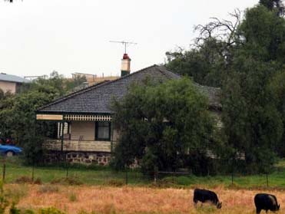Heritage Significance Citation Prepared Yes
Recommended for HO Yes

Lara Heritage Review Phase 2. Draft. February 2013 Appendices

6.04 VPP Practice Note: Applying the Heritage Overlay

Dr David Rowe: Authentic He ritage Services Pty Ltd & We ndy Jacobs: Architect & Heritage Consulta nt

Practice Note | 01
Revised September 2012

Applying the
Heritage Overlay

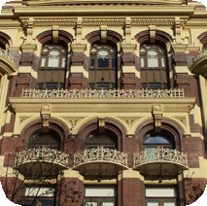This practice note provides guidance about the use of the Heritage Overlay.

What places should be included in the Heritage Overlay?
• Any place that has been listed on the Australian Heritage Council’s now closed Register of the National Estate.
• Any place that has been referred by the
Heritage Council for consideration for
an amendment to the planning scheme.

• Places listed on the National Trust Register of the National Trust of Australia (Victoria), provided the significance of the place can be shown to justify the application of the overlay.
• Places identified in a local heritage study, provided the significance of the place can be shown to justify the application of the overlay.
Places listed on the former Register of the National Estate or on the National Trust Register of the National Trust of Australia (Victoria) do not have statutory protection unless they are protected in the planning scheme.
The heritage process leading to the identification of the place needs to clearly justify the significance of the place as
a basis for its inclusion in the Heritage
Overlay. The documentation for each place
shall include a statement of significance that clearly establishes the importance of the place and addresses the heritage criteria.

What are recognised heritage criteria?
The following recognised heritage criteria shall be used for the assessment of the heritage values of the heritage place. These model criteria have been broadly adopted by heritage jurisdictions across Australia and should be used for all new heritage assessment work.

Criterion A: Importance to the course or pattern of our cultural or natural history (historical significance).

Criterion B: Possession of uncommon rare or endangered aspects of our cultural or natural history (rarity).

Criterion C: Potential to yield information that will contribute to an understanding of our cultural or natural history (research potential).

Criterion D: Importance in demonstrating the principal characteristics of a class of cultural or natural places or environments (representativeness).

Criterion E: Importance in exhibiting particular aesthetic characteristics (aesthetic significance).

Criterion F: Importance in demonstrating a high degree of creative or technical achievement at a particular period (technical significance).

Criterion G: Strong or special association with a particular community or cultural group for social, cultural or spiritual reasons. This includes the significance of a place to Indigenous peoples as part of their continuing and developing cultural traditions (social significance).

Criterion H: Special association with the life or works of a person, or group of persons,
of importance in our history (associative
significance).

The adoption of the above criteria does not diminish heritage assessment work undertaken before 2012 using older versions of criteria.

The thresholds to be applied in the assessment
of significance shall be ‘State Significance’ and
‘Local Significance’. ‘Local Significance’ includes those places that are important to a particular community or locality. Letter gradings (for example, “A’, “B’, “C’) should not be used.

In order to apply a threshold, some comparative analysis will be required to substantiate the significance of each place. The comparative analysis should draw on other similar places within the study area, including those that have previously been included in a heritage register or overlay. Places identified to be of potential State significance should undergo limited analysis on a broader (Statewide) comparative basis.

Places of significance for historical
or social reasons
Planning is about managing the environment and changes to it. An appropriate test for a potential heritage place to pass in order to apply the Heritage Overlay is that it has ‘something’ to be managed. This ‘something’ is usually tangible but it may, for example, be an absence of built form or the presence of some other special characteristic. If such things are present, there will be something to manage and the Heritage Overlay may be applied. If not, a commemorative plaque is an appropriate way of signifying the importance of
the place to the local community.
Group, thematic and serial listings Places that share a common history and/or significance but which do not adjoin each other or form a geographical grouping may be considered for treatment as a single heritage place. Each place that forms part of the group might share a common statement of significance; a single entry in the Heritage Overlay Schedule and a single Heritage Overlay number.

This approach has been taken to the listing of Chicory Kilns on Phillip Island in the Bass Coast Planning Scheme. The kilns are dispersed across the island but share a common significance.
Group listing of the kilns also draws attention to the fact that the kilns are not just important on an individual basis, but are collectively significant as a group.

The group approach has also been used for the former Rosella Factory Complex in the Yarra Planning Scheme. This important factory complex had become fragmented through replacement development making it hard to justify a precinct listing. The group listing, with a single Heritage Overlay number, has meant that the extent
and significance of the complex can still be
appreciated.

Writing statements of significance For every heritage place (that is, a precinct or individual place) a statement of significance should be prepared using the three-part format of
‘What is significant?’; ‘How is it significant?’ and
‘Why is it significant?’.

What is significant? - This section should be brief, usually no more than one paragraph or a series of dot points. There should be no doubt about the elements of the place that are under discussion. The paragraph should identify features or elements that are significant about the place, for example, house, outbuildings, garden, plantings, ruins, archaeological sites, interiors as
a guide to future decision makers. Mention could
also be made of elements that are not significant.

How is it significant? - A sentence should be included to the effect that the place is important because of its historical significance, its rarity,
its research potential, its representativeness, its

aesthetic significance, its technical significance and/or its associative significance. These descriptors are shown in brackets at the end of the heritage criteria listed above. The sentence should indicate the threshold for which the place is considered important.

Why is it significant? - This should elaborate on
the criteria that makes the place significant.
A separate point or paragraph should be used
for each criterion satisfied. The relevant criterion should be inserted in brackets after each point or paragraph. Each point or paragraph may include the threshold for which the place is considered important.

Saving and displaying statements of
significance
All statements of significance should be securely stored in the Department of Planning and Community Development’s HERMES heritage database.

Where a place (either a precinct or individual place) is included in the Heritage Overlay, the statement of significance for that place should be publicly viewable through the Department of
Planning and Community Development’s Victorian
Heritage Database.

Additional resources may be required When introducing the Heritage Overlay, a council should consider the resources required to administer the heritage controls and to provide assistance and advice to affected property
owners. This might include providing community
access to a heritage adviser or other technical or
financial assistance.

Drafting the Heritage Overlay schedule
What is a heritage place?
A heritage place could include a site, area, building, group of buildings, structure, archaeological site, tree, garden, geological formation, fossil site, habitat or other place of natural or cultural significance and its associated land. It cannot include movable or portable objects such as machinery within a factory or furniture within a house.
What is the planning scheme map reference number?
In column one of the schedule, the Planning Scheme Map Reference prefix should read HO1, HO2, HO3 and so on. Each heritage place in the schedule will have its own identifying number. The planning scheme maps should also record these numbers as a cross reference between the maps and the schedule.

Street numbers and location descriptions
Street numbers and locality addresses should be included for properties wherever possible. Where a street address is not available, plan of subdivision details (for example, Lot 1 of PS12345) should be used. Avoid using Crown Allotment details, Certificate of Title details or obscure location descriptions if possible.

How should the Heritage Overlay schedule be arranged?
There are two preferred options for arranging the schedule. Heritage places may be grouped according to their suburb, town or location and then arranged alphabetically by street address within each grouping. Alternatively, all places may be listed alphabetically by their street address irrespective of their location. Use the method which most assists users of the planning scheme to find the relevant property by a simple search through the schedule.

Applying external painting controls External painting controls over particular heritage places can be applied in the schedule by including a ‘yes’ in the External Paint Controls Apply? column.

Applying internal alterations controls Internal alteration controls over specified buildings can be applied in the schedule by including a ‘yes’ in the Internal Alteration Controls Apply? column. This provision should be applied sparingly and
on a selective basis to special interiors of high
significance. The statement of significance for the heritage place should explain what is significant about the interior and why it is important.

Applying tree controls
The schedule can apply tree controls over heritage places. The tree controls could apply to

the whole of a heritage place (for example, over a house site or an area) or a tree or group of trees could be specifically nominated as the heritage place. Tree controls are applied by including a
‘yes’ in the Tree Controls Apply? column.

The control is designed to protect trees that are of intrinsic significance (such as trees that are included on the National Trust Register or trees that contribute to the significance of a heritage place (for example, trees that contribute to the significance of a garden or area). The control is not meant to protect trees for their amenity value. See Practice note 7 – Vegetation Protection in Urban Areas for alternative methods of vegetation protection.

How should places on the Victorian Heritage Register be treated in the schedule?
Under Clause 43.01-3, places on the Victorian Heritage Register are subject to the requirements of the Heritage Act 1995 and not the planning provisions of the Heritage Overlay. Places
included on the Victorian Heritage Register should be listed in the schedule.

A dash should be recorded in columns three (external paint controls), four (internal alteration controls), five (tree controls) and six (outbuildings and fences) to avoid any possible confusion as
to whether planning provisions apply to these properties. In column seven (‘Included on the Victorian Heritage Register ...’) the reference number of the property on the Victorian Heritage Register should be included as an aid to users of the planning scheme.

Allowing a prohibited use of a heritage place
It is possible to make a prohibited use permissible at specific places by including a ‘yes’ in the Prohibited uses may be permitted? column.

This provision should not be applied to significant areas because it might result in the de facto rezoning of a large area. The provision should only be applied to specific places. For example, the provision might be used for a redundant church, warehouse or other large building complex where it is considered that the normally
available range of permissible uses is insufficient to provide for the future conservation of the building. Currently this provision applies in the metropolitan area of Melbourne to places that are included on the Victorian Heritage Register.

Aboriginal heritage places
Scarred trees, stone arrangements and other places significant for their Aboriginal associations can be identified by including a ‘yes’ in the Aboriginal Heritage Place? column. As with
any place listed in the Schedule to the Heritage Overlay, supporting justification is expected to apply this provision.

The standard permit requirements of Clause
43.01-1 of the Heritage Overlay apply to Aboriginal heritage places included in the schedule. Clause 43.01-6 reminds a responsible authority that the requirements of the Aboriginal Heritage Act 2006 apply to these places.

How are heritage precincts and areas treated?
Significant precincts and areas should be identified
in the schedule as well as being mapped.

How are individual buildings, trees or properties of significance located within significant areas treated?
The provisions applying to individual buildings and structures are the same as the provisions applying to areas, so there is no need to separately schedule and map a significant building, feature or property located within a significant area.

The only instance where an individual property within a significant area should be scheduled and mapped is where it is proposed that a different requirement should apply. For example, external painting controls may be justified for an individual building of significance but not over the heritage precinct surrounding the building.

Alternatively, tree controls may be justified for a specific tree or property within a significant precinct but not over the whole precinct. In such situations the individual property or tree should be both scheduled and mapped.

Significant buildings or structures within a significant precinct can be identified through a local planning policy.

How is a building, tree or feature on a large parcel of land listed and mapped?
The Heritage Overlay applies to both the listed heritage item and its associated land (refer Clause
43.01 - Scope). It is usually important to include land surrounding a building, structure, tree or feature of importance to ensure that any new development does not adversely affect the setting or context of the significant feature. In most situations, the extent of the provision will be the whole of the property (for example, a suburban dwelling and its allotment).

However, there will be occasions when the area to which the provision applies should be reduced so that it does not apply to the whole of the property. Examples might include:

• a homestead on a large pastoral property where only the buildings and their immediate surroundings are important but not the remainder of the property
• a significant specimen tree on an otherwise
unimportant property

• a horse-trough, fountain or monument in a road reservation
• a grandstand or shelter in a large but otherwise unimportant public park.
Where a heritage place does not encompass the whole of the property, care should be taken to accurately show the area to which the provision applies. For instance, if a homestead is affected by the Heritage Overlay but not the whole of the farm, a polygon should be allocated to the area
of affected buildings and associated land. The wording to describe the Heritage Place in the schedule should be specific to identify the area covered by the overlay. (See the example of Heritage Place HO4 in the attached schedule.)

Mapping Heritage places
All heritage places must be both scheduled and mapped.

In each case, care should be taken to ensure that there is an accurate correlation between
the Heritage Overlay schedule and the Heritage
Overlay map.

If there is a discrepancy between the schedule and the map, the description of the place given in the schedule to the Heritage Overlay, supported by the statement of significance, should be the predominant means of identifying the areas to which the overlay applies.

ISBN 978-1-921940-58-3

Published by the Victorian Government Department of Planning and Community Development Melbourne, September 2012.
© The State of Victoria Department of Planning and Community Development 2012.

This publication is copyright. No part may be reproduced by any process except in accordance with the provisions of the Copyright Act 1968. Authorised by the Victorian Government, 1 Spring Street, Melbourne.
This publication may be of assistance to you but the State of Victoria and its employees do not guarantee that the publication is without flaw of any kind or is wholly appropriate for your particular purposes and therefore disclaims all liability for any error, loss or other consequence which may arise from you relying on any information in this publication.

www.dpcd.vic.gov.au/planning


Practice Note 1 | Applying the Heritage Overlay
6

Schedule to the Heritage Overlay
The requirements of this overlay apply to both the heritage place and its associated land.

PS Map Ref | Heritage Place | External Paint  Controls Apply? | Internal Alteration Tree Controls  Controls Apply? Apply? |  | Outbuildings or fences which are Not exempt under Clause 43.01-3? | Included on the Victorian Heritage Register under  the Heritage Act  1995? | Prohibited uses may be permitted? | Name of Incorporated Plan under Clause  43.01-2
HO1 | House  1 Albert Street, Belmont | Yes | No | No | No | No | No
HO2 | Athol House  57 Albert Street, Belmont | - | - | - | - | - | Yes
HO3 | Jones Foundry  4 William Street, Breakwater |  | Yes | No | No | No | No
HO4 | Moreton Bay Fig Tree  26 Bryant Street, Ceres  The heritage place is the Moreton Bay Fig Tree and land beneath the canopy edge of the tree for a distance of five metres from the canopy edge. | No | No | Yes | No | No | No
HO5 | House  13 Albert Street, Geelong | Yes | No | No | Yes | No | No
HO6 | Bay Villa  122 Middle Street, Geelong | Yes | Yes | No | No | No | No
HO7 | Barwon River Bridge  Station Street, Geelong | - | - | - | - | Yes  Ref No H789 | No
HO8 | William Street Precinct  William Street, Geelong | Yes | No | No | No | No | No
HO9 | Mount Rothwell Stone Arrangement  Mount Rothwell Station  Little River-Ripley, Little River | No | No | No | No | No | No

