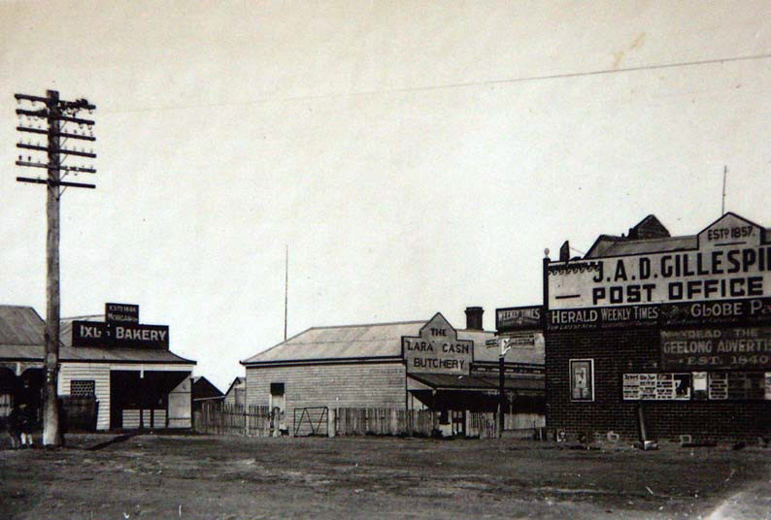Draft Document

Thematic Environmental History

Volume 2

Dr David Rowe, Authentic Heritage Services Pty Ltd
&
Wendy Jacobs, Architect & Heritage Consultant

February 2013

THEMATIC ENVIRONMENTAL HISTORY

Volume 2 (Draft Document)
Commissioned & Funded by

City of Greater Geelong

Author:
Dr David Rowe

Consultants:
Dr David Rowe, Authentic Heritage Services Pty Ltd
&
Wendy Jacobs, Architect & Heritage Consultant

Historical Research
Pam Jennings: Authentic Heritage Services Pty Ltd

February 2013

Cover Photo: Shops at the intersection of Forest Road South and Patullos Road, c.1925. Source: Holmes collection c/o David Rowe.

TABLE OF CONTENTS

THEME 1
1.0 Shaping the Environment of the Lara Region
1.1 Existing Natural Environment 1
1.2 Natural Lara Environment 2
1.3 Living with Natural Processes 3

THEME 2
2.0 Arrival & Settlement
2.1 The Wathaurung Community 7
2.2 Exploring, Surveying & Mapping 8
2.3 Promoting Settlement 10

THEME 3
3.0 Transport & Communications
3.1 Establishing Early Roads 14
3.2 Building Early Bridges 14
3.3 Geelong to Melbourne Railway 15
3.4 Avalon Airport 15
3.5 Establishing & Maintaining Communications 16

THEME 4
4.0 Transforming & Managing Land & Natural Resources
4.1 Farming & Agriculture 18
4.2 United Farmers’ Common of Little River & Duck Ponds 21
4.3 Lime Burning 21
4.4 Water Supplies 24
4.5 Forestry: The Timber Reserve 25

THEME 5
5.0 Building the Lara’s Industries, Workforce & Entertainment Venues
5.1 Manufacturing from the Land 28
5.2 Dairy Production 30
5.3 Other Industries 31
5.4 Commerce 31
5.5 Entertaining & Socialising 33

THEME 6
6.0 Building the Lara Region
6.1 The Towns 38
6.2 Building Homes in the Lara Area 40

THEME 7
7.0 Governing the Lara area
7.1 Local Government: Corio Shire 50
7.2 Law & Order 52
7.3 Defence 54

THEME 8
8.0 Building Community Life
8.1 Spiritual life 58
8.2 Education 61
8.3 Health & Welfare 63
8.4 Community Organisations 65
8.5 Commemoration 68

THEME 9
9.0 Sport & Recreation
9.1 Sport 75
9.2 Recreation 77

THEME 10
10.0 Bibliography 80

THEME 11
11.0 Appendices 85
11.1 Enlarged Version of Historical Figures
11.2 Victoria’s Framework of Historical Themes

Introduction
The City of Greater Geelong commissioned Dr David Rowe Authentic Heritage Services Pty Ltd and Wendy
Jacobs, Architect and Heritage Consultant, to undertake Phase 2 of the Lara Heritage Review in October
2012. Although not part of the Project Brief, this Thematic History of the Lara area has been prepared to provide an historical and contextual basis to the Review. Some information is an adaptation and expansion
of the Environmental History prepared by the late Ian Wynd for Authentic Heritage Services Pty Ltd as part of the Greater Geelong Outer Areas Heritage Study Stage 2 in 1998‐2000, although substantially more research and historical analysis has been carried out as part of the preparation of this Thematic History.

The Thematic History is based on Victoria’s Framework of Historical Themes published by the Heritage Council of Victoria in February 2010 (see Appendix 11.02), although it has been tailored to accord with the specific history and themes within Lara. The Environmental History therefore:

• Outlines the key historic themes relevant to Lara.

• Provides information about some of the key places of significance in Lara under the relevant historic themes. These themes are illustrated with photographs, maps and plans where possible.

• Provides a context for comparative analysis of individual heritage places assessed in the Lara
Heritage Review Phase 2.

The Thematic History is not a definitive history of the Lara area. Rather, there is an emphasis on historic themes relevant to existing fabric which in turn helped to establish Lara’s physical heritage. Consequently, there is a concentration of Lara’s history between the mid 19th century and World War Two of the 1940s. However, historical associations of overriding important to the Lara area are outlined.

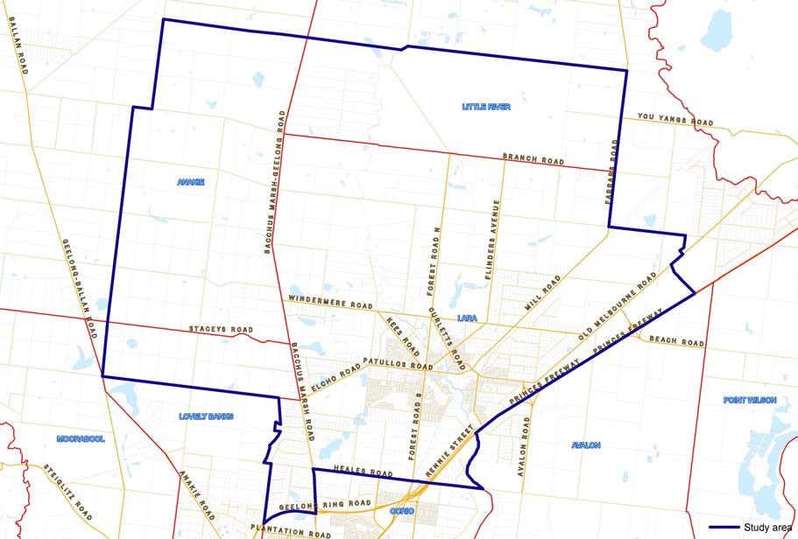The study area comprises the Lara region as shown below.

Source: City of Greater Geelong.

1. Shaping the Environment of the Lara Region
1.1 Existing Natural Environment
Boundaries of the Lara Region, Population and Topography1
Lara (earlier known as Duck Ponds) is a residential suburb in the City of
Greater Geelong covering an area of 14.5 square kilometres. It is situated
15 km north‐east of the city of Geelong and in 2011 it had a population of
13,846 people. There were also 5,002 private dwellings.

While the central area of Lara is largely suburban residential, the outlying areas reflect its original rural character. The open, grassed plains are dominated by the You Yangs to the north, being granite peaks that rise dramatically to a height of 352 m and form a visible landmark across most parts of Geelong. Traversing the Lara region is Hovells Creek. It runs to Limeburners Bay, being an inlet of Corio Bay, to the south‐east of the area.

Geology
The geology of the area comprises the rich clay soils giving opportunity for the broad plains of grassland vegetation and the landmark granite You Yangs. Trevor Pescott in The You Yangs Range gives an overview:

The You Yangs were never volcanic, the granite having been formed by the solidification of molten rock or magma deep beneath the surface of the ground. That magma may have moved into ancient, long extinct volcanic vents that remained from earlier ages is possible, although for much of the Cambrian period (500 million years ago) and into the Silurian (450 million years ago), Victoria was beneath a deep sea.

But volcanoes have had a marked impact on the You Yangs range, for lava from their eruptions has helped shape the nature of the land around the granite outcrops …

… Basaltic lava also flowed from (the Mt Anakie and Three Sisters volcanoes), covering land to the east and south, pushing Hovells Creek eastward against the granite deposits of the You Yangs.2

The monolithic granite outcrops of the You Yangs Range formed the scene of many romantic images published in the 19th century. Several images were included in the Illustrated Australian News in the 1880s. They were described in 1888 in Victoria and Its Metropolis as follows:

The [Geelong] district consists for the most part of extensive open plains, diversified with rolling downs and not very lofty hills and plateaus. The principal exceptions are the Barrabool hills, a range which lies to the S.W. of Geelong, and is mostly taken up for farming purposes, and the Anakies, or familiarly, the You Yangs, consisting of the Anyaghe Youang (meaning twin hills) and the Wurdi Youang (big hill). … The southern termination of the group is the Wurdi Youang (Station Peak), the culminating peak, which attains an altitude of 1154 feet. This peak is detached, and has a base of something like a square mile in extent, beside which the greatest of the Egyptian pyramids would seem a pigmy.
… The Wurdi‐Youang consists of coarse‐grained granite, with large
crystals of feldspar, susceptible of high polish, and deposits of kaolin have been found on the flanks of the mountain. At the base of this

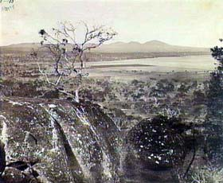
Figure 1.01: R. Daintree, View looking east from The Granites to
the You Yangs, c.1861. Daintree was an English‐born geologist who came to Melbourne in 1852. Source: La Trobe Picture collection, State
Library of Victoria, image b47482 & Pescott, The You Yangs, p.24.

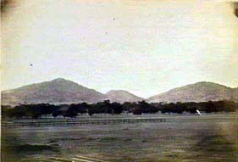
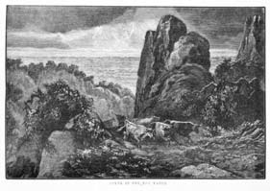Figure 1.02: E.W.E. De Balk, Lara Plains and the You Yangs, 1866. Source: La Trobe Picture Collection, State Library of Victoria, accession H87.251.

Figure 1.03: Scene in the You Yangs,
Illustrated Australian News, 2
September 1885. Source: La Trobe Picture Collection, State Library of Victoria, image mp005364.

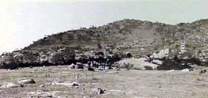
Figure 1.04: You Yangs, n.d.
Source: La Trobe Picture Collection, State Library of Victoria, image a15035.

range are enormous masses of granite. One huge rock at the western extremity is supposed to be 1000 feet in circumference and about 100 feet in height. At a rough estimate it must contain 4,000,000 cubic feet and weigh about 300,000 tons.3

Critical to the success of Lara in the 19th century was lime burning (details of the industry are given in Theme 4). The locally ubiquitous limestone deposits have their origins in the geology of the area, as outlined by Neville Rosengren:

The river cliffs on the north side of Hovells Creek, and a small disused quarry west of the railway line, expose sections of the crystalline Lara Limestone. This freshwater limestone was deposited over the Newer Volcanics, in lakes that formed from the damming of streams by the newly erupted lavas. The lakes have since drained and Hovells Creek has incised a
valley exposing the limestone and underlying sediments.4

1.2 Natural Lara Environment
The natural environment of the Lara region changed substantially with
the onset of European settlement from the 1840s, and particularly after closer settlement and the establishment of the village of Lara from the
1850s. The causes and effects of these changes are given in Theme 4. Perceptions of the largely untouched environment can be traced through documentary evidence: through the diaries and stories of the early explorers, settlers and surveyors; and through survey and parish maps and plans.

As early as 1802, Matthew Flinders observed the broad sweep of the western plains from the top of the You Yangs as ‘low, grassy and very slightly covered with wood, presenting great facility to a traveller desirous of penetrating inland.’5 It was at this time when he named the You Yangs Station Peak. In 1803, another expedition party led by Charles Grimes traversed the Lara region. An account of the Grimes exploration was given by James Flemming, ‘whose task it was to comment on the nature of the soil and vegetation.’6 A map of Grimes’ exploration described the area:

Swampy near the shore, grassy plains back to the foot of the mountains
[You Yangs], the soil very bad and stony, no timber.7

Such a negative critique of the Lara landscape was contradicted by Hume and Hovell in 1824 which described the area between the Little River and Hovells Creek as follows:

… the soil, generally speaking, is everywhere good. I have seen none bad, but I have seen some (I do not speak of a few acres, but of large spaces) equal to the best of any land, and the grass and herbage denotes it. Notwithstanding, it is dried and parched by the long drought which has shrivelled up the leaves, it is generally of a fine silky nature, and in
places is intermixed with the long forest grass.8

Eleven years later in 1835, John Helder Wedge gave a description of the Lara plains and You Yangs, as paraphrased by Ian Wynd in So Fine a Country:

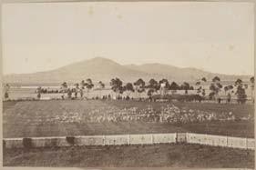
Figure 1.05: F. Kruger, You Yangs and Lara plains, 1866. Source: La Trobe Picture collection, State Library of Victoria, accession H488.

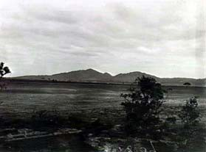
Figure 1.06: J. Lockwood Studios, You Yangs and Lara plains, 4 May
1933. Source: La Trobe Picture collection, State Library of Victoria, image b52749.

Wedge continued on towards the You Yangs … The open plains he describes as “quite destitute of timber, and covered with grass, but not of that luxuriance that I should have expected from the soil.” The low hills running up to the You Yangs were thinly timbered, the soil light and sandy and the grass more luxuriant than on the plains.

Wedge’s survey led to the production of the Map of Port Phillip in 1836 and it described Station Peak as Mount Vilumnata.9 The name, Station Peak, was however adopted until it was changed to Flinders Peak in honour of the original explorer, Matthew Flinders.

Such descriptions continued in ensuing years, including A.J. Skene’s Map of the Country Lands in the Parish of Lara in 1855. He stated that:

The entire Survey may be described as grazing country of first quality that to the westward of the Duck Ponds [Hovells Creek] is almost destitute of timber, to the eastward the country is well wooded.

The Map showed that the “well wooded” land was a ‘Forest of Gum, She‐ Oak and Honeysuckle’ with indifferent soil. The southern portion of the plan gave the location of open plains, sandy soil, with some parts
‘producing rich pasture’ and others being ‘good grazing land.’

Hovells Creek – also known as Duck Ponds – was an ephemeral stream and earliest recognised as a chain of water holes.10 It appears that some of these were fed by underground aquifers or springs. In the southern portion of the Lara region, adjacent to the village settlement, was Lara Lake, 39.5 acres of fresh water as shown in J.E. Bates’ Plan for the Village of Lara in 1853.

1.3 Living with Natural Processes
Being a rural area, Lara has experienced a number of natural hardships, including drought, bushfires and floods. Throughout the 19th and early
20th centuries, these natural processes impacted on the local community socially, economically and emotionally. A notable proportion of the
region’s original and early built heritage has also succumbed to these natural processes.

Droughts
Throughout the 19th and 20th centuries, Lara’s dry plains have witnessed
several droughts. The area is situated in the Otway Ranges’ ‘rain shadow’, forming one of the driest regions in south Victoria.11

One of the earliest‐recorded droughts occurred during the fledgling years of Lara’s settlement in 1869. With a lack of a reliable water supply, cattle and sheep grazing and the growing of crops was halted with devastating consequences. The Bacchus Marsh Express reported on instructions of the Corio Shire Council ‘to burn or bury all carcases found’ with ‘many of the cattle having died of starvation.’12 Squatters and farmers looked to sell or temporarily relocate their stock, as reported in The Bacchus Marsh Express:

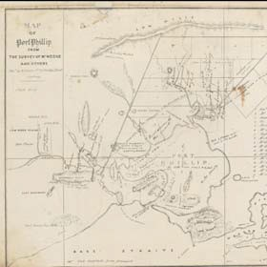
Figure 1.07: J.H. Wedge, Map of Port Phillip, 1836. Source: National Library of Australia online, MAP RM3595. See Appendix 11.01 for enlarged image.

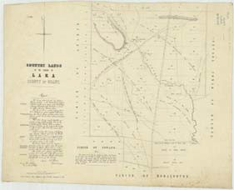
Figure 1.08: A.J. Skene, Map of the
Country Lands in the Parish of Lara,
31 December 1856. Source: La Trobe Picture collection, State Library of Victoria. See Appendix
11.01 for enlarged image.

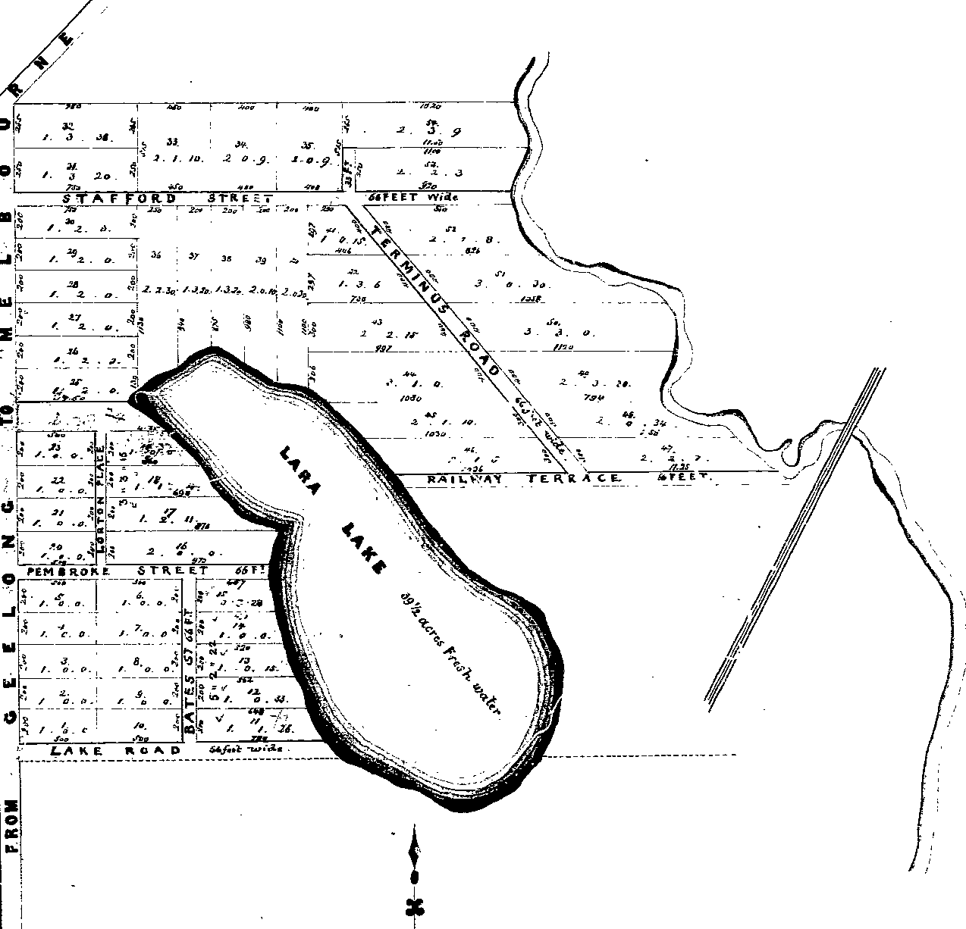
Figure 1.09: Portion of the Plan for the Village of Lara, 1853 showing Lara Lake. Source: Geelong Heritage Centre, Map 031. See Appendix
11.01 for enlarged image.

The Geelong correspondent of the Argus remarks that the drought of the present season is in some districts unprecedented. This is especially the case in the Duck Ponds and Little River districts; there is no grass left, and no water. The holders of stock are either disposing of them, or sending them to more favourable quarters. Mobs of from 50 to 100 cattle have been drafted almost daily from those districts for some time past, being purchased from small holders at from 20s. to 30s. each. In this emergency, a meeting of farmers was held at the Little River on Tuesday evening, to devise means to remedy the evil. It was resolved to appoint a deputation to proceed to the Cape Otway ranges to ascertain if land could there be found for grazing; the object being, if the search was successful, to apply to the Commissioner for a license to depasture, and to draft the cattle thither in charge of a herd, rather than dispose of them at the ruling prices. Mr. Armytage has drafted some 7,000 sheep to Winchelsea, and Mr. Bullivant a like number, it is said, to Westernport. On Mr. Chirnside’s estate on the Werribee there is nothing left but a few head of cattle and horses, the large flocks of sheep
having been drafted off.13

Bushfires
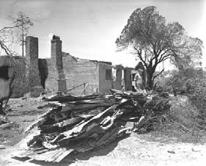Often a consequence of drought was bushfires. The forested areas
around the base of the You Yangs Range and the open grassed plains have provided fuel for fires with devastating consequences.

As early as 1840, the Geelong Advertiser reported on a bushfire in the area:

For several nights the bush around Station Peak has been continually on fire in several places. From the distance and distinctiveness the fires must be very extensive. By the day the sides of the mountains are enveloped in smoke.14

Eight years later in 1848, another bushfire occurred:

An extensive bush fire was raging through the whole of Thursday night along the line of the Yowangs. After sunfall, the appearance from Geelong was exceedingly grand and imposing. The origins of the fire has not been ascertained; but it is supposed to have been done by some of the wood‐cutters who are located on that side of the bay.15

On 9 January 1969, Lara witnessed its most disastrous bushfire. The devastation was considerable, with 18 lives lost, 43 homes burnt, 8,000 stock killed and over 12,000 hectares of farmland effected, as outlined by Peter Begg:

The holocaust, which at the time was coined “the Black Wednesday fires”, left an indelible impression on the people of Lara, which only now is starting to fade after 21 years. The town’s agony had its origins in the previous day. A fire started on Bacchus Marsh Road on the Tuesday, wiping out hundreds of hectares of grassland on the Wooloomanata sheep station. But, while firemen and volunteers working through the night appeared to have contained the fire, the hot north‐westerly wind the following morning rekindled the flames. This time, the fire was heading straight for Lara, and at 9 am, as the township was preparing to

Figure 1.10: Burnt Out Farmhouse,
1969. Source: National Library of
Australia, image A1200‐L79659.
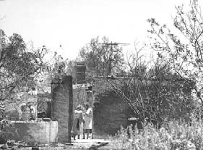
Figure 1.11: Burnt Out House, 1969. Source: National Library of Australia, image A1200‐19.
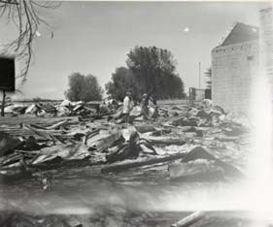
Figure 1.12: Burnt Out School Library, 1969. Source: National Library of Australia, image vn4589309‐v.

evacuate, the wind was gusting to 120 km/h. At first it was hoped that the wall of fire would miss Lara, but a wind change sent it tearing through the Lara Lake area. By 11 am, it was burning on a number of fronts before jumping the Princes Highway and continuing towards Port Phillip Bay. More than 500 men fought the blaze, but there was little they could do. … Apart from houses, the Lara Lake State School, the Church of England Holy Trinity Church, a Caltex service station on Princes Highway, and part of the Geelong and Cressy Trading Co’s bulk
grain storage depot were destroyed.16

Across Victoria, assistance was given to the Lara residents. An overview is provided in From Duck Ponds to Lara:

As a stunned township counted its losses, the spotlight shone onto Lara. Relief agencies began sending supplies and a public appeal was launched to help the homeless. Farms from around the state sent emergency fodder for stock and the local Red Cross Group was inundated with donations of clothing, bedding and goods to help those who had fled without the chance to save any possessions. Many victims of the fire later said that the only good that came from the fire was the kindness of
strangers who helped them as they struggled to cope.17

Snow
According to Trevor Pescott, the first recorded snow at Lara was on 30
August 1849.18 Another recording was in the winter of 1868 and again in
1872. An observer wrote at this time:

The whole of the flat land (around Geelong) was covered with a white crust, and the hills in the vicinity had snowy caps. The You Yangs were arrayed in white …19

In 1901, the Geelong Advertiser reported one of the heaviest snowfalls, with ‘The Anakie hills, You‐Yangs, Brisbane ranges, and the plain between the You‐Yangs and Anakies, in their white mantles, [having] presented a magnificent spectacle.’20

Floods
Although an ephemeral stream, during the 100 year period between 1889 and 1989 there have been 19 major flash floods from Hovells Creek, causing considerable damage to property and farms at Lara.21 One of the more significant flooding events occurred in 1973 when water flowed into
15 homes in the Flinders Avenue area.22 In Saintfield Street, nearly half a
metre of water surrounded the newly‐built homes, although only one of the houses was flooded.23

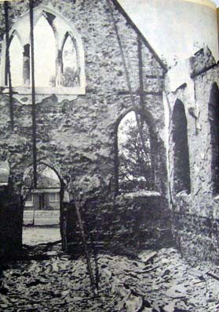
Figure 1.13: Interior of burnt out Holy Trinity Church, 1969. Source: Geelong News, 15 January 1969.

1 Information from ‘Lara, Victoria’ in Wikipedia, http://en.wikipedia.org/wiki/Lara,_Victoria#cite_note‐abs‐0 & Australian Bureau of Statistic Census online, 23 October 2012, http://www.censusdata.abs.gov.au/census_services/getproduct/census/2011/quickstat/SSC20771?opendocument&navpos
=220.
2 T. Pescott, The You Yangs Range, Yaugher Print, Belmont, 1995, p.10.
3 A. Sutherland, Victoria and Its Metropolis Past and Present, McCarron Bird & Co., Melbourne, 1888, CD edn., Archive CD Books Australia Pty Ltd, 2006, p.146.

4 N. Rosengren, Sites of Geological and Geomorphological Significance in the Western Region of Melbourne, 1986 referenced in ‘Victorian Resources Online: Werribee Plains’, http://vro.dpi.vic.gov.au/dpi/vro/portregn.nsf/pages/werribee_gg_significance_la2.
5 R. Peterson & D. Catrice, ‘Environmental History: Bacchus Marsh Heritage Study, prepared for the Bacchus Marsh Shire
Council & the Historic Buildings Council, 1995, p.13.
6 I. Wynd, So Fine a Country: A History of the Shire of Corio, Shire of Corio, 1981, p.2.
7 Ibid., p.5.
8 Ibid., p.13.
9 J.H. Wedge, Map of Port Phillip from the survey of Mr. Wedge & others, 1836, National Library of Australia online, MAP RM3595.
10 Pescott, op.cit., p.13.
11 ‘Lara, Victoria’, op.cit.
12 Bacchus Marsh Express newspaper, 10 January 1869.
13 Ibid., 9 January 1869.
14 Geelong Advertiser newspaper, 28 November 1840, Geelong Heritage Centre.
15 Ibid., 29 April 1848.
16 P. Begg (comp.), ‘Lara’s “Black Wednesday”’, Geelong – The First 150 Years, The Geelong Advertiser Pty Ltd, Geelong 1990.
17 M. Budd, C. Delaney, J. Grainger (eds.), From Duck Ponds to Lara: A Collection of Memories, Lara Heritage Festival Inc., Lara,
2004, p.95.
18 Pescott, op.cit., p.15.
19 Ibid.
20 Geelong Advertiser, 3 August 1901.
21 Budd, et.al., op.cit., p.109.
22 Ibid.
23 Ibid., pp.109‐110.

2. Arrival & Settlement
2.1 The Wathaurong Community
The original inhabitants of the area traversed by the explorers were members of the Wathaurong1 tribe of Aborigines, one of four tribes that formed the Kulin confederacy.2 Assistant Protector Sievwright, in his biannual report for March‐August 1839,3 described their tribal territory as follows:

The Wad‐dow‐ro or Barrabul tribe occupy the range of country from the coast, south of Geelong. This is their principal hunting ground upon Indented Head and the Balla River hills,4 from this they range to about twenty miles north of the River Barwon, where the Jay‐bourne5 falls into it and from the range of mountains called [Flinders Peak] Kurdi‐you‐yang6 on the N.N.E. to the River Barwon on the S.W. they are principally found on the banks of the Barwon.

Lou Lane7 indicates that their territory extended eastward to the Werribee River and northward towards Buninyong and states that they were divided into five or six clans whose territories were more limited. It seems likely that the You Yangs were inhabited by the Worinyaloke clan. Pescott claims that:

The Worinyaloke were people of a solid build and average height, the men close‐shaven, using mussel sheels to trim their beards, or singeing the hair with a smouldering fire‐stick. The women wore nose‐ring ornaments, the emu nose‐styles, and they used the skins of kangaroo, dingo, quoll and possum to make cloaks, the only item of clothing needed for warmth. More decorative were the women’s head‐bands made of fibrous bark or hair into which were woven small, bright feathers, and pendants decorated with feathers, shells and mammal teeth. Waist‐bands of human hair and possum fur were favoured by the men.

Red ochre and white kaolin were used to decorate their bodies at ceremonial times, or when the men fought with other clans or tribes as they did on occasions. Both ochre and kaolin were prized resources, particularly valuable in trade.

The lifestyle of the Worinyaloke was itineratnt, and they moved from one camp site to another to take advantage of the seasonal prevalence of food or to obtain protection from the extremes of the weather. Shelters of bark‐slabs or tree branches were built at favoured sites. The women had the responsibility of gathering the vegetable foods, and as soon as they could toddle, the children accompanied their mothers to learn the art of foraging in their own environment. The men hunted communally for fast game, ranging up to eight kilometres from camp, but they did not hunt
every day.8

The Wathaurong numbers were never very great. Dr. Alexander Thomson, who assembled them in December 1836 to distribute blankets, counted only 279 and was assured by William Buckley9 that the whole tribe was present. Captain Foster Fyans, the first police magistrate appointed to the area, repeated the exercise in September 1837 and counted 275. Pescott claims that the Worinyaloke clan probably numbered less than 50.10 In 1839, Sievwright estimated the numbers of all the Wathaurang had fallen to 260, 60 men, 80 women and 120

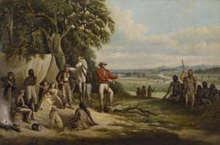
Figure 2.01: Frederick William Woodhouse, The first settlers discover William Buckley, oil painting, 1861. Source: La Trobe Picture Collection, State Library of Victoria, accession no. H26103, image no. mp010578.

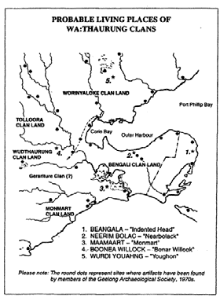
Figure 2.02: Aboriginal Living Places. Source: L. Lane, Investigator, vol.29, no.24. See Appendix 11.01 for enlarged image.

children.11 By 1854 the numbers had been reduced to double figures ‐ Thomson reckoned there were only 34 adults and two children under five. In 1885 the last survivor, Willem Baa:niip died in the Geelong Benevolent Asylum.

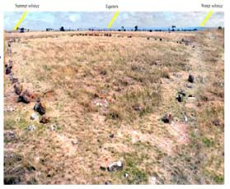While belligerent towards other tribes,12 the Wathaurong showed little animosity towards the European settlers. It was the latter, however, who had sought the appointment of Fyans to protect them from Aboriginal attack, but most of the incidents seem to have occurred further inland, giving credence to George Russell’s statement:

The natives that inhabited the country about Geelong were quieter in their habits and more easily reconciled to the white population than the tribes who inhabited the country more in the interior.13

In 1861, when the tribal numbers had been reduced to six males and one female, a reserve was set aside for them in Ghazepoore Road in the Duneed parish but with such low numbers the demise of the Wathaurong tribe was inevitable.

Today, archaeological evidence provides historical and cultural markers of the existence of the Wathaurong tribe. Native wells exist in the You Yangs; camp sites have been found on Wooloomanata station (located near the You Yangs), at the head of Hovells Creek, and along the Little River; and an ovoid stone arrangement north of the You Yangs, approximately 151 m in circumference that is believed to be an initiation and ceremonial site.14

2.2 Exploring, Surveying & Mapping
Explorations
As briefly outlined in Theme 1, the earliest European exploration15 of the
area was made by Matthew Flinders in 1802. He crossed Corio Bay and climbed the salient feature of the area, the You Yangs. From here he obtained a commanding view of the area and wrote that it was well suited to cattle “though better calculated for sheep” – a forecast that was later proved to be accurate. Monuments on the Melbourne Road and the You Yangs commemorate Flinders’ visit.

In the following year, 1803, Charles Grimes, acting surveyor‐general, was sent by Governor King to explore the Port Phillip area more thoroughly. Most of this exploration was by sea with only occasional forays ashore, one of which was on the north‐eastern shores of Corio Bay and led to Grimes recording on his map of the area that the soil was bad and stony. It was the same area that was investigated in October of 1803 by Lieutenant Tuckey of the Calcutta, one of the two vessels that had brought settlers and convicts to the abortive settlement at Sorrento. He made the first contact with the local Aborigines, the Wathaurong, a contact which tragically ended in confrontation and the death of one Aborigine. Tuckey was more complimentary than Grimes about the potential of the area, saying that it was the only spot in Port Phillip he had seen which “would answer for raising wheat or any other grain that requires moisture”.

Figure 2.03: ‘Wurdi Youang IP Investigation and Consultation Project’, information brochure, 11
December 2010.

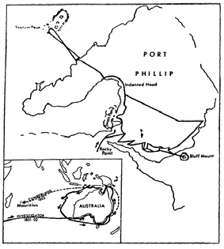
Figure 2.04: Flinders’ exploration. Source: Wynd, Outer Areas Heritage Study Environmental History, vol.2,
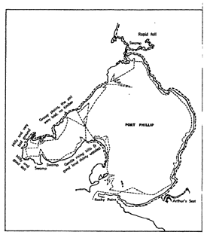2000. See Appendix 11.01 for enlarged image.

Figure 2.05: Grimes’ exploration. Source: Wynd, Outer Areas Heritage Study Environmental History, vol.2,
2000. See Appendix 11.01 for enlarged image.

The next explorers came overland ‐ from Lake George in New South Wales. In December 1824 Hamilton Hume and William Hovell reached the northern shores of Corio Bay either at Point Wilson or Bird Rock. They explored in the present day Lara region and learned from the natives that the bay was called Jillong and the highest peak of the You Yangs was Wibamanharter, a name which has survived in the district as Villamanta (a street in Geelong West) and Wooloomanata (the homestead near the You Yangs). They gave high praise to the soil. No settlement followed, however, as due to a miscalculation, the explorers thought they had reached Western Port and it was there that a settlement was made, existing briefly from 1826 to 1828.

A decade passed before the next explorers arrived, this time from the south, Van Diemen’s Land. In 1835 John Batman, on behalf of the Port Phillip Association, using Indented Head as a base, carried out more extensive exploration of the Port Phillip area than had hitherto been done. He examined the You Yangs and Lovely Banks areas, giving his own names to the salient features and made friendly contact with the Aborigines. Batman travelled further afield to what is now the Melbourne area where he concluded a “treaty” with the Aborigines to purchase 500,000 acres around Melbourne and 100,000 acres near Geelong. Whether the Aborigines understood the significance of what they were doing is doubtful, but Batman was the first European even to consider that they had a title to the land.

Batman’s exploration was followed up in August of 1835 by that of another member of the Port Phillip Association, John Helder Wedge, a surveyor, whose field book and later map – which guided the way of the pastroalists that were to soon flock to the Shores of Port Phillip (as outlined in Theme 1) ‐ makes it possible to reconstruct his journeys accurately.

Arrival of the Early Squatters
Once Batman broke the news of his discoveries on his return to Launceston, squatters streamed across Bass Strait with their flocks to take up land in the areas he and Wedge had explored (map 8). It was only after the land nearest the coast had been occupied that later comers as well as some of the first comers moved further inland. Members of the Port Phillip Association were among the first to stock their sections of Batman’s purchase. Those within and nearby the Lara region were James Simpson (from the Werribee River to Station Peak) and Michael Connolly (from the You Yangs to the Moorabool River), and J. and W. Robertson (between the head of Corio Bay and the Barwon River). North of Station Peak were the Synnot Brothers and Wallace.

Proximity to water was an important consideration for the early squatters. To the south of the You Yangs, Thomas Bates, his wife and children took up 80‐90,000 acres at Hovells Creek. Bates initially established the home station at the Duck Ponds (near the Lara railway station) but he later moved it about five miles closer to the You Yangs. At this time the Run was called Worringalook.

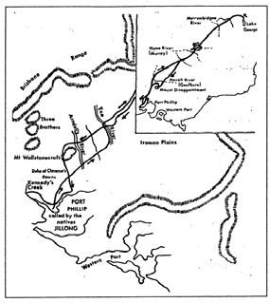Figure 2.06: Hume and Hovell’s exploration. Source: Wynd, Outer Areas Heritage Study Environmental History, vol.2, 2000. See Appendix
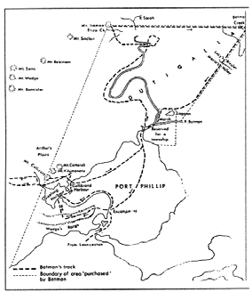11.01 for enlarged image.

Figure 2.07: Batman’s exploration. Source: Wynd, Outer Areas Heritage Study Environmental History, vol.2,
2000. See Appendix 11.01 for
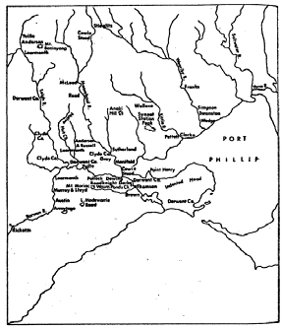enlarged image.

Figure 2.08: The early squatters of the Geelong district, including the Lara region. Source: Wynd, Outer Areas Heritage Study Environmental History, vol.2, 2000. See Appendix
11.01 for enlarged image.

It was in 1847 when the most significant developments in land tenure for the early 19th century squatters occurred. The Orders‐in‐Council passed an Act that divided the colony into settled, intermediate and unsettled districts.16 This gave the squatter an opportunity to obtain a lease of his run, with restrictions on: the period of the lease, the extent of land to be leased and the fee payable. Most importantly, it gave the squatter the pre‐emptive right during the course of the lease to prevent anyone from purchasing the 640 acres around the homestead, except for the original lessee.17

At Lara, John von Stieglitz – who took up the Station Peak Run in 1852 – exercised his pre‐emptive right to purchase 640 acres of the Run. The stone foundations of the homestead, named Villamanta, remain today.18
Monckton Synnot also acquired the pre‐emptive right to the Moyong Run on the Little River, to the north‐east of Lara. However, the debt‐laden Bates family were not in a position to purchase a pre‐emptive right of Worringalook19 although they were to aquire considerable land in the Lara area. In 1859 Thomas Bates built a bluestone homestead on the Worringalook Run (near his original homestead) and named it Melrose.20
It no longer survives. Another pre‐emptive right was taken up by Grant before 1861 to the north of Station Peak.

2.3 Promoting Settlement
Early Land Sales
In the early‐mid 1850s, land in the Parishes of Lara, Woornyalook,
Moranghurk and Wurdiyouang within the Lara region was put up for sale.21 A large portion of the land in Woornyalook was purchased by James Austin, Robert De Little and Thomas Bates Junior. In the Moranghurk Parish, land was acquired by George Bell, J.E. Bates and James Austin and J. Kiddle, with further land purchased from the late
1850s by landholders including George Armytage, F.W. Armytage and J. Gray. George Armytage had also acquired a considerable portion of land in the Lara Parish, as had A.R. Cruickshank. In Wurdiyouang, much of the north‐east portion had been taken up by George and Monckton Synnot.

Of particular note were the acquisitions by the wealthy pastoral Armytage and Fairbairn families. In the 1850s, Frederick William Armytage acquired the Station Peak Run near the foot of the western flank of the You Yangs and built Wooloomanata Homestead in c.1860‐
63.22 By 1888, Woolomanata had expanded to 22,768 acres. In 1863,
George Fairbairn – husband of Virginia Armytage – purchased 1239 acres from Robert De Little (an architect of Launceston), south of the You Yangs. He subsequently built a homestead in the mid 1860s that was replaced in c.1869 and then by a more substantial two storey mansion in
1880 known as Windermere (it was later known as Lara House and then
Pirra).23 Fairbairn also acquired neighbouring land between 1867 and
1903, including the land of Thomas Bates (Melrose Homestead) in 1877 and the freehold of John Oliver and Thomas Barber in 1897. This brought Fairbairn’s landholdings to a total of 8300 acres. Further west of Pirra Homestead off the Bacchus Marsh Road, F.W. Armytage’s sister, Elizabeth, together with her husband John Galletly, purchased 4000 acres

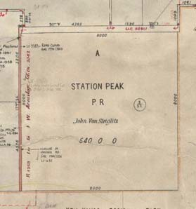
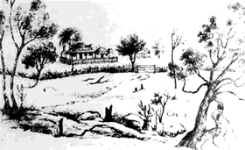Figure 2.09: Station Peak Pre‐ emptive right, Woornyalook Parish Plan. Source: VPRS16171, PROV.

Figure 2.10: Villamanta Homestead,
1852. Source: K.R. von Stieglitz,
Emma Von Stieglitz: Her Port Phillip
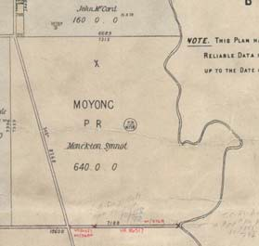& Victorian Album, 1964.

Figure 2.11: Moyong Pre‐emptive right, Woornyalook Parish Plan. Source: VPRS16171, PROV.

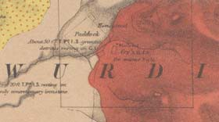
Figure 2.12: Grant’s Pre‐emptive right in the Wurdiyouang Parish. Source: R. Daintree, Geological Survey of Victoria, No. 19, 1861 (published 1863), MAP RM2335/19, National Library of Australia. See Appendix 11.01 for enlarged image.

in 1864 where they built Elcho Homestead.24

Medium and small‐sized allotments (including town allotments) were sold within the newly‐created Lara township and in outlying areas (see Theme
6 for further details). This land was taken up by well‐known early families of the area, including James English, John McGillivray, James Blair, John Wild Branch, John Walker, Robert Bell Walker, John Spalding, David McHarry, John Thompson William McClelland and the Grills brothers – Richard, John, William and Joseph.25

Of importance in 1869 was an amendment to the Land Act of 1865, and in particular, Clause 42. In Section 31 of the amended Land Act enabled less affluent selectors of licences to purchase their land or obtain a lease leading to purchase.26 According to Michael Murray in ‘Prayers and Pastures Moidart immigrants in Victoria, 1852‐1920’, ‘a permanent residence had to be constructed on the land whilst the land had to be cultivated and improved.’27 The selected land ‘could become freehold after three years on payment of 14 shillings, or after seven years, on the payment of two shillings an acre.’28 At Duck Ponds, the Bacchus Marsh Express reported that ‘Mr Spalding has taken up six acres of land under the 42nd clause, immediately opposite Mr. Henderson’s, with the intention of erecting thereon a store.’29 There were also references to other ‘forty seconders’ at Duck Ponds in 1869. The Moranghurk, Woornyalook and Wurdiyouang Parish Plans show a number of landholders who acquired their land under Section 31, including William Foot at 80 Gebbies Road, William Harding at 85 Curletts Road and John McGillivray at 60 Branch Road. This suggests that building developments in parts of the Lara area prior to 1869 were largely temporary, given the uncertainty of land ownership.

Subdivisions and Closer Settlement
In 1903, a portion of the Elcho Estate was subdivided into 24 allotments.30 The land made available for subdivision totalled 3118 acres and included land under crop.

The following year, 1904, witnessed the sale of 3000 acres of F.W. Armytage’s Wooloomanata Estate.31 The public auction occurred in the Lara Hall with a good attendance of buyers.32

In 1907, the Pirra landholdings were sold to the Government for Closer Settlement, in accordance with the Closer Settlement Act of 1904.33 The vast outlying grazing land that was once part of the Fairbairn estate was subdivided and offered for sale as the ‘Lara Estate’.34 Immediately prior to the sale, the Weekly Times published the following:

The Lara Estate, which was purchased by the Government some time ago for the purposes of closer settlement, and is now open to application, is illustrated in this issue. The area of land available is about 8,300 acres. It is situated between Lara and Little River railway stations, on the west side of the railway line, and the nearest points are within a mile of both stations.

The soil consists of chocolate, black, grey and light sandy loam, and

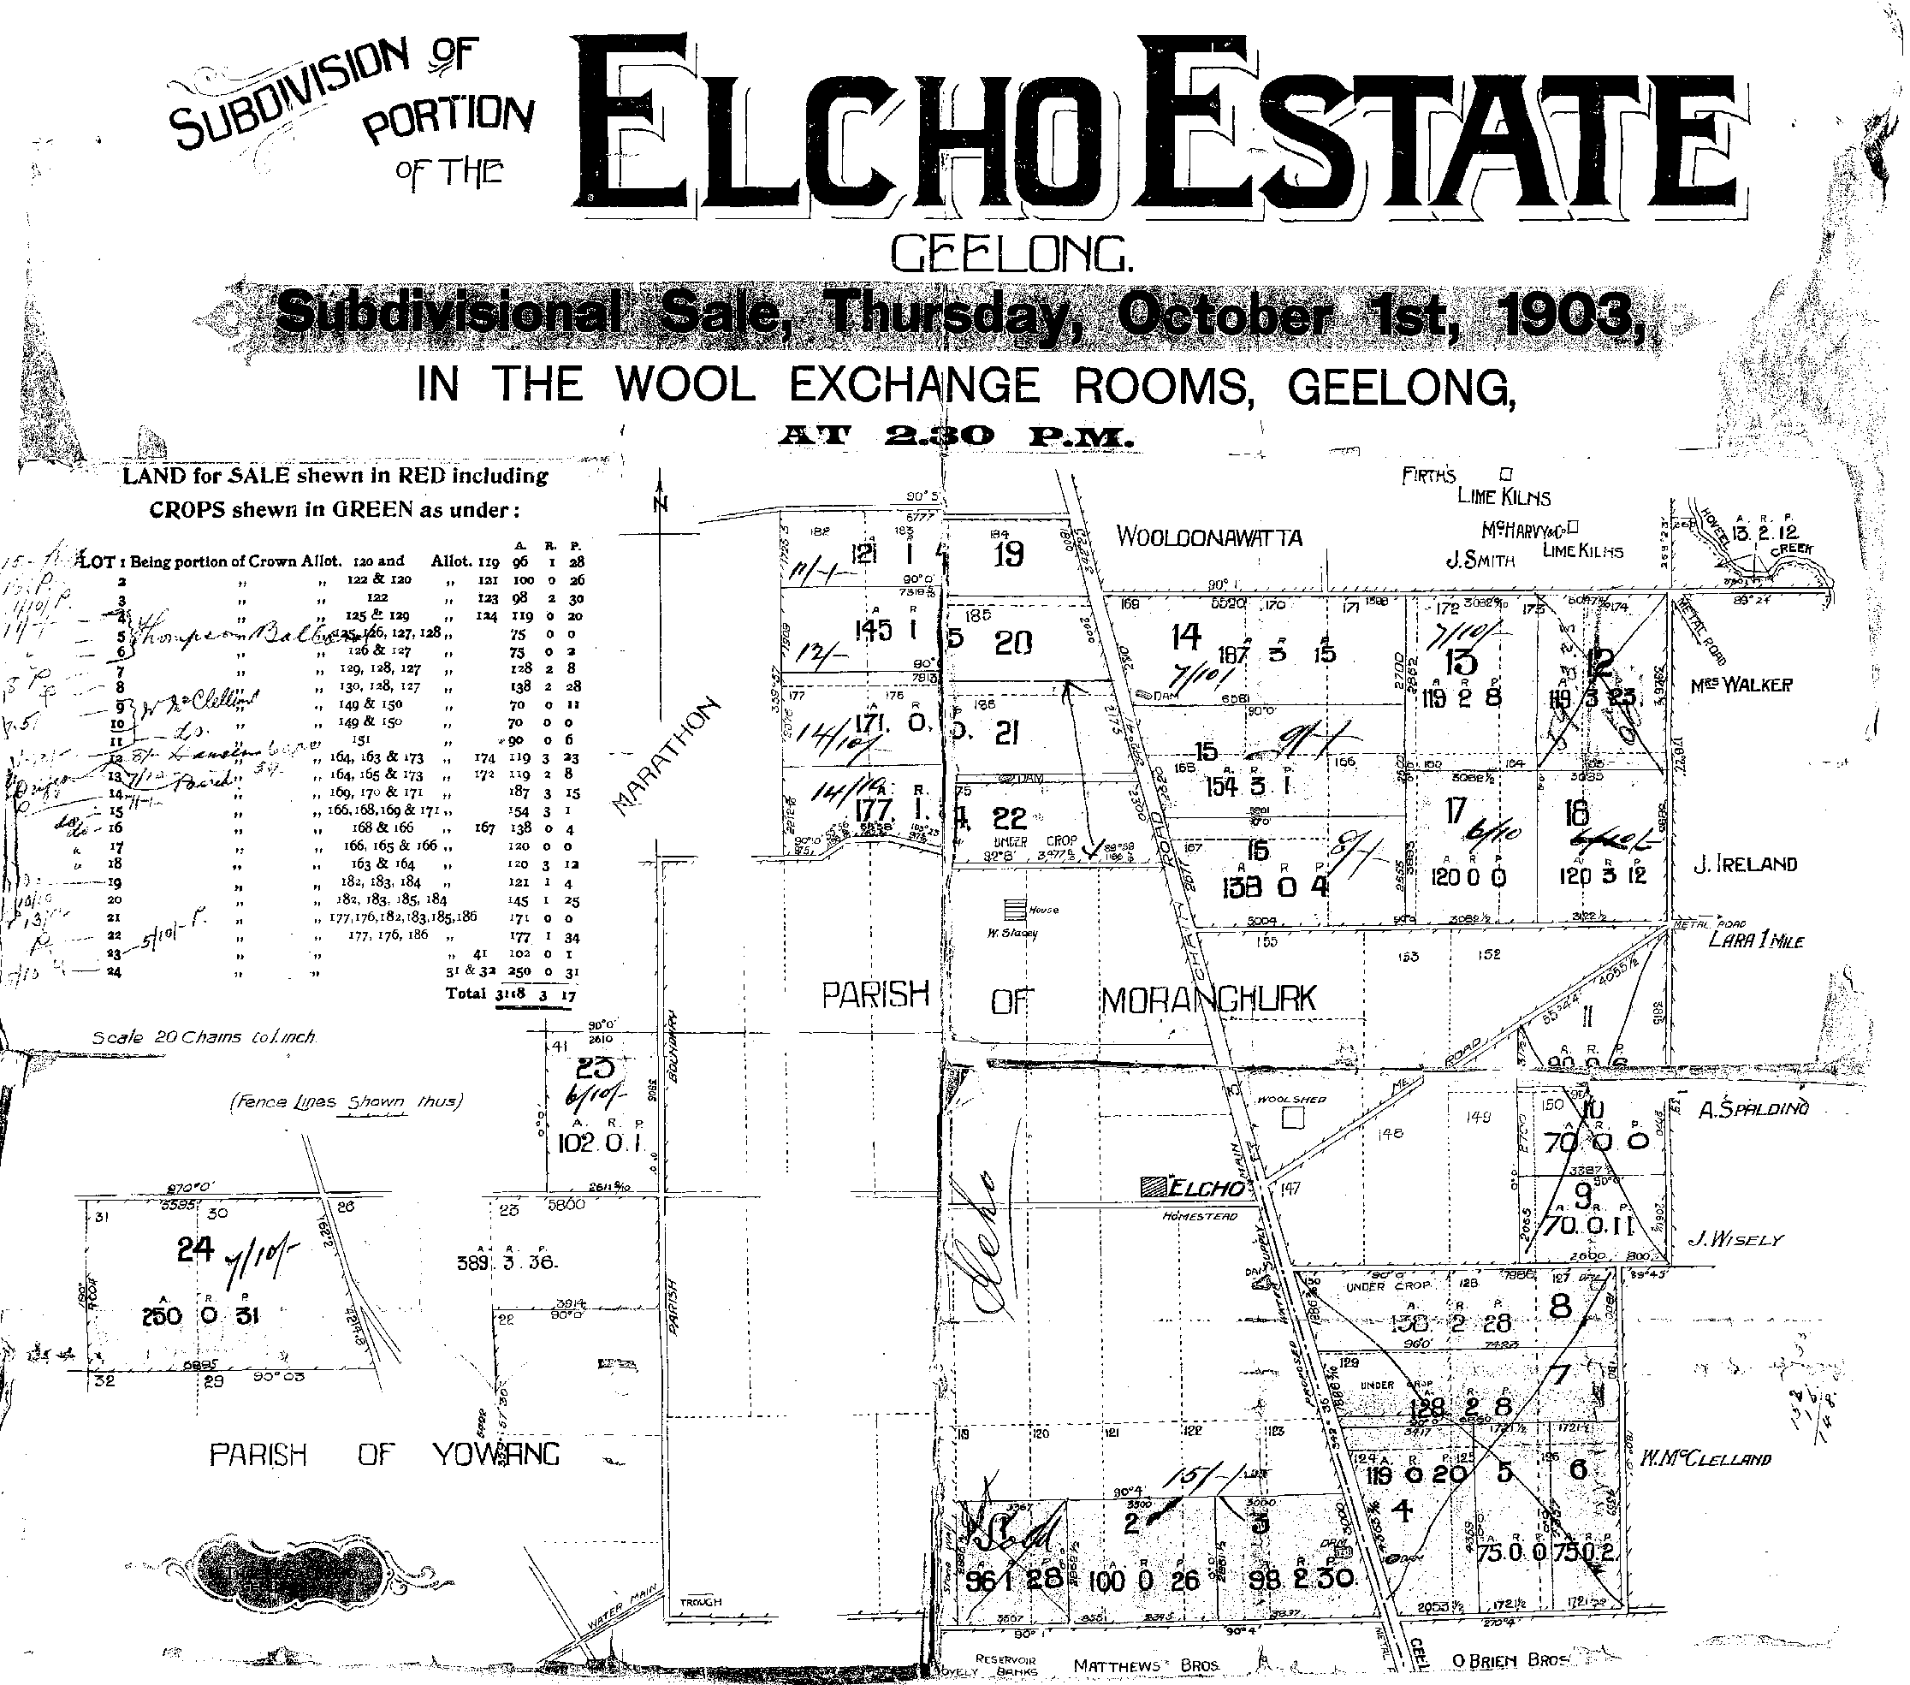

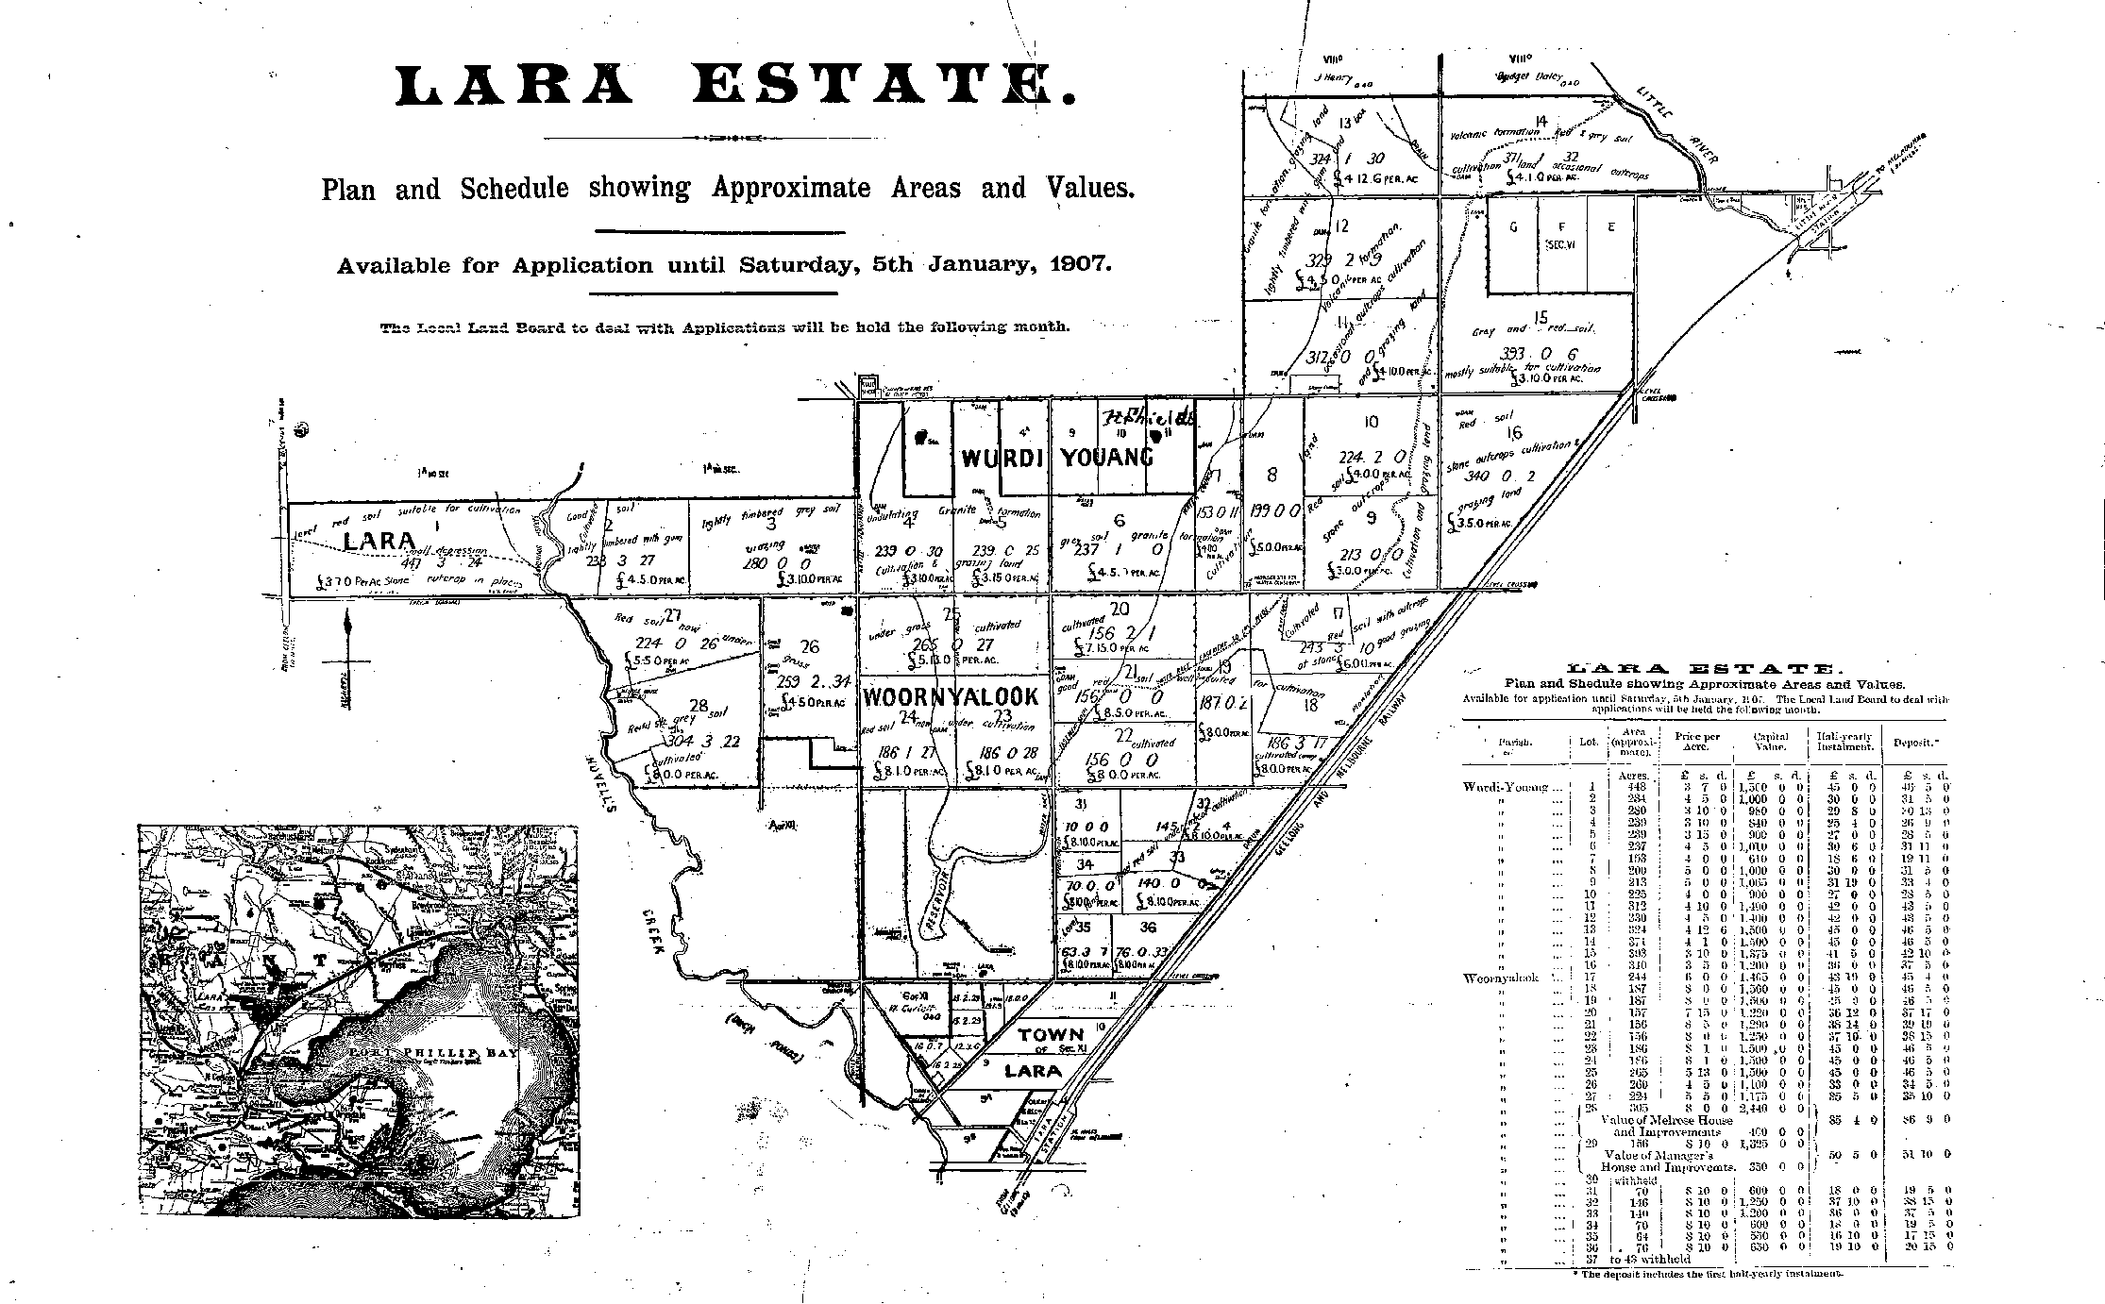Figure 2.13: Elcho Estate Subdivision plan, 1903. See Appendix 11.01 for enlarged image.

Figure 2.14: Lara Estate Plan & Schedule, 1907. See Appendix 11.01 for enlarged image.

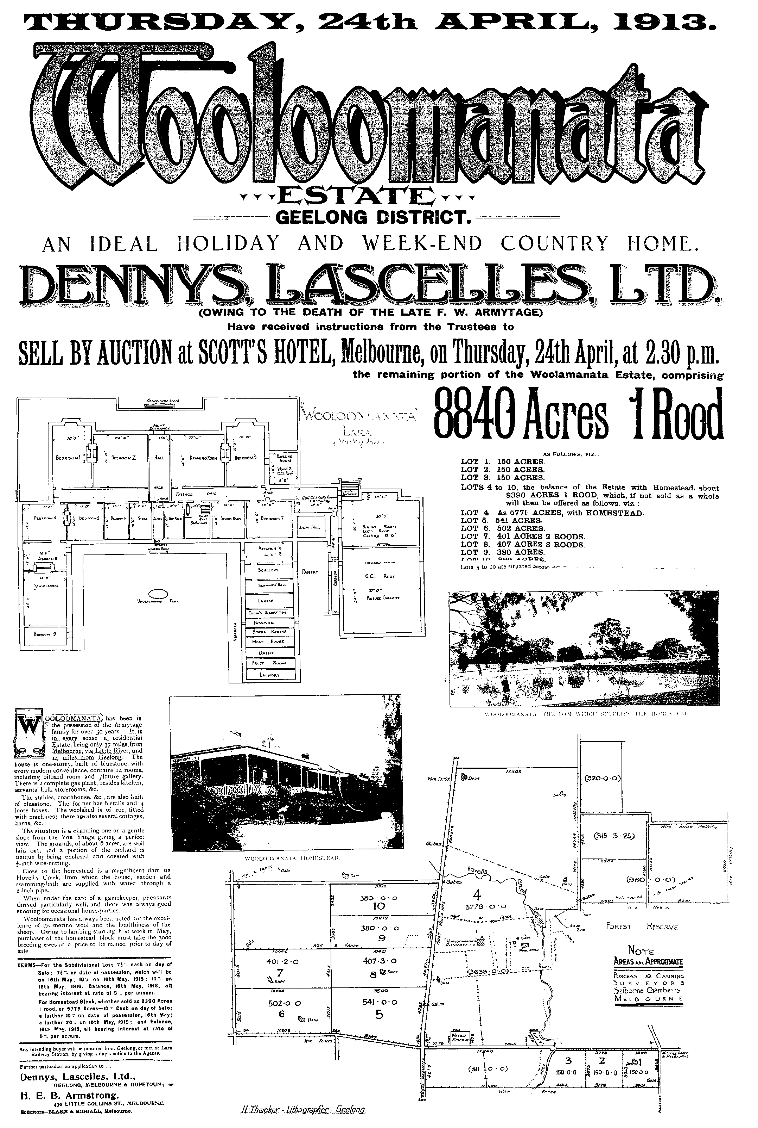

Figure 2.15: Wooloomanata Estate Auction Notice, 23 April 1913. See Appendix 11.01 for enlarged image.

the bulk of it is easily worked. Good crops have been grown on the estate. Most of the land is level, and is suitable for irrigation. A considerable area of the property can be watered from the Little River. A survey has been made and a small channel which was constructed as a trial was successful in carrying the water for several miles.

The rainfall is generally enough for all purposes, the yearly average being about 24 inches.

The nearest point of the estate is nine miles from Geelong, and it is from 30 to 36 miles from Melbourne.

… The estate is divided into 35 allotments, ranging from 70 acres to
448 acres, and in value from £550 to £2480. Two valuable homestead allotments are included, both of which are well improved.35

Some allotments had been withheld from the Lara Estate sale. In 1909, they were made available as agricultural labourers’ allotments.36

Similar to the Lara Estate, part of the Staughton Vale landholdings (which stretched into the Parish of Lara) were opened up for closer settlement as the Staughton Vale Estate in 1908.

In this same year, 1908, the “Rolyat Estate”, comprising 531 acres of Woolomanata land, was sold by Mrs F.W. Armytage.37 It was purchased by James Milbourne of Warracknabeal who in 1910‐11 acquired the neighbouring Tallaranie Homestead.38 With the death of F.W. Armytage in 1912,39 over 3,000 acres of Wooloomanata were auctioned by Messrs. H.A. Wood and Co and Dennys Lascelles Ltd.40 This created additional opportunities for new smaller farms.

In 1911, Sir Samuel Wilson sold Marathon Homestead at Anakie to Messrs. Fell and McNamara.41 They subdivided the large estate into farm areas, with a total of 3269 acres having been sold in four allotments by 4
March 1911.42

In 1923, Elcho was taken up by the Closer Settlement Board for use as a training farm for British immigrant farmers.43 Just over a decade later in
1934 and 1935, Elcho was sold by the Closer Settlement Commission. Comprising 2,641 acres, the land was described as having:

‘… soil that is volcanic, varying from red to chocolate loam to dark and red clayey loam … The property is eminently suited for mixed farming –
600 acres have been regularly cultivated and produced good crops of
wheat, oats, barley, &c. In addition, 1,800 ewes have been carried in a normal season.44

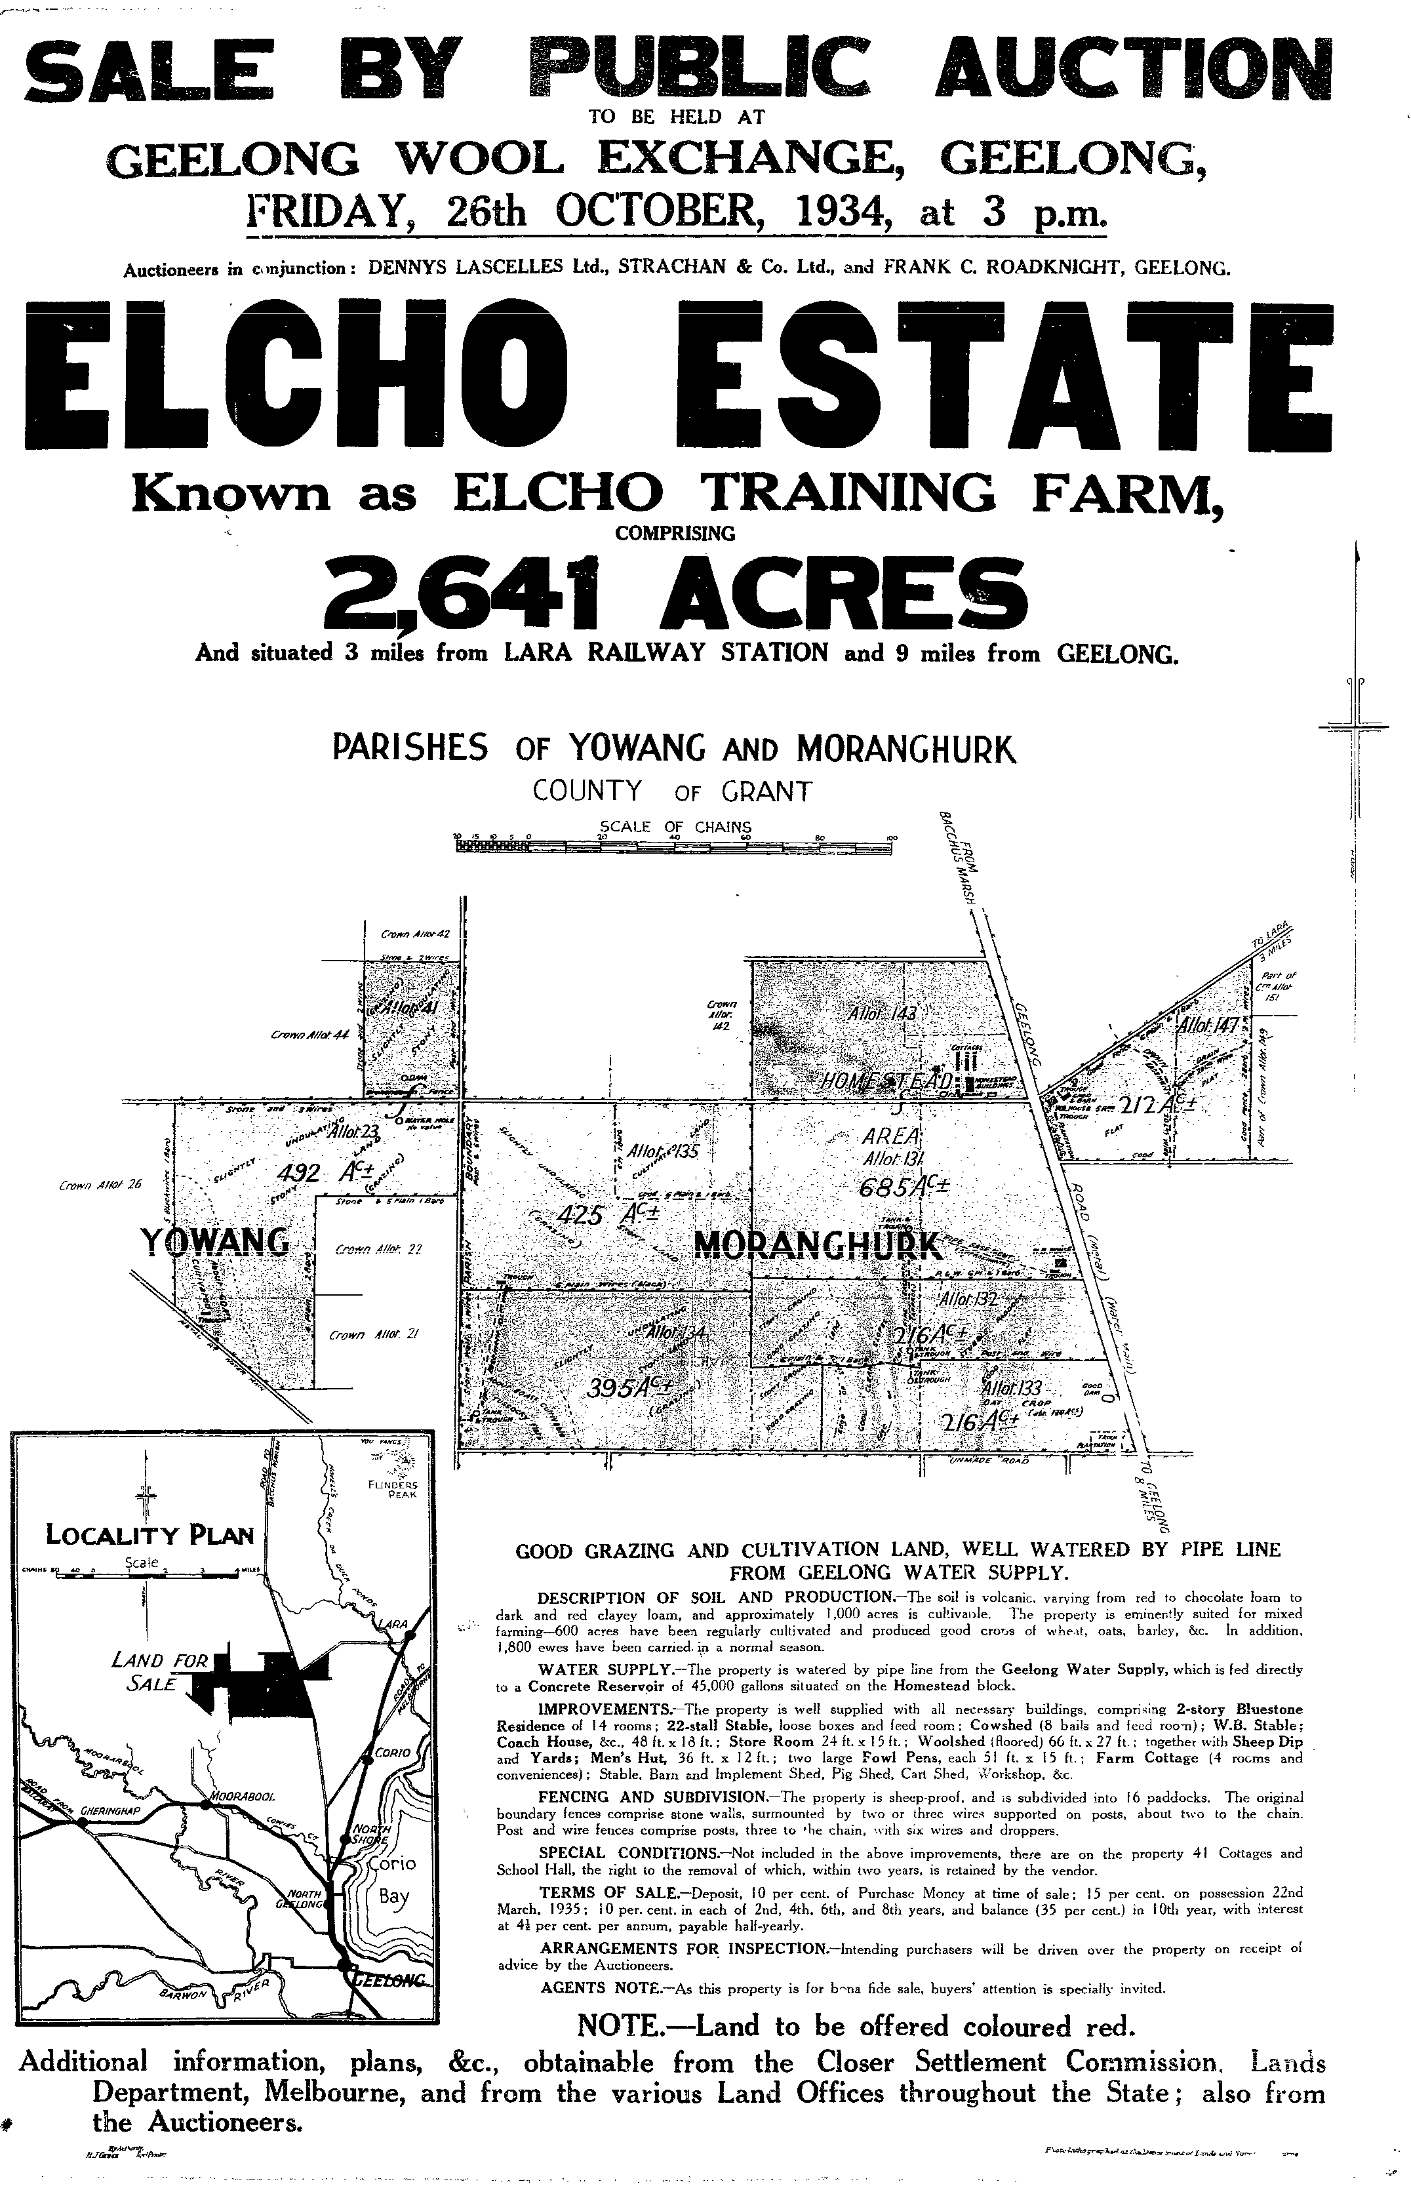

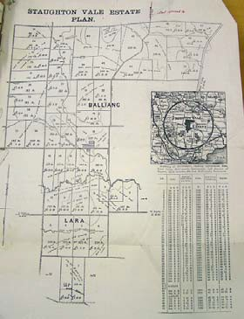Figure 2.16: Elcho Estate Auction notice, 1934. See Appendix 11.01 for enlarged image.

Figure 2.17: Staughton Vale Estate subdivision plan, c.1908. Source: VPRS5714, Unit 1279, PROV. See Appendix 11.01 for enlarged image.

1 Early and recent references also refer to the Wathaurong as the Barrabool tribe.
2 T. Pescott, The You Yangs Range, Yaugher Print, Geelong, 1995, p.69.
3 M. Cannon (ed.), Historical Records of Victoria (HRV), vol. 7, Melbourne 1998, p. 349.
4 This is probably meant to be Ballarina Hills, a name used on an early map to denote the heights of the Bellarine Peninsula.
5 The Leigh River.
6 This should be Wurdi‐you‐yang, a name which survives in a different form as a parish name.

7 L. Lane, “The Inhabitants of Terra Nullius,” Investigator, Vol. 29, No. 4, December 1994, pp. 135 ff.
8 Pescott, op.cit., pp.69‐70.
9 The “wild white man” who had lived with the tribe from the time of his escape from the settlement at Sorrento in 1803 until
1835, when he walked into Batman’s camp at Indented Head. C.E. Sayers (ed.), Letters from Victorian Pioneers, Melbourne
1983. p.132.
10 Pescott, op.cit., p.69.
11 Cannon, HRV7, p. 349
12 The records show them as the aggressors in 1839 against the Melbourne tribe who called on the Goulburn tribe to assist them in repelling the attack. Cannon, HRV 2B, pp. 454, 557, 609; HRV 7, p.362.
13 Quoted in I. Wynd, Barrabool. Land of the Magpie, p. 12.
14 ‘Wurdi Youang IP Investigation and Consultation Project’, information brochure, 11 December 2010, provided by Kevin
Krastins, Community Development Planner, City of Greater Geelong.
15 The following account is based on more detailed accounts by I. Wynd in So Fine A Country (1981), Barrabool. Land of the
Magpie (1992) and various articles in Investigator, Vols. 1 and 2, 1965‐67.
16 H.G. Turner, A History of the Colony of Victoria, Heritage Publications, Melbourne, 1973, p.64.
17 Ibid. & Billis & Kenyon, op.cit., pp.10‐11.
18 Wynd, So Fine a Country, op.cit., p.25.
19 Ibid., p.29.
20 Ibid., p.232.
21 Ibid., p.41.
22 A. Willingham, Geelong Region Historic Buildings & Objects Study, vol.1, Geelong Regional Commission, Geelong, 1986, sheet
134. According to Wynd, op.cit., p.238, the name ‘Wooloomanata’ is a variation of the original name of the homestead,
‘Villamanta’, being the Aboriginal translation for Station Peak.
23 D. Rowe, ‘Pirra Homestead’ Conservation Analysis, prepared for the owner, June 2002.
24 Wynd, op.cit., p.239 & Geelong Advertiser, 18 May 1864.
25 See Wynd, So Fine A Country & M. Budd, C. Delaney, J. Grainger (eds.), From Duck Ponds to Lara: A Collection of Memories, Lara Heritage Festival Inc., Lara, 2004.
26 ‘Land Act 1869 (Second Grant Act)’, Lands Guide, Public Record Office Victoria.
27 M. Murray, ‘Prayers and Pastures Moidart immigrants in Victoria, 1852‐1920’, PhD Thesis, School of History, Heritage and
Society, Deakin University, 2007, p.278.
28 Ibid.
29 Bacchus Marsh Express, 3 April 1869.
30 ‘Subdivision of Portion of the Elcho Estate, Geelong’, 1 October 1903, map E12, Geelong Heritage Centre.
31 The Bacchus Marsh Express, 8 October 1904, p.3.
32 Ibid.
33 ‘Lara Estate Plan and Schedule’, 5 January 1907, Geelong Heritage Centre.
34 Ibid.
35 Weekly Times, 15 December 1906.
36 The Argus newspaper, 27 January 1909, p.10.
37 The Argus, 30 November 1908, p.10.
38 Ibid., 7 November 1908.
39 A. Henderson, Henderson’s Australian Families: A Genealogical and Biographical Record, A. Henderson, Melbourne, 1941, facs. edn., The Genealogical Society of Victoria Inc., Melbourne, 2004, pp.307‐309.
40 The Argus, 27 June 1912, p.6 & ‘Wooloomanata Estate” auction notice, 24 April 1913, map 185, Geelong Heritage Centre.
41 The Argus, 4 March 1911, p.21 & Wynd, op.cit., p.216, 273.
42 Ibid.
43 Ibid., p.240.
44 ‘Elcho Estate’ Auction notice, 26 October 1934, map E13, Geelong Heritage Centre.

3. Transport & Communications
3.1 Establishing Early Roads
The earliest tracks in the Lara region were established soon after the land had been explored, as Wedge’s Map of Port Phillip in 1836 (Figure 1.07) showed the ‘usual route from the settlement of the Barrabull Hills &c.’ passing by Bates’ Run.’ This track initially provided basic access from the fledgling settlement at Melbourne to the Geelong region and beyond to the Western District and Portland. By 1845, A.J. Skene’s Map of the District of Geelong revealed that an additional route to Melbourne from Geelong had been created closer to Port Phillip Bay, which traversed the northern tip of the nearby Limeburners Bay (south of Lara). Another track to the north of Station Peak crossed over the Runs of the Synotts’, and connected with the route to Mt Buninyong. A track from Bacchus Marsh to Geelong was also formed to the west of Lara. By 1856, a “main road” to Bacchus Marsh to the east of this track was formed which led to the newly‐laid out (but undeveloped) township of Ripley on the southern bank of the Little River (see Figure 1.08). These straighter roads had resulted from Government surveys from the 1840s.1

The creation of a Central Roads Board in the 1850s meant that some attention was paid to main roads but it was not until the creation of local road boards that consideration was given to local roads. The Corio Road Board was created in 1861. Tolls were imposed by these boards until the
1870s but there was never enough money to provide satisfactory highways and complaints about the state of the roads were loud and frequent. The main roads ceased to be a problem for local government after 1912 when the Country Roads Board (today’s Vicroads) was formed. Councils could then turn their attention to the lesser roads in their municipalities.2

3.2 Building Early Bridges
The creation of roads from the 1840s brought with it the need for safe and efficient river crossings. Bridge building was one of the biggest tasks that faced the fledgling local government authorities in these early years, including the Corio Road Board (later Corio Shire Council). Within the Lara and Little River regions, safe and reliable bridges were required over the Little River and in the centre of the Lara settlement. Of the latter, a bridge had been constructed over the Duck Ponds by 1861 as it is shown on Daintree’s Geological Survey Map. However, more substantial bluestone bridges were required on the main route to Melbourne at Rothwell and further west at Garrett’s crossing (the thoroughfare linking the Geelong to Bacchus Marsh Road). It was in 1863 when a drowning at the Rothwell ford had instigated the need for a permanent bridge. However, indecision about its location and the need for co‐operation between the Corio and Werribee Shire Councils caused delays.3 The two‐ arched bluestone structure was built in 1866‐67 following the design of the Werribee Shire engineer, John Baxter.4 The single‐arched bluestone structure at Garrett’s Crossing was built in 1867 and named Grant’s Bridge,5 presumably after John Grant whose pre‐emptive right was to the north of Station Peak.6 Both these bluestone bridges still exist.

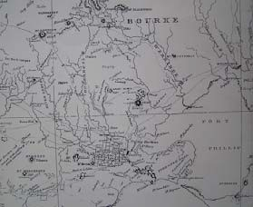
Figure 3.01: A.J. Skene, Map of the District of Geelong, 1845. See Appendix 11.01 for enlarged image.

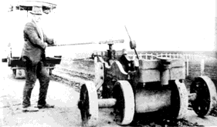
Figure 3.02: Early road‐making equipment. Source: H. Spalding in Wynd, So Fine a Country, p.67.

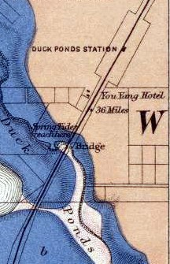
Figure 3.03: R. Daintree, Victorian
Geological Survey, 1861 (published
1863) showing bridge over the Duck Ponds. Source: National Library of Australia.

3.3 Geelong to Melbourne Railway
A more permanent bridge over the Little River had been built much earlier than the bluestone road bridge. It resulted from the construction of the first railway trunk line in Victoria between Melbourne and Geelong in 1857.7 Another railway bridge over the Duck Ponds (including two 12‐ foot culverts) was also built at a cost of £28,000 in the mid 1850s.8 As early as 1850, a company had been formed in Geelong , with Edward Snell employed as its engineer. In addition to the 200 workers contractors employed, convict labour was also exploited with the convicts housed in the hulk Sacramento, moored off Cowies Creek. In particular, convict labour was used to build the section between Cowies Creek and Duck Ponds (Lara) in 1853.9

Significantly, the opening of the railway fostered the development of the
Lara township.10 A temporary terminus had opened at Duck Ponds in
1856 and this sparked a number of land subdivisions in its vicinity.11 A
timber railway station had been erected for the opening of the line. In
1896, the Bacchus Marsh Express gave the following romantic description of the building:

Like that at Little River, [the Lara Railway Station] has exactly the rural cottage home coziness which may be seen on country branch lines in England. It neighbours the Shire hall and surrounding plantations like one of the family, and adds greatly to the picturesqueness of the group. A little more verandah protection would be welcome, we should imagine, but it should not be of the grim iron‐ribbed character usual at Victorian
stations, but something light and ornamental.12

In 1886, pressures mounted on the inadequacy of the local railway to cater for the burgeoning local lime industry (see Themes 5 & 6 for further details on the lime industry). A deputation of lime burners met with the Commissioner of Railways seeking the erection of a siding about three quarters of a mile from Lara, in the vicinity of the kilns.13 Instead, in the following year, the existing lime shed at the Lara station was extended by Parker and Vickers.14

The railway station was subsequently destroyed by fire and the existing brick station building and platform were built in 1926, as outlined in The Argus:

A commencement has been made with the erection of a new railway station at Lara. The new platform will be 400ft. longer than the existing one to cope with the long trains now run on the Geelong line.15

3.4 Avalon Airport
In 1949, the owner of Avalon Homestead, Richard Austin, sold 2,400 acres of his Avalon Homestead sheep grazing property to the Commonwealth Aircraft Corporation for use as a jet test field and assembly plant.16 In
1987, the Government Aircraft factories were partially privatised, with operations being taken over by Aerospace Technologies Australia.17 By 31
December 1997, the airport was completely owned by Linfox Transport
(Aust.) Pty Ltd.18 Air shows were held at Avalon from around this time.

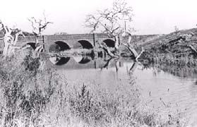Figure 3.04: Rothwell Bridge, n.d. Source: Werribee & District Historical Society.

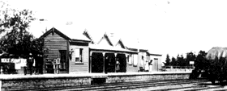
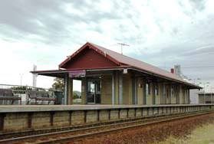Figure 3.05: Lara Railway Station, n.d. [c.1900]. Source: K. Eastman in From Duck Ponds to Lara, p.60.

Figure 3.06: Altered Lara Railway
Station, 2012.

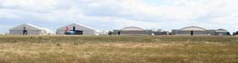
Figure 3.07: Hangers at Avalon Airport, c.2000. Source: ‘Avalon Airport’, Wikipedia.

Although the first schedule passenger flights from Avalon began in February 1995 and operated by Hazelton Airlines, the service was discontinued due to a lack of patronage.19 In 2004, Avalon airport became a terminus for Jetstar and from 2010 Tiger Airways (although the latter ceased operating from Avalon a year later).20 In 2012, it was announced that Avalon was to become Victoria’s second international airport terminal.

3.5 Establishing & Maintaining Communications
Postal and Telegraph Services
The establishment of a postal service at Duck Ponds occurred 185721 and
it was essential to the ongoing development of the rural township. The first post office officially opened on 1 March 1858 at Lara Lake, with John Spalding as Postmaster.22 A post office was built by the Spalding family as part of a small group of buildings in 1860 on the Sixways corner.23 In
1872, the name of the post office changed to Hovells Creek Post Office and then to the Lara Lake Post Office in 1880.24 A new brick Post Office (as part of a larger building complex) had been constructed by c.1925 when the Postmaster was J.A.D. Gillespie. The post office closed in
1993.25

A second post office had been established on railway land in Walkers Road. This was a more central location in the fledgling township that developed around the railway station. Until c.1910, the station master also acted as the postmaster. Robert Hutchison was appointed Postmaster on 8 August 1864.26 He was replaced by H. Jukes on 16
January 1867.27 In 1889‐89, Alexander Crow was station and post master
but by 1891‐92 Charles H. Allen had taken up the role.28 In 1899‐1900, a
Mr McGillicuddy was the station and postmaster but by 1904 John A. McArthur was in the role.29 Six years later in 1910, a telephone exchange was installed in the post office, the first postmaster responsible for the exchange being A. Strong.30 In ensuing years the post office and telephone exchange were operated by Don Walker.31 The post office shared the building with James Murray’s General Store (see Theme 5 for further details).32 The manual telephone exchange operated until 1965.33
Both the early Lara and Lara Lake Post Office buildings no longer survive.

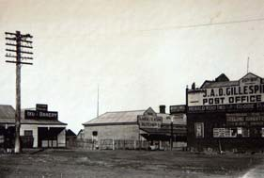
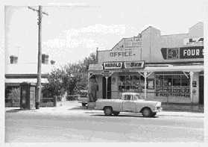Figure 3.08: Side view of the Lara Lake Post Office (right), c.1925. Source: Holmes collection c/o David Rowe.

Figure 3.09: Lara Lake Post Office,
1968‐69. Source: National Library of
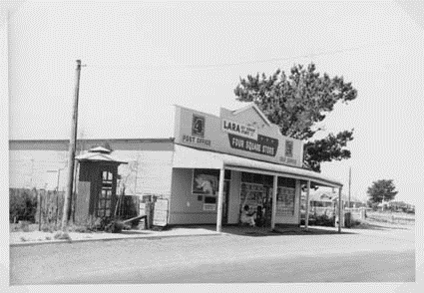Australia, image B5919.

Figure 3.10: Lara Post Office, Walkers Road, n.d. c/1968‐69]. Source: National Library of Australia, image B5919.

1 I. Wynd, ‘City of Greater Geelong Outer Areas Heritage Study Stage 2 Environmental History’, prepared for Authentic Heritage
Services Pty Ltd for the City of Greater Geelong, 2000.
2 I. Wynd, So Fine A Country, Shire of Corio, 1981, pp. 28, 30, 55, 68, 131, 257.
3 Ibid., pp.67‐68.
4 ‘Rothwell Bridge’, Victorian Heritage Database online, 26 October 2012.
5 Context Pty Ltd, ‘City of Wyndham Heritage Study’, prepared for the City of Wyndham, 1997.
6 Grant’s pre‐emptive right is shown in Figure 2.11
7 Wynd, op.cit.
8 Empire newspaper, Sydney, 8 June 1855, p.6. Another railway bridge was built at Duck Ponds in 1875. See The Cornwall
Chronicle, Launceston, Tasmania, 29 September 1875, p.3.
9 M. Budd, C. Delaney, J. Grainger (eds.), From Duck Ponds to Lara: A Collection of Memories, Lara Heritage Festival Inc., Lara,
2004, p.58.
10 Wynd, op.cit., p.46.
11 Ibid., p.50.
12 The Bacchus Marsh Express, 25 April 1896, p.3.
13 The Argus, 27 May 1886.

14 Victoria Government Gazette, vol.64, 15 July 1887, p.2114.
15 The Argus, 16 June 1926, p.10.
16 Wynd, op.cit., p.243. Budd, et.al., p.165 states that the land was purchased on 7 February 1952.
17 Ibid.
18 Ibid.
19 ‘Avalon Airport’, Wikipedia at http://en.wikipedia.org/wiki/Avalon_Airport.
20 Ibid.
21 The date, 1857, is shown on the parapet of the Post Office in Figure 3.08.
22 Premier Postal at https://www.premierpostal.com & Budd, et.al., op.cit., p.143.
23 Ibid.
24 Premier Postal, op.cit.
25 Ibid.
26 Victoria Government Gazette, no. 91, 6 September 1864, p.1935.
27 Ibid., vol. 12, 29 January 1867, p196.
28 Wises’ Directory, 1888‐89, 1891‐92.
29 Ibid., 1899‐1900, 1904.
30 Wynd, op.cit., p.160 & Budd, et.al., op.cit., p.56.
31 Ibid. & Budd, et.al., op.cit.
32 Ibid., p.153.
33 Ibid.

4. Transforming & Managing Land & Natural Resources
The arrival of the settlers to the Lara region in the mid 19th century
brought about the first wave of land transformation based around farming and agriculture. In particular, sheep and cattle grazing was the principal purpose of the development of the numerous Runs and farms. A farmers’ common was created at the You Yangs for Town Herdsmen. The unlocking of the lands also brought with it a multitude of agricultural industries including hay, wheat and barley cropping as well as some other cereal and potato cropping, and to a lesser degree, orchards, dairying and vineyards. In addition, from the outset of settlement at Lara in the 1850s, the substantial deposits of lime in the area was the catalyst for a booming lime excavation and burning industry until the early 20th century. Both farming and lime burning formed the backbone to the rural development of Lara, an area without a regular and satisfactory water supply.

Another natural resource – timber – was initially taken from the reserve at the You Yangs to fire the local lime burning operations until it became a Forestry Reserve.

4.1 Farming & Agriculture
One of the earliest farming activities in the Lara area was sheep grazing,
and to a lesser degree, cattle grazing. In 1858, there were 24,400 sheep being grazed in the Parishes of Lara, Moranghurk, Woornyalook and Wurdiyouang (that took in all or part of the Lara region), as well as 2,935 horned cattle and 292 pigs.1 This was for a population of just 119. Large estates including Thomas Bates’ Run (established in 1837), James Austin’s Avalon Homestead (first established in 1842), F.W. Armytage’s Wooloomanata Homestead (established c.1860), George Fairbairn’s Windermere Homestead (later known as Lara House and then Pirra, first established in 1863) John Gallety’s Elcho Homestead (established in 1864) were the principal sources of sheep grazing in the area.2 While portions of the rural land of these sheep stations survive today, few agricultural buildings remain. Those that exist include the bluestone stables at Wooloomanata and the Stables and the Woolshed at Avalon (now no longer part of the Avalon Homestead property).

A significant number of farms in the Lara area generated crops. In 1867 in the Parishes of Lara, Moranghurk, Woornyalook and Wurdiyouang, there were 353 acres of wheat crops, 354 acres of oats and 145 acres of barley.3

It was from the 1850s when a number of farms were established at Lara. One of the earliest was a 20 acre property taken up by Robert Walker at
270 Windermere Road in c.1856. 4 All that remains today are the ruins of
his cottage built by a Mr Harding in c.1860‐64.5 In 1866, William
McClelland commenced farming (cultivation and dairying) at ‘Clover Hill’,
155 Forest Road South.6 His homestead – rebuilt in 1926 – is a physical
legacy.7 At 125 Buckingham Street, a 60 acre farm was established by
John Hewitt in 1867.8 The property was sold to David McHarry in 1874,9 a
long‐time resident of Lara, and he created a successful lime burning and
farming enterprise. The cottage and ruins of the stables to the property now known as Laurence Park are a physical legacy of McHarry’s tenure.

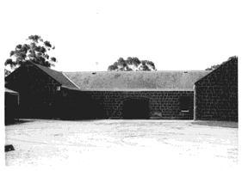
Figure 4.01: J. Collins, Stables, Wooloomanata, 14 November 1965. Source: La Trobe Picture Collection, State Library of Victoria, image jc010974.
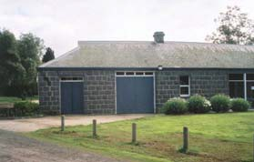
Figure 4.02: Stables, Avalon, 2006. Source: HLCD Pty Ltd, ‘Avalon’ Conservation Management Plan.

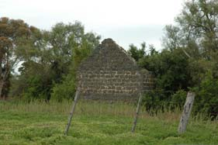
Figure 4.03: Cottage ruins, 270
Windermere Road, 2012.

Most of the other farms throughout the region have suffered from the ravages of bushfires and deterioration, although some continue to survive. These other farms include those at 60 Branch Road (established in 1870 and now the ruins of John McGillivray’s farm house built in
1871),10 85 Curletts Road (the farm commenced by William Harding in
1869 with the stone cottage and dairy built in 1874),11 575 Flinders
Avenue (now the ruins of James English’s farm from c.1859),12 25 Blairs
Road (the ruins of ‘Blairgowrie’, a dairy farm owned from 1868 by the early Secretary of the Corio Shire, James Blair and his wife – it was previously known as Oakland’s Farm),13 and 120 Duggans Lane (the ruins of Maxwell Bell’s farm cottage and outbuildings built in c.1864‐84).14
Greater physical evidence of some of the other smaller Victorian farms include the altered dwelling at 35 Gebbies Road (apparently part of John Edward Meyrick’s 8 acre farm from at least 1876)15 and the cottage complex at 80 Gebbies Road established from 1869 by the farmer and lime burner, William Foot.16 In addition to the cottages are a number of farm outbuildings, such as the early dairy at 80 Gebbies Road.

The Closer Settlement and other subdivisions of the substantial Runs of Pirra, Elcho, Wooloomanata, Marathon and Staughton Value during the Federation era brought about the creation of more farms for grazing and pasture. Farms established as a result of the Elcho Estate subdivision of
1903 included those at 785 Bacchus Marsh Road where Richard Wisely built the existing timber dwelling in c.1906‐07,17 and “Lochnaben” at 295
Patullos Road, where the Richmond Brothers built the existing Federation styled dwelling in 1905.18 In 1904, W.H. Ham acquired lots 9 and 10 of the Wooloomanata Estate subdivision and in 1907 he established his “Lara Hill” farm, the timber dwelling having been designed by the architects, Laird and Buchan.19 Only the stone ruins of the farm complex remain, with Ham’s timber weatherboard dwelling long since removed. “Tallaranie Homestead” (earlier known as “Tallarannie”) at 170 Peak School Road, first established by Archibald Shannon (and funded by his father, Charles Shannon) in c.1906, was also a consequence of the Wooloomanata Estate subdivision.20

A physical legacy of the farms established as a result of the Lara (Pirra) Estate subdivision include “The Pines” at 450 Flinders Avenue (that was first owned by George Jones in 1907 and who appears to have had the existing dwelling constructed at this time),21 “Glenoe” at 10 Windermere Road (the first owners being Frederick and Janet Smith who built the existing timber dwelling as well as a stables in 1907‐08),22 and a farm at
270 Peak School Road first owned by Adolph Schwartz in 1908‐09.23 All
that survives today of Schwartz’s tenure are bluestone dairy ruins.

The Federation styled “Roselea”, 450 Staceys Road, built in in 1912‐13 for the Leigh brothers of Ceres, was the result of the Marathon Estate subdivision of 1911. 24 It appears that early farm outbuildings also survive.

Other farms were also established in the 20th century. These included
“Kia Ora” at 75 Staceys Road, with the surviving timber dwelling having

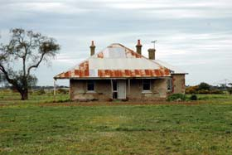Figure 4.04: Clover Hill Farm House,
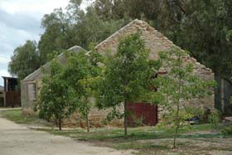155 Forest Road South, 2012.

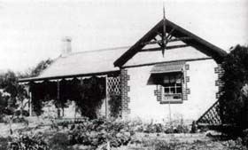Figure 4.05: Stables remains, Laurence Park, 125 Buckingham Street, 2012.

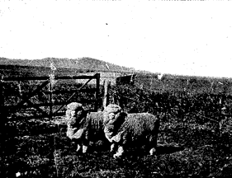Figure 4.06: ‘Blairgowrie’, c.1930s. Source: From Duck Ponds to Lara, p.30.

Figure 4.07: “Lara Hill” rams with outbuilding and the You Yangs in the background. Source: “Lara Hill” Auction notice, 13 September 1923, Geelong Heritage Centre.

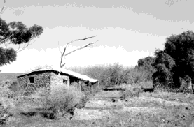
Figure 4.08: Remnant farm outbuildings of the former ‘Lara Hill’ Farm, 1998. Source: David Rowe.

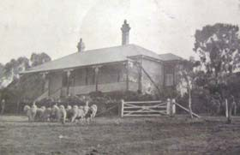been built in 1906.25 It was constructed for John Sutherland (and funded by his father, Hugh Sutherland of Elcho Homestead.

Around half the population of the Lara area were farmers in the early 20th century. In 1904, Wises’ Directory recorded 52 farmers of a total of 103 occupiers. In 1914 after the subdivisions of the larger pastoral estates, there were 153 farmers from a total population of approximately 215.26

Hay was the main produce grown in the Lara area from the 19th century and until after World War Two.27 Unlike the initial years of settlement in the 1850s and 1860s, wheat was grown on a much smaller scale as the proximity to Corio Bay brought about an abundance of moisture and the prevalence of weevils.28 Instead, barley was the principal crop that was grown as it suited the soil and climate conditions of the district.29 In
1916, the success of farming in Lara was reported in The Leader:

The average of the farmers in the Lara district is up to a very good standard in the working of their land. This is shown in the continued fertility of the older farms lying outside of the Fairbairn [Lara Estate] subdivision. The Lee [sic. – Leigh] Brothers reflect credit upon their training, obtained originally on the Barrabool Hills. Their proportion of grain cultivation for market over and above that provided for their sheep grazing is larger than the average, and the quality of their work is indicated by their yields of oats, running to averages of from 35 to 45 bushels per acre, and their Cape barley from 30 to 35 respectively. The older settlers did not consider the district suitable for wheat, but Mr. Wisley, from the mallee, has attracted attention by the growth of a very fine crop of Federation wheat last year. Not much has yet been done about lucerne, although there is no reason against that best of all fodder plants doing well here, considering its success (without irrigation) in the adjoining Western district, whose climate and conditions generally are much the same as those of Lara. Lara is essentially a good winter country. The temperature is comparatively mild, and growth, both of crops and pasture, continues right through the winter season. There is a tradition about Mr. McCarry [sic. – McHarry], a very early settler in this district, having once put in a small paddock with lucerne, only he did not then know the value of the plant. He called it a weed, and tried to get rid of it by ploughing. He remarked that it was the most stubborn weed he had ever met with, as the more he ploughed it up in the effort to exterminate it the better and more persistently it grew. Mr. McLennon [sic. – McClelland], who has earned a reputation for the breeding of high‐class Clydesdales, is one of the earliest settlers in this locality, and also Mr. Sutherland, whose name is well known as a breeder of pure Border‐Leicesters. The rams of this breed, on Lincoln‐merino ewes, take a leading place here among the crossbreds for lamb production, either for local consumption or export. The pure merino breeders, such as Mr. W.H. Ham, however, have the conviction that it will pay them to adhere to their pure merinos, whose lineage has come down to them from a lengthened period of years in the past, because, whatever breed of ram may be most popular for a time among the crossbreds for the lamb grade, the pure merino must always be in permanent demand as the
indispensable foundation of the cross‐breeding business itself.30

A vineyard had been first established on Bates’ land at Lara Lake (the location of “Limella Cottage” at 31‐45 Forest Road South) as early as

Figure 4.09: ‘Lara Hill’ Farm House,
1923. Source: “Lara Hill” Auction Notice, 13 Sept 1923, Geelong Heritage Centre.

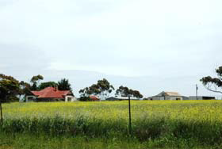
Figure 4.10: “Roselea”, 450 Staceys
Road, showing farm outbuildings,
2012.

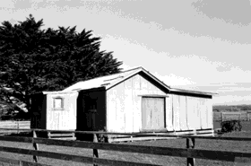
Figure 4.11: Farm Outbuilding, 115
Duggans Lane, 1998. Source: David
Rowe.

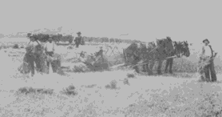
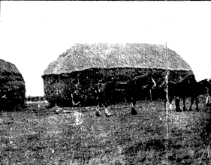Figure 4.12: Farming near the You Yangs, c.1920. Source: Wynd, So Fine a Country, p.77.

Figure 4.13: Horses & Haystack, “Lara Hill”. Source: “Lara Hill” Auction notice, 13 September 1923, Geelong Heritage Centre.

1871.31 Another vineyard was develolped in Rennie Street in 1902 by the vigneron, Jules Favre.32 The success of the vineyard was not to be realised as Favre was killed in 1909 when run down by a railway locomotive at the Lara Station level crossing.33 It seems that Patrick Hewitt took over the wine growing industry at Lara for a time as he is listed as a vigneron in Wises’ Directory for 1914.

The natural resources of the local area were exploited to improve the crop potential. As early as 1877, the Bendigo Advertiser reported on the use of lime as a crop fertilizer:

The efficacy of lime as a manure has (say the Geelong Advertiser) lately been practically demonstrated at the Duck Ponds. Two years ago a portion of the farm was heavily manured with stock‐yard manure for the growth of peas, whilst an adjoining portion was spread over the lime. Last year, owing to the drought, the effect of the lime was not seen; but this year the portion so fertilised gives promise of a large, if not a larger, yield than that manured n the old way. It is expected that lime will become more in demand, as it is known to invigorate and soften hard clayey soils. The clayey lands became, by its application, mellow, so much so that it is estimated that the saving of the labor of one horse in
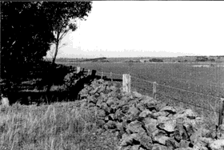ploughing may be effected.34

The stony ground, particularly over the western region of the Lara area, was also used to create dry stone walls. Some of these survive in Bacchus Marsh Road and Hams Lane today.

4.2 United Farmers’ Common of Little River & Duck Ponds
The passing of the Duffy Act in 1862 enabled the creation of farmers’ commons. They gave opportunities for farmers to graze stock for an annual licence fee. The United Farmers’ Common of Little River and Duck Ponds at the You Yangs was established in 1861 and gazetted in 1863.35
At the Corio Shire Hall at Duck Ponds in 1866, twenty‐two rules and regulations were passed.36 Managers had been appointed since the inception of the Common and in 1865 they were Francis Beech, James English and John Miller.37 English was replaced with Moodie Drysdale in
1867 and James Ramage was appointed in place of Francis Beech in
1868.38 However, English returned to the role in the ensuing years,
serving until at least the 1890s. He had originally settled at Lara in 1857.39

4.3 Lime Burning
The abundance of limestone at Lara brought about the creation of a
highly successful lime manufacturing industry. Impetus for establishing local lime burning activities came from a confluence of circumstances. Firstly, there was increased concern of the lime burning operation near the newly‐established Geelong Botanical Gardens at Limeburners Point. There, lime burning had been in operation since 1838.40 Secondly, the goldrush of the 1850s had created a building boom that increased the demand for lime.41 The material was essential in making mortar.

A lime kiln had been established at Lara beside the northern bank of Lara Lake as early 1853, as it was shown on J.L. Shaw’s Plan of the Village of Lara (see Figure 6.01). Other lime kilns had been created by 1861 at the

Figure 4.14: Dry Stone Wall, Bacchus Marsh Road, 1998. Source: David Rowe.

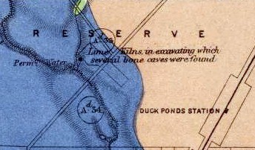
Figure 4.15: Lime Kilns at the confluence of Hovells Creek. Source: R. Daintree, Geological Survey of Victoria, No. 19, 1861
(published 1863), MAP RM2335/19,
National Library of Australia.

confluence of Hovells Creek (Duck Ponds) near the crossing of Flinders Avenue. They are shown on Daintree’s Geological Survey Map with the annotation “Lime Kilns in excavating which several bone caves were found.”

The Victorian Directory for 1868 listed six lime burners that were operating at Duck Ponds and beside the nearby Limeburners Bay to the south‐east of the Lara village.42 They included John Jenkins and the Melbourne Builders Lime and Cement company that was managed on its behalf by Robert Bell Walker.43 The kiln was 30 feet (9.1 m) high and it cost £300 to build. In 1878, Walker opened his own lime burning and crushing business in Walkers Road known as the Waverley Lime Works,44 although no physical evidence survives today. Walker had quarries in Kees Road and Curletts Road (behind the Holy Trinity Church).45 The name of the lime works – Waverley – originated from the name of the train station in Scotland, the birth place of R.B. Walker.46 In 1888, he had
‘worked up a good connection, sending away about 4000 bags per month.’47

David McHarry (senior) was another pioneer lime burner in Lara. He had arrived by 1868, having been listed in the Victorian Directory at that time. McHarry had previously taken up the position of foreman of lime kilns at Daylesford48 and so he possessed experience in the lime industry. At Lara, he commenced his own lime burning business at a time when the Melbourne Builders Lime and Cement Company had been established locally. According to Victoria and Its Metropolis in 1888, ‘… Mr McHarry declined to go into’ business with this company. ‘He had his lime tested by the Government, and it was declared to be of the first quality, the result being that his business began to increase at once, and he now ships some 8000 bags per month.’49 While McHarry owned a farm property at
125 Buckingham Street, it is not known whether he carried on lime burning from this location. It is known that he operated a kiln immediately north of Windermere Road and adjacent to Hovells Creek as in 1903, the ‘McHarvy [sic.] & Co. Lime Kilns’ were annotated on the Subdivision Plan of the Elcho Estate.

Other early lime burners included James Sullivan and John Spalding.50
The latter was to become a long‐standing resident of Lara. Spalding had emigrated from Suffolk, England in 1854 and in the following year he had established the first store and a butcher’s shop at Lara.51 He subsequently commenced operations as a lime merchant and proprietor of lime kilns in 1862 and in 1866 his sales had amassed a remarkable
52,887 bags.52 Spalding resided at “Limella Cottage”, 31‐45 Forest Road
South, although it is not known whether any lime burning operations were carried out there. James Spalding established the Lara Lime Works which became a successful industrial operation and local employer (see Theme 5 for further details).

Other lime burning operations were established by McClelland, Foot, Firth, Reeves and Fletcher, and James Spalding (Reeves and Fletcher being listed as lime burners of Duck Ponds in 1863).53 William Foot’s lime burning operations were nearby Hovells Creek, possibly on or near his

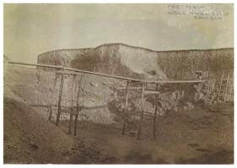
Figure 4.16: Waverley Lime Quarry, off Curletts Road near Holy Trinity Church, before World War 1. Source: Joan Wilks, Lara.

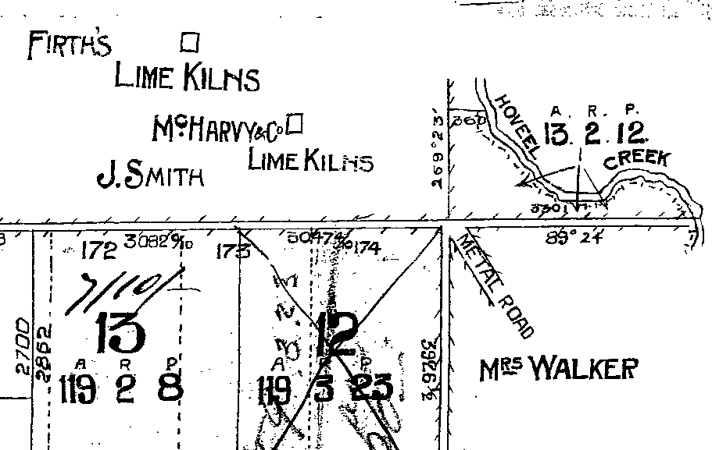
Figure 4.17: Lime Kilns of Firth, McHarry and Co. shown on Elcho Estate subdivision plan, 1 October
1903. Source: Map E12, Geelong
Heritage Centre.

farm property at 80 Gebbies Road. Today, there is only evidence of lime quarries near the banks of the Creek (remnant quarries being almost ubiquitous throughout the Lara area).

The success of the lime industry at Lara is recorded in 19th century newspapers. In 1883, The Argus reported that ‘the quantity of Lime forwarded from Lara to different parts of the colony this month was over
770 tons.’54 In 1894, the Bacchus Marsh Express commented that 6000
bags of lime were trucked from the Lara Railway Station and declared:

Thus it would appear that a rift is breaking in the cloud of depression that has hung over the country for so long, and that a gleam of prosperity is beginning to shine upon the building trade. The Lara lime is of a hydraulic character, and is largely used by the cement
manufactories.55

A lime burner who commenced business much later in the 19th century was James McClelland of ‘Clover Hill’. McClelland went in for lime crushing. In 1891, the Geelong Advertiser reported on his lime burning and crushing activities:

Mr. McClelland’s kilns are situated within a stone’s throw of the Lara creek, and are backed by several acres of limestone country. Although not in the business many years McClelland, jun., has shown any amount of enterprise in introducing the lime crushing machinery to Lara in order that he should be equal to outside competition, and place the product of his kilns upon the market in the condition most acceptable to buyers. He is satisfied with the results attained by the crusher, although the demand for lime is just entering upon a revival after the depressing influence [of
the collapse of the land boom].56

In addition to the use of lime for the making of cement, it was also produced as a fertiliser. The success of ‘liming the land’ was outlined in The Leader in 1916:

The advantages of applying agricultural lime to the soil have been well tested in this district. The examples are very marked, especially in the poorer fields, where, for instance, a crop of oats being grown for grazing and eventual harvesting for hay can be observed where it has been limed, showing up a bright green in color, thick and dense, some eighteen inches high, even now in the middle of winter, sharply defined up to where there has been no lime applied, and where the crop is short, scraggy and a dull, unhealthy yellow in color. This is quite in accord with the scientific position, the action of lime being partly physical, affecting the texture of the soil, and partly chemical, setting free the dormant
supplies of plant food.57

In 1904 and again in 1914, there were 11 lime burners listed in Wises’ Directory at Lara. The Lara Lime Company site and three kilns near Hovells Creek at 105 Blairs Road are all that appear to survive of the once‐ thriving lime burning industry. At 105 Blairs Road, the kilns are now in poor condition and there is little noticeable evidence of the tram line that once linked the kilns near Hovells Creek to Blairs Road.

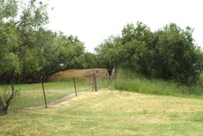
Figure 4.18: Lime quarry at 35
Gebbies Road, adjacent to Hovells
Creek, 2012.

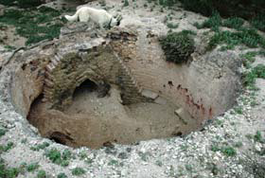
Figure 4.19: Lime kiln, 105 BLairs
Road, 2012.

4.3 Water Supplies
Public Supplies
In the early 1850s, a reservation was created to provide free access to
‘the permanent fresh water hole in the Duckponds.’ 58 The Geelong
Advertiser even reported on oysters being ‘in fresher condition’ at Cowie’s Creek or the Duck Ponds in 1855.59 Yet, the Duck Ponds and Hovells Creek could not be relied upon as a major water‐course.60
According to Trevor Pescott, the creek ‘is an ephemeral stream, dry for most of the time …61 Hopes were held for a water supply from the 39 acre fresh water lake that formed the centre piece of the Plan of the Village of Lara in 1853. In 1870, The Portland Guardian and Normanby General Advertiser declared that ‘the late heavy rains have filled Lake Lara, near the Duck Ponds, and it is estimated there is now sufficient water in it to supply the inhabitants for about five years.’62 However, this lake could not be relied upon and it had come under the ownership William McClelland as part of ‘Clover Hill’ farm. In the early 1900s, he dug a drain so that the water could be drained into Hovells Creek.63 Other water sources included some natural springs in the vicinity of the You Yangs (which in 1877 were reported to have dried up)64 and water holes that had been constructed in different parts of the Lara region by 1861.65

While a Water Reserve beside Hovells Creek was gazetted in 1872, its substantial distance from the Lara township appears to have made it impractical.66 Ten years later in 1882, as a consequence of complaints from the Victorian Railways Department about the condition of water supplied to the railway engines at Little River, W.H. Bullivant commenced initial discussions for a water supply for the Lara township from the Geelong reservoir supplies.67 Nothing was to eventuate from these preliminary discussions. Consequently in 1885, the Corio Shire Council commenced boring operations and in 1887 this provided a reliable and continuous water supply.68 It was located in Forest Road South in the vicinity of the Swimming Pool complex today.69 Private underground tanks and wells were also common throughout the area in the 19th century. However, the quality of the water was not satisfactory for human consumption, as outlined in the Geelong Times in 1891:

Complaints reach us of the scarcity of drinking water at Lara. Some of the residents have had to come in as far as the North Geelong standpipe, in order to obtain a supply for domestic purposes. Within a radius of a mile at Lara, 17 windlasses have been erected for the purpose of raiding water from wells sunk, but only brackish water is obtained, and this at a depth of from 15 feet to 20 feet. This water is useful for stock, which like it, and is said to suit for irrigation, but of course it is not fit for domestic
purposes70.

On 17 December 1947, Lara was connected to the main water supply for the Geelong region by the Geelong Waterworks and Sewerage Trust.71

Private Reservoirs
The scarcity of a reliable water supply led to some of the wealthy pastoralist and graziers to construct their own reservoirs. In 1861, a small dam was constructed in the small creek or depression situated on the
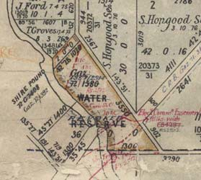
Figure 4.20: Water Reserve adjacent to Hovells Creek & the Melbourne Road. Source: Woornyalook Parish Plan, VPRS16171, Public Record Office Victoria.

Windermere (Pirra) property.72 By 1875, a large artificial reservoir, measuring 70 acres in extent, was established in the vicinity of the early dam.73 A channel was cut from the reservoir almost to the Little River to serve other parts or the huge holding.74 The reservoir has remained relatively unchanged to the present day. From the 19th century, the reservoir has not only served as a practical and much‐needed resource, but also for boating and its attractive sandy shores have provided a popular bathing location.75

At Wooloomanata, F.W. Armytage building a substantial reservoir on his property in 1882, on Hovells Creek. The proposal was described in the Geelong Times:

Mr Armytage, the owner of the Wooloomanata Estate at Lara, is having constructed at the present time on his estate, a reservoir which, when finished, will be the finest of its kind in the colony. It will be sixteen feet high, a mile in length, nine feet wide at the bottom, tapering to two feet at the top, the whole to be constructed of blue‐stone blocks. The work of constructing the reservoir is now going on, and will be of the utmost
service next summer.76

4.5 Forestry: The Timber Reserve
The burgeoning lime burning industry in the 19th century resulted in the
need for timber. The Little River and Duck Ponds Common and associated
forested land at the You Yangs were an ideal source to fuel the lime burning fires. The reserve took in Station Peak and the immediately surrounding land. In 1865, members of the Corio Shire Council became concerned about the extensive cutting of both dead and green timber and in 1866, 800 hectares was declared a timber reserve.77 A ranger was appointed in 1868 to police the reserve. In 1877, the timber reserve was increased to 2000 hectares and a tree planting program commenced in the following years.78 However, tree removal continued until a sustained tree planting effort commenced in the 1880s. By 1896, 480,000 trees had been planted including wattles to provide bark for leather‐tanning, willows for making baskets and bamboo to prevent erosion.79 The superintendent of the plantations was John Blair.80

With the establishment of the Forestry Commission in the 1920s, further reafforestation efforts of the Timber Reserve were made.81 Since the Second World War, many sugar and brown mallet trees have been planted. Habitats for native fauna were established by the Geelong Field Naturalists’ Society and the Bird Observers’ Club.82

Yet, since the 19th century and throughout the 20th century, the You Yangs has provided gravel for roads, timber for public sale and sand for the ready mix concrete market.83

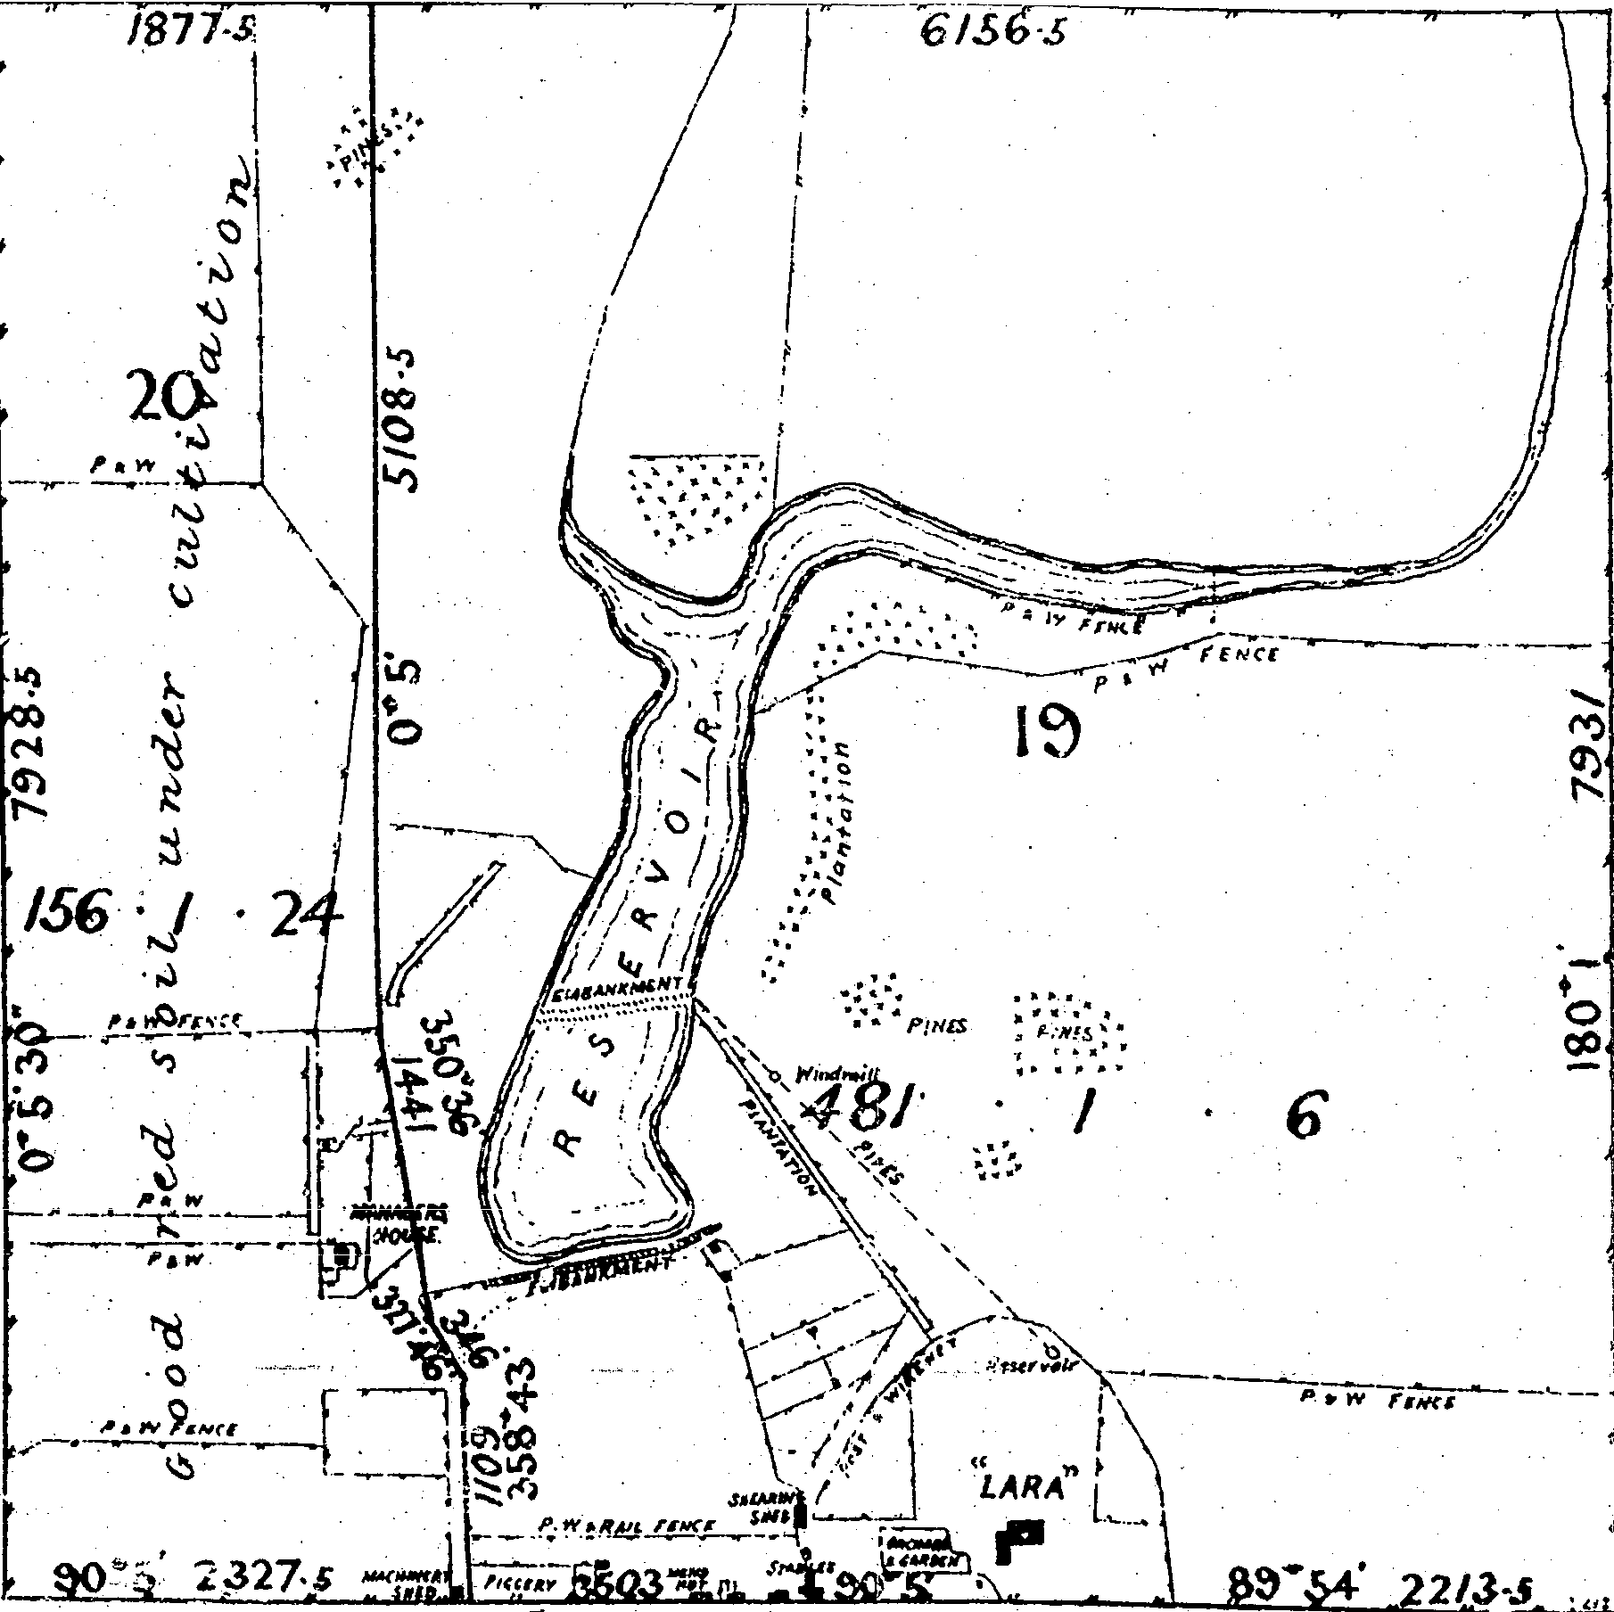

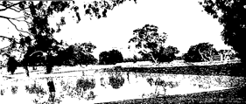Figure 4.21: Reservoir at Lara Homestead, 18 June 1907. Source: Land Purchase & Management Board Map, Victorian Land Office, Melbourne.

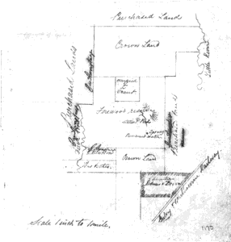Figure 4.22: Wooloomanata Reservoir, 1913. Source: Wooloomanata Estate Auction notice, 24 April 1913, Map 185, Geelong Heritage Centre.

Figure 4.23: ‘Firewood Reserve’ (large central rectangular portion), c.1860. Source: Historic Plans collection, no. 1174, PROV. See Appendix 11.01 for an enlarged image.
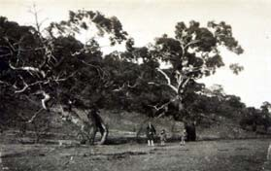
Figure 4.24: Trees at the foot of the
You Yangs, c.1925. Source: Holmes

collection, c/o David Rowe.

1 I. Wynd, So Fine A Country, Shire of Corio, 1981, p.74.
2 Details on these homesteads are given in Ibid. & HLCD Pty Ltd, ‘Avalon Homestead Complex’, Conservation Management
Plan, 2006.

3 Wynd, op.cit., p.74.
4 Genealogical research carried out by Darcy Seller on Robert Walker, December 1999, Corio Shire Rate Books 1865‐1959, Geelong Heritage Centre & Interview by Darcy Seller with Jack Darcy (recollecting information from George Harding, early
20th century).
5 Ibid.
6 Geelong Advertiser, 16 December 1958.
7 Ibid.
8 Shire of Corio Rate Books, 1869‐1957, Geelong Heritage Centre.
9 Ibid.
10 Ibid., 1870 & J. McGillivray, Land Application under Clause 42 of the amended Land Act, VPRS 627, Unit 270, Public Record
Office Victoria.
11 Corio Shire Rate Books, 1869, op.cit. & W. Harding, Land Application under Clause 42 of the amended Land Act, VPRS 627, Unit 238, Public Record Office Victoria.
12 P. Jennings’, Family Group Record for James English, November 2012, sourcing Victorian Birth Deaths and Marriages Indexes
& Geelong Cemeteries Trust Database, lists English’s second son, James, as having been born at Duck Ponds in November
1859. A. Sutherland, Victoria and Its Metropolis Past and Present, McCarron Bird & Co., Melbourne, 1888, CD edn., Archive CD Books Australia Pty Ltd, 2006, p.163, states that English had emigrated from England to Sydney, N.S.W. in 1857 before relocated to Lara after a short time.
13 Wynd, op.cit., p.81 & M. Budd, C. Delaney, J. Grainger (eds.), From Duck Ponds to Lara: A Collection of Memories, Lara
Heritage Festival Inc., Lara, 2004, p.30.
14 Shire of Corio Rate Books, op.cit., 1866‐67.
15 Ibid., 1876, 1891‐92.
16 Ibid., 1869‐70 & W. Foot, Land Application under Clause 42 of the amended Land Act, VPRS 627, Unit 130, Public Record
Office Victoria.
17 Corio Shire Rate Books, 1905‐1907, op.cit.
18 Ibid.,
19 Ibid. 1903‐1912, Bacchus Marsh Express, 8 October 1904, p.3 & Laird & Buchan, Architects, Contractors’ Book 27 May – 26
October 1907, Geelong Heritage Centre.
20 Laird & Buchan Architects, Contractors’ Book, op.cit., December 1906, p.155.
21 Corio Shire Rate Books, op.cit., 1900, 1906‐08.
22 Ibid., 1905‐08.
23 Ibid., 1906‐09.
24 The Argus, 4 March 1911, p.21.
25 Corio Shire Rate Books, op.cit., 1906‐10. See also Laird & Barlow, architects, Contactors’ Book, 1906, Geelong Heritage
Centre.
26 Wises’ Directory, 1914.
27 H. Spalding, ‘Lara, Collected Notes’, Geelong Heritage Centre.
28 Budd et.al., op.cit., p.163.
29 Ibid., p.162.
30 The Leader, 26 August 1916, p.6.
31 Corio Shire Rate Books, 1871‐74, Geelong Heritage Centre.
32 The Argus, 16 December 1902, p.9, lists Favre’s vineyard license for the first time.
33 Ibid., 10 August, 1909, p.8.
34 Bendigo Advertiser, 7 July 1877.
35 Victoria Government Gazette, vol. 13, 5 February 1863, p.286.
36 Ibid., vol. 57, 18 May 1866, p.1086.
37 Ibid., vol. 88, 18 July 1865, p.1580.
38 Ibid., vol. 107, 1 October 1867, p.1875.
39 Wynd, op.cit., p.548.
40 J. Harrington, An Archaeological and Historical Overview of Limeburning in Victoria, Victorian Heritage Council, 2000, p.32.
41 Ibid.
42 Ibid. See also J. Harrington, ‘The Lime‐Burning Industry in Victoria: An Occupance Approach’, Australian Historical
Archaeology, vol. 14, 1996.
43 Harrington, An Archaeological and Historical Overview, op.cit.
44 Sutherland, op.cit., p.170.
45 Budd, et.al., op.cit., p.161.
46 J. Wilks, grand‐daughter of David Walker, to J. Hurse, City of Greater Geelong, 14 November 2012.
47 Sutherland, op.cit.
48 Ibid., p.165 & Harrington, op.cit.
49 Sutherland, op.cit.
50 Harrington, op.cit.
51 Sutherland, op.cit., p.169.

52 Ibid. & Spalding, The Lara Lime Company 1874‐1974, Geelong Heritage Centre.
53 Geelong Advertiser, 18 April 1863.
54 Ibid., 1 August 1883, p.5.
55 Bacchus Marsh Express, 4 August 1894, p.3.
56 Geelong Advertiser, 10 June 1891.
57 The Leader, 26 August 1916, p.6.
58 Wynd, op.cit., p.71 & T. Pescott, The You Yangs Range, Yaugher Print, Belmont, 1995, p.13
59 Geelong Advertiser, 3 July 1855.
60 Wynd, op.cit., & Pescott, op.cit.
61 Ibid.
62 The Portland Guardian and Normanby General Advertiser, 11 July 1870.
63 A.W. Mathieson, My Reflections on 77 Years in Lara, Lara Heritage Festival, 1985, p.26.
64 Williamstown Chronicle, 1 December 1877, p.3.
65 See R. Daintree, Geological Survey of Victoria, No. 19, 1861 (published 1863), MAP RM2335/19, National Library of Australia.
66 Victoria Government Gazette, vol. 57, 23 August 1872, p.1580.
67 The Geelong Times, 2 November 1882.
68 Budd, et.al., op.cit., p.57.
69 Ibid.
70 The Geelong Times, 23 February 1891.
71 L. Edmunds, Living By Water: A history of Barwon Water and its predecessors, Barwon Water, 2005, p.162.
72 ‘Almond Orchard Novel Feature of Serendip’, Geelong Advertiser, 7 October 1958.
73 Ibid.
74 Ibid.
75 Ibid.
76 Geelong Times, 2 November 1882.
77 Pescott, op.cit., p.78 & Victoria Government Gazette, vol. 12, 30 January 1866, p.236.
78 Pescott, op.cit.
79 Ibid.
80 Ibid.
81 Wynd, op.cit., p.249.
82 Ibid.
83 Ibid.

5. Building Lara’s Early Industries, Workforce & Entertainment Venues Lara’s farming and lime burning sector provided much of the industrial development in the 19th and early 20th centuries. Another extractive industry was also established: Cheetham Saltworks at Avalon. Commerce
played an important role in the establishment of village life, initially near the intersection at Lara Lake that is now known as Sixways. As a rural village, the temperance hall and later the public hall provided meeting places for entertainment and other social activities.

5.1 Manufacturing from the Land
Lara Lime Works
Lime burning was an important industry in the Lara region from the earliest years of its settlement as outlined in Theme 4. Larger lime works operations were created that became important sources of employment.

Waverley Lime Works
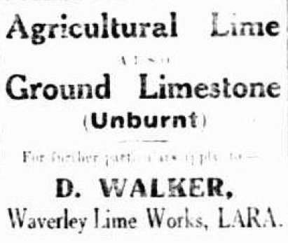Waverley Lime Works was established 1878 in Walkers Road by Robert Bell Walker. In 1891, Walker’s operations were described in the Geelong Advertiser:

Mr R.W. Walker [sic.], whose annual output is something considerable, has erected one of Buncle’s machines, similar in general principle to the bark crusher by the same maker. It is worked by a twelve horse‐power steam‐engine, and pulverises and bags the lime at the rate of 60 to the hour. Each bag contains 1½ cwt. of crushed lime, the price of which, landed on the railway station is 1s 8d. Mr Walker has a large area of limestone to work upon, and has five kilns burning. The kilns are 30 feet in circumference, with a depth of 13 feet, and use up a large amount of firewood when in operation, over 300 tons of that fuel being consumed yearly in addition to coal. The material from Mr Walker’s kilns’ is sent all over the country, but he finds his principal market in the metropolis. It has been used in the erection of the public buildings, and Mr Walker is at present supplying a contract in connection with the Spencer‐street railway viaduct to connect the Spencer‐street and Flinders‐street
stations.1

Upon his death in 1899, R.B. Walker’s property was described as having a four‐roomed stone dwelling, engine shed and outbuildings on 43 acres of land.2 The property and Lime Works business was continued by Walker’s son, David. After his death in 1945, the business was taken over by his son, Albert Alexander Walker.3 In the second half of the 20th century, the Waverley Lime Works closed. There is no immediate evidence of this once thriving industrial business in Walkers Road today.

Lara Lime Works4
James Spalding (son of the Lara pioneer, John Spalding) developed the Lara Lime Works at 45 Forest Road North in c.1874‐75. The building boom in Melbourne was the main reason for this extensive lime quarry and burning. Except for bagging, the rest of the work was carried out in the open. The stone was quarried next to the existing works at that time by the use of explosives. At a later date, further deposits of stone were brought some distance to the works. The original crushing plant was driven by horses, later by oil engine, suction gas and eventually,

Figure 5.01: Waverley Lime Works Advertisement, 1927. Source: Morwell Advertiser, 10 June 1927, p.4.

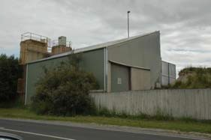
Figure 5.02: Former Lara Lime
Company, 45 Forest Road North,
2012.

electricity. The works need skilled burners to make good oxide lime, and the stone had to be man handled with pick and shovel through sieves before passing into the kilns. The Lara Lime Company continued to be owned and operated by James Spalding until about the early 20th century, and in 1917‐19, Mary Ann Spalding was listed as the owner and operator. She was recorded in this capacity until the 1940s, when the works were listed as being owned by the Trustees of A.J. Spalding. In about 1991, the Lara Lime Company was sold to a subsidiary of the Lilydale Lime Company, and it continues as the only lime works in operation in Lara today.

Mitchell’s Works
In 1908, David Mitchell of the well‐known Cave Hill Lime Works at Lilydale purchased 10 acres at Lara for establishing a lime and cement works. It was estimated that Mitchell’s works would employ 150 men but it is not known whether the plan eventuated.5 Mitchell did however lease part of the Clover Hill farm of William McClelland at 155 Forest Road South for lime quarrying.6

Chaff Mills
The 1880s witnessed new developments in farm machinery and
technologies associated with harvesting methods. Hugh Victor McKay
‘refined an earlier efficient but unreliable harvester that combined stripping and winnowing into a workable, light but strong machine that would deliver grain in bags.’7 In 1885, he patented the well‐known Sunshine Harvester which was originally manufactured in Ballarat.8

It was also by the end of the 1880s when mechanization had been widely adopted on Australian cropping farms which resulted in considerably larger cropping areas. Part of the mechanization of the post‐harvesting process was the development of Chaff Mills in Victoria from the 1860s.9
Chaff (made from hay) was the main fuel for horse‐drawn vehicles and farm implements in the 19th century and until the Second World War.10
Chaff was one of the primary sources of food for working horses, together with oats, maize, barley and wheat.11 The wide production of reapers for harvesting hay brought with it the need for chaff cutters. While mobile chaff cutting machinery was manufactured in large numbers by two Melbourne companies: John Buncle and Cliff and Bunting; Chaff Mills were also established to cater for the demands for chaff by transport companies, bakeries, dairies, breweries and other delivery agents.12

Commonly situated nearby railway lines as a cheap and efficient method of transportation of the chaff, Chaff Mills were predominantly constructed in Victoria (and particularly the region west of Melbourne, Geelong and Ballarat) from the 1880s until the 1920s.

While the production of the motor car became more popular and affordable in the early‐mid 20th century, the onset of the Second World War between 1939 and 1945 brought with it a need for chaff. Shortage of motor fuel resulted in the retention of horse drawn vehicles and farm horses.13 However the period after the war witnessed a decline in chaff

milling.14

At Lara, a Chaff Mill was established in the early 1900s by Harry Lyall. Situated in Mill Road adjacent to the Railway Station, most oaten hay from the nearby farms was sold to Lyall’s Mill.15 Difficulties arose in freighting the chaff. In 1910, the Argus reported that:

Lara farmers complain of the difficulty of securing empty trucks for produce freight at the district station. On Saturday eight wagon loads of chaff were drawn up in the yard awaiting trucks which had been ordered three and four days before.16

The demand to freight chaff from the Lara Railway Station is also confirmed by Harold Spalding, who indicated that in the 1920s the Lara Railway Station ‘was a very busy place, sometimes loading nearly a train load of hay and chaff in one day.’17 In 1929, Lyall’s Mill was completely destroyed by fire.18 The Geelong Advertiser reported the disaster:

Damage estimated at £5,000 was caused when a corrugated iron building in the Railway yards at Lara owned by Lyall and Son was completely gutted by fire on Tuesday afternoon. Two hundred tons of hay and two machines recently installed with the complete plant were also destroyed.19

Lyall’s Mill was rebuilt and continued to be an important business in Lara throughout the 20th century although demand for chaff subsided with the rising popularity of the motor car after World War Two.20 The mill was sold to the Geelong Cressy Company and it operated until it was destroyed by the Lara bushfires in 1969.21 The buildings were replaced with the existing Grain Mill.22

Travelling chaff‐cutters were also numerous in Lara.23 One mobile operation was that of J. Reynolds and Son.24

5.2 Dairy Production
The dairy farmer of Springbank Farm and Dairy at Mt Egerton, David Wilson, transformed the agricultural pursuit of dairy farming in Victoria into a recognised, scientifically‐controlled and regulated production industry. Keenly interested in improving practices and quality control, he made a systematic study of dairying.25 Not surprisingly, he was one of the first to import a De Laval cream separator for farm use, having read in a Scottish newspaper of its success in Denmark and Sweden.26

Wilson’s greatest achievement came when he was appointed State dairy expert in 1888.27 He superintended the Victorian Government’s model dairy at the Centennial International Exhibition and in the following year he travelled throughout northern and western Victoria with Alexander Crawford demonstrating the cream separator and instructing farmers in its operation.28

Small creameries with separators were subsequently established throughout the Victoria in the 1890s as part of a broader, mechanised and regulated system of dairy production connected with butter

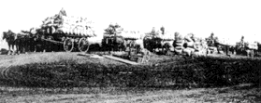
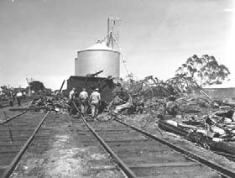Figure 5.03: Chaff wagons at the Lara Railway Station, n.d. Source: From Duck Ponds to Lara, p.147.

Figure 5.04: Railway officials inspect damaged Chaff Mill Silos after Lara bushfires in 1969. Source: National Library of Australia, accession no. A1200‐19.

factories. Local farmers delivered milk to these creameries for separation.

At Lara, a creamery was established in 1892 by the Model Dairy Company.29 Its success was to be short‐lived as it closed temporarily, as outlined in The Queenslander newspaper in 1897:

The creamery at Lara, worked by the Model Dairy Company, will be started again shortly. The company were anxious tor the farmers to take over the creamery, and work it themselves on the co‐operation principle; but notwithstanding all that has of late been written about farmers' co‐ operation, the farmers in this district do not seem to favour it. They prefer to allow the factory proprietors to take all risk, and there is not the least doubt the prices that have been paid by the manufacturers are more than the farmers could command had they the Industry in their own hands. Fat cattle are now scarce in the district, and there is also a
very great demand for store cattle.30

5.3 Other Industries
Other industries were also established in the Lara region. They too were largely extractive industries. Carting shell grit from Avalon beach to the railway station was a once thriving business by the Dando family.31 They had settled near Point Wilson in the 1890s. According to A.W. Mathieson in My Reflections on 77 Years in Lara:

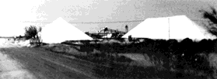Firstly, by horse and wagon and after by motor vehicles … thousands of tons of shell grit were sent by rail, mainly to glass works.32

In 1951, the Cheetham Salt Company put in salt pans on the foreshore at Avalon Beach, Avalon.33 It was an extension of the company’s original operations established near Point Henry in 1888.34

5.4 Commerce
Although Lara became a successful farming and lime burning region from the 1850s and 1860s, commercial development was less ubiquitous. The village was a service town for the outlying rural farms and industries from the 19th century, with general stores, grocers, bakeries and butchers having been established, along with a small number of hotels.

As outlined in Theme 6, there were two village centres at Lara: one at Lara Lake and the other near the railway station. The earliest to be established was in 1855 by John Spalding. A second earlier store keeper was James Henderson. He established a store in 1867 that was to become part of the Lake Bank Hotel (first built in c.1859 as part of Cheddar Farm).35 In 1869 the Bacchus Marsh Express reported on the premises being considerably enlarged.36 Other businesses followed. In
1884‐85, Wises’ Postal Directory listed three storekeepers in the Lara region. Jane Henderson and John Spalding operated stores in the Lara portion of the township, while at Lara Lake Mrs Euphemia Henderson was operating a store there, having taken over the shop adjoining the Lake Bank Hotel that had been owned by her husband, James. In 1888, George McClelland, son of William McClelland of ‘Clover Hill’, Lara Lake, opened a bakery.37 This business continued until at least the early 1890s.38 In

Figure 5.05: Salt stacks at Avalon, c.1981. Source: Wynd, So Fine a Country, p.107.

1888‐89, the Wises’ Directory also listed John Blair as a storekeeper at Lara Lake and by 1899‐1900 the business was being operated by Mrs Blair.39 John Branch had opened a butcher’s shop at Lara by 1891‐92 and he was followed by Benjamin Duggan by 1895‐96 (also at Lara) and William Murrie at Lara and Peter Armour at Lara Lake by 1899‐1900.40

Two separate commercial centres continued in the early 20th century. In
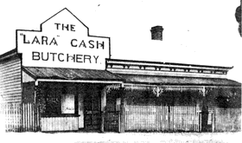1904, Wises’ Postal Directory listed six commercial operators at Lara, all in the Lara Lake area. They were Walter Abley (greengrocer), Mrs Blair (storekeeper), Alfred J. Spalding (storekeeper), Charles Taylor (storekeeper) and Margaret Walker (baker). By 1914, three commercial operators were recorded in the vicinity of the railway station (Lara) in Wises’ Directory. They were Thomas Stewart (butcher), Arth Strong (storekeeper) and Thomas Winstanley (butcher). At Lara Lake, those listed were Mrs Blair (storekeeper), E.G. Loft (baker), F. Samblebe (baker) and T. Stewart (butcher).

Sixways Commercial Development
The earliest commercial development in Lara was situated at Lara Lake, at the intersection now known as Sixways.

First General Store
The first general store was established by John Spalding in 1855 at the corner of Forest Road South and Patullos Road.41 By 1880, he had built a butcher’s shop on the same site and the grouping of buildings included the post office (see Theme 3).42 After the death of John Spalding in 1893, the General Store was taken over by his son, Alfred, and it was later leased to James Gillespie.43 Alfred Spalding had operated a blacksmith’s shop further south along Forest Road from 1877 (this building was recently demolished).44

Other Stores at Lara Lake
In c.1906, William McClelland of ‘Clover Hill’ farm built a timber house and shopfront at 3 Forest Road South which he leased to the Commercial Bank.45 The Bank used the premises as a banking agency, with the Manager travelling from Geelong by train each day to attend to the business.46 When the bank closed in 1921, the building was taken over by Williams McClelland’s sons, Abraham and Robert.47 The latter son opened a butcher’s shop soon after the closure of the bank, known as the Lara Cash Butchery.48 This building has been demolished in recent times.

A rival butcher’s shop was established by a Mr Branch in the early 1900s at the corner of Flinders Avenue and Kees Road.49 It became a fruit and vegetable shop after it was acquired by a Mr Barnes whose daughter Ruby, and her husband, Allan Mathieson, operated it between 1932 and
1957.50 This building was later removed.

The only surviving building related to commercial activity in Lara Lake is the south wing of the former Lake Bank Hotel at 120 Forest Road South. It may represent the addition of 1869 as reported in the Bacchus Marsh Express (the earlier portion of the building having been constructed in
1861). It was initially owned by James Henderson with Mrs Euphemia
Figure 5.06: Lara Cash Butchery, c.1925. Source: Mathieson, My Reflections on 77 Years in Lara, p.31.
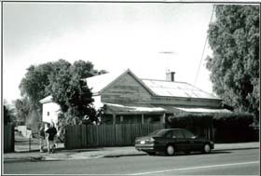
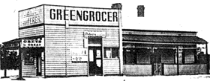Figure 5.07: Former Lara Cash Butchery, 1998. Source: David Rowe.

Figure 5.08: Mathieson’s Fruit & Vegetable Shop, corner Flinders Ave
& Kees Rd, n.d. Source: Mathieson, My Reflections on 77 Years in Lara, p.30.

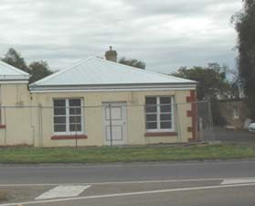
Figure 5.09: Former Grocery Store, Lake Bank Hotel, 2012.

Henderson operating the grocery store after James Henderson’s death in
1873.51

Commerce at Lara (railway station vicinity)
In addition to the stores and butcher’s shops established at Lara in the
19th century, it was between 1904 and 1914 when Arth Strong’s General
Store, Thomas Stewart’s butcher’s shop and Thomas Winstanley’s butcher’s shop were first listed. Strong’s General Store appears to have been established in 1910.52 A second general store with post office was built by James Murray next the railway station in Walker Street.53 In
1926, the store was damaged by fire and soon rebuilt, as in 1927 it was sold to James Gillespie who had previously operated a store at Lara Lake. Gillespie employed a Mr Anderson as manager and in 1944 he became the owner. It was later purchased by Don Walker (who had worked at the store since its ownership by Murray) and he continued business there until 1959.54 The building was later demolished.

The only surviving commercial building in the original Lara portion of the township is the noticeably altered General Store at 14 Hicks Street. It was built in c.1918 by the Spalding brothers and leased to Rupert Gillett, hairdresser.55

Bakeries
Throughout the 19th and early 20th centuries, Lara was serviced by at least
three bakeries, all at Lara Lake. As early as 1866, a timber bakery with attached dwelling had been established in Forest Road South, opposite Spalding’s General Store. In c.1925 it was known as Morgan’s IXL’s Bakery and at about this time it was operated by Frank and Ann Foot.56
The building has subsequently been demolished.

At the corner of Forest and Kees Road, the Samblebe family established a bakery after 1904. It was sold to a Mr Ran in the 1920s and later removed when flats were built.57

The only surviving early bakery building at Lara today is the former Walker’s Bakery at 80 Gebbies Road. It forms part of the cottage farm complex first established in 1870 by farmer and lime burner, William Foot. It appears that the bakery was established by Mrs Margaret Walker after the death of her husband, George, in 1900.58 She operated the bakery until her death in the early 1920s.59

5.5 Entertaining & Socialising
Hotels
Apart from churches, hotels were one of the earliest locations for entertaining and socialising, particularly for those residents and travellers not part of the temperance movement. These buildings were important to the early development of the fledgling Lara township: as accommodation houses for board and lodging; meeting rooms for public gatherings; and equally importantly, as venues for entertainment including balls, concerts, weddings and other family and community celebrations.

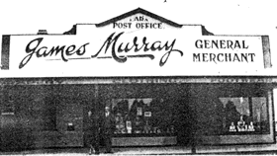Figure 5.10: James Murray’s General Store & Post Office, n.d. Source: Mathieson, My Reflections on 77
Years in Lara, p.32.

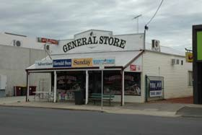
Figure 5.11: General Store, 14 Hicks
Street, 2012.

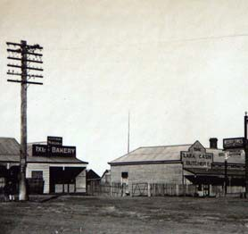
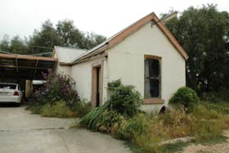Figure 5.12: Morgan’s IXL’s Bakery (left) & Lara Cash Butchery (right), c.1925. Source: Holmes collection, c/o David Rowe.

Figure 5.13: Former Walker Bakery,
80 Gebbies Road, 2012.

Robin Hood Hotel60
Lara’s first hotel was the Robin Hood, established in 1858. It was the Cobb and Co. coach stop for picnic groups en route to the You Yangs. Situated near the Melbourne Road, it was demolished in the 1950s to allow for the duplication of the highway.

Barracks Hotel61
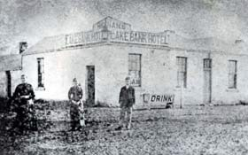The Barracks Hotel, located on the Clover Hill estate on the site of the existing St. Laurence Park retirement village, was opened in 1860. However, it was demolished in 1866 when the land (and including the hotel) had been purchased by William McClelland.

Lake Bank Hotel
At 120 Forest Road South, James Henderson established a “beer shop” in in 1867 in the former Cheddar Farm cottage that had been built in c.1859. He had established a store at this address in 1865.’62 The building was
‘considerably enlarged’ in 1869.63 The hotel was operated by Elizabeth
Helliar from 1872. By 1875, Mrs Henderson was the storekeeper.64 It was
once the last Cobb and Co. stop before Cowies Creek.65 The hotel portion
of the building was subsequently leased to a Mrs Elizabeth Hennan
between 1884 and 1886, before being taken over by her son in‐law, David McHarry Junior.66 In 1909 it became a private residence.67 A small stone shelter in the wall once provided overnight shelter for swaggies and impoverished travellers, particularly during the Depression years.68 The Lake Bank Hotel is the last of the 19th century former hotel building surviving in Lara today.

Lara Hotel, Hicks Street69
Formerly Colenso’s Hotel that opened in Waverley Road in 1912, the Lara Hotel was relocated in three pieces in 1915 after complaints by parishioners of the neighbouring Presbyterian Church (now the Community Centre). This hotel building has subsequently been replaced.

Public Buildings
Lara Hall
A venue not associated with hotels that was a focus for community recreation was the Lara hall. Situated at the north‐west corner of the Sixways on a site donated by D. McHarry,70 the first timber hall was erected in November 1886 for the Lara Hall Company.71 It had been designed by the Geelong architect, Joseph Watts.72 The Lara Hall company was owned by shareholders and in 1921 its secretary was David Walker.73 The hall appears to have had a hipped roof with a front door to the main road and an ante room and fireplace at the rear (which represented a later addition.74 In 1922, the hall was replaced with the existing timber building.75 In 1956, the Corio Shire Council purchased the hall from the Lara Hall Company. A kitchen and supper room extension was carried out in 1968.76 Further additions were made in later years.

The Lara Hall provided a much‐needed social hub. Dancing was a popular recreation pursuit as outlined in From Duck Ponds to Lara:

Figure 5.15: Hennan’s Lake Bank Hotel, n.d. [c.1884‐86]. Source: GRS2009, Geelong Heritage Centre.

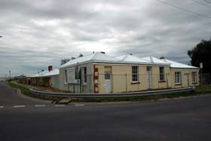
Figure 5.16: Lake Bank Hotel, 129
Forest Road South, 2012.

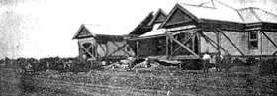
Figure 5.17: Newly relocated Lara Hotel in Hicks Street, 1915. Source: Mathieson, My Reflections on 77
Years in Lara, p.34.

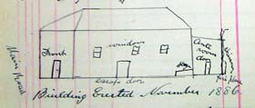
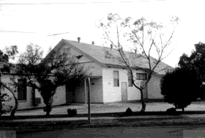Figure 5.18: D. Walker, Sketch plan of old Lara Hall, 1921. Source: VPRS7882/P1, Unit 358, PROV.

Figure 5.19: Lara Public Hall, 1998. Source: David Rowe.

Dancing was the greatest entertainment for most people between 1920 and 1950. Dances were held nearly every Saturday night. Music ranged from an accordion to a four piece Orchestra … Most sporting clubs and other organisations held an Annual Ball with a homemade supper.77

Other events held in the hall included movie pictures, roller skating, and
Debutante Balls.78

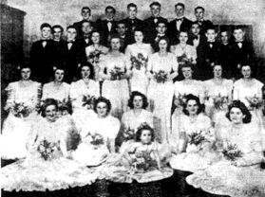
Figure 5.20: Debutante Ball, 1946. Source: From Duck Ponds to Lara, p.70.

1 Geelong Advertiser,10 June 1891.
2 ‘Statement of Assets and Liabilities’, Probate Jurisdiction in the Will of Robert Bell Walker, 28 July 1899, VPRS 28, P0002, Unit
1522, Public Record Office Victoria.
3 Corio Shire Rate Books 1945 & 1954, Geelong Heritage Centre, & Camperdown Chronicle, 27 July 1945, p.7.
4 Sutherland, Victoria & Its Metropolis, Past & Present, McCarron Bird & Co., Melbourne, 1888, CD edn., Archive CD Books Australia Pty Ltd, 2006, p.169 & Spalding, The Lara Lime Company 1874‐1974, Geelong Heritage Centre . All information on the Lara Lime Company is taken from Spalding.
5 The Argus, 30 December 1908, p.7.
6 Corio Shire Rate Books, 1900‐34, Geelong Heritage Centre.
7 See ‘Technology in Australia 1788‐1988: The Development of Appropriate Technology, Chapter 1, pp.13‐14, Importation, adaptation and innovation in cropping, Chapter 1, pp.15‐16, The Effects of the Gold Rush – Ballarat in Particular’, Chapter 12, pp.833‐834, http://www.austehc.unimelb.edu.au/tia.html

8 Ibid.
9 Ibid.
10 G. Vines, ‘Chaff‐Mills in Melbourne’s West: An Industrial Sites Study’, prepared for Melbourne’s Living Museum of the West
Incorporated, February 1987, p.3.
11 G. Vines, ‘Chaff‐Mills in Melbourne’s West’, historical brochure produced for Melbourne’s Living Museum of the West, funded by the Ministry for Conservation, Forests and Lands, Melbourne, 1987.
12 Ibid.
13 Vines, Industrial Sites Study, op.cit., p.23.
14 Ibid., pp.23‐24.
15 M. Budd, C. Delaney, J. Grainger (eds.), From Duck Ponds to Lara: A Collection of Memories, Lara Heritage Festival Inc., Lara,
2004, p.162.
16 The Argus, 29 August 1910.
17 H. Spalding, ‘Lara – Collected Notes’, manuscript, Geelong Heritage Centre.
18 Geelong Advertiser, 26 December 1929.
19 Ibid.
20 Mathieson, op.cit., p.36.
21 Budd, et.al., op.cit.
22 Ibid.
23 Spalding, op.cit.
24 The Camperdown Chronicle, 29 April 1919, refers to J. Reynolds and Sons’ Chaffcutter at Lara in reporting a narrow escape of a serious accident to S. Charles who was ‘snicked’ by the fly wheel of the engine. Although not seriously injured, he was ‘out of action for some weeks.’
25 K.T.H. Farrer, ‘Wilson, David (1830?‐1899), Australian Dictionary of Biography, vol.12, Melbourne University Press, 1990,
pp.519‐520.
26 Ibid. & Huggins, J. Huggins, ‘David Wilson 1831‐1899: Dairy Expert to the Victorian Government’, in The Settler: Official Quarterly Newsletter of the Ballan Shire Historical Society, vol.4, no.7, March 1997, pp.3‐4. For further details on the De Laval cream separator, see N. Godfold, Victoria – Cream of the Country: A History of Victorian Dairying, Dairy Industry Association Australia, Victorian Division, Hawthorn, 1989, p.15, 55‐56.
27 Ibid.
28 Ibid.
29 I. Wynd, So Fine A Country, Shire of Corio, 1981, p.81.
30 The Queenslander, 11 September 1897, p.522.
31 Mathieson, op.cit., p.37.
32 Ibid.
33 Ibid.
34 Wynd, op.cit., p.107.
35 Geelong Advertiser, 24 Septmeber 1860 & Certificates of Title for the property, Land Titles Office, Melbourne.
36 Bacchus Marsh Express, 3 April 1869.
37 Geelong Advertiser, 1 November 1888.
38 George McClelland was listed as a baker in Wises’ Directory for 1891‐92 but not in 1895‐96.
39 Wises’ Directory, 1888‐89, 1899‐1900.
40 Ibid., 1891‐92, 1895‐96, 1899‐1900
41 Sutherland, op.cit.
42 Budd, et.al., op.cit., p.143.
43 Ibid., p.145. See also The Argus, 24 May 1893, p.6 for the death of John Spalding. Further details are also given in Theme 6.
44 Corio Shire Rate Books, 1867‐70, 1876, 1877, 1879. According to Wynd, op.cit., p.152, the limestone for the blacksmith’s shop was the remnants of the former Primitive Methodist Church built in1854 in Forest Road North.
45 Corio Shire Rate Books, 1903‐06 & Mathieson, op.cit., p.31.
46 Ibid.
47 Corio Shire Rate Books, 1921‐22, 1926‐27.
48 Ibid.
49 Budd, et.al., op.cit., p.147.
50 Ibid.
51 Ibid., p.155 7 & Corio Shire Rate Books, 1867, 1875. Further details are given in the heritage citation for the Lake Bank Hotel.
52 Mathieson, op.cit., pp.32‐33.
53 Ibid.
54 Ibid.
55 Ibid., pp.35‐36 & Corio Shire Rate Books, 1918‐23.
56 See name and date of establishment of business on Figure 3.06 & Budd, et.al., op.cit., p.146.
57 Ibid., p.147.
58 ‘George Walker Probate Jurisdiction’, 16 February 1900, VPRS 28, P0000, Unit 947, Public Record Office Victoria.
59 Budd, et.al, op.cit., p.148.

60 Ibid., p.155.
61 Ibid.
62 Corio Shire Rate Books, op.cit., 1867‐68.
63 Bacchus Marsh Express, 3 April 1869, op.cit.
64 Wynd, op.cit. Budd et.al., op.cit., claims that the Lake Bank Hotel was built in 1861.
65 Budd, et.al., op.cit.
66 Corio Shire Rate Books, 1884‐1887, op.cit.
67 Budd, et.al., op.cit.
68 Ibid.
69 Ibid.
70 Geelong Advertiser, 18 September 1886.
71 ‘Public Hall, Flinders Avenue, Lara Lake’, Public Building file no. 2010, VPRS7882/P1, Unit 358, Public Record Office Victoria.
72 Geelong Advertiser, 13 December 1886.
73 ‘Public Hall, Flinders Avenue, Lara Lake’, op.cit.
74 Ibid.
75 Ibid.
76 Ibid.
77 Budd, et.al., op.cit., p.68.
78 Ibid., pp.68‐70.

6. Building the Lara Region
6.1 The Towns
Lara1
Lara was the result of three subdivisions of land earlier held by squatters and pastoralists. In 1853, J.E. Bates offered Section 15 A of the parish of Moranghurk in lots varying from one to three acres as the village of Lara to the south of the Duck Ponds. A centre piece of the village layout was the Lara Lake, comprising 39.5 acres of fresh water. An advertisment by J.B. Hutton for this subdivision ‘stressed its closeness to the proposed railway station, the abundance of water and building materials (stone and lime), and concluded “there is not a more fravoured locality in the colony for a township”.’2

Simultaneous to the Lara Village subdivision was the sale by James Austin of the Cheddar Farms and Cheddar Township sale to the west while on the east John Highett had created the township of Swindon, the streets of which were named for famous scientists and engineers. This flurry of subdivisional activity was prompted by the fact that the Geelong‐ Melbourne railway was to run through the area and both Bates’ and Highett’s plans show a railway station, though in different locations. Thus there were three names for the locality which was already known as Duck Ponds (from Duck Ponds Creek ‐ today’s Hovells Creek). It was not until
1874 that the name Lara was officially proclaimed and the boundaries of the town laid down. The early commercial settlement at the corner of Forest Road South and Patullos Road was outside the newly‐proclaimed town boundary. Derived from separate private subdivisions, this caused two disparate town settlements to form. This was reflected in the substantial geographical distance between the first Post Office in Forest Road South on the west side of Hovells Creek and the Railway Station that had been located to the north‐east on the east side of the Creek. It was also reflected in the differing names of these key infrastructure buildings: the Post Office was known as Hovells Creek and the station as Duck Ponds. Even Bailliere’s Victorian Gazette for 1879 described Lara as a
‘postal township’ with a railway station and yet with ‘adjoining small villages of Cheddar, Swindham [sic.] and Gheringhap to which there are horse tracks only.’3

The first buildings in Lara appear to have been hotels. The Robin Hood, described as being at Duck Ponds but situated in James Austin’s subdivision of Lanercost on the Melbourne Road, was opened by William Grass but closed after two years. Longer lasting was the You Yangs Hotel, built by William Bragg to take advantage of the opening of the Geelong‐ Melbourne railway in 1857. He catered for picnic parties and ran horse races on a course adjoining the hotel. In 1861 the Lakebank Hotel was opened and continued in business until 1908.

By 1882 Lara had a state school, three churches and a population of about 200. The first church was built by the Primitive Methodists in 1854 in Forest Road, north of Hovells Creek. When the centre of population moved further south down Forest Road, a new church was erected in
1868; it still stands next to the Lara Lake school but is no longer in use as
a church. Although they had been active in the area from the 1850s,

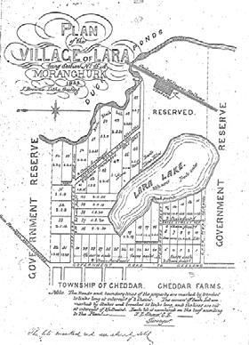
Figure 6.01: J.L. Shaw, Plan of the
Village of Lara, 1853. See Appendix
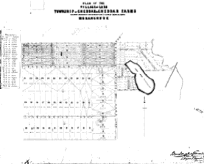11.01 for enlarged image

Figure 6.02: Plan of the Village of Lara, Township of Cheddar & Cheddar Farms, c.1855. See Appendix 11.01 for enlarged image.

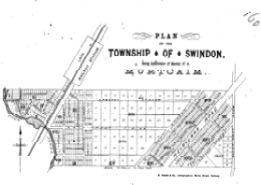
Figure 6.03: Plan of the Township of
Swindon, c.1855. See Appendix
11.01 for enlarged image.

Anglicans did not build a church until 1877 when Holy Trinity was constructed. This building was destroyed in the 1969 bushfires but part of it has been retained as a memorial.

The first recorded school in Lara township was established at Lara Lake in
1864. Apparently it was already operating in a stone building 12 feet by
13 by 8 when a committee successfully obtained Government assistance. A school to hold forty pupils was erected immediately and a residence for the teacher followed in 1871. In 1873 brick additions allowed the school to accommodate 120. The school too was destroyed in the 1969 bushfires. While first in the town, the school was not the first in the district. In 1855 a school was established at the You Yangs by the Anglicans; it was variously known as Station Peak, Duck Ponds and Flinders Peak. When the Common School system was introduced in 1862, it became No. 188 Duck Ponds. After the 1872 Education Act the building was rented to the Education Department and still used for services on Sundays. Eventually the Department bought the building which became State School No. 2107.

Lara had one significant advantage over other settlements in that it became the headquarters for local government. In 1863, while still a road board, it was decided to build offices on two acres of land near the Duck Ponds station. In 1937 the shire moved its headquarters to Osborne House, North Geelong; the old building eventually became the headquarters of Lara RSL. The presence of the shire headquarters lent a stability and solidity to Lara which is evident in the growth of community organizations. In 1865 there was a You Yangs Lodge of Oddfellows; by
1873 the temperance society had built its own hall (today’s Uniting Church) which also doubled as the Duck Ponds Free Library; in 1879 there was a Reform and Protection League; in 1873 the formation of the Duck Ponds Cricket Club showed that the days of life being a grim struggle for existence had passed; in 1880 some 17 acres were reserved for recreational purposes followed in 1885 by the reservation near the railway station of the 12 acres of Austin Park; tennis made its appearance in the early days of this century. A police presence did not occur until
1907, an indication of a law‐abiding community. More churches appeared
‐ Presbyterians in 1909 and Catholics in 1912.

Lara’s progress was steady, if not spectacular. A romantic description of the town and surrounding farmland was given in the Bacchus Marsh Express in 1896:

Lara and the You Yangs
There is a placid English landscape appearance about these urban
outposts of Geelong which is more marked in relation to all the country surrounding that town than in any other part of the colony. Geelong was the original capital of the colony, and still remains the natural one. It was never much disturbed by gold‐fields noise and flashness, nor disfigured by Melbourne suburban squalor. An ancient air of solidity and peaceful repose has grown up since 1840 or thereabouts in all the relation within 15 miles of Geelong, and is very noticeable on a calm Autumn day such as Wednesday last was, with the cheering effect of wayside pools of crystal water and sprouting crops and glistening grass

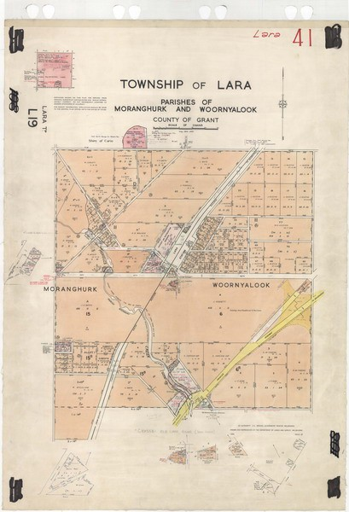
Figure 6.04: Plan of the Lara
Township, 1959. See Appendix
11.01 for enlarged image.

with light clouds breaking away after the unwonted fall of two inches of rain the previous night. The roadside hedge rows and plantations, the low range of hills to the far westward of Lara, with patches of ploughed land on the slopes of the Elcho estate, the towering You Yangs to the northward, the park‐like middle distance, with the sun lighting up the thin smoke wreathes drifting over the white lime‐kilns and the small cluster of buildings forming the village, all made up a picture of Westmoreland like picturesqueness, the imagination in that respect being aided by the fact that the Fairbairn mansion, just discernible from
the main road, is called Windermere.4

From the 1950, Lara experienced rapid expansion into a dormitory suburb for both Geelong and Melbourne. This expansion has increased markedly south of Windermere Road in more recent years.

Rothwell
A second village was proposed at the crossing of the Little River, north of the You Yangs. In February 1852, the new township was proclaimed and town lots and large blocks – which had been laid out in a grid – were sold.5 According to Ian Wynd in So Fine a Country, ‘prospects of steady development were enhanced by the announcement that the Geelong‐ Melbourne railway would follow the line of the road and a station would be established at Rothwell.’6 However, due to engineering considerations, the railway was built approximately half a mile further north, with the station building on the northern side of the river. Settlement gradually moved to the north and the proposed Rothwell township never took root.7 In 1861 with all the railway construction activities in the vicinity of Rothwell, the area boasted a population of two males and two females and one inhabited dwelling.8 Physical evidence of the ‘lost’ Rothwell township is the cemetery at the corner of Hughes and Calvert Roads (see Theme 8 for further details).

6.2 Building Homes in the Lara Area
Pastoral Homesteads
A physical legacy of the squatting and pastoral era from the late 1830s in the Lara area is the surviving homesteads. There are four homesteads of particular note and of distinctive and varying designs: Wooloomanata, Elcho, Pirra and Avalon. They were all designed by notable 19th century architects.

Wooloomanata Homestead
The symmetrical, single storey, bluestone, Victorian Italianate Wooloomanata Homestead was built for Frederick William Armytage in c.1860‐63 to a design by the prolific Melbourne architect, Leonard Terry.9
The dwelling has a U plan layout with intricate encircling iron verandah detail of an usual design and fabrication. Timber for the construction of the homestead was brought from Tasmania.10 A biography of F.W. Armytage is given in Henderson’s Australian Families:

He was a great lover of horses, and his coach, drawn by four magnificent specimens, used to attract much attention in the early days. During his world travels he collected many valuable pictures, some of which were exhibited in the National Gallery in Melbourne and later acquired by the

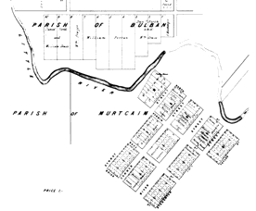
Figure 6.05: Plan of the Township of Rothwell, 1862. Source: Wynd, So Fine a Country, p.124. See Appendix
11.01 for enlarged image.

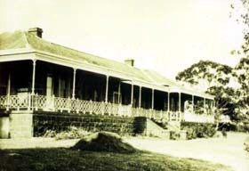
Figure 6.06: Wooloomanata Homestead, n.d. Source: Geelong Heritage Centre.

Trustees. Many of the Victorian and visiting Governors were entertained by Mr. Armytage at Wooloomanata, which was renowned for its good pheasant shooting … Both Mr. Armytage and his wife took a great interest in the welfare of the aborigines around Wooloomanata, one of whom, Billy Leigh, ‘king’ of the tribe, was baptised and confirmed at the Church of England at Lara. … Frederick William Armytage, together with George Fairbairn and Hastings Cunningham, pioneered the frozen meat export industry in Australia, and the greater part of the initial shipment to England in the steamer “Strathleven” in 1879 was owned by him, and the first bill of lading for frozen products shipped from Australia was in his name. … He was appointed a Justice of the Peace in 1871, was a director of several companies in Melbourne, and a prominent member of the Melbourne Club. He married Mary Susan, daughter to Simon Staughton, of Exford, Melton, Victoria. … Frederick William Armytage
died at Como, South Yarra, 3rd September 1912, at the age of 74.11

Elcho Homestead
The substantial bluestone Victorian Picturesque Gothic styled Elcho homestead was built in 1864 for John Galletly and his wife, Elizabeth (nee Armytage) on a four thousand acre property fronting the Bacchus Marsh Road. The homestead was designed by the eminent Melbourne architect, Leonard Terry.12 A wing on the north side of the dwelling was added in c.1872.13

In the 1890s, the property was owned by Hugh M. Sutherland, a successful sheep grazier and a well‐known breeder of pure Border‐ Leicester sheep.14 Born about 1849 in Sutherlandshire, Scotland, H.M. Sutherland married Sarah Crossley in 1878 and one of their five children, John (born in 1881 in Shepparton), later acquired the Elcho property on his father’s death in 1916.15

Elcho homestead is one of the more substantial and picturesque examples of its type in Victoria. The asymmetrical dwelling has steeply‐ pitched gable roof forms and a squat square tower on the south side. The gable ends are adorned with decorative timber bargeboards and finials. There is a return verandah with simple timber decoration at the front and south side.

In c.1920, Elcho passed to the Repatriation Department, being the location of acclimatisation of Indian Army would‐be settlers.16

Pirra Homestead17
First known as Windermere and then Lara House, Pirra Homestead has its roots during the Fairbairn family occupation between 1863 and 1907. George Fairbairn (senior), one of Australia’s most prosperous pastoralists and owner of millions of acres of land throughout Australia, established Pirra as a premier sheep stud. An original homestead was built in the early‐mid 1860s (and has been subsequently demolished), with a second extant single storey homestead built in c.1869. The brick two storey hipped roofed two storey mansion house was designed in 1880‐82 by the prolific architectural firm of Alexander Davidson and Co. The Victorian Eclectic house style, with several highly unusual French mediaeval decorative features, represented an important example of the work of
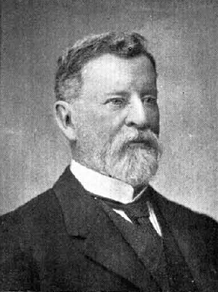
Figure 6.07: Frederick William Armytage. Source: Henderson, Henderson’s Australian Families, p.308.

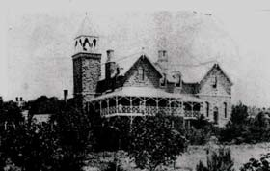
Figure 6.08: Elcho Homestead, n.d. Source: Wynd, So Fine a Country, p.242.

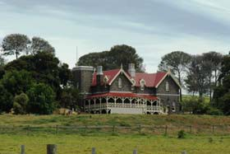
Figure 6.09: Elcho Homestead, 2012.

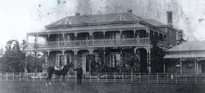
Figure 6.10: Pirra Homestead, c.1910. Source: Geelong Heritage Centre.

the Davidson practice.

During the Fairbairn ownership, Pirra developed into a large property of
5436 acres and included the construction of a 70‐acre water reservoir to service the expansive grazing land and homestead complex. This complex included several outbuildings such as stables, manager’s house, slaughter house, shearing shed, men’s huts, dairy, and machinery shed. As a typical
19th century homestead complex, Pirra also was known for its cultivated
areas, including the house orchard and garden, tennis and croquet courts, and the cricket ground to the north of the mansion with a view of the You Yangs framed by stone pine trees.

By the early 1890s, Pirra was managed by George Fairbairn’s sons, Thomas and George junior. The latter son eventually had sole ownership of the property. As a member of the Victorian Legislative Assembly from
1903, George junior (later Sir George) used Pirra as his country residence,
whereby he developed a well‐known Merino and Shropshire sheep stud.

By 1907, the Pirra property had been sold for Closer Settlement as the Lara Estate, with the homestead and 637 acres being taken over by the Lara Inebriates’ Institution. This Government sanatorium constructed an Inebriates’ Dormitory at this time, and in 1927 an Inebriates’ Laundry was built south of the two storey mansion house (see Theme 8 for further details).

After the closure of the Inebriates’ Institution in 1930, Pirra was sold to James McDonald in 1938. He grew crop on part of the property and ran sheep on the remainder. In 1946, he leased the former Inebriates’ building to the States Tobacco Company.

In 1948, the Tobacco Company had folded and Pirra was sold to Oscar and Edna Mendelsohn. Employees from the Tobacco Company were employed by the Pelaco Factory which occupied the former Inebriates’ building. The Mendelsohn’s renamed the property ‘Serendip’. They established a commercial almond orchard in the vicinity of the original orchard and the large water reservoir was proclaimed a sanctuary for the protection of the local birdlife. Oscar Mendelsohn was also appointed assistant inspector of the Fisheries and Game Department at this time.

Further subdivision of the Pirra property was experienced in 1959, after the Mendelsohn’s sold to the Department of Fisheries and Wildlife who took control of the 600 acres surrounding the sanctuary. The immediate homestead, now reduced to 37 acres, was taken over by the Social Welfare Department. The two storey mansion house and nearby buildings became the Pirra Girls’ Home in 1961 and it was at this time when the property was named “Pirra” (see Theme 7 for further details).

The Girls’ Home closed in 1983 and was leased to Rex Keogh and Geoff Dombrain when the property became an accommodation and community establishment for the lessees and invited artists. In 1996, the property, then 6.665 hectares (16.469 acres), was sold to Rex Keogh and has continued as a home for artists and as special, community‐based

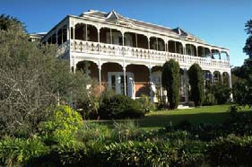
Figure 6.11: Pirra Homestead, 2002. Source: David Rowe.

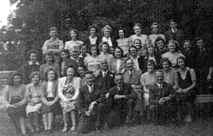
Figure 6.12: Employees of the States Tobacco Company, c.1947. Source: Margaret Deller.

accommodation for a limited number of disabled persons. In recent years the property was sold to the Bisinella family.

Avalon Homestead18
‘Avalon Station’ was first taken up by James Austin in the late 1830s as a sheep Run. While there is some debate whether Austin ever lived at Avalon, it continued under his ownership. He had returned to England in
1856 and made only one further visit to Avalon in 1889. Austin died in England in 1895. From 1879, the Avalon property was leased to James Austin’s, son, Frank. At this time, the property was also occupied by W.H. Buillivant. Both were sheep graziers and they became well‐known sheep breeders.19

It appears that the first bluestone dwelling at Avalon was built in 1842‐43. The existing single storey, Victorian Picturesque Gothic styled homestead was built in 1880‐81 to a design by the well‐known architect, Alexander Davidson, who simultaneously had also been responsible for the design of nearby Windermere (Pirra). A description of the new residence in the Geelong press declared that the building ‘promises to be a very handsome one’. The article continued:

The house is to be built in the domestic gothic style, and is to be of bluestone, with Waurn Ponds freestone dressing. It will have a frontage of
132 ft. to the bay or north shore, the centre wing being 96 ft. in depth, and
the side wings each 60 feet in depth. There will be twelve principal rooms in the building, in addition to the kitchen, dairy, pantry, etc. The new residence will have two verandahs, each 7ft. 6in. in width, and the entrance to the interior of the house will be through a vestibule 16ft. by 11 ft. and along a corridor 96ft. in length, by 6ft. in width, and ornamented with arches. The stables, coach‐house, and groom’s room will be detached from the main building.

In 1896, the Melbourne architect Walter Butler was engaged to design a porte cochere extension to the homestead. It was described as ‘one of the largest such structures in Victoria’, designed ‘to mask the west end of the main body well as to provide weather protection.’

Smaller Homes of the Victorian Era
More prevalent throughout the Lara area, particularly from the 1869 and
1870s were smaller‐scaled homes both within the Lara township and in the surrounding farmland. The building of a number of these homes w as a consequence of the 42nd Clause of the amended Land Act of 1869 which enabled the acquisition of smaller parcels of land so long as it was cultivated and improved, and a permanent residence built.20 These dwellings are largely Victorian vernacular in design, mainly having gabled forms and front verandahs. They are also vernacular in construction, with most having been built of local materials close to the source. Surviving dwellings associated with Section 31 of Clause 42 of the amended Land Act include the cottage at 85 Curletts Road and the cottage complex at 80
Gebbies Road. North of the Lara township near the southern foothills of the You Yangs, dwellings were mainly constructed of basalt or granite. Examples include the ruins of James English’s farmhouse at 575 Flinders Avenue (that was built in granite in c.1859),21 John McGillivray’s house at

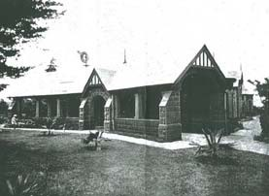
Figure 6.13: Porte cochere at Avalon Homestead, 1908. Source: ‘The Avalon Merino Stud’, in the Pastoralists’ Review, 1908.

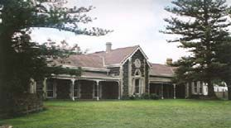
Figure 6.14: Avalon Homestead,
2006. Source: HLCD Pty Ltd, ‘Avalon Homestead Complex’ Conservation Management Plan.

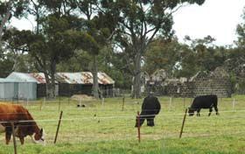
Figure 6.15: Bluestone ruins, 120
Duggans Lane, 2012.

60 Branch Road (built of granite in 1871),22 and Maxwell Bell’s cottage and outbuildings at 120 Duggans Lane (of bluestone construction possibly built in c.1864‐84).23

Surviving Victorian vernacular dwellings in Lara built between the 1860s and 1900 are mainly constructed of limestone. All of these dwellings have experienced some form of noticeable alteration and/or addition but their original design and historical associations with the earlier years of Lara’s development are clearly discernible. Other examples include:

Laurence Park, 125 Buckingham Street24
Forming part of the Cheddar Farms estate, it appears that this gabled limestone cottage with front verandah was built in 1873‐74 when first owned by David McHarry, farmer and lime burner. The dwelling is accentuated by the brick quoinwork around the building corners and openings. A limestone stables building also survives on the property. McHarry was born in about 1834. In addition to his success as a farmer and lime burner, McHarry was a Councillor with the Corio Shire Council between 1881 and 1889 and 1900 and 1903. In 1902, McHarry retired to Geelong and a farewell social was reported in The Argus as follows:

LARA.— On Friday evening about 70 residents of the district tendered a farewell social to Councillor D. McHarry, who for 45 years resided in the township. Mr. McHarry has removed to Geelong. The president of the shire (Councillor H. M. Sutherland) presided, and Captain Percy Chirnside, M.L.A., was present. A number of toasts were honoured, and Mr. McHarry was presented with a hand‐painted address, bearing photos, of Mr. and Mrs. McHarry. The Misses McHarry were the recipients of mementoes from the members of the local Sunday‐
school.25

Cottage, 85 Curletts Road26
This Victorian styled limestone cottage with a simple gable roof that projects to form a front verandah and symmetrical brick chimneys was built in 1874 by William Harding, farmer and builder. Harding had applied for the purchase of his landholding in 1875, under Section 31 of Clause 42 of the amended Land Act. A detached stone dairy was also constructed in
1874.

Cottage, 51 Forest Road South27
The cottage at 51 Forest Road South was also designed with a traversing gable roof form, front verandah (later replaced with existing verandah) and symmetrical composition defined by a central doorway and flanking windows, and symmetrical chimneys. Owned by John Spalding, pioneer of Lara, it was built of limestone, possibly in c.1879. The property was occupied by Spalding’s son, Alfred John Spalding, after his marriage to Mary Ann Danns in 1879. A.J. Spalding was a wheelwright, working from the blacksmith’s shop that had been built by 1877 between his and his father’s homes. The blacksmith’s shop was jointly‐owned by John and Alfred Spalding (it was demolished in February 2012). After the death of John Spalding in 1893, Alfred took over his father’s general store in Forest Road South (at the Patullos Road intersection).

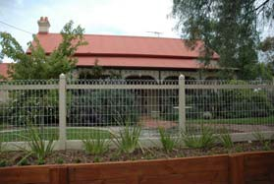
Figure 6.16: Laurence Park, 2012.

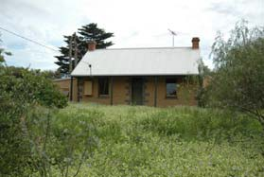
Figure 6.17: Cottage, 85 Curletts
Road, 2012.

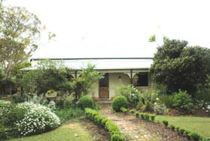
Figure 6.18: Cottage, 51 Forest Road
South, 2012.

“Limella” Cottage, 31‐45 Forest Road South28
The property at 31‐45 Forest Road South originally formed part of the Lara Village subdivision of 1853. In late 1872 or early 1873, the land was purchased by John Spalding, pioneer of Lara, a result of Section 31 of the amended Land Act. The front section of the existing gabled limestone cottage may have been constructed at this time (the current return verandah having replaced an earlier verandah that was possibly only located at the front). In 1874 and again in 1878, Spalding’s property was rated as having a store, dwelling and lime kiln.

Spalding was born in Birmingham, Suffolk, England in about 1822 and emigrated to Victoria in 1855. He opened his first store and butcher’s shop in Lara in 1855, was the first local Postmaster and also went into a successful lime burning operation. From the earliest years of settlement at Lara, Spalding was a lay Preacher of the Primitive Methodist Church. Importantly, he was one of the first Members of the Corio Road Board in
1861 and an inaugural Councillor on the Corio Shire Council from 1864 until 1867. He served a second term between 1876 and 1893. Spalding was also a Justice of the Peace and he attended the Geelong court every Monday. Spalding’s death in 1893 was recorded in The Argus:

An old resident of Lara, named John Spalding, 71 years of age, died suddenly at his residence late last night. He went out to the stables at the rear of his house to look after his horses just before going to bed, and not returning within a reasonable time, search was made for him, and his body was found in the yard close to the stables. The deceased
was much esteemed by all classes in the district.29

After John Spalding’s death, his son, A.J. Spalding moved into the property.30 It is un clear whether it was at this time when it was known as “Limella” or during the ownership of John Spalding.31

Cottage, 80 Gebbies Road32
The property at 80 Gebbies Road was originally taken up by William Foot,
farmer and lime burner, in 1869, under application associated with Section 31 of Clause 42 of the amended Land Act. The original stone cottage and store on the site were built at this time, with the main dwelling constructed in later years, and possibly between 1872 and 1884. The main dwelling has an encircling verandah, the early timber posts having been replaced with the existing brick balustrades and piers, and square fluted columns, during the interwar period. Immediately adjacent to the dwelling is a partially submerged and gabled stone store (built in
1869). At the rear is the original cottage (built in 1869). The property also features a stone former bakery (used by Margaret Walker from c.1900) and a number of stone and galvanised corrugated steel outbuildings, reflecting the evolution and development of the property throughout the 19th and 20th centuries.

Dwelling, 30 Hicks Street33
A surviving variation of the masonry Victorian vernacular dwelling type is the timber mid Victorian styled dwelling at 30 Hicks Street. Designed with

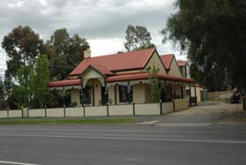Figure 6.19: Cottage, 31‐45 Forest
Road South, 2012.

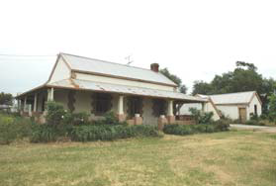
Figure 6.20: Main cottage, 80
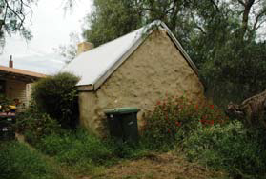Gebbies Road, 2012.

Figure 6.21: Kitchen outbuilding, 80
Gebbies Road, 2012.

a hipped roof form and front verandah, the timber weatherboard dwelling appears to have been built in 1886 upon the marriage of David Walker and Mary Teresa Tayler. It was owned by David Walker’s father, Robert Bell Walker, until his death in 1899 when David Walker took up ownership.

Robert Bell Walker and his son, David, operated the nearby, successful lime burning and crushing company, Waverley Lime Company, in Walkers Road, first established by R.B. Walker in 1878. Further details are given in Themes 4 and 5.

Homes Associated with Closer Settlement & Other Subdivisions
Of particular note in the Lara area are the timber Federation styled dwellings that are a physical legacy of the Closer Settlement and other subdivisions of the large pastoral estates of Pirra, Wooloomanata, Elcho and Marathon between 1903 and 1913. Generally, they feature hipped roof forms with projecting minor gable wings at the front and side that are linked by return verandahs. They have been designed with distinctive chimneys and decorative verandah details. These dwellings include:

Lochnaben, 295 Patullos Road34
Lochnaben was built for the Richmond brothers (James, Frederick and Joseph) in 1905, a consequence of the Elcho Estate subdivision. The property was acquired by Benjamin Spalding in c.1910, where he established an enduring sheep farm. Benjamin Spalding was the son of A.J. Spalding and grandson of the Lara pioneer, John Spalding. Benjamin Spalding farmed the Lochnaben property until his death in 1967.

The existing timber weatherboard Federation styled dwelling is a distinctive and intact example of its type in the Lara area.

Roselea, 450 Staceys Road35
The timber Federation styled farm house, ‘Roselea’ was built in 1912‐13 for the Leigh Brothers, Albert, Frederick and Roland, the result of the subdivision of the Marathon Estate. The Leigh family were pioneers in the Ceres area. The farming success of the Leigh brothers was outlined in The Leader newspaper in 1916:

The Lee [sic. – Leigh] Brothers reflect credit upon their training, obtained originally on the Barrabool Hills. Their proportion of grain cultivation for market over and above that provided for their sheep grazing is larger than the average, and the quality of their work is indicated by their yields of oats, running to averages of from 35 to 45 bushels per acre, and their Cape barley from 30 to 35 respectively.

Roselea had become the family home of Frederick and Ethel Leigh by the early 1930s. The house is a predominantly intact example of Federation design.

Other Federation Era Dwellings
Some of these dwellings have been designed by architects of Geelong. Designs by the prolific architectural firm of Laird and Buchan included the

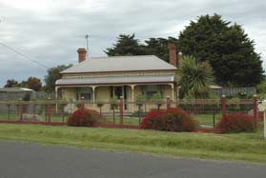
Figure 6.22: Dwelling, 30 Hicks
Street, 2012.

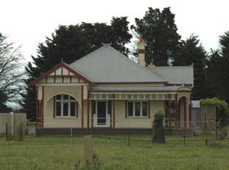Figure 6.23: Lochnaben, 2012.

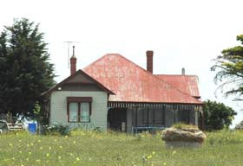
Figure 6.24: Roselea, 2012.

following:

Tallaranie Homestead, 170 Peak School Road36
The single storey, timber weatherboard, Tallaranie Homestead was built in 1907 for Archibald Shannon ((1878‐1946), having been funded by his father, Charles Shannon. The land appears to have been a subdivision of F.W. Armytage’s Wooloomanata Homestead and the property was originally known as “Tallarannie”. Charles Shannon was a pioneer of commercial enterprise in Geelong, a successful wool broker, mill owner and fellmonger. Archibald Shannon’s ownership was to be short‐lived because it was sold to William and Idea Milbourne, graziers, in 1910‐11.

Former Shire Engineer’s Residence, 8 Rennie Street37
In 1911, the Corio Shire Council commissioned Laird and Buchan to design a new timber Federation styled dwelling at 8 Rennie Street. The contextually substantial timber dwelling was first occupied by the Joint Shire Engineer and Secretary, H.G. Oliver.

Other noteworthy Federation styled examples in Lara include (but are not limited to) the following:

Waverley, 14 Walkers Road38
The Federation styled timber dwelling was built in c.1902‐03 for David Walker, lime burner. It was named “Waverley” after the train station in Scotland and more locally, the Waverley Lime Company located on the site. The lime company had been established by Walker’s father, Robert Bell Walker (1834‐1899). It appears that the existing dwelling replaced an earlier house built in c.1885‐86 for R.B. Walker and his wife, Jane, and family, although Walker had made a successful application for land in
1871, as part of Clause 42 of the amended Land Act.

Interwar Era Homes39
The farmhouse, ‘Clover Hill’ at 155 Forest Road South represents a noteworthy example of a 19th century farming property in the Lara area, with the main dwelling having been rebuilt during the interwar era. The original limestone dwelling was built in 1853 and from 1866 it was owned by William McClelland. In 1926, it was gutted by fire and according to the Geelong Advertiser, ‘the walls remained sound for use in the re‐building of the homestead there today.’

In the early days, McClelland ran a dairy farm on the property. The farm later included stud stock (with a Clydesdale horse stud established by William and later carried on for many years by his sons, and a jersey cow stud first established by Abraham and Robert McClelland) and cereal crops (wheat, barley, peas and lucerne).

The McClelland family of Clover Hill contributed much to local municipal life in Lara. In 1958, the Geelong Advertiser described the service to local government by the family as follows:

For 76 years out of the 92 since William McClelland came to the property, there has been a councillor on the Peak Riding in the Shire of

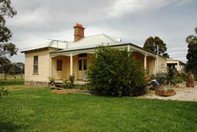
Figure 6.25: Tallaranie Homestead,
2012.

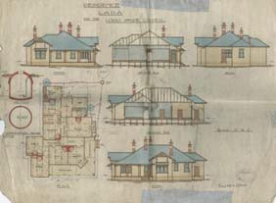
Figure 6.26: Laird & Barlow,
‘Residence in Lara for Corio Shire Council’, n.d. Source: Geelong Heritage Centre. See Appendix
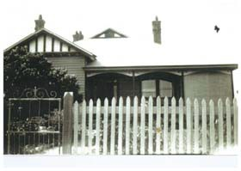11.01 for enlarged image.

Figure 6.27: Waverley, n.d. [c.1920s]. Source: Joan Wilks, Lara.

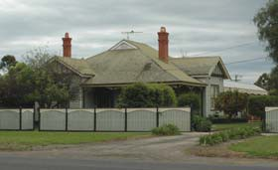
Figure 6.28: Waverley, 2012.

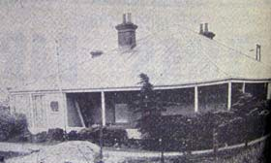
Figure 6.29: Clover Hill, 1958. Source: Geelong Advertiser, 16
December 1958.

Corio, residing on it. William served 33 years. Robert (his son) for 21 years. Cr A A McClelland is now in his 22nd year which includes 6 successive terms as President, covering the war years. When it comes to a matter of what has been produced on Clover Hill, municipal legislators must be on the list.40

Upon the death of William McClelland in 1919, the property was acquired by his son, Robert although by 1915‐26 it was under the joint ownership of Robert and his brother, Abraham.

Although in disrepair, the existing rendered limestone dwelling is a locally distinctive example of rural interwar housing having 19th century origins. The steeply‐pitched galvanised corrugated steel roof of the front wing extends to form an encircling verandah supported by timber posts. It has an affinity with the steeply‐pitched hipped dwellings with return verandahs built in Charlton constructed between c.1911 and the 1920s.41

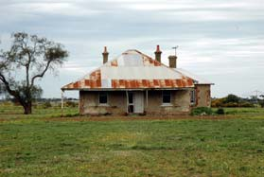
Figure 6.30: Clover Hill, 2012.

1 The following history of the development of the Lara township is taken from I. Wynd, ‘Greater Geelong Outer Areas Heritage Study Environmental History’, vol.2, prepared for Authentic Heritage Services Pty Ltd for the Greater Geelong Outer Areas Heritage Study Stage 2, 2000, unless referenced otherwise.
2 I. Wynd, So Fine A Country, Shire of Corio, 1981, p.147.
3 ‘Lara Through Pioneer’s Eyes’, newspaper cutting (newspaper and date unknown), sourcing Ballierre’s Victorian Gazeteer,
1879, Geelong Heritage Centre.
4 Bacchus Marsh Express, 25 April 1896, p.3.
5 Wynd, op.cit., p.125.
6 Ibid.
7 Ibid.
8 Ibid., p.126.
9 A. Willingham, Geelong Region Historic Buildings and Objects Study, Geelong Regional Commission, Geelong, 1986, vol.1, sheet 134.
10 A. Henderson, Henderson’s Australian Families: A Genealogical and Biographical Record, A. Henderson, Melbourne, 1941, facs. edn., The Genealogical Society of Victoria Inc., 2004, p.307.
11 Ibid., pp.308‐309.
12 Wynd, op.cit., pp.239‐242, Willingham, op.cit., sheet 131 & Geelong Advertiser, 18 May 1864.
13 Willingham, op.cit.
14 The Leader, 26 August 1916, p.6.
15 P. Jennings, Family Group Record for H.M. Sutherland, November 2012, sourcing Victorian Births, Deaths and Marriages
Indexes & Geelong Cemeteries Trust Database.
16 ‘Elcho and Wooloomanata’ in The Investigator: Magazine of the Geelong Historical Society, March 1971, p.30.
17 Information taken from D. Rowe, ‘Pirra Homestead’ Conservation Analysis, vol.1, June 2002, unless otherwise referenced.
18 Information taken from HLCD Pty Ltd, ‘Avalon Homestead Complex’, 480 Avalon Road, Lara, Conservation Management Plan, June 2006, unless referenced otherwise.
19 ‘The Avalon Merino Stud’, in the Pastoralists’ Review, 1908.
20 M. Murray, ‘Prayers and Pastures Moidart immigrants in Victoria, 1852‐1920’, PhD Thesis, School of History, Heritage and
Society, Deakin University, 2007, p.278.
21 P. Jennings’, Family Group Record for James English, November 2012, sourcing Victorian Birth Deaths and Marriages Indexes
& Geelong Cemteries Trust Database, lists English’s second son, James, as having been born at Duck Ponds in November
1859. A. Sutherland, Victoria and Its Metropolis Past and Present, McCarron Bird & Co., Melbourne, 1888, CD edn., Archive CD Books Australia Pty Ltd, 2006, p.163, states that English had emigrated from England to Sydney, N.S.W. in 1857 before relocated to Lara after a short time.
22 J. McGillivray, Land Application under Clause 42 of the amended Land Act, VPRS 627, Unit 270, Public Record Office Victoria.
See also Corio Shire Rate Books, 1870, 1875, 1879‐80, 1890‐91, 1891‐92 & Wynd, op.cit., p.155.
23 Ibid., 1866‐67, 1871‐82, 1876‐882, 1883‐84, 1884‐86.
24 Information taken from Corio Shire Rate Books, 1869, 1871, 1873, 1873‐74, 1874‐75, 1881‐82, 1891‐92, 1900, 1903‐04, op.cit., P. Jennings, Family Group Record for David McHarry, op.cit. & Wynd, op.cit., p.273.
25 The Argus, 23 October 1902
26 W. Harding, Land Application under Clause 42 of the amended Land Act, VPRS 627, Unit 238, Public Record Office Victoria.
See also Corio Shire Rate Books, 1869, 1885‐86, 1893.

27 Information taken from Corio Shire Rate Books, 1867‐70, 1876, 1877, 1879, 1882‐83, 1884‐87, 1887‐88, 1888‐90, 1900‐01,
1902‐03, op.cit., Wynd, op.cit., p.152 & P. Jennings, Family Group Record for John Spalding, op.cit.
28 Ibid.
29 The Argus, 24 May 1893, p.6.
30 According to the Corio Shire Rate Books, A.J. Spalding (senior) was owner by 1897.
31 The Argus, 30 April 1902, listed the wedding of A.J. Spalding’s eldest son, Alfred J. Spalding Junior at the residence of A.J.
Spalding (senior). The residence was given as “Limella”.
32 W. Foot, Land Application under Clause 42 of the amended Land Act, VPRS 627, Unit 130, Public Record Office Victoria. See also Corio Shire Rate Books, 1869, 1870, 1872, 1884‐85, 1890‐91, op.cit., & Interview by David Rowe with Jack Blair, July
1999.
33 Corio Rate Books, 1886, 1891, 1897, 1899, op.cit., ‘Walker, Robert Bell, Will’, VPRS28 P0002, Unit 1522, Public Record Office
Victoria & P. Jennings, Family Group Report for David Walker, op.cit.
34 Ibid., 1905‐07, 1908‐09, 1909‐10, 1910‐1, Elcho Estate subdivision plan, 1 October 1903, Geelong Heritage Centre, The Argus,
12 August 1910, p.3, 23 August 1921, The Bacchus Marsh Express, 23 February 1907, p.3, The Colac Herald, 6 October 1903, p.2, P. Jennings, Family Group Report for Benjamin Spalding, op.cit. & information from Val England, Member, Geelong Family History Group, to Pam Jennings, October 2012 including V. England, ‘Rothwell Cemetery History’.
35 Corio Shire Rate Books, 1911‐12, 1912‐13, 1919‐20, 1926‐27, 1932‐33, op.cit.
36 Corio Rate Books, 1907‐08, 1908‐09, 1909‐10, 1910‐11, 1911‐12, Laird & Buchan Architects Contractors’ Book, 1902‐1907, p.154, Geelong Heritage Centre, P. Jennings, Family Group Records for Charles Shannon and James Milbourne, op.cit., R.J. Southy, ‘Strachan, Hugh Murray (1851‐1933)’, Australian Dictionary of Biography, Australian National University, at http://adb.anu.edu.au/biography/strachan‐hugh‐murray‐8692 & W.H., Brownhill & I Wynd, History of Geelong and Corio Bay with Postscript, The Geelong Advertiser, Geelong, 1990, p.121, J. Smith (ed.), Cyclopedia of Victoria, facs. edn., Archive CD Books Australia Pty Ltd, 2005, originally published by The Cyclopedia Company, Melbourne, 1903, pp.253‐254 & A. Henderson (comp.), Australian Families: A Genealogical and Biographical Record, facs. edn.,, The Genealogical Society of Victoria Inc., Melbourne, 2004, originally published by A. Henderson, Melbourne, 1941, pp.104‐105.
37 Wynd, op.cit., p.273 & Laird and Buchan Architects, Contractors’ Book, 1907‐1911, Geelong Heritage Centre.
38 Corio Rate Books, 1881‐82, 1883‐84, 1885‐86, 1891‐92, 1897, 1900, 1902‐03, op.cit. & R.B. Walker, Letter to H.B. Moore, Lands Department, 19 July 1871, VPRS 627, Unit 270, Public Record Office Victoria.
39 Corio Shire Rate Books, 1872, 1875, 1881, 1885‐86, 1890, 1898, 1900, 1905‐06, 1915‐16, 1925‐26, op.cit., Wynd, op.cit., p.247
& Geelong Advertiser, 16 December 1958.
40 Ibid.
41 Jacobs, Taylor, Johnson & Ballinger, ‘Buloke Heritage Study Stage 2’ for The Buloke Shire, 2010, draft.

7. Governing the Lara area
7.1 Local Government: Corio Shire
Corio Road Board
As early as 1851 a Select Committee of the new Victorian Legislative Council investigated the state of the Colony’s roads and bridges. It found that the location and condition of these roads were defective, constituting no more than a track in a number of instances. The Committee’s recommendations led to the formation of the Central Road Board whose aims ‘were to commence the formation of macadamized roads in the towns and extend them into the exterior.’1 Importantly, the Act of Parliament which led to the formation of the Central Road Board also proclaimed the establishment of local road districts managed by district boards that were ultimately controlled by the Central Board.2

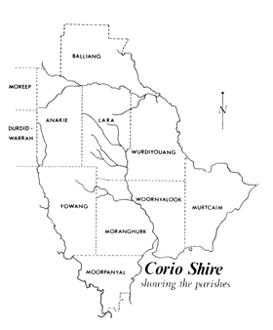On 25 April 1861 a meeting was held at Bragg’s Yowang Hotel, Duck Ponds, where the Corio Road Board was formed.3 The meeting, presided by John Myles, J.P., M.L.A., elected Michael J. Cummins, John Thomson, John Nixon, James Campbell, Thomas Abbey, John Spalding and Thomas Bates junior as the first representatives of the seven member Board.4
Cummins was elected the first Chairman. Most of these members were farmers with comparatively small landholdings, with Bates being the only representative of the squatting interests of earlier years.5 Bates, Nixon and Abbey only lasted 12 months on the Board.

The jurisdiction of the newly‐established Board was the Parishes of Moranghurk, Yowang, Woornyalook, Murtcaim, Wurdiyouang, Lara, and the portion of Moorpanyal outside the Corporation of Geelong. The northern boundary was the Little River.6 The first premises of the Board were located well outside the Board’s boundaries, it has had rented offices at 13 Great Malop Street in Geelong.7

Fundamental to the successful management of the Corio Road Board was the establishment of bye‐laws and the appointment of a Secretary and Engineer. As Ian Wynd in So Fine a Country states:

[The Board] … laid down the duties of the secretary: he was to attend to the duties of the Board from 2.00 pm to 5.00 pm on weekdays, and from
10.00 am to 6 pm on Saturdays, to attend all meetings of the Board, and
be paid £100 per annum. The Board adopted 27 bye‐laws, including one that money was to be spent in strict proportion to the amount of rates levied in each parish.8

The services of a suitable Secretary proved difficult in the initial years. T. Halliwell was the first Secretary in 1861, although by September of that year there were ‘complaints about the secretary’s laxity in attending to his duties.’9 Halliwell argued that his son had substituted but he was forced to resign once the Board declared that this could not be continued. The second secretary, D. O’Niel, provided the lowest tender for the position. However, he too resigned – in writing – after the Board discovered that his ‘experience in writing was not sufficient to enable him to take down the minutes of the meeting.’10 The appointment of James Blair in 1862 brought with it reliability, stability and loyalty.

Figure 7.01: Parishes in the Corio Road Board and Corio Shire. Source: Wynd, So Fine a Country, p.56.

Edward Prowse was the Board’s first Engineer. His tenure was short‐lived due to his death in 1861.11 He was replaced in by J.V. Bartlett and in 1862
J.L. Shaw, local Geelong architect, engineer and surveyor became
Engineer. In 1863, he was replaced with D.K. Goodall.12

Corio Shire Council
In 1863, the Local Government Act gave opportunity for a Road District Board to petition for conversion to a Shire when it reached a certain level of rate revenue. The roles and responsibilities of local government also extended beyond roads and bridges.

In 1864, the Corio Road Board was replaced with the Corio Shire Council. The first Councillors to the Shire were W. Cooper, J. Thomson, J.T. Kirk, Morris, J. Spalding, F. Beech and R. Coverdale.13 Eventually, after much controversy and deliberation by the Attorney General, Thomson was elected the Shire’s first president.14 The newly‐formed municipality was divided into three ridings: Peak, Moorpanyal and Lara.15

Officers were again appointed to manage Council affairs. Between 1864 and 1965, fifteen Engineers had been appointed to Council. The first was D.K. Goodall.16 Between 1902 and 1940, the Engineer also acted as Shire secretary.17

The first Shire secretary was James Blair, who had continued the role first taken up with the Road Board. Blair was a long‐serving officer of Council whose tenure lasted 38 years until 1902. He was born on 5 March 1818 in County Monagham, Ireland, the son of Captain Thomas Blair who had fought under Wellington at Waterloo.18 James Blair arrived in Melbourne on 17 July 184119 and removed to Geelong where he stayed for 7 years, working for the woolbroker, J.F. Strachan.20 It was in Geelong in 1851 when he married Grace Rock (they had seven children). James and Grace Blair soon left for the Ballarat diggings, moving onto Castlemaine and Bendigo where they had reasonable success.21 He relocated to Lara in
1854 where he took up 80 acres of land at the corner of Peak School Road and Flinders Avenue.22 In 1868, he purchased 29 acres at 25 Blairs Road and built his stone dwelling, ‘Blairgowrie’.23 With James Blair’s appointment as Secretary to the Road Board in 1862, the ‘Blairgowrie’ dairy farm was managed by Grace Blair with hired help.24

In 1896, the Bacchus Marsh Express gave a glowing account of James Blair in his role as Shire Secretary:

THE PATRIARCH OF THE LARA DISTRICT, and the Warden of all its interests, is Mr James Blair, the remarkably active and clear‐headed Secretary to the Shire of Corio, a position he has held from a time to which the memory of man (local man) runneth not to the contrary, and with most paternal solicitude has he watched all local interests and advanced them too. The old brigade of Shire Secretaries is thinning, and Mr. Blair must be the senior municipal officer in Victoria, or nearly so. Present day officials, and Councillors, are free from and forget the old responsibilities of launching local governing bodies and combatting such matters as rival boundaries or responsibilities for Gabrielli loans, and

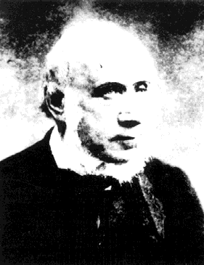
Figure 7.02: James Blair. Source: Wynd, So Fine a Country, p.59.

obtaining special grants of various kinds; but the ratepayers of the Corio Shire should take a pride in showing perennial gratitude for the remainder of the life of their old leader (we cannot call him servant) for the services (municipal and extra‐municipal) he has rendered them in the past and is still fully capable of continuing to give for many years to come, notwithstanding that he is getting well advanced into his eighth
decade.25

Blair also held the positions Electoral Registrar and Registrar of Births, Deaths and Marriages.26 His retirement as Shire Secretary in 1902 was marked by a celebratory cricket match of Councillors of the Bannockburn and Corio Shires.27 Upon his death in September 1907, the Bacchus Marsh Express gave details of his memorial service:

Rev A Caffin, of Ascot Vale, conducted a memorial service at Lara on the Sunday, and considered them to be the founders of the beautiful Holy Trinity church, Lara. Mr Blair had only missed 16 Sundays during the preacher’s 12 years term at Lara. Mr & Mrs Blair were by birth Presbyterians, but as there were so few of that denomination in the early days, the Church of England being the majority, they gave
assistance to the latter.28

Physical evidence of the Corio Shire Council survives at Lara today in two buildings. The central bluestone gabled wing of the former Corio Shire Hall at 2 Rennie Street was built by Clement Nash in 1864 to a design by the Shire Engineer, D.K. Goodall.29 Additions were made to the hall in
1911 and more substantially in 1926, when parapeted brick wings were constructed.30 Both additions had been designed by the Geelong architects, Laird and Buchan. The building served the centre of local government administration until the Council headquarters were relocated to Osborne House, North Geelong, in 1938.31

In conjunction with designing additions to the hall in 1911, Laird and Buchan had also been commissioned to design a residence for the Shire Engineer at 8 Rennie Street.32 The timber weatherboard Federation styled house survives largely intact today.

City of Greater Geelong
In 1994, the Victorian Government restructured local government to create fewer municipalities. Under an amalgamation of the Shire of Corio, City of Geelong, City of Geelong West, Rural City of Bellarine and parts of the Cities of South Barwon and Barrabool, the City of Greater Geelong was formed. The headquarters of the new Council were the Geelong City Hall in Gheringhap Street.

7.2 Law & Order
Police
It was not until 1907, over 50 years after the establishment of Lara, when the township had its first police presence. The first police station opened on 9 May of that year in Station Lake Road, with Alexander Patullo the first police officer.33 It resulted from the closure of the police station at Little River. Although Patullo’s tenure as police officer lasted only twelve months, the later name of Patullos Road marks the pioneering role he

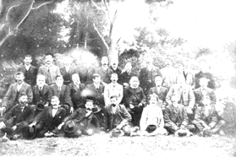
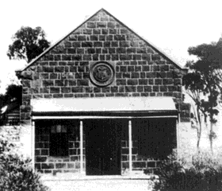Figure 7.03: Bannockburn & Corio Shire Councillors at the James Blair retirement cricket match, 1902. Blair is fifth from the right in the centre row. Source: Wynd, So Fine a Country, p.59.

Figure 7.04: Corio Shire Hall before
1926. Source: From Duck Ponds to
Lara, p.19.

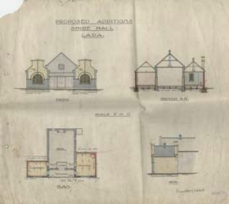
Figure 7.05: Laird & Buchan,
‘Proposed additions, Shire Hall, Lara’, n.d. Source: GRS 401/S7/1, Geelong Heritage Centre collection. See Appendix 11.01 for enlarged image.

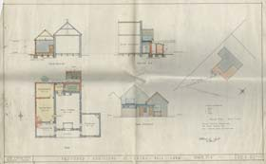
Figure 7.06: Laird & Buchan,
‘Proposed additions, Shire Hall, Lara’, 1926. Source: GRS 401/S7/3, Geelong Heritage Centre collection. See Appendix 11.01 for enlarged image.

played in the town’s law and order.34

In subsequent years (and prior to 1929), the police station moved to 24
Hicks Street.35 Alexander Shields was the ‘foot constable’ and subsequent
constables included Manfield, Caffyn, Naughtin McLeod, Rundell, Bolton, Meikle and Kelly.36

In 1929, the decision to close the Lara Police Station was met with resentment by locals. The Argus reported the matter as follows:

The decision to close the Lara police station and re‐establish it at Little River had caused much resent at Lara. In reply to a communication on the subject from the Corio Shire Council, the chief commissioner of police (Brigadier‐General Blamey) has written stating that full consideration was given to the proposed change, and it was felt that it would be “entirely in the interests of the district”. In future Lara would have the protection of the police, who were equipped with motor‐cycles, at Little River and North Geelong. The council is dissatisfied with Brigadier‐General Blamey’s statement and intends to send a deputation to the Chief Secretary (Dr. Argyle) to protest again the closing of the Lara
station.37

The closure of the station was to be short‐lived. By the 1940s, the Victoria Police Department had purchased the Corio Shire Engineer’s residence at 8 Rennie Street.38 An office and a police cell were erected in the backyard.39

Detention & Prisons
Pirra Girls’ Home
Pirra Girls’ Home was officially opened on 20 June 1961 by the Director‐ General of Social Welfare, A.R. Whatmore.40 Other official guests at the opening included the Minister for Shipping and Transport, Mr Opperman, President of the Legislative Council, Sir Gordon McArthur, and assistant Chief Secretary, L.H.S. Thompson.41

It was at this time when the property was first named “Pirra”, an aboriginal word for moon, being a symbol of happiness. Pirra was one of
16 homes in operation at the time, and was not regarded as an institution but a “home”.42 Pirra was a home for orphans, semi‐orphans and victims of broken homes. It was supervised initially by Miss C. Ross Morrison and later by Miss N. McDonald.43 In 1963, Miss McDonald described the lives of the children at Pirra:

Their lives are as normal as we can make them. They are not prisoners and they are not criminals … We allow them as much freedom as they would get in normal family life – the girls who are old enough can go to dances on Saturday night, wear make‐up and keep up with the fashions. They go on outings to the beach and attend things such as the Geelong Show and Gala … Mrs McDonald says that the children – there are 25 girls and three little boys ranged from
three years to 17 – attend schools throughout Geelong and district.44

Pirra Girls’ Home closed in 1983.

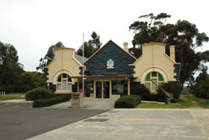
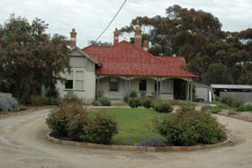Figure 7.07: Corio Shire Hall, 2012.

Figure 7.08: Former Shire Engineer’s residence (later Police Station),
2012.

HM Barwon Prison and Marngoneet Correctional Centre45
In January 1990, after local controversy, HM Barwon Prison opened in Bacchus Marsh Road. It has served as a maximum security prison. Five years later on adjoining land, the medium security Marngoneet Correctional Centre was constructed. It opened on 3 March 2006.

7.3 Defence
Military Encampment at the You Yangs
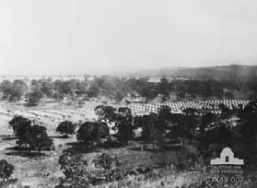In April 1870, Victorian volunteer military units gathered at the You Yangs to conduct their annual Easter encampment. Tents were erected in neat rows and the Easter break enabled the volunteers to conduct drill exercises, exhibitions of horsemanship and displays and demonstrations in using small arms and horse drawn guns. Visitors were invited to some of the encampment activities. The Argus described the event as follows:

The You Yangs Encampment has just begun to exist … Men and material were soon en route for the camp itself, beneath the You Yangs, where the tents had been pitched days before, and the other arrangements necessary for the temporary occupation of the ground were in rapid course of completion. It may, indeed, be remarked as sufficiently descriptive of the present aspect of affairs, that ever one here is up to his eyes in work, preparing, altering, fixing, arranging, and, generally, getting things to rights … To‐morrow the first instalments of troops will arrive – 500 men from Melbourne, 50 from Sandhurst, 50 from Castlemaine, 30 from Kyneton, 100 from Ballarat, 75 from Geelong, and most of the various cavalry corps.

The future arrangements may be described as under:‐
Thursday. – First receipt of troops, and commencement of military duty.
Friday (Good Friday). – Further receipt of troops, and field‐day, to witness the operations of which visitors are invited.
Saturday. – Arrival of His Excellency the Governor, who will forthwith
reside in camp, and Major‐general Sir Trevor Chute, the commander‐in‐ chief of Her Majesty’s forces in Australia, who will forthwith take charge of the camp.
Sunday. – Divine service and a few field operations in the afternoon. In
all probability the Rev. Captain Henderson, of Ballarat, will preach. Monday. – Arrival of rest of troops, and grand field‐day and review. Tuesday. – Departure of troops, and breaking up of camp.46

Volunteer Defence Corps at the You Yangs
During World War Two, a volunteer defence corps was established that involved 25‐30 local men.47 Lectures were given in the local hall by Army officers from Geelong.48 The former Corio Shire Hall was also used by the Volunteer Defence Corps during the war.49

Volunteer Air Observers’ Corps, Lara
An ancillary service of value to the war effort in Victoria during the
Second World War from 1941 was the inauguration of the Volunteer Air Observers’ Corps.50 Critical to the home defence system, a network of observation posts was arranged in a uniform pattern to cover the coastal belt and the industrial areas of the country. According to Douglas Gillison in Royal Australian Air Force, ‘the telephone system, with direct lines

Figure 7.09: Victorian Volunteer Military Encampment at Sunbury, c.1866, showing rows of tents in the open plains. The You Yangs encampment would have presented a similar scene. Source: Australian War Memorial website online, ID P03749‐007.

when necessary, was used to link observation and control posts, and teleradio sets were installed at control posts to provide continuous communication between these points and the main controls posts.’51
Gillison continues:

A high degree of priority was given by the Postmaster‐Generals
Department in all aircraft sighting reports, which were known as
‘airflash’ messages and which could be transmitted to the appropriate
centre within minutes. The naval and military authorities and the local defence coordinating committees all collaborated in the inauguration of the system. By 31st March 1942 six main control posts, 13 subsidiary posts and 483 observer posts were in operation on a 24‐hour basis.52

A counterpart of the English civilian organization known as the Royal Observer Corps, the functions of the Volunteer Air Observers’ Corps (V.A.O.C.) were to:

• Report aircraft, and if possible, identify hostile aircraft passing over observation points.
• Transmit aircraft sighting reports to an appropriate central control post for warning to Defence Services and to the Air Raids Precaution authorities in each State.53

Air observation posts were manned on a volunteer basis, with volunteers having to be 45‐60 years of age.54 By the end of the war, around 34,000 volunteers had participated in the V.A.O.C.

At Lara, an air spotters’ hut was erected on the south side of Station Lake
Road, between Forest Road and Hovells Creek.55

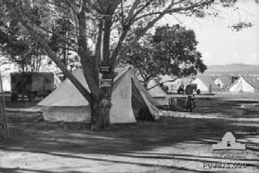RAAF Training School at Wooloomanata
It was also during World War Two when Wooloomanata Homestead was the location of a temporary RAAF airfield and Training School. The property was the Estate of the late J.V. Fairbairn, former Minister of Air, who was killed in an aircraft accident near Canberra on 13 August 1940.56

During its occupation, Wooloomanata accommodated the 79 Squadron that had been formed at Laverton RAAF base on 26 April 1943 with Mark VC Spitfires.57 Secret training for plant operators was then carried out at Wooloomanta.58 Ian Wynd in So Fine a Country gives an account of the training:

… instruction in the use of all types of earth‐moving equipment was provided. Two projects carried out during the training were the Griffin’s Hill deviation of the Geelong‐Ballan Road, west of Staughton Vale Road, and the formation of Clarkes Road, south of De Motts Road. Once trained, the men joined RAAF Airfield Construction Squadrons which
built many airfields in the south‐west Pacific.59

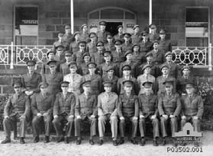Figure 7.10: RAAF Encampment at Wooloomanata, 24 May 1943. Source: Australian War Memorial online, ID P02875.020.

Figure 7.11: Group of RAAF Officers, Wooloomanata, 18 December 1945. Source: Australian War Memorial online, ID P03502.001.

1 P.M. Griffiths, Three Times Blest: A History of Buninyong and District 1837‐1901, Buninyong & District Historical Society, Buninyong, 1988, p.40.
2 Ibid., p.42.
3 I. Wynd, So Fine A Country, Shire of Corio, 1981, p.55.
4 Ibid.
5 Ibid.
6 Ibid., pp.56‐57.
7 Ibid., p.57.
8 Ibid.
9 Ibid., p.58.
10 Ibid.
11 Ibid., p.272.
12 Ibid.
13 Ibid., p.273.
14 Ibid., p.61.
15 Ibid., pp.61‐63.
16 Ibid., p.273.
17 Ibid.
18 Bacchus Marsh Express, 21 September 1907 & ‘Blair, David’, Re‐Member Database, Parliament of Victoria at http://www.parliament.vic.gov.au/re‐member/bioregfull.cfm?mid=229.
19 M. Budd, C. Delaney, J. Grainger (eds.), From Duck Ponds to Lara: A Collection of Memories, Lara Heritage Festival Inc., Lara,
2004, p.30.
20 Ibid.
21 Ibid.
22 Ibid.
23 Ibid.
24 Ibid.
25 Bacchus Marsh Express, 25 April 1896.
26 Ibid., 21 September 1907.
27 Wynd, op.cit., p.59.
28 Bacchus Marsh Express, op.cit.
29 A. Willingham, Geelong Region Historic Buildings and Objects Study, Geelong Regional Commission, Geelong, 1986, vol.1, sheet 133.
30 Ibid. & Laird and Buchan Architects Contractors’ Book, 1907‐1911, Geelong Heritage Centre.
31 Willingham, op.cit.
32 Laird and Buchan Architects Contactors’ Book, op.cit.
33 Budd, et.al., op.cit., p.156.
34 Ibid.
35 Ibid.
36 Ibid. & Corio Shire Rate Books 1945, 1951, 1954 & 1957, Geelong Heritage Centre.
37 The Argus, 31 May 1929, p.4.
38 Corio Shire Rate Books 1936, 1945.
39 Budd, et.al., op.cit., p.156.
40 J. Manton, ‘Windermere’, History of Architecture IV Research Essay, 1965, p.10, in Heritage Victoria file no. HER/2001/000067 and ‘Pirra Girls’ Home at Lara Opened’ in the Geelong Advertiser, 21 June 1961.
41 Ibid.
42 Ibid.
43 Ibid. & ‘Pirra takes the pressure off our less fortunate youngsters’ in the Geelong News, 29 October 1963[?].
44 Ibid.
45 ‘Lara, Victoria’ at Wikipedia, http://en.wikipedia.org/wiki/Lara,_Victoria.
46 The Argus, 14 April 1870, p.5.
47 A.W. Mathieson, My Reflections on 77 Years in Lara, Lara Heritage Festival, 1985, p.15.
48 Ibid.
49 Budd, et.al., op.cit., p.19.
50 D. Gillison, Royal Australian Air Force 1939‐1942, Australian War Memorial, Canberra, 1962, pp.492‐493.
51 Ibid.
52 Ibid.
53 Series notes for Series AWM191, referenced in the National Archives of Australia website.
54 Ibid.
55 Mathieson, op.cit., p.35.
56 Budd, et.al., op.cit., p.136.

57 Ibid.
58 Ibid.
59 Wynd, op.cit., p.256.

8. Building Community Life
8.1 Spiritual Life
Early Development of Churches in Lara
Central to the development of the Lara community from the mid 19th
century has been the establishment of churches. Church of England, Catholic, Presbyterian and Wesleyan Methodist denominations formed the foundation to spiritual life throughout the Lara area. The prevalence of these denominations was largely dependent on the ethnic and cultural backgrounds of the population, and the development of the Lara region as a consequence of farming and lime burning.

The earliest religious presence in Lara was the Primitive Methodist Church in 1854, when the first service was conducted in the home of John Spalding.1 A granite church was subsequently built in Forest Road North (north of the creek) and it was claimed to have been the first church erected between Williamstown and Geelong.2 This church building was to be short‐lived. Given that the centre of the Lara population was established further south, the Primitive Methodists relocated to a new building at Lara Lake next to the school in 1868.3 The first chapel was demolished and the stone was used to construct Spalding’s blacksmith’s shop at 31‐45 Forest Road South.4 The second chapel in Lara – designed to accommodate 100 people5 survived the bushfires but is appears to have been demolished after 1981.6

Like the Primitive Methodists, the Anglicans established a church well north of the Lara town centre. On 14 March 1864, one acre of land near the southern slopes of the You Yangs on Branch Road was temporarily reserved as a site for the Church of England.7 A month later on 28 April
1864, tenders were called for the construction of a bluestone Victorian Picturesque Gothic styled parsonage. It was designed by the Corio Shire Engineer, D.K. Goodall.8 Church of England services centred on this building for the next 14 years.9

Other Protestant denominations formed churches at Lara in the 19th and early 20th centuries, including the Bible Christians, Wesleyans and Presbyterians. There was also the establishment of a Seventh Day Adventist Church at Lara in 1901 and the construction of a small timber chapel. Ironically, the Corio Shire Council had ‘no knowledge of any such Church having been built or even in course of erection.’10

The Roman Catholic Parish of St. Michael’s, Little River, was established by Bishop Goold in 1857 to serve the communities of both Little River and Lara.11 A small bluestone church was built on reserved land adjoining the Little River Railway Station. The death of Father Rankin in later years brought about the closure of the parish due to a shortage of priests.12
Mass was held at a home in Caddys Road until the building of a church in
Lara in 1912.13

Surviving Church Buildings in Lara
Spiritual life is physically manifested in the Lara area today in the surviving church buildings, a number of which now serve a different purpose.

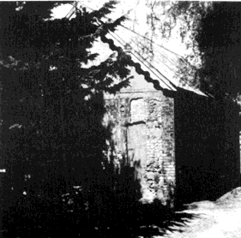
Figure 8.01: Primitive Methodist Church, Lara Lake, n.d. Source: Wynd, So Fine a Country, p.152.

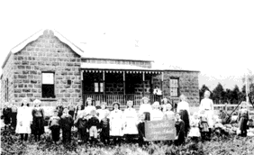
Figure 8.02: Former Church of England Vicarage (when the Duck Ponds School), n.d. Source: Wynd, So Fine a Country, p.157.

Former Wesleyan Chapel (Lara Uniting Church)
In the 1850s, the Wesleyan Methodist congregation was formed at Lara.14
In May 1865, one acre of land at the corner of Flinders Avenue and Forest Road was temporarily reserved for Wesleyan Church purposes and the existing Primitive Gothic‐styled limestone chapel was built soon after.15
In 1902, the Wesleyans united with the Primitive Methodists and the Bible Christians. A fence divided the Primitive Methodist Chapel grounds from the adjoining Temperance Hall.16 In 1891, John Spalding – who had purchased the Temperance Hall in 188617 gave the property to the Primitive Methodists.18 Six years later in 1897, the Geelong architects, Laird and Barlow organised repairs and fencing at the Methodist Church, which were carried out by Wirner and Nott for £25.19 In 1902, the Primitive and Wesleyan Methodist Churches amalgamated and the fence dividing the church buildings was removed, to become a larger Methodist Church property.20 The new Church building was refurbished internally, with a central aisle created and flanking pews. A raised platform measuring 16 feet by 10 feet was installed in the north‐east corner.21

In 1979‐80, a new brick church building was constructed on the site between the old limestone church buildings.22 It was designed by Keith Butler, architect, and constructed by Len Bell Pty Ltd.

Holy Trinity Anglican Church, 29 Curletts Road
The most substantial church building constructed at Lara was the bluestone Victorian Gothic Revival styled Holy Trinity Anglican Church at
29 Curletts Road in 1877.23 It was erected at a cost of £2,000, with £1,500
of this amount having been donated by F.W. Armytage of Wooloomanata and the balance provided by George Fairbairn of Lara House (Pirra). The building was erected by the builders, Trevena and Gubby to a design by the Geelong architect, Joseph Watts.24 On 4 October 1877, the Geelong Times reported on building progress:

The new church at the Duck ponds is rapidly approaching completion. The slaters are now engaged in roofing in the church, which is of bluestone, with white stone facings. The roof is similar to that of St. Mary’s church in Geelong, being of blue and red slate, cut.25

Holy Trinity Church became a local landmark in the rural setting of Lara. It was described in the Mercury and Weekly Courier in 1882 as follows:

About half a mile from the railway station, looking to the right, this land‐ mark stands out in bold prominence, being the exceedingly pretty village church of Lara, substantially built of bluestone, with freestone dressings round doors, windows, tower and spire “pointing to the skies,” a very “sermon in stones” to every beholder … It consists of nave, chancel tower and spire; the side walls being pierced on each side by four dual arched windows between each buttress; the glassing being the church‐like diamond panes. The chancel has windows in its three walls, as also has the front gable. The chancel has a side door, where it is intended to erect a vestry or room suitable for meetings or school. It is very prettily finished inside, the pews being of a rather ornamental class of white pine, varnished; reading desk and pulpit on either side of chancel, in front of

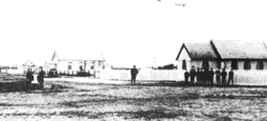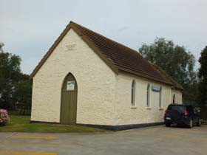Figure 8.03: View north along Forest Road showing the Wesleyan Methodist Chapel (right) with the Temperance Hall in the background, n.d. Source: Wynd, So Fine a Country, p.160.

Figure 8.04: Wesleyan Methodist
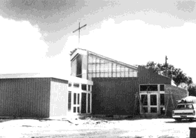Chapel, 1B Flinders Avenue, 2012.

Figure 8.05: Lara Uniting Church nearing completion, 1980. Source: B.E. Giddings, ‘A Church in the World’, p.12.

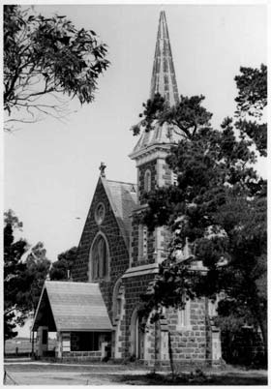
Figure 8.06: Holy Trinity Anglican
Church, 4 November 1961 – 25
October 1965. Source: J. Collins, La Trobe Picture Collection, State Library of Victoria, image jc010992.

which is a white stone baptismal font. The choir and cabinet organ are in the centre of the west end of the nave. The whole is well lighted for evening service by very handsome kerosene lamp chandeliers and side brackets, with ornamental globes and chimneys.26

A Vicarage was constructed after 1882 and in 1899, the Geelong architects, Seeley and King, called tenders for the construction of a weatherboard Sunday School.27 A new Vicarage was erected in 1955 at a cost of £4,500. Built of brick ‘and designed on attractive lines,’ was dedicated by the Archbishop of Melbourne, Dr Booth.28 In c.1964, the Geelong architectural firm of McGlashan and Everist designed a Sunday School building between the hall and the tennis courts.29

All that survives of the 19th century Anglican Church buildings at Lara today is the bluestone tower of the early church. The building was substantially destroyed in the bushfires of 1969 (see Theme 1 for further details). The tower acts as a legacy of 19th century Anglican faith as well as a symbol of resilience.

The existing church building – with the original tower as a centrepiece – was completed and dedicated by the Archbishop of Melbourne, Sir Frank Woods, on 3 September 1971.30 It was designed by Schefferle, Chomley and Associates, architects of Newtown.31

Former Presbyterian Church (Community Centre), 11‐15 Waverley Road In 1904, a local Presbyterian Church was established at Lara.32 The congregation first worshipped in the Methodist Church building at a rental of one shilling per week.33 Five years later in 1909, a Federation Carpenter Gothic styled church building was erected in Waverley Road. It was designed by the Geelong architects, Laird and Buchan and built at a cost of £224.34 The newly‐completed building was described in the News of the Week:

… a weatherboard structure of Gothic design. The interior has plastered walls with kauri dado and ceiling; varnished Muranese glass; vestry and porch in similar lines to the new building; pulpit in kauri; Gothic design. Building seated to accommodate 150 people.35

According to the architects, Laird and Buchan, the building was ‘erected in an open paddock, and there are no other buildings within 5 chains.’36
Consequently, David Walker, representing the Presbyterian Church, petitioned for the formation of a road to the church.37

In 1962, the Geelong architects, Shefferle, Chomley and Associates designed a brick Church hall. The shallow‐gabled building was erected next to the church and it opened in 1964.38

With the amalgamation of the Methodist and Presbyterian Churches in
1977 to form the Uniting Church of Australia, the Presbyterian Church property was sold to the Corio Shire Council in 1980 for use as a Community Centre from 1982.

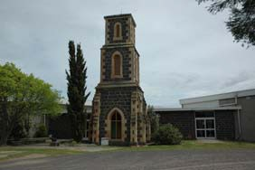
Figure 8.07: Holy Trinity Anglican
Church tower, 2012.

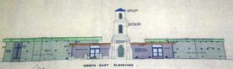
Figure 8.09: Schefferle, Chomley & Associates, architects, elevation drawing of proposed Holy Trinity Church, 1971. Source: VPRS8044, Unit 763, PROV.

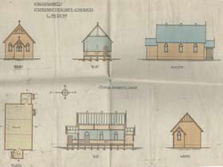
Figure 8.10: Laird & Buchan,
‘Proposed Presbyterian Church, Lara’, n.d. Source: GRS
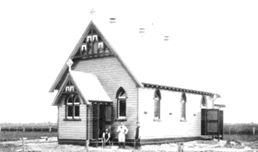401/PRES4/1, Geelong Heritage Centre. See Appendix 11.01 for enlarged image.

Figure 8.11: Lara Presbyterian Church, 1909. Source: News of the Week, 14 November 1909.

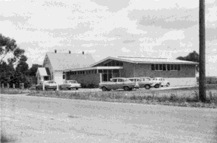
Figure 8.12: Lara Presbyterian Church and Hall, c.1960s. Source: B.E. Giddings, ‘A Church in the World’, p.6.

Former Catholic Church (Lara Baptist Church), 76 Flinders Avenue
The first permanent physical presence of the Roman Catholics at Lara
came in 1912 with the opening of a Federation Carpenter Gothic styled church building. It was built by C.O. Stock and designed by Thomas Slevin,39 architect of Geelong who was associated with a small number of buildings for the Catholic Church in the early 20th century. The church had a central entrance porch with side aisles and centrally‐located pews, and a sanctuary and sacristy at one end.

In 1977, the local Catholic community was joined to the newly‐formed Parish of Corio. A new church, St. Anthony’s, was subsequently built in Kees Road in 1992, next to the Catholic school of the same name.40

In subsequent years, the church property was acquired by the local Baptist congregation. In the past 10 years, the church building has been substantially altered and extended as part of a major redevelopment of the Baptist Church site.

8.2 Education
Denominational Schools
From the mid 19th century, the education of Lara’s young population was
critical to its ongoing cultural development. The basis of the education system at this time has its roots in the late 1840s, when Governor Charles Fitzroy established both a Denominational Board of Education and the National Board of Education in Sydney, and the Port Phillip Denominational Schools Board in Melbourne.41 The Denominational Boards funded church schools, but they remained under local ownership.42 On 31 December 1851, the National Board of Education in Victoria was established which built and owned its own “vested” schools.43

A Church of England Denominational School was first established at the entrance to the You Yangs reserve in Branch Road in 1855.44 It opened on
29 January that year with John H. Murphy as Head Teacher. First known as Station Peak School and then Duck Ponds School, the building measured 24 feet by 18 feet, and there were two rooms for the teacher as well as a store.45 This building was removed after 1878.

A second Church of England Denominational School opened in 1857 on the other side of the You Yangs in a building supplied by Monckton Synnot on his property, Mowyong, north of Little River.46

Common Schools
On 1 September 1862, the Common Schools Act was enforced which abolished the National and Denominational Boards for the Victorian Board of Education.47 This was intended to amalgamate schools and particularly to reduce denominational influence.48 Common Schools were all publicly owned and from 1863, they were afforded official numbers.49
Designs for new schools were specifically prescribed, although almost none were funded until 1864. The Board had looked to England for ideas, and particularly towards the implementation of the English Privy Council system of school organisation including the shape and layout of school

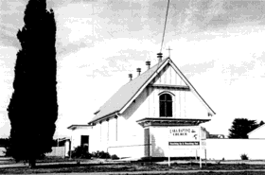
Figure 8.13: Lara Baptist Church,
1998. Source: David Rowe.

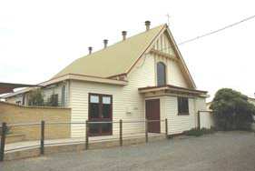
Figure 8.14: Lara Baptist Church,
2012.

buildings.50 The English Committee of Council of Education established standardized plans in 1851, and it was from these designs where the Victorian Board of Education found ideas to form the standard schemes in Victoria in the 19th century.51

In the Lara area, there were three Common Schools in the 1860s. These were the former Church of England Denominational Schools in Branch Road (which became the Duck Ponds Common School) and at the base of the You Yangs (having relocated from Monckton Synnot’s property in
1858), known as Wurdiyouang Common School No. 760. Both these schools became common schools in 1862.52

The third Common School opened at Lara Lake on 1 February 1866. It resulted from a proposal by John Spalding, on behalf of the citizens of Lara.53 A weatherboard, single‐room school, it had been built at a cost of
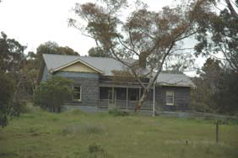£90.54

Department of Education Schools
In 1873, the Education Department was established which brought about the disbandment of the Board of Education.55 From this time, education became free, compulsory and secular (except in schools fully funded by their denominations).56 The standard one‐room school plans developed by the previous Department became the foundation of school design until the turn of the century.57 It was also the Education Department that standardized the exteriors, under the design guidance of Henry Robert Bastow, head of the architectural branch of the Department.58 The rudimentary construction of these school buildings were largely offset by some minimal ornamentation in the gable ends, with the use of timber finials, gable ventilators, and moulded bargeboards, the school room being accessed by the projecting gabled porch.

At Lara, the former Duck Ponds Common School No. 188 opened as Flinders Peak State School No. 2107. The Education Department purchased the former Church of England church site and Vicarage in Branch Road to serve as a school building (the Department had leased the site in previous years).59 The Head Teacher at this time was John Tydeman and there was an attendance of 49 pupils. The school closed in
1899 and reopened in December 1907 until 1911.60 In 1912, the school
relocated 1 mile closer to the Lara township. A gabled timber school building was erected at the new site on the south‐west corner of School and Forest Roads.61 This building served the local community until June
1944 when it closed. The school building was subsequently relocated to
Armytage in the Western District for use as a rural training school.62 In
1950 it was again relocated, this time to Belmont where it survives as part of the Belmont Primary School complex in Mt Pleasant Road.63

At Lara Lake, the former Common School became State School No. 769. In 1870, a teacher’s residence was erected and in 1874 another room was added to the school. This provided a double gabled building with a skillion porch.64 In 1969, the Lara Lake school was destroyed by bushfire. A new school was constructed and it was officially opened by the Governor of Victoria, Sir Rohan Delacombe, on 11 June 1970.65

Figure 8.15: Former Duck Ponds
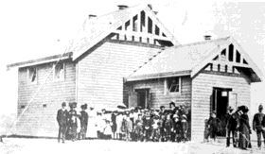School (former Vicarage), 2012.

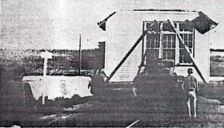Figure 8.16: Flinders Peak State School, n.d. Source: Wynd, So Fine a Country, p.157.

Figure 8.17: Former Flinders Peak School being relocated from Armytage to Belmont in 1950. Source: Geelong Advertiser, 24 May
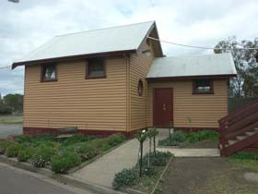1950.

Figure 8.18: Former Flinders Peak State School at the Belmont Primary School, 2007. Source: David Rowe.

Three other schools opened in the Lara area in the 20th century. They were at Avalon (opened in 1913) and Elcho (opened 1925).66 These schools closed in 1950 and 1929 respectively. In 1965, the Lara State School was opened to meet the needs of the increasing population of the town.67

Catholic School – St. Anthony’s
In addition to the State schools in the Lara area, St. Anthony’s Catholic School opened in the early 1980s in the former Catholic Church building (now the Baptist Church) in Flinders Avenue.68 The church site was considered too small to construct a large school building and so a new site was purchased in Kees Road and a new school building erected that opened in 1983. A second stage of school buildings were constructed in
1897.69

Other Educational Buildings
In 1967, the first kindergarten opened in Lara, in Walkers Road.70 It was
followed by the opening of the Flinders Kindergarten in Kees Road in
1975.71 In the ensuing years, the Uniting Church Hall (former Wesleyan
Methodist Chapel) at 1B Flinders Avenue became the location of the
Morongo Kindergarten.72

It was not until the 21st century when Lara boasted the establishment of secondary education. On 29 January 2003, the Lara Secondary College opened.73

8.3 Health & Welfare
Given its rural status, little appears to have occurred in developing any formal health service Lara in the 19th century. In fact, it was not until the late 1950s when Lara first had a resident doctor, when Doctor Gray Thompson took rooms at Mrs Osborne’s home at the corner of Forest Road South and Buckingham Street.74

Physical evidence survives of two local institutions that provided health and welfare: the Inebriate’s Retreat at Pirra Homestead; and St. Laurence Park Retirement Village.

Lara Inebriates’ Institution, Pirra Homestead
On 21 June 1907, the Lara Inebriates Institution was established by an Order‐in‐Council on the 637 acres of the original Fairbairn estate (which included the homestead, outbuildings and gardens).75 In a booklet entitled ‘Government Sanatorium, Lara’, the Institution was to become ‘a place for the reception, control, and treatment of inebriates …’76
However, it was to be ‘neither a hospital nor asylum, but … rather a hygienic home or health resort.’77 Other places in Victoria were used to treat other problems. Royal Park was initially considered as the location for an inebriates’ retreat but was used instead as an Acute Mental Diseases Hospital.78 Meanwhile, the Castlemaine gaol was the ‘receiving house for irreclaimable topers.’79

An inebriate was defined by the Inebriates Act 1904 as ‘a person who

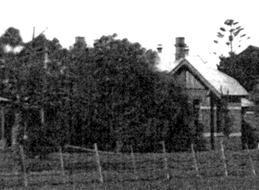
Figure 8.19: Former Inebriates’ Dormitory, Pirra Homestead, 1938‐
48. Source: Margaret Deller.

habitually used alcoholic liquors or intoxicating or narcotic drugs to excess.’80 The Lara Institution housed both compulsory and voluntary patients, which was visited twice weekly by a Government Medical Officer.81

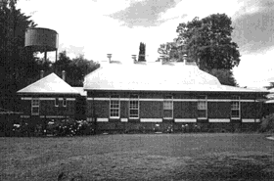The remaining farmland at Pirra provided food for the retreat and work for the patients.82 According to the Public Record Office Victoria:

Crops grown on site, including grains, and other produce such as wool and meat were sold to the Lunacy Department. Patients carried out work such as farming, clearing the land, painting, cutting firewood, vegetable and flower cultivation, making picture frames, egg farming, dairy farming and general house keeping.83

Some of the more skilled patients provided their services to locals in the
Lara area. Alan Mathieson recalled that:

… one patient a dentist would – when given leave – come to your house, extract your teeth and make a false set for a reasonable charge. Another, a tailor would make you a first class suite provided that you supplied the material. Many Lara people took advantage of these
facilities.84

Patients at the Inebriates Institution were also provided with a number of outdoor and indoor amusements. The ‘Government Sanatorium’ booklet for 1907 outlined the most significant equipment and activities available:

A fine billiard room, containing a full‐sized table (Alcock’s Imperial, low cushions, &c.), and complete in every detail; a reading‐room and library, stocked with good classical and modern novels; cards, chess, &c.; an excellent piano (Steinway grand); tennis court and cricket ground;
fishing, quoits; Indian clubs; dumb‐bells, &c.85

Cricket matches were also played on the Pirra field with teams comprised of locals or from Geelong, and an Institute team.86

On 11 November 1927, the Geelong Advertiser detailed the Inebriates
Institution:

… The daily average number of cases treated at Lara was 36; and there is accommodation for 50, but it rarely happens that there are more than
40 or less than 30 cases in the residence. The inspector invariably found
the men content. They rapidly convalesced in the healthy environment of the institution, although they went there more or less shattered in health and not infrequently bankrupt in pocket. The institution had been practically free from any epidemic disorder, accident, or serious illness.

Seven patients absconded from Lara during the year, and all of them belonged to that undesirable class who are refractory to any form of treatment or reformation, and for whom separate institutional treatment is recommended.

The institution is generally in good repair and comfortable … The institution has been equipped with an excellent wireless set, which gives

Figure 8.20: Former Inebriates’ Dormitory, Pirra Homestead, 2002. Source: David Rowe.

a great deal of pleasure to the inmates, especially in the evening.87

Ian Wynd in So Fine A Country also provided some details on the number of admissions to the Institution:

The admissions to the home averaged well over 100 per year with a peak of 195 in 1924. During World War I the admissions dropped as many who might otherwise have been admitted enlisted in the A.I.F.; 42 inmates enlisted in the first year of the war; on the other hand there was an increase in the use of narcotics, and doctors, chemists, dentists and nurses formed 44% of admissions. In the 1920s a good number of the
patients were returned soldiers, over one‐third in 1928.88

One patient at the Institution was to become Australia’s Prime Minister. In 1916, having reached the lowest point in his life, John Curtain admitted himself to the Lara Institution.89

With the increasing costs associated with the Institution’s operations, the Inebriate Institution was closed in 1930.90 Today, a brick Federation styled former dormitory building and a brick interwar era laundry outbuilding are physical legacies of the Inebriates’ Institution at Pirra.91

St. Laurence Park Retirement Village92
In 1959, 42 acres of land in Lara were purchased by the Brotherhood of St. Laurence under the direction of its founder, Father Gerard Kennedy Tucker (1885‐1974), O.B.E., for the purpose of developing a retirement village. The first four cottages were subsequently erected and they were officially opened by the Governor of Victoria, Sir Dallas Brookes, on 3
October 1959. There were a number of benefactors that assisted financially in the establishment of St. Laurence Park and these early cottages were named in their honour. Those original cottages that survive today are the Spalding, Wills and Hallows cottages.

Four years later in 1963, the first stage of Father Tucker’s support care building, Tucker Court, was officially opened by Lieutenant‐General, the Hon. Sir Edmund Herring and Dame Mary Herring. An additional 23 acres of land were acquired on the western side of Hovells Creek in 1967 and in
1973, Richard Austin, in the presence of Sir James Darling, officially opened the next stage of the village, Hume Court. Further development of St. Laurence Park occurred in the ensuring years, including the opening of Flinders Lodge Nursing Home in 1982, opening of the Eric Hart Activities Centre in 1985, and the Costa Aged Care Facility in 2001.

8.4 Community Organisations
Equally critical in the evolution and development of Lara has been the establishment of community organisations. Those that were established in the 19th century included the You Yangs Lodge of Oddfellows (established before 1865), Lara Sons of Temperance Society (established in 1865), Duck Ponds Free Public Library (opened in 1874), and the Lara Reform and Protection League (established in 1879). 93

Other organisations followed in the early 20th century. By 1901, the Lara
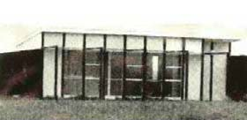
Figure 8.21: First Cottage at St. Laurence Park completed 1958‐59. Source: Daley, St. Laurence Park Retirement Village Fiftieth Anniversary, p.22.

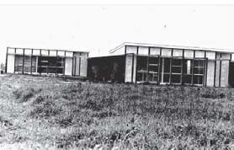
Figure 8.22: Other early cottages at St. Laurence Park. Source: Daley, St. Laurence Park Retirement Village Fiftieth Anniversary, p.22.

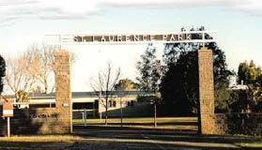
Figure 8.23: St Laurence Park, 1999. Source: Daley, St. Laurence Park Retirement Village Fiftieth Anniversary, p.17.

Mutual Improvement Society had formed to petition for a centralised post office and telephone exchange as well as improved footpaths and street works.94 It was succeeded by the Lara Progress Association in
1908. It had similar aims of improving the amenity of the township throughout the 20th century.95

In 1928, the Lara Sub‐branch of the Returned Services League (R.S.L.) was formed with the Late Reverend Colonel W.E. Dexter, D.S.O., M.C., D.C.M., M.I.D., as its first president.96 The R.S.L. first met in the Lara Public Hall until 1949 when the sub‐branch leased the former Corio Shire Hall in Rennie Street.97 The hall was subsequently given to the Lara R.S.L. in
1956.98

Efforts to establish a fire brigade in Lara began in 1929.99 The loss of Lyall and Sons Chaff Mill not only had serious consequences for the chaff mill operator, but disastrous effects on local farmers. As a result, a public meeting was to be called in early 1930 with the possibility of forming a brigade.100 However, another nine years were to elapse before the Lara Fire Brigade was formed in 1939.101

Other organisations formed from the late 1940s, including the Lara Branch of the Country Women’s Association in 1949 (the result of a meeting in the Holy Trinity Church Hall), 102 First Lara Scout Group in 1957, Lara Girl Guides in 1961, Lara branch of the Australian Red Cross in 1962, Lara Masonic Lodge in 1963 and the Lara Lions Club in 1969 following the aftermath of the bushfires.103

Apart from the Lara R.S.L., physical evidence of 19th and 20th century community organisation is identified in the former Temperance Hall at 1B Flinders Avenue, and the Lara Community Centre in Waverley Road.

Former Lara Temperance Hall, 1B Flinders Avenue
In 1865, the You Yangs No. 21 Division of the Sons of Temperance was formed at Lara.104 Three years later in 1868, two roods of land immediately adjacent to the Wesleyan Church Reserve in Flinders Avenue were temporarily reserved for the Temperance Society.105 The existing gabled limestone hall was built in the following months, having been completed by September 1869.106 The first Trustees were James English, James Blair, Charles Olive, William McClelland and Joseph Kirk.107

Until the erection of the Lara Public Hall in 1886, the Temperance Hall served as a community hub. In 1872, there was a public meeting at the Hall in an effort to raise funds for the widow and six children of the recently deceased Robert Owen Phipps, killed in a duck shooting accident.108 In 1874, the Temperance Hall became the location of the Duck Ponds Free Library, with the first issue of books taking place in August of that year (this being the humble beginnings of a public library service culminating with the opening a new Lara Public Library building in Walkers Road on 20 December 2011).109 The Hall was also the location of a Church of England Sabbath School in 1875.110 Further associations with the Church of England are known in 1879, when a concert was given in the Hall in aid of the Holy Trinity furnishing fund (as the Anglican Church

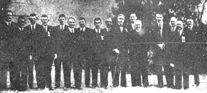
Figure 8.24: Group at the Anzac Day
Commemoration Service, Lara,
1938. The Federal Treasurer, R.G. Casey is fourth from the right. Source: Geelong Advertiser, 26 April
1938.

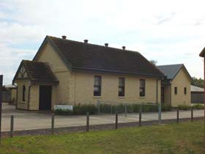
Figure 8.25: Former Temperance
Hall, Flinders Avenue, 2012.

had no hall of its own at this time).111 The concert was reported in the
Geelong Times:

A very enjoyable entertainment took place at Lara last evening in the Temperance Hall, the proceeds of which are to be devoted to furnishing Trinity Church. The performers were all Geelong amateurs, and created a very favourable impression. Mr H. Meeking presided at the piano, and the vocalists were Messrs T. Brearley, R. Webber, J. Bayley, J.B. Hall, F. Hodges, and T. Mayer, and Mr H. Steedman performed two piccolo sols. The whole of the performers acquitted themselves very creditably, and the audience showed their appreciation of their efforts by vociferous applause, both the comic singers, Messrs Mayer and Webber being encored. The programme was varied by a ventriloquial performance by Mr Webber, which brought down the house, and Miss Dora D’Helin surprised the company by her artistic performance on the piano. At the conclusion the concert the hall was cleared, and the devotees of Terpsichore worshipped at his shrine
until an early hour this morning.112

In 1886, following the opening of the Lara Public Hall, John Spalding purchased the Temperance Hall and leased it to the Sons of Temperance. The Geelong Advertiser reported that this measure was ‘to protect the interests of the bodies concerned.’113 It appears that the opening of the Lara Public Hall brought about the demise of the Sons of Temperance. Spalding gave the Hall to the Primitive Methodist Church in 1891.114

Lara Community Centre115
On 30 June 1982, the Lara Community Centre was established by the
Corio Shire Council. Seventeen people were members of the Committee of Management, including ten local citizens, three ex‐officio Shire Councillors, two members of the Lara Progress Association and two members of the Lara Lions Club. The Committee took charge of managing the property then known as the Lara Community Centre in Waverley Road, having previously been the Lara Presbyterian Church and Hall.

The earliest programs of the Community Centre continued community activities that had been occurring on the property before 1982. These activities included dancing and karate and other groups including the Lara Play Group, Lara Guides, Lara Brownies and the You Yangs Yarners, as well as educational programs such as aerobics, cake decorating and pottery. Mrs Phyl Walker was responsible for bookings and cleaning the hall. It was available for hire.

In January 1983, Joan Reeve was appointed the first coordinator of the Community Centre. She established a creche and the approval of additional community classes including bread making, mixed handcrafts and lead lighting. There were also children’s activities on offer, including school holiday programs. The Lara Happenings community newsletter was prepared from the Centre from this time. The following year, 1984, a Youth Club was established and led by Bill Neave. A youth room was subsequently constructed and it opened in March 1985 during the Lara Heritage Festival. Childcare and a three year old kindergarten were also established at the Centre in following years.

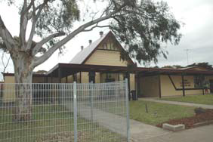
Figure 8.26: Lara Community
Centre, Waverley Road, 2012.

8.5 Commemoration
In the Lara region are a select number of places that commemorate past events and people associated with the area. They are an important legacy of the community’s values of respect, memory and identity.

Cemeteries
Former Primitive Methodist Burial Ground
Possibly as early as 1854 with the establishment of the Primitive Methodist Church at 175 Forest Road North, a cemetery was established in the Church reserve. Seven burials were recorded at the site before the relocation of the Church in 1868. The only known physical evidence of the burial ground today is a thin piece of farmland and a stone marker that lists those once buried at the site. They were Duggan (Senior), c.1860, Pownall (male), Walker (male), Spalding (infant), daughter of John and Sara Spalding, Unknown (young man killed by a dray, no name) and two other unknown persons.116

Rothwell Cemetery117
On 21 July 1859, land at Rothwell was set apart as a site for a general cemetery. The first Trustees were William McCord, John Henry, Jeremiah Dooley, Daniel Corcoran, John Rees, Edward Connot, Samuel McNaughten, John Snedden, John Morris, Ebenezer Cousins and Henry Nickless. Mr J.D. Buckley, Headmaster of the Catholic School at Little River acted as secretary. The first burial took place on 29 October 1859, when Mr Gordon Cameron was interred.

While considerably distant from the Lara township and because there was no registered burial ground there, the Rothwell Cemetery became the resting place for a number of locals of Lara, Lara Lake and the You Yangs. Residents of Lara buried at Rothwell Cemetery in the 19th and early 20th centuries included members of the Bates, Beardsell, Berry, Blair, Branch, Calvert, Curlett, Duggan, Fairbairn, Frisch, Frost, Gebbie, Gillespie, Gillett, Grass, Grills, Groves, Harding, Hawksford, Hedges, Mathieson, McGillivray, Oakley, Perkins, Spalding, Teesdale and Walker families.

Flinders Memorial Park118
In 2002, the Flinders Memorial Park was established in Forest Road South by the Geelong Cemeteries Trust as a cemetery for residents of Lara and Geelong’s northern suburbs. The first burial took place on 4 April 2003. Cremated remains are also catered for at the Park.

Veteran‐Related Memorials
War Memorial Gates at Recreation Reserve
On 22 December 1929, the gates commemorating the service of the 104 men and women of the Lara region who served in World War One were officially unveiled by the Governor of Victoria, Lord Sommers.119
Comprising four square granite piers with central vehicular and flanking pedestrian metal gates, and they were erected at a cost of £380 by Barklamb Brothers of Caulfield.120 The construction of the gates at the entrance to the Recreation Reserve was one of the first projects carried out by the recently‐formed Lara sub‐branch of the R.S.L. (then known as

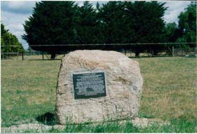
Figure 8.27: Interpretive plaque on a rock outside the former Primitive Methodist Church burial ground, Forest Road North, 1998. Source: David Rowe.

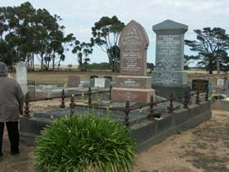
Figure 8.28: Grave of Henry Grove, Rothwell Cemetery, 2008. Source: David Rowe.

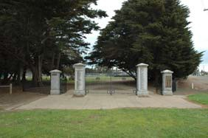
Figure 8.29: Lara Memorial Gates,
2012.

the R.S. & S.I.L.A.). The ceremony involved a large gathering where Lord Sommers inspected a guard of honour from the 23rd Battalion (City of Geelong Regiment). In addition to a parade of returned soldiers, music was provided by the Geelong City Band.121 According to the Geelong Advertiser:

The names of the killed inscribed on the Lara gates represented one in about four and half of the number who joined the A.I.F. from the township and district. The end was not yet. Many of the men who returned still bore the result of those hard and strenuous years.122

Memorial Pine Plantation & Soldiers’ Avenue of Sugar Gums, Recreation
Reserve
A pine plantation reserve had earlier been established in 1918. The
Ballarat Courier commented on the postponement of the planting due to inclement weather. The men were to dig the holes and each lady present at the occasion was to plant a tree ‘in honour of a soldier friend at the Front.’123 Guards were to be erected around the trees and individual trees were ‘to be allotted to the ladies to take care of till their soldier boys returned from the Front.’124 In 1945, The Argus reported that ‘A memorial of pines planted after the last war has done well.’125 It appears that approximately 30 trees were originally planted,126 possibly along the northern portion of the Mill Road boundary of the Recreation Reserve. However, it is not known whether the existing rows of Pinus Lambertianas along the southern boundary (Walkers Road) of the Recreation Reserve and along the Mills Road boundary (southern portion) represent part of the World War One Pine plantation planted in 1918 or trees established in the ensuing years.127 An aerial photograph of the Lara Recreation Reserve in 1947128 shows that these trees were reasonably mature by this time. The existing row of Cypresses along the northern portion of the Mills Road boundary appears to have been planted immediately prior to 1973 (replacing the earlier row of trees).129

It was also in 1918 at the time of the planting of the pine plantation when
150 Sugar Gums were planted as a Soldiers’ Avenue.130 In 1945, the Lara
Recreation Reserve Committee proposed ‘to plant a section of the reserve with flowering gums as a memorial to district servicemen’ of World War Two.131 Residents were invited to plant a tree for each of their relatives.132 A small stand of gum trees survive in the south‐west corner of the northern oval reserve that appear to date from the planting of 1918.133 It would appear that the flowering gums to commemorate district servicemen at World War Two did not eventuate.

Memorial Guns
In 1945, it was proposed to install artillery guns at Lara as a World War Two memorial.134 Presumably to be situated adjacent to the Memorial Gates, this proposal does not appear to have been carried out.

Avenue of Honour, Walkers Road
During 1946, a committee of Lara residents and RSL members was formed to organise a memorial for returned service personnel.135 On 17 June
1947, a public meeting was held to decide on an appropriate memorial to

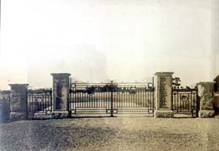
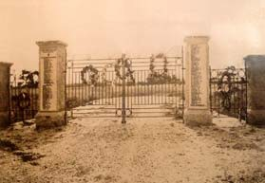Figure 8.30: Lara Memorial Gates & Fencing, 1928. Source: Bruce Challoner, Lara RSL Sub‐Branch.

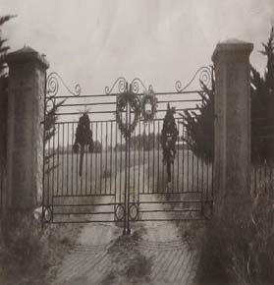Figure 8.31: Lara Memorial Gates & Fencing, 1945. Source: Bruce Challoner, Lara RSL Sub‐Branch.

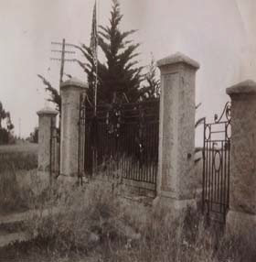Figure 8.32: Lara Memorial Gates showing Pinus Lambertiana trees adjacent, 1948. Source: Bruce Challoner, Lara RSL Sub‐Branch.

Figure 8.33: Lara Memorial Gates showing Pinus Lambertiana trees on southern boundary of Reserve,
1948. Source: Bruce Challoner, Lara
RSL Sub‐Branch.

that were discussed were a memorial swimming pool and an avenue of honour.137

Ultimately, on 28 August 1948, an Avenue of Honour of 84 trees was planted along from the memorial gates on the north side of Walkers Road adjacent to the recreation reserve, and further south‐west along Walkers Road.138 An additional six trees honouring the six who never returned were also planted closest to the memorial gates. These six trees were Golden Lambertianas with the other trees being Pinus Lambertianas (known as Lambert’s Cypress).139 The names of the fallen were Jim Austin (tree 1), Alex Bowler (tree 3), Gordon McIntyre tree (5), John Austin (tree
2), Keith Jenkins (tree 4), and Jim Payne (tree 6).140

Other Memorials
Hume & Hovell Monument, Princes Freeway141
In 1924, to celebrate the centenary of Hamilton Hume and William Hilton Hovell’s highly significant expedition from Lake George in New South Wales to Victoria, a Hume and Hovell Centenary Celebrations Committee was formed. It included representatives from the National Parks Committee, Historical Society, Education Department, Lands Department and the Royal Automobile Club. Between 1924 and 1927, 37 Hume and Hovell monuments were erected along the 1824 route that had been mapped by Herbert Hansford of the Lands Department. In association with the central Committee, each local township committee organized an official unveiling ceremony to mark the important anniversary.

Over one thousand people met at the corner of the Melbourne‐Geelong Road and Lara Road (now Rennie Street), Lara, on 17 December 1924 for the official unveiling ceremony of the rough‐hewn granite Hume and Hovell obelisk. Situated atop the Melbourne Hill in a prominent location (now in a lower position near the original location due to earthwork excavations), the monument was designed by the eminent sculptor, Paul Montford. It represented the southern‐most memorial to the famous explorers, and the last of a long line of similar memorials stretching to Albury, and beyond to Campbelltown, New South Wales.

Pioneers’ Memorial Cairn, Sixways
In October 1938 a Pioneers’ Memorial Cairn built of granite from the You Yangs was officially unveiled by the Minister for Water Supply, Mr F.E. Old.142 The cairn was situated at the intersection of Flinders Avenue, Forest Road and Patullos Road, known as Sixways. In attendance were some of the early residents of the Lara district, ranging in age from 70 to
91 years.143

On 22 March 1977, to perpetuate the memory of Matthew Flinders, a plaque was added to the memorial cairn.144 The adjacent road was also officially renamed Flinders Avenue by Cr. J. Deppler, Shire President as part of the Bicentenary celebrations.145

Figure 8.34: Avenue of Honour, Walkers Road, 2012.

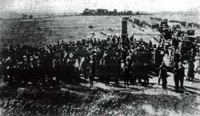
Figure 8.35: Unveiling of Hume & Hovell Monument, Lara, 1924. Source: The Argus, 17 December
1924.

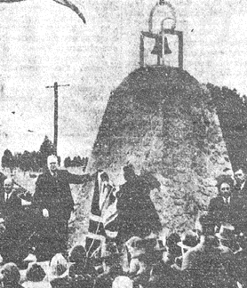
Figure 8.36: Unveiling of the Pioneers’ Memorial Cairn, 1938. Source: Geelong Advertiser, 18
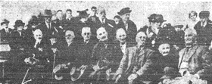October 1938.

Figure 8.33: Early residents of Lara at the unveiling of the Cairn. Source: Geelong Advertiser, 18
October 1938.

Bills Trough, Rennie Street
In 1927, a concrete horse and dog trough was installed on the Rennie
Street roadside near the Corio Shire Hall. It was donated by Annis and George Bills and installed by the Metropolitan Drinking and Cattle Trough Association that had been set up in England by an organisation established in 1859 to provide water facilities for both drivers and animals.146 In late October 2012, the trough was removed from its site so that much‐needed repairs could be carried out.

Fairbairn Memorial outside Community Centre, Waverley Road
On 26 Mar 1935, George Patrick Fairbairn and his wife, Mary Robertson
(nee Murray), of Wooloomanata Homestead, were accidentally killed in an aeroplane accident. Their tragic deaths were reported as far away as Carnarvon, Western Australia, in the Northern Times:

Mr. George Patrick Fairbairn, of Lara, and his wife, formerly Miss Mary Stuart Murray, were killed this morning when their Hermes sports plane crashed two miles from Essendon aerodrome. Mrs. Fairbairn was flying the machine, in which they had attended the Empire Air Celebrations on the previous day and when about 300 feet up the engine failed. Apparently, Mrs. Fairbairn attempted a left‐hand turn to glide towards the field to land, but the plane went into a spin and crashed onto the macadamised surface of Keilor‐road (narrowly missing a truck). Mrs. Fairbairn was thrown 10 yards from the machine, despite the fact that she was wearing a safety belt, while Mr. Fairbairn was crushed by the engine. The machine was a mass of wreckage. Both victims were aged 26. They
were married only two years ago and leave a small daughter.147

To commemorate the lives of George and Mary Fairbairn and to mark their deaths, the parents of Mary Fairbairn erected a memorial plaque on the front gate of the Presbyterian Church in Waverley Road.148 In later years (possibly when part of the Community Centre), the plaque was relocated to a large rock in the front garden. In more recent times, it has been transferred to a stainless steel stand outside the former church building.

Flinders Memorial Cairn, Princes Freeway149
On 22 March 1977, a cairn in memory of Matthew Flinders was unveiled by the Chairman of the Country Roads Board, R.E.V. Donald, on the Princes Highway, Avalon. The cairn commemorated the Flinders Bi‐ centenary, marking the line Flinders took on his journey from Kirks Point to and from the You Yangs on 30 April 1802.

Lara Bushfire Memorial Sculpture & Interpretive Display, Walkers Road
In 2009, to mark the 40th anniversary of the Lara bushfire, a memorial
sculpture and interpretive display (giving a history of the Lara bush fire) was unveiled in the north‐west corner of Austin Park. The plaque on the sculpture was dedicated by Betty Davey‐Walker, in memory of those who lost their lives and to the people of Lara affected by the disaster.150
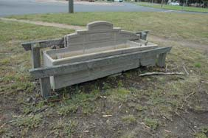
Figure 8.37: Bills Trough, Rennie
Street, 2012.

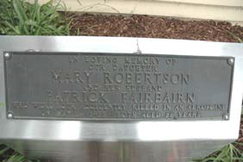
Figure 8.38: Fairbairn Memorial Plaque outside the former Presbyterian Church, 2012.

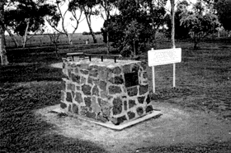
Figure 8.39: Flinders Memorial
Cairn, Princes Highway, Avalon,
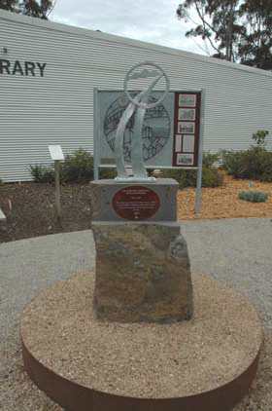1998. Source: David Rowe.

Figure 8.40: Lara Bushfire Memorial
Sculpture, Walkers Road, 2012.

1 M. Budd, C. Delaney, J. Grainger (eds.), From Duck Ponds to Lara: A Collection of Memories, Lara Heritage Festival Inc., Lara,
2004, p.118.
2 I. Wynd, So Fine A Country, Shire of Corio, 1981, p.152.
3 Ibid.
4 Ibid. & Geelong Advertiser, 5 June 1978.
5 Ibid.
6 Wynd, op.cit.
7 Victoria Government Gazette, vol. 32, 24 March 1864, p.743.
8 A. Willingham, Geelong Region Historic Buildings and Objects Study, vol. 1, Geelong Regional Commission, Geelong, 1986, sheet 135.
9 Ibid.
10 J. Blair, Corio Shire Secretary, to the Secretary of the Board of Public Health, 23 November 1901, in ‘Seventh Day Adventist
Church’ public building file no. 5420, VPRS7882/P1, Unit 692, Public Record Office Victoria.
11 Budd, et.al., op.cit., p.114.
12 Ibid.
13 Ibid.
14 Ibid., p.118.
15 Victoria Government Gazette, vol. 57, 26 May 1865, p.1196.
16 B.E. Giddings, ‘A Church in the World: The Lara‐Meredith Uniting Church Parish: The opening of the Lara Worship Centre, October 26th 1980’, booklet, p.5.
17 Geelong Advertiser, 9 September 1886.
18 Giddings, op.cit.
19 Laird and Barlow, architects, Contractors’ Book 1894‐1899, p.68, Geelong Heritage Centre.
20 Giddings, op.cit.
21 Board of Public Health Sketch Plan, 1921 in ‘Methodist Church Lara’, public building file no. 938/A, VPRS7882/P1, Unit 190, Public Record Office Victoria.
22 Giddings, op.cit.
23 Geelong Advertiser, 21 March 1877.
24 D. Rowe, ‘Architecture of Geelong 1860‐1900’, B.Arch. Thesis, Deakin University, 1991, p.74.
25 Geelong Times, 4 October 1877.
26 Mercury and Weekly Courier, 7 October 1882, p.3.
27 Budd, et.al., op.cit., p.116 & Cazalys Contractor Reporter, 3 October 1899, p.53, State Library of Victoria.
28 Geelong Advertiser, 16 April 1955.
29 ‘Holy Trinity Church of England’, public building file no. 6998, VPRS7882/P1, Unit 825, Public Record Office Victoria.
30 Budd, et.al., op.cit.
31 Schefferle, Chomley and Associates, architects, ‘Proposed Scheme for Rebuilding, Holy Trinity Anglican Church, Lara’, Geelong
Heritage Centre.
32 Budd, et.al., op.cit., pp.119‐120.
33 Giddings, op.cit.
34 R. Aitken, ‘Edwardian Geelong: an architectural introduction’, Architectural Research Thesis, Architecture Division, Deakin
University, 1979, p.55.
35 News of the Week, 14 October 1909.
36 Laird and Buchan to the Department of Public Health, 27 May 1909 in ‘Church, Waverley Road (Uniting Church)’, public building file no. 5422, VPRS7882/P1, Unit 692, Public Record Office Victoria.
37 Wynd, op.cit., pp.160‐161.
38 Shefferle, Chomley and Associates, ‘Proposed Church Hall at Lara for the Presbyterian Church – Site Plan and Working
Drawings’, August 1962, public building file no. 5422, op.cit.
39 Cazalys Contractor Reporter, 8 October 1912.
40 Budd, et.al., op.cit., pp.114‐115.
41 R. Peterson, ‘Historic Government Schools: A Comparative Study’, prepared for the Heritage Management Branch, Building
Division, Department of Planning & Development, June 1993, p.1.
42 Ibid.
43 Ibid.
44 Wynd, op.cit., pp.154‐155.
45 Ibid.
46 Ibid., p.157.
47 Peterson, op.cit., p.2.
48 Ibid.
49 Ibid.
50 L. Burchell, Victorian Schools: A Study of Colonial Government Architecture 1837‐1900, Melbourne University Press in association with the Victorian Education Department, Carlton, 1980, pp.13‐17, 75.

51 Ibid.
52 L.J. Blake (ed.), Vision & Realisation: a centenary history of state education in Victoria, Education Department of Victoria, Melbourne, 1973, vol.2, p.1007.
53 Ibid.
54 Ibid.
55 Peterson, op.cit., p.3.
56 Ibid.
57 Ibid., p.4.
58 Burchell, op.cit., p.113.
59 Wynd, op.cit., p.155.
60 Blake, op.cit. & Budd, et.al., op.cit., p.122.
61 Blake, op.cit.
62 Geelong Advertiser, 24 May and 3 June 1950.
63 Ibid.
64 Blake, op.cit.
65 Ibid.
66 Wynd, op.cit., pp.157‐158.
67 Ibid., p.158.
68 Budd, et.al., op.cit., p.129.
69 Ibid., pp.129‐131.
70 Ibid., p.131.
71 Ibid., p.132.
72 Ibid.
73 Ibid.
74 Ibid., p.151.
75 ‘Lara Inebriate Retreat 1907‐1937, VA 2849’, Summary Guide 2001, Public Record Office, Victoria online.
76 J. Manton, ‘Windermere’, History of Architecture IV Research Essay, 1965, p.10, in Heritage Victoria file no.
HER/2001/000067.
77 Ibid.
78 Wynd, op.cit., p.236.
79 Ibid.
80 ‘Lara Inebriate Retreat’, op.cit.
81 Ibid.
82 Ibid.
83 Ibid.
84 A. Mathieson, My Reflections on 77 Years in Lara, pp.8‐9.
85 Manton, op.cit., p.22.
86 Mathieson, op.cit.
87 Geelong Advertiser, 11 November 1927.
88 Wynd, op.cit., p.237.
89 R. Marles, ‘Curtain’s Lara Legacy’ in the Geelong Advertiser, 26 March 2010.
90 Wynd, op.cit.
91 D. Rowe, ‘Pirra Homestead’ Conservation Management Plan, vol.1, June 2002.
92 All information on St. Laurence Park Retirement Village taken from D. Daley, St. Laurence Park Retirement Village Fiftieth
Anniversary, D. Daley, 2009.
93 Wynd, op.cit., p.158.
94 Ibid., p.160.
95 Ibid.
96 ‘Lara Returned Services League’ in the Lara Heritage Festival magazine, 1994, p.19.
97 Ibid. and Geelong Advertiser, 24 February 1949.
98 Geelong Advertiser, 28 June 1956.
99 Ibid., 26 December 1929.
100 Ibid.
101 Budd, et.al., op.cit., p.171.
102 Lara Heritage Festival magazine, op.cit., p.37.
103 Budd, et.al., op.cit., pp.173‐179.
104 J. Blair to Commission of Lands and Survey, 9 September 1869, in ‘Duck Ponds Temperance Hall’ file, VPRS242, Unit 30, Public
Record Office Victoria.
105 Ibid. & Moranghurk Parish Plan showing the subject allotment with the date, 30 November 1869 and listing J. English and Ors. (others) as managers.
106 Blair, op.it.
107 J. Ramage to President of Land and Works, 23 February 1869 in ‘Duck Ponds Temperance Hall’ file, op.cit.

108 The Argus, 10 January 1872.
109 Geelong Advertiser, 6 August 1874 & ‘New Lara Library Opens’, Geelong Regional Libraries website, 15 December 2011, at http://www.geelonglibraries.vic.gov.au/news/new%E2%80%90lara%E2%80%90library%E2%80%90opens.
110 Geelong Advertiser, 5 August 1875.
111 Ibid., 30 September 1879.
112 Geelong Times, 18 August 1879.
113 Geelong Advertiser, 9 September 1886.
114 Giddings, op.cit.
115 Information on the Lara Community Centre taken from B. Stretton, Celebrating Our Past, Meeting our Future, Lara
Community Centre Inc., Lara Community Centre Inc., Lara, October, 2002.
116 Information taken from stone marker at the site in 1998.
117 See P. Jennings, Rothwell Cemetery 1859‐2009: 150 Years of Community Service, Little River Historical Society for the Rothwell
Cemetery Trust, Little River, 2009.
118 See Geelong Cemeteries Trust website at http://www.gct.net.au/historic.html.
119 Geelong Advertiser, 23 December 1929 and information from a plaque on one of the gate piers and from Bruce Challoner, Curator, Lara R.S.L. Branch.
120 Ibid.
121 Ibid.
122 Ibid.
123 Ballarat Courier, 26 August 1918, p.6.
124 Ibid. See also the Geelong Advertiser, 17 June 1947.
125 The Argus, 4 April 1925.
126 Ballarat Courier, op.cit.
127 It is also possible that some of these trees were also planted as replacements for the Soldiers’ Avenue of Sugar Gums planted in 1918, although no documentary evidence has been found in support of this claim.
128 Aerial photograph of the Lara Recreation Reserve, 1947, GRS 2030/C182/2, Geelong Heritage Centre.
129 The young trees are shown adjacent to the mature Pinus Lambertianas along the Mill Road boundary in an aerial photograph of 1973. The photograph is at the Geelong Heritage Centre, GRS 1262/36/96.
130 News of the Week, 29 August 1918 & 26 September 1918.
131 Ballarat Courier, op.cit.
132 Ibid.
133 Information kindly provided to Pam Jennings by Bruce Challoner, Curator, Lara RSL, 30 November 2012, and to David Rowe,
22 February 2013 and personal comments by Alan Dawson, Maintenance Officer, Trees, City of Greater Geelong, to David
Rowe, 25 February 2013.
134 Index to War Memorial Survey 1920‐85 initiated as a questionnaire by the Commonwealth Department of Home Affairs
(1920), Australian War Memorial, Canberra.
135 Challoner, op.cit., 6 & 7 November 2012.
136 Geelong Advertiser, op.cit.
137 Ibid.
138 Challoner, op.cit.
139 Ibid.
140 Ibid.
141 D. Rowe, ‘Hume and Hovell Monument, Lara’, Conservation Management Plan, prepared for the City of Greater Geelong, April 2002.
142 Geelong Advertiser, 18 October 1938.
143 Ibid.
144 Information from a plaque on the cairn.
145 Ibid.
146 Information on Annis and George Bills, source unknown, courtesy Jessie Cameron, St. Arnaud. Interview held by Vicki
Johnson with Jessie Cameron, St. Arnaud. A. W. Brown letter re: Annis and George Bills to Kemsey Historical Society, 25
February 1986
147 Northern Times, 29 May 1935.
148 Information from a staff member at the Lara Community Centre, 23 October 2012.
149 Information on the cairn in 1998.
150 Information on the plaque, 23 October 2012.

9. Sport & Recreation
9.1 Sport
The cultural development and social cohesion within the Lara area has relied on the numerous sporting activities, competitions and clubs that were established from the 19th century.

Popular Sports
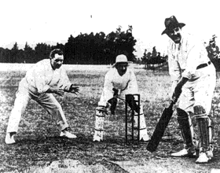The popular sports in the Lara area have included cricket, football, tennis, cycling, croquet and horse racing. Another important very early sport was the running of the hounds. In 1845, the Geelong Advertiser reported on the last meet of the season that was to be held ‘at Messrs Bates Station, Duck Ponds, at daybreak.’1 The Werribee Hounds met at sunrise at Station Peak, Synot’s and at Duck Ponds in 1847.2

Given the large farming population at Lara, it is not surprising that ploughing matches were a local sporting feature in the early years. The first annual event took place in September 1862 at Hawford’s farm that adjoined the railway.3

Horse racing became an important sporting activity in Lara in the 19th century. The earliest reference to horse racing was in 1876, when the Geelong Advertiser reported Henry Williams as Honorary Secretary of the Duck Ponds Race Club, the course being ‘on Gillot’s and Darcy’s land.’4
Yet, a year later in 1877, the Geelong Advertiser claimed that a racing club was being formed at Duck Ponds with the first meeting being held on Boxing Day of that year.5 This Race Club appears to have been short‐lived as in 1887 a new Lara Racing Club was formed with F. Austin as President and F. Armytage as Vice President. Land was made available for F. Austin free of charge behind the Lara Railway Station.6 By the early 20th century, races were held in a paddock on the south‐west corner of Forest Road South and Canterbury Road, opposite the Lake Bank Hotel.7

Other sporting groups were formed in the 20th century, including the Lara
Bowling Club, Swimming Club, Athletics Club, Elcho Golf Club and from
1975, the Lara Sporting Club. This Club was created from an amalgamation of the Lara Cricket and Football Clubs and it now encompasses baseball, cricket, football, netball, soccer and softball competitions at both senior and junior levels.8 In 1976, Avalon Raceway, north‐east of the Lara township, was established by Doug and Norm Drew. It became the location for races of sprintcars, super and modified production sedans, motorcross bikes, monster trucks and go karts.9

There were more informal sporting challenges, such as the wheelbarrow trek from Lara to the You Yangs by D. Spalding and Councillor R. McCelland in 1935. The light‐hearted adventure was reported in The Argus:

Mr. D. Spalding, of Lara, challenged Councillor R. McClelland, of the Corio Shire Council, that he would wheel him in a wheelbarrow from Lara to the rotunda on the slopes of Flinders Peak, at the You Yangs, a distance of about five miles in a day. Councillor McClelland accepted the challenge, and to make it interesting a side wager of £5 was decided on. The date of

Figure 9.01: George Fairbairn at the wicket, possibly Lara, 1904. Source: The Australian, 30 January 1904, p.57.

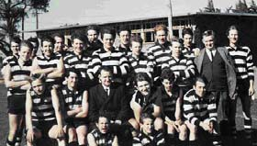
Figure 9.02: Lara Football Club, n.d. Source: http://www.larasportingclub.com.a u/lsc/index.php/football/history.

the contest will possibly be fixed after the meeting of the Corio Shire
Council, which will be held on June 26.10

Physical evidence of some of Lara’s organised sports is the Lara
Recreation Reserve and the McClelland Memorial Swimming Pool.

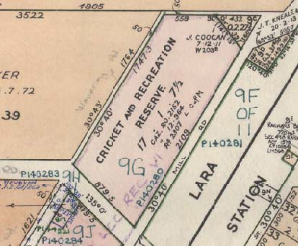Sports at the Lara Recreation Reserve
One of the earliest sports clubs to be established at Lara was the Duck
Ponds Cricket Club. It formed in 1873 with James Ramage as president and G.A. Sandford as secretary, the early cricket ground was threatened when a new road was constructed through it.11 A private cricket ground was also established by George Fairbairn outside his Windermere (Pirra) Homestead. Two years later in 1875, the Lara Football Club was formed.12

On 24 August 1880, 17 acres of land was proclaimed for recreational purposes to the west of the railway station. The first trustees were George Fairbairn, David McHarry and Samuel Pownall.13 In 1882, regulations ‘for the care, protection, and management of a Reserve for Cricket and other purposes of public recreation in the town of Lara’ were gazetted.14

In the early 1900s a gun club met at the southern end of the reserve for trap shooting of live birds.15 In 1919, tennis courts replaced the trap shooting in the reserve, the tennis club having earlier established a court in Austin Park.16 The secretary of the Club at this time was C.E. Kean.

It was also in 1919 when a ‘small grandstand and two dressing rooms’ were constructed in the recreation reserve.17 It was erected ‘by returned soldier labor with locally subscribed materials’18 forming a long rectangle in plan tiered timber seating and a roof supported by large posts. Both the grandstand and the tennis court were funded through the Victorian Government’s repatriation gift to the Corio Shire.19 The grandstand no longer survives.

In 1929, gates and piers were constructed at the south‐east entrance to the reserve as a memorial to those who fought and died in World War One. A tree plantation was also established. Further trees were added in
1948 as an Avenue of Honour to the locals involved in World War Two
(see Theme 8 for further details).

McClelland Pool and the Lara Swimming Pool
During the 20th century, the Lara Swimming Club was founded. Swimming
training was initially carried out at Eastern Beach and Rippleside Beach.20
On 9 March 1963, the swimming pool complex was officially opened in Forest Road South, at the site of the water bore in Forest Road South first used in 1887. The pool was named after Abe and Jean McClelland who had donated the land.21 As the first municipal pool in the Geelong region, it attracted huge popularity with 13,500 visitors in the first six weeks of its opening.22
Figure 9.03: Lara Cricket & Recreation Reserve in the Township of Lara Plan, VPRS16171, Public Record Office Victoria.

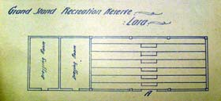
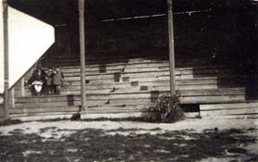Figure 9.04: Plan of Grand Stand, Recreation Reserve, Lara, 1919. Source: VPRS7882/P1, Unit 497, PROV.

Figure 9.05: Holmes family in the grandstand of the Lara Recreation Reserve, c.1925. Source: Holmes collection c/o David Rowe.

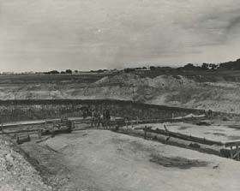
Figure 9.06: McClelland Swimming Pool under construction, c.1962. Source: Geelong Heritage Centre Image Library, image 1263‐08‐395.

9.2 Recreation
The natural landscape and topography of the You Yangs has provided
opportunities for recreation and leisure as a local tourist attraction since the 19th century. Other recreational areas – apart from those associated with sport – were more deliberately established. They included a public park in the town centre and a wildlife sanctuary created in the first half of the 20th century. Private recreational structures were also built, including the private sea baths at Avalon beach for Frank Austin. They were constructed in brick in 1895 and designed by the Geelong architects, Watts, Tombs and Durran.23

You Yangs as a Tourist Attraction
Since the beginnings of European settlement in Victoria, the You Yangs has provided interest due to its natural geological formation and the uninterrupted picturesque views gained from Flinders Peak. The You Yangs have been a focal point for tourists since the 19th century. In 1879, the Illustrated Australian News gave the following on the potential of the You Yangs as a holiday resort:

Station Peak, You Yangs
To all lovers of truly wild nature and enjoyers of a good scramble, we
recommend this route to enjoy a holiday. The You Yangs are a group of thickly‐wooded volcanic hills between Melbourne and Geelong, about two miles from Little River station, from which township an excellent road runs into the town common at their foot, and such a town common as for picturesque beauty and singularity has not its equal in the colony, perhaps not in the world. … The highest peak of this group is Station Peak; its height is about 1600 feet, and it is crowned by the wooden erection used by the geodetic survey. It is a favorite [sic.] resort of picnic parties from Geelong, and occasionally, Melbourne … The only wonder is that the easy distance from Melbourne of the You Yangs has not made them a more
popular resort for pleasure‐seekers and sportsmen.24

The advent of the motor car in the early 20th century gave greater accessibility to the You Yangs to a larger number of the population. One group of visitors to come by car in 1916 was J.H. Bishop with his father and uncle. In 1925, there was a proposal to ‘beautify’ the drive to the You Yangs for tourists. It was reported in the Werribee Shire Banner:

With a view to beautifying the drive and surroundings to the “saddle” of the You Yangs, a committee consisting of members of the various councils interested and other bodies has been formed. If £200 is raised in Geelong the Government Tourists Committee will make a donation of £200 towards the scheme, and the work will be started. Geelong has yet to
raise £70 by the end of the week to reach its quota.25

Climbing to the top of Flinders Park and enjoying the native game sanctuary at the foot of the You Yangs were particular tourist attractions. The Holmes family, for example, enjoyed such an experience in c.1925.
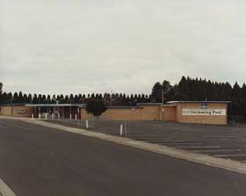
Figure 9.07: McClelland Swimming Pool, 1991. Source: Geelong Heritage Centre Image Library, image 1263‐08‐410.

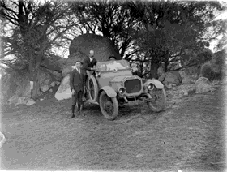
Figure 9.08: J.H. Bishop with his father and uncle at the foot of the You Yangs, 1916. Source: La Trobe Picture collection, State Library of Victoria, accession no. H87.34/218.

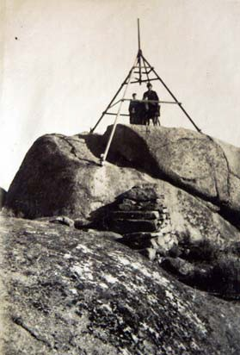
Figure 9.09: Visiting the summit of Flinders Peak, c.1925. Source: Holmes collection c/o David Rowe.
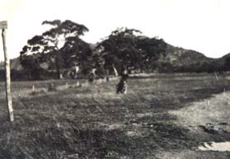
Figure 9.10: ‘Native Game Sanctuary
– Flinders at back’, c.1925. Source: Holmes collection c/o David Rowe.

Austin Park
In 1885, 12 acres of land to the south of the recreation reserve were
temporarily reserved ‘as a site for Public Park and Garden in the town of Lara.’26 The Corio Shire Council was appointed the Committee of Management. In 1890, the reserve was named Austin Park in honour of James Austin, owner of nearby Avalon Homestead who resided in England.27 In 1896, the Bacchus Marsh Express gave a description of the Park:

… on the opposite side of the road, are plantations (some 11 acres in extent) dignified by the name of Austin Park, after the President who promoted the work and whose family has a large estate (Avalon Park) in the neighbourhood. This Austin public Park is not much availed of at present, but the Council did well to plant it, as trees are doubly a blessing in any part of the region between Melbourne and Geelong, and future generations have the foundations laid for them of a wooded reserve which
they can embellish according to their tastes and finances.28

Serendip Wildlife Sanctuary
In 1947‐48, Oscar and Edna Mendelsohn purchased Pirra Homestead at a cost of £400‐£500.29 They renamed it ‘Serendip’, meaning “happy place”.30 The Geelong Advertiser provided a short biography of the Mendelsohns in 1958:

Both [Oscar and Edna] have a strong background of country life since childhood, and before coming to Lara had small properties at Doncaster and Keilor. Mr Mendelsohn, a member of the well‐known family of public analysts, has had much to do with rural life over many years in the course of his professional duties. It was a combination of all these circumstances which brought about the purchase of Serendip [Pirra] the
new name which the Mendelsohns selected for their new property.31

It was during the Mendelsohns’ ownership when the property (and particularly the reservoir) was proclaimed a sanctuary by the State Government for the protection of the thousands of ducks, swans and other bird life.32 With his professional background, Oscar Mendelsohn was appointed assistant inspector of the Fisheries and Game Department for his involvement with the Serendip sanctuary.33

In 1959, Pirra was sold to the Government where the Department of Fisheries and Wildlife took control of the 622 acres surrounding the reservoir (known as allotment 18A.34 It became a Wildlife Research Station by 1961, with ‘experimental work’ initiated ‘to show how native wildlife can be promoted in “peaceful co‐existence” with normal farming operations.’ The Donald Times gave an explanation of the proposed work at Serendip in 1961:

Wildlife management at Serendip will include pond management for waterfowl, revegetation or protective cover in farm land for wild birds, and specialised farming methods for wild fowl food on agricultural land with cover strips, grasses, shrubs and so on for quail, pigeon and other wild birds.

This work at present centres on a five‐chain‐wide “buffer area” around the
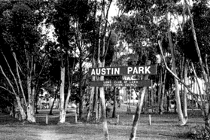
Figure 9.11: Austin Park, 1998. Source: David Rowe.

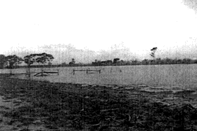
Figure 9.12: Shores of Serendip reservoir, 1938‐48. Source: Margaret Deller.

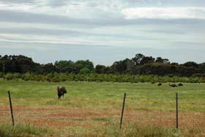
Figure 9.13: Emus at Serendip sanctuary, 2012.

lake, which has been cleared and planted with a variety of native trees and shrubs, and fenced off from the rest of the property.

Mr Downes explained that this buffer area was necessary so that normal farming operations could be carried on outside it, without disturbing the waterfowl and other birds on and around the lake. 35

Serendip Sanctuary opened to the public in 1991. From February 2009, it was been managed by Parks Victoria.36

1 Geelong Advertiser, 17 September 1845.
2 Ibid., 25 May 1847.
3 Ibid., September 1862.
4 Ibid., 20 July 1876.
5 Ibid., 3 October 1877.
6 Ibid., 15 April 1877.
7 M. Budd, C. Delaney, J. Grainger (eds.), From Duck Ponds to Lara: A Collection of Memories, Lara Heritage Festival Inc., Lara,
2004, p.186.
8 Ibid., pp.179‐180.
9 Ibid., p.79.
10 The Argus, 14 June 1935, p.10.
11 I. Wynd, So Fine A Country, Shire of Corio, 1981, p.158.
12 Lara Sporting Club website at http://www.larasportingclub.com.au/lsc/index.php/football/history.
13 Victoria Government Gazette, vol.13, 10 February 1882, p.383.
14 Ibid.
15 Budd, et.al., op.cit., p.185.
16 Wynd, op.cit., p.159.
17 H.G. Oliver, Corio Shire Secretary, to The Secretary, Public Health Department, 11 October 1919, in ‘Grandstand, Recreation
Reserve, Lara’, public building file no. 3220, VPRS7882/P1, Unit 497, Public Record Office Victoria.
18 Ibid., 2 February 1920.
19 Werribee Banner, 12 June 1919.
20 Budd, et.al., op.cit., p.184.
21 Wynd, op.cit., p.162.
22 Ibid. & Budd, et.al., op.cit. The pool had informally opened on 12 December 1962.
23 Oral information from Frank Austin, Barwon Heads, 1998 (as part of the Outer Areas Heritage Study Stage 2 1998‐2000 by
Authentic Heritage Services Pty Ltd), T. Ashehour & T. Perks, ‘Avalon Estate Conservation Analysis Report’, Deakin University,
1991, p.19 & Geelong Advertiser, 23 October 1895.
24 Illustrated Australian News, 22 January 1879, p.10.
25 Werribee Shire Banner, 20 August 1925, p.1.
26 Victoria Government Gazette, vol. 51, 22 May 1885, p.1325.
27 Wynd, op.cit., p.158.
28 Bacchus Marsh Express, 25 April 1896, p.3.
29 J. Manton, ‘Windermere’, History of Architecture IV Research Essay, 1965, p.10, in Heritage Victoria file no.
HER/2001/000067.
30 ‘Lara – collected notes by Harold Spalding’, taken from the Weekly Times, 30 July 1952, Geelong Heritage Centre.
31 ‘Almond Orchard Novel Feature of Serendip’, Geelong Advertiser, 7 October 1958.
32 Ibid.
33 Ibid.
34 Manton, op.cit.
35 The Donald Times, 17 February 1961 in ‘Serendip Research Station’ file, VPRS12011/P1, Unit 185, Public Record Office
Victoria.
36 J. Katz, The Planning Group, Expert Witness Statement to City of Greater Geelong Amendments C73 & C198, May 2010, at http://www.geelongaustralia.com.au/library/docs/c73/C73%20and%20C198%20Planning%20Expert%20Witness%20Stateme nt.pdf.

10. Bibliography

Official Publications & Records

Australian Heritage Database online

Ballierre’s Victorian Gazetteer,

Crown Land Files, Public Record Office Victoria

National Archives of Australia

Parliament of Victoria ‐ Member Database

Public Building Files, Public Record Office Victoria

Sands and McDougall Directory

Victorian Government Gazette, various years Victorian Births, Deaths and Marriages Indexes Wises’ Victoria Post Office Directory
Published Works

Billis, R.V. & Kenyon, A.S. Pastoral Pioneers of Port Phillip, 2nd edn., Stockland Press Pty Ltd, Melbourne, 1974

Blake, L.J. (ed.), Vision & Realisation: A Centenary History of State Education in
Victoria, Education Department of Victoria, Melbourne, 1973

Brownhill ,W.R. & Wynd, I. History of Geelong and Corio Bay With Postscript 1955‐1990, postscript edn., The Geelong Advertiser, Geelong, 1990

Budd,M., Delaney, C., Grainger, J. (eds.),
From Duck Ponds to Lara: A Collection of Memories,

Burchell, L. Victorian Schools: A Study of Colonial Government Architecture 1837‐
1900, Melbourne University Press in association with the Victorian
Education Department, Carlton, 1980

Cannon M. (ed.), Historical Records of Victoria (HRV), vol. 7, Melbourne 1998
Daley, D St. Laurence Park Retirement Village Fiftieth Anniversary, 2009. Giddings, B.E., ‘A Church in the World: The Lara‐Meredith Uniting Church Parish:
The opening of the Lara Worship Centre, October 26th 1980’

Edmunds, L. Living By Water: A history of Barwon Water and its predecessors, Barwon Water, 2005

Gillison, D. Royal Australian Air Force 1939‐1942, Australian War Memorial, Canberra, 1962

Godfold, N. Victoria – Cream of the Country: A History of Victorian Dairying, Dairy
Industry Association Australia, Victorian Division, Hawthorn, 1989

Griffiths, P.M. Three Times Blest: A History of Buninyong and District 1837‐1901, Buninyong & District Historical Society, Buninyong, 1988

Harrington, J An Archaeological and Historical Overview of Limeburning in Victoria, Victorian Heritage Council, 2000
Henderson, A. Henderson’s Australian Families: A Genealogical and Biographical
Record, Melbourne, 1941

Jennings, P. Rothwell Cemetery 1859‐2009: 150 Years of Community Service, Little
River Historical Society for the Rothwell Cemetery Trust

Mathieson, A.W. My Reflections on 77 Years in Lara, Lara Heritage Festival, 1985

Pescott, T The You Yangs Range, Yaugher Print, Geelong, 1995

Sayers (ed.), C.E. Letters from Victorian Pioneers, Melbourne 1983. Spalding, The Lara Lime Company 1874‐1974
Stretton, B Celebrating Our Past, Meeting our Future, Lara Community Centre
Inc., Lara Community Centre Inc., Lara, October, 2002

Sutherland, A Victoria and Its Metropolis Past and Present, McCarron Bird & Co., Melbourne, 1888, CD edn., Archive CD Books Australia Pty Ltd, 2006

Turner, H.G. A History of the Colony of Victoria, Heritage Publications, Melbourne,
1973

Vines, G. ‘Chaff‐Mills in Melbourne’s West: An Industrial Sites Study’, prepared for Melbourne’s Living Museum of the West Incorporated, February
1987

Willingham, A Geelong Region Historic Buildings and Objects Study, Geelong
Regional Commission, Geelong, 1986, vol.1.

‘Wurdi Youang IP Investigation and Consultation Project’, information brochure, 11 December 2010, provided by Kevin Krastins, Community Development Planner, City of Greater Geelong.
Wynd, I. Barrabool. Land of the Magpie

Wynd, I. So Fine A Country (1981)

Wynd, I. ‘City of Greater Geelong Outer Areas Heritage Study Stage 2
Environmental History’, prepared for Authentic Heritage Services Pty
Ltd for the City of Greater Geelong, 2000.

Journals & Newspapers

Bacchus Marsh Express – newspaper Bendigo Advertiser – newspaper Camperdown Chronicle ‐ newspaper

Cazalys Contractor Reporter ‐ journal The Cornwall Chronicle ‐ newspaper Empire – newspaper
Geelong Advertiser – newspaper Geelong News – newspaper Geelong Times – newspaper
Illustrated Australian News – newspaper

Investigator , Geelong Historical Society Inc. – journal

Lara Heritage Festival ‐ magazine

Mercury and Weekly Courier – newspaper

Morwell Advertiser – newspaper News of the Week – newspaper Northern Times ‐ newspaper Pastoralists’ Review – newspaper The Argus – newspaper
The Australian – newspaper

The Leader ‐ newspaper

The Queenslander ‐ newspaper

The Settler: Official Quarterly Newsletter of the Ballan Shire Historical
Society – newsletter
Weekly Times – newspaper Werribee Shire Banner – newspaper Williamstown Chronicle ‐ newspaper

Maps, Plans, Auction Notices & other Drawings

Geelong Heritage Centre, various documents.

Land Purchase & Management Board Map, Victorian Land Office, Melbourne.

National Library of Australia, various documents.

Public Record Office Victoria – Crown land files, Public building files von Stieglitz, K.R. Emma Von Stieglitz: Her Port Phillip & Victorian Album, 1964.

Wynd, I. Outer Areas Heritage Study Environmental History, vol.2, 2000.

Unpublished Material

Aitken, R ‘Edwardian Geelong: an architectural introduction’, Architectural
Research Thesis, Architecture Division, Deakin University, 1979

Ashehour, T. & Perks, T. ‘Avalon Estate Conservation Analysis Report’, Deakin University,
1991, p.19.

Australian Dictionary of Biography, Melbourne University Press, Carlton, 1983 & 1986

‘Avalon Airport’, Wikipedia at http://en.wikipedia.org/wiki/Avalon_Airport.

Context Pty Ltd ‘City of Wyndham Heritage Study’, prepared for the City of Wyndham,
1997.

Geelong Cemeteries Trust website at http://www.gct.net.au/historic.html.

HLCD Pty Ltd ‘Avalon Homestead Complex’, Conservation Management Plan, 2006.

Jacobs, Taylor, Johnson & Ballinger
‘Buloke Heritage Study Stage 2’ for The Buloke Shire, 2010, draft.

Katz, J. The Planning Group, Expert Witness Statement to City of Greater
Geelong Amendments C73 & C198, May 2010, http://www.geelongaustralia.com.au/library/docs

‘Lara Through Pioneer’s Eyes’, newspaper cutting (newspaper and date unknown

Lara, Victoria’ at Wikipedia, http://en.wikipedia.org/wiki/Lara,_Victoria.
Manton, J ‘Windermere’, History of Architecture IV Research Essay, 1965, p.10,
in Heritage Victoria file no. HER/2001/000067

Marles, R ‘Rehab 1916‐style for a future Prime Minister’, The Punch, 31 March
2012, at http://www.thepunch.com.au/articles/rehab‐1916‐style‐for‐a‐future‐
prime‐minister/desc/

Murray, M ‘Prayers and Pastures Moidart immigrants in Victoria, 1852‐1920’,
PhD Thesis, School of History, Heritage and Society, Deakin University,
2007.
‘New Lara Library Opens’, Geelong Regional Libraries website, 15
December 2011, at http://www.geelonglibraries.vic.gov.au/news/

Premier Postal at https://www.premierpostal.com

Peterson, R ‘Historic Government Schools: A Comparative Study’, prepared for the Heritage Management Branch, Building
Division, Department of Planning & Development, June 1993, p.1.

Shire of Corio Rate Books, 1869‐1957

Rowe, D ‘Architecture of Geelong 1860‐1900’, B.Arch. Thesis, Deakin
University, 1991

Rowe, D ‘Pirra Homestead’ Conservation Analysis, prepared for the owner, June 2002.

Spalding, H Lara, Collected Notes’

Technology in Australia 1788‐1988: The Development of Appropriate
Technology

The Effects of the Gold Rush – Ballarat in Particular’, http://www.austehc.unimelb.edu.au/tia.html

Archival & Photographic Collections

Australian War Memorial website online
Deller, Margaret
National Archives of Australia
State Library Victoria
Werribee & District Historical Society.

Oral Information

Interview held by Vicki Johnson with Jessie Cameron, St. Arnaud. Oral information from Frank Austin, Barwon Heads, 1998 interview by David Rowe with John Darcy, 10 June 1998. Interview by David Rowe with Jack Blair, July 1999.
Genealogical research carried out by Darcy Seller
Interview by Darcy Seller with Jack Darcy
Staff member ‐ Lara Community Centre, 23 October 2012. Bruce Challoner, Curator, Lara RSL, 2012
Val England, Member, Geelong Family History Group, 2012

11. Appendices

Appendix 11.01: Enlarged Historical Figures

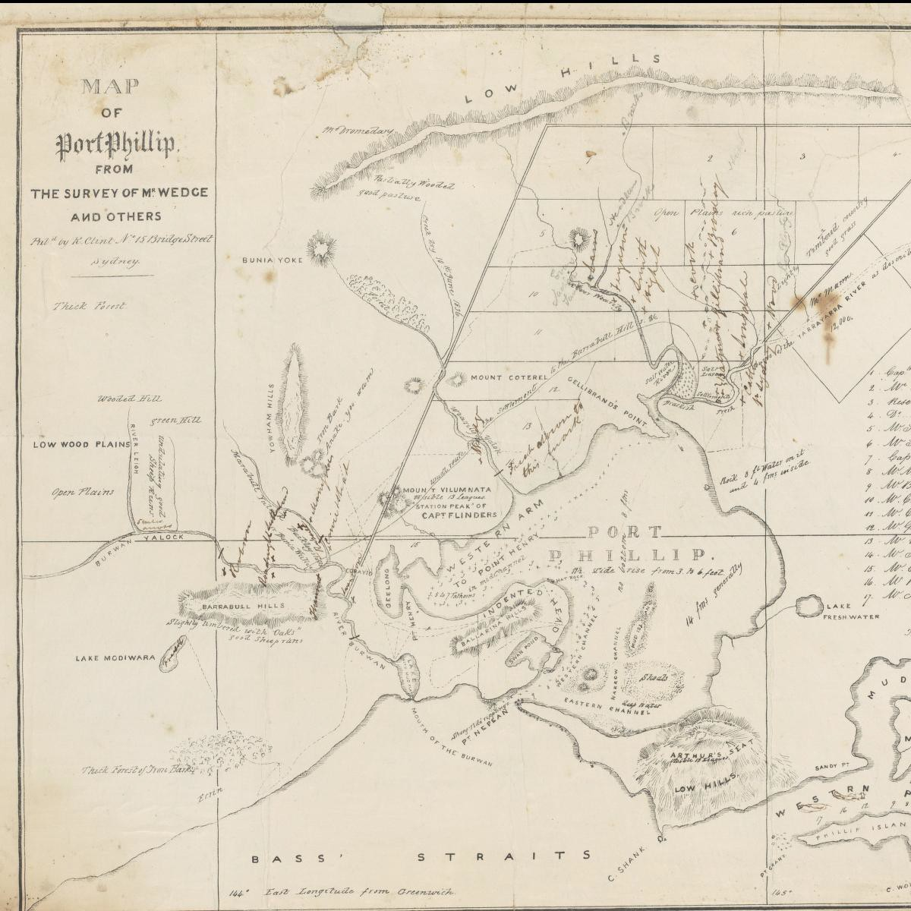
Figure 1.07: J.H. Wedge, Map of Port Phillip, 1836. Source: National Library of Australia online, MAP RM3595.

-L"£"9''tr
reo e

. 9 !\ v .I 0 1 U II J it

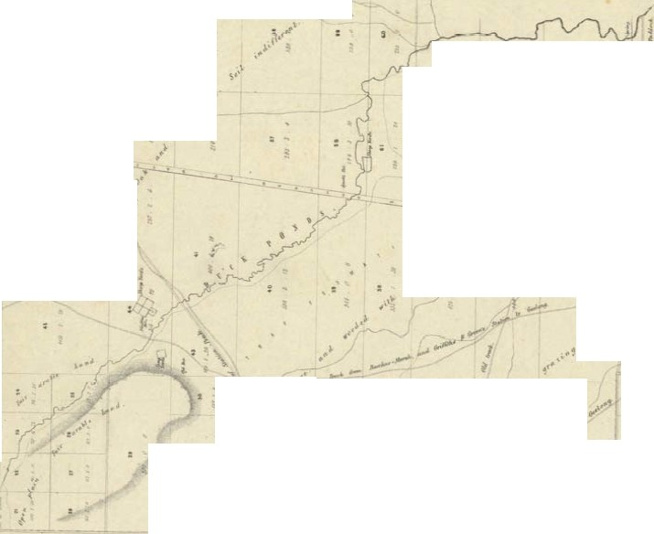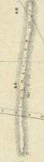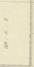-

i 0 ll S I II r d

.,.. .. ,....
' ... J .t
..

..•,.
...··"'
f'' <'
'. •j t :.
! =
t· :
i

l-
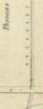o( l -.
j
,· l
'
i
,. 1

., './
I
{
{

)

..
,.
\ ,..
,\. /.
'
.._,.

,,..,0".1,1'
·

...

:..
p

..••

.., H
"' ,i' l
...:1, s

=

....

..... ....
.
"
,.
<-'
.... ,..
...:

e...

e
Hp h. ,;l, I' J i
jlj

"..'
l

liI
L

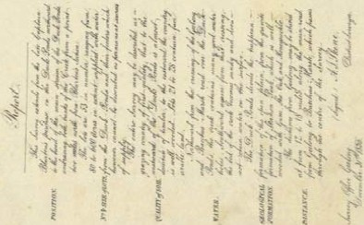0 II S 1 r
= l "l!
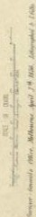... :l·

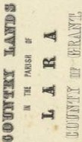

Figure 1.08:A.J. Skene, Map of the Country Lands in the Parish of Lara, 31December 1856. Source: La Trobe Picture collection, State Library of Victoria.

Figure 1.09: Portion of the Plan for the Village of Lara, 1853 showing Lara Lake. Source: Geelong Heritage Centre, Map 031.

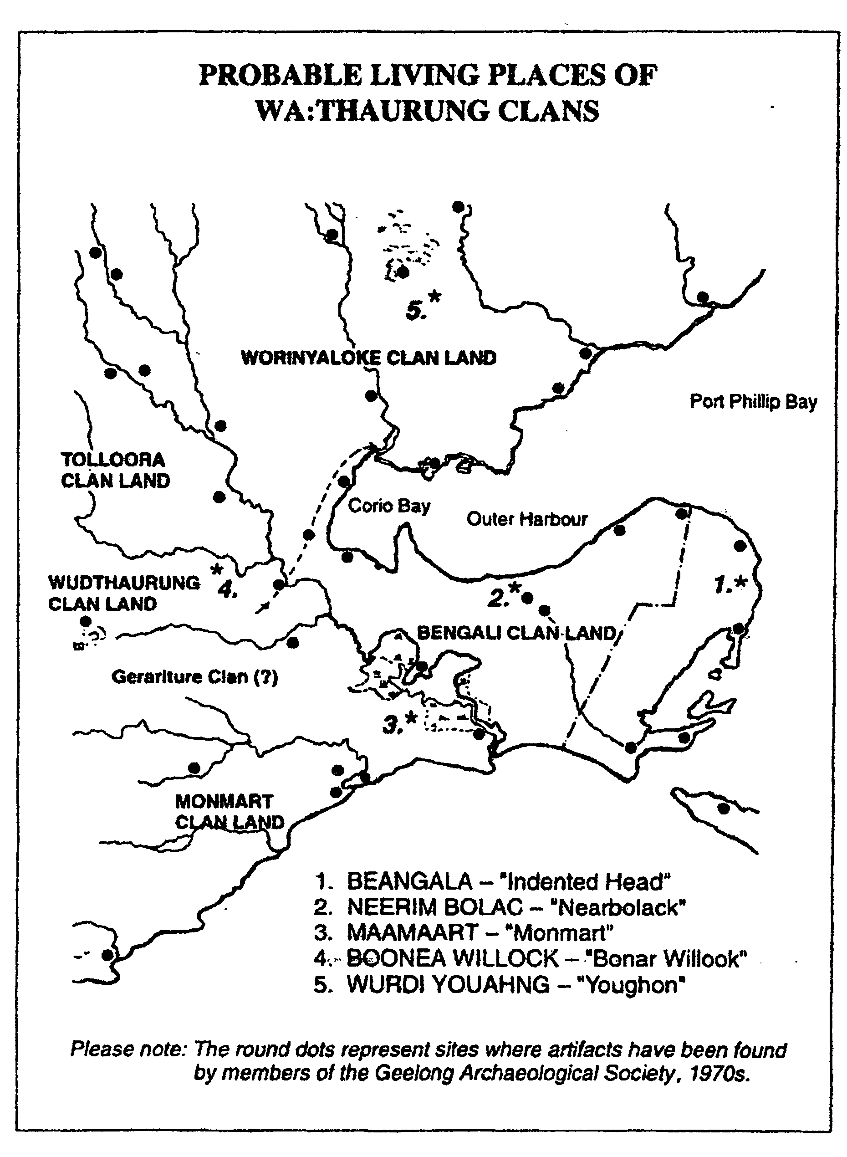

Figure 2.02: Aboriginal Living Places. Source: L. Lane, Investigator, vol.29, no.24.

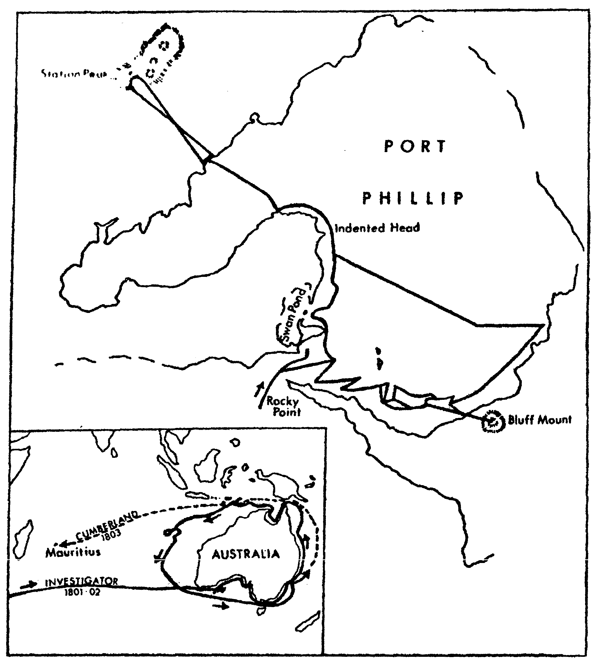
Figure 2.04: Flinders’ exploration. Source: Wynd, Outer Areas Heritage Study Environmental History, vol.2, 2000.

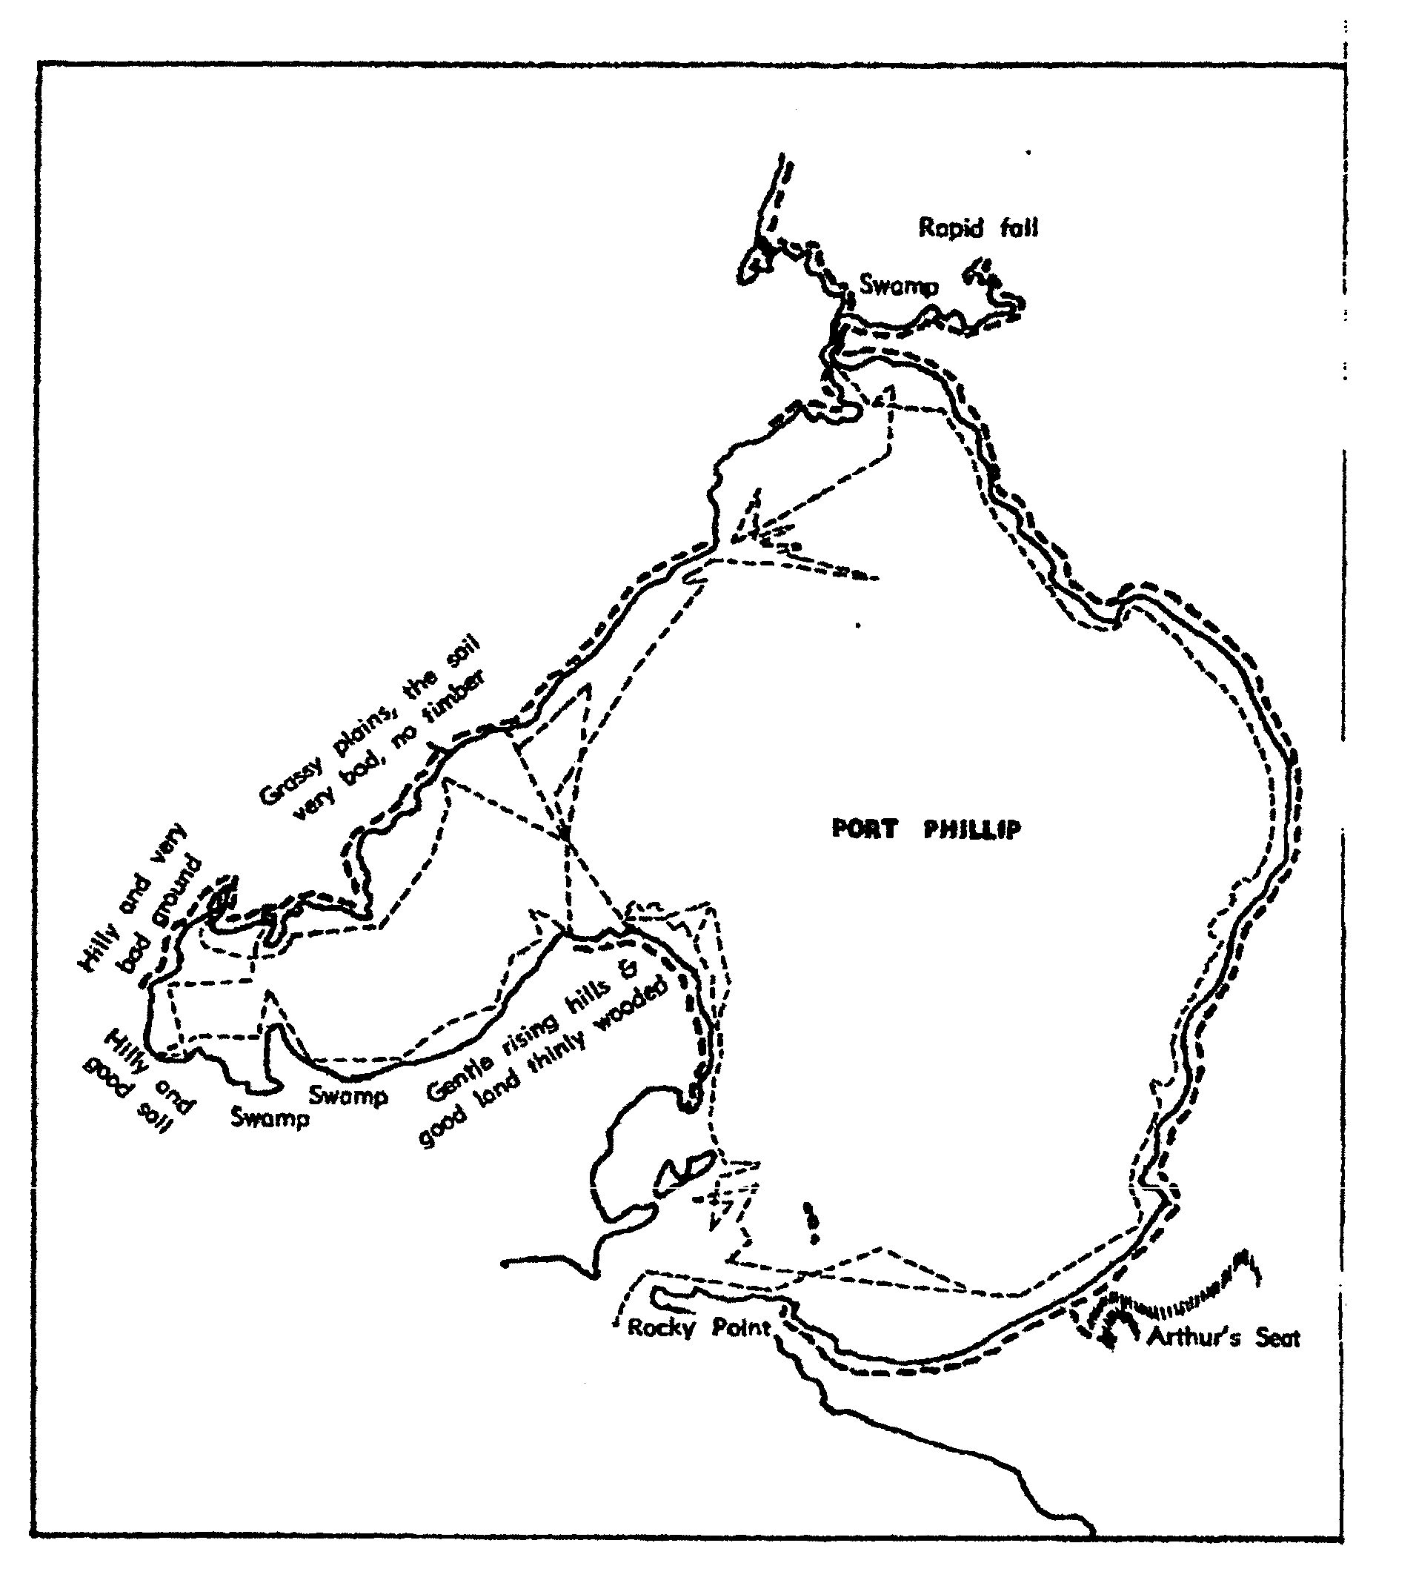

Figure 2.05: Grimes’ exploration. Source: Wynd, Outer Areas Heritage Study Environmental History, vol.2, 2000.

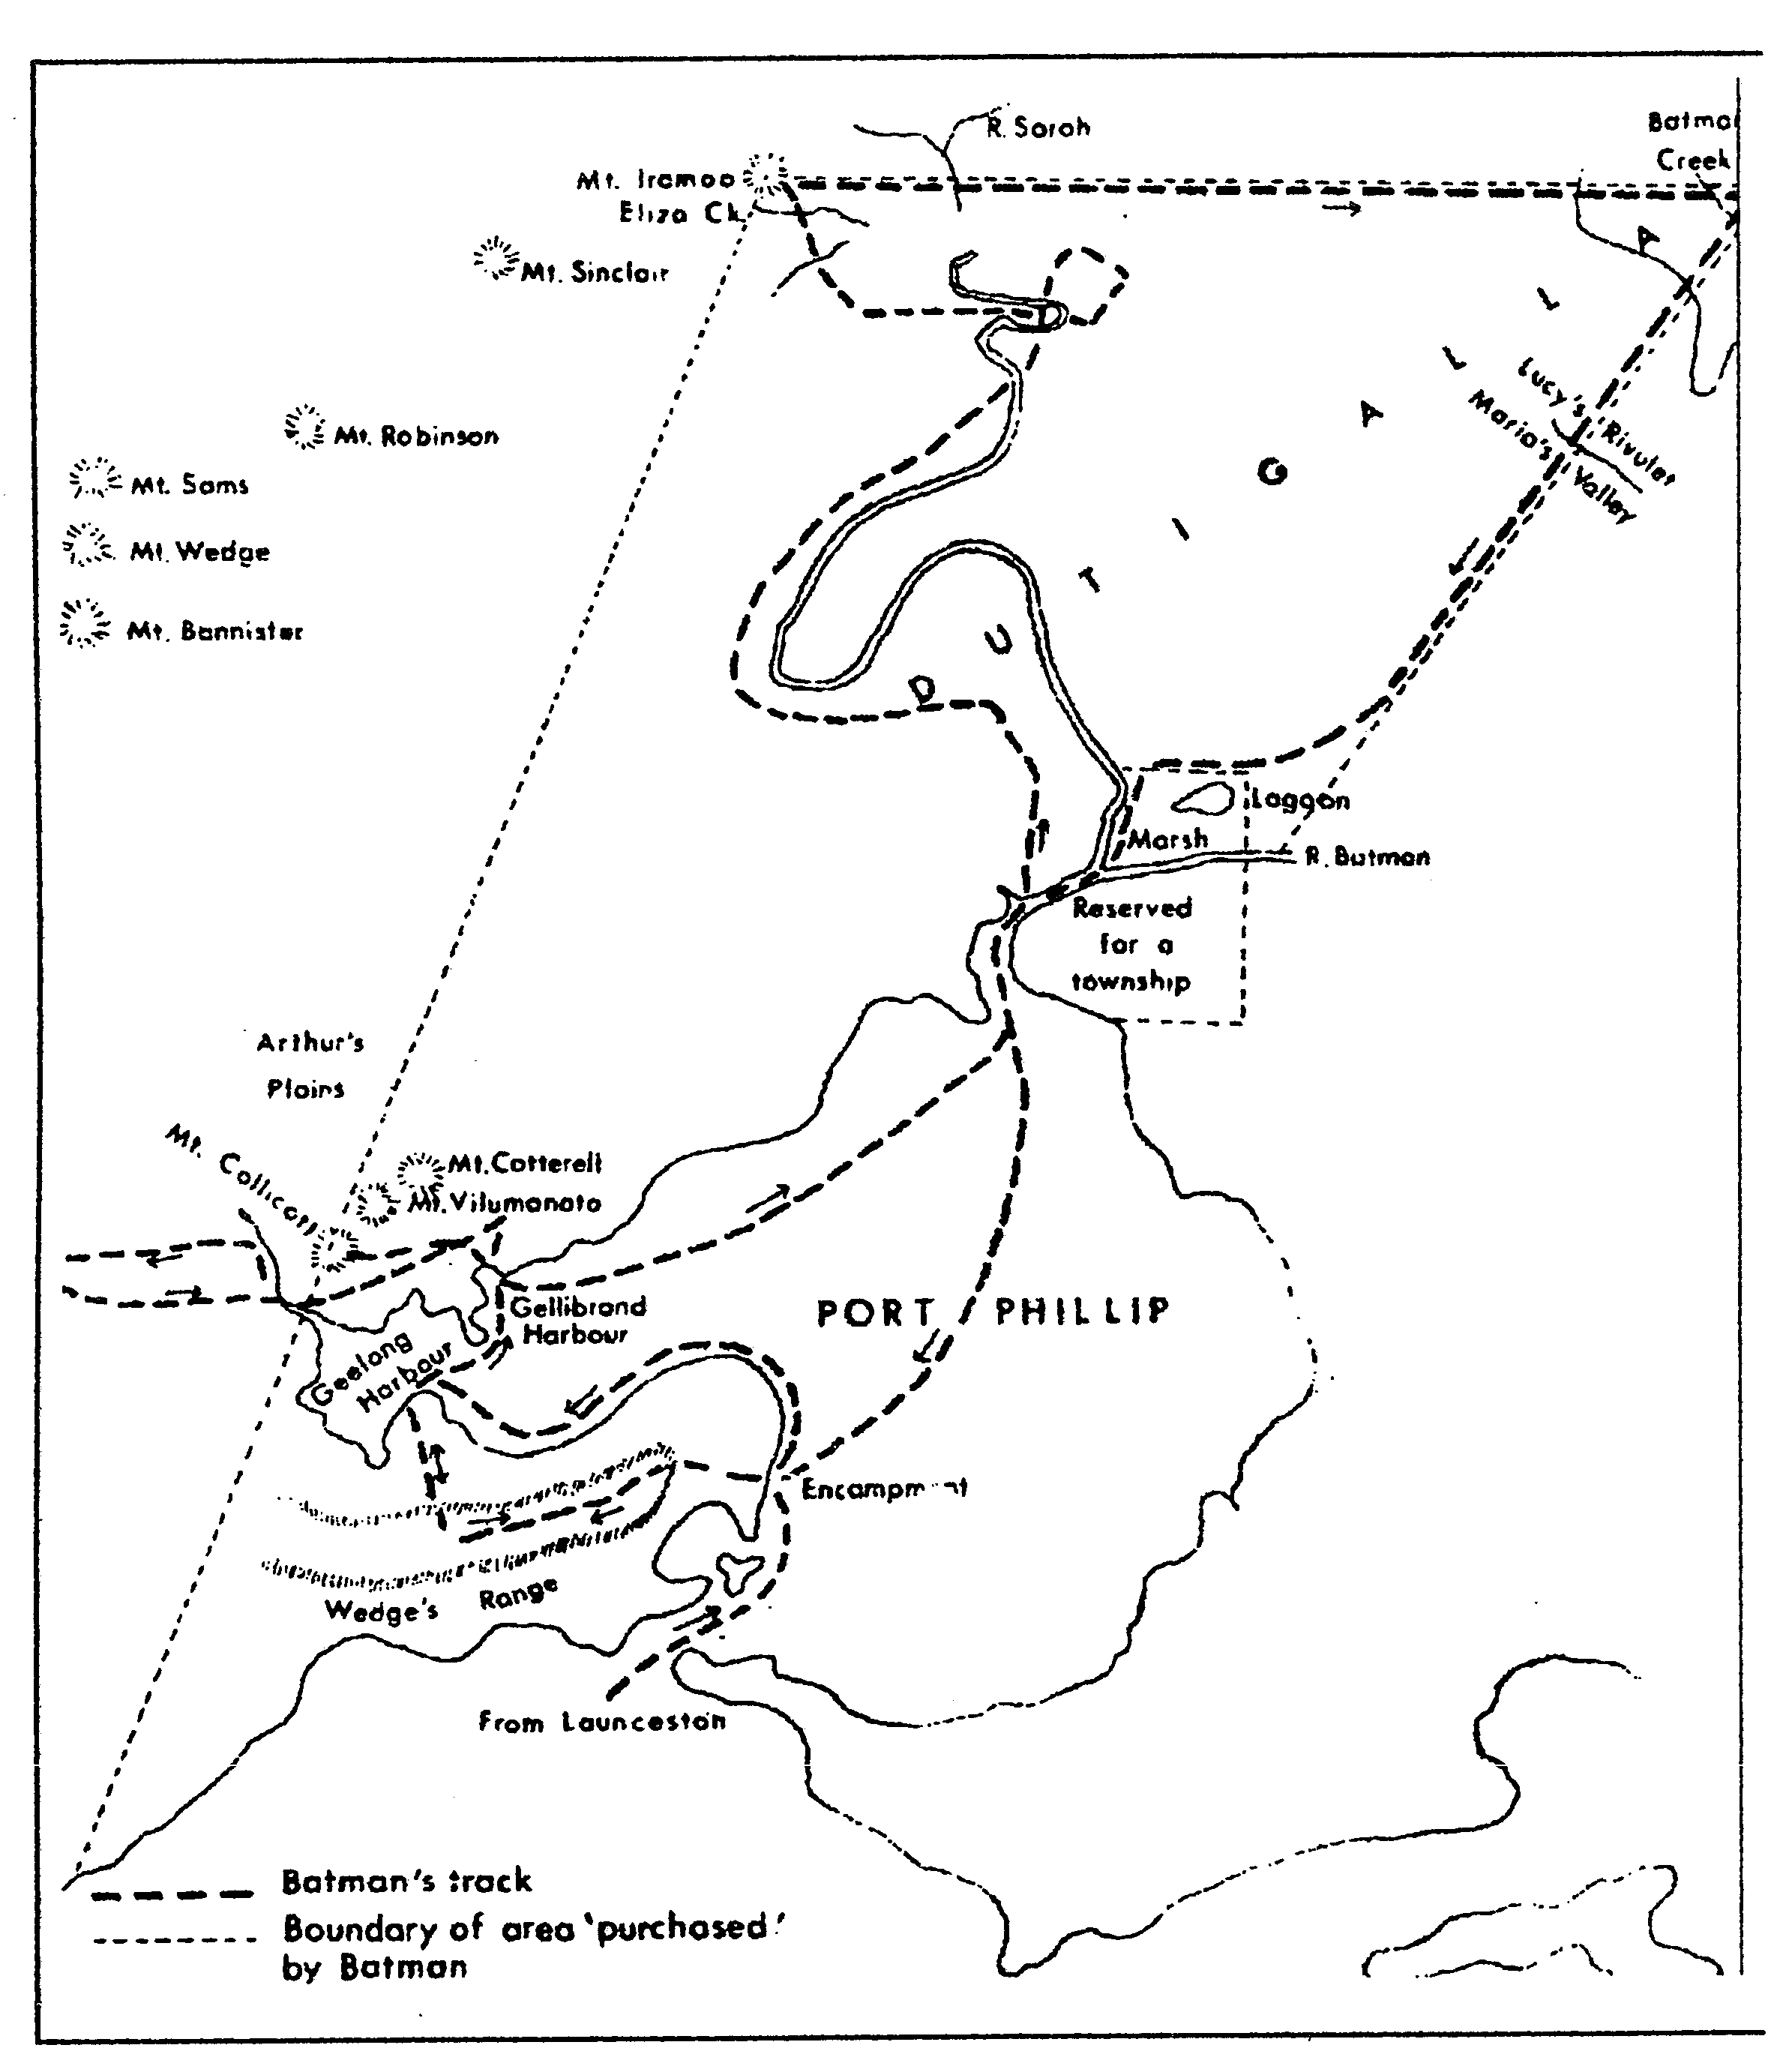
Figure 2.07: Batman’s exploration. Source: Wynd, Outer Areas Heritage Study Environmental History, vol.2, 2000.

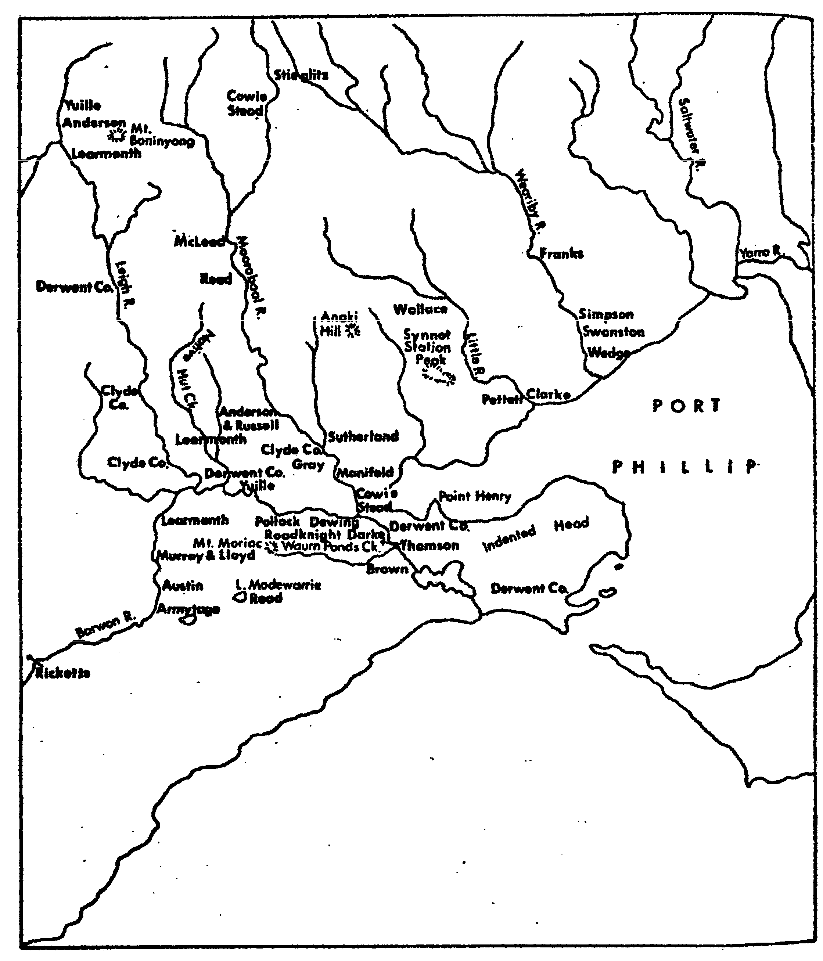

Figure 2.08: The early squatters of the Geelong district, including the Lara region. Source: Wynd, Outer Areas Heritage Study
Environmental History, vol.2, 2000.

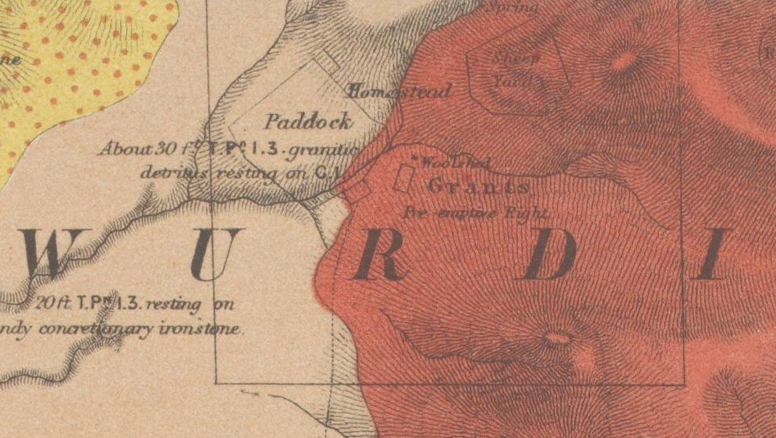
Figure 2.12: Grant’s Pre‐emptive right in the Wurdiyouang Parish. Source: R. Daintree, Geological Survey of Victoria, No. 19, 1861 (published 1863), MAP RM2335/19, National Library of Australia.

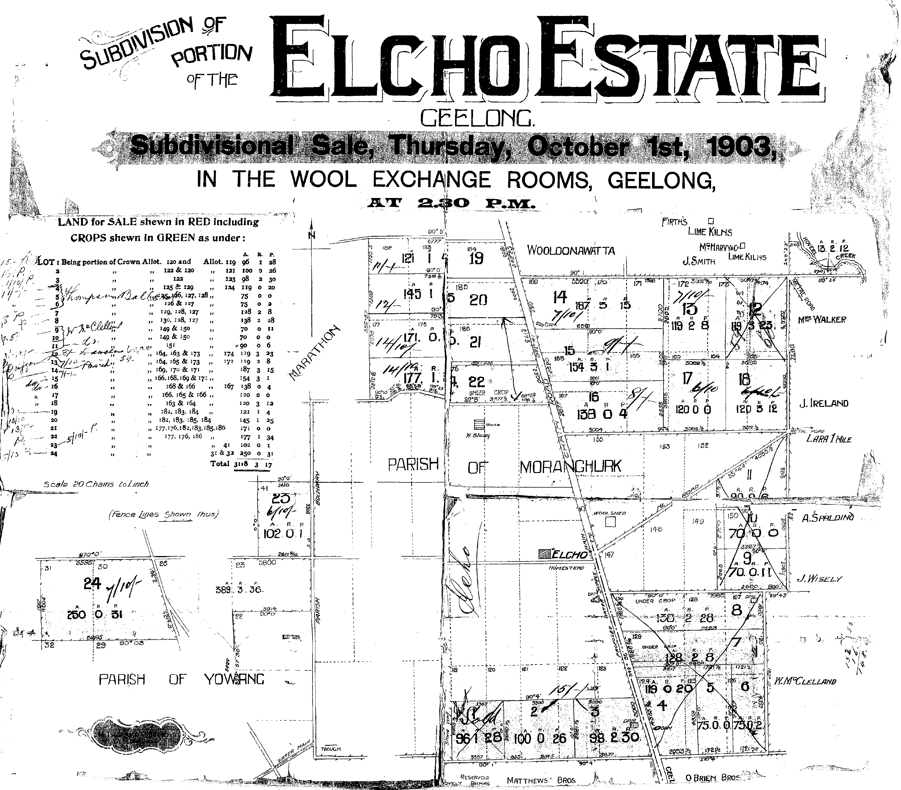

Figure 2.13: Elcho Estate Subdivision plan, 1903. Source: Geelong Heritage Centre maps & plans collection.

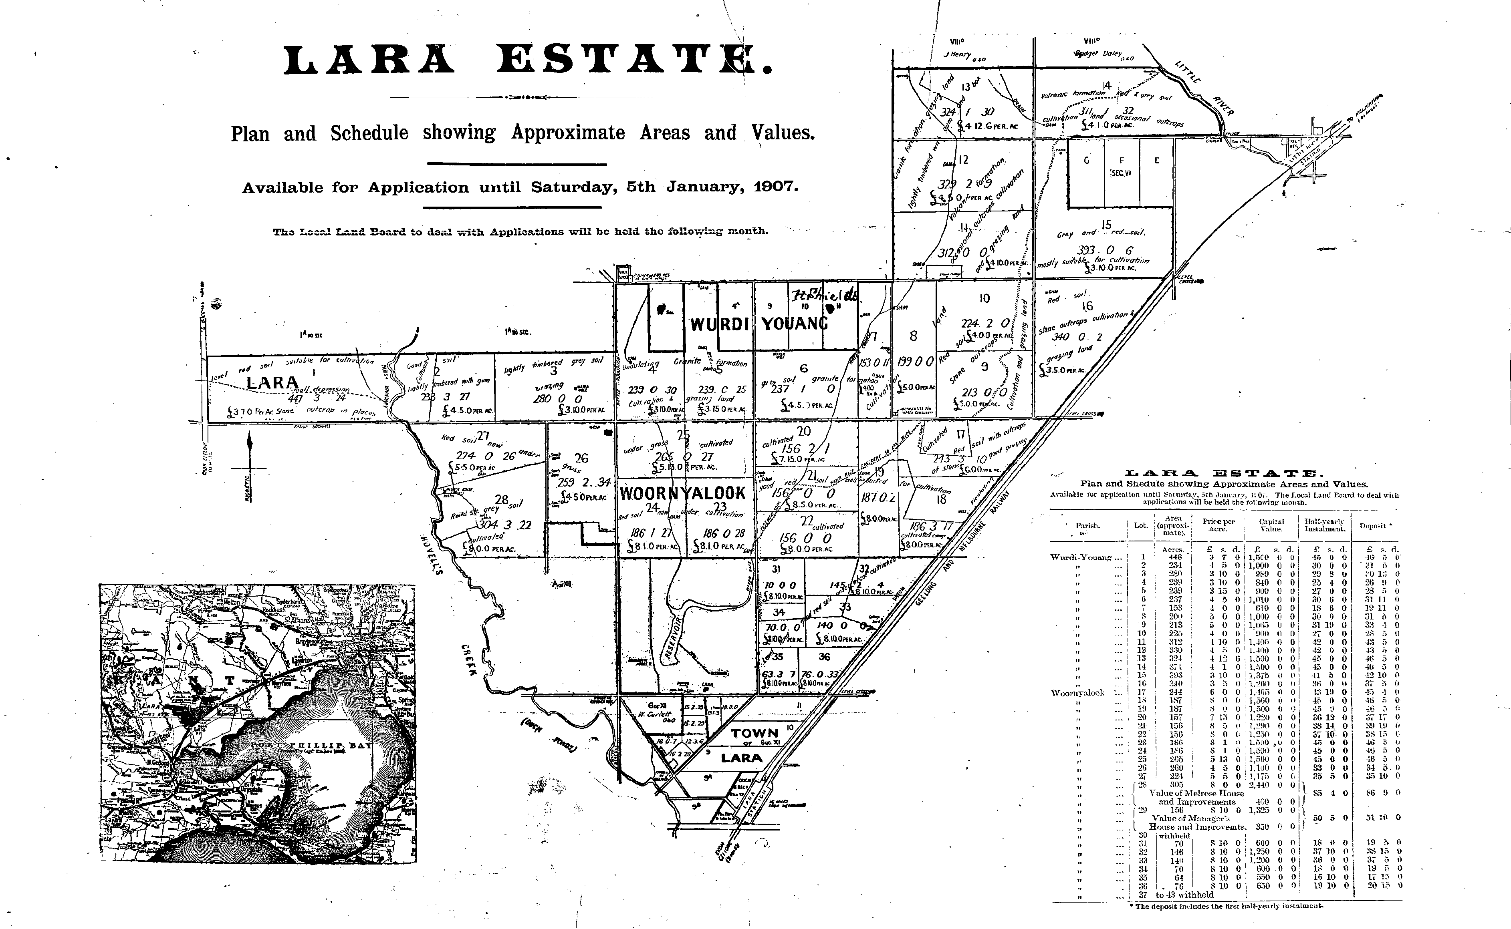
Figure 2.14: Lara Estate Plan & Schedule, 1907. Source: Geelong Heritage Centre maps & plans collection.

T 'UR.SDA'Y24th APR.IL, 1913.


AN IDEAL
====GEELONG DISTRICT.==
HOLIDAY AND WEEK-END COUNTRY HOME.

THE DEATH OF THE LATE F. W. ARMYTAGE) Have received instructions from the Trustees to
SELL BY AUCTION at SCOTT'S HOTEL, Melbourne, on Thursday, 24th April, at 2.30 p.m.
the remaining portion of the Woolamanata Estate, comprising
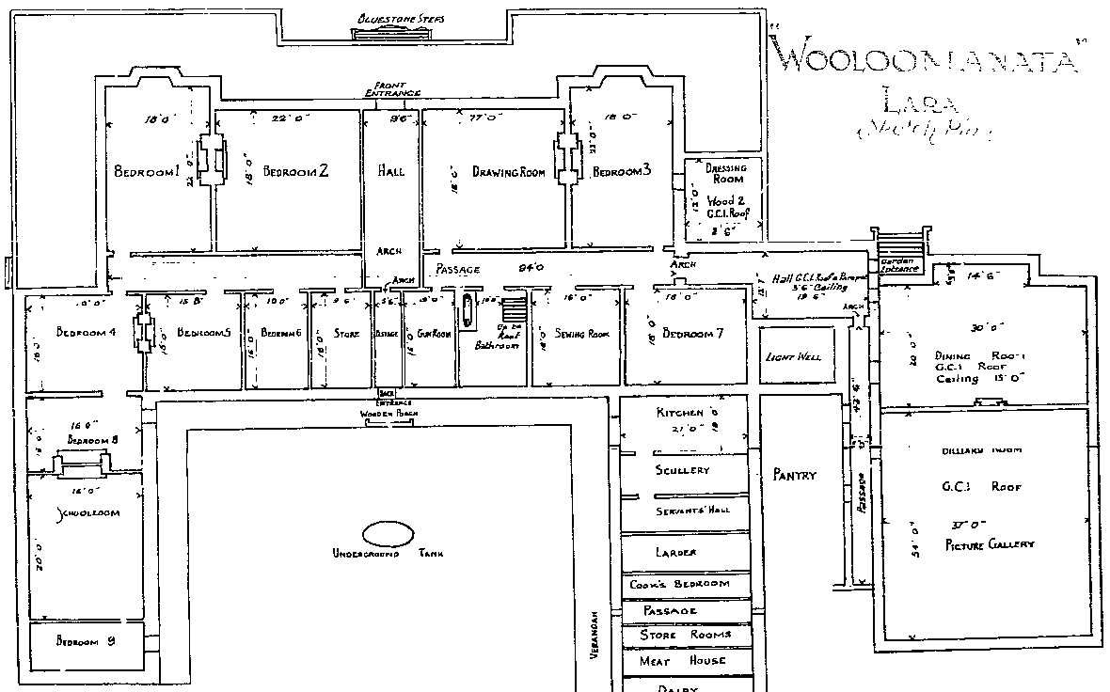8840 Anres 1Hood
AS FOLLOWS, VIZ.­
LOT 1. 150 ACRES LOT 2. 150 ACRES. LOT 3. 150 ACRES.
LOTS 4 to 10, the ba.!ano9 of the E ta.te with Homestead. about
8390 ACRES 1 ROOD, which, if not sold as a whole
will \hen be offered as follows. viz. :
LOT 4 AB 577(ACRES, with HOMESTEAD. LOT 5. 541 ACRES.
LOT 6 602 ACRES.
LOT 7. 401 ACRES 2 ROODS. LOT 8. 407 ACRES 3 ROODS LOT 9. 380 ACRES.
1' nm 10. aero ao'DVQ,
Lots sto roaresrtuated< .c:=,, ..._ --

(?Ol:OO A:r·A) has been ir
.:"·,-t-he -·po.e' ' ' r· ·sJsOn:.e:osf ttIheea;A:s.rim:lyetagj_ej E.state._b_ ng Qnly 37 m!l _s_frcm M lj)_gurne, vi _LHtl_e_ RJve ,_apd
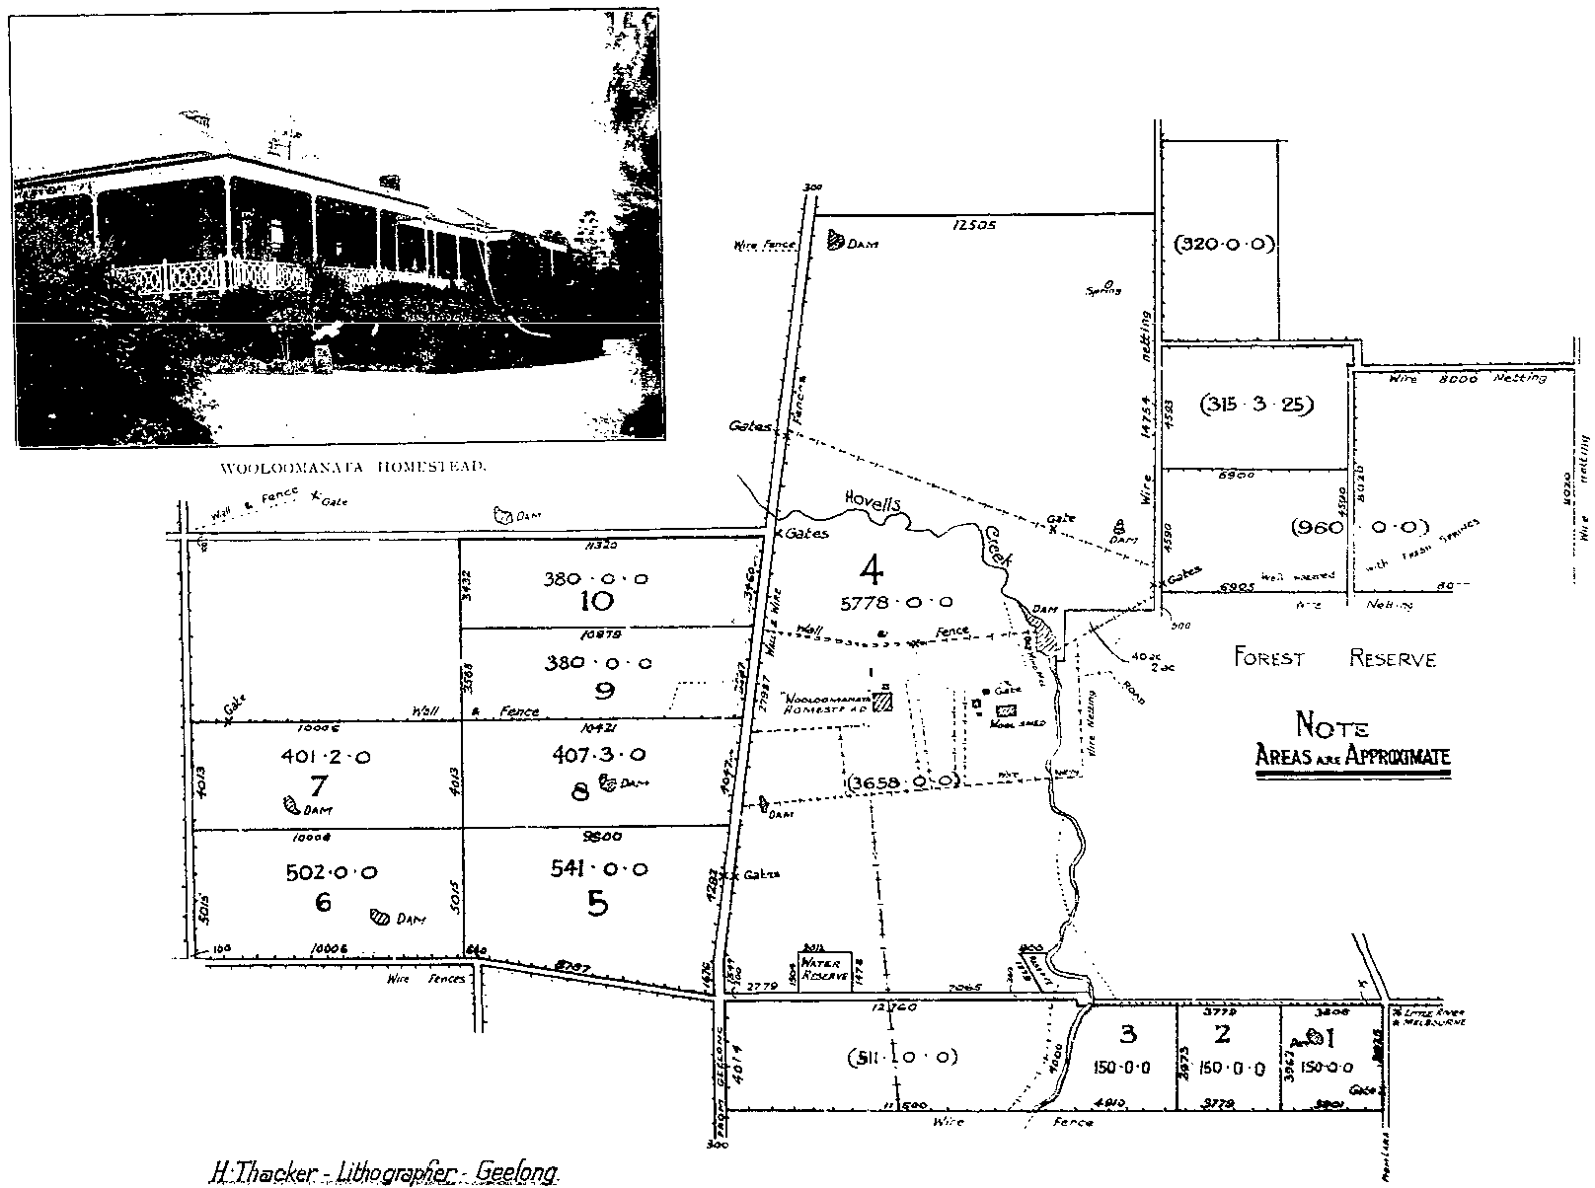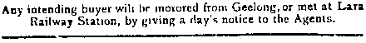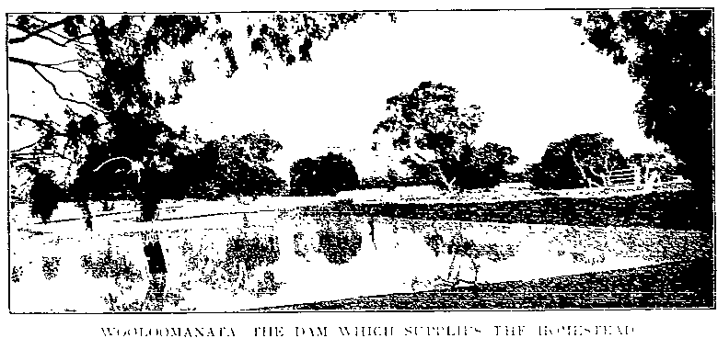14 m1l!:s om Geelong, T_he house is one-storey, built of bluestone.with
!: r :; ; : ; ,t sl
0 4i !Fii:
servants' l:all, storerooms, &c.
The stables,coachhouse, &c., arealsoi..uil\ of bluestone. The formerhas6stallsand 4 loose bo..;es. The woolshed is of 1ron, fitted with machones; therea calsoscvcralcctt:tgcs, barns,&c
Thesituat10n isacharmingoneonagcntlc
\ f: fr · e u .o : g v s a :rf:
laid out, ,.a a portiOn of the orcl.ard. IS
umc,ue by bcmg enclosed and covered wnh
!·inchwire-ncttmg
Clo e to thr: homcst£ad is a m«gnificent dam on Hovel! Cr ek, from which the lwnsc, garden and swimm ng·IJath are With water througb a z.inchpipe.
supplied
th :n p ; : :. \: e l:;;: ao"o
shooung fnrocca5Ional houbc-partles
len :o lt a :trin:as\\ < ll ; (\'e l"h; : ' cte [
01
; :; !ha t 1 ; E : i': }r:ti :
sale

TERMS-For the Subdivlslonal Lots 71".. cash on day of Sale; 7!; ·,on date of possession, which will be on lllth M01y; to·x. on 16th May. 1915; 10';, on lllth May, 1916. Balance, 16th May, 1918, all be rlng ir.tcrnt at rate ol s·. per aunum.
For Homeato11ad Block, whether sold as 6390 P. rea
1 rood, or 5776 Aorea-10'. Cash on day of ::01le;
1 further JO·x,on d;ote ol possnslon,lllth May;
further 20: on I15th May, 1915; and balance,
18t!> ·. 1916, all boarlng intorut 1t rate of
5\, per ar.,um.
ll

fuROiA:<o CANNING SuRv E:.Y OR !I
.')elborne C.h3mbei'S
ME.LE'.> 0 URN E.

Furth•rparu ulnson opplkati<>r•to.
Dennys, Lascelles, Ltd.,
OEE!LONO, MELBOU!,!NE! 6: HOPE!TOUN: or
H. E. B. Armstrong,
4.10 LITTLE COLLIN5 ST., ME!LIJOUR:-.1.1!.
lloUolWra-BLAJO!I &; KlGOALL, Y.elboW'lle.

Figure 2.15: Wooloomanata Estate Auction Notice, 23 April1913. Source: Geelong Heritage Centre maps & plans collection.

PUBLIC AUCTION
SALE BY
TO BE HELD AT

GEELONG
WOOL EXCHANGE, GEELONG,

fRIDAY,
26th OCTOBER, 1 _34
,_,_a_t 3
.._p_.m_.

Auctioneers in c.mjunction: DENNYS LASCELLES Ltd., STRACHAN & Co. Ltd., and FRANK C. ROADKNIGHT, GEELONG.
ELCHO ESTATE
Known as ELCHO TRAINING FARM,
COMPRISING
2,641 ACRES
And situated 3 miles from LARA RAILWAY STATION and 9 miles from GEELONG. I

PARISHES OF YOWANG AND MORANGHURK
COUNTY or GRANT
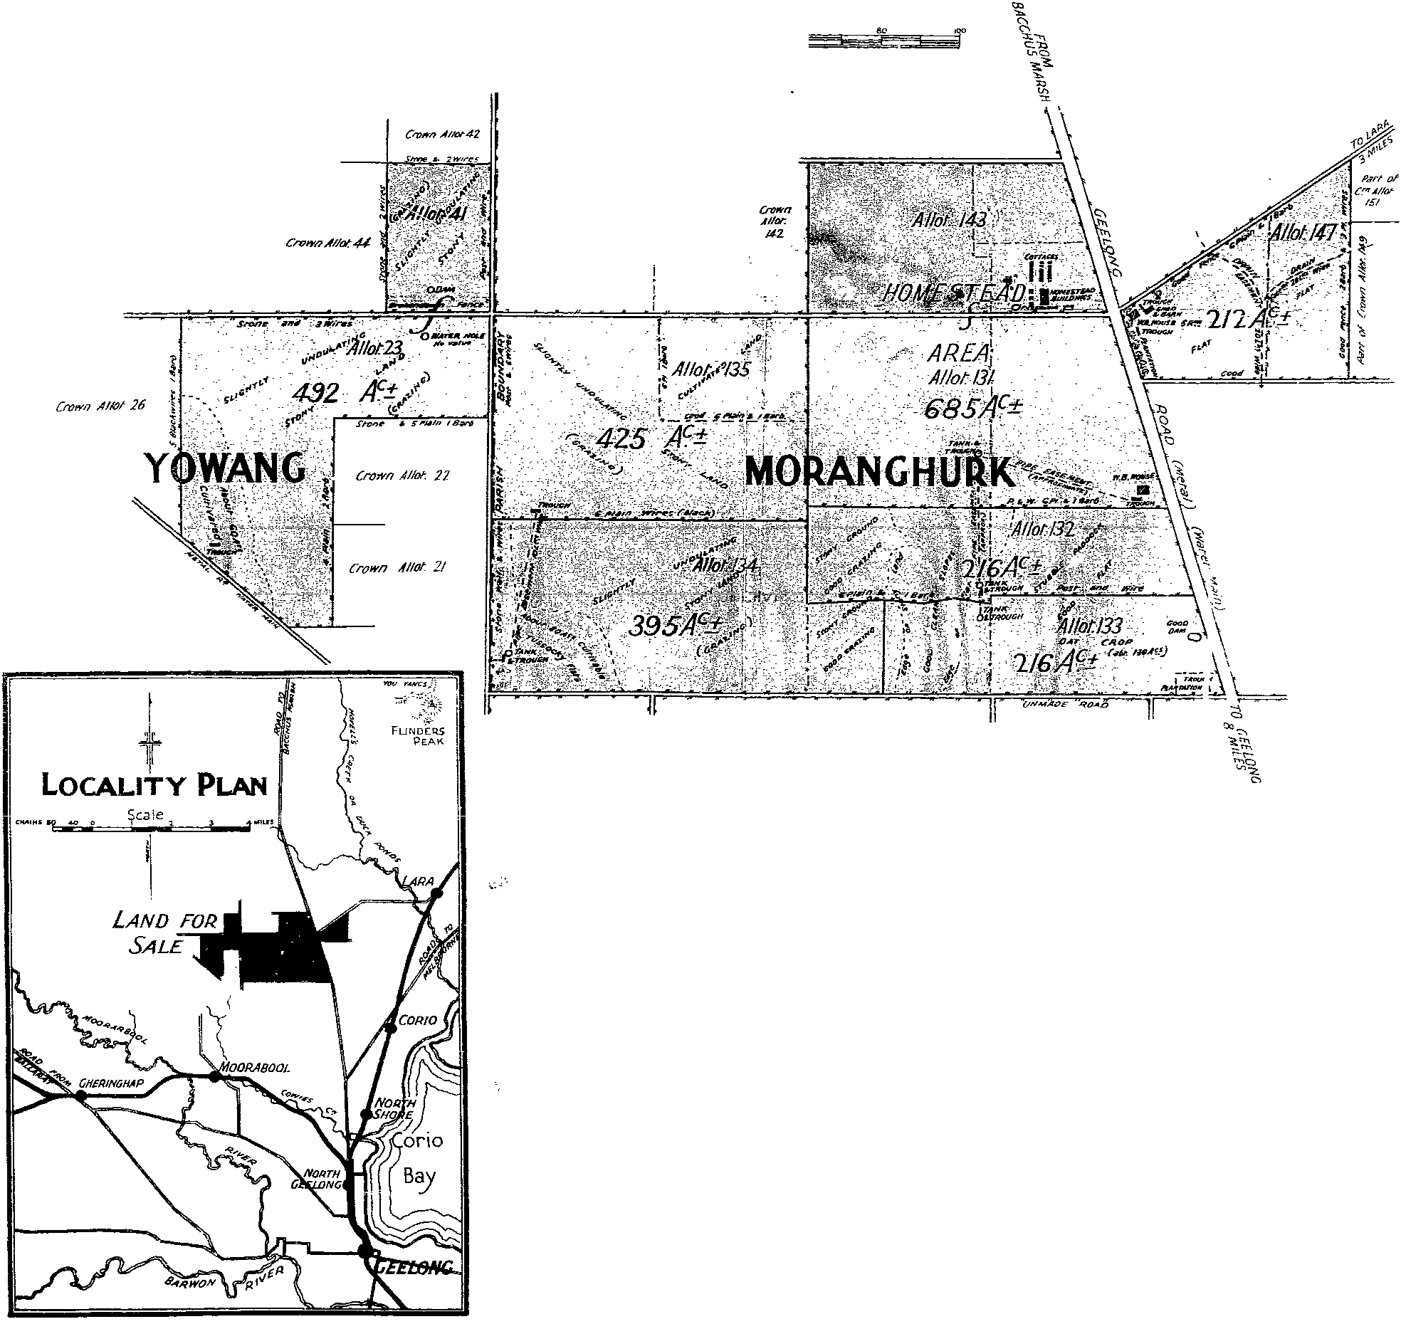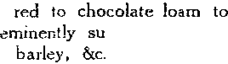,;:;cALE Sf CHAIN§

GOOD GRAZING AND CULTIVATION LAND, WELL WATERED BY PIPE LINE FROM GEELONG WATER SUPPLY.
-+
Ill

DESCRIPTION OF SOIL AND PRODUCTION.-The .oil ;, volcanic. dark and red clayey loam, and approximately I ,000 acres is cultivallle. T!-Je farming-600 acres have been regularly cultivated and produced good cro.-_.s of
1,800 ewes have been carried. i,n a normal season.
from

suited for mixed
In addition.

WATER SUPPLY.-The property is watered by pipe line from the Geelong Water Supply, which is fed directly to a Concrete Reserv ir of 45.000 gallons situated on the Homestead block.
IMPROVEMENTS.-The property is '''ell supplied with all necrMary buildings, compri ing 2·story Bluestone
Residence of 14 rooms; 22·stall Stable, louse boxes and feed room; Cowshed (8 bails and feed ruo-n); W.B. Stable; Coach House, &c., 48ft. X 1 a ft.; Store Room 24ft. X 15ft.; Wool shed (Roared) 66ft. X 27 ft.; together with Sheep Dip
and Yards; Men's Hut. 36ft. x 12ft.; two large Fowl Pens, each 51 ft. x 15ft.; Farm Cottage (4 roc.ms and conveniences); Stable, Barn and Implement Shed, Pig Shed, Carl Shed, :'orkshop, &c
FENCING AND SUBDIVISION.-The property is and ;s subdivided into 16 paddocks. The original boundary fences comprise stone walls, surmounted by t\•.-o or supported on posts, about two to the chai."J.. Post and wire fences comprise posts, three to •he chain, with and droppers.
SPECIAL CONDITIONS.-Not included in the above improvements, thete are on the property 41 Cottages and
School Hall, the right to the removal of which, within two years, is retained by the vendor.
TERMS OF SALE.-Deposit, I 0 pe-r cent. of Purchase Money at time of sale; 15 per cent. on possession 22nd March, 1935; I 0 per. cent. in each of 2nd, 4th, 6th, and 8th years, and balance (35 per cent.) in I Oth year, with interest at 4l per cent. per annum, payable half-yearly.
ARRANGEMENTS FOR INSPECTION.-Intending purchasers will be driven over the property on receipt of advice by the Auctioneers. .
AGENTS NOTE.-As this property is for b"na fide sale, buyers' attention is specially invited.
NOTE.-Land to be offered coloured reel.
Additional information, plans, &c., obtainable from the Closer Settlement Cor.tmission, Lands
Department, Melbourne, and from the various Land Offices throughout the State ; also from
, the Auctioneers.

Figure 2.16: Elcho Estate Auction notice, 1934. Source: Geelong Heritage Centre maps & plans collection.

S'I_'AUGHTON VALE PLAN.
ESTATE

,,\',/ ·... 1
._....,

_ .. Ollllll
SCHtoot.c Ot' Ali.OTWt..,. Tl, lhio.ng appriomste Are:t. ,
it"•!;h•:: { 5::'kc r,21:IJi!i: :)1·:er::i!:n:
,.... .....

AJ"I>t'<ld·
matot Prkoe

V&h\fl. ll.all·\'t:a.rl.J DtP<-!t.
ln-tahntnt..

- - -ro-r,\ tr-t.

1--
-
- --- r--

A. ll. )", c .. d. £ £ .. d. ... d.
l Itil 0 0 7 0 0 1110 33 G 0 i11 0
2 IQl 0 0 7 0 0 1110 33 G 0 31 ll 0
3 7 ,, 0 1<90 HU 0 -4!1 19 0
• w 0 0
m 0 0 7 16 0 I <6 0 0 4tl fi 0
0 0 7 7 0 1<85 4-111 0 ..U I G 0
c 234 0 0 • 8 0 1000 <6 0 0 <G 6 0
7 1117 0 0 c 0 0 m 3S 0 M 10 0

ley 10 l!fl 0 0 7 4 0 1:175 ..

0 { 1 0

8 lM 0 0 8 u 0 1280 3S 8 0 M IS 0

Tb Rtp
g
lw 0 0 7 17 0 12:>/) :s8 17 0 0
5

I I M
tlt.s
IS: 0 0 D 10 0 ISOO 39 0 0 <O 6 0
120 0 0 1l 0 0 l m :19 12 0 40 17 0

·... .......
6
1•1 137 0 ..

/ 13 "" 0 0 10 19 0 1000 4.1 0 0 <G 6 0
0 10 10 0 1&00 <6 0 0 <G • 0
..
.. 8 0 <6 13 0
· 10 0 1.1>00 46 0 0 •• 6• 0
"18
40 10
8 7 0 1500 •• 0 0 •• • •
16 133 0 0 ll & 0 1&00 45 0 0 <G 6 0

IG 141 0 0 10 0 0 1470
0 8 0 0 1®
• 0 •• 7 0

,.,.....
0
231 0 0 tl 0

10 l flli 0 0 7 10 0 1<00 -42 0 0
41 lA 0

'10 I 0 0 7 • 0 1350 0

,,,.•• ' • I •"'I !
...
21 loG 0 0
7 • 0 1350 <tO 10 0 .f,\16 0

:2 ISO 0 0 .. 46 0 0 46 • 0
Zt I 0 0 7 7 0 1435 43 1 0
23 -42 tG 0 •

.. l!lO 0 0 7 10 0
.
42 0 0 43 5 0

2054, ··''193.4<. ••• 202 4
.fi. '-t.:•[;1· .fi. 7. 0
··'•"'
C.".,:..
23i .c.,

8::--J
.• ··...... ,.
I to) 0 0 8 7 0 ! GOO 4·1 0
2< 100 0 0 7 10 0 142h 42 15 0 44 0 0
:IG 200 0 0 1 0 0 1400 44 6 0
45 17 0
2lS 14'10 42 12 0
183 0 0 7 16 0 U20 42 1 2 0 43 17 0
:19 183 0 0 7 IG 0 U20 42 12 0 4$ 1 7 0
30 183 0 0 7 16 0 127 S8 5 0 39 10 0
31 I;Q 0 0 7 10 0 1275 38 5 0 39 10 0

'l. •.
32 liO 0 0 7 10 0 0

33 170 0 0
8-1 1$) 0 0
7 10 0 l!l75 3S 5 0 S9 10
7 0 0 12!1 3S 17 0 40 2 0

36 18.\ 0 0 7 0 0
1m 3S 17 0 40 2 0
40 14 0

....,o
30 23S 0 0 6 10 0 1$16 39 D 0

37 11>0 0 0 8 0 0
1'100 3S 0 0 :17 5 0

3S 11>0 0 0 8 0 0 1'100
SG 0 0 :17 6 0

S9 200 0 0 7 0 0
4".0.} wiU.htld
u
1400 42 0 0 43 • 0

<3 200 0 0 7 Q 0 1400 42 0 0 43 6 0
0
:!:,0 0 0 6 10 0 1375 41 5 0 42 10
4 191 0 0 7 )0 0 0 .. 9 0
45 wid•ht1d HM 43 13 0 44 18 0
47 154 0 0 8 0 0 1440 43 4
·:· 0

48 Uil 0
0 6 tr. 0 I 'W 31 16 0 3<J I Q

49 21:.0 0 0 G 6 0 1200 :rt lll 0

r.o
-
210 0
0 6 10 0 13:'.0 "'' 12 II <1 0 li 0

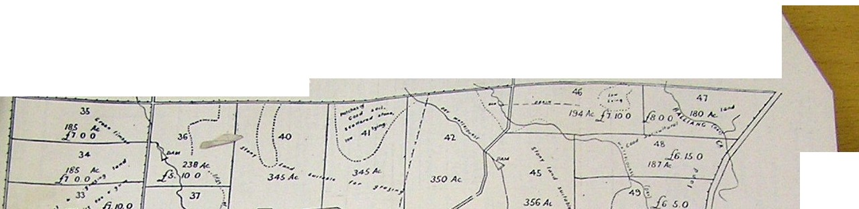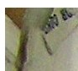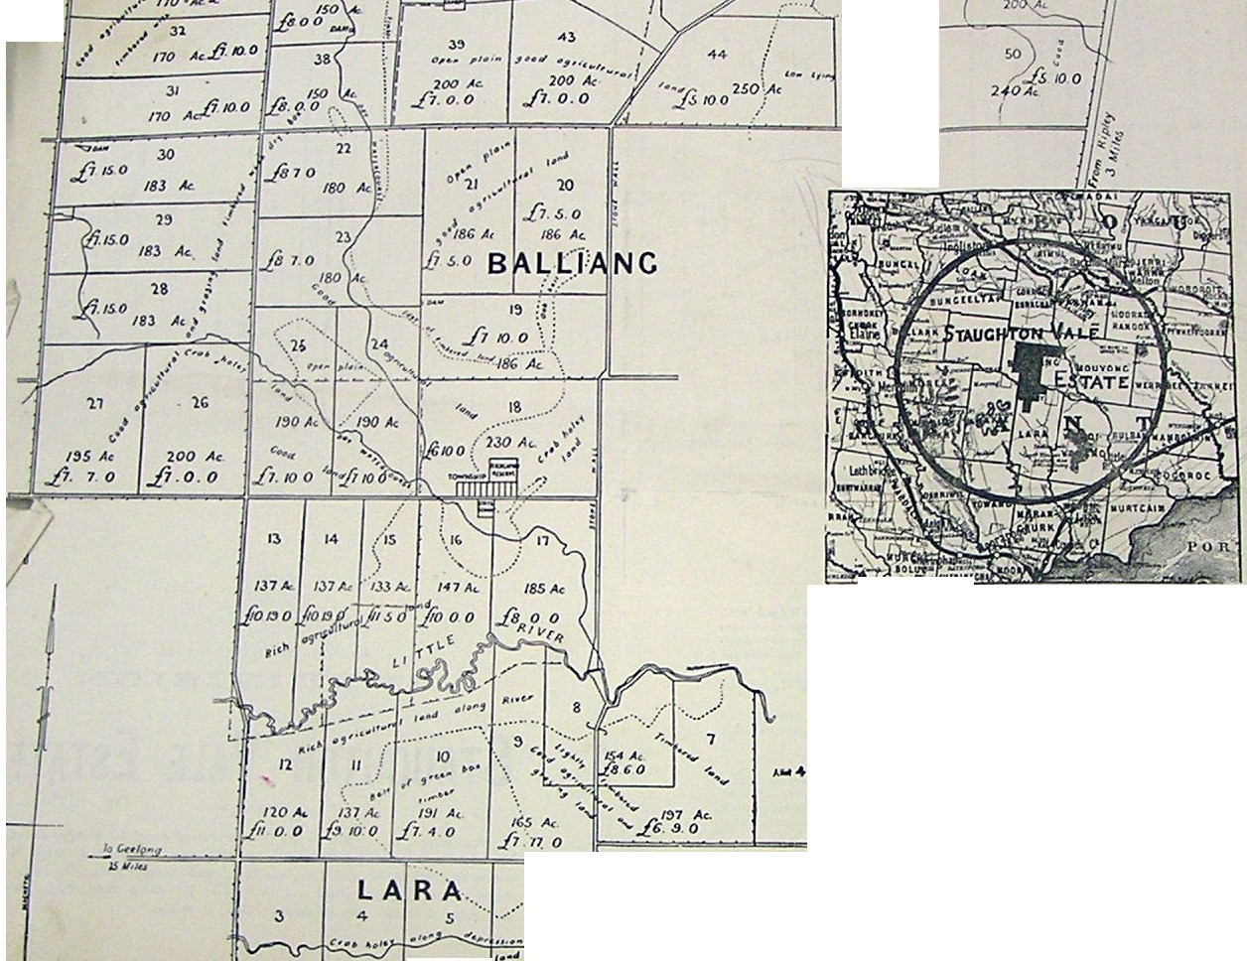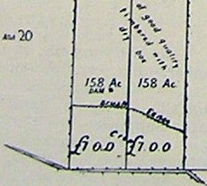Figure 2.17: Staughton Vale Closer Settlement Subdivision plan, c.1908. Source: VPRS5714, Unit 1279, Public Record Office
Victoria.

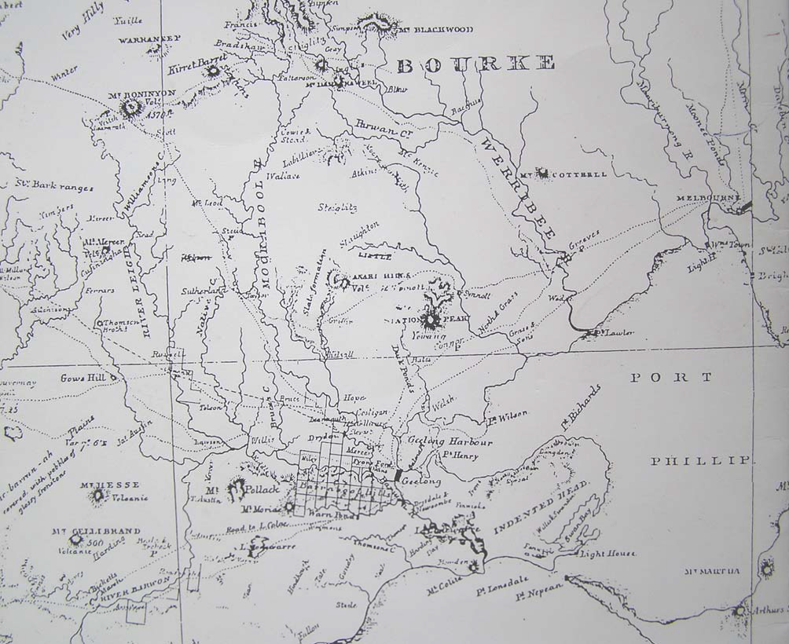
Figure 3.01: A.J. Skene, Map of the District of Geelong, 1845. Source: Geelong Heritage Centre maps & plans collection.

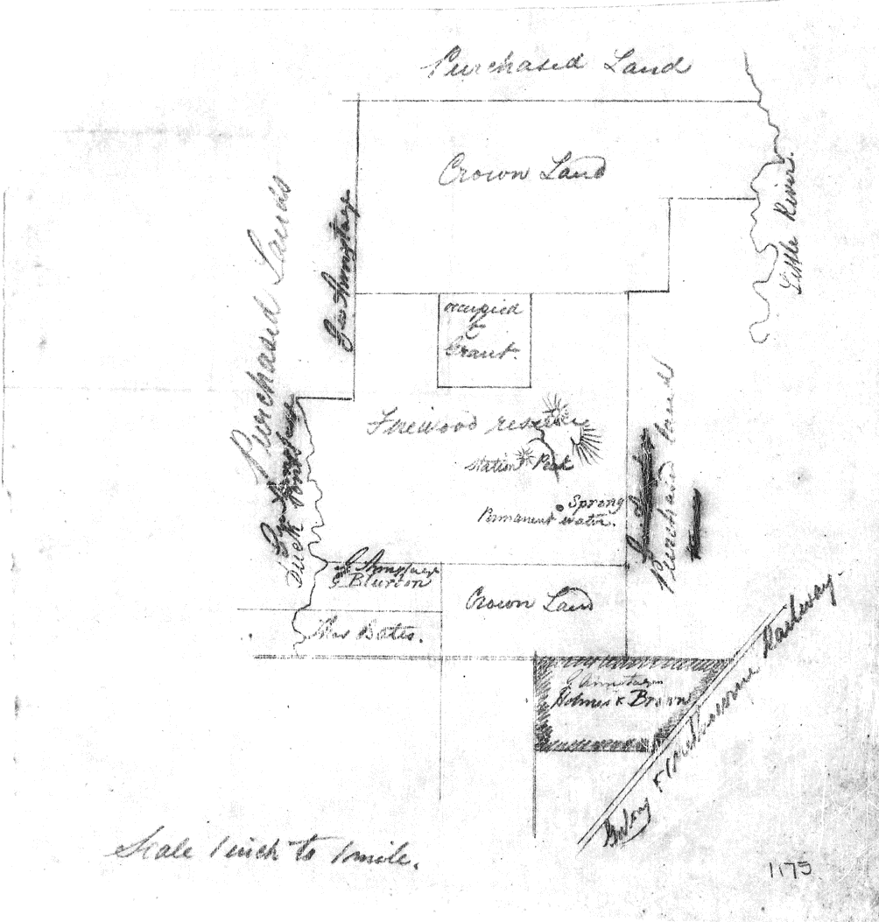

Figure 4.23: ‘Firewood Reserve’ (large central rectangular portion), c.1860. Source: Historic Plans collection, no. 1174, Public
Record Office Victoria.

,t·;..;, . .....
i. . .
' :' ;·!
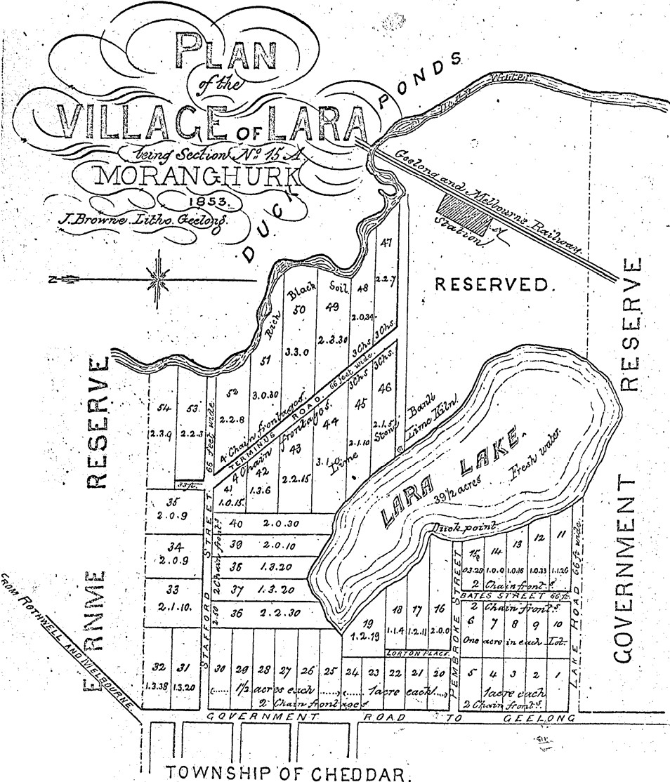'j..: ·. ·.
!
' ..·--

...;. ,•

··.

·.
'.. , '..
• <:·)·'. .•. . . '·. .

..
2
J.J
·.·.
. .

... r'.-· >
'\. 0
U..

. .

CHEDDAR · FARMS.
&e: :17 .-&_ and a.,; If iz-n.w f/' ?-rDJUrhf a ':m!"rJlC.i lm•che.s' .
. ·. .. ,. -fJlm7u' ':f/ al-r-nc rllid.J"g/'.2 Cl.am.J", :Z:n.e C<Jr Ur.J"'iJ!'!adv..Zoca-re. ,
." .. . .,.na.-r.fli:Wi.e.f an<Z cr nt:l:.CJ' 2() Zm7.:.r l<J,"ff, an.Cb llu:aiu..r ar" cu.Z
4J'nkrv.d.J' .Zp i-w': 'Jv Ubwnurn'ltercon eM- ctt;f" 2z7;j
1o M ...P <x,.,;:/, , · · . .T..Z. haW:tJ..E · -'----- · . ·
" Jlir . . .:·

! '

-. .

'·
: i)/,:._\/;-;:-_- ,,".vl_,!f::....

'u- ---<-'4,--.U·e!. ·
.. . / ' . . - .

Figure 6.0l: J.L Shaw Plan of.the Village of Lara,1853. Source: Geelog Heri aCentre maps & plans collection.

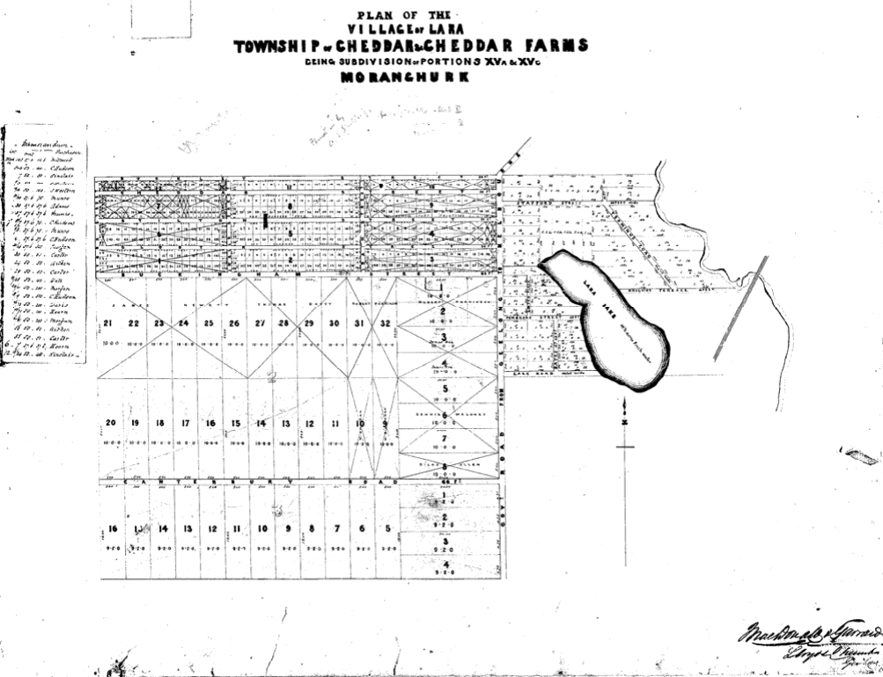
Figure 6.02: Plan of the Village of Lara, Township of Cheddar & Cheddar Farms, c.1855. Source: Geelong Heritage Centre maps &
plans collection.

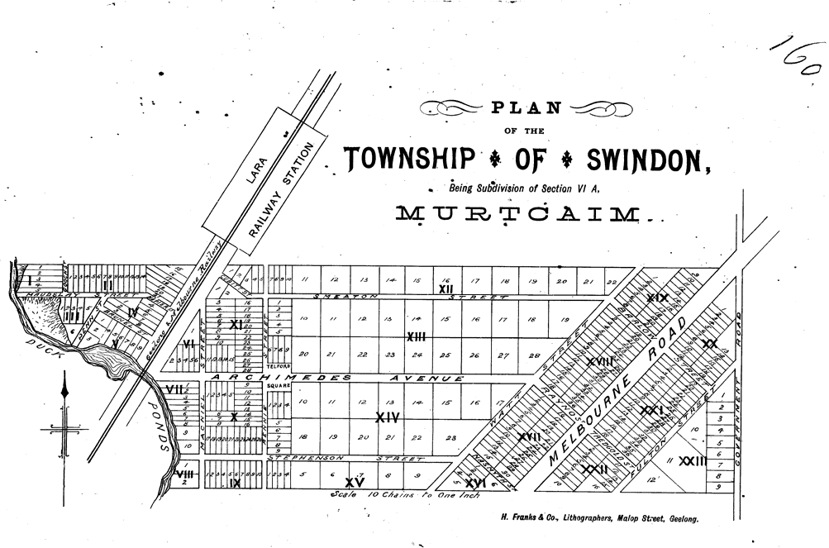
Figure 6.03: Plan of the Township of Swindon, c.1855. Source: Geelong Heritage Centre maps & plans collection.

TOWNSHIP OF LARA

PARISHES
MORANGHURK AND

OF
WOORNYALOOK

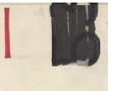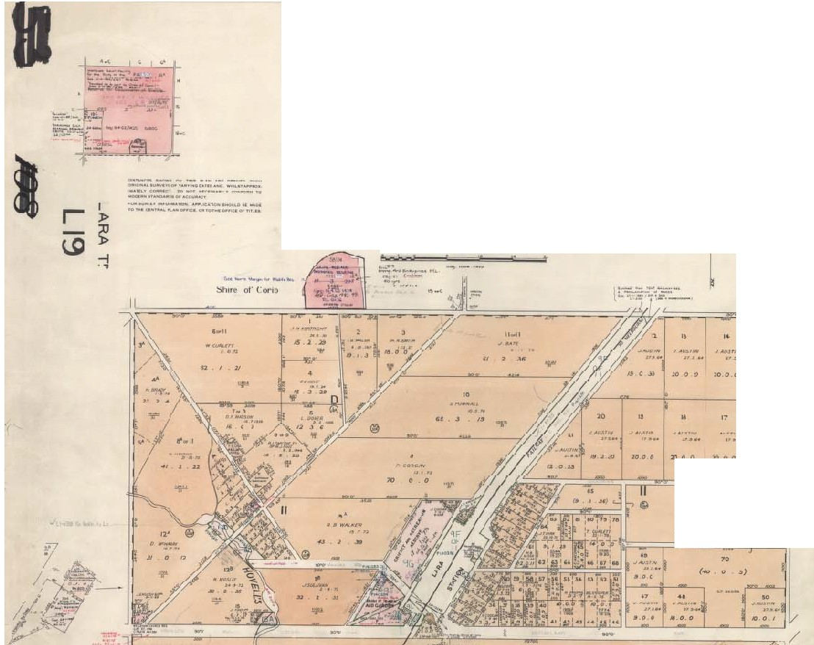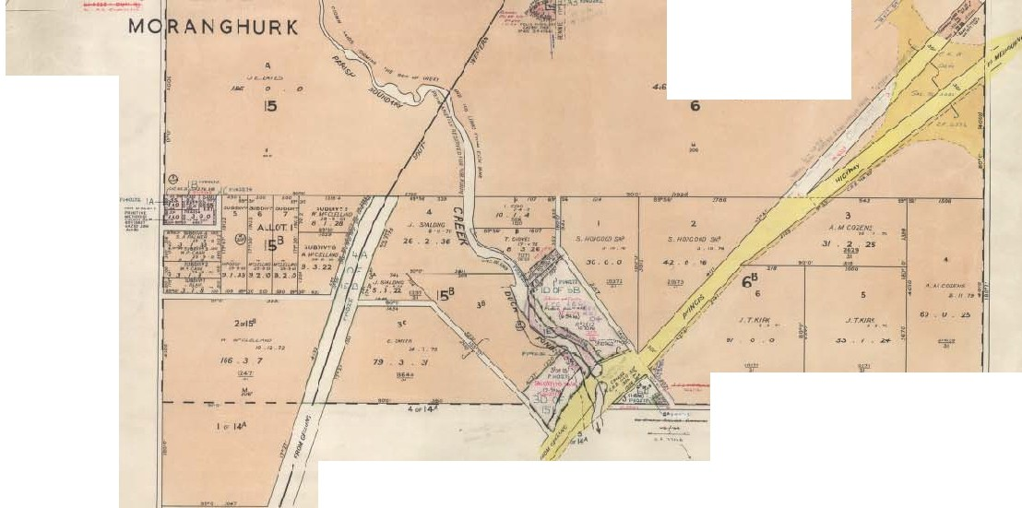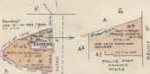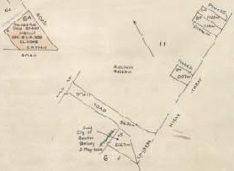
COUNTY OF GRANT
JCALI!: Of' CHANI S

'"''

,,... J :JJ:.)
104 ' j • 2'

WOORNYALOOK

6

"•> ..-n •c: )1<!1.o ·nrt rtt1.,• •niOUII<L
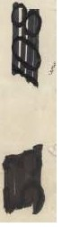I I II'I•WI'.uD.MCiiUUIII,III•t lr-(Jofl(ftAIMUCIIo!ll!lf 1((_,1,...
PMUt/

/:(;/ I
.. "'..I
I -J'
l , . r
I -: I....".',.,. 't""'··
( .... .....,
........ f'
f

Figure 6.04:Plan of the Lara Township,1959. Source: VPRS16171,Public Record Office Victoria.

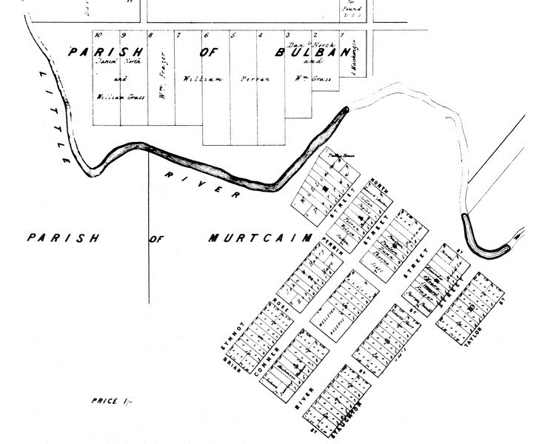
Figure 6.05: Plan of the Township of Rothwell, 1862. Source: Wynd, So Fine a Country, p.124.

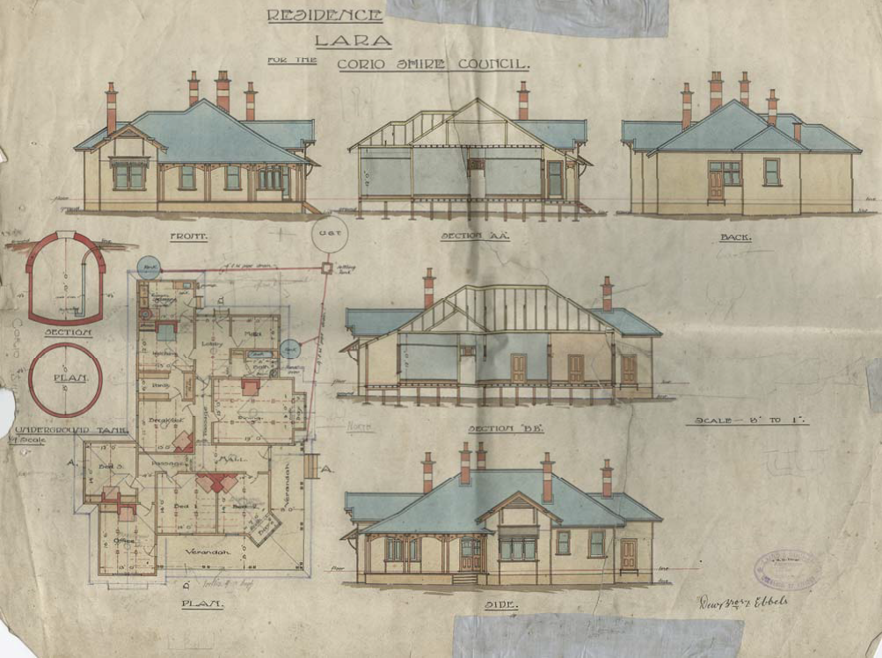
Figure 6.26: Laird & Barlow, ‘Residence in Lara for Corio Shire Council’, n.d. Source: GRS 401/S7/2, Geelong Heritage Centre collection.

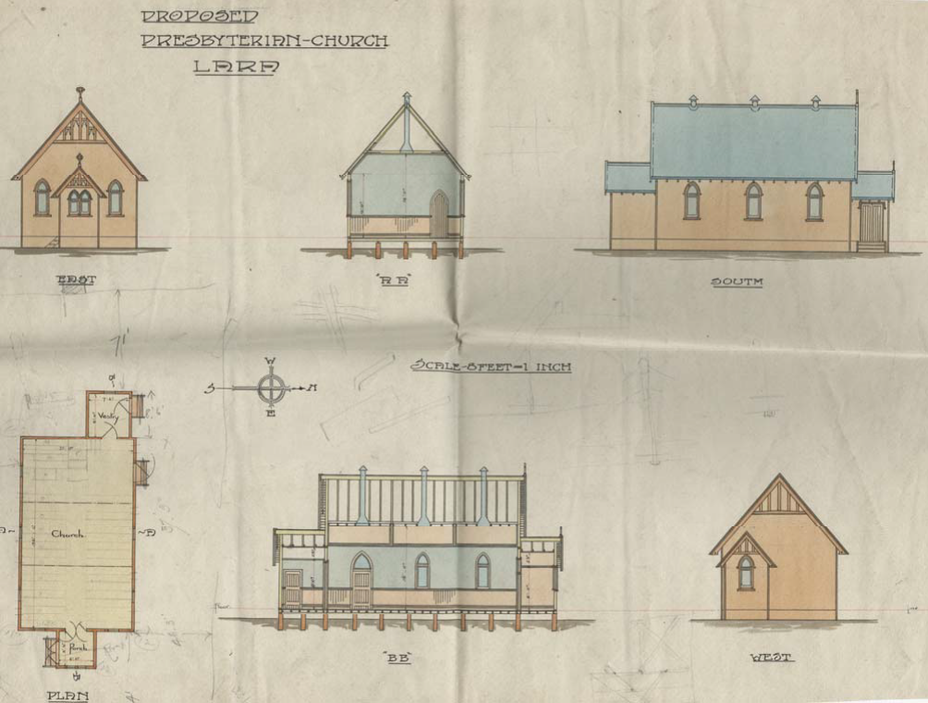
Figure 8.10: Laird & Barlow, ‘Residence in Lara for Corio Shire Council’, n.d. Source: Geelong Heritage Centre collection.

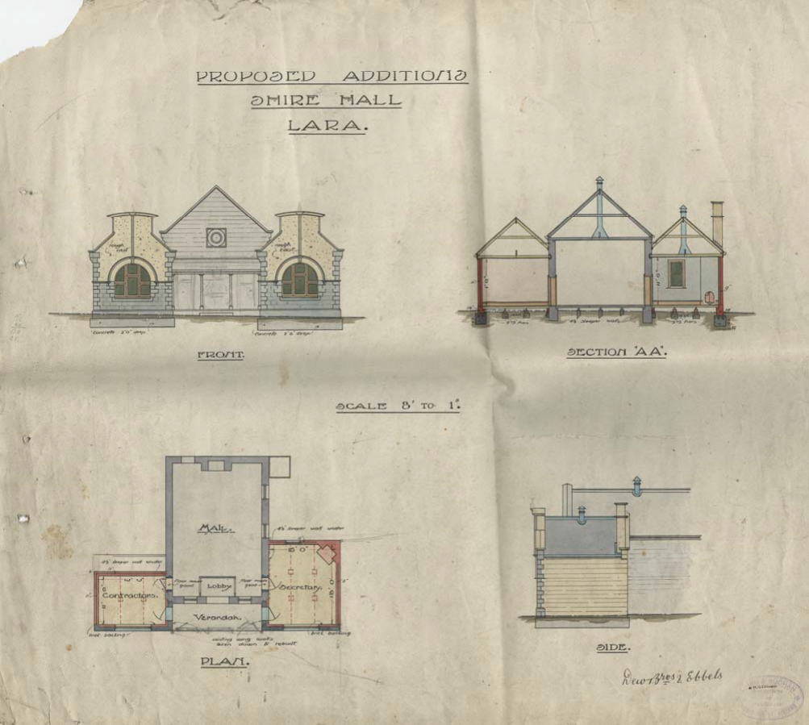
Figure 7.05: Laird & Buchan, ‘Proposed additions, Shire Hall, Lara’, n.d. Source: GRS 401/S7/1, Geelong Heritage Centre collection.

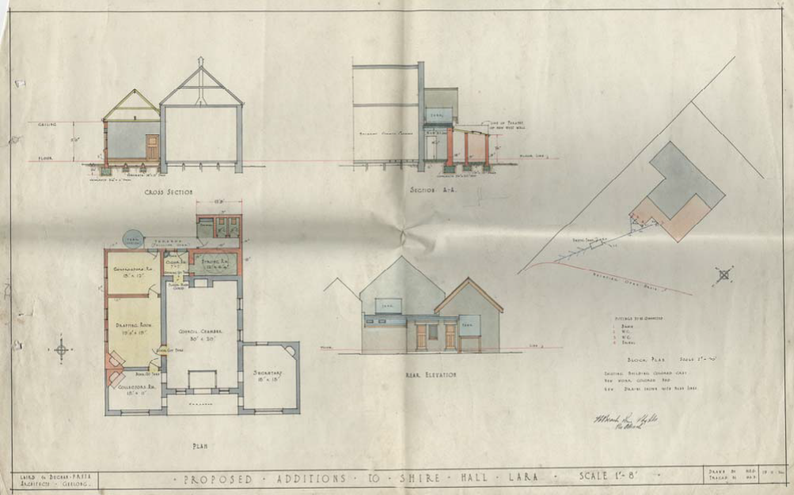
Figure 7.06: Laird & Buchan, ‘Proposed additions, Shire Hall, Lara’, 1926. Source: GRS 401/S7/3, Geelong Heritage Centre collection.

Appendix 11.02:Victoria's Framework of Historical Themes

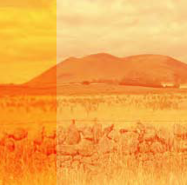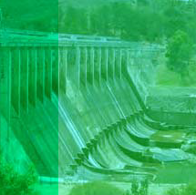Victoria’s Framework of
Historical Themes

Shaping Victoria’s environment
01

… covers how Victoria’s distinctive geology, landscapes, ﬂora and fauna have evolved over millions of years. It traces the factors that have made Victoria’s natural variety an important part of Australia’s biodiversity, and includes Aboriginal people’s traditions about how the land and its features were created – stories that are unique to Victoria, and of great cultural signiﬁcance.
1. Tracing climate and topographical change
1.2 Tracing the emergence of Victoria’s plants and animals
1.3 Understanding scientiﬁcally diverse environments
1.4 Creation stories and deﬁning country
1.5 Living with natural processes
1.6 Appreciating and protecting Victoria’s natural wonders

Peopling Victoria’s places and landscapes
02
… is a key theme for understanding the many ways in which people have arrived and settled in Victoria, and the successive waves of migration that have created a multicultural society expressed in the built fabric of our towns and cities. The high points of migration were the gold rush generation that inﬂuenced social and economic development until the First World War, and the post World War II migration, when Victoria had more migrants than any other state. This has had an enormous inﬂuence on the state’s, and also the nation’s economic, social and political development.
2. Living as Victoria’s original inhabitants
2.2 Exploring, surveying and mapping
2.3 Adapting to diverse environments
2.4 Arriving in a new land
2.5 Migrating and making a home
2.6 Maintaining distinctive cultures
2.7 Promoting settlement
2.8 Fighting for identity

Connecting Victorians by transport and communications
03
Early European routes often followed the pathways by which Aboriginal people moved through country over thousands of years. This theme traces the networks of routes and connections by which goods and people were moved and linked.
In the 19th and early 20th centuries, Victoria used overseas technologies to build an ambitious rail system serving the entire state. Since the 1950s, cars and road transport have had a huge impact on Victoria’s rural and urban landscapes.
3. Establishing pathways
3.2 Travelling by water
3.3 Linking Victorians by rail
3.4 Linking Victorians by road in the 20th century
3.5 Travelling by tram
3.6 Linking Victorians by air
3.7 Establishing and maintaining communications

Transforming and managing land and natural resources
04
… is critical to understanding how occupation and use of the land, and exploitation of its natural resources, have changed Victoria and produced its varied cultural landscapes. Important aspects are the evidence of a continuing Aboriginal occupation across the state, and the European exploitation of grasslands, minerals and forests,
a source of wealth reﬂected in Victoria’s colonial and post-Federation heritage.
This theme also illuminates the historical development of Victoria’s distinctive areas of rural development, from the pastoral estates of the Western District to the family farms of Gippsland and the Mallee, and irrigation settlements.
4. Living off the land
4.2 Living from the sea
4.3 Grazing and raising livestock
4.4 Farming
4.5 Gold mining
4.6 Exploiting other mineral, forest and water resources
4.7 Transforming the land and waterways

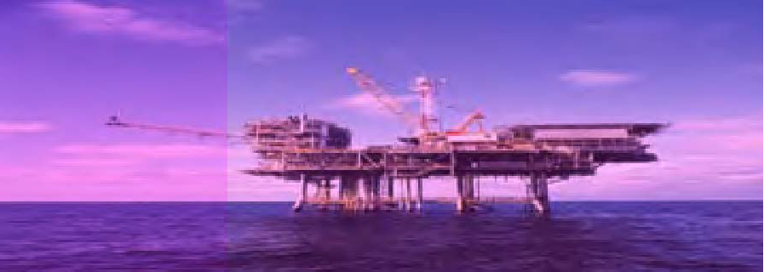Building Victoria’s industries and workforce
05
… embraces the development of Victoria’s industrial and manufacturing base, and the development of service industries such as banking and ﬁnance. This has left a rich architectural and historical legacy, for example banks in every Victorian town and in Melbourne, and also the industrial complexes, large and small, throughout Victoria.
5. Processing raw materials
5.2 Developing a manufacturing capacity
5.3 Marketing and retailing
5.4 Exhibiting Victoria’s innovation and products
5.5 Banking and ﬁnance
5.6 Entertaining and socialising
5.7 Catering for tourists
5.8 Working

Building towns, cities and the garden state
06
… covers the development of goldrush cities and agricultural service centres, as well as the emergence of Melbourne as a world leader in suburban development and the expression of this in the range and variety of Melbourne’s suburbs. Victoria’s areas
of ethnic and cultural diversity, and the distinctive heritage of our country towns, are also important under this theme.
6.1 Establishing Melbourne Town, Port Phillip District
6.2 Creating Melbourne
6.3 Shaping the suburbs
6.4 Making regional centres
6.5 Living in country towns

Governing Victorians
07
… covers the phases of government in Victoria’s history, as well as the varied heritage associated with defence, law and order and local government. It features the role Victoria played as a centre for reform campaigns, including reform of Aboriginal policies in the 20th century.
7. Developing institutions of self-government and democracy
7.2 Struggling for political rights
7.3 Maintaining law and order
7.4 Defending Victoria and Australia
7.5 Protecting Victoria’s heritage

Building community life
08
… highlights the role of churches, schools, hospitals and community halls in transferring old-world belief systems, ideals and institutions to the new colonial offshoot. This includes the range and inﬂuence of women’s organisations; for example the Country Women’s Association had a larger membership in Victoria than any other state and was a major political force. Victoria’s pioneering role in providing for women’s secondary school education is also an important aspect of this theme.
8. Maintaining spiritual life
8.2 Educating people
8.3 Providing health and welfare services
8.4 Forming community organisations
8.5 Preserving traditions and commemorating
8.6 Marking the phases of life

Shaping cultural and creative life
09
… covers the rich legacy of places and strong interconnecting creative culture, supported locally, which is highly valued by the community as part of its history and identity. Victoria’s cultural life in its many facets: sport, arts, popular culture and science.

9.1 Participating in sport and recreation

9.2 Nurturing a vibrant arts scene

9.3 Achieving distinction in the arts

9.4 Creating popular culture

9.5 Advancing knowledge

