COMBINED PLANNING SCHEME AMENDMENT AND PLANNING PERMIT APPLICATION

AT

357 PAKINGTON STREET, NEWTOWN

PART A – PLANNING SCHEME AMENDMENT

1. Introduction

Sincock Planning have been engaged to prepare a report to accompany an application for a combined rezoning and planning permit application.

The site is currently within a General Residential Zone – Schedule 1 and comprises a single title with frontage to Pakington Street of 11.81m, and with rear access via a carriageway easement along the western boundary.

The amendment application seeks to rezone the land to the Commercial 1 Zone. At the request of officers at the City of Greater Geelong, the mapping also encompasses the property to the south at 359 Pakington Street, such that the Commercial 1 Zone would extend from Percy Street up to 357 Pakington Street. The rezoning request does not necessitate any changes to existing policy.

An application for planning permit for buildings and works associated with an office and two dwellings and the partial reduction in car parking is detailed later in Part B of the report.

The application follows pre-application meetings with the City of Greater Geelong on 13th May and 12th August 2014 to discuss the strategic justification for the proposal, car and bike parking requirements, layout, siting and development matters generally, and the level of documentation/assessment required.

2. Proposal

The application seeks to amend Planning Scheme Map No. 49 to the Greater Geelong Planning Scheme by applying the Commercial 1 Zone.

The land is required to be rezoned to provide for an office use at the ground floor along with car parking and common areas for use by the office and the residential occupants at the first floor. Two dwellings are proposed at the first floor and are permitted within the Commercial 1 Zone. The proposal provides for a very small increase in commercial land within an existing neighbourhood shopping centre and provides a natural extension to the Commercial 1 Zone.

The proposal provides the following:

- 223sq.m of commercial space at the ground floor with a zero front setback to Pakington Street;
- Two two-bed dwellings at the first floor setback 2m from Pakington Street, with a balcony projecting to the Pakington Street boundary;
- Car parking at the rear, accessed via Percy Street and the carriageway easement on the western boundary;
- Bicycle parking provided in Pakington Street;
- Advertising sign panels

A detailed description of the development is provided at Part B of this submission.

3. Site and locality

The subject site is located on the west side of Pakington Street, approximately 50m north of Percy Street Newtown.

The land is on a single title and has an area of 450sq.m. The site has a frontage to Pakington Street of 11.8m and a depth of 36.58m. A carriageway easement, to which the subject site benefits, is located along the western boundary. The carriageway easement has a width of 3.66m and is currently used to provide vehicle access to car parking spaces in the south west corner of the site.

The site is currently developed with a single storey weatherboard dwelling and shed. A crossover is also provided to Pakington Street in the south east corner of the site and this provides access to a single car space adjacent to the dwelling.

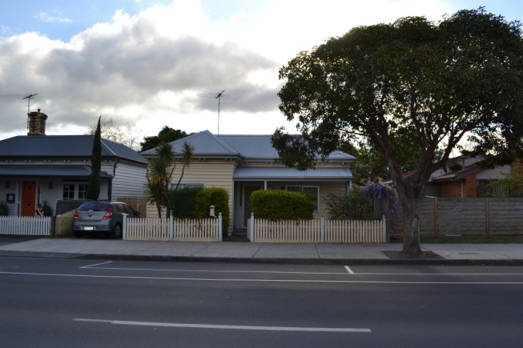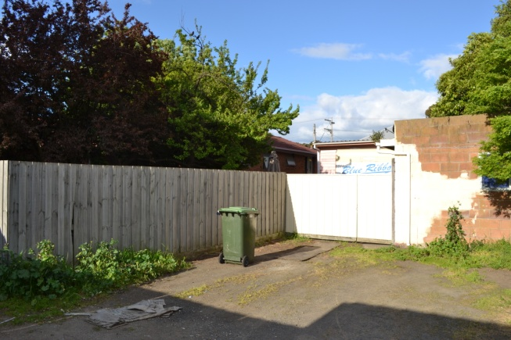
Subject site as viewed from Pakington Street (left) and from the carriageway easement (right).

The property has a slight fall from east to west of 0.97m. Two trees are located on the northern boundary and some small shrubs within the front setback.

A site analysis – existing conditions plan is included in the plan package prepared by Mark Gratwick Architects at TPO1 & TPO2.

The property to the north comprises a substantial parcel of land that is developed with ten single storey brick dwellings with a central common driveway. At the closest point the adjoining dwellings are setback 3.2m from the common boundary, extending to between 5.1-6.2m in the south east corner of the adjoining dwellings where they are provided with secluded open space.

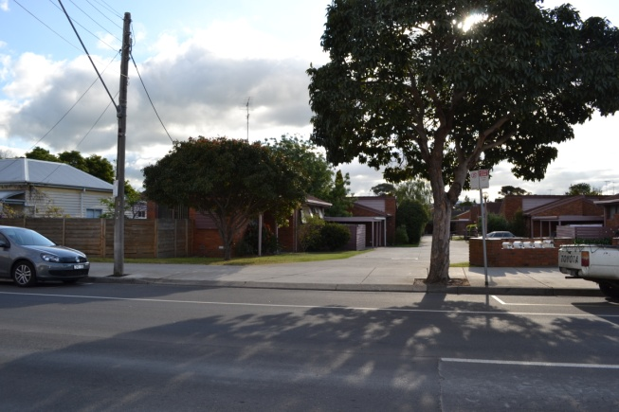
Unit development at 351-355 Pakington Street.

To the south, at 359 Pakington Street, is a single storey weatherboard building that is used as a café. The building is constructed along the northern boundary and the front setback is paved and used for outdoor dining. At the rear is a gravel courtyard that is also used for outdoor dining, with shading provided by large trees and shade umbrellas on tables. Two sheds are located in the North West corner of the site and bin storage is provided in the south west corner.

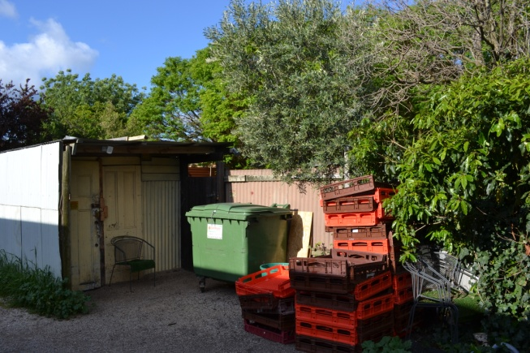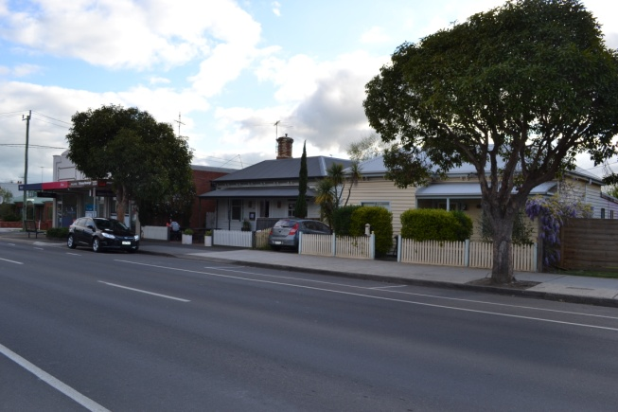
Shed and storage area at the western end of 359 Pakington Street (left) and café as seen from the east side of Pakington Street between the subject site and shops at 361 Pakington Street..

To the west at 1/4 Percy Street is a recently constructed single storey brick dwelling. Secluded open space is located directly opposite the subject site, with vehicle access for the dwelling at 2/4 Percy Street located to the north of their courtyard and reliant on access along the carriageway easement.

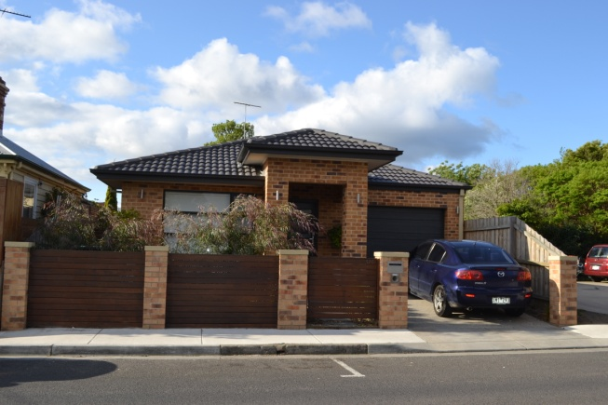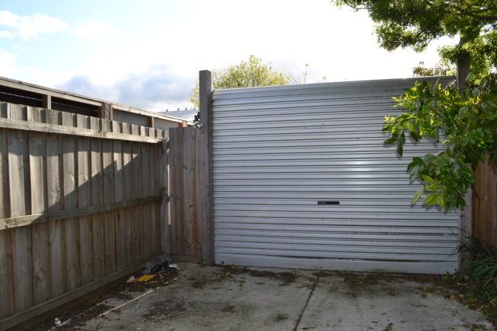
Dwelling at 1/4 Percy Street (to left). Vehicle access to the property at 2/4 Percy Street as viewed from the northern end of the carriageway easement (to right).

The carriageway easement has a concrete surface for the depth of 2 Percy Street where it provides access to parking for 361 Pakington Street and 2 Percy Street. The remainder of the carriageway easement is unsealed.

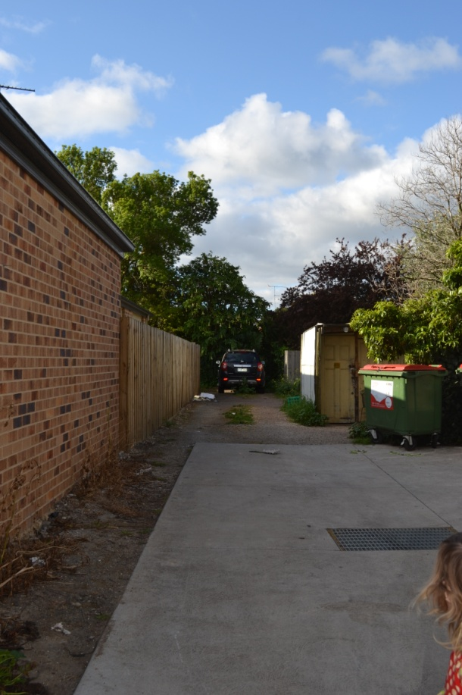
View north along the carriageway easement, noting concrete seal at the southern end and unsealed to the north.

At 361 Pakington Street, on the North West corner of Percy Street, are three single storey shops that are within the Commercial 1 Zone. The east side of Pakington Street, from the Marshall Street intersection as far north as Clarendon Street, is within the Commercial 1 Zone and used for a range of commercial uses but primarily shops and food and drink premises.

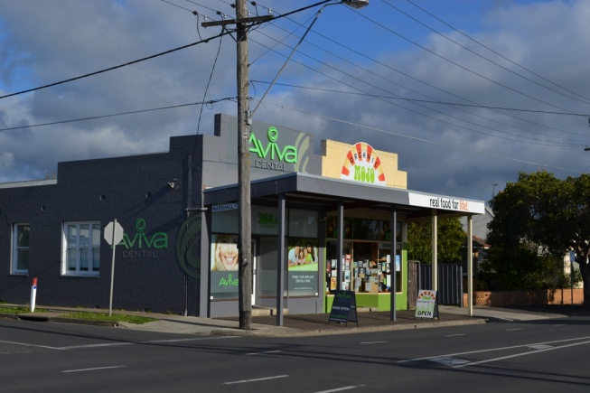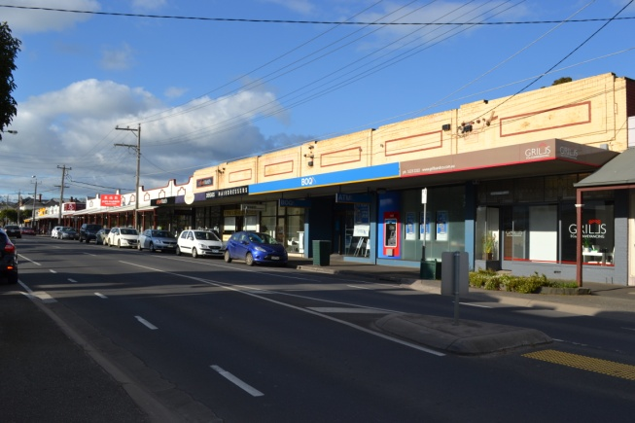
Shops at 361 Pakington Street to the south of the site (on the left) and shops along the east side of Pakington Street (to the right).

4. Current Planning Scheme Provisions

4.1 Zoning
The property is within the General Residential Zone, Schedule 1 as shown on Planning Scheme Map No. 49.
The context of the site and the relationship to the existing Commercial 1 Zoned land in Pakington Street is shown on the excerpt from the planning scheme map (No.49) above.

As detailed earlier, the east side of Pakington Street from Marshall Street to the south side of Clarendon Street is within the Commercial 1 Zone, whilst the west side of Pakington Street from Fairview Avenue (south side) to 347 Pakington Street is also in the Commercial 1 Zone. To the south of the site, 1-3/361 Pakington Street and 2 Percy Street are also in the Commercial 1 Zone.

4.2 Overlays
The property is not affected by any overlays as the Design and Development Overlay - Schedule 14 was removed from the residential land in Newtown between Shannon Avenue and La Trobe Terrace by Amendment C245 in July 2012.

4.3 State Planning Policy Framework (SPPF)
The following provides a summary of the applicable policies contained within the State Planning Policy Framework as relevant to the planning scheme amendment application:

11 Settlement

Planning is to anticipate and respond to the needs of existing and future communities through provision of zoned and serviced land for housing, employment, recreation and open space, commercial and community facilities and infrastructure.

11.01-1 Activity centre network

Objective
- To build up activity centres as a focus for high-quality development, activity and living for the whole community by developing a network of activity centres.
Strategies

Develop a network of activity centres that:
- Comprises a range of centres that differ in size and function
- Is a focus for business, shopping, working, leisure and community facilities.
- Provides different types of housing, including forms of higher density housing.
- Is connected by public transport and cycling networks.
- Maximises choices in services, employment and social interaction.
Support the role and function of the centre given its classification, the policies for housing intensification, and development of the public transport network.
11.01-2 Activity centre planning

Objective
- To encourage the concentration of major retail, residential, commercial, administrative, entertainment and cultural developments into activity centres which provide a variety of land uses and are highly accessible to the community.

Strategies
- Encourage a diversity of housing types at higher densities in and around activity centres.

11.05-1 Regional settlement networks

Objective
- To promote the sustainable growth and development of regional Victoria through a network of settlements identified in the Regional Victoria Settlement Framework plan.

11.05-4 Regional planning strategies and principles

Objective
- To develop regions and settlements which have a strong identity, are prosperous and are environmentally sustainable.

Strategies
- Ensure regions and their settlements are planned in accordance with any relevant regional growth plan.
- Apply the following principles to settlement planning in Victoria’s regions, including the hinterland areas:

A network of integrated and prosperous regional settlements
Support a network of integrated and prosperous regional settlements by:
▪ Strengthening networks of settlements by maintaining and improving transport links, spatial patterns of service delivery, and promoting commercial relationships and community activities.
▪ Ensuring there is a sufficient supply of appropriately located residential, commercial, and industrial land across a region to meet the needs identified at regional level.

Regional Victoria’s competitive advantages
Maintain and enhance regional Victoria’s competitive advantages by:
▪ Strengthening settlements by ensuring that retail, office-based employment, community facilities and services are concentrated in central locations.
Distinct and diverse regional settlements
Support the growth and development of distinctive and diverse regional settlements by:
▪ Encouraging high-quality urban and architectural design which respects the heritage, character and identity of each settlement.
▪ Limiting urban sprawl and directing growth into existing settlements, promoting and capitalising on opportunities for urban renewal and redevelopment.
Liveable settlements and healthy communities
Promote liveable regional settlements and healthy communities by:
▪ Encouraging the development of compact urban areas which are based around existing or planned activity centres to maximise accessibility to facilities and services.

11.07-1 Planning for growth
Objective
- To optimise infrastructure and consolidate growth.

Strategies
- Maximise capacity and leverage off existing infrastructure and services, particularly near central retail and transport nodes.

11.07-3 Connected communities
Objective
- To create unique and connected communities.

Strategies
- Support growth that enhances choice, health and wellbeing, liveability, amenity and diversity and creates a sense of place.
11.07-6 Sustainable communities
Objective
- To allow communities to live, work and participate locally.

Strategies
- Facilitate infill development in Central Geelong and West Fyans and around activity areas within urban Geelong and district towns.

15.02-1 Energy and resource efficiency
Objective
- To encourage land use and development that is consistent with the efficient use of energy and the minimisation of greenhouse gas emissions.

Strategies
- Ensure that buildings and subdivision design improves efficiency in energy use.
- Promote consolidation of urban development and integration of land use and transport.
- Improve efficiency in energy use through greater use of renewable energy.
- Support low energy forms of transport such as walking and cycling.
16.01-2 Location of residential development

Objective
- To locate new housing in or close to activity centres and employment corridors and at other strategic redevelopment sites that offer good access to services and transport.

Strategies
- Increase the proportion of housing in Metropolitan Melbourne to be developed within the established urban area, particularly at activity centres, employment corridors and at other strategic sites, and reduce the share of new dwellings in greenfield and dispersed development areas.
- Encourage higher density housing development on sites that are well located in relation to activity centres, employment corridors and public transport.
17.01-1 Business

The objective is:
- To encourage development which meets the communities’ needs for retail, entertainment, office and other commercial services and provides net community benefit in relation to accessibility, efficient infrastructure use and the aggregation and sustainability of commercial facilities.

Relevant strategies include:
- Locate commercial facilities in existing or planned activity centres.

18.02-5 Car parking

The objective is:
- To ensure an adequate supply of car parking that is appropriately designed and located.

Relevant strategies include:
- Allocate or require land to be set aside for car parking subject to the existing and potential modes of access including public transport, the demand for off-street car parking, road capacity and the potential for demand management of car parking.
- Encourage the efficient provision of car parking through the consolidation of car parking facilities.
- Protect the amenity of residential precincts from the effects of road congestion created by on-street parking.

4.4 Local Planning Policy Framework (LPPF)
21.06 – Settlement & Housing

Housing
The ageing of the population will contribute substantially to the increase in demand for low maintenance dwellings and retirement accommodation. This accommodation will need to be close to urban services.
There is a need to maintain competition and diversity in the housing market.

Settlement
There is an environmental, economic and social imperative to reduce urban sprawl and improve accessibility to urban services, principally by consolidating urban development around places of activity and public transport infrastructure.
New infill development should be directed to well serviced areas and should be of a high design quality and respond to the locality.Outward urban growth needs to be carefully managed and directed to designated locations that offer the greatest net benefit to the Geelong community, can be appropriately serviced and which have the capacity to accommodate sustainable development.
All development should contribute positively to the quality of the urban environment so that it may be enjoyed and respected by the existing and future community.
21.06-3 Urban consolidation
Objectives
- To provide for the consolidation of existing urban areas in a managed way.
- To encourage an appropriate range of development densities.
- To improve accessibility to urban services.

Strategies
Manage urban consolidation and housing change across the municipality, by:
- Accommodating medium and high density housing in Key Development Areas (as defined by the maps included in this clause).
- Maximising opportunities for housing within Increased Housing Diversity Areas (as defined in Clause 22.63 Increased Housing Diversity Areas) by accommodating;
  - high density housing in the activity centres consistent with their primary commercial and retail role; and
  - medium density housing in residential areas with more intensive development being located closest to the core of activity centres.

21.07 Economic development and employment

Key retail issues include:
- The City of Greater Geelong Retail Activity Centre Hierarchy has been established to articulate the role and function fulfilled by centres of different sizes.
- The retail hierarchy supports the primacy of Central Geelong as the focus of retail activity in the region.
- There is a need to ensure a mix of commercial uses in activity centres.
- The retail hierarchy will be enhanced through high quality urban design and improved pedestrian and public transport accessibility.

A relevant objectives is:
- To facilitate the development of vibrant and viable retail activity centres in accordance with the Geelong Retail Activity Centre Hierarchy included at Clause 21.07-8.
Strategies include:
- Encourage a mix of retail, office, cafes, entertainment, housing, education and community facilities to locate within activity centres.
- Support accommodation uses above ground level floor space in activity centres subject to appropriate provision of parking and access requirements.

22.03 Assessment Criteria for Retail Planning Applications

The policy basis states:

This policy sets out retail assessment criteria which are to be used as a basis for considering applications for new or expanded retail floorspace.

The criteria consists of the following:
- Information required to be submitted with an application.
- Issues to be considered in the preparation and consideration of an economic impact assessment and contribution to net community benefit.
- Issues to be considered in the preparation and consideration of an out-of-centre retail proposal.
Where a permit or planning scheme amendment is required to increase the leasable retail floor area, it is policy to require the following information and address the following issues as appropriate:

Economic Impact Assessment
An economic impact assessment should be provided for:
- New major retail development involving 2,000m2 or more in gross leasable floor area.
- Proposals involving a key major tenant such as a supermarket.
- Out-of-centre proposals.
- Applications relating to an increase in an existing floor space cap.

The responsible authority may waive a requirement to prepare an economic impact assessment.

5. Proposed Planning Scheme Provisions

The planning scheme amendment is consistent with the current policy provisions and as such does not require any changes to policy.
The proposal seeks to amend the zone from the General Residential Zone Schedule 3 to a Commercial 1 Zone.

5.1 Proposed Zoning
The purpose of the Commercial 1 Zone is:

- To implement the State Planning Policy Framework and the Local Planning Policy Framework, including the Municipal Strategic Statement and local planning policies.
- To create vibrant mixed use commercial centres for retail, office, business, entertainment and community uses.
- To provide for residential uses at densities complementary to the role and scale of the commercial centre.

We submit that the Commercial 1 Zone is the most appropriate zone to reflect the proposed mix of uses having regard also to the context of the site and the zoning applied to the surrounding land uses. Had the surrounding land not been in the Commercial 1 Zone, it may have been more appropriate to consider the Mixed Use Zone in the context of all surrounding land being residentially zoned.
The planning scheme amendment is sought to enable an office use to function at the ground floor level. An office does not require a planning permit in the Commercial 1 Zone providing the following condition is met:
The leasable floor area for all offices must not exceed any amount specified in the schedule to this zone.

The Commercial 1 Zone does not have a schedule applicable to the Pakington Street (Newtown) neighbourhood shopping centre.

Accommodation also does not require a planning permit where the following condition is met:

- Any frontage at ground floor level must not exceed 2 metres (other than a bed and breakfast and caretaker's house).

6. Strategic Planning Assessment

This section of the report provides the strategic planning assessment of the proposal against the policy framework, any reference or incorporated documents and discusses the need for the planning scheme amendment.
6.1 City of Greater Geelong Retail Strategy 2006
The proposal seeks only 223sq.m of commercial floor space for use as an office, and therefore the strategic assessment is tempered slightly, in that the small scale of the proposal will have minimal impact on the total floor space of the centre, and therefore requires little justification pursuant to the requirements of the City of Greater Geelong Retail Strategy 2006, and particularly Clause 22.03.
The City of Greater Geelong Retail Strategy 2006 guides the development and growth of activity centres, the vision of which is:
“Geelong’s retail activity centre network will be developed in a way that promotes the vibrancy and sustainability of the activity centre hierarchy; is efficient and viable for retail traders and other businesses; generates employment and income opportunities; and functions in a manner which focuses on the needs of residents and visitors to the Region.”
Objectives designed to assist in achieving the vision comprise the following:
- To promote economic development and job creation
- To foster small business development
- To encourage the development of interesting, viable and vibrant retail activity centres
- To improve the range and quality of shopping and business services provided at activity centres and at other locations
- To improve the amenity of the built environment in activity centres
- To create safe and liveable activity centres
- To encourage accessibility and sustainability as key features of activity centre policy
- To introduce activities such as housing and mixed use development at appropriate locations which support the role of activity centres
In order to achieve this Vision and the several important objectives listed above, a number of strategic policies have been developed to guide Council’s decision-making process with regard to the future development of retailing in the municipality. These strategic policies relate to:
- Support for the retail hierarchy;
- Encouragement of centre management and business development; and
- Enhanced urban design in activity centres.
These strategies have been incorporated into the policy framework of the planning scheme, in particular at Clause 21.07 (Economic development and employment) and Clause 22.03 (Assessment criteria for retail planning applications).
Relevant principles and actions to support the strategy include:
The retail activity centre hierarchy will be supported so that the specific roles, functions and themes of centres in each level in the hierarchy are easily identifiable, thus providing certainty for stakeholders including Council, developers, property owners and businesses.
Maximise the retention of retail expenditure through the provision of an efficient activity centre hierarchy.
Geelong has an established hierarchy of retail activity centres that provides the focus for ongoing retail and business development, and these are the locations where ongoing private and public investment will be directed and consolidated.
Encourage the development of activity centres as lively foci for a wide range of uses including shopping, business, work and leisure, and where such uses are commercially viable.
Encourage land use and development that is integrated with transport infrastructure (principally bus services) so that activity centres are well-served by public transport alternatives, and improve the amenity of centres by reducing car- based traffic.
Apply the Retail Planning and Development Criteria for Retail Proposals in New Centres and for Expansion of Existing centres.
The site is within the identified Pakington Street Newtown Neighbourhood Centre as shown on the following page:

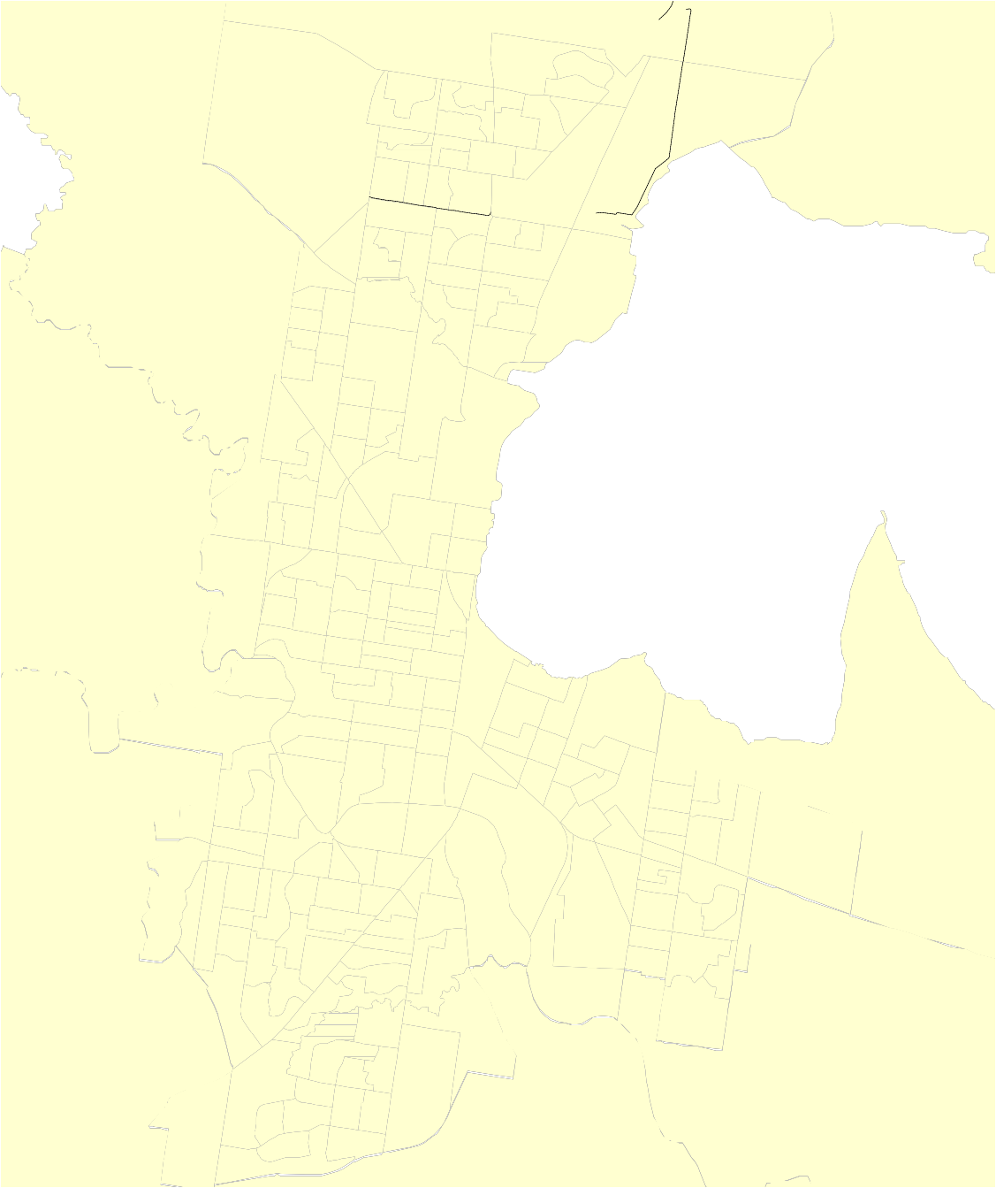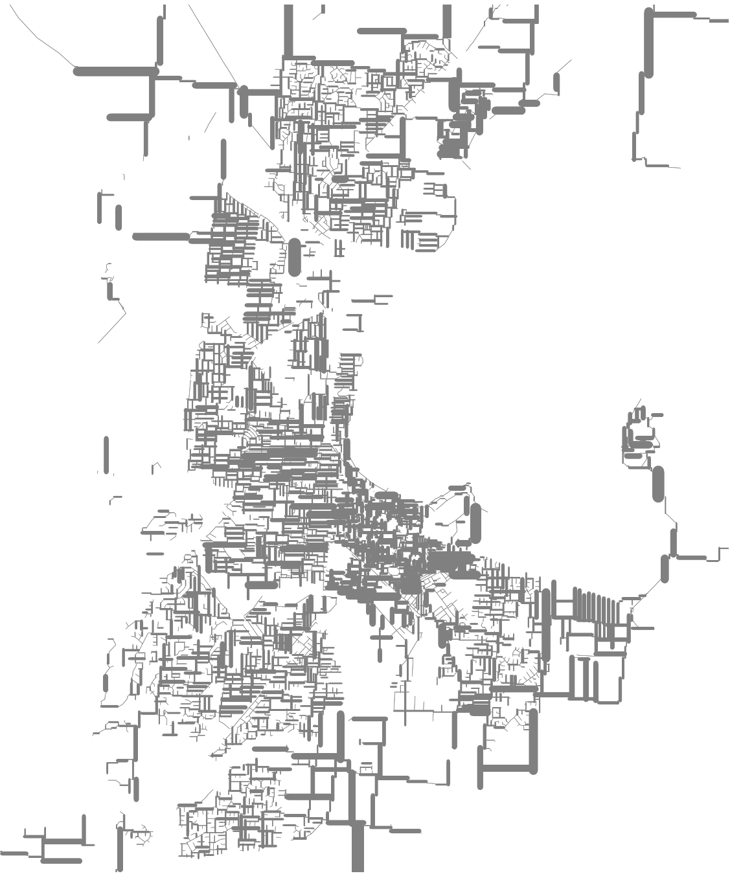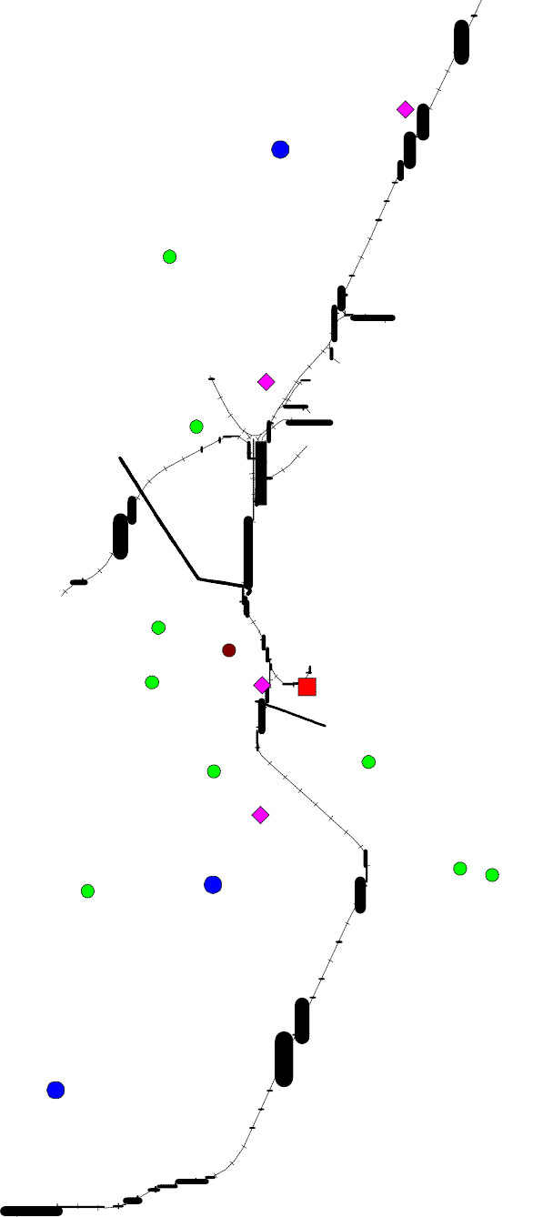
Regional Centre

Sub - Regional Centre

Community Centre

Neighbourhood Centre

Town Centre

Homemaker Precinct

Retail Activity Centre Hierarchy

A neighbourhood centre is defined in the City of Greater Geelong Retail Strategy 2006 as a centre which provides for weekly (or more frequent) grocery shopping based around a supermarket tenant; in some cases, it has a small lower-order specialty retail or non-retail component (small office, medical, etc).
Neighbourhood centres are generally characterised by a range of mainly convenience-related shopping needs such as newsagent, chemist, hairdresser, green grocer, butcher, takeaway food, etc, and anchored by a supermarket. Typically, Large Neighbourhood Centres can be distinguished by their greater level of retail provision (around 5,000 – 10,000 m2), their wider trading catchment, and the location of major full-line supermarket brands as major tenants.
Small Neighbourhood Centres typically serve a similar convenience related role, but with a smaller (not full-line) supermarket or self-serve grocery store as the anchor tenant.
Neighbourhood centres play an important role in providing for the regular shopping needs of residents in the surrounding catchment, and this typically revolves around the weekly (or more frequent) grocery shopping trip. There may be opportunities to accommodate a more diversified retail mix in these centres. For example, the Newcomb Central has an opportunity to expand the retail offer to include an ALDI store and other new floorspace. And at Leopold there is a current proposal to construct a neighbourhood activity centre.
There is also a need to plan for the provision of shopping facilities to meet the needs of new residents moving into future urban areas. In particular, there is potential to locate new neighbourhood activity centres in the growth area west of Drysdale; in Wandana Heights; and in association with the Armstrong Creek urban growth corridor. The establishment of a small neighbourhood centre in Fyansford may also be considered.
The proposal is consistent with the City of Greater Geelong retail Strategy. The proposal provides only a very small commercial floor space (223sq.m), however fosters small business development via the opportunity to locate in a successful and vibrant neighbourhhod shopping centre and provide office based activity that is in short supply in this centre. The location of the site within the existing boundaries of the centre, with Commercial 1 land located two properties to the north and south, and along the east side of Pakington Street, effectively means the boundary of the centre doesn’t change, but infill development is occurring and supporting the existing centre and customer base.
The architectural and built form outcomes are discussed in greater detail in the planning permit application section (Section B) and in summary the proposal is considered to address the design and built form policies and objectives of the Retail Strategy.
The small growth of the centre via this development doesn’t challenge the size or role of the neighbourhood centre, and is therefore consistent with the existing hierarchy. The floor space proposed is insignificant and effectively doesn’t warrant any assessment against Clause 22.03 as it is well under the 2000sq.m threshold, does not propose a key major tenant, is not considered to be an out of centre proposal and does not increase an existing floor space cap.
The proposal consolidates an existing neighbourhood centre and via the mixed use nature of the proposal, supports vitality and activity at the centre during the day and evening.
6.2 Policy
Clause 11, Settlement, states that:
“Planning is to anticipate and respond to the needs of existing and future communities through provision of zoned and serviced land for housing, employment, recreation and open space, commercial and community facilities and infrastructure.”
Strategies contained within Clause 11 include:
Support the role and function of the centre given its classification, the policies for housing intensification, and development of the public transport network.
Ensuring there is a sufficient supply of appropriately located residential, commercial, and industrial land across a region to meet the needs identified at regional level.
Strengthening settlements by ensuring that retail, office-based employment, community facilities and services are concentrated in central locations.
Support growth that enhances choice, health and wellbeing, liveability, amenity and diversity and creates a sense of place.
Clause 17.01-1 relates to business and seeks to:
Locate commercial facilities in existing or planned activity centres.
Clause 21.07 further considers the issue of economic development and employment and builds on the business policy at Clause 17 and states:
“Key retail issues include:
- The City of Greater Geelong Retail Activity Centre Hierarchy has been established to articulate the role and function fulfilled by centres of different sizes.
- The retail hierarchy supports the primacy of Central Geelong as the focus of retail activity in the region.
- There is a need to ensure a mix of commercial uses in activity centres.
- The retail hierarchy will be enhanced through high quality urban design and improved pedestrian and public transport accessibility.
A relevant objectives is:
To facilitate the development of vibrant and viable retail activity centres in accordance with the Geelong Retail Activity Centre Hierarchy included at Clause 21.07-8.”
Clause 22.03 provides the retail assessment criteria and specifies the type of information required to be submitted with an application. This matter has been previously discussed.
The planning scheme amendment application responds to these policies as follows:
- It provides a small increase in floorspace consistent with the nature of the neighbourhood centre and without conflicting with the hierarchy of centres as defined by the Retail Strategy;
- It provides an opportunity for small boutique office space within the boundary of the neighbourhood centre;
- It provides for infill development on a small parcel that is surrounded by similarly zoned land (Commercial 1 Zone);
- It builds on and supports the existing customer base to the centre and provides floor space that is accessible on foot and by public transport, not relying entirely on car traffic;
- It provides for commercial use without any loss of residential use by providing residential accommodation at the first floor;
- It supports a range of activities and uses via the commercial/residential mix;
- Information supporting the proposal is lodged in accordance with the requirements of Clause 22.03.
A response to the policy provisions of the planning scheme in relation to the planning permit application is discussed at Section 9 of the report.
6.3 Need for the Amendment
A planning scheme amendment is quite simply required to enable the mixed use development of the site, primarily the provision of office floor space that is operated independently of any dwelling.
The Pakington Street Newtown shopping centre has limited office space available, and particularly has very few options for office space at a ground floor level. Whilst three residential parcels were rezoned on the south side of Mervyn Street in recent years, the development specifically provided for retail use at the ground floor and office use at the first floor, therefore providing limited opportunity for ground floor frontage for office uses in the centre.
As the proposal doesn’t provide any retail floor space, and the office floor space is limited to 223sq.m in total, an economic analysis was not required by the City of Greater Geelong, and this approach is consistent with the retail planning application Policy at Clause 22.03.
6.4 Suitability of the Site
The state and local planning policy framework support the provision of commercial space within an existing activity centre, and we submit that the subject site is within the defined boundaries of the activity centre, with Commercial 1 Zoned land to the north (347 Pakington Street) and to the south (361 Pakington Street), whilst the east side of Pakington Street is also commercially zoned.
The site is effectively surrounded by similarly zoned and developed land, and whilst there is a residential interface, the residential property to the west is separated by the carriageway easement, whilst the dwelling to the north is setback between 3-5m from the common boundary and the site is proposed to be developed with setbacks to the ground and first floor, as such providing building separation and ensuring no loss of amenity for the occupants of the dwellings.
The site provides an infill development opportunity that increase commercial floor space and provides for a modern and attractive building form, building on the existing catchment of the centre and being accessible by foot, bicycle, public transport and car.
The property to the south is included in the maps as being rezoned at the request of the City of Greater Geelong to ensure the application appropriately provides for the Commercial 1 Zone to extend in a southerly direction to the boundary of the existing Commercial 1 Zone. The property to the south is used in a commercial manner already and this application des not seek to alter the manner in which that property is used.
A single dwelling currently occupies the property, and whist this will be lost in the redevelopment, the dwelling density is increased by the development of two dwellings at the first floor level, therefore compensating for the loss of residential land.

PART B – PLANNING PERMIT APPLICATION

7. Introduction

This application for planning permit is based on the Planning Scheme amended in accordance with the Amendment request at Part A of this report.

The application assumes that the subject land is located within a Commercial 1 Zone and is not subject to any Overlays. Section 96A(3) of the Planning and Environment Act 1987 allows an application to be made for a permit under this section even if it could not be granted under the existing Planning Scheme.

The following discussion outlines the basis of the Application for Planning Permit.

7.1 Proposal

The application proposes buildings and works associated with an office and two dwellings, a partial reduction in car parking and three lot subdivision.

The office is located on the ground floor level and has an area of 223sq.m in total, including office floor area, bathrooms and lunch room. The building is designed with a zero frontage to Pakington Street with the main entry opening directly from the street. The building comprises meeting rooms, three offices, an open plan office space toward the rear of the building and a lunchroom on the north side. Bathroom facilities are located in the south west corner of the building.

Pedestrian entry via gates, is also provided along the north side of the building from both Pakington Street and the carriageway easement at the rear. This provides direct access to the central courtyard around which the building is designed. A second entry to the office is provided at the southern end of the courtyard.

A staff only entry is located at the western end of the building via stairs from the car park. A store for the office is also located in this area.

Four car spaces are provided for the office use in a tandem arrangement with access from the carriageway easement. These car spaces are located to the immediate north of the staff entrance, and also have pedestrian entry along their north side to the courtyard.

The building is proposed to be constructed along the southern boundary for a length of 28.18m. The wall on the boundary varies in height from 3.72m to 4.5m due to the natural fall of the land.

The building has a minimum setback of 1.51m to the northern boundary (adjacent to the lunch room), 1.61m at the north east corner, 2m at the North West corner of office 1 and 5.2m to the southern side of the courtyard.

Two sections of the pedestrian walkway on the north side of the building are roofed, adjacent to the stairwell and adjacent to meeting room 1 and office 1 in the north east corner of the building. Glazed openings provide light into the area adjacent to the office and meeting room.

At the first floor are two dwellings that are accessed via a stairwell to the west of the communal courtyard and use the pedestrian access from both Pakington Street and from the carriageway easement.

Each dwelling has two bedrooms and an open plan kitchen/living space. Dwelling 1 also has an ensuite bathroom to the master bedroom. Apartment 1, at the front of the site, has a 17sq.m balcony on the east side adjacent to the Pakington Street frontage.

Dwelling 2 is located on the west side of the building and has a 16sq.m terrace in the south west corner. The south side of the terrace has a 1700mm high louvre screen and the north side has opaque glazing to 1700mm.

The dwellings are setback 1.5m from the southern boundary. Apartment 1 has a minimum setback of 1.61m to the northern boundary, with an angled living room wall that extends to a 2m setback in the North West corner of the living room. The kitchen wall has a 3.4m setback and has a void to the courtyard below.

Air conditioning equipment is located on the southern wall of each of the apartments, and on the western wall of the Apartment 2 terrace for the office tenancy.

Two car spaces (one per apartment) are provided in the south west corner of the site adjacent to the bins and store. Residents obtain access from the car park along the ramp on the northern boundary to the central stairwell. This is obtained along the west side of the car park, however remains within the title boundary.

A communal bin storage area is located in the south west corner of the building with roller door access.

The building has a flat roof and is a modern design with substantial glazing to the front facade at both levels. Landscaping has been designed to soften the form on the northern and eastern facades, with a green wall extending along the northern boundary up to the western edge of the Apartment 2 terrace. The green wall concept extends along the western edge of the Apartment 2 terrace only at first floor level.

The maximum height of the building is 7.7m in the South West corner of Apartment 2.

Signage panels are located in three areas for the office, on the front canopy facing east (0.9sq.m), on the front canopy facing north and south (0.5sq.m each), on the northern wall of the first floor (1.4sq.m) and the southern façade of the first floor (1.4sq.m).

Bicycle parking is proposed on the footpath in front of the building to enable their shared use by visitors not only to the subject site, but also surrounding commercial premises.

External cladding includes the following:

- Scyon Matrix cladding in Dulux Silkwort;
- Rendered blockwork in Dulux Stepney;
- Fascia has Scyon Matrix cladding in dark grey;
- Steel expressed frame is Dulux Raku;
- Windows are aluminium framed in Dulux Charcoal;
- Canopy over the footpath is Alucobond in Rusted metal;
- Louvre screen is powdercoated metal in Grey.

A full set of development plans prepared by Mark Gratwick Architects are included in the application.

8. Zoning

The subject site is located in the Commercial 1 Zone as shown on Planning Scheme Map No. 49. An excerpt of the planning scheme amendment map is shown below:

The purpose of the Commercial 1 Zone is:

- To implement the State Planning Policy Framework and the Local Planning Policy Framework, including the Municipal Strategic Statement and local planning policies.
- To create vibrant mixed use commercial centres for retail, office, business, entertainment and community uses.
- To provide for residential uses at densities complementary to the role and scale of the commercial centre.

34.01-1 USE

The table at Clause 34.01-1 provides that a permit is not required for use of an office or accommodation providing any condition associated with it is met. The table states:

Accommodation (other than corrective institution):
Any frontage at ground floor level must not exceed 2 metres (other than a bed and breakfast and caretaker's house).

Office:
The leasable floor area for all offices must not exceed any amount specified in the schedule to this zone.

The accommodation has a shared frontage at ground floor level of 1.61m and therefore satisfies the condition and a permit is not required for the use.

The land is not included within the Schedule to the Commercial 1 Zone, and therefore a permit is not required for the office use.

34.01-3 SUBDIVISION

A permit is required to subdivide land pursuant to Clause 34.01-4.

34.01-4 BUILDINGS AND WORKS

A permit is required to construct a building or construct or carry out works pursuant to Clause 34.01-4.

APPLICATION REQUIREMENTS

An application to construct a building or construct or carry out works must be accompanied by the following information, as appropriate:

Requirement. | Comment.
A plan drawn to scale which shows:
The boundaries and dimensions of the site. | See attached plan of survey by St Quentin Consulting.
Adjoining roads. | See Drawing TPO1-TPO4.
The location, height and purpose of buildings and works on adjoining land. | See Drawing TPO2.
Relevant ground levels. | See Drawing TPO2 and plan of survey.
The layout of existing and proposed buildings and works. | See Drawing TPO1-TPO6 and plan of survey.
All driveway, car parking and loading areas. | See TPO4 & TPO5.
Proposed landscape areas. | See MGA drawings TPO5, TPO6 and Facet Design LO3 & LO4.
All external storage and waste treatment areas. | See TPO5.
Areas not required for immediate use. | N/A
Elevation drawings to scale showing the colour and materials of all buildings and works. | See TPO7 & TPO8.
Construction details of all drainage works, driveways, vehicle parking and loading areas. | See TPO5 for location of driveways and parking areas. A loading bay is not required. Construction details can be deal with via planning permit conditions.

34.01-8 DECISION GUIDELINES

Before deciding on an application, in addition to the decision guidelines in Clause 65, the responsible authority must consider, as appropriate:

General
- The State Planning Policy Framework and the Local Planning Policy Framework, including the Municipal Strategic Statement and local planning policies.

Refer to Section 6 & 9 of this report for an assessment against the policy framework of the planning scheme.

- The interface with adjoining zones, especially the relationship with residential areas.

The subject site has an interface with residential areas to the north and west of the site. The design of the building has had regard to this sensitive interface and has sought to maximise separation between buildings at the ground and first floor level, and also to treat the setback are in a manner that will provide for a pleasing aspect for the residential neighbours.

To the north is a property comprising ten single storey dwellings, two of which immediately adjoin the common boundary. The architect has provided a minimum 1.51m setback to both levels, increasing to 3.4m at the first floor, and 5.4m at the ground floor. The setback area provides pedestrian access through the site and is framed by a green wall on the common boundary. The green wall has a steel framed structure with vertical wires and will be planted with bamboo and climbers that will provide a reasonably dense screen to the neighbours such that they will have filtered views of the lower level of the building upon maturity of the planting.

Similarly, a Maidenhair vine is proposed on the western wall of the Apartment 2 terrace, and this will ultimately screen any direct views to /from the western neighbour once the landscaping reaches maturity. This terrace is 11.5m from the eastern boundary of the closest neighbour to the west, and this substantial setback will further reduce any perceived loss of amenity.

The western wall of the proposed building has a 16.9m setback to the eastern title boundary of the neighbour to the west, and given the relatively low height of the building and residential scale of the building, no loss of amenity due to building bulk or overlooking will result.

The architect has resolved a well articulated building, using a combination of angled walls, materials, varying window sizes and orientation and the green wall courtyard to address building bulk at the zone interface. These measures will create an attractive built form that will result in no loss of amenity for neighbours.

Amenity impacts from overlooking and overshadowing are shown on TP10 & TP11. As clear glazing at the first floor level would result in direct views into the secluded open space of the two dwellings to the immediate north, each of the windows will either contain obscure glazing to 1700mm above floor level or have sill heights a minimum of 1700m above floor level to prevent overlooking and any loss of amenity. Similarly, the northern side of Apartment 1 balcony and Apartment 2 terrace will have screens to 1700mm above floor level with opaque glazing to prevent any direct overlooking. The use of obscure glazing will however still allow lights into these areas and therefore not impact their use and enjoyment by future residents.

Due to the orientation of the property and the carriageway easement to the west, the overshadowing diagrams demonstrate that there will be no shadows formed over any residential property as a result of the development.

Given all of the above we submit that the design has had due regard to the residential interface and the proposal will result in no loss of amenity for the residential neighbours.

Subdivision
- Provision for vehicles providing for supplies, waste removal and emergency services and public transport.

The site has access to public transport with a bus stop to the south of the site in Pakington Street providing transport into central Geelong (Moorabool Street). The bus timetable provides for 10 buses between 7.23am and 8.40pm. Buses and trains throughout Geelong and Melbourne can be accessed from central Geelong.

Emergency services can obtain access to the office and both apartments via Pakington Street, or via the carriageway easement if required. It is expected that in most instances emergency services would use the Pakington Street entry.

Given the office use of the site, very few deliveries would be made and a designated loading bay is not required. The level of delivery would be limited to goods in vans that can easily be accommodated within Pakington Street using the parking bays already provided.

Waste removal will be collected from either Pakington Street or Percy Street as directed by the City of Greater Geelong contractors, with bins wheeled out to the street for collection.

- The effect the subdivision will have on the potential of the area to accommodate the uses which will maintain or enhance its competitive strengths.

The subdivision comprises a building subdivision, rather than land, as such not impacting or limiting the potential development of the neighbourhood shopping strip.

Buildings and works
- The movement of pedestrians and cyclists, and vehicles providing for supplies, waste removal, emergency services and public transport.

Good access is provided for pedestrians and bicycles given the location of the site within an existing neighbourhood shopping strip. Bicycle access will be enhanced by the provision of bicycle parking in the road reserve in front of the site. This bicycle parking will be used not only by the tenants of the proposed development, but by visitors to other premises in the area.

A response to the issue of vehicles for supplies, waste, emergency services and public transport was provided earlier in the report.

- The provision of car parking.

Car parking has been provided at the rear of the site with 6 spaces, 4 of which are for the office use and 1 for each dwelling. Cardno Victoria Pty Ltd have provided a traffic and parking assessment to accompany the application, and this addresses the design of the car parking spaces and the appropriateness of the parking provision on site.

- The streetscape, including the conservation of buildings, the design of verandahs, access from the street front, protecting active frontages to pedestrian areas, the treatment of the fronts and backs of buildings and their appurtenances, illumination of buildings or their immediate spaces and the landscaping of land adjoining a road.

The building has been designed by a well-known local architecture firm, Mark Gratwick Architects, in a site responsive manner that provides for a modern, attractive and light filled commercial building. The scale of the building had regard to the scale of existing commercial development in Pakington Street and the residential scale of recent two storey dwellings in the nearby residential area.

Alucobond canopies are designed over the footpath and provide wether protection for visitors and further articulation of the streetscape. The vertical greenery at the first floor and along the northern boundary softens the development and provides a modern landscape design outcome that will grow and evolve over time. This softens the hard edge normally associated with a commercial development and also provides privacy to the future residents within the first floor balcony, limiting the need for screening and window coverings in the living area.

The lower level has a glazed façade and activates the street frontage, with the primary entry to the office being located in the Pakington Street façade.

The back of the building has also been appropriately treated, as discussed earlier, with climbers used on the west face of the first floor terrace to soften the built form, and with a substantial setback to the closest residential neighbour to the west. Glazing, materials and colours also articulate the building and provides for an interesting built form.

- The storage of rubbish and materials for recycling.

The building design has sought to incorporate bin storage areas to ensure bins are kept tidy and out of sight. A bin storage facility is located at the south west corner of the building, and access is provided via a roller door.

A further store is provided for the office tenant, along with space within the office tenancy for bins and recycling facilities (for paper, cardboard etc).

It is considered that the facilities provided for waste storage on site will easily provide for the needs of both the office tenant and the residents.

- Defining the responsibility for the maintenance of buildings, landscaping and paved areas.

The pedestrian access ramps and courtyard in the centre of the site will be common property and have shared responsibilities for each of the owners.

- Consideration of the overlooking and overshadowing as a result of building or works affecting adjoining land in a General Residential Zone, Neighbourhood Residential Zone, Residential Growth Zone or Township Zone.

Overlooking and overshadowing has been discussed in response to the interface with adjoining zones. In summary, the proposal will complies with the overshadowing and overlooking requirements of Standards B21 & B22 as specified in Clause 55 (ResCode).

- The availability of and connection to services.

All of the necessary services and infrastructure are available to the site.

- The design of buildings to provide for solar access.

Solar access is optimised to the apartments and the office with substantial glazing to the north and east facades of the office tenancy allowing light to spill through the building into all of the spaces. Internal office partitions and a glazed corner to the open plan office space assists to obtain solar access to all spaces.

At the upper level, both of the apartments have solar access to all rooms with glazing to all four facades. Whilst obscure glazing and sill heights of 1700mm above floor level have been used, these still provide more than enough light to provide for a high level of amenity for the occupants.

- The objectives, standards and decision guidelines of Clause 54 and Clause 55. This does not apply to a development of five or more storeys, excluding a basement.

An assessment against Clause 55 is contained at Section 10.4 of this report.

9. State & Local Planning Policy Framework

The State and Local Planning Policy Framework has been discussed in Section 6 of this report in response to the planning scheme amendment, therefore this section will address compliance with the policy framework as relevant to the planning permit application.

The planning permit application is consistent with each of the relevant state and local planning policies. The development supports the activity centre network at Clause 11.01-1, providing a high quality development in a scale that provides housing choice and supports existing business in the activity centre. The small office component provides a high quality office at the ground floor that is in short supply in this centre. The scale of the development reflects the role and function of this centre, with a modest development that complements residential and commercial scale of buildings.

Clause 11.01-2 supports a diversity of housing types at higher densities, and the application provides for two small dwellings within the activity centre to replace the loss of a single dwelling. Shop top housing provides for greater activity and surveillance in the evenings in a strip shopping centre. This is further supported by the regional planning strategies and principles at Clause 11.05-4 in which office based employment is concentrated in central locations, and high quality architecture is encouraged, respecting the character and identity of settlements. In this instance, the architectural response has resulted in a contemporary building of a modest scale, with an integrated landscape design that complements the building and also adds a soft natural element into the streetscape.

Infill development (at Clause 11.07-3 & 11.07-6) is supported around activity centres that provide for health and wellbeing, liveability, amenity and diversity, and the redevelopment of this site is consistent with these strategies. The development provides for attractive spaces for residents and employees in both the residential and commercial spaces, provides indoor and outdoor spaces that will enhance liveability and general amenity, and supports the use of low energy forms of transport including walking and cycling by providing opportunities for both via the provision of car parking and bicycle rails, and increasing the density of residential accommodation within the shopping centre. Energy efficiency is a strategy particularly encouraged at Clause 15.02-1 and we submit that the building design and siting supports and encourages energy efficient outcomes.

Clause 18.02-5 encourages the consolidation of car parking facilities, and this is a strategy that needs to be implemented on a broader scale, however the proposal has sought to protect residential amenity via the provision of an appropriate level of parking on site such that long term staff parking won’t affect the residential areas.

Clause 21.06 (Settlement & Housing) builds on the state policy at Clause 16.01-2, by the provision of development that meets the communities’ needs for office (and retail and entertainment) services and provides net community benefit in relation to accessibility. The provision of greater choices in relation to office space within this existing centre and also shop-top housing is consistent with these policies, and infill development is appropriate in this location in what is effectively the current boundary of the activity centre given the commercial zoning applying to the shops to the south and the east.

Clause 21.06-3 specifically seeks to encourage urban consolidation in activity centres along with the primary commercial and retail role, and we submit that the mixed use nature of the proposed development is consistent with this outcome. It also supports the desire to provide a mix of uses in the activity centre at Clause 21.07, with few small boutique office spaces currently available in the centre. This policy also encourages high quality urban design which we submit has occurred through the architectural design of Mark Gratwick Architects and the landscape design prepared by Facet Design.

In summary we submit that the development is consistent with the policy framework.

10. Particular Provisions

10.1 Clause 52.05 Advertising Signs

The purpose of Clause 52.05 is:

- To regulate the display of signs and associated structures.
- To provide for signs that are compatible with the amenity and visual appearance of an area, including the existing or desired future character.
- To ensure signs do not contribute to excessive visual clutter or visual disorder.
- To ensure that signs do not cause loss of amenity or adversely affect the natural or built environment or the safety, appearance or efficiency of a road.

The permit triggers for the subject site are identified at Clause 52.05-7, being the Category 1 – commercial areas.

Category 1 is a minimum limitation area, in which the purpose is to provide for identification and promotion signs and signs that add vitality and colour to commercial areas.

A business identification sign does not require a planning permit providing the following condition is met:

- The total advertisement area of all signs to each premises must not exceed 8 sq m. This does not include a sign with an advertisement area not exceeding 1.5 sq m that is below a verandah or, if no verandah, that is less than 3.7 m above pavement level.
A business identification sign is defined as:

- A sign that provides business identification information about a business or industry on the land where it is displayed. The information may include the name of the business or building, the street number of the business premises, the nature of the business, a business logo or other business identification information.

The plans provide for advertising signs on the front canopy and also on the north and south walls of the first floor, with a total area of 4.7sq.m, therefore a permit is not required.

10.2 Clause 52.06 Car Parking

The purpose of Clause 52.06 is:
- To ensure that car parking is provided in accordance with the State Planning Policy Framework and Local Planning Policy Framework.
- To ensure the provision of an appropriate number of car parking spaces having regard to the demand likely to be generated, the activities on the land and the nature of the locality.
- To support sustainable transport alternatives to the motor car.
- To promote the efficient use of car parking spaces through the consolidation of car parking facilities.
- To ensure that car parking does not adversely affect the amenity of the locality.
- To ensure that the design and location of car parking is of a high standard, creates a safe environment for users and enables easy and efficient use.

Clause 52.06-3 states

Unless a schedule to the Parking Overlay or the schedule to Clause 52.06 specifies otherwise, a permit is required to:
- Reduce (including reduce to zero) the requirement to provide the number of car parking spaces required under this clause,
- Allow some or all of the required number of car parking spaces to be provided on another site,
- Provide more than a maximum parking provision specified in a schedule to the Parking Overlay.

A car parking assessment by Cardno Victoria Pty Ltd addresses the requirements of Clause 52.06.

10.3 Clause 52.34 Bicycle Facilities

The purpose of Clause 52.34 is:

- To encourage cycling as a mode of transport.
- To provide secure, accessible and convenient bicycle parking spaces and associated shower and change facilities.

52.34-1 states:
Provision of bicycle facilities
A new use must not commence or the floor area of an existing use must not be increased until the required bicycle facilities and associated signage has been provided on the land.
Where the floor area occupied by an existing use is increased, the requirement for bicycle facilities only applies to the increased floor area of the use.

52.34-2 states:
A permit may be granted to vary, reduce or waive any requirement of Clause 52.34-3 and Clause 52.34-4.

As the floor area for office does not exceed 1000sq.m and the development is less than 4 storey, bicycle parking is not required to be provided on site.

Bicycle parking is however provided as part of this proposal and the report prepared by Cardno Victoria Pty Ltd addresses the provision of bicycles.

10.4 Clause 55 Two or More Dwellings on a Lot or Residential Buildings

The purpose of Clause 55 is:
- To implement the State Planning Policy Framework and the Local Planning Policy Framework, including the Municipal Strategic Statement and local planning policies.
- To achieve residential development that respects the existing neighbourhood character or which contributes to a preferred neighbourhood character.
- To encourage residential development that provides reasonable standards of amenity for existing and new residents.
- To encourage residential development that is responsive to the site and the neighbourhood.

55.02-1
NEIGHBOURHOOD CHARACTER
Standard B1
The design response must be appropriate to the neighbourhood and the site.
The proposed design must respect the existing or preferred neighbourhood character and respond to the features of the site.
Comment
This issue has been addressed in some detail earlier in the report, and in summary the proposal is considered to be an appropriate fit in the context of the site, particularly given the consideration given to the residential/commercial interface and the use of a green wall to soften the development and provide some privacy between spaces.
The building scale reflects recent two storey residential development in the local area, and is also reflective of small scale commercial development that has occurred in recent times.
The building is well articulated with considerable thought given to setbacks, window form and shape, use of materials and colours that are timeless, setbacks and spacing between buildings and an integrated signage concept that provides for small signage panels that can accommodate the needs of the tenant in a modest manner.
The footprint of the building is not substantial, and whilst the hard surface area is extensive, this is appropriate in a commercial zone.
55.02-2
RESIDENTIAL POLICY
Standard B2
An application must be accompanied by a written statement to the satisfaction of the Responsible Authority that describes how the development is consistent with any relevant policy for housing in the State Planning Policy Framework and the Local Planning Policy Framework, including the Municipal Strategic Statement and local planning policies.
Comment
As discussed earlier in the submission in response to the policy provisions of the scheme.
The development meets the residential policy objective.
55.02-3
DWELLING DIVERSITY
Standard B3
Developments of ten or more dwellings should provide a range of dwelling sizes and types, including:
- Dwellings with a different number of bedrooms.
At least one dwelling that contains a kitchen, bath or shower, and a toilet and wash basin at ground floor level.
Comment
The application proposes two small apartments with two bedrooms each, as it is unlikely that this form of accommodation would be sought by families.
55.02-4
INFRASTRUCTURE
Standard B4
Development should be connected to reticulated services, including reticulated sewerage, drainage, electricity and gas if available.
Development should not unreasonably exceed the capacity of utility services and infrastructure, including reticulated services and roads.
In areas where utility services or infrastructure have little or no spare capacity, developments should provide for the upgrading of or mitigation of the impact on services or infrastructure.
Comment
Each of the dwellings will be connected to all infrastructure as required by Council’s engineers and the servicing authorities.
The development meets the infrastructure objective.
55.02-5
INTEGRATION WITH THE STREET
Standard B5
Developments should provide adequate vehicle and pedestrian links that maintain or enhance local accessibility.
Development should be oriented to front existing and proposed streets.
High fencing in front of dwellings should be avoided if practicable.
Development next to existing public open space should be laid out to complement the open space.
Comment
The primary pedestrian entry is via the gate in the north east corner of the site, with a common stairwell providing access to the front door of each apartment. Alternate access for the residents of each apartment is provided via the rear car park, along a pedestrian ramp to the stairwell. These options provide appropriate pedestrian links.
Apartment 1 will face Pakington Street whilst Apartment 2 faces the carriageway easement.

55.03-1
STREET SETBACK
Standard B6
Walls of buildings should be set back from streets:
- At least the distance specified in the schedule to the zone, or
- If no distance is specified in the schedule to the zone, the distance specified in Table B1.
Porches, pergolas and verandahs that are less than 3.6 metres high and eaves may encroach not more than 2.5 metres into the setbacks of this standard.
Comment
Apartment 1 has a 2m setback to Pakington Street, with this setback area used to provide a balcony and private open space for the residents. This setback does not comply with the standard, however it does have regard to the context of the commercial area and makes efficient use of the site as sought by the objective.
55.03-2
BUILDING HEIGHT
Standard B7
The maximum building height should not exceed:
- The maximum height specified in the schedule to the zone, or
- If no maximum height is specified in the schedule to the zone, the maximum building height should not exceed 9 metres, unless the slope of the natural ground level at any cross section wider than 8 metres of the site of the building is 2.5 degrees or more, in which case the maximum building height should not exceed 10 metres.
Changes of building height between existing buildings and new buildings should be graduated.
Comment
The proposed building has a maximum height of 7.7m which is quite compact in a commercial zone, and also reflects the scale of two storey development in residential areas in Chilwell.
55.03-3
SITE COVERAGE
Standard B8
The site area covered by buildings should not exceed:
- The maximum site coverage specified in the schedule to the zone, or
- If no maximum site coverage is specified in the schedule to the zone, 60 per cent.
Comment
The site coverage proposed for the development is 83.1%, this exceeds the requirements of the standard, however the standard has been designed to apply to a residential zone. It is commonly accepted that a commercial zone will have a higher site coverage particularly given the purpose of the Commercial 1 Zone seeks to provide for residential uses at densities complementary to the role and scale of the commercial centre. An 83% site coverage is consistent with the site coverage of most commercial developments in a strip shopping centre.
55.03-4
PERMEABILITY
Standard B9
At least 20 per cent of the site should not be covered by impervious surfaces.
Comment
The site is limited in its potential to accommodate permeable surface areas given the commercial zoning and the need to provide for car parking and access on site for occupants of the office and the apartments. Hard surfaces cover the entire site as normally occurs in a commercial zone.
Whilst the permeable surface standard cannot be met, a very attractive landscape design results from the use of vertical gardens to the north, east and south, as such softening the development.
55.03-5
ENERGY EFFICIENCY
Standard B10
Buildings should be:
- Oriented to make appropriate use of solar energy.
- Sited and designed to ensure that the energy efficiency of existing dwellings on adjoining lots is not unreasonably reduced.
Living areas and private open space should be located on the north side of the development, if practicable.
Developments should be designed so that solar access to north facing windows is maximised.
Comment
Energy efficiency and northern orientation to both dwellings is difficult to achieve due to the layout of the lower level and the use of the structure to support the upper level including the terrace. Further to this, the desire to locate the terrace for Apartment 2 as far away from the residential neighbours impacts the location of the living spaces within this dwelling.
As a result, Apartment 1 has northern and eastern orientation, and therefore achieves morning and midday direct sun, whilst Apartment 2 is orientated to the west and will receive direct afternoon sun to the bedroom and living area, whilst the terrace will have solar access from late morning.
This design still provides for a high level of amenity for residents and meets the objective if this clause.
55.03-6
OPEN SPACE
Standard B11
If any public or communal open space is provided on site, it should:
- Be substantially fronted by dwellings, where appropriate.
- Provide outlook for as many dwellings as practicable.
- Be designed to protect any natural features on the site.
- Be accessible and useable.
Comment
A communal courtyard is located adjacent to the residential stairwell and the northern access to the office. This courtyard is designed to provide light and space around the office and provides for an outdoor area that can be used by staff during the day, whilst it also provides an attractive entry courtyard for the apartments.
55.03-7
SAFETY
Standard B12
Entrances to dwellings and residential buildings should not be obscured or isolated from the street and internal accessways.
Planting which creates unsafe spaces along streets and accessways should be avoided.
Developments should be designed to provide good lighting, visibility and surveillance of car parks and internal accessways.
Private spaces within developments should be protected from inappropriate use as public thoroughfares.
Comment
The stairwell entry is located within the communal courtyard and access to this area is provided via gates at the east and west ends of the pedestrian path such that it is secure and will not compromise safety for residents. The area will be lit to provide access at night.
55.03-8
LANDSCAPING
Standard B13
The landscape layout and design should:
- Protect any predominant landscape features of the neighbourhood.
- Take into account the soil type and drainage patterns of the site.
- Allow for intended vegetation growth and structural protection of buildings.
- In locations of habitat importance, maintain existing habitat and provide for new habitat for plants and animals.
- Provide a safe, attractive and functional environment for residents.
Development should provide for the retention of planting of trees, where these are part of the character of the neighbourhood.
Development should provide for the replacement of any significant trees that have been removed in the 12 months prior to the application being made.
The landscape design should specify landscape themes, vegetation (location and species), paving and lighting.
Comment
A landscape plan has been prepared and this provides for a vertical garden theme throughout the development. The vertical garden provides a level of privacy and softens the development when viewed from the residences to the north. A vertical garden provides the opportunity to landscape a commercial site without losing valuable floor space.
The density and success of the proposed planting as a visual screen will be dependent on the spacing of the cables, but the allocated number of plants is adequate to provide a reasonably dense green space. Once planted, a landscaper will need to come back periodically to prune plants and 'train' them to the climbing structure to ensure the green wall courtyard concept is achieved.
The landscape plan provides a very attractive and modern landscape outcome for a commercial property and it will complement and enhance the modern building design.
55.03-9
ACCESS
Standard B14
Accessways should:
- Be designed to allow convenient, safe and efficient vehicle movements and connections within the development and to the street network.
- Be designed to ensure vehicles can exit a development in a forwards direction if the accessway serves five or more car spaces, three or more dwellings, or connects to a road in a Road Zone.
- Be at least 3 metres wide.
Have an internal radius of at least 4 metres at changes of direction.
- Provide a passing area at the entrance that is at least 5 metres wide and 7 metres long if the accessway serves ten or more spaces and connects to a road in a Road Zone.
The width of accessways or car spaces should not exceed:
- 33 per cent of the street frontage, or
- if the width of the street frontage is less than 20 metres, 40 per cent of the street frontage.
No more than one single-width crossover should be provided for each dwelling fronting a street.
The location of crossovers should maximise the retention of on-street car parking spaces.
The number of access points to a road in a Road Zone should be minimised.
Developments must provide for access for service, emergency and delivery vehicles.
Comment
The existing crossover to Pakington Street will be removed as part of this development, and all vehicle access will be obtained via the carriageway easement.
As the property has frontage to Pakington Street, emergency vehicles can access the site directly from the street.
The car park layout including aisle widths has been assessed by Cardno Vic Pty Ltd and a detailed assessment is contained within their report that also forms part of the application package.
55.03-10
PARKING LOCATION
Standard B15
Car parking facilities should:
- Be reasonably close and convenient to dwellings and residential buildings.
- Be secure.
- Be designed to allow safe and efficient movements within the development.
- Be well ventilated of enclosed.
Large parking areas should be broken up with trees, buildings or different surface treatments.
Shared accessways or car parks of other dwellings and residential buildings should be located at least 1.5 metres from the windows of habitable rooms. This setback may be reduced to 1 metre where there is a fence at least 1.5 metres high or where window sills are at least 1.4 metres above the accessway.
Comment
Car parking is provided to the west of the building with access via the carriageway easement. The access provides safe and efficient vehicle movements and is reasonably close to the two dwellings. The parking layout is typical of that in a commercial zone where direct access from garaging is less likely to occur than in a pure residential scenario.
55.04-1
SIDE AND REAR SETBACKS
Standard B17
A new building not on or within 200mm of a boundary should be set back from side or rear boundaries:
- At least the distance specified in the schedule to the zone, or
- If no distance is specified in the schedule to the zone, 1 metre, plus 0.3 metres for every metre of height over 3.6 metres up to 6.9 metres, plus 1 metre for every metre of height over 6.9 metres.
Sunblinds, verandahs, porches, fascias, gutters, masonry chimneys, flues, pipes, domestic fuel or water tanks, and heating or cooling equipment or other services may encroach not more than 0.5 metres into the setbacks of this standard.
Landings having an area of not more than 2 square metres and less than 1 metre high, stairways, ramps, pergolas, shade sails and carports may encroach into the setbacks of this standard.
Comment
As can be seen on TPO7 & TPO8, the setback of the upper level walls does not comply with this standard, with the exception of the walls adjacent to the courtyard which exceed the standard. A minor variation is sought to both the north and south setbacks is sought.
Whilst a reduced setback is sought to the northern boundary, the impact of this reduction is considered to be minor given the siting of the closest affected dwelling with a 3-5.1m setback existing or that dwelling, and most windows in that façade being highlight, such that residents don’t have a direct view to the wall and therefore the visual impact of the reduced setback is inconsequential. The site is also to the south of the affected dwelling, such that the reduced setback doesn’t result in any overshadowing that may result in a loss of amenity.
The reduced setback to the south side also has limited impact given the property to the south is expected to be rezoned to a Commercial 1 Zone as a result of this proposal. The existing café use is not expected to be impacted by the reduced setback with the vegetation in the rear courtyard providing shade to the outdoor area, and the shade created by the building having limited additional impacts. The owner of the site has been consulted and has raised no objection to the proposal.
55.04-2
WALLS ON BOUNDARIES
Standard B18
A new wall constructed on or within 200mm of a side or rear boundary of a lot or a carport constructed on or within 1 metre of a side or rear boundary of a lot should not abut the boundary for a length or more than:
- 10 metres plus 25 per cent of the remaining length of the boundary of an adjoining lot, or
- Where there are existing or simultaneously constructed walls or carports abutting the boundary on an abutting lot, the length of the existing or simultaneously constructed walls or carports,
Whichever is the greater.
A new wall or carport may fully abut a side or rear boundary where the slope and retaining walls or fences would result in the effective height of the wall or carport being less than 2 metres on the abutting property boundary.
A building on a boundary includes a building set back up to 200mm from a boundary.
The height of a new wall constructed on or within 200mm of a side or rear boundary or a carport constructed on or within 1 metre of a side or rear boundary should not exceed an average of 3 metres with no part higher than 3.6 metres unless abutting a higher existing or simultaneously constructed wall.
Comment
A 28.84m wall is proposed on the southern boundary of land that is similarly zoned, Commercial 1 Zone, such that the impact of walls on boundaries is expected to have limited impact due to the expectation of building on the boundary in a commercial zone. As the café has a window on the northern boundary, negotiations with the owner have resulted in an agreement to remove that window and provide a skylight to the space, as such ensuring solar access is retained.
55.04-3
DAYLIGHT TO EXISTING WINDOWS
Standard B19
Buildings opposite an existing habitable room window should provide for a light court to the existing window that has a minimum area of 3 square metres and minimum dimension of 1 metre clear to the sky. The calculation of the area may include land on the abutting lot.
Walls or carports more than 3 metres in height opposite an existing habitable room window should be set back from the window at least 50 per cent of the height of the new wall if the wall is within a 55 degree arc from the centre of the existing window. The arc may be swung to within 35 degrees of the plane of the wall containing the existing window.
Where the existing window is above ground floor level, the wall height is measured from the floor level of the room containing the window.
Comment
As discussed above, the café window on the northern boundary is to be removed and replaced with a skylight such that natural light continues to be provided to the café and a high level of amenity is retained.
55.04-4
NORTH-FACING WINDOWS
Standard B20
If a north-facing habitable room window of an existing dwelling is within 3 metres of a boundary on an abutting lot, a building not on or within 150mm of the boundary should be setback from the boundary 1 metre, plus 0.6 metre for every metre of height over 3.6 metres up to 6.9 metres, plus 1 metre for every metre of height over 6.9 metres, for a distance of 3 metres from the edge of each side of the window. A north-facing window is a window with an axis perpendicular to its surface oriented north 20 degrees west to north 30 degrees east.
Comment
As discussed previously, the café window on the northern boundary is to be removed and replaced with a skylight such that natural light continues to be provided to the café and a high level of amenity is retained.
55.04-5
OVERSHADOWING OPEN SPACE
Standard B21
Where sunlight to the secluded private open space of an existing dwelling is reduced, at least 75 per cent, or 40 square metres with minimum dimension of 3 metres, whichever is the lesser area, of the secluded private open space should receive a minimum of 5 hours of sunlight between 9am and 3pm on 22 September.
If existing sunlight to the secluded private open space of an existing dwelling is less than the requirements of this standard, the amount of sunlight should not be further reduced.
Comment
The proposed development does not reduce sunlight to any secluded open space of an adjoining residence. There will be some overshadowing resulting to the café courtyard at 359 Pakington Street as shown on TP11, however well over half of the courtyard will be unaffected by shadow for the entire day.
55.04-6
OVERLOOKING
Standard B22
A habitable window, balcony, terrace, deck or patio should be located and designed to avoid the direct views into the secluded private open space and habitable room windows of an existing dwelling within a horizontal distance of 9 metres (measured at ground level) of the window, balcony, terrace deck or patio. Views should be measured within a 45 degree angle from the plane of the window or perimeter of the balcony, terrace, deck or patio, and from a height of 1.7 metres above floor level.
A habitable room window, balcony, terrace, deck or patio with a direct view into a habitable room window of existing dwelling within a horizontal distance of 9 metres (measured at ground level) of the window, balcony, terrace, deck or patio should be either:
- Offset a minimum of 1.5 metres from the edge of one window to the edge of the other, or
- Have sill heights of at least 1.7 metres above floor level, or
- Have fixed obscure glazing in any part of the window below 1.7 metres above floor level, or
- Have permanently fixed external screens to at least 1.7 metres above floor level and be no more than 25 per cent transparent.
Obscure glazing in any part of the window below 1.7 metres above floor level may be openable provided that there are no direct views as specified in this standard.
Screens used to obscure a view should be:
- Perforated panels or trellis with a maximum of 25 per cent openings or solid translucent panels.
- Permanent, fixed and durable.
- Designed and coloured to blend in with the development.
This standard does not apply to a new habitable room window, balcony, terrace, deck or patio which faces a property boundary where there is a visual barrier at least 1.8 metres high and the floor level of the habitable room, balcony, terrace, deck or patio is less than 0.8 metres above ground level at the boundary.
Comment
There is no overlooking to any neighbour resulting from the proposed development due to the use of screens, obscure glazing and 1700mm sill heights in windows and balconies/terraces. The residential amenity of the two residential neighbours is maintained by the current design.
55.04-7
INTERNAL VIEWS OBJECTIVE
Standard B23
Windows and balconies should be designed to prevent overlooking of more than 50 per cent of the secluded private open space of a lower-level dwelling or residential building directly below and within the same development.
Comment
There is no internal overlooking within the development.
55.04-8
NOISE IMPACTS OBJECTIVES
Standard B24
Noise sources, such as mechanical plant, should not be located near bedrooms of immediately adjacent existing dwellings.
Noise sensitive rooms and secluded private open spaces of new dwellings and residential buildings should take account of noise sources on immediately adjacent properties.
Dwellings and residential buildings close to busy roads, railway lines or industry should be designed to limit noise levels in habitable rooms.
Comment
There are no noise sources on the subject site or adjoining lots that will result in any loss of amenity, or require acoustic measurements to be put in place.
55.05-1
ACCESSIBILITY
Standard B25
The dwelling entries of the ground floor of dwellings and residential buildings should be accessible or able to be easily made accessible to people with limited mobility.
Comment
As the two dwellings are located at the first floor level, these spaces will not be accessible to people with limited mobility. This is unavoidable in a small scale commercial/residential development of this nature.
55.05-2
DWELLING ENTRY
Standard B26
Entries to dwellings and residential buildings should:
- Be visible and easily identifiable from streets and other public areas.
- Provide shelter, a sense of personal address and a transitional space around the entry.
Comment
As discussed earlier, the two apartment’s entry is easily identifiable from the common walkway and courtyard in the centre of the site. The gate will be clearly signed on Pakington Street to ensure visitors are aware of the access also.
55.05-3
DAYLIGHT TO NEW WINDOWS
Standard B27
A window in a habitable room should be located to face:
- An outdoor space clear to the sky or a light court with a minimum area of 3 square metres and minimum dimension of 1 metre clear to the sky, not including land on an abutting lot, or
- A verandah provided it is open for at least one third of its perimeter, or
- A carport provided it has two or more open sides and is open for at least one third of its perimeter.
Comment
All new windows within the development are located to face an outdoor space clear to the sky and all will receive more than adequate daylight to ensure a high level of amenity for future residents.
55.05-4
PRIVATE OPEN SPACE
Standard B28
A dwelling or residential building should have private open space of an area and dimensions specified in the schedule to the zone.
If no area or dimensions are specified in the schedule to the zone, a dwelling or residential building should have private open space consisting of:
- An area of 40 square metres, with one part of the private open space to consist of secluded private open space at the side or rear of the dwelling or residential building with a minimum area of 25 square metres, a minimum dimension of 3 metres and convenient access from a living room, or
- A balcony of 8 square metres with a minimum width of 1.6 metres and convenient access from a living room, or
- A roof-top area of 10 square metres with a minimum width of 2 metres and convenient access from a living room.
Comment
Private open space has been provided to both dwellings via a balcony/terrace with direct access from the living room. The spaces exceed the minimum requirements and dimensions and provide more than adequate space for the needs of residents in an apartment in this location.
The site has good access to Kardinia Park and the Barwon River walking tracks, such that the residents will be able to accommodate their recreational needs in the local area.
55.05-5
SOLAR ACCESS TO OPEN SPACE
Standard B29
The private open space should be located on the north side of the dwelling or residential building, if practicable.
The southern boundary of secluded private open space should be set back from any wall on the north of the space at least (2 + 0.9h) metres, where ‘h’ is the height of the wall.
Comment
The balcony for Apartment 1 has good morning and midday solar access with a north and easterly orientation, whist the terrace for Apartment 2 has good solar access from late morning through the afternoon. Both shade and direct sun will be provided to both spaces.
55.05-6
STORAGE
Standard B30
Each dwelling should have convenient access to at least 6 cubic metres of externally accessible, secure storage space.
Comment
External storage space is not provided with 6 cubic metres per apartment, however this is not considered to be detrimental to the future use by the occupants, as apartment living in a commercial shopping strip generally relies on smaller spaces and there needs to be some level of compromise for the convenience of this style of living.
55.06-1
DESIGN DETAIL
Standard B31
The design of buildings, including:
- Façade articulation and detailing,
- Window and door proportions,
- Roof form, and
- Verandahs, eaves and parapets,
Should respect the existing or preferred neighbourhood character. Garages and carports should be visually compatible with the development and the existing or preferred neighbourhood character.
Comment
As discussed elsewhere in this report the building has been designed in a contemporary manner with regard given to a good level of façade articulation and detailing via angled walls, materials, colours, vertical green gardens and boundary setbacks.
The form of the building I consistent with the form of commercial buildings in the shopping strip and the modern design is reflective of recent developments.
55.06-2
FRONT FENCES
Standard B32
The design of front fences should complement the design of the dwelling or residential building and any front fences on adjoining properties.
A front fence within 3 metres of a street should not exceed:
- The maximum height specified in the schedule to the zone, or
- If no maximum height is specified in the schedule to the zone, the maximum height specified in Table B3.
Comment
N/A
55.06-3
COMMON PROPERTY
Standard B33
Developments should clearly delineate public, communal and private areas.
Common property, where provided, should be functional and capable of efficient management.
Comment
The communal areas are clearly defined and easily able to be managed as discussed previously.

55.06-4
SITE SERVICES
Standard B34
The design and layout of dwellings and residential buildings should provide sufficient space (including easements where required) and facilities for services to be installed and maintained efficiently and economically.
Bin and recycling enclosures, mailboxes and other site facilities should be adequate in size, durable, waterproof and blend in with the development. Bin and recycling enclosures should be located for convenient access by residents. Mailboxes should be provided and located for convenient access as required by Australia Post.
Comment
The building design has had regard to all services, storage areas and stair access so that the building can be managed and maintained easily in the future. Mail boxes can be accommodated at the front entry gate for the residents and the office.

11. Clause 65 Decision Guidelines
Before deciding on an application or approval of a plan, the responsible authority must consider, as appropriate:
- The matters set out in Section 60 of the Act.
The application is consistent with all of the matters set out in Section 60 of the Act. Section 60 requires consideration to be given to the objectives of planning in Victoria, and we submit that again the application is consistent.

In particular, the objectives of planning in Victoria are, at Section 4(1)(a):
- to provide for the fair, orderly, economic and sustainable use, and development of land;

The redevelopment of the site for a mixed use development in a manner that is consistent with the Commercial 1 Zone, the relevant policy framework and the provisions of Clause 55 provides for fair, orderly and sustainable use and development of the land. The development enhances and positively contributes to an attractive and highly functioning shopping strip. The development provides economic growth to the area and enables a small office business to locate in the shopping strip, with limited office space currently available.

- The State Planning Policy Framework and the Local Planning Policy Framework, including the Municipal Strategic Statement and local planning policies.
As discussed earlier in this submission.

- The purpose of the zone, overlay or other provision.
As discussed earlier in this submission.

- Any matter required to be considered in the zone, overlay or other provision.
As discussed earlier in this submission.

- The orderly planning of the area.
The proposal is consistent with all clauses of the planning scheme and seeks to redevelop the site in a manner consistent with the Commercial 1 Zone, and in a scale that is consistent with recent residential development in the area.

- The effect on the amenity of the area.
Amenity impacts have been discussed in the Clause 55 assessment and also in response to the policy provisions and the Commercial 1 Zone. We don’t consider that the proposal will result in any significant loss of amenity, but will bring greater vibrancy and activity to the area.

- The proximity of the land to any public land.
The site is separated from any public land and the proposal will have no negative impact on public land. The occupants of the dwellings will likely use nearby recreational spaces, however not to the detriment of the Barwon River walking paths or Kardinia Park, both of which have substantial capacity for greater use.

- Factors likely to cause or contribute to land degradation, salinity or reduce water quality.
N/A

- Whether the proposed development is designed to maintain or improve the quality of stormwater within and exiting the site.
Any planning permit issued will require the stormwater on site to be collected and appropriate managed such that it will not have any detrimental impact on water quality in the stormwater system.

- The extent and character of native vegetation and the likelihood of its destruction.
N/A

- Whether native vegetation is to be or can be protected, planted or allowed to regenerate.
N/A

- The degree of flood, erosion or fire hazard associated with the location of the land and the use, development or management of the land so as to minimise any such hazard.
N/A

12. Conclusion
The combined application for Planning Scheme Amendment and Planning Permit will facilitate a natural extension to the Commercial 1 Zone and the Chillwell shopping strip in a manner that provides for an effective infill proposal within the current boundaries of the Neighbourhood Shopping Centre.

The small scale of the commercial development does not compete with existing commercial activity, but provides an opportunity for a small office use at ground floor level, a floor space offering that is lacking within the existing centre. The centre has a retail and food and drink focus, and the provision of a small office will add to the mix of uses and vibrancy of the centre.

The proposal supports the strategic direction outlined in the policies of the Greater Geelong Planning Scheme and provides an opportunity for employment and mix of commercial uses that is limited at present, and doesn’t challenge the hierarchy of activity centres.

Land use conflicts have been minimised by the design and siting of the building in a manner that will ensure overshadowing and overlooking impacts do not result to any residential property, whilst car parking and bicycle parking is provided in a manner that is supported by Cardno Victoria and will enable safe and efficient vehicle movements. The increased traffic in the carriageway easement will not be substantial, with staff and residents parking at the rear, and all visitors to the site entering via Pakington Street.

The green wall landscaping will enhance the contemporary building and add a new dimension to the built form and the character of the shopping strip by reducing the hard edged nature of commercial development that typically occurs.

The proposal does not result in the loss of residential uses, with two new dwellings proposed to replace the existing dwelling, therefore maintain supply of accommodation in the area.

The proposal provides certainty to adjoining property owners by obtaining approval for both components of the planning scheme amendment and planning permit, and accordingly it is requested that the City of Greater Geelong support the application.

SINCOCK PLANNING

