SCHEDULE TO CLAUSE 52.01
13/12/2012
Proposed C301

Type or location of subdivision | Amount of contribution for public open space
See Waurn Ponds Creek Environs Subdivision Diagram 1 | 10%
See Armstrong Creek Urban Growth Area Diagram 2 | 10% (unencumbered)
The subdivision of land zoned for residential purposes | 1 additional lot – none  2 to 9 additional lots – 1 per cent per additional lot, up to a maximum of 5 per cent  10 or more lots on land zoned for residential purposes prior to August 31st 2007 – 5 per cent  10 or more lots on land zoned for residential purposes after August 31st 2007 – 10 per cent
See Armstrong Creek Urban Growth Area – North East Industrial Precinct Diagram 3 | 3.1% (unencumbered)

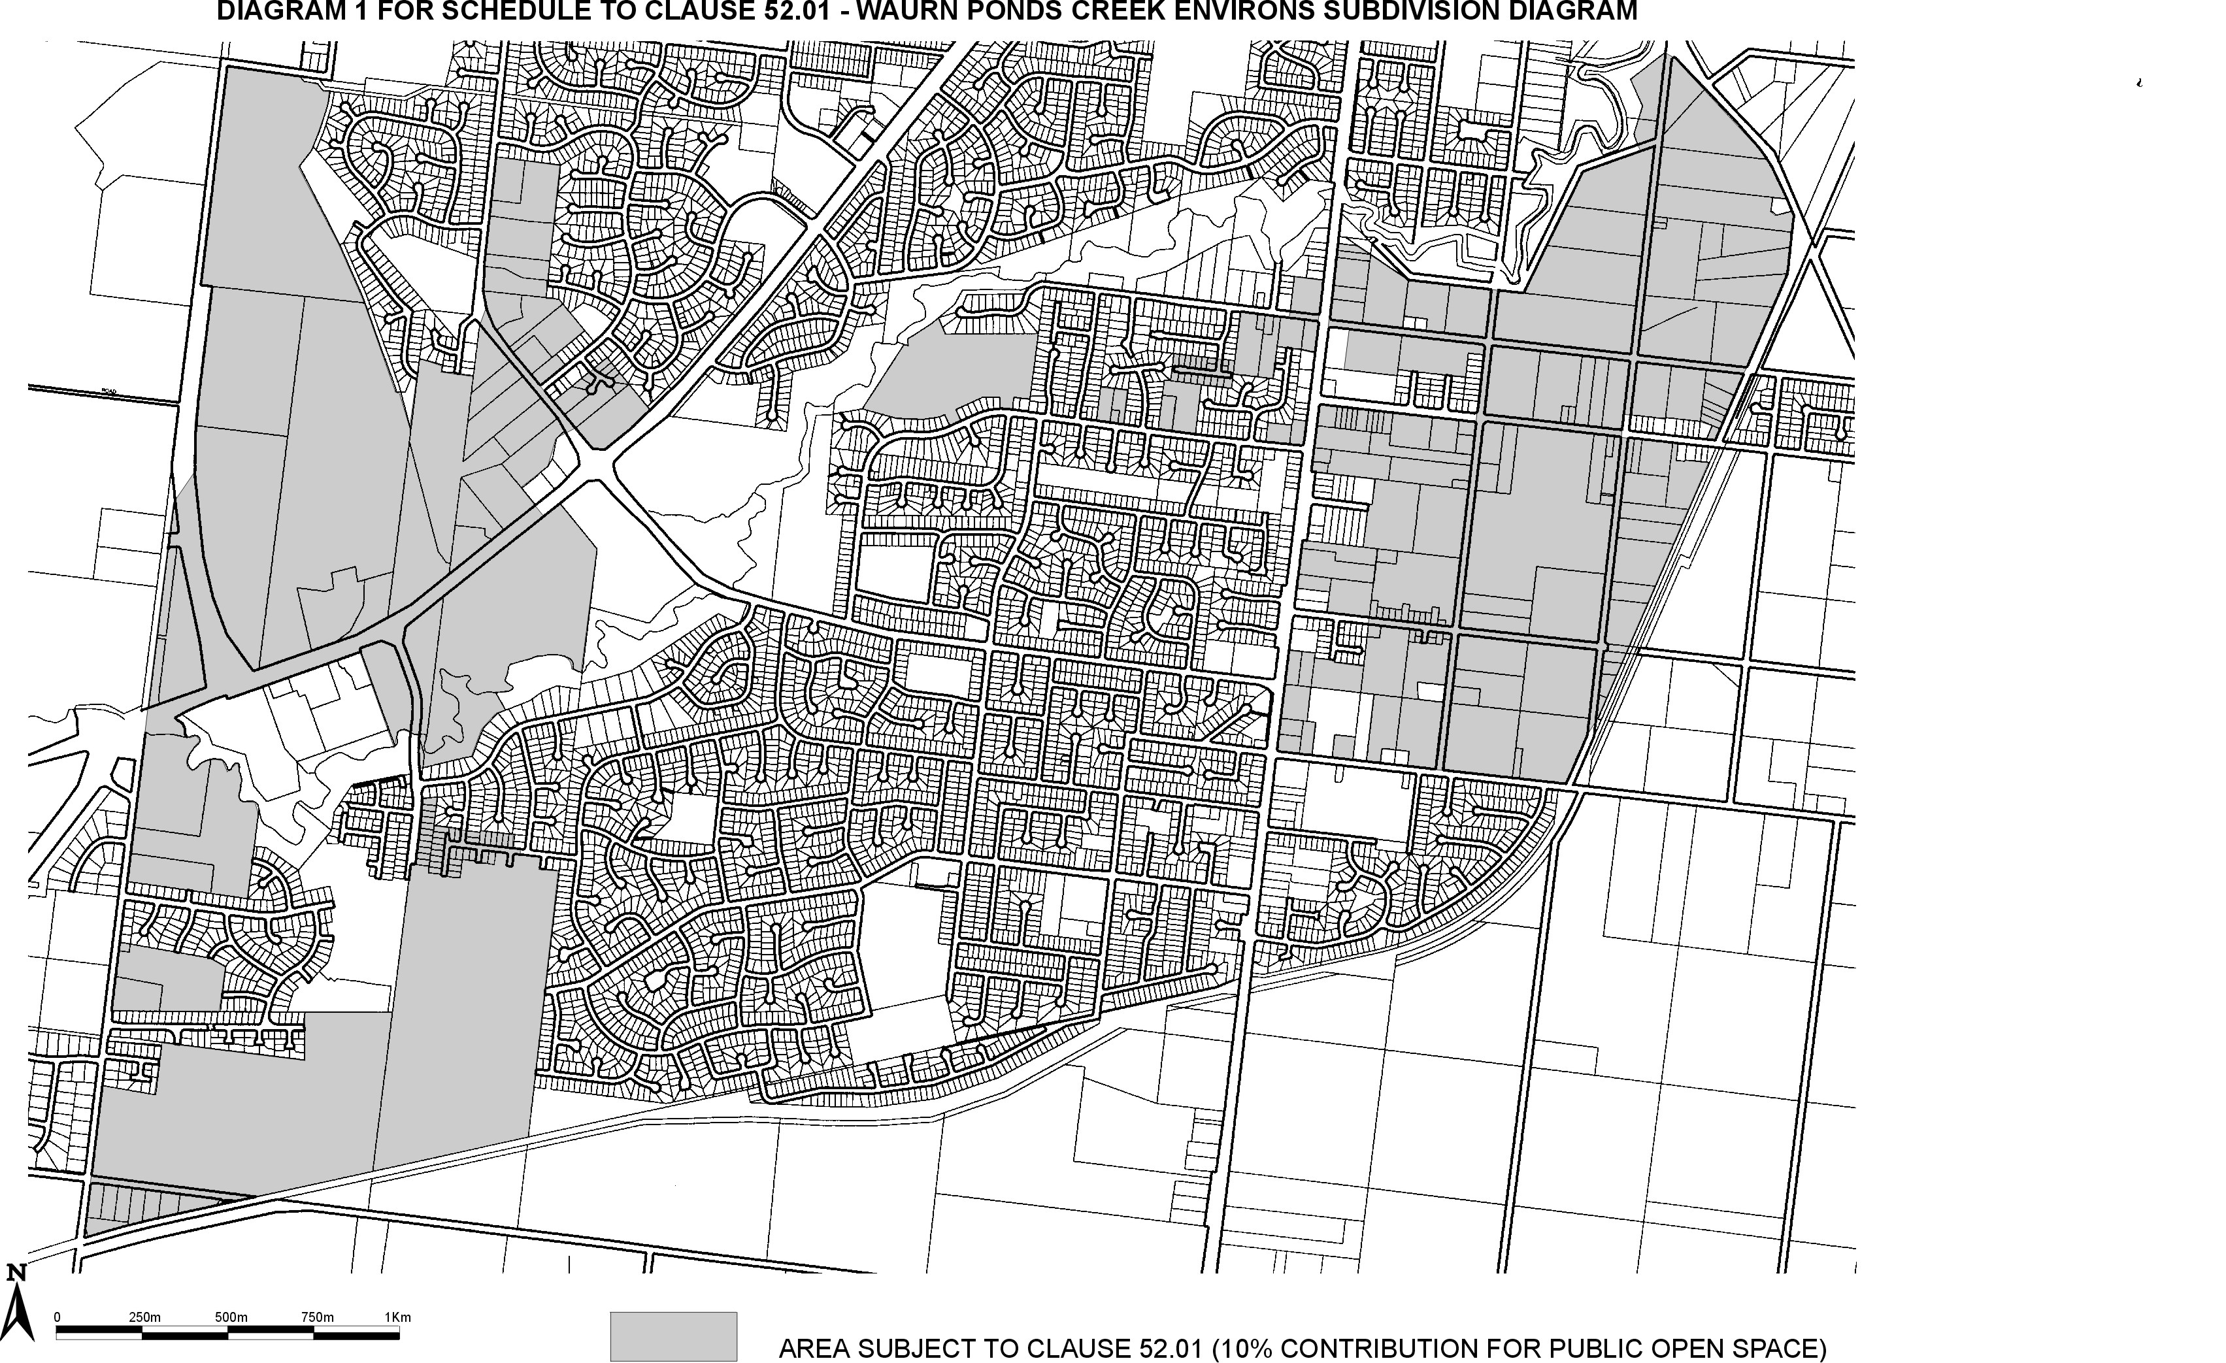
DIAGRAM 2 FOR SCHEDULE TO CLAUSE 52.01 – ARMSTRONG CREEK URBAN GROWTH area DIAGRAM
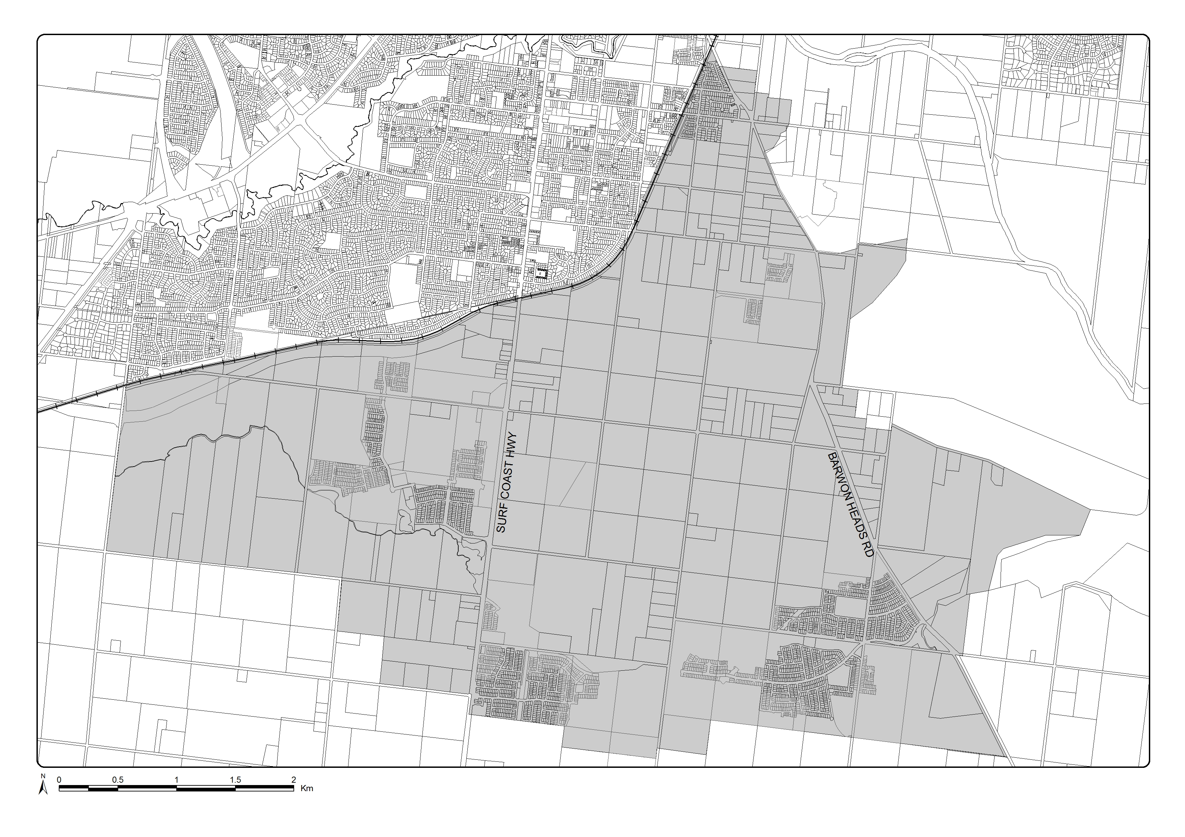
DIAGRAM 3 FOR SCHEDULE TO CLAUSE 52.01 – ARMSTRONG CREEK URBAN GROWTH AREA – North east industrial precinct DIAGRAM
