To: Peter Smith - Coordinator, Strategic Implementation
From: Peter Schembri - Senior Strategic Planner
Subject: St Leonards Growth Area 1 Rezoning
File number: Amendment C317 & Planning Permit Ap 970/2014

Purpose
This report seeks delegated Council support to exhibit a planning scheme amendment to rezone the land at the 321-399 Ibbotson Street, St Leonards, to the General Residential Zone 1 concurrently with a draft subdivision permit.
Summary
- An Amendment request was made by TGM Group on behalf of Costa Property Nine Pty Ltd, the owner of land at 321-399 Ibbotson Street, St Leonards.
- The Amendment proposes to rezone the land from the Farming Zone to the General Residential Zone Schedule 1.
- The land has a total area of 38.72 hectares and sits at the western edge of urban St Leonards. The land is relatively featureless with little native vegetation other than within the creek which traverses the southern part of the site.
- The Amendment is to be exhibited concurrently with a draft multi lot subdivision planning permit (Permit No. Application 970/2014).
- The draft Permit is considered to allow for an appropriately staged and designed residential form that will provide new housing and public open space in St Leonards.
- The Amendment is supported by a Section 173 Agreement to provide developer contributions for the establishment of an Early Learning Community Centre in St Leonards.
- The Amendment is consistent with State and Local Planning Policy and has strong strategic support. The land is identified for rezoning in the 2015 St Leonards Structure Plan and Clause 21.14 of the Greater Geelong Planning Scheme.
- It is recommended that the Amendment be placed on public exhibition subject to authorisation from the Minister for Planning.
Recommendation
That Council, under delegation, resolves to:
- Support the preparation and exhibition of Amendment C317 to the Greater Geelong Planning Scheme to rezone the land at 321-399 Ibbotson Street, St Leonards from the Farming Zone to the General Residential Zone Schedule 1;
- Consider the application for a planning permit for a multi lot subdivision on the land at 321-399 Ibbotson Street, St Leonards, concurrently with the preparation of the Amendment in accordance with Section 96A of the Planning and Environment Act, and that draft Planning Permit 970/2014 be prepared and exhibited with the Amendment, subject to resolution of the detail of the permit conditions;
- Request the Minister for Planning to authorise the preparation and exhibition of Amendment C317 and Planning Permit 970/2014; and
- Exhibit a draft Section 173 Agreement accompanying the Amendment documentation as outlined in this report.
Report
Background
In August 2014 TGM Group on behalf of Costa Property Nine Pty Ltd submitted a combined Planning Scheme Amendment Application in accordance Section 96A of the Planning and Environment Act 1987 for the rezoning and multi-lot staged subdivision (484 lots) of land at 321-399 Ibbotson Street, St Leonards.
It is proposed to rezone the land from the Farming Zone to the General Residential Zone Schedule 1. Residential properties abut to the east and south, the St Leonards Golf Course is located to the north, while rural properties face the western boundary. The proposed new estate has convenient access to the primary road network on the northern Bellarine and is only a short distance to the St Leonards Town Centre and foreshore.
The site is referred to as ‘Growth Area 1’ in the St Leonards Structure Plan, March 2015.
An aerial map of the area is shown at Appendix 1 and a current zoning map is shown at Appendix 2. The proposed rezoning map is shown at Appendix 3.
The application is supported by a number of technical reports addressing town planning, stormwater drainage, transport, native vegetation, cultural heritage, environmental site assessment and infrastructure servicing. Because the rezoning is accompanied by a planning permit for subdivision, additional reports include an assessment against Clause 56 of the Planning Scheme, proposed lot layout and staging plans, feature survey and landscape plans.
The subject land consists of two separate titles and covers a total area of 38.72 hectares. The land is rectangular in shape and can be accessed from Old St Leonards Road, Ibbotson Street and the existing street network to the immediate east. The site is relatively featureless except for a creek at its southern end which contains native vegetation including mature River red-gums.
The stormwater drainage catchment is complex and includes cross-catchment flows to the land south of the creek. Water generally flows to the creek but also disperses over Old St Leonards Road during peak storm events.
A thorough land and site context assessment is provided in the TGM application.
Discussion
Strategic planning merits
The site is recommended for rezoning in the adopted March 2015 St Leonards Structure Plan and falls inside the Town’s settlement boundary. The Structure Plan refers to the site as ‘Growth Area 2’ and along with land north of Murradoc Road (referred to as ‘Growth Area 1’), will provide sufficient residentially zoned land for the Township into the foreseeable future.
The Structure Plan states on page 8: “The rezoning of this land to residential will provide certainty regarding the long term size of St Leonards Township and allow Council and other service providers to plan for any changes to the service and infrastructure needs of the town”. The Structure Plan then identifies a need for an Early Learning Community Facility and that the growth area developers fairly contribute to the construction of this facility.
There is strategic support to rezone the site in the G21 Regional Growth Plan (April 2013). Small coastal towns are expected to continue to experience modest growth and identified planned growth is supported. The plan on page 25 shows the site as ‘identified planned growth’.
In June 2015 the Minister for Planning approved Amendment C312 which made changes to the strategies for St Leonards in Clause 21.14 of the Greater Geelong Planning Scheme. Appendix 4 shows the new Clause 21.14-4 St Leonards Structure Plan map with the subject land identified for rezoning to the General Residential Zone.
Subdivision design
The rezoning is combined with a planning permit application seeking approval for a staged multi lot subdivision for 484 residential lots. The draft permit will include a range of conditions as required by Council as the Responsible Authority and Service Authorities.
A proposed plan of subdivision showing the residential lot and road layout will be placed on exhibition in conjunction with the draft planning permit.
The proponent has worked closely with Council engineers to prepare, design and model a stormwater management system that will improve the offsite drainage network and reduce, or at least make no worse, the risk of flooding to private properties.
Development of the land south of the creek is problematic due to cross-catchment flows and bottlenecks at the Murradoc Road outfall. The proponent is continuing to work with Council to provide a drainage solution for this area as the Amendment progresses to exhibition.
Access will be from Old St Leonards Road, Ibbotson Street and three existing road reserves to Lake View Crescent. The main feature of the estate will be the natural creek line crossing from west to east which will form part of the open space network, together with a municipal park along the creek’s northern edge and a landscape corridor along Ibbotson Street to the golf course. Assessment of native vegetation has identified patches of native vegetation which will be retained within the creek linear reserve.
The TGM planning application responds appropriately to the Decision Guidelines at Clause 65.02 of the Greater Geelong Planning Scheme, stating the following reasons:-
The land is largely surrounded by developed land and therefore it is located within an appropriate urban context to establish residential subdivision.
The subdivision of the land for conventional residential use and development is supported by the Draft St Leonards Structure Plan 2014.
There are no environmental impediments that would prevent residential subdivision Refer to Attachment 11 Site Assessment Report.
The subdivision will introduce a number of important benefits including opportunities to meet the future housing needs of St Leonards, additional open space opportunities and protection and integration with the surrounding neighbourhood character.
The subdivision of this land will improve drainage and reduce downstream flooding and will improve and enhance the natural creek system. The lot sizes and density are considered to accord with the overall density targets for conventional residential development at this location which will provide a variety of lot sizes.
The proposed road layout has been assessed as acceptable by Cardno which provides a number of appropriate vehicle, cycle and pedestrian opportunities to access the subdivision. The proposed subdivision design also demonstrates appropriate linkages within and outside the subdivision to facilitate the orderly planning and development of this land. The proposed road network includes the provision of pedestrian paths and off street parking to each lot.
The land can be fully serviced to facilitate conventional residential development.
A draft planning permit will be exhibited in conjunction with the Amendment.
Section 173 Agreement
As noted earlier in the report, the St Leonards Structure Plan 2015 has identified a need for an Early Learning Community Centre within the Township. The Structure Plan states on page 8:
“To equitably assist with infrastructure funding, the City of Greater Geelong has resolved to implement either Development Contributions Plans (DCP’s) or 173 agreements over the two growth areas. A DCP is a statutory tool used to levy the proponents of new development for fair contributions towards specific, pre-scheduled infrastructure items. A 173 Agreement is an agreement made under section 173 of the planning and Environment Act between Council and a third party.”
Council and the landowner have agreed to prepare an Agreement. The Agreement will legally bind the parties to deliver on the terms of the agreement.
The Agreement also states the key planning requirements to be delivered as part of any subdivision permit. This ensures that the current and potential future owners/developers are aware of the requirements to develop the land and are bound by them.
The draft Agreement will be exhibited with Amendment C317.
Environmental Implications
The subject land contains a stand of River Red gums located within the riparian zone of the Creek. These trees are proposed to be retained and will form part of the landscape attraction of this reserve.
Two smaller stands of native vegetation are located outside the subject land within the Ibbotson Street Road Reserve. The removal of this vegetation will provide for the future upgrading of Ibbotson Street. The vegetation has been surveyed by Mark Trengove Ecological Services in the Attachment 9 Roadside Vegetation Offset Calculations Report. The report determined that the proposed removal to be a ‘low risk pathway’ under current regulations. This approach is supported by Council’s Environment Unit and the Department of Environment regional office.
The proposed management and treatment of stormwater runoff will result in improved downstream water quality and outfall to the bay.
Financial Implications
The Section 173 Agreement will legally bind Council to deliver an Early Learning Community Centre in St Leonards. The developer will contribute $40,000 per hectare towards the facility, totalling approximately $1.2 million.
Policy/Legal/Statutory Implications
The proposed rezoning and permit are consistent with a range of State and Local policies as outlined in the Amendment C317 Explanatory Report.
The site is identified for rezoning to the General Residential Zone in the Municipal Strategic Statement at Clause 21.14 The Bellarine Peninsula.
Alignment to City Plan
The Amendment supports the ‘Growing our Economy’ strategic direction of City Plan, by providing additional residentially zoned land in a constrained housing market.
Officer Direct or Indirect Interest
No officers involved in this report have any direct or indirect interest In accordance with Sec 80 (c) of the Local Government Act.
Risk Assessment
Processing of this Amendment is considered to be a low level risk for Council.
Social Considerations
The Amendment will generate positive social impacts by levying developers for contributions to deliver an Early Years Learning Centre in St Leonards.
Human Rights Charter
The Amendment will not impact on any basic rights, freedoms and responsibilities as set out in the Charter. Planning legislation ensures an open community consultation process occurs, enabling people to freely express their views and if necessary obtain a fair hearing before an Independent Panel.
Communication
Nearby landowners/occupiers will be formally notified during the exhibition period, as well as notices published in the local newspapers and on the Geelong Australia website.
Appendix 1 - Aerial Map

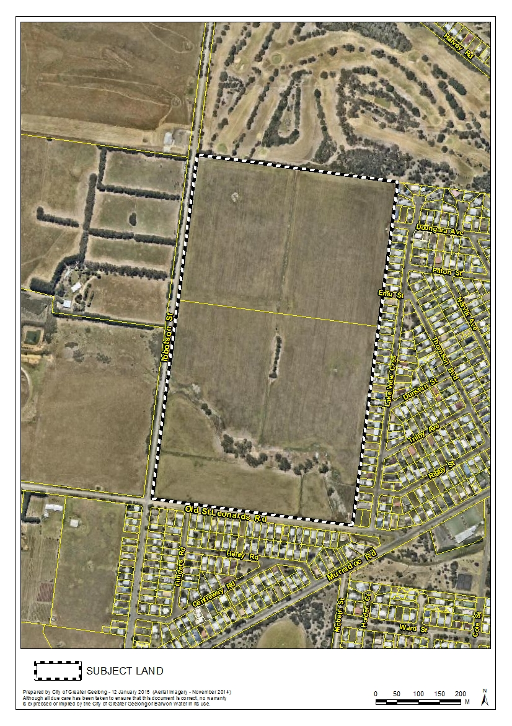

Appendix 2 - Existing Zoning Map

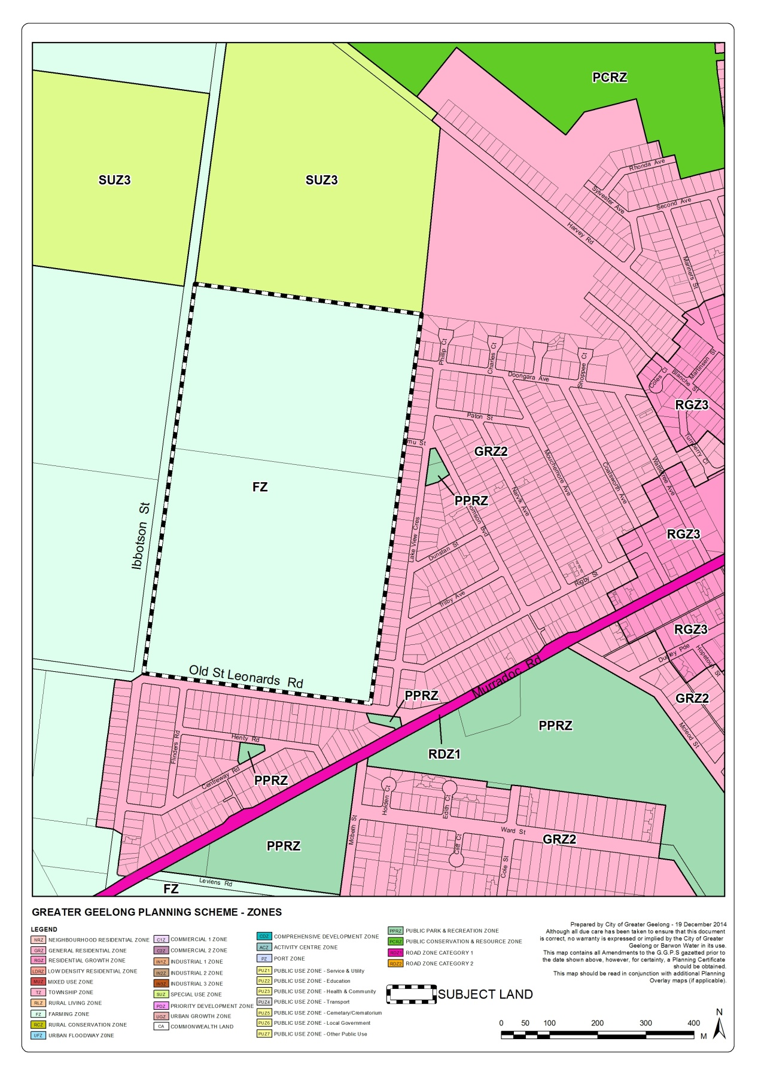

Appendix 3 - Proposed Rezoning Map

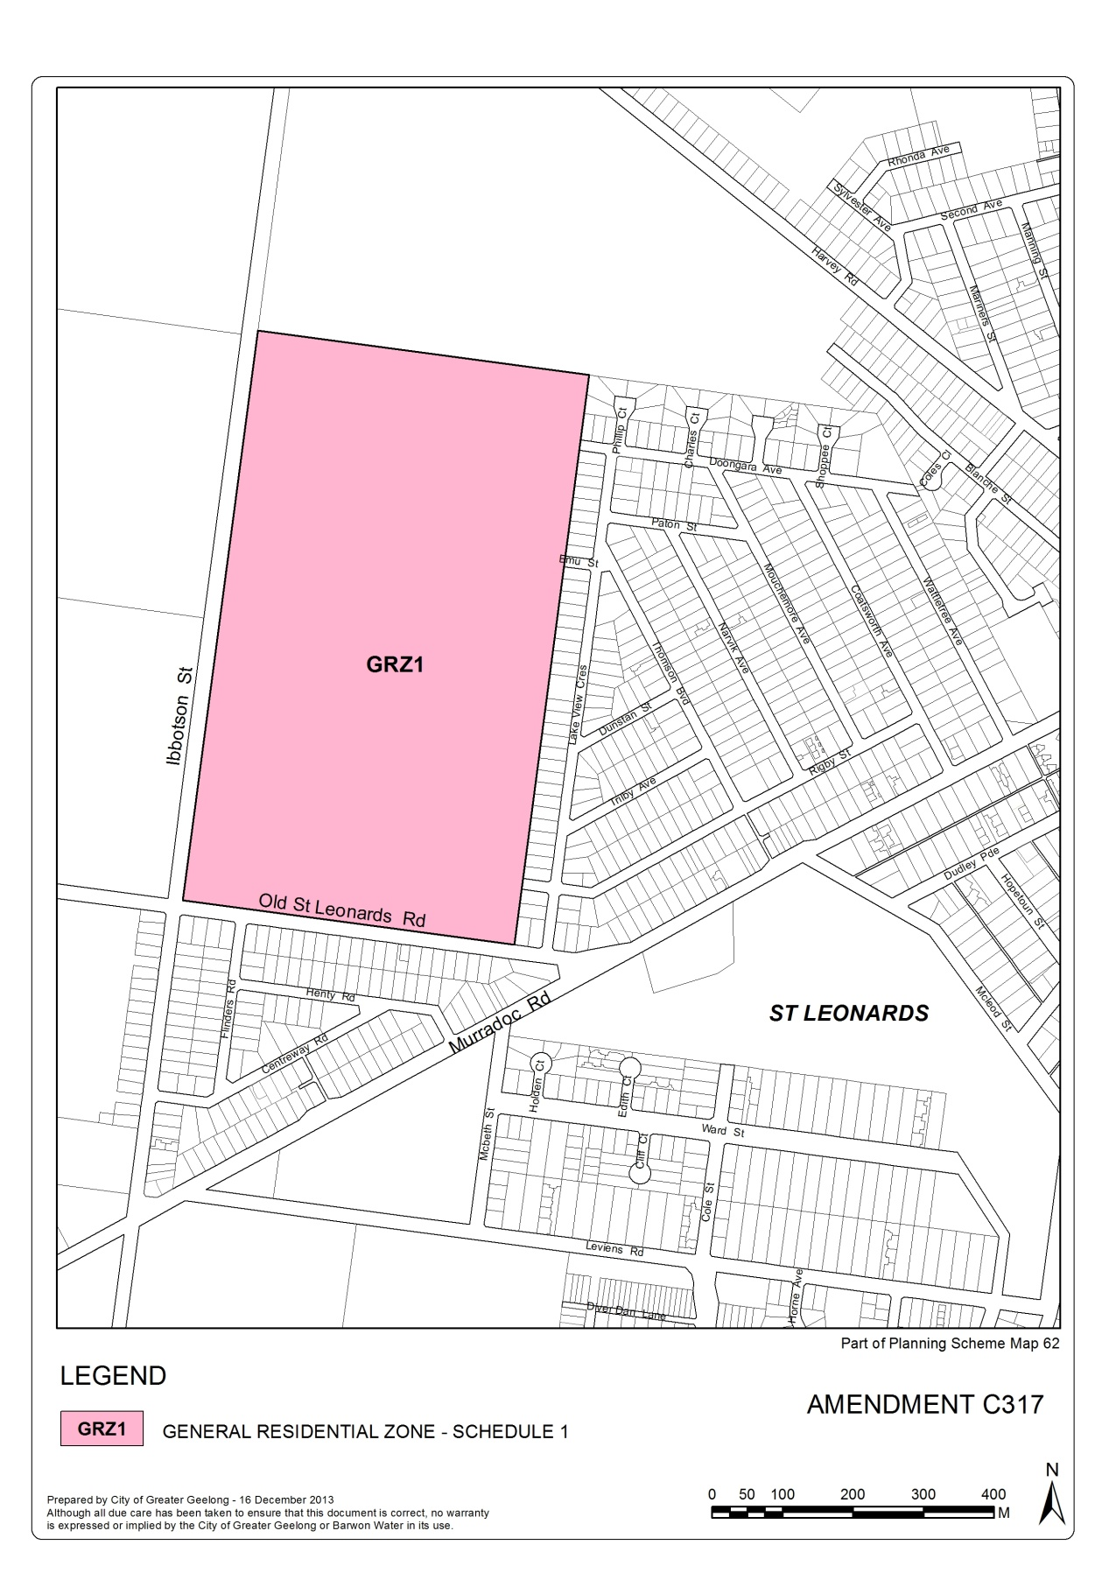

Appendix 4 - Clause 21.14-4 St Leonards Structure Plan Map

