To: Peter Smith - Coordinator, Strategic Implementation
From: Peter Schembri - Senior Strategic Planner
Subject: St Leonards Growth Area 2 Rezoning
File number: Amendment C325

Purpose
This report seeks delegated Council support to exhibit a planning scheme amendment to rezone land in St Leonards for residential use.
Summary
- An Amendment request has been made by St Quentin Consulting on behalf of St Leonards Property Holdings P/L, R & B Robinson and ABC Project Management P/L, landowners of Growth Area 2 as identified in the St Leonards Structure Plan 2015.
- The Amendment proposes to rezone the land from the Farming Zone to the General Residential Zone Schedule 1.
- The land is made up of 7 titles each in separate ownership, has a total area of 70 hectares and sits at the south-western edge of the St Leonards Township. Three of the properties are developed with dwellings.
- The Amendment is accompanied by a Design and Development Overlay (DDO) Schedule to identify specific subdivision requirements relating to the design of the new development.
- The draft DDO Schedule addresses a range of site constraints and planning matters, and is considered to allow for an orderly and integrated residential form that will provide new housing and public open space in St Leonards.
- The DDO requires that permits for subdivision accord with the St Leonards Growth Area 2 Shared Infrastructure Funding Plan (SIFP), which has been jointly prepared by Council and developers to formalise equitable developer contributions for new parks and trails, drainage basins and road upgrades.
- The Amendment is supported by Section 173 Agreements to give effect to the SIFP and to provide developer contributions for the establishment of an Early Learning Community Centre in St Leonards.
- The Amendment is consistent with State and Local Planning Policy and has strong strategic support. The site is identified for rezoning in Clause 21.14 of the Greater Geelong Planning Scheme.
- It is recommended that the Amendment be placed on public exhibition subject to authorisation from the Minister for Planning.
Recommendation
That Council, under delegation, resolves to:
- Support the preparation and exhibition of Amendment C325 to the Greater Geelong Planning Scheme to rezone the land at:
2-20 Leviens Road;
22-40 Leviens Road;
152-200 Bluff Road;
481-505 Ibbotson Street;
511-529 Ibbotson Street;
531-539 Ibbotson Street; and
541-569 Ibbotson Street;
all in St Leonards, from the Farming Zone to the General Residential Zone Schedule 1;
- Apply a Design and Development Overlay to the land being rezoned and to 42 Pearl Bay Passage, St Leonards;
- Request the Minister for Planning to authorise the preparation of Amendment C325; and
- Exhibit a draft Section 173 Agreement accompanying the Amendment documentation as outlined in this report.

Report
Background
In November 2014 St Quentin Consulting on behalf of St Leonards Property Holdings P/L, R & B Robinson and ABC Project Management P/L, lodged a request to amend the Greater Geelong Planning Scheme.
The request incorporates all the land bounded by Ibbotson Street, Murradoc Road, Leviens Road, Bluff Road and established residential properties on the eastern boundary.
It is proposed to rezone the land from the Farming Zone to the General Residential Zone Schedule 1. Residential properties abut to the east and south, the Charles McCarthy reserve is located to the north, while rural properties face the western boundary. The proposed new estate has convenient access to the primary road network on the northern Bellarine and is only a short distance to the St Leonards Town Centre and foreshore. Approximately 975 residential lots are expected to be created over the life of the development.
An aerial map of the area is shown at Appendix 1 and a current zoning map is shown at Appendix 2. The proposed rezoning and overlay maps are shown at Appendices 3 and 4 respectively.
The application is supported by a number of technical reports addressing town planning, stormwater drainage, traffic and movement, vegetation, cultural heritage and infrastructure servicing.
The subject land consists of seven separate titles and covers a total area of 70 hectares. The land is rectangular in shape and can be accessed from Leviens Road, Bluff Road and Ibbotson Street. Dwellings are developed on three of the properties and scattered native trees are located in the southern portion of the site. The Ibbotson Street road reserve is signposted for its conservation values.
As part of the preliminary planning process, Council officers initiated and facilitated an Enquiry by Design workshop in October 2014 with a range of stakeholders, where site constraints and opportunities were addressed.
Discussion
Strategic planning merits
The site is recommended for rezoning in the adopted March 2015 St Leonards Structure Plan and falls inside the Town’s settlement boundary. The Structure Plan refers to the site as ‘Growth Area 2’ and along with land north of Murradoc Road (referred to as ‘Growth Area 1’), will provide sufficient residentially zoned land for the Township into the foreseeable future.
The Structure Plan states on page 8: “The rezoning of this land to residential will provide certainty regarding the long term size of St Leonards Township and allow Council and other service providers to plan for any changes to the service and infrastructure needs of the town”. The Structure Plan then identifies a need for an Early Learning Community Facility and that the growth area developers fairly contribute to the construction of this facility.
There is strategic support to rezone the site in the G21 Regional Growth Plan (April 2013). Small coastal towns are expected to continue to experience modest growth and identified planned growth is supported. The plan on page 25 shows the site as ‘identified planned growth’.
The Minister for Planning has approved Amendment C312 which makes changes to the strategies for St Leonards in Clause 21.14 of the Greater Geelong Planning Scheme. The Amendment was gazetted on 25 June 2015 and now forms part of the Scheme. Appendix 5 shows the new Clause 21.14-4 St Leonards Structure Plan map with the subject land identified for rezoning to the General Residential Zone.
Subdivision design
The rezoning is accompanied by a Design and Development Overlay Schedule (DDO). The purpose of the DDO is to identify areas which are affected by specific requirements relating to the design and built form of new development.
The DDO Schedule has been informed by the outcomes of the Enquiry by Design workshop and technical reports prepared to support the Amendment. The DDO includes an Outline Development Plan as shown in Appendix 6.
The site falls into four rainwater catchments, generally draining north and south. The Afflux Consulting 2014 Stormwater Management Plan proposes retardation basins abutting the north and south boundaries. The report does not address outfall requirements external to the site which will need to be specifically addressed prior to subdivision.
The internal road network will feature a central north-south connector road and intersection works will be required to Murradoc Road and Leviens Road. Road connections are proposed to Pearl Bay Passage while Ibbotson Street, between Murradoc Road and Bluff Road, will not allow direct residential lot or new road access. It is proposed that this section of Ibbotson Street will become a ‘greenway’ catering for pedestrians and cyclists, and eventually discontinued.
Two 1 hectare parks will be provided and a continuous pedestrian/cycle corridor will loop around the site including the greenway. The DDO will include strategies to avoid and minimise removal of remnant roadside vegetation and scattered trees on the site
The DDO also requires that permits for subdivision implement the requirements of the St Leonards Growth Area 2 Shared Infrastructure Funding Plan. This plan has been prepared in partnership between Council and developers. The purpose of the Infrastructure Funding Plan is to guide the timely delivery of community and civil infrastructure.
Section 173 Agreement
As noted earlier in the report, the St Leonards Structure Plan 2015 has identified a need for an Early Learning Community Centre within the Township. The Structure Plan states on page 8:
“To equitably assist with infrastructure funding, the City of Greater Geelong has resolved to implement either Development Contributions Plans (DCP’s) or 173 agreements over the two growth areas. A DCP is a statutory tool used to levy the proponents of new development for fair contributions towards specific, pre-scheduled infrastructure items. A 173 Agreement is an agreement made under section 173 of the Planning and Environment Act between Council and a third party.”
Council and the landowners have agreed to prepare an Agreement which will give statutory effect to contributions towards the Community Centre as stated in the Agreement.
The Agreement also references the St Leonards Growth Area 2 Shared Infrastructure Funding Plan. The Infrastructure Funding Plan identifies shared infrastructure to support the development, apportions costs and provides clear principles regarding obligations of developers to deliver and/or facilitate works.
The draft Agreement and St Leonards Growth Area 2 Shared Infrastructure Funding Plan will be exhibited with Amendment C325.
Environmental Implications
The Ibbotson Street road reserve contains important conservation values which will be protected as the road reserve is proposed to be discontinued and used as a pedestrian and cycle corridor. Native vegetation within the Leviens and Bluff Road reserves will require management plans to limit loss and disturbance.
Scattered patches of native vegetation and River Red Gum and Drooping Sheoak mature trees are located in the southern portion of the site, which will require further arbourcultural assessment to inform possible retention.
The stormwater management plan prepared by Afflux Consulting identifies the locations for retarding basins and management requirements. This report will form the basis for more detailed assessments at the subdivision permit application stages. Developers will need to resolve water quality and volume outflow concerns to the Swan Bay catchment as part of the approvals process.
Financial Implications
The Section 173 Agreement will legally bind Council to deliver an Early Learning Community Centre in St Leonards. Developers will contribute $40,000 per hectare towards the facility, totalling approximately $2.5 million.
Policy/Legal/Statutory Implications
The proposed Amendment is consistent with a range of State and Local policies as outlined in the Amendment C325 Explanatory Report.
The site is identified for rezoning in the Municipal Strategic Statement at Clause 21.14 The Bellarine Peninsula of the Greater Geelong Planning Scheme. This clause states that the General Residential Zone Schedule 1 should be applied together with a Development Plan Overlay (DPO).
It is considered that a Design and Development Overlay (instead of a DPO) will better facilitate the orderly and integrated residential development of the site by streamlining the planning approvals process and clearly outlining design objectives for subdivision.
Alignment to City Plan
The Amendment supports the ‘Growing our Economy’ strategic direction of City Plan, by providing additional residentially zoned land in an area identified for growth.
Officer Direct or Indirect Interest
No officers involved in this report have any direct or indirect interest In accordance with Sec 80(c) of the Local Government Act.
Risk Assessment
Processing of this Amendment is considered to be a low level risk for Council.
Social Considerations
The Amendment will generate positive social impacts by levying developers for contributions to deliver an Early Learning Community Centre in St Leonards and other community infrastructure; and providing new housing in an orderly planning manner.
Human Rights Charter
The Amendment will not impact on any basic rights, freedoms and responsibilities as set out in the Charter. Planning legislation ensures an open community consultation process occurs, enabling people to freely express their views and if necessary obtain a fair hearing before an Independent Panel.
Communication
All the landowners whose land is to be rezoned as part of the Amendment have been consulted in the preparation of the Amendment.
Nearby landowners/occupiers and other interested parties will be formally notified during the statutory exhibition period, as well as notices published in local newspapers and on the Geelong Australia website.
Appendix 1 - Aerial Map

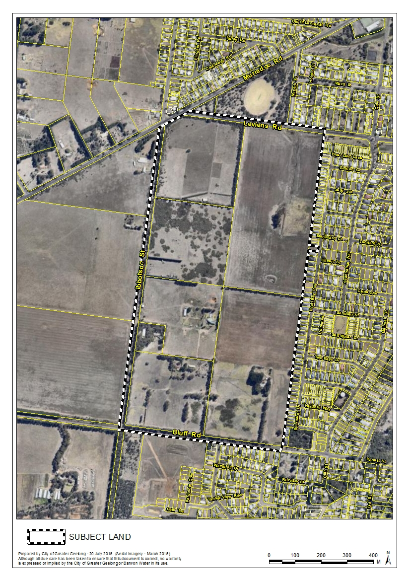

Appendix 2 - Existing Zoning Map

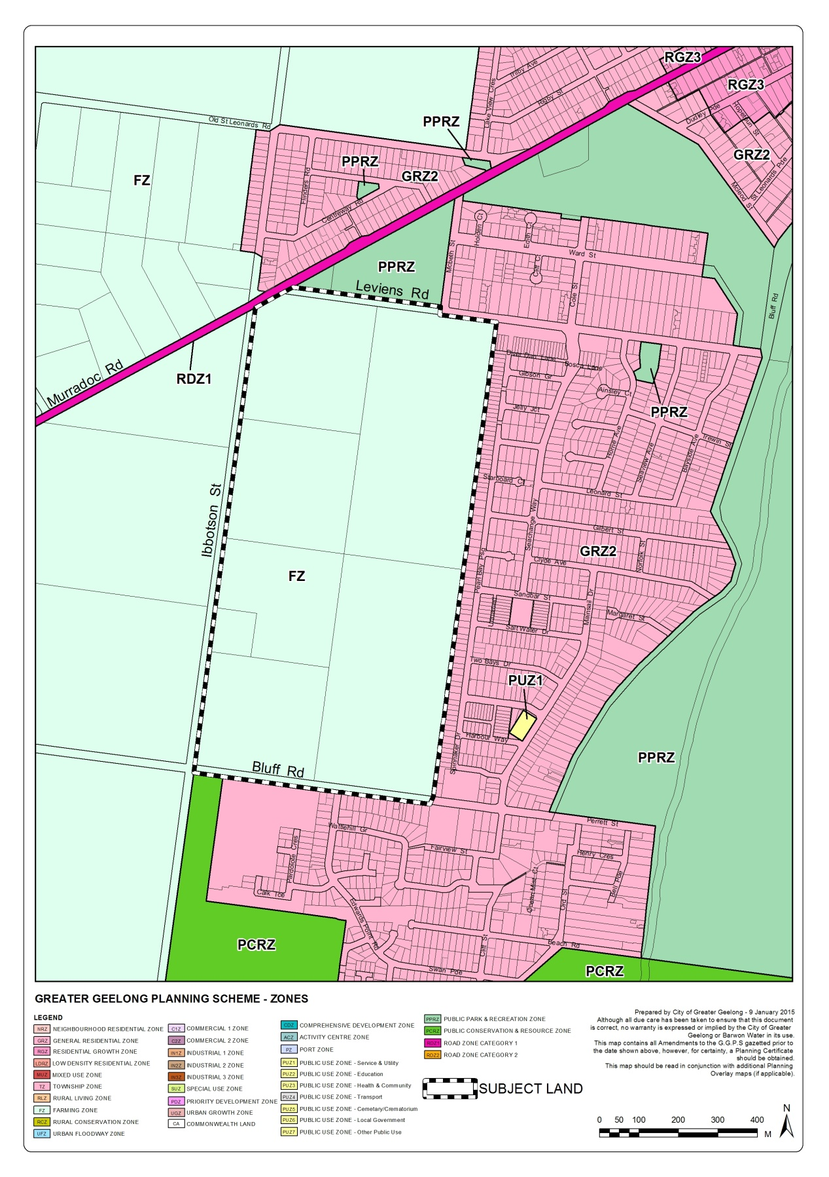

Appendix 3 - Proposed Rezoning Map

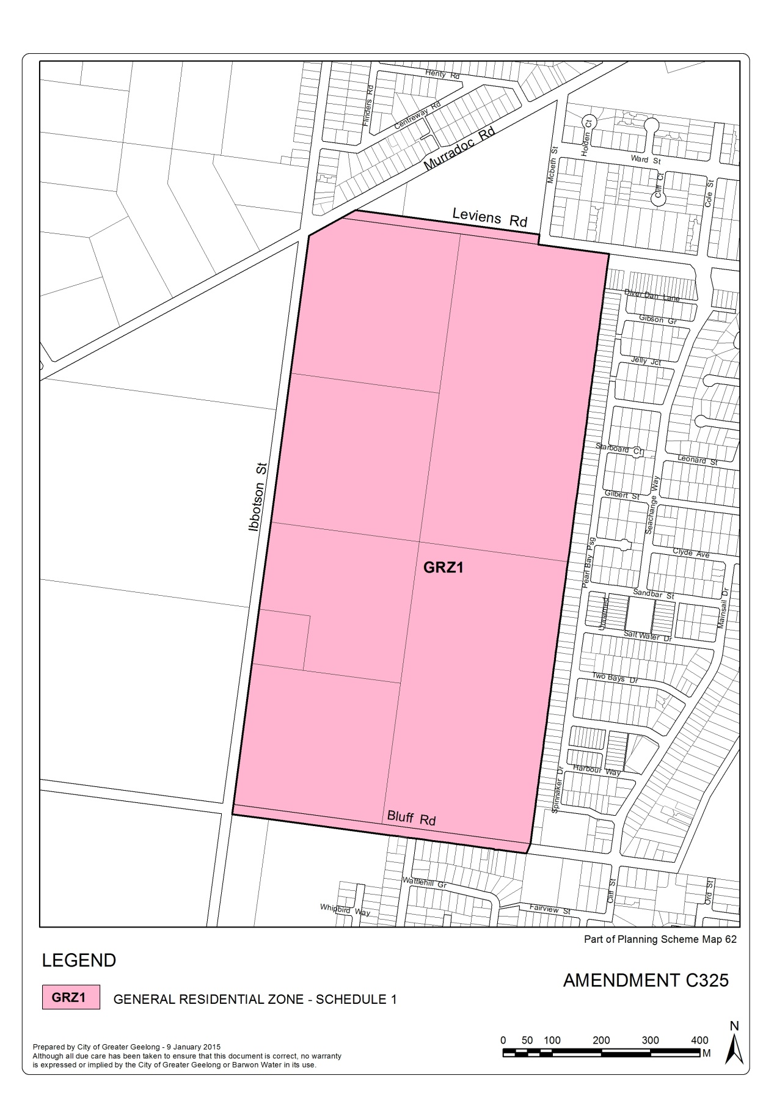

Appendix 4 - Proposed Design and Development Overlay
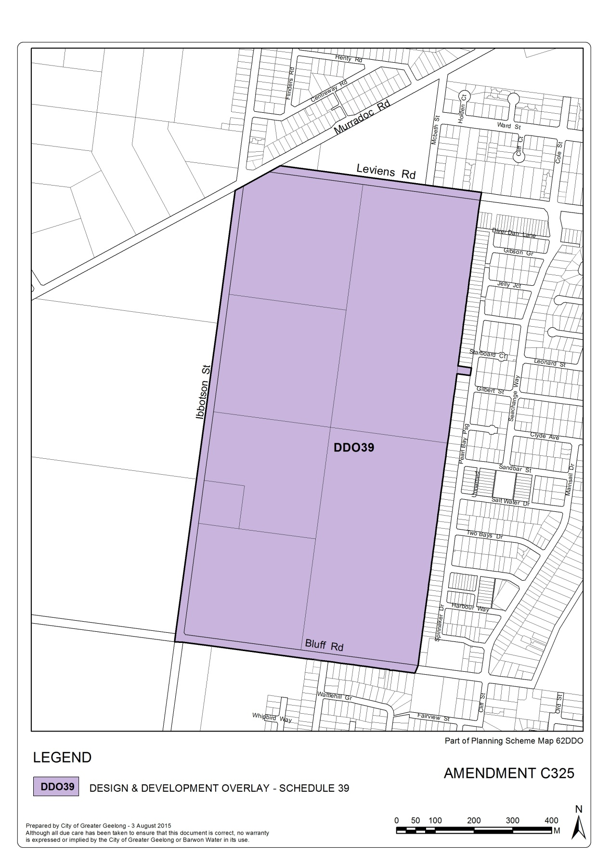

Appendix 5 - Clause 21.14-4 St Leonards Structure Plan Map

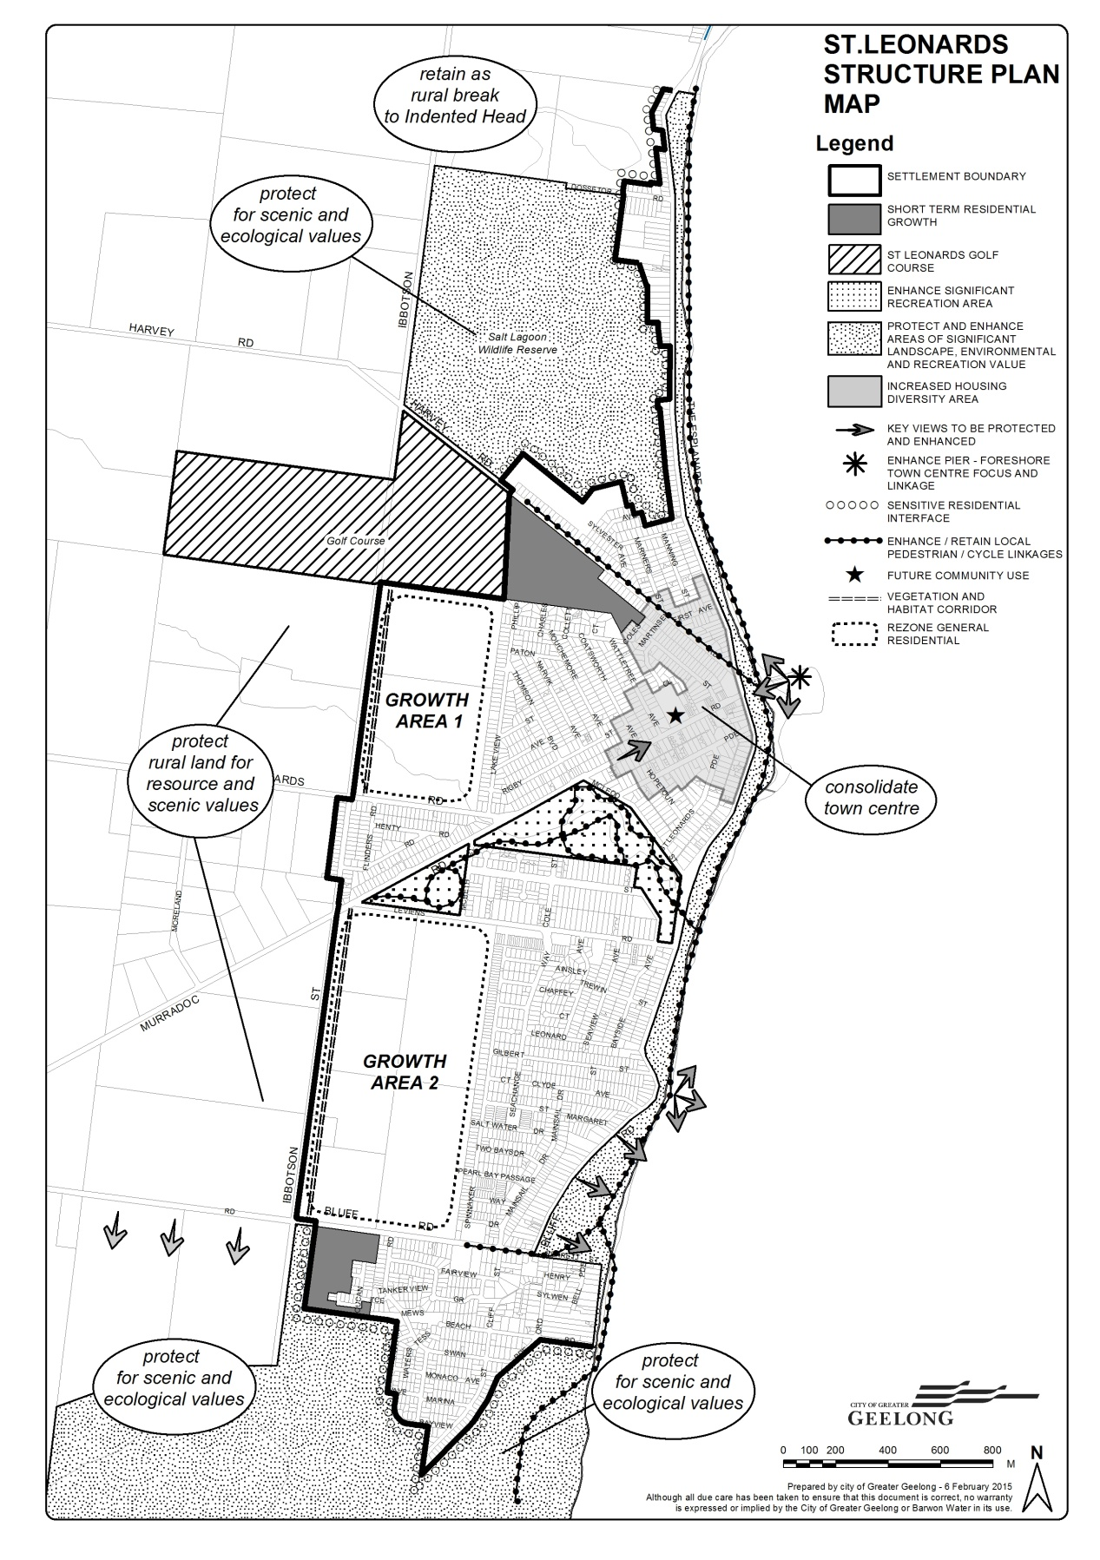

Appendix 6 - Proposed Outline Development Plan

