GREATER GEELONG PLANNING SCHEME
INCORPORATED DOCUMENT
This document is an incorporated document in the Planning Scheme pursuant to Section 6(2)(j) of the Planning and Environment Act 1987.
BUPA Aged Care Facility,
Bellarine Lakes
September 2015

GREATER GEELONG PLANNING SCHEME
INCORPORATED DOCUMENT Page 2 of 12
INTRODUCTION:
This document is an incorporated document in the Schedule to Clause 52.03 and the Schedule to Clause 81.01 of the Greater Geelong Planning Scheme (the Scheme).
Despite any provision to the contrary in the Scheme, pursuant to Clause 52.03 of the Scheme the land identified in this incorporated document may be developed in accordance with the specific controls contained in this document.
ADDRESS OF THE LAND/PROJECT:
This Incorporated Document applies to land shown on the incorporated plan titled “BUPA Care Service, Bellarine Lakes 402-404 Bellarine Highway, Moolap, Victoria: Location Plan”, which forms part of this Incorporated Document (referred to hereafter as ‘the land’).
PURPOSE:
The purposes of the Incorporated Document are:
• To facilitate the subdivision of land in the Farming Zone that would otherwise be prohibited.
• To facilitate the subdivision of land in the Floodway Overlay that would be otherwise prohibited.
• To allow a residential aged care facility to have a separate title to a retirement village that is in separate ownership and that was always anticipated to operate as a separate entity.
• To help to ensure the economic viability and effective operation of an aged care facility that will provide much needed housing for the elderly along with employment opportunities.
THIS DOCUMENT ALLOWS:
This Incorporated Document allows for the development of the land for the purposes of:
- a two lot subdivision
.

GREATER GEELONG PLANNING SCHEME
INCORPORATED DOCUMENT Page 3 of 12
THE FOLLOWING CONDITIONS APPLY TO THIS DOCUMENT:
Layout Not Altered
- The subdivision as shown on the plan that forms part of this incorporated document must not be altered without the prior written consent of the Responsible Authority.

Reticulated Services
- Reticulated water, sewerage and electricity must be available to each lot shown on the plan that forms part of this incorporated document before any lot can be used.

Lot Drainage
- Each lot shown on the plan that forms part of this incorporated document must be drained to the satisfaction of the Responsible Authority.

Clause 66.01-1 Two Lot Subdivision
- The owner of the land must enter into agreements with the relevant authorities for the provision of water supply, drainage, sewerage facilities, electricity, gas and telecommunication services to each lot shown on plan that forms part of this incorporated document in accordance with that authority’s requirements and relevant legislation at the time.

- All existing and proposed easements and sites for existing or required utility services and roads on the land must be set aside in the plan of subdivision submitted for certification in favour of the relevant authority for which the easement or site is to be created.

- The plan of subdivision submitted for certification under the Subdivision Act 1988 must be referred to the relevant authority in accordance with Section 8 of that Act.

S173 Subdivision prior to completion of development
- Prior to the issue of a Statement of Compliance for this subdivision, the owner of the land to which this incorporated document relates must enter into an agreement with the Responsible Authority under Section 173 of the Planning and Environment Act 1987. In addition to the usual provisions, the agreement must provide for the following matters:
- Except with the consent of the Responsible Authority, the land and any lot created by the subdivision of the land may only be developed in accordance with the Residential Aged Care Facility authorised in Planning Permit No. 10/2006 and depicted in the endorsed plans that form part of Planning Permit No. 10/2006;
- The development shall not be occupied or used until all works, including landscaping and drainage have been completed;
- The costs of the Responsible Authority in relation to the agreement are to be borne by the owner.

GREATER GEELONG PLANNING SCHEME
INCORPORATED DOCUMENT Page 4 of 12

Time for Starting and Completion
- The specific controls contained in this document will expire if any of the following circumstances applies:
- The plan of subdivision is not certified within 2 years of the date of approval of the amendment.
- The subdivision is not completed within five years of the date of certification of the plan.
The responsible authority may extend the periods referred to if a request is made in writing before these controls expire or within six months afterwards.

GREATER GEELONG PLANNING SCHEME
INCORPORATED DOCUMENT Page 5 of 12

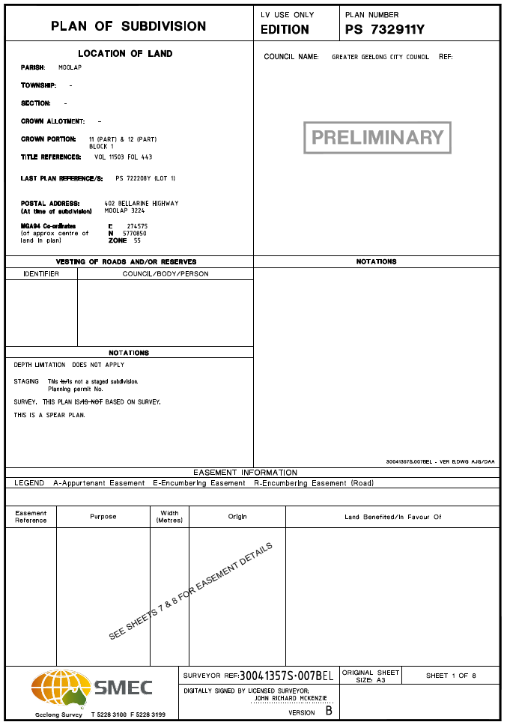

GREATER GEELONG PLANNING SCHEME
INCORPORATED DOCUMENT Page 6 of 12
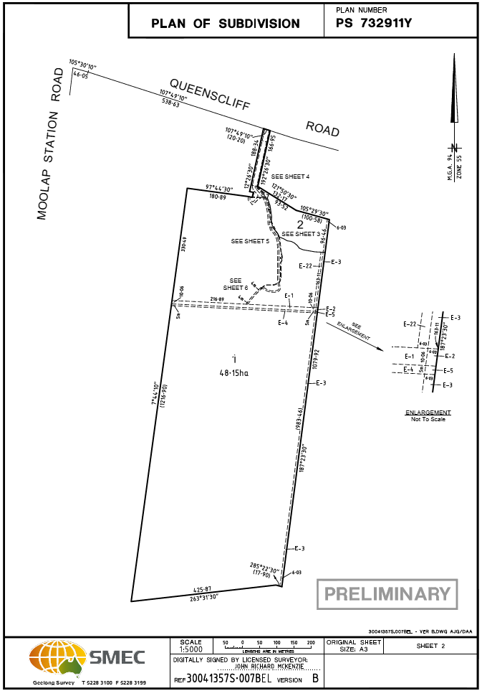

GREATER GEELONG PLANNING SCHEME

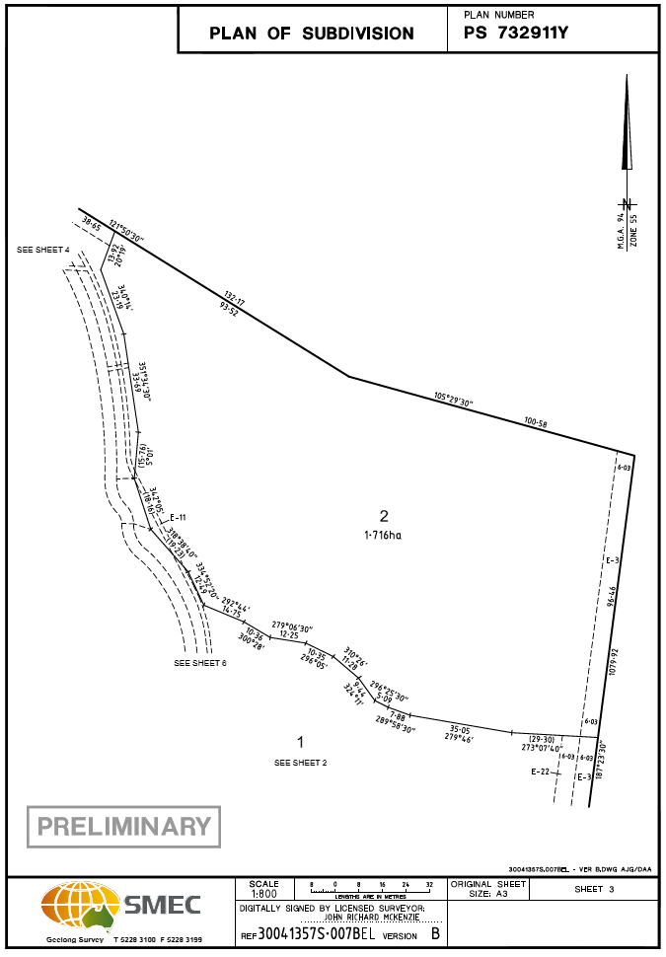
GREATER GEELONG PLANNING SCHEME

INCORPORATED DOCUMENT Page 7 of 12

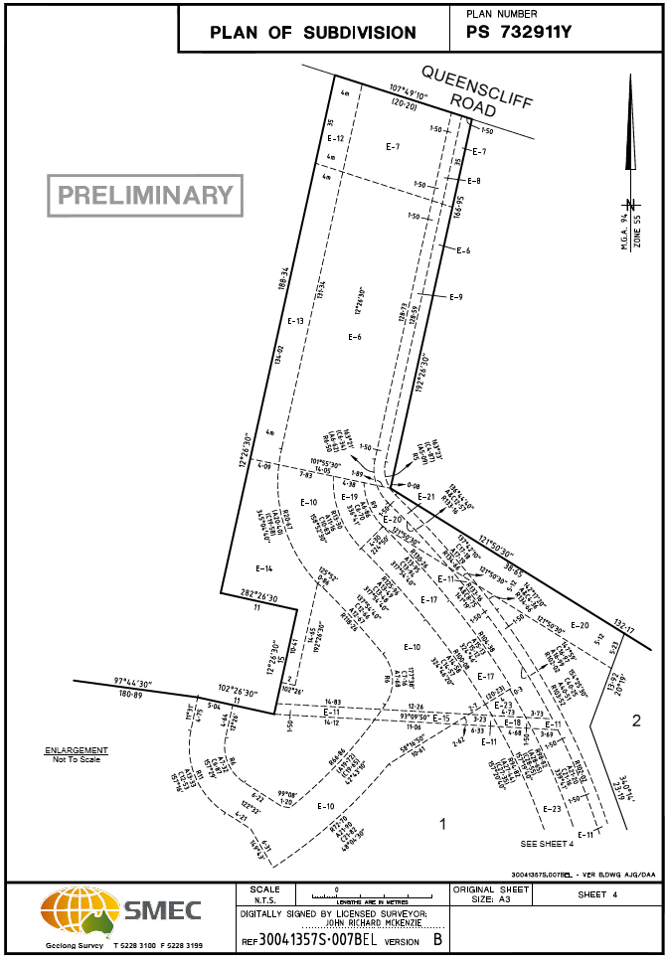
GREATER GEELONG PLANNING SCHEME

INCORPORATED DOCUMENT Page 8 of 12
DOCUMENT Page 5 of 5

GREATER GEELONG PLANNING SCHEME
INCORPORATED DOCUMENT Page 9 of 12
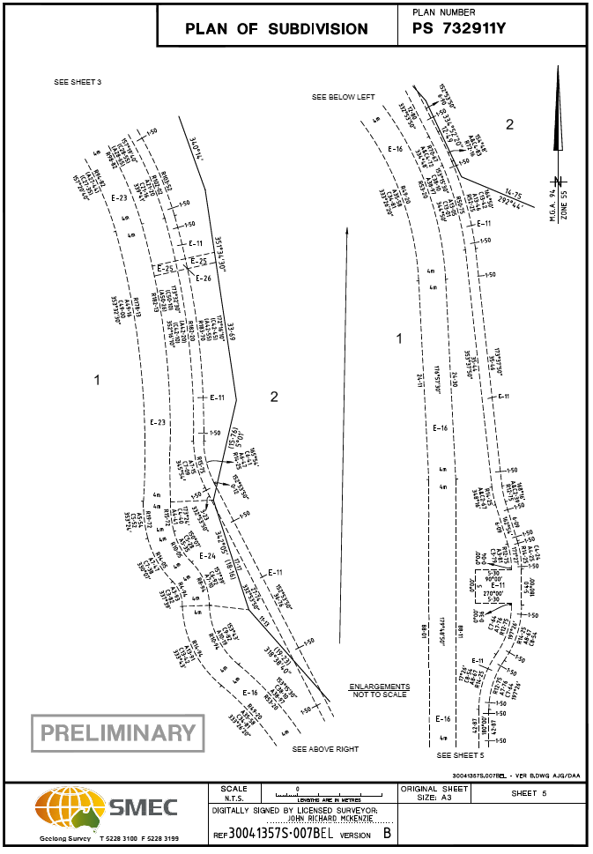

GREATER GEELONG PLANNING SCHEME
INCORPORATED DOCUMENT Page 10 of 12
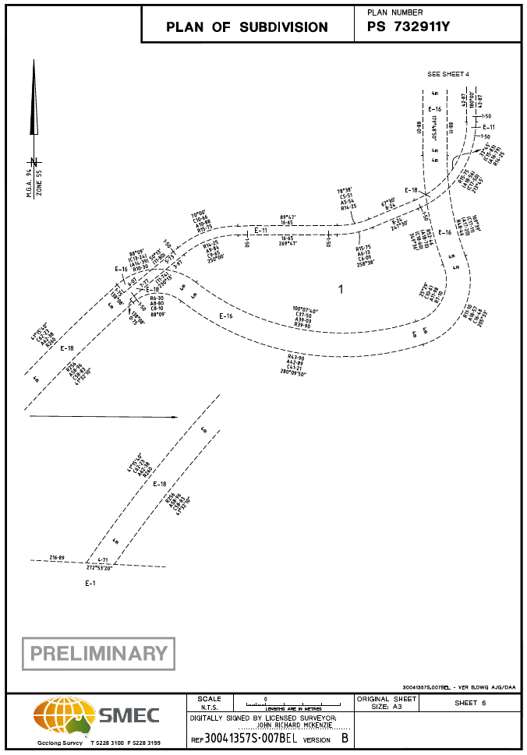

GREATER GEELONG PLANNING SCHEME
INCORPORATED DOCUMENT Page 11 of 12

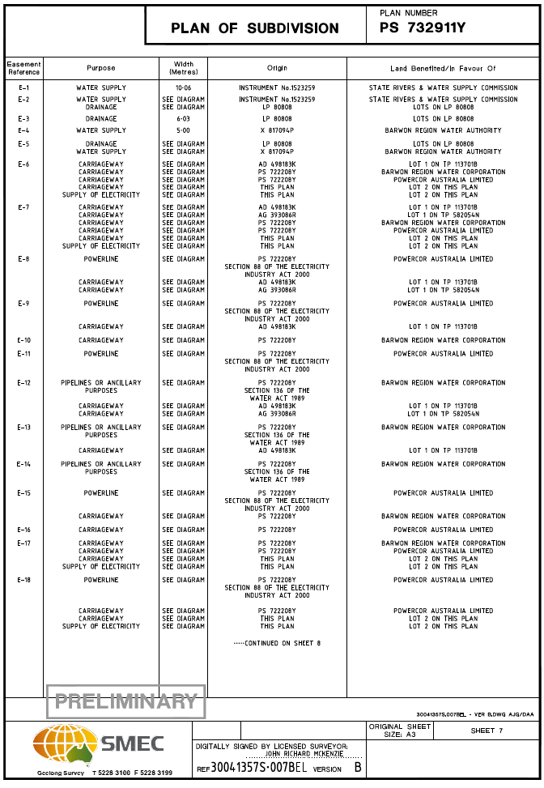

Page 5 of 5

GREATER GEELONG PLANNING SCHEME
INCORPORATED DOCUMENT Page 12 of 12

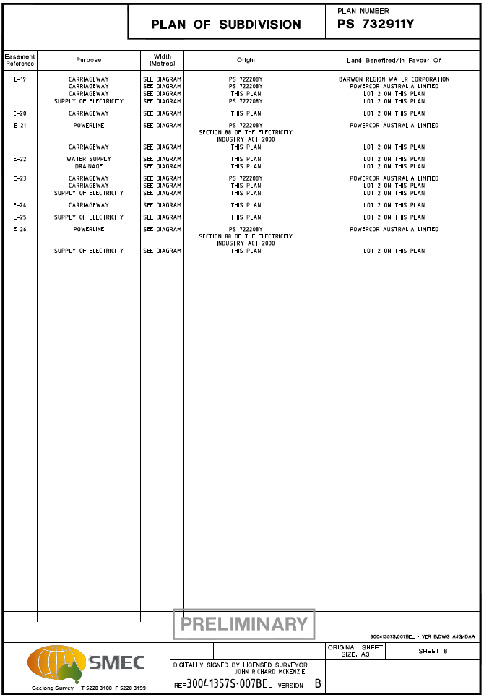

END OF DOCUMENT

