SCHEDULE 40 TO THE DESIGN AND DEVELOPMENT OVERLAY
--/--/----
Proposed C346

Shown on the planning scheme map as DDO40.
OCEAN GROVE TOWN CENTRE
Precinct 1 – The Terrace
Precinct 2 – The Avenue
Precinct 3 – Hodgson Street
Refer to Map 1 for precinct boundaries
1.0 Design objectives
--/--/----
Proposed C346

- To implement the objectives of the Ocean Grove Town Centre Urban Design Framework (2014).
- To strengthen the role of the Ocean Grove Town Centre as the commercial and civic heart of Ocean Grove.
- To promote contemporary design and built form that demonstrates design excellence, contributes to the relaxed coastal atmosphere and has strong connections with the beach and surf culture.
- To promote the redevelopment of underutilised land and identified Council owned sites in the Town Centre.
- To improve pedestrian and cyclist safety and amenity in the Town Centre.
- To reduce the dominance of car parking and access ways through site layout and landscaping.
- To ensure that the supply of car parking increases commensurate with parking demands from new development.
- To ensure development does not prejudice the use of The Terrace (east of Hodgson Street) as the long term arterial road route.
2.0 Buildings and works
--/--/----
Proposed C346

Permit Requirements
A permit is required to construct a building or construct or carry out works.
This does not apply to:
- The installation of an automatic teller machine.
- An alteration to an existing building façade provided:
            - The alteration does not include the installation of an external roller shutter.
            - At least 80 per cent of the building façade at ground floor level is maintained as an entry or window with clear glazing.
- An awning that projects over a road if it is authorised by the relevant public land manager.
A permit is required to construct a fence which abuts a road or public area, including a car park.
Design Guidelines
Design and built form
Development, where relevant should:
- Ensure the height of buildings is consistent with Map 2 of this clause. Where the building height exceeds the preferred maximum building height a specific urban design benefit must be demonstrated.
- Meet the design objectives and requirements for the relevant precinct detailed in Table 1.
- Achieve design excellence by incorporating contemporary building design that complements the coastal character of Ocean Grove.
- Provide a high quality designed signature building on the locations shown on Map 1 that respond to the visual prominence of the sites in the surrounding landscape and mark the gateway to the Town Centre.
- Provide active pedestrian oriented frontages on streets and pedestrian connections shown in Map 1. On other frontages the built form should address the street and make a positive contribution to the activation of the streetscape.
- Avoid blank walls on facades fronting public areas. Where blank walls cannot be avoided, windows or openings should be provided to promote interaction with the street. If windows or openings are not appropriate other design treatments may be considered to break up the surface and provide visual interest.
- Encourage the use of retractable doors to provide interaction with outdoor and indoor dining areas.
- Use a colour palette that reflects the vegetated landscape character of Ocean Grove.
- Use a variety of building materials to provide visual interest and break up the building bulk of upper levels.
- Use lighter looking building material such as timber.
- Avoid the use of exposed brick and masonry cladding that do not contribute to the coastal character.
- Encourage the siting and design of buildings that minimises the impacts on solar access to adjoining balconies and open space areas.
- Encourage the siting of buildings to maximise the opportunity for passive energy efficiency.
- Provide ground floor setbacks and building corner splays in accordance with Map 2.
- Provide upper floor setbacks in accordance with Map 2 that provide articulation and reduce the visual bulk of new developments.
- On upper floors vary the setback of the front wall to create articulation and break up the bulk of the building.
- Encourage the use of balconies and roof top areas to provide passive surveillance of streets, lanes and open space areas.
- Provide balconies that are at least 30 per cent transparent.
- New development should minimise amenity impacts on the surrounding residential area and provide a sensitive transition on sites abutting or adjacent to a Residential Zone.
Access and parking
Car parking and vehicle access should be designed to:
- Provide parking areas at the rear of properties or in a basement car park.
- Provide one crossover per property and encourage the sharing of access ways and car parking areas where possible to maximise pedestrian safety.
- Provide safe, attractive and convenient pedestrian facilities along key desire lines within new car parking areas.
- Provide on-site car parking to meet the demand generated by the development or provide the car parking requirements at an alternative site within close proximity to the Town Centre.
- Ensure that customer and visitor parking is visible and accessible for users.
- Provide water sensitive urban design treatments for stormwater in new or upgraded car parking areas.
- Discourage the use of pedestrian fences. If necessary use landscaping to discourage mid-block crossing.

Landscaping
New development should:
- Provide landscaping in new developments and car parking areas that enhances the coastal character of Ocean Grove through the use of species suitable for a coastal environment, dense understorey planting and moderate size canopy trees.
- Provide trees with a canopy cover of at least 25% of the parking areas in public and larger private car parks.
- Encourage the incorporation of landscaping into the design of facades, setbacks, balconies and roof top areas.
Exemption from notice and review
An application is exempt from the notice requirements of Section 52(1)(a), (b) and (d), the decision requirements of Section 64(1), (2) and (3) and the review rights of Section 82(1) of the Act. This exemption does not apply to an application for buildings and works that exceeds the preferred building height or does not comply with the preferred setback requirements outlined in Table 1 and Map 2 to this Schedule.
Application requirements
For development of three storeys and above include a site analysis and urban context report and shadow assessment, which demonstrates how the proposal achieves:
- The design objectives of this schedule and relevant precinct objectives and requirements at Table 1 and Map 2 of this schedule.
- Environmentally sustainable design principles in terms of orientation, day lighting, thermal comfort, energy ratings, as well as the minimisation of energy consumption, waste emissions and water usage.
3.0 Subdivision
--/--/----
Proposed C346

A permit is required to subdivide land.
Exemption from notice and review
An application is exempt from the notice requirements of Section 52(1)(a), (b) and (d), the decision requirements of Section 64(1), (2) and (3) and the review rights of Section 82(1) of the Act.
4.0 Advertising signage
--/--/----
Proposed C346

Where a permit is required to display an advertising sign, the signage should:
- Be proportionate to the design and scale of the building on which it is displayed and does not impact on the amenity of the Town Centre.
- Encourage the design and colour of signage to respect the coastal vegetated setting.
- Avoid the use of internally illuminated, animated and electronic signage that will distract from the coastal setting.
- Avoid promotional signage fronting Ocean Grove Park that will impact on the amenity of the Park.
- Avoid signage on the back or side walls of buildings, particularly at upper levels where it will be highly visible on entry points to the Town Centre.
- Avoid the use of signage above verandah height unless the signage is incorporated in the building architecture in an innovative way and will enhance the streetscape.
- Encourage the co-location of signage for buildings with multiple tenancies.

5.0 Decision guidelines
--/--/----
Proposed C346

Before deciding on an application the Responsible Authority must consider:
- Whether the development achieves the design objectives and design guidelines of this schedule.
- The need to waiver of car parking requirements to facilitate the reuse or change of use of existing buildings.
Reference Document
Ocean Grove Town Centre Urban Design Framework 2014

Table 1:
Precinct 1 – The Terrace
Design objectives | Building design requirements | Access and parking requirements
- To promote development in The Terrace and Park Lane that includes shops on the ground floor and office or residential on upper floors.  - To reinforce the low scale, open air repeating shopfronts that are built to the front and side boundaries that characterise the existing street environment.  - To ensure new development provides upper floor setbacks to reduce the amenity impacts of new development on properties in Dare Street, the bulk and prominence of development when viewed from the south and the visual dominance of upper floors in The Terrace.  - To ensure rear access is provided for new development.  - To provide a future town square in The Terrace. | - A building should have a zero front setback at ground level unless civic space is integrated with the footpath.  - Buildings should include simple cantilevered verandahs to reflect the prevailing character of verandahs in The Terrace.  - At ground floor level facades should provide a high proportion of glazing to promote visibility to stores.  - Where large buildings are proposed the traditional pattern of repeating small shop fronts should be provided.  - In the rear laneway, balconies at the first floor level must not extend beyond the wall of the ground floor. | - New vehicle access must not be provided from The Terrace.  - Existing driveways in The Terrace should be removed when sites are redeveloped.  - Loading and unloading should occur in Park Lane or the rear lane way and be avoided on The Terrace.

Precinct 2 – The Avenue
Design objectives | Building design requirements | Access and parking requirement
- To create a landscaped pedestrian linkage from The Avenue to The Terrace.  - To promote new development that responds to the landscape setting of the Ocean Grove Park.  - To promote a mix of office, retail and residential uses within buildings that can adapt over time as demand for retail and commercial floor space grows.  - To provide a transition from the commercial areas to the surrounding residential areas.  - To maximise the opportunity for shared car parking. | - Space should be provided between buildings for the provision for landscaping.  - Built form should address the street, the pedestrian linkage and the Park and provide visual interest and articulation.  - Low scale fencing and landscaping in the front and side setbacks should provide a strong connection with the Park.  - Built form should allow for ground floor residential uses to be adapted for future office and retail uses.  - Provide a combination of glazing and solid materials at ground floor level.  - Development adjoining the pedestrian linkage should provide a landscape buffer to the car park that is integrated with the footpath and public realm.  - Any buildings or works constructed on a lot that abuts land in the Residential Growth Zone should meet the requirements of Clauses 55.04-1, 55.04-2, 55.04-3, 55.04-5 and 55.04-6 along that boundary. | - New parking areas fronting the Park should provide a dense landscaping buffer that enhances the public realm and connection with the park.  - Maintain access to the existing car parking on The Avenue and The Parade to disperse traffic.  - Access to a consolidated redevelopment of 89 and 91 The Parade should be from Hodgson Street. If necessary access to The Parade should be restricted to left turn in, left turn out.

Precinct 3 – Hodgson Street
Design objectives | Building design requirements | Access and parking requirement
- To improve pedestrian safety and amenity through improvements to the public realm and intersection upgrades.  - To maximise opportunities to capture views from upper levels.  - To provide a continuation of the retail character of The Terrace around the corner to Hodgson Street. | - The traditional image of repeating shop fronts with awnings should be provided on Hodgson Street.  - At ground floor level facades should provide a high proportion of glazing to promote visibility to stores.  - Development should establish a high quality design outcome that responds to the precinct as a key gateway to the Town Centre. | - Vehicle access must not be provided from Hodgson Street.  - Maximise distance between driveways and arterial road intersections.  - Consolidated car parking should be located at the rear of the buildings or underground.

Map 1: Framework Plan
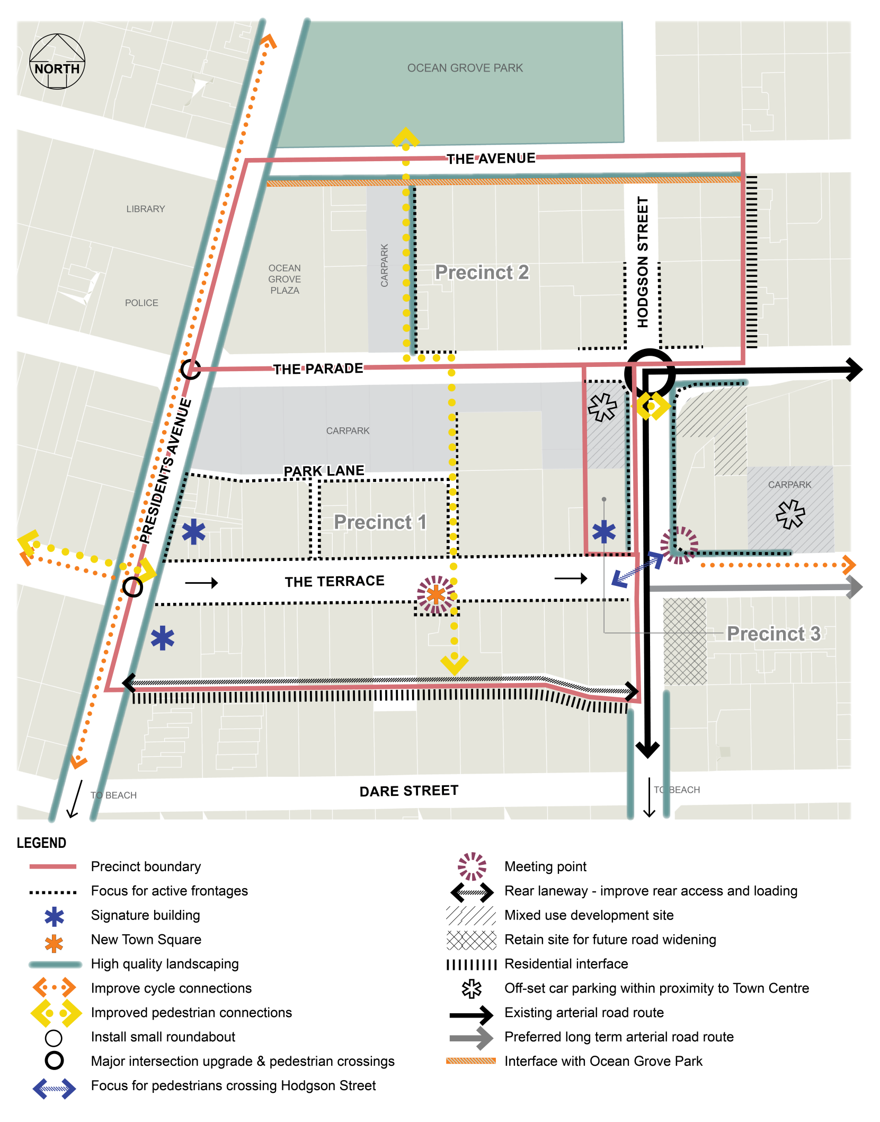

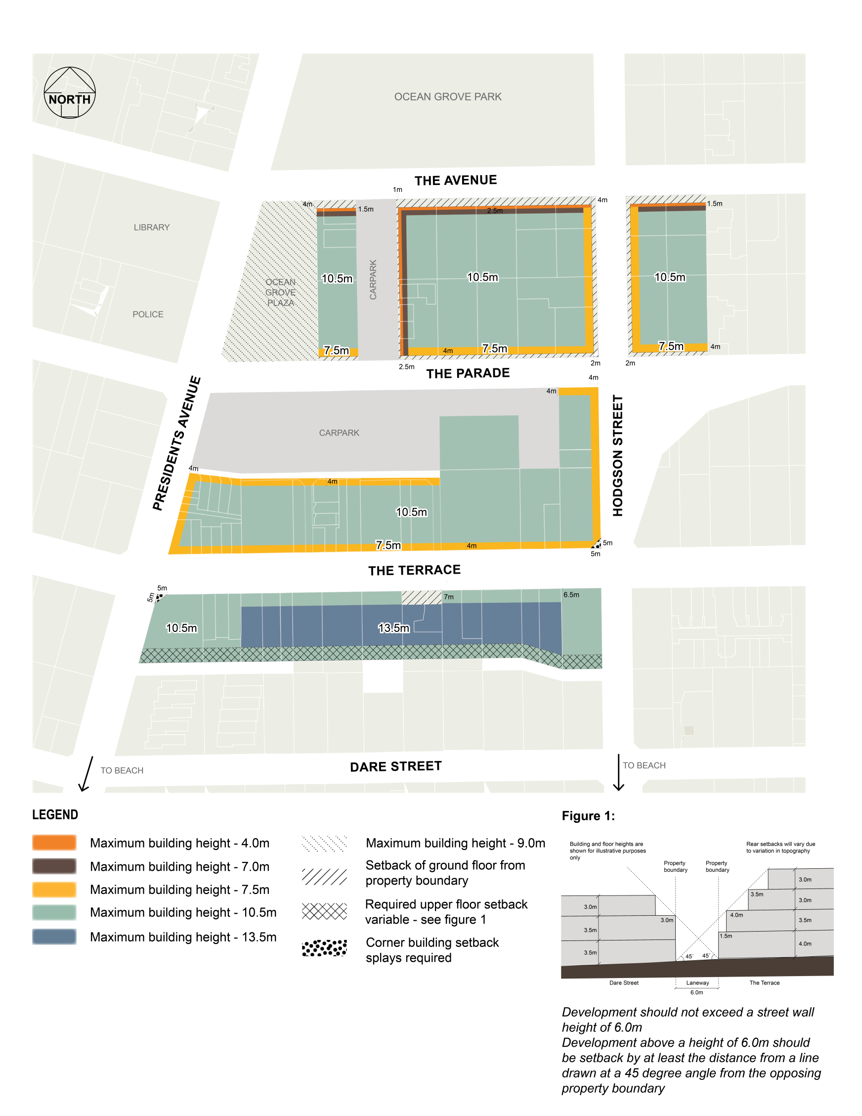
Map 2: Building height and setback

