21.14 the bellarine peninsula
25/06/2015
Proposed C346

21.14-1 Key issues and Influences
28/01/2010
C129(Part 1)

The Bellarine Peninsula comprises a series of contained townships separated by rural and coastal areas.
The rural and coastal areas on the Bellarine Peninsula form an important non-urban break between settlements. They are highly valued for their scenic attributes, tourism function, environmental function and lifestyle appeal.
The Bellarine Peninsula is one of the fastest growing areas in the City of Greater Geelong. Population growth on the Bellarine Peninsula is being driven by the attractiveness of the peninsula as a relaxed lifestyle destination within close proximity to urban Geelong.
Appropriately managing urban growth on the Bellarine Peninsula will be critical to retaining the peninsula’s identity and attributes.
21.14-2 Objectives
25/06/2015
Proposed C346

- To protect and enhance the rural and coastal environment on the Bellarine Peninsula and maintain non-urban breaks between settlements.
- To facilitate the development of Ocean Grove, Drysdale/Clifton Springs and Leopold as hubs of development and service provision on the Bellarine Peninsula. In all other townships on the Bellarine Peninsula provide retail, commercial and community uses and facilities that serve the daily needs of the community and encourage street based activity.
- To provide for sustainable industrial, commercial, retail, agricultural and tourism development in designated locations, to service the wider Bellarine community.
- To preserve the individual character, identity and role of each Bellarine township.
Strategies
- Ensure that development responds to the identity and character of the individual township in which it is located.
- Protect rural and coastal environments from inappropriate urban encroachment.
- Ensure land use and development proceeds generally in accordance with the relevant Structure Plan maps included in this Clause.
- Ensure that development outside of settlement boundaries (as shown in the Structure Plan maps included in this clause) does not compromise the rural, environmental and landscape values of the non-urban breaks.
- Direct the bulk of residential growth and retail development to Ocean Grove, Drysdale/Clifton Springs and Leopold consistent with the relevant Structure Plan maps included in this clause.
- Direct bulky goods retailing and industrial development to existing and future areas as identified in Structure Plan maps included in this clause.
St Leonards:
- Support a mix of retail, commercial, community and entertainment uses within the town centre.
- Encourage development which respects the coastal landscape setting of St Leonards by:
- Providing reasonable sharing of views of the coast and foreshore.
- Promoting contemporary design that reflects the existing scale, setbacks, spacing, forms and materials of the buildings in the locality.
- Ensuring that development allows for the protection of significant vegetation and/or planting around buildings and has minimal impact on roadside vegetation.
- Support the on-going management, enhancement and sensitive development of the foreshore, Salt Lagoon Wildlife Reserve and Edwards Point State Faunal Reserve.
- Protect the scenic qualities of Murradoc Hill and Swan Bay.
- Support the development of a focal building, comprising retail and tourist related activities, at the south west corner of Murradoc and Bluff Roads.
- Support the development of Growth Areas 1 and 2 identified on the Structure Plan map.
- Facilitate development of a community facility including an Early Years Learning Centre, preferably at 1345 Murradoc Road.
- Integrate the town centre and pier-foreshore area.
Portarlington:
- Support a mix of retail, commercial, community and entertainment uses within the town centre.
- Encourage development which respects the coastal landscape setting of Portarlington by:
- Providing reasonable sharing of views of the coast and foreshore.
- Promoting contemporary design that reflects the existing scale, setbacks, spacing, forms and materials of the buildings in the locality.
- Ensuring that development allows for the protection of significant vegetation and/or planting around buildings and has minimal impact on roadside vegetation.
- Support the establishment of a Community Centre in Portarlington within an existing public building.
- Support the provision of a new fire station at Portarlington.
- Support the integration of the Portarlington town centre and pier-foreshore area.
- Support the development of a focal building at 22-34 Newcombe Street, Portarlington, to contain retail uses, tourist accommodation and tourism related activities.
- Support development in the Portarlington town centre incorporating accommodation uses above ground level retail floor space, where such development meets all parking and access requirements.
Indented Head:
- Encourage development which respects the coastal landscape setting of Indented Head, by:
- Providing reasonable sharing of views of the coast and foreshore.
- Promoting contemporary design that reflects the existing scale, setbacks, spacing, forms and materials of the buildings in the locality.
- Ensuring that development allows for the protection of significant vegetation and/or planting around buildings and has minimal impact on roadside vegetation.
- Support the on-going management, enhancement and sensitive development of the foreshore, Point Richards Flora and Fauna Reserve and Salt Lagoon Wildlife Reserve.
- Support expansion of the existing retail premises on The Esplanade, Indented Head.
Ocean Grove:
- Contain urban development within the defined settlement boundary on the Structure Plan map.
- Encourage development which respects the coastal landscape setting of Ocean Grove, by:
- Providing reasonable sharing of views of the coast and foreshore.
- Promoting contemporary design that reflects the existing scale, setbacks, spacing, forms and materials of the buildings in the locality.
- Ensuring that development allows for protection of significant vegetation and/or planting around buildings and has minimal impact on roadside vegetation.
- Support the continued development of the north-east growth area as shown on the Structure Plan map.
- Encourage a range of accommodation and housing options, including aged care within and adjacent to the Town Centre and other existing and proposed activity centres.
- Ensure development avoids impacts on environmental assets including the coast, Buckley Park Foreshore Reserve, Goandra Estate, Ocean Grove Nature Reserve, Begola Wetlands, Barwon River/Lake Conneware and the Lake Victoria Wetlands.
- Ensure the Town Centre remains the primary retail centre for Ocean Grove by providing for a range of retail, business and accommodation uses.
- Ensure that the supply of car parking in the Town Centre increases commensurate with parking demands from new development.
- Preserve The Terrace as the preferred long-term arterial route through the Town Centre.
- Support the development of a new Neighbourhood Activity Centre, including community, recreation and open space uses, in the north-east growth area adjacent to Grubb Road
- Support the development of the restricted retail and industrial precincts within the north-east growth area.
- Support the development of a strategic footpath network for the town that provides permeable and safe routes to key destinations and services,
- Where appropriate, ensure new development assists in the establishment of a safe bicycle-pedestrian path network around the town connecting the foreshore, river, nature reserve, Grubb, Banks and Bonnyvale Roads as shown on the Structure Plan map.
- Where appropriate, ensure new development contributes to the improvement of open spaces, key pedestrian links and roads.
- Provide for a range of appropriately scaled and located tourism accommodation and activities, including opportunities for revitalisation of existing uses.
- Support further development of existing caravan parks and accommodation uses in residential areas, particularly those close to the beach and river, to provide a broader range of accommodation type and mix.

- Where appropriate, encourage a range of appropriately scaled tourism related activities on the rural periphery of the town which are complementary to the environmental and rural setting.
- Support the duplication of Grubb Road in a manner which preserves significant roadside vegetation, provides an attractive town entry, safe crossing points, pedestrian/cycle paths and undergrounding of powerlines.
- Support the provision of community and social infrastructure commensurate with population growth, including the investigation of a site for a new primary school in the north-east growth area.
Leopold:
- Support Leopold as a Sub Regional Retail Activity Centre for the Bellarine Peninsula, whilst providing local community, recreational and employment facilities to Leopold’s residents.
- Ensure the retention of Leopold as an urban island - supporting urban growth contained to the settlement boundary and preserving the surrounding rural hinterland.
- Support the development of the Ash Road Growth Area and other areas identified for residential development on the Structure Plan map.
- Support increased housing densities around the Sub Regional Retail Activity Centre and neighbourhood shopping strips at Ash Road and Dorothy Street.
- Encourage the northerly expansion of the Sub Regional Retail Activity Centre, ensuring any development integrates with the existing centre and surrounding community facilities, and enhances its appearance and functionality.
- Support the local convenience role of the Ash Road and Dorothy Street neighbourhood shopping centres, whilst restricting any future expansion of these centres.
- Support the development of Council’s Kensington Road Community Hub to provide a wide range of community, health, education and civic services/facilities.
- Encourage the creation of an additional local mixed use centre on the south east corner of Bellarine Highway and Melaluka Road. Any redevelopment of this site could accommodate restaurants, convenience shops, offices and residential development.
- Provide public open space within existing and proposed residential areas to cater for the passive and active recreation needs of the community.
- Provide an improved transport network which includes better traffic movements, pedestrian and cyclist linkages and public transport options.
- Ensure environmentally sensitive areas including Lake Connewarre and Reedy Lake are protected from localised development pressure.
- Investigate opportunities for public access to Port Phillip Bay.
Barwon Heads:
- Maintain a compact urban form and avoid outward sprawl.
- Protect the unique character of Barwon Heads as a coastal village located within a sensitive environment and significant landscape setting.
- Ensure the Hitchcock Avenue shopping centre remains the focus of retail activity in Barwon Heads.
- Restrict new commercial development to the existing business and mixed use zones in Hitchcock Avenue between Bridge Road and Ozone Road and the south side of Bridge Road.
- Ensure new housing development complements the character of Barwon Heads and provides for a variety of housing sizes and types.
- Support the continued development of 13th Beach Resort as a tourist destination.
- Continue upgrading the Barwon Heads Village Park and foreshore reserves in accordance with established master plans.
- Support development of appropriate tourist accommodation around the Barwon Heads town centre.
Drysdale/Clifton Springs:
- Contain urban development within the defined settlement boundary on the Structure Plan map.
- Support the development of the Jetty Road Urban Growth Area and other areas identified for residential development on the Structure Plan map.
- Ensure new development incorporates sustainability principles including environmentally sustainable design, energy efficiency, connectivity and water sensitive urban design.
- Reinforce the Drysdale town centre as the primary retail centre including the development of an additional supermarket on the south side of Murradoc Road
- Provide for the expansion of the Drysdale town centre to the east along Murradoc Road.
- Locate future development of a service business or industrial nature in the identified precinct along Murradoc Road extending to the proposed Drysdale Bypass.
- Locate and integrate future education, community and recreation facilities to enhance their accessibility and to maximise joint use wherever possible.
- Develop the Council owned Palmerston Street site and the Drysdale Regional Community and Cultural Hub for community and recreation purposes.
- Ensure any development of short term tourist accommodation at the Curlewis Golf Course is located at the eastern end of the course in close proximity to the Jetty Road Urban Growth Area, functions as a minor component to the primary role of the site as a golf course and maintains the rural landscape character of the site.
- Provide additional bicycle and pedestrian opportunities throughout the townships including new footpaths and bicycle lanes.
- Provide for the creation of consolidated parking areas in the town centre.
Point Lonsdale
- Support low scaled and designed tourism opportunities on designated land identified on the Point Lonsdale Structure Plan map at Clause 21.14-12.
- Ensure new development strengthens the township’s coastal village character and landscape setting by requiring a high standard of architectural and urban design response including;
- Low scale forms
- Articulation (materials, openings or features such as decks, balconies, wide eaves or canopies).
- Contemporary design quality.
- Use of materials such as timber, corrugated iron, weatherboard or light coloured render.
- Limiting site coverage and provide front and side setbacks that reflect existing neighbourhood patterns and provide opportunities for maintenance and planting of native coastal and indigenous vegetation.
- Ensure that new urban development street works and road designs contribute to the implementation of the identified primary and secondary pedestrian/cycle routes and are designed to complement the informal coastal streetscape character.
21.14-3 Implementation
25/06/2015
Proposed C346

These strategies will be implemented by:

Applying Zones and overlays
Ocean Grove
Apply the Commercial 1 Zone to the surplus park at 94 The Parade.
Apply the Commercial 1 Zone to the surplus road reserve from upgrade of the Hodgson Street/The Parade intersection.
Apply the Design and Development Overlay to the Town Centre to implement the findings of the Ocean Grove Town Centre Urban Design Framework.
Apply the Design and Development Overlay to the Commercial 1 and Commercial 2 Zone precincts in the north-east growth adjacent to Grubb Road.
Apply schedule 20 to the Design and Development Overlay to the Industrial 3 Zone in the north-east growth area.
Apply the Public Acquisition Overlay to The Terrace rear laneway.

Leopold
Apply the Residential 1 Zone and the Development Plan Overlay to land designated for future residential growth shown on the Leopold Structure Plan map included in this clause.
Apply a combination of business zones, a Design and Development Overlay and a Development Plan Overlay to facilitate the expansion of the Leopold Sub Regional Retail Activity Centre.
Drysdale
Apply the Residential 1 Zone with a Development Plan Overlay (DPO) based on the principles identified in the Structure Plan to Princess Street, Central Road and Oakden Road.
Support the application of the Residential 1 zone to identified residential infill areas to a Residential Zone with appropriate DPO and Developer Contribution Plan (DCP) controls.
Support a joint rezoning and development application at the Curlewis Golf Club to facilitate short term tourist accommodation.
Point Lonsdale
Apply the Residential 1 Zone with a Development Plan Overlay to the portion of the Lonsdale Golf Course shown for residential growth on the Point Lonsdale Structure Plan map at Clause 21.14-12 subject to an amendment and EES process.
Apply appropriate design and environmental overlays to areas of consistent urban and landscape character.
Rezone the Business 4 Zone land on the corner of Fellows Road and Bellarine Highway to facilitate tourism development.
St Leonards
Apply the General Residential Zone Schedule 1 to Growth Areas 1 and 2.
Apply the Development Plan Overlay to Growth Area 2.
Apply the Development Contributions Plan Overlay (or an equivalent agreement with landowners) in conjunction with the rezoning of Growth Areas 1 and 2.
Further work
Review township structure plans as scheduled (in structure plans) to meet emerging needs of communities.
Review the planning framework for land identified in the Coastal Spaces Landscape Assessment Study as regionally significant in the south west of the Bellarine Peninsula to ensure the protection of landscape values is adequately addressed.
Point Lonsdale
Work with the Borough of Queenscliffe to address climate change issues in Point Lonsdale and implement any relevant outcomes.
Prepare detailed streetscape design plans for designated primary and secondary routes as identified in the Point Lonsdale Structure Plan.
Investigate opportunities to establish a railway station-transport interchange precinct to link with the Queenscliff tourist railway service.
Portarlington
Prepare an Urban Design Framework for the Portarlington Town Centre.
Support Parks Victoria Safe Harbour Project, including ensuring appropriate integration with the adjacent foreshore reserve and Town Centre.
Ocean Grove

Review the application of schedule 7 to the Significant Landscape Overlay.
Undertake a review of the older parts of the town as identified on the Structure Plan map to investigate the introduction of new planning overlay controls to protect important landscape and built form attributes.
Work with VicRoads to prepare a network operating plan (SmartRoads) for the town.

Leopold
Implement the Leopold Activity Centre Urban Design Framework, 2011.
Implement the Memorial Park Masterplan, 2011.
Support the implementation of the Kensington Road Community Hub Concept Design, 2008.
Undertake further assessment of sites nominated as “Urban Consolidation” in the plan attached to this Schedule.
Undertake a Flood Study to introduce controls over areas identified appropriate for Floodway Overlay (FO) or Land Subject to Inundation Overlay (LSIO).
Barwon Heads
Undertake a Landscape Assessment Study for the Ewing Blyth/Golf Links/Bridge Road and the Warrenbeen Court residential areas with the intention to apply an overlay to protect the existing character and vegetation.
Undertake a detailed study of Murtnaghurt Lagoon to establish whether the boundaries of the existing Environment Significant Overlay require review.
Implement the findings of the Barwon Heads Parking & Traffic Study.
Consider the impacts of climate change on the future development of Barwon Heads in accordance with the Climate Change Adaptation Strategy to be developed by Council during 2010-2011.
Drysdale/Clifton Springs
Investigate the relocation of the Council depot site at 22A Collins Street
Prepare a Master Plan for the development of a community hub on the Council owned land at Palmerston Street site in the town centre.
Undertake a Drysdale Town Centre Community Facilities Planning Project to investigate and provide direction for future development and community use of 38 – 40 High Street and 2 – 8 Wyndham Street (senior citizens building) adjacent to the Town Square.
Prepare a Master Plan for the development of the Drysdale Regional Community and Cultural Hub.
Review the extent of the Heritage Overlay in the Drysdale Commercial Heritage Area.
References
Bellarine Peninsula Strategic Plan, City of Greater Geelong, 2006.
Ocean Grove Structure Plan, City of Greater Geelong, 2015.
Ocean Grove Urban Design Framework, City of Greater Geelong, 2014.
Portarlington Structure Plan, City of Greater Geelong, 2007.
Indented Head Structure Plan, City of Greater Geelong, 2007.
St Leonards Structure Plan, City of Greater Geelong, 2015.
Leopold Structure Plan, City of Greater Geelong, 2011 (amended January 2013).
Leopold Urban Design Framework, City of Greater Geelong, 2011.
Barwon Heads Structure Plan, City of Greater Geelong, 2010.
Drysdale Clifton Springs Structure Plan, City of Greater Geelong, 2010.
Jetty Road Urban Growth Plan, City of Greater Geelong, 2007 (amended September 2008).
City of Greater Geelong Municipal Reference Document, Coastal Spaces Landscape Assessment Study, Planisphere, 2006.
Point Lonsdale Structure Plan, Planisphere, 2009 (amended November 2011).
Drysdale Urban Design Framework, City of Greater Geelong, 2012.
21.14-4 St Leonards Structure Plan map
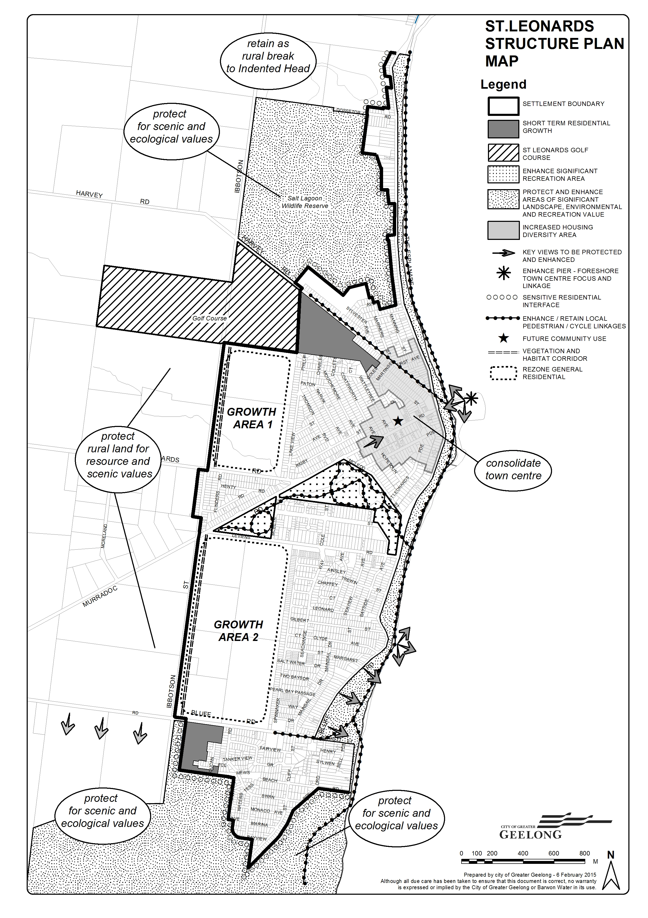
25/06/2015
C312

21.14-5 Portarlington Structure Plan map
29/11/2012
C273

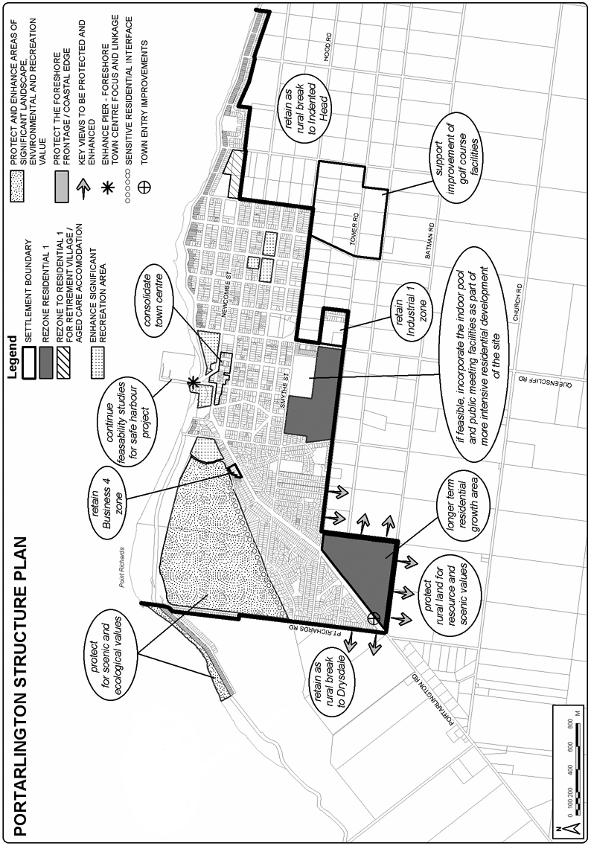
21.14-6 Indented Head Structure Plan map
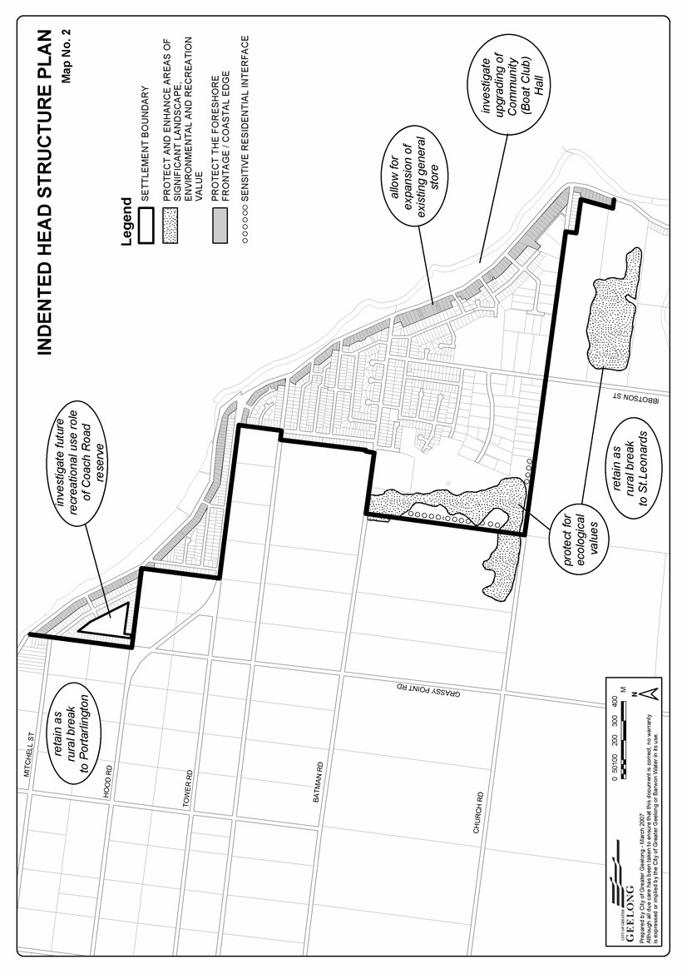
28/01/2010
C129(Part 1)

21.14-7 Ocean Grove Structure Plan map
28/01/2010
Proposed C346

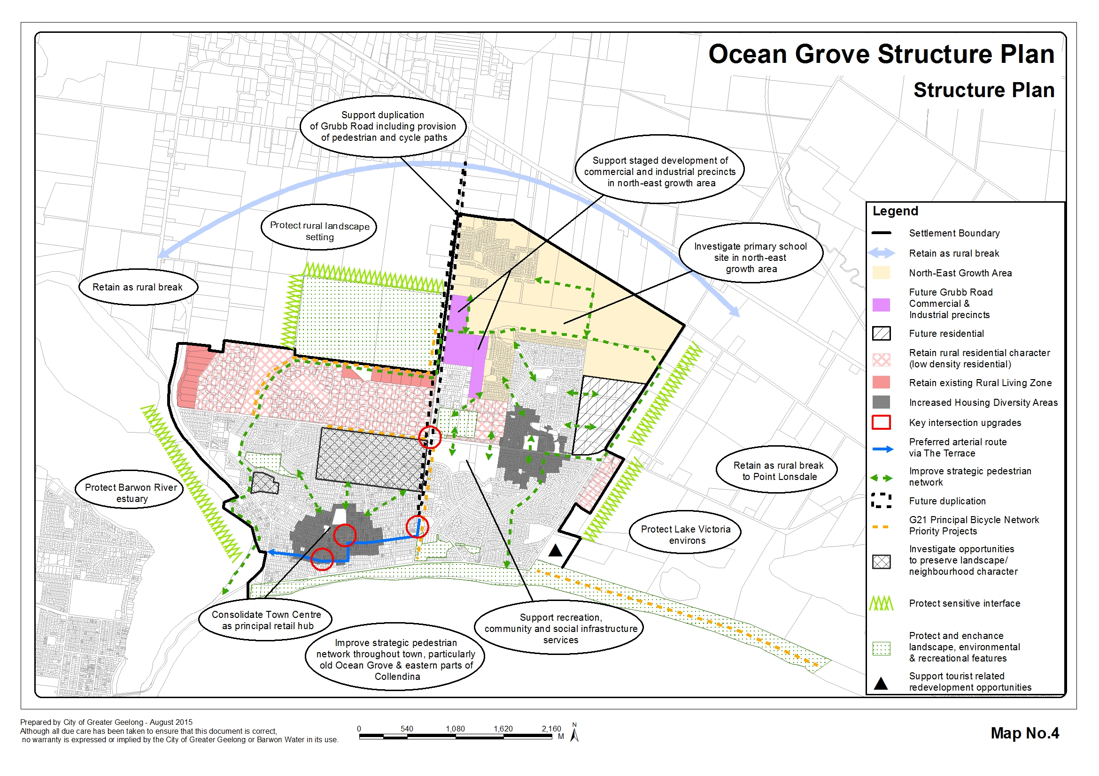

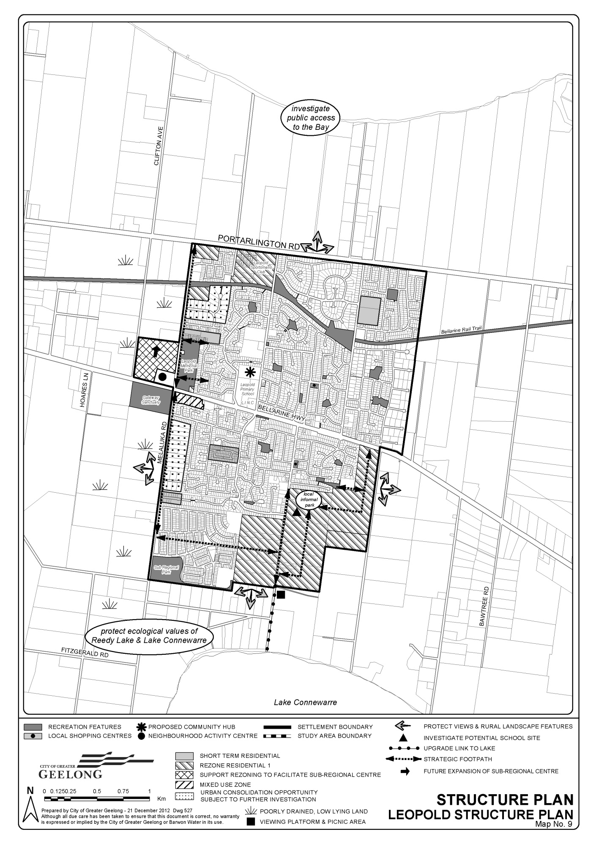21.14-8 Leopold Structure Plan map
16/05/2013
C254

21.14-9 Barwon Heads Structure Plan map
26/08/2010
C159

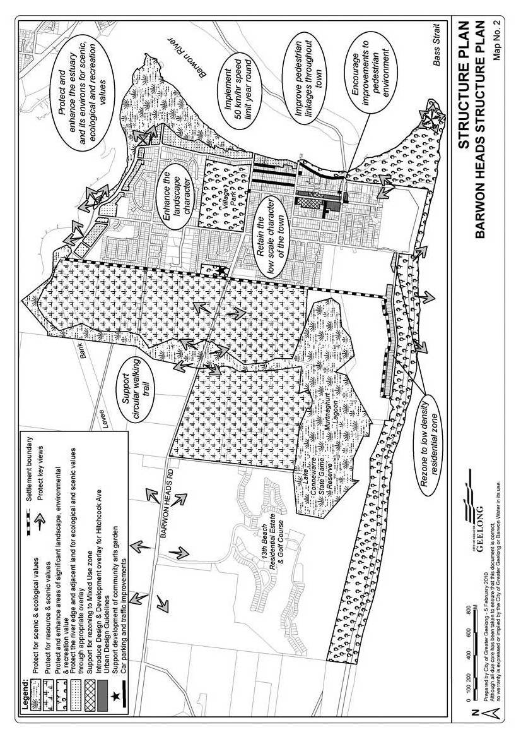
21.14-10 Drysdale Clifton Springs Structure Plan map
27/11/2014
C283

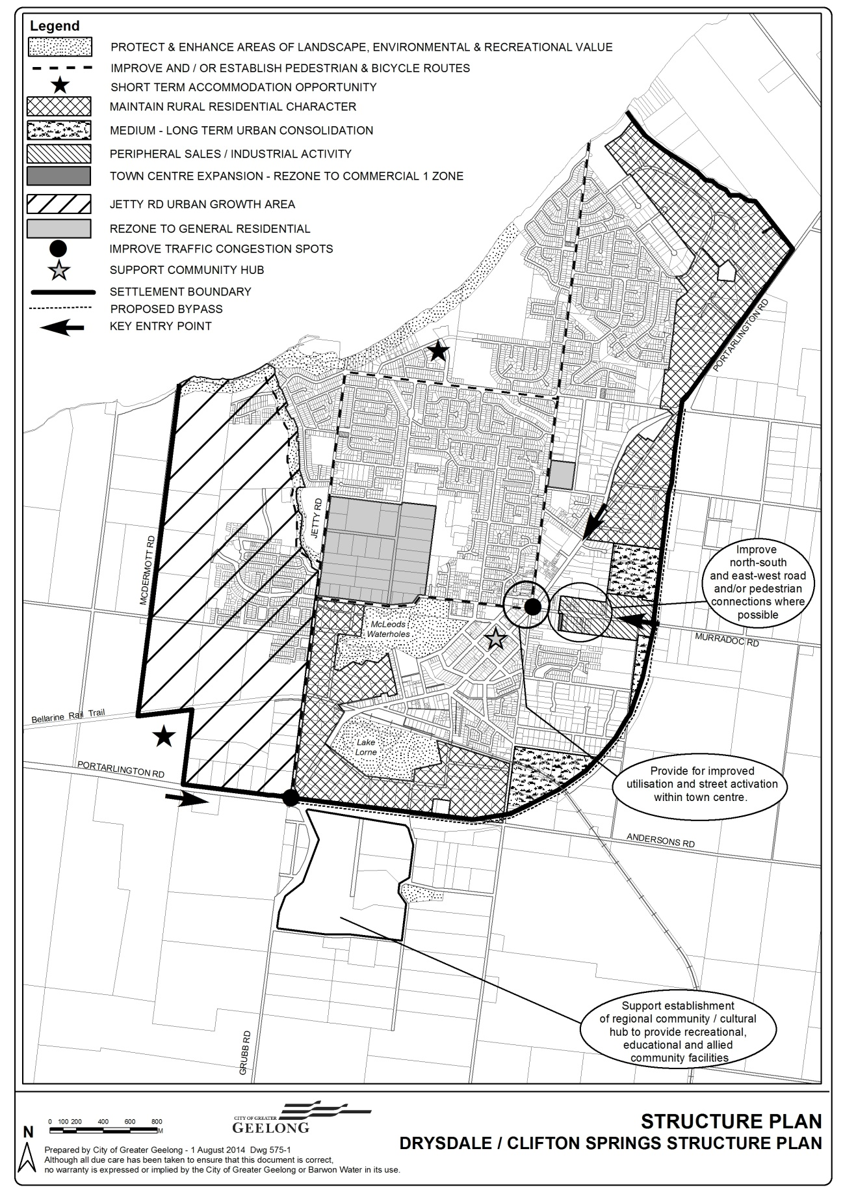
21.14-11 Jetty Road Urban Growth Plan map
28/01/2010
C129(Part 1)

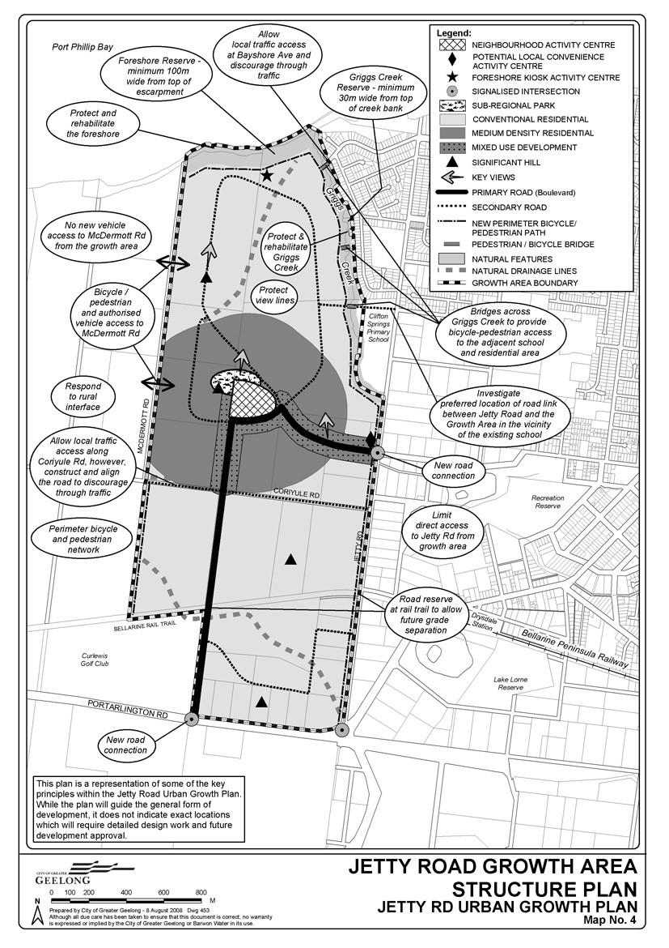
21.14-12 Point Lonsdale Structure Plan map
26/07/2012
C165

