Planning and Environment Act 1987

GREATER GEELONG PLANNING SCHEME

AMENDMENT C346

EXPLANATORY REPORT

Who is the planning authority?
This Amendment has been prepared by the City of Greater Geelong, which is the planning authority for this amendment.
The Amendment has been made at the request of the City of Greater Geelong Council.

Land affected by the amendment
The Amendment applies to the town of Ocean Grove, as generally shown on the Study Area map below.

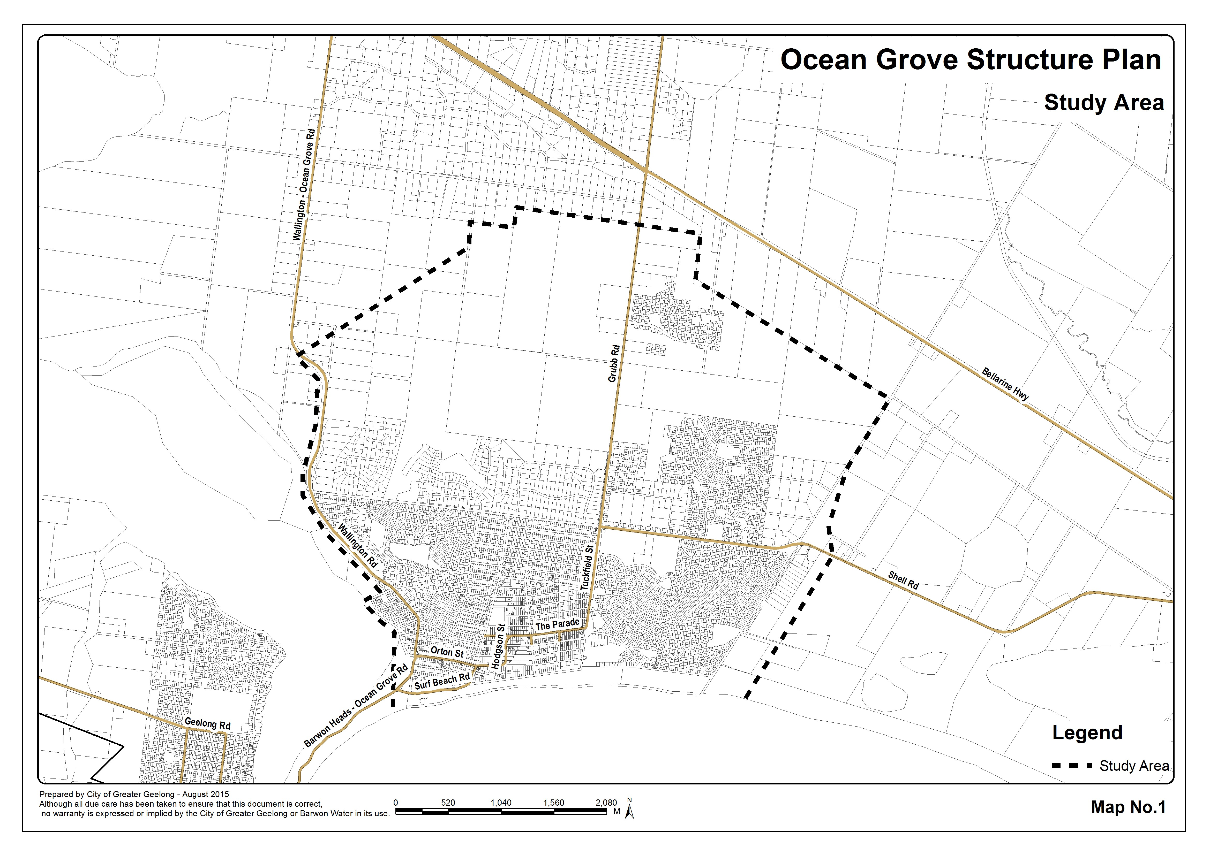

What the amendment does
The Amendment seeks to implement the findings of the following Council adopted documents into the Greater Geelong Planning Scheme:
- the Ocean Grove Structure Plan (December 2015); and
- the Ocean Grove Town Centre Urban Design Framework (June 2014).
The Amendment will:
- Amend Clause 21.14 Bellarine Peninsula to include the key strategies of the Ocean Grove Structure Plan (December 2015) and the updated Ocean Grove Structure Plan Map, and the recommendations of the Ocean Grove Town Centre Urban Design Framework Plan (June 2014).
- Insert a new schedule 39 to Clause 43.02 Design and Development Overlay to implement key urban design recommendations for the Grubb Road activity centre and restricted retail precinct in the north-east growth area.
- Insert a new schedule 40 to Clause 43.02 Design and Development Overlay to implement the key design recommendations of the Ocean Grove Town Centre Urban Design Framework (2014) for the Town Centre.
- Delete schedule 16 to Clause 43.02 Design and Development Overlay (Presidents Avenue Ocean Grove).
- Delete schedule 27 to Clause 43.02 Design and Development Overlay (Hodgson Street Mixed Use Precinct).
- Apply schedule 20 to Clause 43.02 Design and Development Overlay (Industrial 1, 2 and 3 Zones) to the Industrial 3 Zone land within the north-east growth area.
- Amend Planning Scheme Maps 81DDO and 82DDO.

Strategic assessment of the amendment

Why is the amendment required?
The Amendment is required to give effect to the adopted Ocean Grove Structure Plan (December 2015) and the adopted Ocean Grove Urban Design Framework (June 2014) within the Greater Geelong Planning Scheme.
The existing Clause 21.14 of the Greater Geelong Planning Scheme acknowledges the need for additional work to be undertaken for the Town Centre, specifically stating:
“Prepare an Urban Design Framework and Parking Precinct Plan for the Ocean Grove Town Centre.”
The Town Centre Urban Design Framework sought to address movement within and around the Town Centre, provision of space for future growth of commercial, community and social facilities and how to preserve and build on Ocean Grove’s character and identity.
As part of five year strategic work plan review, Council undertook a review of the 2007 Ocean Grove Structure Plan.

The review built upon the current Structure Plan (2007) but has been amended to include updated State and Local Planning Polices, population growth, lot supply and dwelling construction rates, the location of the settlement boundary, environmental and social considerations including further service provisions for the town and a future review period.
Based on the high population growth rate adopted by the 2007 Structure Plan, it was necessary to undertake a review of population change since this time and the forecast population over the lifetime of the updated Structure Plan 2015. This assisted in determining the relevance of the existing and indicative long-term settlement boundaries identified on the 2007 Structure Plan map. The town has seen significant land use and development changes since 2007 resulting in the need to update the 2007 Structure Plan in terms of its principles and directions.
This Amendment gives effect to the principles and directions contained within the Ocean Grove Structure Plan and Town Centre Urban Design Framework.
In order for the new principles and directions to have statutory weight in the consideration of planning permits and rezoning requests, it is necessary for the Ocean Grove Structure Plan to be included in the Greater Geelong Planning Scheme.
The accompanying overlay changes are required to give effect to the recommendations contained within the Structure Plan and Urban Design Framework.

How does the amendment implement the objectives of planning in Victoria?
The Amendment implements the objectives of planning in Victoria pursuant to Section 4 of the Planning and Environment Act 1987 by providing for the fair, orderly and sustainable development of land where environmental, social and economic effects are recognised.

How does the Amendment address any environmental, social and economic effects?
The Structure Plan clearly defines a nominated settlement boundary for township, which will accommodate the forecast population increase, reduce urban sprawl and protect surrounding costal, wetland and rural environments. Minor boundary realignments are proposed at Banks Road.
In particular protection and enhancement of significant environmental areas such as Lake Connewarre, Lake Victoria environs, Ocean Grove Nature Reserve, and adjacent landscapes will be strengthened and protected through this amendment.
The Amendment has positive social and economic effects on the community as it provides strategic direction of the future development of the town, resulting in the provision of additional social, recreational and commercial infrastructure. It will generate positive social and economic benefits through significant job creation in the construction industry and meet community needs and demands for housing and associated uses.

Does the amendment address relevant bushfire risk?
Land to the north, east and west of the town is subject to bushfire prone designation. Undeveloped land within the north-east east growth falls within the designated area until such a time as it is developed.
The Ocean Grove Nature Reserve is also subject to the Bushfire Management Overlay. The nominated settlement boundary does not propose any urban extension that would encroach on the Nature Reserve and consequently, any existing bushfire risk will not be exacerbated.

Does the amendment comply with the requirements of any Minister’s Direction applicable to the amendment?
The Amendment is consistent with the Ministerial Direction on the Form and Content of Planning Schemes under section 7(5) of the Act, Ministerial Direction 11 Strategic Assessment of Amendments as the Explanatory Report includes all requirements to be met and Ministerial Direction No. 17 Localised Planning Statements.
The Amendment is also consistent with Ministerial Direction No. 15 The Planning Scheme Amendment Process.

How does the amendment support or implement the State Planning Policy Framework and any adopted State policy?
The Amendment supports a number of State policies, particularly Clause 11 – Settlement. The Clause requires planning authorities to facilitate the orderly development of urban areas through the preparation of strategic plans.
Clause 11.02 Urban growth outlines strategies to ensure a sufficient supply of urban land is available and plan to accommodate population growth over at least a 15 year period providing clear direction on locations where growth should occur. It states that residential land supply will be considered on a municipal basis, rather than a town-by-town basis. The Amendment acknowledges the adequacy of residential land supply in the municipality, in the town and the role of the town as an urban growth location.
Clause 11.14 Planning for identified distinctive areas outlines the role of localised planning statements and that of the Bellarine Localised Planning Statement (LPS). The Amendment supports the LPS in terms of protecting non-urban breaks between settlements, supporting the growth of identified growth locations generally in line with adopted Structure Plans and seeking to protect, preserve and enhance built heritage, cultural and urban character values and preserve the individual identity and role townships.
Clause 11.05 Regional development outlines strategies to promote regional development, including that settlements are planned in accordance with any relevant regional growth plan and that coastal towns identify a clear settlement boundary and avoid linear urban sprawl along the coastal edge. The G21 Regional Growth Plan identifies Ocean Grove as a district town and the need to support the growth of these towns by building on existing and planned infrastructure. The Amendment seeks to implement a single coastal settlement boundary that accommodates future urban growth whilst protecting sensitive environmental assets and landscapes surrounding the town.
The Structure Plan lists other State policies that have been considered in the preparation of the Plan. Key policies include: Clause 12 Environmental and Landscape Values; Clause 13 Environmental Risks; Clause 16 Housing; and Clause 19 Infrastructure.

How does the amendment support or implement the Local Planning Policy Framework, and specifically the Municipal Strategic Statement?
During the preparation and adoption of the Ocean Grove Structure Plan 2015, full consideration was given to all adopted Council policies, many of which are incorporated into the Municipal Strategic Statement. In particular, the 2007 Structure Plan called for a review in five years to assess development and lot supply. The Structure Plan advised that should lot supply fall to a rate less than 10 years, a full review of the Structure Plan should be undertaken. As the adequacy of lot supply on a municipal and township basis is sufficient for the lifetime of the 2015 Structure Plan, a full review was not required.
The existing Clause 21.14 of the Greater Geelong Planning Scheme acknowledges the need for additional work to be undertaken for the centre, specifically stating:
“Prepare an Urban Design Framework and Parking Precinct Plan for the Ocean Grove Town Centre.”
This Amendment supports the further work requirement in terms of implementing the key findings of the Town Centre Urban Design Framework in the Greater Geelong Planning Scheme.
The Amendment directly supports the Local Planning Policy Framework clauses by:
- Clause 21.05-7 (Flooding) by discouraging land use and development in floodplains where flood function may be impaired.
- Clause 21.06-2 (Settlement) by directing the majority of new greenfield residential development to the designated primary urban growth areas.
- Clause 21.05 (Natural environment) by protecting significant environmental features, directing urban coastal development within existing urban settlements, and acknowledging impacts of climate change.
- Clause 21.07 (Economic development and employment) by identifying opportunities for Ocean Grove to provide for the commercial service needs of the growing population through the identification of land for commercial and industrial use in the north-east growth area.
- Clause 21.14 (Bellarine Peninsula) by directing the bulk of residential growth and retail development to Ocean Grove, Drysdale/Clifton Springs and Leopold consistent with the relevant Structure Plans.
The Structure Plan lists other Local policies that have been considered in the preparation of the Structure Plan.

Does the amendment make proper use of the Victoria Planning Provisions?
The Amendment reflects the recommendations of the 2015 Ocean Grove Structure Plan. The most appropriate tool for including the new land use directions and policies for Ocean Grove in the Greater Geelong Planning Scheme is to update the Local Planning Policy Framework at Clause 21.14 Bellarine Peninsula.
The Amendment also introduces a number of overlay changes which are all consistent with the proper use of the Victoria Planning Provisions.

How does the amendment address the views of any relevant agency?
The views of any affected agencies were considered during the preparation of the Ocean Grove Structure Plan February 2014. Key agencies were also consulted with as part of the detailed engagement process undertaken for the Town Centre Urban Design Framework.

Does the amendment address relevant requirements of the Transport Integration Act 2010?
There are no significant impacts on the transport system defined by the Transport Integration Act as a result of this amendment.

Resource and administrative costs
- What impact will the new planning provisions have on the resource and administrative costs of the responsible authority?
The Amendment will have minimal impact on Council’s resource and administrative costs.

Where you may inspect this Amendment
The amendment is available for public inspection, free of charge, during office hours at the following places:
Greater Geelong City Council, Customer Service Centre, Ground Floor, 100 Brougham Street. GEELONG – 8.00am to 5.00pm weekdays
Greater Geelong City Council, Customer Service Centre, 66-70 The Avenue, OCEAN GROVE – 9.00am to 5.00pm weekdays
‘Amendments’ section of the City’s website www.geelongaustralia.com.au/amendments/
The Amendment can also be inspected free of charge at the Department of Environment, Land, Water and Planning website at www.delwp.vic.gov.au/public-inspection .
Submissions
Any person who may be affected by the Amendment may make a submission to the planning authority.
Submissions about Amendment C346 should be received by 4 March 2016 and addressed to:
The Coordinator
Strategic Implementation
City of Greater Geelong
- either by mail to: PO Box 104, GEELONG VIC 3220
- or by email to: strategicplanning@geelongcity.vic.gov.au
- or lodged online at: www.geelongaustralia.com.au/amendments/

Panel hearing dates
In accordance with clause 4(2) of Ministerial Direction No.15 the following panel hearing dates have been set for this amendment:
- directions hearing: week commencing 4 April 2016
- panel hearing: week commencing 2 May 2016
Further information
For further information about Amendment C346, please contact the Strategic Implementation Unit at the City of Greater Geelong on (03) 5272 4820 or via email strategicplanning@geelongcity.vic.gov.au

