Planning and Environment Act 1987

GREATER GEELONG PLANNING SCHEME

AMENDMENT C347

EXPLANATORY REPORT

Who is the planning authority?
This amendment has been prepared by the Greater Geelong City Council, which is the planning authority for this amendment.
The amendment has been made at the request of the City of Greater Geelong Council.

Land affected by the amendment

The amendment affects all land in the Farming Zone and Rural Conservation Zone in the City of Greater Geelong Council:

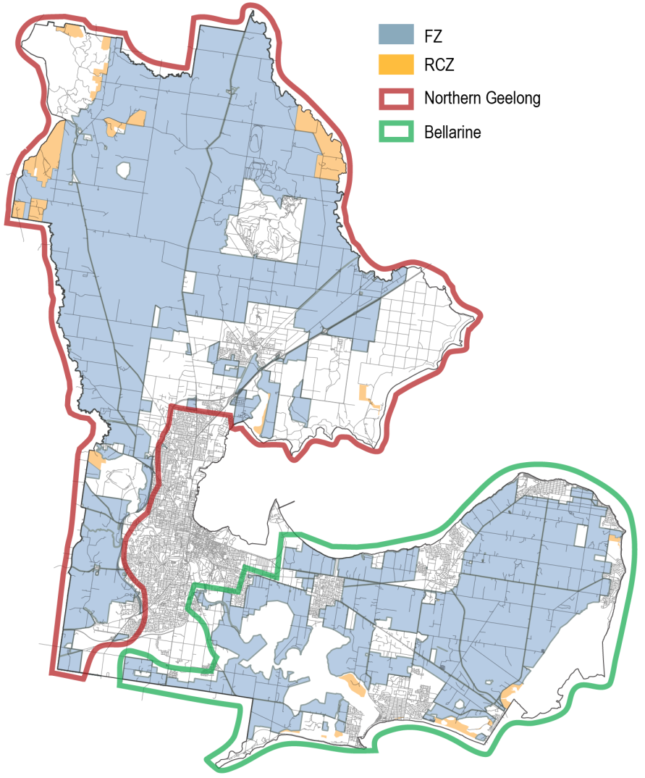

What the amendment does
Amendment C347 changes the Local Planning Policy Framework at Clauses 21.06 and 22.06, and introduces a new Clause 22.64.
The proposed Clauses are as follows:
Municipal Strategic Statement
- Amend Clause 21.07 - Economic Development and Employment to align with the implementation of amended Clause 22.06 and new Clause 22.64 of the local planning policy.
Local Planning Policies
- Replace Clause 22.06 - Tourism Development in Rural Areas with a new Clause 22.06 – Tourism, Accommodation and Function Centre Development in Rural Areas to reflect changes made to the Farming Zone and Rural Conservation Zone in the Victoria Planning Provisions under Amendment VC103.
- Insert a new Clause 22.64 - Discretionary Uses in Rural Areas to reflect changes made to the Farming Zone and Rural Conservation Zone in the Victoria Planning Provisions under Amendment VC103.

Strategic assessment of the amendment

Why is the amendment required?
The amendment responds to changes made to the Farming and Rural Conservation Zones of the Victorian Planning Provisions under Amendment VC103. Changes to the zones have impacted on how non-rural uses are managed under the Greater Geelong Planning Scheme. A number of land uses that were previously prohibited have been made discretionary. Changes related to some accommodation, retail, commercial, industry, schools and community uses.
The amendment is required to ensure that the new zones are interpreted in a manner consistent with Council’s local planning policy, the Bellarine Peninsula Localised Planning Statement 2015 and the adopted Rural Land Use Strategy 2007.
The Rural Land Use Strategy recognises the importance of managing development in rural areas to avoid a proliferation of buildings or overdevelopment that could lead to the fragmentation of land and threaten the ability to use it for farming. The Bellarine Peninsula Localised Planning Statement also outlines the pressure for growth and change that is being experienced and sets strategies to ensure the key attributes of the Bellarine Peninsula are preserved.
How does the amendment implement the objectives of planning in Victoria?
The objectives for planning in Victoria listed under Section 4(1) of the Planning and Environment Act 1987 contains the following:
- to provide for the fair, orderly, economic and sustainable use, and development of land;
- to secure a pleasant, efficient and safe working, living and recreational environment for all Victorians and visitors to Victoria;
- to facilitate development in accordance with the objectives set out [above].
It is considered that this amendment balances ongoing agricultural activity in rural zones with supporting appropriate non-rural uses that positively contribute to tourist and employment growth. The amendment also seeks to ensure that new development in rural areas does not compromise valued landscape character and non-urban breaks between towns.
How does the amendment address any environmental, social and economic effects?
No adverse environmental effects are foreseen as a consequence of this amendment. The amendment retains support for the preservation of the productive capacity of land. It also recognises the need to protect rural landscape character and the diversity of natural, environmental and scenic assets of importance.
In terms of social impacts the amendment allows farmers to continue to live on and use their land. The amendment also promotes food security and the retention of a local produce market. Clause 22.64 ensures that non agricultural uses that attract significant numbers of visitors, traffic demand and car parking are provided in urban areas where there are appropriate services and transport connectivity. Amended Clause 22.06 seeks to ensure camping and caravan parks do not provide for long term housing options that could lead to poor social outcomes and community connectivity.
The amendment acknowledges the important economic contribution of agricultural production to the City’s rural communities, while continuing to support and grow the tourism sector. The new policies seek to ensure that the impacts of non-farming uses are appropriately managed, and that the rural character is maintained in a manner that encourages tourism.
Does the amendment address relevant bushfire risks?
There are no relevant bushfire risks as a result of the proposed amendment. Development in bushfire prone areas is addressed through the Bushfire Management Overlay and permit applications, where relevant.
Does the amendment comply with the requirements of any Minister’s Direction applicable to the amendment?
The amendment is consistent with the Ministerial Direction on the Form and Content of Planning Schemes under Section 7(5) of the Act and complies with Ministerial Direction 11 – Strategic Assessment of Amendments.
Ministerial Direction No. 17 requires planning authorities to have regard to the adopted Bellarine Peninsula Localised Planning Statement (Victorian Government 2015) when preparing a planning scheme amendment affecting land on the Bellarine. The Bellarine contains land zoned Farming and Rural Conservation, to which this amendment applies. The amendment accords with the Statement by promoting discretionary uses and development that support and are consistent with the areas valued scenic attributes, established agricultural activity and natural tourism advantages.
How does the amendment support or implement the State Planning Policy Framework and any adopted State policy?
The amendment is consistent with, and gives effect to, the State Planning Policy Framework (SPPF), including the following clauses:
- Clause 11 – Settlement, in terms of regional growth for Geelong where it will ensure rural breaks between towns are maintained, agricultural productivity is protected, and it seeks to provide for a diversified economy; including tourism and agricultural land resources. Specifically, the amendment is consistent with Clause 11.14 which seeks to protect and enhance the valued attributes of the Bellarine Peninsula under the Bellarine Peninsula Localised Planning Statement.
- Clause 12 - Environment and Landscape Values, as it will ensure the protection of coastal areas and coastal biodiversity and ecological areas. The amendment will ensure that tourism developments demonstrate an accommodation need at an appropriate scale and intensity. It will also protect landscapes and significant open spaces.
- Clause 13 - Environmental Risks, in that it will assist the control on noise effects on sensitive land uses and the protection and improvement of air quality.
- Clause 14 - Natural and Resource Management, as it will protect productive farmland of local strategic importance and encourages the sustainable use of agricultural land.
- Clause 17 - Economic Development, in that it supports tourism development, including a range of well designed and sited tourist facilities that are compatible with and build on the assets and qualities of surrounding rural activities and cultural and natural attractions. The amendment also reinforces the need to ensure an adequate supply of Industry and commercial land is provided in appropriate locations in urban areas.
- Clause 18 – Transport, whereby new Clause 22.64 seeks to discourage non-rural uses from rural areas that would attract significant numbers of visitors and traffic a car parking demand and are generally incompatible with farming activities and should be directed to urban areas. This includes community infrastructure and education facilities uses that should be located in urban areas that maximise walking and cycling consistent with Clause 19 Infrastructure.
How does the amendment support or implement the Local Planning Policy Framework, and specifically the Municipal Strategic Statement?
The amendment makes changes to the Local Planning Policy Framework to ensure the relevant provisions align with amended Clause 22.06 and new Clause 22.64. The amendment is consistent with the following clauses of the Local Planning Policy Framework:
Clause 21.07 - Economic Development and Employment.
Both amended Clause 22.06 and new Clause 22.64 recognise the need to support the use of land for productive agriculture, preserve the farmed rural landscape and protect the highly significant landscapes; by ensuring non rural uses will not compromise farming activity.
Support for the economic growth sector potential of the Bellarine for the development of food, horticulture and viticulture industries is also recognised, by protecting productive agriculture land while also allowing some tourism uses that complement the agricultural use of the land. Across the rural area Clause 22.06 promotes appropriate tourism and function centre development provided that the impacts are carefully managed and are designed to an appropriate scale. New Clause 22.64 discourages retail uses from being located in areas outside of the urban area and settlement strategy identified in the retail hierarchy.
Clause 21.14 - The Bellarine Peninsula.
The amendment promotes the protection and enhancement of the rural and coastal environment on the Bellarine Peninsula from inappropriate development and will maintain non-urban breaks between settlements. The proposed Clause 22.64 directs new industrial and warehouse development to existing commercial and industrial land and areas identified in Township structure plans.
Does the amendment make proper use of the Victoria Planning Provisions?
The amendment makes proper use of the Victoria Planning Provisions by applying controls consistent with the form and content of the VPPs to facilitate appropriate consideration of land use and development in the Farming and Rural Conservation zones in the City of Greater Geelong.
How does the amendment address the views of any relevant agency?
The views of relevant agencies will be sought during the formal exhibition of the amendment and will be considered accordingly.
Does the amendment address relevant requirements of the Transport Integration Act 2010?
There are no significant impacts on the transport system defined by the Transport Integration Act as a result of this amendment.
Resource and administrative costs
- What impact will the new planning provisions have on the resource and administrative costs of the responsible authority?
The new local policies will have minimal impact on Council’s resource and administrative costs.
Where you may inspect this Amendment
The amendment is available for public inspection, free of charge, during office hours at the following places:
Greater Geelong City Council, Customer Service Centre, Ground Floor, 100 Brougham Street GEELONG – 8.00am to 5.00pm weekdays
Greater Geelong City Council, Customer Service Centre, 18-20 Hancock Street DRYSDALE (inside the library) – 9.00am to 5.00pm weekdays
Lara Library, 5 Walkers Road LARA
‘Have Your Say’ section of the City’s website www.geelongaustralia.com.au/council/yoursay
The amendment can also be inspected free of charge at the Department of Environment, Land, Water and Planning website at www.delwp.vic.gov.au/publicinspection

Submissions
Any person who may be affected by the amendment may make a submission to the planning authority. Submissions about the amendment must be received by Tuesday 29 March 2016.

A submission must be sent to:

The Coordinator
Strategic Implementation
City of Greater Geelong

Either by mail to:
PO Box 104, GEELONG VIC 3220

Or by email to:
strategicplanning@geelongcity.vic.gov.au

Alternatively, a submission may be lodged online at the City’s website: www.geelongaustralia.com.au/amendments

Panel hearing dates
In accordance with Clause 4(2) of Ministerial Direction No.15 the following Panel Hearing dates have been set for this amendment:
- Directions Hearing: Week beginning 13 June 2016
- Panel Hearing: Week beginning 11 July 2016
Further information
For further information about Amendment C347 please contact the Strategic Implementation Unit at the City of Greater Geelong on (03) 5272 4820 or via email strategicplanning@geelongcity.vic.gov.au

