To: Peter Smith – Coordinator Strategic Implementation
From: Stuart Thiele – Strategic Planner
Subject: Proposed rezoning of four Barwon Water sites & two Planning Permits for subdivision
File number: C328, PP 762/2015 & PP 959/2015

Purpose
This report recommends that Council, under delegated authority, seek authorisation from the Minister for Planning to prepare and exhibit a Section 96A combined planning scheme amendment and planning permits for various sites owned by Barwon Water to rezone all or some of four sites in Staughton Vale, Anakie, Lovely Banks and St Leonards and to subdivide two sites in Lovely Banks and St Leonards.
Summary
- Barwon Water is seeking to rezone some or all of four sites in Staughton Vale, Anakie, Lovely Banks and St Leonards to facilitate their disposal. This is part of a wider program of property realisation Barwon Water is carrying out for its surplus land.
- Planning permits for subdivision have also been lodged for 600 Anakie Road, Lovely Banks (to create one rural living lot already used for rural residential purposes and a Barwon Water reserve) and 38-42 Mainsail Drive, St Leonards (to create two residential lots, a Barwon Water reserve and a reserve for public open space).
- The four sites have been grouped into a single amendment for administrative efficiency. The applications have been lodged by SMEC Urban and St Quentin Consulting Pty Ltd, acting on behalf of Barwon Water.
- The proposed rezonings are to the logical underlying zoning of the land in each case (Farming Zone in Staughton Vale and Anakie; Rural Living Zone in Lovely Banks and General Residential Zone Schedule 2 in St Leonards). Application of appropriate overlays is proposed.
- The proposed planning permits for subdivision of two of the sites are consistent with planning scheme requirements for the proposed zones.
- Issues raised in internal and external referrals have been resolved or are addressed by conditions of the draft Planning Permits.
- It is recommended that the applications for a combined planning scheme amendment and planning permits be supported and that Council seeks authorisation from the Minister to prepare and exhibit this amendment.

Recommendation
That Council:
1) supports the preparation and exhibition of Amendment C328 to the Greater Geelong Planning Scheme to:
i) rezone 45 Staughton Vale Road, Staughton Vale from Public Use Zone 1 (Service & Utility) to Farming Zone;
ii) apply Schedule 5 to the Significant Landscape Overlay to 45 Staughton Vale Road, Staughton Vale;
iii) rezone 2395 Ballan Road, Anakie from Public Use Zone 1 (Service & Utility) to Farming Zone;
iv) rezone a portion of 600 Anakie Road, Lovely Banks from Public Use Zone 1 (Service & Utility) to Rural Living Zone;
v) remove Heritage Overlay 1721 from a portion of 600 Anakie Road, Lovely Banks;
vi) rezone a portion of 38 – 42 Mainsail Drive, St Leonards from Public Use Zone 1 (Service & Utility) to General Residential Zone Schedule 2 and apply Schedule 14 to the Design and Development Overlay to that land;
vii) rezone a portion of 38 – 42 Mainsail Drive, St Leonards from Public Use Zone 1 (Service & Utility) to Public Park and Recreation Zone;
viii) rezone a portion of Reserve No. 2 (PS526864F) at 38-42 Mainsail Drive, St Leonards from General Residential Zone Schedule 2 to Public Use Zone 1 (Service & Utility); and
ix) rezone Reserve No. 1 (PS526864F) at 124 Pearl Bay Passage, St Leonards from General Residential Zone Schedule 2 to Public Park and Recreation Zone;
2) considers the applications for planning permits for:
i) subdivision of 600 and 602 Anakie Road, Lovely Banks into one lot and one reserve (Planning Permit 959/2015); and
ii) subdivision of Lot 1 and a portion of Reserve No. 2 (PS526864F), 38-42 Mainsail Drive, St Leonards to create two lots and two reserves (Planning Permit 762/2015)
concurrently with the preparation of the Amendment in accordance with the Planning and Environment Act, and that draft Planning Permits 762/2015 and 959/2015 be prepared and exhibited with the Amendment, subject to resolution of the detail of the permit conditions; and
3) requests the Minister for Planning to authorise the preparation and exhibition of Amendment C328 and Planning Permits 762/2015 and 959/2015.
Background
Council has received planning scheme amendment requests for four sites from SMEC Urban and St Quentin Consulting Pty Ltd, acting on behalf of Barwon Water. These sites are:
- 45 Staughton Vale Road, Staughton Vale
- 2395 Ballan Road, Anakie
- 600 Anakie Road, Lovely Banks
- 38-42 Mainsail Drive, St Leonards
Planning permits for subdivision have also been lodged for 600 and 602 Anakie Road, Lovely Banks and 38-42 Mainsail Drive, St Leonards.
Barwon Water is seeking to rezone some or all of these four sites to facilitate their disposal. This is part of a wider program of property realisation that Barwon Water is carrying out for its land that is surplus to its operational requirements. The four sites have been grouped into a single amendment for administrative efficiency.
Location plans, current zoning and proposed rezoning plans for the four sites, and proposed plans of subdivision for the two Planning Permit applications are in the Appendices (see discussion of individual sites below).
Discussion
All or a portion of the four sites are surplus to Barwon Water requirements. The proposed rezonings are to the logical underlying zoning of the land in each case and application of appropriate overlays is proposed. The proposed planning permits for subdivision of two of the sites are consistent with planning scheme requirements for the proposed zones. More detailed discussion is provided on each of the sites below.
45 Staughton Vale Road, Staughton Vale
45 Staughton Vale Road is an 8.678 ha lot, created by a recent consolidation of Barwon Water lots that also created a 4620 m² Reserve for Barwon Water purposes. Easements across 45 Staughton Vale Road provide for water supply and right of carriageway between the Reserve and Staughton Vale Road. The lot is located around 3 km north of the Anakie townsite (location plan is at Appendix 1). The lot has frontage to Staughton Vale Road. It also abuts a portion of the Ballan Road reserve, though at a point where vehicular access is impractical and undesirable. Abutting the lot to the north is Crown Allotment 2003 Ballan Road, formerly owned by Barwon Water, but now part of Brisbane Ranges National Park.

45 Staughton Vale Road contains two decommissioned water reservoirs. It also contains a dwelling previously used as a caretaker’s dwelling. There is substantial native vegetation in the northwest of the lot and plantation pines in the west, but the majority of the land is cleared.
Surrounding land is zoned Farming Zone (current and surrounding zoning is at Appendix 2). A small portion of Crown Allotment 2003 Ballan Road immediately north is also in Public Use Zone 1 (Service & Utility). This represents an historical anomaly as that land was once owned by Barwon Water but is now part of the Brisbane Ranges National Park. This zoning anomaly will be rectified by an upcoming Anomalies Amendment.
It is proposed that 45 Staughton Vale Road be rezoned from Public Use Zone 1 (Service & Utility) to Farming Zone (proposed rezoning plan is at Appendix 3). Farming Zone is considered the underlying zone.
Private land to the east and west of 45 Staughton Vale Road is subject of Significant Landscape Overlay SLO 5 (Edges of the Brisbane Ranges and Anakie). 45 Staughton Vale Road has similar landscape characteristics and, for consistency, this amendment also proposes to apply SLO 5 to the site (proposed overlay change is at Appendix 4).
A small portion of the site, in the northwest, is subject to the Wildfire Management Overlay. This will remain unchanged by the proposed amendment. Vegetation Protection Overlay VPO 1 (Significant Roadsides and Linear Reserves) applies to Staughton Vale Road adjacent to the site. This will also remain unchanged by the proposed amendment.
2395 Ballan Road, Anakie
2395 Ballan Road, Anakie is a 5.14 ha property. It fronts Ballan Road and is located around 2 km north of the Anakie townsite (location plan is at Appendix 5). Surrounding land is in the Farming Zone (current and surrounding zoning is at Appendix 6). While most surrounding lots are much larger, there are several much smaller lots to the north along Ballan Road, each containing a dwelling. The Environmental Significance Overlay ESO 4 (Grasslands within the Werribee Plains Hinterland) applies to the land. This will remain unchanged by the proposed amendment.
2395 Ballan Road contains a building that was constructed, but never used, for water treatment purposes. A portion of the site around this building is contained within a security fence. The majority of the lot is leased and farmed in conjunction with the adjacent much larger rural property to the west. The whole of the site is surplus to Barwon Water requirements.
It is proposed that 2395 Ballan Road be rezoned from Public Use Zone 1 (Service & Utility) to Farming Zone (proposed rezoning plan is at Appendix 3). Farming Zone is considered the underlying zone. No additional overlays are required.
Barwon Water and SMEC Urban have been advised that it is uncertain whether a planning permit would be issued for a dwelling on the lot under the Farming Zone; that, in light of this, it is strongly recommended that Barwon Water explore the possibility of consolidating the lot with adjacent land; and that if such consolidation is not possible, prospective purchasers of the land should be advised that it should not be assumed that a planning permit for a dwelling would necessarily be granted. Notwithstanding this, there a range of other rural uses for the land that could be considered on their merits should the lot not be consolidated with adjacent land.
The existing vehicular access to the site from Ballan Road is inadequate as there is no deceleration lane and insufficient space for a rigid truck to prop between Ballan Road and the gate in the security fence. Barwon Water has committed to rectify this by indenting the entry gate to the site by 10 metres prior to the completion of rezoning.
600 Anakie Road, Lovely Banks
600 Anakie Road, Lovely Banks is a 13.543 property, comprising three lots on two Titles (location plan is at Appendix 7) – one of those lots has the address 602 Anakie Road. Surrounding land is in the Rural Living Zone (current and surrounding zoning is at Appendix 8).
The Environmental Significance Overlay ESO 4 (Grasslands within the Werribee Plains Hinterland) applies to a portion of 600 Anakie Road, but outside (north of) the portion of the site proposed to be rezoned by this proposed amendment. This Overlay will remain unchanged by the amendment. Heritage Overlay 1721 applies to the site; this amendment proposes to delete the Overlay from a portion of the site. This is discussed below.
The site contains three water reservoirs and a settling pond, various ancillary buildings and a former caretaker’s dwelling in the southeast of the land. The dwelling and its driveway are separated from the balance of the site by a security fence and this portion of the site is separately rented for residential use. Most surrounding land is in rural residential use, though a private school is located immediately southeast of the site. This school is within the Rural Living Zone.
Barwon Water has identified a 1.133 ha portion of the site, including the caretaker’s dwelling, as surplus to its operational requirements. The proposed amendment seeks to rezone this portion from Public Use Zone 1 (Service & Utility) to Rural Living Zone (proposed rezoning plan is at Appendix 9) and to delete Heritage Overlay 1721 from that portion (proposed overlay change is at Appendix 10). The Rural Living Zone is considered the underlying zone. The Planning Permit application is to consolidate and subdivide the subject land into a 12.41 ha Reserve for ongoing Barwon Water use and this 1.1.33 ha lot for disposal (proposed plan of subdivision is at Appendix 11).
HO 1721 (Barwon Water Lovely Banks Basin) applies to all of 600 Anakie Road. The statement of significance for the site in the Greater Geelong Outer Areas Heritage Study (Stage 2, 2000) identifies significant fabric including:
- three circular water basins;
- settling pond;
- open brick channel;
- brick outbuilding;
- brick lime house/inlet tower;
- brick outbuilding with a chimney;
- former timber and brick caretaker’s cottage;
- avenues of Cypress trees forming the main drive and southern boundary.
The former caretaker’s cottage referred to is a different, older structure to the current residence in the southeast of the site.
The statement of significance concludes that elements of the site are aesthetically, historically, scientifically and socially significant at a regional level.
With respect to the proposed deletion of the Heritage Overlay from the 1.133 ha portion of the site proposed to be rezoned to Rural Living Zone, the City’s Heritage Advisor has advised:
While the pattern of the subdivision will not retain the rectangular boundary layout, it should ensure that the surviving fabric of the significant setting is maintained. The removal of the heritage overlay from the smaller excised allotment should therefore have no negative heritage impacts because there is no fabric of significance on this portion of the site. Given the location and contextually smaller scale of this allotment, there should be no adverse affect on the significant setting or the potential for visual intrusion on the significant setting. ... The proposed wire fence should have no adverse affects in this context.

The proposed 1.133 ha lot complies with the 1 ha minimum lot size specified for the Rural Living Zone. It also complies with the 1.5 ha minimum average of lots in a subdivision if the 12.41 ha Reserve is considered a lot. While it is an irregular shape, the proposed lot boundary excludes all areas required for Barwon Water operations and all fabric of heritage significance. An easement for water supply is proposed that will provide for future pipeline infrastructure. Internal Council departments and external referral agencies were consulted in preparing the draft Planning Permit which is proposed to be exhibited with the amendment.
38-42 Mainsail Drive, St Leonards
38-42 Mainsail Drive St Leonards comprises a lot and a Reserve (location plan is at Appendix 12). Lot 1 is approximately 2657 m² and is owned by Barwon Water. Reserve No. 2 is 217 m² and is for the use of Barwon Region Water Authority.
At present, the majority of Lot 1, 38-42 Mainsail Drive, along with Reserve No. 2, is contained within a security fence, with screening trees inside most of the perimeter of the lot. The land contains a Barwon Water storage tank, located near the northern end of the lot. The balance of the land had originally been set aside for a second water storage tank, but Barwon Water has now determined that an additional storage tank is not required.
A 138 m² portion of Lot 1 is located outside the security fence. It contains several trees but appears to be part of the adjacent public open space (Reserve No. 1, 124 Pearl Bay Passage). When land adjacent to the Barwon Water site was subdivided, it was agreed by Barwon Water and the City that the portion of Lot 1 outside of the security fence would be maintained by Council and be considered to be part of the adjacent Council Reserve for maintenance purposes.

Dwellings on lots from 387 to 393 Halyard Terrace have been designed and located so as to front and overlook the Public Open Space adjacent to the Barwon Water site. In this context, the 138 m² portion of Lot 1 located outside the security fence is important, because if this portion was developed for residential use, only a 2 m walkway would separate it from the apparent front of the nearest residential lot (386 Halyard Terrace) and only a narrow strip of Public Open Space would separate it from the apparent front of the adjacent lots immediately north (387, in particular, and 388 Halyard Terrace).
Lot 1 is currently zoned Public Use Zone 1 (Service & Utility). Reserves No. 1 and No. 2 are zoned General Residential Zone Schedule 2 (current and surrounding zoning is at Appendix 13). Design and Development Overlay Schedule 14 (DDO 14 - Dwellings over 7.5 metres in areas with access to views) applies to Reserves No. 1 and No. 2 and to all other surrounding land zoned General Residential Zone Schedule 2.
Barwon Water has identified the southern portion of Lot 1, comprising just over half of the lot, as surplus to operational requirements. This portion of Lot 1 is proposed to be rezoned from Public Use Zone 1 (Service & Utility) to General Residential Zone Schedule 2 to allow for residential subdivision and sale (see below).
To facilitate this proposed subdivision and to reflect current and intended future land use and tenure, this amendment also proposes to:
- rezone the 138 m² portion of Lot 1 outside the security fence from Public Use Zone 1 (Service & Utility) to Public Park and Recreation Zone;
- rezone most of Reserve No. 2 from General Residential Zone Schedule 2 to Public Use Zone 1 (Service & Utility); and
- rezone Reserve No. 1 from General Residential Zone Schedule 2 to Public Park and Recreation Zone.

A plan detailing the proposed rezoning is at Appendix 14.
For consistency, this amendment proposes to apply DDO 14 to land being rezoned to GRZ 2 and to remove DDO 14 from land being rezoned from GRZ 2 to other zones. A plan detailing the proposed overlay changes is at Appendix 15. No other overlays are required.
The proposed planning permit seeks to subdivide Lot 1, and an adjacent 20 m² portion of Reserve No. 2, to create two residential lots of 724 m² and 584 m², a 1231 m² Reserve for Barwon Water use and a 138 m² Reserve for public open space to be vested in Council (proposed plan of subdivision is at Appendix 16).
The planning permit application also seeks:
- partial removal of a reservation (the portion of Reserve No. 2 to be included in a residential lot);
- creation of a sewerage easement on Reserve No. 1 and the proposed Reserve for public open space to be vested in council; and
- associated works.
The planning permit application also sought approval for removal of native vegetation, but a planning permit is not required under the planning scheme for removal of the planted screening vegetation on the site.
The proposed lot sizes are consistent with the General Residential Zone Schedule 2 and with prevailing lot sizes in the area. As both lots are over 500 m², no development application is required to accompany the subdivision application.
Internal Council departments and external referral agencies were consulted in preparing the draft Planning Permit which is proposed to be exhibited with the amendment. Conditions of the draft Planning Permit reflect comments from internal and external referrals.
An arborist’s report submitted with the application indicated that no trees were of significance or had any outstanding attributes, and that most are in a heavy state of decline. The City’s Parks Unit has viewed the trees located on Lot 1 outside the fence, on land proposed to be incorporated in public open space, and determined that the trees are unsafe. Accordingly, a condition of the draft planning permit requires the removal of those trees and their replacement with ten new trees to the satisfaction of the City. It is intended that planting will take place within the public open space between the Halyard Terrace residences and the Barwon Water site, compensating for any aesthetic impacts of the loss of the existing trees.
Conditions also include a requirement to relocate a Public Transport Victoria bus stop on Mainsail Drive that would be affected by crossovers to the proposed residential lots. Another condition requires, unless otherwise approved in writing by the City, construction of a 1.8 m high semi-permeable timber paling fence along the boundary of the residential lots abutting the existing and/or proposed public open space reserves.
Environmental Implications
No adverse environmental consequences have been identified with respect to these proposals.
Financial Implications
It is not anticipated that these proposals will result in any financial implications for Council.
Policy/Legal/Statutory Implications
The amendment is consistent with State Planning Policy in:
- Clause 11.02-1 (Settlement – Supply of urban land), which indicates that planning for urban growth should consider opportunities for the consolidation, redevelopment and intensification of existing urban areas.
- Clause 11.07-5 (Geelong (G21) Regional Growth – Agricultural productivity), by zoning new land Farming Zone and making it available for sale.
- Clause 11.14-1 (Localised planning statements), by applying Design and Development Overlay Schedule 14, consistent with the Bellarine Peninsula Localised Planning Statement’s recommendation to encourage development which respects the setting of coastal settlements by providing reasonable sharing of views of the coast.
- Clause 15.03-1 (Heritage conservation), by refining the extent of heritage controls over the Barwon Water Lovely Banks Basin.
- Clause 16.01-1 (Residential development – Integrated housing), by providing additional housing within the existing St Leonards urban area on under-utilised urban land.
- Clause 16.02-1 (Rural residential development), by appropriately zoning existing rural residential use within the Lovely Banks rural residential area.

The amendment is consistent with the Local Planning Policy Framework in:
- Clause 21.06-3 (Urban consolidation), by providing land in St Leonards for incremental change within General Residential Zone Schedule 2.
- Clause 21.06-4 (Neighbourhood character), by appropriately zoning existing rural residential use in Lovely Banks to protect and maintain the character of this Rural Living area.
- Clause 21.07-5 (Rural areas), by zoning new land Farming Zone to provide for agricultural use.
- Clause 21.14-2 (The Bellarine Peninsula - Objectives) and 21.14-4 (St Leonards Structure Plan map), by providing additional residential land in St Leonards for infill development, consistent with the St Leonards Structure Plan and applying Design and Development Overlay Schedule 14 to encourage development which respects the coastal landscape setting by providing reasonable sharing of views of the coast and foreshore.
- Clause 22.09 (Cultural Heritage), by refining the extent of heritage controls over the Barwon Water Lovely Banks Basin.

Alignment to City Plan
The Amendment is consistent with City Plan’s Growing our Economy priority as it provides for additional development, albeit minimal, to capitalise on existing services and infrastructure.
Officer Direct or Indirect Interest
No Council Officers have any direct or indirect interest, in accordance with Section 80 (c) of the Local Government Act to which this amendment relates.
Risk Assessment
There are no identifiable risks associated with implementing the recommendation contained in this report.
Social Considerations
The Amendment will have minimal social impacts. The draft planning permit for 38-42 Mainsail Drive, St Leonards reflects a negotiated improvement to the original application, which would have had an adverse visual impact on nearby residents.
Human Rights Charter
The Amendment will not impact on any basic rights, freedoms and responsibilities as set out in the Charter. Planning legislation ensures an open community consultation process occurs, enabling people to freely express their views and if necessary obtain a fair hearing before an Independent Panel.
Consultation and Communication
Council sought referral comments from internal Council departments and external referral agencies. All issues raised in the comments received have been resolved or are addressed by draft planning permit conditions. The combined planning scheme amendment and draft planning permit will be exhibited in the usual manner in accordance with the requirements of the Planning and Environment Act 1987.

Appendix 1 Location Plan – 45 Staughton Vale Road

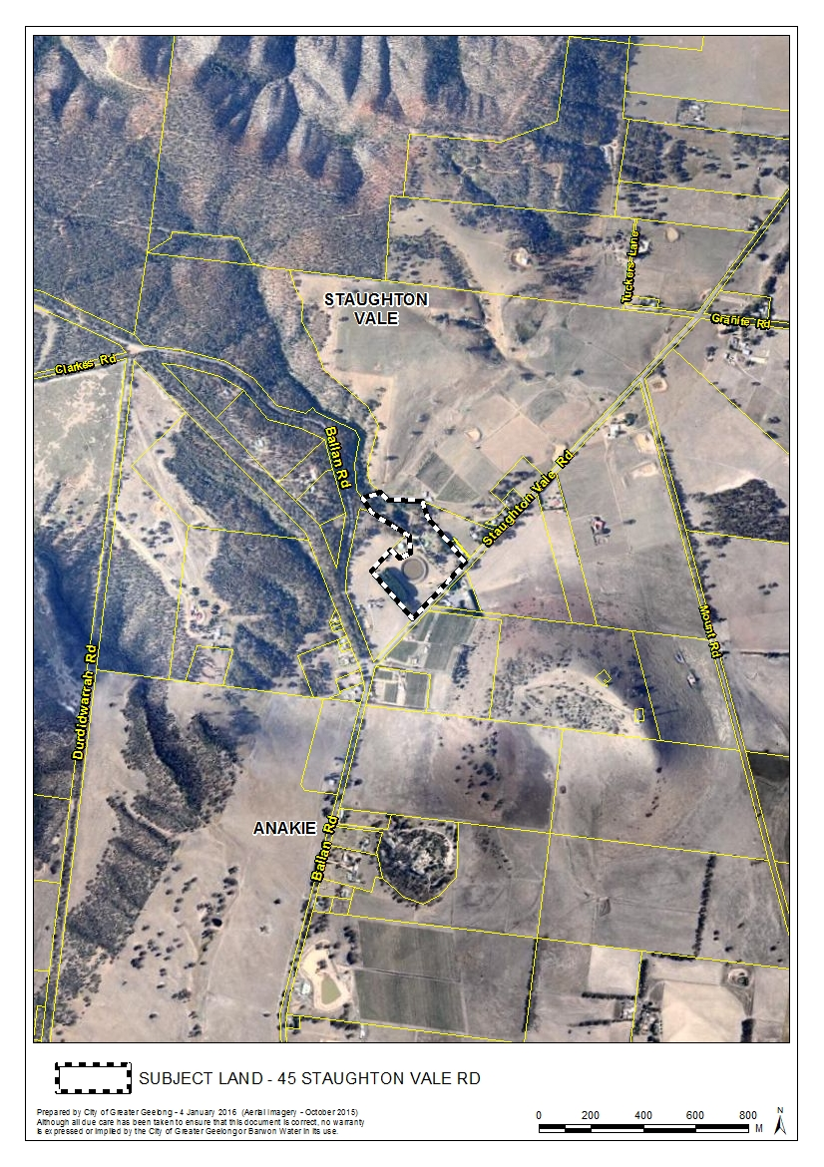
Appendix 2 Current zoning – 45 Staughton Vale Road

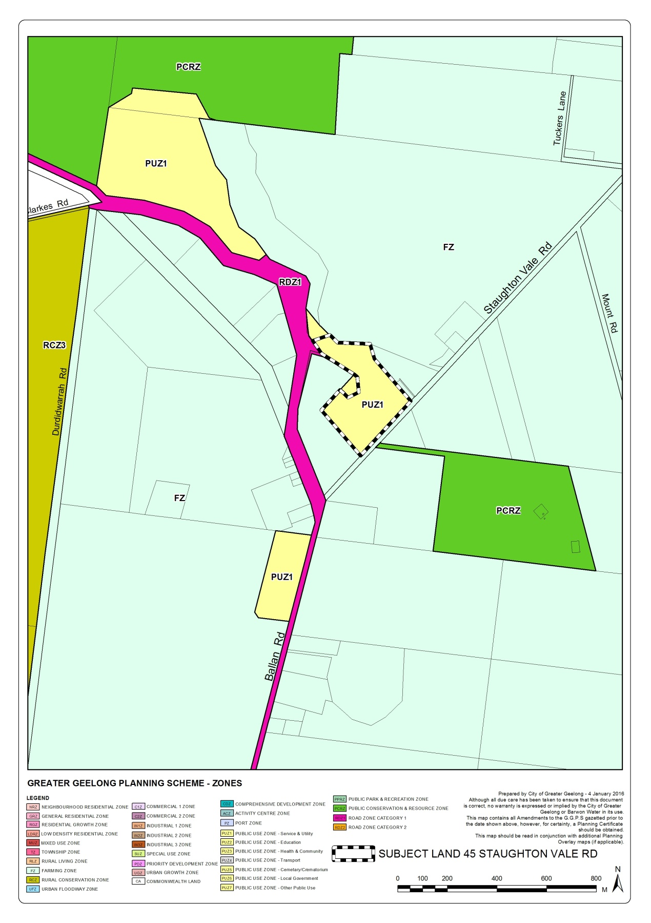
Appendix 3 Proposed zoning – 45 Staughton Vale Rd, 2395 Ballan Rd
Appendix 4 Proposed overlay – 45 Staughton Vale Road

Appendix 5 Location Plan – 2395 Ballan Road

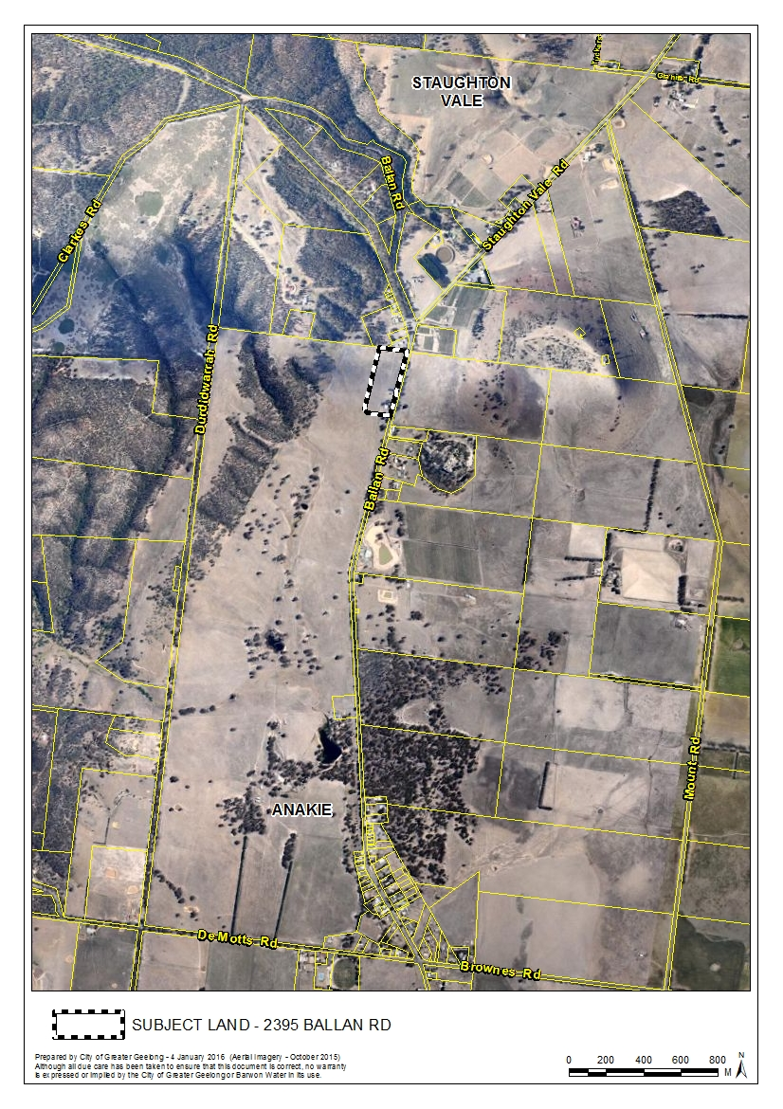

Appendix 6 Current zoning – 2395 Ballan Road

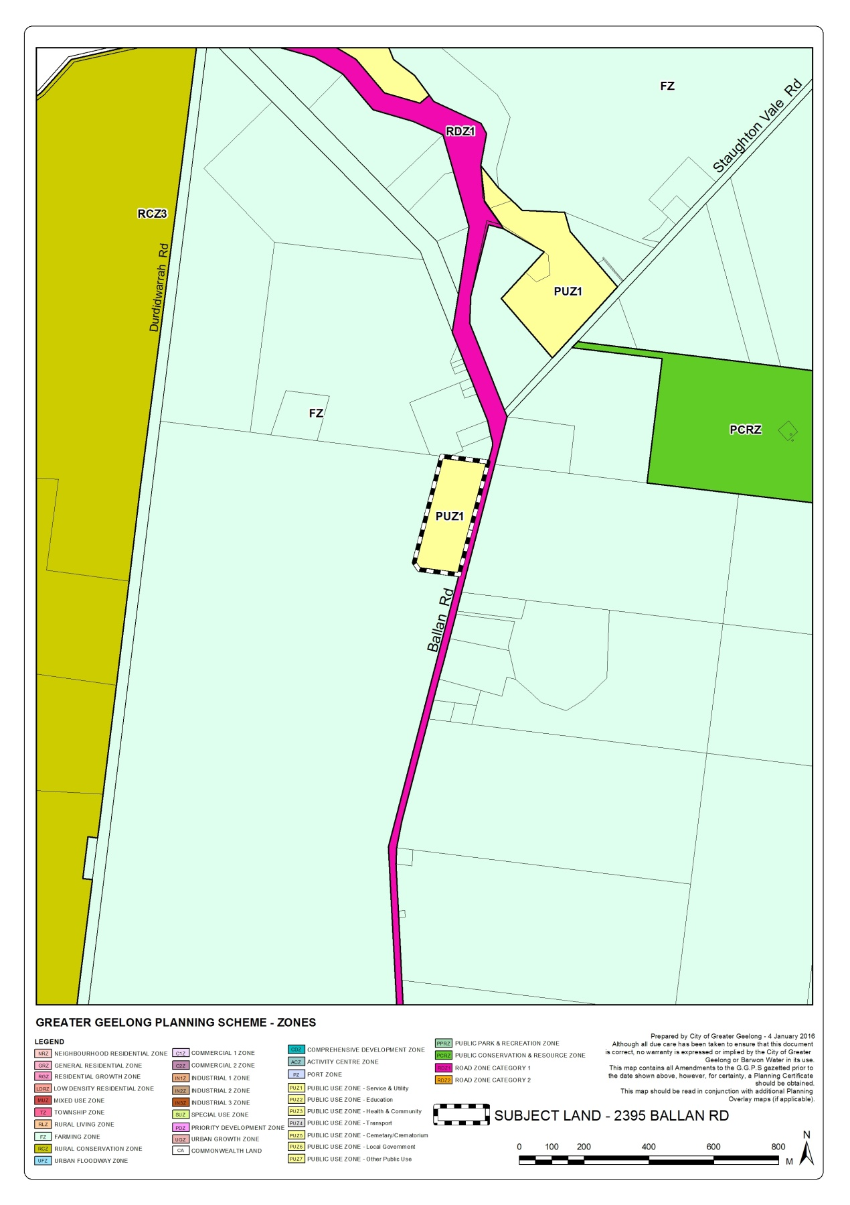

Appendix 7 Location Plan – 600 Anakie Road

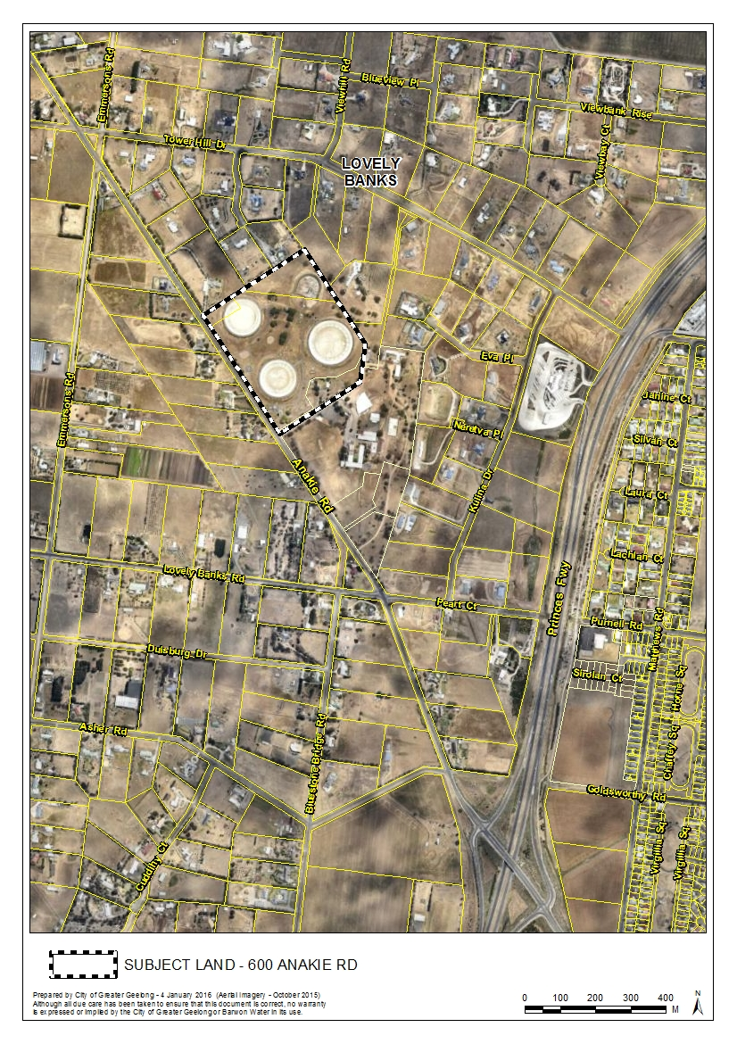

Appendix 8 Current zoning – 600 Anakie Road

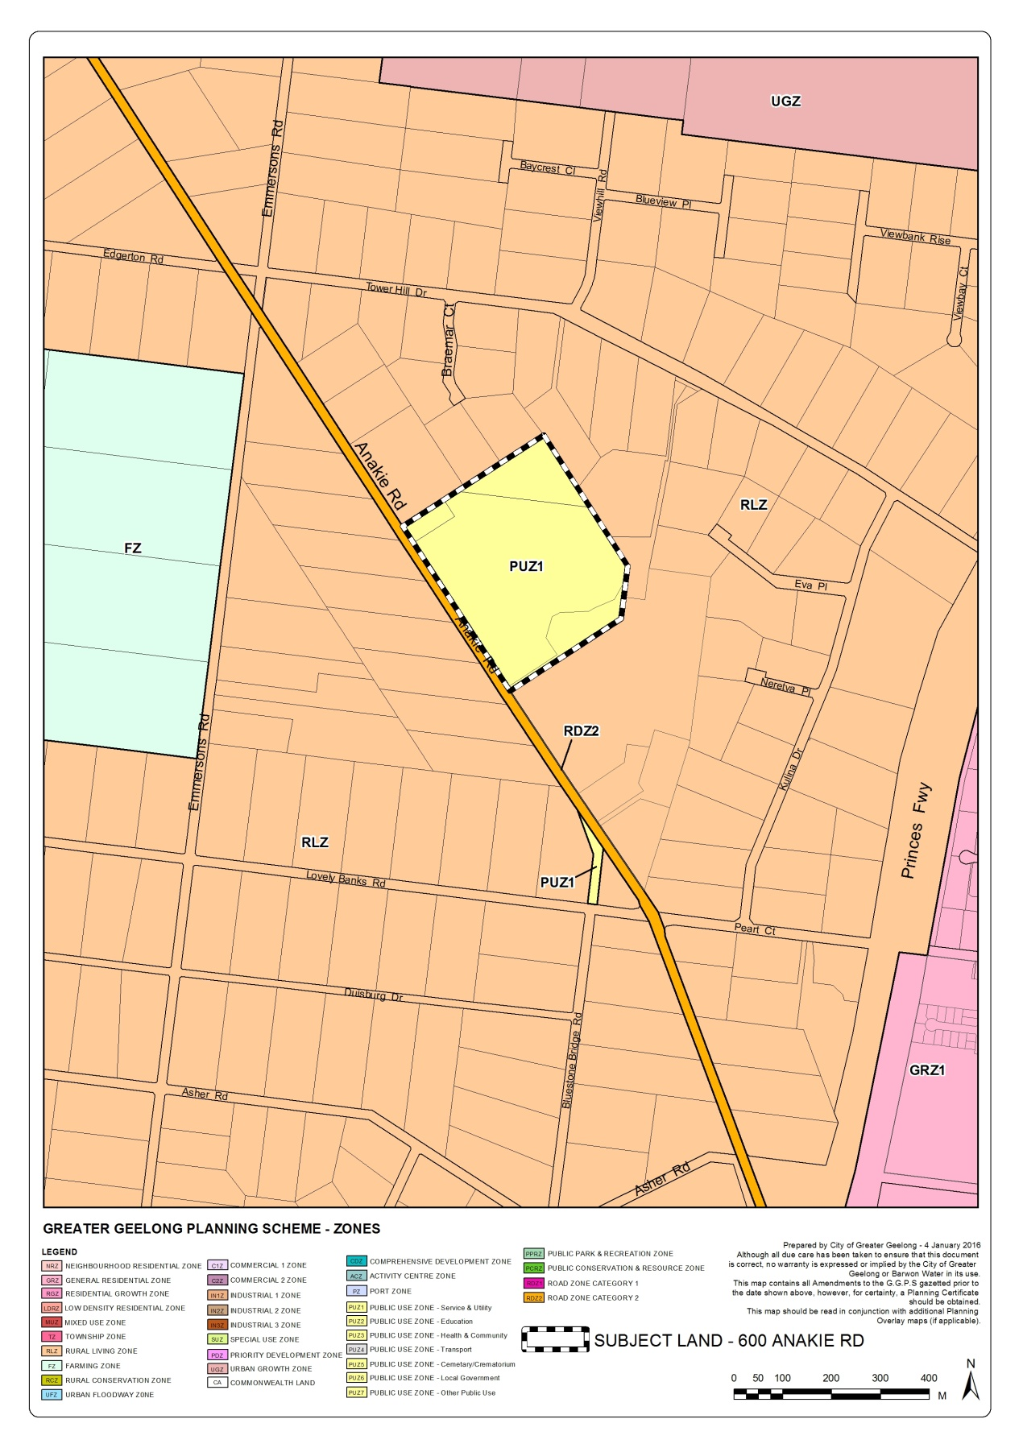

Appendix 9 Proposed zoning – 600 Anakie Road

Appendix 10 Proposed overlay deletion – 600 Anakie Road

Appendix 11 Plan of subdivision – 600 Anakie Road

Appendix 12 Location Plan – 38-42 Mainsail Drive

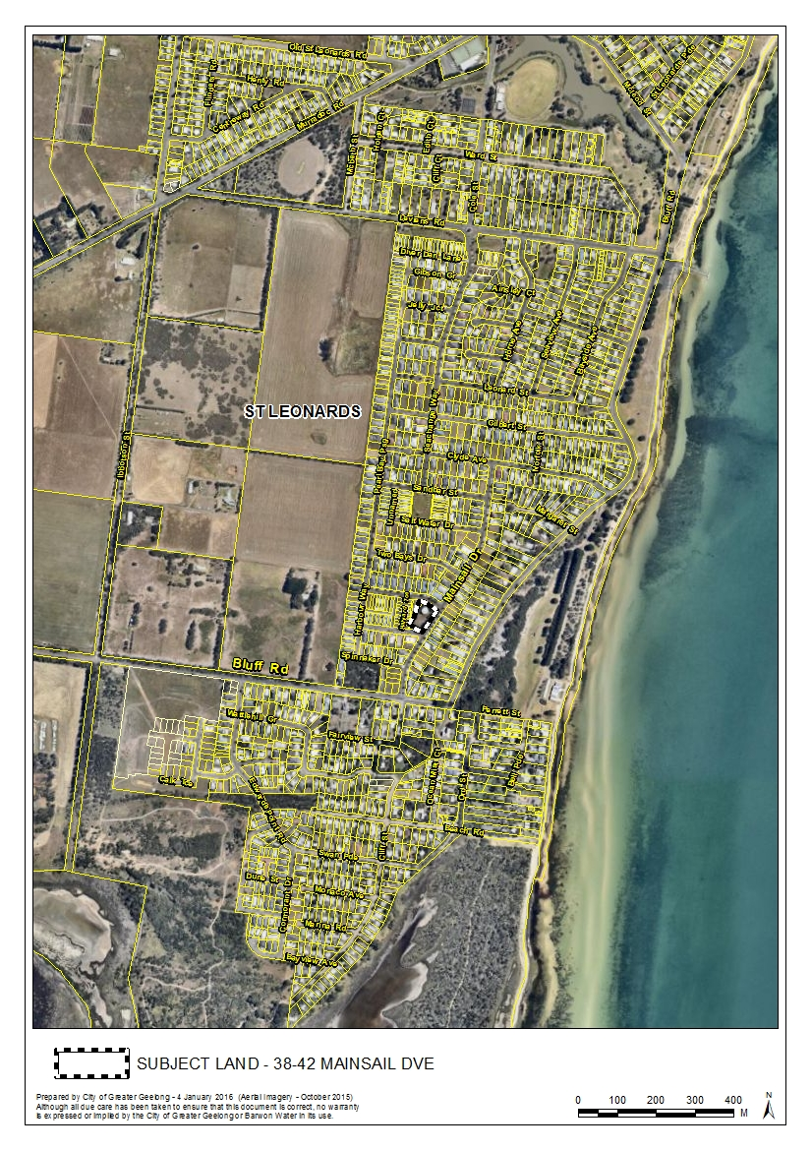

Appendix 13 Current zoning – 38-42 Mainsail Drive

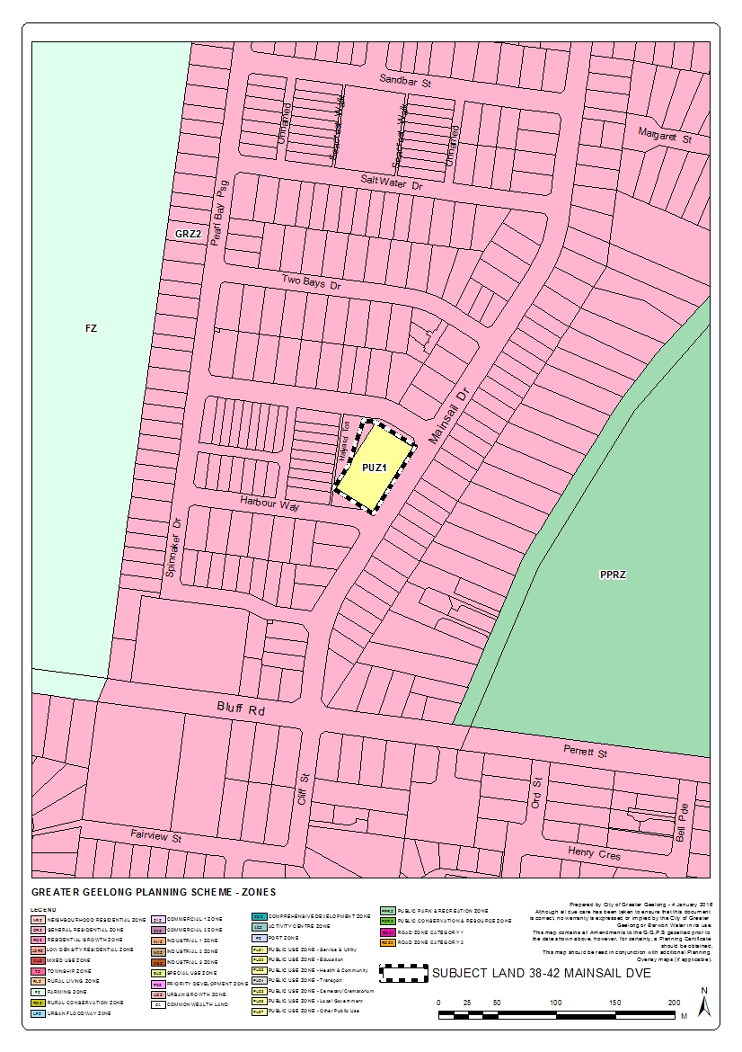

Appendix 14 Proposed zoning – 38-42 Mainsail Drive

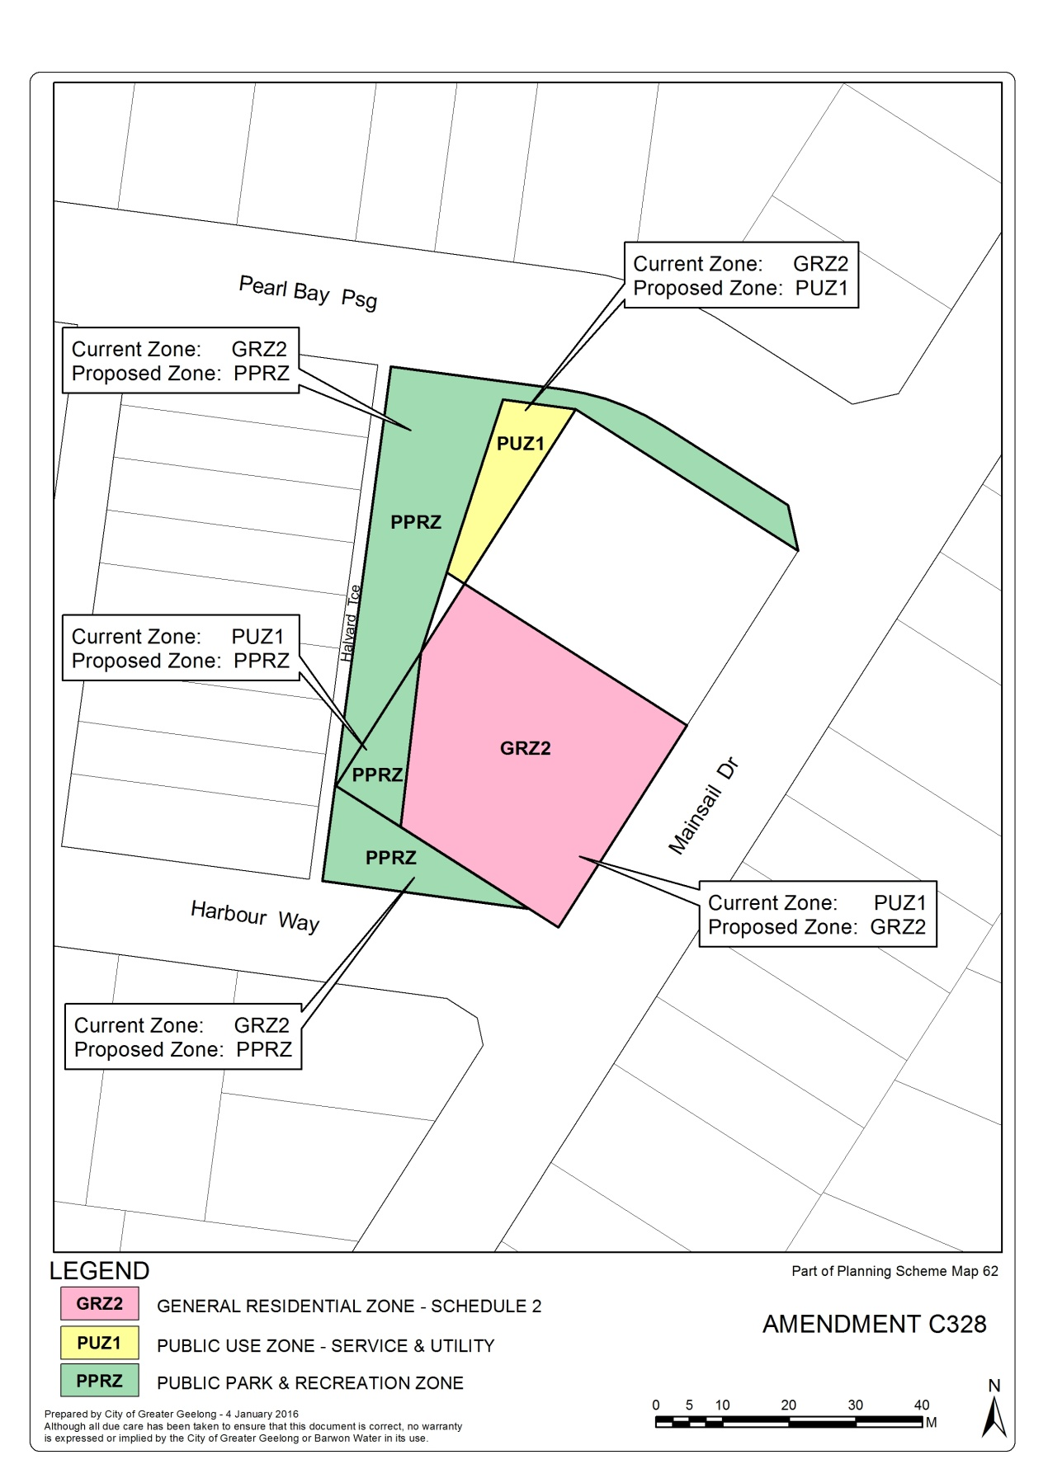

Appendix 15 Proposed overlay changes – 38-42 Mainsail Drive

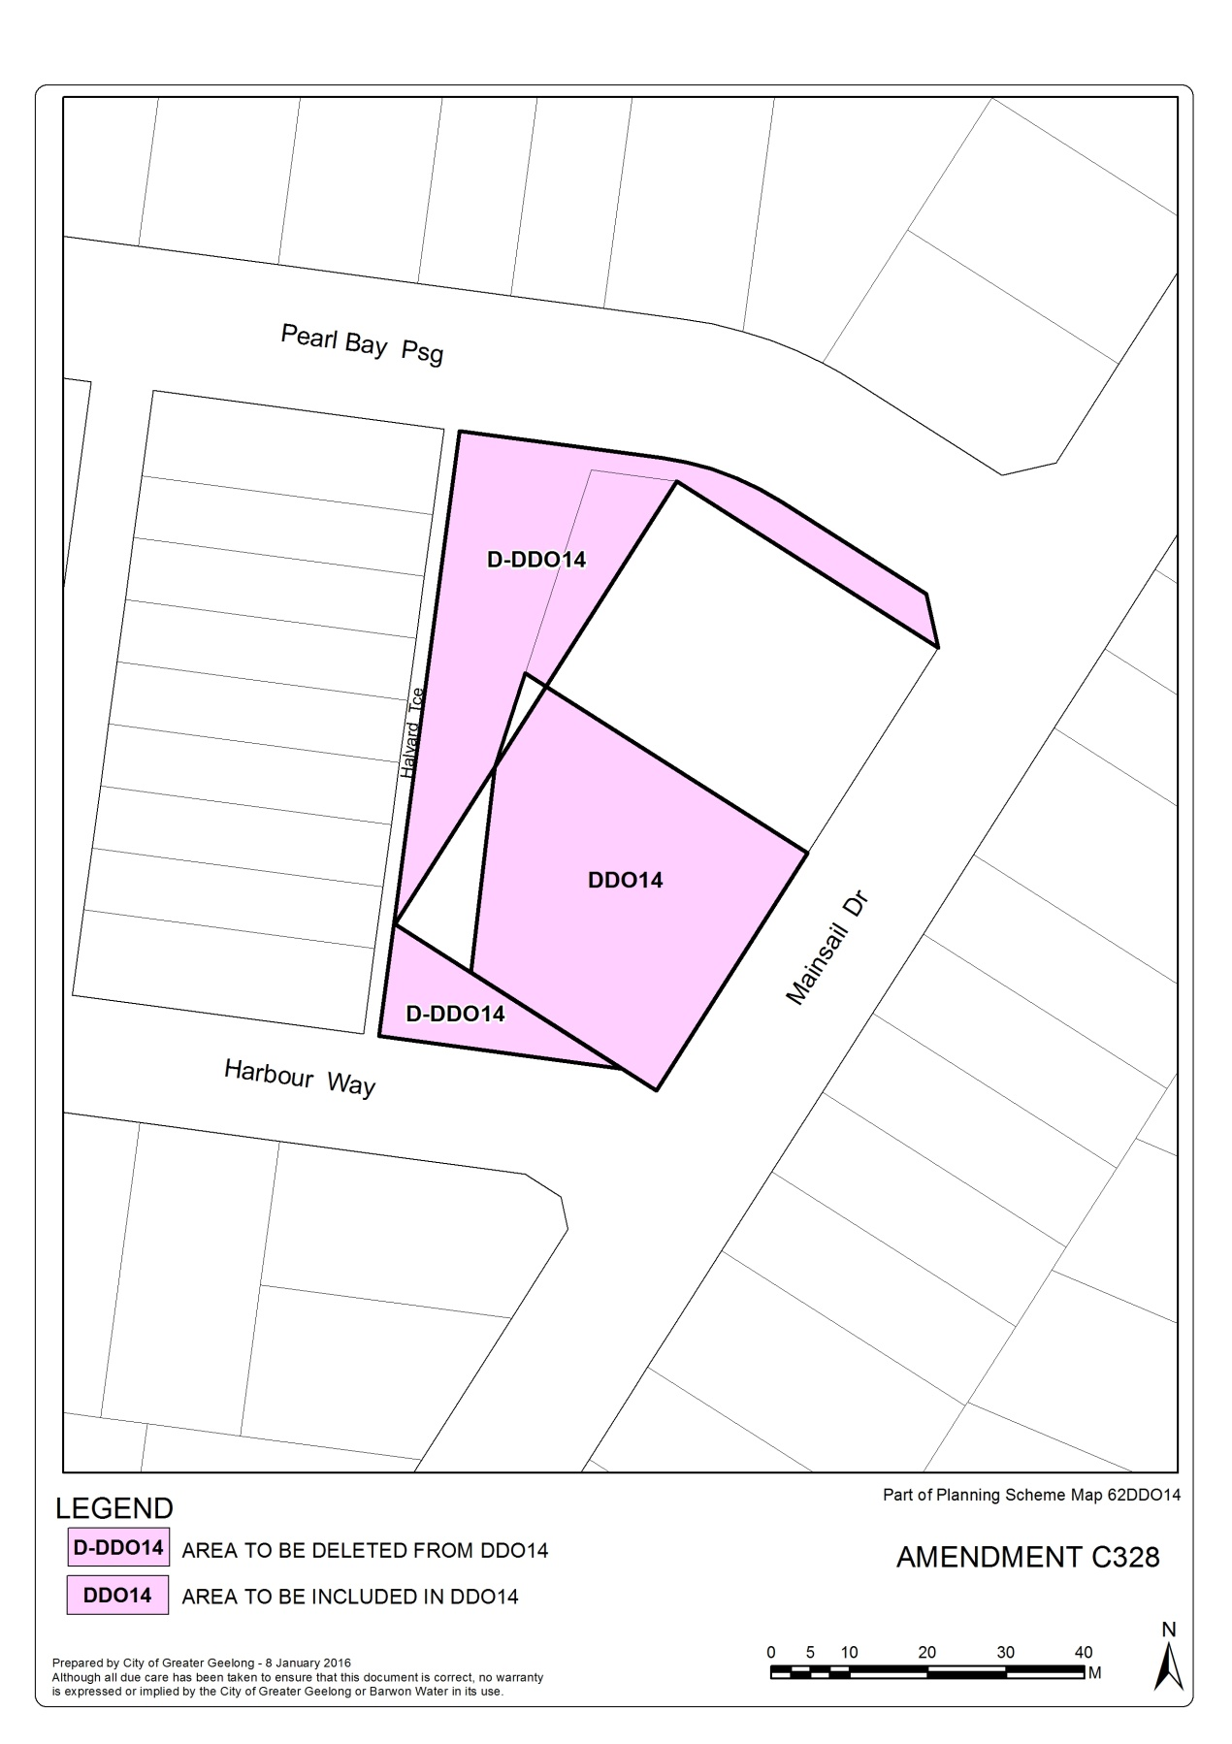
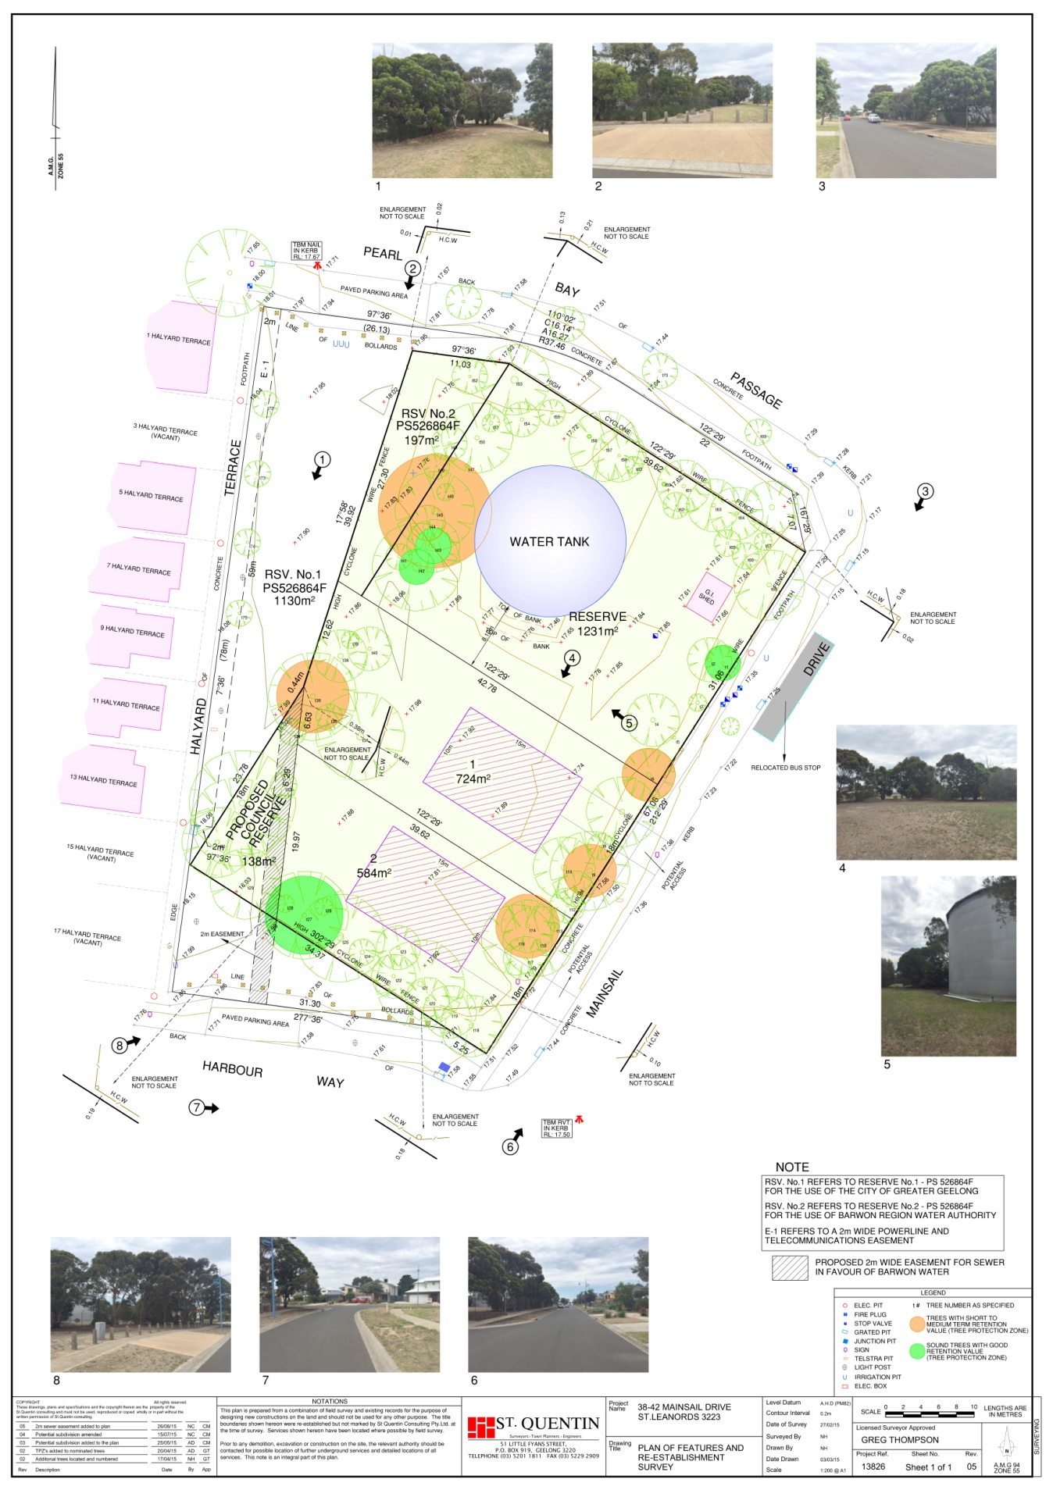
Appendix 16 Plan of subdivision – 38-42 Mainsail Drive

