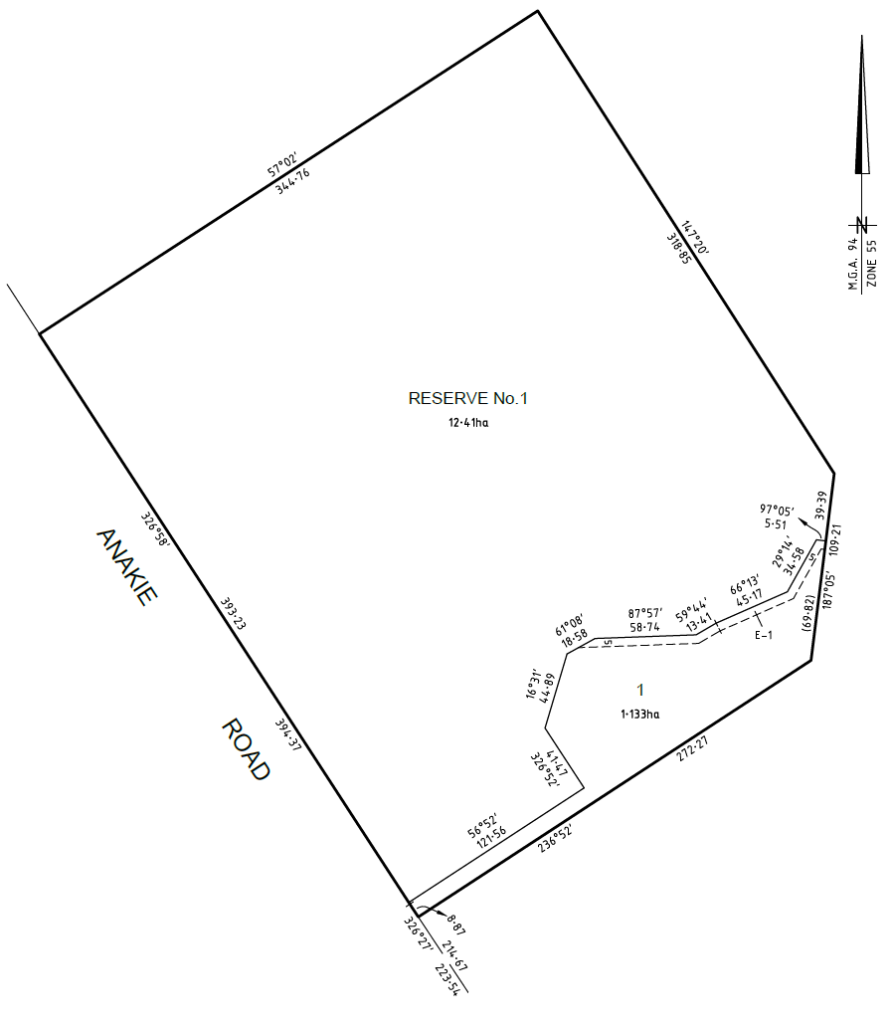

www.smec.com
Planning Application Report
2 Lot Subdivision - 600 Anakie Road, Lovely Banks
Concurrent Application & Amendment C328
July 2015
Table of Contents
1 Introduction 3
1.1 Project Synopsis 3
1.2 Assessment Summary 3
2 Site and Context Description 4
2.1 Parcel details 4
2.2 Site conditions 5
2.3 Surrounding area 5
3 Proposal 6
4 Planning Controls 7
4.1 State Planning Policy Framework (SPPF) 7
4.2 Municipal Strategic Statement 7
4.3 Local Planning Policy Framework (LPPF) 8
4.3.1 Clause 22.04 ‘Use and Development in Rural Living Areas’ 8
4.3.2 Clause 22.09 ‘Cultural Heritage’ 8
4.4 Zoning 9
4.4.1 Public Use Zone (PUZ1) 9
4.4.2 Rural Living Zone (RLZ) 9
4.5 Overlays 11
4.5.1 Heritage Overlay (HO1721) 11
4.5.2 Environmental Significance Overlay (ESO4) 12
4.6 Particular Provisions 12
4.6.1 Clause 52.01 ‘Public Open Space Contribution and Subdivision’ 12
4.7 General Provisions 12
4.7.1 Clause 65 ‘Decision Guidelines’ 12
4.7.2 Clause 66 ‘Referral and Notice Provisions’ 13
5 Conclusion 14
Appendix A Certificate of Title 15
Appendix B Proposed Plan of Subdivision 16

Introduction
SMEC acts on behalf of Barwon Regional Water Corporation (Barwon Water) in relation to this planning permit application. Barwon Water own the land and have proposed to subdivide a portion in the south-east of the site, as it is no longer required for their ongoing use. The portion contains an existing residential dwelling and the subdivision would facilitate the appropriate ownership and planning provision of the land.
The proposal is to subdivide the land into two (2) lots. The application is to be assessed simultaneously with the proposed Planning Scheme Amendment C328, which seeks to amend a number of Barwon Water sites throughout the municipality. The amendment seeks to rezone the smaller of the two proposed lots to the Rural Living Zone (RLZ) and deletes the Heritage Overlay (HO1721) from the proposed lot.
Use and development on the site is governed by the Greater Geelong Planning Scheme. The site is within a Public Use Zone (PUZ1) and a planning permit is required to subdivide the land.
This planning permit application seeks approval for the subdivision of land and this report provides an assessment of the proposal against the provisions of the Greater Geelong Planning Scheme.

Project Synopsis

Parcel Details | Lot 1 on Title Plan 951640T  Lots 1 & 2 on Title Plan 951638E
Planning Controls | ZONE:  OVERLAYS: | Public Use Zone (PUZ1)  Rural Living Zone (RLZ)  Heritage Overlay (HO1721)  Environmental Significance Overlay (ESO4)
Development Proposal | TOTAL SITE AREA: | 13.543ha
Development Proposal | SUBDIVISION AREA: | Reserve 1 | 12.41ha
Development Proposal | SUBDIVISION AREA: | Lot 1 | 1.133ha
Planning Permit Trigger | Subdivide land - Clause 35.03-3 (RLZ), Clause 36.01-2 (PUZ1)
Is The Application Exempt From Advertising | No

Assessment Summary
The assessment of the proposed subdivision within this report is to be read in conjunction with the zoning amendments proposed to the site through Planning Scheme Amendment C328. Because of this, the assessment being undertaken relates to the planning controls applicable to the south-east portion of the site, which is proposed to be rezoned within the Rural Living Zone (RLZ) and not covered by the Heritage Overlay (HO1721) or the Environmental Significance Overlay (ESO4).

Site and Context Description

Parcel details
The site is located at 600 Anakie Road, Lovely Banks. Title details are shown below and full details at Appendix A.

Land Description | Volume | Folio
Lot 1 on Title Plan 951640T | 11411 | 126
Lot 1 on Title Plan 951638E | 11411 | 349
Lot 2 on Title Plan 951638E | 11411 | 350

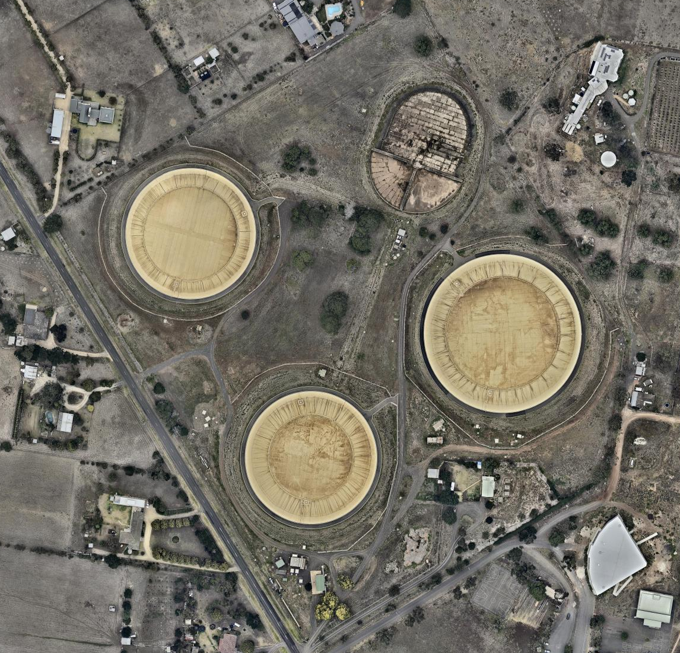
Figure 1: Aerial view of site SITE

Site conditions
The site is located on the north side of Anakie Road, approximately 1km from the Geelong Bypass, and approximately 11km north of the Geelong CBD. The site is accessed via a number of entrances in the southern corner of the site on Anakie Road and predominantly contains four water reservoirs and associated ancillary buildings. The south-east portion of the site to be subdivided comprises an existing dwelling and is used for residential purposes.
The site is currently used as a utility site by Barwon Water. The reservoirs and ancillary buildings within the site have historical significance as the first water source for Geelong, and are covered by a heritage overlay for their protection. The site is currently separated from the portion of land to be subdivided in the south-east by a temporary fence, approximately arranged in an identical location to the subdivision being proposed.
Apart from the water reservoirs and ancillary buildings, the site is predominantly vacant, with some scattered vegetation located within the central and northern portions of the site, as well as the residential dwelling in the south-east. Ancillary buildings are also scattered but are predominantly located within the southern and central portions of the site.

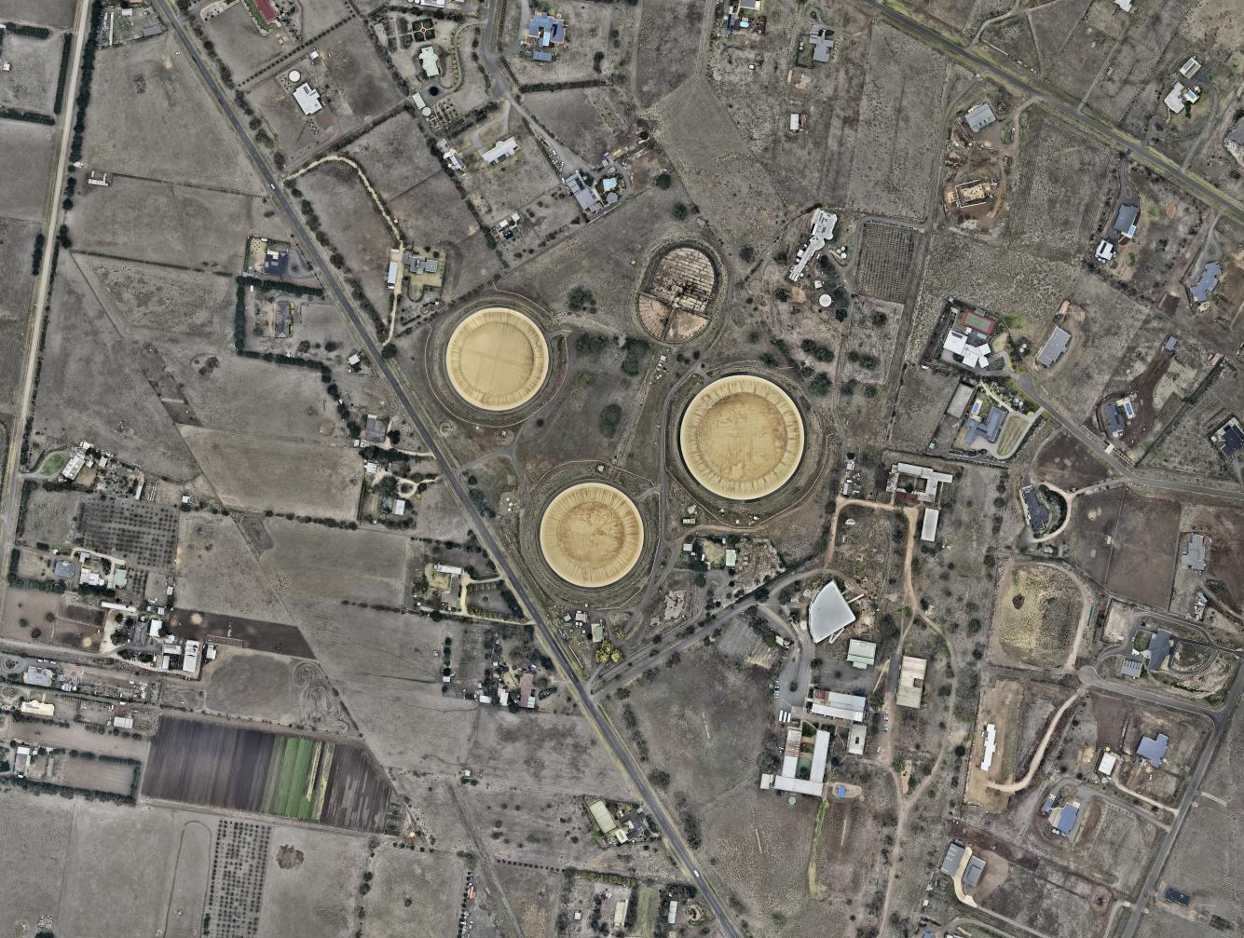
Figure 2: Aerial view of surrounds SITE

Surrounding area
The site is located within a rural residential area, stretching from the Geelong Bypass in the east to Evans Road in the west. Agricultural land is located further west of Evans Road, while urban growth has been earmarked for land further north of the existing residential area.
A school (Geelong Baptist College) is located directly south-east of the site, while rural residential developments are located directly north, west and south of the site.

Proposal
The proposal is to subdivide the land into two (2) lots. The portion of the site being subdivided is located within the south-east and comprises an existing dwelling currently used for residential purposes. The subdivision would separate the title to allow the ongoing use of the site by Barwon Water (Reserve 1), and the ongoing use of the south-east portion of the site as a residential dwelling.
Both titles have existing access to Anakie Road and would continue to do so under this arrangement. The residential land would be accessed via a 10m wide, 122m long vehicle accessway from Anakie Road and creates a 1.133ha lot. An easement (E-1) would also be created as part of the subdivision, which is required for the allowance of future pipeline infrastructure.
A full set of plans showing the proposed Plan of Subdivision is provided at Appendix B.

Figure 3: Proposed Plan of Subdivision

Planning Controls
This section outlines the planning controls and policies of the Greater Geelong Planning Scheme that are relevant to this proposal.

State Planning Policy Framework (SPPF)
The following clauses of the SPPF are considered relevant to the proposed subdivision of the subject site.

Clause 11.05-1 ‘Regional settlement networks’ seeks to promote the sustainable growth and development of regional Victoria through a network of settlements identified in the Regional Victoria Settlement Framework plan.
Clause 11.05-4 ‘Regional planning strategies and principles’ seeks to develop regions and settlements which have a strong identity, are prosperous and are environmentally sustainable.
Clause 11.07 ‘Geelong (G21) regional growth’ seeks to optimise infrastructure and consolidate growth; to create unique and connected communities; and to allow communities to live, work and participate locally.
Clause 14.02-1 ‘Catchment planning and management’ seeks to assist the protection and, where possible, restoration of catchments, waterways, water bodies, groundwater, and the marine environment.
Clause 14.02-3 ‘Water conservation’ seeks to ensure that water resources are managed in a sustainable way.
Clause 15.01-3 ‘Neighbourhood and subdivision design’ seeks to ensure the design of subdivisions achieves attractive, liveable, walkable, cyclable, diverse and sustainable neighbourhoods.
Clause 15.03-1 ‘Heritage conservation’ seeks to ensure the conservation of places of heritage significance.
Clause 16.01-1 ‘Integrated housing’ seeks to promote a housing market that meets community needs.
Clause 16.02-1 ‘Rural residential development’ seeks to identify land suitable for rural living and rural residential development.
Clause 19.03-2 ‘Water supply, sewerage and drainage’ seeks to plan for the provision of water supply, sewerage and drainage services that efficiently and effectively meet State and community needs and protect the environment.

ASSESSMENT OF SPPF
The proposed subdivision provides a more appropriate response to the current and ongoing use of the land. Appropriately sited rural residential land is provided as part of the subdivision which is presently used for residential purposes and generally in accordance with the residential nature of the local area. The subdivision simultaneously provides a more effective response to the ongoing conservation and protection of a highly-quality, valuable heritage site, whilst differentiating between the existing residential and utilitarian nature of the site.

Municipal Strategic Statement
The following clauses of the MSS are considered relevant to the proposed subdivision of the subject site.
The MSS breaks down objectives and strategies into a number of different sections. Objectives that area relevant to the proposed subdivision include:
- To provide for the consolidation of urban areas in a managed way.
- To encourage an appropriate range of development densities.
- To conserve and enhance individual places and areas of pre and post contact cultural heritage significance.
- To ensure that rural areas provide an attractive setting through the preservation of a farmed rural landscape.

ASSESSMENT OF MSS
The proposed subdivision responds to the objectives of the MSS by managing the consolidation of urban growth within a rural setting which complements the existing low-density character of the area and by conserving and enhancing a highly valued heritage site within the municipality.

Local Planning Policy Framework (LPPF)
The following clauses of the LPPF are considered relevant to the proposed subdivision of the subject site.

Clause 22.04 ‘Use and Development in Rural Living Areas’
Clause 22.04 seeks to:
- Protect the amenity of rural living and low density residential locations from activities incompatible with the primary residential purposes of the zones.
- Maintain the semi rural and low density character of these locations.
- Protect areas of high environmental quality.
- Ensure effective disposal of wastewater and stormwater drainage.
- Ensure the subdivision of land creates lots which a clearly identifiable street frontage.
Pursuant to the Clause, where a permit is required for subdivision, it is policy to:
- Discourage uses which are likely to disturb the residential amenity such as animal boarding and dog keeping.
- Discourage intensive urban activities providing accommodation for large numbers of people or which attract substantial numbers of visitors to a site.
- Discourage second dwellings on a lot.
- Require new vehicle access ways to have a minimum width of 4m where the length of the driveway exceeds 30m.
- Require new lots to have a minimum street frontage of 4m.

ASSESSMENT OF CLAUSE 22.04
The proposed subdivision seeks to differentiate the existing uses of the land, none of which are considered to disturb the residential amenity of the local area or encourages large numbers of people to the site. No second dwellings are proposed on either lots and the proposed vehicle accessway complies with the requirements by providing site access which is 10m wide.

Clause 22.09 ‘Cultural Heritage’
Clause 22.09 seeks to:
- Encourage the retention of culturally significant and contributory heritage places within Heritage Overlay areas.
- Encourage development to be undertaken in accordance with the accepted conservation standards of the ICOMOS Burra Character.
- Conserve and enhance the natural or cultural features of an area or site and to ensure that any alterations or development complement their form and appearance.
- Ensure that new development and external alterations of existing buildings make a positive contribution of the built form and amenity of the area.
- Encourage the retention or re-instatement of streetworks including street trees and bluestone kerbs, street construction form, asphalt footpaths, channels and crossovers.
Pursuant to the Clause, where a permit is required for subdivision (as relevant to this proposal), it is policy to:
- Require that all buildings and works should be in accordance with the City of Greater Geelong Heritage and Design Guidelines, 1997.
- Require an application to subdivide land to provide documentation which demonstrates:
  - That the pattern of the proposed subdivision will not adversely affect the significance of the original subdivision.
  - How the subdivision will enhance/conserve the significance of the surrounding heritage buildings and/or precinct.
  - That the effects of the subdivision on the cultural heritage significance of the place are minimised.

ASSESSMENT OF CLAUSE 22.09
The Heritage Overlay applying to the site (HO1721) is proposed to be deleted from the 1.133ha lot, as it does not comprise any elements of heritage significance that are covered by HO1721. The Heritage Overlay will be retained on the 12.41ha lot to continue to enhance and conserve the significance of the heritage buildings/precinct on the land, which is complemented by the proposed subdivision through the separation of the existing residential use.
The subdivision is minimal in nature (two lot subdivision) and would not impact the heritage significance of the overall site. The site is also not within a cultural heritage sensitivity area.

Zoning
The site is currently located within the Public Use Zone (PUZ1), however this application is to be assessed in conjunction with the proposed Planning Scheme Amendment C328, which rezones the land to be subdivided within the Rural Living Zone (RLZ) and this zone will ultimately be used to guide the assessment of the proposed subdivision.

Public Use Zone (PUZ1)
Pursuant to the PUZ1, a planning permit is required to subdivide land. It should also be noted that an application for a permit by a person other than the relevant public land manager must be accompanied by the written consent of the public land manager. Because Barwon Water are the relevant public land managers of the site, no written consent is required.

Rural Living Zone (RLZ)
The subject site is located in the Rural Living Zone (RLZ). The purposes of the RLZ are:
- To provide for residential use in a rural environment.
- To provide for agricultural land uses which do not adversely affect the amenity of surrounding land uses.
- To protect and enhance the natural resources, biodiversity and landscape and heritage values of the area.
- To encourage use and development of land based on comprehensive and sustainable land management practices and infrastructure provision.
Pursuant to the RLZ, a planning permit is required to subdivide land.
The Clause states that each lot must be at least the area specified for the land in a schedule to this zone. If no area is specified, each lot must be at least 2 hectares. The Clause also states that a permit may be granted to create smaller lots if any of the following apply:
- The subdivision is the re-subdivision of existing lots and the number of lots is not increased.
- The number of lots is no more than the number the land could be subdivided into in accordance with a schedule to this zone.
- The subdivision is by a public authority or utility service provider to create a lot for a utility installation.

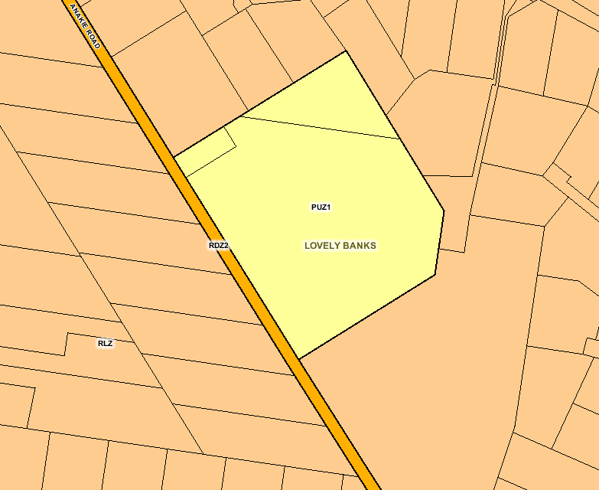
Figure 4: Zoning Map SITE

The Schedule to the RLZ provides a requirement for the minimum subdivision area. It is as follows:
- Minimum subdivision area of 1ha, with the average area of lots in a subdivision being at least 1.5ha (for the purpose of calculating average area, all lots exceeding 3ha must be considered as 3ha, and the balance of a staged subdivision should be excluded).
All other requirements specified in the Schedule to the RLZ are not applicable to this application.
In determining the application the Council will need to consider the following Decision Guidelines, as relevant to this proposal:
- Any Regional Catchment Strategy and associated plan applying to the land.
- The capability of the land to accommodate the proposed use or development.
- Whether the site is suitable for the use or development and whether the proposal is compatible with adjoining and nearby land uses.
- The impact on the natural physical features and resources of the area and in particular any impact caused by the proposal on soil and water quality and by the emission of noise, dust and odours.
- The impact of the use or development on the flora, fauna and landscape features of the locality.
- The need to protect and enhance the biodiversity of the area, including the need to retain vegetation and faunal habitat and the need to revegetate land including riparian buffers along waterways, gullies, ridgelines, property boundaries and saline discharge and recharge area.
- The location of on-site effluent disposal areas to minimise the impact of nutrient loads on waterways and native vegetation.
- The impact on the character and appearance of the area or features of architectural, historic or scientific significance or of natural scenic beauty or importance.
- The location and design of existing and proposed infrastructure including roads, gas, water, drainage, telecommunications and sewerage facilities.
- Whether the use or development will require traffic management measures.

ASSESSMENT OF THE RLZ
A permit is required to subdivide the land, and this application is not exempt from advertising requirements.
The subdivision of the subject site creates two lots, one which is 1.133ha and the other 12.41ha. The size complies with the minimum subdivision area specified within the Schedule to the RLZ. Both lots are greater than the minimum 1ha required and the average area of the lots (2.067ha) is greater than the minimum 1.5ha required.
In response to the Decision Guidelines, the proposed development comprises of the subdivision of land exclusively and does not propose any development that would not be appropriately supported by the land or adversely affect any adjoining properties.
The impact of the proposed subdivision on the natural features, vegetation, resources, and fauna on the site is insignificant, with no adverse potential originating from the proposal. No changes are proposed to the built form, siting or design on the subject site and the subdivision would not negatively impact the heritage significance of the land or any contributory elements located within it.

Overlays
There are no overlays applicable to the proposed subdivided portion of the land. The existing land title is covered by the Heritage Overlay (HO1721) and the Environmental Significance Overlay (ESO4). The following provides justification for the applicability of the overlays to this assessment.

Heritage Overlay (HO1721)
Proposed Planning Scheme Amendment C328 seeks to delete the Heritage Overlay (HO1721) from the portion of the subject site being subdivided, as it does not comprise any historical or heritage values specifically relevant to HO1721.
HO1721 specifically relates to the Barwon Water Lovely Banks Basin. Notably, the dominant heritage values comprised within the site are the water reservoirs and other structures ancillary to the former use of the land as the water supply of the Geelong region during the later nineteenth century.
Because the HO1721 does not apply to the subdivided land it is not applicable to this application.

Environmental Significance Overlay (ESO4)
The subject site is partially covered by the Environmental Significance Overlay (ESO4), in the northern portion of the land. ESO4 specifically relates to Grasslands within the Werribee Plains Hinterland. As stated, the ESO4 only relates to the northern portion of the land, and does not cover the subdivided portion of the site in the south-east.
Because the ESO4 does not apply to the subdivided land it is not applicable to this application.

Particular Provisions
The following Particular Provisions are considered relevant to the proposed subdivision of the subject site.

Clause 52.01 ‘Public Open Space Contribution and Subdivision’
Clause 52.01 requires, ‘a person who proposes to subdivide land must make a contribution to the council for public open space in an amount specified in the schedule to this Clause. If no amount is specified, a contribution for public open space may still be required under Section 18 of the Subdivision Act 1988’.

ASSESSMENT OF CLAUSE 52.01
The schedule to this clause does not specify a public open space contribution for the subject site because the subdivision of land is zoned for rural residential purposes, creating one (1) additional lot, which does not require a contribution.

General Provisions
The following General Provisions are considered relevant to the proposed subdivision of the subject site.

Clause 65 ‘Decision Guidelines’
Approval of an application or plan, states that before deciding on an application to subdivide land, the responsible authority must also consider, as appropriate:
- The suitability of the land for subdivision.
- The existing use and possible future development of the land and nearby land.
- The availability of subdivided land in the locality, and the need for the creation of further lots.
- The effect of development on the use or development of other land which has a common means of drainage.
- The subdivision pattern having regard to the physical characteristics of the land including existing vegetation.
- The density of the proposed development.
- The area and dimensions of each lot in the subdivision.
- The layout of roads having regard to their function and relationship to existing roads.
- The movement of pedestrians and vehicles throughout the subdivision and the ease of access to all lots.
- The provision and location of reserves for public open space and other community facilities.
- The staging of the subdivision.
- The design and siting of buildings having regard to safety and the risk of spread of fire.
- The provision of off-street parking.
- The provision and location of common property.
- The functions of any body corporate.
- The availability and provision of utility services, including water, sewerage, drainage, electricity and gas.
- If the land is not sewered and no provision has been made for the land to be sewered, the capacity of the land to treat and retain all sewage and sullage within the boundaries of each lot.
- Whether, in relation to subdivision plans, native vegetation can be protected through subdivision and siting of open space areas.
Clause 65 does not introduce any additional decision making criteria that has not been considered as part of the applicable planning controls.

Clause 66 ‘Referral and Notice Provisions’
Clause 66 sets out referral and notice requirements. The application must be referred to the following authorities pursuant to Clause 66.01. All referral authorities have 28 days to respond to a referred application.

Conclusion
The proposed subdivision would facilitate the parting of separate land uses currently being undertaken on the site. The residential component proposed through the subdivision creates a lot which complements the low-density, rural nature of the local residential area. The site provides a generous frontage and vehicular access that meets the requirements specified in the Rural Living Zone.
In conjunction with the residential component, the subdivision would enable the ongoing conservation of the heritage site currently utilised by Barwon Water. The site is of heritage significance to the Greater Geelong municipality and would continue to be protected through the separation of land uses which may have impacted on heritage elements of the site.
The proposed subdivision would not adversely affect the ongoing purpose of the land or the heritage elements valued within it, ultimately providing a more efficient and appropriate use of land within the subject site and its surrounds.
As demonstrated in this report the proposal is appropriate and warrants Council approval.

- Certificate of Title

- Proposed Plan of Subdivision

DOCUMENT / REPORT CONTROL FORM

File Location Name: | L:\Work\FEAS\Paid\30048000F.00_Barwon Water Property Realisation\#8 Anakie Road, Lovely Banks\Docs\Reports\150729_RO_PP App Report_Lovely Banks 2 lot sub.docx
Project Name: | #8 Anakie Road, Lovely Banks
Project Number: | 30048000F
Revision Number: | FINAL

Revision History
Revision # | Date | Prepared by | Reviewed by | Approved for Issue by
DRAFT | 22.07.15 | Nick Felstead  Petar Simic | Justine Williams | Justine Williams
FINAL | 29.07.15 | Nick Felstead | Justine Williams | Justine Williams

Issue Register
Distribution List | Date Issued | Number of Copies
Barwon Water | 29.07.15 | 1
City of Greater Geelong | 29.07.15 | 1
SMEC Project File | 29.07.15 | 1

SMEC Company Details
Justine Williams
Level 10, 71 Queens Road, Melbourne VIC 3004
Tel: | 9869 0846 | Fax: | 9869 0900
Email: | justine.williams@smec.com | Website: | www.smec.com

The information within this document is and shall remain the property of SMEC.

