

Tony Belcher
Strategic Projects Coordinator
Barwon Water
61-67 Ryrie Street (PO Box 659)
Geelong VIC 3220

Cc. Chris Mason, St Quentin

24 March 2015

Dear Tony,
RE: ABORIGINAL CULTURAL HERITAGE DUE DILIGENCE

38-42 MAINSAIL DRIVE, ST LEONARDS – Lot RES2 PS526864 (c.0.28HA)
I respond to your enquiry regarding the proposed rezoning and subdivision of the property at 38-42 Mainsail Drive, St Leonards. This brief letter/report outlines the requirements of the Aboriginal Heritage Act 2006 during the planning process and assesses the risk that the proposed works pose to Aboriginal cultural heritage values. In particular, this advice assesses whether a Cultural Heritage Management Plan (CHMP) is triggered by the proposed activity under the Regulations of the Act.
In order to determine APA's obligations the following steps have been undertaken:
- a review of the Aboriginal Heritage Act 2006, including the Aboriginal Heritage Regulations 2007;
- a check of the Office of Aboriginal Affairs Victoria (OAAV) Victorian Aboriginal Heritage Register (VAHR) for place records;
- a review of previous Aboriginal archaeological assessments, where relevant;
- a check of the ‘Areas of Cultural Heritage Sensitivity’ as defined by the Aboriginal Heritage Regulations 2007; and,
- a brief site inspection.

Aboriginal Cultural Heritage Legislation
The Aboriginal Heritage Act 2006 (referred to as 'the Act' hereafter) provides blanket protection for Aboriginal cultural heritage. This means that all Aboriginal cultural heritage (recorded and as yet unrecorded) is protected from harm and it is illegal to carry out an activity that can disturb Aboriginal places without the appropriate authorities under the Act (and its associated Aboriginal Heritage Regulations 2007). There are two principal mechanisms under the Act that remove the risk of illegal harm to Aboriginal cultural heritage, namely:
- Cultural Heritage Management Plan (CHMP)
- Cultural Heritage Permit (CHP)
A CHP is relevant only where an Aboriginal place/s is registered in the works area and a CHMP is not a mandatory requirement. As this is not the case for the study area, only CHMP processes are discussed below.

Cultural Heritage Management Plan
A CHMP is a report recommending measures to be taken to protect Aboriginal cultural heritage affected by a development or use of land. It must include recommendations for measures to be taken before, during and after a relevant activity. The underlying philosophy of the CHMP is to minimise harm to Aboriginal places, however it is the document through which provisions can be made to legally harm Aboriginal places. A CHMP must be approved by a Registered Aboriginal Party or where no party exists for the area, the Secretary of the Department of Planning and Community Development, before the activity may commence.
A CHMP usually involves a staged investigation of the risk posed by a proposed activity to Aboriginal cultural heritage. The Act and associated Regulations set out the requirements for different levels of investigation:
- Desktop Assessment.
- Standard Assessment (Field Survey).
- Complex Assessment (Subsurface Testing; Controlled Excavation).
The Sponsor (usually the proponent) of a CHMP must ensure that the plan is prepared in accordance with prescribed standards which are outlined in the Act, associated Regulations, and Approved Forms. The CHMP must consider the following matters:
  - Whether the activity will be conducted in a way that avoids harm to Aboriginal cultural heritage.
  - If it does not appear to be possible to conduct the activity in a way that avoids harm to Aboriginal cultural heritage, whether the activity will be conducted in a way that minimises harm to Aboriginal cultural heritage.
  - Any specific measures required for the management of Aboriginal cultural heritage likely to be affected by the activity, both during and after the activity.
  - Any contingency plans required in relation to disputes, delays and other obstacles that may affect the conduct of the activity.
  - Requirements relating to the custody and management of Aboriginal cultural heritage during the course of the activity.
Provisions relating to enforcement of the Act include: cultural heritage audits, protection declarations and stop orders, inspection arrangements and penalties. Maximum penalties are likely to be more than $180,000 for an individual or more than $1 million for a company.
What Are The Triggers For A CHMP?
Section 46 of the Act specifies the circumstances in which preparation of a CHMP is mandatory:
- When required by the Regulations;
- When the Minister directs a CHMP to be prepared for an activity; or
- When an EES is required for an activity.
Clause 6 of the Regulations states that a CHMP is required when:
- All or part of the activity is a high impact activity.
and
- All or part of the activity area is in an area of cultural heritage sensitivity - which has not been subject to prior significant ground disturbance.
‘High impact activities’ and ‘areas of cultural heritage sensitivity’ are defined in the Regulations. For activities which trigger a CHMP, a statutory authorisation cannot be granted for the activity without an approved CHMP.
Is The Proposed Activity A High Impact Activity?
Rezoning and Subdivision
The majority of the property is currently zoned as PZZ1 – Public Use – Service & Utility (Figure 1). A small section of the property to the north west is zoned GRZ2 – General Residential Schedule 2. It is intended that the balance of the property will be rezoned General Residential in preparation for subdivision. The property will be subdivided into two lots or more.

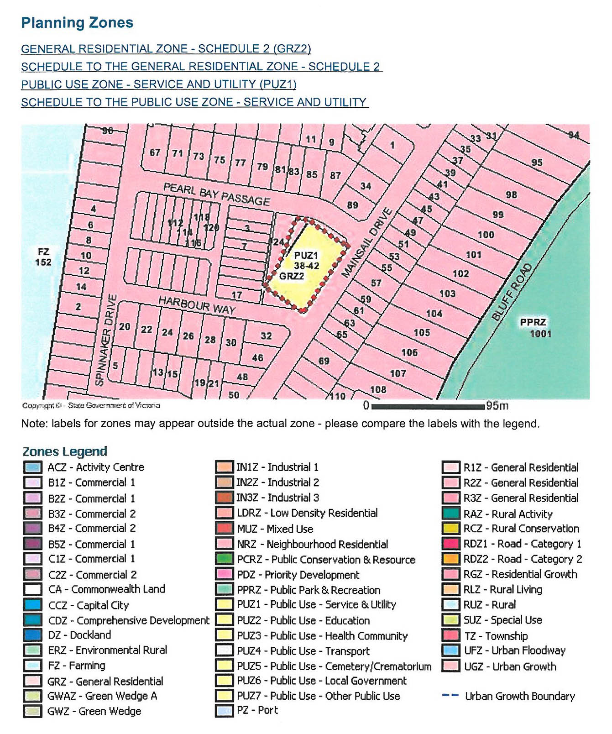
Figure 1: Planning map showing the study area.

Where the subdivision is for is for two lots or less, the Regulations imply that it is an exempt activity; Regulation 46 – Subdivision of land, states that a subdivision of land into three or more lots is a high impact activity, viz:
46 Subdivision of land
(1) The subdivision of land into three or more lots is a high impact activity if—
(a) the planning scheme that applies to the activity area in which the land to be
subdivided is located provides that at least three of the lots may be used for a dwelling or may be used for a dwelling subject to the grant of a permit; and
(b) the area of each of at least three of the lots is less than eight hectares.
By implication, subdivision of land into one or two lots is not a high impact activity. Regulation 46 makes it clear that subdivision of three or more lots is a high impact activity.
Is The Activity In An Area of Cultural Heritage Sensitivity?
In order to determine whether the study area is situated an area of Cultural Heritage Sensitivity (CHS) it is necessary to establish:
- whether the study area is in an area of CHS as defined by r.41(2) Aboriginal Heritage Regulations 2007; and if so,
- whether that area has been subject to prior significant ground disturbance which would mean that the area is not an area of cultural heritage sensitivity under r.41(3) of the Aboriginal Heritage Regulations 2007.
Figure 2 shows the location of the study area in relation to the mapped areas of Aboriginal CHS as defined by the Aboriginal Heritage Regulations 2007. The figure shows that no areas of CHS occur in the study area. As no areas of CHS occur in the study area, it is not necessary to consider whether significant ground disturbance has taken place in any part of the activity area.
Registered Aboriginal Party (RAP)
Wathaurung Aboriginal Corporation (WAC) is the appointed Registered Aboriginal Party (RAP) for the study area. RAPs have important responsibilities under the Aboriginal Heritage Act 2006 in relation to management and protection of Aboriginal cultural heritage within their RAP area. RAPs can chose to evaluate CHMPs and participate in Aboriginal cultural heritage assessment processes.
Registered Aboriginal Places
No registered Aboriginal places occur in the study area. The closest registered Aboriginal places (VAHR 7821-0797, 7821-0603 and 7821-0529) occur just over 500 m from the study area and comprise stone artefact scatters and a shell midden (in addition to stone artefact scatter at 7821-0603). Figure 3 shows the wider distribution of registered Aboriginal places in relation to the study area.
A brief analysis of Figure 3 indicates that Aboriginal places have been registered on a wide range of landforms in the region including elevated land, creeks, swamps, coastal cliffs and flat coastal plain. The majority of the Aboriginal places are stone artefacts that have been registered as artefact scatters or Low Density Artefact Distributions. In addition to VAHR 7821-0603 noted above, a shell midden (VAHR 7821-0886) is recorded c.1.5km to the north of the study area. Figure 3 shows the study area occurs on a flat coastal plain.

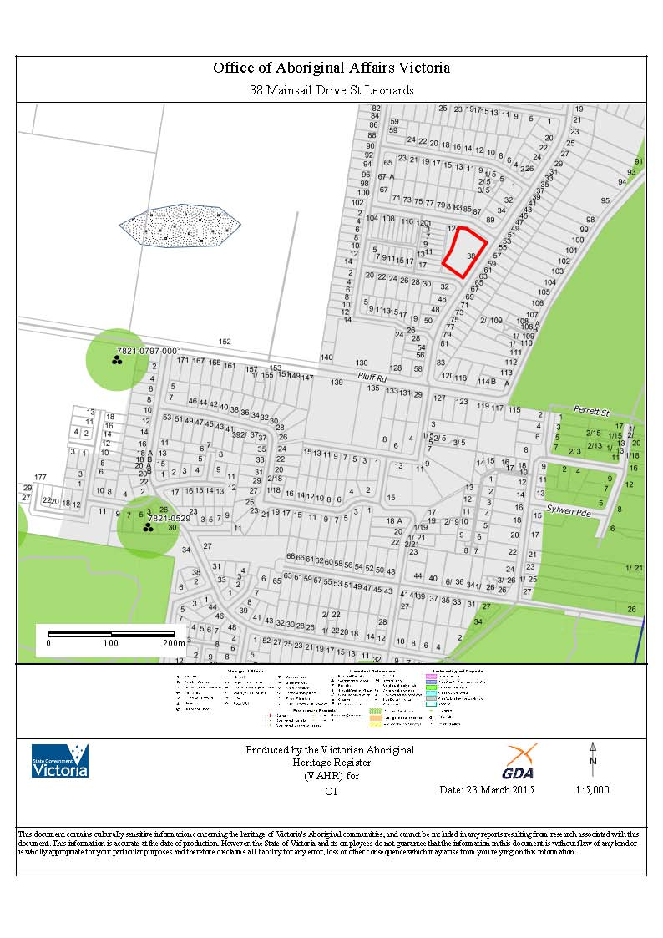
Figure 2: Areas of Cultural Heritage Sensitivity in relation to 38-42 Mainsail Drive, St Leonards (study area shown in red).

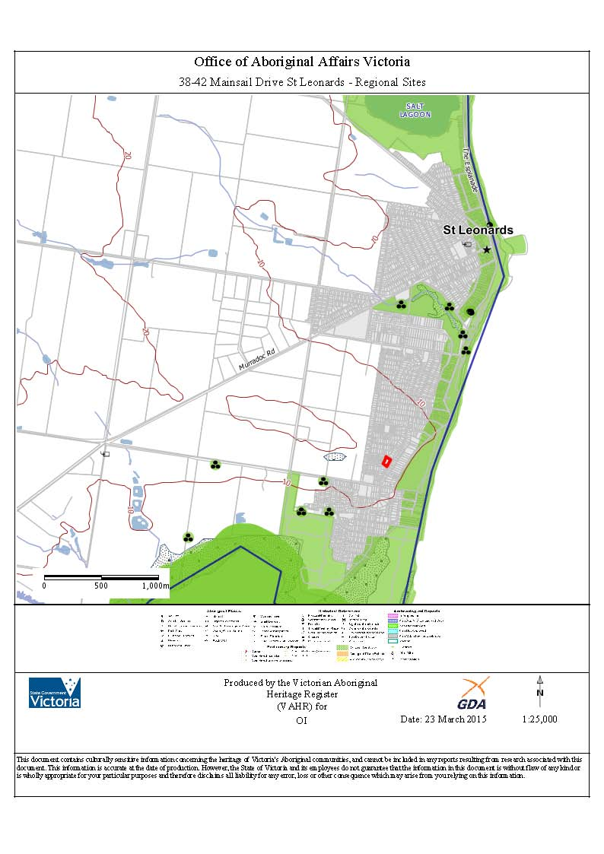
Figure 3: Registered Aboriginal places in the wider area (study area shown in red).

Previous Aboriginal Archaeological Assessments
No archaeological assessments have been undertaken within the study area. Three archaeological surveys, a subsurface testing project and one CHMP have been conducted within 1km of the study area and are briefly summarised here.
An archaeological survey of the Bluff Road (St Leonards) extension to the proposed Bellarine Peninsula Gas Supply Route (2002)]
Duncan & Stone (2002) undertook a survey of the along Bluff Road for a proposed gas pipeline, approximately 80m east of the study area. While no Aboriginal cultural heritage was identified during the survey, the report determined that if Aboriginal places were present in the study area they would occur as stone artefact and shell midden deposits, particularly along the resource rich foreshore (Duncan & Stone 2002: 1-5).
Proposed Residential Sub-Division. Corner of Point Edwards Road and Wattlehill Grove, St. Leonards (2001)]
Weaver (2001: 1-10) prepared an archaeological survey for a proposed subdivision on the corner of Point Edwards Road and Wattle Tree Grove, 450 m south west of the study area. The subject land comprised a high sandy slope tending to the south towards Swan Bay. One Aboriginal place (VAHR 7821-0529) was identified during the field survey comprising 13 stone artefacts associated with brown silty clay located adjacent to a drainage ditch. Artefacts were blades, flakes and a core made on silcrete, quartzite, quartz, and chert. She concluded that the artefacts were identified within a disturbed context and most likely redeposited during excavation of the drainage ditch. Weaver (2001: 8-10) determined that the there was potential for Aboriginal cultural heritage within the top of the slope in the northern section of the subject land given the presence of VAHR 7821-0529. While the lower southern portion contained large amounts of fill, Weaver (2001: 11) determined that the presence of fill restricted the effectiveness of the survey and the potential for subsurface Aboriginal cultural heritage was unknown, recommending that all initial earthworks should be monitored.
Proposed Residential Sub-Division. Lot A, Bluff Road, St. Leonards, Victoria:
- A Survey for Aboriginal and Historic archaeological sites (2001a)
- Archaeological Sub-surface testing project (2004)
- Cultural Heritage Management Plan (CHMP 10059) (2011)
Two archaeological assessments (Weaver 2001; 2004) and a subsequent CHMP (10059) were undertaken 500 m to the south west of the study area resulting in the identification of a high density stone artefact deposit and shell midden (VAHR 7821-0603) and low density stone artefact deposit (VAHR 7821-0797), both of which comprised surface and subsurface deposits (Weaver 2011: 55-91).
VAHR 7821-0603 was identified within shallow grey/brown sand deposits (20cm depth) overlying buckshot gravel within the southern portion of the subject land. Stone artefacts were made on quartz, quartzite, silcrete, greenstone, sandstone and fine grain basalt, and comprised flakes and tools including an axe and grinding stone. VAHR 7821-0797 was identified within a dune deposit located within the elevated north western corner of the subject land to a maximum depth of 55 cm, and comprised silcrete, quartz and quartzite flakes and cores, and Oyster, Mud Whelk and Hairy Ark shellfish species (Weaver 2011: 78-86). Weaver (2011: 90-91) indicated that VAHR 7821-0797 is located within the south western corner of an extensive sand sheet landform extending further north, and would have been utilised by Aboriginal people as elevated land overlooking Swan Bay. This landform extends into the current study area (see Figure 3).
Site Inspection
An inspection of the study area was undertaken by Cultural Heritage Advisor Sarah Collins (Project Manager, Ochre Imprints) on 18 March 2015. The study area is situated within a predominantly semi-residential/rural landscape approximately 400 metres north west of the coastline. The following observations were made during the inspection:
- the main site is used for a water reserve. The majority of the property has been cleared of native vegetation and contains pasture grasses (see Plate 1);
- mature native vegetation occurs along the boundary of the study area (Plate 3). No mature native trees of a sufficient age to have potential to contain scars associated with Aboriginal cultural activities, occur in the study area;
- the property contains a large water storage tank, associated pipe infrastructure and a shed within the northern half, and cleared flat land within the southern half (Plate 2 and 3);
- the ground surface immediately adjacent to the water tank is lower than the surrounding ground surface and contains a layer of bluestone gravel. It is likely that construction of the water tank and associated pipe infrastructure has extensively disturbed underlying deposits (Plate 4 and 5);
- soils within the southern portion of the study area appear to be local grey/brown sand with areas of introduced bluestone gravel and has been subject to less obvious ground disturbance; and,
- the property is situated within a generally flat landscape that slopes very gently to the east towards the St Leonards foreshore, that is characterised as mid slopes.
Land Use History
The Bellarine Peninsula was settled during the 1850s, initially by small scale agricultural holdings with a focus on cropping and timber felling, and later grazing. Land sales within the township of St Leonards occurred during this period, however the township remained small due to its isolated location and poor access.
The study area, located to the south west of the main township, was purchased by the State Rivers and Water Supply Commission (SRWSC) in 1963. Prior to this the study area was cleared of vegetation and most likely used for agriculture (Tony Belcher, Barwon Water, pers.com).

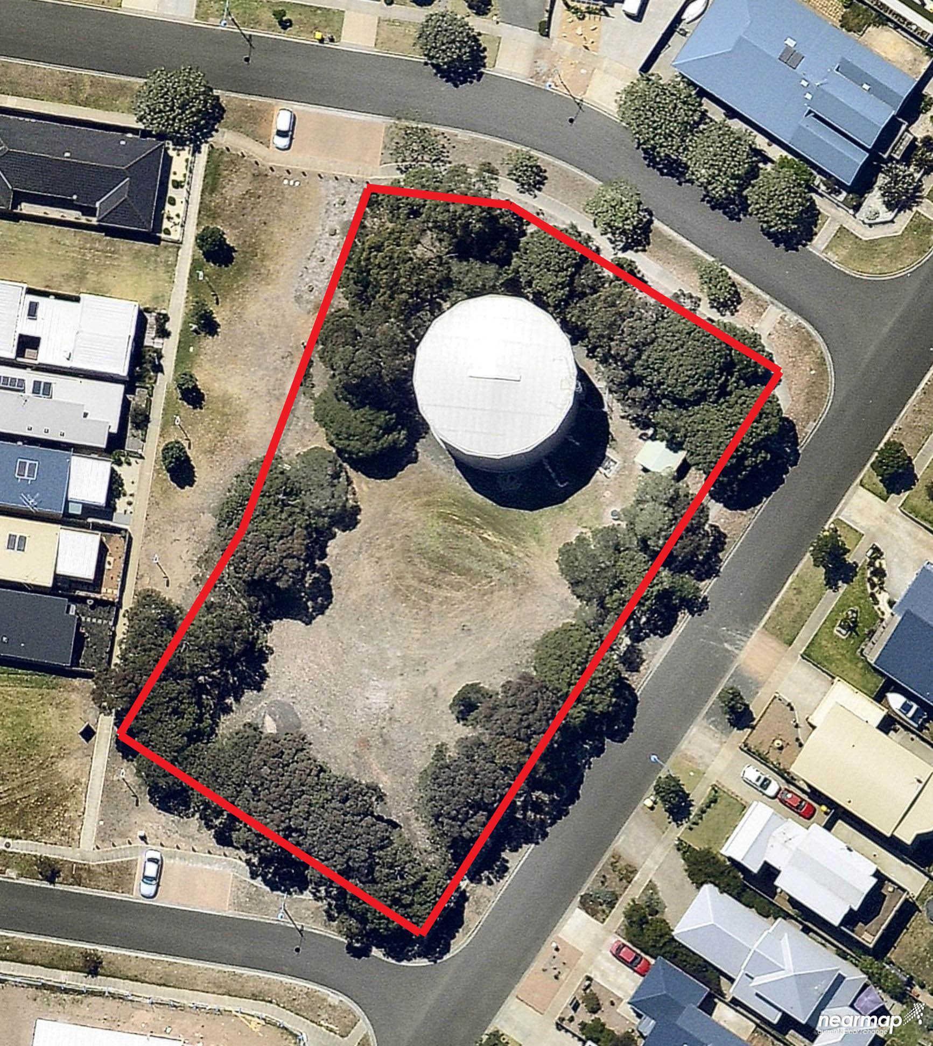
Plate 1: View of the study area (shown in red) (Source: NearMap).

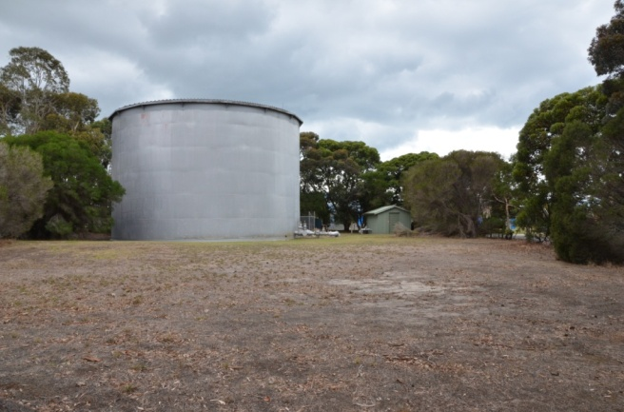Plate 2: View of the study area facing north. | 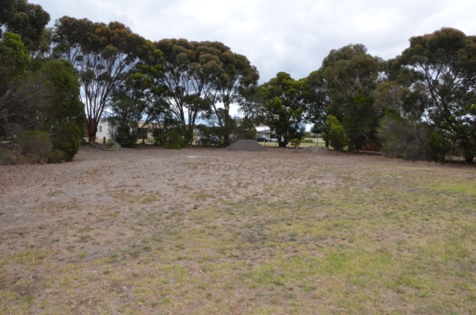Plate 3: View of the study area facing south.
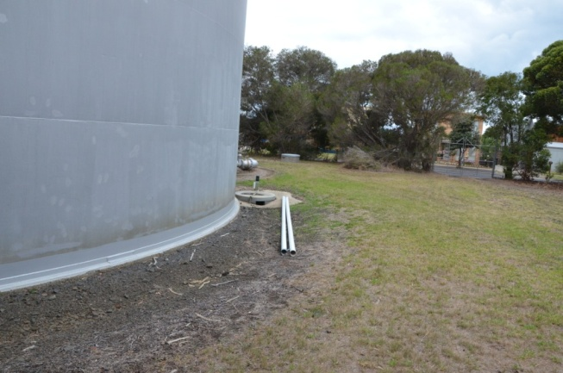Plate 4: Showing the disturbance surrounding the water tank. | 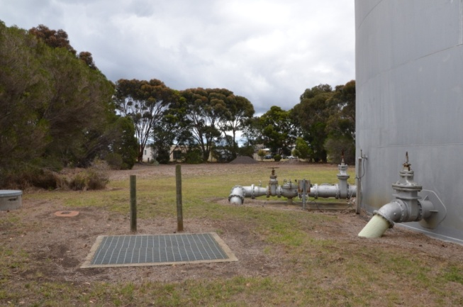Plate 5: Showing pipe infrastructure.

The 500,000 gallon welded steel tank was designed by SRWSC and built within the northern section of the study area around 1963-64. A booster pump station next to the tank was subsequently built in 1974-75. The southern portion of the study area was retained for a second tank, however this was not constructed.
What is The Aboriginal Archaeological Potential of The Study Area?
The study area has not been subject to an Aboriginal archaeological assessment. Archaeological assessments in the region, in tandem with the distribution of registered Aboriginal places, have highlighted that Aboriginal places in the region occur on a range of landforms, including the sand sheet landform that dominates the study area. The dominant Aboriginal place types include surface and subsurface stone artefact scatters. The other site type recorded in the local region is shell middens.
The results of these local archaeological assessments indicate that there is the potential for Aboriginal cultural heritage, in the form of surface and subsurface stone artefact and shell midden deposits, to occur within the study area. If present, this Aboriginal cultural heritage will have been impacted by land clearing and is unlikely to be in situ. It is unlikely that any other type of Aboriginal cultural heritage will occur in the study area.

RECOMMENDATIONS
Is A CHMP A Mandatory Requirement?
Through this review I have formed the opinion that a CHMP is not a mandatory requirement under the Aboriginal Heritage Act 2006 for the proposed rezoning and subdivision of the study area. While the activity would constitute a high impact activity under r.46(1a&b) if it involves the subdivision of 3 or more lots it does not occur in an area of Cultural Heritage Sensitivity.
Managing the Risk to Aboriginal Cultural Heritage
This review has determined that there is a risk that ground disturbing works associated with development of the property may impact on as yet unidentified Aboriginal cultural heritage. If present in the study area, Aboriginal places will most likely occur as stone artefacts in surface and subsurface deposits.
If Aboriginal cultural heritage is found within the study area significant delays could be incurred if works cease until the appropriate permissions are sought so that the Aboriginal cultural heritage can be harmed legally. If Aboriginal cultural heritage is impacted outside of the context of a CHMP or CHP, it could be construed as a breach of the Aboriginal Heritage Act 2006 and those responsible could face legal action.
The following options are available to reduce the risk of harming Aboriginal cultural heritage:
- Undertake a voluntary CHMP. An approved CHMP would identify any Aboriginal cultural heritage that may be in the study area; provide measures to manage any Aboriginal cultural heritage identified; and, specify contingency measures to follow should previously unrecorded Aboriginal cultural heritage be detected during construction. – This option provides the best way of managing the risk of harm to Aboriginal cultural heritage and would ensure that Barwon Water conducts its proposed activity in a way that complies with the Aboriginal Heritage Act 2006, especially if Aboriginal cultural heritage is extant on the property.
- Undertake a Cultural Heritage Assessment, including a field survey of the proposed works area, with the RAP (in this instance Wathaurung Aboriginal Corporation), to further assess the impact of works on Aboriginal cultural heritage – This option may provide Barwon Water with additional information on the nature of cultural heritage and/or cultural heritage sensitivity of the property. Conversely, it may add little to no additional information on the cultural heritage sensitivity of the property than has been provided in this due diligence.
- Follow reporting requirements set out under Sections 17 and 24 of the Aboriginal Heritage Act 2006 in the event that suspected Aboriginal cultural heritage (including human remains, Aboriginal places and objects) is identified during the proposed works. – This option would reduce the risk of harm to Aboriginal cultural heritage as works would be required to stop so that further harm can be averted. However, it should be noted that reporting the discovery of Aboriginal cultural heritage disturbed during an activity does not remove the legal constraints set by the Aboriginal Heritage Act 2006.
If you require any further information or have any questions regarding this matter, please do not hesitate to contact me.
Yours sincerely,



Megan Goulding
Chief Executive Officer/ Principal Heritage Adviser
ochre imprints pty ltd

References
Duncan, J. & Stone, T., 2002. An archaeological survey of the Bluff Road (St Leonards) extension to the proposed Bellarine Peninsula Gas Supply Route, Victoria. A report to GCI Kenny.
Weaver, F.J., 2001. Proposed Residential Sub-Division. Corner of Point Edwards Road and Wattlehill Grove, St. Leonards, Victoria. A survey for Aboriginal and Historical Archaeological sites. A Report to Tregallas Pty Ltd and Grant St. Quentin Surveyors Pty Ltd, Geelong.
Weaver, F.J., 2001a. Proposed Residential Sub-Division. Lot A, Bluff Road, St. Leonards, Victoria. A Survey for Aboriginal and Historic archaeological sites. A report to Tregallus Pty Ltd, and Grant St. Quentin Surveyors Pty Ltd.
Weaver, F.J., 2004. Proposed Residential Sub-Division. Lot A, Bluff Road, St. Leonards, Victoria Archaeological Sub-surface testing project. A report to Tregallus Pty Ltd and St. Quentin Consulting Pty Ltd, Geelong.
Weaver, F. 2011. Proposed Residential Sub-Division Lot A, Bluff Road, St. Leonards, Victoria. CHMP 10059. Unpublished report to St. Quentin Consulting Pty Ltd.

Ochre Imprints is well qualified to comment on these matters. Our staff meet the requirements to be a ‘cultural heritage advisor’ under the Aboriginal Heritage Act 2006, and have extensive experience with due diligence assessments, Cultural Heritage Management Plans (CHMPs) and Aboriginal cultural heritage assessments, both state-wide and in the region of the study area.
No consultation was undertaken with Aboriginal stakeholders for this due diligence assessment.
The Department of Premier and Cabinet replaced the Department of Victorian Communities, as referred to in the Aboriginal Heritage Act 2006, in early 2013. It should also be noted that the Office of Aboriginal Affairs Victoria carries out the day-to-day administrative functions on behalf of the Secretary.
This inspection does not constitute a cultural heritage field survey.
Ochre Imprints can provide more detail on these requirements.

